


Conservation implications of source-sink dynamics within
populations of endangered Maculinea butterflies
Natalia Timus1 • Zsolt Czekes2,3 • Laszlo Rákosy1 • Piotr Nowicki4
Received: 19 April 2016 / Accepted: 19 August 2016 / Published online: 30 August 2016
© The Author(s) 2016. This article is published with open access at Springerlink.com
Abstract Conservation programmes are often based on
snapshot information on animal abundance. However, land
fragments with high numbers of individuals do not neces-
sarily represent their natal areas, which are crucial for spe-
cies persistence. A classic example of the above principle
are source-sink systems, in which excess individuals emi-
grate from source areas during their lifetime and gather in
sink areas. We demonstrated the existence of source-sink
dynamics in two species of endangered Maculinea (=Phen-
garis) butterflies. Sympatrically occurring M. nausithous
and M. teleius were investigated with mark-recapture sam-
pling during the entire flight period. In the first half of the
season a great majority of butterflies were captured within
the relatively small central part of the site, while later their
numbers became similar between the site centre and its
peripheries. The analysis of movements indicated that most
individuals captured in the peripheral zone eclosed in the
central zone. Moreover, the timing of the sharp increase
in movements from the site centre to its peripheries cor-
responded well with the period when the number of eggs
laid in the former area reached carrying capacity, defined
by the number of the Sanguisorba officinalis foodplant
S Piotr Nowicki
piotr.nowicki@uj.edu.pl
- Department of Taxonomy and Ecology, Babes-Bolyai
University, Clinicilor 5-7, Cluj-Napoca, Romania
- Hungarian Department of Biology and Ecology, Babes-
Bolyai University, Clinicilor 5-7, Cluj-Napoca, Romania
- Interdisciplinary Research Institute on Bio-Nano-Sciences,
Treboniu Laurian 42, Cluj-Napoca, Romania
- Institute of Environmental Sciences, Jagiellonian University,
Gronostajowa 7, 30-387 Kraków, Poland
flowerheads available for oviposition. Within the periph-
eral zone the foodplant availability greatly exceeded the
egg load, but in contrast the abundance of host ants (i.e.
the other essential resource) was low, which presumably
results in low Maculinea larval survival there. Our find-
ings imply that setting conservation priorities over differ-
ent land fragments should take into account dispersion of
individuals among them.
Keywords Mark-recapture • Population survey •
Resource availability • Source-sink system • Species
conservation

Introduction
Source-sink dynamics is a phenomenon of high importance
for population ecology (Pulliam 1988; Pulliam and Daniel-
son 1991). Populations with intrinsic growth rate exceeding
one may either increase in size or, in the more frequent case
when the carrying capacity of their habitats limits popu-
lation increase, they produce surplus individuals, which
tend to emigrate from their natal sites (Diffendorfer 1998).
Therefore, such populations become sources of immigrants
into sink populations with intrinsic growth rate below one
(Pulliam 1988; Tittler et al. 2006). The continuous influx
of immigrants provides rescue effects for declining popula-
tions, supporting their persistence (Hanski et al. 1996).
The existence of source and sink populations has serious
consequences for species conservation. Its most important
implication is the fact that only source populations guar-
antee long-term species survival (Dias 1996). In turn, sink
populations are in principle not necessary for species sur-
vival. Actually, their existence may occasionally be harm-
ful in this respect, as exemplified by the case of so-called
J Insect Conserv (2017) 21:369-378
DOI 10.1007/s10841-016-9906-6
ORIGINAL PAPER

370
J Insect Conserv (2017) 21:369-378
attractive sinks (Delibes et al. 2001; Battin 2004). These
represent areas that strongly attract immigrants, typically
through the high availability of certain resources required
by the species, but they are short in other crucial resources,
for instance those which are essential for offspring. In such
areas the chances of successful reproduction are precluded
or at least substantially reduced, and in this way attrac-
tive sinks loose the reproductive potential of the immi-
grants, which could otherwise enhance the viability of other
populations.
Consequently, conservation efforts should be focused
on source populations and not on the sink ones. However,
when setting conservation priorities most programmes rely
on snapshot information on the occurrence or abundance
of certain target species rather than on the thorough under-
standing of their population dynamics, and thus distinguish-
ing between sources and sinks is difficult in practice (Dias
1996; Runge et al. 2006). This is particularly true in the case
when individuals are more abundant or just more conspicu-
ous in their sink habitats.
Most empirical studies have so far investigated source-
sink systems at a relatively large scale of entire metapopu-
lations (Thomas et al. 1996; Boughton 1999; Tittler et al.
2006). Nevertheless, source-sink dynamics is similarly
likely to occur at a much smaller spatial scales, namely
within habitat patches inhabited by single local populations.
This is because resource availability within habitat patches
is typically not uniform, but rather highly heterogeneous.
Consequently, certain patch fragments are rich in resources
and they are able to produce net excess of individuals, which
can subsequently move to the fragments of low quality. The
aim of the present study was to demonstrate the existence of
a within-patch source-sink system in endangered Maculinea
(=Phengaris) butterflies. For this purpose we used the data
provided by an intensive survey of M. nausithous and M.
teleius, occurring sympatrically at a highly heterogeneous
site in central Transylvania, Romania. We also discuss the
implications of such a small scale source-sink dynamics for
the conservation of the two focal species.

Materials and methods
Study system
Butterflies of the genus Maculinea are regarded as flagships
of insect conservation in Europe and useful indicators of
grassland biodiversity (Maes and van Dyck 2005; Settele
et al. 2005). They are highly specialised myrmecophilous
species, requiring two essential resources to complete their
life cycle. These comprise specific foodplants, on which
Maculinea larvae feed in their initial stages, and specific
host ants of the genus Myrmica, in the colonies of which
Maculinea larvae act as social parasites and complete their
development (Thomas 1995; Witek et al. 2010). Foodplants
are typically patchily distributed and thus their occurrence
defines the spatial limits of Maculinea habitats (Nowicki
et al. 2007; Nowicki and Vrabec 2011). In turn, Myrmica
host ants are usually widespread but their abundance var-
ies greatly and it shapes the carrying capacity of Maculinea
habitat patches (Hochberg et al. 1994; Nowicki et al. 2009).
The study was conducted at the Fanatul Domnesc site
near the village of Rascruci in central Transylvania, Roma-
nia (46.92°N, 23.73°E; 410-460 m a.s.l.). The site is a
mesohygrophilous meadow with a relatively large patch of
Sanguisorba officinalis, which is the exclusive larval food-
plant of both M. nausithous and M. teleius, as well as the
primary nectar source for their adults (Elmes and Thomas
1992; Thomas 1995). The central part of the patch (2.37 ha
in area) comprises a boggy depression with Molinion caeru-
leae Koch 1926, whereas its peripheral fragments (12.89 ha
in area) are dryer and covered with Cirsio-Brachypodion
pinnati Hadac et Klika ex Klika 1951 (Stoianov et al. 2012;
see this reference for further information about the site).
The peculiarity of the Fanatul Domnesc site is the fairly
low density of S. officinalis (see the “Results”). While at
most other sites with M. nausithous and/or M. teleius, the
availability of the S. officinalis flowerheads, in which lar-
vae of both species feed for the initial 3-4 weeks, usually
exceed the population requirements by at least an order of
magnitude (Nowicki et al. 2007, 2009), this is clearly not
the case at Fanatul Domnesc. Consequently, unlike at other
sites, the foodplant availability can be considered a limiting
factor for the focal populations of both Maculinea species.
The other constraint for population dynamics is the avail-
ability of host ant nests. Earlier field studies have revealed
that M. nausithous and M. teleius share the same local host
ant in the region, namely Myrmica scabrinodis (Tartally
and Varga 2008; Tartally et al. 2008). In the case of the for-
mer butterfly, which within its European distribution range
is mostly associated with Myrmica rubra, such a host spe-
cies is unusual, although not exceptional (cf. Munguira and
Martin 1999; Witek et al. 2008), but it is typical for the sub-
species M. nausithous kijevensis occuring in Transylvania
(Rakosy et al. 2010).
Maculinea populations at Fanatul Domnesc are rela-
tively isolated. The only other nearby locality inhabited
by M. nausithous and M. teleius is Fanatul Satesc, situated
ca. 1 km away. Such a separation distance is several times
longer than typical movement distances for both species in
grassland landscapes (Nowicki et al. 2014). Furthermore,
this other locality is much smaller and few adult butterflies
have been observed there in recent years (authors’ unpubl.
data). Consequently, a considerable exchange of individuals
between our focal site and other populations in the region is
unlikely; in fact we recorded merely two cases of inter-patch


J Insect Conserv (2017) 21:369-378
371
movements of Maculinea butterflies (one for each species)
between Fanatul Domnesc and Fanatul Satesc.

Field surveys
In summer 2009 low intensity mark-recapture sampling
of M. nausithous and M. teleius was conducted at Fanatul
Domnesc to provide general information about the size
of their populations (Voda et al. 2010). This preliminary
study suggested a somewhat surprising pattern: butterflies
tended to concentrate in the central part of the meadow in
July, roughly corresponding to the first half of the season,
whereas in August their distribution was far more dispersed
all over the site. However, the data gathered were not good
enough to allow a detailed analysis of the pattern observed.
Consequently, in order to investigate the pattern we decided
to launch a more intensive mark-recapture survey in 2010.
The survey was conducted between 12 July and 27
August, thus spanning the entire flight period of both inves-
tigated species. Butterflies were captured between 9:00 and
17:00 on roughly every third day (weather allowing), and
the sampling intensity was kept fairly uniform across the
whole site. Captured individuals were marked with consec-
utive numbers written on the underside of their hind wings
using permanent sharp-tipped markers, and immediately
released at the spot. In each case we determined the butterfly
sex and recorded the position of its capture with GPS units
Garmin GPSMAP 60CSx (Olathe, USA).
In the same year we assessed the abundance of foodplants
and host ants at Fanatul Domnesc. For the purpose of food-
plant surveys, we established 1 m2 square sampling plots,
which were randomly distributed all over the site, although
with stratification so as to ensure representative numbers of
sampling plots within both the central part as well as the
peripheral fragments of the site (63 and 319 plots respec-
tively). In each plot we counted the number of S. officinalis
shoots and flowerheads on each shoot. When estimating the
availability of flowerheads for Maculinea, we assumed that
only about one-third of them were in the proper phenologi-
cal state for oviposition during the flight period of these but-
terflies (Figurny and Woyciechowski 1998).
Ant surveys were conducted in circular plots of 4-m
diameter (32 within the central part and 84 within the
peripheral fragments of Fanatul Domnesc). These plots
were thoroughly searched for ant nests between 28 June
and 20 July 2010. From each nest we took ca. 20 workers
for species identification. In addition, we collected forag-
ing ant workers using pitfall traps. We used standard plastic
cups of 75 mm diameter, half-filled with ethylene glycol.
One pitfall trap was placed in the centre of each plot and
left for 10 days from 16 to 26 September 2010. Since some
pitfall traps were destroyed by grazing animals, the sample
size was reduced to 28 and 40 traps within respectively the
central and peripheral part of the site. Ant species identifica-
tion was conducted with the help of the keys by Radchenko
and Elmes (2010), Czechowski et al. (2012), and Czekes et
al. (2012).

Analysis
Each butterfly capture was classified as occurring either in
the central part of Fanatul Domnesc or in its peripheral frag-
ments. Subsequently, the mark-recapture data gathered were
analysed with MARK 8.0 software (White and Burnham
1999) using the multi-state recapture models of Brownie
et al. (1993). The analyses were conducted separately for
M. nausithous and M. teleius, with two different zones of
the site (central part and peripheries) adopted as ‘states’.
The model allows the estimation of capture probability (p)
and survival (<f>) within each state as well as the probabil-
ity of transition between the states (y), i.e. in our case the
probability of movement between the two defined zones of
Fanatul Domnesc. We tested model variants with different
patterns in all the above parameters including constant value
denoted as (.), intersexual difference (s), temporal variation
(t), additive effects of intersexual difference and temporal
variation (s+t) as well as their independent effects (s*t).
The performance of specific models was compared using
the Akaike Information Criterion corrected for small sample
size (AICc) (Akaike 1973; Hurvich and Tsai 1989). While
the lowest AICc value indicates the best performing model,
all the models with the AICc value exceeding the lowest one
by less than 2 should be regarded as supported by the data
(Burnham and Anderson 2001). Since for each species there
were several supported models performing similarly well,
we decided to rely on the parameter values calculated as
weighted means for all the supported models using their
Akaike weights. Akaike weight can be interpreted as the
probability of a particular model being the most appropriate
one (Burnham and Anderson 2001).
Based on the Brownie model parameters obtained with
MARK program (p, Q, y), we estimated further parameters
describing within-season dynamics of the investigated pop-
ulations. Daily numbers of butterflies present in both zones
(C=patch centre, M=patch margins) on day i were calcu-
lated as:
where nCi and nMi represent the numbers of captured
individuals, which are known from capture records. The
Brownie model is based on the assumption of equal capture
probability for all individuals, which may be problematic
to meet for butterflies, in which intersexual differences in
catchability have often been reported (Nowicki et al. 2008).
However, we avoided this problem by relying on capture
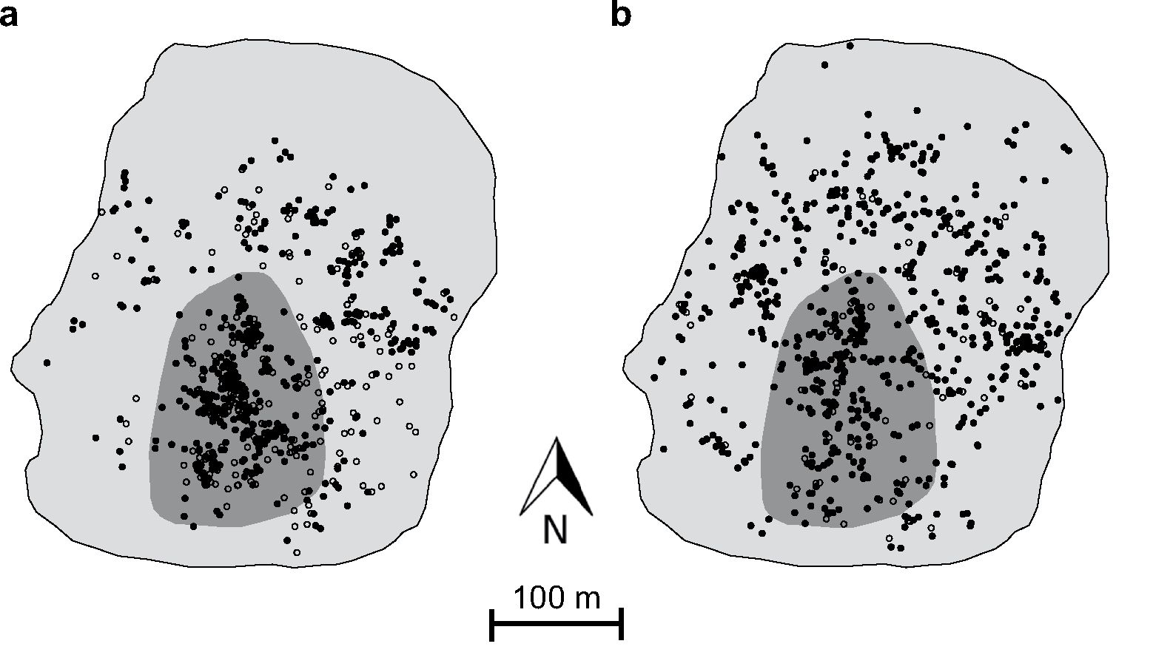

372
J Insect Conserv (2017) 21:369-378
and similarly in the case of BM ;
All the above population parameters were estimated sepa-
rately for both sexes, and then summed up, because the
model selection routine based on AICc indicated intersex-
ual differences in several Brownie model parameters. It is
worth noting that the sum of recruitments throughout the
flight period constitutes the total number of butterflies origi-
nating from a particular zone (Ntotal), and the total number
of individuals moving from one to the other (Mtotal) can be
obtained in a similar way.
We also assessed the number of eggs present on each sam-
pling day through multiplying the numbers of females fly-
ing prior to the date by 75 eggs per female. The above figure
represents the average fecundity in closely related M. arion
(Thomas et al. 1998a); it is also in good agreement with our
own rough estimates forM. nausithous andM. teleius obtained
in Poland (ca. 80 eggs per female; P. Nowicki unpubl. data).
We compared the overall egg load estimated in this way with
the number of S. officinalis flowerheads available in the cen-
tral and marginal zone, calculated as the product of zone area,
flowerhead density, and the proportion of flowerheads in the
proper phenological state for oviposition, assumed as one-
third after Figurny and Woyciechowski (1998).

Results
During the entire season we recorded 1350 captures of 842
M. nausithous adults, and 392 captures of 258 M. teleius
adults. In the first half of the season, namely in July, the
captures of both species were made predominantly within
the central part of the investigated site, whereas in August
their distribution was more balanced, with similar numbers
of captures occurring in both the central part as well as the
marginal fragments (Fig. 1).
The multi-model selection routine based on the Akaike
Information Criterion revealed that several multi-state recap-
ture models were well supported by the data collected for each
species (Table 1). Nevertheless, the structure of these models
differed only with regard to survival rate and capture prob-
ability. At the same time all the models indicated an identical
pattern in the butterfly transition probabilities between the two
zones defined, namely intersexual differences and additionally
the existence of temporal variation in the probability of mov-
ing from the central to the marginal zone of Fanatul Domnesc
but not the other way round (Table 1 ). Daily survival was rela-
tively high in both species, with the values given in Table 2
corresponding to adult life span of approximately 4 to 8 days.
Fig. 1 Distribution of capture points of M. nausithous (solid dots) and
M. teleius (empty dots) within the central part (dark grey area) and
marginal fragments (light grey area) of the studied site in July (a) and
August (b). It should be noted that the number of capture points within
the former area is visually underestimated, because in many cases sev-
eral individuals were captured in exactly the same locations
probability estimates derived separately for both sexes (see
below). Subsequently, the numbers of butterflies moving
from one zone to the other within the interval between sam-
pling days i and i + 1 were derived as:
Finally, it was also possible to estimate the demographic
recruitments within this interval, i.e. in our case the num-
bers of butterflies eclosing in each zone, as the difference
between the butterfly numbers on day i + 1 and the sum of
survivors from day i and immigrants from the other zone:
J Insect Conserv (2017) 21:369-378
373
Table 1 Performance of the
supported multi-state recapture
models for the two investigated
Maculinea species, as indicated
by their Akaike Information
Criterion corrected for small
sample size (AICc), its differ-
ence from the value of the best
performing model (AAICc), and
Akaike weight (w)
Model type | No. of parameters | AICc | AAICc | w
M. nausithous
MO Ms) Pc(t) Pм(.) Vc^ds + t) Ум^') | 35 | 2305.14 | 0 | 0.270
Ms) фм(.)Pc(t)Pм(.) Vc^ds + t) Ум^') | 35 | 2305.76 | 0.62 | 0.19B
Ms) Ms)Pc(t)Pм(.) Vc^ds + t) Ум^') | 36 | 2306.0B | 0.94 | 0.169
MO Ms) Pc(s*t) Pм(.) Vc^ds + t) Ум^с^") | 49 | 2306.41 | 1.2B | 0.143
MO Ms) Pc(t) Pм(s) Vc^ds + t) Ум^') | 36 | 2306.B5 | 1.71 | 0.115
МО фм(.) Pc(t) Pм(s) Vc^ds + t) Ум^') | 35 | 2307.03 | 1.B9 | 0.105
M. teleius
МО фм(.) Pc(.) Pм(.) Vc^ds + t) Ум^') | 17 | 590.63 | 0 | 0.224
Ms) фм(.) Pc(.) Pм(.) Vc^ds + t) Ум^') | 18 | 591.01 | 0.3B | 0.1B5
MO Ms) Pc(.) Pм(.) Vc^ds + t) Ум^') | 18 | 591.47 | 0.B3 | 0.14B
МО фм(.) Pc(s) Pм(.) Vc^ds + t) Ум^') | 18 | 591.57 | 0.94 | 0.140
МО фм(.) Pc(.) Pм(s) Vc^ds + t) Ум^') | 18 | 591.72 | 1.09 | 0.130
Ms) фм(.) Pc(s) Pм(.) yc^ds + t) Ум^') | 19 | 592.51 | 1.BB | 0.0BB
Ms) Ms) Pc(.) Pм(.) yc^ds + t) Ум^') | 19 | 592.54 | 1.91 | 0.0B6
The notation of the models follows the standard system (see the “Analysis” section of the text for a detailed
explanation), with subscripts C and M representing respectively the central and marginal part of the stud-
ied site
Table 2 Weighted mean parameter estimates (±SE) of the supported multi-state recapture models for the two investigated Maculinea species in
the central (C) and marginal part (M) of the studied site
Species | Sex | Survival rate |  | Capture probability |  | Transition probability
 |  | c | м | c | м | C ^ M | M ^ C
M. nausithous | Males | 0.B9 ± 0.01 | 0.B2 ± 0.01 | 0.44 ± 0.06* | 0.47 ± 0.06 | 0.3B ± 0.06* | 0.21 ± 0.05
 | Females | 0.B4 ± 0.03 | 0.77 ± 0.02 | 0.22 ± 0.06* | 0.41 ± 0.06 | 0.91 ± 0.07* | 0.44 ± 0.0B
M. teleius | Males | 0.B7 ± 0.04 | 0.79 ± 0.03 | 0.47 ± 0.16 | 0.40 ± 0.14 | 0.6B ± 0.15* | 0.03 ± 0.03
 | Females | 0.B3 ± 0.04 | 0.7B ± 0.03 | 0.30 ± 0.09 | 0.49 ± 0.17 | 0.B0 ± 0.10* | 0.13 ± 0.07
The parameter values marked with asterisks are shown for the sake of consistency, even though the supported models revealed temporal varia-
tion in these parameters (see Table 1). In such cases the means were first estimated separately for each supported model using the numbers
of individuals captured per capture day as weights, and subsequently they were weighted across the supported models based on their Akaike
weights
Besides, the survival was consistently (although rather slightly)
higher within the central zone as well as in males as compared
with females. Capture probabilities reached a noteworthy level
of 40-50 % in most cases (Table 2), which resulted in fairly
good precision of butterfly abundance estimates.
The within-season population dynamics in both Macu-
linea species reflected very well the aforementioned change
in the spatial distribution of capture points with the season
progression. In July the daily numbers of butterflies present
within the central part of Fanatul Domnesc greatly exceeded
those estimated for the site peripheries, but in the follow-
ing month the difference in the numbers of individuals fly-
ing within the two zones was rather small in the case of M.
nausithous or hardly existent at all in the case of M. teleius
(Fig. 2). The seasonal population size for the entire site was
assessed at 2131 M. nausithous adults and 593 M. teleius
adults, the great majority (ca. 80 % regardless of the species)
of which eclosed within the central zone (Table 3).
In concordance with the above proportion we found that
host ant availability was considerably poorer within the site
margins. The density of My. scabrinodis nests in this part was
about four times lower than in the central zone, and in the
case of the numbers of foragers recorded in pitfall traps this
disproportion rose to almost an order of magnitude (Table 3).
This indicates small sizes of host ant colonies, many of
which may thus be too small to support the full development
of Maculinea larvae. In contrast, there was hardly any dif-
ference in the densities of the other essential resource, i.e.
the flowerheads of S. officinalis foodplants, between the two
defined zones of the Fanatul Domnesc site (Table 3). Nev-
ertheless, the much larger area of the peripheral fragments
made the difference, and hence the overall availability of the
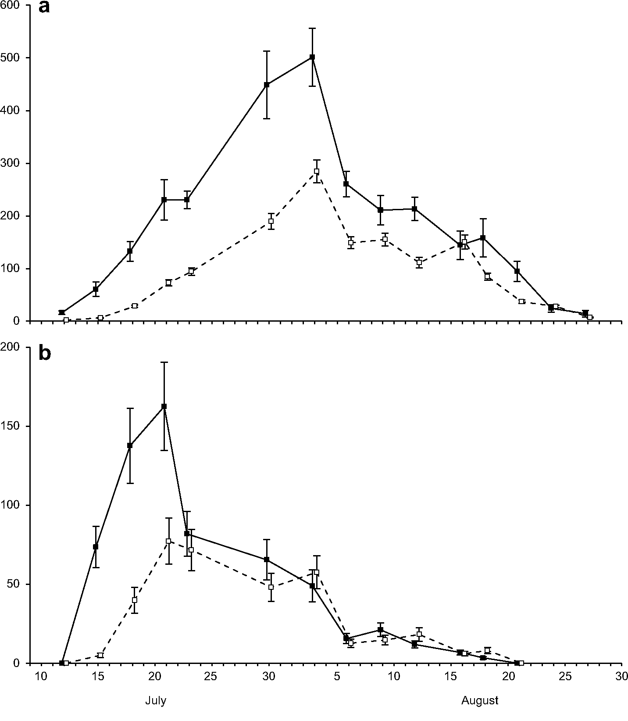
374
J Insect Conserv (2017) 21:369-378
Fig. 2 Within-season dynamics of the daily numbers (±SE) of M. nausithous (a) and M. teleius (b) within the central part (solid squares, solid
line) and marginal fragments (empty squares, broken line) of the studied site
Table З Numbers of eclosing adult butterflies of the two investigated
Maculinea species and the availability of their crucial resources within
the central and marginal part of the studied site
Parameter | central part | Marginal part
M. nausithous adults | 1715±376 | 416 ± 92
M. teleius adults | 470 ± 130 | 12З ± 40
S. officinalis
Flowerhead density per m2 | 6.BB ± 2.09 | 7.44 ± 1.63
Total number of flowerheads | 163 ± 50 | 959±210
(in thousands)
My. scabrinodis
Nest density per m2 | 0.122 ± 0.027 | 0.034 ± 0.009
Workers per pitfall trap | 4.57 ± 1.56 | 0.60 ± 0.15
All the estimated values are presented with their SEs
foodplant flowerheads was far greater there. Consequently,
the estimated number of eggs laid by both species within the
central part of the site was likely to exceed the number of
flowerheads available at the beginning of August (Fig. 3c),
whereas in the site peripheries the flowerhead availability
surpassed the egg load by over an order of magnitude.
The moving between the two defined zones was invari-
ably more frequent in females. The probability of transition
from the marginal to central zone reached a moderate level
only in M. nausithous females, otherwise being relatively low
(Table 2). In turn, the probability of moving in the opposite
direction showed strong temporal variation (Fig. 3a, b). It was
close to zero at the beginning of flight period, and then rose
to a very high level (>80 % in females). Interestingly, the tim-
ing of this sharp increase in frequency of movements from the
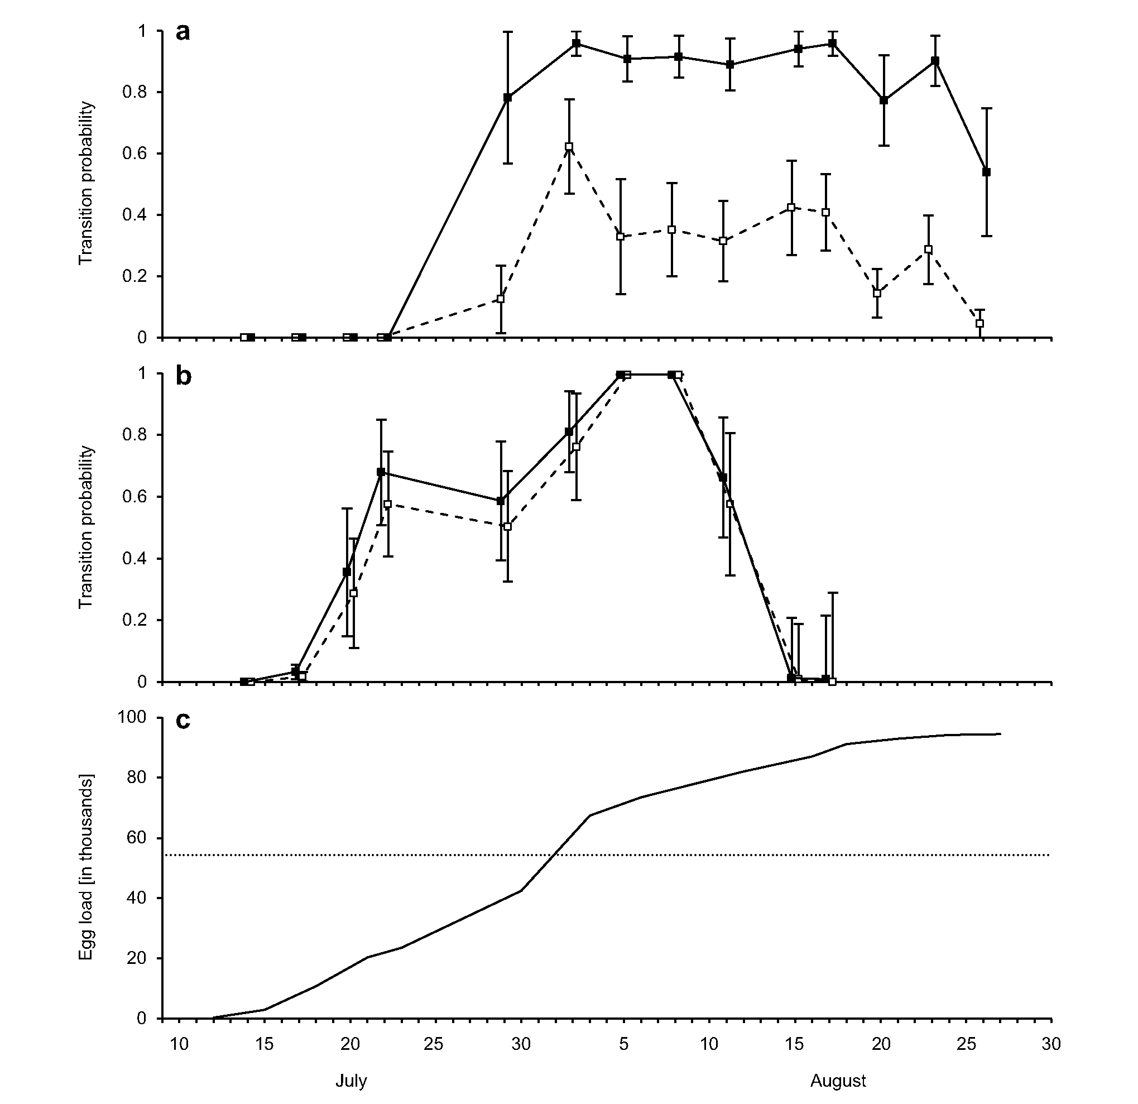
J Insect Conserv (2017) 21:369-378
375
Fig. 3 Within-season dynamics of movements of M. nausithous (a)
and M. teleius (b) from the central part to marginal fragments of the
studied site, expressed with multi-state recapture model estimates of
transition probabilities (±SE) for both sexes (males: empty squares,
broken line; females: solid squares, solid line). It should be noted that
for the sake of consistency with the standard multi-state model nota-
tion, transition probabilities in each case are presented for the last day
of the period between consecutive capture days, but they refer to the
entire preceding period, starting from the previous capture day. The
bottom panel (c) shows the dynamics of the number of Maculinea eggs
oviposited within the central part of the site (solid line), assessed on
the basis of the total number of both species’ females present there
prior to the date and average fecundity of 75 eggs per female (see the
“Analysis” section of the text for rationale). The carrying capacity
(dotted line) assumed as one-third of S. officinalis flowerheads avail-
able within this area is also shown for comparison
patch centre to its margin coincided well with the period when
egg load within the former area approached and exceeded
the S. officinalis flowerhead availability. At the end of sea-
son the transition probabilities dropped again (except for M.
nausithous females), but it should be underlined that these esti-
mates referred to very small numbers of individuals still flying
then.

Discussion
M. nausithous and M. teleius often coexist (Sliwinska et al.
2006; Dierks and Fischer 2009; Nowicki et al. 2014), but
the situation that they use the same host ant at a single local-
ity is very infrequent (cf. Witek et al. 2008). The implication
is that they are forced to utilise exactly the same limited
376
J Insect Conserv (2017) 21:369-378
resources at Fanatul Domnesc. Therefore, our results indi-
cating that M. nausithous is about four times more abundant
than M. teleius suggest that the former species is appar-
ently more efficient in using the resources. The most likely
explanation of the fact is its more efficient parasitic strategy.
Inside ant nests Maculinea larvae either prey on ant brood
(‘predatory strategy’) or are fed by ant workers (‘cuckoo
strategy’), with the latter strategy resulting in their higher
survival (Thomas and Wardlaw 1992; Thomas and Elmes
1998). While M. teleius follows a strictly predatory strategy,
M. nausithous shows the characteristics of both strategies
(Thomas and Elmes 1998).
More importantly, our findings showed that a prevailing
majority (ca. 80 %) of adult individuals in both investigated
species eclosed within the relatively small central part of
Fanatul Domnesc (ca. 15 % of the total area of the site). We
also demonstrated that with the flight period progression the
butterflies gradually spread from the site centre to its periph-
eral fragments. This spreading was female-biased and its tim-
ing coincided well with the period when most of S. officinalis
flowerheads present in the patch centre were likely to already
contain Maculinea eggs. Females in several butterfly species,
including Maculinea, were found to prefer foodplants without
previously oviposited eggs in order to minimise intra-specific
competition (in our specific case of M. nausithous and M.
teleius potentially also interspecific one) experienced by their
larval offsprings (Rausher 1979; Jones 1991; Dempster 1992;
Van Dyck et al. 2000). Therefore, it may be expected that in
order to find vacant flowerheads, female individuals eclosing
in the patch centre are inclined to move towards outer frag-
ments of the site in the second half of the season. Many males
are likely to follow them when searching for mating partners
(cf. Nowicki and Vrabec 2011).
While S. officinalis foodplants are similarly abundant in
the peripheral fragments of Fanatul Domnesc, host ant colo-
nies are relatively scarce there, and thus Maculinea larvae
have little chance to be adopted by ants after they finish their
initial development on foodplants. Consequently, these outer
fragments apparently constitute sink areas with population
growth rate well below one, and absorbing the excess indi-
viduals from the site centre. Obviously, in order to confirm
source-sink dynamics in our study system the data spanning
several years would be required (cf. Dias 1996). Regretfully,
the data we have gathered in other years through non-inten-
sive monitoring of the Fanatul Domnesc populations are not
comprehensive enough so as to allow repeating the analyses
conducted for 2010. However, they clearly indicate a simi-
lar pattern, i.e. in July butterflies of both species were cap-
tured almost exclusively in the central fragment, whereas in
August they were fairly evenly distributed between the two
parts of the site (authors’ unpubl. data).
The results we have obtained are in sharp contrast with
several earlier studies on Maculinea, which found that edge
fragments of habitat patches are typically of better qual-
ity and preferred by adult butterflies (Batary et al. 2009;
Korosi et al. 2012; Nowicki et al. 2013). The higher densi-
ties of host ant colonies due to their influx from surround-
ing areas free from the parasitic pressure by Maculinea
were suggested as a potential explanation for such a pattern
(Nowicki et al. 2007, 2013). Nevertheless, this explanation
is reasonable for relatively homogeneous habitat patches,
with different fragments being equally suitable for host ant
colonies. At our clearly heterogeneous study site the ant
community composition appears to be driven primarily by
microhabitat conditions, which in turn are shaped by topog-
raphy. The abundance of My. scabrinodis is relatively high
only within the humid central part of the meadow, while
in the drier peripheral fragments this host ant is partly out-
competed by other Myrmica species (Czekes 2012). Our
findings thus imply that higher host ant availability at patch
margins should not be regarded as a general rule applicable
for any Maculinea site. Instead, local knowledge must be
used in conservation actions, especially in setting manage-
ment plans for different land fragments.
In the case of the Fanatul Domnesc site, its central part
constituting the source area is undoubtedly crucial for the
preservation of the local populations of M. nausithous and
M. teleius. Moreover, it may be important for the persis-
tence of both species in a wider region, since their popula-
tions at Fanatul Domnesc are the largest known in the region
(authors’ unpubl. data). Conservation efforts should thus be
focused on maintaining the core area of Fanatul Domnesc
in its present state, which is apparently near optimal for the
focal species, since it supports relatively high densities of
M. nausithous and moderate densities of M. teleius (com-
pare Nowicki et al. 2007, 2014). This aim can presumably
be achieved by the continuation of the current management
regime, namely irregular mowing combined with extensive
grazing (Stoianov et al. 2012).
The peripheral fragments of Fanatul Domnesc, repre-
senting sink areas, have lower conservation value. Never-
theless, it does not mean that they are of no importance for
the persistence of the focal populations. As mentioned in the
Introduction, it is often claimed that true sink areas are not
helpful for preserving species of conservation concern, and
they may even have a detrimental effect through ‘sucking
out’ individuals from source areas and thus decreasing the
overall population growth rate (Delibes et al. 2001; Robert-
son and Hutto 2006). However, this is not the case in our
study system. If too many Maculinea larvae get into a single
host colony, then they overexploit it (Thomas and Wardlaw
1992). Subsequently, they suffer from low survival and in
the extreme case they may all die. This scramble competi-
tion among larvae leads to an increased level of population
fluctuations (Thomas et al. 1998a). Therefore, by absorbing
the excess individuals from the central source the peripheral
J Insect Conserv (2017) 21:369-378
377
sink fragments may reduce the extent of larval competition
within the former area. In this way, they stabilise the entire
population and enhance its long-term persistence.
One could argue that in the absence of sink fragments
within the patch, population fluctuations could instead be
buffered by the emigration of excess individuals. Posi-
tive density-dependence of emigration has indeed been
reported for Maculinea butterflies (Nowicki and Vrabec
2011). Nevertheless, ‘internal emigration’ in the form
of moving to peripheral sink areas is definitely more
beneficial for the demography of the focal populations.
Although, the reproductive success within the sink areas is
low, it is still above zero and thus the butterflies eclosing in
these areas increase the effective population sizes of both
species. In fact, it is even possible that the site peripher-
ies act as pseudo-sinks (sensu Watkinson and Sutherland
1995), i.e. they alone may be able to support small but
still viable populations. On the other hand, genuine emi-
grants could enhance the persistence of further populations
in the region, but such a possibility seems remote. This
is because in reality few emigrants become immigrants
elsewhere due to dispersal mortality, which is particularly
high if the natal site is highly isolated and/or surrounded
by inhospitable matrix (Bonelli et al. 2013; Nowicki et al.
2014). Especially the former problem is definitely true for
Fanatul Domnesc.
All concerned, the existence of sink fragments surround-
ing the central source area improve the situation of both
Maculinea species at Fanatul Domnesc. Nevertheless, they
could benefit the focal populations far more, if it was pos-
sible to increase the reproductive success of the butterflies
laying their eggs within these peripheral fragments through
improved habitat quality. Our results imply that the avail-
ability of My. scabrinodis host ants is the limiting resource.
Myrmica communities are determined by microhabitat con-
ditions, deriving primarily from topography (Elmes et al.
1998). Obviously, the topography of our study site cannot
be changed, but microhabitat conditions of meadow habi-
tats are also dependent on turf height. Higher turf provides
cooler and more humid conditions in the upper soil layers
inhabited by ants (Elmes et al. 1998; Thomas et al. 1998b),
thus favouring the colonies of My. scabrinodis. Therefore,
reduced intensity of mowing and grazing should be recom-
mended for the peripheral fragments of Fanatul Domnesc in
order to allow higher vegetation growth there.
Acknowledgments The analysis was funded by the Polish National
Science Centre through its grant DEC-2013/11/B/NZ8/00912. Chris-
tine Richards improved the English of the manuscript.
Open Access This article is distributed under the terms of the
Creative Commons Attribution 4.0 International License (http://cre-
ativecommons.org/licenses/by/4.0/), which permits unrestricted use,
distribution, and reproduction in any medium, provided you give
appropriate credit to the original author(s) and the source, provide a
link to the Creative Commons license, and indicate if changes were
made.

References
Akaike H (1973) Information theory and an extension of the maximum
likelihood principle. In: Petrov BN, Csaki F (eds) Second inter-
national symposium on information theory. Akademiai Kiado,
Budapest, pp 267-281
Batary P, Korosi A, Orvossy N, Kover S, Peregovits L (2009) Spe-
cies-specific distribution of two sympatric Maculinea butterflies
across different meadow edges. J Insect Conserv 13:223-230
Battin J (2004) When good animals love bad habitats: ecological
traps and the conservation of animal populations. Conserv Biol
18:1482-1491
Bonelli S, Vrabec V, Witek M, Barbero F, Patricelli D, Nowicki P
(2013) Selection on dispersal in isolated butterfly metapopula-
tions. Popul Ecol 55:469-478
Boughton DA (1999) Empirical evidence for complex source-sink
dynamics with alternative states in a butterfly metapopulation.
Ecology 80:2727-2739
Brownie C, Hines JE, Nichols JD, Pollock KH, Hestbeck JB (1993)
Capture-recapture studies for multiple strata including non-Mar-
kovian transitions. Biometrics 49:1173-1187
Burnham KP, Anderson DR (2001) Model selection and multi-model
inference: a practical information-theoretic approach. Springer-
Verlag, New York
Czechowski W, Radchenko AG, Czechowska W, Vepsalainen K
(2012) The ants of Poland with reference to the myrmecofauna
of Europe. Fauna Poloniae 4. Natura Optima Dux Foundation,
Warsaw
Czekes Zs (2012) Host ant communities and oviposition strategies of
myrmecophilic butterflies Maculinea alcon and M. ‘rebeli’ (Lepi-
doptera: Lycaenidae) in Transylvania, Romania. PhD Thesis.
Babes-Bolyai University, Cluj-Napoca, Romania
Czekes Zs, Radchenko AG, Csosz S, Szasz-Len A, Benedek K, Marko
B, Taujan I (2012) The genus Myrmica Latreille, 1804 (Hyme-
noptera: Formicidae) in Romania: distribution of species and key
for their identification. Entomol Rom 17:29-50
Delibes M, Gaona P, Ferreras P (2001) Effects of an attractive sink
leading into maladaptive habitat selection. Am Nat 158:277-285
Dempster JP (1992) Evidence of an oviposition-deterrency pheromone
in the orange-tip butterfly Anthocharis cardamines (L.). Ecol
Entomol 17:83-85
Dias PC (1996) Sources and sinks in population biology. Trend Ecol
Evol 11:326-330
Dierks A, Fischer K (2009) Habitat requirements and niche selection
of Maculinea nausithous and M. teleius (Lepidoptera: Lycaeni-
dae) within a large sympatric metapopulation. Biodivers Conserv
18:3663-3676
Diffendorfer JE (1998) Testing models of source-sink dynamics and
balanced dispersal. Oikos 81:417-433
Elmes GW, Thomas JA (1992) The complexity of species conserva-
tion: interactions between Maculinea butterflies and their ant
hosts. Biodivers Conserv 1:155-169
Elmes GW, Thomas JA, Wardlaw JC, Hochberg ME, Clarke RT, Sim-
cox DJ (1998) The ecology of Myrmica ants in relation to the
conservation of Maculinea butterflies. J Insect Conserv 2:67-78
Figurny E, Woyciechowski M (1998) Flowerhead selection for ovi-
position by females of the sympatric butterfly species Maculinea
teleius and M. nausithous (Lepidoptera: Lycaenidae). Entomol
Gen 23:215-222
З78
J Insect Conserv (2017) 21:369-378
Hanski I, Moilanen A, Gyllenberg M (1996) Minimum viable meta-
population size. Am Nat 147:527-541
Hochberg ME, Clarke RT, Elmes GW, Thomas JA (1994) Population
dynamic consequences of direct and indirect interactions involv-
ing a large blue butterfly and its plant and red ant hosts. J Anim
Ecol 63:375-391
Hurvich CM, Tsai C (1989) Regression and time series model selec-
tion in small samples. Biometrika 76:297-307
Jones RE (1991) Host location and oviposition on plants. In: Bailey
WJ, Ridsdill-Smith J (eds) Reproductive behaviour of insects:
individuals and populations. Chapman and Hall, London,
pp 108-138
Korösi A, Örvössy N, Batary P, Harnos A, Peregovits L (2012) Dif-
ferent habitat selection by two sympatric Maculinea butterflies at
small spatial scale. Insect Conserv Divers 5:118-125
Maes D, van Dyck H (2005) Habitat quality and biodiversity indica-
tor performances of a threatened butterfly versus a multispecies
group for wet heathlands in Belgium. Biol Conserv 123:177-187
Munguira ML, Martin J (eds) (1999) Action plan for Maculinea but-
terflies in Europe. Nature and Environment No. 97. Council of
Europe Publishing, Strasbourg
Nowicki P, Vrabec V (2011) Evidence for positive density-dependent
emigration in butterfly metapopulations. Oecologia 167:657-665
Nowicki P, Pepkowska A, Kudlek J, Skórka P, Witek M, Settele J,
Woyciechowski M (2007) From metapopulation theory to con-
servation recommendations: lessons from spatial occurrence
and abundance patterns of Maculinea butterflies. Biol Conserv
140:119-129
Nowicki P, Settele J, Henry P-Y, Woyciechowski M (2008) Butterfly
monitoring methods: the ideal and the real world. Isr J Ecol Evol
54:69-88
Nowicki P, Bonelli S, Barbero F, Balletto E (2009) Relative importance
of density-dependent regulation and environmental stochasticity
for butterfly population dynamics. Oecologia 161:227-239
Nowicki P, Halecki W, Kalarus K (2013) All natural habitat edges mat-
ter equally for endangered Maculinea butterflies. J Insect Conserv
17:139-146
Nowicki P, Vrabec V, Binzenhöfer B, Feil J, Zaksek B, Hovestadt T,
Settele J (2014) Butterfly dispersal in inhospitable matrix: rare,
risky, but long-distance. Landscape Ecol 29:401-412
Pulliam HR (1988) Sources, sinks, and population regulation. Am Nat
132:652-661
Pulliam HR, Danielson BJ (1991) Sources, sinks, and habitat selec-
tion: a landscape perspective on population dynamics. Am Nat
137:S50-S66
Radchenko AGG, Elmes GWW (2010) Myrmica ants (Hymenoptera:
Formicidae) of the Old World. Natura Optima Dux Foundation,
Warsaw
Rakosy L, Tartally A, Goia M, Mihali C, Varga Z (2010) The Dusky
Large Blue—Maculinea nausithous (Bergsträsser 1779) in the
Transylvanian basin: new data on taxonomy and ecology. Nota
Lepid 33:31-37
Rausher MD (1979) Egg recognition: its advantage to a butterfly.
Anim Behav 27:1034-1040
Robertson BA, Hutto RL (2006) A framework for understanding eco-
logical traps and an evaluation of existing evidence. Ecology
87:1075-1085
Runge JP, Runge MC, Nichols JD (2006) The role of local populations
within a landscape context: defining and classifying sources and
sinks. Am Nat 167:925-938
Settele J, Kuhn E, Thomas JA (eds) (2005) Studies in the ecology
and conservation of butterflies in Europe. Vol 2. Species ecol-
ogy along a European gradient: Maculinea butterflies as a model.
Pensoft Publishers, Sofia
Sliwinska EB, Nowicki P, Nash DR, Witek M, Settele J, Woy-
ciechowski M (2006) Morphology of caterpillars and pupae of
European Maculinea species (Lepidoptera: Lycaenidae) with an
identification table. Entomol Fenn I7:35I-35B
Stoianov E, Barbos MI, Rus A, Paulini I (20I2) Some population
structure features and biometrical observations on Sanguisorba
officinalis in Dabaca commune (Cluj County, Romania). Acta
Horti Bot Bucur 39:43-51
Tartally A, Varga Z (200B) Host ant use of Maculinea teleius in the
Carpathian-Basin (Lepidoptera: Lycaenidae). Acta Zool Acad Sci
Hung 54:257-26B
Tartally A, Rakosy L, Vizauer TC, Goia M, Varga Z (200B) Macu-
linea nausithous exploits Myrmica scabrinodis in Transylvania:
unusual host ant species of a myrmecophilous butterfly in an iso-
lated region (Lepidoptera: Lycaenidae; Hymenoptera: Formici-
dae). Sociobiology 5I:373-3B0
Thomas JA (I995) The ecology and conservation of Maculinea arion
and other European species of Large Blue Butterfly. In: Pullin AS
(ed) Ecology and conservation of butterflies. Chapman and Hall,
London, pp IB0-I97
Thomas JA, Elmes GW (I99B) Higher productivity at the cost of
increased host-specificity when Maculinea butterfly larvae
exploit ant colonies through trophallaxis rather than by predation.
Ecol Entomol 2:457-464
Thomas JA, Wardlaw JC (I992) The capacity of a Myrmica ant nest
to support a predacious species of Maculinea butterfly. Oecologia
9I:I0I-I09
Thomas CD, Singer MC, Boughton DA (I996) Catastrophic extinc-
tion of population sources in a butterfly metapopulation. Am Nat
I4B:957-975
Thomas JA, Clarke RT, Elmes GW, Hochberg ME (I99Ba) Population
dynamics in the genus Maculinea (Lepidoptera: Lycaenidae). In:
Dempster JP, McLean IFG (eds) Insect population dynamics in
theory and practice. Symposia of the Royal Entomological Soci-
ety I9. Chapman and Hall, London, pp 26I-290
Thomas JA, Simcox DJ, Wardlaw JC, Elmes GW, Hochberg ME,
Clarke RT (I99Bb) Effects of latitude, altitude and climate on the
habitat and conservation of the endangered butterfly Maculinea
arion and its Myrmica ant hosts. J Insect Conserv 2:39-46
Tittler R, Fahrig L, Villard MA (2006) Evidence of large-scale source-
sink dynamics and long-distance dispersal among wood thrush
populations. Ecology B7:3029-3036
Van Dyck H, Talloen W, Oostermeijer JGB, Feenstra V, Van der Hidde
A, Wynhoff I (2000) Does the presence of ant nests matter for
oviposition to a specialized myrmecophilous Maculinea butter-
fly? Proc R Soc Lond B 267:B6I-B66
Voda R, Timu§ N, Paulini I, Popa R, Mihali C, Crięan A, Rakosy L
(2010) Demographic parameters of two sympatric Maculinea
species in a Romanian site (Lepidoptera: Lycaenidae). Entomol
Rom 15:25-32
Watkinson AR, Sutherland WJ (I995) Sources, sinks and pseudo-
sinks. J Anim Ecol 64:I26-I30
White GC, Burnham KP (I999) Program MARK: survival estimation
from populations of marked animals. Bird Study 46:I20-I3B
Witek M, Sliwinska E, Skórka P, Nowicki P, Wantuch M, Vrabec V,
Settele J, Woyciechowski M (200B) Host ant specificity of large
blue butterflies Phengaris (Maculinea) (Lepidoptera: Lycaeni-
dae) inhabiting humid grasslands in East-central Europe. Eur J
Entomol I05:B7I-B77
Witek M, Nowicki P, Sliwinska E, Skórka P, Settele J, Schönrogge
K, Woyciechowski M. (20I0) Local host ant specificity of Phen-
garis (Maculinea) teleius butterfly, an obligatory social parasite
ofMyrmica ants. Ecol Entomol 35:557-564

