EPJ Web of Conferences 88,01010 (2015)
DOI: 10.1051/epjconf/ 201588 01010
© Owned by the authors, published by EDP Sciences - SIF, 2015

Charged-particle flow measured with the
KRATTA detector in the ASY-EOS
experiment
S. Kupny1, J. Brzychczyk1, J. Łukasik2, P. Pawłowski1 and
the ASY-EOS Collaboration
1 Institute of Physics, Jagiellonian University, Kraków, Poland
2 Institute of Nuclear Physics, PAN, Kraków, Poland
Abstract
The flow of light charged particles from the Au+Au reaction at
400 AMeV measured with the KRATTA detector is presented. The
results are compared with the FOPI data.
The KRATTA detector (Krakow Triple Telescope Array) [1] has been
used to measure the energy, emission angles and isotopic composition of light
charged reaction products in the ASY-EOS experiment at GSI laboratory [2].
This versatile, low threshold, broad energy range system consists of 38
independent modules which can be arranged in an arbitrary configuration -
Fig. 1 presents the used 7x5 array. A single module, covering actively about
4.5 msr of the solid angle at the optimal distance of 40 cm from the target,
consists of three identical, 500 ¡im thick, large area photodiodes, used also
for direct detection, and of two CsI(1500 ppm Tl) crystals of 2.5 and 12.5
cm length, respectively. The presented results come from the analysis of the
experimental data for Au+Au at 400 MeV/nucleon incident energy.
Signals from the KRATTA modules have been stored for the off-line
analysis using the 100 MHz V1724 CAEN digitizers. The pulse shape anal-
ysis allowed to decompose the complex signals from the middle photodiode
(Single Chip Telescope [3] segment, SCT) into the ionization and scintil-
This is an Open Access article distributed under the terms of the Creative Commons Attribution License 4.0, which
permits unrestricted use, distribution, and reproduction in any medium, provided the original work is properly cited
Article available at http://www.epj-conferences.org or http://dx.doi.org/10.1051/epjconf/20158801010
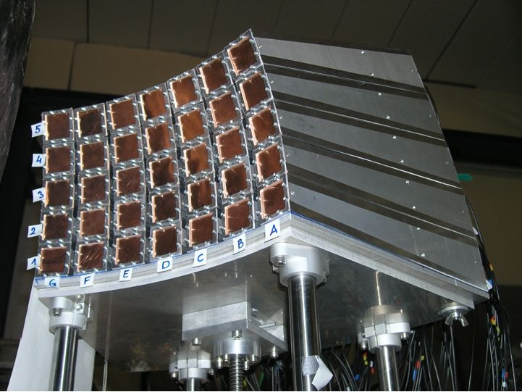
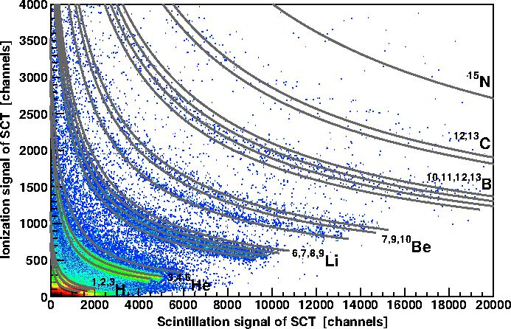
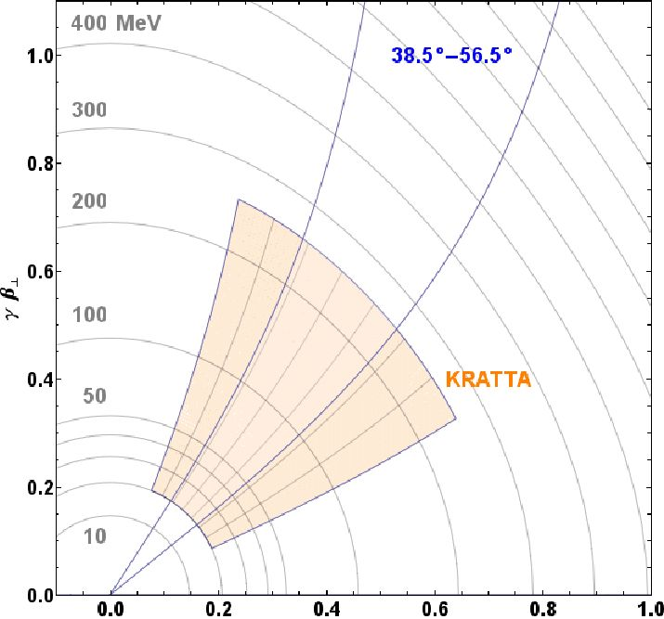
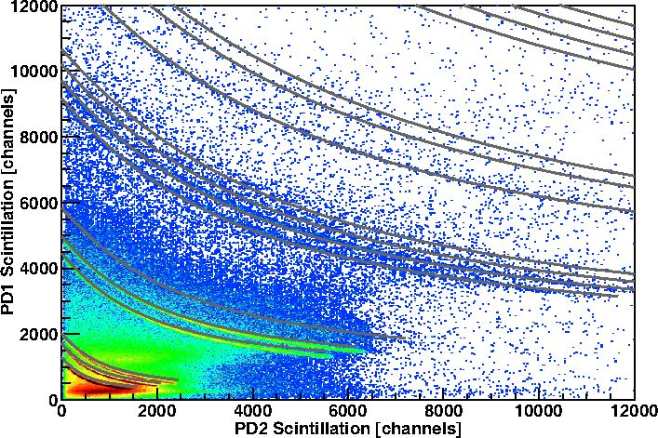
EPJ Web of Conferences
Figure 1: KRATTA detector during the
ASY-EOS experiment (May 2011).
lation components and to obtain a
single readout channel.
Figure 3: Identification spectrum for the
SCT segment.
tanh-'(ft)
Figure 2: Acceptance for protons and
angular range used for comparisons with
FOPI.
satisfactory isotopic resolution with a
Figure 4: AE — E map for the thin vs
thick CsI(Tl) crystals.
The isotopic resolution obtained using a single readout channel was found
to compete very well with that obtained using the standard two channel
readout (Fig. 3). The applied pulse shape analysis permitted also the iden-
tification of particles stopped in the first photodiode and the reduction of
the identification threshold, due to the thickness of the first photodiode, by
a factor of three. Thanks to the pulse shape analysis, it was also possible
to obtain the ballistic deficit free amplitudes, which allowed for easy energy
01010-p.2
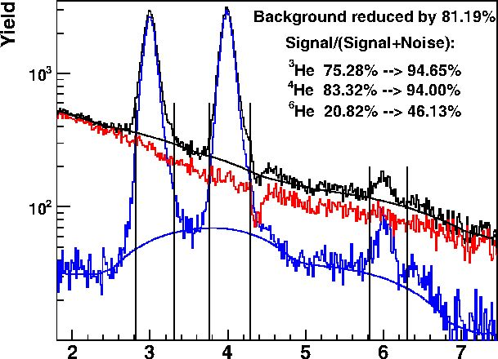
IWM-EC 2014
calibration and identification based on the predictions of the range-energy
tables. For further analysis the parameters of the decomposed pulses were
used in order to speed up the calculations.
In the identification maps, the isotopic lines are clearly visible, even
though the background due to the secondary reactions in the long CsI(Tl)
crystals is substantial (Fig. 4). In order to identify the events contributing
to the background, a recognition procedure based on the self- organizing
neural network has been developed [4]. This method groups together events
with similar pulse shape descriptors. It allows to identify up to 90% of the
background events. The efficiency of this method is presented in Fig. 5.
AReal
Figure 5: (Colour online) Helium iso-
topic distribution. Black line raw
distribution, blue after background
subtraction, red the background.
17500  15000 |  | Target rapidity
12500
10000
 |  | Mid-rapidity
 | ••
12000 | m/*'’
 | ■ | ** .
4000 | - | •••
3000  2000 |  | Projectile rapidity
-150 -100 -50 0 50 100 150
A ^
Figure 6: Azimuthal distributions
of protons measured in three re-
gions of the rapidity; b =(0-7.5
fm) for Au+Au collisions at 400
MeV/nucleon.
The energy calibration was performed using the characteristic punch-
through points, curvatures of the AE — E lines, light-energy conversion
formula and the ATIMA range-energy tables. Probabilities of the secondary
reactions for light charged particles as a function of their range in the
CsI(Tl) crystals was estimated using the Monte Carlo simulations within
the GEANT4 environment. The data analysis was performed within the
FairRoot framework.
The data measured with the KRATTA array in the ASY-EOS experi-
ment was used to construct flow observables for light charged particles. The
reaction plane orientation and the centrality of the collision were provided
by the CHIMERA and ALADIN TOF Wall detectors. The reaction plane
resolution corrections have been calculated according to [5].
Figure 6 shows the azimuthal distributions of protons measured with
respect to the reaction plane in three rapidity regions. Target and projectile
rapidity regions are dominated by the in-plane emissions, while the mid-
01010-p.3
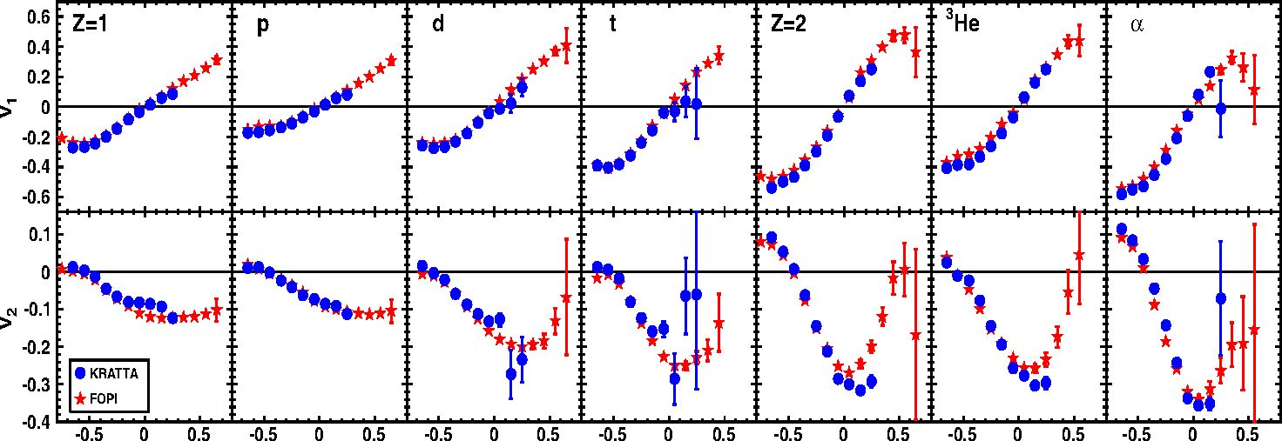
EPJ Web of Conferences
rapidity range shows a strong squeeze-out signal.
Figure 7 presents the flow parameters v\ and v2 for LCPs as a function
of the scaled center of mass rapidity measured for semi-central collisions
with the KRATTA detector (circles) and the FOPI detector [6] (stars) in a
common angular range (Fig. 2) The upper energy thresholds of KRATTA,
associated with the CsI(Tl) crystal thickness, limit the range of the avail-
able rapidities. The data points are corrected for the secondary reaction
background. The agreement between these two detectors and experiments
is very satisfactory.
y <"VCm)
1 proj
Figure 7: Flow of LCP measured with the KRATTA (circles) and FOPI (stars)
detectors. Both measurements were performed in the polar angle range 38.5-56.5
deg and for the interval of reduced impact parameter range of 0.25-0.45.
The KRATTA array, together with the CHIMERA and TOF-wall detec-
tors, has proven its usefulness in flow measurements of light charged reaction
products during the ASY-EOS experiment conducted at GSI. The prelim-
inary comparison with the FOPI results measured for the same reaction
in a different campaign shows a remarkable agreement and quality of the
data. The results will be compared with UrQMD predictions in order to
extract the information contained therein regarding the symmetry term in
the nuclear equation of state.

Acknowledgments
The authors would like to thank W. Reisdorf for providing the FOPI flow
data. One of us (S. K.) acknowledges the support by the Foundation for
Polish Science - MPD program, co-financed by the European Union within
the European Regional Development Fund. Work made possible through
01010-p.4
IWM-EC 2014
funding by Polish Ministry of Science and Higher Education under grant
No. DPN/N108/GSI/2009.

References
- J. Lukasik et al., Nucl. Instr. Meth. A 709 (2013) 120128
- P. Russotto et al., Journal of Physics: Conference Series, 420. 5 (2013)
- G. Pasquali, et al., Nucl. Instr. Meth. A 301 (1991) 101
- S. Kupny, et al Acta Phys. Polon. B Suppl. 6, 1115-1119 (2013)
- J.-Y. Ollitrault arXiv:nucl-ex/9711003v2
- W. Reisdorf, FOPI Collaboration, private communication.
01010-p.5

