7lh International Workshop
for Young Mathematicians
Applied Mathematics
Kraków, 20-26 September 2004
pp. 167-173
LYAPUNOV EXPONENTS
KATARZYNA PIECYK
Abstract. The aim of this paper is to present Lyapunov exponents as one of the basic instruments, which can be applied to find out, measure, and assess chaotic behavior in dynamical systems. Methods of Lyapunov exponents determination for discrete and continuous time systems will be discussed, with focus on logistic map and Lorenz system.
- Sensitive dependence on initial conditions
In 1961 Edward Lorenz discovered a very strange phenomenon, which accompanied small changes of initial data in an idealized mathematical model of thermal convection. This behavior is called sensitive dependence on initial conditions. It consists in such rapid increase of small initial errors, that after some time we can not predict their values. This property in case of dynamical systems can be presented as follows. Let us consider metric space (X, q),x 6 X and a flow tt:RxX —> X.
Definition 1.1. We say that dynamical system has a property of sensitive dependence on initial conditions (property S) if there exists e > 0, such that for all x € X and for all [/-neighborhoods of x, there exists x' & U satisfying following condition:
p(7r(t, x'),ir(t,xy) > e for t > 0.
Figure 1 presents this dependence graphically.
Property (S) is characteristic for all chaotic systems. But it is not equivalent to chaos. This is necessary but not sufficient for appearance of chaotic behaviors. Following example can be a proof that chaos is not only a result of sensitive dependence on initial conditions.
Example 1.2. Let us imagine a discrete dynamical system (R,7r), where
7r: Z x K —> R,
n—times
x) = fn(x) = f O f o f o ...o f(x),
7r(l,a;) = fix') = ax, where a € R.

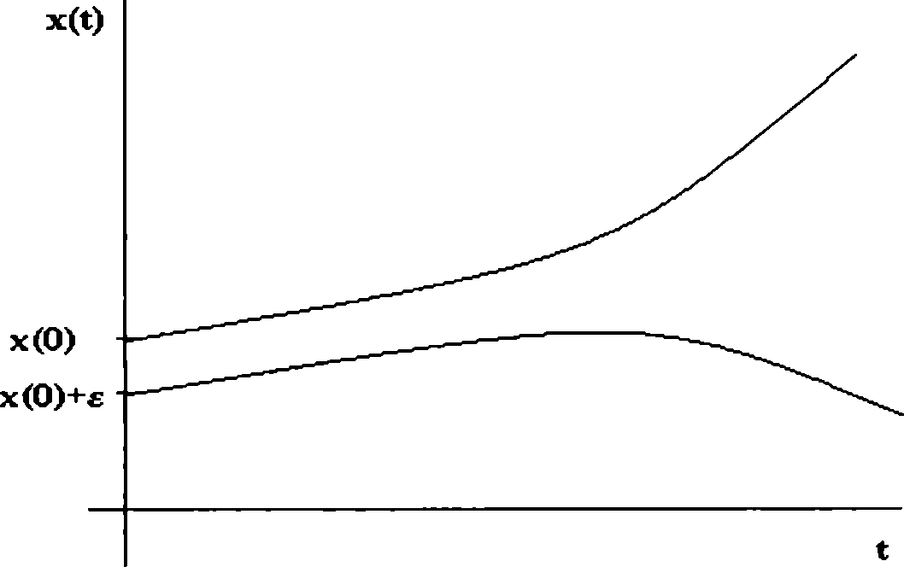
168
KATARZYNA PIECYK
Fig. 1. Exponential divergence of two orbits starting with nearby points x(0) and x(0) + e.
In this case the trajectories take the form of infinite sequences:
(rr0,xi, 12,..., Tn, • • •) = (^(0), /(z(0)), /2(t(0)), ..., /n(x(0)),...).
If the position of initial point t(0) is disturbed by a small error £, we will obtain trajectory:
(s/o, 3/1 > 2/2, - •• ,yn,-- •) = (t(0) + e,/(t(0) +e),/2(a;(0) + e),.. . ,/n(a:(0) +e),.. .) = (t(0) + e, az(0) + as, a2x(0) + a2£,..., anT(0) + ans,..
We can determine the n-th error (value disturbance in n-th step):
En — 2/n — GE.
We should notice that the initial error grows in Example 1, but this happens in very regular manner. The error increases exactly a-times with each step. As a result we can read the error value from disturbed signal for all iterations of linear systems. There is no place for chaotic behavior.
Completely different is the case of logistic map
f : [0,1] —► [0,1], f(x) = iix(l — x), where fi G R. (1.1)
This map generates discrete dynamical system, which behaves chaotically for certain values of parameter p.. In this system error grows exponentially (for reliable p > 3.56).
For the purpose of taking these differences between systems into consideration, the following chaos definition was proposed in 1989:
Definition 1.3 (Devaney). Let X be a metric compact space. Then (X, 7r) is called chaotic dynamical system if it satisfies the following conditions:
- is transitive (which means, that there exists x G X : 7r(a;) = t),

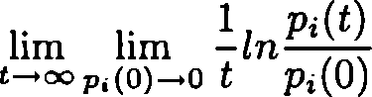
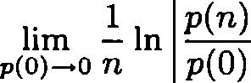
LYAPUNOV EXPONENTS
169
- {x : x — periodic point for 7t} = X,
- has property (S).
It is worth underlining that above definition is just one of several attempts to define chaos. And it turned out to be not the best one. In 1992 Banks and Brooks proved that:
Fact 1.4. If cardinal number of X is greater than or equal to No, then conditions (1) and (2) imply condition (3) in Definition 2.
- Lyapunov exponents
To the testing of dynamical systems with regard to sensitive dependence on initial conditions Lyapunov exponents can be used. They have proven to be the most useful dynamical diagnostic for chaotic systems. They determine average growth or decline of infinitesimal errors. General definition of exponents is as follows:
Definition 2.1. Let (X, q) be a space with measure. Then
is called the i-th Lyapunov exponent (number of Lyapunov exponents is equal to system dimension), where i e N, t € K, however Pi(0) and p,(t) are the lengths of the i-th principal axis of the ellipsoid at 0 and after time t respectively.
In order to determine exponents for n-dimensional system, we observe the evolution of infinitesimal n-sphere with center in one of principal trajectory points. Points on the surface of the sphere correspond to fixed states of neighboring trajectories. This sphere deforms continuously as a result of expanding or contracting nature in different directions in phase space. For this reason the sphere turns into n-dimensional ellipsoid. Migration of the sphere in K2 space can be seen in Fig. 3.
In accordance with Definition 3, the neighboring trajectories, initially distant from each other by Pi(0), will be distant by p,(0)eAii after time t, therefore:
Pi(t) =Pi(0)eAt.
Thus, following dependence occurs:
Xi > 0 <=> error growth <=> divergence of trajectories, Xi = 0 <=> error stability <=> periodical trajectories, Ai < 0 <=> error decline <=> convergence of trajectories.
2.1. Systems with discrete time. At first let us look at the easy example:
Example 2.2. We can once again consider linear system from Example 1 and calculate its Lyapunov exponent (in this case we have only one exponent). Let initial error p(0) be equal to e. We have already learnt, that the n-th error will take value of ane. Thus, from Definition 3 we obtain:
n—*oo
lim
= In |a|

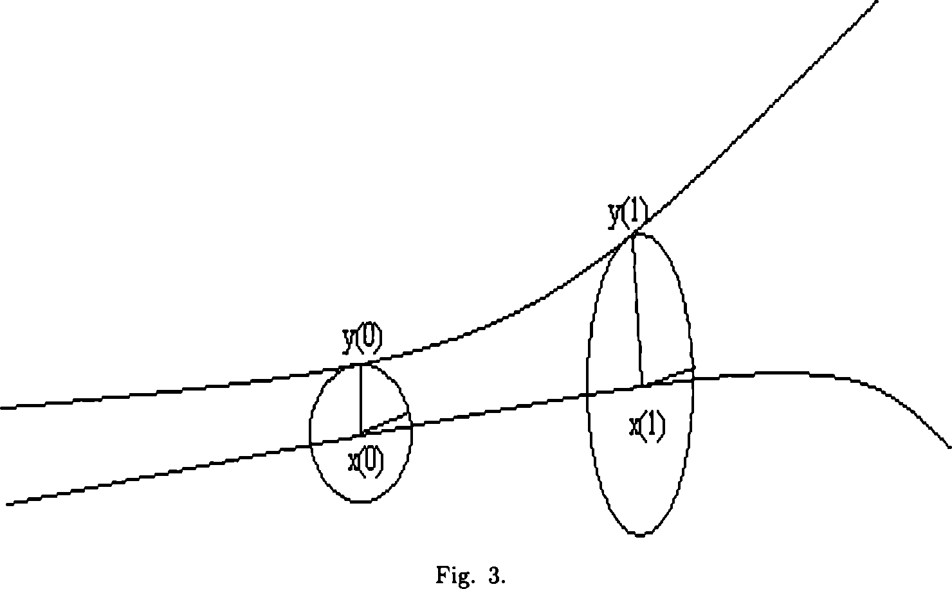
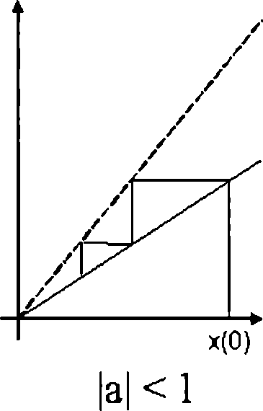
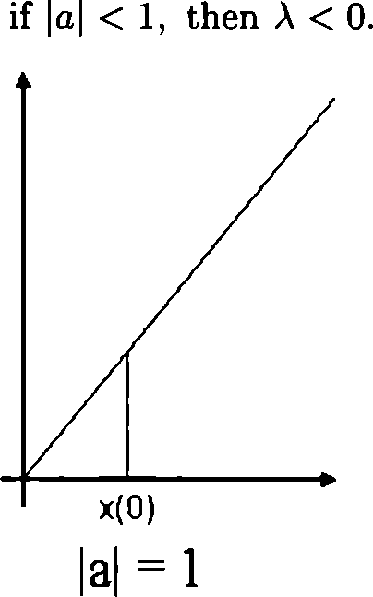
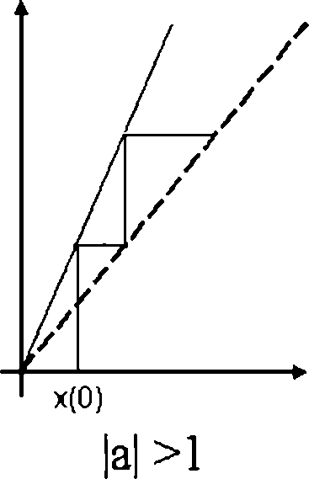
170
KATARZYNA PIECYK
Hence it appears:
if |a| > 1, then A > 0,
if |a| = 1, then A = 0,
Fig. 3. Trajectories of the linear system depending on parameter a.
In the case of |a| > 1 the system is sensitive on initial conditions. However, as aforementioned, it is not chaos, because the remaining conditions from Definition 2 are not satisfied.
Before we calculate Lyapunov exponent for logistic map, let us observe a important fact:

LYAPUNOV EXPONENTS
171
Fact 2.3. Let (X, 77) be a discrete dynamical system, such that 77(71,2:) = fn(x). Let also f : X —> X be a smooth 1-dimensional function. Then Lyapunov exponent for this system can be expressed with the formula:
1 n_1
A = lim — Xln |/'(2:s)|, where Xk = fk(xo), k — 0, ...,n — 1. n—*00 TL
3=0
The following property can be a conclusion of Fact 2.
Fact 2.4. With the same assumptions and notations as in Fact 2, for k-period orbit (k g N) true is below dependence:
1 fc_1
A = £Elnl/W- (2-1)
s=0
Let us consider a dynamical system generated by logistic map (formula (1.1)). Fixed points of this system are x = 0 and x = Using the formula (2.1) with
k equal to 1, we obtain for orbits starting from these points the following Lyapunov exponents : A(0) = In |/z| and A(i£j^-) = In |2 — p\. As a result we have got two different values. It is worth to ask the question if Lyapunov exponents depend on initial conditions choice. The answer to this question is multiplicative ergodic theorem by Oseledec, which says among other things that the particular Lyapunov exponents are equal for //-almost every starting point r:(0) G X (where p is the ergodic measure for /). The trajectories starting from fixed points are called atypical trajectories. For typical orbit, generated by point i(0) = 0,202 as an example, we obtain exponent equal to In 2 (for /z = 4) through numerical calculations. This value is considered as sensitivity measure (Lyapunov exponent) for the logistic map (for p = 4).
2.2. Systems with continuous time. Suppose the flow (Y, 77) is generated by Cauchy problem:
i ^!'=F('X^ where F:Y—► Rn is C1, Y C R",2: G Y.
Then definition of Lyapunov exponents is following.
Definition 2.5. Let 2?o G Y. We define
A(2;0,u0) = limsup y In ||(dxo7r(t))(u0)||)
t—*00 t
where uq is a vector, in the direction of which we determine particular exponent, and dxn(t,x0) = limUo_0
In the case of systems with continuous time numerical methods should be used for the purpose of estimating Lyapunov exponents. It is obvious because of not rare difficulties caused by resolving Cauchy’s problem generating particular flow (with the assistance of analytical methods) for instance. Therefore, for the purpose of introducing efficient algorithms, it has been proved, that Lyapunov exponents can be defined the following way:

A(z01u0) = lim -ln|Ö(xo,i)uo|,
t—>oo t
where O(xo,t) is matrix solution of problem:
i = DF{x{t})0(X0tt}
1 Ö(xo,0) = I
 | f | 1 | 0 | 0 |  | / |  | 3F(1) | dF(1'>
 |  | 0 | 1 | 0 |  |  |  | dx^ | dx^
and I = |  | 0 |  | 0 |  | ,T>F =
 |  |  |  |  |  |  |  | dFin>> | dFM
 | \ | 0 | 0 . | . 1 | J |  | \ | dx^ | dx(n> | /
Let us have a look at the stages of such an algorithm using an exemplary system
of thermal convection by Lorenz:
^=a(y-x)
< = rx — y — xz , where parameters a, r, b G R and x,y,z 6 R.
. Tt = ~bz + xy
Algorithm should deal with the following aspects:
- integration of Lorenz system with steady initial conditions and iteration steplength, for example Runge-Kutta method,
- integration of the linearized equations of motion in Lorenz system. Thus numerical solution of problem (2.2). It corresponds to anchoring orthogonal vectors vi, i>2, V3 to the steady point of the main trajectory, and then shifting this structure (3-dimensional sphere of radius equal to 1, which principal axes are vi,U2,^3 vectors) along main trajectory,
- summing of the vector lengths corresponding to steady direction (in this case we deal with three directions, therefore we consider three sums). Afterwards sums averages should be calculated, which consists in dividing each of these sums by the time which elapsed from to to tn, which means by the product of integration step-length and step number.
But the long-term evolution of 3-dimensional sphere involves two problems:
Firstly, the vectors wi,v2,u3 have a tendency to reach very big lengths/become very long (their lengths may be of order of magnitude to the extent of the attractor).
Secondly, all vectors tend to fall along the direction of most rapid growth.
If the first problem is not taken into consideration, the condition of small local separations of trajectories will not be satisfied. However, if the second problem is not solved, then we will obtain only the greatest positive Lyapunov exponent, because of the limited precision of computer calculation (the directions of all vectors are indistinguishable for computer). The repeated application of the Gram-Schmidt reorthonormalization procedure on the vectors is the solution to both of these
problems.
If above specified algorithm for Lorenz system is applied, the Lyapunov exponents seen in Table 1 can be obtained (for b — 4,a= 16 and variable value of r).
Positive Lyapunov exponent is responsible for chaotic behavior in the system.

LYAPUNOV EXPONENTS
173
parameter r | Ai | A2 | A3
10 | -1.63 | -1.63 | -27.06
30 | -0.16 | -0.16 | -29.99
45 | 2.14 | 0 | -32.46
55 | 2.42 | 0 | -32.72
Table 1. The result of algorithm application with the iteration steplength^.001, and the step number=10000000.
- Conclusion
Lyapunov exponents provide relevant experimental method, which allows to distinguish stable and unstable chaotic behaviors.
References
- G. L Baker, J. P. Gollub, Wstąp do dynamiki układów chaotycznych, PWN, Warszawa 1998.
- E. Ott, Chaos w układach dynamicznych, WNT, Warszawa 1997.
- H.-O. Peitgen, H. Jiirgens, D. Saupe, Granice chaosu. Fraktale, PWN, Warszawa 1998.
- A. Wolf, J. B. Swift, H. L. Swinney and J. A. Vastano, Determining Lyapunov exponents from a time series, Phys. D (1985), 285-317.
Nicolaus Copernicus University in Toruń, The Ludwik Rydygier Medical University in Bydgoszcz
E-mail address: piecykCcm.umk.pl

