Jerzy SADOWSKI Prof. MD PhD Karol WIERZBICKI MD PhD Bogusław KAPELAK MD PhD Janusz KONSTANTY MD Piotr PRZYBYŁOWSKI MD PhD Sławomir WÓJCIK MD PhD Rafał DRWIŁA MD, PhD Krzysztof WRÓBEL MD Jacek PIĄTEK MD
Discontinuation of calcineurin inhibitors in heart transplant patients with end stage renal insufficiency as an alternative model of immunosuppression
Department of Cardiovascular
and Transplantation Surgery,
Institute of Cardiology, Jagiellonian University Krakow, Poland
Head: Prof. Jerzy Sadowski, MD, PhD
Additional key words:
renal insufficiency
calcineurin inhibitors
heart transplantation
Dodatkowe słowa kluczowe:
ihibitory calcineuryny
przewlekła niewydolność nerek przeszczep serca
Adres do korespondencji:
Prof. Jerzy Sadowski, MD, PhD
Department of Cardiovascular and Transplantation Surgery,
Institute of Cardiology, Jagiellonian University
31-202 Kraków, ul. Prądnicka 80
Fax: 0048124233900.
e-mail: kardiochir@szpitaljp2. krakow. pl
Five heart recipients were followed up with mycophenolate mofetil and low dose cyclosporine due to progressive severe chronic postcyclosporine renal failure. Cyclosporine was gradually withdrawn and finally eliminated from immunosuppressive regimen to slow the rate of renal function loss. Improvement of renal function was observed. In the follow up after cyclosporine elimination no risk increase of acute rejection and no deterioration of left ventricle function was observed. Non- calcineurin inhibitors model in heart recipients can be the treatment of choice (but only in very selective cases) in patients with severe chronic renal insufficiency.

Introduction
The introduction of cyclosporine - the calcineurin inhibitor - into clinical heart transplantation in 1980 was followed by marked improvement in survival rate from 60-70% to 80-90% [2, 12]. Chronic cyclosporine augmentation causes several adverse effects among which the most frequent and dangerous is chronic renal insufficiency. Cyclosporine appears to cause a decrease in renal blood flow (RBF) and decrease glomerular filtration rate (GFR) by direct effects on the renal vasculature and involvement of the renin-angiotensin system [3, 4, 6, 11]. Introduction of an inhibitor of the de novo purine synthesis pathway has created a new model of immunosuppressive therapy. In a randomized trial held by Koba- shigawa, which included 28 centers with 650 patients conversion from azatioprine to mycophenolate mofetil has been proved to lower mortality and frequency of rejection in the first year after heart transplantation. After this trial mycophenolate mofetil originally used in renal transplant patients is now introduced in heart transplant patients on a regular basis. [9].
Administration of the immunosuppressive model including mycophenolate mofetil and low doses of cyclosporine in patients with chronic renal failure after HTX, improves renal function. This is characterized by lower serum creatinine, urea nitrogen, uric
Analizie poddano pięciu chorych leczonych mykofenolanem mofetilu i niskimi dawkami cyklosporyny z powodu postępującej ciężkiej niewydolności nerek. Dawki cyklosporyny były stopniowo obniżane aż do całkowitego odstawienia leku w celu próby zahamowania postępującej niewydolności nerek. Po wdrożeniu przyjętego postępowania zaobserwowano poprawę funkcji nerek. W okresie obserwacji po eliminacji cyklosporyny nie zauważono zwiększonego ryzyka ostrego odrzucania i pogorszenia funkcji lewej komory.
acid levels and higher creatinine clearance, with low risk of acute rejection in heart transplant patients. [1]. There is no widely accepted protocol for management of progressive renal failure in heart transplant patients with chronic nephropathy. Withdrawal of calcineurin inhibitors from immunosuppressive regimen in order to slow the rate of renal function loss has been proven safe and effective in renal transplant patients [15]. In heart transplant patients and progressive postcycloporine renal failure there is clear data considering withdrawal of calcineurin inhibitors.
The aim of this study: Evaluation of potential benefit of complete cyclosporine elimination in heart transplant patients with end stage renal failure treated with mycophenolate mofetil.

Materials
The data of 5 males (age 42-65 years, follow up from 48-76 months after HTX) were retrospectively analyzed. Immunosuppressive regimen based on cyclosporine, azathioprine and steroids. RATG was administered in three patients during the induction of immunossupre- sion (2. 5 mg/kg through 5 days). Ketoconazole was used in one patient to reduce dose of cyclosporine. From 0. 5- 5 years after HTX all patients developed chronic postcyclosporine renal failure. Immunosuppressive regimen was reevaluated due to progressive renal dysfunction. Cyclosporine doses were reduced to 0. 7-1. 5 mg/kg with predose level from 25-130 ng/ml during worsening of renal insufficiency. In three patients: K. EG., M. M., S. J.
1256
Przegląd Lekarski 2006 /63/12
J. Sadowski et al.

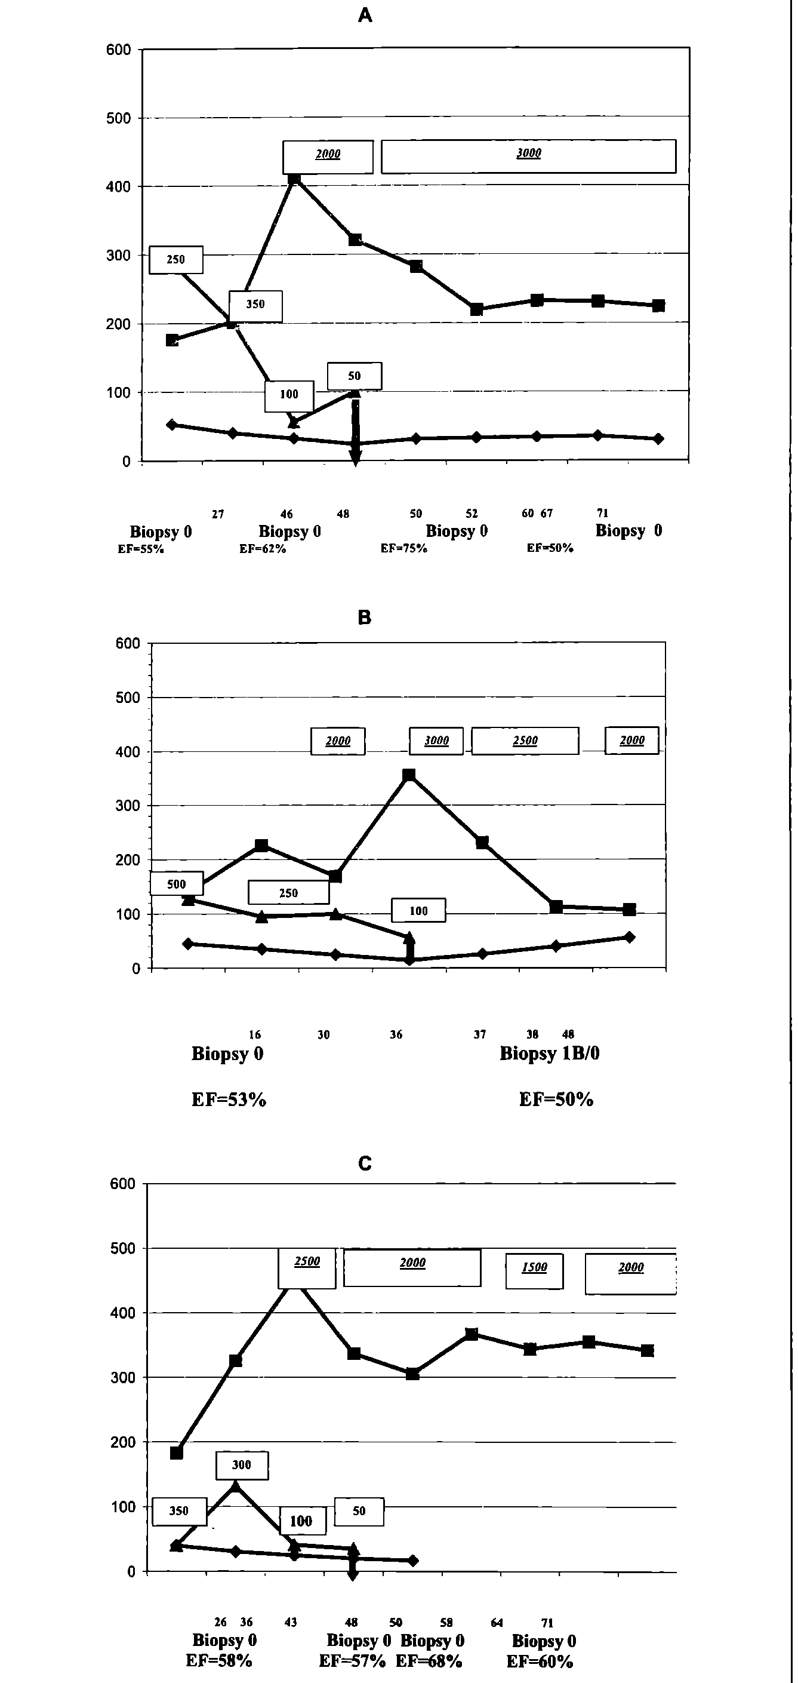
during the period of reduction of cyclosporine doses, azathioprine (1 mg/kg) was converted to mycophenola- te mofetil (2000-2500 mg/24h) (figure 1). In two patients: K. E., Z. T. azathioprine was converted to mycophenolate mofetil simultaneously with elimination of cyclosporine from the immunosuppressive protocol (figure 2). Despite correction of immunosuppressive regimen (dose reduction of calcineurin inhibitor) progressive deterioration of the renal function was observed with creatinine clearance ranging from 33. 7 to 15. 0 ml/min. In all these patients cyclosporine was finally eliminated from immunosuppressive therapy at the time between 24-67 months after HTX. After elimination of cyclosporine the regimen consisted of mycophenolate mofetil ranging from 2000 to 5000 mg/24h and oral prednisone starting from 1mg/ kg/24h in reduced doses 5 mg per day.

Methods
Cyclosporine and mycophenolate mofetil blood levels were monitored using the standard procedure based on high-performance liquid chromatography. Acute rejection of the transplanted heart was diagnosed based on heart biopsy specimens using histopathologic criteria (ISHLT). Estimation of the left ventricle function was done by transthoracic echocardiography. Renal function was diagnosed using creatinine clearance and creatinine level. Cyclosporine was eliminated from immunosuppressive regimen during hospitalization after exclusion of acute rejection.

Results
In the follow up after discontinuation of cyclosporine (10-28 months), statistically significant reduction of creatinine blood level [ranging from 60 to 243 pmol/l] was observed. Simultaneous improvement of creatinine clearance [ranging from 7. 2 to 51 ml/ min] was measured. In one patient - ZT - 5 months after cyclosporine withdrawal, slow progressive decrease of creatinine clearance was observed and remained stable at the level of 33 ml/min. Control biopsies revealed presence of acute rejection 1A in one patient K. E. and in other patient M. M. - 1B, which resolved to 0 according to ISHLT. Transthoracic echocardiography showed no deterioration of left ventricular function with stable ejection fraction in all patients (Figure 1, 2).

Discusion
In order to prevent rejection of solid organ allografts and to provide correct graft function, all patients after solid organ transplantation require chronic administration of an immunosuppressive therapy. The immune reactivity and the tendency for graft rejection are highest in the early postop period and decrease with time, although they never entirely disappear. Most regimens employ the highest closes of immunosuppressive drugs immediately after surgery with later decrease to maintenance levels compatible with recurrent graft rejection [8].
The prospective HLA matching and crossmatch in cardiac and cardiopulmonary transplantations are not performed, because of lack of time (short tolerable cold ischemia time) and allocation of donors. In fact, the risk of acute rejection in cardiac allograft recipients is higher comparing to renal recipients, in which HLA matching is performed on the regular basis. Moreover in heart recipients the more disastrous consequence of graft lost with no equivalent of dialysis is observed. This is why the heart transplant patient requires relatively "stron-
Figure 1
Analysis of cyclosporine level and doses, mycophenolane mofetil doses, creatinine level and creatinine clearance in the follow up period after HTX in patients converted from azatioprine to mycophenolane mofetil before cyclosporine withdrawal (A, B, C).
Analiza poziomu cyklosporyny i jej dawki, dawek mycopenalonu mofetilu, poziomu kreatyniny i klirensu kreatyniny w okresie obserwacji po HTX u pacjentów, którym zmieniono azatioprynę na mycophenalon mofetilu przed odstawieniem cyklosporyny (A, B, C).
Przegląd Lekarski 2006 /63/12
1257

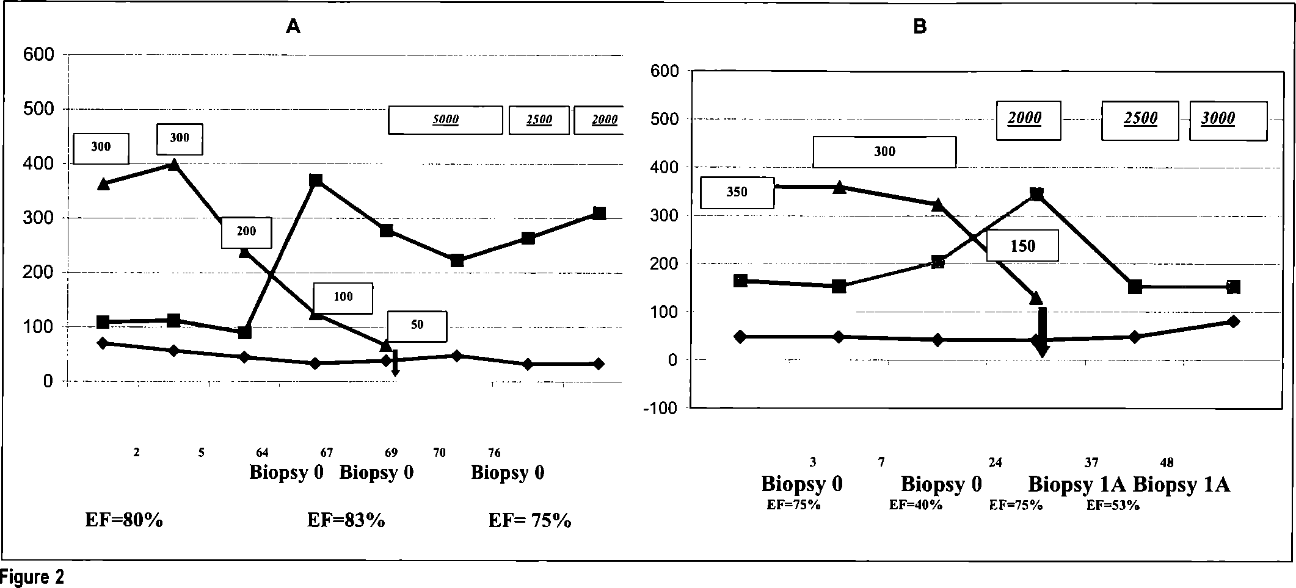
Analysis of cyclosporine level and doses, mycophenolane mofetil doses, creatinine level and clearance in the follow up period after HTX in patients converted from azatioprine to mycophenolane mofetil in the time of cyclosporine withdrawal (A, B).
Analiza poziomu cyklosporyny i jej dawki, dawek mycophenalonu mofetilu, poziomu kreatyniny i klirensu kreatyniny w okresie po HTX u pacjentów, którym zmieniono azatioprynę na mycophenalon mofetilu w czasie odstawienia cycklosporyny (A, B).
ger"immunosupresive regiments [8, 14]. On the other hand, preservation of correct function of the other organs progressively damaged by immunosuppressive drugs toxicity, improves long-term survival of solid organs recipients. Better adjustment of strength of immunosuppresion becomes as important as inhibition of acute graft rejection [16]. Most clinically used immunosuppressive regimens employ calcineurin inhibitors (cyclosporine or tacrolismus), which allow for safe follow up of graft recipients in terms of inhibition of rejection with simultaneous deterioration of renal function with time [6, 11, 13]. Routine monitoring of calcineurin inhibitor blood levels makes it possible to adjust the lowest efficient doses. Unfortunately, it only partially decreases the risk of post cyclosporine renal failure [7]. Progressive deterioration of renal function during immunosuppressive therapy forces introduction of newer immunosuppressive agents and drug regimens -such as a low dose calcineurin inhibitor with mycopheno- late mofetil and steroids. Aleksic et al. in 11 heart and Legendere in 41 renal recipients proved possible and effective lowering of cyclosporine dose to improve renal function without increasing risk of acute graft rejection. If this immunosuppressive model fails to inhibit deterioration and to improve renal function, then there is no definite treatment [9, 10]. In renal recipients there are attempts to discontinue cyclosporine administration and put the patients on a two drug model with mycophenolate mofetil and steroids. Ducloux et all. showed improvement of renal function in 6 patients, after conversion of cyclosporine to mycophenolate mofetil without increasing risk of acute rejection [5]. There are no clear data considering safe calcineurin inhibitors discontinuation in heart recipients, because of higher risk of acute rejection. In analyzed groups of patients, despite constant reduction of cyclosporine doses to 0, 7-1, 5 mg/kg progressive dete
rioration of renal function was observed. Finally, cyclosporine was discontinuated. Improvement of renal function without acute rejection reaction > 2 acc. to ISHLT and preservation of correct left ventricular function with EF > 50% was observed. Analyzed patients are closely followed up. In the case of constant renal function improvement, introduction of low dose cyclosporine will be considered.
Presented data suggests that progressive cyclosporin withdrawal to the point of complete discontinuation in patients treated with mycophenolate mofetil may stop deterioration of renal function without acute allograft rejection.
No-cyclosporine model in heart recipients can be the treatment of choice in patients with severe chronic renal insufficiency. Routine employment of "no-cyclosporine'' model of immunosuppressive therapy in cardiac recipients with progressive severe renal failure should be considered as a rescue therapy before decision of dialysis or renal transplantation. Our observations are based on a very small number of patients and should be proved in controlled trials.

Appendix
Przedstawiona analiza dotyczy chorych leczonych przed 2003 rokiem. Obecnie dostępne są inne metody postępowania w tej grupie chorych np. coraz częściej wykonuje się przeszczep nerki po przeszczepie serca (vide baza danych ISHLT za rok 2005). Stosuje się także alternatywne modele leczenia immunosupresyjnego oparte na lekach o obniżonej nefrotoksyczności (np. Everoli- mus).

References
- Aleksic J., Baryalei M., Bush T. et al.: Improvement of impaired renal function in heart transplant recipients treated with mycophenolate mofetil and low dose cyclosporine. Transplantation 2000, 69, 1586.
- Caine R. J., White D. J. G., Thiru S. et al.: Cyclosporine A in patients receving renal allografts from cadaver donors. Lancet 1978, 2, 1323.
- Cantarovich M., Giannetti N, Cyr E, Chartier R.,
Cecere R.: Improvement of acute renal dysfunction (ARD) in heart transplant (TX) patients (PTS) during calcineurin inhibitor (CNI) 'holiday" without rejection under anti-CD 25 monoclonal antibody (MAB) coverage. J. Heart Lung Transplant. 2001, 20, 233.
- Curtis I. J., Dubovsky E., Whelchel J. D. et al.: Cyclosporin in theraupetic doses increases renal allograft vascular resistance. Lancet 1986, 2, 477.
- Ducloux D., Fournier V., Bresson-Vautrin C. et al.: Mycophenolate mofetil in renal transplant recipients with cyclosporine-associated nephrotoxicity: a preliminary report. Transplantation 1998, 65, 1504.
- Goldstein J., Thoua A., Wellens F. et al.: Cyclosporine nephropathy after heart and heart-lung transplantation. Proc. EDTA ERA 1984, 21, 97.
- Kahan B. D., Grevel J.: Optimization of cyclosporine therapy in renal transplantation by a pharmacokinetic strategy. Transplantation 1988, 46, 631.
- Kapoor A. S.: Cardiomyopaties and heart lung transplantation. McGraw-Hill Inc. 1991, 247.
- Kobashigawa J., Miller L., Renlund D. et al.: A randomized active-controlled trial of mycophenolate mofetil in heart transplant recipients. Mycophenolate Mofetil Investigators. Transplantation 1998, 66, 507.
- Legendre C., Thervet E., Skhiri H. et al.: Histologic Features of chronic allograft nephropathy revealed by protocol biopsies in kidney transplant recipients. Transplantation 1998, 65, 1506.
- Mattos M. A., Olyaei A. J., Bennet W. M.: Nephrotoxicity of Immunosupresive Drugs: long Term Conseqences and Challenges for the future. Am. J. Kidney Diss. 2000, 35, 333.
- Oyer P. E., Stinson E. B., Jamieson S W. et al.: Cyclosporine A in cardiac allografting a preliminary experiences. Transplant Proc 1983: 15: 1257-52
- Taylor D. O., Barr M. L., Radovancevic B. et al.: A randomized multicenter comparison of tacrolimus and cyclosporine immunosupressive regimens in cardiac transplantation: decreased hyperlipidemia and hypertension with tacrolimus. J. Heart Lung Transplant. 1999, 18, 336.
- Thompson J. S., Thacker L. R., Takemoto S.: Inluence of conventional and cross-reactive group HLA match on cardiac transplant outcome: an analysis from lhe United Network Organ Sharing Scientific Registry. Transplantation 2000, 27, 2178.
- Weir M. R., Ward M. T., Blahut S. A. et al.: Long term impact of discontinued or reduced calcineurin inhibitor in patients with chronic allograft nephropathy. Kidney Int. 2001, 59, 1567.
- Wiliam B.: Approaches to improve allograft half life. Transplanation Proc. 1998, 30.
1258
Przegląd Lekarski 2006 /63/ 12
J. Sadowski et al.

