
FOLIA Vol. 20(4): 271-277

MALACOLOGICA
ISSN 1506-7629
The Association of Polish Malacologists
& Faculty of Biology, Adam Mickiewicz University
Poznań 2012

doi: 10.2478/v10125-012-0024-0

PHYLOGENETIC POSITION OF TEFENNIA SCHÜTT ET
YILDIRIM, 2003 (CAENOGASTROPODA: RISSOOIDEA)
DUYGU CEREN ÇAGLAN¹, M. ZEKI YILDIRIM², MAGDALENA SZAROWSKA³, ANDRZEJ FALNIOWSKI³
'Mehmet Akif Ersoy Üniversitesi, Fen Edebiyat Fakültesi, Biyoloji Bölümü, Burdur, Turkey
²Süleyman Demirel University, Burdur Faculty of Education, 15100 Burdur, Turkey
(e-mail: mzekiyildirim@gmail.com)
³Department of Malacology, Institute of Zoology, Jagiellonian University, Gronostajowa 9, 30-387 Kraków,
Poland (e-mail: andrzej.falniowski@uj.edu.pl)
ABSTRACT: The phylogenetic position of Tefennia tefennica Schutt et Yildirim, 2003, an endemic snail species
from southwestern Turkey, was inferred with maximum likelihood analyses of DNA sequences of mitochon-
drial cytochrome oxidase subunit I and nuclear 18S rRNA. Tefennia belongs to the Hydrobiidae,
Sadlerianinae; its sister clade comprises Grossuana Radoman, 1973, Trichonia Radoman, 1973 and Daphniola
Radoman, 1973. Shell, radula and soft parts of T. tefennica are presented.
KEYWORDS: Rissooidea, endemism, COI, 18S rRNA, radula, anatomy, phylogeny, secondary loss of receptacle

INTRODUCTION
The Hydrobiidae of Turkey are represented by the
subfamilies Hydrobiinae Troschel, 1857 (2 genera);
Pyrgorientalinae Radoman, 1973 (2 genera) and Sa-
dlerianinae Radoman, 1973 (8 genera) (RADOMAN
1983, Szarowska 2006, Yildirim et al. 2006). The
monotypic genus Tefennia Schütt et Yildirim, 2003 is
known from only one locality in the Burdur Province,
SW. Turkey (YILDIRIM et al. 2006). In the original de-
scription it is included in the Hydrobiidae (SCHÜTT &
YILDIRIM 2003), and listed among the Orientalininae
by YILDIRIM et al. (2006). The type species, Tefennia
tefennica Schütt et Yildirim, 2003, has minute dimen-
sions and a peculiar anatomy of female genitalia, with
a bursa copulatrix in an anterior position and only
one rudimentary seminal receptacle (rs₂). The aim of
this paper was to establish the phylogenetic position
of this interesting genus using partial sequences of
the mitochondrial COI and nuclear 18S rRNA genes
of T. tefennica. Additionally, the shell, radula and
soft-part anatomy of this species were studied. The
protoconch and radula, not described earlier, were
examined using SEM.

MATERIAL AND METHODS
Material: Ba°pinar spring, Tefenni, Burdur, Tur-
key, leg. D. C. Raglan
The snails were fixed with 80% ethanol. The shells
were cleaned in an ultrasonic cleaner and photo-
graphed with a CANON EOS 50D digital camera.
Three adult males and three females were dissected,
using a NIKON SMZ-U stereomicroscope. The female
genitalia (pallial oviduct) were examined using a
MOTIC light microscope. The protoconchs and
radulae were examined using a JEOL JSM-5410 scan-
ning electron microscope, applying the techniques
described by FALNIOWSKI (1990).
DNA was extracted from foot tissue of each snail.
The tissue was hydrated in TE buffer (10 mM
TRIS-HCl pH 8.0, 1 mM EDTA) (3x10 min); then to-
tal genomic DNA was extracted with the SHERLOCK
extracting kit (A&A Biotechnology), and the final
product was dissolved in 20 pl TE buffer. The PCR re-
action was performed with the following primers:
LCO1490 (5’-GGTCAACAAATCATAAAGATATTGG-3’)
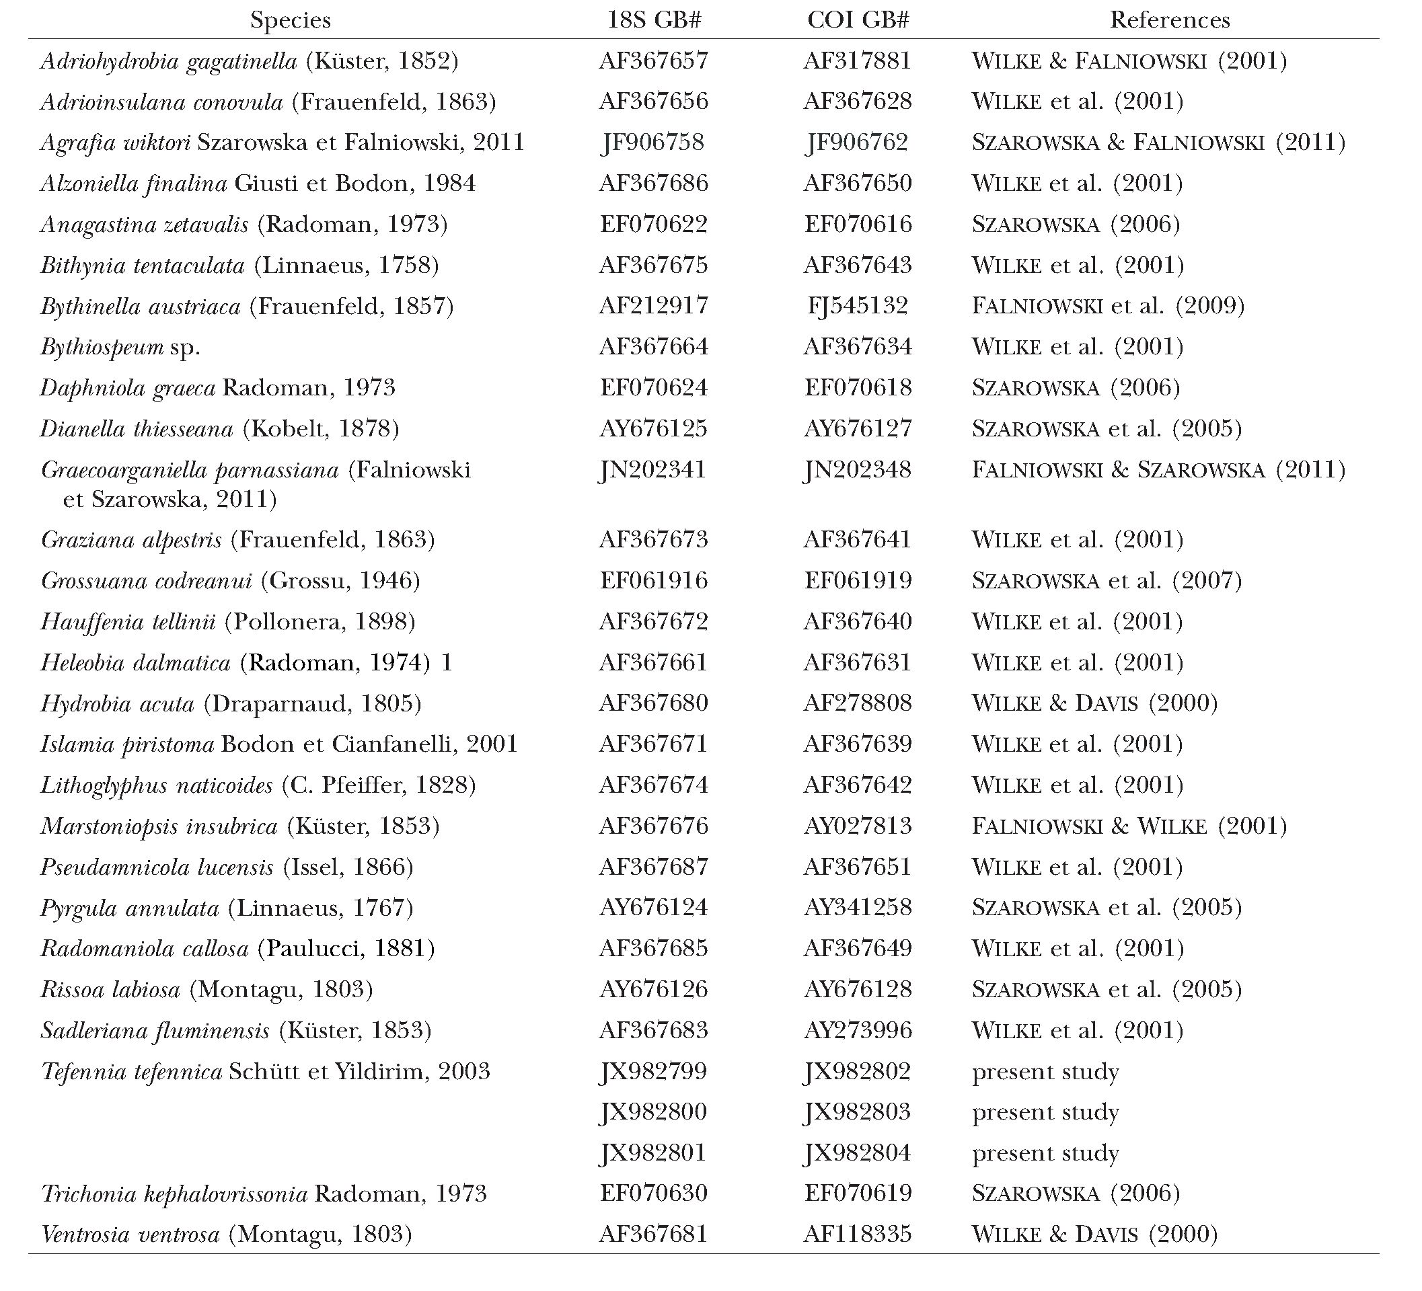
272 Duygu Ceren Çaglan, M. Zeki Yildirim, Magdalena Szarowska, Andrzej Falniowski

(Folmer et al. 1994) and COR722b (5’-TAA ACTT
CAGGGTGACCAAAAAATYA-3’) (WILKE & DAVIS
- for the cytochrome oxidase subunit I (COI) mi-
tochondrial gene; SWAM18SF1 (5’-GAATGGCTCA
TTAAATCAGTCGAGGTTCCTTAGATGATCCAAAT
C-3’) and SWAM18SR1 (5’-ATCCTCGTTAAAGGG
TTTAAAGTGTACTCATTCCAATTACGGAGC-3’) for
the 18S ribosomal RNA gene (PALUMBI 1996). The
PCR conditions were as follows: COI - initial denatur-
ation step of 4 min at 94°C, followed by 35 cycles of 1
min at 94°C, 1 min at 55°C, 2 min at 72°C, and a final
extension of 4 min at 72°C; 18S - initial denaturation
step of 4 min at 94°C, followed by 40 cycles of 45 s at
94°C, 45 s at 51 °C, 2 min at 72°C and, after all cycles
were completed, an additional elongation step of 4
min at 72°C was performed. The total volume of each
PCR reaction mixture was 50 pl. To check the quality
of the PCR products 10 pl of the PCR product was run
on 1% agarose gel. The PCR products were purified
using Clean-Up columns (A&A Biotechnology) and
the purified PCR products were amplified in both di-
rections (HILLIS etal. 1996) using BigDye Terminator
v3.1 (Applied Biosystems), following the manufac-
turer’s protocol and with the primers described
above. The sequencing reaction products were puri-
fied using ExTerminator Columns (A&A Biotechnol-
ogy); DNA sequences then underwent electrophore-
sis on an ABI Prismsequencer. All the sequences were
deposited in GenBank (Table 1).
The COI sequences were aligned by eye using
BioEdit 5.0.0 (HALL 1999) and edited with
MACCLADE 4.05 (MADDISON & MADDISON 2002).
For 18S, an initial alignment was performed using
CLUSTALX 1.82 (THOMPSON etal. 1997) and edited
Table 1. Taxa used for phylogenetic analyses, with their GenBank Accession Numbers and references

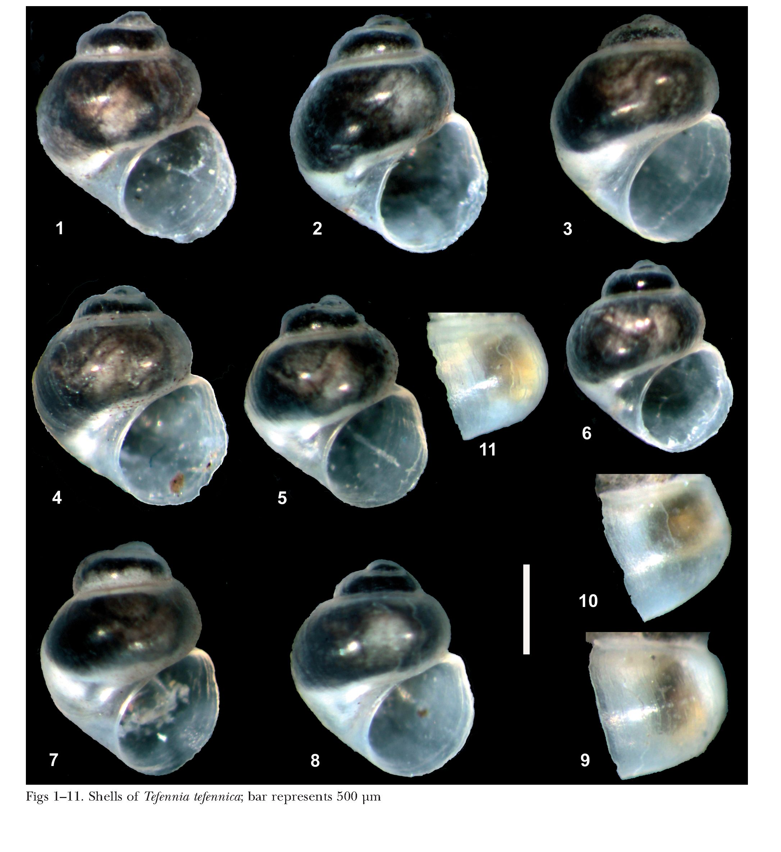
Phylogenetic position of Tefennia Schütt et Yildirim, 2003
273
with MACCLADE. Mutational saturation for the COI
dataset was examined by plotting the numbers of tran-
sitions and transversions for all the codon positions
together, and for the 3rd position separately, against
the percentage sequence divergence, using DAMBE
5.2.9 (XIA 2000). We also used DAMBE 5.2.9 to per-
formthe saturation test (XIA et al. 2003). It revealed a
significant degree of saturation in the third position
of the sequences. In rissooids, COI approaches satura-
tion with about 18.6 % or 120 nucleotide differences
(DAVIS et al. 1998), which seems to happen after ap-
proximately 10 million years. However, to avoid a sub-
stantial loss of information in the case of closely re-
lated species, this position was not excluded from the
dataset and it was used for the analysis. Initially, we
performed phylogeny reconstruction for 18S and
COI data separately, using the maximum likelihood
(ML) technique.
For each ML analysis, we used the best fit model of
sequence evolution found by Modeltest v3.06 (POSA-
DA & CRANDALL 1998, POSADA 2003). The best model
for each dataset was chosen using the Akaike Informa-

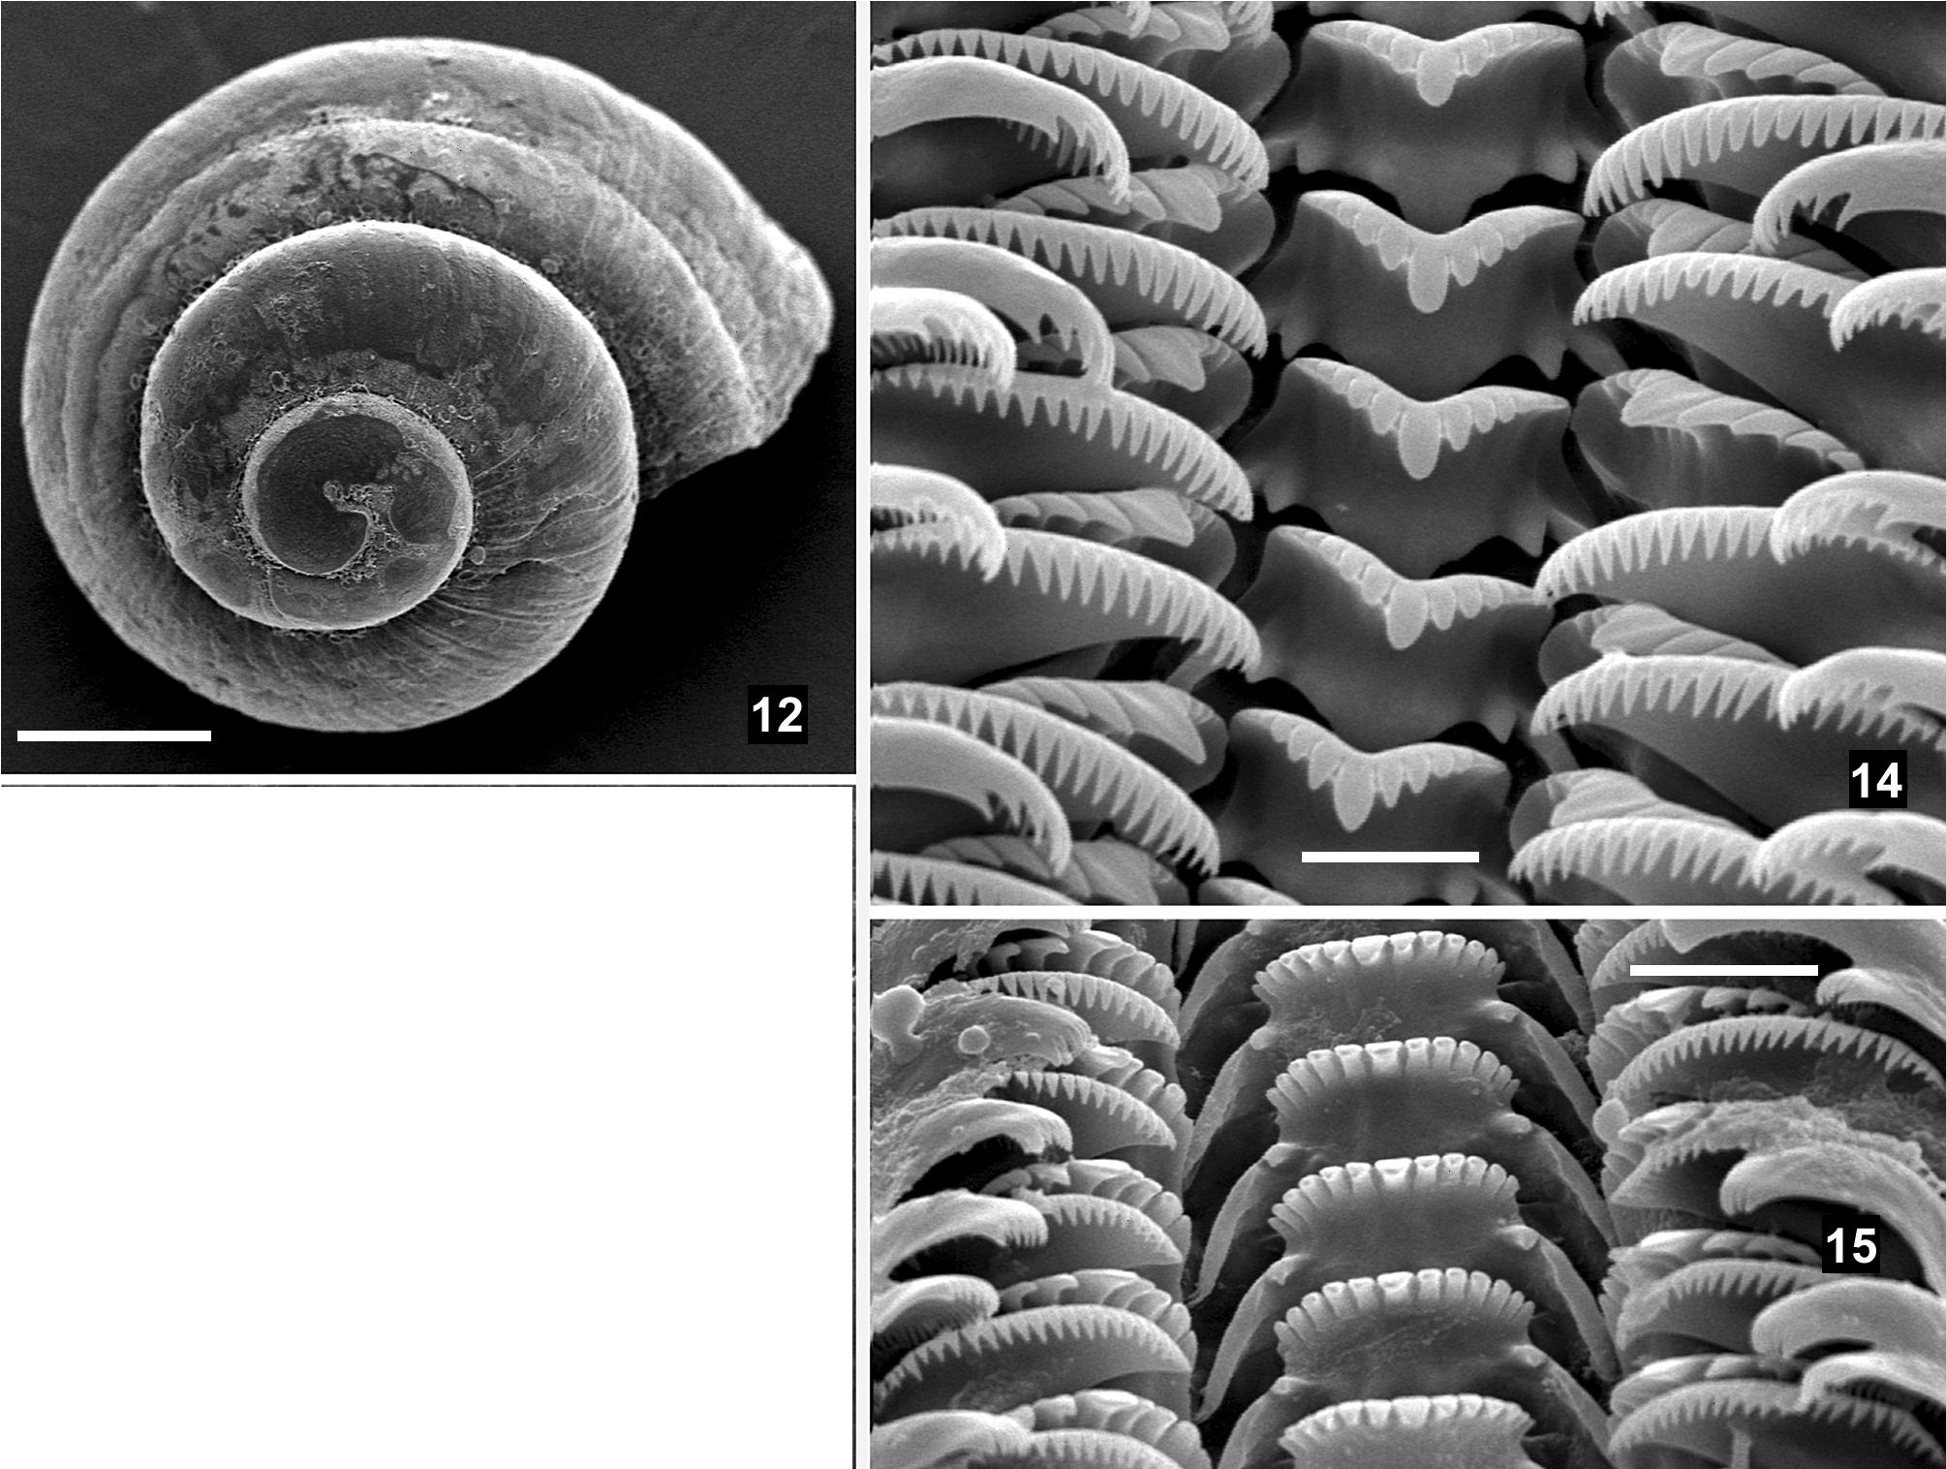
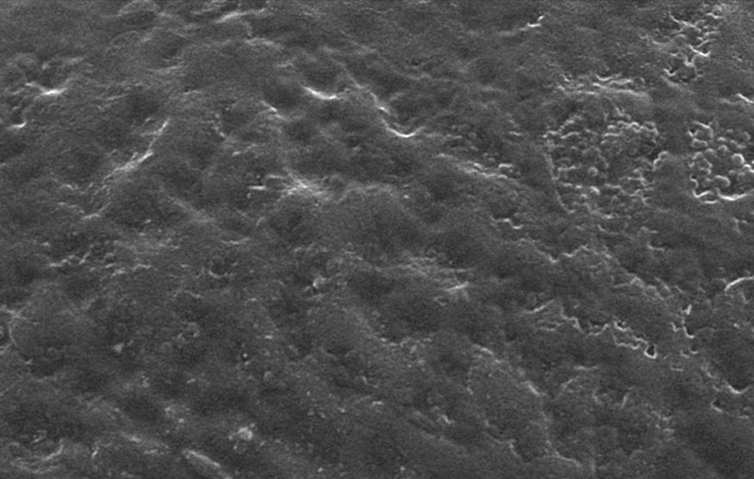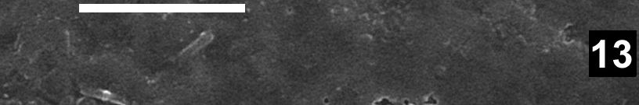
274 Duygu Ceren Çaglan, M. Zeki Yildirim, Magdalena Szarowska, Andrzej Falniowski

tion Criterion (AkaIKE 1974). We performed ML ana-
lyses in PAUP*4.0b10 (SWOFFORD 2002) and used a
heuristic search strategy with stepwise addition of
taxa, 10 random-sequence addition replicates, and
tree-bisection-reconnection (TBR) branch swapping
(SWOFFORD etal. 1996). Nodal support was estimated
using the bootstrap (BS) approach (FELSENSTEIN
1985). Bootstrap values for ML trees were calculated
using 1,000 bootstrap replicates, the “fast” heuristic
search algorithm, and the same model parameters as
for each ML analysis. Next, the partition homogeneity
test (FARRIS et al. 1995) was performed (1,000 repli-
cates) with PAUP*, to check whether the two genes
could be analysed together. Due to its results
(p>0.7253), the maximum likelihood heuristic search
was then run for the combined molecular data.
In the phylogeny reconstruction, we used Gen-
Bank sequences from 27 rissooid taxa (Table 1). Se-
ven of these, used as an outgroup, represented the
main non-hydrobiid lineages within the Rissooidea
(WILKE et al. 2001); another seven taxa represented
the Hydrobiinae (including “Pyrgulinae”: SZAROWSKA
et al. 2005). The remaining taxa were chosen to rep-
resent all the main lineages within the European
Sadlerianinae (SZAROWSKA 2006).

RESULTS AND DISCUSSION
The shell of T tefennica (Figs 1-11) corresponds to
the description of the species and drawings by
SCHÜTT &YILDIRIM (2003: fig. 1). Protoconch surface
malleated (Figs 12-13). Head and body pigmentation
like in SCHÜTT & YILDIRIM (2003: fig. 1). Ctenidium
present, number of ctenidial lamellae 8-11. Osphra-
dium crescent-shaped. Radula (Figs 14-15) taenio-
glossate, central tooth formula:
6 -1 - 6
1 -1

Figs 12-15. SEM pictures of shell and radula of Tefennia tefennica: 12 - shell, 13 - protoconch surface, 14-15 - radula; bars
represent 250 pm, 10 pm, 5 pm and 20 pm, respectively
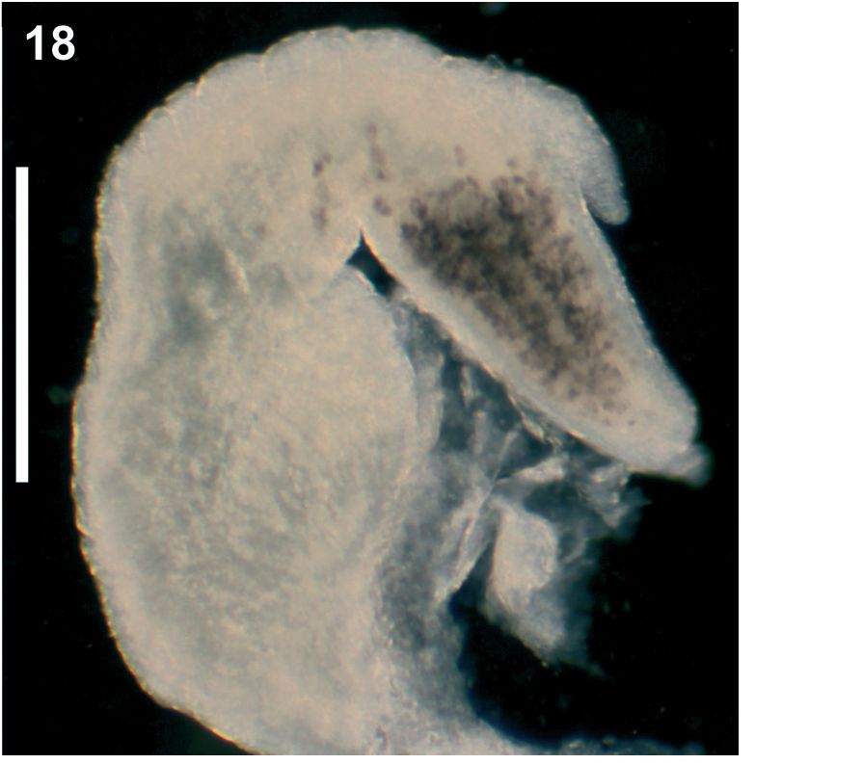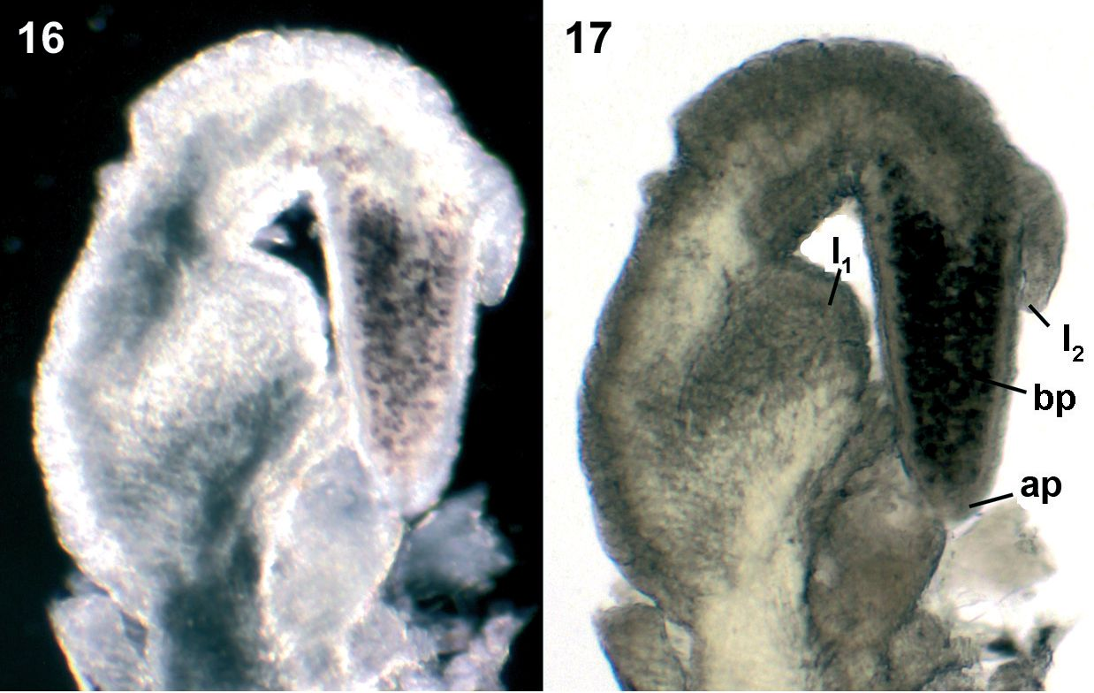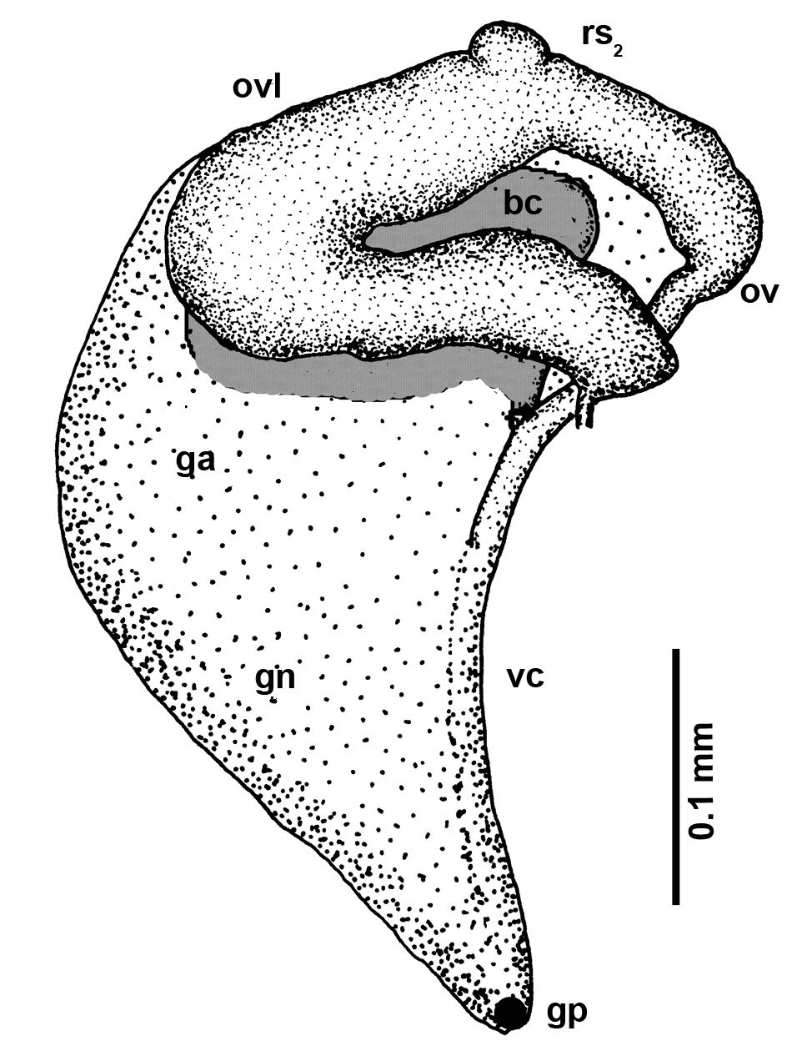
Phylogenetic position of Tefennia Schütt et Yildirim, 2003
275

Figs 16-18. Penis of Tefennia tefennica (ap - apical papilla, bp - black pigment, l1, l2 - lobes); bar represents 100 pm
Lateral tooth formula: 4-14. All cusps on central
and lateral teeth comparatively stout and massive. In-
testine course S-shaped. Stomach without caecum.
Penis (Figs 16-18) apically pigmented black, with
apical papilla and 2 lobes: one bigger in basal part
and one smaller at 1/3 length distal. Female genitalia
(Fig. 19) correspond to the description and drawings
by SCHÜTT & Yildirim (2003: fig. 1). Proximal semi-
nal receptacle (rs2) rudimentary and inconspicuous,
yet present.
Three sequences of COI and three of 18S (Table
1) were analysed for T. tefennica. For the COI se-
quences the Akaike Information Criterion (AIC) with
ModelTest found model GTR+I+T, with base frequen-
cies: A=0.3356, C=0.1493, G=0.1434, T=0.3716; substi-
tution rate matrix: [A-C]=0.8707, [A-G]= 8.1241,
[A-T]=0.3577, [C-G]=2.7037, [C-T]=13.1246,
[G-T] = 1.0000, proportion of invariable sites:
(I)=0.6074, and T distribution with the shape parame-
ter =0.3721. For the combined data set the Akaike In-
formation Criterion (AIC) with ModelTest found
model GTR+I+T, with base frequencies: A=0.3356,
C=0.1493, G=0.1434, T=0.3716; substitution rate ma-
trix: [A-C]=0.8707, [A-G]=8.1241, [A-T]=0.3577,
[C-G]=2.7037, [C-T]=13.1246, [G-T]=1.0000, propor-
tion of invariable sites: (I)=0.6074, and T distribution
with the shape parameter =0.3721.
In the COI analysis (Fig. 20) Tefennia was resolved
within the Hydrobiidae Troschel, 1857, subfamily
Sadlerianinae Radoman, 1977 (after SZAROWSKA
2006). Its sister clade consisted of Grossuana
Radoman, 1973, Trichonia Radoman, 1973, and
Daphniola Radoman, 1973. The bootstrap support for
this placement was 57% (Fig. 20). In an ML tree com-
puted for all molecular data (COI and 18S) the sister
group of Tefennia was the same as in Fig. 20 but its sup-
port was higher (68%: Fig. 21). On the other hand,
the relationships between this clade (Tefennia,
Daphniola, Grossuana and Trichonia) and the other
genera of the Sadlerianinae in Fig. 21 were somewhat
different from the corresponding relationships
shown in Fig. 20. However, in both trees (Figs 20-21)
the clade was placed within the Sadlerianinae. It has
to be noted, however, that low values of supports may
only suggest the pattern presented.
The molecularly-inferred phylogenetic relation-
ships of Tefennia suggest that the loss of the distal re-
ceptacle (rsj) in this genus is secondary. Within the
genera included in the phylogenetic analysis in the

Fig. 19. Renal and pallial section of female reproductive or-
gans of Tefennia tefennica (bc - bursa copulatrix, ga -
albuminoid gland, gn - nidamental gland, gp -
gonoporus, ov - oviduct, ovl - loop of the (renal) ovi-
duct, rs₂ - seminal receptacle, vc - ventral channel)

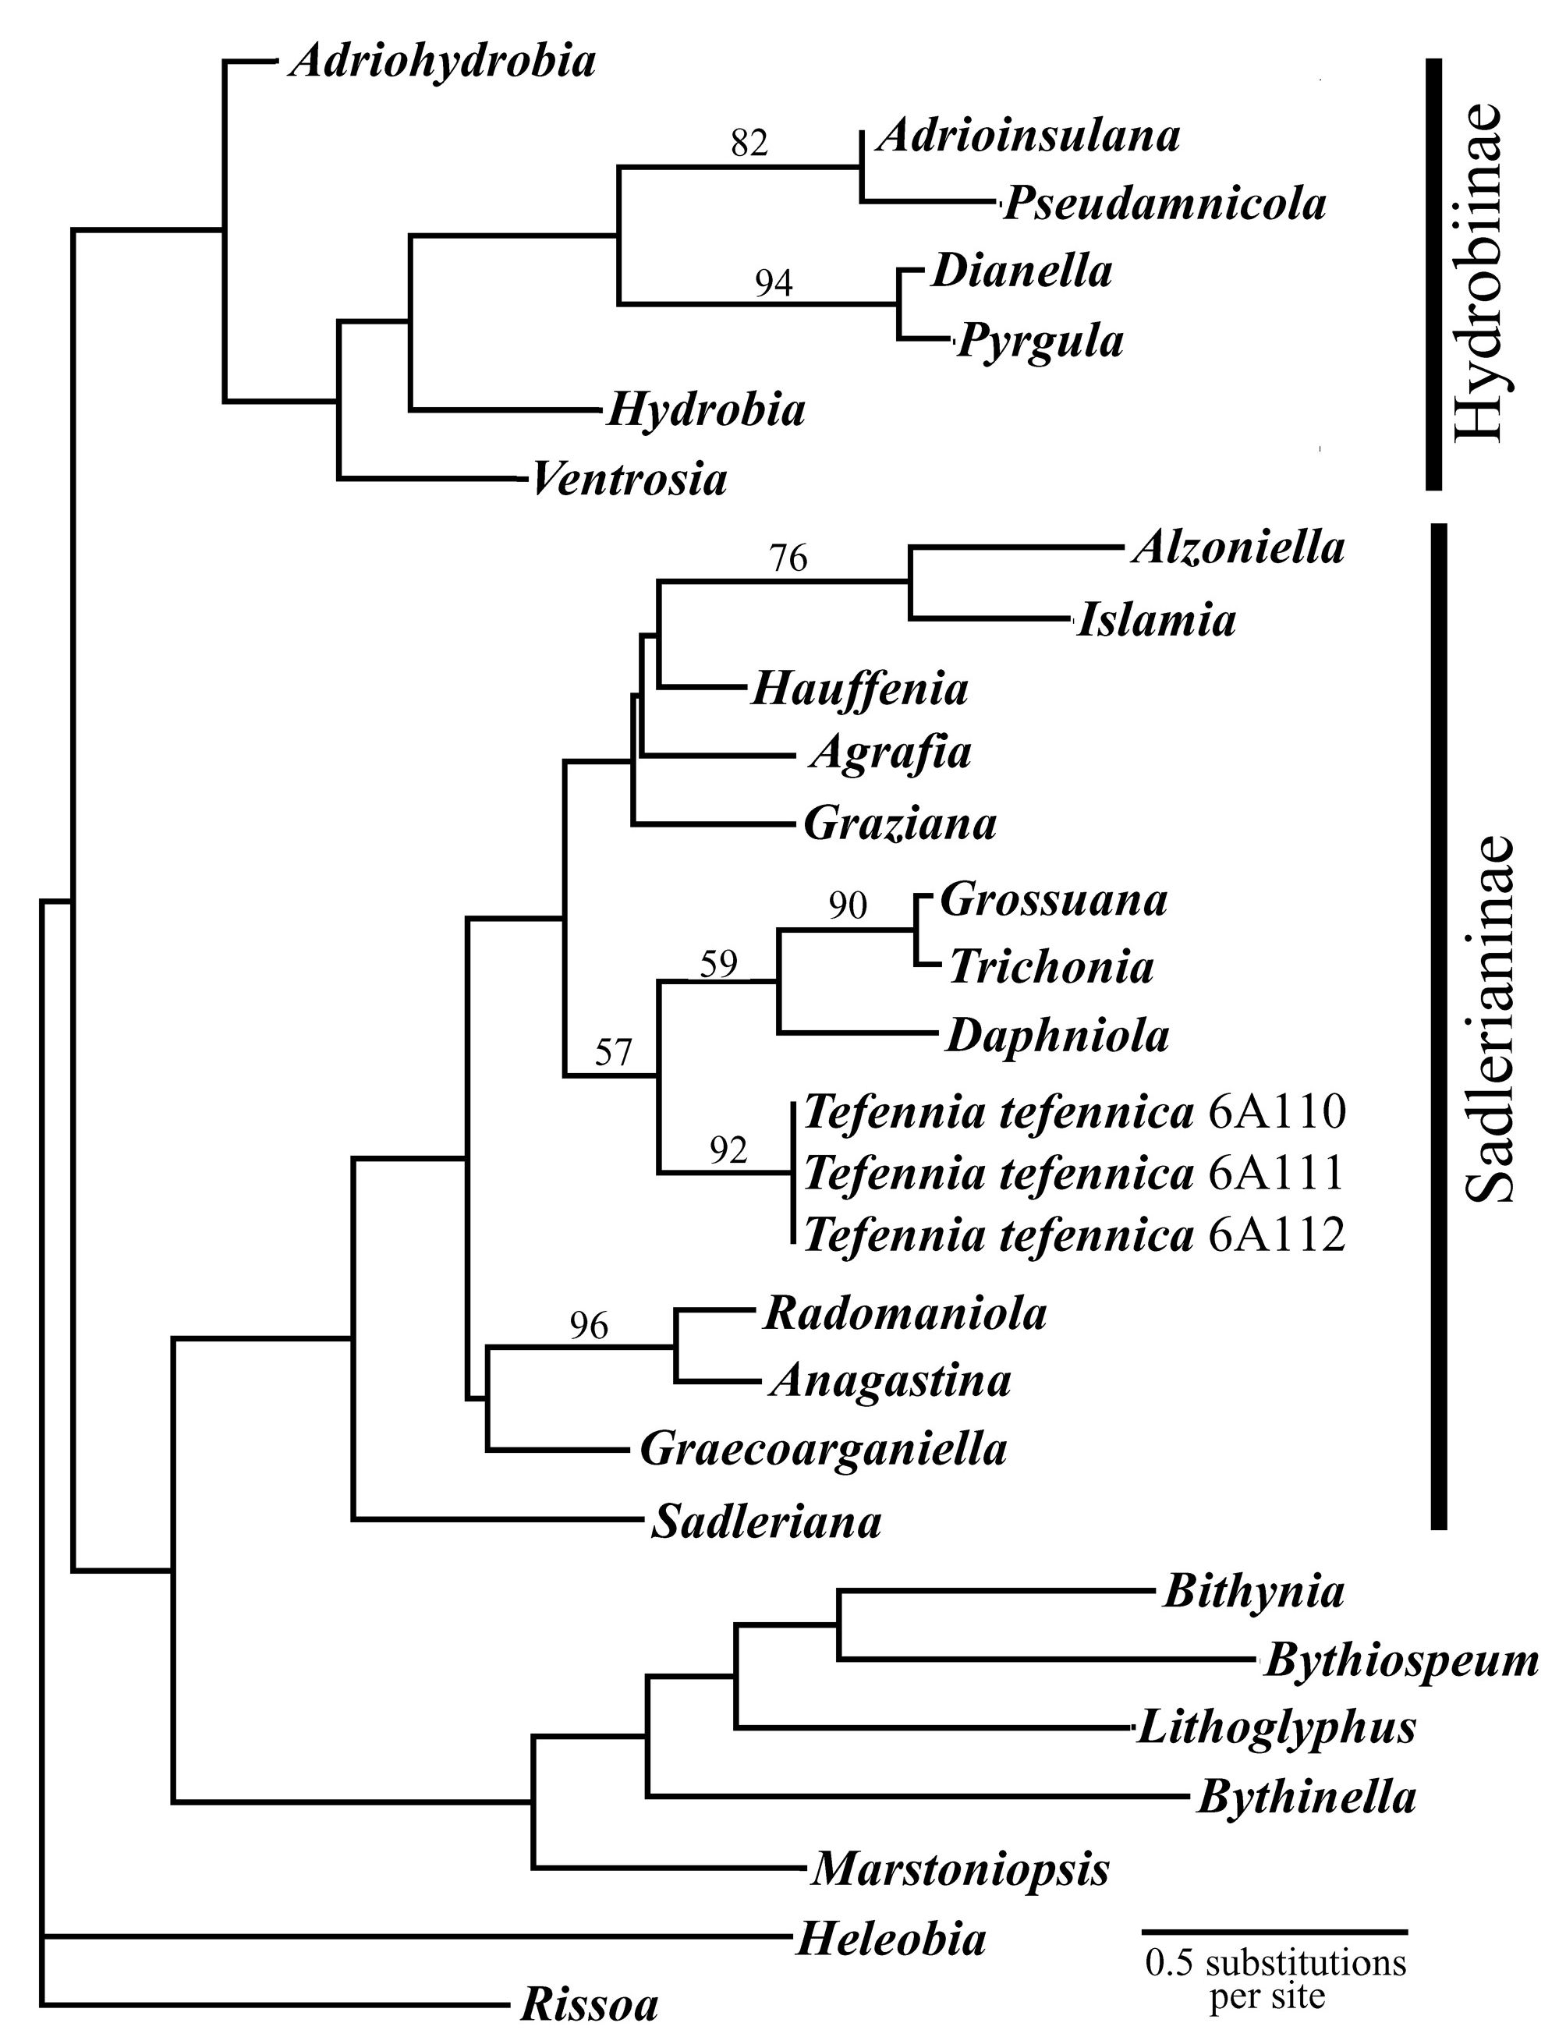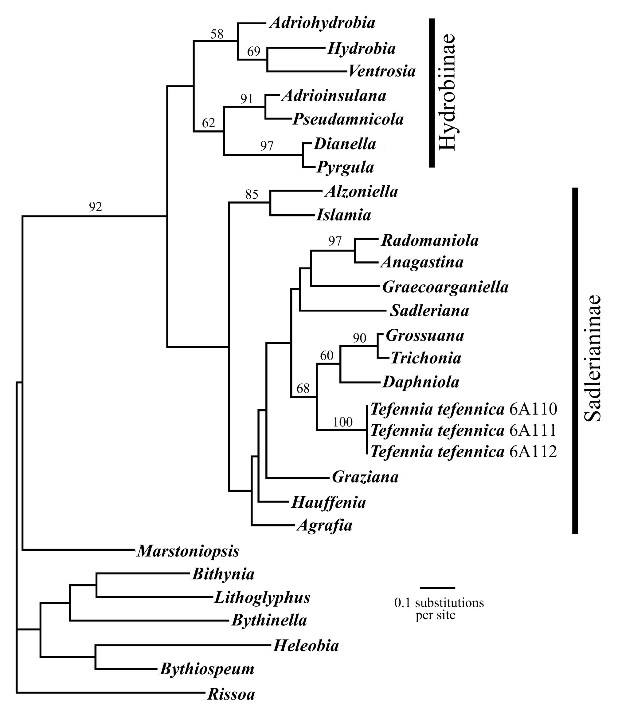
276 Duygu Ceren Çaglan, M. Zeki Yildirim, Magdalena Szarowska, Andrzej Falniowski

Fig. 20. ML phylogram based on COI, bootstrap supports
given where >50
present study (Figs 20-21) a parallel loss of the distal
seminal receptacle concerns Hauffenia (BODON et al.
- . There are other valvatiform hydrobiids that
have lost their rs_{x} (Lyhnidia, Pseudohoratia, Strugia,
Zaumia: BODON et al. 2001) but without molecular
Fig. 21. ML phylogram based on COI and 18S, bootstrap
supports given where >50
data the phylogenetic relationships of these genera
are not clear.
ACKNOWLEDGEMENTS
The study was supported by a grant from the Na-
tional Science Centre (2011/01/B/NZ8/01721) to
Andrzej Falniowski.

REFERENCES
AKAIKE H. 1974. A new look at the statistical model identifi-
cation. IEEE Trans. Automat. Contr. 19: 716-723. doi:
10.1109/TAC.1974.1100705
BODON M., MANGANELLI G., GIUSTI F. 2001. A survey of the
European valvatiform hydrobiid genera with special ref-
erence to Hauffenia Pollonera, 1898 (Gastropoda: Hy-
drobiidae). Malacologia 43: 103-215.
DAVIS G. M., WILKE T., SPOLSKY C., QIU C.-P., QIU D.-C., XIA
M.-Y., ZHANG Y., Rosenberg G. 1998. Cytochrome oxi-
dase I-based phylogenetic relationships among the Po-
matiopsidae, Hydrobiidae, Rissoidae and Truncatelidae
(Gastropoda: Caenogastropoda: Rissoacea). Malacologia
40: 251-266.
FALNIOWSKI A. 1990. Anatomical characters and SEM struc-
ture of radula and shell in the species-level taxonomy of
freshwater prosobranchs (Mollusca: Gastropoda:
Prosobranchia): a comparative usefulness study. Folia
Malacol. 4: 53-142.
Falniowski A., Szarowska M. 2011. A new genus and new
species of valvatiform hydrobiid (Rissooidea; Caeno-
gastropoda) from Greece. Moll. Res. 31: 189-199.
Falniowski A., Szarowska M., Sirbu I. 2009. Bythinella
Moquin-Tandon, 1856 (Gastropoda: Rissooidea:
Bythinellidae) in Romania: species richness in a glacial
refugium. J. Nat. Hist. 43: 2955-2973. doi: 10.1080/0022
2930903359636
FALNIOWSKI A., WILKE T. 2001. The genus Marstoniopsis
(Gastropoda: Rissooidea): intra- and intergeneric phylo-
genetic relationships. J. Moll. Stud. 67: 483-488. doi:
10.1093/mollus/67.4.483
FARRIS J. S., KÄLLERSJÖ M., KLUGE A. G., BULT C. 1995. Test-
ing significance of incongruence. Cladistics 10: 315-319.
doi: 10.1111/j.1096-0031.1994.tb00181.x
FELSENSTEIN J. 1985. Confidence limits on phylogenies: an
approach using the bootstrap. Evolution 39: 783-791.
doi: 10.2307/2408678
Folmer O., Black m., Hoeh w., lutz r. A., Vrijenhoek r.
C. 1994. DNA primers for amplification of mitochon-
drial cytochrome c oxidase subunit I from diverse meta-
zoan invertebrates. Mol. Mar. Biol. Biotechnol. 3:
294-299.
Phylogenetic position of Tefennia Schütt et Yildirim, 2003
277
HALL T. A. 1999. BioEdit: a user-friendly biological sequence
alignment editor and analysis program for Windows
95/98/NT. Nucleic Acids Symp. Ser. 41: 95-98.
Hillis D. M., Mable B. K., Larson A., Davis S. K., Zimmer
E. A. 1996. Nucleic acids IV: sequencing and cloning. In:
Hillis D. M., MORITZ C., mable B. K. (eds). Molecular
systematics. 2 ed. Sinauer Associates, Inc., Sunderland,
Massachusetts, pp. 321-381.
MADDISON D. R., MADDISON W. P. 2002. MACCLADE. Ver.
4.05. [Computer software and manual]. Sinauer Associ-
ates Inc., Sunderland.
PALUMBI S. R. 1996. Nucleic acids II: the polymerase chain
reaction. In: HILLIS D. M., MORITZ C., MABLE B. K. (eds).
Molecular systematics. 2 ed. Sinauer Associates Inc.,
Sunderland, pp. 205-247.
POSADA D. 2003. Selecting models of evolution. In: SALEMI
M., VANDAMME A.-M. (eds). The phylogenetic hand-
book. A practical approach to DNA and protein phylog-
eny. Cambridge University Press, Cambridge, pp.
256-282.
POSADA D., Crandall K. A. 1998. Modeltest: testing the
model of DNA substitution. Bioinformatics 14: 817-818.
doi: 10.1093/bioinformatics/14.9.817
RADOMAN P. 1983. Hydrobioidea a superfamily of
Prosobranchia (Gastropoda). I. Systematics. Serbian
Academy of Sciences and Arts, Monographs 547, Depart-
ment of Sciences 57: 1-256.
SCHÜTT H., Yildirim M. Z. 2003. A new freshwater snail
from Turkey, resembling the genus Lyhnidia HadZisce
1956. Arch. Moll. 132: 97-103.
SWOFFORD D. L. 2002. PAUP ^-Phylogenetic analysis using
parsimony (* and other methods). Ver. 4. [Computer
software and manual]. Sinauer Associates Inc.,
Sunderland.
Swofford D. L., Olsen G. J., Waddell P. J., Hillis D. M.
1996. Phylogenetic inference. In: HILLIS D. M., MORITZ
C., MABLE B. K. (eds). Molecular systematics, 2 ed.,
Sinauer Associates, Inc., Sunderland, pp. 407-514.
SZAROWSKA M. 2006. Molecular phylogeny, systematics and
morphological character evolution in the Balkan
Rissooidea (Caenogastropoda). Folia Malacol. 14:
99-168.
SZAROWSKA M., FALNIOWSKI A. 2011. An unusual, flagel-
lum-bearing hydrobiid snail (Gastropoda: Rissooidea:
Hydrobiidae) from Greece, with descriptions of a new
genus and a new species. J. Nat. Hist. 45: 2231-2246. doi:
10.1080/00222933.2011.591067
SZAROWSKA M., FALNIOWSKI A., RIEDEL F., WILKE T. 2005.
Phylogenetic relationships of the subfamily Pyrgulinae
(Gastropoda: Caenogastropoda: Hydrobiidae) with em-
phasis on the genus Dianella Gude, 1913. Zootaxa 891:
1-32.
SZAROWSKA M., GRZMIL P., FALNIOWSKI A., SIRBU I. 2007.
Grossuana codreanui (Grossu, 1946) and the phylogenetic
relationships of the East Balkan genus Grossuana (Rado-
man, 1973) (Gastropoda: Rissooidea). Hydrobiologia
579: 379-391. doi: 10.1007/s10750-006-0530-4
Thompson J. D., Gibson T. J., PlewniakE, Jeanmougin F.,
HIGGINS D. G. 1997. The ClustalX windows interface:
flexible strategies for multiple sequence alignment aided
by quality analysis tools. Nucleic Acids Res. 24:
4876-4882. doi: 10.1093/nar/25.24.4876
WILKE T., Davis G. M. 2000. Infraspecific mitochondrial se-
quence diversity in Hydrobia ulvae and Hydrobia ventrosa
(Hydrobiidae: Rissoacea: Gastropoda): Do their differ-
ent life histories affect biogeographic patterns and gene
flow? Biol. J. Linn. Soc. 70: 89-105. doi: 10.1111/j.1095-
8312.2000.tb00202.x
Wilke T., Davis G. M., Falniowski A., Giusti F., Bodon M.,
SZAROWSKA M. 2001. Molecular systematics of Hydro-
biidae (Gastropoda: Rissooidea): testingmonophylyand
phylogenetic relationships. Proc. Acad. Nat. Sci. Phila-
delphia 151: 1-21. doi: 10.1635/0097-3157(2001)151
[0001:MS0HMG]2.0.C0;2
WILKE T., Falniowski A. 2001. The genus Adriohydrobia
(Hydrobiidae: Gastropoda): polytypic species or poly-
morphic populations? J. Zool. Sys. Evol. Res. 39:
227-234. doi: 10.1046/j.1439-0469.2001.00171.x
XIA X. 2000. Data analysis in molecular biology and evolu-
tion. Kluwer Academic Publishers, Boston, Dordrecht &
London.
XIA X., XIE Z., SALEMI M., CHEN L., WANG Y 2003. An index
of substitution saturation and its application. Mol. Phyl.
Evol. 26: 1-7. doi: 10.1016/S1055-7903(02)00326-3
Yildirim M. Z., Koca S. B., Kebapci U. 2006. Supplement to
the Prosobranchia (Mollusca: Gastropoda) fauna of
fresh and brackish waters of Turkey. Turk. J. Zool. 30:
197-204.
Received: April 4th, 2012
Revised: May 30th, 2012
Accepted: June 9th, 2012

