Design of indole- and MCR-based macrocycles as p53-MDM2 antagonists
Constantinos G. Neochoritis1, Maryam Kazemi Miraki2, Eman M. M. Abdelraheem1,
Ewa Surmiak3, Tryfon Zarganes-Tzitzikas1, Beata Łabuzek3, Tad A. Holak3 and Alexander Dömling*1
Abstract
Macrocycles were designed to antagonize the protein–protein interaction p53-MDM2 based on the three-finger pharmacophore F19W23L25. The synthesis was accomplished by a rapid, one-pot synthesis of indole-based macrocycles based on Ugi macrocycliza- tion. The reaction of 12 different α,ω-amino acids and different indole-3-carboxaldehyde derivatives afforded a unique library of macrocycles otherwise difficult to access. Screening of the library for p53-MDM2 inhibition by fluorescence polarization and 1H,15N HSQC NMR measurements confirm MDM2 binding.
Introduction
Macrocycles are the chemical entities that are consisting of a 12-membered or even bigger ring. It is estimated that 3% of the known natural products consists of a macrocyclic ring [1-5]. Compared to macrocycles in synthetic molecules, the aforemen- tioned occurrence is still over proportional; for that reason, these compounds have delighted scientists worldwide due to their special physicochemical properties, their roles in biologi- cal systems and the associated synthetic challenges [6,7]. How- ever, only few synthetic methods allow for the convergent and
fast access to a large macrocyclic chemical space [8-10]; most
of the times their synthesis is complex, multistep and sequen- tial [11,12]. For this reason a great effort is ongoing to utilize multicomponent reactions for the synthesis of macrocycles
[8,13-25].
The p53 protein is a well-studied protein which has a leading role in protecting our organism from cancer. It was found that most of the human cancers have either mutated the p53 itself or the p53 pathway is inhibited. The latter group of tumors retains
the wild type p53 (wt-p53) but its pathway is inactivated by
513
Full Research Paper Open Access
Address: Beilstein J. Org. Chem. 2019, 15, 513–520.
1Department of Drug Design, University of Groningen, Antonius doi:10.3762/bjoc.15.45 Deusinglaan 1, 9700 AD Groningen, The Netherlands, 2Chemistry
Department, Tarbiat Modares University, P.O. Box 14155-4838, Received: 25 October 2018 Tehran, Iran and 3Faculty of Chemistry, Jagiellonian University, Accepted: 14 February 2019 Gronostajowa 2, 30-387 Krakow, Poland Published: 20 February 2019

Email: This article is part of the thematic issue "Multicomponent reactions III". Alexander Dömling* - a.s.s.domling@rug.nl
Guest Editor: T. J. J. Müller
* Corresponding author
© 2019 Neochoritis et al.; licensee Beilstein-Institut.
Keywords: License and terms: see end of document.
1H,15N HSQC NMR; indole; macrocycles; multicomponent; p53-MDM2; Ugi reaction

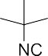
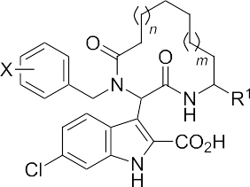
Beilstein J. Org. Chem. 2019, 15, 513–520.
Results and Discussion
Synthesis
Based on our previous studies [13], unprotected diamines 3 were reacted in one-step with cyclic anhydrides 4 at rt affording the appropriate α,ω-amino acids 5 in excellent yields (see Sup- porting Information File 1). Elongated diamines (n = 2–4, 6, 8 and 10) and cyclic anhydrides that bear a heteroatom in the 4-position as oxygen or sulfur (Y = O, S, Scheme 2) were em- ployed in order to enhance the diversity of our macrocycles [4]. Thus, in a parallel way, we readily synthesized 12 different amino acids which were subsequently subjected to the Ugi macrocyclization.
negative regulators, mainly the MDM2 and MDMX proteins. Thus, the design and synthesis of an inhibitor of the MDM2–p53 interaction could enable p53 and reverse tumor formation [26-28]. Based on our knowledge to antagonize the oncogenic protein–protein interaction p53–MDM2 [23,29-40] we designed macrocyclic inhibitors in continuation of our previous work [13,23]. Herein, an indole-based macrocycle syn- thesis is reported in a one-pot fashion based on Ugi macrocy- clization with readily available α,ω-amino acids. Moreover, in continuation of our efforts in the design and synthesis of macrocycles targeting the p53–MDM2 interaction demon- strating the potential of these indole-based macrocycles, a subset of them was screened searching for MDM2 inhibitors. Compared to our previous indole-based macrocycles 1 following a different strategy (employing a classical Ugi-4C as the key reaction) [23], this one-pot Ugi macrocyclization leading to macrocycles 2 offers speed (one-pot procedure with one purification step), much better yields, no need of expensive catalysts as in ring-closing metathesis (RCM) reaction and higher complexity/diversity on the macrocyclic ring, e.g., inser- tion of heteroatoms that could improve the ADMET properties
(Scheme 1) [4].
After quite some optimization, we improved the Ugi-macrocy- clization procedure compared to our previous findings utilizing microwave irradiation (see Supporting Information File 1); Firstly, the corresponding amino acid was irradiated with indole-3-carboxaldehyde derivatives 6 using MeOH as solvent (5 mL) at 120 °C for 1 h. Then, tert-butyl isocyanide was added, diluted with more MeOH and irradiated again the reaction mixture at 120 °C for an additional 1 h in a final
concentration of 0.1 M (Scheme 3). By this way, a rapid, one-
514

Scheme 2: Reaction of unprotected diamines 3 with cyclic anhydrides 4 at rt affording α,ω-amino acids 5 in quantitative yields.

Scheme 1: MCR approach to indole-based macrocycles; a more effective strategy is proposed in this work, based on α,ω-amino acids and an Ugi macrocyclization.

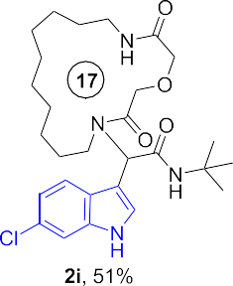
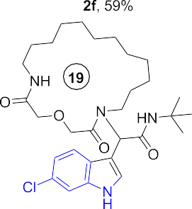
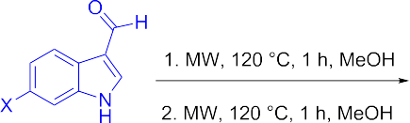
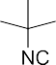
Beilstein J. Org. Chem. 2019, 15, 513–520.
515

Scheme 3: Ugi macrocyclization in a one-pot fashion and synthesis of diverse indole-based macrocycles. The circle depicts the size number of the macrocycle.

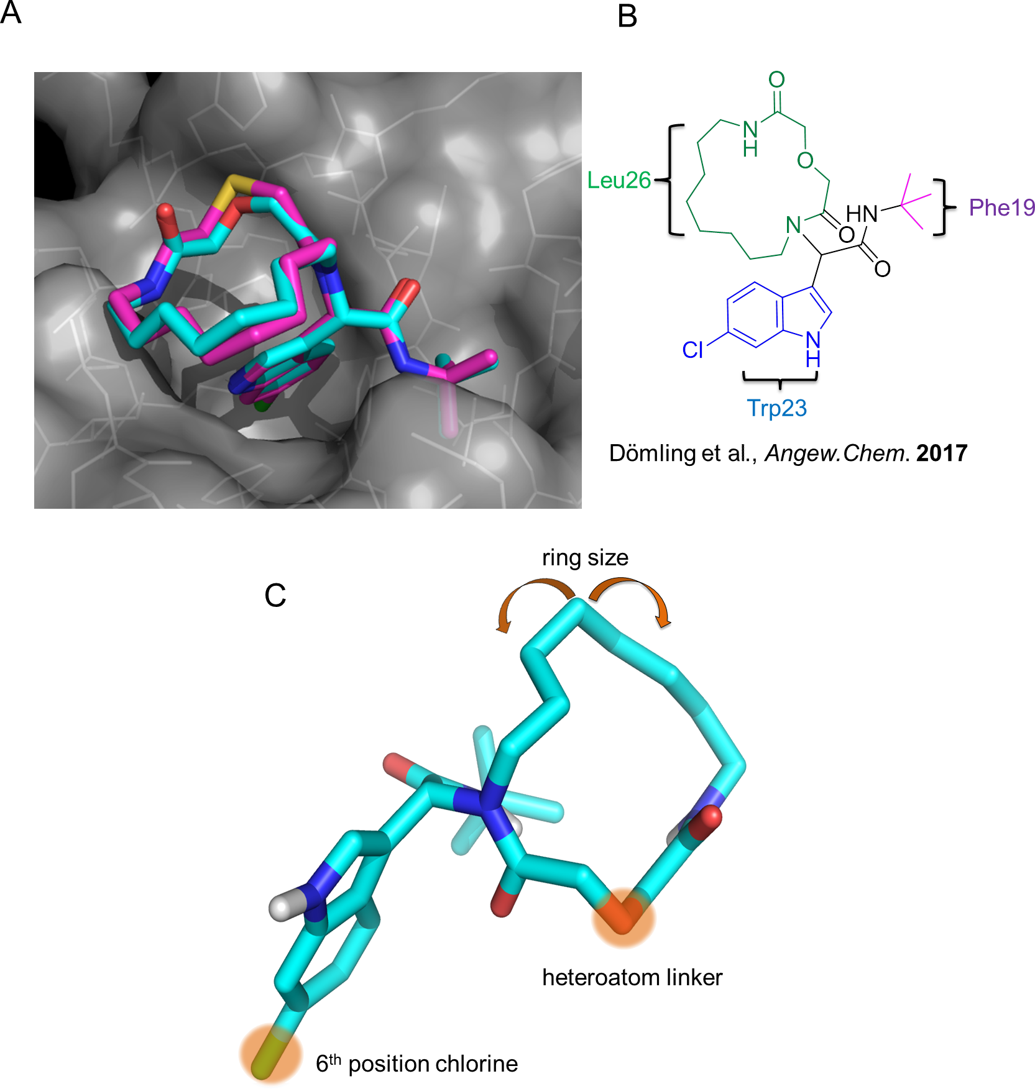
Beilstein J. Org. Chem. 2019, 15, 513–520.
pot access to macrocycles 2a–p was achieved otherwise very difficult to synthesize in relatively good yields (29–60%). 16 different indole-based macrocycles were synthesized with their size varying from 11–13, 15, 17 and 19 atoms
(Scheme 3).
constrain the two other substituents but also as an “anchor” mimicking the Trp23. The bulky tert-butyl group would mimic the Phe19 and the macrocyclic ring would fill the Leu26 sub- pocket as shown by our docking studies (Figure 1A,B, Figure S4 in Supporting Information File 1). Thus, extending our previous work [13], the Leu26 subpocket was probed by utilizing the different ring sizes and the different heteroatoms (oxygen or sulfur) of our macrocyclic library. In addition, the influence of the chlorine atom in the 6-position of the indole ring (Figure 1C) was examined. Macrocycles 2a–j consist of an
oxygen linker whereas 2g–j bear also a chlorine atom in the
Biological evaluation
Our previously introduced three-point pharmacophore model on mimicking the hot triad (Phe19, Trp23 and Leu26, F19W23L26) was the basis of the evaluation of the current derivatives as po- tent inhibitors [33]. The indole moiety could be used not only to
516

Figure 1: (A) Modeling of the macrocycle 2h (cyan sticks) and 2n (magenta sticks) into the MDM2 receptor (PDB ID: 1YCR); (B) 2D structure of 2h with the substituents targeting the subpockets of MDM2; (C) Analysis of the synthesized macrocycles probing the subpockets of MDM2 and expan- sion of the chemistry compared to previous studies [13].
Beilstein J. Org. Chem. 2019, 15, 513–520.
6-position in the indole ring. Macrocycles 2k–p incorporate both a sulfur linker and the chlorine on the indole ring
(Scheme 3).
showed a Kd of 4.8 μΜ (Table 1, Figure 2). Moreover, macro- cycles 2g and 2n demonstrated a Kd of 9 μΜ and 17 μΜ, re- spectively (Table 1). With this preliminary analysis, it was
found that a ring size of 15–17 atoms and an oxygen as the heteroatom linker improves the binding affinity. All the active macrocycles have a 6-chloro-substituted indole core. It is well established that at the bottom of the Try23 pocket a hydro- phobic small subpocket exists which is formed by Phe86, Ile103, Leu82 and Leu57. This pocket when filled with a smaller hydrophobic substituent such as -Cl boosts the inhibitor
activity in accordance with literature [33].
In order to exclude false positive hits, two biorthogonal assays were chosen; 1H,15N HSQC NMR and fluorescence polariza- tion (FP, Table 1). FP assay was employed to determine the inhibitory affinities (Ki) of the derivatives against MDM2 as previously described [36]. Besides 2h (Ki = 2.3 μΜ, Kd = 12.1 μΜ), it was shown that 2i demonstrated a promising
activity with a Ki of 5.5 μΜ. Furthermore, 1H,15N HSQC
517
Table 1: Measurement of Ki and Kd of the selected macrocycles based on FP and 1H,15N HSQC NMR assays, respectively.a
Entry Name Structure K_{i} MDM2 [µM] K_{d} MDM2 [µM]

1 2h 2.3 12.1 ± 8.5

2 2i 5.5 4.8 ± 1.5

3 2n 316 17.2 ± 3.8

4 2g n.a. 8.9 ± 1.2

an.a. no activity against MDM2 protein. Ki and Kd values were calculated based on fluorescence polarization binding and 1H,15N HSQC NMR assay, respectively.

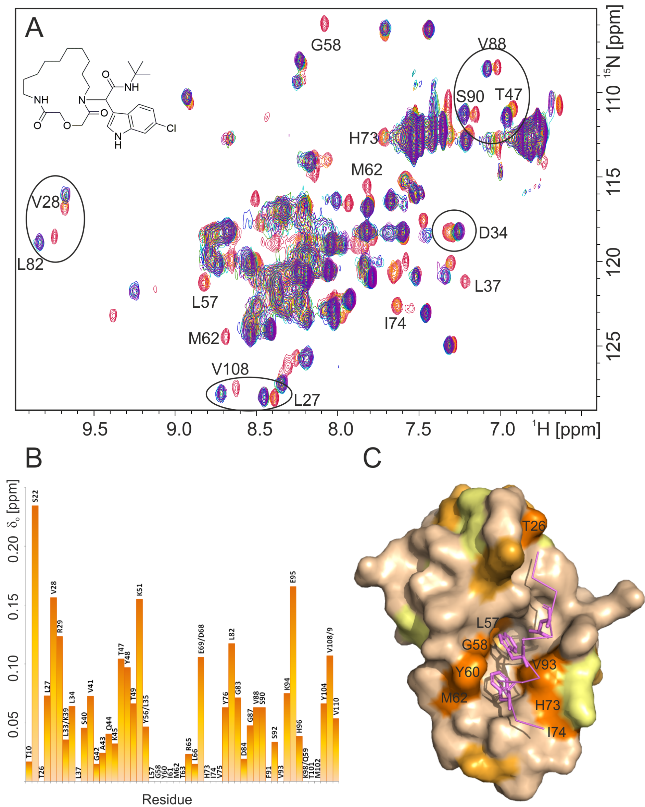
Beilstein J. Org. Chem. 2019, 15, 513–520.
518

Figure 2: (A) Overlay of 1 H,15N-HSQC spectra of the reference MDM2 (red) and the titration steps with the 2i inhibitor. MDM2/2i ratios 4:1 (orange), 4:2 (yellow), 4:3 (green), 1:1 (light blue), 1:2 (blue), 1:5 (purple). Examples of most perturbed residues are labeled on the spectrum. (B) Normalized chemical shift perturbations (δo) of MDM2 residue (calculated according to Stoll et al. [41]). Residue with δo equal 0 are either despairing from MDM2 spectrum upon titration or cannot be identified. (C) Chemical shift perturbations plotted onto the structure of MDM2 (wheat); orange (despairing – indi- cating stronger binding), light orange (>0.1 ppm), yellow (0.05–0.1 ppm). Residues which disappear upon titration experiment are labeled on the Mdm2 surface.
Beilstein J. Org. Chem. 2019, 15, 513–520.
Conclusion
We effectively synthesized p53-MDM2 antagonists based on an artificial macrocyclic scaffold. 16 different derivatives were ob- tained and screened. The aforementioned artificial macrocycles combine the indole ring, a motif found in many bioactive mole- cules with the drug-like properties of a non-peptide macrocycle. We hypothesize that these chimeric derivatives of an indole and a macrocycle will offer new potential on specific PPIs and other postgenomic targets as it was demonstrated with the p53-
MDM2 interaction.
5.
Doak, B. C.; Zheng, J.; Dobritzsch, D.; Kihlberg, J. J. Med. Chem.
2016, 59, 2312–2327. doi:10.1021/acs.jmedchem.5b01286
Yu, X.; Sun, D. Molecules 2013, 18, 6230–6268.
doi:10.3390/molecules18066230
White, C. J.; Yudin, A. K. Nat. Chem. 2011, 3, 509–524.
doi:10.1038/nchem.1062
Failli, A.; Immer, H.; Götz, M. Can. J. Chem. 1979, 57, 3257–3261. doi:10.1139/v79-533
Gartner, Z. J. Science 2004, 305, 1601–1605.
doi:10.1126/science.1102629
6.
7.
8.
9.
- Jebrail, M. J.; Ng, A. H. C.; Rai, V.; Hili, R.; Yudin, A. K.; Wheeler, A. R. Angew. Chem., Int. Ed. 2010, 49, 8625–8629. doi:10.1002/anie.201001604
- Koopmanschap, G.; Ruijter, E.; Orru, R. V. A. Beilstein J. Org. Chem.
2014, 10, 544–598. doi:10.3762/bjoc.10.50
- Iyoda, M.; Yamakawa, J.; Rahman, M. J. Angew. Chem., Int. Ed. 2011,
50, 10522–10553. doi:10.1002/anie.201006198
- Madhavachary, R.; Abdelraheem, E. M. M.; Rossetti, A.; Twarda-Clapa, A.; Musielak, B.; Kurpiewska, K.; Kalinowska-Tłuścik, J.; Holak, T. A.; Dömling, A. Angew. Chem., Int. Ed. 2017, 56, 10725–10729. doi:10.1002/anie.201704426
- Abdelraheem, E.; Khaksar, S.; Dömling, A. Synthesis 2018, 50,
1027–1038. doi:10.1055/s-0036-1590946
- Janvier, P.; Bois-Choussy, M.; Bienaymé, H.; Zhu, J. Angew. Chem., Int. Ed. 2003, 42, 811–814. doi:10.1002/anie.200390216
- Wessjohann, L. A.; Voigt, B.; Rivera, D. G. Angew. Chem., Int. Ed.
2005, 44, 4785–4790. doi:10.1002/anie.200500019
- Wessjohann, L. A.; Rivera, D. G.; Vercillo, O. E. Chem. Rev. 2009,
109, 796–814. doi:10.1021/cr8003407
- Abdelraheem, E. M. M.; Kurpiewska, K.; Kalinowska-Tłuścik, J.; Dömling, A. J. Org. Chem. 2016, 81, 8789–8795. doi:10.1021/acs.joc.6b01430
- Beck, B.; Larbig, G.; Mejat, B.; Magnin-Lachaux, M.; Picard, A.; Herdtweck, E.; Dömling, A. Org. Lett. 2003, 5, 1047–1050. doi:10.1021/ol034077e
- Liao, G. P.; Abdelraheem, E. M. M.; Neochoritis, C. G.; Kurpiewska, K.; Kalinowska-Tłuścik, J.; McGowan, D. C.; Dömling, A. Org. Lett. 2015, 17, 4980–4983. doi:10.1021/acs.orglett.5b02419
- Abdelraheem, E. M. M.; Khaksar, S.; Kurpiewska, K.;
Kalinowska-Tłuścik, J.; Shaabani, S.; Dömling, A. J. Org. Chem. 2018,
83, 1441–1447. doi:10.1021/acs.joc.7b02984
- Abdelraheem, E.; Shaabani, S.; Dömling, A. Synlett 2018, 29,
1136–1151. doi:10.1055/s-0036-1591975
- Estrada-Ortiz, N.; Neochoritis, C. G.; Twarda-Clapa, A.; Musielak, B.; Holak, T. A.; Dömling, A. ACS Med. Chem. Lett. 2017, 8, 1025–1030. doi:10.1021/acsmedchemlett.7b00219
- Abdelraheem, E. M. M.; de Haan, M. P.; Patil, P.; Kurpiewska, K.; Kalinowska-Tłuścik, J.; Shaabani, S.; Dömling, A. Org. Lett. 2017, 19, 5078–5081. doi:10.1021/acs.orglett.7b02319
- Abdelraheem, E. M. M.; Madhavachary, R.; Rossetti, A.; Kurpiewska, K.; Kalinowska-Tłuścik, J.; Shaabani, S.; Dömling, A. Org. Lett. 2017, 19, 6176–6179. doi:10.1021/acs.orglett.7b03094
- Gu, J.; Wang, B.; Liu, Y.; Zhong, L.; Tang, Y.; Guo, H.; Jiang, T.; Wang, L.; Li, Y.; Cai, L. Eur. J. Cancer 2014, 50, 1184–1194. doi:10.1016/j.ejca.2013.12.027
- Brown, C. J.; Lain, S.; Verma, C. S.; Fersht, A. R.; Lane, D. P.
Nat. Rev. Cancer 2009, 9, 862–873. doi:10.1038/nrc2763
Acknowledgements
This research has been supported to (AD) by the National Insti- tute of Health (NIH) (2R01GM097082-05), the European Lead Factory (IMI) under grant agreement number 115489, the Qatar National Research Foundation (NPRP6-065-3-012) and to (TAH) by Grant UMO-2014/12/W/NZ1/00457 from the National Science Centre, Poland. Moreover funding was received through ITN “Accelerated Early stage drug dIScovery” (AEGIS, grant agreement No 675555) and COFUND ALERT (grant agreement No 665250), Hartstichting (ESCAPE-HF, 2018B012) and KWF Kankerbestrijding grant (grant agreement
No 10504).
ORCID® iDs
Constantinos G. Neochoritis - https://orcid.org/0000-0001-5098-5504 Maryam Kazemi Miraki - https://orcid.org/0000-0003-4834-1990 Eman M. M. Abdelraheem - https://orcid.org/0000-0002-9008-2729 Ewa Surmiak - https://orcid.org/0000-0002-4103-4675
Tad A. Holak - https://orcid.org/0000-0001-9369-6024
References
- Giordanetto, F.; Kihlberg, J. J. Med. Chem. 2014, 57, 278–295. doi:10.1021/jm400887j
- Davis, A. M.; Plowright, A. T.; Valeur, E. Nat. Rev. Drug Discovery
2017, 16, 681–698. doi:10.1038/nrd.2017.146
- Scott, D. E.; Bayly, A. R.; Abell, C.; Skidmore, J.
Nat. Rev. Drug Discovery 2016, 15, 533–550. doi:10.1038/nrd.2016.29
- Villar, E. A.; Beglov, D.; Chennamadhavuni, S.; Porco, J. A.;
Kozakov, D.; Vajda, S.; Whitty, A. Nat. Chem. Biol. 2014, 10, 723–731. doi:10.1038/nchembio.1584
519
Supporting Information
Supporting Information File 1
Experimental procedures, analytical data, NMR spectra, fluorescence polarization binding assays, 1H,15N HSQC NMR spectra of 15N-labeled MDM2 and computational modeling studies.
[https://www.beilstein-journals.org/bjoc/content/ supplementary/1860-5397-15-45-S1.pdf]
Beilstein J. Org. Chem. 2019, 15, 513–520.
- Cheok, C. F.; Verma, C. S.; Baselga, J.; Lane, D. P.
Nat. Rev. Clin. Oncol. 2011, 8, 25–37. doi:10.1038/nrclinonc.2010.174
- Huang, Y.; Wolf, S.; Beck, B.; Köhler, L.-M.; Khoury, K.;
Popowicz, G. M.; Goda, S. K.; Subklewe, M.; Twarda, A.; Holak, T. A.; Dömling, A. ACS Chem. Biol. 2014, 9, 802–811. doi:10.1021/cb400728e
- Bista, M.; Wolf, S.; Khoury, K.; Kowalska, K.; Huang, Y.; Wrona, E.; Arciniega, M.; Popowicz, G. M.; Holak, T. A.; Dömling, A. Structure 2013, 21, 2143–2151. doi:10.1016/j.str.2013.09.006
- Estrada-Ortiz, N.; Neochoritis, C. G.; Dömling, A. ChemMedChem
2016, 11, 757–772. doi:10.1002/cmdc.201500487
- Neochoritis, C. G.; Wang, K.; Estrada-Ortiz, N.; Herdtweck, E.; Kubica, K.; Twarda, A.; Zak, K. M.; Holak, T. A.; Dömling, A. Bioorg. Med. Chem. Lett. 2015, 25, 5661–5666. doi:10.1016/j.bmcl.2015.11.019
- Czarna, A.; Beck, B.; Srivastava, S.; Popowicz, G. M.; Wolf, S.; Huang, Y.; Bista, M.; Holak, T. A.; Dömling, A. Angew. Chem., Int. Ed. 2010, 49, 5352–5356. doi:10.1002/anie.201001343
- Neochoritis, C.; Estrada-Ortiz, N.; Khoury, K.; Dömling, A. Annu. Rep. Med. Chem. 2014, 49, 167–187. doi:10.1016/b978-0-12-800167-7.00012-2
- Popowicz, G. M.; Czarna, A.; Wolf, S.; Wang, K.; Wang, W.; Dömling, A.; Holak, T. A. Cell Cycle 2010, 9, 1104–1111. doi:10.4161/cc.9.6.10956
- Czarna, A.; Popowicz, G. M.; Pecak, A.; Wolf, S.; Dubin, G.;
Holak, T. A. Cell Cycle 2009, 8, 1176–1184. doi:10.4161/cc.8.8.8185
- Huang, Y.; Wolf, S.; Koes, D.; Popowicz, G. M.; Camacho, C. J.; Holak, T. A.; Dömling, A. ChemMedChem 2012, 7, 49–52. doi:10.1002/cmdc.201100428
- Surmiak, E.; Neochoritis, C. G.; Musielak, B.; Twarda-Clapa, A.; Kurpiewska, K.; Dubin, G.; Camacho, C.; Holak, T. A.; Dömling, A. Eur. J. Med. Chem. 2017, 126, 384–407. doi:10.1016/j.ejmech.2016.11.029
- Shaabani, S.; Neochoritis, C. G.; Twarda-Clapa, A.; Musielak, B.; Holak, T. A.; Dömling, A. Med. Chem. Commun. 2017, 8, 1046–1052. doi:10.1039/c7md00058h
- Koes, D. R.; Dömling, A.; Camacho, C. J. Protein Sci. 2018, 27,
229–232. doi:10.1002/pro.3303
- Stoll, R.; Renner, C.; Hansen, S.; Palme, S.; Klein, C.; Belling, A.; Zeslawski, W.; Kamionka, M.; Rehm, T.; Mühlhahn, P.; Schumacher, R.; Hesse, F.; Kaluza, B.; Voelter, W.; Engh, R. A.;
Holak, T. A. Biochemistry 2001, 40, 336–344. doi:10.1021/bi000930v
520
License and Terms
This is an Open Access article under the terms of the Creative Commons Attribution License (http://creativecommons.org/licenses/by/4.0). Please note that the reuse, redistribution and reproduction in particular requires that the authors and source are credited.

The license is subject to the Beilstein Journal of Organic Chemistry terms and conditions:
(https://www.beilstein-journals.org/bjoc)

The definitive version of this article is the electronic one which can be found at:
doi:10.3762/bjoc.15.45

