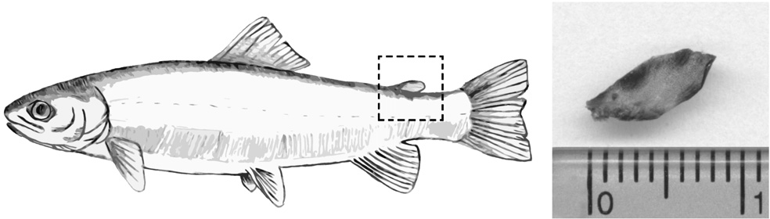
ENVIRONMENTAL BIOTECHNOLOGY 3 (1) 2007, 20-24
CYP1A gene expression in adipose fin of rainbow trout (Oncorhynchus mykiss Walbaum) exposed to benzo[a]pyrene
Paweł Brzuzan1, Maciej Woźny1, Michał K. Łuczyński2, Maciej Góra3
1 Department of Environmental Biotechnology, University of Warmia and Mazury in Olsztyn, ul. S∏oneczna 45G, 10-712 Olsztyn, Poland, e-mail: brzuzan@uwm.edu.pl, phone: +48 89 5234187
2 Department of Chemistry, University of Warmia and Mazury in Olsztyn, pl. ¸ódzki 4, 10-957 Olsztyn, Poland
3 Department of Organic Chemistry, Jagiellonian University, ul. Ingardena 3, 30-060 Kraków, Poland Key words: adipose fin, benzo[a]pyrene, CYP1A mRNA, gill, rainbow trout, Real-Time PCR
ABSTRACT
-PCR). The results of the study demonstrated that constitutive CYP1A mRNA was present in adipose fin of rainbow trout, but the transcripts were far less abundant than those in gill tissue. We confirmed high CYP1A gene induction potential of the gills in rainbow trout injected with benzo[a]pyrene, but also sho- wed moderately and transiently induced CYP1A mRNA in adipose fin. The modest and transitory gene expression may preclude rainbow trout adipose fin CYP1A mRNA levels from using it as an indicator of sustained exposure of fish to the polycyclic aromatic compounds.
Proximate to the environment, adipose fin of fish may be con- sidered as a lipid storing tissue, and thus can be a target for either waterborne or dietary polycyclic aromatic compounds (PACs). We determined the effects of benzo[a]pyrene (B[a]P), a model PAC member, on CYP1A gene expression in adipose fin and compared that with the effects in gill of juvenile rain- bow trout (Oncorhynchus mykiss Walbaum) using the quanti- tative reverse transcription polymerase chain reaction (Q-RT-
INTRODUCTION
if so, might the molecular responses be indicative of the exposure and effect. Among a number of enzyme systems that may be contributing to the biotransformation of PAC chemicals, the most important is that of cytochrome P450 (Ioannides 2007).
The small, non-rayed adipose fin is present in eight extant orders of fishes, including Salmoniformes (Nelson 1994), but neither functional significance of the trait is known, nor physiology of the tissue forming the fin is understood. Recent evidence suggests a hydrodynamic function of the adipose fin in juvenile salmonids (Reimchen and Temple 2004), and observations of sexually dimorphic adipose fin expression and female preference for the trait indicate a role in reproduction by mature individuals (Helfman et al. 1997; Næsje et al. 1988).
On the other hand, in an increasingly chemical environment, the adipose fin (Figure 1) might serve as a site of molecular biomarkers for certain classes of organic compounds. The pro- ximate to the environment adipose fin may be considered as a lipid storing tissue, and therefore can easily be a target for either waterborne or dietary polycyclic aromatic compounds (PACs). It is known that in other tissues which directly contact the contaminated environment, such as the gill and intestine, highly lipophilic PACs traverse rapidly lipoid barriers (Van Veld et al. 1988). Furthermore, a number of enzyme systems exist that allow the tissues to eliminate these chemicals, thus preventing them from accumulating with detrimental consequences to the organism (Ioannindes 2007). In the present study, we were interested whether the biotransformation systems present in other tissues occur also in adipose fin, and
Figure 1. Adipose fin shown on rainbow trout illustration (left) and a photograph of a representative fin sampled in this study (right).
The PAC-dependent P4501A (CYP1A) gene expression (mRNA) primarily studied in fish liver as a biomarker to identify exposure to a number of PACs (Stegeman et al. 1992; Van der Oost et al. 2003), has also been measured in a number of other tissues including brain (Huang et al. 2000), pituitary (Andersson et al. 1993), intestine (Van Veld et al. 1988), gills (Levine and Oris 1999), heart (Andreasen et al. 2002), head kidney (Brzuzan et al. 2006), or eye (Wang et al. 2006).

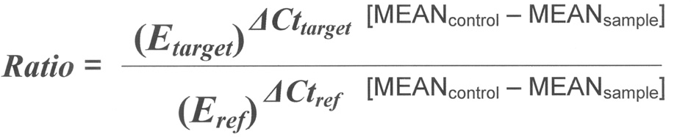
CYP1A expression in adipose fin of rainbow trout 21
ribosomal protein L19 (RPL19-F: 5’-GTC ACG GTG CAC TCT CGC GC-3’; RPL19-R: 5’-CGG GCA TTG GCT GTA
CCC TT-3’) was chosen because it was found to be expressed at a range closer to the Ct (threshold cycle) of the target gene than β-actin. In similar Ct range, reference and target undergo similar cycle condition with respect to the reaction product inhibition (Kainz 2000).
Real-Time PCR assays were performed in MicroAmp™ optical tubes (Applied Biosystems; Foster City, CA) using the ABI 7500 Real-Time PCR system (Applied Biosystems). All samples were analyzed in duplicate in the singleplex mode (1 pair of primers per well). On the plate, negative water controls and genomic DNA control were included to rule out the possibility of PCR amplification resulting from upstream contamination. Each sample reaction mixture contained 10 µl of 2x FastStart SYBR® Green Master ROX mix (Roche Diagnostics; Mannheim, Germany), 5 pmol of forward and reverse primer, 2 µl of cDNA as a template, and PCR-grade water adjusted to a final volume of 20 µl. The reaction was performed in standard thermal conditions: 50°C for 2 min, 95°C for 10 min, then 40 cycles of 95°C for 15 s and 60°C for 1 min. To test for the quality of the PCR products, a melting curve analysis was performed after each run. Additionally, specificity of all PCR products was documented by electro- phoresis in standard 2% gels each containing 40 ng of ethidium bromide per 100 ml of an agarose gel, and visualization under UV light (Gel Logic 200 Imaging System, Kodak).
The relative expression ratio of CYP1A was computed, based on single individual real time PCR efficiency (E), and the threshold cycle Ct difference (Δ) of an unknown sample versus a control (ΔCtcontrol – sample) according to the mathe-
matical model given by Pfaffl (2001):
Brzuzan et al.
Studies in some species including salmonids indicate also that CYP1A enzyme activities are induced in olfactory organs of fish exposed to PACs (Chung-Davidson et al. 2004), thus serving the first protection line in the brain for the xeno- biotics. Once determined and confirmed, high level of CYP1A gene induction in adipose fin of fish exposed to polycyclic aromatic compounds could indicate its role in biomonitoring studies of dietary and environmental contamination with PACs.
Therefore, in the present study we determined the effects of benzo[a]pyrene (B[a]P), a model PAC member, on CYP1A gene expression in adipose fin and compared that with the effects in gill of juvenile rainbow trout (Oncorhynchus mykiss Walbaum) using the quantitative reverse transcription poly- merase chain reaction (Q-RT-PCR).
MATERIAL AND METHODS
A group of hatchery raised rainbow trout, with an average body mass of 49.4 g and total length of 15.5 cm were given an intraperitoneal injection (10 mg•kg-1) of B[a]P in corn oil (2 mg B[a]P•ml-1 corn oil) or corn oil alone (Control). After
8 and 24 h (T = 7°C), trout gills and adipose fins (n =
4)
were immediately stored in RNA stabilizing buffer (RNA Later™, Qiagen, Hilden, Germany) at -20°C. The fish were treated in accordance with the rules approved by the Local Ethical Commission No. 38/N issued on 29.07.2004 (conforming to principles of Laboratory Animal Care, NIH publication No. 86-23, revised in 1985).
Total RNA isolation, quantification and storage were descri- bed recently (Brzuzan et al. 2007), except that RNALater™ preserved whole adipose fins (13.0 ± 1.0 mg) or small pieces of gills (15.0 ± 2.0 mg) were used. The total RNA was used to synthesize cDNA with a commercially available RevertAid™ First Strand cDNA Synthesis Kit (Fermentas; Burlington, Canada). Mixture of each sample contained 1 µg of total RNA
and 0.5 µg of oligo(dT)18 primers, and the reaction was perfor- med according to the manufacturer’s recommendations. cDNA samples were stored at -20°C until used.
We examined CYP1A mRNA levels in either adipose fin or gill tissue of control and exposed rainbow trout using relative quantification method implemented in Relative Expression Software Tool (REST©, version 2; Pfaffl et al. 2002), based on the data obtained from the Real-Time PCR assay. Real-Time PCR primers for CYP1A (forward WML158 5’-CCA ACT TAC CTC TGC TGG AAG C-3’ and reverse WML159
5’-GGT GAA CGG CAG GAA GGA-3‘) were taken from the paper of Rees and Li (2004). To avoid misinterpretation of the derived expression profiles of the target gene two combined endogenous controls were used to normalize the results in either tissue. The primers used for amplification of β-actin were ENDO1F (5’-GTG GCG CTG GAC TTT GAG CA-3’) and ENDO1R (5’- ACC GAG GAA GGA GGG CTG GA-3’),
previously designed for whitefish cDNA (Brzuzan et al. 2005). The other reference gene, rpl19, encoding rainbow trout
Before using the above method for quantification, we performed a validation experiment to verify that efficiencies of target (CYP1A) and either reference gene, β-actin or rpl19 (endogenous controls) are approximately equal. We performed dilution series of different input amounts (1, 0.1, 0.01, and
0.001 per tube; n = 3) of cDNA (reverse transcribed total RNA) extracts of either adipose fin or gill, and spiked into separate tubes. The PCR reactions on serially diluted cDNA templates were monitored in real time by fluorescence with the incorporation of the dye, SYBR® Green. Ct versus cDNA were plotted to calculate respective slope values (data not shown). The corresponding real-time efficiencies were calculated according to the equation: E=10[-1/slope] (Pfaffl 2001). The resulting E-values were high (from 1.95 to 1.99) and were the basis for the calculation and further randomization tests with REST© (Pfaffl et al. 2002).
Differences in CYP1A expression between control and B[a]P treated samples were assessed in group means for statistical
22
ENVIRONMENTAL BIOTECHNOLOGY 3 (1) 2007
significance by randomization tests (REST©). Randomization tests are a useful alternative to more standard parametric tests for analyzing experimental data. A statistical test is based on the probability of an effect as large as that observed occurring under the null hypothesis of no treatment effect. It is assumed that if the hypothesis is true, the values in one treatment group were just likely to have occurred in the other group. The randomization test repeatedly and randomly reallocates the observed values to the two groups and notes the effect each time. The proportion of the effects that are as great as that observed in the experiment gives the P-value of the test (Pfaffl et al. 2002). In the study for each particular data set 2000 randomizations were performed.
Real time PCR results for CYP1A gene for two examined tissues, time points and treatments are given in Figure 2. The data were presented as the mean CYP1A expression ratio (ER) for each sample, normalized by expression of either,
β-actin or rpl19, or both. B[a]P exposure for 8 h caused 2-4 fold increase of expression ratio (ER) of CYP1A mRNA levels in either tissue (adipose fin, ER = 2.84 ± 1.85;
P =
0.067; gill, ER = 2.79 ± 2.09; P =
0.250). After 24 h
of the treatment, only CYP1A gene in gill was significantly induced by B[a]P (ER = 14.12 ± 12.25; P = 0.001), whereas the CYP1A mRNA in adipose fin decreased to control levels (ER = 1.46 ± 0.79; P = 0.596).
The results of this study demonstrate that constitutive CYP1A mRNA was present in adipose fin of rainbow trout, but the transcripts were far less abundant than those in gill tissue. Furthermore, the CYP1A gene in adipose fin was moderately induced by B[a]P after 8 h of the treatment, at a rate comparable to that in gill (~2-4 fold increase, depending on the reference gene expression used for normalization; Figure 2). We expected this because B[a]P is known to be distri- buted rapidly within the body (Moir et al. 1998) and its meta- bolites can readily penetrate cell membranes (Brown and Chee 1992). However, whereas gill CYP1A increased signi- ficantly (~14 fold) after 24 h of the experiment, CYP1A mRNA levels in adipose fin did not. Therefore, it is very likely that accumulation of adipose fin (and gill) CYP1A mRNAs during the first 8 hours of exposure appeared primarily as a result of de novo synthesis, through an intracellular receptor complex (the aryl hydrocarbon receptor, AhR; Hahn et al. 2005), rather than from CYP1A mRNA stabilization or from decreased CYP1A mRNA degradation rates. The cause for the decrease of rainbow trout CYP1A mRNA in adipose fin
RESULTS AND DISCUSSION
At similar efficiencies of PCR amplification of every two genes compared, without normalizing by another reference gene, the lower value of the mean Ct represents higher mRNA ex- pression. As shown in Table 1, variations of sample mean Cts for investigated transcripts remained stable, with a CV ranging from 0.85 to 6.06%. For either tissue analyzed, single individual constitutive mRNA expression of β-actin or rpl19, measured in control samples, were not significantly different between the studied time points of the experiment (REST©, P > 0.05). Furthermore, the reference genes showed no changes in their mRNA levels as a result of treatment with B[a]P. The constitutive levels of CYP1A mRNA, as measured in control fish, were significantly lower in adipose fin compared to those in gill at either 8 or 24 h of the experiment (REST©; P = 0.003, P = 0.046, respectively).
Table 1. Variation in the number of threshold cycles (Cts) for β-actin, rpl19 and CYP1A determined in adipose fin and gill of rainbow trout by real time PCR. Given are the mean, standard error (S.E.), coefficient of variation (CV), each one based on n = 4 for controls and B[a]P-treated fish for 8 and 24 h.
Adipose fin
Gill
Treatment/hour
β-actin
rpl19
CYP1A
β-actin
rpl19
CYP1A
Control/8
mean S.E.
CV (%)
15.67
0.31
1.97
16.82
0.43
2.57
24.31
0.61
2.51
14.15
0.52
3.64
17.53
0.42
2.37
20.84
0.50
2.42
B[a]P/8
mean S.E.
CV (%)
15.15
0.37
2.42
17.54
0.24
1.38
22.84
0.59
2.58
13.10
0.35
2.67
16.93
0.42
2.49
18.53
0.75
4.02
Control/24
mean S.E.
CV (%)
14.98
0.33
2.19
17.08
0.28
1.64
23.22
0.22
0.94
13.17
0.21
1.57
16.68
0.17
1.03
21.34
0.30
1.41
B[a]P/24
mean S.E.
CV (%)
14.41
0.13
0.89
16.61
0.14
0.85
22.40
0.68
3.03
13.43
0.55
4.12
16.69
0.55
3.29
17.65
1.07
6.06

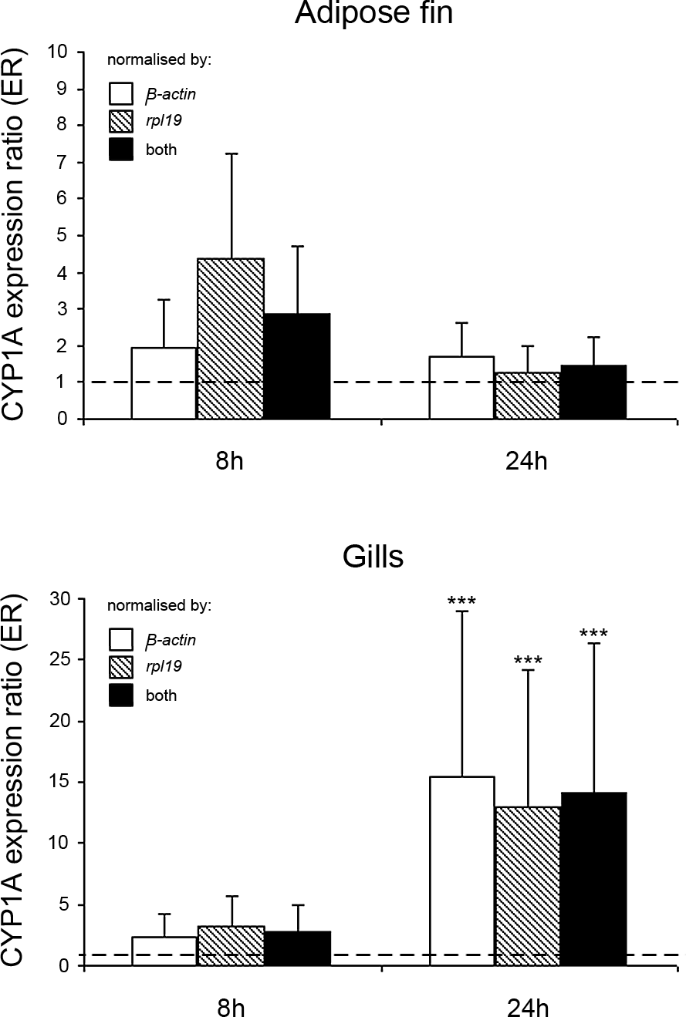
CYP1A expression in adipose fin of rainbow trout 23
waterborne B[a]P concentrations of 0.78 ± 0.11 µg/l had gill CYP1A mRNA levels significantly induced after 6 h of expo- sure and the tissue remained at this high level of induction through 120 h. Interestingly, the apparently different routes of B[a]P exposure, i.e. intraperitoneal, (this study) or water- borne (Levine and Oris 1999), produced similar effects on CYP1A mRNA levels in rainbow trout gill within the compa- rable exposure period.
In summary, our results not only confirmed high CYP1A gene induction potential of the gills in rainbow trout injected with benzo[a]pyrene, but also showed moderately induced CYP1A mRNA in adipose fin. The observed CYP1A mRNA levels in adipose fin of rainbow trout may be used as a sur- rogate for CYP1A enzyme abundance in the tissue, and thus may add to results of previous investigations that have shown that tissues other than the liver, contain active CYP1A enzyme systems that can modify the absorption, toxicity and fate of CYP1A substrates (Andersson and Pratt 1989; Kennedy and Walsh 1994; Miller et al. 1989; Ueng et al. 1992; Van Veld et al. 1997; Wang et al. 2006). Unfortunately, the transitory CYP1A gene induction, decreasing through the 24 h of ex- posure, may preclude from using rainbow trout adipose fin CYP1A mRNA levels as an indicator of sustained exposure to polycyclic aromatic compounds.
Brzuzan et al.
ACKNOWLEDGEMENTS
We thank Dr. Henryk Kuêmiƒski and Dr. Stefan Dobosz from the Department of the Salmonid Research in Rutki, Inland Fisheries Institute in Olsztyn, Poland, for their excellent technical assistance during hatchery operations. This work was supported by the Polish Committee for Scientific Research, Project No. 2 P06D 001 29.
Figure 2. Expression pattern of CYP1A mRNA levels in adipose fin and gill of B[a]P-treated rainbow trout at 8 and 24 h of the experiment. Bars represent mean values of expression ratios (ER) with their respective standard errors of the mean (S.E.; n = 4), normalized by different endogenous references: β-actin, rpl19 or combined (both) and relative to a control sample (ER = 1.00; dashed line) of a respective tissue and time of the experiment. The ER values were calculated by REST© from Table 1. Tripple asterisk indicates significant difference (P = 0.001) between gill CYP1A expression of control and that of B[a]P-treated rainbow trout after 24 h of the study.
REFERENCES
Andersson, T., P. Pratt. 1989. Benzo[a]pyrene metabolism in isolated perfused rainbow trout gills. Marine Environment Research 28: 3–7.
Andersson, T., L. Förlin, S. Olsen, A. Fostier, B. Breton. 1993. Pituitary as a target organ for toxic effects of P4501A1 inducing chemicals. Molecular and Cellular Endocrinology 91: 99–105.
Andreasen, E.A., J.M. Spitsbergen, R.L. Tanguay, J.J. Stegeman,
W. Heideman, R.E. Peterson. 2002. Tissue-specific expression of AHR2, ARNT2, and CYP1A in zebrafish embryos and larvae: effects of developmental stage and 2,3,7,8-tetrachlorodibenzo-p-dioxin exposure. Toxicological Sciences 68: 403–419.
Brown, S., C.T.Y. Chee. 1992. Benzopyrene metabolism and transport by cells in culture. Biochemical Society Transactions 20: 279S.
Brzuzan, P., ¸. Jurczyk, M.K. ¸uczyƒski, M. Góra. 2005. Relative quantification of CYP1A gene expression in whitefish (Coregonus lavaretus) exposed to benzo[a]pyrene. Environmental Biotechno- logy 1: 11-15.
Brzuzan, P., M. Góra, M.K. ¸uczyƒski, ¸. Jurczyk, H. Kuêmiƒski,
W. Nitek, M. Woêny. 2006. Molecular geometry, CYP1A gene induction and clastogenic activity of cyclopenta[c]phenanthrene in rainbow trout. Polycyclic Aromatic Compounds 26: 345–365.
to a basal level between the 8 and 24 h of exposure remains unknown. We hypothesize that the decrease in CYP1A mRNA level in adipose fin may be in part due to an increased rate of CYP1A-catalyzed first-pass metabolism of parent B[a]P by the liver, and possibly other biotransformation systems, that lowered concentration of parent B[a]P reaching the adipose tissue. Further studies may determine if the observed decrease can occur due to either increased breakdown of CYP1A mRNA molecules, rapid saturation of Ah receptors present in the tissue, or increased rate of B[a]P metabolism.
With regard to the CYP1A expression in gill tissue of rainbow trout, the results of the present experiment almost replicated previously reported data by Levine and Oris (1999). The authors have shown that rainbow trout exposed to
24
ENVIRONMENTAL BIOTECHNOLOGY 3 (1) 2007
Brzuzan, P., M. Woêny, S. Dobosz, H. Kuêmiƒski, M.K. ¸uczyƒski,
M. Góra. 2007. Blue sac disease in larval whitefish (Coregonus lavaretus): pathological changes in mRNA levels of CYP1A, ERa, and p53. Journal of Fish Diseases 30: 169–173.
Chung-Davidson, Y.-W, C.B. Rees, H. Wu, S.S. Yun, W. Li. 2004.
β-naphthoflavone induction of CYP1A in brain of juvenile lake trout (Salvelinus namaycush Walbaum). Journal of Experimental Biology 207: 1533–1542.
Hahn, M.E., R.R. Merson, S.I. Karchner. 2005. Xenobiotic receptors in fish: Structural and functional diversity and evolutionary insi- ghts. In: Biochemical and Molecular Biology of Fishes (ed.
T.W. Moon, T.P. Mommsen). Environmental Toxicology, volume 6, pp. 191-228. Elsevier, New York.
Helfman, G.S., B.B. Collette, D.E. Facey. 1997. The Diversity of Fishes. 544 p. Blackwell, Science Inc., Cambridge, Mass.
Huang, P., A. Rannug, E. Ahlbom, H. Hakansson, S. Ceccatelli. 2000. Effect of 2,3,7,8-tetrachlorodibenzo-p-dioxin on the expression of cytochrome P4501A1, the aryl hydrocarbon receptor and the aryl hydrocarbon receptor nuclear translocator in rat brain and pituitary. Toxicology and Applied Pharmacology 169: 159–167.
Ioannides, C. 2007. Bioactivation of chemicals by cytochromes P450. Environmental Biotechnology 3: 1–9.
Kainz, P. 2000. The PCR plateau phase – towards an understanding of its limitations. Biochimica et Biophysica Acta 1494: 23–27.
Kennedy, C.J., P.J. Walsh. 1994. The effects of temperature on the uptake and metabolism of benzo[a]pyrene in isolated gill cells of the gulf toadfish (Opsanus beta). Fish Physiology and Bio- chemistry 13: 93–103.
Levine, S.L., J.T. Oris. 1999. CYP1A expression in liver and gill of rainbow trout following waterborne exposure: implications for biomarker determination. Aquatic Toxicology 46: 279–287.
Miller, M.R., D.E. Hinton, J.J. Stegeman. 1989. Cytochrome P-450E induction and localization in gill pillar (endothelial) cells of scup and rainbow trout. Aquatic Toxicology 14: 307–322.
Moir, D., A. Viau, I. Chu, J. Withey, E. McMullen. 1998. Pharmaco- kinetics of benzo[a]pyrene in the rat. Journal of Toxicology and Environment Health 53: 507–530.
Næsje, T.F., L.P. Hansen, T. Järvi. 1988. Sexual dimorphism in the adipose fin of Atlantic salmon, Salmo salar L. Journal of Fish Biology 33: 955–956.
Nelson, J.S. 1994. Fishes of the World. 624 p. John Wiley & Sons, Inc., New York.
NIH. 1985. Guide for the care and use of laboratory animals. National Institute of Health, Public Health Service. NIH publication No. 86-23. Bethesda.
Pfaffl, M.W. 2001. A new mathematical model for relative quantification in real-time RT-PCR. Nucleic Acid Research 29: 2002-2007.
Pfaffl, M.W., G.W. Horgan, L. Dempfle. 2002. Relative expression software tool (REST©) for group-wise comparison and statistical analysis of relative expression results in real-time PCR. Nucleic Acid Research 30: e36.
Rees, C.B., W. Li. 2004. Development and application of a real-time quantitative PCR assay for determining CYP1A transcripts in three genera of salmonids. Aquatic Toxicology 66: 357–368.
Reimchen, T.E., N.F. Temple. 2004. Hydrodynamic and phylogenetic aspects of the adipose fin in fishes. Canadian Journal of Zoology 82: 910–916.
Stegeman, J.J., M. Brouwer, R.T. Di Giulio, L. Forlin, B.A. Fowler,
B.M. Sanders, P.A. Jr. Van Veld. 1992. Molecular responses to environmental contamination: enzyme and protein systems as indicators of chemical exposure and effect. In: Biomarkers: Biochemical Physiological and Histopathological Markers of Anthropogenic Stress (ed. R.J. Hugget, R.A. Kimerle, P.M.Jr. Mehrle, H.L. Bergman), pp. 235–251. Lewis Publishers, Chel- sea, MI.
Ueng, T.H., Y.F. Ueng, S.S. Park. 1992. Comparative induction of cytochrome P-450-dependent monooxygenases in the livers and gills of tilapia and carp. Aquatic Toxicology 23: 49–64.
Van der Oost, R., J. Beyer, N.P.E. Vermeulen. 2003. Fish bioaccumu- lation and biomarkers in environmental risk assessment: a review. Environmental Toxicology and Pharmacology 13: 57–149.
Van Veld, P.A., J.J. Stegeman, B.R. Woodin, J.S. Patton, R.F. Lee. 1988. Induction of monooxygenase activity in the intestine of spot (Leiostomus xanthurus), a marine teleost, by dietary polycyclic aromatic hydrocarbons. Drug Metabolism and Disposition 16: 659–665.
Van Veld, P.A., W.K. Vogelbein, M.K. Cochran, A. Goksøyr, J.J. Ste- geman. 1997. Route-specific cellular expression of cytochrome P4501A (CYP1A) in fish (Fundulus heteroclitus) following exposure to aqueous and dietary benzo[a]pyrene. Toxicology and Applied Pharmacology 142: 348–359.
Wang, L., B.E. Scheffler, K.L. Willett. 2006. CYP1C1 messenger RNA expression is inducible by benzo[a]pyrene in Fundulus heteroclitus embryos and adults. Toxicological Sciences 93: 331–340.

