

www.czasopisma.pan.pl
ACTA BIOLOGICA CRACOVIENSIA Series Botanica 52/2: 103-107,
DOI: 10.2478/v10182-010-0031-7
www.journals.pan.pl
POLSKA AKADEMIA :

Threshold Change in Expression of GFP-FABD2 Fusion
Protein During Development of Arabidopsis thaliana Leaves

Justyna Labuz, Weronika Krzeszowiec, and Halina Gabrys
Department of Plant Biotechnology, Jagiellonian University,
Gronostajowa 7, 30-387 Cracow, Poland
Received October 20, 2010; revision accepted December 23, 2010
One of the most important technical challenges in cell biology is visualization of the actin cytoskeleton. The wide-
ly used GFP-FABD2 fusion protein is a helpful tool for investigating actin architecture in living plants. Here we
report our attempt to visualize F-actin in mature leaves of transgenic Arabidopsis thaliana. With a confocal
microscope we observed loss of GFP fluorescence in mature Arabidopsis leaves between 19 and 21 days of devel-
opment. As this pattern was characteristic of all investigated plants and dependent on the age of the plants, we
performed precise expression studies at the mRNA (semiquantitative PCR) and protein (Western blot) levels. Our
results clearly show a sudden decrease of GFP-FABD2 expression in Arabidopsis leaves after the third week of
growth. This means that transgenic Arabidopsis bearing the GFP-FABD2 construct is not a good model system
for visualization of the actin cytoskeleton in leaves of mature plants.
Key words: Actin, Arabidopsis thaliana, gene silencing, GFP-FABD2, mature leaves.

INTRODUCTION
Visualization of actin cytoskeleton architecture in
plant cells presents a challenge. Actin filaments may
be labeled with phalloidin conjugated to a fluores-
cent marker (Krzeszowiec et al., 2007), or immuno-
cytochemically with antibodies against actin and flu-
orescence-labeled secondary antibodies (van Gestel
et al., 2001). The main drawback of these methods
is that they require cell fixation. The unique features
of green fluorescent protein (GFP) enable imaging of
cells in vivo. Since efforts to visualize actin conju-
gated to GFP have remained unsuccessful, an indi-
rect method using fusion constructs bearing GFP
and actin-binding proteins has been developed.
Among them, the GFP-FABD2 fusion protein derived
from the C-terminal part of Arabidopsis FIMBRIN1
(Sheanan et al., 2004; Wang et al., 2004; Voigt et al.,
2005) is considered one of the best systems. It
enables visualization of very detailed F-actin struc-
tures in practically all cell types of Arabidopsis
seedlings (Voigt et al., 2005). Stably transformed
Arabidopsis does not show phenotypic changes, nor
any alteration of phototropic and gravitropic
responses (Voigt et al., 2005), unlike GFP mouse
talin construct GFP-mTn, which perturbs the diffuse
growth of cells (Sheanan et al., 2004). The GFP-mTn
system also shows diffuse labeling of the nucleo-
plasm, a phenomenon not observed in plants
expressing GFP-FABD2 (Sheanan et al., 2004).
Along with some positive features, the GFP-FABD2
system also has some drawbacks. Actin networks
observed in the pollen tubes of Nicotiana tabacum
transformed with GFP-FABD2 are differently visual-
ized in fixed cells (Wilsen et al., 2006). Moreover, the
presence of this fusion protein reduces cytoplasmic
streaming (Holweg, 2006). Finally, we can report
here that Arabidopsis stably transformed with GFP-
FABD2 shows rapid loss of fluorescence during the
growth and maturation of leaves.

MATERIALS AND METHODS
PLANT GROWTH CONDITIONS
Arabidopsis thaliana wild-type Columbia was
acquired from Lehle seeds (Round Rock, TX,
U.S.A.). The seeds of Arabidopsis transformed with
a GFP-FABD2 construct were given us by Dr. Boris
Voigt (Bonn, Germany). Arabidopsis thaliana plants
were vernalized for 2 days after sowing and grown in
commercial soil in an environmental chamber
(Sanyo MLR 350H, Japan) at 23°C and constant 85%
humidity, with a 10 h photoperiod. Illumination was
e-mail: halina.gabrys@uj.edu.pl
PL ISSN 0001-5296
© Polish Academy of Sciences and Jagiellonian University, Cracow 2010
104
www.czasopisma.pan.pl
PAN
POLSKA AKADEMIA N/
www.joumals.pan.pl
provided by fluorescent lamps (Sanyo, FL40SS.W/37;
light intensity 70-100 pmol m-2 s-1).
SEMIQUANTITATIVE PCR
Total RNA was isolated from leaves using Trizol
reagent (Invitrogen, U.S.A.) according to the manu-
facturer's protocol. First-strand cDNA synthesis was
performed using a Revertaid™ First Strand cDNA
Synthesis Kit (Fermentas UAB, Lithuania) with ran-
dom hexamer primers. A QuantumRNA™ 18S RNA
Kit (Ambion Europe Ltd, UK) was used as internal
standard (18S primer : competimer ratio 3:7) in
simultaneous PCR amplification with 25 cycles. For
amplification of the GFP-FABD2 construct the
primers used were forward 5'CCCGGGATG
GTAAAGGAGAAGAACTTTTCACTGGAGTT3' and
reverse 5'GCTTGCAGTTCATTCTCTCTGC3'. For
amplification of Arabidopsis FIMBRIN1 the primers
were forward 5'ATGTCTGGGTACGTGGGTGT3'
and reverse 5'ATCCTTTGCATCTAGTGTAGCCG3'.
WESTERN BLOT ANALYSIS
Leaves were lyophilized overnight, homogenized in
liquid nitrogen, suspended in denaturing Laemmli
buffer and incubated 10 min at 100°C. Samples
were separated by SDS-PAGE on 10% gel and trans-
ferred to a PVDF membrane. Detection was per-
formed using an anti-GFP primary antibody (Living
Colors GFP Monoclonal Antibody, Clontech, no.
632375, Canada), followed by secondary antimouse
antibody conjugated with alkaline phosphatase
(Sigma, No. A3562, U.S.A.).
CONFOCAL MICROSCOPY
GFP fluorescence was tested every 3 days starting
from the seventh day of growth up to the end of the
third week. Seedlings were gently infiltrated with
distilled water in a plastic syringe at room tempera-
ture. Images, taken with a BioRad MRC 1024 confo-
cal microscope (BioRad, Hercules, CA, U.S.A.), were
collected using a 60x (NA 1.4) PlanApo oil-immer-
sion objective mounted on a Nikon microscope. The
excitation wavelength was 488 nm (blue light) emit-
ted by a 100 mW argon-ion air-cooled laser (ITL,
U.S.A.) used at 10-30% maximum power for imag-
ing. GFP fluorescence was collected in the green
channel with a 540 DF30 filter, and chloroplast aut-
ofluorescence in the red channel with a 585LP filter.

RESULTS
GFP fluorescence was monitored starting from the
first week of plant growth up to the end of the third
week, that is, until complete decay of fluorescence.
Distinct bundles of actin were seen in the epidermis
and mesophyll cells of 11-day-old Arabidopsis
leaves (Fig. 1a,b). Particularly strong fluorescence
was observed in guard cells (Fig. 1a). Fluorescence
diminished during plant growth and maturation.
Only the cytoskeleton of guard cells remained
labeled in 20-day-old leaves (Fig. 1c), but fluores-
cence in these cells dimmed. We emphasize that in
our growth conditions and photoperiod these plants
were still very immature, at a very early stage of
development. At the end of the fourth week no actin
network could be observed; only the inner part of
the guard cells showed weak and diffuse fluores-
cence unrelated to GFP (Fig. 1d).
Semiquantitative PCR with a low cycle number
was performed to determine the expression profile
of the GFP-FABD2 construct in transgenic
Arabidopsis thaliana plants. The primers were
designed to anneal to the 5' end of GFP and the 5'
end of the FABD2 domain. The results (Fig. 2) clear-
ly show that the amount of GFP-FABD2 transcript
rapidly decreased to a very low level after the third
week of growth, as maturation of the Arabidopsis
leaves proceeded. This expression pattern was
matched at the protein level (Fig. 3). On Western
blots, sudden loss of the GFP-FABD2 fusion protein
(the band corresponding to ~72 kDa of the protein
marker) was observed after the third week.
Interestingly, the decrease of the GFP-FABD2 tran-
script coincided with a decline in the mRNA level of
natural FIMBRIN1 in transgenic Arabidopsis leaves
(Fig. 4), but this effect was not observed in wild-type
plants (Fig. 5). To amplify the natural FIMBRIN1
from Arabidopsis, the primers had been designed to
anneal to the 5' end of the gene in order to avoid any
amplification of the GFP-FABD2 construct.

DISCUSSION
Stable expression of the GFP-FABD2 construct in
Arabidopsis has been widely described, but all stud-
ies have focused on root tissues and seedlings at
very early stages of development. Images of tri-
chomes, leaf epidermis and stomata come from
young plants 4-7 days old (Sheanan et al., 2004;
Voigt et al., 2005), and no data from mature leaves
are available. Our results make it plain that GFP-
FABD2 expression rapidly decreases in Arabidopsis
thaliana after the third week of growth. The loss of
GFP fluorescence observed with a confocal micro-
scope and the decrease in the amount of fusion pro-
tein were due mainly to reduction of the mRNA level.
It is unlikely that GFP-FABD2 transcription can
be regulated by modulating the activity of the 35S pro-
moter, as the latter is a constitutive promoter (Odell
et al., 1985). Reports show that the 35S promoter is
more active in young leaves of tobacco (Williamson et

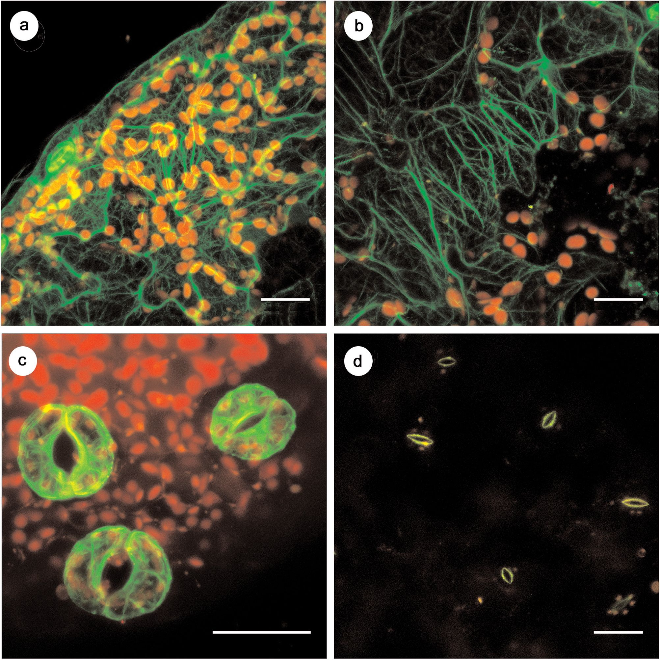
- www.czasopisma.pan.pl
Change in expression
www.journals.pan.pl
D2 in Arabidopsis leaves
105
POLSKA AKADEMIA
Fig. 1. Actin network in transgenic Arabidopsis thaliana bearing GFP-FABD2 construct. (a) Epidermis of young leaf.
Guard cells, strong labeling seen at left, day 11 of growth, (b) Leaf mesophyll, day 11, (c) Guard cells, no labeling of the
epidermis is observed, day 20, (d) Guard cells, only faint fluorescence visible in inner part, day 27. Bar = 26 pm.
al., 1989) than in old ones, as its expression is S-
phase-specific (Nagata et al., 1987). Three-week-old
Arabidopsis leaves are still developing and actively
growing. A more recent study on transgenic cotton
transformed with GFP under the 35S promoter
demonstrates good GFP fluorescence in leaf meso-
phyll (Sunilkumar et al., 2002). All these data point to
RNA silencing as a probable explanation of the effect
observed in Arabidopsis thaliana.
Cosuppression of an endogenous gene by a
transgene has been reported in many plant species
(Napoli et al., 1990; de Carvalho et al., 1992; de
Borne et al., 1994). Truncated transgenes also trig-
ger this phenomenon (Smith et al., 1990). Two find-
ings of
ours support transgene-induced gene silencing in
GFP-FABD2-expressing Arabidopsis. First, loss of
natural FIMBRIN1 transcript was observed along
with the decrease in GFP-FABD2 mRNA. Second, the
mRNA level of FIMBRIN1 remained unchanged in
wild-type plants. Rapid loss of the transgene mRNA
at some stage of development, with subsequent reset
after meiosis, has also been reported in transgenic
tobacco (de Borne et al., 1994; Balandin and
Castresana, 1997) and Arabidopsis (Scheid et al.,
1991; de Carvalho et al., 1992; Dehio and Schell,
1994; our observations). A similar pattern of gene
silencing, with guard cells unaffected, was shown for
tobacco leaves transformed with GFP (Voinnet et al.,
1998), and was attributed to the lack of symplastic
connections of these cells via plasmodesmata (Wille
and Lucas, 1984). Very efficient silencing has been
attributed to 35S promotor with a double enhancer
(Elmayan and Vaucheret, 1996; Que et al., 1997), the
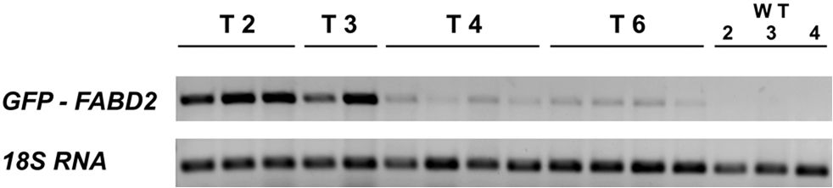
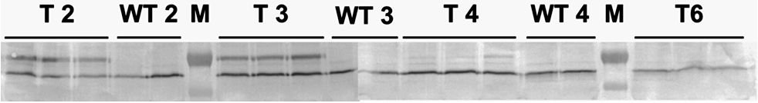
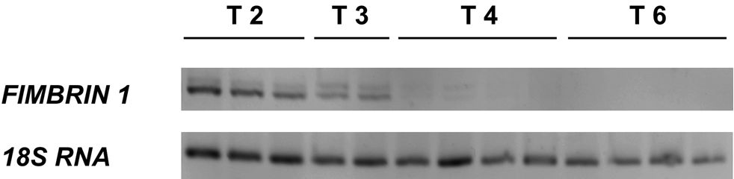
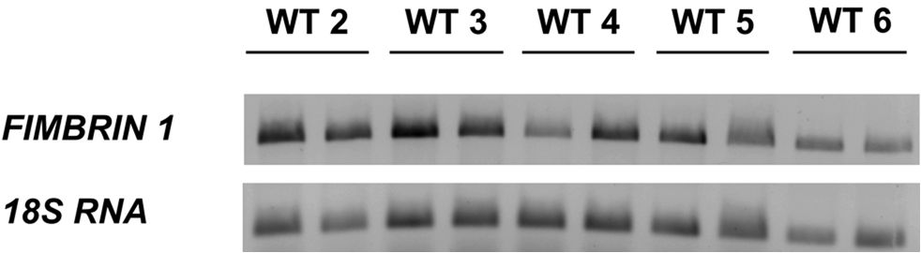
106
www.czasopisma.pan.pl
PAN
POLSKA AKADEMIA N/
www.joumals.pan.pl
Fig. 2. Expression of GFP-FABD2 construct at mRNA level
in transgenic Arabidopsis thaliana (T) and control
Arabidopsis plants (wild-type, WT): 2, 3, 4, 6 - weeks of
growth. 1% agarose gel stained with ethidium bromide.
Fig. 3. Expression of GFP-FABD2 construct at protein
level (Western blot) in transgenic (T) and control (wild-
type, WT) Arabidopsis thaliana: 2, 3, 4, 6 - weeks of
growth; M - Page Ruler prestained protein ladder
(Fermentas UAB, Lithuania), upper band corresponds to
72 kDa, lower band to 55 kDa. Lower nonspecific band
corresponding to ~60 kDa given to show that equal
amounts of proteins were loaded per well onto the SDS-
PAGE gel.
Fig. 4. Expression of Arabidopsis FIMBRIN1 at mRNA
level in transgenic Arabidopsis thaliana (T): 2, 3, 4, 6 -
weeks of growth. 1% agarose gel stained with ethidium
bromide.
Fig. 5. Expression of Arabidopsis FIMBRIN1 at mRNA
level in Arabidopsis thaliana wild-type (WT) plants: 2, 3,
4, 5, 6 - weeks of growth. 1% agarose gel stained with
ethidium bromide.
DICER-LIKE 4, and subsequent sequence-specific
ARGONAUTEl-guided mRNA cleavage (reviewed by
Vaucheret, 2006). Although this is the most proba-
ble scenario, it is worth mentioning that transgene-
induced gene silencing of GFP under the 35S pro-
motor also has been reported (Schubert et al.,
2004), and different classes of siRNA have been
detected (Hamilton et al., 2002).
A less likely hypothesis is that the FABD2 part
of the construct is regulated via an endogenous
miRNA pathway. Using software developed by Adai
et al., 2005, (http://sundarlab.ucdavis.edu/mirna/)
we found out that the FABD domain of Arabidopsis
FIMBRIN1 has three putative miRNA target sites,
but none of the miRNA candidate molecules have
been discovered so far.
Interestingly, the loss of fluorescence during
maturation of FABD2-based GFP fusion proteins
appears to be a general characteristic. It was report-
ed to a lesser extent in Arabidopsis plants stably
transformed with GFP-ABD2-GFP and ABD2-GFP
constructs (Wang et al., 2008).
Our work shows that the GFP-FABD2 system
cannot serve as a model for investigation of the actin
cytoskeleton network in mature leaves of
Arabidopsis. Finding a universal system for F-actin
visualization remains a challenge.
ACKNOWLEDGEMENTS
We thank Dr. Boris Voigt (Institute of Cellular and
Molecular Botany IZMB, University of Bonn,
Germany) for kindly providing seeds of Arabidopsis
transformed with the GFP-FABD2 construct, and Dr.
Jerzy Dobrucki (Division of Cell Biophysics,
Jagiellonian University, Cracow) for the use of the
confocal microscope. This study was supported by
the Polish Ministry of Science and Higher Education
(PB 1395/B/P01/2007/33). The Faculty of
Biochemistry, Biophysics and Biotechnology of the
Jagiellonian University is a beneficiary of European
Union structural funds (grant no. POIG.02.01.00-12-
064/08, "Molecular biotechnology for health").
same as that used in the GFP-FABD2 construct
(Voigt et al., 2005). The resulting rise in expression
exceeds the putative threshold level beyond which
RNA is degraded (Que et al., 1997). This threshold
level depends on the nature of the coding region
(Schubert et al., 2004). The postulated mechanism
by which postranscriptional gene silencing trig-
gered by a sense transgene occurs consists of three
steps: conversion of single-stranded RNA to double-
stranded RNA by RNA-DEPENDENT RNA POLY-
MERASE6, cleavage of long dsRNA into siRNA by

REFERENCES
Adai A, Johnson C, Mlotshwa S, Archer-Evans S, Manocha V,
Vance V, and Sundaresan V. 2005. Computational pre-
diction of miRNAs in Arabidopsis thaliana. Genome
Research 15: 78-91; http://sundarlab.ucdavis.edu/mirna/.
Balandin T, and Castresana C. 1997. Silencing of a-1,3-glu-
canase transgene is overcome during seed formation.
Plant Molecular Biology 34: 125-137.
de Borne F D, Vincentz M, Chupeau Y, and Vaucheret H.
1994. Co-suppression of nitrate reductase host genes
and transgenes in transgenic tobacco plants. Molecular
Genetics and Genomics 243: 613-621.

- www.czasopisma.pan.pl
Change in expression
www.journals.pan.pl
D2 in Arabidopsis leaves

107
POLSKA AKADEMIA I
de Carvalho F, Gheysen G, Kushnir S, van Montagu M, Inze D,
and Castresana C. 1992. Suppression of 3-1,3-glucanase
transgene expression in homozygous plants. The EMBO
Journal 11: 2595-2602.
Dehio C, and Schell J. 1994. Identification of plant genetic
loci involved in a posttranscriptional mechanism for mei-
otically reversible transgene silencing. Proceedings of
the National Academy of Sciences 91: 5538-5542.
Elmayan T, and Vaucheret H. 1996. Expression of single
copies of a strong expressed 35s transgene can be
silenced post-transcriptionally. The Plant Journal 9:
787-797.
Hamilton A, Voinnet O, Chappell L, and Baulcombe D. 2002.
Two classes of short interfering RNA in RNA silencing.
The EMBO Journal 21: 4671-4679.
Holweg CL. 2006. Living markers for actin block myosin-
dependent motility of plant organelles and auxin. Cell
Motility and the Cytoskeleton 64: 69-81.
Krzeszowiec W, Rajwa R, Dobrucki J, and Gabryś H. 2007.
Actin cytoskeleton in Arabidopsis thaliana under blue
and red light. Biology of the Cell 99: 251-260,
Nagata T, Okada K, Kawazu T, and Takebe I. 1987. Cauliflower
mosaic virus 35 s promoter directs s phase specific
expression in plant cells. Molecular Genetics and
Genomics 207: 242-244.
Napoli C, Lemieux C, and Jorgensen R. 1990. Introduction of
a chimeric chalcone synthase gene into petunia results in
reversible co-suppression of homologous genes in trans.
The Plant Cell 2: 279-289.
Odell JT., Nagy F, and Chua N-H. 1985. Identification of DNA
sequences required for activity of the cauliflower mosaic
virus 35S promoter. Nature 313: 810-812.
Scheid OM, Paszkowski J, and Potrykus I. 1991. Reversible
inactivation of transgene in Arabidopsis thaliana.
Molecular Genetics and Genomics 228: 104-112.
Sheahan M, Staiger C J, Rose R.J, and McCurdy DW. 2004.
A green fluorescent protein fusion to actin-binding
domain 2 of Arabidopsis fimbrin highlights new features
of a dynamic actin cytoskeleton in live plant cells. Plant
Physiology 136: 3968-3978.
Schubert D, Lechtenberg B, Forsbach A, Gils M, Bahadur S,
and Schmidt R. 2004. Silencing in Arabidopsis T-DNA
transformants: the predominant role of a gene-specific
RNA sensing mechanism versus position effects. The
Plant Cell 16: 2561-2572.
Smith CJS, Watson CF, Bird CR, Ray J, Schuch W, and
Grierson D. 1990. Expression of a truncated tomato
polygalacturonase gene inhibits expression of the
endogenous gene in transgenic plants. Molecular
Genetics and Genomics 224: 477-481.
Sunilkumar G, Mohr LA, Lopata-Finch E, Emani C, and
Rathore KS. 2002. Developmental and tissue-specific
expression of CaMV 35S promoter in cotton as revealed
by GFP. Plant Molecular Biology 50: 463-474.
Que Q, Wang H-Y, English JJ, and Jorgensen RA. 1997. The
frequency and degree of cosuppression by sense chal-
cone synthase transgenes are dependent on transgene
promoter strength and are reduced by premature non-
sense codons in the transgene coding sequence. The
Plant Cell 9: 1357-1368.
van Gestel K, Le J, and Verbelen JP. 2001. A comparison of
F-actin labeling methods for light microscopy in different
plant specimens: multiple techniques supplement each
other. Micron 32: 571-578.
Vaucheret H. 2006. Post-transcriptional small RNA pathways
in plants: mechanisms and regulations. Genes and
Development 20: 759-771.
Voigt B, Timmers CJ, Samaj J, Muller J, Baluska F, and Men-
zel D. 2005. GFP-FABD2 fusion construct allows in vivo
visualization of the dynamic actin cytoskeleton in all cells
of Arabidopsis seedlings. European Journal of Cell
Biology 84: 595-608.
Voinnet O, Vain P, Angell S, and Baulcombe DC. 1998.
Systemic spread of sequence-specific transgene RNA
degradation in plants is initiated by localized introduc-
tion of ectopic promoterless DNA. The Cell 95: 177-187.
Wang YS, Motes CM., Mohamalawari DR, and Blancaflor EB.
2004. Green fluorescent protein fusions to Arabidopsis
fimbrin 1 for spatio-temporal imaging of F-actin dynam-
ics in roots. Cell Motility and the Cytoskeleton 59:
79-93.
Wang YS, Yoo CM, and Blancaflor EB. 2007. Improved imag-
ing of actin filaments in transgenic Arabidopsis plants
expressing a green fluorescent protein fusion to the C-
and N-termini of the fimbrin actin-binding domain 2.
New Phytologist 177: 525-536.
Wille AW, and Lucas WJ. 1984 Ultrastructural and histo-
chemical studies on guard cells. Planta 160: 129-142.
Williamson JD, Hirsh-Wyncott ME, Larkins BA, and Gelvin SB.
1989. Differential accumulation of a transcript driven by
the CaMV 35S promoter in transgenic tobacco. Plant
Physiology 90: 1570-1576.
Wilsen KL, Lovy-Wheeler A, Voigt B, Menzel D, Kunkel JG,
and Hepler PK. 2006. Imaging the actin cytoskeleton in
growing pollen tubes. Sexual Plant Reproduction 19:
51-62.

