
Signature:©PolJRadiol,2009;74(4):7-21
ORIGINALARTICLE
Theroleofcholine(Cho)inthediagnosticsand
Received:2009.07.17
Accepted:2009.09.29
differentiationofbraintumourswithHMRStechnique
BarbaraSobiecka,AndrzejUrbanik
DepartmentofRadiology,CollegiumMedicum,JagiellonianUniversity,Cracow,Poland
Author’saddress:AndrzejUrbanik,DepartmentofRadiology,CollegiumMedicum,JagiellonianUniversity,Kopernika19Str.,31-501Cracow,Poland,e-mail:aurbanik@mp.pl
Summary
TheaimoftheresearchwasacomprehensiveanalysisofChoconcentrationandCho/Cr,NAA/Cho,NAA/Cho+Crratiosforthepurposesofthediagnosticsanddifferentiationofbraintumours(thetypeofthe pathologicallesionin patientswithbrain tumours)withthe useof HMRStechnique.
TheHMRSexaminationswereperformedwiththeuseoftheMRISignaExcite1.5Tsystem,inPRESStechnique(TR=1500ms,TE=35ms)andinvolved100patientswithbraintumours(agerange:18to81yrs,meanage50.61).Spectraweretakenfromthreedifferentlocations:tumourcentre,thetumouredgeandcontralateralunchangedcerebraltissue.
Allpatientsunderwentsurgeryfollowedbyhistopathologicalanalysis,onthebasisofwhichtwogroupswereseparated(benigntumours,malignanttumours–50caseseach).
Additionally,30healthyvolunteersintheageof20to79years(meanage40.8)wereexamined.
ThecomparisonoftheexaminedpatientswiththecontrolgrouprevealedsignificantlyhigherChoconcentrationsinpatientswithbraintumours.
TheanalysisofChoconcentrationwasalsoperformedwithconsiderationoftheagefactor(underandover60yearsofage).SignificantlylowermeanChoconcentrationswerediscoveredinagroupofpatientsunder60yearsofage.
TheanalysisofChoconcentrationsandCho/Crratiosreveledstatisticalsignificancefortwofactors:voxellocationfactorandthetypeofthepathologicallesion.TheaverageofChoconcentrationandCho/Crratioswerehigherinthegroupofpatientswithmalignanttumours.ThehighestChoconcentrationsandCho/Crratioswereobservedinthetumourcentre.
TherelativeNAA/ChoandNAA/Cho+Crratioswerestatisticallysignificantwhentakingintoconsiderationthevoxellocationfactoronly.
Theresultsreceivedfromcontralateralnormalcerebraltissue(theinternalmodel)werecomparedwithcontrolgroup(theexternalmodel).MeanvaluesofChoconcentrationwereslightly(insignificantly)increasedintheinternalmodel,especiallyinthegroupofpatientswithmalignantbraintumour.
Choisanimportantmetabolite,usefulinthediagnosticsofbraintumoursanddifferentiationofthetype ofbraintumour.
Background:
Material/Methods:
Results:
Conclusions:
Keywords:
protonmagneticresonancespectroscopy(1-HMRS)•choline•brain•tumours
PDFfile:
http://www.polradiol.com/fulltxt.php?ICID=900365
Background
InPoland,thereare10–12CNStumoursdiagnosedper100000persons-years,whichconstitutes2%ofallneoplasms.
PopulationstudiescarriedoutinthelastdecadesoftheXXth centuryrevealanincreasedincidence of CNStumours.
Over50%oftheprimaryintracranialneoplasmsareofneu-roepithelialorigin.Thesecancersaremuchmorefrequent
7

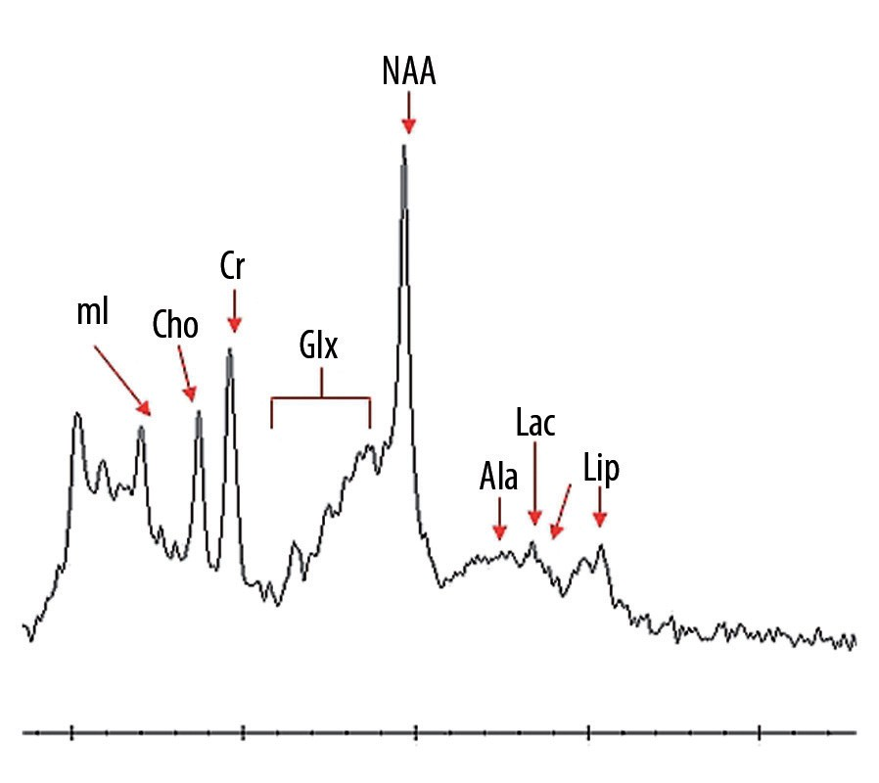
OriginalArticle
©PolJRadiol,2009;74(4):7-21
in men.Othermostfrequent typeofcancersarethemenin-giomas(about25%ofallprimarytumours),2timesmorefrequentinwomen.Acousticneurinomasconstitute5–8%,metastaticcancersfromotherorgans5–10%(25%ofallcancersmetastasedtothebrain)andadenomasofthepituitarygland–benigntumours8–10%ofallprimarytumours.Theincidenceofmalignantgliomasandmenin-giomasincreaseswithage[1].
Theclinicalpictureofthebraintumoursisveryheterog-enousanddependsonthetypeoftumouranditslocation.The basicmethodsappliedintumourdiagnosticsaswell asintra-andpost-therapeuticalfollow-upexaminationsarecurrently:thecomputedtomographyandmagneticreso-nancetomography[2].
Thesetechniquesareusefulinlesiondetection,indeter-miningitslocation,size,andvascularisation.However,some casesare connectedwitha problemofdifferentiationbetweentheneoplasticlesionsandthefocallesionsofsomeothertype,e.g.ischaemicfocusorfocusofpost-radiationnecrosis.Insuchinstances,themethodsupplementingthediagnosticsimagingissocalledMRS,i.e.magneticreso-nancespectroscopy,becauseitisawell-knownfactthateverypathologycausesspecificmetabolicchangesbeforeappearingonimagingstudies[2].
Figure1.HMRSspectrum–healthyindividual.
(Lac),glutamineandglutamicacid(Glx),andalanine(Ala)
–Figure1[2].
OneofthemostimportantmetabolitescreatingtheHMRSspectrumischoline,anorganicchemicalcompound–(2-Hydroxyethyl)trimethylammoniumhydroxide.Itcon-stitutessomeofthephospholipids(animportantcom-poundofthecellmembrane),lecithineandsphingomyelin.Sphingomyelinisacomponentofthemyelinsheathsofthenerves,andlecithineprotectsthem.
MRS,magneticresonancespectroscopy,asacomplete-lynon-invasivemethod,allowsfortheevaluationofthechemicalcompositionofagiventissuesampleVOI(volumeofinterest).
Theanalysisinvolvestheidentificationofthespectrallinesappearinginpathologies,theevaluationofconcentrationsofselectedmetabolitesandcalculationoftheirmutualrelativeproportions.Andthus,theMRSexaminationinvivoallowsforthedetectionofpathologiesinaveryearlystage,facilitatesthedifferentialdiagnosisofthemorpho-logicallesions,enablestheevaluationofthecourseofthepathologicalprocess,andfinally,enablesthemonitoringofthetreatmentprocess.Duetothefactthatthisdiagnos-ticmethodisnotinvasiveandallowsfortheevaluationofthemetabolicstateofthewholesystem,theMRSexamina-tionperformedinvivoiscalleda'non-invasivebiochemicalbiopsy'[3].
Inthemetabolicprocesses,cholineistheprecursoroface-tylcholine(neuromediatorsynthesisedincholinergicneu-rons)andphosphatidylcholine,andaproductofsphingo-myelindisintegration.Cholinecanbefoundinhumanbodyinafreeform,orasapartofwater-solubleandemulsifiedcompounds(plasmalogen,glycerophosphocholine,phos-phorylcholine,cytidinediphosphohcholine,acetylcholine),aswellascompoundssolubleinfats(phosphatidylcholineandsphingomyelin)
IntheHMRSspectrumofthebrain,cholineisasourceofastrongsignalandisvisibleasasinglepeak–3.21intheppmscale–forwhichresponsiblearetheprotonsofthetrimethylamoninesN-(CH3)3presentincholine-containingcompounds,incytozole,includinggliceropholphocholine,phosphocholineandcholine.Theinfluenceofindividualcomponentsonthelevelofthepeak(itsarea)iscurrent-lynotwellknown,andthusthechangeofitsvaluemayfollowbothfromthechangeinmutualproportionsoftheabovementionedcompounds,aswellasfromchangesintheirtotalconcentration(combined).Phosphatidylcholineandsphingomyelin,i.e.compoundsincludingcholineandpresentinthecellmembrane,donothave(mostprobably)anyinfluenceonpeakgeneration,duetoalimitedmobilityoftheseparticleswithinthecellmembrane.
IntheMRStechnique,thekeyroleisplayedbyprotonMRspectroscopy(1HMRS)duetothehighestconcentrationofhydrogenintissuesandthestrongestsignalinducedbyprotonsinthechosenarea[2].
Spectroscopyiscurrentlyperformedroutinelyintheevalu-ationofthetypeoflesion,malignancygradeofthebraintumour,its response to thetreatment course, and detectionofpossiblerecurrences[4–8].
Atthepresentleveloftechnologicaladvancement,itispossibletoidentifyonlyafewmetabolitesinthe1HMRSspectrumofthebrain.Thesourceofthestrongestreso-nancesignalsare:N-acetylaspartate(NAA),choline(cho)andcreatinine(Cr),togetherwithphosphocreatinine(PCr).Othermetabolites,theevaluationofwhichmaybesig-nificantinbrainpathologiesare:lipids(Lip),lacticacid
Toputitsimply,cholinecouldbedescribedasanindica-torofmyelinedisintegrationandcellproliferation.Thisisreflectedbythemetaboliccycleoftheactivecellsandcellmembranemetabolism[9,10].
8

©PolJRadiol,2009;74(4):7-21
SobieckaBetal–Theroleofcholine(Cho)inthediagnostics…
Table1.Thesummaryofanalysedbenignandmalignanttumoursaftertumourresectionandhistopathologicalanalysis.
Astrocytomadiffusum,n=3
AstrocytomafibrillarediffusumII,n=1
Glioma,n=25
Benigntumoursn=50
AstrocytomapilocyticumI,n=2
OligodendrogliomaII,n=2
Meningioma(IandII),n=19
Schwannoma,n=6
AstrocytomaII/III,n=2
Astrocytomamalignum(12IIIgrade,3III/IV),n=15
Glioma(2II/III,12III,5III/IV,17IV),n=36
Astrocytomamalignum/glioblastomamultiformaeIII/IV,n=2
Malignanttumoursn=50
GlioblastomamultiformaeIV,n=16
GliosarcomaIV,n=1
Cancer,n=9
Adenocarcinoma,n=4
Chordoma,n=1
Pathologicallesionsresultinginthechangeofthelevelandareaofthecholinepeakcanbeobservedasrelativelylargefluctuationsoftheheightandhalf-widthofthepeak.
theelectivesurgery,thewholegroupwassubjectedtotheHMRSexamination.Onthebasisofthehistopathologicalexamination afterthe surgicalprocedure,weclassifiedthepatientsintotwogroups:withbenignandmalignanttumours.
Theanalysisofcholineconcentration(areabelowthepeak)isusedforfurthercalculations,i.e.proportionsofconcen-trations.Themostfrequentlyanalysedratiosare:Cho/CrandCho/NAA.
Thegroupwithbenigntumoursinvolved50patientsintheageof17–77years(46.04±17.65–mean±standarddeviation).Thegroupwithmalignanttumoursinvolved50patientsintheageof26–81years(55.18±13.60–mean±standarddeviation).ThedataareshowninTable1.
Accordingtomanyauthors,theroleofChoconcentrationassessmentiscrucialinthedifferentiationoftheCNSfocallesions,especiallywhenevaluatingtheirmalignancyandthedegreeofmalignancy.MostofthepapersonmalignantbraintumoursrevealasubstantialincreaseinChocon-centration[4–8]butinsomeofthearticlesitwaspointedoutthatthisincreasemaybeinsignificantorevenreduced[11,12].Thatiswhy,theaimofthisworkwastoanalyse,onthebasisofownmaterial,thetendenciesconnectedwithChopeakrevealedinHMRSspectrumwithinbraintumours,andtodifferentiatethetypeofthelesionandtodefinethebestmethodofvoxellocalisationaswellasthemethodofanalysisofdataobtainedduringacquisition.
Thecontrolgroupcomposedof30healthyindividualsintheageof20–79years(40.8±18.3–mean±standarddevi-ation).Thestudygroupincluded:
- 18womenintheageof20–70years(36.39±16.13–mean
±standarddeviation),
•12menintheageof23–79(47.42±19.36–mean±stan-darddeviation).
Allpatientsfromthecontrolgroupwerediagnosedasfreeofintellectualdisturbances,craniocerebralinjuries,drugsandalcoholaddictions,poisonings,aswellashistoryofneurologicalandpsychiatrictreatment.Also inthiscaseweperformedtheimaging studyfirst,followed bythe HMRS.
MaterialandMethods
Patientsandcontrolgroup
HMRSexaminationtechnique
TheMRandHMRSexaminationswereperformedinthegroupof100patientsintheagerangingfrom17to81years(50.61±16.34–mean±standarddeviation).Thestudygroupincluded:
•52womenintheageof17–78(49.88±17.24–mean±standarddeviation),
- 48men in the age of 17–81 years(51.40±15.45 – mean±standarddeviation).
TheHMRSexaminationwasperformedwiththeuseoftheMRSignaExcite(GEMS)system,andasuperconductingmagnetwithmagneticfieldinductionof1.5T.
Weappliedthetransmitting-receivingcoilusedforstan-dardheadexaminations.
Patients
AllpatientswerediagnosedwithtumourinapreviouslyperformedMRI.Inordertodefinethetypeoflesionbefore
TheHMRSstudyprotocolincluded:
9

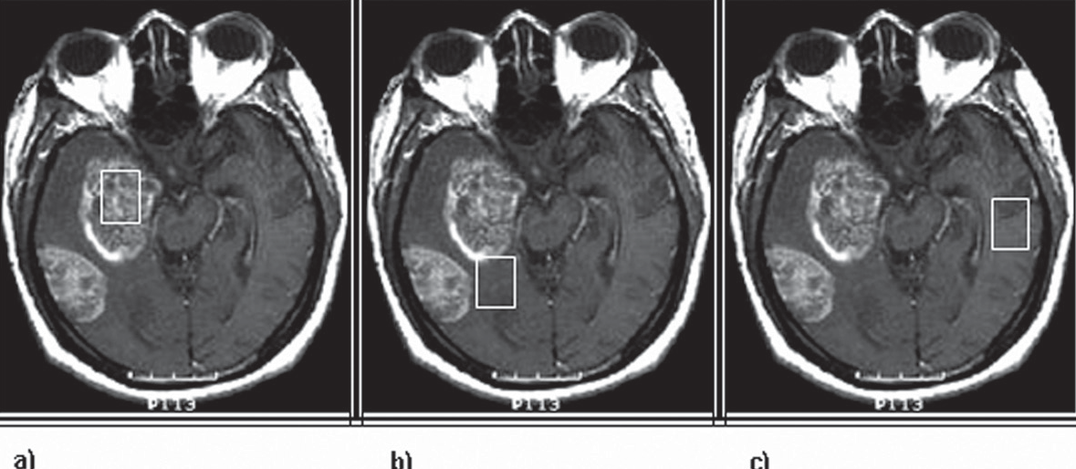
OriginalArticle
©PolJRadiol,2009;74(4):7-21
Figure2.Thevoxellocation:(A)thetumourcentre,
(B)thetumourborder,(C)contralateralunchangedcerebraltissue.
- 3Dlocaliser,
- LocaliserinSEsequence,T2-weightedintheaxialsection,
- PRESSsequence–tumourcentre,
- PRESSsequence–tumourborder,
- PRESSsequence–contralateral,normaltissue.
(PointResolvedSpectroscopySequence).Threeparameterswereused:
TR=1500ms,
TE =35ms,
Numberofacquisitions:64or128,Sequencetime:2.14minor3.43min.
ThevolumeofinterestwasselectedonthebasisofimagesobtainedintheSET2sequence.Fromamong10-20slicesobtainedinthelocalisationstudy,weselectedthosewiththebestimageofthetumour.Ineachpatient,themea-surementswereperformedinthreedifferentlocations.Thefirstmeasurementwasdonebyplacingthevoxelinthecentreofthepathologicallesion(Figure2A).Wetriedtovisualisethesolidmassandtoavoidnecroticandosseoustissue,andthefluid-filledspaces.
Thenumberofacquisitionsand,appropriately,thetimeofsequencedependedonthevoxelsize. Largervoxelsrequiredalowernumberofacquisitions,whichshortenedthesequencetime.Incaseofsmallvoxels,weincreasedthenumberofacquisitionandthusincreasedthesequencetime(guidedbytherule'thesmallerthevoxel,theweakerthesignal-to-noiseratio').
BeforeeveryPRESSsequence,therewasanautomatedprescanningperformed.Itconsistedof'shimming'andwatersuppression.Duringshimming,allheterogeneitiesofthestablemagneticfieldwereregulated.Theresultsofshimmingwerepresentedasthefullwidthathalfmaxi-mumandamountedto2–7Hz.
Thesecondmeasurementconcernedtheareaattheborder-lineofthelesionandthesurroundingnormal(unchanged)tissue(Figure2B).Thethirdmeasurementwasperformedwithinthenormal,contralateralbraintissue(Figure2C).
Voxelsize,dependingontumoursizeandtumourlocation,rangedfrom1.58cm3to14.96cm3inalllocations.
Duringanautomatedprocessofwatersuppression,wesuppressedthesignaloffluidspresentinthevolumeofinterest.Thelevelofwatersuppressionamountedinmostcasesto98or99%.Afewcasesfailedtoobtaintheoptimalresultsof theshimming process (FWHMvaluesexceeding7Hzorwatersuppressionbelow98%)anditwasnecessarytoperformshimmingmanually.
Controlgroup
TheHMRSstudiesofthecontrolgroupwereperformedaccordingtothefollowingprotocol:
- 3Dlocaliser
- FSET2inaxialsection(localiserforspectroscopicexamination),
- SET1inaxialsection,
- SEPDinaxialsection,
- FLAIRinaxialsection,
- 3-planelocaliser,19s,
- PRESSsequence–rightfrontallobe.
Dataanalysis
Theanalysisoftheobtainedspectrausedanoriginalsoft-ware:SAGE(GEMS).Wemeasuredtheareasbelowtheselectedpeaks,proportionaltotheconcentrationofpartic-ularmetabolites.
Forthepurposesofthisworkweselectedsomedataoncholine(Cho):
- Choline–Cho3.22ppm(–CH3)3.
Everypersonfromthecontrolgroupunderwentmeasure-mentsinthe regionof theright frontallobe.
Thevoxelwasplacedwiththeuseofsimilarstandardsasinpatientswithbraintumour(weavoidedtheosseoustis-sueandthespacesfilledwithfluidorair).
InordertoevaluateCho/Cr,NAA/Cho+CrratiosintheHMRS spectrum, weanalysed other metabolitesas well:
- N-acetylaspartate–NAA2.02ppm(–CH3),
- Creatinine,phosphocreatinie–CR+PCr3.02ppm(–CH3).
Voxelsizerangedfrom1.54cm3to8.27cm3.
The analysis involved:
- EvaluationofthetotalChoconcentration(measurementofareasbelowtheselectedpeaks),
AllHMRSstudieswereperformedintheSVStechnique(singlevoxelspectroscopy).WeusedthePRESSsequence
10

A B C

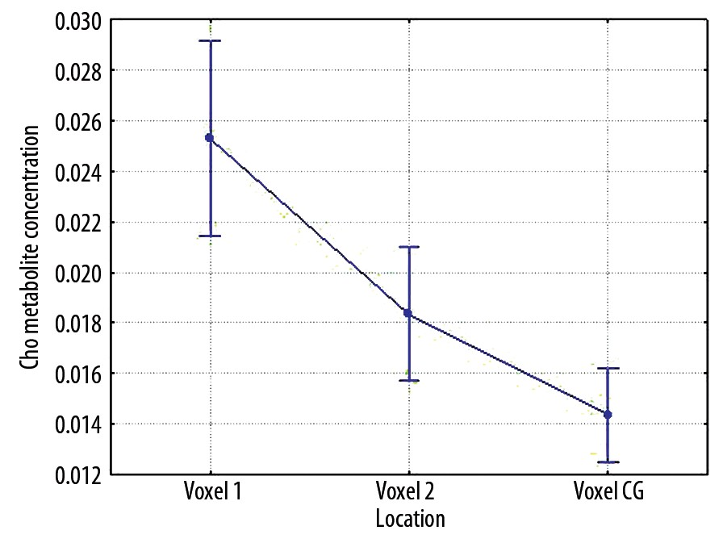
©PolJRadiol,2009;74(4):7-21
SobieckaBetal–Theroleofcholine(Cho)inthediagnostics…
Table2.ThesummaryofmeanChoconcentrationsinanalysedlocationsamongpatientswithbraintumoursandhealthyvolunteerswithconsiderationofstandarddeviationandstandarderrorsfor95%confidenceinterval.
Confidenceinterval
Location
Mean
Standarddeviation
Standarderror
–95%
95%
Voxel1
0.0253
0.0192
0.0019
0.0214
0.0290
Voxel2
0.0183
0.0140
0.0015
0.0160
0.0218
VoxelCG
0.0144
0.0049
0.0009
0.0125
0.0162
Table3.ThesummaryofstatisticalsignificancedifferencesbetweenmeanChoconcentrationsinanalysedlocationsamongpatientswithbraintumoursandhealthyvolunteers,p<0.05.
SS×10–4
MS×10–4
Location
Degreesoffreedom
F
p
Voxel1
27.09
1
27.09
9.32
0.0028
Voxel2
4.67
1
4.67
3.03
0.0841
SS–sumofsquares;MS–meansquare;F–FisherandSnedocortestresults;p–levelofsignificance.
performedtheanalysiscomparingmeanChoconcentra-tionsinpatientswithtumourandinpersonsfromthecon-trolgroup.Incaseofpatientswithtumour,weanalysedeverymeasurementinthecentreofthelesion(voxel1)andattheborderofthelesion(voxel2).Inthecontrolgroup,themetaboliteswereanalysedinaselectedareaoftherightfrontallobe.
Dataofpatientsfrombothgroupswerecompared:
- Voxel1withacontrolgroupvoxel(CGvoxel),
- Voxel2withacontrolgroupvoxel(CGvoxel).
One-wayanalysisof variancewasapplied.
1.AnalysisofChoconcentrationforthewholestudygroup
Figure3.MeanChoconcentrationsinanalysedlocationsamongpatientswithbraintumoursandhealthyindividuals.
MeanChoconcentrationsmeasuredinthegroupofpatientswithtumourwerecomparedwithanalogousval-uesobtainedinthecontrolgroup.HighermeanChocon-centrationswerefoundinthegroupofpatientswithbraintumour.Thehighestmeanvalueswererevealedinthemeasurementstakeninthelesioncentre,lowerintheloca-tionofvoxel2,andthelowestinthelocationsofthecon-trolgroup(Figure3,Table2).
- Relativeconcentrationratiosofcholineandcreatinine(Cho/Cr),andofothermetabolitestocholine(webasedonthereportsoftheworldliterature):NAA/Cho,NAA/Cho+Cr.
ThedatabaseofthebaselineresultswascreatedinExcel.Thatprogramwasalsousedfordataprocessing.Thestatisticalanalysiswascarriedoutwiththeuse oftheSTATISTICAsoftwareandtheapplicationofone-wayanal-ysisofvariance.
Statisticallysignificantdifferenceswerefoundin:
- thecomparisonsofmeanChoconcentrationsinvoxel1withavoxelofthecontrolgroup,p=0.0028.
Results
Nostatisticallysignificantdifferenceswerefoundin:
- thecomparisonsofmeanChoconcentrationsinvoxel2withavoxelofthecontrolgroup,p=0.0841.
ThecomparativeanalysisofmeanChoconcentrations,onthebasisofthemeasurementscarriedoutinthecontrolandthestudygroupofpatientswithtumour(regardlessoftumourtype–benign/malignant)intwolocations:inthelesioncentreandattheborderofthelesion
Theresultsofthemeasurementsconcerningthesignifi-canceofthedifferencesinmeanChoconcentrationswerelistedinTable3.
Whenanalysingthestatisticallyobtainedresults,theauthorsrevealedthatsignificantlyhigherChoconcen-trationsarefoundwithinvoxelslocatedinthelesion
InordertofindoutwhetherChoisasignificantmetabo-liteintheanalysisof1HMRSspectraofthebrain,we
11

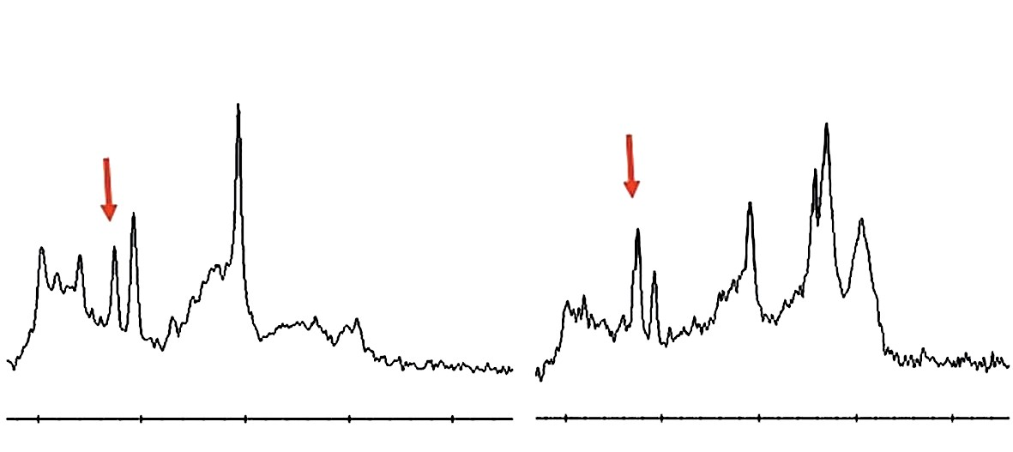
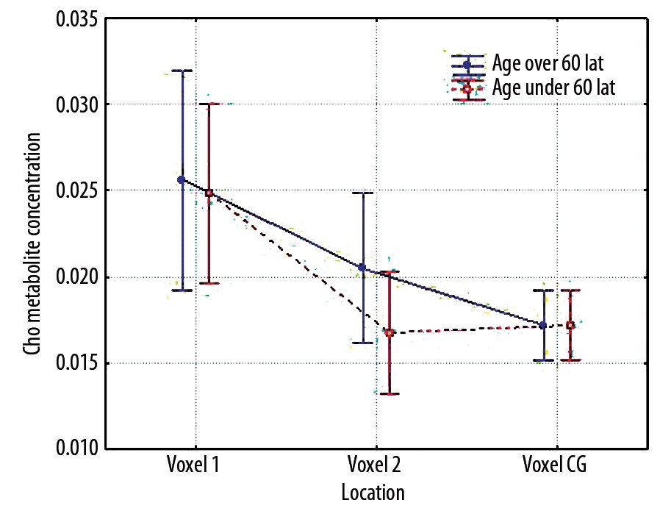
OriginalArticle
©PolJRadiol,2009;74(4):7-21
Figure4.TheexamplesofHMRSspectra:
(A)healthyvolunteer,(B)patientwithbraintumour.
However,nosignificantdifferencesinthemeanChocon-centrationwererevealedbetweenlocationonthelesionborderandlocationsinthecontrolgroup(p>0.05).Inthiscase,werevealedonlyatendencyforhighermeanChoconcentrationsonthelesionborder.
WeconcludedthatChoconcentrationisanimportantparameterinHMRSspectrumevaluationinpatientswithbraintumour.
Someexamplesofspectrainahealthyindividualandinapatient with brain tumourwere shown inFigure4.
2.TheanalysisofChoconcentrationsforthewholegroup,withrespecttoagedistribution
Weanalysedtheresultsofexaminationscarriedoutin100patientsintheagerangingfrom17to81years,dividedintotwoagegroups:
- 66patientsintheageofupto60years(from17to59,41.71±12.35–mean±standarddeviation),
- 34patientsintheageofover60(from61to81,67,88±5.90 – mean±standard deviation).
Figure5.MeanChoconcentrationsinanalysedlocationsamongpatientswithbraintumoursandhealthyindividuals,withconsiderationofagedistribution(underandover60yearsofage).
centre,ascomparedtovoxellocationsinthecontrolgroup(p<0.05).
Table4.Thegroupunder60yearsofage–thesummaryofmeanChoconcentrationsinanalysedlocationsamongpatientswithbraintumoursandhealthyvolunteerswithconsiderationofstandard deviationandstandarderrorsfor95%confidenceinterval.
Confidenceinterval
Location
Men
Standarddeviation
Standarderror
–95%
95%
Voxel1
0.0256
0.0190
0.0030
0.0204
0.0326
Voxel2
0.0205
0.0164
0.0027
0.0154
0.0263
VoxelCG
0.0117
0.0048
0.0012
0.0094
0.0145
Table5.Thegroupover60yearsofage–thesummaryofmeanChoconcentrationsinanalysedlocationsamongpatientswithbraintumoursandhealthyvolunteerswithconsiderationofstandard deviationandstandarderrorsfor95%confidenceinterval.
Confidenceinterval
Location
Mean
Standarddeviation
Standarderror
–95%
95%
Voxel1
0.0249
0.0195
0.0025
0.0193
0.0293
Voxel2
0.0168
0.0120
0.016
0.0143
0.0209
VoxelCG
0.0172
0.0035
0.0009
0.0151
0.0192
12

A B

©PolJRadiol,2009;74(4):7-21
SobieckaBetal–Theroleofcholine(Cho)inthediagnostics…
Table6.Thegroupunder60yearsofage–thesummaryofstatisticalsignificancedifferencesbetweenmeanChoconcentrationsinanalysedlocationsamongpatientswithbraintumoursandhealthyvolunteers,p<0.05.
SS×10–4
MS×10–4
Location
Degreesoffreedom
F
p
Voxel1
24.36
1
24.36
9.14
0.0038
Voxel2
8.90
1
8.90
4.51
0.0385
SS–sumofsquares;MS–meansquare;F–FisherandSnedocortestresults;p–levelofsignificance.
Table7.Thegroupover60yearsofage–thesummaryofstatisticalsignificancedifferencesbetweenmeanChoconcentrationsinanalysedlocationsofpatientswithbraintumoursandhealthyvolunteers,p<0.05.
SS×10–4
MS×10–4
Location
Degreesoffreedom
F
p
Voxel1
5.82
1
5.82
1.86
0.1764
Voxel2
0.02
1
0.02
0.02
0.8914
SS–sumofsquares;MS–meansquarelF–FisherandSnedocortestresults;p–levelofsignificance.
Forcomparisons,theresultsobtainedin30healthyindi-viduals intheage rangingfrom20 to79(40.8±18.3– mean
±standarddeviation)wereused:
- 16patientsintheageofupto60years(from20to59,33.19±11.79–mean±standarddeviation),
- 14patientsintheageofover60years(from61to79,64.79±5.10–mean±standarddeviation).
Theresultsofmeasurementsconcerningsignificantdif-ferencesbetweenmeanChoconcentrationsinbothgroupswerepresentedinTables6and7.
Whenanalysingthestatisticallyobtainedresultsforthewholestudygroupdividedintoagegroups,theauthorsrevealedthatsignificantlyhigherChoconcentrationsarefoundwithinvoxelslocatedbothinthelesioncentreandonitsborder,ascomparedtovoxellocationsinthecontrolgroup(p<0.05).Thisconcernsonlythegroupofpatientsunder60yearsofage.
WecomparedmeanChoconcentrationsinpatientswithbraintumour,withmeanChoconcentrationsrevealedinthecontrolgroup.Theanalysiswasperformedintwoagegroups:underandover60years.
Inthegroupofpatientsover60yearsold,themeanChoconcentrationsdidnotreachthelevelofstatisticalsignifi-cance (p>0.05).However,inthisgroup,we revealedaten-dencyforhighermeanChoconcentrationsamongpatientswithbraintumour,ascomparedtothecontrolgroup.
Groupunder60y.o.a.
Incomparisontothecontrolgroup,themeanChoconcen-trationsinpatientswithbraintumourwerehigher.Thehighestvaluewasfoundinthetumourcentre(Figure5,Table4).
I.ThecomparisonofmeanChoconcentrationsinthegroupofpatientswithmalignantandbenigntumours
Groupover60y.o.a.
Byapplyingtheone-wayanalysisofvariance,weevalu-ateddifferentChoconcentrations.Wetookintoconsider-ation:lesiontype(benignandmalignant),voxellocation(voxel1–inthelesioncentre,voxel2–lesionborder,voxel3–normal,unchangedtissue)andinteractionsofthesetwofactors.TheresultswerepresentedinFigure6andTable8.
Incomparisontothecontrolgroup,themeanChoconcen-trationsinpatientswithbraintumourweresignificantlyhigherinthemeasurementswithinthelesioncentre.Asig-nificantlylowermeanconcentrationwasfoundintheloca-tionofvoxel2(Figure5,Table5).
Inthegroupofpatientsunder60y.o.a.,statisticallysignifi-cantdifferenceswerefoundin:
- thecomparisonsofmeanChoconcentrationsinvoxel1withavoxelofthecontrolgroup,p=0.0038,
- thecomparisonsofmeanChoconcentrationsinvoxel2withavoxelofthecontrolgroup,p=0.0385,
MeanChoconcentrationsdiffer,dependingonthetypeofthedetectedlesion.Highermeanconcentrationscanbefoundinthe groupof patientswith malignantlesion.
Inbothgroupsofpatients,themeanChoconcentrationsdiffer,dependingonvoxellocation.
Inthegroupofpatientsover60y.o.a.,nostatisticallysig-nificant differences werefound in:
- thecomparisonsofmeanChoconcentrationsinvoxel1withavoxelofthecontrolgroup,p=0.8914,
- thecomparisonsofmeanChoconcentrationsinvoxel2withavoxelofthecontrolgroup,p=0.1764.
Highermeanconcentrationscanberevealedinthelesioncentre, loweron theborderof thelesion. In locationswithinanormaltissue(voxel3),thedifferencesinmeanChocon-centrationsfoundbetweenbothgroupsarenotsignificant.
Statisticallysignificantdifferenceswerefoundin:
- thecomparisonsofgroupsofpatientswithbenignandmalignant lesions,p=0.0016,
13

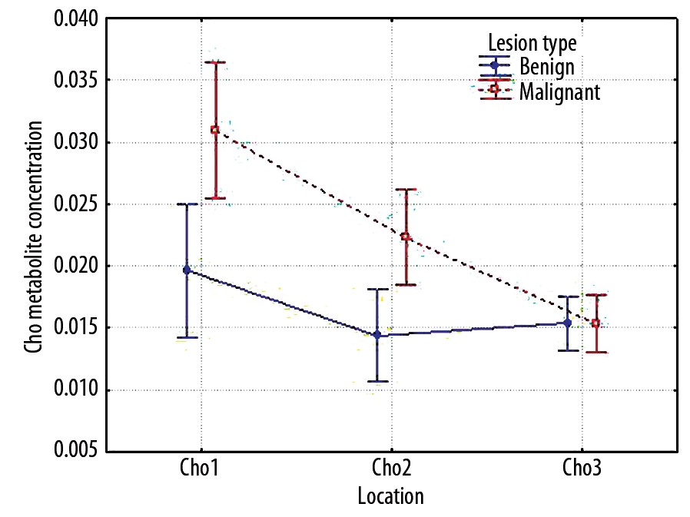
OriginalArticle
©PolJRadiol,2009;74(4):7-21
Table8.ThesummaryofmeanChoconcentrationsinanalysedlocationsofpatientswithbenignandmalignantbraintumours,consideringstandard deviationandstandarderrorsfor95%confidenceinterval.
Confidenceinterval
Standarddeviation
Location
Lesiontype
Mean
Standarderror
–95%
95%
Total
0.0252
0.0191
0.0020
0.0212
0.0292
Voxel1
Benign
0.0197
0.0125
0.0018
0.0159
0.0234
Malignant
0.0309
0.0229
0.0035
0.0239
0.0379
Total
0.0183
0.0132
0.0014
0.0155
0.0210
Voxel2
Benign
0.0144
0.0083
0.0012
0.0119
0.0168
Malignant
0.0223
0.0160
0.0024
0.0174
0.0272
Total
0.0154
0.0075
0.0008
0.0138
0.0169
Voxel3
Benign
0.0154
0.0079
0.0012
0.0130
0.0177
Malignant
0.0153
0.0071
0.0011
0.0132
0.0175
Table9.EvaluationofthesignificanceofdifferencesbetweenmeanChoconcentrationsintheanalysedlocations,inthegroupofpatientswithbenignandmalignantbraintumour,p<0.05.
SS
Degreesoffreedom
MS
F
p
Absoluteterm
0.1043
1
0.1043
399.74
0.0000
Typeoflesion
0.0028
1
0.0028
10.58
0.0016
Error
0.0230
88
0.0003
Location
0.0047
2
0.0023
15.90
0.0000
Location*typeoflesion
0.0015
2
0.0008
5.13
0.0068
Error
0.0258
176
0.0001
SS–sumofsquareslMS–meansquare;F–FisherandSnedocortestresults;p–levelofsignificance.
ThecomparisonofmeanChoconcentrationsshowsahighlevelofstatisticalsignificance(p<0.05)bothforthelesiontype(highermeanvaluesforthegroupofpatientswithmalignanttumours)andvoxellocation(thehighestmeanvaluesinthecentreofthelesion),aswellasforinterac-tionsofboththesefactors.
OnthatbasiswecametotheconclusionthatChocon-centrationisanimportantparameterintheevaluationofHMRSspectruminpatientswithbraintumour,dependingonthelesiontype(benign/malignanttumour).
ExamplesofspectrainpatientswithbenignandmalignanttumourswereshowninFigure7.
II.ThecomparisonofmeanCho/Crratiosinthegroupofpatientswithmalignantandbenigntumours
Figure6.MeanChoconcentrationsinanalysedlocationsamongpatientswithbenignandmalignantbraintumours.
Weevaluateddifferencesinmetaboliteratiosbyapplyingone-wayanalysisofvariance.Thetypeoflesion(benign,malignant),voxellocation(lesioncentre–voxel1,lesionborder–voxel2,voxel3–normaltissue)andinteractionsofthesetwofactorsweretakenintoconsideration.
- thecomparisonsofvoxelfromthelesioncentreandfromitsborder,p=0.0000,
- interactionsbetweenlesiontypeandvoxellocation,p=0.0068.
ResultsofcalculationswerepresentedinTable9.
14

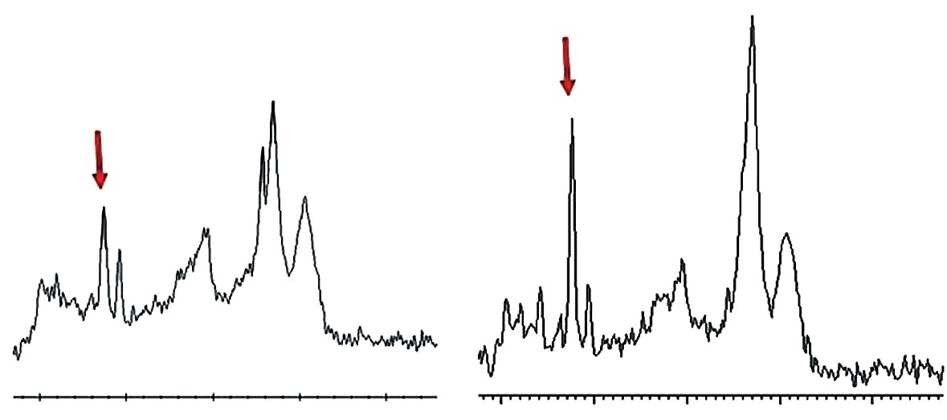
©PolJRadiol,2009;74(4):7-21
SobieckaBetal–Theroleofcholine(Cho)inthediagnostics…
Figure7.TheexamplesofHMRSspectra:
- patientwithbenignbraintumour,
- patientwithmalignantbraintumour.
Table10.ThesummaryofmeanCho/Crratiosinanalysedlocationsamongpatientswithbenignandmalignantbraintumoursconsideringstandarddeviationandstandarderrorsfor95%confidenceinterval.
Confidenceinterval
Standarddeviation
Standarderror
Location
Typeoflesion
Mean
–95%
95%
Total
3.9963
5.4378
0.5732
2.8573
5.1352
Voxel1
Benign
2.9661
4.0359
0.5951
1.7676
4.1646
Malignant
5.0733
6.4680
0.9751
3.1069
7.0397
Total
1.7400
1.9427
0.2048
1.3331
2.1469
Voxel2
Benign
1.1897
0.3438
0.0507
1.0876
1.2918
Malignant
2.3153
2.6506
0.3996
1.5095
3.1212
Total
1.0484
0.4163
0.0439
0.9612
1.1356
Voxel3
Benign
1.0507
0.4677
0.0689
0.9118
1.1896
Malignant
1.0461
0.3601
0.0543
0.9366
1.1556
Table11.EvaluationofthesignificanceofdifferencesbetweenmeanCho/Crvaluesintheanalysedlocations,inthegroupofpatientswithbenignandmalignantbraintumour,p<0.05.
SS
Degreesoffreedom
MS
F
p
Absoluteterm
1394.9
1
1394.9
105.89
0.0000
Typeoflesion
78.1
1
78.1
5.93
0.0169
Error
1159.2
88
13.2
Location
433.7
2
216.9
22.51
0.0000
Location*typeoflesion
50.2
2
25.1
2.61
0.0766
Error
1695.5
176
9.6
SS–sumofsquares;MS–meansquare;F–FisherandSnedocortestresults;p–levelofsignificance.
1.Cho/Crratioanalysis
tissue(voxel3),thedifferencesinCho/Crfoundbetweenbothgroupsareinsignificant.
MeanCho/Crvaluesdiffer,dependingonthelesiontype(Figure8,Table10).
Statisticallysignificantdifferenceswerefoundin:
- thecomparisonsofvoxelfromthelesioncentreandfromitsborder,p=0.0000,
- thecomparisonsofgroupsofpatientswithbenignandmalignantlesions,p=0.169.
Highermeanvaluescanbefoundinthegroupofpatientswithmalignanttumour.
MeanCho/Crvaluesalsodiffer,dependingonlocation.Highermeanvaluescanbefoundinlesioncentre,lowerontheborderofthelesion.Withinthenormal,contralateral
Nostatisticallysignificantdifferenceswerefoundin:
- interactionsbetweenlesiontypeandvoxellocation,p=0.0766.
15
A B

OriginalArticle
©PolJRadiol,2009;74(4):7-21
Table12.ThesummaryofmeanNAA/Chovaluesintheanalysedlocationsinthegroupofpatientswithbraintumourofbenignandmalignanttype,withconsiderationofstandarddeviationandstandarderrorsfor95%confidenceinterval.
Confidenceinterval
Standarddeviation
Location
Typeoflesion
Mean
Standarderror
–95%
95%
Total
1.1080
0.9313
0.0982
0.9130
1.3031
Voxel1
Benign
0.9014
0.6612
0.0975
0.7051
1.0978
Malignant
1.3240
1.1155
0.1682
0.9849
1.6632
Total
1.6041
1.6966
0.1788
1.2487
1.9594
Voxel2
Benign
1.8071
2.2511
0.3319
1.1386
2.4756
Malignant
1.3918
0.7512
0.1132
1.1634
1.6202
Total
1.9398
0.8093
0.0853
1.7703
2.1093
Voxel3
Benign
2.0634
0.9945
0.1466
1.7680
2.3587
Malignant
1.8106
0.5359
0.0808
1.6477
1.9736
Table13.EvaluationofthesignificanceofdifferencesbetweenmeanNAA/Chovaluesintheanalysedlocations,inthegroupofpatientswithbenignandmalignantbraintumour,p<0.05.
SS
Degreesoffreedom
MS
F
p
Absoluteterm
648.1
1
648.1
454.58
0.0000
Typeoflesion
0.5
1
0.5
0.32
0.5750
Error
125.5
88
1.4
Location
30.9
2
15.4
10.58
0.0000
Location*typeoflesion
8.9
2
4.4
3.04
0.0503
Error
256.9
176
1.5
SS–sumofsquares;MS–meansquare;F–FisherandSnedocortestresults;p–levelofsignificance.
ResultsofcalculationswerepresentedinTable11.
MeanNAA/Chovaluesdifferdependingonlocationaswell.Thelowestmeanvaluesarefoundintumourcentre(espe-ciallyinthegroupofpatientswithbenigntumour),higherontheborderofthelesion,andthehighestwithinthenor-mal,healthytissue.
ThecomparisonofmeanCho/Crvaluesshowedahighlevelofstatisticalsignificance(p<0.05)bothforthelesiontype(highermeanvaluesforthegroupofpatientswithmalig-nanttumour)andvoxellocation(thehighestmeanvaluesinthecentreofthetumour).
Statisticallysignificantdifferenceswerefoundin:
- thecomparisonsofvoxelfromthelesioncentreandfromitsborder,p=0.0000.
Nostatisticalsignificance(p>0.05)ofmeanCho/Crvalueswas found for the interaction of both these factors.
Nostatisticallysignificantdifferenceswerefoundin:
- thecomparisonsofgroupsofpatientswithbenignandmalignant lesions,p=0.5750,
- interactionsbetweenlesiontypeandvoxellocation,p=0.0503.
ItwasconcludedthattheCho/CrratioisanimportantparameterinHMRSspectrumevaluationinpatientswithbraintumours,dependingonthelesiontype(benign/malig-nanttumour).
3.NAA/Choanalysis
ResultsofcalculationswerepresentedinTable13.
MeanNAA/Choratiovaluesdifferdependingonthetypeoflesionandlocation,whichwasshowninFigure9,Table12.
ThestatisticalanalysisofmeanNAA/Chovaluesshowedahighlevelofstatisticalsignificance(p<0.05)forvoxellocationonly(thelowestmeanvaluesinthecentreofthelesion).
Inmalignantlesions,ascomparedtothegroupofbenigntumours,themeanvaluesarelower;theonlyexceptionislesioncentreinwhichthemeanNAA/Chovalueishigher.
Nostatisticalsignificance(p>0.05)ofmeanNAA/Choval-ueswasfoundforlesiontypeandtheinteractionbetweenlesiontypeandvoxellocation.
16

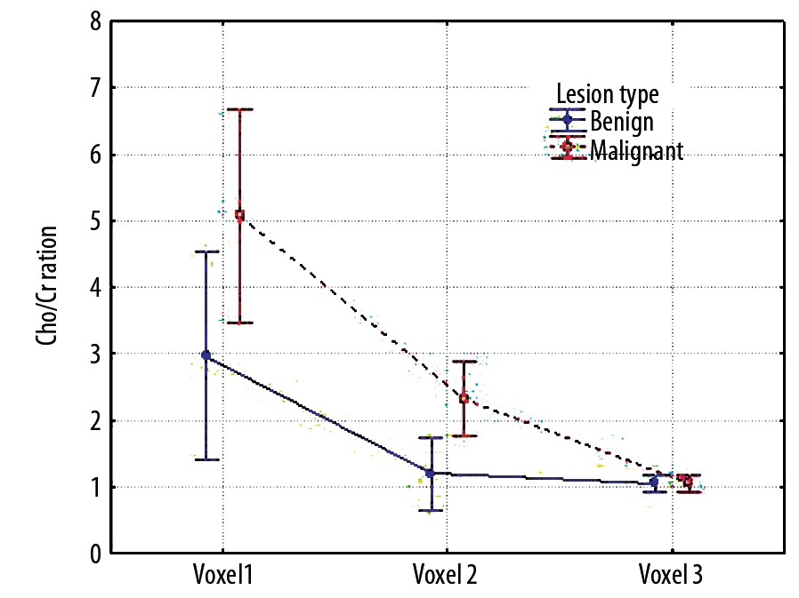
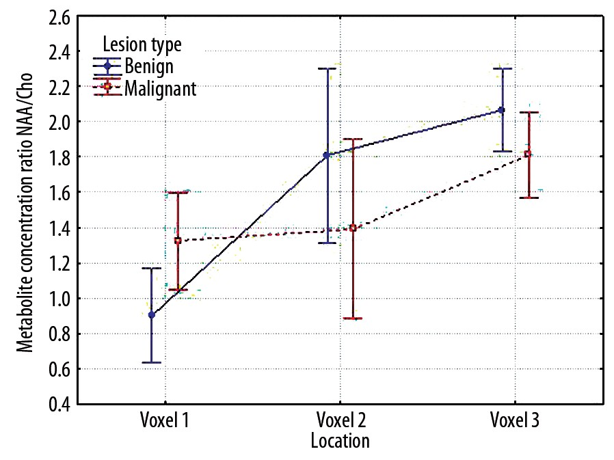
©PolJRadiol,2009;74(4):7-21
SobieckaBetal–Theroleofcholine(Cho)inthediagnostics…
Figure8.MeanCho/Crratiosinanalysedlocationsamongpatientswithbenignandmalignantbraintumours.
Figure9.MeanNAA/Choratiosinanalysedlocationsinpatientswithbenignandmalignantbraintumours.
Table14.ThesummaryofmeanNAA/Cho+Crvaluesintheanalysedlocationsinthegroupofpatientswithbraintumourofbenignandmalignanttype,withconsiderationofstandarddeviationandstandarderrorsfor95%confidenceinterval.
Confidenceinterval
Standarddeviation
Standarderror
Location
Typeoflesion
Mean
–95%
95%
Total
0.6387
0.4608
0.0488
0.5416
0.7357
Voxel1
Benign
0.6933
0.4360
0.0643
0.5638
0.8228
Malignant
0.5802
0.4842
0.0738
0.4312
0.7292
Total
0.7958
0.3328
0.0353
0.7257
0.8659
Voxel2
Benign
0.8064
0.2750
0.0405
0.7247
0.8881
Malignant
0.7844
0.3883
0.0592
0.6649
0.9039
Total
1.0484
0.4163
0.0439
0.9612
1.1356
Voxel3
Benign
1.0507
0.4677
0.0690
0.9118
1.1896
Malignant
1.0461
0.3601
0.0543
0.9366
1.1556
Onlesionborderandwithinthecontralateralunchangedtissue,werevealedatendencyforhighermeanNAA/Chovaluesinthegroupofpatientswithbenigntumour,ascomparedtothegroupofpatientswithmalignanttumours(nostatisticalsignificance).
Nostatisticallysignificantdifferenceswerefoundin:
- thecomparisonsofgroupsofpatientswithbenignandmalignant lesions,p=0.0615,
- interactionsbetweenlesiontypeandvoxellocation,p=0.6525.
4.NAA/Cho+Cranalysis
ResultsofcalculationswerepresentedinTable15.
MeanNAA/Cho+Crvaluesdifferdependingonthetypeoflesion.The datawere shown inFigure10,Table14.
ThestatisticalanalysisofmeanNAA/Cho+Crvaluesshowedahighlevelofstatisticalsignificance(p<0.05)forvoxellocation only (the lowest mean values in the centre ofthelesion).
Highermeanvaluesarefoundinthegroupofpatientswithbenignlesion.
Nostatisticalsignificance(p>0.05)ofmeanNAA/Cho+Crvalueswasfoundforlesiontypeandtheinteractionoflesiontypeandvoxellocation.
MeanNAA/Cho+Crvaluesdifferdependingonlocationaswell.Lowermeanvaluesarefoundinlesioncentre,higherontheborderofthelesion,andthehighestwithinthenor-mal,healthytissue.
InalllocationswerevealedatendencyforhighermeanNAA/Cho+Crvaluesinthegroupofpatientswithbenigntumour,ascomparedtothegroupofpatientswithmalig-nanttumour(nostatisticalsignificance).
Statisticallysignificantdifferenceswerefoundin:
- thecomparisonsofvoxelfromthelesioncentreandfromitsborder,p=0.0000.
17

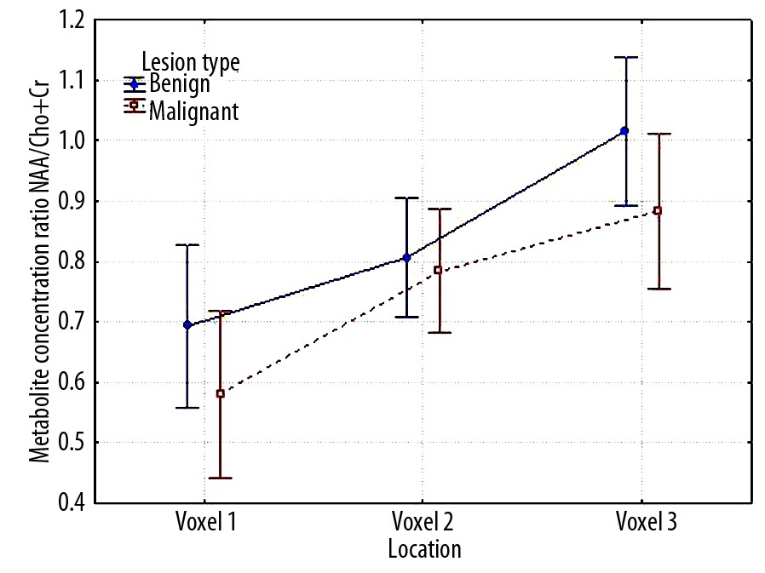
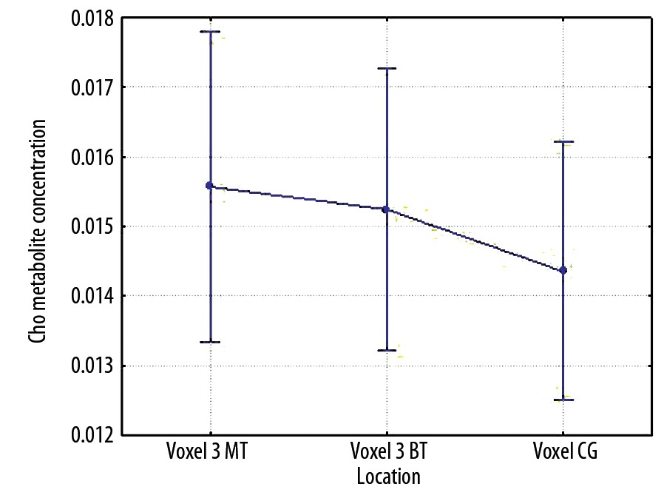
OriginalArticle
©PolJRadiol,2009;74(4):7-21
Figure10.MeanNAA/Cho+Crratiosinanalysedlocationsinpatientswithbenignandmalignantbraintumours.
Figure11.MeanChoconcentrationsinthelocationstudies(normal,unchangedtissue–voxel3MTandBT),inthegroupofpatientswithbraintumourofbenignandmalignanttype,aswellasinthecontrolgroup(voxelCG).
Table15.EvaluationofthesignificanceofdifferencesbetweenmeanNAA/Cho+Crvaluesintheanalysedlocations,inthegroupofpatientswithbenignandmalignantbraintumour,p<0.05.
SS
Degreesoffreedom
MS
F
p
Absoluteterm
168.1
1
168.1
1146.56
0.0000
Typeoflesion
0.5
1
0.5
3.59
0.0615
Error
12.8
87
0.1
Location
4.3
2
2.2
12.20
0.0000
location*typeoflesion
0.2
2
0.1
0.43
0.6525
Error
31.0
174
0.2
SS–sumofsquares;MS–meansquare;F–FisherandSnedocortestresults;p–levelofsignificance.
Table16.ThesummaryofmeanChoconcentrationsinthelocationstudies(normal,unchangedtissue–voxel3MTandBT)inthegroupofpatientswithbraintumourofbenignandmalignanttype,aswellasinthecontrolgroup(voxelCG),withconsiderationofstandarddeviationandstandarderrorsfor95%confidenceinterval.
Confidenceinterval
Location
Mean
Standarddeviation
Standarderror
–95%
95%
Voxel1MT
0.0156
0.0078
0.0011
0.0133
0.0178
Voxel3BT
0.0152
0.0071
0.0010
0.0132
0.0173
VoxelCG
0.0144
0.0049
0.0009
0.0125
0.0162
Table17.EvaluationofthesignificanceofdifferencesbetweenmeanChoconcentrationsintheanalysedlocations,inthegroupofpatientswithbenignandmalignantbraintumour(normal,unchangedtissue–voxel3MTandBT)andinthecontrolgroup(voxelCG),p<0.05.
SS×10–4
MS×10–4
Metabolite
Degreesoffreedom
F
P
Cho
0.28
2
0.14
0.29
0.7476
SS–sumofsquares;MS–meansquare;F–FisherandSnedocortestresults;p–levelofsignificance.
18

©PolJRadiol,2009;74(4):7-21
SobieckaBetal–Theroleofcholine(Cho)inthediagnostics…
III.Thecomparisonoftheexternalmodel(controlgroup)withtheinternalmodel(healthypartofthebraininpatientswithbenignandmalignanttumours),onthebasisofmeanChoconcentrations
Additionally,themeanChoconcentrationsinpatientswithbraintumourwerecomparedwithananalogousmeanvaluemeasuredinthecontrolgroup.Theanalysiswascarriedoutintwoagegroups:underandover60yearsofage.Wereviewedarticlespublished intheworldliterature,concerningdifferencesinmetabolismdependingontheageofthepatientanddescribingtheuseofHMRStechniquesintheexaminationofthephysiologicalagingprocess.Thosearticlesrevealeddifferencesinmetaboliteconcen-trationandinmetaboliteratios[10,15–17].ThestatisticallysignificantincreaseofChoconcentrationinthegroupofolderpatients,incomparisontothegroupofyoungerindi-viduals,aswellasCho/CrincreasewithagewasshownintheworkbyPfefferbaumetal.[15].
Wecomparedthemeanconcentrationsofsomeselectedmetabolites,measuredin:
- thenormal,unchangedpartofbrainofthepatientswithbenigntumour(BT)–voxel3BT,
- thenormal,unchangedpartofbrainofthepatientswithmalignanttumour (MT)–voxel3MT,
- therightfrontallobeinindividualsfromthecontrolgroup.
One-wayanalysisofvariancewasused.
Accordingtoownresults,bothintheolder(over60yearsofage)andintheyoungeragegroup(under60yearsofage),themeanChoconcentrationsinpatientswithbraintumourwerehigherthaninthecontrolgroup.Thesediffer-encesarestatisticallysignificantinthegroupofindividu-alsunder60yearsofage.
Thedataobtainedinthepatientswithtumourwerecom-paredwiththedataofthecontrolgroup:
- voxel3BTwithvoxel3MT,
- voxel3BTwithvoxelfromthecontrolgroup,
- voxel3MTwithvoxelfromthecontrolgroup.
MeanChoconcentrationsdifferslightly,dependingonthelocation.ThedatawereshowninFigure11andTable16.ThecomparablemeanChoconcentrationsarefoundinlocationwithintheunchanged,normaltissueinthepatientswithtumour(slightlyincreasedinthegroupofpatientswithmalignanttumour).Theyarehigherincom-parisontothecontrolgroup(voxelCG).
Inthegroupover60yearsofagewerevealedonlyaten-dency(nostatisticalsignificance)ofhighermeanChocon-centrationsinpatientswithbraintumour.Thetendencywasparticularlywellmarkedwhencomparingtheresultsfromlesioncentreandfromvoxelofthecontrolgroup.Incomparisontothatlocation,themeanconcentrationsmeasuredonlesionborderandinthecontrolgroupwerelower.
NosignificantdifferenceswerefoundinthecomparisonofmeanChoconcentrationinselectedlocations,p=0.7476
Thekeyissueofthisworkwastheevaluationofdiffer-encesinChoconcentration.Theevaluationconsideredthelesiontype(benignormalignant),voxellocation(voxel1
–lesioncentre,voxel2–lesionborder,voxel3–normal,unchangedtissue)andinteractionsofthesetwofactors.Byevaluatingtheinteractionsbetweenthevoxellocationandthetypeoflesioninthegroupofpatientswithbraintumour,it was possibleto answer the questionwhether thedifferencesbetweenthepatientgroups(benign/malignanttumour)arestableforeveryvoxellocation.
ResultsofcalculationswerepresentedinTable17.
TheobtainedresultsofcomparisonsofmeanChoconcen-trationsinthecontralateral,normaltissuewithexternalcontrolgroupshowedsomeslightandinsignificantstatisti-caldifferences.
Werevealedatendency ofhighermean Choconcentrationsinthenormal,unchangedtissueinpatientswithtumourthanintheexternalcontrolgroup.
Theresultsofownstudiesconfirmtheresultspresentedinthecollectedliterature[4,6,7,9,13,14,18].AuthorsoftheaforementionedworksrevealedtheincreasedmeanChoconcentrationsinpatientswithmalignanttumour.TheabovementionedarticlesdonotinvolveacomprehensiveanalysisoftheresultsobtainedintheHMRSexaminations,includingtheinformationontheinfluenceofvoxellocationandlesiontypeonChoconcentration.
Discussion
Byanalysingthesofarpublishedstudyresultsconcerningpatientswithbraintumours,wemaysaythatoneofthebasic,evaluatedmetabolitesischoline.
Inourwork,thebaselinefortheevaluationofthedegreeofChoconcentrationchangeisthecomparativeanalysisofresultsofpatientswithbraintumourandoftheexternalcontrolgroup.HigherChoconcentrationswererevealedinthemeasurementsinpatientswithbraintumourthaninthecontrolgroup.Thehighestconcentrationswerefoundinthecentreof lesion,slightlylowerontheborderofthetumour,andthelowestinthecontrolgroup.Thedis-cusseddifferencesarestatisticallysignificant.Theobtainedresultsareinthiscaseinagreementwiththemajorityofresultspresentedinthecollectedarticles,underscoringtheincreasedChoconcentrationsinpatientswithbraintumoursincomparisontothecontrolgroup[6,9,13,14].
Theresultsofthestudyrevealedstatisticalsignificanceofvoxellocation(lesioncentre,lesionborder,contralateralunchangedtissue),lesiontype(benign/malignanttumour)andinteractionsbetweenthosetwofactors.Dependingonthelesiontype,meanChoconcentrationsdiffersignifi-cantly.Highermean Choconcentrations canbe foundinthegroupofpatientswithmalignantlesion.
MeanChoconcentrationsdifferdependingonthelocationaswell.Highermeanvaluesarefoundinthelesioncen-tre,loweronthelesionborder,thelowestinthehealthytissue.
19

OriginalArticle
©PolJRadiol,2009;74(4):7-21
TheobtainedresultsindicatethatChoconcentrationisanimportantparameterintheevaluationofHMRSspectrumofpatientswithbraintumour,dependingonthetypeandlocationofthelesion.
centre,ascomparedtothenormal,unchangedtissue.NosignificancewasrevealedintheNAA/Choanalysisregard-inglesiontype.InthiscasewerevealedonlyatendencyoflowerNAA/Chovaluesinpatientswithamalignanttumour.
Dataonmetaboliteconcentrationsarefrequentlynotsuf-ficientbecausetheareabelowthepeakdoesnotreflectthevalueofabsoluteconcentrationofthemetaboliteandisonlyproportionatetoit.Measurementsofabsoluteconcen-trationsaretime-consumingandcomplicated.Thisleadstothesituationinwhichmostauthorsusemeasurementtechniquesbasedonconcentrationvaluesclosetotheabso-luteconcentrationsofmetabolitesandpresenttheirstudyresultsintheformofconcentrationratios.
The paperbyBulakbasiet al.[4] presentstheanalysisoftheNAA/Cho+Crindicator.Itwasshownthat,similarlytotheNAA/Choconcentrationratio,thisindicatorisstatisticallysignificantinmalignantandbenigntumourdifferentiation.
Ownresultsconfirmed(similarlytotheabovementionedwork)lowerNAA/Cho+Crvaluesinthegroupofmalignanttumoursthaninthegroupofbenigntumours.However,nostatisticalsignificancewasfound.Statisticallysignificantwastumourlocationonly.Thehighestvaluesofthisindi-catorwereobtainedwithinthenormal,unchangedtissue,andthelowestwithin thelesioncentre.
ThemostfrequentlypresentedratioisCho/Cr,ascreatinineisbelievedtobeareferentialmetabolite,theconcentrationofwhichremainsrelativelystable.Thisratioallowsforanobjectiveevaluationofthespectrum.
Takinginto consideration the results obtained for that indi-cator,wemayconcludethattheanalysesofthatratiodonotimprovethedifferentiationofthetumourtype,espe-ciallyinthesituation ofNAA/Choratio analysis.
Assumingthattheconcentrationofcreatininedoesnotchangesubstantiallywithvoxellocation,thiswillbemain-lycholine(inthenumerator)thatwillinfluencetheCho/Crratio.Theanalysisofcholineconcentrationindifferentlocations,presentedinourwork,revealedhigherconcen-trationsofthatmetaboliteinpatientswithmalignantbraintumour,especiallyinitscentre.Thus,wemayexpectthattheCho/Crratiowillbehigherinthosepatientsaswell.
Additionally,weperformedacomparativeanalysisofChoconcentrationsinthecontralateralareas,inthegroupofpatientswithamalignantandbenigntumour(voxel3–BTandMT),comparedwithanexternalcontrolgroup(voxelCG).OnthebasisoftheobtainedresultsweconcludedthattheChoconcentrationsinthemeasurementsfromvox-elslocatedintheunchangedtissueofthepatientswithalesionareinsignificantlyhigherthanthevaluesfortheexternalcontrolgroup(nostatisticalsignificance).Whencomparingstudyresultsobtainedwithinthehealthytis-sueofpatientswithatumour(voxel3MTandBT),werevealedaslightlyhigher(statisticallynotsignificant)meanChoconcentrationinpatientswithbenigntumourthaninthegroupof malignanttumours.
TheresultsofthepublishedstudiesshowanincreasedCho/Crratiowithintumours,ascomparedtotheunchanged,nor-maltissue.Theseworksrevealachangingvalueofthatindi-cator,dependingonthetumourtype.TheyalsoshowahigherCho/Crratioinpatientswithmalignanttumours[5–8,18–20].
Theanalysisofownresultsconfirmstheresultspresent-edintheabovementionedarticles.Werevealedbothanincreasedcholineconcentrationinpatientswithmalig-nant lesionsandasignificantlyincreasedCho/Crratiointhatgroupofpatients,ascomparedtothegroupofpatientswithbenignlesions.Statisticalsignificancewasalsorevealedduringtheanalysisofthelocationfactor.ThehighestvaluesoftheCho/Crratioswerefound inthelesioncentre;thelowestinthenormal,healthytissue.
Kumaretal.[6]werethefirsttocomparetheresultsofexaminationsperformedwithinthenormalunchangedtis-sueofpatientswithbraintumourandtheresultsobtainedintheexternalcontrolgroup.ThoseauthorsrevealedalsothatthedifferencesinChoconcentrationsbetweentheexternalandtheinternalmodelareminorandstatisticallynotsignificant.
AnindicatorfrequentlymentionedintheliteratureistheNAA/Choratio,astheconcentrationsofboththesemetabo-liteschangesubstantiallyinpatientswithbraintumours.ConsideringthefactthatNAAconcentrationdecreasesinpatientswithbraintumours,whiletheChoconcentrationincreases,weshouldexpectlowermeanNAA/Chovaluesinthe tumour centre thanon the border ofthe lesion orin theunchanged,normaltissue,
Takingintoconsiderationtheobtainedresultsandlitera-turereports,wemayconcludethatanadditionalmeasure-mentwithintheunchangedtissuemayseemunnecessary,especiallyinthesituationwhenweareinpossessionoftheresultsofthecontrolgroup(externalmodel).Thisispar-ticularlyimportantforthepatientsinsevereconditions,forwhomeverylong-lastingMRIandHMRSexaminationmaybearduous.Ontheotherhand,thelackoftheexter-nalmodel can be replacedwith an additional measurementwithinthecontralateraltissue.
Articles4,5,6,13,21presentedresultsshowingNAA/Choratiodecreaseinpatientswithbraintumour,ascomparedtothenormal,unchangedtissue,andapossibilityoflesiondifferentiationonthebasisoftheNAA/Chovalues(lowervaluesinpatientswithamalignanttumour).
Inthestudiedmaterial,patientswithatumourproducinginhomogenoussignalintensification(e.g.malignantastrocy-tomasoftheIIIandIVgradeintheWHOscale–36cases)wereconstitutingalargegroup.Consideringtheheteroge-neityandsizeofsuchtumours,itisnecessarytoperformafewmeasurementsfromthelesionarea,todiagnosethe
Accordingtotheresultsofourwork,thestatisticalsig-nificancewasobtainedbythefactorofvoxellocation.ThelowestNAA/Chovaluescouldbefoundinthetumour
20

©PolJRadiol,2009;74(4):7-21
SobieckaBetal–Theroleofcholine(Cho)inthediagnostics…
Conclusions
regionsofnecrosisandofhighcellactivity[13,22].Thisworkusedonlythosespectrathatrevealedthemetaboliccycleoftheactivecellsandmembranemetabolism(Chopeakclearlydominatesoverotherpeaksandisconsiderablyhigherthaninthecontrolgroup).Regionswithnecrosis,showingcarbo-hydratecatabolism,producingspectrawithaclearlyvisiblepeakoflactateorreducedpeaksofothermetaboliteswerenotevaluated.Whentakingintoaccountthe heterogeneityoftheanaplasticastrocytomasandGBM,itispossibletoavoidmistakesconnectedwitharightinterpretationofthespec-tra.Acquisitionwithinthenecroticregionandtheregionofhighproliferationmayfalsifytheresults.SpectraobtainedinsuchawaymayevenindicateChodecrease,ascomparedtothecontrolgroup.Thisexplainsthefactofparadoxallycontradictoryresultsofsomestudies[11,12].Unambiguousresultsareguaranteedbyadetailedselectionofthevolumeofinterestandbyauthor'schoiceofthosevoxelsonly,inwhichthespectraindicateahighcellularactivity.
1.TheperformedHMRSexaminationsandtheanalysisoftheresultsrevealedasignificantroleofcholineinthediagnosticsof patients with braintumour.
2.Choconcentrationisasignificantfactordifferentiatingpatientswithbraintumour(highermeanvalues)fromthecontrolgroup(especiallypatientsunder60yearsofage).
3.MeanCho/Cr,NAA/Chovaluesareanimportantfac-tordifferentiatingthelesiontype(benign/malignant)inpatientswithbraintumour.
4.Forthemeasurementsperformedinthecentreandbor-derofthelesion,theresultsofthecontrolgroup(exter-nalmodel)orofthenormal,unchangedtissue(contralat-eral)of patients with brain tumour (internalmodel) maybeusedasthereferencevalues.
References:
- DidkowskaJ,WojciechowskaU,TarkowskiWetal:NowotworyzłośliwewPolscew2000roku.KrajowyRejestrNowotworówCentrumOnkologii,Warszawa,2003
- BrandaoLA,DominiguesRC,CecilKM:MRspectroscopyofthebrain.LippincottWilliams&Wilkins,Philadelphia,2003
- YoungIR:Methodsinbiomedicalmagneticresonanceimagingandspectroscopy.Willey,NewYork2000
- BulakbasiN,KocaogluM,OrsFetal:Combinationofsingle-voxelprotonMRspectroscopyandapparentdiffusioncoefficientcalculationintheevaluationofcommonbraintumors.AmJNeuroradiol,2003;24(2):225–33
- LawM,YangS,WangHetal:Gliomagrading:sensitivity,specificity,andpredictivevaluesofperfusionMRimagingandprotonMRspectroscopicimagingcomparedwithconventionalMRimaging.AmJNeuroradiol,2003;24:1989–98
- KumarA,KaushikS,TripathiRPetal:RoleofinvivoprotonMRspectroscopyintheevaluationofadultbrainlesions:Ourpreliminaryexperience.NeurologyIndia,2003;51(4):474–78
- MajosC,AlonsoJ,AguileraCetal:Adultprimitiveneuroectodermaltumor:protonMRspectroscopicfindingswithpossibleapplicationfordifferentialdiagnosis.Radiology,2002;225(2):556–66
- WaleckiJ,JurkiewiczE:Diagnostykaobrazowanowotworówośrodkowegoukładunerwowego.PolskiPrzeglądNeurologiczny,2007;(3):155–71
- SoaresDP,LawM:Magneticresonancespectroscopyofthebrain:reviewofmetabolitesandclinicalapplications.ClinicalRadiology,2009;64:12–21
- UrbanikA:Ocenaprocesustarzeniasięmózgumetodąprotonowejspektroskopiirezonansumagnetycznego.Wyd.DębyRogalińskie,Kraków,2002
- LondoñoaA,CastilloaM,ArmaoaDetal:UnusualMRSpectroscopicImagingPatternofanAstrocytoma:LackofElevatedCholineandHighmyo-InositolandGlycineLevels.AmJNeuroradiol,2003;(24):942–45
- Saraf-LaviaE,BowenaBC,PattanyaPetal:ProtonMRSpectroscopyofGliomatosisCerebri:CaseReportofElevatedMyoinositolwithNormalCholineLevels.AmJNeuroradiol,2003;24:946–51
- HouraniR,BrantLJ,RizkTetal:CanprotonMRspectroscopicandperfusionimagingdifferentiatebetweenneoplasticand
nonneoplasticbrainlesionsinadults?AmJNeuroradiol,2008;(29):366–72
- MajosC,AguileraC,AlonsoJetal:ProtonMRSpectroscopyImprovesDiscriminationbetweenTumorandPseudotumoralLesioninSolidBrainMasse.AmJNeuroradiol,2009;30(3):544–51
- PfefferbaumA,AdalsteinssonE,SpielmanDetal:InvivospectroscopicquantificationoftheN-acetylmoiety,creatine,andcholinefromlargevolumesofbraingrayandwhitematter:effectsofnormalaging.MRM,1999;41:276–84
- LundbomN,BarnettA,BonavitaSetal:MRimagesegmentationandtissuemetabolitecontrastin1Hspectroscopyimagingofnormalandagingbrain.MRM,1999;(41):841–45
- RossB,MichaelisTetal:Clinicalapplicationsofmagneticresonancespectroscopy.MagneticResonanceQuarterly,1994;10:191–247
- MukherjiSK:ClinicalApplicationsofMagneticResonanceSpectroscopy.Wiley-Liss,1998
- FayedN,ModregoPJ:Thecontributionofmagneticresonancespectroscopyandechoplanarperfusion-weightedMRIintheinitialassessmentofbraintumours.JNeurooncol,2005;72(3):261–65
- MajósC,Julià-SapéM,AlonsoJetal:BrainTumorClassificationbyProtonMRcomparisonofdiagnosisaccuracyatshortandlongTE.AmJNeuroradiol,2004;25:1696–704
- WaleckiJ,GriebP,ChojnackaEetal:SpektroskopiaprotonowaMRinvivoguzówwewnątrzczaszkowych.Doniesieniewstępne.PolPrzeglRadiolog,1998;63:225–32
- WaleckiJ:Neuroradiologia.UpowszechnienieNauki–Oswiata„Un-O”,Warszawa,2000
21

