OPEN 3 ACCESS Freely available online
^ PLos one

On the Mechanism of Action of SJ-172550 in Inhibiting
the Interaction of MDM4 and p53

Michal Bista1,29, David Smithson39, Aleksandra Pecak2, Gabriella Salinas3, Katarzyna Pustelny2,
Jaeki Min3, Artur Pirog4, Kristin Finch3,5, Michal Zdzalik6, Brett Waddell7, Benedykt Wladyka2,
Sylwia Kedracka-Krok4,8, Michael A. Dyer5,9,10, Grzegorz Dubin6,8, R. Kiplin Guy3*
1 Max-Planck Institute for Biochemistry, Martinsried, Germany, 2 Department of Analytical Biochemistry, Faculty of Biochemistry, Biophysics and Biotechnology,
Jagiellonian University, Krakow, Poland, 3 Department of Chemical Biology and Therapeutics, St. Jude Children's Research Hospital, Memphis, Tennessee, United States of
America, 4 Department of Physical Biochemistry, Faculty of Biochemistry, Biophysics and Biotechnology, Jagiellonian University, Krakow, Poland, 5 Department of
Developmental Neurobiology, St. Jude Children's Research Hospital, Memphis, Tennessee, United States of America, 6 Department of Microbiology, Faculty of
Biochemistry, Biophysics and Biotechnology, Jagiellonian University, Krakow, Poland, 7 Hartwell Center for Biotechnology, St. Jude Children's Research Hospital, Memphis,
Tennessee, United States of America, 8 Malopolska Centre of Biotechnology, Krakow, Poland, 9 Department of Ophthalmology, University of Tennessee Health Science
Center, Memphis, Tennessee, United States of America, 10 Howard Hughes Medical Institute, Chevy Chase, Maryland, United States of America

Abstract
SJ-172550 (1) was previously discovered in a biochemical high throughput screen for inhibitors of the interaction of MDMX
and p53 and characterized as a reversible inhibitor (J. Biol. Chem. 2010;285:10786). Further study of the biochemical mode
of action of 1 has shown that it acts through a complicated mechanism in which the compound forms a covalent but
reversible complex with MDMX and locks MDMX into a conformation that is unable to bind p53. The relative stability of this
complex is influenced by many factors including the reducing potential of the media, the presence of aggregates, and other
factors that influence the conformational stability of the protein. This complex mechanism of action hinders the further
development of compound 1 as a selective MDMX inhibitor.
Citation: Bista M, Smithson D, Pecak A, Salinas G, Pustelny K, et al. (2012) On the Mechanism of Action of SJ-172550 in Inhibiting the Interaction of MDM4 and
p53. PLoS ONE 7(6): e37518. doi:10.1371/journal.pone.0037518
Editor: Matthew Bogyo, Stanford University, United States of America
Received April 7, 2012; Accepted April 20, 2012; Published June 4, 2012
Copyright: © 2012 Bista et al. This is an open-access article distributed under the terms of the Creative Commons Attribution License, which permits
unrestricted use, distribution, and reproduction in any medium, provided the original author and source are credited.
Funding: This work was supported by grants 77/L-1/09 from the Polish National Centre for Research and Development (to G.D.); 2023/B/P01/2010/39 (K/PBW/
000676) from the Polish Ministry of Science and Higher Education (to S.K.-K.); the European Union structural funds (grants POIG.02.01.00-12-064/08 and
POIG.02.01.00-12-167/08); and the American Lebanese Syrian Associated Charities (ALSAC) and St Jude Children's Research Hospital. No additional external
funding was received for this study. The funders had no role in study design, data collection and analysis, decision to publish, or preparation of the manuscript.
Competing Interests: The authors have declared that no competing interests exist.
* E-mail: kip.guy@stjude.org
. These authors contributed equally to this work.

Introduction
The p53 pathway is inactivated in virtually every human cancer
by mutations in the p53 gene itself or other genes in the pathway
[1]. One of the most common mechanisms of p53 suppression in
tumors with wild type p53 is increased expression of the p53
antagonists MDM2 or MDMX (MDM4) [2,3]. In some tumors,
the increased expression of MDM2 or MDMX correlates with
genetic amplification, but there are also other non-genetic
mechanisms that can contribute to increased protein levels such
as alternative splicing [4] or changes in miRNA-mediated
regulation of steady state mRNA and protein levels [5]. For
tumors with elevated levels of MDM2 or MDMX and wild type
p53, it may be possible to induce p53-mediated cell death by
disrupting the MDM2-p53 or MDMX-p53 interaction. Indeed,
Vassilev and colleagues [6] identified the first small molecule
inhibitor of MDM2-p53 called nutlin-3a and showed that this
MDM2 antagonist can induce cell death in cancer cells with
elevated MDM2 in a p53 dependent manner. Since the original
report of nutlin-3a, several other MDM2 antagonists have been
reported. [7-9].
More recently, small molecule inhibitors of MDMX have been
described. The first (Figure 1, Panel A, SJ-172550, 1) was
identified in a high-throughput screen using a biochemical assay to
recapitulate the binding of MDMX and p53 [10]. SJ-172550
could compete for the wild type p53 peptide binding to MDMX
with an EC50 ~ 5 pM and caused p53 dependent cell death of
retinoblastoma cells [10]. For comparison, nutlin-3a inhibited the
MDMX-p53 interaction with an EC50 ~ 30 pM [10]. Another
small molecule inhibitor of MDMX-p53 that has been character-
ized is WK298 [11]. This molecule binds to MDMX with
a binding constant of ~ 20 pM and structural studies have shown
that it mimics binding of the p53 peptide [11]. In addition to small
molecule inhibitors of the MDMX-p53 interaction, there have
been several reports of peptide inhibitors [12]. For example,
a stapled peptide that mimics the p53 helix that interacts with the
MDMX protein was effective at disrupting the MDMX-p53
interaction in vitro and in vivo [13].
The chemotype embodied by compound 1 contains a functional
group, an a,b-unsaturated amide, that is capable of undergoing
reaction with protein sulfhydryls to form covalent adducts
(Figure 1, Panel B). Indeed compound 1 will form adducts
with glutathione (Figure S1) or cysteine containing peptides
PLoS ONE | www.plosone.org
1
June 2012 | Volume 7 | Issue 6 | e37518
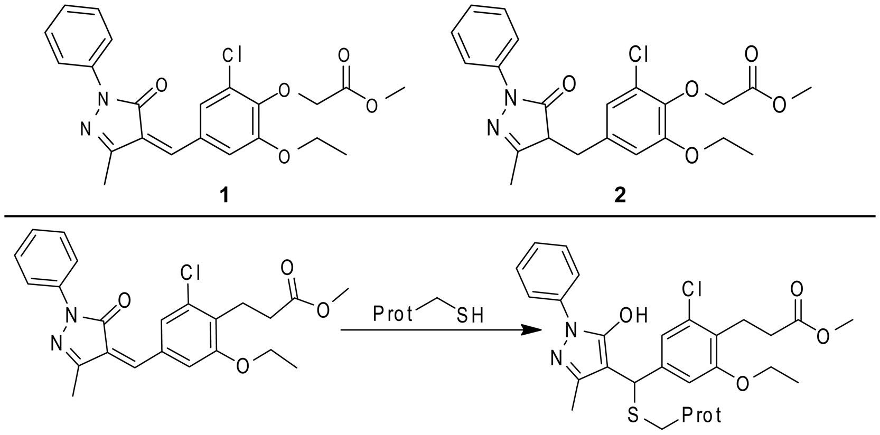

Mechanism of Action of SJ-172550
(Figure S2) under forcing conditions. While irreversible inhibitors
remain a viable option for clinical development, particularly in
oncology, [14-17] they carry certain liabilities as a class and
require a high degree of selectivity either at the protein level or the
site of action, or ideally both. In order to properly delineate the
risk involved in developing an irreversible inhibitor it is critical to
understand its mechanism of action at the protein level and how
this will relate to efficacy on the target, pharmacokinetics, and off-
target effects.
In prior work, we carried out preliminary characterization of
the mechanism of action of 1 using two experiments: mass
spectrometry of MDMX treated with 1; and a washout of 1 from
treated MDMX, followed by a functional test of recovered protein.
[10] In the first case, incubation of MDMX with 1 for two hours in
non-reducing but otherwise pseudo-physiological buffer, followed
by dialysis, afforded no detectable covalent adducts by MALDI
mass spectrometry. Likewise, when this protein was tested for its
ability to bind p53 peptide, it retained function. The interpretation
of these results was that 1 acted as a reversible inhibitor of the
interaction ofp53 and MDMX. However, two subsequent findings
led us to explore this conclusion more fully: 1) Compound 1 only
appeared to function under non-reducing conditions; and 2)
allowing MDMX and compound 1 to react in neutral pH acetate
buffer gave clear covalent adducts detectable by mass spectrom-
etry (see Figures S7, S8, S9, and S10).
Therefore, we carefully analyzed the molecular mechanism of
action. These studies led to three major findings: 1) MDMX exists
as an ensemble of conformations that differ in both their ability to
bind p53 and their reactivity with alkylating agents; 2) in non-
reducing conditions or high inhibitor and MDMX concentrations,
the majority of MDMX adopts a conformation that fails to bind
p53 and is sensitive to alkylation - under these conditions 1 binds
covalently but reversibly to MDMX; and 3) under reducing
conditions the majority of MDMX adopts a conformation that is
competent to bind p53 and relatively non-reactive with compound
1. Additionally, compound 1 appears to shift the MDMX
conformational equilibrium towards the conformation unable to
bind p53 by reversible alkylation of Cys76. This complex, multi-
mode mechanism greatly complicates the interpretation of
experiments using 1 and limits its value as a lead compound for
further development as a selective MDMX inhibitor.

Results and Discussion

Demonstration of the Formation of Covalent Adducts
between Compound 1 and MDMX
In our original report, mass spectrometry following dialysis of
a mixture of compound 1 and MDMX failed to yield detectable
adducts [10]. However, preliminary mass spectrometry experi-
ments involving direct injection of a mixture of compound 1 and
MDMX revealed clear adduct peaks (Figures S7, S8, S9, and
S10). This disparity prompted us to more carefully study the
mechanism of action of compound 1. We hypothesized that the
difference between the two experimental results might be
explained by reversibility of the adduct formation over the time
course of tens of minutes combined with the use of extended
dialysis in prior experiments to remove excess compound 1.
Therefore, we undertook studies to examine the formation of
adducts directly by mass spectrometry of mixtures of MDMX and
compound 1 without prior separation by dialysis (Figure 2). In
order to eliminate the possibility that adducts were forming solely
on the GST fusion tag (because tagged protein was used for all
prior experiments) the experiments were carried out side-by-side
with protein containing or not containing the tag. In both cases,
the unmodified protein ionized well from the buffer mixture and
the expected correct mass could be detected (Figure 2, Panels
a and d). When high concentrations of compound 1 were allowed
to react with either construct of the protein (20 mM protein;
100 mM compound 1), and injected with minimal manipulation,
adducts clearly formed, with either multiple alkylation events
(GST-tagged protein) or a single alkylation event (untagged
protein). These constructs were stable enough to at least partially
survive a rapid desalting procedure prior to injection in the mass
spectrometer. In the case of the untagged protein this stoichiom-
etry afforded only partial labeling, which may reflect either low
reactivity, or rapid reversal during desalting, or both. Thus, clearly
compound 1 is capable of alkylating the single cysteine present in
the p53 binding domain of MDMX. However, under these
conditions the compound is not fully soluble (solubility of 12 mM
Figure 1. Structures of relevant compounds. Panel A. Structure of SJ-172550 (1) and a non-reactive analog (2). Panel B. The potential
mechanism of covalent adduct formation.
doi:10.1371/journal.pone.0037518.g001
PLoS ONE | www.plosone.org
June 2012 | Volume 7 | Issue 6 | e37518
2
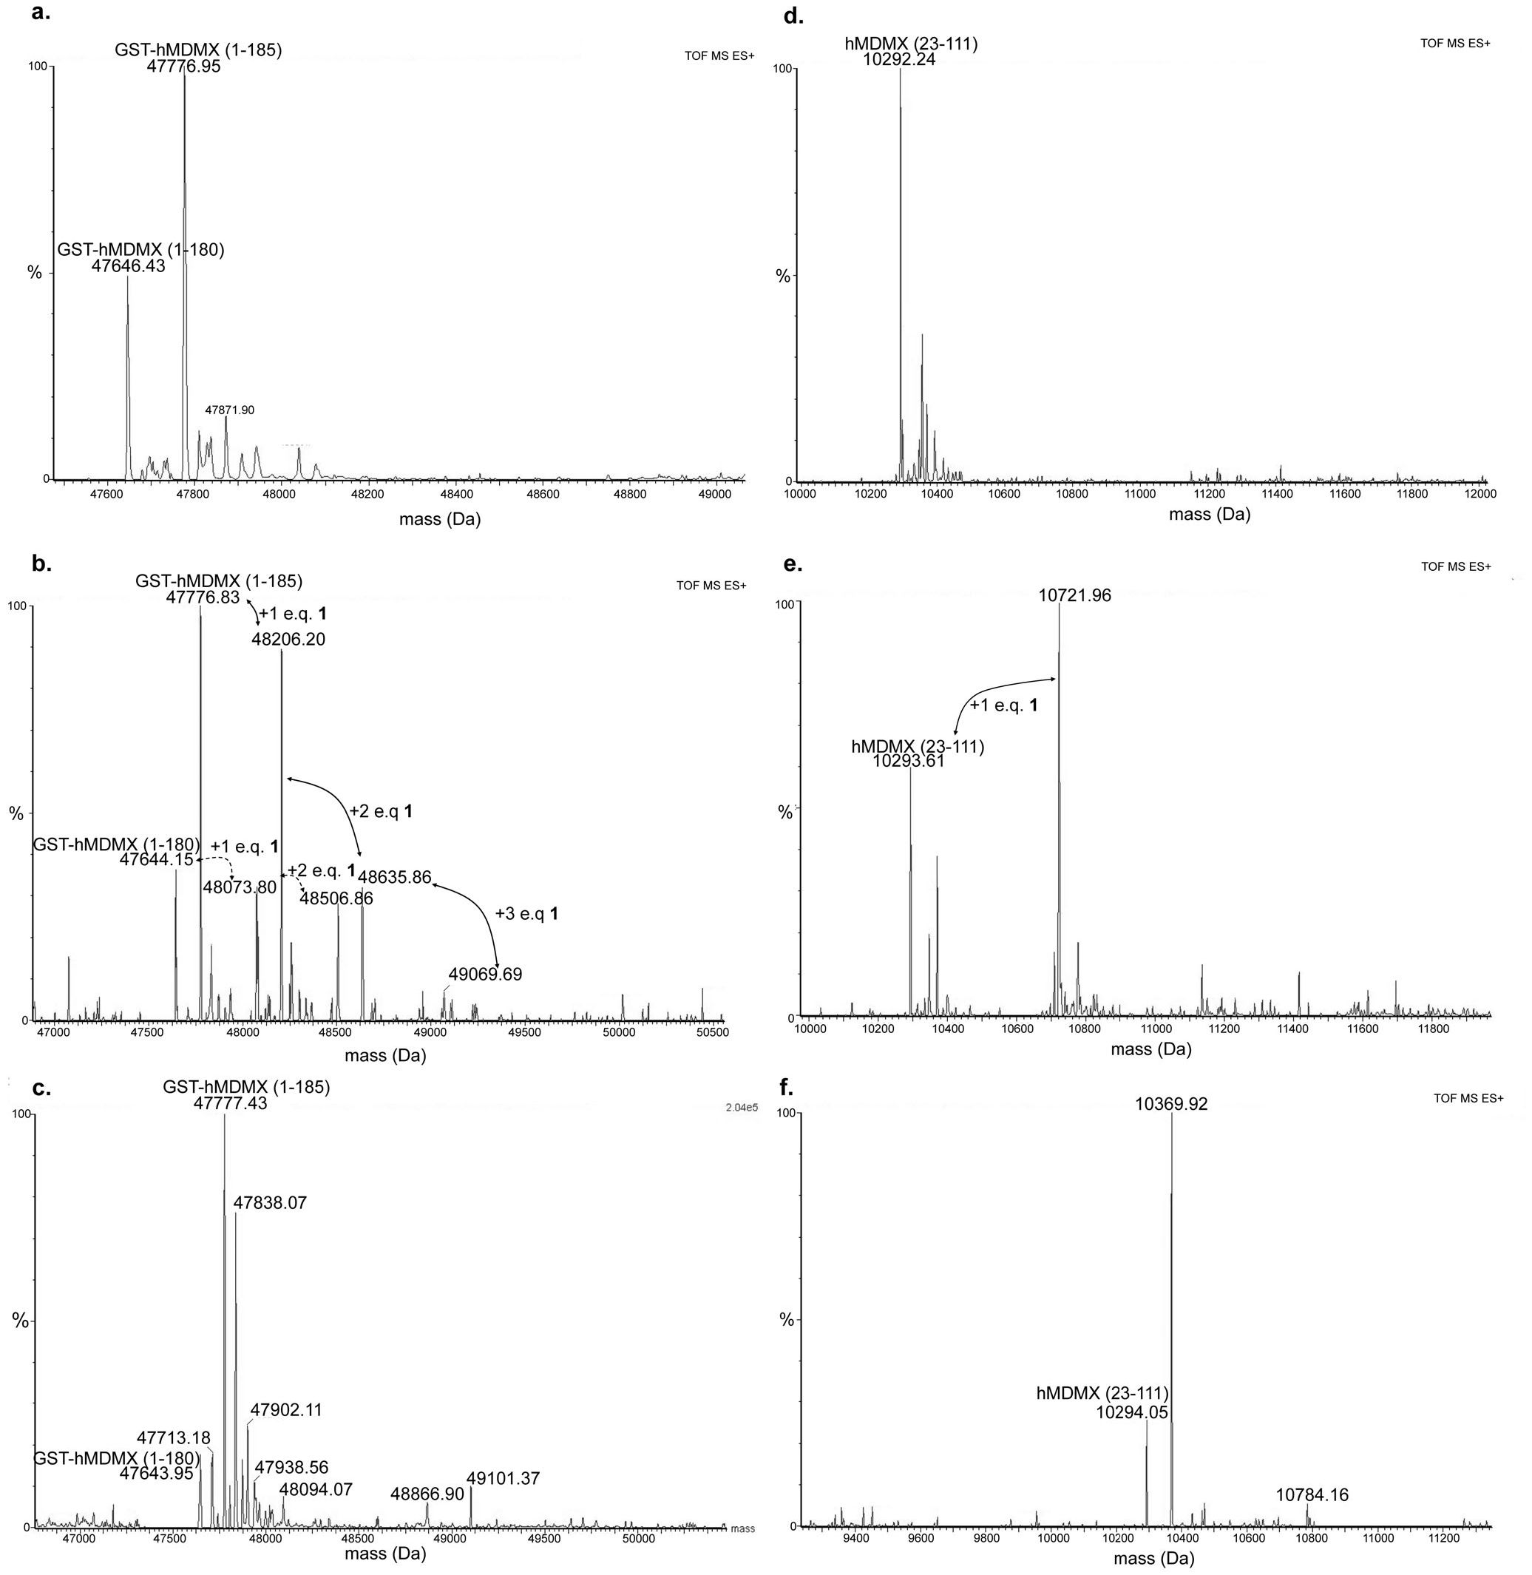
Mechanism of Action of SJ-172550
Figure 2. Formation of covalent adducts between compound 1 and MDMX. Panel a. Mass spectrum arising from unmodified hMDMX (GST-
tagged screening construct) showing unmodified mass of the protein. Panel b. Mass spectrum arising from treatment of 20 pM GST-hMDMX with
100 pM of compound 1 demonstrating multiple alkylation events. Note that 100 pM is well above the solubility limit of compound 1 and significant
aggregation of compound exists. Panel c. Mass spectrum arising from treatment of 1 pM GST-hMDMX with 5 pM of compound 1 demonstrating no
alkylation events. Panel d. Mass spectrum arising from unmodified hMDMX (untagged aa 23 to 111 construct) showing unmodified mass of the
protein. Panel e. Mass spectrum arising from treatment of 20 pM hMDMX with 100 pM of compound 1 demonstrating partial alkylation. Panel f.
Mass spectrum arising from treatment of 1 pM hMDMX with 5 pM of compound 1 demonstrating no alkylation.
doi:10.1371/journal.pone.0037518.g002
in aqueous buffer) and exists mostly in aggregated form, which we
have previously shown can result in aberrant protein behavior.
[18].
In order to test whether aggregation was a driver for the
observed activity of compound 1, the reactions were also carried
out at conditions more closely resembling those used in the
original report (20-fold reduction in total concentration of each
component, same stoichiometry). Under these conditions the
binding of p53 peptide to MDMX is fully inhibited at equilibrium.
In order to provide enough protein to give strong signal in the
mass spectrometer, this mixture had to be rapidly concentrated (5
minutes) prior to desalting. No adducts were detected for either
PLoS ONE | www.plosone.org
June 2012 | Volume 7 | Issue 6 | e37518
3
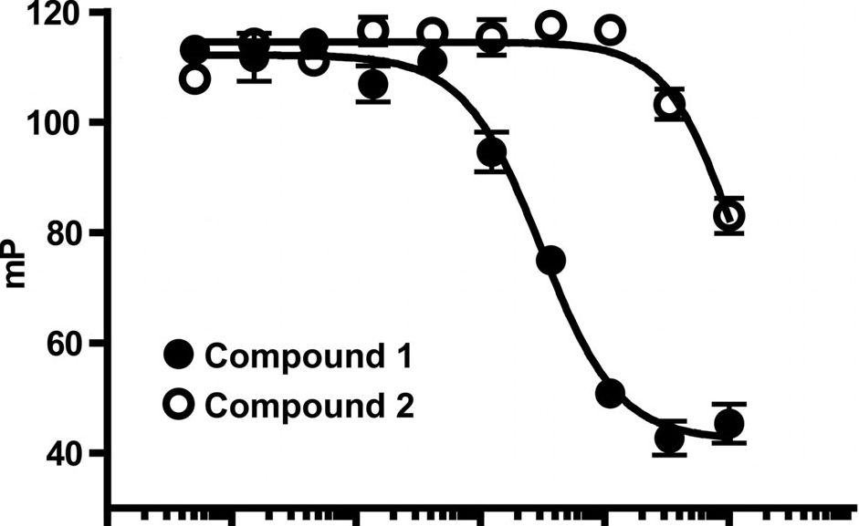
Mechanism of Action of SJ-172550
protein construct. One can conclude from these experiments and
the data published in our original report [10] that the interaction
of compound 1 with MDMX is covalent but reversible.
These experiments also suggest that any conditions that perturb
conformational equilibria may lead to adduct formation. We have
carried out similar experiments with a wide variety of protein
constructs of hMDMX and hMDM2 and demonstrated that
covalent adduct formation can occur with compound 1 in-
dependent of construct and in a wide variety of conditions (Figures
S7, S8, S9, and S10). Adduct formation is enhanced by changes in
ionic concentration, substantial increases in protein concentration,
or use of large amounts of the inhibitor (higher than its solubility
limit). The adduct formation appears to require the cysteine
residue within the protein.

Molecular Mechanism of Interaction of Compound 1 and
MDM Family Members
Careful consideration of these results suggests that compound 1
exerts its effect upon MDMX binding p53 by forming a covalent
complex with MDMX through reaction with the cysteine residue
in the binding domain but that the resulting adduct exists in
dynamic equilibria rather than being irreversible. If this were the
case, then the activity would be dependent upon the presence of
the electrophilic group within the chemotype and upon the
presence of the cysteine. To test this hypothesis, an experiment
was carried out to compare inhibition of MDMX-p53 peptide
binding with compound 1 and compound 2, which lacks the
required electrophilic center (Figure 3). Saturation of the ene-
amide group reduced the inhibitory potency by at roughly 30-fold,
consistent with covalent bond formation being important to the
mechanism of action. A similar result could be obtained by
allowing compound 1 to react with glutathione in situ, reducing
potency by 10-fold but not completely removing efficacy (Figure
S5). These experiments suggest that the binding of compound 1 to
MDMX utilizes both covalent and non-covalent interactions.
Most likely this takes the form of pre-organization of the
compound with the ‘‘active site’’ cysteine, followed by formation
of a covalent adduct, which we have previously reported with
other cysteine reactive electrophilic inhibitors [19].
The hypothesis also implies that the interaction requires the
presence of the cysteine residue in the binding domain. While we
have not tested this hypothesis on MDMX, we have shown that
a mutant of MDM2 protein (hMDM2(18-125)C77V) lacking the
cysteine (Figure S6) is inhibited by compound 1 with 10-fold
weaker potency than that seen with the MDM2 while the p53
binding potency of the mutant remains the same as that of the wild
type MDM2. This reinforces the key concept outlined above - the
interaction between compound 1 and MDMX/2 involves both
covalent and non-covalent components with both being required
for maximal potency. Moreover, the covalent component requires
the presence of both the unsaturated functionality of compound 1
and the cysteine of the protein. The most likely mechanism is
outlined in Figure 1 .

Conformational Flexibility of MDMX
MDMX contains a single cysteine residue within the N-terminal
p53 binding domain. Crystallographic studies have shown that the
residue is buried within the protein (inaccessible to the solvent).
Clearly, covalent modification would require at least partial
unfolding of the protein. The initial hypothesis concerning
reconciling the variation in alkylation with 1 was that the varying
buffer conditions were leading to partial denaturation of the
MDMX protein rendering it non-functional and simultaneously
revealing the cysteine - thus allowing for reaction with the
0.001 0.01 0.1 1 10 100 1000
Concentration (pM)
Figure 3. Inhibition of MDMX-p53 peptide binding by com-
pound 1 (IC50 = 3 uM), compound 2 (IC50>100 uM).
doi:10.1371/journal.pone.0037518.g003
unsaturated group on 1. In order to test this concept, we carried
out two series of experiments: 1) examination of binding of
MDMX immobilized to a surface by p53 peptide using surface
plasmon resonance (SPR) and 2) examination of the thermal
stability of MDMX.
The results of the SPR study are shown in Figure 4. In these
experiments, hMDMX (23-111) was immobilized to the SPR
chips using a biotin tag. Synthetic p53 peptide, in the presence or
absence of reducing agent, was then flowed across the SPR chip
and binding measured. When the experiment is carried out under
non-reducing conditions (Figure 4, Panels a and b; mimicking
the conditions of the original assays), the p53 peptide does bind,
but magnitude of the response is small (Panel a), the data quite
noisy, and the resulting binding isotherm not well defined (Panel
b). On the other hand, when the same protein on the same chip is
reduced in situ (1 mM TCEP) and probed with p53 peptide, the
response is robust (Panel c), the data clean, and the resulting
binding isotherm well defined (Panel d). Of note is the fact that
the measured Kd remains the same for both assays.
Thus, it appears that a substantial proportion of the protein in
the non-reducing conditions is not functionally active. However,
this is not a case of classic denaturation but rather a partial
unfolding because the protein remains dis-aggregated on analytical
chromatography (data not shown) and regains function with
addition of reducing agents. The comparable Kd values suggest
that the conformer responsible for binding p53 remains the same
in both conditions while reversibility of the ‘‘inactive’’ state
strongly suggests that the differences in behavior are due to
changes in conformer populations.
Next, the effects of buffer condition changes and exposure to
compound 1 upon the conformational equilibria of MDMX were
examined by a different technique - thermal stability as measured
by hydrophobic dye binding (Figure 5) [20]. Initially, MDMX
was allowed to interact with varying concentrations of 1 for 1 h.
Then the dye binding capacity of the protein was assessed across
a temperature range in order to induce a phase transition from low
to high dye binding - normally interpreted as the ‘‘melting point’’
of the protein - the point at which the conformational flexibility of
the protein cooperatively opens to many confirmations (Panel a)
[9]. In this case, compound 1 increases the temperature required
to reach a phase transition, which would normally be interpreted
as increasing stability. Our prior work has shown that similar
covalent inhibitors of protein interactions often show slow on rates,
PLoS ONE | www.plosone.org
4
June 2012 | Volume 7 | Issue 6 | e37518
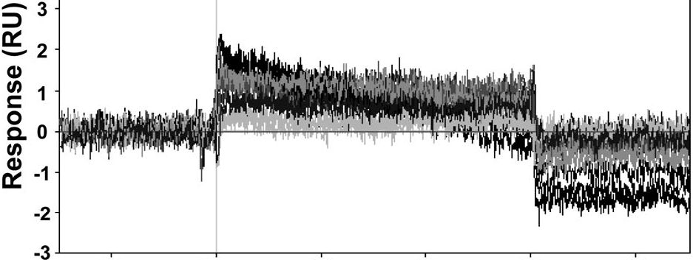
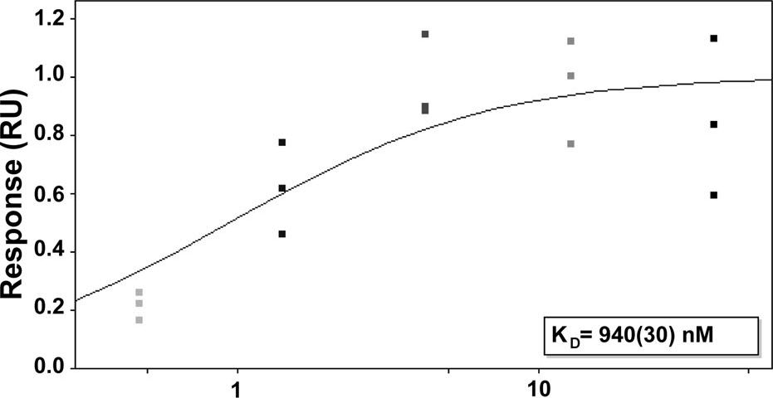
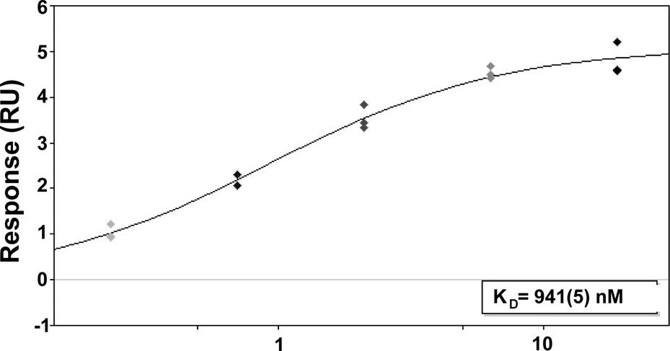
Mechanism of Action of SJ-172550

a.
5
4
-20 0 20 40 60 80
Time (sec)
b.
Concentration
-20 0 20 40 60 80
Time (sec)
d.
Concentration (jiM)
Figure 4. Variation in function of MDMX depending upon buffer conditions. Panel a. SPR binding of hMDMX(23-111) to p53 peptide
under non-reducing conditions. Note poor response indicating many of the protein molecules are not ''active.'' Panel b. The p53 binding curve
generated in non-reducing conditions showing a Kd of 940 nM. Panel c. SPR binding of hMDMX(23-111) to p53 in the presence of 1 mM TCEP is
much improved, indicating that more of the protein molecules are ''active.'' Panel d. The p53 binding curve generated under reducing conditions -
the Kd is the same as that determined under non-reducing conditions.
doi:10.1371/journal.pone.0037518.g004
relative to non-covalent inhibitors, and will show time dependen-
cies in their behaviors. [21-23] In order to assess if the shift in
MDMX melting point was time dependent the experiment was
carried out with long (1 h) and short (5 min) incubation times; no
change was observed in the phase transition temperature. Next,
the effects of reducing agents were examined. For both TCEP and
DTT, addition of the reducing agent to the preformed mixture of
MDMX and compound 1 (at apparent EC50 from the first
experiment) reversed the stabilization of the protein caused by
compound 1. When used alone, TCEP actually destabilized the
protein at high concentrations while DTT had no apparent effect.
This study strongly suggests that the binding of 1 to MDMX is
reversible and that its effect is suppressed by reducing agents,
whether or not they contain a nucleophilic thiol.

The Nature of the Reversibility of the Binding of
Compound 1 to MDMX
Key issues arising from these studies are whether or not the
interaction between compound 1 and the cysteine residue is truly
as depicted in Figure 1 (Panel b) and how it may influence or be
influenced by the conformational equilibrium of MDMX de-
scribed above. Preliminary experiments indicated that 1 could
form stable adducts with glutathione and with cysteine containing
peptides as detected by LC/MS (Figures S1 & S2). This was also
true with other analogs (Figure S11 and S12) that bind MDM2
and MDMX (Table S1). This raises the possibility that the
reversion of inhibition after treatment with reducing agents is due
to the trapping of compound 1 by excess nucleophilic reducing
agent while at equilibrium. Additionally, if MDMX was treated
with Ellman’s reagent (DTNB), which is known to form mixed
dithianes, the protein became unable to bind p53 peptide and the
melting point was partially stabilized (Figures S3 and S4). This
raises the possibility that DTT, which is capable of forming such
species might reverse the effects of compound 1 by inducing
formation of a new protein adduct.
In order to address these issues, compound 1 was allowed to
interact with MDMX in the presence or absence of TCEP (a non-
thiol reducing agent) and binding monitored by SPR. TCEP is
neither expected to trap compound 1 nor form adducts with
MDMX. When MDMX was immobilized to the chip and then
treated with compound 1 in the absence of reducing agent, there was
clear strong signal representing binding (Figure 6, Panel a) and
after the initial binding a decay of signal indicating that compound 1
binds reversibly. The off rate was relatively slow, requiring almost 5
minutes to return to baseline after the pulse of compound 1. If the
same experiment was carried out in the presence of the non-
nucleophilic reducing agent no binding was observed (Panel b). In
control experiments where compound 1 was exposed to an excess of
TCEP in the same buffers used for the MDMX protein experiments,
no adduct formed between compound 1 and TCEP (data not
shown). While not unexpected, this clearly indicates that compound
1 should be available for covalent reaction with the reduced cysteine.
This study indicates that the binding of 1 to MDMX is reversible and
requires access to a conformation that is suppressed by reducing
conditions. This also explains why no covalent adduct is observed
after treatment of MDMX with 1 when the protein is dialyzed prior
to mass spectrometry - the dialysis time was sufficient to allow
reversal of the reaction.
PLoS ONE | www.plosone.org
June 2012 | Volume 7 | Issue 6 | e37518
5
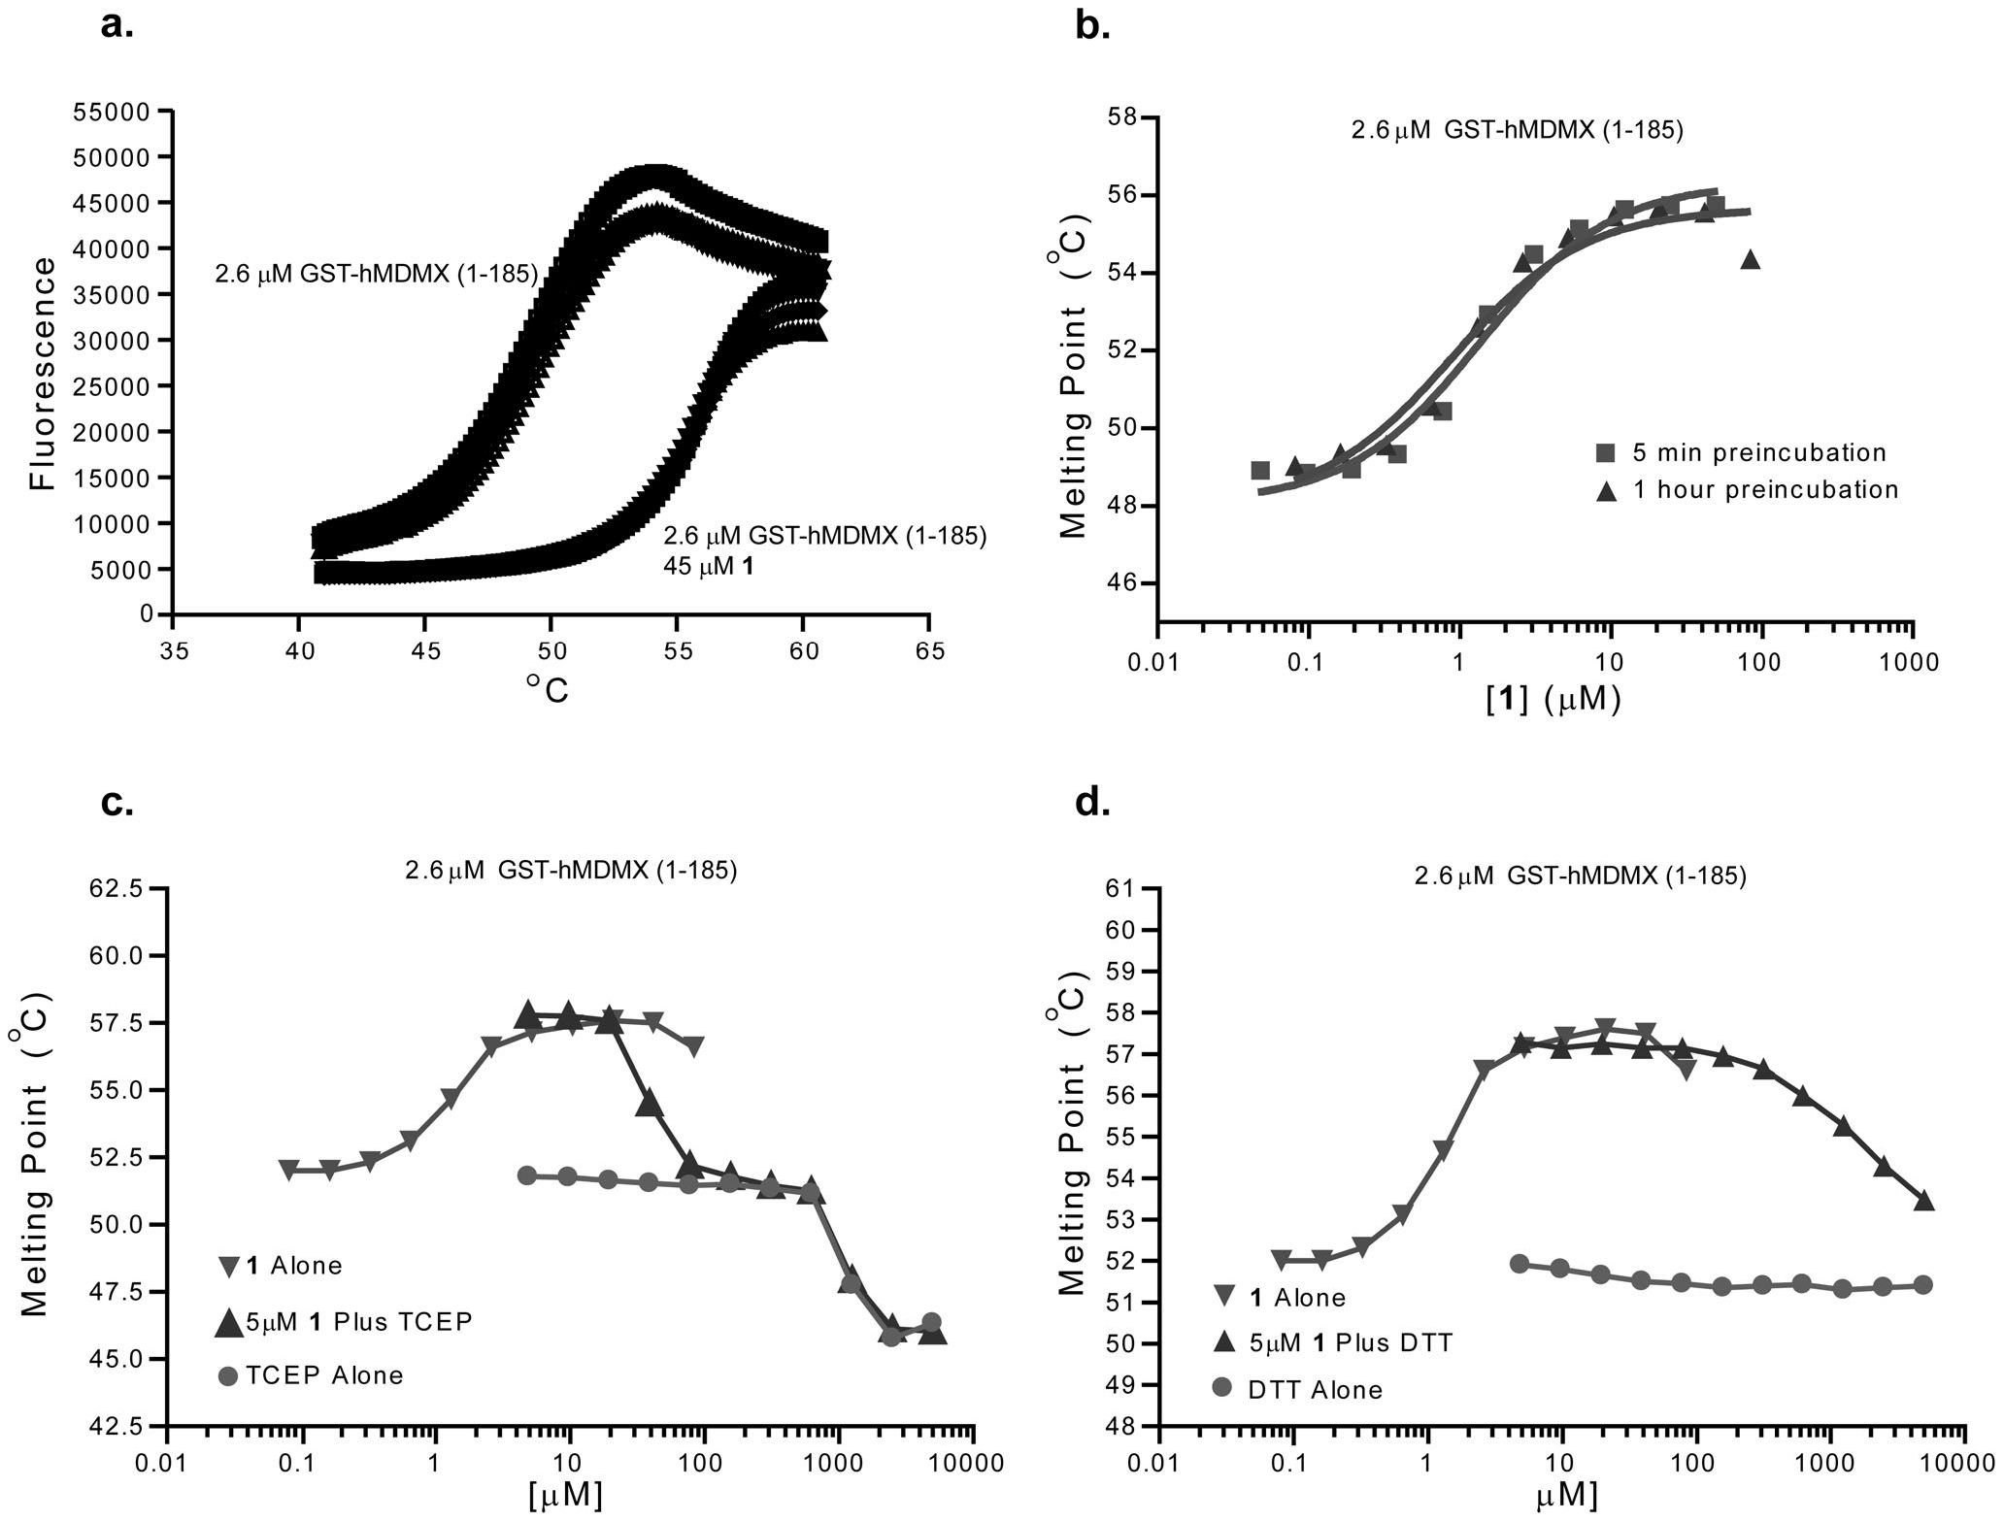
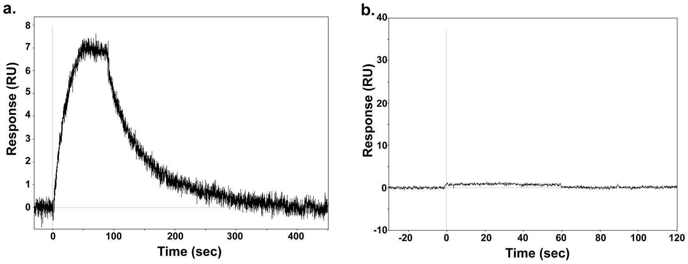
Mechanism of Action of SJ-172550
Figure 5. Thermal stability equilibria of MDMX. Panel a. Thermal shift data for MDMX (23-111) showing a 7 degree stabilization of the
protein's melting point by addition of compound 1. The panel shows individual data sampling points from 3 independent experiments from each
condition. Panel b. Dose dependency and time dependency of the effect showing an apparent EC50 of roughly 1 mM and minimal time dependency.
Panel c. Dose dependent reversal of the effects of compound 1 by TCEP. Panel d. Dose dependent reversal of the effects of compound 1 by DTT.
doi:10.1371/journal.pone.0037518.g005
Figure 6. Reversibility of the interaction of compound 1 with MDMX. Panel a. SPR study of the binding of 1 (100 mM) to hMDMX (aa 23-
111) under non-reducing conditions. While the off-rate is slow, the interaction is reversible. Panel b. SPR study of the binding of 1 (100 mM) to
hMDMX (aa 23-111) under reducing conditions. No binding is observed.
doi:10.1371/journal.pone.0037518.g006
PLoS ONE | www.plosone.org
June 2012 | Volume 7 | Issue 6 | e37518
6
Mechanism of Action of SJ-172550

Model of Interaction of MDMX with 1
The studies described above suggest a consistent model of
MDMX inhibition by compound 1. MDMX exists in a dynamic
conformational equilibrium of at least two states that is biased both
by the effects of compound 1 and reducing agents. In one state,
which is favored by non-reducing conditions and concentrations of
compound 1 above the solubility limit, MDMX is not competent
to bind p53 and the side chain of cysteine 76 is exposed to the
solvent and thus available for alkylation. Alkylation of Cys76 with
1 stabilizes this form, thus explaining the effect of compound 1 on
p53 binding. A second state is favored in the presence of reducing
agents and inhibitor concentrations below the solubility limit. In
this state MDMX is able to bind p53 and the cysteine 76 side
chain is buried inside the protein and thus resistant to alkylation.
The fact that irreversible alkylation with DTNB also blocks p53
binding suggests that any alkylation of cysteine 76 will result in
a conformational bias towards the conformation unable to bind
p53. The mechanism by which reducing agents push the
equilibrium towards the p53 binding competent conformation is
unclear and may not simply be explained by forcing Cys76 into
a reduced state.
Thus, the MDMX protein exists in a complex conformational
equilibrium that is biased both by the effects of compound 1 and
reducing agents. Taken together these studies demonstrate that
MDMX exists in conformers that are respectively either 1)
relatively conformationally closed and competent to bind p53
peptide; or 2) relatively conformationally open and incompetent to
bind p53 peptide. These conformational states appear to be in
equilibrium with one another. Compound 1 appears to lock the
protein into the latter state while reducing agents push it towards
the former. These findings highlight the complex mechanism of
compound 1, which does not appear to act as a simple competitive
inhibitor but rather by affecting the conformation of its target
protein. The study also emphasizes the role of the single cysteine
residue in the p53 binding domain of MDMX which appears to be
critical both for controlling the conformational equilibria of the
protein and for the mechanism of action of compound 1. The
originally reported data on reversibility of 1 were thus only a part
of the full story uncovered here. This complex, multi-mode
mechanism complicates the interpretation of experiments using 1
and limits its value as a lead compound for further development as
a selective MDMX inhibitor.

Materials and Methods

Protein Expression and Purification
A GST fusion protein of the p53-binding domain of human
MDMX (a.a. 1-185) was cloned into a pGEX-4T1 plasmid. A
second construct expressing a shorter hMDMX (a.a. 23-111) with
a HIS-tag into a pGEX plasmid. Both constructs were expressed
in BL21(DE3) E. coli. The bacterial cells were collected by
centrifugation and lysed by sonication. Lysates were cleared by
ultra centrifugation (100,000 g for 30 minutes). For the GST-
tagged version the supernatant was purified using a GSTrap Fast-
Flow column (GE Healthcare). For the His-tagged version, the
protein was purified using Talon nickel resin and the His-tag was
subsequently removed by proteolytic cleavage. In both cases, the
eluted protein was further purified by a Mono Q anion-exchange
chromatography and gel filtration using S200 column. Peak
fractions were combined and dialyzed into phosphate-buffered
saline (pH 7.6) with 2 mM phenylmethylsulfonyl fluoride. Biotin-
MDM4 was prepared using avi-tagged MDM4 (a.a. 23-111) and
biotin labeled as recommended by the vendor (Genecopeia).

Isothermal Denaturation (ITD)
The ITD measurements were performed with a RT-PCR
instrument (Applied Biosystems 7900HT) equipped with a 384-well
probe using SYBR detection (excitation 495/emission 537). The
program used started at 45° C and the temperature increased at a rate
of 1 degree per minute. The final concentrations were 0.125 mg/ml
of GST-hMDMX (a.a. 1-185), varying concentrations of test
compound (25 nM to 100 mM) and Sypro orange (Invitrogen) at 5-
fold the protein concentration in a buffer consisting of 10 mM TRIS
(pH 8.0) and 25 mM NaCl [24]. The final volume was 20 ml for
each well using 384 ABI PRISMTM plates (Applied Biosystems).
The data was exported and evaluated using a custom data
processing algorithm coded in Pipeline Pilot (Scitegic). Apparent
melting temperatures were calculated by measuring the temperature
at which the observed fluorescence signal was halfway between the
baseline and the maximum. Binding curves were determined by
graphing observed apparent melting temperature as a function of
test compound concentrations. These curves were then fit to a four
parameter sigmoidal dose response model using PRISM 5.0
(GraphPad Software, Inc.).

Solubility
Solubility assay was carried out on Biomek FX lab automation
workstation (Beckman Coulter, Inc., Fullerton, CA) using mSOL
Evolution software (pION Inc., Woburn, MA). The detailed
method is described as following. 10 mL of 10 mM compound
stock (in DMSO) was added to 190 pL 1-propanol to make
a reference stock plate. 5 mL from this reference stock plate was
mixed with 70 pL 1-propanol and 75 pL SSB (system solution
buffer, pH adjusted to 7.4, pION Inc., Woburn, MA) to make the
reference plate, and the UV spectrum (250 nm -500 nm) of the
reference plate was read. 6 pL of 10 mM test compound stock was
added to 594 pL SSB in a 96-well storage plate and mixed. The
storage plate was sealed and incubated at room temperature for 18
hours. The suspension was then filtered through a 96-well filter
plate (pION Inc., Woburn, MA). 75 pL filtrate was mixed with
75 pL 1-propanol to make the sample plate, and the UV spectrum
of the sample plate was read. Calculation was carried out by
pSOL Evolution software based on the AUC (area under curve) of
UV spectrum of the sample plate and the reference plate. All
compounds were tested in triplicates.

Fluorescence Polarization Assay
All fluorescence polarization assays were performed in binding
buffer (10 mM Tris, pH 8.0, 170 mM NaCl, 0.05% Tween-20)
unless otherwise noted. For competition assays a master mix of
15 nM Texas red-labeled (N-terminal label) P53 Peptide (sequence:
GSGSSAETFSDLWKLLPEN) with 1 pM hMDMX (GST-
tagged, a.a. 1-185) was prepared and 20 pl was added to black
polystyrene 384 well plates (Corning #3573). DMSO stock solutions
of test compounds were then added by pin transfer (V&P scientific) in
nano-liter volumes (maximum final DMSO percentage = 1%). The
assay mixture was incubated at room temperature for one hour and
read on an EnVision multi-label plate reader using a 555 nm
excitation filter, a 632 nm emission filter, and a Texas Red FP
dichroic mirror. Binding inhibition curves and IC50 values were
determined by fitting observed mP values to a 4-parameter
sigmoidal binding curve using PRISM 5.0 (GraphPad Software,
Inc.).

Mass Spectroscopy Experiments
Samples were prepared in binding buffer (10 mM Tris, pH 8.0,
170 mM NaCl) with a 50 pl final volume. Final concentration of
PLoS ONE | www.plosone.org
7
June 2012 | Volume 7 | Issue 6 | e37518
Mechanism of Action of SJ-172550
test compounds (0 to 100 pM) and hMDMX constructs (1 or
20 pM) were varied as indicated in figure legends. Samples were
incubated at room temperature for 1.5 hours after which they
were stored overnight at 4°C before analysis by mass spectrom-
etry. Samples containing 1 pM hMDMX constructs were
concentrated to 20 pM using 3000 MWCO centrifugal protein
concentrators (Vivascience, Inc.) immediately prior to analysis.
Prior to injection all samples were desalted using a reverse phase
C8 Zip Tip (Millipore) and eluted in 50% acetonitrile, 2% formic
acid. The samples were ionized by static nanospray using
EconoTips (New Objective) on a Waters LCT Premier XE mass
spectrometer using positive mode. The resultant charge envelope
was deconvoluted using MaxEnt 1 algorithm of MassLynx V
- sp 4 software. A mass error of 1Da for every 10,000 Da is
permissible using this mass spectrometer.

Surface Plasmon Resonance Assay
Binding studies were performed at 25°C using a Biacore T100
(GE Healthcare) surface plasmon resonance (SPR) instrument.
Either streptavidin or NeutrAvidin (Thermo Scientific) was
immobilized on a carboxymethyldextran-coated gold surface
(CM5 chip; GE Healthcare) by standard amine coupling methods.
The carboxymethyl groups of dextran were activated with N-ethyl-
N-(3-dimethylaminopropyl) carbodiimide (EDC) and N-hydroxy-
succinimide (NHS). For peptide experiments, streptavidin was
attached at pH 4.5 in 10 mM sodium acetate to levels of
~3000 RU per flow cell. For small molecule experiments,
NeutrAvidin was attached at pH 5.0 in 10 mM sodium acetate
to levels of ~ 11000-12000 RU per flow cell. Any remaining
reactive sites were blocked by reaction with ethanolamine. Biotin-
MDM4 was captured on the chip by injection over the
streptavidin or NeutrAvidin surface.
For peptide binding experiments, p53wt peptide was prepared
as a 3-fold serial dilution in peptide binding buffer (20 mM Bis-
Tris pH 6.5, 200 mM NaCl, 0.1 mg/mL bovine serum albumin,
- 005. Tween20, +/ — 1 mM TCEP). The peptide was injected in
triplicate at each concentration at a flow rate of 75 pL/min. In
non-reducing conditions the peptide concentration range was
38 pM -469 nM, and in reducing conditions it was 19 pM -
235 nM. For small molecule binding, compound SJ-172550 (1)
was prepared in binding buffer (20 mM Bis-Tris pH 6.5,
200 mM NaCl, 0.01% Tween20, 5% DMSO) and injected at
a single concentration of 100 pM at a flow rate of 100 pL/min.
Data were processed, double-referenced and solvent corrected
(where appropriate) using the software package Scrubber2 (version
- b, BioLogic Software). Equilibrium dissociation constants (Kd)
for peptide binding were determined by equilibrium affinity
analysis with a 1:1 binding model using Scrubber2.

Supporting Information
Figure S1 Formation of adducts by glutathione and
compound 1.
(TIF)

References
- Hanahan D, Weinberg RA (2011) Hallmarks of cancer: the next generation.
Cell 144: 646-674.
- Vazquez A, Bond EE, Levine AJ, Bond GL (2008) The genetics of the p53
pathway, apoptosis and cancer therapy. Nat Rev Drug Discov 7: 979-987.
- Marine JC, Dyer MA, Jochemsen AG (2007) MDMX: from bench to bedside.
J Cell Sci 120: 371-378.
- Mancini F, Di Conza G, Moretti F (2009) MDM4 (MDMX) and its Transcript
Variants. Curr Genomics 10: 42-50.
Figure S2 Formation of adducts by cysteine containing
peptide and compound 1.
(TIF)
Figure S3 Inhibition of interaction of p53 and MDMX
with DTNB.
(TIF)
Figure S4 Partial Stabilization of melting point of
MDMX with DTNB.
(TIF)
Figure S5 Effects of glutathione upon potency of
compound 1 and nutlin in blocking binding of p53
peptide by MDMX.
(TIF)
Figure S6 C77A mutation abolishes the ability of
compound 1 to covalently label MDM2.
(TIF)
Figure S7 Formation of adducts by hMDMX(1-134) and
compound 1.
(TIF)
Figure S8 Formation of adducts by hMDMX(1-111) and
compound 1.
(TIF)
Figure S9 Formation of adducts by hMDM2(1-118) and
compounds 1 and 3.
(TIF)
Figure S10 Formation of adducts by hMDM2(1-125) and
compound 1.
(TIF)
Figure S11 Formation of adducts by P-mercaptoetanol
and compound 3 evidenced by NMR.
(TIF)
Figure S12 Reduced sensitivity of C77A mutant of
MDM2 to compound 3 but not nutlin in blocking the
interaction with p53 peptide.
(TIF)
Table S1 Binding affinities of close and distant deriva-
tives of 1 towards Mdm2 and Mdmx.
(PDF)

Acknowledgments
We thank Dr. Brenda Schulman and Danny Scott for the donation of
biotinylated MDMX used in the SPR studies.

Author Contributions
Conceived and designed the experiments: MB DS GD RKG. Performed
the experiments: MB DS AP GS KP JM AP KF MZ B. Waddell B.
Wladyka SK-K. Analyzed the data: MB DS JM MAD GD RKG.
Contributed reagents/materials/analysis tools: MB DS AP GS KP JM AP
KF MZ B. Waddell B. Wladyka SK-K. Wrote the paper: RKG GD.
- Wynendaele J, Bohnke A, Leucci E, Nielsen SJ, Lambertz I, et al. (2010) An
illegitimate microRNA target site within the 3’ UTR of MDM4 affects ovarian
cancer progression and chemosensitivity. Cancer Res 70: 9641-9649.
- Vassilev LT, Vu BT, Graves B, Carvajal D, Podlaski F, et al. (2004) In vivo
activation of the p53 pathway by small-molecule antagonists of MDM2. Science
303: 844-848.
- HeroldJM, Wigle TJ, Norris JL, Lam R, Korboukh VK, et al. (2011) Small-
molecule ligands of methyl-lysine binding proteins. Journal of medicinal
chemistry 54: 2504-2511.
PLoS ONE | www.plosone.org
8
June 2012 | Volume 7 | Issue 6 | e37518
Mechanism of Action of SJ-172550
- Artz JD, Wernimont AK, Allali-Hassani A, Zhao Y, Amani M, et al. (2011) The
Cryptosporidium parvum kinome. BMC genomics 12: 478.
- Senisterra G, Chau I, Vedadi M (2011) Thermal Denaturation Assays in
Chemical Biology. Assay and drug development technologies.
- Reed D, Shen Y, Shelat AA, Arnold LA, Ferreira AM, et al. (2010)
Identification and characterization of the first small molecule inhibitor of
MDMX. J Biol Chem 285: 10786-10796.
- Popowicz GM, Czarna A, Wolf S, Wang K, Wang W, et al. (2010) Structures of
low molecular weight inhibitors bound to MDMX and MDM2 reveal new
approaches for p53-MDMX/MDM2 antagonist drug discovery. Cell Cycle 9:
1104-1111.
- Pazgier M, Liu M, Zou G, Yuan W, Li C, et al. (2009) Structural basis for high-
affinity peptide inhibition of p53 interactions with MDM2 and MDMX. Proc
Natl Acad SciU S A 106: 4665-4670.
- Bernal F, Wade M, Godes M, Davis TN, Whitehead DG, et al. (2010) A stapled
p53 helix overcomes HDMX-mediated suppression of p53. Cancer Cell 18:
411—422.
- Bose P, Ozer H (2009) Neratinib: an oral, irreversible dual EGFR/HER2
inhibitor for breast and non-small cell lung cancer. Expert Opin Investig Drugs
18: 1735-1751.
- Kuhn DJ, Orlowski RZ, Bjorklund CC (2011) Second generation proteasome
inhibitors: carfilzomib and immunoproteasome-specific inhibitors (IPSIs). Curr
Cancer Drug Targets 11: 285-295.
- Ocana A, Amir E (2009) Irreversible pan-ErbB tyrosine kinase inhibitors and
breast cancer: current status and future directions. Cancer Treat Rev 35:
685-691.
- Wallentin L (2009) P2Y(12) inhibitors: differences in properties and mechanisms
of action and potential consequences for clinical use. Eur Heart J 30:
1964-1977.
- Feng BY, Shelat A, Doman TN, Guy RK, Shoichet BK (2005) High-throughput
assays for promiscuous inhibitors. Nature chemical biology 1: 146-148.
- Arnold LA, Estebanez-Perpina E, Togashi M, Jouravel N, Shelat A, et al. (2005)
Discovery of small molecule inhibitors of the interaction of the thyroid hormone
receptor with transcriptional coregulators. J Biol Chem 280: 43048-43055.
- Vedadi M, Niesen FH, Allali-Hassani A, Fedorov OY, Finerty PJ Jr., et al.
(2006) Chemical screening methods to identify ligands that promote protein
stability, protein crystallization, and structure determination. Proc Natl Acad
Sci U S A 103: 15835-15840.
- Hwang JY, Attia RR, Zhu F, Yang L, Lemoff A, et al. (2012) Synthesis and
Evaluation of Sulfonylnitrophenylthiazoles (SNPTs) as Thyroid Hormone
Receptor-Coactivator Interaction Inhibitors. Journal of medicinal chemistry.
- Hwang JY, Huang W, Arnold LA, Huang R, Attia RR, et al. (2011)
Methylsulfonylnitrobenzoates, a new class of irreversible inhibitors of the
interaction of the thyroid hormone receptor and its obligate coactivators that
functionally antagonizes thyroid hormone. J Biol Chem 286: 11895-11908.
- Hwang JY, Arnold LA, Zhu F, Kosinski A, Mangano TJ, et al. (2009)
Improvement of pharmacological properties of irreversible thyroid receptor
coactivator binding inhibitors. Journal of medicinal chemistry 52: 3892-3901.
- Lavinder JJ, Hari SB, Sullivan BJ, Magliery TJ (2009) High-throughput thermal
scanning: a general, rapid dye-binding thermal shift screen for protein
engineering. Journal of the American Chemical Society 131: 3794-3795.
PLoS ONE | www.plosone.org
9
June 2012 | Volume 7 | Issue 6 | e37518

