GEOLOGIA • 2009 • Tom 35 • Zeszyt 3/1 • 9-15

MYSTERIOUS HIGH-PYROPE DETRITIC GARNETS
IN THE MIDDLE JURASSIC CLASTICS
OF THE CRACOW REGION

Zagadkowy, wysokopiropowy detrytyczny granat
w środkowojurajskich utworach klastycznych
regionu krakowskiego
Roman AUBRECHT¹, Stefan MERES²,
Michał GRADZIŃSKI³ & Milan SYKORA¹
¹Comenius University, Faculty of Natural Sciences,
Department of Geology and Paleontology,
Mlynska dolina - G, 842 15 Bratislava, Slovakia;
e-mail: Aubrecht@fns.uniba.sk, sykora@nic.fns.uniba.sk
Comenius University, Faculty of Natural Sciences, Department of Geochemistry,
Mlynska dolina - G, 842 15 Bratislava, Slovakia;
e-mail: meres@fns.uniba.sk
³Jagiellonian University, Institute of Geological Sciences;
ul. Oleandry 2a, 30-063 Kraków, Poland;
e-mail: michal.gradzinski@uj.edu.pl
Treść: W celu rozpoznania składu minerałów ciężkich środkowojurajskich piasków i piaskowców,
analizie poddano utwory tego wieku z kilku odsłonięć okolic Krakowa (Dębnik, Dębnik-Czatkowice,
Racławice, Paczółtowice). Wykazano w ich obrębie wysoki udział minerałów z grupy granatu, wska-
zując na duże podobieństwo do minerałów tego typu znanych z zewnętrznych Karpat Zachodnich.
Tym niemniej bezpośrednie wskazanie obszaru źródłowego tych minerałów nie jest możliwe,
a stwierdzić można jedynie, że ten enigmatyczny region obfitował w granulity, eklogity i perydotyty.
Słowa kluczowe: minerały ciężkie, jura, monoklina śląsko-krakowska, analiza proweniencji, granat
Key words: heavy minerals, Jurassic, Polish platform, provenance analysis, garnet

INTRODUCTION
Detritic heavy mineral analysis of the Middle Jurassic sands and sandstones in the
southern part of the Kraków-Wieluń Upland was performed to compare the heavy-mineral
assemblages with those published from the Tethyan Jurassic of the Western Carpathians
10
R. Aubrecht, Ś. Meres, M. Gradziński & M. Sykora
(Łoziński 1956, 1957, 1966, Aubrecht 1993, 2001), Eastern Alps (Faupl 1975) or from the
Tethyan margin of the Bohemian Massif (Stelcl et al. 1972, 1977). The results from the
Tethyan regions show big differences in the heavy mineral spectra between the internides
and externides. The externides are dominated by garnet, accompanied by zircon, rutile and
tourmaline, with subordinate amounts of other minerals. The internides are characterized by
predominance of tourmaline and apatite, accompanied with zircon and rutile. The results
from the margin of the Bohemian Massif correlate well with the results from the externides.
Analyses of detritic garnet in the samples from the externides (Jurassic to Paleogene of the
Pieniny Klippen Belt and Flysch Zone) display big portion of pyrope-almandine garnets
coming from granulites and eclogites (Otava et al. 1997, 1998, Aubrecht & Meres 1999,
2000, Salata 2004, Grzebyk & Leszczyński 2006). Wieser (1985) reports about rich granu-
litic pebble material from the Silesian Unit of the Flysch Zone. Exotic, pyrope-almandinic
garnets were also reported from the Carboniferous of the Moravo-Silesian Culm basin
(Copjakova et al. 2001, Hartley & Otava 2001). Most of the authors derived this exotic
garnet material from Moldanubian zone of the Bohemian Massif. Except of this zone, there
are only two other known occurrences of granulites and eclogites - Góry Sowie Block and
the Snieżnik area complex in the Western Sudetes (Smulikowski 1967, Oberc 1972, Kryza
et al. 1996). These are, however, too small to be a regionally important source of clastic
material.

GEOLOGICAL SETTING
Middle Jurassic deposits of the Kraków region (Kraków-Wieluń Upland, Poland) rep-
resent the transgressive sequence. They were laid down on the erosional surface, which is
developed on the older, Palaeozoic and Mesozoic rocks. In some places the lower or early
Middle Jurassic continental clays (mainly lacustrine) are preserved. The sequence of
Middle Jurassic deposits commences with quartz sand and sandstone, which comprises con-
glomeratic horizons. These deposits are devoid of any fossils excluding silicified fragments
of tree trunks. They are of shallow marine origin, however their basal part might be depo-
sited in fluvial environment. They gradually pass upwards into sandy limestone of Callo-
viense zone. The transgression caused the filling of the uneven basement topography. It is
reflected by variable thickness of clastic deposits, which varies from zero up to 10 m while
the sandy limestone is about 3 m in thickness. The latter belongs to Calloviense Zone
whereas the underlying clastics are of uppermost Bathonian and lowermost Callovian age.
Percentual ratios of heavy minerals in this formation were previously published by
Krysowska (1960, 1962). She reported about the heavy mineral spectra dominated by gar-
net, accompanied by zircon and rutile, with subordinate amount of turmaline and staurolite.
We studied the following localities: quarry at the road between Dębnik and Czatkowice
Mysterious high-pyrope detritic garnets in the Middle Jurassic elastics.
11
(N 50°13T6.5", E 19°47'41.3"), Dębnik Quarry (N 50°09'52.1", E 19°40T7.4"), Pa-
czółtowice (N 50°10'33", E 19°39'22.9") and Racławice (N 50°11,7.8^{M}, E 19°40,34.5").

METHODS USED
The heavy minerals were separated from the sands in heavy liquids (bromoform, den-
sity ca 2.8). The fraction 0.08-0.25 mm was studied in transmitting light, the whole fraction
was examined also by binocular lense. Percentual ratios of the heavy mineral assemblages
were determined by ribbon point counting. The opaque minerals in all samples were domi-
nated by limonite and pyrite, that are insignificant from the point of view of clastic prove-
nance. Therefore, the results presented in this paper are exclusively from translucent heavy
minerals. The composition of garnets was determined using a CAMECA SX-100 electron
microprobe at the State Geological Institute of Dionyz Stur in Bratislava. The analytical
conditions were 15 kV accelerating voltage and 20 nA beam current, with a peak counting
time of 20 seconds and a beam diameter of 2-10 |j,m. Raw counts were corrected using
a PAP routine.

RESULTS AND INTERPETATIONS
The studied heavy mineral spectra were slightly dominated by garnet but the contents
of zircon, rutile and turmaline were also high which is in contradiction with previous results
of Krysowska (1960, 1962). These four minerals were accompanied by lesser amounts of
staurolite and apatite. The microprobe analyses of detrital garnet grains show that they can
be divided into 5 groups, according to their composition (Fig. 1):
- Garnets coming from garnet peridotites. These have high contents of pyrope molecule
(~70 mol %), relatively low contents of almandine (~15 mol %), grossular (~12 mol %)
and very low spessartine molecule (< 1 mol %).
- Garnets coming from granulites. They have relatively lower contents of pyrope
(30-50 mol %) than the previous ones, but have higher contents of almandine
(50-60 mol %), low proportion of grossular (~5 mol %) and very low contents of spes-
sartine (~2 mol %).
- Garnets coming from eclogites. These have pyrope contents about 30-56 mol %, al-
mandine contents of 35-45 mol % and that of spessartine less than 1 mol %. They differ
from the group No. 2 by higher proportion of the grossular molecule (20-30 mol %).
- Garnets coming from gneisses. They have high almandine contents (~60 mol %), low
pyrope contents (~10 mol %) and higher contents of spessartine (10-27 mol %) than
granulitic garnets. Contents of grossular were less than 6 mol %.
- Garnets coming from amphibolites. They are characteristic by pyrope contents of
about 15-25 mol %, low spessartine contents (< 10 mol%), gigher grossular contents
(20-30 mol %) and relatively high contents of almandine (~75 mol %).
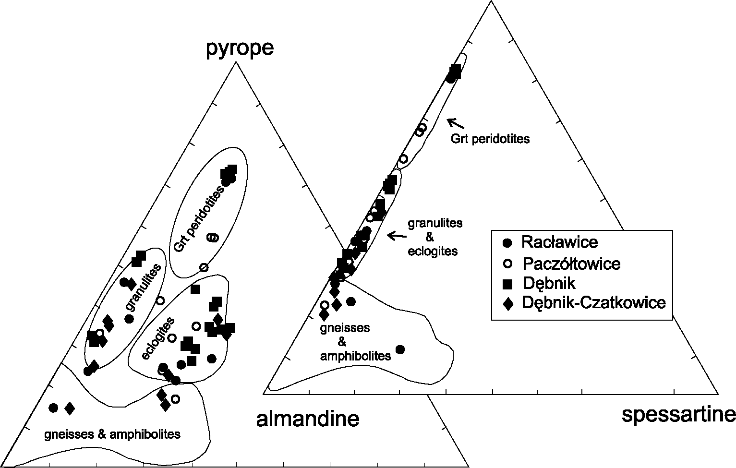
12
R. Aubrecht, Ś. Meres, M. Gradziński & M. Sykora

pyrope

almandine grossular
Fig. 1. Composition of the detrital garnets from the Bathonian-Callovian sands
from the Cracow Region and their source rocks
Fig. 1. Skład detrytycznych granatów z batońsko-kelowejskich piaskach
z obszaru krakowskiego i ich skały źródłowe
All the garnets from the Dębnik locality are characterized by high pyrope contents
(> 30 mol %). Such garnets are typical for high-grade metamorphics. According to chemi-
cal variability, they represent garnets from garnet peridotites, granulites and eclogites. In
the quarry between Dębnik and Czatkowice, garnets from garnet peridotites, granulites
and eclogites were distinguished. Garnets from gneisses were in minority. The source rocks
of the garnets from Racławice locality were granulites, eclogite, gneisses and amphibolites.
Paczółtowice locality contains ganets from garnet peridotites, granulites and eclogites.

DISCUSSION AND CONCLUSIONS
All the examined samples yielded surprisingly high portion of pyrope-almandine to
pyrope garnets. The heavy mineral percentages and the garnet chemistry are very similar to
the data from the West Carpathian externides. In this part of the Hercynides, however, it is
difficult to estimate the source area. As mentioned in the introduction, there are only small
Mysterious high-pyrope detritic garnets in the Middle Jurassic clastics.
13
terrains with granulites and eclogites in Poland (Góry Sowie and Śnieżnik). Granulitic
rocks are generally considered as exotic in the area of Cracow. Some granulitic pebbles
were found in the Carboniferous sediments of the Upper Silesia Coal Basin (Paszkowski et
al. 1995). In the Carboniferous clastics of the Moravo-Silesian Zone, the authors invariably
derive the clastic material from the Moldanubian Zone of the Bohemian Massif (Paszkows-
ki et al. 1995, Hartley & Otava 2001). Similarly, the crustal segments of the Pieniny Klip-
pen Belt were interpreted to be derived from the Moldanubian Zone (Aubrecht & Méres
1999, 2000). However, the new data presented in this paper indicate that the source area
should be more proximal to the recent Polish Platform. The detrital garnet chemistry shows
that the source area was predominantly formed by granulites, eclogites and peridotites. Any
river draining recently known crystalline areas in the Moravo-Silesian Zone would bring
a big portion of almandine-rich garnets coming from phyllites, mica-schists and gneisses,
because they form majority of these terrains. Góry Sowie and Śnieżnik cannot solely repre-
sent a source area. The only possible interpretation is to admit an existence of yet unknown
terrane with granulites, eclogites and peridotites that was situated near the Moravian-Sile-
sian area before the Jurassic rifting.
The authors are thankful to the APVV grant agency for grant No. 0571-06 and VEGA
grant agency for grant No. 1/2031/05 and No. 1/4035/07.

REFERENCES
Aubrecht R., 1993. Clastic admixture in Dogger crinoidal limestones of Czorsztyn Unit.
Geologica Carpathica, 44, 2, 105-111.
Aubrecht R., 2001. Jurassic heavy mineral distribution provinces of the Western Carpa-
thians. Mineralia Slovaca, 33, 5, 473-486.
Aubrecht R. & Méres S., 1999. Possible Moldanubic provenance of the Pieniny Klippen
Belt crystalline basement deduced from detrital garnets. Geologica Carpathica, 50,
spec. issue, 13-14.
Aubrecht R. & Méres S., 2000. Exotic detrital almandine-pyrope garnets in the Jurassic
sediments of the Pieniny Klippen Belt and Tatric Zone: where did they come from?
Mineralia Slovaca, 32, 1, 17-28.
Copjakovà R., Sulovsky P. & Otava J., 2001. Utilization of detrital garnet chemistry for
determination of the provenance and lithostratigraphy of the Culm of Drahany Upland.
Mineralia Slovaca, 33, 5, 509-511 (in Czech).
Faupl P., 1975. Kristallinvorkommen und terrigene Sedimentgesteine in der Grestener Klip-
penzone (Lias-Neokom) von Ober und Niederosterreich. Ein Beitrage zur Herkunft
und Genese. Jahrbuch der Geologischen Bundesanstalt, 118, 1-74.
14
R. Aubrecht, Ś. Meres, M. Gradziński & M. Sykora
Grzebyk J. & Leszczyński S., 2006. New data on heavy minerals from the Upper Creta-
ceous-Paleogene flysch of the Beskid Śląski Mts. (Polish Carpathians). Geological
Quarterly, 50, 2, 265-280.
Hartley A.J. & Otava J., 2001. Sediment provenance in a deep marine foreland basin: the
Lower Carboniferous Culm Basin, Czech Republic. Journal of the Geological Society,
158, 137-150.
Krysowska M., 1960. Zespoły minerałów ciężkich w osadach jury brunatnej okolic Krze-
szowic. Biuletyn Institutu Geologicznego, 152, 289-320.
Krysowska M., 1962. Analiza petrograficzna utworów środkowojurajskich z Rzeszotar.
Rocznik PTG, 32, 4, 565-578.
Kryza R., Pin C. & Vielzeuf D., 1996. High-pressure granulites from the Sudetes (south-
west Poland): evidence of crustal subduction and collisional thickening in the Variscan
Belt. Journal of Metamorphic Geology, 14, 531-546.
Łoziński J., 1956. Minerały ciężkie jurajskich piaskowców egzotycznych z Bachowic.
Rocznik Polskiego Towarzystwa Geologicznego, 25, 1, 89-102.
Łoziński J., 1957. Porównanie zespołów minerałów ciężkich fliszu podhalańskiego, aalenu
fliszowego w pasie skałkowym i egzotyków jurajskich z Bachowic. Rocznik Polskiego
Towarzystwa Geologicznego, 26, 2, 157-164.
Łoziński J., 1966. Minerały okruchowe w piaskowcach fliszowych pienińskiego pasa skał-
kowego i obszarów sąsiadujących. Prace Geologiczne PAN, 37, 1-72.
Oberc J., 1972. Budowa geologiczna Polski. Tektonika - 2. Wydawnictwa Geologiczne,
Warszawa, 1-307.
Otava J., Krejci O. & Sulovsky P., 1997. The first results of study of garnet chemisty from
the sandstones of the Raca Unit of the Magura Flysch. Geologicky vyzkum Moravy
a Slezska v r. 1996, 39-42 (in Czech).
Otava J., Sulovsky P. & Krejci O., 1998. The results of chemistry of detrital garnets from
the Cretaceous sediments of the Raca Unit, Magura Group. Geologicky vyzkum Mora-
vy a Slezska v r 1997, 10-12 (in Czech).
Paszkowski M., Jachowicz M., Michalik M., Teller L., Uchman A. & Urbanek Z., 1995.
Composition, age and provenance of gravel-sized clasts from the Upper Carboniferous
of the Upper Silesia Coal Basin (Poland). Studia Geologica Polonica, 108, 45-127.
Salata D., 2004. Detrital garnets from the Upper Cretaceous-Paleogene sandstones of the
Polish part of the Magura Nappe and the Pieniny Klippen Belt: chemical constraints.
Annales Societatis Geologorum Poloniae, 74, 3, 351-364.
Smulikowski K., 1967. Eclogites of the Snieżnik Mts. in the Sudetes. Geologica Sudetica,
3, 7-180.
Mysterious high-pyrope detritic garnets in the Middle Jurassic elastics.
15
Stelcl J., Schmidt J., Svoboda L. & Novotny M., 1972. Notes to the petrography of auto-
chtonous Paleozoic, Mesozoic and Paleogene in the basement of the Carpathian Fore-
deep and Flysch Belt in southern Moravia. Folia Facultatis Scientiarum Naturae Uni-
versitatis. Purkynianae Brunensis, 13, Geologia, 23, 2, 3-106 (in Czech).
Stelcl J., Svoboda L., Schmidt J. & Zàdrapa K., 1977. Notes to the petrography of autochto-
nous Paleozoic and Mesozoic in the platform basement of the Carpathian Foredeep and
Flysch Belt (sections „SOUTH” and „CENTRE”). Folia Facultatis Scientiarum Natu-
rae Universitatis. Purkynianae Brunensis, 18, Geologia, 29, 14, 5-120 (in Czech).
Wieser T., 1985. Some remarks on the sedimentation, composition and provenance of exo-
tics-bearing conglomerates in the Western Polish Carpathians flysch formations. In:
Wieser T. (ed.), Fundamental researches in the western part of the Polish Carpathians.
Guide to excursion 1. XIII CBGA Congress, Cracow, Poland, 57-68.

