Few-Body Syst (2011) 50: 231-234
DOI 10.1007/s00601-010-0205-6
H. Kamada • W. Glöckle • H. Witała • J. Golak • R. Skibiński

Determination of Wolfenstein Parameters in NN Scattering
Directly from Observables
Received: 31 October 2010 / Accepted: 18 December 2010 / Published online: 13 January 2011
© The Author(s) 2011. This article is published with open access at Springerhnk.com
Abstract The Wolfenstein parameters are for the first time obtained analytically in terms of observables. It is
shown that a set of ten nucleon-nucleon (NN) observables, which contains polarization observables together
with the differential cross section, determines uniquely the solution for Wolfenstein parameters except for
a common insignificant phase. Using such analytical solutions one expects to get more accurate theoretical
parameters for the potential models by y2 fitting to the resulting Wolfenstein parameter data than the standard
manner of a phase-shift analysis. An example of fixing a unique set of physical solutions for the Wolfenstein
parameters from a set of 16 solutions based on nine observables alone and adding one more observable is
illustrated using pseudo data generated by the CD Bonn potential.
1 Introduction
Chiral effective field theory [1] provides an approach to NN potentials which systematically improves by
increasing the order in the chiral expansion. Like in standard meson-exchange potentials, which are mostly
based on the one-boson exchange picture, the chiral NN potentials contain the whole list of spin-momentum
operators, accompanied by analytically given scalar functions. Free parameters therein are obtained by fitting
theoretical predictions to experimental observables. The standard manner for that fitting procedure relies on a
phase shift analysis [2] of the data.
Two kinds of x2 fitting have been applied. In one approach, a direct fitting of theoretical observables, O',
to experimental ones, Oexp, is performed and y2 minimized:

ID
Presented at the 21st European Conference on Few-Body Problems in Physics, Salamanca, Spain, 30 August-3 September 2010.
H. Kamada (£3)
Department of Physics, Faculty of Engineering,
Kyushu Institute of Technology,
1-1 Sensuicho Tobata, Kitakyushu 804-8550, Japan
E-mail: kamada@mns.kyutech.ac.jp
W. Glöckle
Institut für Theoretische Physik II, Ruhr-Universität Bochum,
44780 Bochum, Germany
- Witała • J. Golak • R. Skibiński
M. Smoluchowski Institute of Physics, Jagiellonian University,
30059 Krakow, Poland
232
H. Kamada et al.
The weights wi are given by the inverse of the squared experimental errors. In the second approach, another
X2 is minimized, namely the difference between S^xp from a phase-shift analysis [2] and theoretical ones,
predicted by a NN potential:
*phaSe = ZlSr-5ff- (2)
i
Usually no weights are attached.
A new kind of fitting, proposed here, is based directly on the Wolfenstein parameters Wk occurring in the
on-shell NN M-matrix
5
M = J^Wk()k. (3)
k=1
The Ok are spin-momentum operators shown below in Sect. 2.
If one would have a unique and analytical solution for the Wolfenstein parameters Wkxp = Wkxp (O \, 0%,
0\,...) in terms of some set of observables the fitting could be performed directly on the level of the Wolfenstein
parameters:
xL, = 'Z\Wf*P-wih\ W
i
Such x2 fitting should be more precise than the approach of Eq. (1).
In Sect. 2, we will present an exact analytical solution for die Wolfenstein parameters in terms of a set of
observables. This will be illustrated based on pseudo data generated by the CD Bonn potential in Sect. 3.
2 Solution for Wolfenstein Parameters
The Wolfenstein parameters Wk for NN scattering are labeled as a, c, g, h and in and they parametrize linearly
the NN M matrix [3,4]:
M = a + c(a(1) +a(2))Ń + m(oiX) Ń )(o{1) N) + (g + h)(a(1) P)(a{2) P)
+ (g-h)(a(1)K)(a(^K), (5)
where a(1^ and a ' 2 l are the standard Pauli matrices for nucleon 1 and 2, respectively, and three unit momenta
K, P and N are defined through the initial, q, and final, q', relative momenta of nucleons 1 and 2 as
K = (q'-q)/|q'-q|, P = (q' + q)/|q' + q|, Ń = (q X q')/|q X q'| . (6)
Knowledge of the M-matrix provides theoretical observables 0th in Eq. (1). The spin averaged differential
cross section /q and the nucleon polarization Po in the final state when die initial state is unpolarized, are
given as
1 + - 1 *
I0 = -Tr[MM% IqPqN = -Tr[M M'o]. (7)
The depolarizations D and R are expressed as

1 * - 1 - - * -
IoD = -Tr[M(aN)M' (aN)], I(,R = -Tr[M(oN x q)Mp{aK)\ (8)
and for further observables see [5]. Any NN observable is expressed by the M matrix and nucleon spin operators
n(l} and al-S) [3-5], Due to (5) all observables can also be expressed in terms of the Wollen stein parameters
Wk. For instance [5]
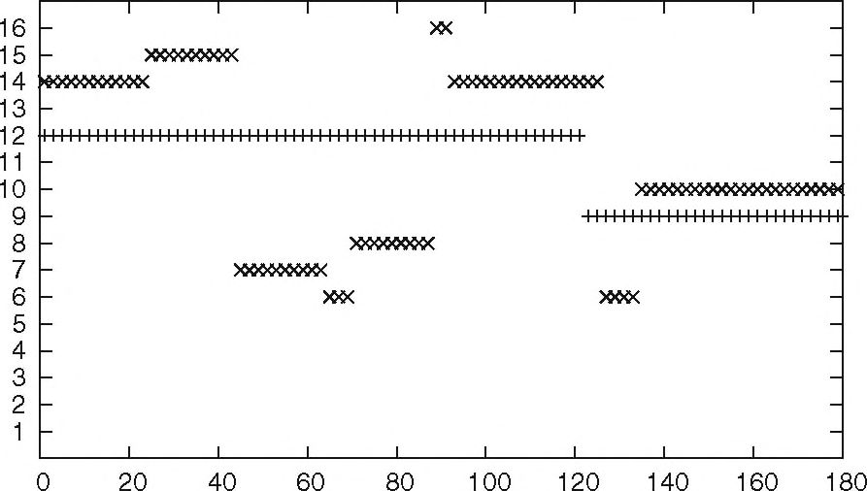
Determination of Wolfenstein Parameters
233
scattering angle [deg.]
Fig. 1 The way in which the physical solution in obtained from all 16 possible solutions. We choose two typical energies described
by the “+” (“x”) line for Ejai, = 10 MeV (E\ai, = 100 MeV). On the y-axis the number of the set of unique physical analytical
solution is given out of the 16 sets of allowed solutions. It is the solution which reproduces an additional observable Cpp or Cpk ■
For details see text
Jo = \a\2 + \m\2 + 2\c\2 + 2\g\2 + 2\h\2,
I0Po = 2M{c*(a+m)}, (9)
I0D = \a\2 + \m\2 + 2|c|2 - 2|g|2 - 2|/?|2,
IoR = cos|(|a|2 - \mf + \g - h|2 - \g + h\2) - sin ^,3{2c(a* - m*)}.
The inverse problem, going from observables to the Wolfenstein parameters, requires the solution of a
complex, nonlinear system of coupled equations. Without loosing generality, the phase of one Wolfenstein
parameter can be put to zero. We take c as such parameter. The full solution together with details will be
presented in [6], Here we show only the solution for the parameter c which is given as
c2 = (crS4 + ßS4 + yS4 + a3S2 + ß3S2 - aß2S2 - ae2S2 - ße2S2 + ye2S2
— a2ßS2 + a2yS2 + ß2y&~ — 2 aßy82 + a3ę~ + ß3e2 — aß2e2 — a2ße2
-oryc2 - ß2yc2 + 2aßyc2 ±2T)/{A((a - ß)2 + H2)2} (10)
where
T2 = (a - ß)282e2( - 54 - y2S2 - y2e2 + 2ßye2 + 4a3ß - ß2 (;y2 + f + e2)
—or (8yß2 + K2 + f + e2) + 2a (2ß3 + (y2 + 382 - e2) ß + yc2) ), (11)
and a, ß,y, 8 and e are defined as
1 h ( & , 0 , , \
a = -(I0 + IqD) + — (cos-(2R + (A - R) cost?) + sin —{2R + {A + R )cos6)J ,
1 h ( 9 , 9 , . \
ß = - (Io + IoD) - j (cos-(2R + (A - R)cos9) + sin-(2R' + (A + R')cos6)\,
y = 2IqCnn ~ Io Ann, (12)
e 9
8 = sin -I0R + cos -IqA,
e s I0 Po.
This is tlie first time that analytical expressions have been obtained for the Wolfenstein parameters in terms
of nine observables (/o- Po, D, R. R'.. A, A', Cnn and Ann)- The nonlinear system of coupled equations
provides 16 sets of solutions, among which only one must be a unique physical solution. That unique set of
Wolfenstein parameters can be selected by using one additional observable (for instance, Cpp or Cpk) and
requiring that all resulting observables must be continuous in the scattering angle.
234
H. Kamada et al.
3 Example Calculation and Outlook
We would like to show how well the unique set of physical solutions can be selected. We use the CD Bonn
potential (np force only) to generate observables. As mentioned in Sect. 2, at each angle we have 16 sets
of solutions derived from 9 specific observables. These sets can be numbered from 1 to 16. An additional
observable, different from the above nine observables, can be used to pick-up at each angle the unique set of
physical solutions. In Fig. 1, we demonstrate that at two energies E\ab = 10 and 100 MeV. That additional
observable (for instance, Cpp or Cpk) enforces, through its continuity in the angle, one unique solution. In
the case of 10 MeV, the 12th solution reproduces that additional observable from 0° to 120°. From 120° to
180° it is the 9th set of solutions which must be taken. In the case of 100 MeV one sees in Fig. 1 that a complex
dependence for the number of the physical set on the scattering angle results. Despite such rapid jumps between
different solutions which appear for different angles, all observables are smooth functions of the angle.
The three-body force at NNNLO in the chiral expansion [7] has many contributing terms which, however,
depend on the same low-energy-constants (LEC's) as the chiral NNLO NN potential. We expect that the new
approach by Eq. (4) will provide more precise values for those LEC's.
Acknowledgments This work was supported in part by a Grant-in-Aid for Scientific Research (A) (19294924) in Japan and by
the Polish 2008-2011 Science Funds as the research project No. N N202 077435.
Open Access This article is distributed under the terms of the Creative Commons Attribution Noncommercial License which
permits any noncommercial use, distribution, and reproduction in any medium, provided the original author(s) and source are
credited.
References
- Epelbaum, E.: Prog. Part. Nucl. Phys. 57, 654 (2006)
- Arndt, R.A., Briscoe, W.Strakovsky, 1.1., Workman, R. L.: Phys. Rev. C 76, 025209 (2007)
- Wolfenstein, L., Ashkin. J.: Phys. Rev. 85. 947 (1952)
- Wolfenstein, L.: Phys. Rev. 96. 1654 (1965)
- Glöckle, W.: The quantum mechanical few-body problem. Springer, Berlin (1983)
- Kamada H., Glöckle W., Witała H., GolakSkibiński R.: In preparation
- Bernard, V., Epelbaum, E., Krebs, H., Meißner, Ulf-G.: Phys. Rev. C 77, 064004 (2008)

