STUDIA GEOMORPHOLOGICA CARPATHO-BALCANICA
ISBN 83-88549-56-1 VOL. XLI, 2007: 117-137 PL ISSN 0081-6434
LAND FORM EVOLU TION IN MOUNTAIN AREAS
JERZY ZASADNI (KRAKÓW)

THE LITTLE ICE AGE IN THE ALPS: ITS RECORD
IN GLACIAL DEPOSITS AND ROCK GLACIER FORMATION
Abstract. Climatic fluctuations of glaciers of the Little Ice Age (LIA)-rank used to show comparable ma-
gnitudes during the Holocene. That is why the extent of maximal LIA moraines in the Alps attains similar
position as those of the previous LIA-type Holocene advances. Consequently, the LIA moraines repres-
ent a massive and frequently multi-ridge depositional system. Certain differences in reaction to climatic
changes and in moraine development result from the glacier size, percentage of debris-covered ice sur-
faces, and topography of alimentary areas. Such differences are particularly spectacular regarding “pure
ice” and debris-covered glaciers. Another system represent rock glaciers which, however, frequently
accompany regular glaciers. Some rock glaciers originated due to one-time transformation of a “glacial”
glacier during its recession, while others formed owing to long-term accumulation of rock debris within
glacial cirques during successive oscillations of small cirque glaciers in the Holocene, given suitable to-
pographic and topoclimatic conditions. The relationship between the ELA and altitude of cirque bottom
and/or debris supply from surrounding walls is of key importance in this case.
Key words: Little Ice Age, moraines, rock glaciers, ELA, climatic change, Alps
INTRODUCTION
The Little Ice Age (LIA) was a global climatic deterioration at a scale of hun-
dreds of years, which has strongly influenced on natural environment and human
civilization. In polar and high mountain areas glaciers advanced and achieved
their maximum postglacial positions during this period. The strongest impact of
cooling was noticeable in the North Atlantic region: in northern latitudes of Eu-
rope, Asia and North America (Hunt 2006).
The term “Little Ice Age” was first used by F. Matthes (1939; after
Luckman 2004) to describe the late Holocene (last 4,000 years) glacier re-ad-
vances in the Sierra Nevada Mountains, following the Hipsithermal warm climate
of the early Holocene. At present, this tenn is resewed for the last cool episode in
the Holocene, which took place in the last millennium. The older meaning of Lit-
tle Ice Age is termed today as Neoglacial (Luckman 2004). It is commonly ac-
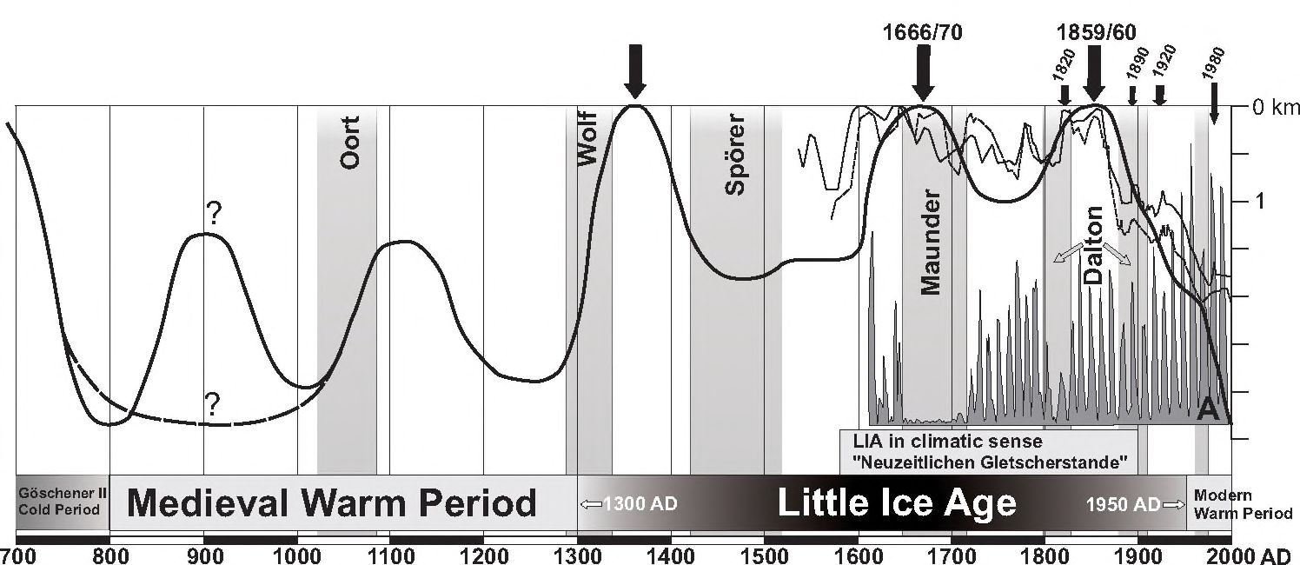
118

Fig. 1. Glaciers fluctuations in the Alps in the last millennium. Thick line — Grosser Aletsch glacier
fluctuations, thin line — Lower Grindelwald Glacier (Holzhauser and Zumbuhl 1996), dashed
line — Mer de Glace (Nussbaumer etal., in press). Note a longer response time in case of Grosser
Aletsch Glacier; minor climatic changes are not noticeable in front oscillation. The LIA time period
according to J. A. M a 11 h e w s and K. R. B r i f f a (2005). A — sunspot cycle derived from the number
of sunspot group (Beer et al. 2000). Period of reduced solar activity (Dalton, Maunder, Sporer; B u n -
tegen et al. 2006) are shaded. Thick arrows indicate main maxima of the Grosser Aletsch glacier
front, tiny arrows indicate minor oscillations of glaciers during the last 200 years
cepted that the LIA occurred between the 16^{lh} through 19^{lh} centuries (Mann
2002; Grove 2004). Frequently, the termination of LIA is assigned to the
years 1850-1860, i.e. the time of maximum extent of glaciers and the beginning of
their retreat. This view, however, does not seem to be justified, because both cli-
matic conditions and glacier sizes at that time were far from typical of climatic
amelioration. According to J. A. Matthews and K. R. Briffa (2005), it seems
necessary to consider two different time spans: 1300-1950 AD in glaciological
sense, and 1570-1900 AD in climatic sense (Fig. 1). This chronology is based
mainly on research on Alpine glacier fluctuations and European palaeoclimate,
although the 14th century initiation of LIA around the polar North Atlantic region is
also recorded (see Grove 2001). In glaciological sense, the duration of LIA is
comparable to a period when glaciers were larger than before or after that time.
For instance, the Great Aletsch Glacier had a greater extent in the years
1280-1935/40 AD than before and after this period (Holzhauser 1983).
The LIA-related glacial landforms and deposits together with associated
periglacial landforms in the Alps represent perfectly preserved evidence of
a cold geological epoch. The cooling took place in historic times; therefore, it
was observed and registered by man; an unique opportunity in Earth history.
Based on the record of glacier fluctuations and climatic changes throughout
the LIA, as well as related landforms and sediments, one can conclude about
older cooling phases, the geomorphic and sedimentary evidence of which are
not so well preserved.
119
In Southern Europe outside the Alps, there are only few areas where the LIA
left its traces in glacial sediments. Well developed LIA moraines are to be found in
those areas which are presently glaciated or bear remnant glaciers, namely: in
the Pyrenees (C i a et al. 2005), Sierra Nevada in Spain, or Central Apennines with
Ghiacciaio del Calderone (D’O r e f i c e et al. 2000). In other mountain massifs the
LIA glacial landforms are either poorly preserved or small, i.e. in Corsica
(Kuhlemann et al. 2005), Kaqkar Mountain range of northeastern Anatolia
(Akqar et al. 2007), and Mount Olympus in Greece (Smith et al. 1997). Still
other mountains, like the Carpathians, lack such landforms at all.
LIA AND “LIA TYPE EVENTS” IN THE HOLOCENE
Throughout the Holocene, Alpine glaciers fluctuated in a relatively narrow
range; the snow line and timberline have never exceeded a certain value of am-
plitude, i.e. ca 200 m (Patzelt and Bortenschlager 1973). During the LIA,
glacier advances were most extensive in the entire Holocene and definitely most
extensive in the Neoglacial period. That is why geomorphic records of the
Postglacial oscillations, older than LIA, were mostly destroyed by LIA advances or
overprinted by new moraine deposits. However, the glacier front positions during
the LIA maxima did not surpass significantly the previous Holocene maxima. In
a few areas, for instance, where palaeoclimatic and topographic situation was fa-
vourable enough, moraines left by the early Holocene advances are preserved.
These moraines are situated farther down the valley or quite close and parallel to
the LIA moraines, and represent the following stadials: Schalten, Kartell
(Preboreal — Patzelt and Bortenschlager 1973; Ivy-Ochs et al. 2006),
Venediger (Boreal — Patzelt and Bortenschlager 1973), and Kromer
(older Atlanticum — Kerschner et al. 2006).
Despite the lack of geomorphic evidence, such as moraines, knowledge of
glacial history of the entire Holocene is increasing owing to dendrochronological,
sedimentological, pedological and palynological investigations and radiocarbon
dating performed on glacier forefields (cf. Patzelt and Bortenschlager
1973; Nicolussi and Patzelt 2000; Hormes et al. 2001; Joerin et al. 2006).
The results of such studies are not always compatible, particularly regarding the
number, duration and intensity of cold Holocene episodes. Some results are even
contradictory; probably due to the use of different methodologies, but also due to
genuine, regional palaeoclimatic and topoclimatic differences (cf. Nicolussi
and Patzelt 2000). It should also be underlined that the above results usually de-
termine the time and environmental conditions of warm intervals, based on
which cold episodes can be detected.
During the Holocene climatic optimum there was no prolonged glacier-free
period in the Alps; even in the Atlantic phase glacier advances of the LIA rank did
occur. The late Holocene is typified by increasing frequency and duration of such
120
episodes. According to U. E. J o erin et al. (2006), during the middle Holocene Al-
pine glaciers advances were associated with short, ca 200 years long, cold inter-
vals which were separated by 500 years long warmer intervals. These proportions
became reversed in the late Holocene. The beginning of intensive glaciation of
the Alps in the Neoglacial is usually dated to 3.5 ka (G a m p e r and S u t e r 1982).
De line and Orombelli (2005) place this event in the interval of 4.6-5.6 ka,
based on evidence of first stages of glacial accumulation in the Miage Glacier ab-
lation complex in the Mont Blanc massif. In the late Holocene, after 3.5 ka, the pat-
tern of glacier fluctuations in the Alps was more equivocal. Detailed data pertain-
ing to fluctuations of individual glaciers are available for this period, obtained
mainly due to dendrochronological methods (e.g., Grosser Aletsch Glacier,
Corner Glacier, Lower Grindelwald Glacier — Holzhauser and Zumbühl
1996; Holzhauser et al. 2005). These data point to at least four glacier ad-
vances of the LIA rank in that period: Lôbben (1300-1900 BC), Gôschener I
(400-1000 BC), Gôschener II (350-800 AD) and, finally, LIA (1300-1950 AD;
Patzelt and Bortenschlager 1973; Gamper and Suter 1982; Holz-
hauser and Zumbühl 1996; D e 1 i n e and Orombelli 2005).
GLACIER FLUCTUATIONS IN THE ALPS IN THE LAST MILLENNIUM
The Little Ice Age was preceded by the Medieval Warm Period, lasting from
800 to 1300 AD. In this warm interval, glaciers fluctuated as well, although being
considerably smaller than during the LIA (High Middle Ages advances; Holz-
hauser and Zumbühl 1996; Holzhauser et al. 2005). Alpine glaciers ad-
vanced in the LIA in three principal stages (Fig. 1). The first advance took place
around 1350 AD and terminated the Medieval Warm Period. The second LIA maxi-
mum occurred in the middle of the 17th century (ca 1650 AD), whereas the last
one marked its appearance in the middle of the 19^{lh} century (ca 1850 AD). The
first maximum was separated from the second one by a decisively longer period,
during which glaciers retreated farther compared to the warming between the
second and third maximum (Holzhauser 1983; Holzhauser et al. 2005).
Despite the fact that the cold maximum in Europe took place in the 17th cen-
tury, during the so-called Maunder minimum (1645-1715 AD; Eddy 1976; Fig. 1),
in most cases the 19^{lh} century advance was the most extensive one. Other cases
are, for instance, represented by fluctuations of Mer de Glace and Lower Grindel-
wald glacier, which had had their maximum LIA extent in the first half of the 17^{lh}
century (Nussbaumer etal., in press; see Fig. 1). The Alpine glaciers attained
the 19th century maximum around 1850-1860 AD (Holzhauser 1982). In some
areas of the Alps, like the Mont Blanc region, in turn, this event took place during
an advance of the 1820s; therefore, the 1850 moraines are placed on the inner
side of the 1820s moraines (cf. Aeschlimann 1983).The 1820 advance took its
appearance in the remaining parts of the Alps; however, the stronger transgres-
121
sion of the 1850s surpassed the older one (Holzhauser and Zumb üh 1 1996;
see Fig. 1 — fluctuations of Mer de Glace and Lower Grindelwald glacier).
In the forefield of some of Alpine glaciers, morainic ridges dated to the 17th
and even 14th centuries did preserve (Patzelt and Bortenschlager 1973;
Holzhauser 1984). The chronology of glacier advances in the 17th and 19th cen-
turies and associated moraines are recognized considerably better compared to
the first maximum, not only due to well preserved geological and geomorphic re-
cords, but also owing to greater number of data obtained from direct observa-
tions, like written records, drawings, paintings, photographs, and maps
(Holzhauser 1983, 1984; Zumbühl et al. 1983; Zângl and Hamberger
2004; Brunner 2006).
Glacier fluctuations in the Alps between the 17th and 19^{lh} centuries used to
be called in German literature as “Neuzeitlichen Gletscherstaride” (“Neu-
zeitlichen Gletscherschwankungen” — modern age moraines; Holzhauser
1982), and the area comprised between the recent glaciers and the 17^{lh} and 19^{lh}
centuries ones is precisely defined as the “Gletscherforfeld” — glacier forefield
(Kinzl 1932; Holzhauser 1982). This zone is clearly different from the sur-
rounding area in respect to geomorphic setting, pedological characteristics,
floristic succession, and the degree of weathering. Moreover, lichenometric
method can easily be applied in this zone, due to relatively young age of deposi-
tion. A few systems of moraines younger than 1850 AD are situated inside the
area in question. These moraines, dated to 1890, 1920, and 1980 AD, were for-
med during short oscillations or episodes of glacier standstill, which broke the
general trend of glacier retreat persisting until now (Patzelt 1985; Zemp et
al. 2007). These oscillations were well recorded owing to direct measurements
of ice volume, area and glacier length changes, which have been monitored in
the Alps during the past 120 years (Zemp 2006). Moreover, constant monitor-
ing of meteorological conditions together with estimation of ice volume bal-
ance make it possible to correlate in detail climatic and glacier geometry
changes, providing a base for prediction of the future Alpine glaciation (cf.
Zemp 2006; Zemp et al. 2006; Paul et al. 2007).
It is worth noting, however, that individual glaciers in the Alps could oscillate
asynchronously, despite good concordance of the first-order oscillations . This re-
sults both from palaeoclimatic differences among individual Alpine regions, and
from topographic conditions and variable sizes of Alpine glaciers, controlling their
mode and time of reaction to climatic changes. The reaction time of glacier front
positions to climatic changes is not simple and linear. It primarily depends on the
size of glaciers, but also on the climate of a number of previous years. For the
most of medium size Alpine glaciers it is about 14-18 years, whereas in case of
larger ones it could be about 40 years (H ormes et al. 2006). According to
T. Johan ess on etal. (1989), it takes 15-60 years for changes in mass in the ac-
cumulation zone to reach the snout of maritime temperate glaciers. However, the
time in which glacier geometry reaches new equilibrium after abrupt climatic
122
change (response time) is much longer; for Grosser Aletsch Glacier it is in the or-
der of 50 to 100years (Haeberli and Holzhauser 2003; cf. Fig. 1).
From 1850 to the 1970s, 5,150 glaciers from the entire Alpine mountain chain
lost about 35% of their areas, and almost 50% by 2000. In 1850, there was about
4,470 km² occupied by glaciers, while in 2000 only 2,270 km² remained (Zemp et
al. 2007). Glacier recession is a result of the increased altitude of the equilibrium
line of mass balance (ELA — equilibrium line altitude; see Gross et al. 1977;
Benn and Lehmkuhl 2000). It is estimated that ELA shifted upwards between
1850 and 1973 AD by 114 m. This was primary triggered by a rise in temperature by
about 0.6°C, which was partially compensated (about one fourth) by an increase in
precipitation by ca 10% (Greene and Broecker 1999). Mean elevations of re-
cent glaciers, which roughly equate to the equilibrium line altitude (ELA, here as-
sumed as the steady-state ELA) is, for the European Alps, 2,945 m a.s.l. ± 214 m
( H o e 1 z 1 e et al. 2007). The altitude of equilibrium line during LIA maximum in the
Alps was strongly variable depending on geographic location and slope aspect. Tak-
ing into account that ELA of individual glaciers is situated above their lateral mo-
raines (cf. the MELM method — maximum elevation of lateral moraines; (see
Benn and Lehmkuhl 2000), it was possible to estimate the altitude of eqilibrium
line during the 1850’s maximum in the central part of Eastern Alps at ca 2,600-3,100
m a.s.l., (Gross et al. 1977). In the northern fringe of the Alps, in Karwendel moun-
tains, ELA was placed even lower, at ca 2,300 m a.s.l. (Kerschner and
Ivy-Ochs 2007). Regional differences in ELA altitudes, known also from older,
Late Glacial glacier advances like Egesen (Younger Dryas), result mainly from re-
gional differentiation in precipitation, since differences in temperatures throughout
the Alps are not so great (Kerschner et al. 2000).
Since the last maximum of 1850 AD, fronts of the following large glaciers have
retreated considerably: Grosser Aletsch — about 3.4 km, Gomer (Alps of Valais) ca
2.6 km, lower Grindelwald (Bernese Oberland) ca 2.0 km, and Pasterze (Flohe
Tauem) ca 1.8 km. It is worth noting, however, that during the Bronze Age climatic
optimum (ca 1200 BC), the Grosser Aletsch glacier was shorter by cal km, and dur-
ing the Roman climatic optimum (400 BC-400 AD) only a little bit shorter in respect
to its present day length. Not all results appear to support a view that the pres-
ent-day position of Alpine glaciers is far from their Holocene minimal extent.
Accoording to G r o s j e a n et al. (2007), the present-day wanning is unprecedented
one since at least 5,000 years, because melting ice on highly elevated Alpine passes
discloses artefacts from the Neolithic, Bronze Age, Roman Period and Medieval
Ages. These artefacts, due to their fragile nature, could not have been preserved
when exposed during earlier warming periods. One should also bear in mind that
the present-day extent of glaciers is very far from balance with climatic conditions,
as shown by the results of climatic-glaciological modelling (Greene and
Broecker 1999). It means that the glaciers have not managed to apply their ge-
ometry to the existing climatic conditions. The rate of glacier retreat in the last de-
cades has been faster than long-term average, particularly after 1985 AD. This fact,
123
together with dramatic changes in alimentary areas of glaciers points to massive
downwasting rather than dynamic glacier response to a changed climate (Paul et
at. 2004). For instance, in one, extremely warm and dry year 2003, the Alpine gla-
ciers lost ca 5-10% of their previous volume (Zemp et al. 2005).
CLIMATIC BACKGROUND
Glaciers are extremely sensitive to climatic changes, their fluctuations de-
pending on temperatures and precipitation totals as well as seasonal distribution
of these factors (Pfister 1980, 1984; Denton et al. 2005). The mass balance of
glaciers is particularly sensitive to summer temperatures and winter precipitation.
Also important are summer snowfalls upon glaciers. Fresh snowfall during the ab-
lation season can increase albedo and effectively protect pure ice against solar ra-
diation, diminishing melting rate of the former.
Climatic fluctuations of the order of tens to hundreds of years during the last
millennium and throughout most of the Holocene, are mainly induced by external
factors related to solar activity (Eddy 1976;Stuiver etal. 1998; May ewski et
al. 2004). The North Atlantic Oscillation (NAO) and its interaction with the atmo-
sphere, as well as inner, random climatic oscillations (Schulz and Paul 2002)
are also very important.
The minima of solar activity reconstructed from atmospheric ¹⁴C residual series
(based on tree ring records; cf. Stuiver et al. 1998) are in good accordance with
glacial advances. This relationship has also been confirmed by direct observations in
the last decades. Some discrepancies are mainly due to long-term glacier response
to climatic changes (H o 1 z h a u s e r et al. 2005) and stochastic processes within the
climatic system (Hunt 2006), which do not allow directly correlate solar activity
with glacier behaviour. Solar activity varies in the 11- (Schwabe cycle), 80- (Gleiss-
berg cycle), and 200- year periodicities (S c h o v e 1983), as is directly demonstrated
in the sunspot number and, in consequence, changes in the solar constant.
Dendrochronological data point to a sharp cooling around 1570/80 AD over
a large area of middle and northern Europe. This region has its southern boundary
in the Alps (Briffa et al. 1999). The cooling, initiating LIA in a climatic sense as
well as modern age glacier fluctuations, is associated with the Maunder and Dal-
ton solar minima activity (see Fig. 1). A distinct advance of Alpine glaciers at the
end of the 16th century (the second LIA maximum) was a result of predominantly
low winter and summer temperatures, and summer snow falls in high Alpine
area, while the last LIA maximum (around 1850 AD) was mainly triggered by low
winter temperature and high amount of winter precipitation; lowering of summer
temperatures was slightly less pronounced than that in the earlier period. During
Maunder minimum (1645-1715 AD), despite low temperatures, no significant ad-
vance was recorded (Fig. 1), probably due to continental, very dry winters
(Pfister 1984).
124
The last two distinct advances in the 19^{lh} century (in the 1820s and 1850s) re-
sulted from cold and enormously wet conditions (Pfister 1980, 1984), although
a role of volcanic activity can not be neglected. Big Plinian eruptions like, for exam-
ple, those of Tambora 1815, Coseguina 1835, and Krakatoa 1883 (compare ad-
vances in Fig. 1), produced a large amount of dust propagated globally in the atmo-
sphere, drastically influencing the climate by substantial lowering of temperature
(for example, 1816 “the year without the summer”, 1838 “the coldest year overall in
Europe”) and increasing cloudiness. Nevertheless, volcanically-induced climatic
deteriorations are rather short (mostly 2-3 years; R o b o c k 2000). It is hypothesized
that the 20^{lh} century climatic amelioration was amplified by the dearth of volcanic
eruptions between 1915 and 1960 AD. In addition, dust layers in ice core records
point to a relatively lower number of volcanic eruptions between 1000 and 1500 AD,
compared to the period of 1500-2000 AD (Robock 2000; Jones and Mann 2004,
and references therein).
The overall loss of Alpine glaciers after the 1850 maximum is coincident with
the positive (warm/wet) NAO index, contrary to the Maunder Minimum when
minimum solar activity together with negative (cold/dry) NAO index produced
cold and severe climate. According to M. S chulz and A. Paul (2002), in the ear-
lier part of the Holocene, between 8.5 and 3 ka, the climate system showed a reg-
ular, ca 900 years long, periodicity related to the North Atlantic thermohaline cir-
culation. The quoted authors maintain that such climatic fluctuations resulted
from an oscillation within the ocean-climate system, which was initiated by exter-
nal cooling force in 8.2 ka cool events (outburst of Lake Agassiz). Later, after 3 ka,
this 900 years climatic periodicity was not visible, but it is worth noting that in the
late Holocene, after Hypsithermal warm interval (—9—5.7 ka BP), increasing fre-
quency and intensity of the LIA-type events (Neoglacial) could have resulted from
progressive decrease in solar radiation and summer temperature lowering due to
external Earth’s orbital forcing (Jones and Mann 2004; Matthews and
Briffa 2005). Bond et al. (1999) concluded that the North Atlantic circulation
and Holocene climate tended to oscillate in a 1-2 ka, Dansgard/Oeschger-like
mode, what means that the LIA and LIA-type events originated like an abrupt
full-glacial cold period events, although in the mild interglacial climate mode
(Bjorck et al. 2001, and references therein).
Despite common belief that the LIA cooling marked its appearance first of all
in the Northern Hemisphere, one should bear in mind that this event was strongly
differentiated both in time and space. For instance, glacier advances in the Alps
are asynchronous compared to those of Scandinavia and North America (for fur-
ther discussion see Matt h ews and Briffa 2005).
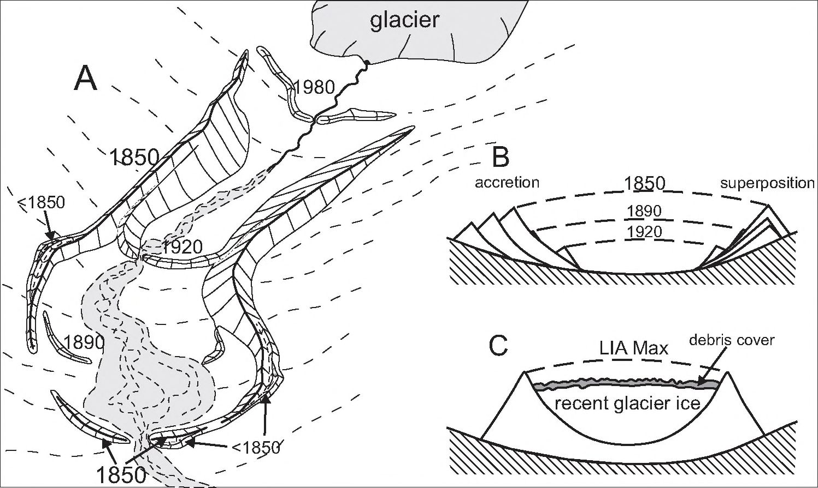
125
RECORD IN GLACIAL DEPOSITS
Moraines of the maximum of LIA represent one of the best developed and
clearly marked morainic systems in the Alps, occurring between < 1,500 and ca
3,000 m a.s.l. The lowermost extent refers to the moraines of large glaciers, like
the Grosser Aletschgletscher or Pasterze Gletscher, which during the LIA reached
the upper timber line. This level in the Alps is at present at 2,100-2,300 m a.s.l.
The LIA moraines developed in front of the middle-size Alpine glaciers present
a characteristic picture (Fig. 2). The lateral moraines, depending on suitable mor-
phology of host valleys, attain a few tens to more than 100 m of height (M a i s c h et
al. 2000), and are typified by extremely sharp profile. The frontal moraines, in turn,
are usually small-size and frequently remodelled by fluvioglacial waters. There also
occur, much more frequently than in lateral moraine zone, multiple ridges owing to
frequent fluctuations of glacier fronts and strong erosion of proglacial waters, unfa-
vourable to the formation of high and massive moraines. In the upper ablation zone,
in turn, where the glacier maximum extent is more stable, massive lateral moraines
can easily be deposited.

Fig. 2. A — Scheme of typical moraine formation in the forefield of a medium-size Alpine glacier, on
valley bottom not affected by rough topography. Note massive (ca tens of metres high) lateral morai-
nes and relatively small and multi-walled front moraines, partially destroyed by outwash fans. Glacier
front position is usually more sensitive to minor climatic fluctuations than glacier surface in the higher
part of the ablation zone, where a lateral moraine is deposited. Numbers indicate time of advances,
“< 1850”, could correspond to the 17th century, late Medieval or early Holocene advances. B — Sche-
me of LIA moraine depositional structure; two modes of moraine building — by accretion and super-
position. C — Scheme of recent debris-covered glacier; note strong lateral moraine and moraine acc-
retion on the sole of glacier which rises the glacier above valley bottom
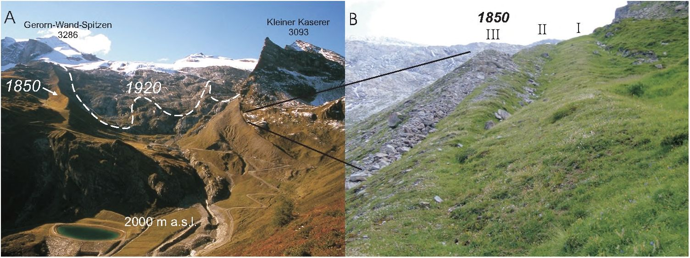
126

Fig. 3. A — Moraines on the forefield of the Hintertux Gletscher (Tuxer Ferner) in Zillertal Alps. Glacier
front during LIA maximal advance (1850) was 1400 m down the valley from recent front position on
the rock threshold. Frontal moraine is only preserved below left lateral moraine (right on the picture);
note a three-folded morainic sequence. The right lateral moraine (on the left) is 35 m high, 1,300 m
long, and 1.46 mln m³ in volume. The 1920 recessional position is reconstructed mainly on the base of
old photos; moraines are only partially preserved. B — accretion depositional structure of the left later-
al moraine. Older moraine ridges (I and II) are more affected by denudation processes
Moraines marking the maximum extent of the LIA (1850 AD), occupy compara-
ble positions to those of the previous LIA maxima, as well as glacier advances in the
entire Holocene. At places, the sedimentological and geomorphic record of such
moraines perfectly reflects their complex and long-term process of deposition. In
certain circumstances, both along frontal and lateral moraines, there are preserved
moraines of glacier advances preceding 1850 AD, occupying a more outer position.
Successive moraines became deposited close to the older ones, fonning multi-ridge
moraines (Figs. 2B, 3). In most cases, morainic material of successive maxima used
to upbuild previously deposited ridges, forming a single ridge. In the inner part of
such moraines, frequently strongly eroded due to slopewash and landsliding, one
can observe layering, in which morainic material of individual advances is separated
by fossil soil horizons (cf. Holzhauser and Zumbühl 1996).
Among moraines younger than 1850 AD, the most clearly marked are those
of the 1920s, although none of them is comparable, as far as the material volume
is concerned, to the maximal moraines. Moraines dated to the end the 19th cen-
tury (1890s) are marked less clearly, as are those of the 1980s. These moraines are
well developed in case of debris-abundant glaciers, while below debris-free gla-
ciers such an oscillation left no moraines at all. Moreover, the lack of recessional
moraines below large glaciers can result from their prolonged reaction and ab-
sence of more important oscillations of the glacier front.
A certain regularity exists regarding the presence of debris within glaciers:
following diminishing glacier size and its retreat towards cirques and rock walls,
the glacier area diminishes in respect to the alimentary area. Glacier melting and
intensive physical weathering of rock walls produce a wealth of ablation debris
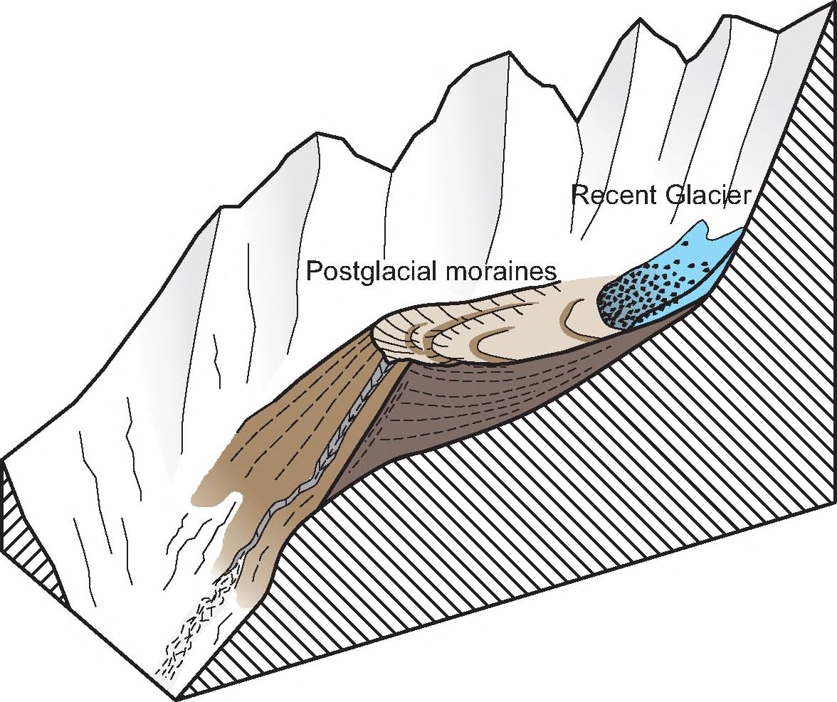
127
and that supplied by rockfalls. In such a case, even minor oscillations of the gla-
cier front leave a certain amount of debris in the form of moraines. When topo-
graphic and lithological conditions do not allow for intensive debris supply, even
marginal glaciation leaves no recessional moraines at all.
Moraines of those glaciers which during the LIA represented small cirque gla-
ciers are usually massive ones and accompanied by periglacial landforms, like rock
glaciers. Such moraines resemble high debris ramps (Fig. 4) (cf. Maisch 1981,
p. 102). Great thickness and/or volume of such moraines results from the fact that
debris supplied from cirque walls during successive Holocene advances became
accumulated on a relatively small area, on cirque thresholds (Maisch 1981). In
case of larger glaciers, the amount of debris derived from the surrounding rock
walls was not considerably larger, although it was deposited on a larger area. Mo-
raines of small and remnant glaciers are usually built up of angular and poorly roun-
ded debris, resulting from a short, usually supraglacial, transport route.

Fig. 4. Scheme of morainic depositional complex of a small Alpine cirque glacier. In such topoclimatic
conditions, glacier deposits were accumulated during a number of narrow-range fluctuations in the
entire Holocene, and produced huge latero-frontal moraine on a cirque threshold
Given suitable topographic conditions, even large glaciers can become cove-
red with debris. A typical place of occurrence of debris-covered glaciers are
mountain chains of Asia, such as Himalaya and Karakoram, where, due to young
high relative relief, intense accumulation of supraglacial debris supplied by ava-
lanches can occur. The debris-covered glaciers are characterised by well-marked
128
moraines with slopes of the angle of repose and a few metres thick debris mantle
on ice surface in the ablation zone (Fig. 2C). This cover masks glacier ice signifi-
cantly and influences surface energy fluxes and discharge of meltwater, leading
to a reduction of the ablation rate and producing an alteration of response of this
kind of glaciers to climatic changes (Dagata and Zanutta 2005). The abun-
dance of supraglacial debris helps to produce complex lateral-frontal moraines
that may record one or more glacial cycles (B e n n and Owen 2002).
The debris-covered glaciers are not common in the Alps. The two best
known, Miage and Brenva glaciers, are situated in the western Italian Alps, on the
southern side of the Mont Blanc massif. They gained their debris cover during one
large rock fall in 1920 AD. After that, they were advancing fill 1940 AD, and finally
achieved their LIA maximum starting from 1818 AD. Before the rock fall event they
behaved like other “clean” glaciers on the northern side of Mont Blanc (Dagata
and Zanutta 2005). On the contrary, like all the remaining glaciers in the Alps,
the debris-covered glaciers on the southern slope of Mont Blanc in the second
half of the 20th century (1959-1997), revealed a net increase in volume and thick-
ness (Dagata and Zanutta 2005). These glaciers lean on the LIA maximum
moraines (cf. Fig. 2C). In such a kind of glaciers, climatic induced mass balance
change in the accumulation zone does not imprint on the glacier front position,
but is rather conducted by kinematic wave, during which ablation zone resulted
in a rise of glacier surfaces (Pel fini et al. 2007).
FORMATION OF ROCK GLACIERS
Rock glaciers were originally defined as landforms produced due to creep of
alpine permafrost (Haeberli 1985; Barsch 1987, 1988), although both origin
and classification of such landforms have been a matter of animated debate.
A widely known controversy exists between advocates of periglacial origin of
rock glaciers (Haeberli 1985; Barsch 1987, 1988), and those who favour gla-
cial origin (“pure ice” glaciers becoming successively covered with rock debris;
cf. Johnson 1987;Ackert 1998; Whalley and Martin 1992).
Rock glaciers occur in the periglacial belt below ELA. The vertical extent of
this belt depends on the degree of climatic continentalism (Haeberli 1985;
Barsch 1988). Formation of rock glaciers requires specific climatic conditions
and debris delivery; therefore, the distribution of such landforms is controlled by
local topographic, topoclimatic, and lithologie conditions (Haeberli 1985;
Barsch 1988; H u m 1 u m 1998; I k e d a and M a t s u o k a 2006).
These landforms are ubiquitous in the Alps, and their number can attain
a few thousand. Active rock glaciers accompany moraines and “glacial” gla-
ciers of Holocene (LIA) age. Huge landforms attain 1.5 km in length, ca 200-300
m in width, and a few tens of metres of thickness. There occur prevailingly two
genetic types of rock glaciers sensu D. Barsch (1988): debris rock glaciers —
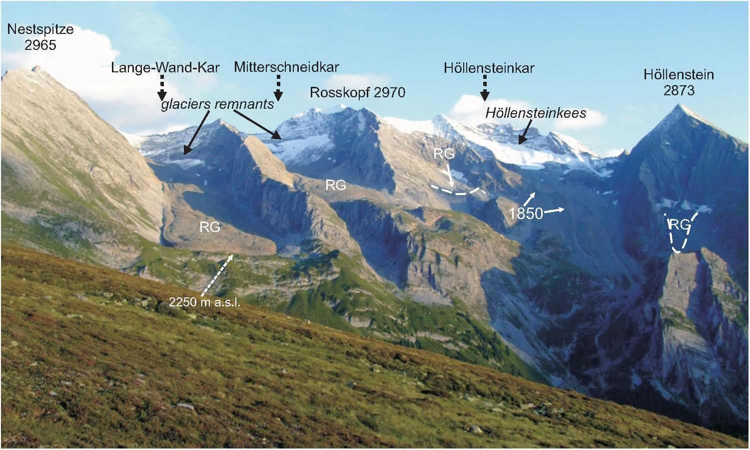
129
Fig. 5. Active rock glaciers and LIA moraines on the northern side of the Tuxer Hauptkamm (Zillertal
Alps, Austria). In the same location and aspect, note coexistence between these two different modes
of debris transport and deposition. Both landforms originated in the Holocene; the Lateglacial morai-
nes (Egesen stadial—Younger Dryas) are situated down the valley below bare rock thresholds. In this
area rock glaciers dominate, as cirque bottoms are substantially below the LIA snow line (2,650-2,700
m a.s.l.). Exception is Hollensteinkar, where the cirque floor near head walls reaches elevation per-
mitting glaciation during the LIA. Moreover, this cirque is also more oval than other neighbouring ci-
rques, which favour rather snow than debris accumulation. In the Lange-Wand-Kar and Mitterschne-
idkar rock glaciers rooting zone, below small glaciers, spoon-shaped depressions are situated (cf.
Fig. 6). 1850 — huge LIA latero-frontal moraine in Hollensteinkar, RG — rock glaciers
associated with moraines and “glacial” glaciers (Fig. 5), and talus rock glaciers
— generated from talus fans.
The best conditions for rock glacier formation are provided by dry, continental
climate. Nevertherless, these landforms occur in all major mountains systems of the
Earth (Barsch 1988). They frequently accompany regular glaciers, particularly in
partly glaciated areas, occupying the locations which are more dry and prone to de-
bris delivery (H u m 1 u m 1998). The key role in formation of the rock glaciers plays
the proportion between snow accumulation and the input of debris (Humlum
1998). In other words, under small delivery of snow and abundant debris influx, rock
glaciers are formed, while under reciprocal conditions pure ice glaciers tend to be
produced. The balance is a delicate one, and can easily change both in time and
space (climatic changes, topographic differences). An important role in rock gla-
ciers distribution plays the relationship between cirques bottom and ELA (see
Fig. 6), as well as the number, height and lithology of rock walls surrounding the
cirque (Ike da and Matsu oka 2006). When the entire cirque bottom is situated
well below ELA, it will provide suitable conditions for rock glacier formation.

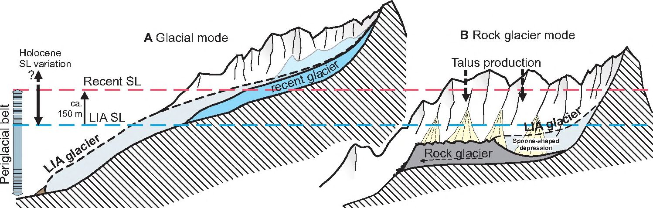
130

Fig. 6. Schematic relation between cirque bottom and snow line and its consequences in glacial/rock
glacier formation. A — glacial mode: glaciers originate where topographic conditions allow for accu-
mulating snow above the snow line. B — rock glacier mode: rock glaciers form where most of the cir-
que bottom is substantially below the snow line and/or sufficient debris load from head walls is ava-
ilable. SL — snow line, LIA SL — snow line during the Little Ice Age maximum (Holocene minimum
elevation)
Small cirque glaciers are frequently being transformed into rock glaciers,
particularly during their melting phase. First, owing to debris covering of the
“pure” glacier, a debris-covered glacier originates, then, the prograding process
leads to the formation of an ice-cored rock glacier (a glacigenic rock glacier — cf.
Ackert 1998; Whalley and Palmer 1998; Berger et al. 2004). During indi-
vidual advances, “glacial” glaciers can advance upon rock glaciers (alpine per-
mafrost) (Haeberli 1979; Whalley 1979; Whall ey and Palmer 1998). Ac-
cording to D. Barsch (1988), debris supplied by glaciers during their advances
can supply rock glaciers of the debris rock glacier-type, and farther transport of
the material proceeds due to permafrost creeping (Fig 6B).
During suitable topoclimatic conditions, frequently recurring glacier oscilla-
tions in the late Flolocene led to formation of large, tongue-shaped rock glaciers.
In the root zone of such rock glaciers, spoon-shaped depressions left after
melt-out “glacial” glaciers are frequently preserved (Fig. 6B) (Barsch 1988;
Avian et al. 2005). These depressions used to be filled with ice during the Flolo-
cene maxima, recently in the 1850s. Other landforms indicating glacial advances
and occurring in the root zones of rock glaciers include: moraine walls, lodge-
ment tills (Berger et al. 2004; Avian et al. 2005), flutes, fresh glacial striations
(Whalley and Palmer 1998), and push moraines (Haeberli 1979).
Spoon-shaped depressions can also be formed in the rooting zone of glacial origi-
nated rock glaciers (ice-cored rock glaciers) as a result of melting of debris-free
part of the “glacial” ice body below head walls (cf. Berger et al. 2004).
The age of active Alpine rock glaciers does not exceed 10 ka (Barsch 1988),
as shown by their position versus the youngest, Late Glacial, moraines (Egesen —
Younger Dryas). Most frequently, however, their age is estimated at 3 to 4 ka
(Neoglacial; cf. Avian et al. 2005). The debris rock glaciers distinguished by
D. Barsch (1988) are of such an age, whereas ice-cored rock glaciers could have
131
originated due to one-time transfonnation of “glacial” glaciers, mostly during a re-
cession postdating 1850 AD (Whalley and Palmer 1998; Berger etal. 2004).
SUMMARY AND CONCLUSIONS
The climatic and LIA-rank glacier fluctuations occurred throughout the Holo-
cene every 1-2 ka; in the late Holocene this regular periodicity was so regular. The
LIA (1300-1950 AD; Matthews and Biff a 2005) represents the youngest cold
period in this series of fluctuations. Climatic conditions in the Alps during LIA
were comparable, or slightly more glacier-friendly, to the earlier Holocene
LIA-type events. Changes in altitude of climatic zones and different ecosystems
(timber line, periglacial belt, snow line) in the Holocene were relatively small, of
the order of ca 200 m, compared to the Late Glacial. These changes resulted in
i.a., fluctuations of glacier fronts from a few hundred metres to more than 3 km,
depending on glacier size. The present-day warming reveals that glacier-occu-
pied surfaces in the Alps can diminish by more than half between cold and warm
periods. The LIA-type events were not only colder by ca 1-2°C than the interven-
ing warmings, but also relatively humid (particularly owing to high winter precipi-
tation), providing suitable conditions for glacier growth and high lake level stands.
The most important role in shaping Holocene climate is played by solar activ-
ity, together with its interactions with the Atlantic circulation and internal, random
climatic fluctuations. Increasing intensity of cool periods in the Late Holocene
(Neoglacial) could have been induced by gradually diminishing solar irradiance
in high latitudes, resulting from the Earth’s orbital forces, mostly Milankovich
cyclicity. The glacier-friendly climate culmination during LIA (1570-1900 AD) was
associated with several episodes of reduced solar activity, particularly during the
Maunder and Dalton minima, being amplified by the negative index of NAO circu-
lation and relatively high volcanic activity.
In the Alps, the three principal LIA glacier maxima of ca 1350, 1650, and 1850
AD attained extents comparable to those of previous Holocene maxima. Apart
from sedimentological, palynological or dendrochronological pieces of evidence,
the long-term and multi-stage deposition of LIA moraines is documented by
well-preserved geomorphic record in the form of massive and multi-ridge mo-
raines. One can infer that Holocene conditions of moraine formation were en-
tirely different from those of the Late Glacial, when every successive advance
was of smaller extent within the valley. Moreover, the Late Glacial glacier ad-
vances were much more shorter than the total time of moraine formation during
the Holocene. Direct observations of the youngest LIA events indicate that inter-
actions between climatic changes and glacier behaviour are reflected in fluctua-
tions of glacier fronts and moraine deposition at the scale of even few decades.
Transport and deposition of material in Alpine cirques and valleys varied de-
pending on palaeoclimatic, topographic, topoclimatic, and lithological condi-
132
tions. A certain continuity between landforms can be inferred between moraines
of debris-free glaciers, ablation landforms of debris-covered glaciers, and
glacigenic and cryogenic rock glaciers. It does not mean, however, that every
landform should have experienced transformation according to the above se-
quence, but rather conditions prone to origin of given landforms could have grad-
ually changed with time and in space.
Formation of rock glaciers is only possible when a certain proportion be-
tween debris supply and snow alimentation is maintained. That is why continen-
tal climate is particularly favourable for the develoipment of such landforms. In
the Alps, however, the great number of active, Holocene, rock glaciers contrasts
with relatively small degree of climatic continentalism. Hence, the most impor-
tant factor in this case appears to be the relation between altitude of cirque bot-
tom, where debris is being accumulated, to the altitude of snow line, i.e. the
topoclimatic factor (Fig. 6), as well as great amount of debris accumulation within
cirques throughout the Holocene, i.e. the palaeoclimatic factor.
Some Alpine massifs, rising not very high above the regional Holocene snow
line, either were or are glaciated. Therefore, large portions of cirques and valleys
are situated below this line, although still within the periglacial belt, provoding
suitable conditions for rock glacier formation (Fig. 6). Those massifs which rise
high above the regional snow line are covered by large, debris-fee glaciers, and
are dominated by glacial transport and moraine deposition.
The conditions suitable for rock glacier formation have changed with time.
Transformation of regular glaciers into rock glaciers took place usually during gla-
cier recessions, when glacier ice balance was negative (little snow accumula-
tion) and rock debris supply increased, owing to more intensive physical weath-
ering. In case of small glaciers, which even during the LIA maximum represented
cirque glaciers, debris accumulated during successive oscillations tended to
build massive morainic ramps (Fig. 3). When the accumulated morainic material
was voluminous enough, periglacial conditions led to its slow creeping and rock
glacier formation. Successive glacier oscillations supplied rock glaciers in their
root zones (debris rock glaciers sensu Barsch 1988; Fig 6B). One can conclude
that the key role in origin of such rock glaciers was played by high productivity
and/or prolonged duration of glacial transport, as well as comparable amplitude
of climatic changes throughout the Holocene. It should be added, however, that
the response time of rock glaciers to climatic changes is uncomparably longer
and completely different than that of regular glaciers (Haeberli 1985). The age
of Alpine rock glaciers is frequently estimated at a few thousands of years, imply-
ing that they survived warm periods separating the LIA-type events, and are still
active during the present-day warming, i.e. they still preserve interstitial ice and
are able to creep.
The LIA depositional landforms in the Alps illustrate very well cold epoch
processes in a high-mountain environment. Careful examination of these land-
forms and their origin helps to understand glacial history of those areas, where
133
such landforms are inactive or fossil. Great diversity of landforms produced by LIA
in the Alps, an area of relatively uniform palaeoelimatic conditions, provides op-
portunity to conclude about similarly high diversity in other glaciated mountain
massifs in the Carpathians, including the Tatra Mountains. Drawing simplified
conclusions on comparable age and origin of rock glaciers throughout the massif
and implying palaeoelimatic suggestions is not justified, though. It seems obvious
that in mountain massifs like the Tatra Mts, rock glaciers and moraines were
formed, depending on local topoclimatic conditions of a cirque or valley, during
all climatic deteriorations from the Last Glacial Maximum to the last glacial-Holo-
cene transition. It does not mean that no certain periods existed being particularly
favourable to a given type of debris transport and deposition, either glacial or
periglacial; however, palaeoelimatic interpretation of individual phases requires
careful identification of related landforms and, what is particularly difficult, sepa-
ration of topoclimatic and topographic factors.
ACKNOWLEDGEMENT
I would like to thank Witold Zuchiewicz for translating the text into English
and helpful editorial comments.
Institute of Geological Sciences
Jagiellonian University
Oleandry 2A, 30-063 Kraków, Poland
e-mail: jerzy.zasadni@gtnail. com
REFERENCES
Ackert R. P., Jr., 1998. A rock glacier/debris — covered glacier system at Galena Creek, Absaroka Mo-
untains, Wyoming. Geografiska Annaler 80A, 267-276.
Aeschlimann H., 1983. Zur Gletschergeschichte des italienischen Mont Blanc Gebietes, Val Veni,
Val Ferret, Ruitor. Universität Zürich.
Akijar N., Yavuz V, Ivy-Ochs S., Kubik P. W., Vardar M., Schlüchter C., 2007. Paleoglacial
Records from Kavron Valley, NE Turkey: Field and cosmogenic exposure dating evidence. Qu-
aternary International 164-165, 170-183.
Avian M., Kaufmann V., Lieb G. K., 2005. Recent and Holocene dynamics of a rock glacier sys-
tem: The example of Langtalkar (Central Alps, Austria). Norsk GeografiskTijdsskrift 59, 49-156.
Barsch D., 1987. Rock glaciers: an approach to their systematics, [in:] Rock Glaciers, eds. J. Giardino,
J. Shroder, J. Vitek, Allen and Unwin, London, 41-44.
Barsch D., 1988. Rockglaciers, [in:] Advances in periglacial geomorphology, ed. M. Clark, Wiley and
Sons, Chichester, 69-90.
Beer J., Mende W., Stellmacher R., 2000. The role of the sun in climate forcing. Quaternary
Science Reviews 19, 403-415.
B e n n D. I., L e h m k u h 1 F., 2000. Mass balance and equilibrium line altitudes of glaciers in high mo-
untain environments. Quaternary International 65/66, 15-29.
Be nn D. I., Owen L. A., 2002. Himalayan glacial sedimentary environments: a framework forreco
structing and dating the former extent of glaciers in high mountains. Quaternary International
97-98, 3-25.
134
Be rge r J., Krainer K., Mostler M., 2004. Dynamics of an active rock glacier (Ötztal Alps, Austria.
Quaternary Research 62, 233-242.
BjörckS.,MuschelerR., Kromer B.,Andresen C. S., HeinemeierJ., Johnsen J., Job n-
sen S. J., Conley D., Ko§ N, Spurk M., Veski S., 2001. High resolution analyses of an early
Holocene climate event may imply decreased solar forcing as an important climate trigger. Geo-
logy 29, 1107-1110.
Briffa K. R., Jones P. D., Vogel R. B., S eh we ingrub e r F. H., Bail lie M. G. L., Shiyatov S. G.,
Vaganov E. A, 1999. European tree rings and climate in the 16th century. Climatic Change 43,
151-162.
Brunner K., 2006. Karten dokumentieren den Rückzug der Gletscher seit 1850. Wiener Schriften zur
Geographie und Kartographie 17, 191-200.
Büntegen U., Frank D. C., Nie vergelt D., Esper J., 2006. Summer Temperature Variations in
the European Alps, A.D. 755-2004. Journal of Climate 19, 5606-5623.
Ci a J. C., Andres A. J., S an che z M. A. S., No vau J. C., Moreno J. I. L., 2005. Responses to cli-
matic changes since the Little Ice Age on Maladeta Glacier (Central Pyrenees). Geomorphology
68, 167-182.
De nton G. H., Alley R. B., Come r G. C., Broe cker W. S., 2005. The role of seasonality in abrupt
climate change. Quaternary Science Reviews 24, 1159-1182.
D’Orefice M.,Pecci M.,Smiraglia C.,Ventura R., 2000. Retreat of Mediterranean Glaciers Sin-
ce the Little Ice Age: Case Study of Ghiacciaio del Calderone, Central Apennines, Italy. Arctic, An-
tarctic, and Alpine Research 32, 197-201.
Eddy J. A., 1976. The Maunder Minimum. Science 192, 1189-1202.
Gamper M., Suter J., 1982. Postglaziale Klirnageschichte der Schweizer Alpen. Geographica Hel-
vetica 35, 105-114.
Gree ne A. M., Broe cke r WS, 1999. Swiss glacier recession since the Little Ice Age: reconciliation
with climate records. Geophysical Research Letters 26, 1909-1912.
Gross G, Kerschner H, Patzelt G, 1977. Methodische Untersuchungen über die Schneegrenze
in alpinen Gletschergebieten. Zeitschrift für Gletscherkunde und Glazialgeologie 12, 2, 223-251.
Grove J. M., 2001. The initiation of the “Little Ice Age" in regions round the North Atlantic. Climatic
Change 48, 53-82.
Grove J. M, 2004. Little Ice Ages: Ancient and Modern. Routledge, London, 718 pp.
Haeberli W, 1979. Holocene Push-Moraines in Alpine Permafrost. Geografiska Annaler 61, 1/2,
43^8.
Haeberli W, 1985. Creep of mountain permafrost: internal structure and flow of alpine rock gla-
ciers. Mitteilungen der ETH Zürich, 77.
Haeberli W, Holzhäuser H., 2003. Alpine glacier mass changes during the past two millennia.
Pages News 11, 13-15.
Hoelzle M.,Chinn T.,Stumm D.,Paul F,Zemp M.,Haeberli W,2007. The application of gla-
cier inventory data for estimating past climate-change effects on mountain glaciers: a compar-
ison between the European Alps and the Southern Alps of New Zealand. Global and Planetary
Change 56, 69-82.
Holzhäuser H., 1982. Neuzeitliche Gletscherschwankungen. Geographica Helvetica 35,115-126.
Holzhäuser II, 1983. Die Geschichte des Grossen Aletschgletschers Während der Letzten 2500 Jah-
re. Bull. Murithienne 101, 113-134.
Holzhäuser H, 1984. Zur Geschichte der Aletschgletscher und des Fieschergletschers. Physische
Geographie 13, p. 452.
Holzhäuser H, Zumbühl H. J, 1996. To the history of the Lower Grindelwald Glacier during the
last 2800 years — paleosols, fossil wood and pictorical records — new results. Zeitschrift für
Geomorphologie, N.F. Suppl. Bd. 104, 95-127.
Holzhäuser H, Magny M, Zumbühl H. .J, 2005. Glacier and lake-level variations in west-cen-
tral Europe over the last 3500 years. The Holocene 15, 789-801.
135
Hormes A., Müller B. U., Sehlüehter Ch., 2001. The Alps with little ice: evidence for eight
Holocene phases of reduced glacier extent in the Central Swiss Alps. The Holoeene 11,
255-265.
Humlum O., 1998. The CBmaticSignificance ofRock Glaciers. Pfermafrast and Fteriglaeial Processes
9, 375-395.
Hunt B. G., 2006. The Medieval Warm Period, the Little Ice Age and simulated climatic Variability. Cli-
mate Dynamics 27, 677-694.
IkedaA.,MatsuokaN., 2006. Pebbly versus bouldery rock glaciers: morphology, structure and pro-
cesses. Geomorphology 73, 279-296.
Ivy-OchsS., KerschnerH., ReutherA., Maisch M., Sailer R., Schaefer J., Kubik P. W,
Synal H., Sc hi üch te r C., 2006. The timing of glacier advances in the northern European Alps
based on surface exposure dating with cosmogenic ^{w}Be, ²⁶AI, ^{S6}CI, and ²¹Ne, [in:] In Situ-Pro-
duced Cosmogenic Nuclides and Quantification of Geological Processes, eds. L. L. Siame. D. L.
Bourlcs, E. T. Brown, Geological Society of America Special Paper 415, 43-60.
Joerin U.E.,Stocker T. F., Sehlüehter Ch., 2006. Multicentury glacier fluctuations in the Swiss
Alps during the Holocene. The Holocene 16, 697-704.
Johannesson T.,Raymond C., Waddington E., 1989. Time-scale for adjustmentof glaciers to
changes in mass balance. Journal of Glaciology 35, 355-369.
Johnson P. G., 1987. Rock glacier: glacier debris system or high-magnitude low-frequency flows,
[in:] Rock Glaciers, eds. J. Giardino, J. Shroder, J. Vitek, Allen and Unwin, London, 175-192.
Jones P. D., Mann M. E., 2004. Climate over past millennia. Reviews of Geophysics 42, 1^2.
KerschnerH.,HertlA.,Gross G., Ivy - Ochs S., Kubik P. W, 2006. Surface exposure dating of
moraines in the Kromer valley (Silvretta Mountains, Austria) — evidence for glacial response to
the 8.2 ka event in the Eastern Alps. The Holocene 16, 7-15.
Kerschner IT., Ivy-Ochs S., 2007 (in press). Palaeoclimate from glaciers: Examples from the Eas-
tern Alps during the Alpine Lateglacial and early Holocene. Global and Planetary Change,
doi: 10.1016/j.gloplacha. 2006.07.034
Kerschner H., Kaser G., Sailer R., 2000. Alpine Younger Dryas glaciers as paleoprecipitation
gauges. Annals of Glaciology 31, 80-84.
Kinzl H., 1932. Die grössten nacheiszeitlichen gletschervorstösse in der Schweizer Alpen und in der
Mont Blanc-Gruppe. Zeitschrift für Gletscherkunde 19, 269-397.
Kuhlemann J., Frisch W., Székely B., Dunkl L, Danisl'k M., Siegers I., 2005. Würmian ma-
ximum glaciation in Corsica. Austrian Journal of Earth Sciences 97, 68-81.
Luckman B., 2004. Neoglaciation, [in:] Encyclopedia of Geomorphology, ed. A. S. Goudie, Vol. 2, Ro-
utledge, London and New York.
Maisch M., 1981. Glazialmorphologische und gletschergeschichtliche Untersuchungen im Gebiet
zwischen Landwasserund Albulatal (Kt. Graubünden, Schweiz). Physische Geographie 3.
Maisch M., Wipf A., Denneler B., Battaglia J., Benz C., 2000. Die Gletscher der Schweizer Al-
pen. Gletscherhochstand 1850, Aktuelle Vergletscherung, Gletscherschwund-Szenarien. Vdf
Hochschulverlag, Zurich.
Mayewski P. A., Rohling E., Stager C., Karlen W., Maasch K., Meeker L. D., Meyerson
E., Gasse F., van Kreveld S., Holmgren K., Lee-Thorp J., Rosqvist G., Rack F.,
Staubwasser M., Schneider R., 2004. Holocene climate variability. Quaternary Research
62, 243-255.
Matthews .1. A., Briffa K. R., 2005. The “Little Ice Age”: réévaluation of an evolving concept. Geo-
grafiska Annaler 87 A, 17-36.
Ni col us si K., Patzel t G., 2000.Discovery of early Holocene wood and peat on the foreland of the
Pasterze Glacier, Eastern Alps, Austria. The Holocene 10, 191-199.
Nussbaumer S. Ü., Zumbühl IT. J., Steiner D., in press. Fluctuations of the “Mer de Glace"
(Mont Blanc area, France) AD 1500-2050: an interdisciplinary approach using new historical
data and neural network simulations. Zeitschrift für Gletscherkunde und Glazialgeologie.
136
Patzelt G., 1985. The period of glacier advances in the Alps, 1965 to 1980. Zeitschrift für Gletscherk-
unde und Glazialgeoiogie 21, 403-407.
Patzelt G., Bortenschlager S., 1973. Die postglazialen Gletscher- und Klimaschwankungen in
der Venedigergruppe (Hohe Tauern, Ostalpen). Zeitschrift für Geomorphologie, Supplementba-
nd 16, 25-72.
Paul F., Kääb A., Maisch M., Kellenberger T., Haeberli W., 2004. Rapid disintegration of Al-
pine glaciers observed with satellite data. Geophysical Research Letters 31, L21402,
doi: 10.1029/2004GL020816.
Paul F., Maisch M., Rothenbühler C., Hoelzle M., Haeberli W., 2007. Calculation and vi-
sualisation of future glacier extent in the Swiss Alps by means of hypsographic modeling. Global
and Planetary Change 55, 343-357.
Pelfini M.,Santilli M.,Leonelli G.,Bozzoni M., 2007. Investigating surface movements of de-
bris-covered Miage glacier, Western Italian Alps, using dendroglaciological analysis. Journal of
Glaciology 53, 141-152.
Pfister Ch., 1980. The climate of Switzerland in the last 450years. Geographica Helvetica 35, 15-20.
Pfister Ch., 1984. Das Klima der Schweiz 1525-1860 und seine Bedeutung in der Geschichte von Be-
völkerung und Landwirtschaft. Klimageschichte der Schweiz 1525-1860. Academica Helvetica 6.
Robock A., 2000. Volcanic eruptions and climate. Reviews of Geophysics 38, 191-219.
S chove D. J. ed., 1983. Sunspot Cycles. Hutchinson Ross Publ. Co., Stroudsburg (Pennsylvania, USA),
378 pp.
Schulz M., Paul A., 2002. Holocene Climate Variability on Centennial-to-Millennial Time Scales: 1.
Climate records from the North-Atlantic realm, [ in: ] Climate development and history of the Nor-
th Atlantic realm, eds. G. Wefer, W. Berger, K.-E. Behre, E. Jansen, Springer-Verlag, Berlin-He-
idelberg, 41-54.
Smith G. W, Nance R. D., Ge nes A. N., 1997. Quaternary glacial history of Mount Olympus, Gree-
ce. Geological Society of America Bulletin 109, 809-824.
Stuiver M., Reimer P. J., Bard E., Beck J. W., Burr G. S., Hug hen K. A., Kromer B., McCor-
mac G., van der Plicht J., Spurk M., 1998. IntcaI98radiocarbon age calibration, 24 000-0
cal BP. Radiocarbon 40, 1041-1083.
Whalley W. B., 1979. The relationship of glacier ice and rock glacier at Grubengletscher, Kanton
Wallis, Switzerland. Geografiska Annaler 61A, 49-61.
Whalley W. B., Martin H. E., 1992. Rock glaciers: II models and mechanisms. Progress inPhysicai
Geography 16, 127-186.
Whalley W B., Palmer C.F., 1998. A glacial interpretation for the origin and formation of the Ma-
rinet Rock Glacier, Alpes Maritimes, France. Geografiska Annaler 80A, 221-236.
Zängl W., Hamberge r S., 2004. Gletscher im Treibhaus. Eine fotografische Zeitreise in die alpine
Eiswelt. Teckienborg Verlag, Steinfurth.
Z e m p M., 2006. Glaciers and climate change — Spatio-temporal analysis of glacier fluctuations in the
European Alps after 1850. PhD thesis, University of Zürich.
Zemp M., Frauenfelder R.,Haeberli W.,Hoelzle M., 2005. Worldwide glacier mass balance
measurements: general trends and first results of the extraordinary year 2003 in Central Europe.
Materiały glyatsiologieheskih issledovanii 99, 3-12.
Zemp M.,Haeberli W,Hoelzle M.,Paul F., 2006. Alpine glaciers to disappear within decades?
Geophysical Research Letters 33, L13504, doi:10.1029/2006GL026319.
Zemp M., Paul F., Hoelzle M., Haeberli W, 2007. Alpine glacier fluctuations 1850-2000: An ove-
rview and spatio-temporal analysis of available data and its representativity, [in:] The Darken-
ing Peaks: Glacial Retreat in Scientific and Social Context, eds. B. Orlove, E. Wiegandt, B. Luek-
man, University of California Press.
Zumbühl 11. J., Me sserli B.,Pfister Ch., 1983. Die Kleine Eiszeit: Gletschergeschichte im Spiegel
der Kunst. Luzern und Bern: Gletschergarten-Museum und Schweizerisches Alpines Museum.
137
STRESZCZENIE
Jerzy Zasadni
MAŁA EPOKA LODOWA W ALPACH: JEJ ZAPIS W OSADACH GLACJALNYCH I FORMOWANIU
LODOWCÓW GRUZOWYCH
Mała Epoka Lodowa (MEL) była globalnym ochłodzeniem klimatu obejmującym kilka
ubiegłych wieków. Ochłodzenie to znacząco odcisnęło swoje piętno w środowisku naturalnym oraz
cywilizacji człowieka, szczególnie w rejonie Północnego Atlantyku, w rejonach polarnych i górskich.
Dzięki temu, że okres ten obejmował czasy nowożytnie, z metodologicznego punktu widzenia jest to
wydarzenie bez precedensu, gdyż, oprócz dużego spektrum metod związanych z naukami o Ziemi,
możliwe było zastosowanie w jego badaniu wyników bezpośrednich obserwacji, jakie celowo lub
nieświadomie prowadził człowiek. MEL najlepiej poznana została w europejskich Alpach. Istnieją
duże rozbieżności co do początku i końca tej epoki. Częściowo rozwiązaniem tego problemu może
być przyjęcie za pracą J. A. Matthews i K. R. Briffa (2005) dwóch oddzielnych przedziałów:
w sensie glacjologicznym 1300-1950 r. i klimatycznym 1570-1900 r.
Mała Epoka Lodowa była najsilniejszym ochłodzeniem spośród kilku, jakie miały miejsce w ho-
Iocenie. Poprzednie nasunięcia lodowców rangi MEL jednak nieznacznie tylko ustępowały zasięgowi
awansów MEL. Intensywność i długość tych zimnych i wilgotnych epizodów wzrastała począwszy od
tzw. optimum klimatycznego holocenu. W Alpach podczas MEL lodowce osiągnęły trzy główne mak-
sima w latach ok. 1350, 1650 i 1850. Te i inne mniejsze oscylacje lodowców podyktowane były fluk-
tuacjami klimatycznymi wynikającymi z cyklicznych zmian aktywności Słońca, wpływem cyrkulacji
Oceanu Atlantyckiego i jego interakcji z atmosferą, aktywnością wulkaniczną oraz wewnętrznych, lo-
sowych fluktuacji klimatu. Czoła lodowców alpejskich cofnęły się po 1850 r. nawet 2-3 km. Związane
jest to z ociepleniem rzędu 1°C i podniesieniem linii wieloletniego śniegu o ok. 150 m. Obecne wa-
runki są bliskie lub porównywalne z tymi okresami holocenu, które uważane są za najcieplejsze.
Poza Skandynawią, w Europie najlepiej wykształcone formy i osady związane z MEL znajdują
się w' Alpach. Specyficzna sytuacja, jaką były powtarzające się holoceńskie awanse lodowców rangi
MEL oraz fluktuacje w obrębie samej MEL, doprowadziła do formowania dość charakterystycznych
form morenowych oraz lodowców gruzowych. Moreny określane jako maksymalne stanowią sedy-
mentologiczny zapis większości poprzednich awansów' w' holoeenie, co tłumaczy ich wyjątkową
masywność, a także wielogrzbietowy charakter. Wykształcenie form akumulacji glacjalnej w dużej
mierze zależy od wielkości lodowców, ich lokalizacji oraz sytuacji topograficznej i topoklimatyeznej.
Ze tego względu, w Alpach możemy obserwować całe spektrum form: od typowych moren formo-
wanych przez “czyste” lodowce, poprzez kompleksy ablacyjne lodowców pokrytych gruzem, do
lodowców gruzowych glacigenicznych i kriogenicznych.
Lodowce gruzowe występują tam raczej w obszarach o marginalnym (karowym) zlodowace-
niu. Warunkiem, który decyduje o formie transportu i depozycji gruzu w karach (transport glacjalny
a ruch lodowców gruzowych) jest stosunek dostawy materiału skalnego do zasilania śniegiem, co
często przekłada się na relację między wysokością linii wieloletniego śniegu związaną z MEL, a dna-
mi karów'. Wielokrotnie powtarzające się awanse małych karowych lodowców podczas MEL oraz we
wcześniejszych zimnych etapach holocenu doprowadziły do nagromadzenia gruzu i uformowania
lodowców gruzowych typu debris rock glaciers (sensu B ars ch 1988). Dość często występują także
w Alpach lodowce gruzowe z jądrem lodowym (lodowce gruzowe glacigeniczne), które powstały
w wyniku jednorazowej transformacji “czystych” lodowców podczas ostatnich faz MEL.

