Inflammation, VoI. 35, No. 4, August 2012 (© 2012)
DOI: 10.1007/s10753-012-9472-3

Oxidized LDLs Inhibit TLR-induced IL-10 Production
by Monocytes: A New Aspect of Pathogen-Accelerated
Atherosclerosis

Małgorzata Bzowska,1 Anna Nogieć,1 Joanna Skrzeczyńska-Moncznik,1 Barbara Mickowska,2
Krzysztof Guzik,1,3 and Juliusz Pryjma1
Abstract—It is widely accepted that oxidized low-density lipoproteins and local infections or end-
otoxins in circulation contribute to chronic inflammatory process at all stages of atherosclerosis. The
hallmark cells of atherosclerotic lesions—monocytes and macrophages—are able to detect and in-
tegrate complex signals derived from lipoproteins and pathogens, and respond with a spectrum of
immunoregulatory cytokines. In this study, we show strong inhibitory effect of oxLDLs on anti-
inflammatory interleukin-10 production by monocytes responding to TLR2 and TLR4 ligands. In
contrast, pro-inflammatory tumor necrosis factor secretion was even slightly increased, when sti-
mulated with lipopolysaccharide from Porphyromonas gingivalis—an oral pathogen associated with
atherosclerosis. The oxLDLs modulatory activity may be explained by altered recognition of pat-
hogen-associated molecular patterns, which involves serum proteins, particularly vitronectin. We
also suggest an interaction between vitronectin receptor, CD11b, and TLR2. The presented data
support a novel pathway for pathogen-accelerated atherosclerosis, which relies on oxidized low-
density lipoprotein-mediated modulation of anti-inflammatory response to TLR ligands.
KEY WORDS: IL-10; TLR; monocytes; lipoproteins; atherosclerosis.

INTRODUCTION
Atherosclerotic vascular disease remains the most
common cause of death and disability in westernized
countries. Although atherosclerosis was recognized for
many years as a simple lipid storage disease, nowadays,
it is widely accepted that both—disturbed lipid metab-
olism leading to accumulation of low-density lipopro-
Electronic supplementary material The online version of this article
(doi:10.1007/s10753-012-9472-3) contains supplementary material,
which is available to authorized users.
1 Department of Immunology, Faculty of Biochemistry, Biophysics, and
Biotechnology, Jagiellonian University, Gronostajowa 7, 30-387
Kraków, Poland
Malopolska Centre of Food Monitoring and Certification, Faculty of
Food Technology, Agricultural University, Balicka 122, 30-149
Kraków, Poland
3 To whom correspondence should be addressed at Department of
Immunology, Faculty of Biochemistry, Biophysics, and Biotechnology,
Jagiellonian University, Gronostajowa 7, 30-387 Kraków, Poland.
E-mail: krzysztof.guzik@uj.edu.pl
teins (LDLs) in the arteries and chronic inflammation of
the vascular wall—are the most prominent features of
this illness [1, 2]. Even though, oxidized forms of low-
density lipoproteins (oxLDLs) are major risk factor,
recently accumulating evidences have implicated that
infectious agents can accelerate atherosclerosis [3-5]. It
has been documented that certain chronic infections such
as periodontitis and chlamydial infection exacerbate
clinical manifestation of atherosclerosis [6, 7]. The
presence of the pathogen-associated molecular patterns
(PAMPs), like lipopolysaccharide (LPS), peptidoglican,
and bacterial DNA, which are shed and released by all
growing and dividing bacteria, was demonstrated in
significant proportion of lesions. It is believed that
predominantly PAMPs and only exceptionally viable
microbes accumulate within atheroma [8-10]. Thus,
human atherosclerosis lesions may be directly exposed
to bacterial ligands of Toll-like receptors (TLR). TLR
receptors is a family of innate immune recognition
receptors that detect PAMPs and play a key role in
initiating inflammatory responses and, most likely, in the

1567
0360-3997/12/0400-1567/0 © 2012 The Author(s). This article is published with open access at Springerlink.com
1568
Bzowska, Nogieć, Skrzeczyńska-Moncznik, Mickowska, Guzik and Pryjma
pathogenesis of atherosclerosis [11-14]. TLRs are
expressed on monocytes and monocyte-derived macro-
phages, which are involved in the atherosclerotic lesion
development as well as in coordination of innate and
acquired immune responses. Cells of monocytic lineage
express a variety of receptors, which enable them to
detect and integrate complex signals derived from other
cells, lipoprotein products, and pathogens (reviewed in
[15]). As immunoregulatory cells, in response to stimuli,
monocytes and macrophages produce considerable
amounts of pro- and anti-inflammatory cytokines, which
in the context of atherosclerosis can be considered as
pro- or anti-atherogenic (reviewed in [16]) and play an
important role in the development, progression, and
complications of atherosclerosis.
Tumor necrosis factor (TNF) as a potent proin-
flammatory cytokine is involved in the induction of
expression of adhesion molecules and chemokines in the
vascular wall, the first step during development of
atherosclerotic lesions. Its key role in atherosclerosis
was demonstrated in mice model showing that athero-
sclerotic lesion size was significantly smaller in animals
deficient in TNF, which was associated with decreased
expression of intracellular adhesion molecule-1 (ICAM-
1), vascular cell adhesion molecule-1 (VCAM-1), and
monocyte chemotactic protein-1 (MCP-1) [17]. Moreover,
it was shown that TNF level correlates strongly with the
burden of atherosclerosis in healthy middle-aged men,
severity of peripheral arterial disease, and also elevated risk
of recurrent myocardial infarction [18]. In contrast,
interleukin-10 (IL-10) is a powerful antiatherogenic
cytokine. As a pleiotropic, anti-inflammatory cytokine, it
inhibits a broad array of immune functions. The role of IL-
10 has been clearly established in mouse model of
atherosclerosis. It was demonstrated that IL-10 deficiency
promotes early atherosclerotic lesions formation [19].
Consistent with a protective role of IL-10 in atherosclero-
sis, overexpression of IL-10 decreases formation of early
fatty streak, prevents exaggerated advanced atherosclerosis
development, and modulates cellular and collagen plaque
composition inmice [20-22]. Furthermore, elevated IL-10
serum levels were associated consistently with significant-
ly improved endothelial function and outcome of patients
with acute coronary syndrome [23,24]. It is believed that
the balance between pro- and anti-inflammatory
factors and magnitude of cytokine release at a site
of lesion formation may affect further disease fate. In
early stages of atherosclerosis, cytokine balance can
alter endothelial function favoring or hampering the
recruitment, adherence, and migration of leucocytes
into the inflamed vessel wall. At a more advanced
stage of disease, pro- and anti-inflammatory balance
may regulate processes of atherosclerotic plaques
destabilization. For example, the imbalance between
matrix degradation and synthesis, destroying fibrous
cap structure and leading to its rupture was correlated
with prevailing proinflammtory cytokine expression
over IL-10 and transforming growth factor secretion
(reviewed in [16]). In the context of atherosclerosis,
research has focused on the potential of proathero-
genic lipids to modulate proinflammatory events, but
as atherosclerosis is a chronic inflammatory disease,
regulation of anti-inflammatory cytokines may be
equally if not more important. As a matter of fact,
experimental and epidemiological data support the
concept that endothelial function, plaque instability,
and patient outcome in atherosclerotic vascular
disease depend on the pro- and anti-inflammatory
balance at the sites of disease development.
What has hitherto remained unexplained is if
oxLDLs influence cytokine production activated by
innate recognition of PAMPs, if such regulation favors
pro- or anti-inflammatory response, and if other serum
factors, which are not considered to interact directly with
TLRs, participate in this regulation. Therefore, we set
out to challenge these concepts in a simple experimental
model employing human peripheral blood monocytes or
derived macrophages, a set of well-defined TLR ligands
and readily reproducible oxLDLs. We suppose that this
model may reflect the pathophysiological milieu during
development of atherosclerosis lesions when monocytes
are exposed directly to proatherogenic lipids and
pathogen-associated molecules.

MATERIALS AND METHODS
Human Peripheral Blood Monocytes
and Monocyte-Derived Macrophages
Peripheral blood mononuclear cells (PBMCs) were
isolated from citrate-treated blood of healthy donors using
standard density gradient centrifugation (Ficoll-Paque
PLUS, Amersham Biosciences, Uppsala, Sweden) and
plated at 3.5x106/well in 24-well Cell+plates (Sarstedt,
Newton, NC, USA) in RPMI1640 (Gibco Invitrogen
Corp., Paisley, UK) supplemented with 2 mM
L-glutamine, 50 p.g/ml gentamycin (Sigma), in later parts
of text called complete medium, and 10 % fetal calf serum
(FCS, Biochrom). After 2 h of incubation at 37°C in
Oxidized LDLs Inhibit TLR-induced IL-10 Production by Monocytes
1569
humidified atmosphere containing 5 % CO2, nonadherent
cells were removed by washing with complete medium. To
obtain elutriation-purified nonadherent monocytes,
PBMCs were subjected to counterflow centrifugation as
described previously [25]. The monocytes phenotype was
routinely controlled (in the case of adherent cells after
nonenzymatic detachment) by immunofluorescence
staining with mAb anti-CD14 (clone: TUK4,
DakoCytomation) and subsequent flow cytometry
analysis (LSRII, Becton Dickinson). The cultures
selected for further experiments were positive in at least
90 % for the CD14. To obtain monocyte-derived
macrophages, adherent monocytes were cultured in
complete medium supplemented with 10 % pooled heat-
inactivated human serum (HS) for at least 7 days. The
medium was changed every 2 days. The human
monocytes-derived macrophages (hMDMs) phenotype
was routinely controlled, after nonenzymatic detachment
of cells, by immunofluorescence staining of CD14 (clone:
TUK4, DakoCytomation), CD11b (clone: ICRF44, Becton
Dickinson and Co, Franklin Lakes, USA), and CD209
(clone: DCN46, Becton Dickinson) and subsequent flow
cytometry analysis. The cultures selected for further
experiments were positive in at least 90 % for the first
two markers and <1 % for CD209. The adherent cells
acquired typical macrophage morphology. Resting
(unstimulated) cells did not produce cytokines: IL-1,
TNF, IL-6, and IL-10.
Isolation and Oxidation of Lipoproteins
Low density lipoproteins (LDLs) were isolated
from the fresh EDTA-treated plasma of healthy donors
by the method of sequential ultracentrifugation through a
discontinuous KBr gradient according to Havel et al.
[26]. Plasma density was adjusted to 1.019 g/ml with
solid KBr, and plasma was centrifuged at 180,000xg for
24 h at 4°C (Beckman L7-65 ultracentrifuge with Ti 60
rotor, Beckman, USA). The top fraction containing very
low-density lipoproteins and intermediate density lip-
oproteins was removed and density of the remaining
solution was raised to 1.063 g/ml by addition of solid
KBr followed by repeated centrifugation. LDL fraction
from the top layer was collected and dialysed overnight
at 4°C against phosphate-buffered saline (PBS) with
0.05 % EDTA pH 7.4 for native LDLs (nLDLs) or
against PBS pH 7.4 for LDLs prepared to be oxidized.
Oxidation of LDLs was performed by incubation with
Cu2+ for 20 h at 37°C (final Cu2+ concentration, 5 p.M)
after adjustment of protein concentration to 0.12 mg/ml.
Obtained oxLDLs were dialyzed overnight against PBS
pH 7.4 at 4°C. nLDLs and oxLDLs preparations were
concentrated by ultrafiltration (Amicon Ultra Centifugal
Filters,100 KNMWL, Millipore, USA) at 3,500xg at 4°C,
and sterilized by filtration through a 0.22-p.m syringe filter
(Millex-GV, Millipore, USA). Minimally modified LDLs
were obtained by storage of nLDLs at 4°C for 6 months.
All materials used during isolation procedures were
endotoxin free, and we have not observed LDL-induced
stimulation of cytokine production. Protein concentration
was quantified by the Lowry method using Total Protein
Kit (MicroLowry, Peterson’s Modification, Sigma, USA).
The purity of LDLs preparations was routinely controlled
by polyacrylamide gel electrophoresis and subsequent gels
staining with Red Oil O for lipids detection (Sigma, USA)
and with Coomasie Briliant Blue R for protein detection
(Sigma, USA).
Treatment with LDLs and Stimulation
In most experiments elutriation-purified, adherent
monocytes or macrophages were placed in complete
medium supplemented with 10% FCS, treated for
30 min with native, minimally modified, or oxidized
low-density lipoproteins (0-50 qg/ml) and then stimu-
lated with PAMPs: Escherichia coli 0127:B8 LPS
(stLPS, Sigma), ultrapure E. coli 011:B4 LPS (upLPS,
Invivogen), synthetic lipopeptides: diacylated Pam2-
CysSerLys4 (Pam2, Invivogen), and triacylated Pam3-
CysSerLys4 (Pam3, Invivogen) at a final concentration
of 10 ng/ml, ultrapure Porphyromonas gingivalis LPS
(pgLPS, Invivogen) at a final concentration of 1 qg/ml.
In some cases, cells were pretreated with oxidized LDLs
as described above or in complete medium supple-
mented with 0.15 % bovine serum albumin (BSA,
Sigma). After pretreatment, oxLDLs were washed out,
and cells were stimulated in complete medium supple-
mented with 10 % FCS. For the experiments concerning
the influence of soluble serum factors on cytokine
production, elutriation-purified monocytes were placed
in culture plates or in polypropylene culture tubes (BD
Falcon) in complete medium supplemented with 0.15 %
BSA, 1 %, 10 %, 30 % FCS, or 10 % HS and stimulated
as described above.
Treatment with LDLs and Immunofluorescence
Staining
To analyze the effect of oxLDLs on expression of
surface receptors on monocytes, cells were placed in
complete medium supplemented with 10 % FCS and
1570
Bzowska, Nogieć, Skrzeczyńska-Moncznik, Mickowska, Guzik and Pryjma
treated for 30 min or 3 h with oxidized low-density
lipoproteins (15 |rg/ml). After nonenzymatic detachment
monocytes were suspended in complete medium supple-
mented with 5% FCS (5 x 105/sample/100 |rl) and
incubated with PE-conjugated antihuman TLR2 (clone
TL2.1, eBiosciences), TLR4 (clone HTA125,
eBiosciences), CD36 (clone CB38, BD Pharmingen),
CD11b (clone ICRF44, BD Pharmingen) or Fluorescein
isothiocyanate (FITC)-conjugated antihuman CD14
(clone RM052, Immunotech) mAbs, or appropriate
isotype controls (BD Pharmingen) for 30 min at 4°C.
After washing with cold medium, the cells were
resuspended and analyzed by flow cytometry using an
LSRII cytometer (Becton Dickinson). The analysis was
performed using the FACSDiva program to determine
the percentage and mean fluorescence intensity (MFI) of
positive cells.

Blocking of TLR Receptors
Adherent monocytes were placed in complete medi-
um supplemented with 10% FCS and incubated with
10 Mg/ml of blocking monoclonal antibodies against
human TLR2 (clone: TL2.1, IgG2a, eBiosciences) or
TLR4 (clone: HTA125, IgG2a, eBiosciences) or appropri-
ate isotype controls (eBiosciences) for 30 min at room
temperature (RT). Then, the cells were stimulated with LPS
from P gingivalis at final concentration 1 Mg/ml for 20 h,
and supernatants were collected.

Regulation of aM, avp3, and avp5 Integrins
Adherent monocytes were placed in complete medium
supplemented with 1% FCS and incubated with ligands for
integrins: recombinant human ICAM-1 (10 Mg/ml, R&D),
human plasma fibrinogen (20-200 Mg/ml, Millipore),
fibronectin (0.1-1 Mg/ml, Millipore), or vitronectin (3-
30 Mg/ml, Millipore) for 30 min at 37°C in humidified
atmosphere containing 5 % CO2. Alternatively, cells were
placed in complete medium supplemented with 10 % FCS
and incubated with 150 mM N-acetyl-D-glucosamine
(Sigma), 10 Mg/ml of blocking monoclonal antibodies
against human CD11b (aM integrin, clone Vim12, IgG1,
Santa Cruz Biotechnology, Inc.) or agonistic monoclonal
antibodies against human |33 (clone RUU-PL 7 F12, IgG1,
BD Pharmingen), av|33 (clone LM609, IgG1, Chemicon),
and av|35 (clone P1F6, IgG1, Chemicon) integrins for
30 min at RT. For applied antibodies corresponding isotype
controls (BD Pharmingen) were used, all at concentration
10 Mg/ml. Then, the cells were stimulated with LPS from
P gingivalis at final concentration of 1 Mg/ml for 20 h, and
supernatants were collected.

Membrane Disruption
Membrane-disrupting agent methyl-|3-cyclodextrin
(M|3CD, Sigma) was added to monocytes at 0.5 and
1 mM. Then, the cells were stimulated with LPS from
E. coIi or P. gingivaIis at final concentration 10 ng/ml or
1 Mg/ml for 20 h. Then, supernatants were collected, and
cell viability was monitored by propidium iodide
exclusion test.

Viability Assay
Cells were evaluated for viability and apoptosis after
LDLs treatment by morphology using bright-field micros-
copy or by the binding of FITC-labeled annexin V and
exclusion of propidium iodide (PI) according to the
manufacturer’s recommendations (Annexin V-FITC kit,
Bender MedSystem, Vienna, Austria) followed by analysis
with LSRII flow cytometer (Becton Dickinson).

Measurement of IL-10 and TNF Production
For the cytokine measurements, supernatants were
collected at different time points after stimulation as
indicated in the figures. All supernatants were centri-
fuged at 500xg for 5 min to remove particulate debris
and stored at -20°C. The concentrations of IL-10 and
TNF in culture supernatants were determined by
enzyme-linked immunosorbent assays (ELISAs) using
the OptEIA Sets (BD Pharmingen) according to the
instructions provided with each set of antibodies. The
assay was sensitive down to concentration of 7 pg/ml.
Selected data (Fig. 2c, d) were presented as IL-10/TNF
biological activity ratio obtained from recalculation of
ELISA results to international units of biological activity
per ml (based on data of ELISA standards against
NIBSC/WHO international standards).

Statistical Analyses
All experiments were performed at least in tripli-
cate. The data are presented as means±SD. All statistics
were calculated using Origin 8.1 (OriginLab Corpora-
tion, Northampton, MA, USA). Statistical significance
was asset at 0.05 and calculated using one-way ANOVA
test.

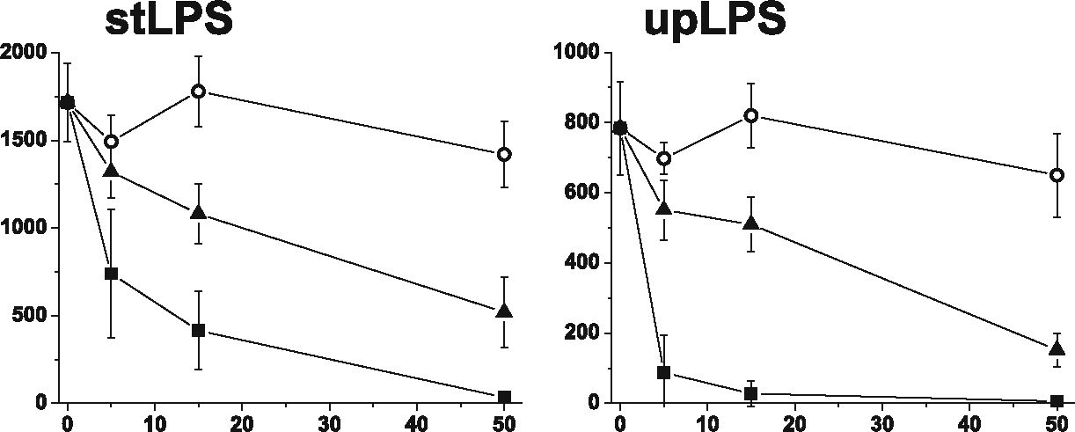
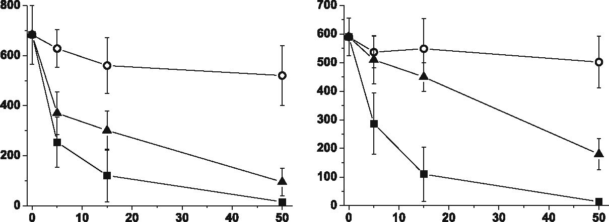
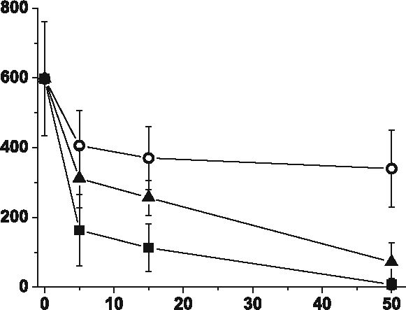
Oxidized LDLs Inhibit TLR-induced IL-10 Production by Monocytes
1571
RESULTS

OxLDLs Inhibit TLR2- and TLR4-Dependent
Production of IL-10
The first series of experiments was aimed at investi-
gating the ability of oxLDLs to modulate anti-inflammatory
cytokine IL-10 production by monocytes. Cells were
isolated from PBMC by adherence or elutriation-purified,
and treated with native (nLDLs), minimally modified
(mmLDLs), or oxLDLs for 30 min. As control, untreated
cells were maintained in culture for the same time.
Monocytes were stimulated with defined PAMPs specific
for TLR4, TLR2, or its heterodimers with TLR1 or TLR6.
Supernatants were collected after 20 h, and IL-10 concen-
trations were measured. Unstimulated cells did not secrete
IL-10, and oxLDLs alone did not activate cytokine
production as well (data not shown). As shown in Fig. 1,
both oxidized and minimally modified LDLs suppressed
the TLR dependent production of IL-10 by monocytes ina
dose-dependent manner. Response to challenge with
stLPS, pgLPS, and Pam2CSK4 was inhibited by oxLDLs
in about 50 % at concentration 5 p.g/ml and reached about
80 % at concentration 15 pg/ml. IL-10 production induced
by upLPS and Pam3CSK4 was inhibited by oxLDLs by
about 80 % already at concentration 5 pg/ml. Moreover,
this inhibition depended on LDLs oxidation state as native
LDLs did not alter the production of IL-10 (Fig. 1). For
Pam3CSK4 stimulation, we observed slight inhibition by
nLDLs, but still, reduction of IL-10 production was much
stronger in the presence of oxidized LDLs. The observed
effect was specific for oxLDLs as high-density lipoproteins
(HDLs) did not influence the IL-10 secretion even oxidated
(data not shown). The inhibitory effects were not attribut-
able to lipoprotein toxicity as we carefully studied the
viability of monocytes incubated with native, minimally
O)
a
pgLPS
Pam2CSK4
O nLDL
▲ mmLDL
■ oxLDL
Pam3CSK4

LDL [pg/ml]
Fig. 1. Oxidized LDLs inhibit TLR2- and TLR4-dependent production of IL-10. Monocytes were isolated from PBMC by adherence and placed in
media supplemented with 10 % FCS. Cells were treated for 30 min with native (nLDLs; open circles), minimally modified (mmLDLs; blach triangles)
or oxidized (oxLDLs; blach squares) low-density lipoproteins at the indicated concentrations and then stimulated with E. coli LPS (stLPS and upLPS),
P. gingivalis LPS (pgLPS), Pam2CSK4 or Pam3CSK4. Supernatants were collected 20 h after stimulation and IL-10 concentrations were determined
by ELISA. Data presented are mean±SD from at least three independent experiments.
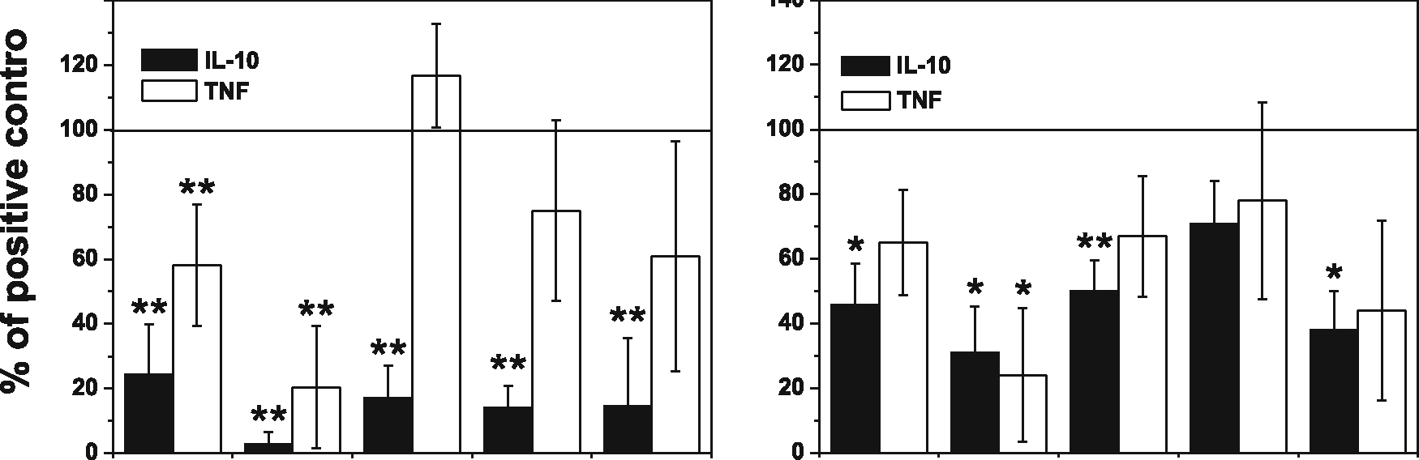
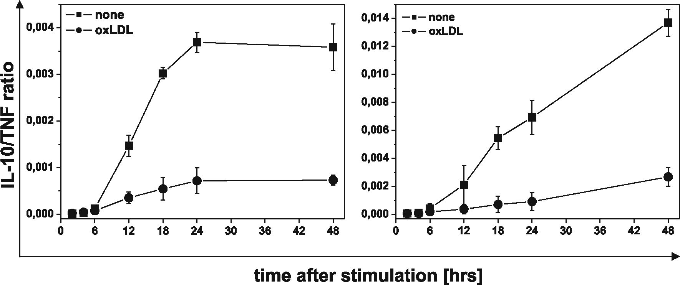
1572
Bzowska, Nogieć, Skrzeczyńska-Moncznik, Mickowska, Guzik and Pryjma
modified and oxidized LDLs at concentrations from 1 to
100 (ag/ml. As clearly indicated by staining with annexin V
and propidium iodide exclusion test, the presence of LDLs
had no effect on monocyte viability (data not shown). In
summary, our data consistently demonstrate that oxLDLs
inhibited TLR2- and TLR4-dependent IL-10 production
by monocytes.
Effect of Oxidized LDLs on PAMPs-Induced IL-10
and TNF Production
In order to determine whether oxLDLs change the
pro- and anti-inflammatory balance, we concurrently
measured the production of IL-10 and TNF by monocytes
and hMDMs. The data presented in Fig. 2a and supple-
140

a Monocytes
b hMDMs
aan _
stLPS upLPS pgLPS Pam2 Pam3

stLPS upLPS pgLPS Pam2 Pam3
c stLPS d pgLPS
Fig. 2. Effect of oxidized LDLs on PAMPs-induced IL-10 and TNF production in monocytes and monocyte-derived macrophages (hMDM). a, b
Monocytes were isolated from PBMC by adherence and placed in media supplemented with 10 % FCS. hMDMs were differentiated from adherent
monocytes for at least 7 days in medium supplemented with 10 % human serum, and before experiment, cells were placed in media supplemented
with 10 % FCS. Cells were cultured alone or treated for 30 min with oxidized LDLs at the 15 jig/ml and then stimulated with PAMPs as indicated in
the X-axis. Supernatants were collected 20 h after stimulation and IL-10 (blach bars) and TNF (white bars) concentrations were determined by ELISA.
Data are expressed as percent of positive control that is cells stimulated in the absence of oxLDLs (indicated as 100 %). Values are the mean±SD from
at least five independent experiments. **p<0.01, *p<0.05 versus corresponding positive controls. Absolute cytokine levels are presented in suppl-
ementary data Table 1. c, d Monocytes were isolated from PBMC by adherence and placed in media supplemented with 10 % FCS. Cells were
cultured alone (blach squares) or treated for 30 min with oxidized LDLs at the 15 j-ig/ml (blach circles), and then stimulated with stLPS (c) or pgLPS
(d). Supernatants were collected at time points indicated in the figure, and IL-10 and TNF concentrations were determined by ELISA. For each time
point, IL-10/TNF biological activity ratios recalculated as described in “Materials and Methods” are presented in the figure (c, d). Values are the mean
±SD from three independent experiments. Absolute cytokine levels are presented in supplementary data Figure 1. Similar experiments were done with
upLPS, Pam2CSK4, or Pam3CSK4 (data not shown).
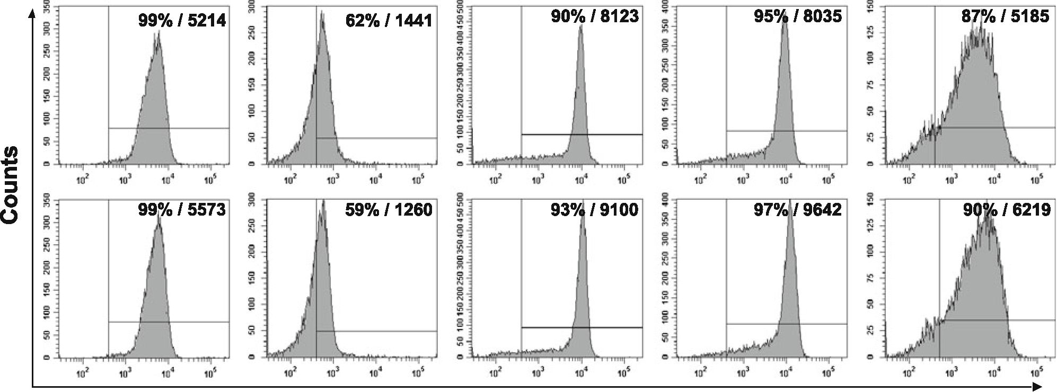
Oxidized LDLs Inhibit TLR-induced IL-10 Production by Monocytes
1573
mentary data Table 1 show that the ability of oxLDLs to
modulate TNF production by monocytes depended on
ligand used to induce the cytokine secretion. Although for
upLPS stimulation TNF production was strongly inhibited,
secretion of TNF induced with stLPS, Pam2CSK4, and
Pam3CSK4 was only moderately reduced. Surprisingly,
oxLDLs did not suppress TNF production stimulated by
pgLPS—while IL-10 production was inhibited, TNF
secretion was even slightly increased. At the same time,
the effect of oxLDLs on TLR-dependent cytokine produc-
tion by hMDMs was completely different (Fig. 2(b) and
supplementary data Table 1), namely, the secretion of both
cytokines, was similarly suppressed.
Consequently, we have also done kinetics experiments
and determined cytokine concentrations in supernatants at
distinct time points after stimulation (supplementary data
Figure 1). We have observed that TNF was secreted very
quickly (maximum at 6-18 h), and subsequently, the
concentration of TNF decreased. The TNF decline was
concomitant with increased production of IL-10 (maximum
at 24 h). Results presented in Fig. 2a and b were obtained
from supernatants collected 20 h after stimulation, that is at
maximum for IL-10 secretion. Based on kinetics experi-
ments, we excluded the possibility that oxLDL-mediated
modulation of cytokine production resulted from altered
kinetics of cytokine release (supplemetary data Figure 1).
We recalculated our results as IL-10/TNF biological activity
ratio at distinct time points in cultures with or without
oxLDLs as described in “Materials and Methods.” As
shown in Fig. 2c and d, after initial intensive TNF
production, the anti-inflammatory reaction started as indi-
cated by considerable increase IL-10/TNF ratio (squares).
While for TLR4 ligands, the ratio reached plateau at 24 h;
for TLR2 ligands, it was growing up constantly for 48 h,
mainly due to much more rapid drop in TNF concentration
in supernatants. What is more important, irrespectively of
oxLDLs-mediated inhibitory effect on both cytokines or
only IL-10 production, IL-10/TNF ratios at distinct time
points were much lower in the presence of oxLDLs (Fig. 2c
and d circles). The results allow to conclude that oxLDLs
hindered expansion of anti-inflammatory response follow-
ing less or more intense pro-inflammatory reaction.

Oxidized LDLs Do Not Affect Surface Expression
of TLR2, TLR4 and Their Coreceptors CD14,
CD11b, and CD36
As we observed oxLDL-mediated inhibition of IL-10
production by monocytes stimulated with TLR ligands, we
studied whether oxLDLs affect expression of TLR2,
TLR4, and their coreceptors on monocytes. We have
measured binding of TLR2-, TLR4-, CD14-, CD11b-, and
CD36-specific mAbs to cells treated with oxLDL for
30 min (data not shown) and 3 h (Fig. 3). Results presented
TLR2
TLR4
CD14
CD11b
CD36
Relative fluorescence intensity (FITC / PE)
Fig. 3. Oxidized LDLs do not affect surface expression of TLR2, TLR4, and their coreceptors CD14, CD11b, and CD36. Control (upper panel) or
treated for 3 h with oxLDLs (lower panel) monocytes were stained with PE-conjugated antihuman TLR2, TLR4, CD36 mAbs, or FITC-conjugated
antihuman CD14, CD11b mAbs and analyzed by flow cytometry. The histogram markers were set based on the signal from appropriate isotype
controls, and they designate section of the histogram representing positive cells. The percent of positive cells and MFI values are given in histograms.
Results of a representative experiment of three performed are presented.
1574
Bzowska, Nogieć, Skrzeczyńska-Moncznik, Mickowska, Guzik and Pryjma
in Fig. 3 clearly demonstrate that oxLDLs did not decrease
surface expression of tested receptors, which was also
apparent after short, 30 min treatment. Contrary, we
noticed slight increase in fluorescence intensities for
TLR2, CD14, CD11b, and CD36. Consequently, we
assumed that diminished production of IL-10 secretion
following treatment with oxLDLs cannot be attributed to
reduced expression of TLRs and/or their coreceptors.

IL-10 and TNF Production Depends on Serum
Soluble Factors
It was shown that the inhibitory effect of oxidized
phospholipids (oxPLs) was in large part attributable to
interaction with accessory molecules, namely, LPS-
binding protein (LBP) and soluble CD14 (sCD14),
participating in TLR activation [27, 28]. Therefore, we
assumed that serum soluble molecules also may take
part in the described regulation of IL-10 and TNF
secretion. To answer this question, we stimulated
monocytes with TLR ligands in serum-free medium or
in media supplemented with 1 %, 10 %, and 30 % FCS,
or 10 % HS. As shown in Fig. 4, production of both
cytokines was equally dependent on FCS when stimu-
lated with LPS from E. coli. In serum-free media and at
1 % of FCS, upLPS-induced production of IL-10 as well
as TNF was minimal and reached the maximum at 10 %
of FCS. In monocytes stimulated with stLPS, we
observed production even in the absence of FCS but
alongside with raising concentration of FCS in media
secretion of IL-10 and TNF increased, reaching the
maximum for TNF at 10 % and for IL-10 at 30 % of
FCS. Interestingly, in milieu with human serum, TLR2-
and TLR4-induced IL-10 secretion was diminished, and
TNF production was augmented in comparison to the
cell cultures with appropriate concentration of FCS.
Surprisingly, for TLR2-induced production of IL-10 and
TNF, we observed distinct dependence on FCS concen-
tration. All three applied TLR2 ligands induced similar
IL-10 secretion in serum-free media and at 1 % FCS,
and IL-10 production was strongly augmented in media
supplemented with 10 % FCS. Interestingly, for maximal
TNF production, 1 % of FCS was sufficient, and further
rising of FCS concentration did not take effect or even
suppressed TNF secretion. Noteworthy, the pgLPS-
induced TNF production seemed completely indepen-
dent on serum. On the basis of obtained results, we
suggest that distinct effect of oxLDLs on TLR-induced
production of IL-10 and TNF resulted from different
dependence on soluble factors, which are main targets of
Fig. 4. IL-10 and TNF production depends on serum soluble fact- b
ors. Monocytes were isolated from PBMC by adherence. Before
stimulation cells were placed in media supplemented with 0.15 %
BSA (serum-free; white bars) or 1 % (dashed bars), 10 % (black
bars), 30 % (checked bars) FCS or 10 % HS (dense-checked bars),
and then activated with PAMPs: E. coli LSP (stLPS and upLPS), P.
gingivaIis LPS (pgLPS), Pam2CSK4, or Pam3CSK4. Supernatants were
collected 20 h after stimulation and IL-10 (left panel) and TNF (right
panel) concentrations were determined by ELISA. Values are the mean±
SD from three independent experiments. **^<0.01 and *^<0.05 versus
serum-free conditions, **p<0.01 versus 10 % FCS.
oxLDLs inhibitory activity. To extend our observation,
we had also preincubated monocytes with oxLDLs, then
washed them with fresh medium and stimulated with
PAMPs in the absence of oxLDLs. The removal of
oxLDLs before stimulation led to complete reconstitu-
tion of TNF production induced by all used PAMPs. IL-
10 secretion was also restored, with the exception of
upLPS stimulated, where we observed significant but
incomplete reversal of oxLDLs inhibitory effect (Fig. 5,
white bars). It was suggested by other authors that
oxPLs inhibit also cell-associated steps in PAMPs
recognition and signaling [27, 28]. Supposing that
affinity of oxLDLs to serum soluble and cellular factors
differs, it cannot be excluded that cells preincubation
with oxLDLs in medium with FCS mask interaction
with cell-associated molecules. Therefore, we preincu-
bated the cells with oxLDLs in serum-free medium, then
washed them out and stimulated in the presence of 10 %
FCS (Fig. 5, dashed bars). We observed complete
restoration of Pam3CSK4- and pgLPS-induced IL-10
production. For the other stimulators, inhibition was still
noticeable. Interestingly, the increased production of
pgLPS-stimulated TNF disappeared after washing out of
oxLDLs, especially when preincubated without serum.

PgLPS-Induced IL-10 Production is Entirely
Dependent on TLR2
Recognition of LPS from P gingivalis is still
controversial. It was demonstrated to be an agonist for
TLR2 and TLR4 and also an antagonist for TLR4 [29-
31]. Such contradictory data could result, from different
preparations of LPS, distinct cell models, and readout
molecules employed to measure cell activation. To
determine the contribution of TLR to pgLPS-induced
production of IL-10 and TNF in monocytes, we used
neutralizing antibodies to block TLR2 or TLR4. We
have shown that proper isotype control did not influence
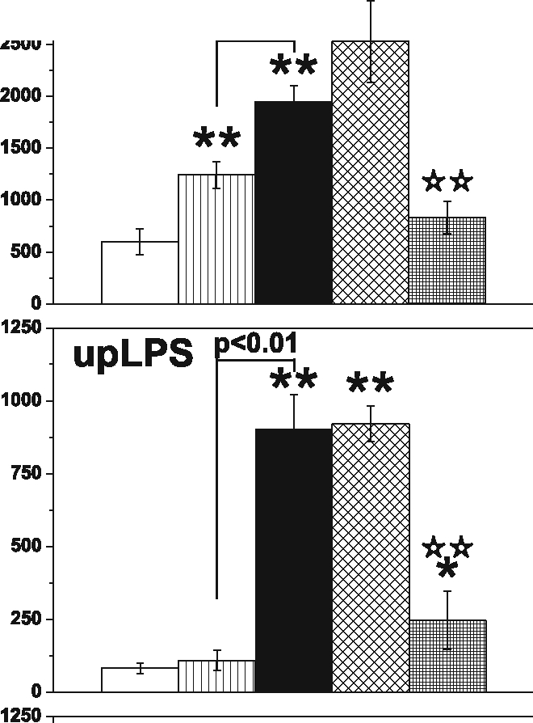
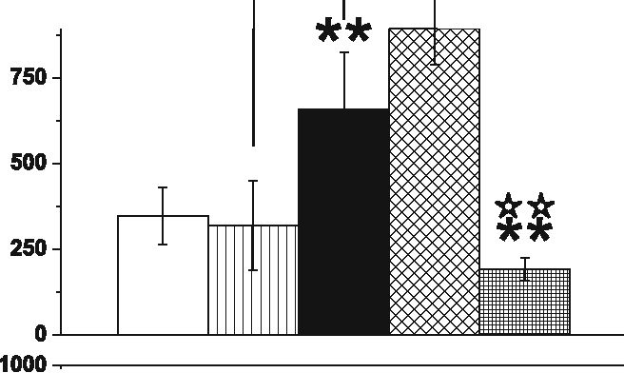
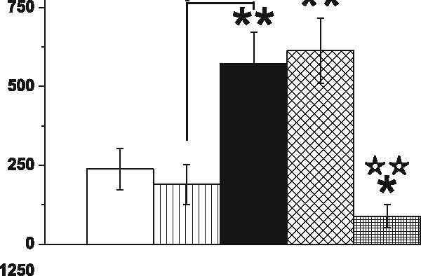
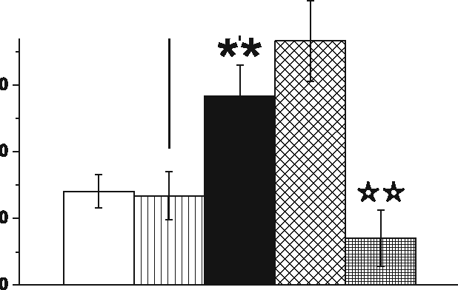
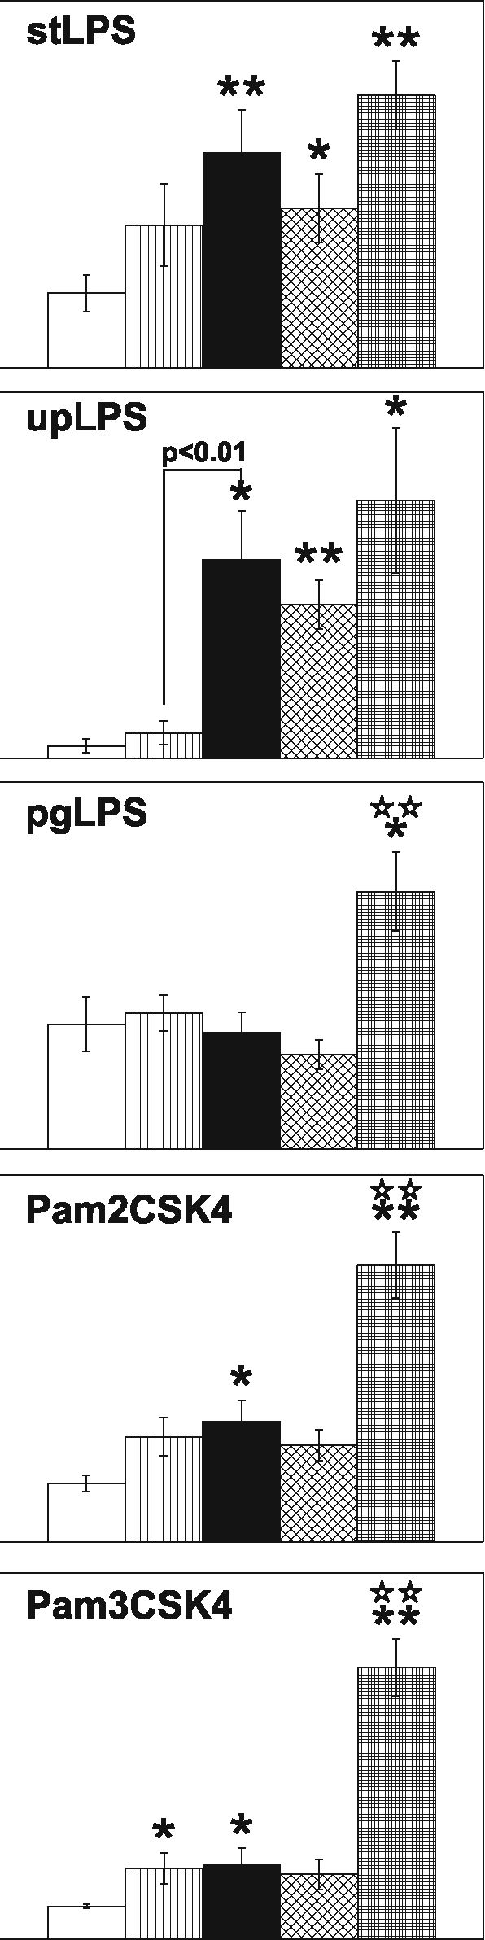
IL-10 [pg/ml]
Oxidized LDLs Inhibit TLR-induced IL-10 Production by Monocytes
1575
stLPS **
p<0.01
pgLPS
P<0.01| **
Pam2CSK4
p<0.01
Pam3CSK4 **
><0.05
 | 80
 | 60
 | 40
 | 20
 | 0
 | 30
 | 20
 | 10
 | 0
 | 30
E
U)
c
LL
Z
H | 10
 | 0
 | 40 -i
 | 30
 | 20
 | 10
 | 0
 | 60
 | 50
 | 40
 | 30
 | 20
 | 10
 | 0
serum-free 1% 10% 30% HS
FCS
serum-free 1% 10% 30% HS
FCS
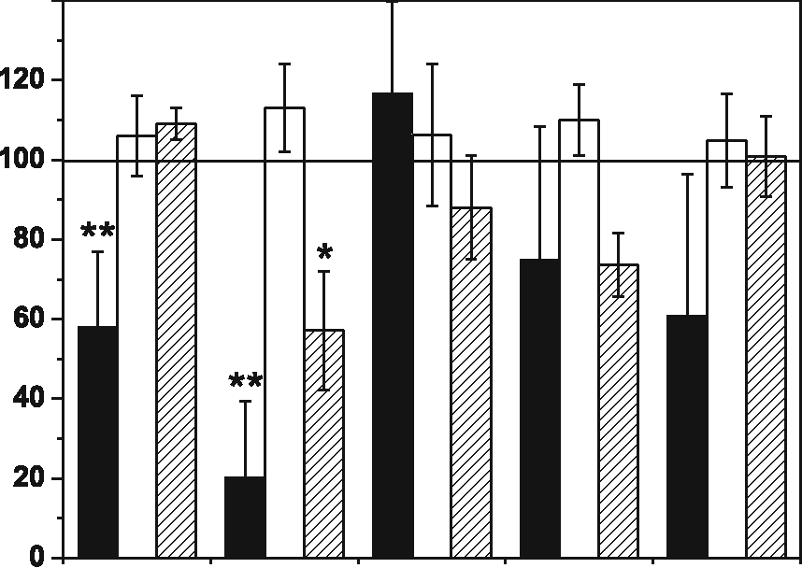
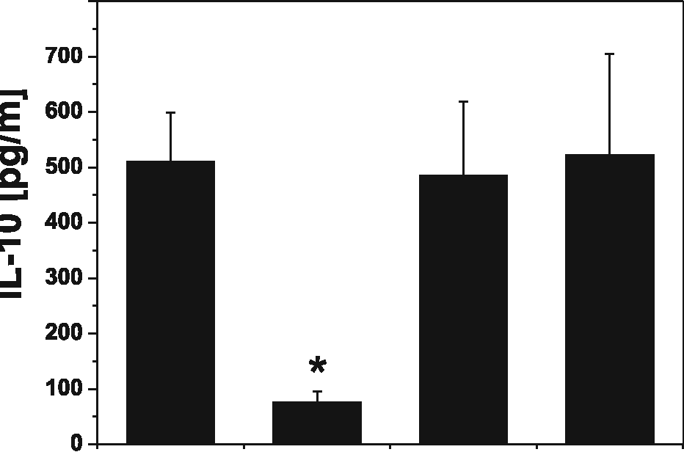
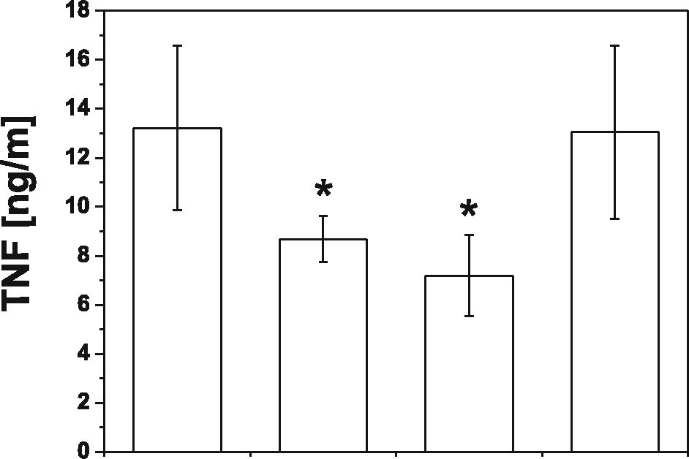
1576
Bzowska, Nogieć, Skrzeczyńska-Moncznik, Mickowska, Guzik and Pryjma
140
120
IL-10
800
100
X
o
o
u
3
TJ
O
i-
a
a>
c
2
o
14-
o
80-
60
40-
20-
0
FCS/without wash
FCS/with wash
serum-free/with wash
** IP
ii.
Ul
stLPS upLPS pgLPS Pam2 Pam3
140
TNF
stLPS upLPS pgLPS Pam2 Pam3
Fig. 5. Oxidized LDLs inhibit both extracellular and cell-associated
components of TLR2 and TL4 activation. Monocytes were isolated
from PBMC by adherence and placed in media supplemented with
10 % FCS. Cells were cultured alone or treated for 30 min with oxi-
dized LDLs at the 15 tig/ml, and then stimulated (blach bars) or pre-
treated with oxLDLs, washed, and stimulated (white bars) with
PAMPs: E. coli LSP (stLPS and upLPS), P. gingivalis LPS (pgLPS),
Pam2CSK4, or Pam3CSK4. In parallel, cells were pretreated for 30-
min with oxLDLs in serum-free medium, washed, and stimulated with
PAMPs (dashed bars) in media supplemented with 10 % FCS. Supe-
rnatants were collected 20 h after stimulation and IL-10 (top) and TNF
(bottom) concentrations were determined by ELISA. Data are expres-
sed as percent of positive control that is cells stimulated in the absence
of oxLDLs (indicated as 100 %). Values are the mean±SD from three
independent experiments, **p<0.01, *p<0.05 versus corresponding
positive controls.
cytokine production. To our surprise, we observed that
IL-10 production in response to pgLPS was exclusively
TLR2 dependent, while TNF secretion was inhibited
partially by both antibodies (Fig. 6).
PC TLR2 TLR4 lgG2a
blocking Abs anti-
Fig. 6. PgLPS-induced IL-10 production is entirely dependent on T-
LR2. Monocytes were isolated from PBMC by adherence and placed in
media supplemented with 10 % FCS. Cells were culture alone (positive
control, PC) or were pretreated for 30 min with blocking antibodies
anti-TLR2, TLR4, or appropriate isotype control (IgG2a) at a concen-
tration of 10 tig/ml, and stimulated with LPS from P. gingivalis. Sup-
ernatants were collected 20 h after stimulation, and IL-10 (black bars)
and TNF (white bars) concentrations were determined by ELISA. Va-
lues are the mean±SD from three independent experiments. Blocking
and control antibodies alone did not induce cytokine secretion (data not
shown). *p<0.05 versus positive control that is cells stimulated with
pgLPS in the absence of antibodies.
TLR2-Dependent IL-10 Production is Regulated
by Integrins
Because of specific IL-10-promoting effect of
serum, we searched for some still unrecognized serum
“accessory molecules.” From the results demonstrated in
Fig. 7a, we inferred that the serum effect was evident
only in freshly adhered monocytes (black bars) in
contrast to cells with established adherence—hMDM

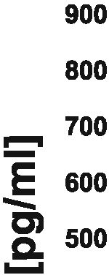
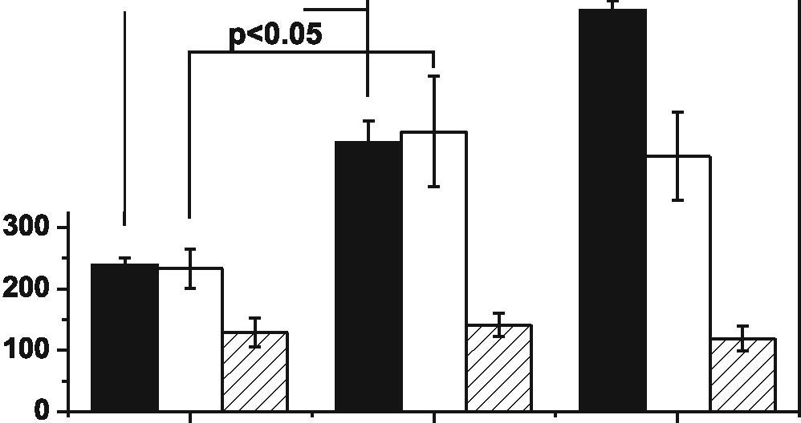
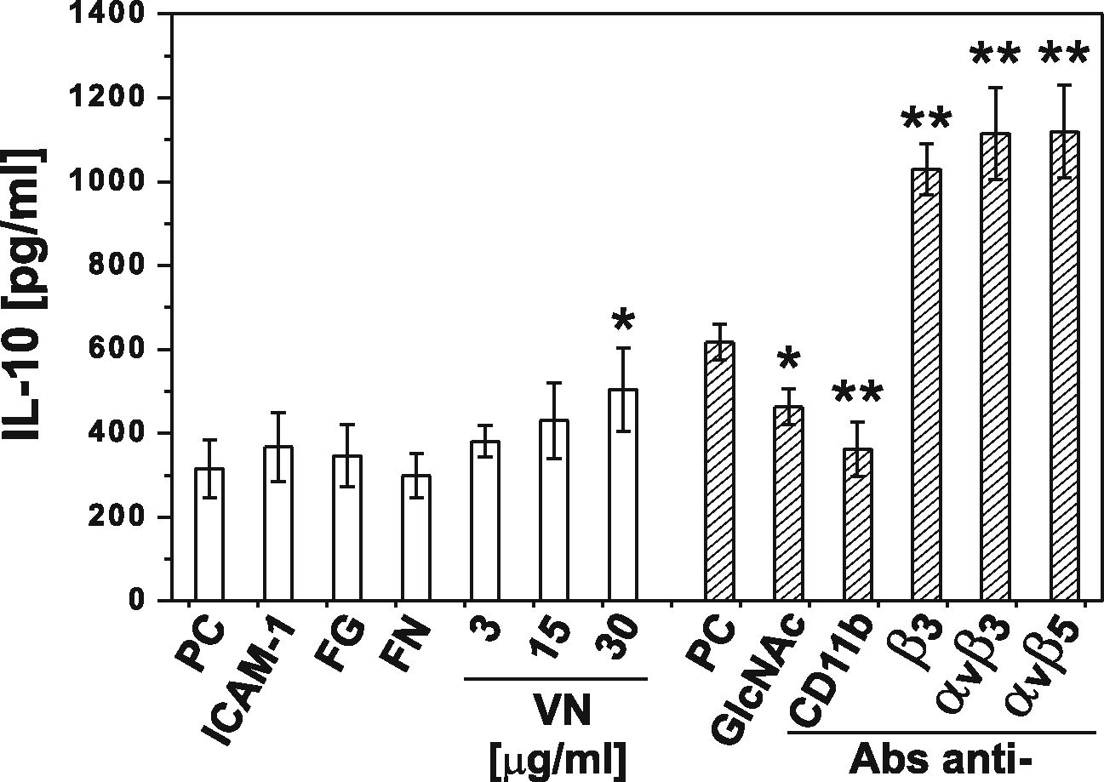
Oxidized LDLs Inhibit TLR-induced IL-10 Production by Monocytes 1577
a
I Mo adherent
I Mo nonadherent
V77* hMDM p<0.05
p<0.05
O 400
1% FCS 10% FCS 30% FCS
b
Fig. 7. Integrins aM, av^3, and av^5 influence TLR-2-dependent IL-10 production. a Monocytes were isolated from PBMC by elutriation and
placed in culture plates (Mo adherent, blach bars) or in polypropylene culture tubes (Mo nonadherent, white bars). hMDMs were differentiated from
adherent monocytes for at least 7 days in medium supplemented with 10 % human serum. Before experiments, cells were placed in media supple-
mented with 1 %, 10 %, or 30 % FCS and stimulated with pgLPS. Supernatants were collected 20 h after stimulation, and IL-10 concentrations were
determined by ELISA. Values are the mean±SD from three independent experiments; p values were determined for the different cell culture
conditions. b Monocytes were isolated from PBMC by adherence and placed in media supplemented with 1 % FCS (white bars). Cells were cultured
alone or pretreated for 30 min with: intercellular adhesion molecule 1 (ICAM-1; 10 jo-g/ml), fibrinogen (FG; 100 jag/ml), fibronectin (FN; 1 jo-g/ml), or
vitronectin (VN; 3-30 jig/ml). Alternatively, cell were placed in media supplemented with 10 % FCS (dashed bars) and cultured alone or pretreated
for 30 min with: N-acetyl-D-glucosamine (GlcNAc, 150 mM), blocking mAb against aM integrin (CD11b, clone Vim12) or agonistic mAbs against
[33 integrin (clone RUU-PL 7F12), av^3 (clone LM609), av^5 (clone P1F6), all at a concentration 10 jag/ml. Then, cells were stimulated with LPS
from P gingivalis. Supernatants were collected 20 h after stimulation, and IL-10 concentrations were determined by ELISA. In the case of blocking or
agonistic mAbs, the corresponding isotype controls were without effect and were not included in the figure. Values are the mean±SD from three
independent experiments. PC indicates positive control that is cells cultured in 1 % FCS or 10 % FCS medium and stimulated with pgLPS. **p<0.01,
*p<0.05 versus corresponding positive controls.
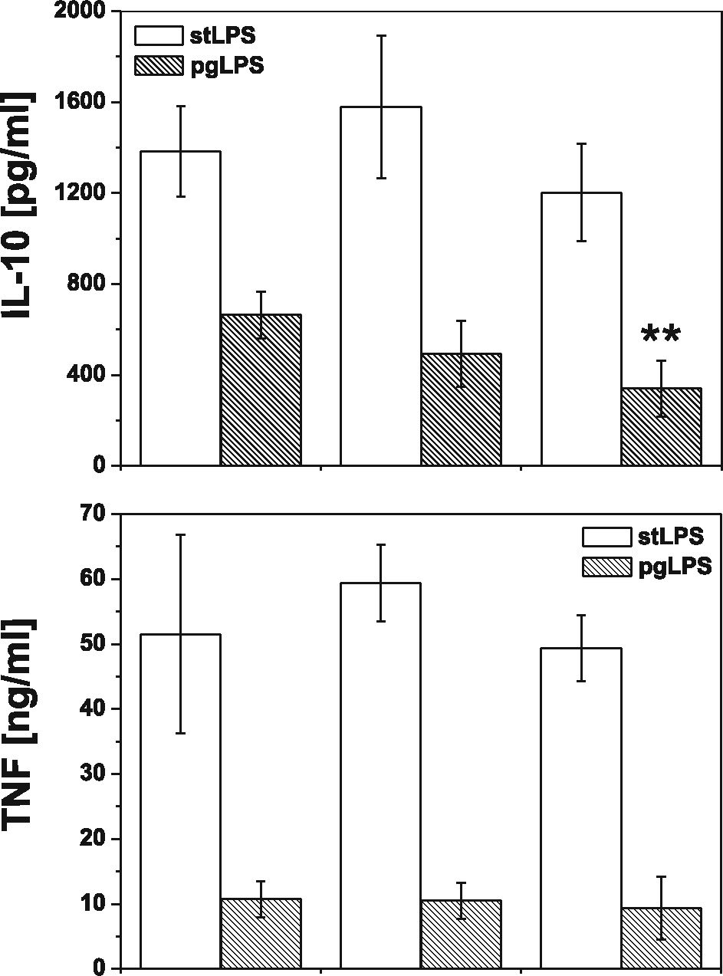
1578
Bzowska, Nogieć, Skrzeczyńska-Moncznik, Mickowska, Guzik and Pryjma

Mf3CD 0 0.5 1

[mM]
Fig. 8. Effects of membrane-disrupting agent on TLR-induced IL-10
and TNF production. Monocytes were isolated from PBMC by adher-
ence and placed in media supplemented with 10 % FCS. Cells were
stimulated with LPS from E. coli (white or P. gingivalis (dashed
bars) in the presence of methyl-p-cyclodextrin (MpCD) at concen-
trations indicated in the figure. Supernatants were collected 20 h after
stimulation, and IL-10 and TNF concentrations were determined by
ELISA. Values are the mean± SD from three independent experiments.
**p<0.01 versus cells cultured in the absence of MpCD and stimu-
lated with the same type of LPS.
costimulation of |33, av|33, and av|35 integrins with
agonistic mAbs. Noteworthy, TNF secretion was not
affected or regulated with these mAbs in an opposite
manner (data not shown). To specifically address the role
of CD11b in the pgLPS-induced IL-10 secretion, we
used ligands specific for CD11b: inter-cellular adhesion
molecule 1 (ICAM-1) and fibrinogen (FG) or its
antagonists: blocking mAb (clone Vim12) and N-
acetylglucosamine (GlcNAc). After such a pretreatment,
cells were stimulated with pgLPS, and cytokine produc-
tion was determined. Appropriate isotype controls were
also applied, and we did not find their effect on cytokine
secretion. Figure 7b shows that although costimulation
of CD11b with ICAM-1 or fibrinogen was without the
effect, IL-10 production was partially inhibited after
blocking of receptor with mAbs or GlcNAc.

Effects of Membrane-Disrupting Agent
on TLR2-Induced IL-10 Production
It has been reported that effective cell activation by
PAMPs require cooperation of TLRs with several host
receptors within membrane microdomains known as
lipid rafts [32], which might be disrupted by oxidized
PLs contributing to suppression of TLR signaling [33].
To test the possibility that effective stimulation of IL-10
and TNF secretion in varying degrees depends on lipid
rafts function, we determined the effect of well-estab-
lished raft-disrupting agent—M|3CD—on LPS-induced
cytokine production. Firstly, we carefully studied cyto-
toxic activity of M|3CD (data not shown), and in further
experiments, we used its sublethal concentrations.
Figure 8 shows that whereas pgLPS-induced TNF
production was lipid raft-independent, IL-10 secretion
was significantly diminished by M|3CD. At the same
concentrations of M|3CD, we did not observe the effect
on TLR4-dependent cytokine production.
(dashed bars) or monocytes—which adherence was
denied by incubation in polypropylene tubes—non-
adherent monocytes (white bars). We concluded that
the serum “accessory molecule” could be one of its
adherence factor, and consequently, we measured IL-10
production by adherent monocytes stimulated with
pgLPS in media supplemented with purified fibronectin
(FN) or vitronectin (VN). We observed concentration-
dependent augmentation of IL-10 secretion when vitro-
nectin substituted for FCS. Additionally, pgLPS-stimu-
lated IL-10 production was increased as a result of

DISCUSSION
In this paper, we describe an unexpected aspect of
pathogen-accelerated atherosclerosis resulting from al-
tered recognition of selected PAMPs by monocytes
exposed to proatherogenic oxidized low-density lip-
oproteins. The dysfunctional recognition was apparently
shifting the physiological balance between pro- and anti-
inflammatory cytokines, represented in our study by the
most biologically active members of both groups, TNF
and IL-10, respectively. Strong inhibition of IL-10
Oxidized LDLs Inhibit TLR-induced IL-10 Production by Monocytes
1579
induced with TLR2 and TLR4 ligands was opposed by
only moderate inhibition of TNF. Thus, it appears that
monocytes recognizing PAMPs in the presence of
established risk factor of atherosclerosis—oxLDLs—
create a cytokine milieu promoting chronic inflamma-
tion. The inhibitory effect of low-density lipoproteins
depended significantly on their oxidation state, and it
was not attributable to oxLDLs toxicity. A potent
antiatherogenic activity of IL-10 has already been shown
by many groups [20-24].
Assuming the proportion between IL-10 and TNF
produced in the absence of oxLDLs as physiological, we
observed that oxLDLs strongly disturbed the balance
between the pro- and anti-inflammatory cytokines
produced by monocytes upon TLR stimulation (Fig. 2a
,c, d, and supplementary data Table 1 and Figure 1).
Irrespective of TLR-ligand used to challenge the mono-
cytes, we observed dramatic inhibition of IL-10 and a
moderate change in secretion of TNF, varying from
subtle stimulation to slight inhibition. In kinetics experi-
ments, oxLDLs inhibited the anti-inflammatory response
following less or more intensely pronounced pro-
inflammatory reaction (Fig. 2c, d and supplementary
data Figure 1). From the same experiments, we also
concluded that modulation of cytokine production by
oxLDLs did not result from altered kinetics of cytokine
release (supplementary data Figure 1). A spectacular
example of the differential regulation of TNF and IL-10
by oxLDLs was seen upon stimulation of monocytes
with LPS from P gingivalis (PG). In spite of strong IL-
10 suppresion, oxLDLs did not inhibit TNF production,
which was even slightly increased (Fig. 2a and supple-
mentary data Table 1). PG is a primary etiological agent
of human periodontal disease, but epidemiological and
experimental studies support the hypothesis that chronic
infection with this bacterium may be associated with
pathogen-accelerated atherosclerosis [7, 34-37]. Recent-
ly, it has been demonstrated that patients with periodon-
tal disease are at greater risk of developing vascular
dysfunction [38] as well as the association between
periodontal pathogens, and subclinical atherosclerosis
has been revealed [39]. Some in vitro studies have
demonstrated that endothelial cells and monocytes
respond to P. gingivaIis, pgLPS, or FimA secreting
various cytokines and chemokines [40-42], but to the
best of our knowledge, there are no reports concerning
the effect of oxLDLs on recognition of LPS from P
gingivaIis. We demonstrated for the first time that
oxLDLs strongly suppress production of IL-10 by
monocytes challenged with PG. PAMP hypothesis of
atherosclerosis postulates that the occasional presence of
PAMPs in the blood may promote the activation of
endothelial cells and the recruitment of monocytes into
the vessel wall. Based on our results, we propose that
also the anti-inflammatory response of monocytes is
inhibited, thus leading to chronic inflammation. In this
context, the altered recognition of PAMPs by monocytes
in the presence of oxLDLs may be proposed as a new,
general mechanism governing pathogen-accelerated ath-
erosclerosis. Interestingly, we have demonstrated that the
differential regulation of IL-10 and TNF is specific for
monocytes. In hMDMs, both cytokines were propor-
tionally inhibited (Fig. 2b and supplementary data:
Table 1). Combined with the finding by Fuhrman et al.
- that oxLDLs accelerate monocyte to macrophage
differentiation, our observation suggests a coherent
picture of pathogenic mechanism in which a modified,
proinflammatory microenvironment can be created be-
fore monocytes differentiate into macrophages—at early
stages of fatty streak development or at later stages by
currently recruited cells.
In this work, we used copper oxidized LDLs, which
do not occur in vivo and are not a physiologic molecule.
Like variety of minimally modified LDLs, extensively
oxidized LDLs contain a myriad of bioactive com-
pounds including oxidized phospholipids, lysophospho-
lipids, oxysterols, oxidized fatty acids, and variably
modified ApoB (reviewed in [44]). However, it is not
clear which of these components is predominant in vivo
and has the most significant pathophysiological effect.
Moreover, some of the biological effects of oxLDLs are
dependent on individual components, while others are
due to the complex signal provided by whole oxLDL
particle. For these reasons, there is no accepted “gold
standard” for preparing oxidized LDLs ex vivo. Never-
theless, copper oxidized LDLs resemble naturally
occurring oxidized LDLs as antibodies raised against
Cu2 LDLs recognize epitopes present in vivo and are
successfully used to detect oxLDLs in patients [45]. We
observed that both copper oxidized as well as minimally
modified LDL obtained by storage of LDLs at 4°C for
6 months inhibited IL-10 production by monocytes
stimulated with TLR ligands, but detailed analysis of
oxidized LDL compounds was beyond of the scope of
this study.
The mechanism of P. gingivaIis LPS recognition is
still controversial. It activates host cells through both
TLR2 and TLR4, and this may result from heterogeneity
of these molecules, containing various forms of lipid A
[29]. A lipoprotein from pgLPS was suggested to be a
1580
Bzowska, Nogieć, Skrzeczyńska-Moncznik, Mickowska, Guzik and Pryjma
principal component for TLR2- and highly purified lipid
A for TLR4-mediated cell activation [30, 31]. On the
other hand, it has been shown that in human vascular
endothelial cells P gingivalis LPS-induced cell activa-
tion is mediated through TLR2, and it is lipid raft-
dependent as well as requires the formation of receptor
complex comprising of TLR2/TLR1, CD36, and
CD11b/CD18 [32]. These results support hypothesis
that innate immune signaling following PG challenge is
cell specific [46]. We observed that TNF secretion was
dependent on TLR4 and TLR2, but IL-10 production
was exclusively TLR2 dependent (Fig. 6), which is
supported by strong association of TLR2 expression on
monocytes with IL-10 inducibility [47].
There are conflicting data on the possibility of TLR
stimulation by LDLs alone. Some authors suggested that
minimally modified LDLs and their components—
oxidized phospholipids—may stimulate TLR-dependent
signaling [33, 48-50]. It has been reported recently that
copper oxidized mmLDLs induce both proinflammatory
cytokines IL-1|3 and IL-6 as well as anti-inflammatory
cytokine IL-10, in human monocytes and U937-derived
macrophages, and this effect can be assigned to CD14,
TLR2, and TLR4 activation [51]. On the contrary, the
evidence has been presented that neither oxPAPC nor
extensively oxidized LDLs are capable of stimulating
TLR2 and TLR4-dependent signaling [52, 53]. The
apparent contradiction may be in part explained by a
suggestion that pro- or anti-inflammatory activities of
oxidized LDLs may depend on their concentration [54]
experimental designs and/or variable LDLs preparations
- . Nevertheless, in our hands, spontaneously oxidized
mmLDLs and oxLDLs alone did not stimulate detectable
TNF or IL-10 secretion (data not shown).
It is clear that the ability of both TLR4 and TLR2
receptors to activate cells relies on “accessory proteins,”
soluble serum or membrane bound factors such as CD14
or LBP [55, 56] The serum factors were also identified
as key targets for oxidized phospholipids, which
specifically inhibit TLR2 and TLR4 by competitive
interaction [27, 28]. Consequently, we were interested if
IL-10 and TNF production by monocytes upon stimula-
tion via TLR2 and TLR4 was dependent on soluble
serum molecules. As shown in Fig. 4, IL-10 and TNF
production responded differently to serum concentration
only following TLR2 activation. Precisely, IL-10 pro-
duction was relatively low in serum-free media and at
1 % FCS and was strongly augmented in 10 % FCS, but
for maximal TNF production, supplementation with 1 %
FCS was sufficient and further raising the FCS concen-
tration suppressed TNF secretion. It is noteworthy that
TNF production induced with LPS from P gingivalis
appeared completely independent on serum (Fig. 4).
These results correlate with data showing that serum-
soluble CD14 effectively transferred P gingivalis LPS to
TLR2 plus TLR1, but poorly to TLR4 [29], and our
observation of TLR2-dependent production of IL-10 by
monocytes stimulated with pgLPS. Assuming that
sCD14 and LBP are main targets for oxPL, the described
dependence of cytokine production on serum factors
correlated well with the inhibition pattern shown in
Fig. 2a. To expand this observation, we treated cells with
oxLDLs and then washed them out before stimulation.
From this experiment, we concluded that inhibition of
IL-10 production occurred mainly by competitive inter-
action of oxLDLs with accessory proteins as removing
the preincubation medium before the stimulation abol-
ished the inhibitory effect of lipoproteins. The “unblock-
ing” effect of medium change was most pronounced for
Pam3CSK4 and pgLPS. The apparent IL-10-promoting
effect of serum attracted our attention to a possibility that
some still unrecognised serum “accessory molecules” may
participate the pgLPS-TLR2-IL-10 pathway. As the effect
of serum was apparent only in freshly adhered monocytes
but neither in hMDMs (where adherence is established) nor
in elutriated monocytes incubated in polypropylene tubes
(where adherence is prevented), we assumed that the serum
“accessory protein” is one of its factors of adherence.
Consequently, we tried to substitute FCS using purified
fibronectin, fibrinogen, or vitronectin. Among the tested
proteins, only vitronectin demonstrated a concentration-
dependent effect on IL-10 production (Fig. 7). Previous
studies concerning vitronectin receptors expression on
human monocytes have produced conflicting results. Some
groups suggested that, although freshly isolated monocytes
lack surface expression of |33 and |35 integrns, it appeared
gradually during monocyte adhesion and maturation [57].
In our hands, expression of av|33 on monocytes 5 h post-
isolation was evident while av|35 was barely detactable.
Still, pretreatment with vitronectin receptors agonistic
mAbs (clones: RUU-PL 7F12, P1F6, or LM609), which
alone did not stimulate cytokine production, resulted in
dramatic increase in pgLPS-induced production of IL-10
(Fig. 7b). The agonistic effect was also observed in serum-
free media (data not shown) suggesting that costimulation
through TLR2 and |33 and |35 integrins leads to increased
IL-10 production.
As CD11b is naturally involved in adherence of
monocytes to solid substratum, we have demonstrated
that some ligands or antagonists of CD11b influenced
Oxidized LDLs Inhibit TLR-induced IL-10 Production by Monocytes
1581
the IL-10 production induced by TLR2 ligands (Fig. 7b).
Significantly, we have not seen any effect of ICAM-1 or
fibrinogen, what may suggest that CD11b is involved
through lateral interaction with other receptor(s) rather
than by direct binding of vitronectin or other serum
“accessory molecules.” As TLR2 and 4 form a func-
tional surface complex with integrin CD11b/CD18 [32],
our results may suggest that vitronectin receptor is a
novel partner in this interaction. An interaction between
CD11b and vitronectin has been described in neutrophils
[58]. The most likely sites for such interactions are
cholesterol-rich membrane platforms containing arrays
of PRRs and other surface proteins, which are now
proposed to play a critical role in interaction of PAMPs
with immune cells [59]. Indeed, disruption of lipid rafts
with methyl-|3-cyclodextrin inhibited the effect of
pgLPS on IL-10 production, while TNF-production
was not afflicted. TLR-containing lipid rafts harbor not
only other PRRs (e.g., Dectin-1 [60]) but also receptors
and proteins, which have not been directly connected to
pattern recognition (e.g., HSP90 [61]). We have previ-
ously reported functional interactions of CD11b with
CD16, which stabilized other surface molecules (phos-
phatidylserine, annexin I) not previously known to
interact with the integrin complex [62-64]. In this paper,
we suggest that also vitronectin receptor may function as
a component of TLR signaling platforms.
Vitronectin has become an important mediator in the
pathogenesis of coronary atherosclerosis because of its
ability to bind platelet glycoproteins and mediate platelet
adhesion and aggregation at sites of vascular injury
(extensively reviewed in [65, 66]). The involvement of
vitronectin and CD11b in the described mechanism is also
supported by interesting clinical findings: Firstly, elevated
levels of vitronectin are connected with coronary athero-
sclerosis and are postulated to be the result of a
compensatory mechanism [67]; on the other hand, inhibi-
tion of vitronectin receptor enhances the uptake of oxLDL
and differentiation of monocytes/macrophages into foam
cells [68]; secondly, transmigrating monocytes from
patients with coronary artery disease have lower expres-
sion of CD11b [69]; thirdly, in children with hypercholes-
terolemia, cell surface expression of CD11b and CD18 on
PBMC was significantly decreased [70]; finally, Toll-like
receptor 2 and 4 stimulation produced an enhanced
inflammatory response in human obese patients with
atherosclerosis [71].
Summarizing, it seems justified to assume that
proatherogenic oxidized LDLs disturbed the balance
between pro- and anti-inflammtory cytokines produced
by monocytes upon TLR2 and TLR4 stimulation. IL-10
release was strongly suppressed by oxLDLs with no
respect to the TLR ligand used for activation. In
contrast, TNF production was reduced to a lesser extent
than IL-10, unaffected or even slightly increased, when
stimulated with LPS from P gingivalis, one of infectious
agent of atherosclerosis. Although the precise mecha-
nisms of observed cytokine modulation remain to be
determined, our results highlight the differential depen-
dence of IL-10 and TNF production on serum accessory
molecules. Significantly, vitronectin or/and its receptor
appear to be the main target of oxidized phospholipids
inhibitory activity on TLR-induced activation.
ACKNOWLEDGMENTS
We are indebted to Ms Ewa Marewicz and Ms Joanna
Maciąg (Jagiellonian University, Kraków) for excellent
technical assistance. This work was mainly supported by
grant no. NN303 291934 (to MB) from Ministry of
Science and Higher Education (Warsaw, Poland) and no.
NN301 033240 (to KG) from the National Science Centre
(Kraków, Poland) and also partially by Statutory Activity
(DS6) from Ministry of Science and Higher Education
(Warsaw, Poland). The Faculty of Biochemistry, Biophys-
ics, and Biotechnology of the Jagiellonian University is a
beneficiary of the structural funds from the European
Union (grant no. POIG.02.01.00-12-064/08—“Molecular
biotechnology for health”.
Open Access. This article is distributed under the terms of
the Creative Commons Attribution License which permits
any use, distribution, and reproduction in any medium,
provided the original author(s) and the source are credited.
REFERENCES
- Libby, P. 2002. Inflammation in atherosclerosis. Nature 420: 868-874.
- Ross, R. 1999. Atherosclerosis—an inflammatory disease. The
New England Journal of Medicine 340: 115-126.
- Kiechl, S., G. Egger, M. Mayr, C.J. Wiedermann, E. Bonora, F.
Oberhollenzer, M. Muggeo, Q. Xu, G. Wick, W. Poewe, and J.
Willeit. 2001. Chronic infections and the risk of carotid athero-
sclerosis: prospective results from a large population study.
Circulation 103: 1064-1070.
- Espinola-Klein, C., H.J. Rupprecht, S. Blankenberg, C. Bickel, H.
Kopp, A. Victor, G. Hafner, W. Prellwitz, W. Schlumberger, and J.
1582
Bzowska, Nogieć, Skrzeczyńska-Moncznik, Mickowska, Guzik and Pryjma
Meyer. 2002. Impact of infectious burden on progression of carotid
atherosclerosis. Stroke 33: 2581-2586.
- Lehr, H.A., T.A. Sagban, C. Ihling, U. Zahringer, K.D. Hungerer,
M. Blumrich, K. Reifenberg, and S. Bhakdi. 2001. Immunopatho-
genesis of atherosclerosis: endotoxin accelerates atherosclerosis in
rabbits on hypercholesterolemic diet. CircuIation 104: 914-920.
- Lalla, E., I.B. Lamster, M.A. Hofmann, L. Bucciarelli, A.P. Jerud,
S. Tucker, Y. Lu, RN. Papapanou, and A.M. Schmidt. 2003. Oral
infection with a periodontal pathogen accelerates early atheroscle-
rosis in apolipoprotein E-null mice. ArterioscIerosis Thrombosis
and VascuIar BioIogy 23: 1405-1411.
- Soder, P.O., B. Soder, J. Nowak, and T. Jogestrand. 2005. Early
carotid atherosclerosis in subjects with periodontal diseases. Stroke
36: 1195-1200.
- Laman, J.D., A.H. Schoneveld, F.L. Moll, M. van Meurs, and G.
Pasterkamp. 2002. Significance of peptidoglycan, a proinflammatory
bacterial antigen in atherosclerotic arteries and its association with
vulnerable plaques. American Journal of Cardiology 90: 119-123.
- Ott, S.J., N.E. El Mokhtari, M. Musfeldt, S. Hellmig, S. Freitag, A.
Rehman, T. Kuhbacher, S. Nikolaus, P. Namsolleck, M. Blaut, J.
Hampe, H. Sahly, A. Reinecke, N. Haake, R. Gunther, D. Kruger,
M. Lins, G. Herrmann, U.R. Folsch, R. Simon, and S. Schreiber.
2006. Detection of diverse bacterial signatures in atherosclerotic
lesions of patients with coronary heart disease. Circulation 113:
929-937.
- Padilla, C., O. Lobos, E. Hubert, C. Gonzalez, S. Matus, M.
Pereira, S. Hasbun, and C. Descouvieres. 2006. Periodontal
pathogens in atheromatous plaques isolated from patients with
chronic periodontitis. Journal of Periodontal Research 41: 350-
353.
- Bjorkbacka, H., V.V. Kunjathoor, K.J. Moore, S. Koehn, C.M.
Ordija, M.A. Lee, T. Means, K. Halmen, A.D. Luster, D.T.
Golenbock, and M.W. Freeman. 2004. Reduced atherosclerosis in
MyD88-null mice links elevated serum cholesterol levels to
activation of innate immunity signaling pathways. Nature Medicine
10: 416-421.
- Michelsen, K.S., M.H. Wong, P.K. Shah, W. Zhang, J. Yano, T.M.
Doherty, S. Akira, T.B. Rajavashisth, and M. Arditi. 2004. Lack of
Toll-like receptor 4 or myeloid differentiation factor 88 reduces
atherosclerosis and alters plaque phenotype in mice deficient in
apolipoprotein E. Proceedings of the National Academy of
Sciences 101: 10679-10684.
- Mullick, A.E., P.S. Tobias, and L.K. Curtiss. 2005. Modulation of
atherosclerosis in mice by Toll-like receptor 2. Journal of Clinical
Investigation 115: 3149-3156.
- Madan, M., and S. Amar. 2008. Toll-like receptor-2 mediates diet
and/or pathogen associated atherosclerosis: proteomic findings.
PLoS One 3: e3204.
- Shalhoub, J., M.A. Falck-Hansen, A.H. Davies, and C. Monaco.
2011. Innate immunity and monocyte-macrophage activation in
atherosclerosis. Journal ofInflammation 28: 9.
- Tedgui, A., and Z. Mallat. 2006. Cytokines in atherosclerosis:
pathogenic and regulatory pathways. Physiological Reviews 86:
515-581.
- Ohta, H., H. Wada, T. Niwa, H. Kirii, N. Iwamoto, H. Fujii, K.
Saito, K. Sekikawa, and M. Seishima. 2005. Disruption of tumor
necrosis factor-alpha gene diminishes the development of athero-
sclerosis in ApoE-deficient mice. Atherosclerosis 180: 11-17.
- Skoog, T.W., S. Dichtl, C. Boquist, F. Skoglund-Andersson, R.
Karpe, M.G. Tang, U. Bond, J. de Faire, P. Nilsson, Eriksson, and
A. Hamsten. 2002. Plasma tumour necrosis factor-alpha and early
carotid atherosclerosis in healthy middle-aged men. European
Heart Journal 23: 376-383.
- Mallat, Z., S. Besnard, M. Duriez, V. Deleuze, F. Emmanuel, M.F.
Bureau, F. Soubrier, B. Esposito, H. Duez, C. Fievet, B. Staels, N.
Duverger, D. Scherman, and A. Tedgui. 1999. Protective role of
interleukin-10 in atherosclerosis. Circulation Research 85: 17-24.
- Pinderski, L.J., M.P. Fischbein, G. Subbanagounder, M.C.
Fishbein, N. Kubo, H. Cheroutre, L.K. Curtiss, J.A. Berliner, and
W.A. Boisvert. 2002. Overexpression of interleukin-10 by activatedT
lymphocytes inhibits atherosclerosis in LDL receptor-deficient Mice
by altering lymphocyte and macrophage phenotypes. Circulation
Research 90: 1064-1071.
- Von Der Thusen, J.H., J. Kuiper, M.L. Fekkes, P. De Vos, T.J. Van
Berkel, and E.A. Biessen. 2001. Attenuation of atherogenesis by
systemic and local adenovirus-mediated gene transfer of interleu-
kin-10 in LDLr-/- mice. The FASEB Journal 15: 2730-2732.
- Potteaux, S., B. Esposito, O. van Oostrom, V. Brun, P. Ardouin, H.
Groux, A. Tedgui, and Z. Mallat. 2004. Leukocyte-derived
interleukin 10 is required for protection against atherosclerosis in
low-density lipoprotein receptor knockout mice. Arteriosclerosis
Thrombosis and Vascular Biology 24: 1474-1478.
- Heeschen, C., S. Dimmeler, C.W. Hamm, S. Fichtlscherer, E.
Boersma, M.L. Simoons, and A.M. Zeiher. 2003. CAPTURE
Study Investigators: serum level of the antiinflammatory cytokine
interleukin-10 is an important prognostic determinant in patients
with acute coronary syndromes. Circulation 107: 2109-2114.
- Fichtlscherer, S., S. Breuer, C. Heeschen, S. Dimmeler, and A.M.
Zeiher. 2004. Interleukin-10 serum levels and systemic endothelial
vasoreactivity in patients with coronary artery disease. Journal of
American College of Cardiology 44: 44-49.
- Guzik, K., M. Bzowska, J. Dobrucki, and J. Pryjma. 1999. Heat-
shocked monocytes are resistant to Staphylococcus aureus-induced
apoptotic DNA fragmentation due to expression of HSP72.
Infection and Immunity 67: 4216^222.
- Havel, R.J., H.A. Eder, and J.H. Bragdon. 1955. The distribution
and chemical composition of ultracentrifugally separated lipopro-
teins in human serum. Journal of Clinical Investigation 34: 1345-
1353.
- Erridge, C., S. Kennedy, C.M. Spickett, and D.J. Webb. 2008.
Oxidized phospholipid inhibition of toll-like receptor (TLR)
signaling is restricted to TLR2 and TLR4: roles for CD14, LPS-
binding protein, and MD2 as targets for specificity of inhibition.
The Journal of Biological Chemistry 283: 24748-24759.
- von Schlieffen, E., O.V. Oskolkova, G. Schabbauer, F. Gruber, S.
Bluml, M. Genest, A. Kadl, C. Marsik, S. Knapp, J. Chow, N.
Leitinger, B.R. Binder, and V.N. Bochkov. 2009. Multi-hit
inhibition of circulating and cell-associated components of the
toll-like receptor 4 pathway by oxidized phospholipids. Arterio-
sclerosis Thrombosis and Vascular Biology 29: 356-362.
- Darveau, R.P., T.T. Pham, K. Lemley, R.A. Reife, B.W. Bainbridge,
S.R. Coats, W.N. Howald, S.S. Way, and A.M. Hajjar. 2004.
Porphyromonas gingivalis lipopolysaccharide contains multiple lipid
A species that functionally interact with both toll-like receptors 2 and
- Infection and Immunity 72: 5041-5051.
- Hashimoto, M., Y. Asai, and T. Ogawa. 2004. Separation and
structural analysis of lipoprotein in a lipopolysaccharide prepara-
tion from Porphyromonas gingivalis. International Immunology
16: 1431-1437.
- Zahringer, U., B. Lindner, S. Inamura, H. Heine, and C. Alexander.
2008. TLR2 - promiscuous or specific? A critical re-evaluation of a
receptor expressing apparent broad specificity. Immunobiology
213: 205-224.
- Triantafilou, M., F.G. Gamper, P.M. Lepper, M.A. Mouratis, C.
Schumann, E. Harokopakis, R.E. Schifferle, G. Hajishengallis, and
K. Triantafilou. 2007. Lipopolysaccharides from atherosclerosis-
associated bacteria antagonize TLR4, induce formation of TLR2/1/
CD36 complexes in lipid rafts and trigger TLR2-induced inflam-
matory responses in human vascular endothelial cells. Cellular
Microbiology 9: 2030-2039.
Oxidized LDLs Inhibit TLR-induced IL-10 Production by Monocytes
1583
- Walton, K.A., X. Hsieh, N. Gharavi, S. Wang, G. Wang, M. Yeh,
A.L. Cole, and J.A. Berliner. 2003. Receptors involved in the
oxidized 1-palmitoyl-2-arachidonoyl-sn-glycero-3-phosphorylcho-
line-mediated synthesis of interleukin-8. A role for Toll-like
receptor 4 and a glycosylphosphatidylinositol-anchored protein.
The Journal of Biological Chemistry 278: 29661-29666.
- Jain, A., E.L. Batista Jr., C. Serhan, G.L. Stahl, and T.E. Van Dyke.
2003. Role for periodontitis in the progression of lipid deposition
in an animal model. Infection and Immunity 71: 6012-6018.
- Li, L., E. Messas, E.L. Batista Jr., R.A. Levine, and S. Amar. 2002.
Porphyromonas gingivalis infection accelerates the progression of
atherosclerosis in a heterozygous apolipoprotein E-deficient murine
model. Circulation 105: 861-867.
- Gibson 3rd, F.C., C. Hong, H.H. Chou, H. Yumoto, J. Chen, E.
Lien, J. Wong, and C.A. Genco. 2004. Innate immune recognition
of invasive bacteria accelerates atherosclerosis in apolipoprotein E-
deficient mice. Circulation 109: 2801-2806.
- Engebretson, S.P., I.B. Lamster, M.S. Elkind, T. Rundek, N.J.
Serman, R.T. Demmer, R.L. Sacco, P.N. Papapanou, and M.
Desvarieux. 2005. Radiographic measures of chronic periodontitis
and carotid artery plaque. Stroke 36: 561-566.
- Amar, S., N. Gokce, S. Morgan, M. Loukideli, T.E. Van Dyke, and
J.A. Vita. 2003. Periodontal disease is associated with brachial
artery endothelial dysfunction and systemic inflammation. Arterio-
sclerosis Thrombosis and Vascular Biology 23: 1245-1249.
- Desvarieux, M., R.T. Demmer, T. Rundek, B. Boden-Albala, D.R.
Jacobs Jr., R.L. Sacco, and P.N. Papapanou. 2005. Periodontal
microbiota and carotid intima-media thickness: the Oral Infections
and Vascular Disease Epidemiology Study (INVEST). Circulation
111: 576-582.
- Zhou, Q., T. Desta, M. Fenton, D.T. Graves, and S. Amar. 2005.
Cytokine profiling of macrophages exposed to Porphyromonas
gingivalis, its lipopolysaccharide, or its FimA protein. Infection
and Immunity 73: 935-943.
- Gibson 3rd, F.C., H. Yumoto, Y. Takahashi, H.H. Chou, and C.A.
Genco. 2006. Innate immune signaling and Porphyromonas
gingivalis-accelerated atherosclerosis. Journal of Dental Research
85: 106-121.
- Hajishengallis, G., M. Wang, S. Liang, M. Triantafilou, and K.
Triantafilou. 2008. Pathogen induction of CXCR4/TLR2 cross-talk
impairs host defense function. Proceedings of the National
Academy ofSciences 105: 13532-13537.
- Fuhrman, B., A. Partoush, N. Volkova, and M. Aviram. 2008. Ox-
LDL induces monocyte-to-macrophage differentiation in vivo:
possible role for the macrophage colony stimulating factor receptor
(M-CSF-R). Atherosclerosis 196: 598-607.
- Levitan, I., S. Volkov, and P.V. Subbaiah. 2010. Oxidized LDL:
diversity, patterns of recognition, and pathophysiology. Antioxi-
dants and Redox Signaling 13: 39-75.
- Holvoet, P., A. Mertens, P. Verhamme, K. Bogaerts, G. Beyens, R.
Verhaeghe, D. Collen, E. Muls, and F. Van de Weif. 2001.
Circulating oxidized LDL is a useful marker for identifying
patients with coronary artery disease. Arteriosclerosis Thrombosis
and Vascular Biology 21: 844-848.
- Gibson 3rd, F.C., T. Ukai, and C.A. Genco. 2008. Engagement of
specific innate immune signaling pathways during Porphyromonas
gingivalis induced chronic inflammation and atherosclerosis.
Frontiers in Bioscience 13: 2041-2059.
- Schaaf, B., K. Luitjens, T. Goldmann, T. van Bremen, F. Sayk, C.
Dodt, K. Dalhoff, and D. Droemann. 2009. Mortality in human sepsis
is associated with downregulation of Toll-like receptor 2 and CD14
expression on blood monocytes. Diagnostic Pathology 4: 12.
- Miller, Y.I., S. Viriyakosol, C.J. Binder, J.R. Feramisco, T.N.
Kirkland, and J.L. Witztum. 2003. Minimally modified LDL binds
to CD14, induces macrophage spreading via TLR4/MD-2, and
inhibits phagocytosis of apoptotic cells. The Journal of Biological
Chemistry 278: 1561-1568.
- Wiesner, P., S.H. Choi, F. Almazan, C. Benner, W. Huang, C.J.
Diehl, A. Gonen, S. Butler, J.L. Witztum, C.K. Glass, and Y.I.
Miller. 2010. Low doses of lipopolysaccharide and minimally
oxidized low-density lipoprotein cooperatively activate macro-
phages via nuclear factor kappa B and activator protein-1: possible
mechanism for acceleration of atherosclerosis by subclinical
endotoxemia. Circulation Research 107: 56-65.
- Stewart, C.R., L.M. Stuart, K. Wilkinson, J.M. van Gils, J. Deng,
A. Halle, K.J. Rayner, L. Boyer, R. Zhong, W.A. Frazier, A. Lacy-
Hulbert, J. El Khoury, D.T. Golenbock, and K.J. Moore. 2010. CD36
ligands promote sterile inflammation through assembly of a Toll-like
receptor 4 and 6 heterodimer. Nature Immunology 11: 155-161.
- Chavez-Sanchez, L., K. Chavez-Rueda, M.V. Legorreta-Haquet, E.
Zenteno, Y. Ledesma-Soto, E. Montoya-Diaz, E. Tesoro-Cruz, A.
Madrid-Miller, and F. Blanco-Favela. 2010. The activation of
CD14, TLR4, and TLR2 by mmLDL induces IL-1<beta>IL-6,
and IL-10 secretion in human monocytes and macrophages. Lipids
in Health and Disease 9: 117.
- Erridge, C., D.J. Webb, and C.M. Spickett. 2007. Toll-like receptor
4 signalling is neither sufficient nor required for oxidised
phospholipid mediated induction of interleukin-8 expression. Ath-
erosclerosis 193: 77-85.
- Erridge, C., D.J. Webb, and C.M. Spickett. 2007. 25-Hydroxycho-
lesterol, 7beta-hydroxycholesterol and 7-ketocholesterol upregulate
interleukin-8 expression independently of Toll-like receptor 1, 2, 4
or 6 signalling in human macrophages. Free Radical Research 41:
260-266.
- Oskolkova, O.V., T. Afonyushkin, B. Preinerstorfer, W. Bicker, E.
von Schlieffen, E. Hainzl, S. Demyanets, G. Schabbauer, W.
Lindner, A.D. Tselepis, J. Wojta, B.R. Binder, and V.N. Bochkov.
2010. Oxidized phospholipids are more potent antagonists of
lipopolysaccharide than inducers of inflammation. Journal of
Immunology 185: 7706-7712.
- Wright, S.D., R.A. Ramos, P.S. Tobias, R.J. Ulevitch, and J.C.
Mathison. 1990. CD14, a receptor for complexes of lipopolysac-
charide (LPS) and LPS binding protein. Science 249: 1431-1433.
- Schroder, N.W., H. Heine, C. Alexander, M. Manukyan, J. Eckert,
L. Hamann, U.B. Gobel, and R.R. Schumann. 2004. Lipopolysac-
charide binding protein binds to triacylated and diacylated lip-
opeptides and mediates innate immune responses. Journal of
Immunology 173: 2683-2691.
- Huang, S., R.I. Endo, and G.R. Nemerow. 1995. Upregulation of
integrins alpha v beta 3 and alpha v beta 5 on human monocytes
and T lymphocytes facilitates adenovirus-mediated gene delivery.
Journal of Vrology 69: 2257-2263.
- Kanse, S.M., R.L. Matz, K.T. Preissner, and K. Peter. 2004.
Promotion of leukocyte adhesion by a novel interaction between
vitronectin and the beta2 integrin Mac-1 (alphaMbeta2, CD11b/
CD18). Arteriosclerosis Thrombosis and Vascular Biology 24:
2251-226.
- Triantafilou, M., P.M. Lepper, R. Olden, I.S. Dias, and K.
Triantafilou. 2011. Location, location, location: is membrane
partitioning everything when it comes to innate immune activa-
tion? Mediators of Inflammation 2011:186093.
- Xu, S., J. Huo, M. Gunawan, I.H. Su, and K.P. Lam. 2009.
Activated dectin-1 localizes to lipid raft microdomains for
signaling and activation of phagocytosis and cytokine production
in dendritic cells. The Journal of Biological Chemistry 284:
22005-22011.
- Triantafilou, K., M. Triantafilou, and R.L. Dedrick. 2001. A CD14-
independent LPS receptor cluster. Nature Immunology 2: 338-345.
- Smagur, J., K. Guzik, M. Bzowska, M. Kuzak, M. Zarebski, T.
Kantyka, M. Walski, B. Gajkowska, and J. Potempa. 2009.
1584
Bzowska, Nogieć, Skrzeczyńska-Moncznik, Mickowska, Guzik and Pryjma
Staphylococcal cysteine protease staphopain B (SspB) induces
rapid engulfment of human neutrophils and monocytes by macro-
phages. Biological Chemistry 390: 361-371.
- Smagur, J., K. Guzik, L. Magiera, M. Bzowska, M. Gruca, I.B.
Thogersen, J.J. Enghild, and J. Potempa. 2009. A new pathway of
staphylococcal pathogenesis: apoptosis-like death induced by
Staphopain B in human neutrophils and monocytes. Journal of
Innate Immunnity 1: 98-108.
- Bzowska, M., M. Hamczyk, A. Skalniak, and K. Guzik. 2011.
Rapid decrease of CD16 (FcyRIII) expression on heat-shocked
neutrophils and their recognition by macrophages. Journal of
Biomedicine and Biotechnology 2011:284759.
- Preissner, K.T., and U. Reuning. 2011. Vitronectin in vascular
context: facets of a multitalented matricellular protein. Seminars in
Thrombosis and Hemostasis 37: 408-424.
- Ekmekęi, O.B., and H. Ekmekęi. 2006. Vitronectin in atheroscle-
rotic disease. Clinica Chemica Acta 368: 77-83.
- Ekmekci, H., H. Sonmez, O.B. Ekmekci, Z. Ozturk, N.
Domanic, and E. Kokoglu. 2002. Plasma vitronectin levels in
patients with coronary atherosclerosis are increased and correlate
with extent of disease. Journal of Thrombosis and Thrombolysis
14: 221-225.
- Antonov, A.S., F.D. Kolodgie, D.H. Munn, and R.G. Gerrity. 2004.
Regulation of macrophage foam cell formation by alphaVbeta3
integrin: potential role in human atherosclerosis. American Journal
of Pathology 165: 247-258.
- Paulsson, J.M., E. Dadfar, C. Held, S.H. Jacobson, and J. Lundahl.
2008. In vivo transmigrated monocytes from patients with stable
coronary artery disease have a reduced expression of CD11b.
Clinical and Experimental Immunology 153: 196-204.
- Martino, F., E. Martino, M. Iacobini, E. Ferrara, L. Pacifico, D.
Noto, A.B. Cefalu, M. Averna, and C. Chiesa. 2009. Down
regulation of CD11b and CD18 expression in children with
hypercholesterolemia: a preliminary report. Nutrition Metabolism
and Cardiovascular Diseases 19: 105-109.
- Scholtes, V.P., D. Versteeg, J.P. de Vries, I.E. Hoefer, A.H. Schoneveld,
P.R. Stella, P.A. Doevendans, K.J. van Keulen, D.P. de Kleijn, F.L.
Moll, and G. Pasterkamp. 2011. Toll-like receptor 2 and 4 stimulation
elicits an enhanced inflammatory response in human obese patients
with atherosclerosis. Clinical Science (Lond) 121: 205-214.

