Annales Societatis Geologorum Poloniae (2007), vol. 77: 105-115.

PROFESSOR MARIAN KSIĄŻKIEWICZ -
CARPATHIAN GEOLOGIST

Andrzej ŚLĄCZKA & Elżbieta MORYCOWA
Institute of Geological Sciences, Jagiellonian University, 30-063 Kraków, Oleandry 2a, Poland
Slączka, A. & Morycowa, E., 2007. Professor Marian Książkiewicz - Carpathian geologist. Annales Societatis
Geologorum Poloniae, 77: 105-115.
Professor Marian Książkiewicz was noticeable among
numerous Carpathian geologists by versatility of his geo-
logical achievements, scrupulosity, and ability to create new
syntheses. He not only prepared geological maps, but also
worked on lithostratigraphy, sedimentology, palaeontology,
tectonics, palaeogeography, and geodynamics. In all these
topics he obtained outstanding results, recognised both in
Poland and abroad.
Prof. Książkiewicz considered geological mapping as a
principle geological task that allowed to understand prop-
erly not only static geological structures, but also geological
processes. He created a specific school of geological map-
ping and educated a number of excellent field geologists.
He carried out geological mapping mainly in the Western
Carpathians, and as a result presented several outstanding
maps. Prof. Książkiewicz also stressed the importance of
geological trips to other areas and countries to broaden geo-
logical knowledge. He often travelled outside the Northern
Carpathians to study other flysch basins, for instance, in
Wienerwald and Caucasus, and usually published interest-
ing deductions and comparative papers (Książkiewicz &
Sokołowski, 1934a; Książkiewicz & Skoczylas-Ciszew-
ska,1937; Książkiewicz & Lesko, 1959a; Książkiewicz,
1962, 1973).
Marian Książkiewicz started geological research al-
ready during his university education and carried out geo-
logical mapping in the area of Wadowice (West Carpathi-
ans) between Radziszów and Andrychów (Książkiewicz,
1929, 1930, 1931b, 1932a and c). Later on, his researches
included the whole sheet Wadowice and adjacent areas, up
to the Olza River towards the west (Książkiewicz, 1931b,
1932b, 1959a, 1964), and up to the Babia Góra Range to-
wards the south (Książkiewicz, 1935d).
As an effect of his mapping, several new modern maps
were presented, for example the map of the northernmost
part of the Western Carpathians between Cieszyn and Biel-
sko (Burtan et al., 1938), the map of a part of the Magura
Nappe in the Beskid Sredni Mts. (Książkiewicz, 1935a,
1958b), and of the Babia Góra Range (Bieda & Książkie-
wicz, 1963). Particularly famous was his map of the Wado-
wice sheet, scale of 1: 25,000, fintshed be tore the World
War II, which was illegally printed by Germans during the
war (Książkiewicz, 1941). For a long time it was the best
geotogical map of the Carpathians. During his fieldwork,
Prof. Książkiewicz not only very precisely localised expo-
sures, but also, first of all, studied lithological successions,
their mutual relationships and age based on analysis of mi-
cro- and macrofaunal species, sedimentological processes,
and tectontcs. He deserved the credit for the distinction of
several new lithostratigraphic units and reambulation of
some older units within the Western Flysch Carpathians. He
distinguished, among others, geize sandttones (Książkie-
wicz, 1936, 1938, 1951a) within the Lower Cretaceous se-
quences and proved that they are replactng a part of the
Grodziszcze and Lgota beds, cherty marls between the
mid-Cretaceous variegated shales and Godula sandstones,
and correlated them with similar deposits from the East Car-
pathians (Książkiewicz, 1951a). He also distinguished the
Upper Cretaceous Jastrzębia Marls, Gorzeń beds, Szydło-
wiec Sandstones, and the Eocene Przybradz beds (Książkie-
wicz, 1951a). With co-workers, he distinguished the mid-
Cretaceous radiolaritic layer (Burtan et al., 1933) bearing
distinct resemblance to the described later “Bonarelli hori-
zon” of Central Apennines. He proved that the thick-bedded
Ciężkowice Sandstones could be replaced by variegated
shales and marls (Książkiewicz, 1932c), and the Godula
Sandstones by red shales (Książkiewicz, 1936). Later on
(Geroch et al., 1967), he presented a model of facies
changes in the Western Flysch Carpathians (Fig. 1).
Another achievement of Prof. Książkiewicz was the
distinction of the Woźniki Unit (Książkiewicz, 1936a) and
its succession, that later provided the basis for the distinc-
tion by him of a new Outer Carpathians unit, the Sub-
Silesian Unit (Książkiewicz, 1951b, 1953 ed.) It should be
stressed that, already in 1936, Prof. Książkiewicz suggested
that a part of the variegated marls in the Wadowice area
could be of Late Cretaceous age, but unfortunately later he
resigned from this opini on. However, aft er successive in-
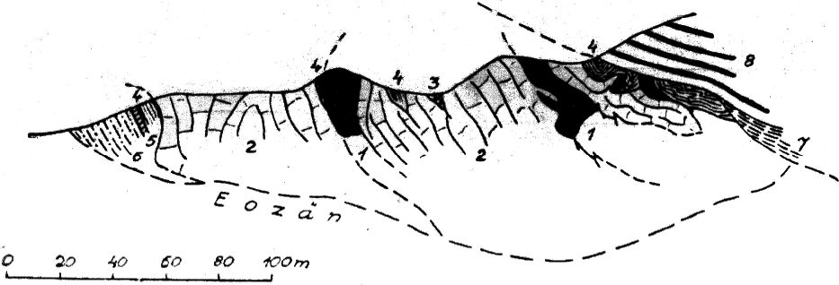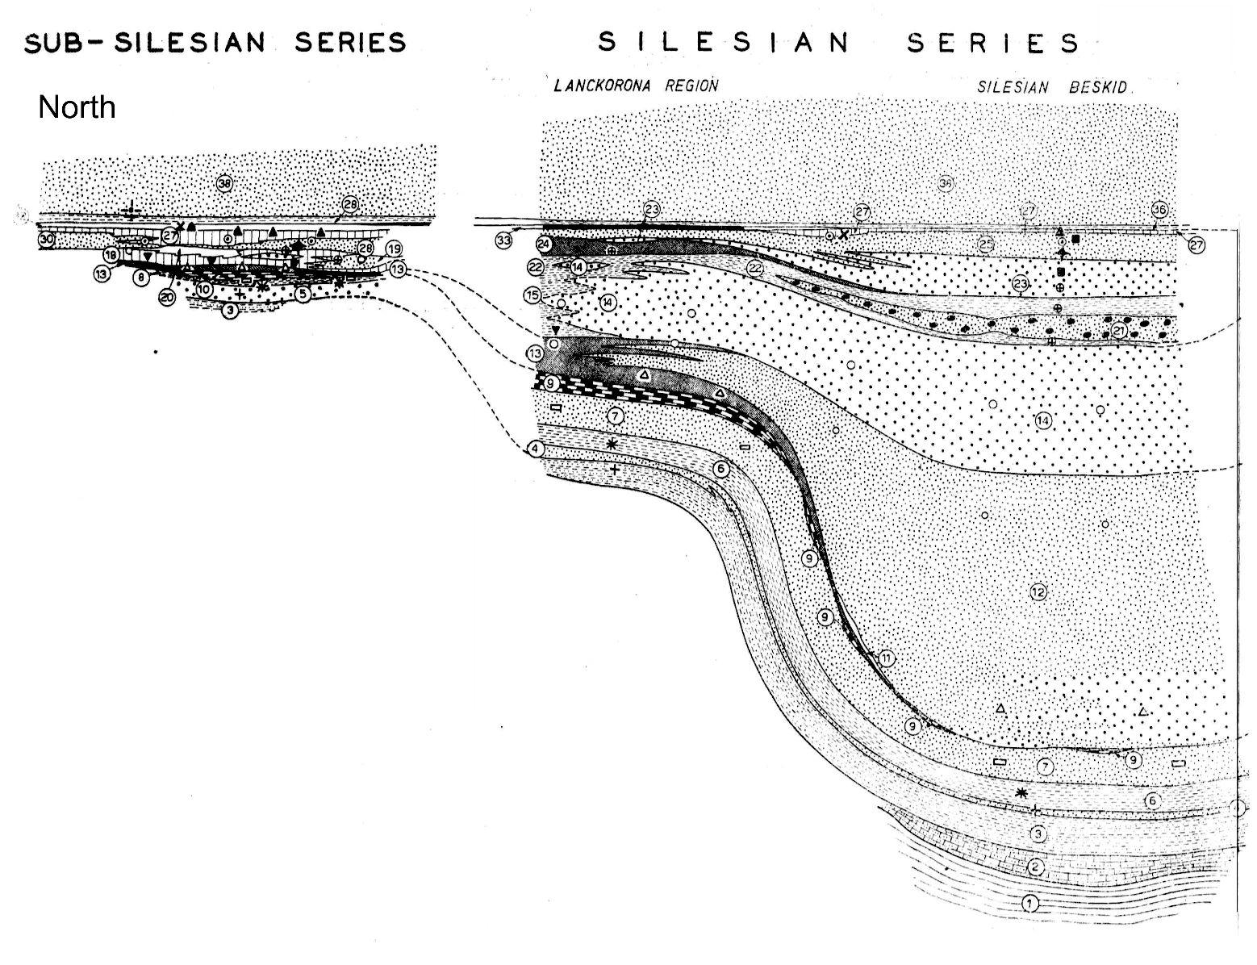
106
A. ŚLĄCZKA & E. MORYCOWA
Fig. 1. Model of change of lithofacies from the inner (Silesian Series) to outer (Sub-Silesian Series) part of the Western Carpathian
Flysch Basin, presented by Książkiewicz (Geroch et al., 1967)
vestigations, especially micropalaeontological ones, and the
discovery of Globotruncana sp., he returned to the primary
opinion (Książkiewicz, 1950a). He was also the first who
described in the Western Carpaihians the Eocene greenish
marls below the Menilite beds (Książkiewicz, 1932c, 1967),
an equivalent of the Globigerina Marls from the Central and
Eastern Carpathians. Another achievement of Prof. Książ-
kiewicz was the systematisation of the Magura Nappe suc-
cession and the disiinction of the Eocene Osielec Sands
stones, Sub-Magura, and Supra-Magura beds (Książkie-
wicz, 1935a, 1948b, 1958b, 1967a, Bieda et al., 1968).
The results of his studies conducted before and directly
afier the Word War II were presented in the above mens
tioned unique explanatory text to the Wadowice sheet
(Książkiewicz, 1951). In this monographic paper, he pre-
sented and thouroughly discussed several probl ems, rang-
ing in scale from individual exposures up to the palaeogeog-
raphy and geodynamic problems of the Western Flysch Car-
pathians.
Prof. Książkiewicz devoted much of his interest to the
geology of calcareous klippen within the outer part of the
Flysch Carpathians, in the Andrychów area (Fig. 2) known

Fig. 2. Schematischer Durchschnitt durch den östlichen Teil der Klippe von
Inwaid. 1. »Mylonite«. 2. Inwalder Kalk. 3—6. Obere Kreide: 3. Konglo-
merate. 4. Mergel. 5. Sandsteine. 6. Mergelschiefer. 7. Wierzowice-Schiefer
8. Ligota-Schichten.
Fig. 2. Schematic section across Inwałd Klippen (Książkiewicz, 1935a) and subsequent sections drawn after drilling of two boreholes
(Książkiewicz & Liszkowa, 1972)

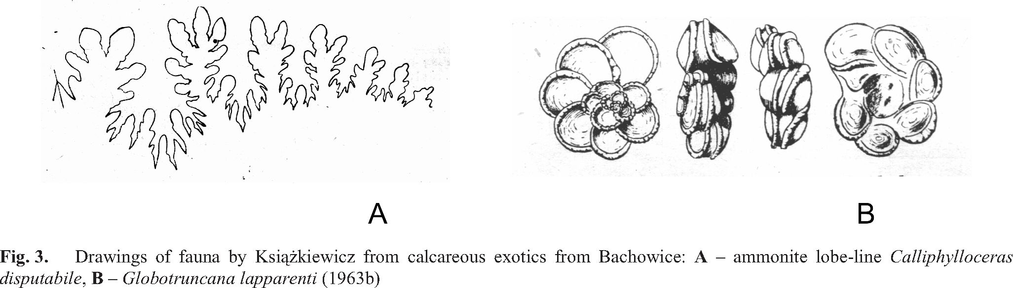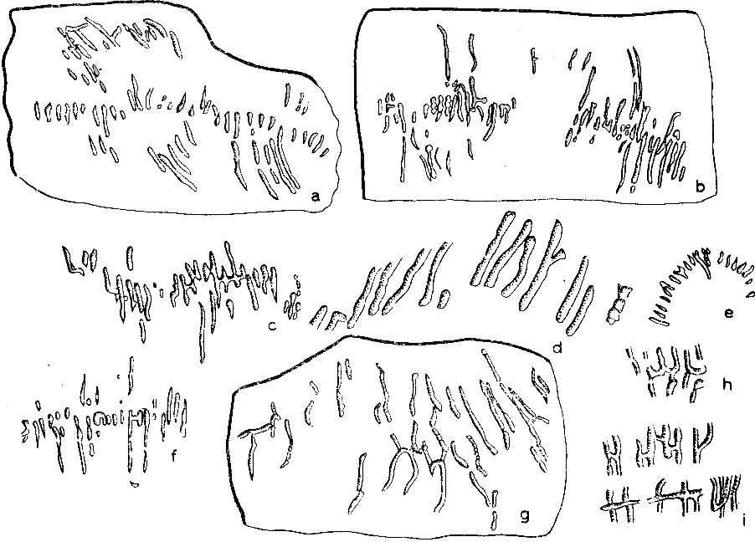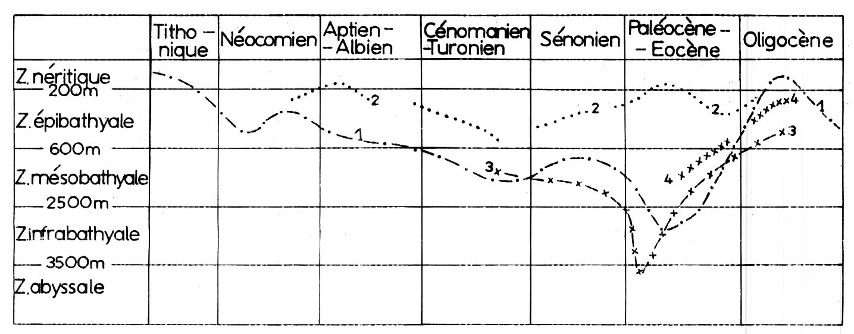
PROFESSOR MARIAN KSIĄŻKIEWICZ - CARPATHIAN GEOLOGIST
107

from the 19th century. He established their geological set-
ting and especially litho stratigraphy (Książkiewicz, 1935a,
b, c; Książkiewicz & Liszkowa,1972), and regarded them as
the remnants of a cordill era “Urantiklinale von Inwałd”
within the West Carpathian basin.
Prof. Książkiewicz also examined in detail a previously
unknown section of the shallow-water Jurassic and Creta-
ceous series from the exotic rocks in the Bachowice village
area, situated north of Andrychów (Książkiewicz, 1955,
1956b). These studl es allowed to reconstruct the Jurassic
and partly Crelaceous sequences, different both from the
foreland and from those known in the Carpathians. It was a
strong proof that a significant part of the deposits of the Car-
patiiian basin could have completely disappeared from the
surface during later tectonic movements. Prof. Książkie-
wicz rel ated the sediment at ion of the Bachowice exotic
rocks with volcanic activity in the Western Carpathian basin
during the Palaeocene. He also published several papers on
other volcanic activities in the Carpatoians, but not all of
them are still valid (Książkiewicz & Gaweł, 1936; Książ-
kiewicz & Wieser, 1954a, b; Książkiewicz, 1958).
Prof. Książkiewicz supplemented his lithostratigraphic
studies by determination of macro- and microfauna. The
most important papers related to this topic re ler to the
macro- and microfauna (Fig. 3) from Bachowice (Książkie-
wicz, 1956b), Early Cretaceous fauna from Lanckorona

Fig. 4. One of new ichnosp. (Desmograpton fuchsi) described
by Książkiewicz (1977)
(Książkiewicz, 1938), Early Crelaceous ammonites from
the Grodziszcze beds at Woźniki (Książkiewicz, 1963b),
Globotruncana from the upper variegated limeltones of
Bachowice (Książkiewicz, 1956a) and from variegated
marls in the West Carpathians (Książkiewicz, 1950a).
Very important and often pioneer studies carried out by
Prof. Książkiewicz were devoted to trace fossils (Fig. 4)
Fig. 1. — Changements tie profondeur dans Je bassin (ä proximite des rivages) ; 3 : Profondeur dans la fosse de
carpalhique. Magura, zones distales ; 1 : Profondeur dans la fosse de
1 : Profondeur dans la fosse principale, zones distales ; Magura, zones proximales.
2 : Profondeur dans la fosse principale, zones proximales
Fig. 5. Changes of depth in the Carpathian Flysch Basin (Książkiewicz, 1976)

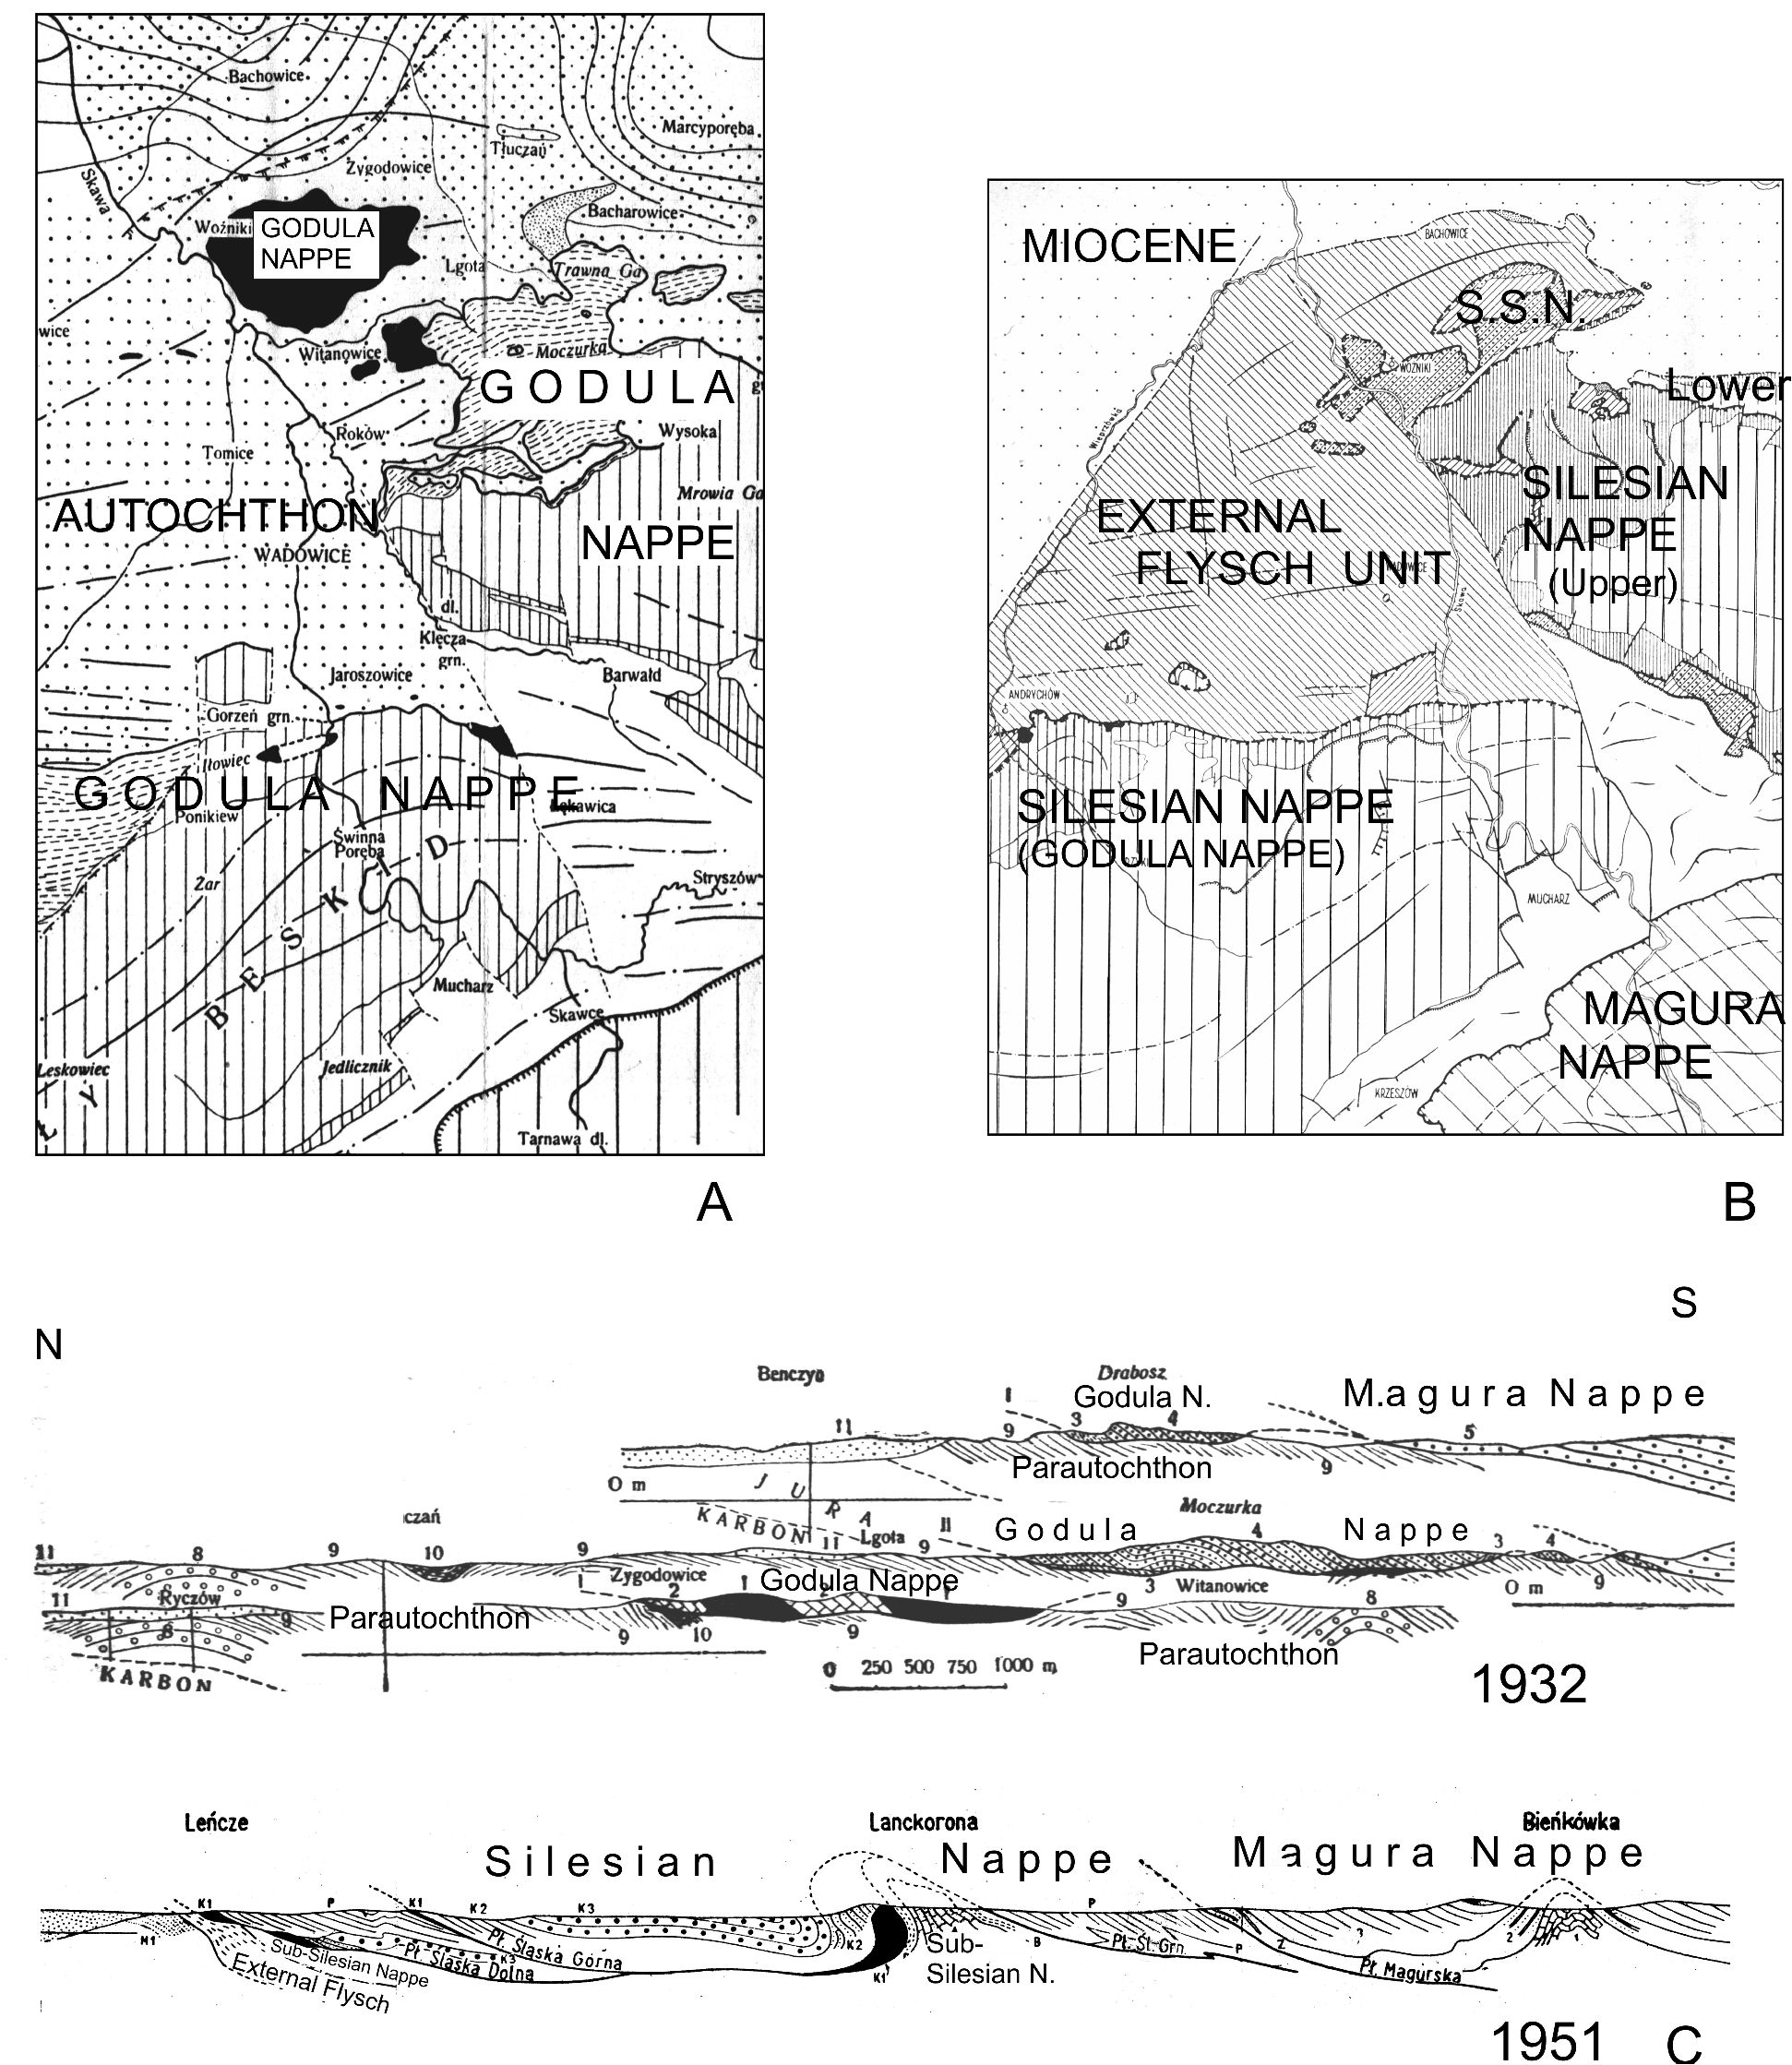
108
A. ŚLĄCZKA & E. MORYCOWA

Fig. 6. Development of the idea of tectonics of the Wadowice region. A - map from year 1932 (Książkiewicz, 1932); B - map from
year 1951 (Książkiewicz 1951a), C - cross-sections through the Wadowice area (Western Flysch Carpathians): upper after Książkiewicz
(1932c), lower - after Książkiewicz (1952)
within the flysch basin (Książkiewicz, 1958b, 1960a,
1961b, 1968a, 1970, 1977c). His collection is one of the
largest in the world. He described 57 ichnogenera and 147
ichnospecies (see Uchman, 1998). He also was a promotor
of researches on life condition in flysch basins (Książkie-
wicz, 1959a, 1961a). He documented an important role of
redeposition of fauna, the influence of marine currents for
the distiibution of microfauna, and the dependence of mi-
cro launal assemblages on the type of sediments. He also
gave some explanations of unfavourable life conditions in
the flysch basins. On the basis of faunal assemblages, trace
fossils and sedimentary structures, Prof. Książkiewicz made
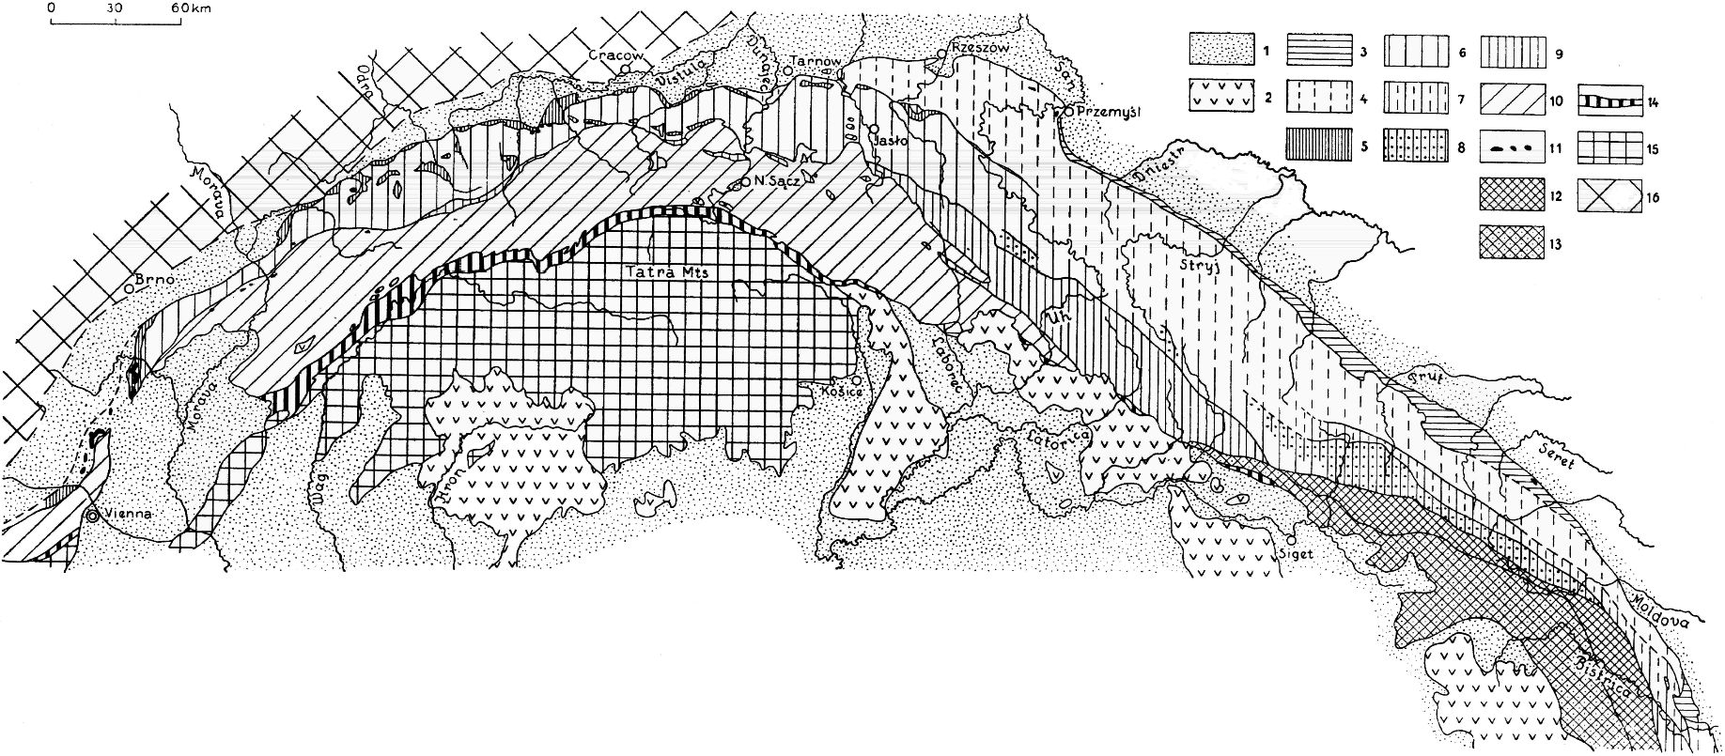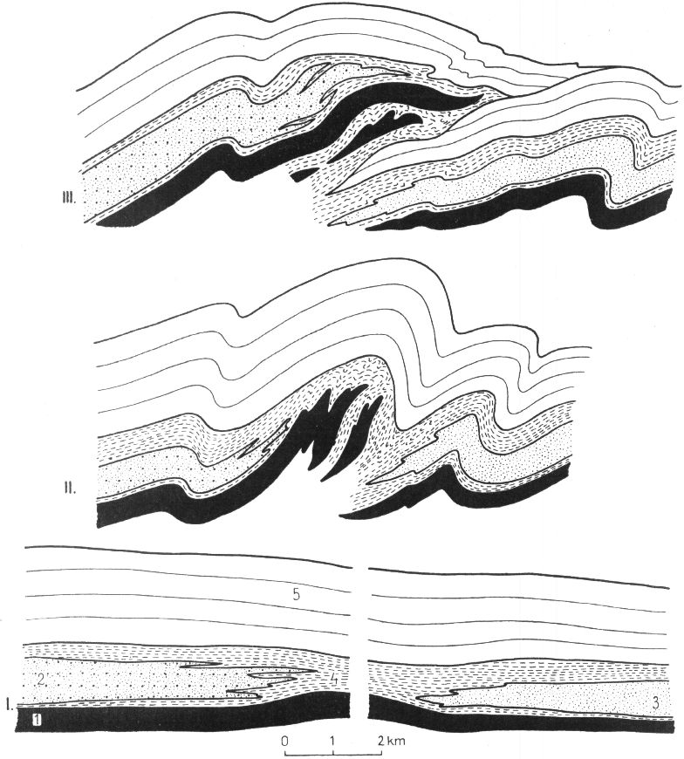
PROFESSOR MARIAN KSIĄŻKIEWICZ - CARPATHIAN GEOLOGIST
109

Fig. 7. Tectonic map of the Northern Carpathians.
1 Miocene; 2 Tertiary volcanics; 3 Marginal nappe; 4 Skole nappe; 5 Sub-Silesian nappe; 6 Silesian nappe; 7 Kostrzyca-Tuzlau
nappe; 8 Czarnohora nappe; 9 Fore-Magura group; 10 Magura nappe; 11 Klippes within the Flysch zone; 12 Internal Flysch of
the Eastern Carpathians; 13 Marmaros zone; 14 Klippes belt of Pieniny; 15 Internal zone of Western Carpathians (Pre-Paleogene
units and their cover); 16 Foreland
Fig. 7. Tectonic map of the Carpathians (Książkiewicz, 1956)
an analysis of the changes of bathymetry within the Carpa-
thian flysch basins (Książkiewicz, 1975, 1976). According
to him, the Carpathian flysch was deposited mostly in epi-
and meso-bathyal zone, but some horizons could have been
deposlted at infra-bathyal and abyssal depths in proximal
areas. Moreover, a part of flysch could have been deposited
in shallow-water, neritic conditions (Fig. 5 ).
Prof. Książkiewicz was the initiator and co-author of
monographs dedicated to litho- and biostiatigraphy of the
Polish Flysch Carpathians (Bieda et al., 1963; Geroch et al.,
1967), in which - on the basis of detailed data and the devel-
opment of lithofacies - their sequences and ages were de-
fined. These monographs are valid up to now, although new
nannoplankton data defined the age of some litho laties
more accurately.
The next important contribution of Prof. Książkiewicz
to the knowledge of the Carpathians is the elucidation of the
tectonics of the Polish Western Carpathians. On the basis of
careful analysis of litho stratigraphy and tectonic structures,
he proposed a new tectonic subdivision of the area. His ear-
lier studies demonstrated a long and laborious way to find a
proper relation between litho stratigraphic units, their age
and tectonic affiliation. An example of this can be the devel-
opment of Prof. Książkiewicz’s ideas on the tectonics of the
Wadowice sheet (Fig. 6). Basing on primary conceptions of
Jan Nowak (1927), he regarded the outer flysch as auto t
chthonous or parautochthonous (Fig. 6), and only more in-
ternal units (Cieszyn, Godula and Magura units) as nappes
(Książkiewicz, 1929, 1930, 1932c). Later on, he distin-
guished the next overthrust Woźnice Unit, in front of the
Godula Unit. Subsequently, after the discovery of tect onic
windows within the Godula Nappe (1936), that showed
similar Upper Cretaceous deposits as in the Woźnice
Nappe, he introduced and defined a new Sub-Silesian Unit

Fig. 8. Origin of overthrusting in the axlal zone of the outer
flysch basin (Książkiewicz, 1956)
(Książkiewicz, 1951a, 1953). Prof. Książkiewicz, after
joining several subunits, distinguished and defined the Sile-
sian Nappe (Książkiewicz, 1951a, 1953) and proved that
this nappe continues into the Eastern Carpathians (Fig. 7)
between the Skole and more internal, Dukla and Magura,
nappes. Therefore, Prof. Książkiewicz can be regarded as
the founder of a modern tect onic model of the Western
Flysch Carpathians (Książkiewicz, 1952c, 1953). He also
attempted to explain the origin of Flysch Carpathians. Im-
portant factors, besides underthrusting of the foreland be-
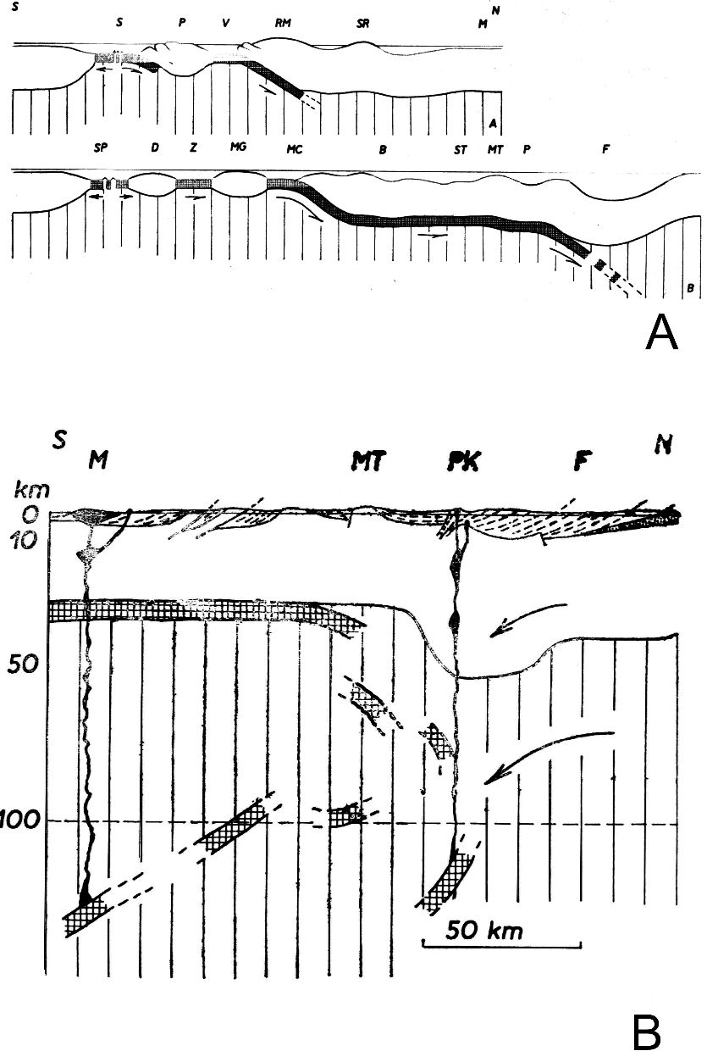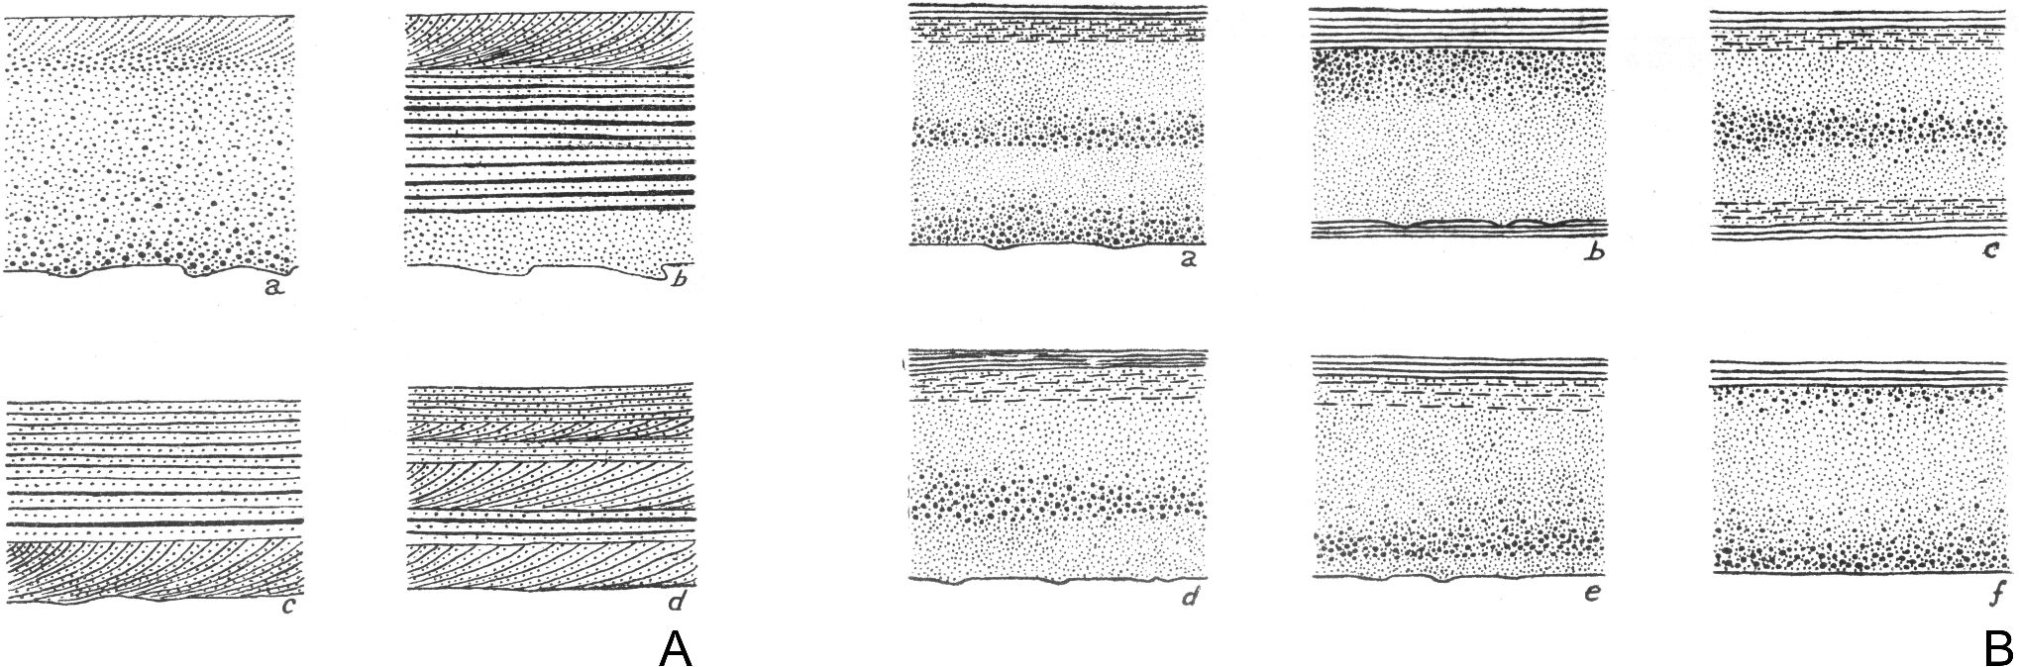
110
A. ŚLĄCZKA & E. MORYCOWA

Fig. 9. A - Spreadtng and subduction in the Carpatho-Balkan
area during Jurassic-Early Cretaceous times (A. Balkan area, B.
Carpathian area, F. Carpathian Flysch Basin); B - Underthrusting
and origin of magmas in the Carpathians (Książkiewicz, 1977)
low the Carpathians, were lithological differences across
the flysch basin (Fig. 8). He developed his tectonic model in
later papers (Książkiewicz, 1956a, 1960-1963), and espe-
cially in the monograph on the tectonics of the entire Polish
Carpathians (Książkiewicz, 1972). In the English version of
this monograph (Książkiewicz, 1977b) and in a special pa-
per (Książkiewicz, 1977a), he presented new plate tectonic
ideas on the geodynamics of the Carpathians; postulating,
for instance, that subduction during the Jurassic and Early
Cretaceous was directed towards the north and only later on
towards the south (Fig. 9). However, he generally stated
”that is very difficult in a simple way to apply the concept of
plate tectonics to the origin of the Carpathians”. This opin-
ion was confirmed in part by recent results of the deep seis-
mic profile CEL05 (Grad et al., 2006).
Prof. Książkiewicz was also interested in tectonic
mesostructures and was a pioneer of systematic studies of
joints in the Carpathian flysch (Książkiewicz, 1968b). He
suggested that the development of all joints was generally
connected with orogenic movements, but in several in-
stances he showed that in the cases where folding took place
twice, the second set of joints is cutting the rocks already
deformed. He also suggested the influence of neotectonic
movements in cases of abnormally preferent ial strike of
joints.
Very detailed knowledge of the Carpathian geology ob-
tained by Prof. Książkiewicz during his field works, excel-
lent orientation in international geological papers, and the
abillty to create synthetic models enabled him to prepare
several monographs, published both in Pollsh (Książkie-
wicz, 1951b, 1953, 1972; Książkiewicz & Samsonowicz,
1952) and English (Książkiewicz, 1956a, 1977b).
Very important and fruitful were the works of Prof.
Książkiewicz on sedimentology and palaeogeography. Al-
ready after returnmg from abroad in 1945, he creatively
combined the studies of sedimentological processes and the
structures of flysch deposits (turbidites). He was one of the
first who noticed frequent occurrences of cross-bedding in
the flysch (turbiditic) rocks (Książkiewicz, 1948b), though
in that period it was believed that the cross-bedding rarely
occurs in geosynclinal basins (Pettijohn, 1943). He de-
scribed, for the first time from the flysch rocks of the Carpa-
thians, the occurrence of sequences (Fig. 10) exhibiting fea-
tures from parallel lamination, through cross lamination, to
once again parallel lamination (1948b), and from graded to

Fig. 10. A - Types of graded bedding in the deposits of the flysch Carpathians; B - Relation of cross bedding to graded and laminated
bedding (Książkiewicz, 1954b)
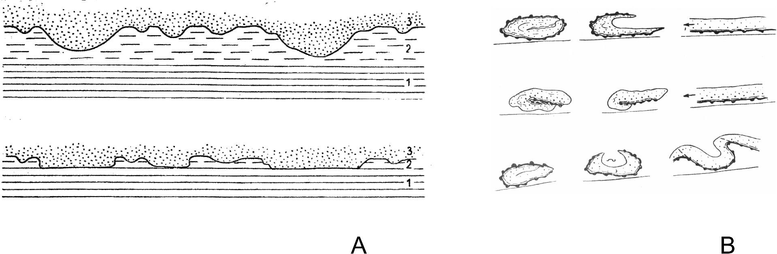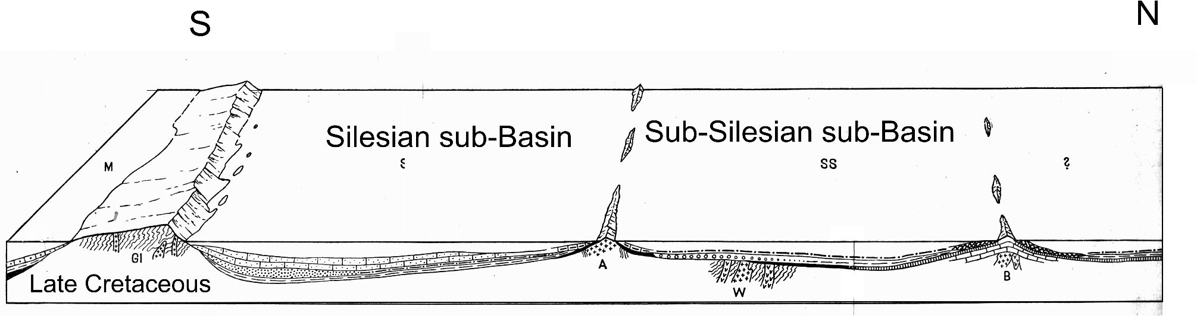
PROFESSOR MARIAN KSIĄŻKIEWICZ - CARPATHIAN GEOLOGIST
111

Fig. 11. A - Flattening of flute casts owing to the subsidence of the sand beds (Książkiewicz, 1961); B - Examples of structures devel-
oped during sliding and rolling up of sandstone layers (Książkiewicz, 1958)
lammated bedding (Książkiewicz, 1954b). He suggested
(Książkiewicz, 1950) that some contorted laminations
within the sandy layers could have resulted from creeping,
and that the direction of creeping of deposited material was
not always showlng the general inclination of the sea bot-
tom, but could be a result of local uplift of the latter. In the
quoted paper, he for first time considered flysch as a
deep-water sediment and stated that the occurrence of shal-
low-water fauna within flysch strata was caused by subma-
rine slumps. The following papers were devoted to the ex-
planation of the origin of flattened sedimentary structures
(Książkiewicz, 1950) and slump deposits (Książkiewicz,
1958c) (Fig.11).
Prof. Książkiewicz also paid attention to the importance
of microfacies analysis of calcareous turbidites (Książkie-
wicz, 1971c) and exotic limestones (Książkiewicz, 1971d),
in order to det ermine shall ow-wat er facies around cordil-
leras. He contluded that exotic limettones could be re-
garded as Bahamite-type sedlments, and that clastic mate-
rial for the Late Jurassic Cieszyn Limestones was derived
from the sediments of shoals and banks bordering the basin.
In his opinion, the conditions of deposition could be com-
pared with calcareous turbidite sedimentation in a deep
basin adjoining to the Bahama Banks.
Very important and masterly was his basin analysis of
flysch of the Carpathians. Already in his early papers he
stressed on importance of the study of occurrence and distri-
bution of exotic rocks for palaeogeographic analysis and for
the reconstruction and position of source areas regarded by
him as pre-Carpathian mountain chains. In a paper pub t
lished in 1931, he presented a map of distribution of exotic
rocks in the Western Carpathians and connected them with
intrabasinal ist ands. In Prof. Książkiewicz’s opinlon, the
detailed study of exotic rocks and klippen, with interpreta-
tion of lithofacies changes, was a key to understanding the
palaeogeography of the Western Carpathians. On the basis
of these early investigations, he presented in 1951 the first
model (Fig. 12) of development of the Western Carpathians
flysch basin (Książkiewicz, 1951b). He already accentuated
the simllarity of sediments within the whole basin during
the Early Cretaceous and diversification of sediments after
mid-Cretaceous. It was caused by sudden uplifts of source
areas, both marginal and intrabasinal ones (Silesian,
Andrychów and Bachowice ridges) (Figs 13, 14 A). As an
eftect, several subbasins (Magura, Silesian, Sub-Silesian,
Skole) were developed in different lithofacies. Subsequent
investigations carried out by Prof. Książkiewicz, including
detailed measurements of transport of clastic material, al-

Fig. 12. 3D model of the Western Carpathian Flysch Basin (Książkiewicz, 1951a); M - Magura sub-Basin, islands: Gl - "Silesian", A -
Andrychów, B - Bachowice
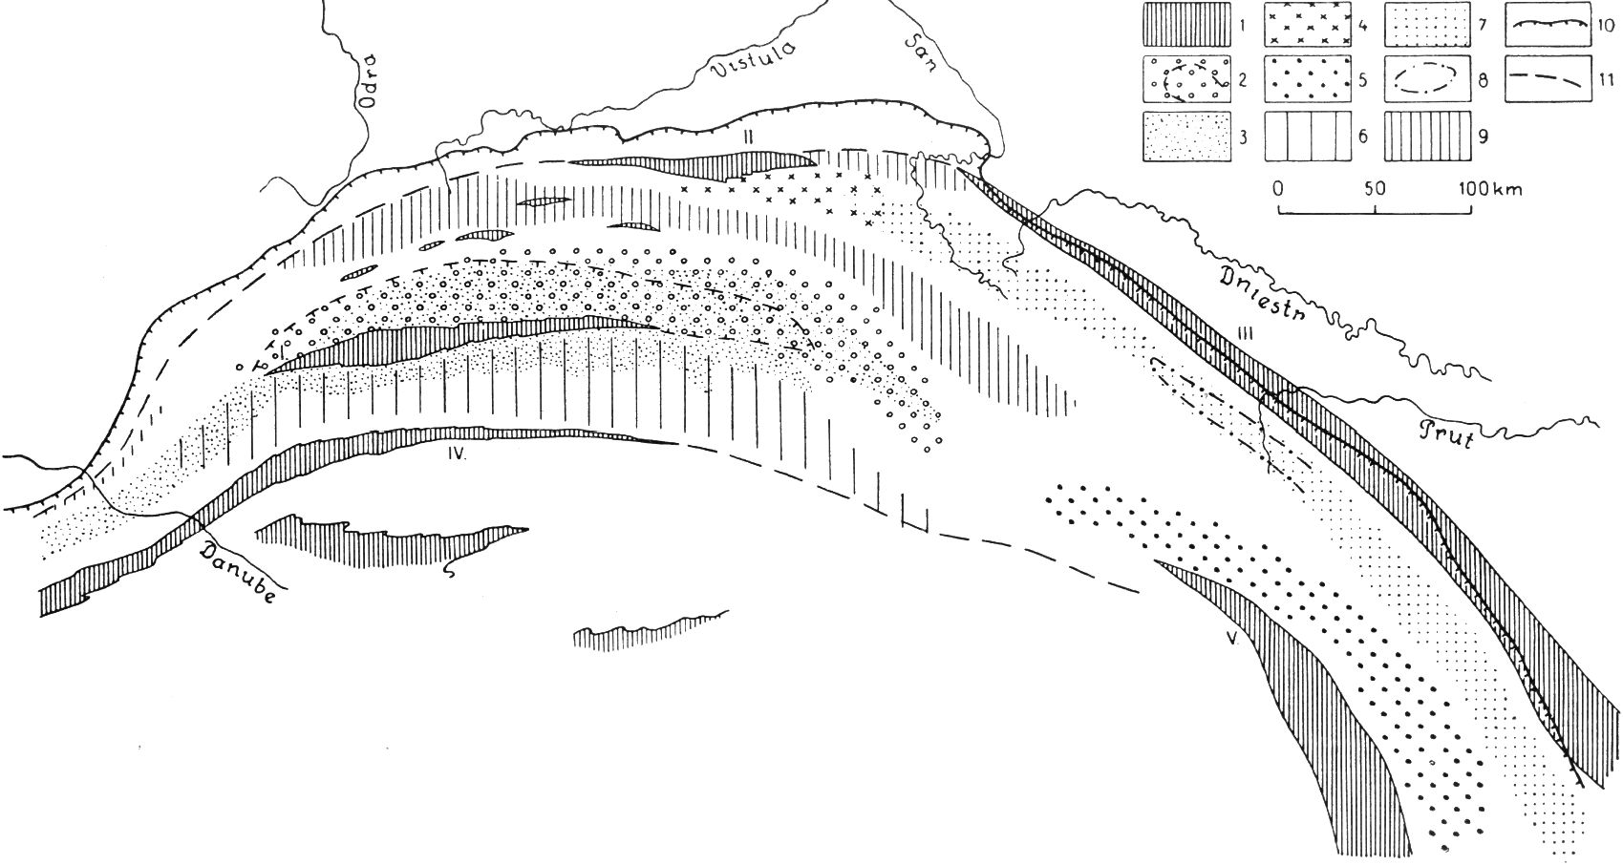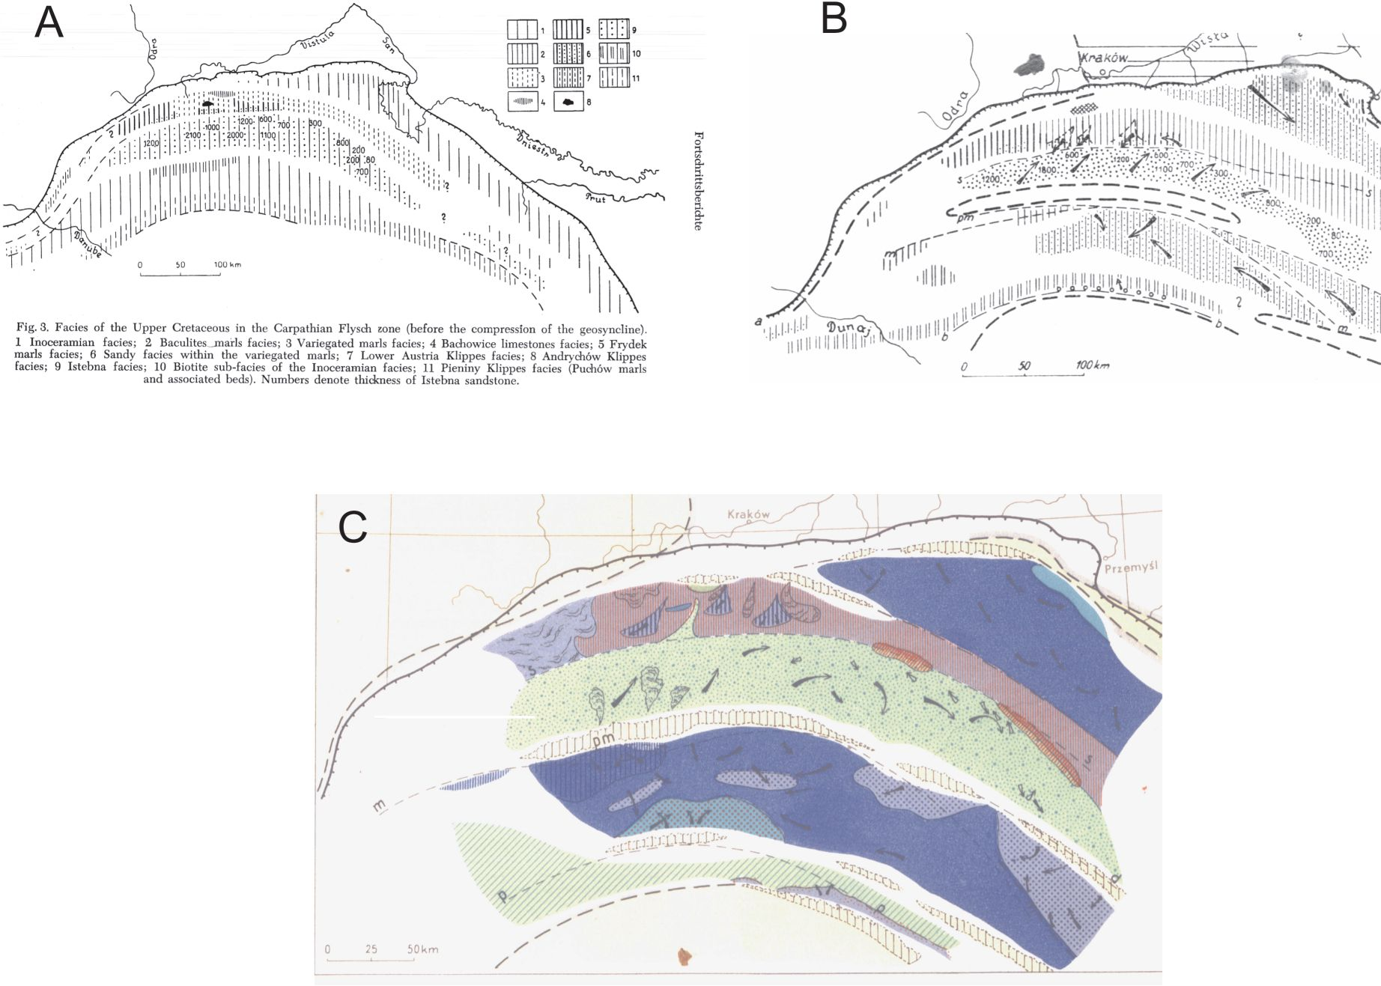
112
A. ŚLĄCZKA & E. MORYCOWA

Fig. 5. Principal source areas of the Carpathian Flysch.
1 Cordilleras and mobile borders of the geosyncline: I Silesian Cordillera, II Debica-Rzeszów cordillera, III Green rocks
zone, IV Pieniny cordillera, V Marmaros zone; 2 Istebna facies with marked Godula sandstone extent; 3 Ciężkowice
facies; 4 Babica exotics bearing clays; 5 Tarcau facies; 6 Magura facies; 7 Kliwa facies; 8 Wygoda facies; 9 Marly
and shaly axial facies; 10 Present border of the Carpathians; fl Presumed borders of the Flysch geosyncline (before
the compression).
Fig. 13. Principal source areas of the Carpathian Flysch (Książkiewicz, 1956)

Fig. 14. Successive palinspastic sketches of the Carpathian Flysch Basin, elaborated by Książkiewicz: A - facies of the Late Cretaceous
(Książkiewicz, 1956); facies of the Late Senonian: B - Książkiewicz (1960), C - Książkiewicz, Ed. (1962)
PROFESSOR MARIAN KSIĄŻKIEWICZ - CARPATHIAN GEOLOGIST
113
lowed him to create (Fig. 14 B and C) a synthetic palaeo-
geographic model for the Flysch Carpathians (Książkie-
wicz, 1954a, 1956a, 1960b, c, 1963a, 1965) as a prominent
tectonically active basin. He emphasized the importance of
internal ridges (cordilleras) as one of the main source areas
for clastic material. It was not a popular idea at that time. It
ought to be stressed out that Prof. Książkiewicz was the first
who adopted and widespread the measurements of current
direct ions (flute marks, cross-bedding) for the reconstruc-
tion of palaeogeography of orogenic basins and showed that
the turbidlty currents were flowlng both along the axis of
the basin and obliquely to it, down marginal slopes. In some
of these maps it is already possible to recognise submarine
fans, although he did not use this term (Fig. 14C). The best
example of this kind of map was, initiated by him, un-
equalled Palaeogeographic Atlas of the Flysch Carpathians
(Książkiewicz, Ed., 1962). It contains 13 facies maps with
palinspastic sketches, practically for every stage of the
Cretaceous and Palaeogene.
His analysis of turbiditic sedlmentation in deep water
basins brought him an international recognition and conse-
quently a number of sedimentologists from abroad vislted
him to learn his methods of basin analysis. Among them
was the outstanding sedimentologist Ph. F. Kuenen. As a re-
sult of this visit, a joint treatise (also with Stan Dżułynski)
on turbidites in flysch of the Polish Carpathian Mountains
(Dżułynski et al., 1959) was prepared, where among others,
the orlgin of structureless sandstones within turbidite se t
quences was presented and the term “fluxoturbidites” was
proposed for them. Even recently, his palaeogeographic re-
constructions are cited (see Okada & Kenyon-Smith, 2005)
as an excellent example of basin analysis of that period.
During the 1950s and 1960s, Prof. Książkiewicz
grouped his students interested in sedimentary structures as-
sociated with turbidites and basin analysis, what led to the
format ion of the worldwide recognized ”Kraków Flysch
School ( see the paper of Kelling et al., this volume).
The above pres ent at ion of the achievements of Prof.
Książkiewicz shows clearly the outstanding role, which he
played in the progress of Carpathian geology and turbidite
sedimentology. It ought to be underlined that he always re-
garded as his duty to present new ideas for discussion dur-
ing numerous lectures and field conferences.

REFERENCES
Bieda, F. & Książkiewicz, M., 1958. On the age of the Babia Góra
sandstone. (In Polish, English summary). Kwartalnik Geolo-
giczny, 2: 841-853.
Bieda, F., Geroch, S., Koszarski, L., Książkiewicz, M. & Żytko,
K., 1963. Stratigraphie des Karpates externes polonaises.
Biuletyn Instytutu Geologicznego, 181: 5-174.
Bieda, F., Jednorowska, A. & Książkiewicz, M., 1967. Stratigra-
phy of the Magura Series around Babia Góra. (In Polish, Eng-
lish summary). Biuletyn Instytutu Geologicznego, 211: 293-
320.
Burtan, J., Książkiewicz, M. & Sokołowski, S., 1933. Über das
Auftreten der Radiolaritschiefer in der mittleren Kreide der
West-Beskiden (In Polish, German summary). Rocznik
Polskiego Towarzystwa Geologicznego, 9: 96-99.
Burtanówna, J., Konior, K. & Książkiewicz, M., 1938. Carte
geologique des Karpates de Silesie, 1: 50,000. (In Polish,
French summary). PAU, Wydawnictwa Śląskie.
Dżułynski, S., Kuenen, Ph. H. & Książkiewicz, M., 1959.
Turbidites in Flysch of the Polish Carpathian Mountains. Bul-
letin of the Geological Society of America, 70: 1089-1118.
Gaweł, A. & Książkiewicz, M., 1936. Die Porphyritgesteine aus
den Westkarpathen. (In Poli sh, German summary) Rocznik
Polskiego Towarzystwa Geologicznego, 12: 569-611.
Geroch, S., Jednorowska, A., Książkiewicz, M. & Liszkowa, J.,
1967. Stratigraphy based upon microtauna in the Western
Polish Carpathians. Biuletyn Instytutu Geologicznego, 211:
185-282.
Grad, M., Guterch, A., Randy Keller, G., Janik, T., Hegedus, E.,
Vozar, J., Ślączka, A., Tura, T. & Yliniemi, J., 2006.
Lithospheric structure beneath trans-Carpathian transect from
Precambrian platform to Pannonian basin: CELEBRATION
2000 seismic profile CEL05. Journal of Geophysical Re-
search, 111, BO3301: 1-23.
Książkiewicz, M., 1929. Spostrzeżenia nad budową geologiczną
wschodniego Beskidu Małego. (In Polish). Sprawozdania
Komisji Fizjograficznej PAU, 63: 151-153.
Książkiewicz, M., 1930. Geologische Untersuchungen in den
Wadowicer Karpathen. I Teil. Stratigraphisch-tektonische
Verhältnisse. Bulletin del’Academie Polonaise des Sciences
et des Lettres, Serie A: 112-144.
Książkiewicz, M., 1931a. Beobachtungen über das Auftreten der
Gerölle der urkarpathischen Gesteine in der Wadowicer
Karpathen. (In Polish, German summary). Rocznik Polskiego
Towarzystwa Geologicznego, 7: 319- 329.
Książkiewicz, M., 1931b. Sprawozdanie z badań geologicznych
wykonanych w 1930 r. w północnej części arkusza Wado-
wice. (In Pollsh). Posiedzenia naukowe Państwowego Insty-
tutu Geologicznego, 30: 48-50.
Książkiewicz, M., 1931c. Tektonika południowej części strefy
cieszyńskiej między Olzą a Wisłą. (In Polish). Sprawozdania
Komisji Fizjograficznej PAU, 36: 40.
Książkiewicz, M., 1932a. Sprawozdanie z badań geologicznych
wykonanych w 1931 r. na arkuszu Wadowice. (In Pollsh).
Posiedzenia naukowe Państwowego Instytutu Geologicz-
nego, 33: 35-37.
Książkiewicz, M., 1932b. Der Bau des südlichen Teiles der
Teschener Zone zwischen der Olsa and der Weichsel. Bulletin
del’Academie Polonaise des Sciences et des Lettres, Serie A:
132-206.
Książkiewicz, M., 1932c. Der Bau der randlichen Wadowicer
Beskiden und ihr Verhältnis zum Vorlande. (In Polish, Ger-
man summary). Rocznik Polskiego Towarzystwa Geologicz-
nego, 8: 49-91.
Książkiewicz, M., 1933. Beitrag zur Kenntnis der mittleren Kreide
der Godula-Decke in der West-Karpaten (In Poli sh, German
summary). Rocznik Polskiego Towarzystwa Geologicznego,
9: 88-95.
Książkiewicz, M., 1934a. Zones des Klippes carpathiques aux en-
virons d’Andrychów. I. Klippes d’lnwałd et de Roczyny. C.
R. Acad. Pol., 2: 7.
Książkiewicz, M., 1934b. Zones des Klippes carpathiąues aux en-
virons d’Andrychów. II. Klippes de Pańska Góra et de Targa-
nice. C. R. Acad. Pol., 3: 5.
Książkiewicz, M., 1935a. Sur la structure des masses marginales
de la nappe de Magura entre Sułkowice et Sucha (In Polish,
114
A. ŚLĄCZKA & E. MORYCOWA
French summary). Rocznik Polskiego Towarzystwa Geolo-
gicznego, 11: 104-120.
Książkiewicz, M., 1935b. Die äussere Karpathische Klippenzone
bei Andrychów. I. Die Klippen von Inwałd und Roczyny.
Bulletin del’Academie Polonaise des Sciences et des Lettres,
Serie A: 92-106.
Książkiewicz, M., 1935c. Die äussere Karpathische Klippenzone
bei Andrychów. II. Die Klippen in Pańska Góra und Targa-
nice. Bulle tin del’Academie Polonaise des Sciences et des
Lettres, Serie A: 209-220.
Książkiewicz, M., 1935d. Die äussere Karpathische Klippenzone
bei Andrychów. III. Die Stratigraphie der Klippenserie und
ihre Stellung im Bau der West-Karpaten. Bulletin del’Aca-
demie Polonaise des Sciences et des Lettres, Serie A: 221-
233.
Książkiewicz, M., 1936. La structure de la zone de Lanckorona.
Bulletin del’Academie Polonaise des Sciences et des Lettres,
Serie A: 299-314.
Książkiewicz, M., 1938. Fauna górnoneokomska z Lanckorony.
(In Polish). Sprawozdania Komisji Fizjograficznej PAU, 72:
223-261.
Książkiewicz, M., 1941. Geologische Karte des General-
gouvernements, Bl. 19-29. Wadowice, 1: 50.000. Amt für
Bodenforschung, Krakau (printed without knowledge of the
author). Mapping conducted in 1926-1937 years.
Książkiewicz, M., 1948a. Current bedding in Carpathian Flysch.
(In Pollsh, English summary). Rocznik Polskiego Towarzy-
stwa Geologicznego, 17: 137-152.
Książkiewicz, M., 1948b. Stratigraphy of the Magura series north
of the Babia Góra (Western Carpathians). (In Polish, English
summary). Biuletyn Państwowego Instytutu Geologicznego,
48: 1-35.
Książkiewicz, M., 1950a. On the age of variegated marls in the
flysch on the Western Carpathians. (In Polish, English sum-
mary). Rocznik Polskiego Towarzystwa Geologicznego, 19:
315-338.
Książkiewicz, M., 1950b. Slip-bedding in the Carpathian Flysch.
(In Pollsh, English summary). Rocznik Polskiego Towarzy-
stwa Geologicznego, 19: 493-501.
Książkiewicz, M., 1951a. Objasniena arkusza Wadowice. Ogólna
mapa geologiczna Polski 1: 50 000. (In Poli sh). Państwowy
Instytut Geologiczny, Warszawa, 283 pp.
Książkiewicz, M. (Ed.), 1951b. Regionalna geologia Polski, T. 1.
Karpaty, Z. 1. Stratygrafia. (In Polish). Polskie Towarzystwo
Geologiczne, Kraków, 206 pp.
Książkiewicz, M. (Ed.), 1953. Regionalna geologia Polski, T. 1.
Karpaty, Z. 2. Tektonika. (In Pollsh). Polskie Towarzystwo
Geologiczne, Kraków: 207-453.
Książkiewicz, M., 1954a. Evolution of the Carpathian Flysch
geosyncline. C. R. XIXSession, Congres geologique interna-
tional, Alger 1952, 14: 9-15.
Książkiewicz, M., 1954b. Graded and lamlnated bedding in the
Carpathian Flysch. (In Poll sh, English summary). Rocznik
Polskiego Towarzystwa Geologicznego, 22: 399-438.
Książkiewicz, M., 1954c. Zagadnienia stratygrafii Karpat na tle
paleogeografii (in Polish, English summary). Przegląd
Geologiczny, 4: 445-455.
Książkiewicz, M., 1955. Stratigraphy of the Jurassic and Creta-
ceous of Bachowice. Bulletin de l’Academie Polonaise des
Sciences, Cl. III, 3: 503-508.
Książkiewicz, M., 1956a. Geology of the northern Carpathians.
Geologische Rundschau, 45: 369-411.
Książkiewicz, M., 1956b. The Jurassic and Cretaceous of
Bachowice (Western Carpathians). (In Poli sh, Eng lish sum-
mary). Rocznik Polskiego Towarzystwa Geologicznego, 24
(1954): 117-303.
Książkiewicz, M., 1958a. Sedimentation in the Carpathian Flysch
sea. Geologische Rundschau, 41: 418-425.
Książkiewicz, M., 1958b. Stratigraphy of the Magura series in the
Średni Beskid (Carpathians). (In Poli sh, Engl ish summary).
Biuletyn Instytutu Geologicznego, 135: 43- 82.
Książkiewicz, M., 1958c. Submarine slumping in the Carpathian
Flysch. (In Polish, English summary). Rocznik Polskiego
Towarzystwa Geologicznego, 28: 123-150.
Książkiewicz, M., 1958d. Thermal contact with volcanic rock at
Kamionna near Bochnia (Carpathians). (In Poll sh, English
summary). Kwartalnik Geologiczny, 24: 706-709.
Książkiewicz, M., 1959a. Life condition in Flysch baslns. Abt
stracts, 1st International Oceanographical Congress. New
York: 280-281.
Książkiewicz, M., 1959b. The Cretaceous of the Pollsh Carpa-
thians. In: El sistema cretacico. Un symposium sobre el
cretacio en el hemisfere occidental y su correlatión mundial,
T. 1: 171-197, Congreso Geol. Intern. XX Sesión - Ciudad de
Mexico 1956.
Książkiewicz, M., 1960-1963. Evolution structurale des Carpa-
thes polonaises. In: Livre a la memoire du Professeur Paul
Fallot, 2: 529-562, Paris
Książkiewicz, M., 1960a. On some problematic organic traces
from the Flysch of the Polish Carpathians. Part. I. (In Polish,
English summary). Kwartalnik Geologiczny, 4: 735-744.
Książkiewicz, M., 1960b. Outline of the paleogeography in the
Polish Flysch Carpathians. (In Polish, English summary).
Prace Instytutu Geologicznego, 30: 209-239.
Książkiewicz, M., 1960c. Pre-orogenic sedimentation in the
Carpathian geosyncline. Geologische Rundschau, 50: 8-31.
Książkiewicz, M., 1961a. Life conditions in flysch basins. (In Pol-
ish, English summary). Rocznik Polskiego Towarzystwa Geo-
logicznego, 31: 4-21.
Książkiewicz, M., 1961b. On some probl ematic organic traces
from the Flysch of the Polish Carpathians. Part II. (In Polish,
English summary). Kwartalnik Geologiczny, 5: 882-887.
Książkiewicz, M., 1961c. On some sedimentary structures on the
Carpathians Flysch. (In Pollsh, English summary). Rocznik
Polskiego Towarzystwa Geologicznego, 31: 23-36.
Książkiewicz, M., 1962. Sur quelques analogies lithostrati-
graphiques entre les Carpates roumaines et polonaises. Bulle-
tin de l’Academie Polonaise des Sciences, Ser. Sc. geol.
geogr., 10: 11-17.
Książkiewicz, M. (Ed.), 1962. Geological Atlas of Poland, Strati-
graphic and facial problems. Fasc.13 - Cretaceous and Early
Tertiary in the Polish External Carpathians, 1:600 000.
Instytut Geologiczny, Warszawa.
Książkiewicz, M., 1963a. Evolution structurale des Carpathes po-
lo naises. In: Livre a la memoire du Professeur Paul Fallot, II:
529-562. Soc. Geol. France, Paris.
Książkiewicz, M., 1963b. La faune tithonique de Woźniki (Carpa-
thes Polonaises Occidentales). Rocznik Polskiego Towarzy-
stwa Geologicznego, 33: 265-272.
.Książkiewicz, M., 1964. On the tectonics of the Cieszyn zone. A
reinterpretation. Bulletin de l’Academie Polonaise des Sck
ences, Ser. Sc. geol. geogr., 12, 4: 251- 259.
Książkiewicz, M., 1965. Les cordilleres dans les mers cretacees et
paleogens des Carpathes du Nord. Bulletin Soc. Geol. France,
Ser. 7, 7: 443-455.
Książkiewicz, M., 1966. Contributions to the geology of the
PROFESSOR MARIAN KSIĄŻKIEWICZ - CARPATHIAN GEOLOGIST
115
Wadowice region. (In Polish, English summary). Rocznik
Polskiego Towarzystwa Geologicznego, 36: 395-406.
Książkiewicz, M., 1967. Globigerina marls at Skawinki. (In Pol-
ish, English summary). Biuletyn Instytutu Geologicznego,
211: 365-367.
Książkiewicz, M., 1968a. On some problematic organic traces
from the Flysch of the Polish Carpathians. Part III. (In Polish,
English summary). Rocznik Polskiego Towarzystwa Geolo-
gicznego, 38: 3-17.
Książkiewicz, M., 1968b. Observations on jointtng in the Flysch
Carpathians. (In Polish, English summary). Rocznik Pols-
kiego Towarzystwa Geologicznego, 38: 335-384.
Książkiewicz, M., 1970 Observations of the ichnofauna in the Pol-
ish Carpathians. In: Crimes, T. P. & Harper, C. (eds), Trace
Fossils. Geological Journal, Special Issue, 3: 283-322.
Książkiewicz, M., 1971a. Contributions to the geology of the
Wadowice region. Part II. (In Polish, English summary).
Rocznik Polskiego Towarzystwa Geologicznego, 40: 369-
375.
Książkiewicz, M., 1971b. Geology of Sidzina near Jordanów
(Western Carpathians). (In Polish, English summary).
Rocznik Polskiego Towarzystwa Geologicznego, 40: 377-
391.
Książkiewicz, M., 1971c. On the origin of the Cieszyn Limestone
in the Carpathian Fłysch. Bulletin de l’Academie Polonaise
des Sciences, Ser. Sc. Terre, 19, 2: 131-135.
Książkiewicz, M., 1971d. On the origin of the Inwałd Limestone
(Outer Carpathian Klippes). Bulle tin de l’Academie Polol
naise des Sciences, Ser. Sc. Terre, 19, 2: 91-98.
Książkiewicz, M., 1972. Karpaty. In: Budowa geologiczna Polski,
T. 4. Tektonika, Część 3. (In Pollsh). Wydawnictwa Geolo-
giczne,Warszawa, 228 pp.
Książkiewicz, M., 1973. On some analogies between the Cauca-
sian and Carpathian Flysch. (In Pollsh, English summary).
Rocznik Polskiego Towarzystwa Geologicznego, 43: 131-
149.
Książkiewicz, M., 1974. Contribution a l’etude de la faune du
Tithonique de Woźniki (Carpathes Polonaises Occidentales).
Acta Geologica Polonica, 24: 437-456.
Książkiewicz, M., 1975. Bathymetry of the Carpathian Flysch Ba-
sin. Acta Geologica Polonica, 25: 309-367.
Książkiewicz, M., 1976. La profondeur du bassin du flysch
carpathique. Bull. Soc. Geol. France, Ser. 7, 18, 1: 191-196.
Książkiewicz, M., 1977a. Hypothesis of Plate Tectonlcs and the
Origin of the Carpathians. (In Polish, English summary).
Rocznik Polskiego Towarzystwa Geologicznego, 47: 329-
353.
Książkiewicz, M., 1977b. The Tectonlcs of the Carpathians. In:
Geology of Poland, vol. 4. Tectonics. The Alpine Tectonic
Epoch. Geological Institute, Warsaw: 476- 608.
Książkiewicz, M., 1977c. Trace Fossils in the Flysch of the Polish
Carpathians. Palaeontologia Polonica, 36: 1- 208.
Książkiewicz, M. & Lesko, B., 1959. On the relation between
Krosno- and Magura-Flysch. Bulle tin de l’Academie Polol
naise des Sciences, Cl. III, Ser. Sc. chim., 7: 773-780.
Książkiewicz, M., & Liszkowa, J., 1959. Subsilesian series near
Goleszów (Silesia). (In Polish, English summary). Kwar-
talnik Geologiczny, 3: 91-101.
Książkiewicz, M. & Liszkowa, J., 1972. On the beds underlytng
the Andrychów Klippen (Western Carpathians). (In Pol ish,
English summary). Rocznik Polskiego Towarzystwa Geolo-
gicznego, 42: 239-269.
Książkiewicz, M. & Liszkowa, J., 1979. Facies changes of the
Lgota Beds (Albian) in the Wadowice area (Western
Carpathians). (In Pollsh, English summary). Rocznik Pols-
kiego Towarzystwa Geologicznego, 49: 23-42.
Książkiewicz, M. & Samsonowicz, J., 1952. Zarys geologii
Polski. (In Polish). Państwowe Wydawnictwo Naukowe,
Warszawa, 212 pp.
Książkiewicz, M. & Skoczylas-Ciszewska, K., 1937. Ein
Vergleich des Wienerwald-Flysches mit dem Karpaten-
Flysch. Bulletin del’Academie Polonaise des Sciences et des
Lettres, Serie A: 493-507; Spraw. PAU, 42: 170; C. R. Acad.
Pol., 6: 11.
Książkiewicz, M. & Sokołowski, S., 1934. Remarques sur la geo-
logie des montagnes de Czywczyn (Carpathes Orientales).
Rocznik Polskiego Towarzystwa Geologicznego, 10: 506-
518.
Książkiewicz, M. & Wieser, T., 1954a. Occurence of tuffites in
the Krosno beds of Carpathian Flysch. Bulletin de l ’Academie
Polonaise des Sciences, Cl. III, 2: 295-297.
Książkiewicz, M. & Wieser, T., 1954b. Upper Cretaceous volca-
nism in the Carpathian Flysch geosyncline. Bulletin de
l’Academie Polonaise des Sciences, Cl. III, 2: 199-201.
Nowak, J., 1927. Esquisse de la tectonique de la Pologne. (In Pol-
ish, French summary). II Zjazd Słowiańskich Geografów,
Kraków: 5-160.
Pettijohn, F. J., 1943. Archean sedimentation. Bulletin of the Geo-
logical Society of America, 54.
Uchman, A., 1998. Taxonomy and ethology of the flysch trace
fossils: revision of the Mari an Książkiewicz coll ect ion and
studies of complementary material. Annales Societatis Geo-
logorum Poloniae, 68: 105-218.

