
Signature:©PolJRadiol,2010;75(3):61-64
CASEREPORT
Lesionsinbasalgangliainapatientwithinvoluntary
Received:2009.11.11
Accepted:2010.05.31
movementsasafirstsignofdiabetes–casereportandreviewoftheliterature
MonikaBekiesińska-Figatowska¹,AnnaRomaniuk-Doroszewska¹,MartaBanaszek²,ArletaKuczyńska-Zardzewiały2
1DepartmentofDiagnosticImaging,InstituteofMotherandChild,Warsaw,Poland2DepartmentofNeurology,WolskiHospital,Warsaw,Poland

Author’saddress:MonikaBekiesińska-Figatowska,DepartmentofDiagnosticImaging,InstituteofMotherandChild,Warsaw,Poland,e-mail:m.figatowska@gmail.com
Summary
WepresentacaseofunilateralhyperdensityofthelentiformandcaudatenucleusonCTwithhyperintesityonT1-weightedimagesonMRIina71-year-oldwomanwithhemichorea-hemiballismandrecentlydiagnoseddiabetes.
Keywords:
hemichorea-hemiballism•brain•computedtomography(CT)•magneticresonanceimaging(MRI)
PDFfile:
http://www.polradiol.com/fulltxt.php?ICID=881152
Background
Bloodglucoselevelwascontrolledwithanintensiveinsu-lintreatmentandthenwithoralantidiabeticmedications.Involuntarymovementsweretreatedwithclonazepam,haloperidol,depakene.Slowregressionofmovementdisor-derswasobserved.
Hemichorea-hemiballismmayappearinolderpatientswithhyperglycaemia,mostlyunilaterally,althoughitcanbebilateralaswell.Inneuroimagingstudies,itisoftenaccompaniedbysomecharacteristiclesions.Theirdescrip-tionscanbefoundinafewdozensofpatientsreportedonintheliterature[1].Authorsofthisstudypresenttheirownmaterial–therewerenoPolishreportsonthissubjectinPubmeddatabase.
Discussion
Involuntarymovementsaremostlypresentinpatientswithapreviouslydiagnoseddiabetesandareconnectedwithhyperglycaemia(nonketonicone,mostofthetime).Inourcase,theyprecededthediagnosisofthediabetes.Theliteraturehasknownsuchacasealready[2].Involuntarymovementsaretheresultofmetabolicdisordersandtendtosubsideassoonasglycaemiaiscontrolled.
CaseReport
A71-year-oldwomanpresentedtohospitalwithinvolun-tarymovementsoftherightlimbs.Themovementsstartedsuddenly,inthemorning,onthedayofadmission.Asthebloodtestsrevealeddiabetes(serumglucoseconcentrationof606mg%),thepatientwasadmittedtothedepartmentofinternalmedicine.Shehadathree-yearhistoryofhyper-tensiontreatment.
TherearenotmanycausesofashortenedT1relaxationtimeofthenervoustissue,expressedbyahyperintensesignalonT1-weightedimages.Theyinclude:ironionsinextravasatedbloodinthephaseoffreemethemglobin(insubacutephaseofintracerebralhaemorrhage),depositsofcopper(e.g.inWilson’sdisease),ofmanganese(inhepaticencephalopathyandduringparenteralnutrition)andofcal-cium, fattissue,melanin(in neurocutaneousmelanosisandin melanomametastases), aswell ashamartomasin neuro-fibromatosistype1[3].
Computedtomographyoftheheadshowedhyperdensityoftheleftlentiformandcaudatenucleus(Figure1).ThepatientwasreferredforanMRIwhichrevealedsimilarresults:hyperintesityonSE/T1-weightedimages(Figure2).Thelesionswereslightlyhypointenseinothersequences:FSE/T2-,T2flair,DWIandGRE/T2*-(Figure3A–D).
61

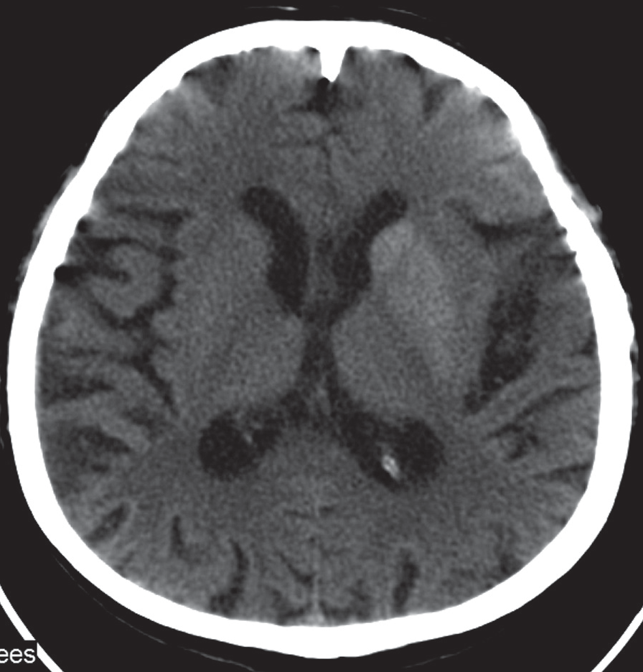
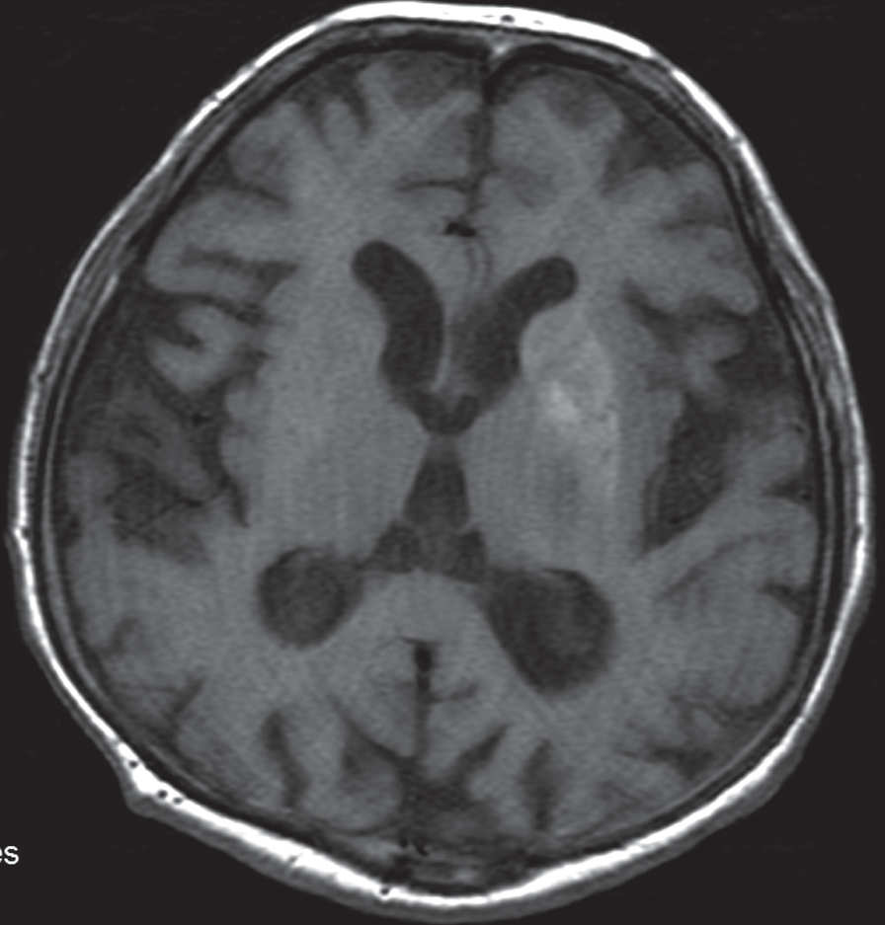
CaseReport
©PolJRadiol,2010;75(3):61-64
Figure1.CTontheseconddayofsymptoms.Hyperdenselentiformandcaudatenucleusofthelefthemisphere.
Figure2.TheMRIperformed4dayslater.SE/T1–Hyperintensesignalfromthelentiformnucleusandalessclearbutalsohyperintensecaudatenucleus.
ExtravasatedbloodisalsohyperdenseonCT,similarlytocalcifications.However,theyshowadifferentattenuationrate.Fattissue,ontheotherhand,revealsnegativevaluesofattenuationcoefficientandishypodenseonCT.
SPECTandPETexaminationsshowedadecreasedperfu-sion/metabolismwithinthelesions[12,13].
Nathetal.publishedanextensivereportonautopsyfind-ingsinoneoftheirpatientsfromwhichitfollowedthatin caseofaclassictriad:hyperglycaemia,hemichorea-hemiballismwithasuddenonsetandhyperintenselesionsinthebasalgangliaonT1-weightedimages,onemayfindnearlyallofthefollowingpathologiesinthecentralateralhemisphere:arelativelyrecentinfarct,localcalcifications,microcalcifications,gemistocyticgliosis[14].
Thepresenceof manganesedepositionsin thebrainresultsinmovementdisorderssimilartotheonesinourcase.Manganeseisdepositedintheglobuspallidus,inparsreticulateofthesubstantianigraand,toalesserdegree,incorpusstriatum,notonlyinthecourseofhepaticencepha-lopathyandparenteralnutritionbutalsoinprofessional-ly-exposedindividuals,e.g.miners.Thelesionsarebilat-eral,symmetrical.Movementdistortionsinthiscaseareofextrapyramidalorigin.Theyincludehypokinesis,stiffnessandtremor[4].
ThecharacteristicsoflesionsfoundonCTandMRIarenotalwaysthesame.AllthereportsmentionanincreasedsignalinT1-weightedimages.SomeauthorsreportthatCTwasnormalandthelesionswerehyperintenseinT1-weightedimages[12,15].ThelesionarealsoclaimedtohavedifferentcharacteristicsinimagesotherthanT1-weightedones.Apartfromthecasessimilartoours(withahypointensesignalindiffusion-weightedimaging),therearealsocaseswithdiffusionrestriction[11,12].TherearealsopublicationsonhyperintensityonT2-weightedimages[7,13].Thismayfollowfromacombinationofdif-ferentanomaliesindifferentratiosindifferentpatients.
Atthebeginning,theincreaseddensityoflesionswithinbasalgangliafoundonCTinpatientswithhemichorea-hemiballismwasascribedtocalcifications[5,6]orhemor-rhagetothosestructures[7].However,duetothefactthatsubsequentfollow-upsrevealeddecreasedhyperdensityoftheinvolvedstructures,uptoitstotalresolution,itwasconcludedthatthecauseoflesionsmustbeotherthancalcifications.Haemorrhagetobasalgangliawasdecidedtobethecauseofclinicalsymptoms[7].AfterobservingdiscrepanciesintheevolutionoflesionsonCTandMRI,thistheorywasquestioned.ShanpointedtothefactthatlesionshyperintenseinT1-weightedimageswerepresentforyearsanddidnotfollowastandardevolutionofextrav-asatedblood.Brainbiopsyinsuchapatientrevealedgliosiswithmultiplegemistocytes,which,accordingtotheauthor,isenoughtoexplaintheshortenedT1relaxationtime[8].Therewasalsoatheorythatthisisnotthebleedingbutashort-lastingischaemiathatleadstosuchanMRIimage[8,9].Finally,itwasprovedthatischaemiawhichdoesnotleadtoafullstrokeresultsinthedepositionofman-ganeseionsinreactiveastrocytesandcausesaparamag-neticeffect[10].SomeauthorsclaimthatthisexplainsthediffusionrestrictionbutnotthehyperdensityonCT[11].
Anunchangingfindinginallpatientsistheinvolmentofthelentiformnucleus(putamen).Insomeofsuchcases,thelesionscanbefoundincaudatenucleusaswell–asitwasinourcase.Someofthepatientspresentwithbilat-erallesionsandwithbilateralinvoluntarymovements.Animportantfeature of thissyndrome is theresolution of MRIabnormalitieswith time and withfollow-ups.
Despitemultipleattempts,thereisstillnohypothesisthatwouldunambiguouslyandcoherentlyaccountforthetypeandoriginofthelesions:thedensityonCTwiththeinten-sityofsignalonMRIatthesametime.
62

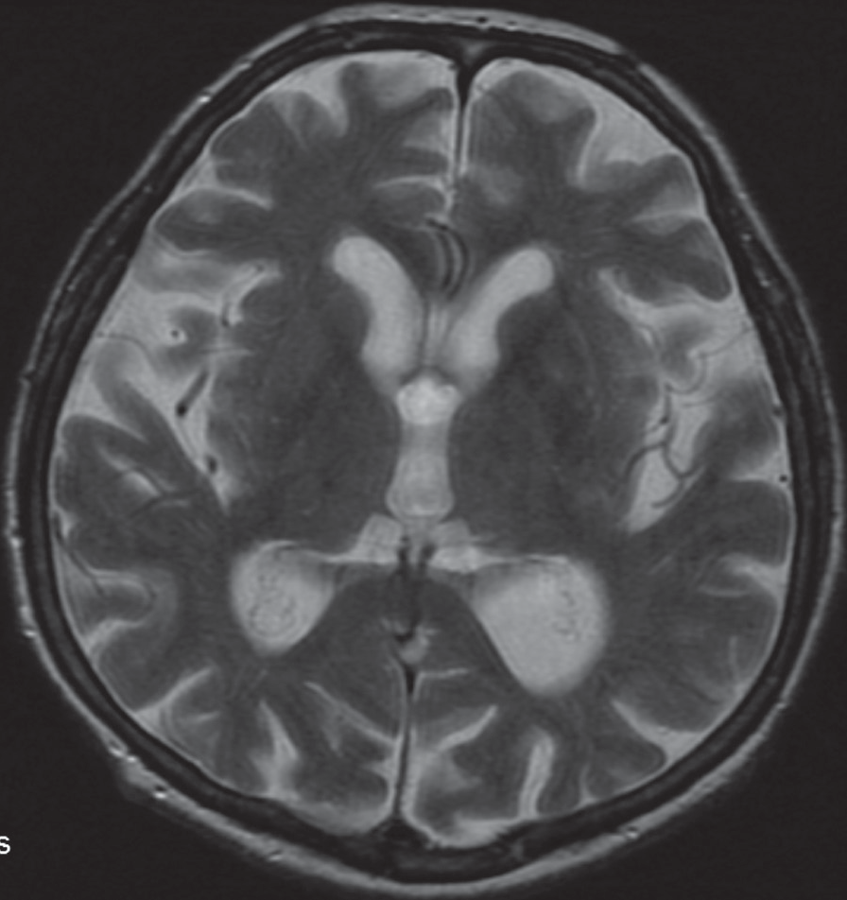
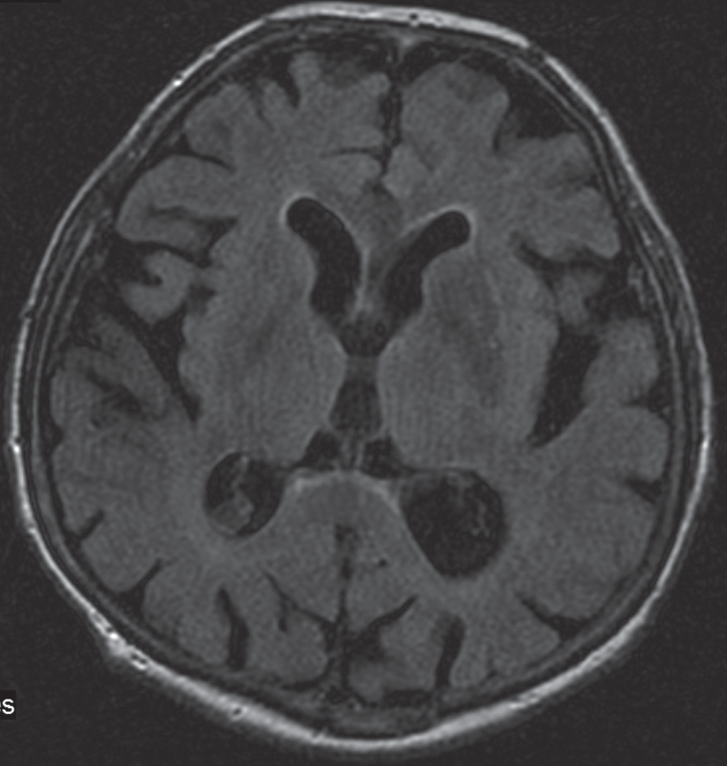
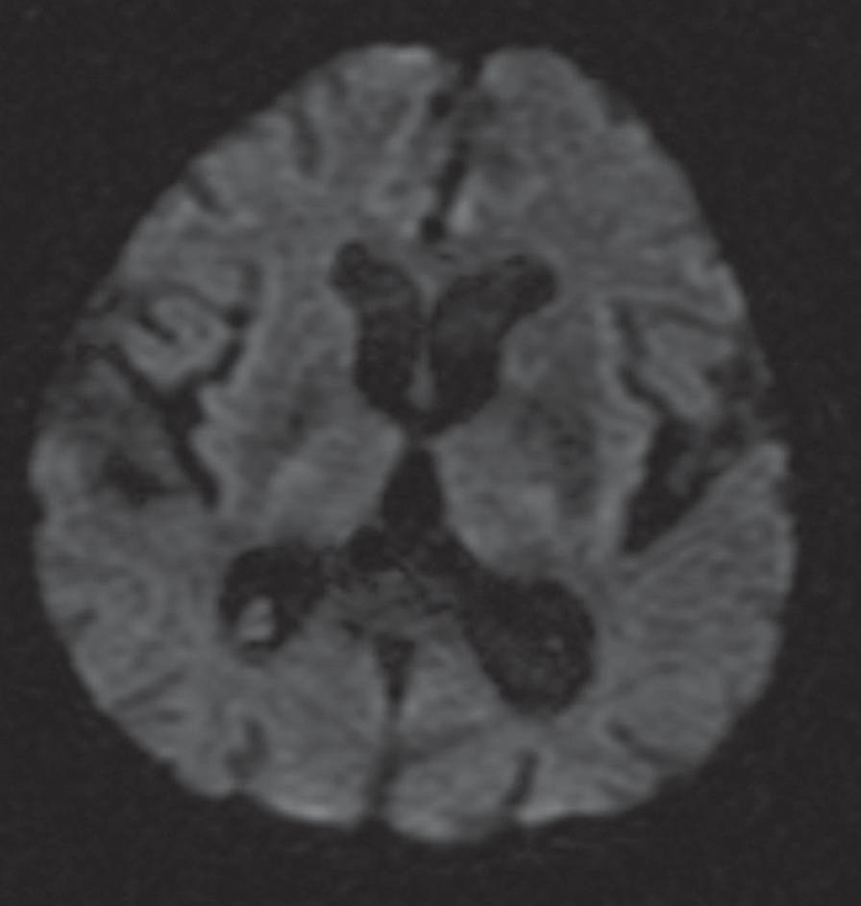
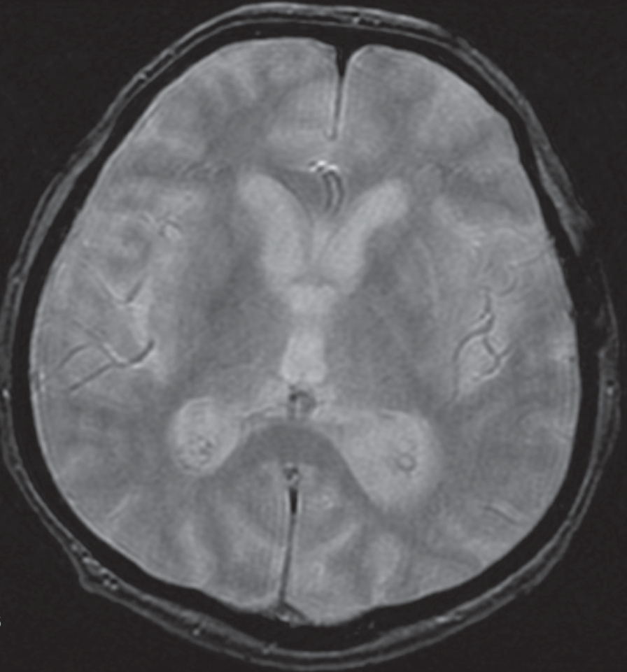
©PolJRadiol,2010;75(3):61-64
Bekiesińska-FigatowskaMetal–Lesionsinbasalgangliainapatient…
Figure3.Discretelyhypointensebasalgangliaontheleftside,withinthesamelayerasinFigure2.(A)FSE/T2-.(B)T2flair.(C)DWI.(D)GRE/T2*-.
References:
- OhSH,LeeKY,Im JH,Lee MS:Choreaassociated withnon-ketotichyperglycemiaandhyperintensitybasalganglialesionon
T1-weightedbrainMRIstudy:ameta-analysisof53casesincludingfourpresentcases.JNeurolSci,2002;200(1–2):57–62
- FelicioAC,ChangCV,Godeiro-JuniorCetal:Hemichorea-hemiballismasthefirstpresentationoftype2diabetesmellitus.ArqNeuropsiquiatr,2008;66(2A):249–50
- Bekiesińska-FigatowskaM,WaleckiJ:ZmianyhiperintensywnewmózgowiuwobrazachT1-zależnychbadaniarezonansu
magnetycznego–przyczynyimożliwościróżnicowania.PolPrzeglRadiol,2001;66(2):15–18
- RoviraA,AlonsoA,CordobaJ:MRimagingfindingsinhepaticencephalopathy.AmJNeuroradiol,2008; 29(9):1612–21
- SanfieldJA,FinkelJ,LewisSetal:Alternatingchoreoathetosisassociatedwithuncontrolleddiabetesmellitusandbasalgangliacalcification.Diabetescare,1986;9:100–1
- InbodyS,JankovicJ:Hyperkineticmutism:bilateralballismandbasalgangliacalcification.Neurology,1986;36:825–27
- ChangMH,ChiangHT,LaiPHetal:Putaminalpetechialhaemorrhageasthecauseofchorea:aneuroimagingstudy.JNeurolNeurosurgPsychiatry,1997;63:300–3
- ShanDE:Hemichorea-hemiballismassociatedwithhyperintenseputamenonT1-weightedMTimages:anupdateandahypothesis.ActaNeurolTaiwan,2004;13(4):170–77
- FujiokaM,TaokaT,MatsuoYetal:NovelbrainischemicchangeonMRI.DelayedischemichyperintensityonT1-weightedimagesandselectiveneuronaldeathinthecaudoputamenofratsafterbrieffocalischemia.Stroke,1999;30(5):1043–46
- FujiokaM,TaokaT,MatsuoYetal:Magneticresonanceimagingshowsdelayedischemicstriatalneurodegeneration.AnnNeurol.,2003;54(6):732–47
63
C

D

A

B

CaseReport
©PolJRadiol,2010;75(3):61-64
- WintermarkM,FischbeinNJ,Mukherjee Petal: UnilateralputaminalCT,MR,anddiffusionabnormalitiessecondarytononketotichyperglycemiainthesettingofacuteneurologicsymptomsmimickingstroke.AmJNeuroradiol,2004;25:975–76
- LeeEJ,ChoiJY,LeeSHetal:Hemochorea-hemiballisminprimarydiabeticpatients:MRcorrelation.JComputAssistTomogr,2002;26(6):905–11
- ShobhaN,SinhaS,TalyABetal:Diabeticnonketotichyperosmolarstate:interestingimagingobservationsin2patientswithinvoluntarymovementsandseizures.NeurolIndia,2006;54:440–42
- NathJ,JambhekarK,RaoCetal:Radiologicalandpathologicalchangesinhemiballism-hemichoreawithstriatalhyperintensity.JMagnResonImaging,2006;23(4):564–68
- OgawaK,SuzukiY,KameiSetal:Choreicinvoluntarymovementthatoccurredduringtherapyfordiabetesmellitus.NipponRonenIgakkaiZasshi,2008;45(2):225–30
64

