
Signature:©PolJRadiol,2010;75(3):47-50
CASEREPORT
Usefulnessofmagneticresonanceimagingwith
Received:2010.04.09
Accepted:2010.05.31
SWIsequence(susceptibility-weightedimaging)
indiagnosingcerebralhemosiderosis–casereport
ElżbietaJurkiewicz1,IwonaPakuła-Kościesza1,SławomirBarszcz2,KatarzynaNowak1,EwaŚwięszkowska3,MarcinRoszkowski2
1MRILaboratory,DepartmentofDiagnosticImaging,TheChildren’sMemorialHealthInstitute,Warsaw,Poland2DepartmentofNeurosurgery,TheChildren’sMemorialHealthInstitute,Warsaw,Poland
3DepartmentofOncology,TheChildren’sMemorialHealthInstitute,Warsaw,Poland

Author’saddress:ElżbietaJurkiewicz,TheChildren’sMemorialHealthInstitute,Al.DzieciPolskich20Str.,04-730Warsw,Poland,e-mail:e-jurkiewicz@o2.pl
Summary
ThepurposeofthisstudywastodeterminewhethertheSWIsequencemayimprovetheMRIevaluationofhemosiderindepositsinthebrain.
Wereportacaseofa7-year-oldgirlafteratotalresectionofalargetumormass(ependymomaGII)locatedinthelefthemisphere.LatecomplicationofsurgerywashemosiderosisofthebraindiagnosedwithSWIsequence.
SWIsequenceisverysensitiveindiagnosinghemosiderindeposits.Itallowedustorecognizecerebralhemosiderosisinthiscase.WesuggesttoincludethissequenceinroutineMRIexaminationsofthebrain,especiallyincasesofpotentialandsuspectedintracranialbleeding
Background:
CaseReport:
Conclusions:
Keywords:
magneticresonanceimaging•SWI(susceptibility-weightedimaging)•hemosiderosis•hemispherectomy•children
PDFfile:
http://www.polradiol.com/fulltxt.php?ICID=881148
Background
Wepresentacaseofaseven-year-oldgirlsubjectedtoatotalresectionofalargetumormassofthelefthemisphere(ependymomaGII)whodeveloped(as alatepostoperativecomplication)cerebralhemosiderosisdiagnosedwiththeuseofSWIsequence.
SWIsequence,i.e.imagingdependingonmagneticsuscep-tibility,isarelativelynewsequenceusedinMRIexamina-tions. Itisbecomingaroutine practiceduetoitsusefulnessindiagnosing diseases accompanied by irondeposition andcalcifications[1].
CaseReport
SWIisespeciallyusefulindiagnosingbrainareasthatunderwentevenslightdisturbancesofthemagneticfieldhomogeneity.
Theseven-year-oldgirlwasadmittedtotheNeurosurgicalDepartmentatthebeginningofJuly2007duetoaCT-andMRI-diagnosedlargetumormassoftheleftposteriorhemi-spherewithamasseffect,dislocationofthemidlinestruc-turesand anactive external hydrocephalus.The tumor waslocatedintheparietal-temporal-occipitalregionwithinthetrigoneoftheleftlateralventricleofthebrain.Themainclinicalsymptoms werethe increased intracranialpressureandmacrocrania.Anextensivecraniotomyoftheleftpari-etal-temporal-occipitalledtoatotaltumorresectionwithanopeningoftheleftlateralventricleofthebrain.
Oneofthecausesofchangesinthelocalhomogeneityofthefieldisthepresenceofblood/hemosiderininsidethebrainorpericerebrally.Duetothatfact,SWIsequencerevealsahighsensitivityindiagnosingmicrocalcifications,severaltimeshigherthantheonepresentedbyother,previ-ouslyused,T2-weightedgradient-echosequences.
47

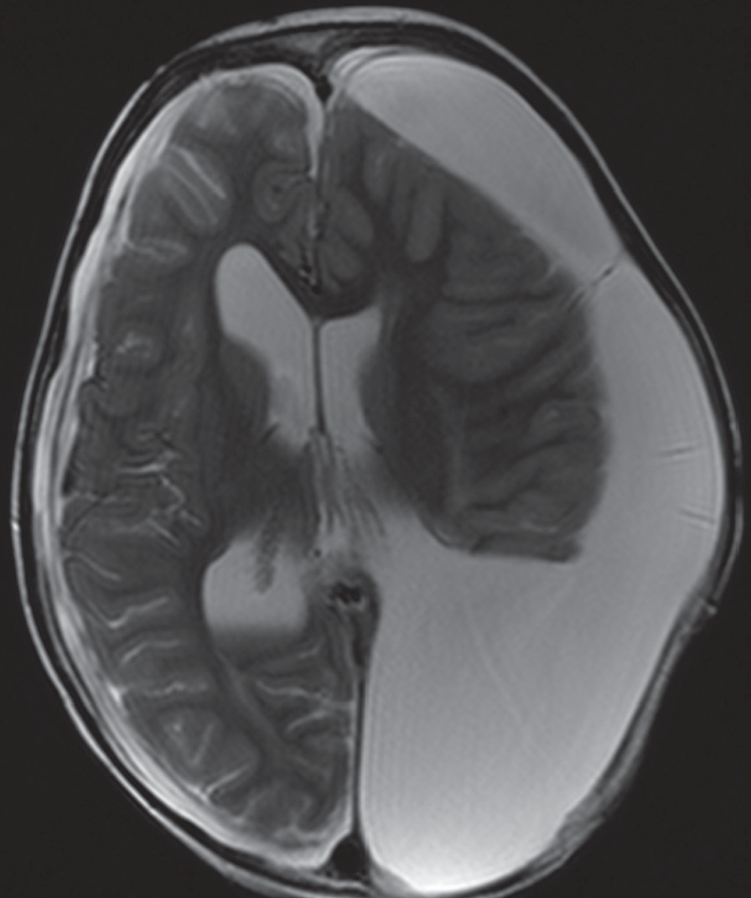
CaseReport
©PolJRadiol,2010;75(3):47-50
imagesshowedadecreasedsignalintensityonthesurfaceofthemedullaoblongataandpartofthecerebralhemi-spheres,aswellasachronichematomaintherightven-tricle.Figure1.SWIsequenceshoweditmorepreciselyandextensively:linear,non-signalproducinglesionsonthesurfaceofthecerebellum,brain,medullaoblongata,andalongthe ependyma ofthe ventricles ofthe ventricular sys-tem;intherightoccipitalhorn–achronichematomawithfluid.Figure2A–C.Basingonthat,apostoperativehemo-siderosisofthebrainwasdiagnosed.InFebruary2009,afurtherneurosurgicaloperationwasperformed.Itwasmeanttofilltheextensivebonedefectinthecranialvaultwithanartificialmaterial(cranioplasty).
Discussion
Cerebralhemosiderosisisnowadaysaveryrarelatecom-plicationofextensiveneurosurgicalprocedures.Itismostlyconnectedwithanatomicalhemispherectomy(sur-gicalmethodofhemisphereremoval,savingbasalgan-glia).Anatomicalhemispherectomyasatechniqueofbraintumortreatmentwasfirstpublishedin1928–aprocedureofgliomaresectionconductedanddescribedbyWalterDandy[2].Inthefollowingyears,thistechniquewasmostlyusedinpatientswithepilepticseizures,resistanttopharmacotherapy.Thefollowingearlypostoperativecomplicationswere reported: aseptic meningitisconnectedwiththepassageofproductsofbloodlysistothecerebro-spinalfluid,dislocationoftheremainingpartofthebrainanditsherniationtowardsthepostoperativehole,aswellashydrocephalus.Thenextyearswitnessedquitefrequent(i.e.in33%ofcases)seriouslatepostoperativecomplica-tionsintheformofsuperficialhemosiderosisofthebrain,aswellasspontaneousandtraumatichematomas[3,4].Theformationofhematomasispromotedbyan‘empty’spaceleftafteranatomicalhemispherectomy.Hydrocephalusandhemosiderosisofthebrainwerethemaincomplicationsandthecauseofdeathinthosepatients.
Figure1.FSET2-weightedimage,transverseplane:hemorrhageinsidetheposteriorhornoftherightlateralventricle.
HistopathologicalexaminationshowedependymomagradeII- ependymoma partimclarocellulare WHOG II.
Theoperationwascomplicatedbyanepiduralabscessatthesiteofcraniotomy.Itwastreatedsurgicallybyremov-alofanosseousflapandimplantationofatemporalepi-duraldrainage.FurthertreatmentwasconductedattheDepartmentofOncology,wherethepatientreceived4coursesofchemotherapy,andthen,fromDecember2007toJanuary2008,atwo-phaseradiotherapyofthewholeCNS:inthefirstphaseitwas2505cGy/tin15fractiondoses,inthesecondphase:5385cGy/tdestinedforthepostoperativefieldandahigherdose–of4000cGy/t–fortheTh8-S3spi-nalcanal.Afteracompletedradiotherapy,sevencoursesofmaintenancechemotherapywereintroducedaccordingtothePackerregimen.
Pathomechanismofhemosiderosisisnotfullyunderstood.Itisbelievedthatthedirectcauseofthiscomplicationisbleeding(superficialsubarachnoidandintraventricular)connectedwithenormousdistortionsofnormalanatomicalrelationsofthebrain–‘theemptyspace’aftertheresectedhemisphere[5].Withlong-lastingorrecurrentsubarach-noidhemorrhages,hemosiderinisdepositedonthesurfaceofthebrain,cerebellum,spinalcordandcranialnerves.Frequentcomplicationsincludedeafness,ataxiaandsmelldisturbances[6].Atypicallocationofthoselesionsisthesurfaceofthebrainstemandcerebellarhemispheres.Histopathologicalexaminationstendtoshowdepos-itsofhemosiderincoveringthesurfaceofthebrainandtheependymaoftheventricles,i.e.regionsremaininginadirectcontactwiththecerebrospinalfluid.Theycausegliosis,neuronallossanddemyelination.Twotypesofglialcellstakepartintheprocessofhemosiderindeposition:microglia,synthesizingferritin,andBergman’sglialcells,whicharethesourceofironandalsotakepartinsynthe-sizingferritin[7,8].
Duringthecomprehensivetreatment,thechildwassub-jectedtoroutinefollow-upsattheMRILaboratory,withanaimtohavetheefficacyoftheintroducedtreatmentassessed.
Theexaminationswereperformedwiththeuseofa1.5Tscanneranda8-channelheadprobe,inthreeplanes,T2-andT1-weightedimages,andtwophases.Theyfoundanextensivepostoperativefieldreachingtheleftlateralventricleandalargefluidcollectionsurroundingthelefthemisphere.Forfurtherdiagnostics,SWIsequencewiththefollowingparameterswasused:bandwidth:90Hz/Px,TR/TE: 58.0/44.1 ms,FOV:230×230 mm, matrix:320×320,
GRAPPA3,sectionthickness:1.6mm,gap:20%,flipangle:19,numberofaverages:1,voxel:0.7×0.7×1.6,acquisition
time:7min.
Intheliterature,therearereportsoncasesofhemosidero-siscausednotonlybyanatomicalhemispherectomy,butalsobybraintumors,e.g.ependymomasorastrocytomas
InasubsequentroutineMRIexaminationcarriedout19monthsafterthesurgicalprocedure,theTSET2-weighted
48

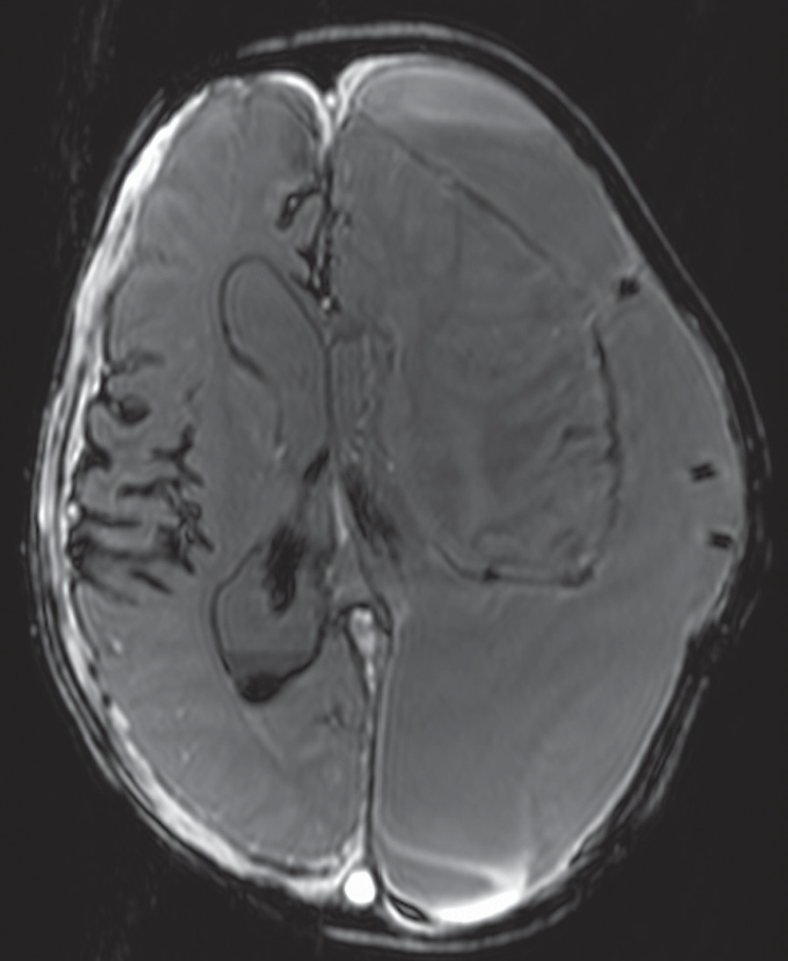
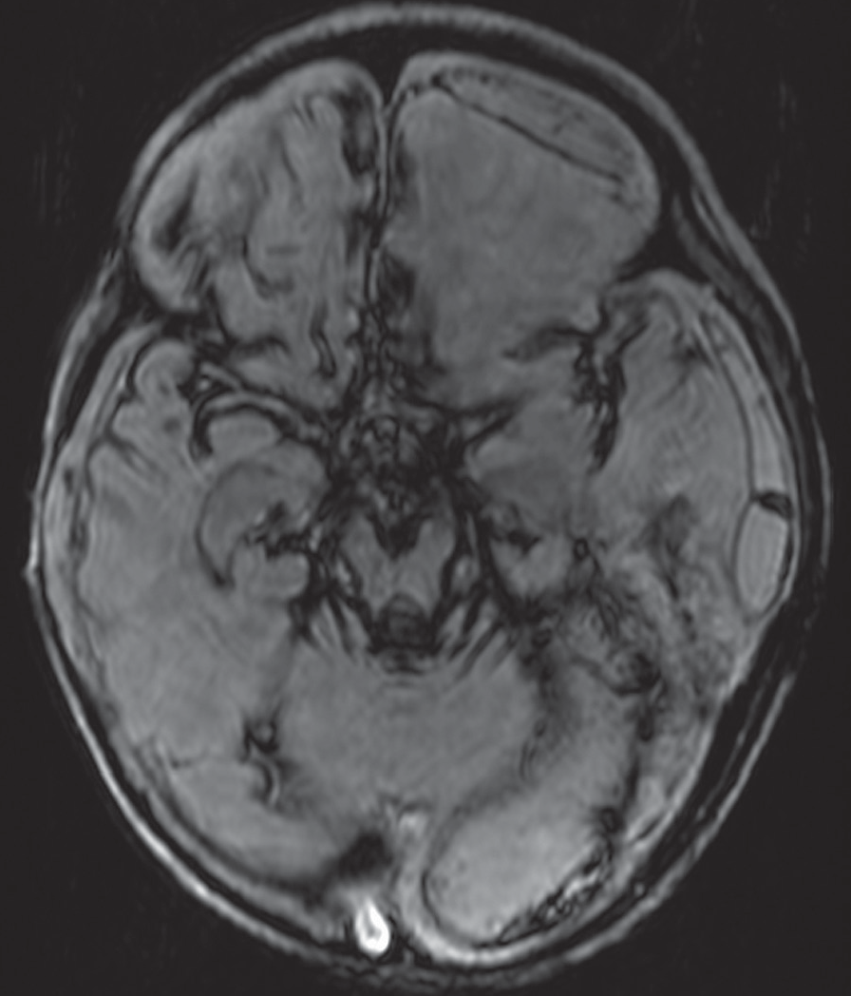
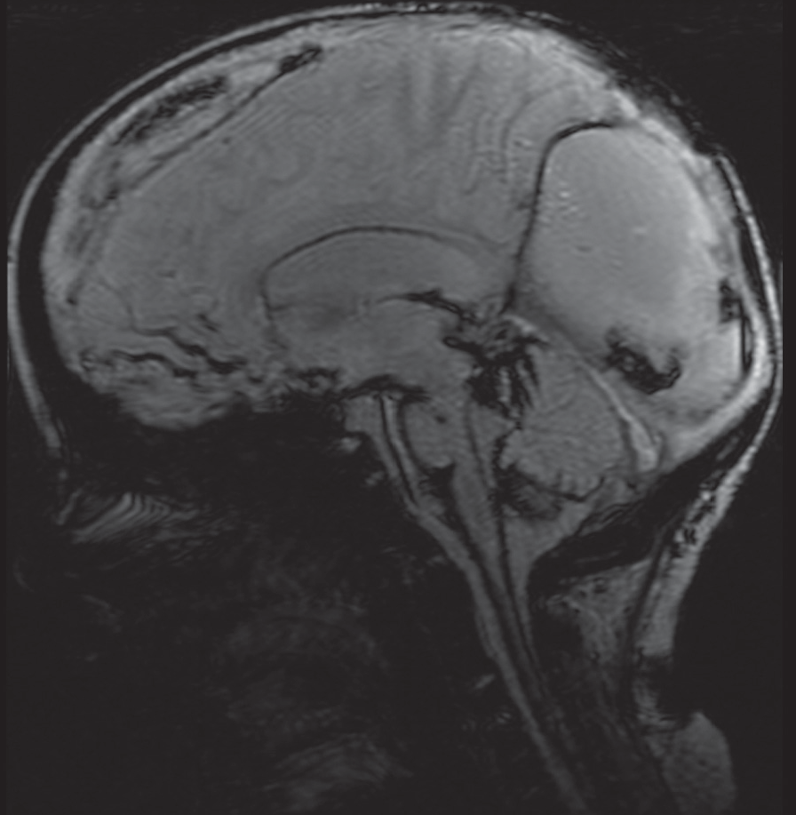
©PolJRadiol,2010;75(3):47-50
JurkiewiczJetal–UsefulnessofmagneticresonanceimagingwithSWI…
ofthecerebellum,venousmalformations,aswellasamy-loidangiopatiesandradiotherapy[9–11].Inordertolimittheriskoftheaforementionedcomplications,neurosurgicalmodificationsofanatomicalhemispherectomyorfunctionalhemispherectomyareapplied[12].
Inthecasepresentedbyus,theoperationconsistedinaselectiveresectionofamassivetumordestroyingthepos-teriorpartofthelefthemisphere.Duetoaslowgrowthofthetumormass,thereappearedsomeatrophiclesionsofthebraininthatregion,connectedwithcompressionexert-ed by thetumor.There was alarge asymmetry between thehemispheres. Due tothe tumorgrowth andwidening ofthebrainventricles,thesizeofthebrainincreased,leadingtoanexcessiveincreaseinthecircumferenceofthechild’shead(macrocrania).Afterresectingthelargetumormassandopeningtheventricleofthebrain,theinternalhydro-cephalusresolvedandthereappearedasignificantdispro-portionbetweenthebrainsizeandthevolumeoftheskull.Thisledtoasubstantialsubarachnoidfluidcollectionandcreatedconditionssimilartotheonesobservedinpatientsafteranatomicalhemispherectomies.
Figure2.(A)SWIsequence,(B)transverseplanesand(C)sagittalplane:laminar loss of signalintensityaroundthe
brainstem,cerebrumandcerebellum,whichindicateshemosiderindeposition.Hemorrhageinsidetheposteriorhornoftherightlateralventricle.
Averyimportantfactorpredisposingtothepresentedcom-plicationwasthepresenceoftheextensivebonedefectinthecranialvaultintheleftparietal-temporal-occipitalregion.Thiscausedabnormalfluctuationsintheintracra-nial pressure, depending on thebody position and patient’sactivitystatus.Periodically,thechildexperienceddistur-bancesinbloodcoagulationconnectedwiththeintroducedradio-/chemotherapy,whichcontributedtotheappearanceoftheaforementionedposthemorrhagiccomplications.
Arapiddevelopmentofdifferentdiagnosticmethods,includingtheMRI,contributesnotonlytoabetterplan-ningofneurosurgicalprocedures,butalsotoamorepreciserecognitionofpostoperativecomplications.AnexampleforthatwouldbetheintroductionofMRIimagingwithSWIsequence.Thisisa3Dgradient-echosequencewithaveryhighspatialresolution.Thistypeofimagingwasprimarilyusedforvisualizationofthevenoussystem,asitappliesthepragmaticpropertiesofdeoxyhemoglobinrunninginveins [13]. Soon, it turned out that SWI uses the differencesinmagneticsusceptibilityoftissueswhichcausediffer-encesinphasesbetweenregionsincludingparamagnetic
Atpresent,duetothedevelopmentofthestate-of-the-artneurosurgicaltechniques,cerebralhemosiderosis,beingsolelytheconsequenceofsurgeries,isdiagnosed veryrarely.
49
B

C

A

CaseReport
©PolJRadiol,2010;75(3):47-50
bloodproducts(deoxyhemoglobin,intracellularmethemo-globinandhemosiderin)andthesurroundingtissue[14].ThisallledtoanincreaseinthenumberofindicationstoSWIuse. It wasfound that thissequence providesaddition-alinformation,veryusefulinthediagnosticsofbraininju-ries,coagulopathies,vascularmalformations,tumorsanddegenerativediseasesaccompaniedbyirondepositsandcalcifications[15,16];butthemostvaluedpropertyofSWIwasitssensitivityindiagnosingextravasatedblood[17,18].
Moreover,inthestudyonMRIpresentedbyus,theappli-cationoftheSWIsequenceallowedforthedetectionandimagingofanactualextensionandofapreciselocationofhemosiderindepositsonthesurfaceofthebrain,cerebel-lumandventricularsystem.
Conclusions
Inthepresentedcase,wefoundtheSWIsequencetobeusefulindiagnosingthepresenceandextensionoftheareasofextravasatedblood.MRIwiththissequenceallowedforthedetectionofanextremelyrarecomplica-tionofthesurgicalprocedure,i.e.cerebralhemosiderosis.AuthorssuggestthatSWIsequenceshouldbeincludedinthesetofroutineMRIprocedures,especiallyinthecasesofextensiveneurosurgicalprocedures,aswellasinmanyotherpathologiesoftheCNSthatmaybecomplicatedbyintracranialbleeding.
SWIsequenceisamethodwiththehighestsensitiv-ityindetectionoffociofmicrohemorrhage;accordingtosomeauthors,sixtimeshigherthantheconventionalT2-weightedgradient-echosequences[19–21].Thiscon-cernsboththesizeandthenumberoffoci,aswellasthevolumeofextravasatedblood.
References:
- RauscherA,SedlacikJ,BarthMetal:MagneticsusceptibilitysensitiveMRphaseimagingofthehumanbrain.AJNRAmJNeuroradiol,2005;26:736–42
- DandyWE:Removalofrightcerebralhemisphereforcertaintumourswithhemiplegia.JAmMedAssoc,1928;90:823–25
- FalconerMA,WilsonPJ.Complicationsrelatedtodelayedhemorrhageafterhemispherectomy.JNeurosurg,1969;30:413–26
- RasmussenT:Postoperativesuperficialhemosiderosisofthebrain,itsdiagnosis,treatmentandprevention.TransAmNeurolAssos,1973;98:133–37
- OppenheimerDR,GriffithHB:Persistentintracranialbleedingasacomplicationofhemispherectomy.JNeurolNeurosurgPsychiatry,1966;29:229–40
- McCarronMO,FlynnPA,OwensCetal:Superficialsiderosisofthecentralnervoussystemmanyyearsafterneurosurgicalprocedures.JNeurolNeurosurgandPsychiatry,2003;74:1326–28
- FearnleyJM, Stevens JM,RudgeP:Superficialsiderosis of thecentralnervoussystem.Brain,1995;118:1051–66
- KoeppenAH,DicksonAC,ChuRCetal:Thepathogenesisofsuperficialsiderosisofthecentralnervoussystem.AnnNeurol,1993;34:646–53
- McCarronMO,McKinstryCS,GibsonJM:Superficialsiderosis20yearsafterbraintumour.LancetNeurol,2002;1:326
- McCarronMO,FlynnPA,OwensCetal:Superficialsiderosisofthecentralnervoussystemmanyyearsafterneurosurgicalprocedures.JNeurolNeurosurgandPsych,2003;74:1326–28
- LinnJ,HermsJ,DichgansMetal:SubarachnoidHemosiderosisandsuperficialcorticalhemosiderosisincerebralamyloidangiopathy.AJNRAmJNeuroradiol,2008;29:184–86
- CookSW,NguyenST,HuBetal:Cerebralhemispherectomyinpediatricpatientswithepilepsy:comparisonofthreetechniquesbypathologicalsubstratein115patients.JNeurosurg,2004;100:125–41
- ReichenbachJR,VenkatesanR,SchillingerDJetal:Smallvesselsinthehumanbrain:MRvenographywithdeoxyhemoglobinasanintrinsiccontrastagent.Radiology,1997;204:272–77
- MittalS,WuZ,NeelayaliiJetal:Susceptibility-weightedMRimaging:technicalaspectsandclinicalapplications,Part2.AJNRAmJNeuroradiol,2009;8:1–20
- HanckeEM,MitkalS,WuZetal:Susceptibility-weightedMRimaging:technicalaspectsandclinicalapplications,PartI.AJNRAmJNeuroradiol,2009;30:19–30
- SehgalV,DelpropostoZ,HanckeEMetal:Clinicalapplicationofneuroimagingwithsusceptibility-weightedMRimaging.JMagnResonImaging,2005;22:439–50
- WycliffeND,ChoeJ,HolsouserBetal:ReliabilityIndetectionofhemorrhageinacutestrokebyanewthree-dimensionalgradientrecalledechosusceptibility-weightedMRimagingtechniquecomparedtocomputeredtomography:aretrospectivestudy.JMagnResonImaging,2004;20:372–77
- TongKA,AshwalS,HolshouserBAetal:HemorrhagicshearinglesionsInchildrenandadolescentswithpostraumaticdiffuseamonalinjury:improveddetectionandinitialresults.Radiology,2003;227:332–39
- TongKA,AshwalS,ObenausAetal:Susceptibility-weightedMRimaging:areviewofclinicalapplicationinchildren.AJNRAmJNeuroradiol,2008; 29:9–17
19.AkterM,HiraiT,HiaiYetal:Detectionofhemorrhagichypointensefociinthebrainonsusceptibility-weightedimagingclinicalandphantomstudiem.AcadRadiol,2007;14:1011–19
21.BabikianT,FrezerMC,TongKAetal:Susceptibility-weightedMRimaging:neuropsychologicoutcomeandpediatricheadinjury.PediatrNeurol,2005; 33:184–94
50

