Studia Linguistica Universitatis Iagellonicae Cracoviensis
128 (2011)
ANNA TERESZKIEWICZ
Jagiellonian University, Cracow

RHETORICAL STRATEGIES ON WWW.IREPORT.COM
Keywords: user-generated content online, participatory websites, discourse analysis

Abstract
The study concentrates on the phenomenon of user-generated content on the inter-
net. The article presents an introductory analysis of various rhetorical strategies used
by the authors of commentaries on one of the popular user-contributory sites, i.e.
www.iReport.com. The analysis of this site shows that there exists a range of diverse
means of expression used by the enthusiasts of broadcasting online, involving the sub-
mission of written articles, live video commentaries, audio files and cartoons. The study
shows that users shape the features of the content in different manners and resort to
the use of a variety of rhetorical devices. To the main properties of discourse belong
personalization, interactivity, use of figurative and vivid language.
As the title suggests, the study aims to review the rhetorical strategies used in online
commentaries on www.iReport.com, a user-generated website. The research focuses
on examples of user-created content on the web specifically, because it is in this
medium that the phenomenon has seen a dynamic increase.
My aim was to examine the means which amateur commentators use in order
to present the news, opinions and commentaries and also the degree to which they
exploit the affordances of the internet. I hypothesized that the lack of editorial in-
sight and also the technological possibilities should encourage the contribution of
uninhibited, unrestrained and deeply varied content.

I. User-generated content
The phenomenon of user-participation in the creation of online content has de-
veloped significantly during the last few years, due to the affordances of internet
180
ANNA TERESZKIEWICZ
technologies. The advent of Web 2.0 technologies, which contributed to the wide-
spread use of easy publishing tools and mobile devices, has played a special role in
the spread of this phenomenon. Web 2.0, in contrast to its predecessor, Web 1.0,
places more emphasis on the content produced by users, on their active participa-
tion in information exchange and their contribution of various data to websites
(cf. Cormode and Krishnamurthy 2008, Harrison and Barthel 2009). In this way,
the online audience has turned into an active participant in the process of producing
online content and publishing commentaries and other type of data (Bowman and
Willis 2003: 7). The Web 2.0 applications include video-sharing web sites, such as
YouTube, networking sites, such as Facebook, MySpace, collaborative knowledge
portals and encyclopedias, such as Knol or H2G2.

II. ¡Report.com
For the following study, I chose one of the popular user-contributory sites, i.e. iRe-
port.com. The headline of the site - “Unedited. Unfiltered. News” - describes the
basic characteristics of the project. The content of the site is generated by users and
is not moderated by the editors before its publication. Moderation of the news can be
performed after the message has been published on the website, as the community
has the right to block a message if it is vulgar or defamatory. The basic and most
conspicuous characteristic of the site is semiotic intertextuality, as it presents both
textual, audio and video content. Still images dominate on the site, especially live
commentaries and graphic representations. (Fig. 1.)
What follows is an introductory content analysis of the project in question.
The material for the following analysis comprises 243 messages which achieved the
status of the most viewed and most commented in August and September 2009.
To the most frequent channels of expression belong video files, graphic messages
and textual commentaries. Due to a heterogeneous shape of the site, the study
required the application of different methods of analysis of the content. In the fol-
lowing research, we present the most conspicuous properties of each of the types
of the comments, presenting content analysis of the page, with special focus on the
linguistic properties of the messages, i.e. their discourse properties, syntactic and
lexical features. This description should be treated as an introductory presentation
of the research area in question, as each of the channels of expression calls for a
more profound study of their shape.
The first look at the collection of the messages proves that it is considerably varied,
ranging from plain, commonplace messages to very sophisticated commentaries and
complex video files. The posts are characterized by ingenuity and daring, which is a
direct consequence of the freedom of publication on the site. Since the authors are not
constrained and influenced by editors or gatekeepers, they can enjoy a significantly
greater autonomy in the choice of the subject and shape of the message. A review
of the messages allows us to observe that the authors resort to the use of different
rhetorical devices to present their point of view and to influence the audience.
Rhetorical strategies on www.iReport.com
181

1. Video files (56%, 136 messages)
As mentioned above, video files belong to the most frequent channels exploited by
the authors. On average, every 2 minutes a new movie is added to the site, which is
a sign of the dynamic activity of the community of users. The messages transmitted
in the movies as well as the behaviour of the users deserve closer attention as they
exhibit interesting properties. The most conspicuous features of the language of
video messages are personalization, interactivity, as well as figurative and vivid style.
  - Personalization
The first feature worth noting is the personalization of the posts. The commentaries
have a strong personal touch. The authors quote stories of their own life and present
their personal experiences. This feature, characteristic of the majority of the posts
in the material analyzed, can be illustrated in the movie posted by a user named
OCGirl, presenting a commentary on the celebration of Mother’s Day. (Fig. 2.)
Hey everybody
I am not only a super mom but I’m a cool mom as well. And the reason I say that is
that ever since my boys were small I have never ever grounded them. And the reason
I have never believed in grounding my boys is that when you just ground somebody
and send them to a room or have them stand in the corner your are not really teach-
ing them to resolve issues so whenever my boys get into a fight or argue with each
other I literally have them talk it out like in a presidential debate. That’s what I do is
because I think that the earlier we can start communication with kids at a younger
age the more it can help them for the rest of their lives.
The author of this message concentrates on herself, quotes her personal experiences
with raising children and cites her methods of educating them. Personalization
is visible in the frequent references to the self, in the use of 1st person pronouns
(I’m a super mom, I teach them, my boys). She tries to convince the viewer that she
is right in her approach and encourages him/her to follow her methods. This may be
also observed in the opposition between I and you, which she introduces (when you
ground somebody...), in order to prove that what you do is wrong. A further point
is the use of inclusive we (the earlier we can start communication.), which stands
for the group of parents or caretakers who are all encouraged to act in the manner
proposed by the speaker.
  - Interactivity
The aforementioned references to viewers signal a further characteristic of the mes-
sages apart from personalization, that is their profoundly dialogical and interac-
tive nature. The authors in the messages posted on the site frequently provoke the
audience and invite the readers to enter into a discussion and to exchange opinions.
The dialogical character of the messages is manifested in direct references to viewers,
in questions directed at listeners, in the use of the 1st and 2nd person plural pronouns
(e.g. we, you). All these means enhance the contact of the authors with the receivers
and mark solidarity with them.
182
ANNA TERESZKIEWICZ
  - Figurative style
The authors, in order to make their expressions more vivid, frequently resort to the
use of figurative language - incorporating analogies, metaphors or similes. For in-
stance, the user identified as Adriana presented a video in which she expresses just
one sentence - the pig is already in the air and has already landed. Though the com-
mentary is short, it is meaningful and rich in content, and can be seen as an example
of a double metaphor. In this statement, the user refers to two important events
which were hotly discussed on the internet, i.e. the flight of the President’s airplane
above Manhattan and the spread of the so-called swine flu at the end of April. In this
short and simple message she expressed her negative attitude towards the flight of
the plane, which terrified many people and brought back the events of 9/11. At the
same time though, she has passed on the news about the first instance of the virus
confirmed in the USA (the pig has landed, i.e. the virus has come).
This particular tendency towards figurativeness of description and also exem-
plification of certain phenomena can be seen in the following movie, in which the
author describes the state of American economic situation by comparing it to an
airplane. (Fig. 3.)
You know our nation, is really nothing more than a big fancy airliner flying in the
sky. It has a number of things that make it work. It has two wings - a right wing
and a left wing, it has a tail which is a kind of centre of things. And most important
it has a pilot who controls. Our nation and this airplane is on a diet now caused
by a failing economy. The airplane is beginning to spin and fall towards the earth.
Now it’s a time that all the various parts must stay intact and connected to the air-
plane. And the pilot, whoever that person is, we have to trust that he knows what
he’s doing. People from the back of the plane should be deterred from rushing up
and grabbing the controls. More than one person on the controls can lead to seri-
ous problem of confusion. At a very critical time this nation must pull together,
because if the airplane doesn’t stay together the chances of pulling it out of the dark
are rather remote my friend.
As the author states - America, just like an airplane, has two wings (political parties),
the centre, and the pilot (the President) who controls the flight. Due to the economic
crisis, American industry is deteriorating - that is the plane has started to go down.
The speaker uses the extended simile, which has certain features of allegory as well,
to make the message more evocative to viewers and thus to encourage cooperation
in the nation and trust in the President in order to go through the difficult period.
The user resorts as well to non-verbal means of expression. The message he wants
to transmit is enhanced by his appearance, as he is wearing a pilot’s cap.
  - Vivid style
The user quoted above, who calls himself Dimmit, is especially creative. In his live
comments, he often applies additional, non-verbal strategies to supplement and
intensify his message. This can be seen in the following post where he presents his
opinion on gun control in America, holding a gun in his hand and wearing another
characteristic cap. (Fig. 4.)
Rhetorical strategies on www.iReport.com
183
here’s nothing that makes me feel more secure than my gun. I feel manly when
I hold it. It’s an AKC 40 caliber Mauser Revolver. And I’ve even taken lessons on
how to shoot it, I went to one of those safety classes. I hear people talking of gun
control. I didn’t like to idea of gun control, but then many years ago one man
climbed up a tower of one of the prestigious universities and started shooting people
with a long gun and I said, My God, we need to control these bloody things, so I’ve
given a though all over the years and the reality is this, we cannot control the gun.
It’s been invented, the same as the computer has been invented. It’s really hard to
uninvent something, once it is, so if anybody could present a plan of gun control
that would really work, then I might be for it. But the reality is there’s no way to
control the guns. We just control the guns of the honest people, not the bad guys -
they’ll always get the guns, and there’s nothing worse than to be in a situation when
the other guy’s got a gun and is shooting at you and you don’t have a gun. It’s just
a bad position to be in. So, I won’t support gun control, unless somebody comes
with a plan that really works.
Due to the non-verbal means used, the message is presented with exceptional
vividness, which is additionally enhanced by the deeply rhetorical nature of the
expression. ^e tone of the message is intensely persuasive - with the very first
sentence, which is a strong assertion about the importance of the gun in his life, the
user tries to convince the viewer of the advantages of possessing a gun. Similarly,
the next sentence, though simple and short, expresses a close association between
the possession of a weapon and masculinity. ^e user also resorts to straightforward
statements of truth, such as the reality is this, we cannot control the gun, there’s
no way to control the guns, etc. ^ese strong affirmations are to convince the ad-
dressee that no other solution to the problem is possible. In addition, persuasive
tone of the message is achieved by the exemplification of the message with real-life
situations, where the user quotes both authentic events (gunfire at university) and
fictitious, yet probable, situations. Rhetorical nature of this post is combined with
orality and informality, which are manifested in the presence of interjections,
the use of colloquialisms and contractions.
^is video also illustrates the above-mentioned personalization - the user quotes
his own feelings and experiences associated with the possession of a gun (the use of
personal pronouns I, my, me). ^ere are also elements of interactivity to be found -
when he refers to the viewers directly (the other guy is shooting at you and you don’t
have a gun).
In both cases, the non-verbal strategies support the textual message, highlight
and enhance the point being made and make it more effective. ^e introduction of
unexpected effects at the end (i.e. the user is lighting a cigarette and suddenly the
“smoke police” knock on the door, at which point he chooses to use his gun) aim at
achieving maximum appeal and originality of the message.
^e use of figurative and vivid language, and the use of non-verbal means of
expression make the messages more expressive, eye-catching and appealing, but also
easier to digest by the users, and bring the message closer to their concrete experience.
^ey help convince listeners and persuade them towards accepting the viewpoint of
the author. ^us, they enhance the expressive function of the message, as well as its
184
ANNA TERESZKIEWICZ
impressive and aesthetic functions. Their role is to influence the viewers’ opinions,
to amaze and / or surprise them and to affect their imagination.
These videos illustrate different approaches toward the form of the presenta-
tions. On the one side, we have the presentations recorded in plain rooms and
halls without much care devoted to the background or to the appearance of the
speaker. On the other side, the rooms are carefully designed, perhaps recording
studios, with well-thought out scenography and ornamentation of the message.
These examples show that the introduction of video commentary allows the au-
thors to achieve a more credible and direct experience than would be possible
with text messages alone.

2. Graphic representations (23%, 55 posts)
In addition to live commentaries, users present their opinions and comments in
graphic form, i.e. with a cartoon or a drawing. Although such forms are also pre-
sent in traditional media, the online drawings deserve mentioning due to their
great variation and the creativity of their authors. The lack of the above mentioned
editorial restraints allows users not to be constrained by standard conventions or
rules of political correctness.
In designing their pictures, the authors utilize a variety of means of expression,
among which, the following are the most frequent:
- The use of cultural symbols, characters and book heroes
The first frequent means of expression is by reference to common film and book
heroes, e.g.:
- famous movie doctors - the author of the collage uses popular doctor-char-
acters from movies and cartoons (e.g. Dr Quinn, Dr House, Dr Hibbert),
suggesting that their help could be sought in the face of swine-flu. (Fig. 5.)
- Star Trek - the author refers to the characters of Star Trek to describe the
activities of the Democrats. He compares the party to the Borg (i.e. an in-
tegrated collective formed through forced assimilation; they do not exhibit
a desire for negotiation or reason). (Fig. 6.)
- Hulk - comparing President Barack Obama to the Incredible Hulk, as a reac-
tion to the overuse of the word outrage by the President. (Fig. 7.)
- Usage of cultural symbols in word plays
Users as well refer to cultural symbols, as in the following picture, where the
title Encyclopedia Baracobama can be seen as a blend of the proper name Barack
Obama and the noun Americana, thus being a clear reference to the Encyclopedia
Americana. (Fig. 8.)
- Drawings describing recent events
A further frequent method of expressing one’s opinion via an image is the use of
drawings. In Fig. 9, the user shows a negative attitude to the extensive coverage
Rhetorical strategies on www.iReport.com
185
of the news concerning the spread of swine flu, which is broadcast at the expense
of the discussion of other problems.
Graphic representations frequently have the role of supplementing textual
messages, which constitute the last type of files.

3. Textual messages (21%, 52 messages)
These messages comprise only textual content. As such they exhibit similar char-
acteristics to the posts which can be found on discussion forums. The basic charac-
teristics of these posts are their informality and a high degree of emotiveness and
expressiveness.
As far as the content of these posts is concerned, we may distinguish two main
content areas - i.e. personal experiences and current world affairs.
- Messages concentrating on the self - personal experiences (54%, 28 posts)
This group of messages concentrates on the presentation of personal experi-
ences; the authors concentrate on the self and on the revelation of subjective
feelings, e.g.:1
My mother was an aspiring actress in Hollywood. She gave up when she got mar-
ried to my Dad. If she were still here I would ask her why she gave up because it
would be fun to tell people my mother is an actress. :)
i love Pontiacs! I’ve always liked them since I was 4 years old & my dad had a ‘69
firebird. I also drove a ‘74 pontiac grand prix when I was 13. I’ve had 2 bonne’s,
grand prix, trans-am, & gto. Loved every single one of ‘em!
When I was growing up, I had a fascination with the stars and astronomy.My
Grandpa bought me about the constellations and taught me to identify Orion,
the Big and Little Dippers and find the North Star.
These messages illustrate the above-mentioned personalization of the posts.
Clearly, the posts represent the authors’ strong need for self-expression.
- Messages directed at particular addressees (46%, 24 messages)
Very often the posts take the format of a message or a letter, directed at a spe-
cific person. These messages contain statements of opinion and raise questions
concerning current affairs. Obviously, the questions are rhetorical in nature and
their function is solely expressive. They also contribute to creating an illusion of
a dialogical and interactive situation, e.g.:
Dear President
My name is Zeeshan Usmani, and I have a quick question to ask. Why can’t we
solve the problem we have created for ourselves? and why we have to beg to USA
everytime anything goes wrong in Pakistan?! appreciate your time, Thank You
1 All the messages are quoted in their original form, keeping the errors made by the authors.
186
ANNA TERESZKIEWICZ
Hi Larry.
I just have a few questions all related. I know you have time restraints and all
but when you ask your guests a question on your show, why don’t you let them
answer before you interupt them, you do this all the time. Oprah does the same
thing and it really bothers me. Do you think they are either boring answers or
long winded? Why is this done so often?
I didn’t vote for you but I do appreciate that you are the right person at the right
time for what must be the ugliest job in the world right now. Heck, I’d even forgive
you if you took up smoking again.
The rhetorical nature of the messages is confirmed by the following passage which
exemplifies the features presented above, i.e. the personalization and dialogical
character of the text:
May I ask you when you will stop this genocide, women and kids are paying the
price of your actions, your Nation is being hurt daily, what about your own family
and your own daughters, would you ever imagined you would have been born a
woman, what would be your position if you were born a woman, why do you let
your own people kill and treat women like less than an animal,
I am asking too much,
to respect your own people and specially kids and women,
what will you do next,
what will be your agreement with the leaders of the world,
what are you waiting to change your position re this crazy war, and what is your
position re Pakistan, well that is an obvious one,
what is exactly what you want to get with this non stop violence, haven’t you see
or you don’t care the way you’re people are suffering
yes politics and rulling a Country can be very dirty,
but I really would like to know how do you feel as a human being,
I bet you don’t feel,
because if you were a true religious man,
you wouldn’t be doing what you are doing to your people and to your brothers
in faith
This user, in contrast to Dimmit, who tried to present rational arguments for his
opinions, resorts solely to emotional persuasion. The message, deeply emotional
in tone, takes the form of a stream of consciousness, presenting an unsegmented
flow of thoughts. Basically, it delineates the complaints associated with the social
situation in Pakistan in the form of an accumulation of questions and accusations
directed at the President of the country. The questions have a different charac-
ter, being both deliberative and persuasive. They range from direct questions
concerning particular problems (what will be your agreement with the leaders
of the world), to conditional questions regarding unreal situations (what would
be your position if you were born a woman). In three places, the list of questions
is interrupted by ironic acknowledgments of truth and an ostensible agreement
(well, that is an obvious one, yes politics and ruling a country can be very dirty).
These suspension points help leave certain things unsaid and achieve the effect
Rhetorical strategies on www.iReport.com
187
of reticence. In the message we can see the elements of doubt, rejection, and
evaluation. The user refers to common moral values, focusing on an emotional,
not rational evaluation of reality.
As far as the form of these posts is concerned, their major characteristics
include the following:
- high frequency of 1st person pronouns, e.g.:
I became an avid Sci Fi fan early on and joined the Science Fiction Book Club
when I was in 7th grade.
I never thought I would ever say this but I think Adam is the first guy I have
ever seen that looks good in makeup. I think he could open the door for
more men to wear it.
100 days in office, you have done so well. Africans will go on singing your
victory.
In Africa you are my Kenyan Brother, President Barack Obama and My beau-
tiful sister, ^e First Lady Michelle Obama.
- contractions, as signals of casual, colloquial style, e.g.:
haven’t you see or you don’t care the way you’re people are suffering
I don’t feel the makeup made him look feminine at all.
- exclamatory sentences, emphatic repetitiveness, use of different rhetorical
devices, such “the list of three”, e.g.:
Great job President Obama!! 'ttank you, thank you, thank you!!
WELL, SORT OF... AND I REALLY LOVE MY CITY!!!
- rhetorical questions, e.g.:
Could the picture not have been made using photoshop and exising images????
Why waste millions in tax payer money???
- emphasis, expressed by means of capital letters, e.g.:
YOU HAVE BOTH BECOME THE ROLE MODEL FOR OUR AFRICAN
CHILDREN AND OUR AFRICAN LEADS.
- wordplay, e.g.:
^e best way to end the mess we are in is to start by making NOBAMA and
his freak followers the NOBAMAITES as long as this MISERABLE FAILURE
is in office we are bound for disaster.
where NOBAMA and NOBAMAITES may be seen as instances of blending, while
the MISERABLE FAILURE is a further example of emphasis described above.
188
ANNA TERESZKIEWICZ
All these features point to the deeply informal and also the emotional nature of the
posts. The expressive nature of these statements is emphasized by an excessive use
of punctuation marks (suspension points, exclamation marks, question marks) and
capital letters. ^ese examples show that textual commentaries, similar to video files,
are subjective, emotional and exhibit a deeply dialogical character. Worth noting
are frequent grammatical and spelling mistakes.

4. Conclusions
Taken together, interactivity and personalization are the most important features
characteristic of the posts. ^e interactive nature can be seen in direct reference to
listeners, in the usage of 1st and 2nd person plural pronouns (we, you), which are used
to highlight common experiences and create a sense of comradery with the receivers.
In addition, worth noting is the frequent use of questions of different types, such as
deliberative questions, expressing the dilemmas of the speaker, persuasive questions
and finally, rhetorical questions, by means of which users express their judgments.
All these aim at influencing the user, and their interactive and dialogical formulas
constitute an attractive means of expressing personal evaluations in a covert way.
^e material analysed lets us see that iReport commentaries present a deeply
personalized view. In the majority of the messages, the authors focus on the presenta-
tion of the self and the description of personal experiences. It seems that participa-
tory sites are treated as the perfect place for satisfying the need for self-expression,
for turning to a wider audience and becoming known in the media.
Interestingly, there is a frequent lack of matter-of-fact argumentation and of
rational judgments. ^e majority of the posts rely solely on emotional persuasion
that aims to influence the emotional attitudes of the receivers. ^e use of colloquial
language predominates in the messages, making the commentaries easier to follow.
It seems, though, that the personal and emotional side actually decides about the
popularity of such collaborative projects. Viewers seem to appreciate the originality
of the posts and the human texture permeating through the messages.
Yet, it is not only personalization and interactivity that decide the popularity
of the site. Its value is additionally enhanced by its multimedia character and the
multitude of the channels of expression available. ^e site is a symbiosis of textual,
audio and visual media and it constitutes a clear confirmation of the popularity of
visual culture. ^e written word is here dominated by images, which are down-
loaded to the website every few minutes. The users seem to appreciate the array of
the multimedia available, which are visible in the form of their messages. ^e ma-
jority of the users want to stand out from other authors and strive for maximum
appeal of their messages. ^is focus on attractiveness is especially noticeable in the
video files. Here, the authors present live shows. These posts assume the character
of an interactive performance.
The freedom to publish anything enhances creativity. It contributes to a greater
diversity of content and enables a more intensive exchange of opinions. Naturally,
this freedom can have a different, negative side. ^e lack of control creates favourable
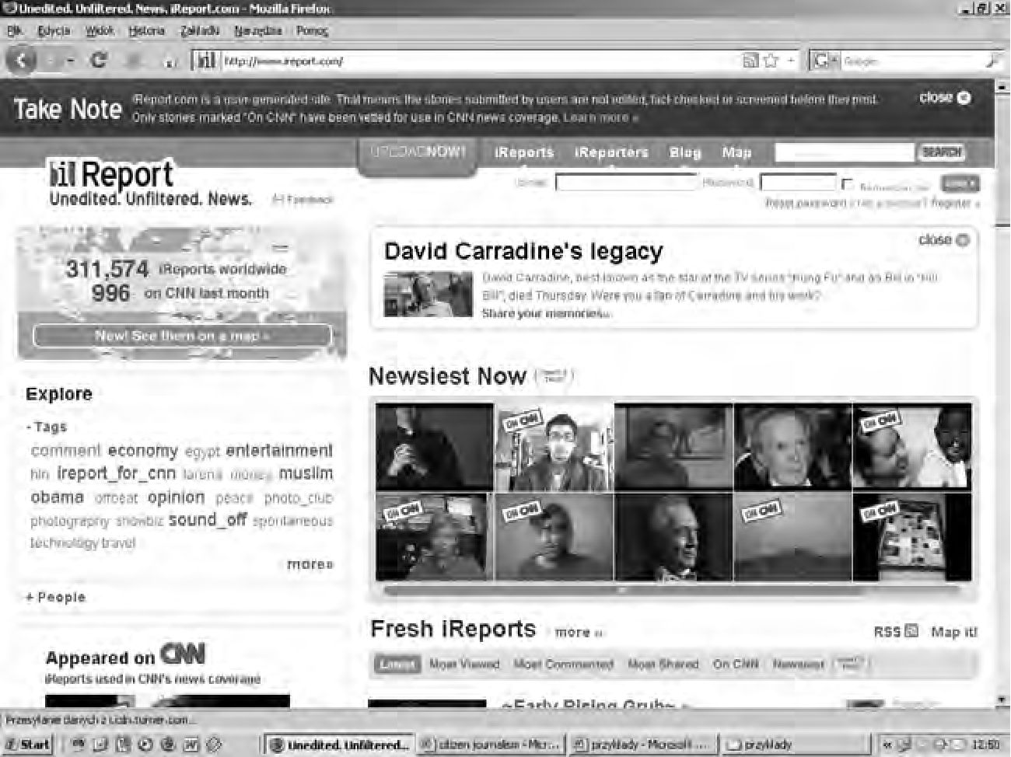
Rhetorical strategies on www.iReport.com
189
conditions for the publication of defamatory and inappropriate messages, which
frequently appear on the site. Additionally, it needs to be acknowledged that the
site is rich in useless and meaningless content. This contributes to the growing
trivialization of the online content. The discovery of a valuable contribution often
constitutes a real challenge.

References
Bowman S., Willis C. 2003. We media. How audiences are shaping the future of news and
information. Retrieved from: www.hypergene.net/wemedia on 18th March 2009.
Brown G., Yule G. 1983. Discourse analysis. Cambridge.
Cormode G., Krishnamurthy B. 2008. Key differences between Web 1.0 and Web 2.0. - First
Monday 13.2. Retrieved from: http://firstmonday.org/htbin/cgiwrap/bin/ojs/index.php/
fm/article/view/2125/1972 on 21st May 2009.
Ferenc T., Olechnicki K. (eds.) 2008. Obrazy w sieci. Socjologia i antropologia ikonosfery
Internetu. Toruń.
Gumperz J. 1982. Discourse strategies. Cambridge.
Harrison T., Barthel B. 2009. Wielding new media in Web 2.0: exploring the history of
engagement with the collaborative construction of media products. - New Media and
Society, 12.1-2: 155-178.
Jones S. 1998. Doing internet research. Chicago.
Korolko M. 1990. Sztuka retoryki. Przewodnik encyklopedyczny. Warszawa.
Ong W. 2002. Orality and literacy. London.
Ziomek J. 1990. Retoryka opisowa. Wrocław.
Fig. 1. iReport home page (www.iReport.com, 20th September 2009)
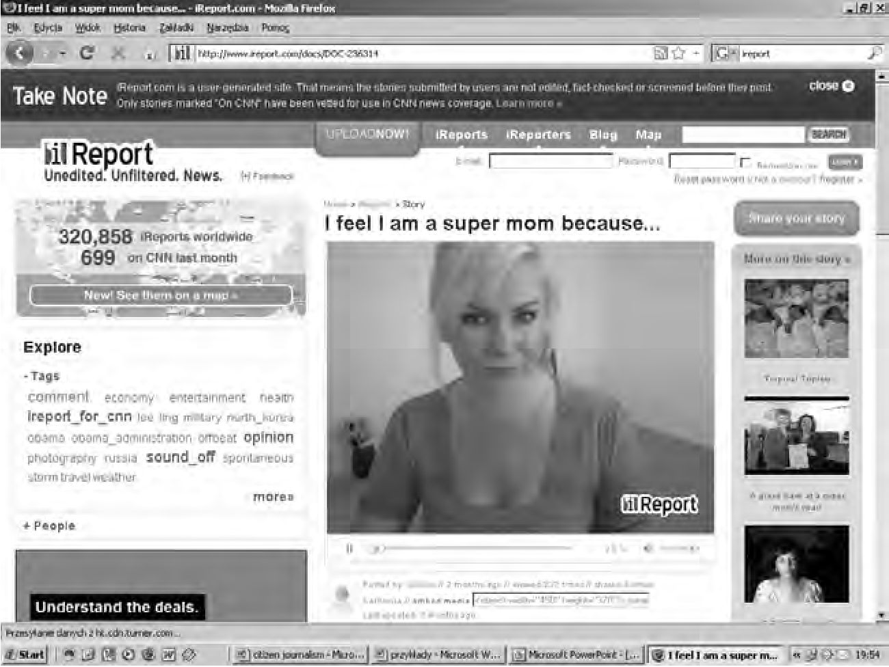
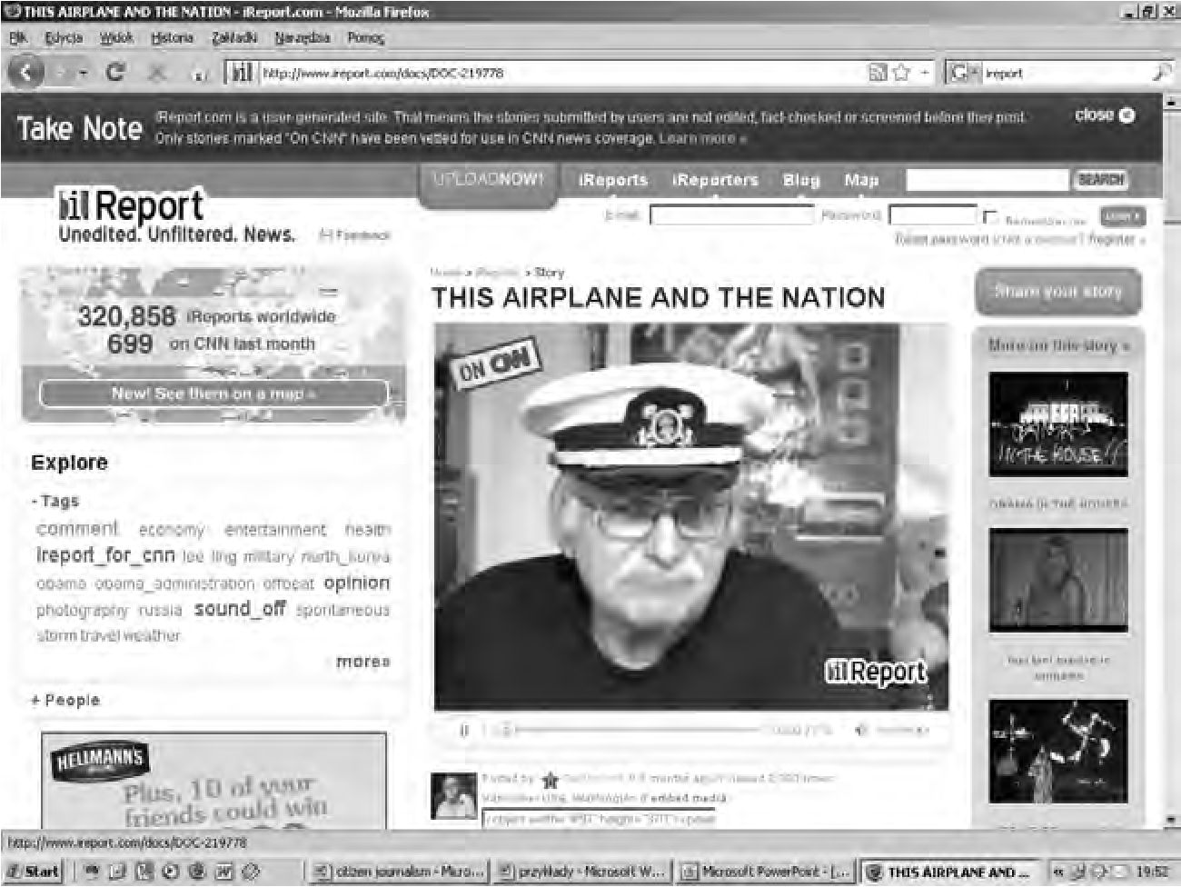
190
ANNA TERESZKIEWICZ
Fig. 2. OCGirl’s commentary (www.iReport.com/docs/DOC-236314, 22nd September 2009)
Fig. 3. Dimmit’s commentary (www.iReport.com/docs/DOC-219776, 15th September 2009)
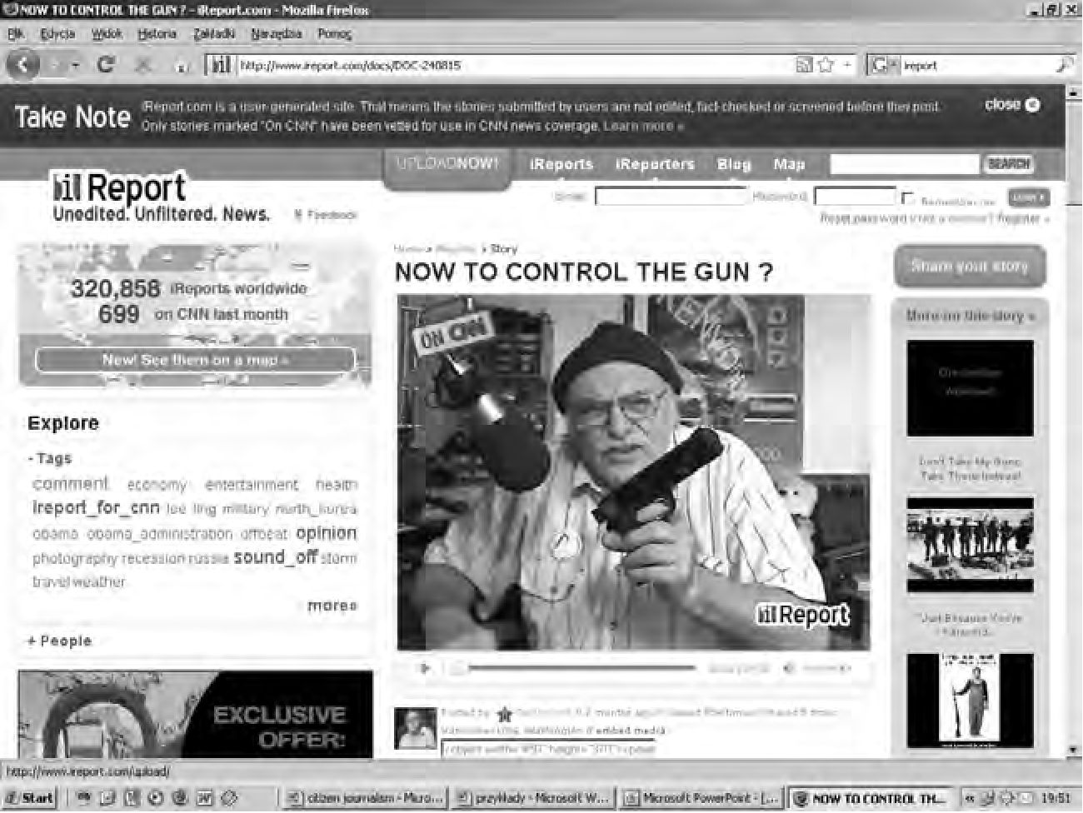
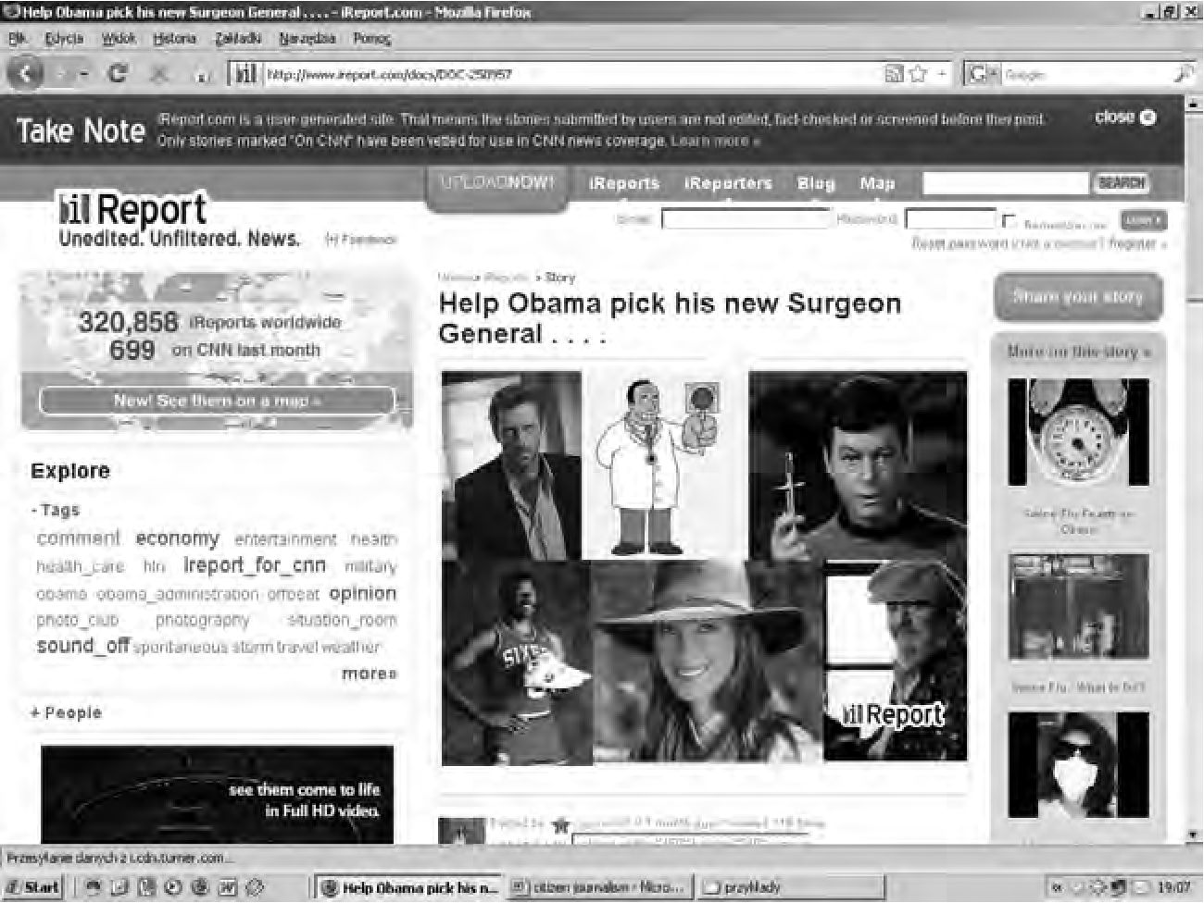
Rhetorical strategies on www.iReport.com
191
Fig. 4. Dimmit’s commentary (www.iReport.com/docs/DOC-240815, 15th September 2009)
Fig. 5. www.iReport.com/docs/DOC-250957, 27th September 2009
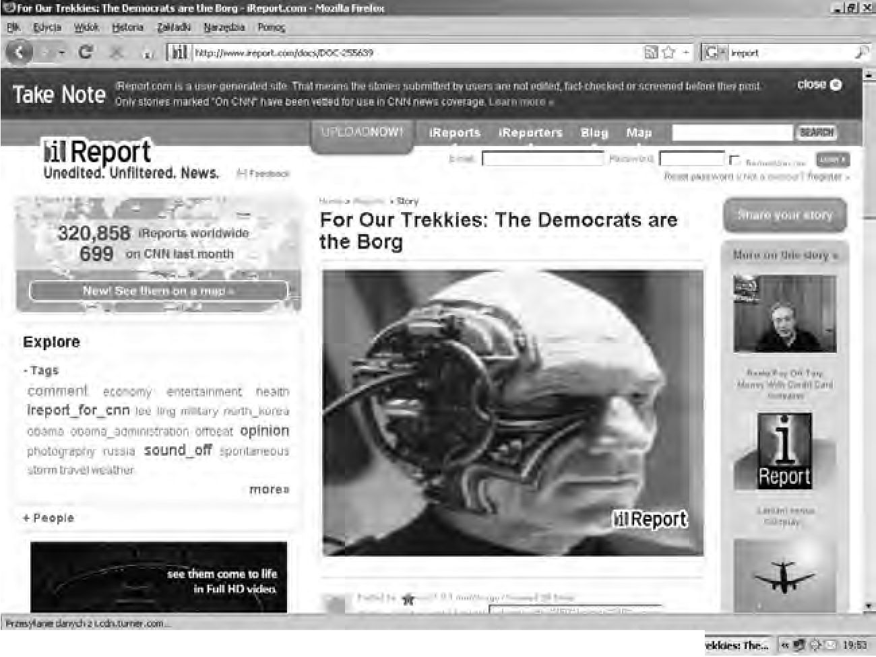
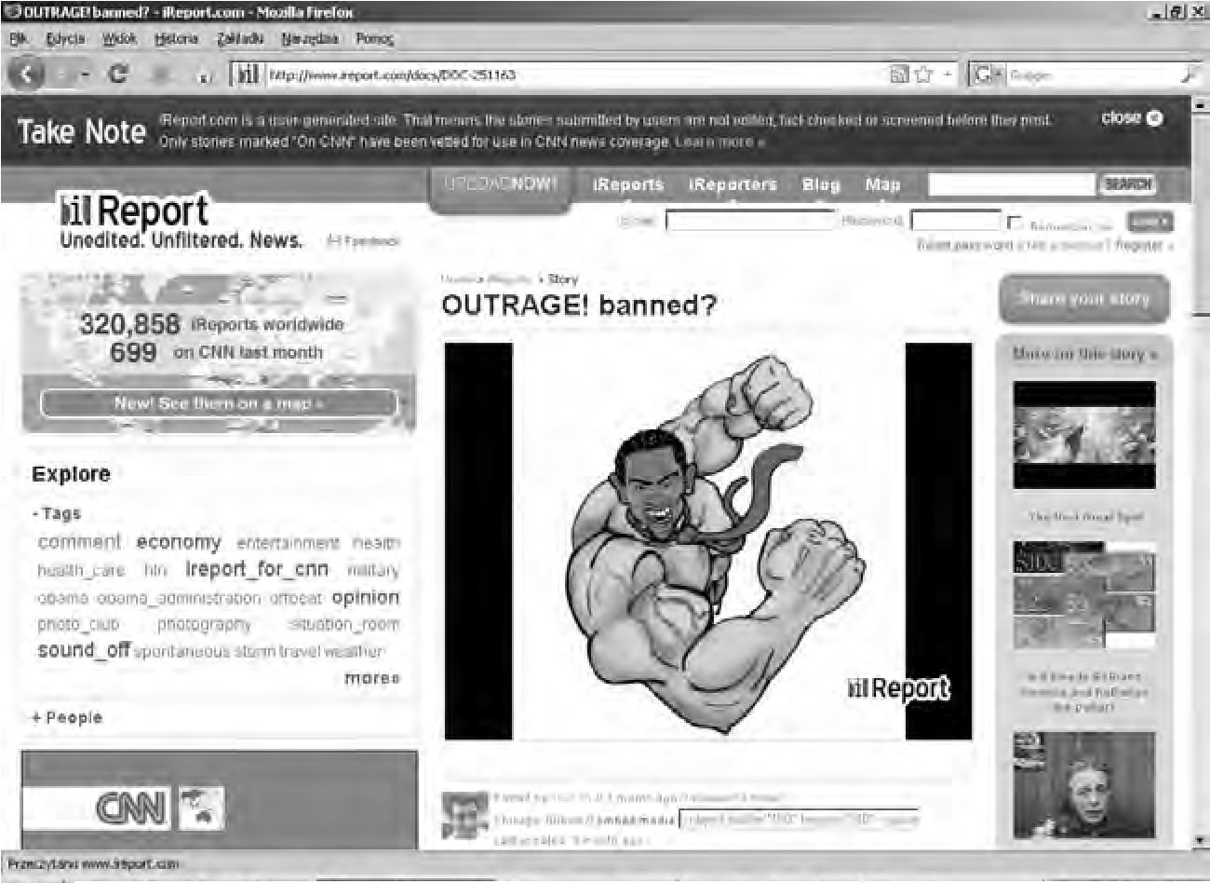
192
ANNA TERESZKIEWICZ
4 S»«rt| * • 2!3 & yeMm* ■ HuomH *■ I ||g for CH»If
Fig. 6. www.iReport.com/docs/DOC-255639, 28th September 2009
g W«r<l * J 3 (i) | ,3 O Itt nmHAfJlhjnwriO _ ^jitoannwn«!»».»»! .. | gj • Wuaal» ■ I <^Jor*lmS | «. H I«
Fig. 7. www.iReport.com/docs/DOC-251163, 28th September 2009
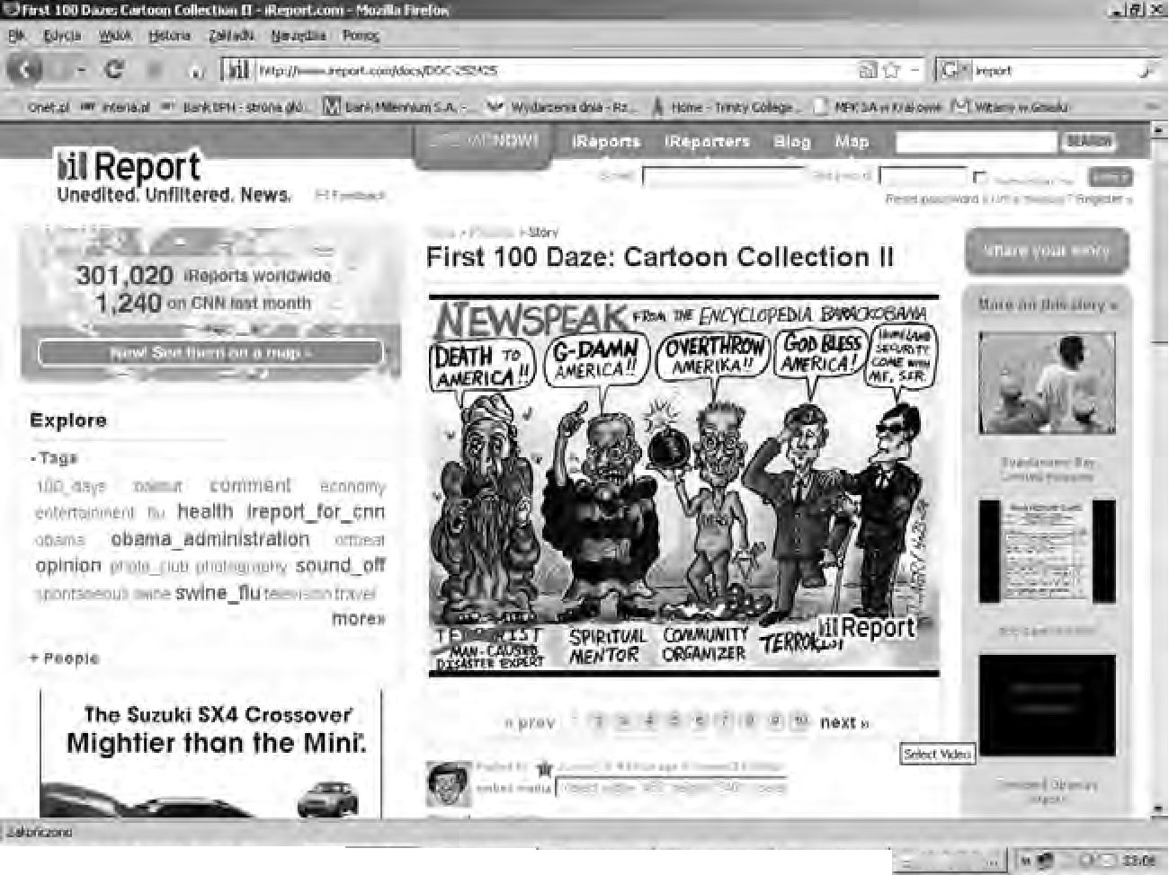
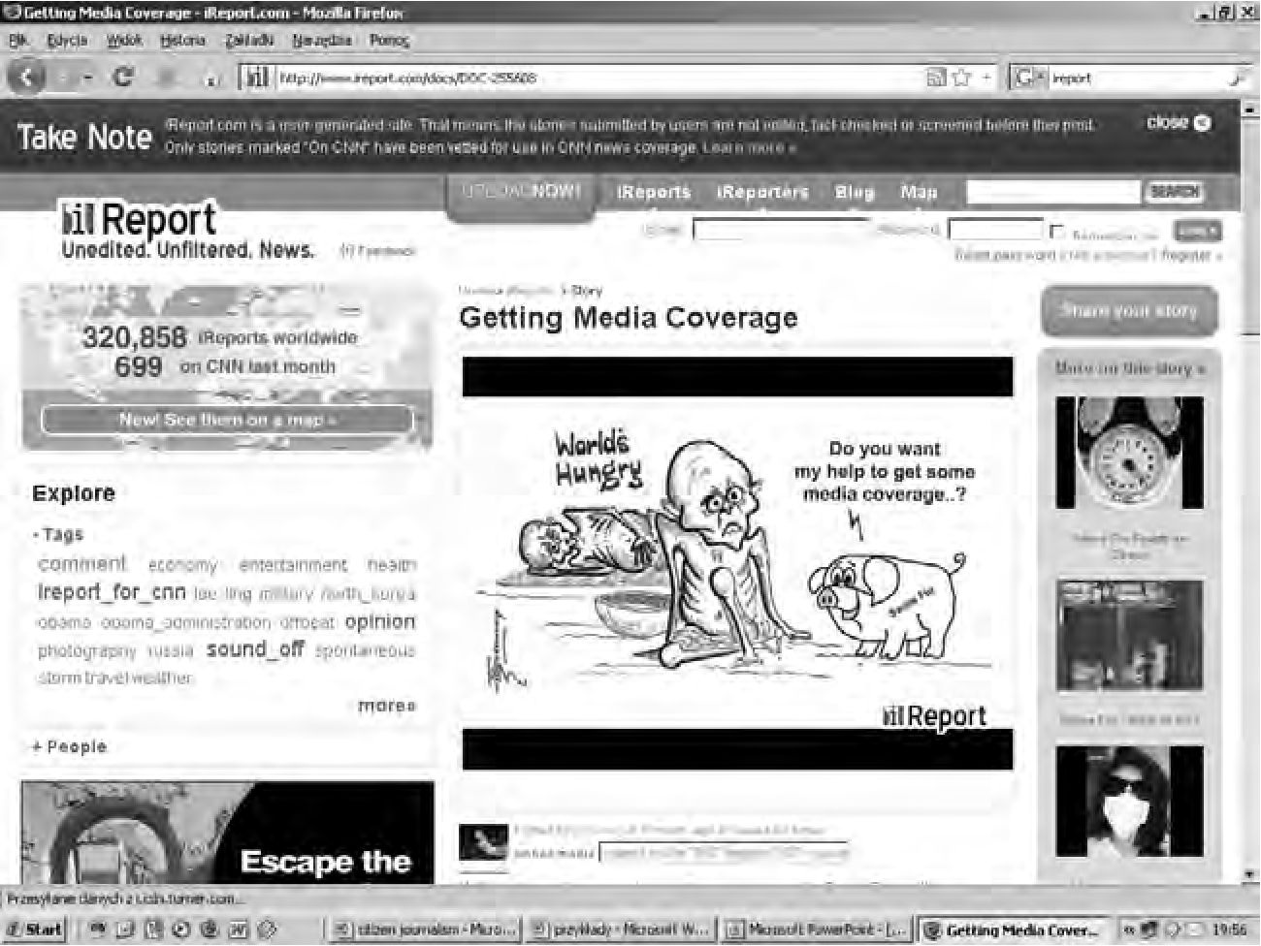
Rhetorical strategies on www.iReport.com
193
I It art | * J 8 y I a O l^nwtlODO- •& Mwmii.. I P<| <m<n»u—« ,| ¿jumiwjh- I fJvnHmh . I t'-}Ut»«rf*»4i
Fig.8. www.iReport.com/docs/DOC-252425, 29th September 2009
Fig. 9. www.iReport.com/docs/DOC-255608, 27th September 2009

