frontiers
in Psychology
OPEN ACCESS
Edited by:
Gabriele Giorgi,
European University of Rome, Italy
Reviewed by:
Robert Jason Emmerling,
ESADE Business School, Spain
Catherine S. Daus,
Southern Illinois University
Edwardsville, United States
Correspondence:
Krystyna Golonka
krystyna.golonka@uj.edu.pl
Specialty section:
This article was submitted to
Organizational Psychology,
a section of the journal
Frontiers in Psychology
Received: 01 August 2017
Accepted: 27 November2017
Published: 13 December 2017
Citation:
Golonka K, Mojsa-Kaja J, Popiel K,
Marek T and Gawlowska M (2017)
Neurophysiological Markers
of Emotion Processing in Burnout
Syndrome. Front. Psychol. 8:2155.
doi: 10.3389/fpsyg.2017.02155
ORIGINAL RESEARCH
published: 13 December 2017
doi: 10.3389/fpsyg.2017.02155

0
Check for
updates

Neurophysiological Markers of
Emotion Processing in Burnout
Syndrome
Krystyna Golonka1*, Justyna Mojsa-Kaja1, Katarzyna Popiel1, TadeuszMarek23 and
Magda Gawłowska1
11nstitute of Applied Psychology Jagiellonian University, Krakow, Poland,2 Department of Cognitive Neuroscience and
Neuroergonomics, Institute of Applied Psychology Jagiellonian University Krakow, Poland,3 Neurobiology Department, The
Malopolska Centre of Biotechnology, Jagiellonian University, Krakow, Poland
The substantial body of research employing subjective measures indicates that
burnout syndrome is associated with cognitive and emotional dysfunctions. The
growing amount of neurophysiological and neuroimaging research helps in broadening
existing knowledge of the neural mechanisms underlying core burnout components
(emotional exhaustion and depersonalization/cynicism) that are inextricably associated
with emotional processing. In the presented EEG study, a group of 93 participants (55
women; mean age = 35.8) were selected for the burnout group or the demographically
matched control group on the basis of the results of the Maslach Burnout Inventory -
General Survey (MBI-GS) and the Areas of Worklife Survey (AWS). Subjects then
participated in an EEG experiment using two experimental procedures: a facial
recognition task and viewing of passive pictures. The study focuses on analyzing
event-related potentials (ERPs): N170, VPP, EPN, and LPP, as indicators of emotional
information processing. Our results show that burnout subjects, as compared to the
control group, demonstrate significantly weaker response to affect-evoking stimuli,
indexed by a decline in VPP amplitude to emotional faces and decreased EPN amplitude
in processing emotional scenes. The analysis of N170 and LPP showed no significant
between-group difference. The correlation analyses revealed that VPP and EPN, which
are ERP components related to emotional processing, are associated with two core
burnout symptoms: emotional exhaustion and cynicism. To our knowledge, we are
one of the first research groups to use ERPs to demonstrate such a relationship
between neurophysiological activity and burnout syndrome in the context of emotional
processing. Thus, in conclusion we emphasized that the decreased amplitude of VPP
and EPN components in the burnout group may be a neurophysiological manifestation
of emotional blunting and may be considered as neurophysiological markers of
emotional exhaustion and cynicism. Additionally, we did not observe a decrease in
LPP, which may be considered as a marker that significantly differentiates burnout from
depression.
Keywords: burnout, neurophysiological markers, emotion processing, ERPs, N170, VPP, EPN, LPP
Frontiers in Psychology | www.frontiersin.org
1
December 2017 | Volume 8 | Article 2155
Golonka et al.
Neurophysiological Markers of Burnout

INTRODUCTION
Studies on burnout syndrome depict the typical characteristics
and consequences of long-term work-related stress. Burnout
has an impact on the mental and physical health of employees
(for a review, see Schaufeli and Enzmann, 1998); as a
consequence, it has the serious socio-economic impact of
decreased productivity levels, increased rates of resignation and
premature retirement (Schaufeli et al., 2009). Therefore, there is
a need for empirical research that provides answers related to
the neuronal mechanisms of burnout and further implication of
this knowledge in interventive programs. Burnout has three main
components: a state of emotional exhaustion, depersonalization
or cynicism and lower personal accomplishment (Maslach and
Leiter, 1997, 2008). The existing studies on burnout analyze the
negative effects of long-term work-related stress on individuals’
functioning in terms of the complex emotional and cognitive
consequences (e.g., Maslach and Leiter, 1997, 2008; Schaufeli
and Greenglass, 2001; Sandstrom et al., 2005; Van der Linden
et al., 2005; Schmidt et al., 2007; Oosterholt et al., 2012,
2014; Deligkaris et al., 2014; Golkar et al., 2014). Together,
the cognitive and emotional dysfunctions caused by long-
term stress can lead to impaired ability to regulate emotional
tension and cope with stressors. Studying the relationship
between emotional exhaustion and emotional regulation in
burnout subjects, Golkar et al. (2014) observed that burnout
individuals have impaired ability to downregulate negative
emotions, which can lead to an increased susceptibility to
depression.
Besides the commonly used subjective measures, in burnout
research there is a limited number of studies dedicated to
behavioral (e.g., Sandstrom et al., 2005; Oosterholt et al., 2012;
Bianchi and Laurent, 2015), neurophysiological (Luijtelaar et al.,
2010; Golkar et al., 2014; Sokka et al., 2014, 2017; Golonka et al.,
2017) and neuroimaging outcomes (Durning et al., 2013; Golkar
et al., 2014; Tei et al., 2014).
Neurophysiological and neuroimaging studies provide
evidence for impairments in cognitive and emotional
processing in burnout that helps broaden our knowledge
of the mechanisms underlying emotional exhaustion and
depersonalization/cynicism, which are the core components of
burnout. Studies that employ functional magnetic resonance
imaging (fMRI) have indicated that burnout is associated
with changes in functional brain anatomy. For example,
Durning et al. (2013) observed that higher burnout scores
are associated with reduced functional activation in the right
dorsolateral prefrontal cortex (rDLPFC), the medial frontal
gyrus (MFG) and increased activation of the right posterior
cingulate cortex (rPCC) during performance of cognitive tasks.
Tei et al. (2014) revealed that burnout severity is explained by
decreased empathy-related brain activity, proving that emotional
functioning is altered in burnout groups. Golkar et al. (2014)
observed that functional connectivity between the amygdala and
the anterior cingulate cortex (ACC) is weaker in burned-out
subjects; this is in contrast to stronger connectivity from the
amygdala to the cerebellum and the insular cortex, which may
have further consequences for regulating mechanisms and
reactive and proactive control in burnout subjects (Golonka
et al., 2017).
In addition to fMRI, other neuroimaging techniques, such
as analyzing event-related potentials (ERPs) in EEG recordings,
enable investigation of the time course of this information
processing in the brain. Existing studies on ERP components
in burnout are still very limited (i.e., Luijtelaar et al., 2010;
Sokka et al., 2014, 2017; Golonka et al., 2017), but their findings
are promising and contribute to the description of the neural
mechanisms underlying burnout syndrome.

Emotional Consequence of Burnout
Burnout is inextricably linked to significant emotional
consequences. Core burnout components are emotional
exhaustion and specific negative emotions and attitudes
toward work (labeled as cynicism) and other people (labeled as
depersonalization). These aspects are well recognized in research
that employed subjective measures (i.e., Maslach et al., 1996;
Maslach and Leiter, 1997, 2004, 2008; Mojsa-Kaja et al., 2015).
Burnout syndrome is associated with emotional exhaustion
and the tendency to experience negative emotions. Additionally,
emotional disengagement and distancing oneself from
work and co-workers/clients/patients, etc. may be seen
as an adaptive defense mechanism that helps in coping
with difficult work-related circumstances. Hypothetically,
this defense mechanism may reduce the anxiety associated
with, for example, an overwhelming workload, a lack of
control, insufficient reward, an unsupportive community,
unfairness, conflicting values, etc.; however, it usually leads
to further problems due to subsequent social and job
consequences (e.g., deterioration in interpersonal relations
and lower professional efficacy). Even if the attitude typical
of depersonalization/cynicism brings temporal profits, it lacks
long-lasting benefits.
Taking into account the state of emotional exhaustion,
depletion and decline in individual functioning in burnout, we
hypothesized that emotion processing in burnout subjects would
differ, compared to a control group.

Emotion Processing and Its
Neurophysiological Indicators
Regarding the strong emotional component in burnout
syndrome, the processing of emotion-related information
remains particularly interesting. Due to the high adaptive
importance of emotional stimuli, they seem to interfere with
other kinds of stimuli (Ramos-Loyo et al., 2013). For the
efficient functioning (defined as fast and competent reactions)
which is crucial in a social and work environment, it is
particularly important to direct attentional resources to the
most important stimuli. A very complex and demanding
work environment usually continuously exploits cognitive and
emotional resources. Regarding long-term work-related stress,
the effect of overstimulation and work overload may significantly
impair the functioning of the individual.
In the presented study, we focus on analyzing the processing
of affect-related information based on the well-documented ERP
Frontiers in Psychology | www.frontiersin.org
2
December 2017 | Volume 8 | Article 2155
Golonka et al.
Neurophysiological Markers of Burnout
indicators of emotional information processing (e.g., Eimer and
Holmes, 2002; Batty and Taylor, 2003; Schupp et al., 2003; Moser
et al., 2006; Olofsson et al., 2008), compared between two groups:
burnout subjects and healthy controls.
Research on emotion processing typically implements two
types of stimuli: images of emotional facial expressions and
natural scenes (Wangelin et al., 2012). In our study, we
implement both these types of stimuli to test whether burnout
symptoms are related to altered or impaired response to affect-
related events. We assumed that the state of emotional depletion
might be related to blunted neurophysiological response to
a specific type of information—stimuli that have emotional
valence. Thus, our main hypothesis states:
H: Burnout subjects demonstrate a weaker response to affect-
evoking stimuli.

ERPs Related to a Facial Recognition
Task: N170 and VPP
The mechanism of face perception has been broadly studied in
brain research. Facial expression is a fundamental stimulus that
conveys socially and emotionally relevant information that is
critical for adaptive functioning in social environments. Given
this crucial significance of faces, it is not surprising that the study
of human face processing is one of the most intensively explored
areas in visual cognition and emotion research.
The ERP components associated with face perception have
been described in many experiments. A substantial body of
research shows that pictures of faces evoke a larger ERP of
negative polarity between 130 and 200 ms than other objects
(Rossion and Jacques, 2008; Eimer, 2011). This ERP component
peaks at occipitotemporal electrode sites about 170 ms after
stimulus onset and has been called the N170 (Bentin et al., 1996).
According to Schweinberger (1996), N170 is reduced if the face
is perceptually degraded. N170 is temporally congruent with a
positive-going ERP component and has maximum amplitude
over central scalp electrodes; this is called vertex positive potential
(VPP) (Botzel and Grusser, 1989). Joyce and Rossion (2005)
stated that N170 and VPP have the same brain generators
and observed that their amplitudes fluctuate conversely. These
two ERP components show similar properties, namely greater
sensitivity to faces than to other types of stimuli (Joyce and
Rossion, 2005; Eimer, 2011).
Abnormalities in face processing measured by VPP and/or
N170 have been studied in a wide range of psychiatric and
neurological disorders, including bipolar disorder, depression,
social phobia, schizophrenia, autism spectrum disorders and
Parkinson’s disease (for a review, see Feuerriegel et al., 2015).
Despite some inconsistencies in findings, the growing body
of research shows that these ERPs might play the role of
neurophysiological markers that reflect social impairments in
these disorders. For example, Foti et al. (2010) showed that in
major depressive disorder, electrocortical response to emotional
faces indexed by VPP was absent.
No studies have yet investigated VPP/N170 modulation by
burnout. Therefore, our hypotheses are based on the close
relation between burnout and depressive symptoms. As the study
sample is not clinical, we expect to observe a significant decline
in VPP amplitude:
H1: Burnout subjects present declined VPP amplitude to
emotional faces.
As it is assumed that N170 and VPP are not only evoked by
the same brain source, but also have converse fluctuation and
demonstrate identical functional properties (Joyce and Rossion,
2005), no additional hypotheses on N170 were formulated.

ERPs Related to Passive Picture
Viewing: EPN and LPP
Many studies have examined ERP responses to complex images
from the International Affective Picture System (IAPS). IAPS
consists of stimuli standardized for the basic dimensions of
emotion (arousal and valence) which categorize stimuli as
pleasant, neutral, or unpleasant; these are used to study both
emotion and emotion regulation in adults (Lang et al., 1999;
Olofsson et al., 2008).
When analyzing processing of affective pictures, there are
two main ERP components which are sensitive to motivational
salience of stimuli: early posterior negativity (EPN) and late
positive potential (LPP). Moreover, their amplitude variance has
been linked with the changes in allocating attentional resources
(Schupp et al., 2000, 2006, 2012; Hajcak and Dennis, 2009). It
has been consistently observed that EPN and LPP amplitudes
increase when stimuli are perceived as more significant; this was
observed in processing pleasant and unpleasant compared to
neutral IAPS stimuli (Schupp et al., 2006; Hajcak and Dennis,
2009).
The EPN component is observed between 150 and 350 ms;
the LPP component is observed between 300 and 700 ms over
centroparietal regions (Schupp et al., 2000, 2006). Sabatinelli
et al. (2013) analyzed the associations between early and late
ERPs using functional MRI signals of cortical and subcortical
brain areas. They found that emotional modulation of the
LPP correlates with subcortical and visual cortical activation;
emotional modulation of the EPN only (and modestly) correlates
with subcortical and corticolimbic brain areas. These findings
suggest that EPN may refer to motivational relevance, while
LPP refers to emotional discrimination. Schupp et al. (2004)
point out that, at the functional level, enhanced EPN reflects
enhanced perceptual processing and may be mediated by the
amygdala activity generated by emotional pictures. Regarding
burnout subjects’ disengagement, emotional blunting and being
“uninvolved,” it may be hypothesized that:
H2: Burnout subjects reveal decreased EPN amplitude when
processing emotional scenes.
This hypothesis is derived from our general assumption
about weaker emotional response in burnout subjects. However,
when analyzing the relation between burnout and depression
and anxiety (Schaufeli and Greenglass, 2001; Bianchi and
Laurent, 2015; van Dam, 2016), a contradictory hypothesis
could be formulated. In neuroimaging studies on depression,
the decreased regulatory effect of the cortical areas over the
Frontiers in Psychology | www.frontiersin.org
3
December 2017 | Volume 8 | Article 2155
Golonka et al.
Neurophysiological Markers of Burnout
limbic regions is emphasized. Positron emission tomography
(PET) and fMRI studies have shown decreased activation of
cortical regions (Ketter et al., 1996; Drevets et al., 1997; Mayberg
et al., 1999) and increased activation of limbic structures
(Mayberg et al., 1999; Drevets, 2000; Sheline et al., 2001).
Anand et al. (2005) found that depressed patients had greater
activation of ACC and limbic regions (amygdala, paleostriatum,
and medial thalamus). Additionally, they observed decreased
cortico-limbic correlations in depressed subjects, compared to
healthy individuals. This may lead to the conclusion that greater
amygdala activity elicits greater neurophysiological response and
greater EPN. Similarly, anxiety-prone subjects reveal increased
activation in the amygdala and insula (Stein et al., 2007),
which may also be reflected in higher EPN amplitude. On
the other hand, depression may be also related to blunted
amygdala response. Thomas et al. (2001) observed that anxiety
disorder was associated with augmented amygdala response to
fearful faces, compared to the blunted amygdala response in
depression.
Moreover, clinical studies have revealed that highly anxious
individuals demonstrate greater LPP amplitude during the
presentation of negative pictures, while individuals with
clinical depression showed a decrease of LPP amplitude
(Hajcak, 2012). Regarding burnout’s strong associations
with depressive symptoms (emotional exhaustion and
cynicism/depersonalization) and taking into account the
characteristics of LPP (i.e., sensitivity to negative valence of
pictures) we hypothesized that:
H3: Burnout subjects reveal decreased LPP amplitude when
processing emotionally negative scenes.

MATERIALS AND METHODS

Participants
The study was conducted on an initial group of 100 participants
aged 25-55 years. The inclusion criteria for the study
were employee status (currently employed, active day-shift
workers with higher education), right-handedness, correct
or corrected-to-normal vision, not pregnant, addiction free
and no history of neurological or psychiatric diseases. The
initial group of 100 participants was selected based on
the results of the Maslach Burnout Inventory - General
Survey (MBI-GS; Maslach et al., 1996) and the Areas of
Worklife Survey (AWS; Leiter and Maslach, 2004). The
controls were matched with subjects with high scores
on burnout, taking into account the latter’s demographic
characteristics.
The non-clinical burnout group had high scores in the
exhaustion and cynicism subscales and low scores in the self-
efficacy subscale (see Table 1) and in at least three of the six AWS
subscales: workload, control, reward, community, fairness, and
values. Low scores in AWS reflected a larger mismatch between
individuals’ values, needs and work environment. This scale was
introduced as a controlling tool to ensure that deterioration in
subjective well-being was linked to work-related stress. Inversely,
TABLE 1 | The means (M) and standard deviations (SD) for the burnout and
control groups on burnout symptoms (exhaustion, cynicism, efficacy), work-life
areas, age and independent-sample t-test between burnout and controls.
 | Burnout (N = 47)  M (SD) | Control (N = 46)  M (SD) | t-value (df = 91)
AGE
 | 37.28 (7.75) | 34.78 (8.57) | 1.47
MBI-GS
Exhaustion | 4.17(0.97) | 1.93(0.72) | 12.62 łłł
Cynicism | 4.04 (0.83) | 1.47(0.57) | 17.49 łłł
Efficacy | 3.32 (1.08) | 4.62 (0.62) | -7.11 ***
AWS
Workload | 2.28 (0.80) | 3.21 (0.82) | -5.49 ***
Control | 2.57 (0.98) | 3.45 (0.67) | -5.00 ***
Rewards | 2.48 (0.74) | 3.43(0.61) | -6.77 ***
Community | 2.72 (0.95) | 3.63 (0.66) | -5.40 ***
Fairness | 2.00 (0.66) | 3.09 (0.55) | -8.69 ***
Values | 2.76 (0.66) | 3.64 (0.55) | -6.99 ***
Asterisks denote significant difference (***p < 0.001).
the second group had lower scores in the exhaustion and
cynicism subscales, higher scores in the self-efficacy subscale, and
medium to high scores in AWS.
Eventually, due to the poor quality of the EEG data (i.e.,
extensive muscle and ocular artifacts), 93 subjects were included
in the study sample. The results of the burnout group (N = 47;
28 women) and the demographically matched control group
(N = 46; 27 women) were analyzed. The descriptive statistics
of the burnout and control groups are presented in Table 1,
including burnout symptoms, work-life areas and independent
t-tests with p-values. The burnout group varied significantly from
the control group, scoring higher on exhaustion and cynicism
and significantly lower on efficacy and all AWS dimensions.
This study was carried out in accordance with the
recommendations of the APA Ethics Code. All subjects gave
written informed consent in accordance with the Declaration
of Helsinki. The study protocol was approved by the Bioethics
Commission at Jagiellonian University. The subjects were paid
for participation in the study.

Experimental Procedure
Participants were presented with two experimental tasks,
prepared and generated using E-Prime 2.0 ©(Psychology
Software Tools): a facial recognition task and viewing of passive
pictures. Stimuli were presented on a 17" LCD monitor placed at
a viewing distance of approximately 60 cm.
In the first task, based on the procedure by Schacht and
Sommer (2009), each trial consisted of an oval-shaped black
and white face presented on a black background. All the faces
were balanced according to their color and tone properties.
Stimuli were prepared based on faces from the NimStim dataset
(Tottenham et al., 2009). The presented faces fall into one of
four categories depending on their visual features: faces with
either neutral, negative, or positive emotional expression and
faces with a morphological distortion (e.g., a missing eye or nose)
Frontiers in Psychology | www.frontiersin.org
4
December 2017 | Volume 8 | Article 2155
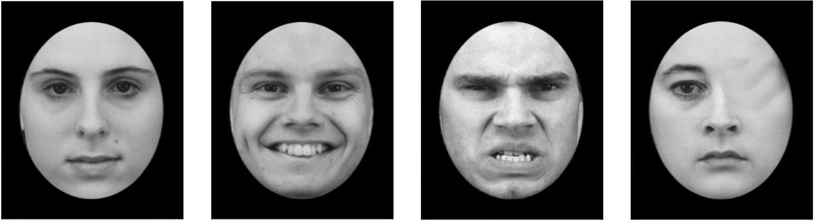
Golonka et al.
Neurophysiological Markers of Burnout
NEUTRAL POSITIVE NEGATIVE DISTORTED
FIGURE 1 | Sample stimuli used in the face recognition task.
(Figure 1). To ensure participants’ engagement in the task, they
were presented with a masking instruction to assess whether the
face was morphologically correct (“press 1”) or distorted (“press
2”). The task consisted of four blocks of 64 stimuli each. All
stimuli were presented until the response was submitted; then,
a blank screen with a fixation cross was displayed for 1,000-
2,000 ms, mean 1,500 ms (Schacht and Sommer, 2009).
For the second task, 120 pictures were selected from the
International Affective Picture System (IAPS; Lang et al., 1999):
40 depicted pleasant scenes (e.g., kittens and picturesque scenes),
40 depicted neutral scenes (e.g., cup and chair), and 40 depicted
unpleasant scenes (e.g., mutilated bodies and dead animals)1.
Prior to each picture, a white fixation cross was presented on a
black screen for 1,000 ms. Each picture was then displayed in
color for 2,000 ms.
After completion of experimental tasks, participants were
asked to rate the pictures they had been presented with (both
IAPS and faces) on a scale from 1 to 9, where 1 corresponded
to very negative, 5 to neutral, and 9 to very positive.

Data Recording and Acquisition
EEG data was recorded and processed in accordance with
guidelines for EEG studies (Keil et al., 2014). Continuous
dense-array EEG data (HydroCel Geodesic Sensor Net, EGI
System 300; Electrical Geodesic Inc., Eugene, OR, United States)
was collected from a 256 channel EEG at a sampling
rate of 250 Hz (band-pass filtered at 0.01-100 Hz with a
vertex electrode as a reference) and recorded with NetStation
Software (Version 4.5.1, Electrical Geodesic Inc., Eugene, OR,
United States). The impedance for all electrodes was kept
below 50 kQ. The offline data analysis was conducted with
the open source EEGLAB toolbox2 (Delorme and Makeig,
2004). Data was digitally filtered to remove frequencies below
0.5 Hz and above 35 Hz. Average reference was recomputed
and bad channels were automatically removed by kurtosis
measures with a threshold value of 5 standard deviations.
LThe IAPS pictures used were pleasant (1050, 1200, 1300, 2730, 2800, 3010, 3160,
3170, 3230, 3261, 3300, 3350, 6200, 6210, 6230, 6244, 6250, 6312, 6313, 6370, 6550,
6560, 6571, 6821, 9040, 9042, 9050, 9253, 9300, 9400, 9405, 9410, 9433, 9520, 9600,
9611, 9810, 9910, 9920, 9921), neutral (2190, 2320, 2570, 2840, 2880, 5390, 5532,
5534, 5731, 5740, 5800, 5900, 7000, 7002, 7004, 7006, 7009, 7010, 7025, 7034, 7035,
7040, 7041, 7060, 7080, 7090, 7100, 7130, 7140, 7150, 7175, 7190, 7217, 7224, 7233,
7235, 7491, 7550, 7595, 7950), and unpleasant (1463,1601,1710,1811, 2000, 2070,
2080, 2091, 2092, 2165, 2340, 2345,4002, 4290,4532, 4572,4608, 4658, 4659,4660,
4664,4810, 5470, 5621, 5626, 5628, 7325, 8021, 8032, 8080, 8200, 8210, 8280, 8320,
8370, 8400, 8461, 8465, 8490, 8540) (Foti et al., 2009).
2http://sccn.ucsd.edu/eeglab
TABLE 2 | The means (M) and standard deviations (SD) for the ratings of IAPS
pictures and faces for the burnout and control group (ratings refer to a scale
ranging from 1-very negative to 9-very positive).
 | Burnout (N = 47)  M (SD) | Control (N = 46)  M (SD)
IAPS
Neutral | 5.19 (0.59) | 5.23 (0.54)
Negative | 2.21 (0.71) | 2.05 (0.80)
Positive | 7.29 (1.03) | 7.54 (0.84)
FACES
Neutral | 4.94 (0.35) | 6.75 (0.94)
Negative | 3.74 (0.93) | 3.67 (0.96)
Positive | 6.29 (1.08) | 5.01 (0.65)
Next, continuous data was visually inspected to remove
remaining artifactual data manually, i.e., channels or time epochs
containing high-amplitudes, high-frequency muscle noise, and
other irregularities.
Independent component analysis was used to remove artifacts
from data. Due to the large number of channels, decomposition
of EEG data with the Infomax algorithm was preceded with
Principle Component Analysis. Fifty independent components
were extracted and visually inspected for each subject. Based on
the spatiotemporal pattern (Bell and Sejnowski, 1995; Jung et al.,
2000), components recognized as blinks, heart rate, saccades,
muscle artifacts, or bad channels were removed. Missing channels
were interpolated and ICA weights recomputed.
For both tasks, the EEG was segmented for each trial
beginning 200 ms before each stimulus onset and continuing for
1,200 ms (i.e., for 1,000 ms following the response); a 200 ms
window (from -200 to 0 ms prior to stimulus onset) served as
the baseline.
For the face recognition task, the VPP component was scored
as the maximum amplitude in the 150-200 ms time-window over
Cz electrodes site; N170 was scored as the minimum amplitude in
the 150-200 ms time-window over O1, O2, P7, and P8 electrodes
sites. For the passive picture viewing, EPN was scored as the
minimum amplitude in the 200-300 ms time-window and LPP
was scored as the mean amplitude in the 400-1,000 ms time-
window (both were measured at CPz electrodes site).

RESULTS
Stimuli Ratings
The ratings of IAPS pictures and faces (Table 2) were submitted
to independent repeated measures ANOVAs with group (two
levels: burnout and control) and stimulus type (three levels:
neutral, negative, positive) factors. There was no significant
between-group difference for IAPS pictures [F(1,91) = 0.266,
p = 0.607] or faces [F(1,91) = 2.406, p = 0.124]. No significant
difference between the burnout group and the control group was
observed.
There were significant differences in the ratings of the
IAPS pictures [F(2,182) = 957.97, p < 0.0001] and faces
Frontiers in Psychology | www.frontiersin.org
5
December 2017 | Volume 8 | Article 2155
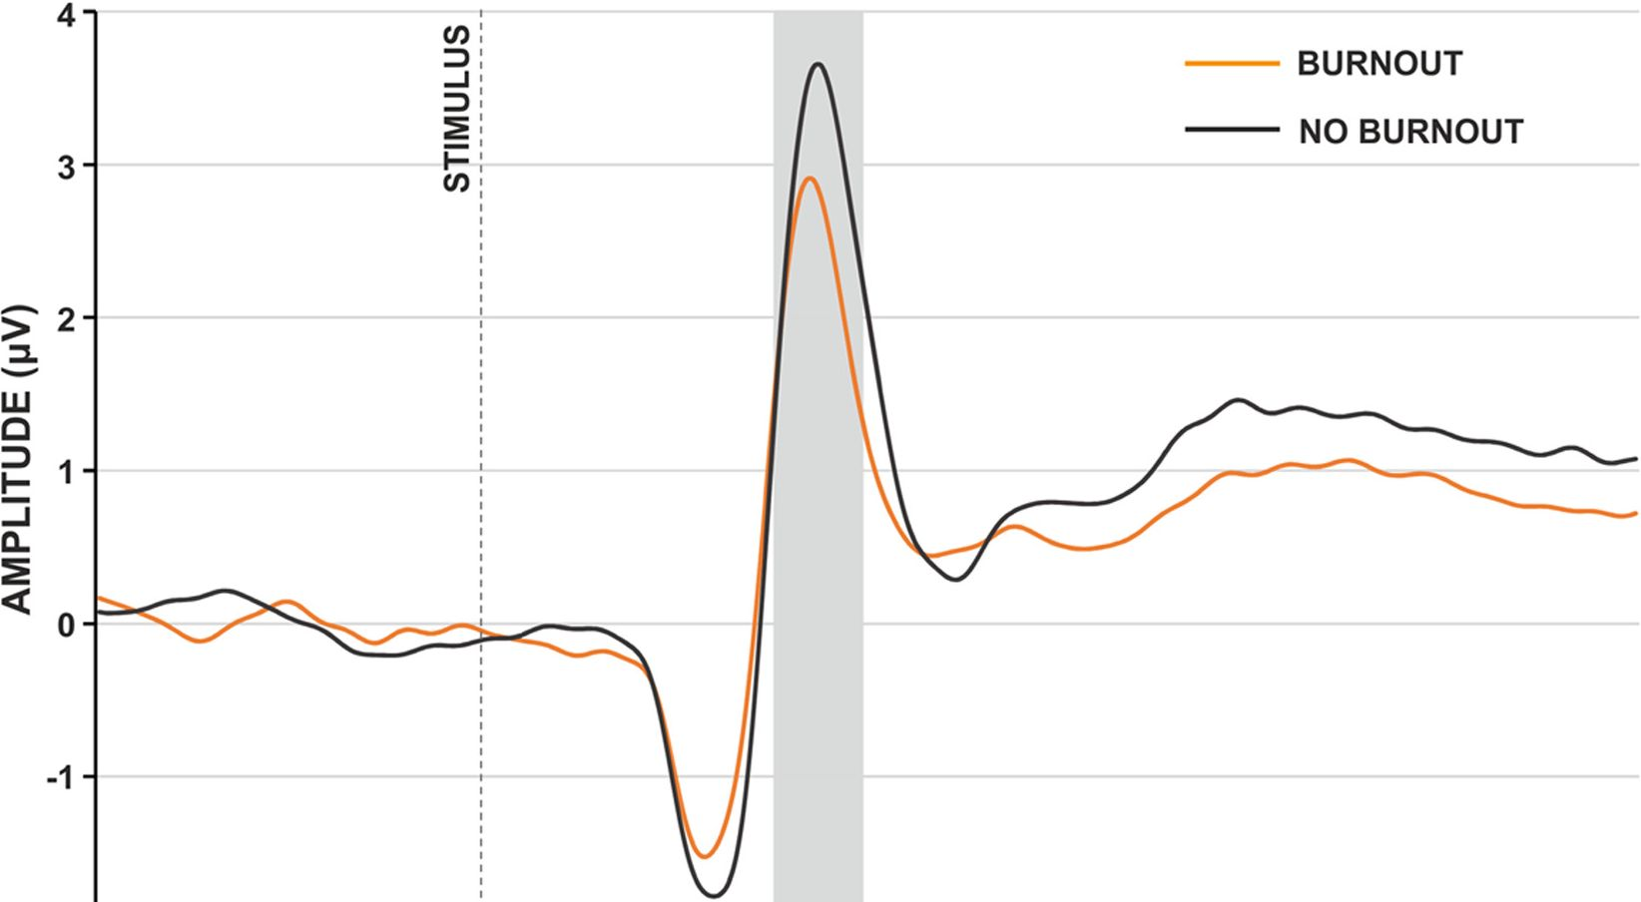
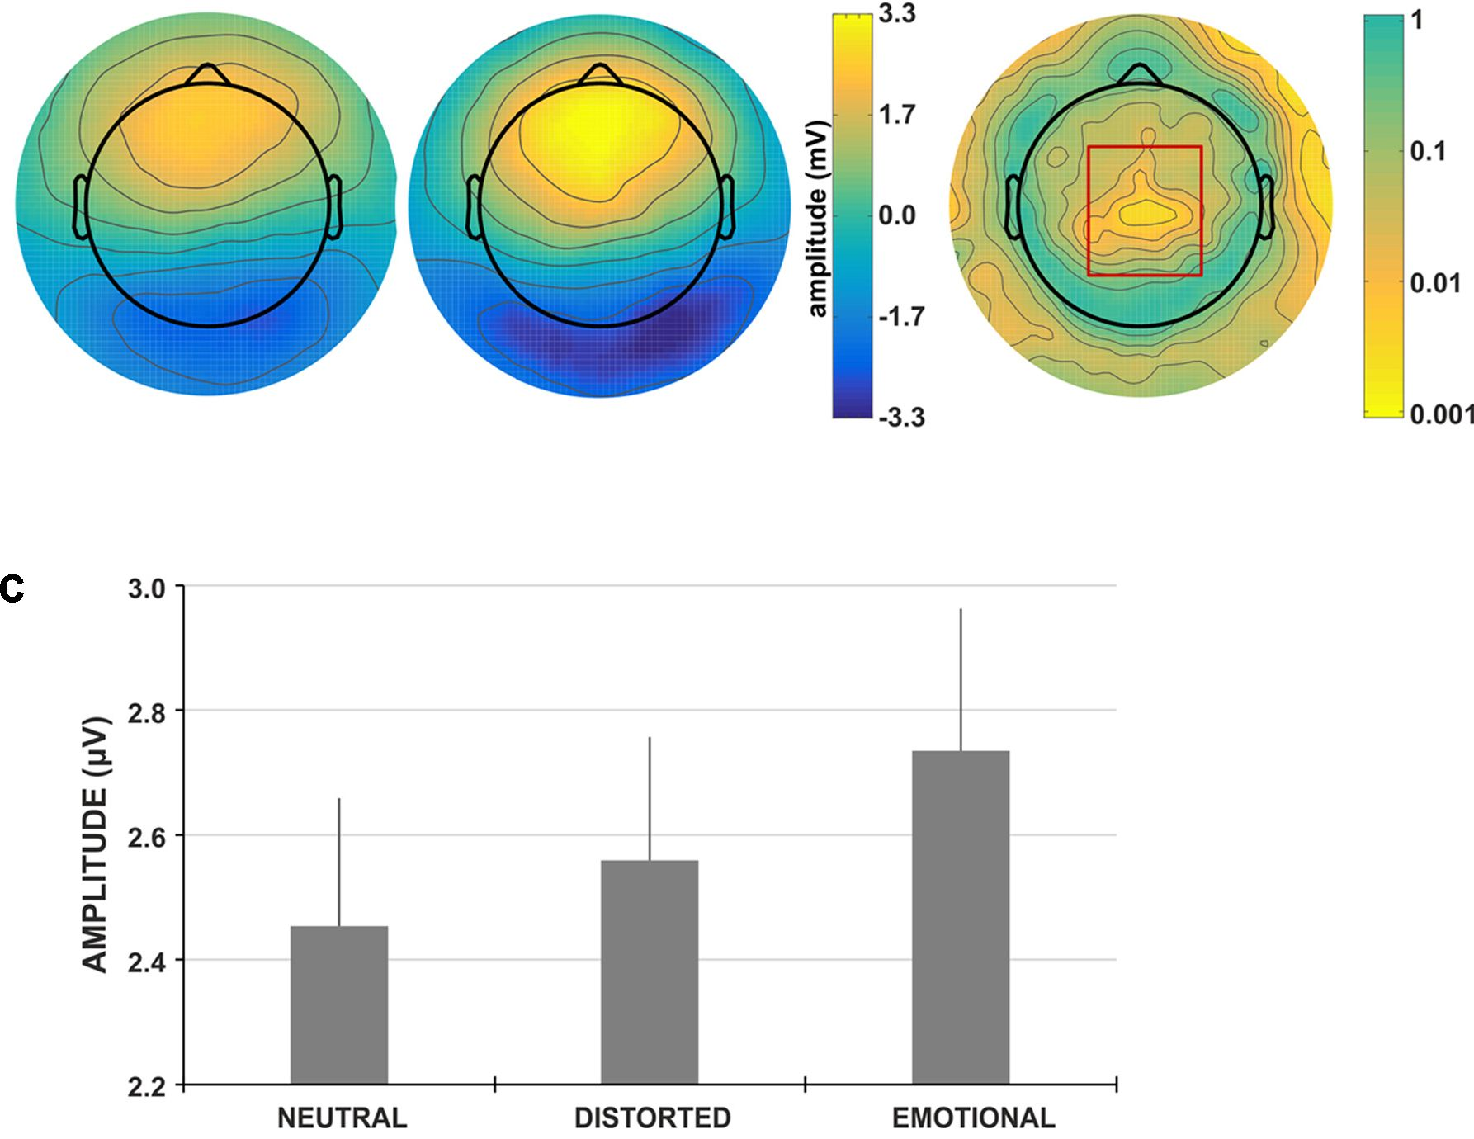
Golonka et al.
Neurophysiological Markers of Burnout
-2-1 . i . 1 . 1 . г
-200 -100 0 100 200 300 400 500 600
TIME (ms)
В
BURNOUT CONTROL p-value
FIGURE 2 | Face-locked ERP characteristics. (A) Grand-average face-locked VPP component at electrode site Cz for burnout (orange line) and control (gray line)
group. The gray rectangle denotes the time-window selected for the ERP analyses. (B) Scalp topography for the time-window of the VPP component for burnout
and control group. The red rectangle denotes the region showing significant between-group difference. (C) Grand-average amplitudes of the VPP component for
neutral, distorted and emotional faces. Vertical bars denote standard errors.
[F(2,182) = 234.60, p = 0.0001] between all stimulus categories
(neutral, negative, and positive). No interaction effects were
found.

Psychophysiological Results of Face
Categorization Task
The values of N170 (separately extracted from O1, O2, P7, and
P8 electrodes sites) and VPP (extracted from Cz electrodes site)
were submitted to independent repeated measures ANOVAs with
group (two levels: burnout and control) and stimulus type (three
levels: neutral, distorted, and emotional faces) factors. In all
the performed analyses, faces with positive and negative facial
expressions were placed in one category called “emotional faces”;
thus, instead of four stimulus types, we operated on three separate
categories: neutral, emotional, and distorted.

N170 ERP Component
The analysis of N170 showed no between-group difference, [O1
electrodes site: F(1,91) = 0.064, p = 0.801; O2 electrodes site:
F(1;91) = 0.025, p = 0.875; P7 electrodes site: F(1,91) = 0.082,
p = 0.776; P8 electrodes site: F(1;91) = 0.166, p = 0.685], thus
we did not explore the N170 component further.
Frontiers in Psychology | www.frontiersin.org
6
December 2017 | Volume 8 | Article 2155
Golonka et al.
Neurophysiological Markers of Burnout
TABLE 3 | Pearson correlation coefficients (r) between subscales of MBI-GS and
amplitude of VPP component in face categorization task in three categories of
stimuli: neutral, distorted and emotional.
 |  | Categories of stimuli
 | Neutral | Distorted | Emotional
MBI-GS subscales
Exhaustion | -0.177 | -0.222* | -0.156
Cynicism | -0.291* | -0.229* | -0.243*
Efficacy | 0.174 | 0.109 | 0.168
Asterisks denote statistical significance (*p < 0.05).
VPP ERP Component
The analysis of the VPP component revealed the main effect
of group type; the amplitude of the VPP component was
significantly lower for participants presenting burnout syndrome
[F(1,91) = 7.546,p = 0.007, np = 0.077; Figures 2A,B). Figure 2A
presents the grand-average face-locked VPP component at
electrode site Cz, where significantly lower VPP amplitude in
burnout subjects is observed. The lower VPP activity in burnout
is also illustrated on topographic activity maps (Figure 2B).
Moreover, the main effect of stimulus type was observed
[F(2,182) = 6.016, p = 0.003, np = 0.062]. The post hoc
analysis showed that the amplitude of VPP for emotional faces
was significantly higher (Figure 2C), compared to neutral and
distorted faces (p < 0.001 and p < 0.05, respectively). No
interaction effect of group and stimulus type was observed.
To explore further the relationship between the amplitude
of the VPP component for different stimuli types, correlation
analysis with MBI subscales was performed; this showed
a consistent, statistically significant relation between VPP
amplitude for all stimuli types and MBI-cynicism scores
(Table 3). Namely, the higher the MBI-cynicism score, the lower
the VPP amplitude for neutral, distorted and emotional faces.

Psychophysiological Results of the IAPS
Task
The values of the EPN and LPP components extracted from
CPz electrodes were submitted to independent repeated measures
ANOVAs with group (two levels: burnout and control) and
stimulus type (three levels: neutral, positive, and negative)
factors.
The LPP component was not sensitive to the group factor
[F(1,91) = 0.381, p = 0.538, np = 0.004]; thus, it was not
analyzed further. For the EPN component, we observed the
main effect of group type (Figure 3A) and the amplitude
of EPN was significantly more negative for participants not
presenting burnout syndrome [F(1,91) = 4.195, p = 0.043,
np = 0.044]. Moreover, the main effect of stimulus type was
observed [F(2,182) = 8.892, p < 0.001, np = 0.089]. The post
hoc analysis revealed that the amplitude of EPN for neutral
IAPS pictures was significantly less negative, compared to EPN
for negative (p < 0.001) and positive (p < 0.05) IAPS pictures
(Figure 3B). No interaction effect of group and stimulus type
was observed.
To explore further the relationship between the amplitude
of the EPN component for different stimuli types and
burnout syndrome, correlation analysis with MBI subscales was
performed: it showed a consistent, statistically significant relation
between the EPN amplitude for negative and positive IAPS
pictures and MBI exhaustion and cynicism scores (Table 4).
Namely, the higher the MBI exhaustion and cynicism scores, the
less negative the EPN amplitude for negative and positive IAPS
pictures.

DISCUSSION
The study results partially confirm the presented hypotheses.
Burnout subjects demonstrate a weaker response to affect-
evoking stimuli (general hypothesis); this is indexed by a
decline in VPP amplitude to emotional faces (hypothesis 1)
and decreased EPN amplitude in processing emotional scenes
(hypothesis 2). The assumption of a possible decrease in LPP
amplitude in response to negative stimuli in burnout subjects
(hypothesis 3) cannot be supported in the light of the presented
results.
In face categorization tasks, the decrease of VPP amplitude
indicated weaker neurophysiological response in burnout
subjects, compared to healthy controls. A decreased response
was observed in each face stimuli category (emotional, neutral,
and distorted). This outcome is consistent with the study
of Tei et al. (2014), in which they showed that burnout is
associated with reduced activity in empathy-related brain areas,
weakened emotional regulation and difficulty in recognizing
emotional state. As VPP is related to the perceptual processing
and structural encoding of facial stimuli, the decreased VPP
may indicate a weaker response to face stimuli among burnout
subjects. This might have further social consequences in work-
related contexts and may be related to weaker responses to
emotional contexts, which appear to be the core characteristic
of cynicism and depersonalization. However, it is worth noting
that when assessing pictures as negative, positive, or neutral, the
rating scores of participants with burnout did not differ from
those of the controls. Thus, careful and conscious perception of
face expressions seems to be intact in burnout individuals.
This tendency is also observed in passive viewing of natural
scenes in three stimuli categories: positive, negative, and neutral
scenes. The response to natural scenes (indexed by EPN) was
significantly weaker (less negative) in the burnout group. As EPN
is related to automatic attentional allocation (Schupp et al., 2006),
it may be hypothesized that in the studied tasks the costs of long-
term work-related stress are observed in very early automatic and
unconscious stages.
Thus, similar conclusions emerge for the two kinds of affect-
related stimuli (faces and natural scenes) in the two types of
affective information processing (active and passive): the initial,
early phase of affective information processing is impaired and
weakened. On the contrary, LPP (described as selective attention
toward motivationally salient information, representation of
stimuli in working memory (Donchin and Coles, 1988) and as
a neural marker of emotion regulation (Qi et al., 2016) did not
Frontiers in Psychology | www.frontiersin.org
7
December 2017 | Volume 8 | Article 2155
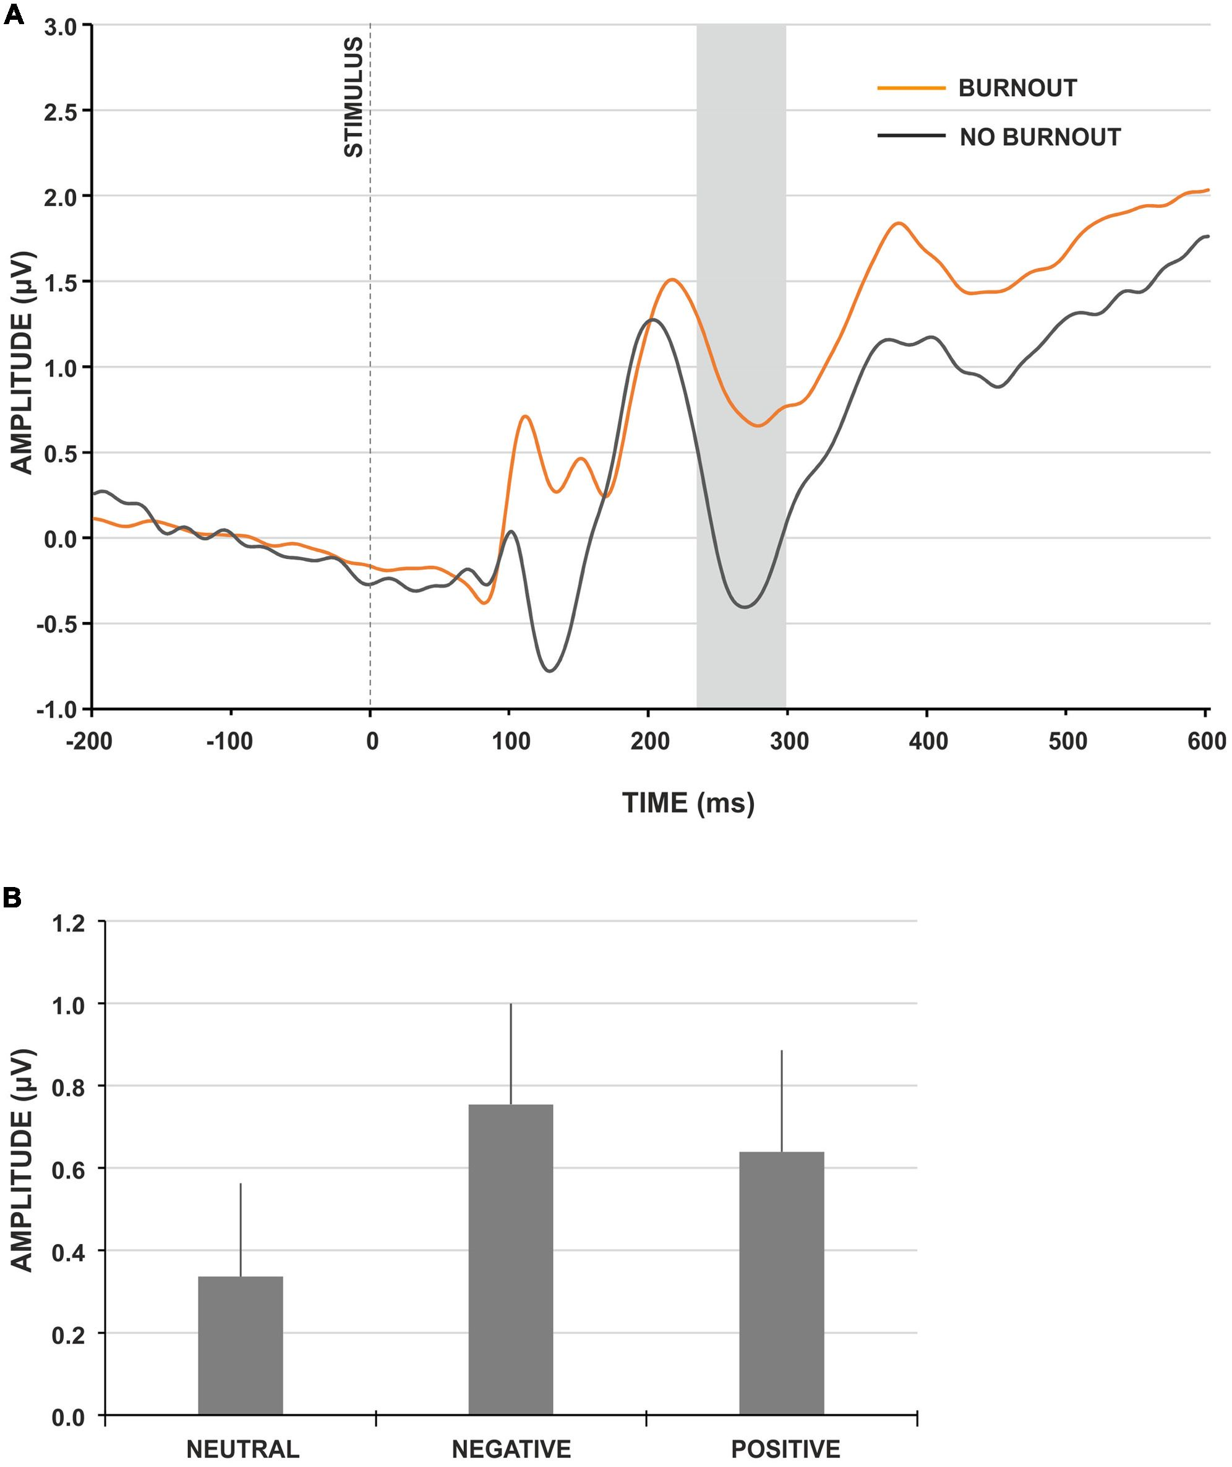
Golonka et al.
Neurophysiological Markers of Burnout
FIGURE 3 | IAPS-locked ERP characteristics. (A) Grand-average IAPS-locked EPN component at electrode site CPz for burnout (orange line) and control (gray line)
group. The gray rectangle denotes the time-window selected for the ERP analyses. (B) Grand-average amplitudes of the EPN component for neutral, negative and
positive IAPS pictures. Vertical bars denote standard errors.
reveal any differences. Again, the electrophysiological results are
in line with the data obtained from the rating of pictures. The
similar rating results of IAPS pictures shows that there was no
significant difference between the burnout group and the control
group on the level of conscious perception. The obtained results
lead to a similar observation as was found in error processing.
The differences in the very early stages of information processing
may not influence further processing, but may be related to the
additional effort required to achieve the same results. This may
suggest the compensatory effort that we described in our previous
findings and may lead to similar conclusions about the possible
“hidden costs” of burnout (Golonka et al., 2017).
Comparing the presented findings with our previous study
on cognitive impairments in burnout (Golonka et al., 2017),
an interesting aspect may be highlighted: in the case of
external affect-related stimuli, the response in the early
TABLE 4 | Pearson correlation coefficients (r) between subscales of MBI-GS and
amplitude of EPN component for three categories of IAPS pictures: neutral,
negative, and positive.
 |  | Categories of IAPS pictures
 | Neutral | Negative | Positive
MBI-GS subscales
Exhaustion | 0.172 | 0.226* | 0.229*
Cynicism | 0.174 | 0.229* | 0.206*
Efficacy | -0.092 | -0.111 | -0.125
Asterisks denote statistical significance (*p < 0.05).
stage of information processing is weaker among burnout
subjects, compared to healthy controls. This tendency changes
if the subject refers to internal and individual contexts
when committing an error: the early phase of information
Frontiers in Psychology | www.frontiersin.org
8
December 2017 | Volume 8 | Article 2155
Golonka et al.
Neurophysiological Markers of Burnout
processing is significantly enhanced (indexed by increased
error related negativity amplitude—ERN). In this situation,
the decrease in neurophysiological response is observed later
(indexed by the lower amplitude of the late positivity ERP
component—Pe); this could possibly lead to difficulties in
proactive control and active goal maintenance.
The decrease in neurophysiological response observed among
burnout subjects when processing emotional information may
be particularly interesting in the context of correlation analyses
(see Tables 3, 4). The correlations consistently show a significant
association between analyzed ERP components and two core
burnout symptoms (emotional exhaustion and cynicism), but
not with efficiency. The amplitude of VPP is negatively related
to cynicism in all stimuli categories (neutral, distorted and
emotional) and with emotional exhaustion in distorted faces: the
higher the burnout scores, the weaker the neurophysiological
response. Similarly, EPN is associated with emotional exhaustion
and cynicism: the correlation coefficients with negative and
positive IAPS stimuli are positive, but—keeping in mind that we
are analyzing negative depletion—it may be assumed that the
higher the burnout scores on exhaustion and cynicism, the less
negative the EPN component that is observed.
In the context of the important debate on the difficulties
related to differentiating burnout from closely related states
and disorders (mainly depression and anxiety, e.g., Korczak
et al., 2010; Golonka et al., 2014; Bianchi and Laurent, 2015),
it is particularly important to discuss discriminative points.
Emotion processing in burnout and depression show some
common features: in both cases, the response to affect-evoking
stimuli is weaker. However, from a more detailed perspective,
we can indicate some important differences: the deficits in
emotion processing are noticed only in the early stage of this
process (decreased VPP, EPN), but not in further processing
(no changes in LPP), while in depression both components
are amplified. Interestingly, in the case of the LPP component,
burnout remains “in between” anxiety and depression: anxious
individuals tend to demonstrate larger LPP amplitude, while
individuals with clinical depression demonstrate the opposite
(Hajcak, 2012).
Regarding the limitations of the study, the weaker
neurophysiological response that is observed in the burnout
group may be considered both as a burnout marker and as the
result of changes observed on behavioral and subjective levels, i.e.,
specific attitudes and behaviors linked to emotional exhaustion,
cynicism and depersonalization. This is still an essential issue
in burnout research. An answer may emerge from longitudinal
studies, but considering the complexity and fluctuating nature
of burnout syndrome, it is highly problematic to design a
longitudinal study on burnout.

CONCLUSION
The obtained results are further evidence for impaired stimuli
processing in individuals presenting burnout symptoms.
Burnout subjects reveal impairments in early stages of emotion
information processing in two different categories of stimuli:
faces and natural scenes.
The correlation analyses revealed that ERP components
related to emotional processing (VPP and EPN) are associated
with two core burnout symptoms: emotional exhaustion and
cynicism.
Event-related potentials that differentiate processing of affect-
related information between burnout and controls (VPP and
EPN) may be potential indicators of burnout syndrome. We
hypothesize that the decreased amplitude of VPP and EPN
components in the burnout group maybe the neurophysiological
manifestation of emotional blunting and may be considered
as neurophysiological markers of emotional exhaustion and
cynicism. Additionally, LPP amplitude, which does not differ
between burnout individuals and controls, may be a diagnostic
criterion that differentiates burnout from depression and anxiety
disorders.
The presented findings contribute to depicting
neurophysiological outcomes as indicators of burnout syndrome.
This might help to improve the diagnostic process of burnout and
lead to a more precise description of the cognitive and emotional
mechanisms underlying burnout syndrome.

AUTHOR CONTRIBUTIONS
KG and MG: substantial contributions to the conception and
design of the work; acquisition, analysis, interpretation of data,
drafting the work and revising it critically; final approval of the
version to be published; agrees to be accountable for all aspects
of the work. JM-K: substantial contributions to the conception
and design of the work; analysis, interpretation of data, drafting
the work and revising it critically; final approval of the version to
be published; agrees to be accountable for all aspects of the work.
KP: substantial contributions to acquisition, analysis, drafting the
work and revising it critically; final approval of the version to be
published; agrees to be accountable for all aspects of the work.
TM: substantial contributions to the conception and design of the
work; drafting the work and revising it critically; final approval
of the version to be published; agrees to be accountable for all
aspects of the work.

FUNDING
The preparation of this paper was supported by a grant
from the National Science Centre (Research project no.
2013/10/E/HS6/00163).

ACKNOWLEDGMENT
The authors would like to thank Michael Timberlake for
proofreading.
Frontiers in Psychology | www.frontiersin.org
9
December 2017 | Volume 8 | Article 2155
Golonka et al.
Neurophysiological Markers of Burnout

REFERENCES
Anand, A., Li, Y., Wang, Y., Wu, J., Gao, S., Bukhari, L., et al. (2005). Activity
and connectivity of brain mood regulating circuit in depression: a functional
magnetic resonance study. Biol. Psychiatry 57, 1079-1088. doi: 10.1016/j.
biopsych.2005.02.021
Batty, M., and Taylor, M. J. (2003). Early processing of the six basic facial emotional
expressions. Cogn. Brain Res. 17, 613-620. doi: 10.1016/S0926-6410(03)
00174-5
Bell, A. J., and Sejnowski, T. J. (1995). An information-maximization approach to
blind separation and blind deconvolution. Neural comput. 7, 1129-1159.
Bentin, S., Allison, T., Puce, A., Perez, E., and McCarthy, G. (1996).
Electrophysiological studies of face perception in humans. J. Cogn. Neurosci.
8, 551-565. doi: 10.1162/jocn.1996.8.6.551
Bianchi, R., and Laurent, E. (2015). Emotional information processing in
depression and burnout: an eye-tracking study. Eur. Arch. Psychiatry Clin.
Neurosci. 265, 27-34. doi: 10.1007/s00406-014-0549-x
Botzel, K., and Grusser, O. J. (1989). Electric brain potentials evoked by pictures of
faces and non-faces: a search for “face-specific” EEG-potentials. Exp. Brain Res.
77, 349-360. doi: 10.1007/BF00274992
Deligkaris, P., Panagopoulou, E., Montgomery, A. J., and Masoura, E. (2014).
Job burnout and cognitive functioning: a systematic review. Work Stress 28,
107-123.
Delorme, A., and Makeig, S. (2004). EEGLAB: an open source toolbox for analysis
of single-trial EEG dynamics including independent component analysis.
J. Neurosci. Methods 134, 9-21. doi: 10.1016/j.jneumeth.2003.10.009
Donchin, E., and Coles, M. G. (1988). Is the P300 component a
manifestation of context updating? Behav. Brain Sci. 11, 357-374.
doi: 10.1017/S0140525X00058027
Drevets, W. C. (2000). Neuroimaging studies of mood disorders. Biol. Psychiatry
48, 813-829. doi: 10.1016/S0006-3223(00)01020-9
Drevets, W. C., Price, J. L., Simpson, J. R. Jr., Todd, R. D., Reich, T., Vannier, M.,
et al. (1997). Subgenual prefrontal cortex abnormalities in mood disorders.
Nature 386, 824-827. doi: 10.1038/386824a0
Durning, S. J., Costanzo, M., Artino, A. R. Jr., Dyrbye, L. N., Beckman, T. J.,
Schuwirth, L., et al. (2013). Functional neuroimaging correlates of burnout
among internal medicine residents and faculty members. Front. Psychiatry
4:131. doi: 10.3389/fpsyt.2013.00131
Eimer, M. (2011). “The Face-Sensitive N170 component of the event-related brain
potential,” in The Oxford Handbook of Face Perception, eds A. J. Calder, G.
Rhodes, M. H. Johnson, and J. V. Haxbyn (Oxford: Oxford University Press),
329-344.
Eimer, M., and Holmes, A. (2002). An ERP study on the time course of emotional
face processing. Neuroreport 13, 427-431. doi: 10.1097/00001756-200203250-
00013
Feuerriegel, D., Churches, O., Hofmann, J., and Keage, H. A. (2015). The N170
and face perception in psychiatric and neurological disorders: a systematic
review. Clin. Neurophysiol. 126, 1141-1158. doi: 10.1016/j.clinph.2014.
09.015
Foti, D., Hajcak, G., and Dien, J. (2009). Differentiating neural responses to
emotional pictures: evidence from temporal-spatial PCA. Psychophysiology 46,
521-530. doi: 10.1111/j.1469-8986.2009.00796.x
Foti, D., Olvet, D. M., Klein, D. N., and Hajcak, G. (2010). Reduced electrocortical
response to threatening faces in major depressive disorder. Depress. Anxiety 27,
813-820. doi: 10.1002/da.20712
Golkar, A., Johansson, E., Kasahara, M., Osika, W., Perski, A., and Savic, I. (2014).
The influence of work-related chronic stress on the regulation of emotion and
on functional connectivity in the brain. PLOS ONE 9:104550. doi: 10.1371/
journal.pone.0104550
Golonka, K., Mojsa-Kaja, J., Gawłowska, M., and Marek, T. (2014). “Work
engagement and burnout: consequences of mismatch between individual and
work environment from the neural perspective,” in Advances in Science,
Technology Higher Education and Society in the Conceptual Age, ed. T. Marek
(Los Angeles, CA: AHFE Conference), 279-290.
Golonka, K., Mojsa-Kaja, J., Gawlowska, M., and Popiel, K. (2017). Cognitive
impairments in occupational burnout-error processing and its indices of
reactive and proactive control. Front. Psychol. 8:676. doi: 10.3389/fpsyg.2017.
00676
Hajcak, G. (2012). What we've learned from mistakes insights from error-
related brain activity. Curr. Dir. Psychol. Sci. 21, 101-106. doi: 10.1177/
0963721412436809
Hajcak, G., and Dennis, T. A. (2009). Brain potentials during affective picture
processing in children. Biol. Psychol. 80, 333-338. doi: 10.1016/j.biopsycho.
2008.11.006
Joyce, C., and Rossion, B. (2005). The face-sensitive N170 and VPP components
manifest the same brain processes: the effect of reference electrode site. Clin.
Neurophysiol. 116, 2613-2631. doi: 10.1016/j.clinph.2005.07.005
Jung, T., Makeig, S., Lee, T., Mckeown, M. J., Brown, G., Bell, A. J., et al. (2000).
“Independent component analysis of biomedical signals” in Proceedings of the
2nd International Workshop on Independent Component Analysis and Blind
Signal Seperation, Helsinki, 633-644.
Keil, A., Debener, S., Gratton, G., Junghofer, M., Kappenman, E. S., Luck, S. J.,
et al. (2014). Committee report: publication guidelines and recommendations
for studies using electroencephalography and magnetoencephalography.
Psychophysiology 51, 1-21. doi: 10.1111/psyp.12147
Ketter, T. A., George, M. S., Kimbrell, T. A., Benson, B. E., and Post, R. M.
(1996). Functional brain imaging, limbic function, and affective disorders.
Neuroscientist 2, 55-65. doi: 10.1177/107385849600200113
Korczak, D., Huber, B., and Kister, C. (2010). Differential diagnostic of the burnout
syndrome. GMS Health Technol. Assess. 6:Doc09. doi: 10.3205/hta000087
Lang, P. J., Bradley, M. M., and Cuthbert, B. N. (1999). International Affective
Picture System (IAPS): Technical Manual and Affective Ratings. Gainesville, FL:
University of Florida, 2.
Leiter, M. P., and Maslach, C. (2004). “Areas of worklife: a structured approach
to organizational predictors of job burnout” in Research in Occupational Stress
and Well Being: Emotional and Physiological Processes and Positive Intervention
Strategies, Vol. 3, eds P. Perrewe and D. C. Ganster (Oxford: JAI Press), 91-134.
doi: 10.1016/S1479-3555(03)03003-8
Luijtelaar, G. V., Verbraak, M., Bunt, M. V. D., Keijsers, G., and Arns, M.
(2010). EEG findings in burnout patients. J. Neuropsychiatry Clin. Neurosci. 22,
208-217. doi: 10.1176/appi.neuropsych.22.2.208
Maslach, C., Jackson, S. E., and Leiter, M. P. (1996). The Maslach Burnout
Inventory-General Survey Manual, 3rd Edn. Palo Alto, CA: Consulting
Psychologist Press.
Maslach, C., and Leiter, M. P. (1997). The Truth AboutBurnout: How Organizations
Cause Personal Stress and What to Do About It. San Francisco, CA: Jossey-Bass.
Maslach, C., and Leiter, M. P. (2004). “Stress and burnout: the critical research,” in
Handbook of Stress Medicine and Health, ed. C. Cooper (London: CRC Press),
155-172.
Maslach, C., and Leiter, M. P. (2008). Early predictors of job burnout
and engagement. J. Appl. Psychol. 93, 498-512. doi: 10.1037/0021-9010.
93.3.498
Mayberg, H. S., Liotti, M., Brannan, S. K., McGinnis, S., Mahurin, R. K., Jerabek,
P. A., et al. (1999). Reciprocal limbic-cortical function and negative mood:
converging PET findings in depression and normal sadness. Am. J. Psychiatry
156, 675-682.
Mojsa-Kaja, J., Golonka, K., and Marek, T. (2015). Job burnout and engagement
among teachers - worklife areas and personality traits as predictors of
relationships with work. Int. J. Occup. Med. Environ. Health 28, 102-119. doi:
10.13075/ijomeh.1896.00238
Moser, J. S., Hajcak, G., Bukay, E., and Simons, R. F. (2006). Intentional modulation
of emotional responding to unpleasant pictures: an ERP study. Psychophysiology
43, 292-296. doi: 10.1111/j.1469-8986.2006.00402.x
Olofsson, J. K., Nordin, S., Sequeira, H., and Polich, J. (2008). Affective picture
processing: an integrative review of ERP findings. Biol. Psychol. 77, 247-265.
doi: 10.1111/j.1469-8986.2004.00174.x
Oosterholt, B. G., Maes, J. H., Van der Linden, D., Verbraak, M. J., and Kompier,
M. A. (2014). Cognitive performance in both clinical and non-clinical burnout.
Stress 17, 400-409. doi: 10.3109/10253890.2014.949668
Oosterholt, B. G., Van der Linden, D., Maes, J. H., Verbraak, M. J., and Kompier,
M. A. (2012). Burned out cognition—cognitive functioning of burnout patients
before and after a period with psychological treatment. Scand. J. Work Environ.
Health 38, 358-369. doi: 10.5271/sjweh.3256
Qi, S., Luo, Y., Tang, X., Li, Y., Zeng, Q., Duan, H., et al. (2016). The temporal
dynamics of directed reappraisal in high-trait-anxious individuals. Emotion 16,
886-896. doi: 10.1037/emo0000186
Frontiers in Psychology | www.frontiersin.org
10
December 2017 | Volume 8 | Article 2155
Golonka et al.
Neurophysiological Markers of Burnout
Ramos-Loyo, J., Gonzalez-Garrido, A. A., Garcia-Aguilar, G., and Del Rio-
Portilla, Y. (2013). The emotional content of faces interferes with inhibitory
processing: an event related potential study. Int. J. Psychol. Stud. 5:52. doi:
10.5539/ijps.v5n2p52
Rossion, B., and Jacques, C. (2008). Does physical interstimulus variance account
for early electrophysiological face sensitive responses in the human brain? Ten
lessons on the N170. Neuroimage 39, 1959-1979. doi: 10.1016/j.neuroimage.
2007.10.011
Sabatinelli, D., Keil, A., Frank, D. W., and Lang, P. J. (2013). Emotional perception:
correspondence of early and late event-related potentials with cortical and
subcortical functional MRI. Biol. Psychol. 92, 513-519. doi: 10.1016/j.biopsycho.
2012.04.005
Sandstrom, A., Rhodin, I. N., Lundberg, M., Olsson, T., and Nyberg, L. (2005).
Impaired cognitive performance in patients with chronic burnout syndrome.
Biol. Psychol. 69, 271-279. doi: 10.1016/j.biopsycho.2004.08.003
Schacht, A., and Sommer, W. (2009). Emotions in word and face processing: early
and late cortical responses. Brain Cogn. 69, 538-550. doi: 10.1016/j.bandc.2008.
11.005
Schaufeli, W. B., and Enzmann, D. (1998). The Burnout Companion To Study And
Practice: A Critical Analysis. London: Taylor & Francis.
Schaufeli, W. B., and Greenglass, E. R. (2001). Introduction to special
issue on burnout and health. Psychol. Health 16, 501-510. doi: 10.1080/
08870440108405523
Schaufeli, W. B., Leiter, M. P., and Maslach, C. (2009). Burnout: 35 years of
research and practice. Career Develop. Intern. 14, 204-220. doi: 10.1108/
13620430910966406
Schmidt, K. H., Neubach, B., and Heuer, H. (2007). Self-control demands,
cognitive control deficits, and burnout. Work Stress 21, 142-154. doi: 10.1080/
02678370701431680
Schupp, H. T., Cuthbert, B. N., Bradley, M. M., Cacioppo, J. T., Ito, T., and Lang,
P. J. (2000). Affective picture processing: the late positive potential is modulated
by motivational relevance. Psychophysiology 37, 257-261. doi: 10.1111/1469-
8986.3720257
Schupp, H. T., Flaisch, T., Stockburger, J., and Junghofer, M. (2006). Emotion and
attention: event-related brain potential studies. Prog. Brain Res. 156, 31-51.
doi: 10.1016/S0079-6123(06)56002-9
Schupp, H. T., Junghofer, M., Weike, A. I., and Hamm, A. O. (2003). Attention
and emotion: an ERP analysis of facilitated emotional stimulus processing.
Neuroreport 14, 1107-1110. doi: 10.1097/00001756-200306110-00002
Schupp, H. T., Junghofer, M., Weike, A. I., and Hamm, A. O. (2004). The
selective processing of briefly presented affective pictures: an ERP analysis.
Psychophysiology 41, 441-449. doi: 10.1111/j.1469-8986.2004.00174.x
Schupp, H. T., Schmalzle, R., Flaisch, T., Weike, A. I., and Hamm, A. O. (2012).
Affective picture processing as a function of preceding picture valence: an ERP
analysis. Biol. Psychol. 91, 81-87. doi: 10.1016/j.biopsycho.2012.04.006
Schweinberger, S. R. (1996). How Gorbachev primed Yeltsin: Analyses of
associative priming in person recognition by means ofreaction times and event-
related brain potentials. J. Exp. Psychol. Learn. Mem. Cogn. 22, 1383-1407.
doi: 10.1037/0278-7393.22.6.1383
Sheline, Y. I., Barch, D. M., Donnelly, J. M., Ollinger, J. M., Snyder,
A. Z., and Mintun, M. A. (2001). Increased amygdala response to masked
emotional faces in depressed subjects resolves with antidepressant treatment:
an fMRI study. Biol. Psychiatry 50, 651-658. doi: 10.1016/S0006-3223(01)
01263-X
Sokka, L., Huotilainen, M., Leinikka, M., Korpela, J., Henelius, A., Alain, C., et al.
(2014). Alterations in attention capture to auditory emotional stimuli in job
burnout: an event-related potential study. Int. J. Psychophysiol. 94, 427-436.
doi: 10.1016/j.ijpsycho.2014.11.001
Sokka, L., Leinikka, M., Korpela, J., Henelius, A., Lukander, J., Pakarinen, S.,
et al. (2017). Shifting of attentional set is inadequate in severe burnout:
evidence from an event-related potential study. Int. J. Psychophysiol. 112,70-79.
doi: 10.1016/j.ijpsycho.2016.12.004
Stein, M. B., Simmons, A. N., Feinstein, J. S., and Paulus, M. P. (2007).
Increased amygdala and insula activation during emotion processing in
anxiety-prone subjects. Am. J. Psychiatry 164, 318-327. doi: 10.1176/ajp.2007.
164.2.318
Tei, S., Becker, C., Kawada,R., Fujino, J., Jankowski, K. F., Sugihara, G., et al. (2014).
Can we predict burnout severity from empathy-related brain activity. Transl.
Psychiatry 4:e393. doi: 10.1038/tp.2014.34
Thomas, K. M., Drevets, W. C., Dahl, R. E., Ryan, N. D., Birmaher, B., Eccard,
C. H., et al. (2001). Amygdala response to fearful faces in anxious and depressed
children. Arch. Gen. Psychiatry 58, 1057-1063. doi: 10.1001/archpsyc.58.
11.1057
Tottenham, N., Tanaka, J. W., Leon, A. C., McCarry, T., Nurse, M., Hare, T. A.,
et al. (2009). The NimStim set of facial expressions: judgments from untrained
research participants. Psychiatry Res. 168, 242-249. doi: 10.1016/j.psychres.
2008.05.006
van Dam, A. (2016). Subgroup analysis in burnout: relations between fatigue,
anxiety, and depression. Front. Psychol. 7:90. doi: 10.3389/fpsyg.2016.
00090
Van der Linden, D., Keijsers, G. P., Eling, P., and Schaijk, R. V. (2005). Work stress
and attentional difficulties: an initial study on burnout and cognitive failures.
Work Stress 19, 23-36. doi: 10.1080/02678370500065275
Wangelin, B. C., Bradley, M. M., Kastner, A., and Lang, P. J. (2012). Affective
engagement for facial expressions and emotional scenes: the influence of social
anxiety. Biol. Psychol. 91, 103-110. doi: 10.1016/j.biopsycho.2012.05.002
Conflict of Interest Statement: The authors declare that the research was
conducted in the absence of any commercial or financial relationships that could
be construed as a potential conflict of interest.
Copyright ©2017 Golonka, Mojsa-Kaja, Popiel, Marek and Gawłowska. This is an
open-access article distributed under the terms ofthe Creative CommonsAttribution
License (CC BY). The use, distribution orreproduction in other forums ispermitted,
provided the original author(s) or licensor are credited and that the original
publication in this journal is cited, in accordance with accepted academic practice.
No use, distribution or reproduction is permitted which does not comply with these
terms.
Frontiers in Psychology | www.frontiersin.org
11
December 2017 | Volume 8 | Article 2155

