AccessibilityofBrzozówbypublictransportonalocal,regionalandnationalscale

ŁukaszFiedeń

JagiellonianUniversity,InstituteofGeographyandSpatialManagement,DepartmentofRegionalDevelopment,ul.Gronostajowa7,30-387Krakowlukasz.fieden@doctoral.uj.edu.pl

Abstract:MajorchangescanbeobservedinthewaythatthepublictransportsysteminPolandoperatesasaresultofthestructuralandownershiptransformationsoftheformerstate-ownedMotorTransportCompany(PrzedsiębiorstwoKomunikacjiSamochodowej[PKS]).Ananalysiswascarriedoutofthetown’sexistingpublictransportconnectionsinordertodeterminetheimpactofthesechangesonthemobilityoftheresidentsofasmalltown.ThetownofBrzozówwasselectedfortheresearch.AfterAugust2013,PKSKrosnoS.A.withdrewfromtheprovisionofservicesonmanybusroutesinthatarea.
TheexternalaccessibilityofpublictransportinBrzozówwaspresentedatthreescales:local,intra-regionalandnational.Eachofthesehasitsowncharacteristics,andthebusroutesprovidedoneachofthesescaleshavedifferentsignificancefortheinhabitantsandthefunctioningoftheeconomy.
AccessibilitybypublictransportinBrzozówisverygoodandstronglycorrelatedwiththecity’sfunctionallinksonlocal,regionalandnationalscales.ThemaintransportaxisofthecityistherouteconnectingRzeszów(thecapitalofPodkarpackieProvince)withtheBieszczadyMountains(anareaofgreatvaluefortourism).
Onthelocalmarket,thedesiretoadaptthecarriers’provisiontotheneedsofstudentsandtheemployeesoflargecompanies,whileprovidingforuniversitystudentsonthemarketforlong-distancetransport,providedthemainmotivationsforchangesinthepublictransportsystemintheareaofBrzozówMunicipality.

Keywords:accessibility,Brzozów,publictransport

submitted:May2017 reviewed:July2017 accepted:August2017


Introduction
URBANISSUES

Accesstoallkindsofgoodsandservicesisveryimpor-tantindailylife.Sometimesitdetermineshumanhealthorevenlifeitself.However,oneshouldkeepinmindthatdif-ferenttypesofresourcesarenotdistributedequally.Asaresult,peoplemustmovetoacquirethem,soitcanbeconcludedthatthepossibilityofmovingingeographicalspacedirectlyaffectshumanlifeandthattheaccessibilityoftransportmaybeoneofthedeterminantsoflivingstandards.
Theterm“accessibility”isfrequentlyused.However,re-searchersunderstandthisconceptdifferently,andthusitisdifficulttoindicateonedefinitionthatwilltakeintoaccountallaspectsofthisconcept(Taylor1999,Moseley1979).Never-theless,itseemsthatthemostsignificantfactisthatwhentalkingaboutaccessibility,geographersemphasisetheneces-sity(ability/inability)totravelcertaindistancesinspace(Rata-jczak1992).Atwo-partdefinitionofaccessibilityisappliedby
Z.Taylor(1997:261).Thefirstpartdescribesaccessibilityasa“chanceoropportunitythatenablesonetotakeadvantageofdifferenttypesofactivities”.Inthesecondpartofthedefinition,theauthoremphasisesthatthesubjectofaccessibilityisaper-sonwhopermanentlyinhabitsagivenarea.Itseemsthattheissueofpermanentortemporaryresidenceinacertainareaisnotcrucial,butreferringaccessibilitytoahumanbeingpresents
themostimportant–human–aspectoftheproblem.Thefactthataccessibilityisdeterminedbylocationismentionedmorefrequently(Guzik2003)whichignoresthekeyroleofhumanbeingsintheuseofgoodsandservices.
Theterm“transportaccessibility”isexplainedbyK.Warakomska(1992:68),whostatesthattransportaccessibil-ityisthe“abilitytoreachagivenpointfromaplaceofper-manentortemporaryresidence,usuallybymeansoftrans-port”.J.BlackandM.Conroy(1977)understandspatialac-cessibilityastheeasewithwhichagivenactivitycanbereached(ataspecificlocation)fromacertainlocationbyusingmeansoftransport.R.Guzik(2003)underlinesthataccessibilityshouldnotbeconsideredequivalenttoreachabil-ity.Accessibilitydoesnotmeantheactualuseoftheservice,butonlythepossibilityofusingit,whichisnotobligatory.Thus,whileaccessibilityshouldbelinkedwithspace,reach-abilityismoreassociatedwithfinancialorsocialissues.
Inthispaper,theauthorwillfocusonanalysingthefunctioningofthepublictransportsysteminBrzozówonthreescales:local,regionalandnational.Theanalysiswillprovideanswerstothefollowingquestions:
- WhatistheexternalaccessibilityofpublictransportinBrzozów?
- WhatchangesarehappeninginthepublictransportsystemintheBrzozówregion?

- WhatshouldbechangedtomakethepublictransportsysteminBrzozówoperatebetter?
Thedefinitionofpublictransportiswellknown.Accord-ingtotheCambridgeDictionary,itisa“systemofvehiclessuchasbusesandtrainsthatoperateatregulartimesonfixedroutesandareusedbythepublic”.ThisdefinitionfullycomplieswithPolishlegislation,soitcanbeusedforthepurposeofresearchinPolishconditions.Thedirectreasonforconductingthere-searchwasprovidedbytheeventsaccompanyingtheprivatisa-tionofPKSKrosnoS.A.,themajorcarrieronthelocalmarket.Afterthesechangesofownershipandfunction(August2013)withintheareaofthecompany’soperation,manyindividualbusrunswerewithdrawnandmanyregularlineswereremoved.Thegapthatoccurrediscurrentlybeingfilledbyservicespro-videdbysmaller,privatecarriers.Detailedresearchwascon-ductedaboutoneandahalfyearsafterthechanges.Itsmainpurposewastoprepareapreciseassessmentoftheexistingpublictransportprovisionwhileatthesametimeattemptingtoidentifythemaincausesofchangesinthesysteminquestion.

Studyarea

BrzozówliesinBrzozówMunicipalityinBrzozówDis-trict,PodkarpackieProvinceinsouth-easternPoland(Fig-

Zmiennica

1
2

Brzozów3
TurzePole4
5
6
7

8
9

StaraWieś

TurzePole

Przysietnica

BRZOZÓW

Humniska

Górki

GrabownicaStarzeńska

0 1 2 3km
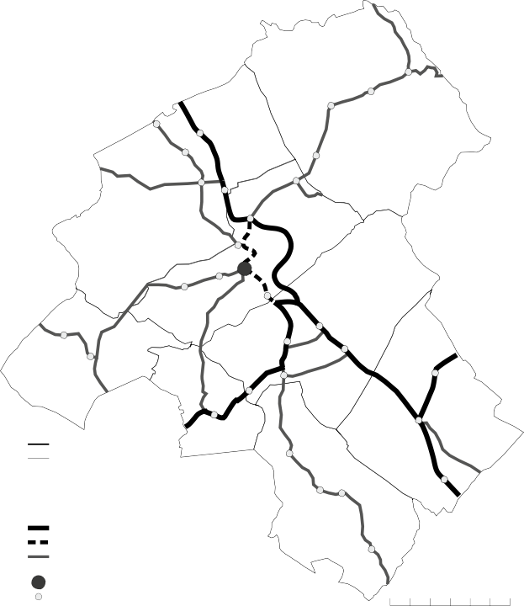
ures1–2).Thetowncoversanareaof11km2andhas7509inhabitants1.TheinhabitantsofBrzozówconstitute28.2%ofthepopulationofthemunicipalitywithapopulationden-sityof683persons/km2.
URBANISSUES
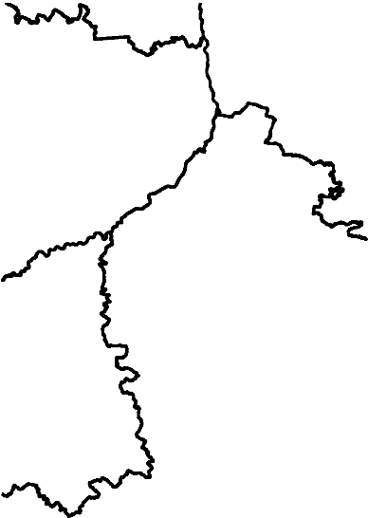
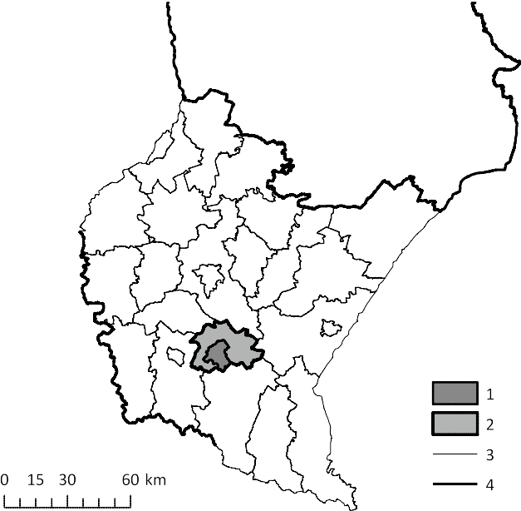
Therearenonationalroadsrunningthroughtheareaofthecommune,buttherearethreeprovincialroads:Nos.835,886and887.ItshouldbementionedthattheeasternringroadofBrzozówwasopenedon19thNov.2015asapartofprovincialroad886.Asaresultofthisevent,thealignment

Figure1.AdministrativelocationofBrzozówCommune
Explanations:1–Brzozówmunicipality,2–BrzozówDistrict,3–districtboundaries,4–provinceboundaries

Source:author’sownresearch.

- statisticaldatafrom2015;source:BDLGUS
Figure2.Administrativedivisionandlocationofroadsandbusstopsin
Brzozówmunicipality.Explanations:1–municipalboundary,2–townorvillageboundaries,3–townname,4–villagename,5–provincialroad,6–provincialroadno.886before19.11.2015,7–districtroad,8–busstation,9–busstop

Source:author’sownresearch.

ofprovincialroadsintheBrzozówareahaschanged(Figure2).Thereisnorailwaylinerunningthroughthetown.

Researchmethods

Theresearchwasbasedontheanalysisofbustimetablesandwassupplementedbyinterviewswithemployeesoftransportcompanies.Thestartingpointfortheanalyseswastheacquisitionofthetimetablesofthe16carriersoperatingonpermanent,year-roundcommunicationlinespassingthroughthecity.ThesedatahavebeenmadeavailablebytheTownHallinBrzozów,theDistrictOfficeinBrzozów,andindividualcarriers.Inthecaseoftwocommunicationlines,thetimetablesmadeavailableonthewebsitewww.autobu-sowykladjazdy.plwereused(thisinformationwasaddition-allyconfirmedbyvisitingselectedbusstopsinthefield).WhetherthetimetablesactuallyoperatedwereverifiedduringafieldvisitconductedonaweekdayatsixbusstopslocatedindifferentpartsofBrzozów.Theactionscarriedoutprovidedthebasisforconcludingthatthedatacollectedwillallowonetoobtainanimageoftheaccessibilityofpublictransportinthecitythatisbothaccurateandcurrent.Nev-ertheless,obtainingtimetablesthatreflectrealityisnotasimpletask(Guziketal.2016).Theproblemofincompleteandoutdatedinformationisaproblemthatisnotonlyas-sociatedwithpublictransportinPoland.Theavailabilityoftimetablesconstitutesoneofthecomponentsofaproperlyfunctioningsystem(Cullinane&Strokes1998)andasaruletheyshouldbemadereadilyavailable(Veeckmanetal.2017).

Thedataderivedfromtimetableshasbeenanalysedac-cordingtothemodifiedmethoddescribedbyR.Guzik(2010,2012),inadatabasecontaininginformationondirectpublictransportconnections(traveltimeandnumberofbusruns)betweenBrzozówand:
- Rzeszów(thecapitalofPodkarpackieProvince);
- thecapitalsofthemunicipalities2inBrzozówDistrict(Domaradz,Dydnia,Haczów,JasienicaRosielna,Nozdrzec);
- capitalsofdistrictssurroundingBrzozówDistrict(Kros-no,Przemyśl,Rzeszów–previouslyincluded,Sanok,Strzyżów),attention:thereisnodirectconnectionwithPrzemyśl;
- anycityinPolandthatisnotmentionedabove.
Whilecreatingthedatabase,onlybusesrunninginonedirectionweretakenintoconsideration(headedforagivenlocation,forexample,Rzeszów).
Conductingtheaccessibilityanalysisrequires,forin-stance,thatonedeterminethepointsatwhichandtowhichsuchaccessibilityisexamined(Guzik2003).Thisiscrucialindeterminingthetraveltimebetweenthetwolocations.Inthecaseofvillages,thispointwasdesignatedinthecentreofthebuilt-uparea,onatopographicalmapatascale1:10000,withconsiderationoftheroadnetworkorthelocationofchurches,schools,shops,etc.(Guzik2003).Inthecaseofcities,itwasabusstationorothersimilarplace.
Therefore,thefactorsthatweretakenintoaccountareasfollows:time(inminutes)neededtowalkfromthecentre(vil-lage)tothebusstop,traveltime,timeneededtowalktothecentre(village)andthetotaltime.Thetimeofwalkingbetweenthecentreandthebusstopwascalculatedassumingthattheaveragepersonwalksataspeedof4km/h(1km/15min)(Guzik2003).Thetimeneededtogetto/fromthebusstationwasesti-matedat5minutes.Thetraveltimewascalculatedastheaver-ageofalltraveltimesforbusjourneysreachingthelocationonaweekdaybetween6:00a.m.and7:59a.m.anditwasroundedtofullminutes.Iftherewasnobusreachingthegivenlocationwithinthehoursspecifiedaboveonthegivenbusroute,thetraveltimeofthefirstbusarrivingafter8:00a.m.wastakenintoaccount.Apartfromthetraveltime,thenumberofbusesarrivingatthegivenlocationwasdetermined:
- onweekdays:
• 4:00a.m.–5:59a.m.
• 6:00a.m.–7:59a.m.
• 8:00a.m.–9:59a.m.
- outsidethehours4:00a.m.–9:59a.m.
- onSaturdays;
- onSundays.
Adetailedanalysiswasonlyconductedforthemorningtrafficpeak,aspeople’sactivityduringthesehoursiscon-nectedwithcommutingtowork,schoolandotherplacesofsimilarimportance(Guzik2012).Therefore,itwasconsideredthatitwassufficienttorestricttheanalysistobusesdepartingfromBrzozówalone–thearrivingbuseswouldrepresentthereturnsfromtheaforementionedlocations.Anotherargumentfortheanalysisofone-waybustripsisthedesignoftimetables
which,inthevastmajorityofcases,takesareturnbusrunintoaccount–hencethehighprobabilityofasimilarnumberofbusesgoingtheotherway(atsimilarhours).Theanalysiswasconductedduringtheperiodofnormaloperationofpublictransport,notduringholidaysornon-workingdays,inthesecondhalfofJanuary.
ThedatacollectedonthebasisoftherulesdescribedabovehavemadeitpossibletodeterminethelocationsthatmaybereachedfromBrzozów,theiraccessibilityintermsoftimeandthefrequency3ofbusesdepartingtothoseplaces.Inthispaper,thetermregularitywasused,representingthereverseoffre-quency.Itwasunderstoodastheintervals(expressedinminutes)betweendeparturesofpublictransportvehicles(Tracz1984).
Detailedinformationonthemotivationofcarrierstocre-ate,changeorremovebusroutescouldonlybeprovidedbythekeydecisionmakersorbyauthorisedemployeesoftransportcompanies.Thesourceofsuchinformationwasthesetofin-terviewsduringwhichissueswerediscussedwhichrelatedtothetimeandnatureofactivityonthepassengertransportmarket,tochangesthattookplaceincompanies’activitiesovertimeandspace,aswellastotheirreasons.Theinterviewswereconductedwiththerepresentativesoffourcompaniesvaryinginthetypeofbusorcoachroute,whichtheyoperate:1)local
2)intercityand3)long-distance.Thefirsthalfoftheresearchwasbasedonliveinterviews,intheofficeofthecarrier,andthesecondonphonecalls.Therespondentsdidnotknowtheques-tionsbeforetheinterview.Theywereaskedabouttheirlengthofpresenceonthemarket,thereasonsforopeningandclosingbusroutes,andreasonsforchangesintimetables.Thecarriersalsoprovidedinformationonfuturedevelopmentplans.

Existingpublictransportlinks

Linkswithinthedistrict
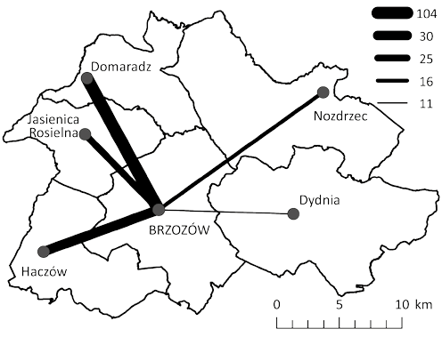
ThenumberofbusesdepartingfromBrzozówtothecapitalsofthefourneighbouringcommunesonaweekdayisratherlow(Figure3).Thisisparticularlynoticeableinthecaseofconnec-

Figure3.NumberoftripsfromBrzozówtothecapitalsofmunicipalitiesinBrzozówDistrictonweekdays.

Source:author’sownresearch.

- Capitalofmunicipality–themaintownorvillageinthemunicipalitywherethemunicipalofficeislocated
URBANISSUES
- Frequencyisthenumberofbustripsperunitoftime(Komornicki,Śleszyński,Rosik,Pomianowski2009).

tionswithNozdrzecandDydnia–busesdeparttotheselocationsonaverageeveryhour(Nozdrzec)andeverytwohours(Dydnia)4.ItisdefinitelyeasiertoreachJasienicaRosielna(every46minutes)andHaczów(every38minutes).ThebusesrunningfromBr-zozówtoDomaradzoperateonanextremelyregularbasisbe-causetheydepartevery11minutes.SuchastrongconnectionbetweenthesetwolocationsresultsdirectlyfromtheverygoodbusrouteexistingbetweenBrzozówandRzeszów,whichisin-fluencedbytheroadnetworkinthearea(Figure2).
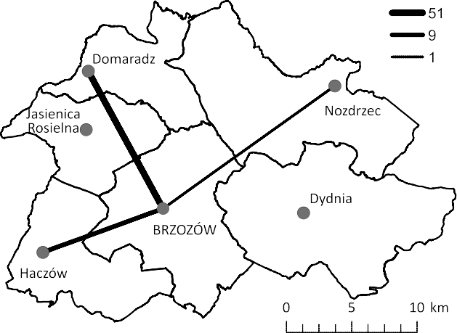
TheaccessibilityofpublictransportinBrzozówDistrictisclearlyworseonSaturdaysandSundays(Figures4–5).Thedemandfortransportationduringtheweekendisobviouslylowerthanonaweekday,butitisdisturbingthattherearenolinkstoJasienicaRosielnaandDydniaoverthewholeweekendorwithNozdrzeconSundays.Oneshouldbearinmindthattheseareimportantlocationshavingvariousfunctionsonalo-calscale.ThenumberoftripstoHaczówalsodecreasessig-nificantlyonSundays(sixtimeslower).Onweekends,thehighnumberoftripstoDomaradzismaintained.

Tripsbetweendistricts
ThereformofPoland’sadministrativedivisionsin1998–1999resultedinachangeintheimportanceandrankofcities(especiallyKrosno,PrzemyślandRzeszów),thereforetheconnectionsthatexistbetweenBrzozówandthosecitieswereanalysed.TheimportanceofthetwocapitalsofdistrictsthatadjoinBrzozówDistrict,StrzyżówandSanok,wasana-lysed.Atthispoint,itshouldbeexplainedthatuntil1999,KrosnowasthecapitalofKrośnieńskieProvinceinwhichBrzozówwaslocated.
ItwasnotedabovethattherearenodirectpublictransportlinksbetweenBrzozówandPrzemyśl.ThesituationisthesameinthecaseofStrzyżow(Figures6–8).However,itispossibletoreachthiscitytwiceaday(oneverydayoftheweek).ThisconnectionisofferedbyoneofthecarriersoperatingontheSanok–Brzozów–Krakowroute.Itisakindofresponseofaprivatecom-panytothelackofaStrzyżów–Brzozów–Sanokrailwayline,theconstructionofwhichhasbeenenvisagedsincethe19thcentury(MarszałekWojewództwaPodkarpack-iego2014).
MuchmoreinterestingisthegreataccessibilityofSanok
–busesrunthereevery10minutesonweekdays,every


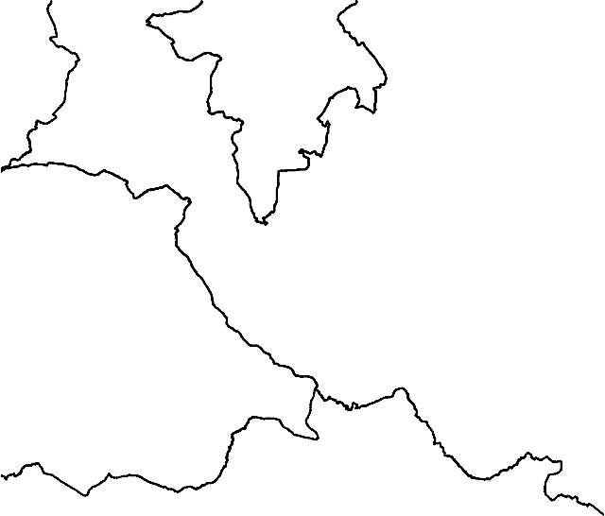
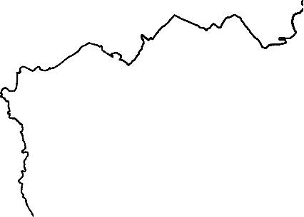
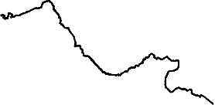
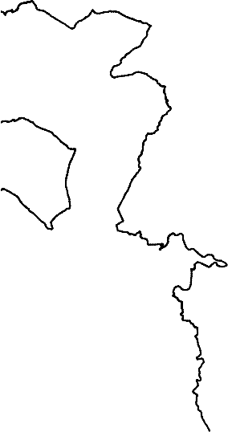
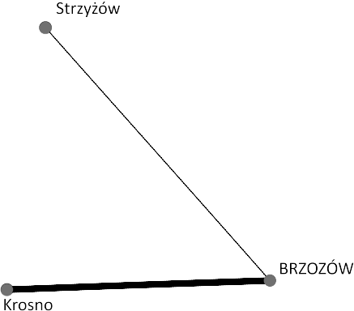
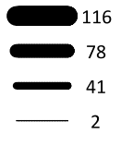
Figure4.NumberoftripsfromBrzozówtothecapitalsofmunicipalitiesinBrzozówDistrictonSaturdays.

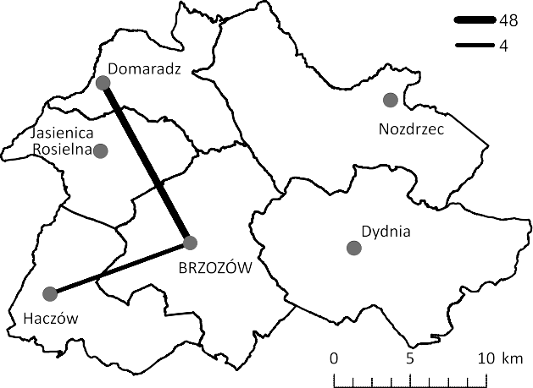
Source:author’sownresearch.

Figure5.NumberoftripsfromBrzozówtothecapitalsofmunicipalitiesinBrzozówDistrictonSundays.
URBANISSUES

Source:author’sownresearch.

- Aperiodof19hourswascountedasoneday(1140minutes)from04:00a.m.to23:00p.m.

Figure6.NumberoftripsfromBrzozówtoRzeszów,Strzyżów,KrosnoandSanokonweekdays.

Source:author’sownresearch.

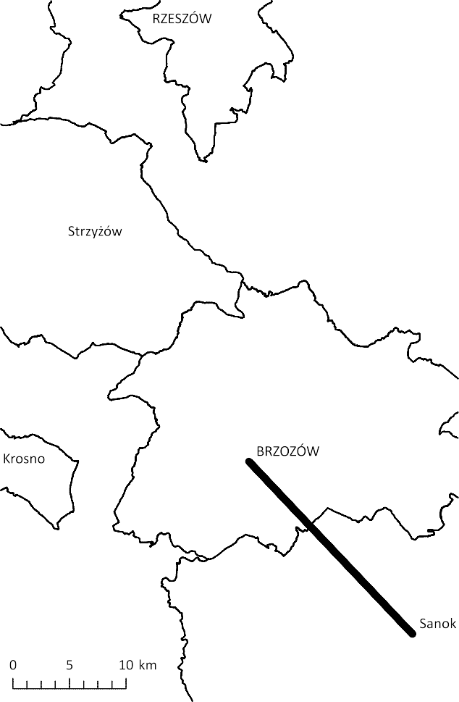

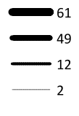
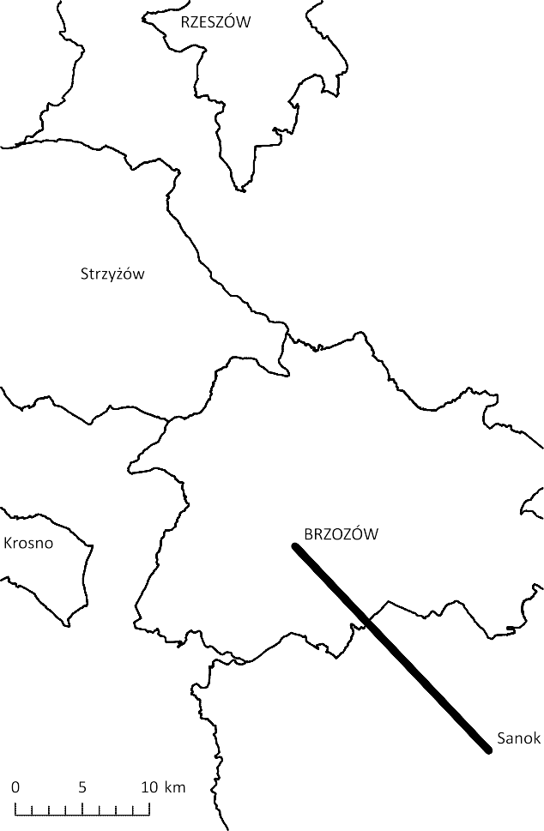

Figure7.NumberoftripsfromBrzozówtoRzeszów,Strzyżów,KrosnoandSanokonSaturdays.

Source:author’sownresearch.
Figure8.NumberoftripsfromBrzozówtoRzeszów,Strzyżów,KrosnoandSanokonSundays.

Source:author’sownresearch.

19minutesonSaturdaysandevery22minutesonSundays.Thisisduetotheexistenceofmanybuscompaniesoperatingbusesalongtworoutes:
URBANISSUES
- theshorteronethroughHumniskaandGrabownicaStarzeńska(route:Rzeszów–Sanok)
- thelongeronethroughHumniskaandTurzePole(routes:Brzozów–Krosno,localrouteTurzePole–ZarszynandKrosno–Sanok).
TheissueofaccessibilitytoRzeszów–thecapitaloftheregion–wasexaminedinamoredetailedmannerandtheanalysesnotonlytookthenumberoftripsandthefrequencyofbusoperationresultingfromitintoaccountbut,accordingtoR.Guzik(2012),alsothetraveltime(Tables1–3).ThebestpossibletraveltimetoRzeszówwasestimatedat60minutesforthebusjourneyplus10minutesforthewalk,whichgaveatotalof70minutes.Thefollow-ingaccessibilityratingsweredeterminedbyincreasingthistimebyintervalsof30minutes.Thebasisfortheas-sessmentofthenumberoftripstoRzeszówwasthefre-quencyofbusoperationindifferenttrafficconditions,wherethebasisforthelowestconvenienceclasswasalackofconnections,andtheexistenceofatleastonetripwasthesecondmostimportantfactor.Onaweekday,a15-min-utefrequencywasadoptedasideal.Inthecaseoffurther
accessibilityratingsthistimewasdoubledandwhenana-lysingtrafficinthemorningtrafficpeakitwasincreasedbyintervalsof15minutes.Inthecaseofweekends,thecriteriawereslightlymodified(Table3).Accordingtothecriterialistedabove,theaccessibilityofRzeszówusingpublictransportfromBrzozówcanbeassessedasalmostideal.Thisappliesbothtoweekdaysandweekends.Thisconvenienceclassificationfallstoaverygoodlevelforconnectionsinthemorningtrafficpeakonweekdays.ItshouldbenotedthatthesecriteriaareverydemandingwhichconfirmstheimportanceoftheBrzozów–Rzeszówrouteandtheexistenceofstrongfunctionallinksbetweenthesecities.
AsKrosnowasthecapitaloftheprovinceuntilrela-tivelyrecently,thedecisionwasmadetoverifytowhatextentBrzozówisconnectedwithKrosno–whetherornottherearestillstrongspatiallinks.Forthispurpose,asinthecaseofRzeszów,asimilaraccessibilityratingtoolwasapplied.However,thecriteriafortraveltimeweredifferentduetothefactthatthedistancebetweenthesetownsisshorter(idealtraveltime:30minutes,furtherclassesincreaseatintervalsof15minutes).ItturnsoutthattheratingofaccessibilityofKrosnofromBrzozówisverygoodonweekdays,goodonSaturdaysandpooron

Table1.EvaluationofaccessibilityofRzeszówviapublictransportonweekdays.

 |  | totaltravelandwalkingtimeinminutes |  |  |  |  |  | regularityofoperation
 |  | <71 | 71–100 | 101–130 | 131–160 | 161–190 | >190
numberofbustrips | >75 |  | BRZOZÓW |  |  |  |  | every15min.
numberofbustrips | 38–75 |  |  |  |  |  |  | every30min.
numberofbustrips | 19–37 |  |  |  |  |  |  | every60min.
numberofbustrips | 10–18 |  |  |  |  |  |  | every120min.
numberofbustrips | 1–9
numberofbustrips | 0
Source:author’sownresearch.

Table2.EvaluationoftheaccessibilityofRzeszówviapublictransportonweekdaysbetween4:00a.m.and9:59a.m.

 |  | totaltravelandwalkingtimeinminutes |  |  |  |  |  | regularityofoperation
 |  | <71 | 71–100 | 101–130 | 131–160 | 161–190 | >190 | regularityofoperation
numberofbustrips | >23 |  |  |  |  |  |  | every15min.
numberofbustrips | 12–23 |  | BRZOZÓW |  |  |  |  | every30min.
numberofbustrips | 8–11 |  |  |  |  |  |  | every45min.
numberofbustrips | 6–7 |  |  |  |  |  |  | every60min.
numberofbustrips | 1–5
numberofbustrips | 0
Source:author’sownresearch.

Table3.EvaluationoftheaccessibilityofRzeszówviapublictransportonweekends.

 |  | totaltravelandwalkingtimeinminutes |  |  |  |  |  | regularityofoperation
 |  | <71 | 71–100 | 101–130 | 131–160 | 161–190 | >190
numberofbustrips | >37 |  | BRZOZÓW |  |  |  |  | every30min.
numberofbustrips | 19–37 |  |  |  |  |  |  | every60min.
numberofbustrips | 10–18 |  |  |  |  |  |  | every120min.
numberofbustrips | 6–9 |  |  |  |  |  |  | every180min.
numberofbustrips | 1–5
numberofbustrips | 0
Source:author’sownwork.

Notetotables:scaleofaccessibilityratings:ideal,verygood,good,poor,verypoor,none.

Sundays.Inviewoftheabove,itcanbeconcludedthatthelinksbetweenBrzozówandKrosnoaresignificantlyweakerthanbetweenBrzozówandRzeszów.InthecaseofKrosno,commutingtoworkisevident–thenumberoftripsonSundaysissmall.
URBANISSUES

Long-distanceconnections
Apartfromthecitiesmentionedabove,itisalsopos-sibletousepublictransporttoreachothercitiesinPoland.TheconnectionsfromBrzozówcanbedividedintofourgroups:
- toWrocławthroughKrakowandKrosnoorRzeszów,DębicaandTarnów;
- toWarsawthroughRadom;
- toLublinthroughJanówLubelskiandNisko;
- toUstrzykiDolnethroughLeskoandZagórz.
Ingeneral,itispossibletoreachthemainPolishcitiesfromBrzozów,especiallythoselocatedinsouthern,easternandcentralPoland(Figures9–10).Thisphenom-enonshouldbeassociatedwiththeacademicfunctionofthesecities.Thisrelationshipisalsoconfirmedbytheweeklytimetables.Thenumberoflong-distanceconnec-tionsdoesnotdecreaseovertheweekendasclearlyasinthecaseoflocalconnections.Thisislinkedwith,amongotherfactors,thoseundertakingfull-timeandweekendstudies,aswellastourism.OnecandistinguishthetripsheadingforthetouristregionoftheBieszczadyMoun-tainsamongthenetworkofconnections.

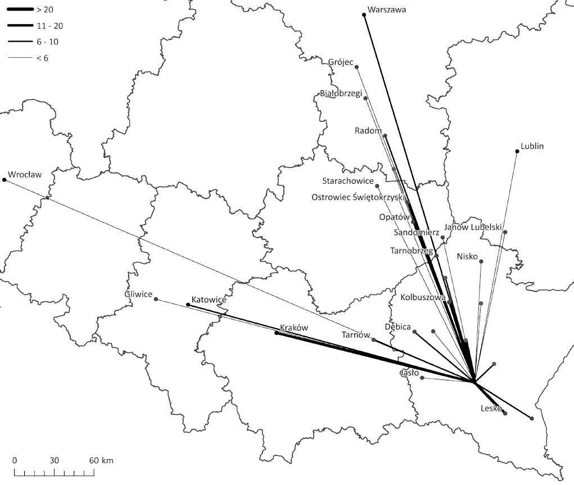
Figure9.NumberofconnectionsfromBrzozówtocitiesinPolandlocatedoutsideofBrzozówDistrict(withoutRzeszów,Strzyżów,KrosnoandSanok)onweekdays.

Source:author’sownresearch.

AccessibilitybypublictransportinBrzozów
URBANISSUES

WithintheterritoryofBrzozówthereisnomunicipalpublictransportsystem.Accesstopublictransportispro-videdbythelocal,intercityandlong-distancebuscompanies.AsmalltownlikeBrzozówneedsstrongconnectionswithneighbouringlargercities–forbotheconomicandsocialreasons.Therefore,theexistenceofpublictransportconnec-tionsiscrucial.
AnimportantfactorthatshapesthepublictransportsysteminBrzozów–apartfromitslocationinthesettle-mentnetwork–isthelocationofthecityonaveryimpor-tantrouteinthispartoftheregionwhichconnectsRzeszówwithSanokandtheregionoftheBieszczadyMountains.Thebestproofofthisisseeninthe170pairsofbuslinksrunningthroughthecitycentre(usingtheformerprovin-cialroad–nowthelocalroad).
Atthelocalscale,DomaradzandHaczówarethelocationsthatarethemostaccessiblefromBrzozów.Onawiderscale,itisRzeszów,SanokandKrosno.Whilediscussingconnections
withcitiesacrossthecountry,thefourlocationshavingstronglinksshouldbeemphasised:UstrzykiDolne,Krakow,WarsawandLublin.
Asfarasaccessibilityisconcerned,thereisabigdispro-portionbetweenthewesternandtheeasternpartofBrzozówDistrict.Poorconnectionsmayrequireimprovement,butthisisunlikelywithoutanypublicsupport.Whenitcomestotherestofthecountry,therearenoconnectionswiththenorthernpartofPoland,howeveritshouldbenotedthatonlyyear-roundrouteswereincludedintheresearch.Thereare,nevertheless,seasonalconnectionsbetweennorthernandsouth-easternPoland.
Accordingtopassengers,thekeychangesinthefunc-tioningofthecommunicationnetworkare:thelaunchingofnewbusroutes,thereorganisationofexistingroutes,andtheirremoval.ThecarriersindicatedtheprofoundchangesinthefunctioningofPKSKrosnoS.A.asthemainreasonforlaunchingthenewroutes.Thiscompanywasuntilrecentlythemajorcarrier(2012–2013),amonopolyonthelocalandintercitymarkets,anditplayedasig-

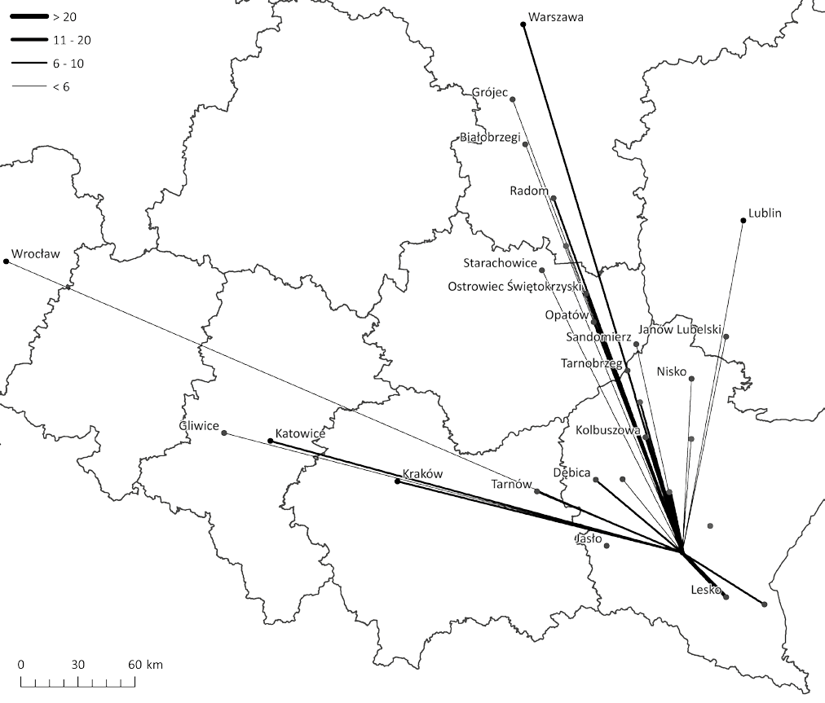
Figure10.NumberofconnectionsfromBrzozówtocitiesinPolandlocatedoutsideofBrzozówDistrict(withoutRzeszów,Strzyżów,KrosnoandSanok)onSaturdaysandSundays.

Source:author’sownresearch.

nificantroleinthefieldoflong-distancetransportser-vices.Nevertheless,aftertheorganisationalchangesandsubsequentprivatisation,mostofthebusrouteswerere-movedandserviceswereoftendeliveredwithoutrespect-ingthetimetables.Smallercompaniesthathadbeende-liveringtheirservicesonsingleroutesquicklyattemptedtofillthisgap.Thedemandfortransportserviceswas,andstillis,veryhigh,whichisconfirmedbythecarrierswhoclaimthatpassengersrequesttheopeningofnewroutesandbusservicesatnewtimes.
URBANISSUES
Thesecondmajorcarrier,bothonthelocal,intercityandlong-distancetransportmarket,wasARRIVASp.o.o.(for-merlyVeoliaTransport,PKSConnex),theprivatisedformerstate-ownedMotorTransportCompany(PKS)inBrzozów.Duringinterviews,thesmallercarriersindicatedthatcompet-ingwiththiscompanywasoneoftheiraims.Theydiditbyimprovingtheirserviceintermsofvehicles,pricesorchangesinthetimetables.InFebruary2017ARRIVASp.zo.o.an-nouncedtheclosingofitsbranchesinBrzozów,SanokandUstrzykiDolne(Fiszer2017).Theirbusesceasedoperating
theirservicesonJune30,2017.ThiswillbeanothercriticaljunctureforpublictransportinBrzozówregion.
Aspecialroleinthepublictransportsystemisplayedbytheso-called“schoolruns”thatensurethetransportofstu-dentstoandfromschools,mostlyhighschoolslocatedinthemajorcitiesoftheregion:Krosno,SanokorBrzozów.Theneedtotransportstudentsisoftenareasonforlaunchingnewbusroutesorbusservicesatnewtimesontheroutesthatalreadyexist.
Anotherveryimportantgroup,theneedsofwhichdeterminethetimetablesinthecommunicationnetwork,consistsofthosewhocommutetoworkplaceslocatedinmajorcities.Thethree-shiftsystemofworkingappliedinthebiggestcompanieswhichhavealargenumberofem-ployeesandthehourswhentheseshiftsstart:6:00a.m.,14:00p.m.and22:00p.m.haveasignificantinfluenceonthedesignofsuchtimetables.
Asfaraslong-distancebusservicesareconcerned,carri-ersclaimthatthemaingroupofpassengersconstitutestudents.Therefore,theroleofcommunicationlinkswiththemain

academiccitiesinthecountryiscrucial.ThismainlyreferstoKrakow,butalsotoLublin,WarsawandWrocław.Thecarri-ers,whiledevelopingtheirofferwithinthestudyareaoftheresearch,seektocreateasystemallowingpassengerstoreachadestinationpointinoneorseveralselectedlocationswithonlyonechangeenroute.Suchactionisdesignedtoincreasetheaccessibilityofacademiccitieswhileatthesametimere-ducingtheoperationalcostsforthecompany.
URBANISSUES
Generally,thecarriersarenotwillingtoremoverouteswhichtheyoperate.Interestingly,theconcludingofinformalagreementsbetweentransportcompaniesoperatingoncertainroutesisquiteacommonpractice.Iftheirbusinessisnotprofitable,onlyonecompanyremainsonthemarketduetosuch“agreements”.Suchactionswereconfirmedinseveralconversationssotheyarenotindividualorisolatedincidents.Anotherproblemthatforcescarrierstoremoveroutesareproblemsassociatedwithobtainingtheofficialadministrativepermissionstousebusstops.
Changesinthecurrentrangeoftransportservicesonofferareusuallyaresponseofcarrierstothemeasuresundertakenbytheircompetition.Sucheventsultimatelyleadtotheimprove-mentofthecommunicationservicestoparticularlocationsbyareductioninprices,improvementofvehiclequalityandin-creaseinthenumberofbusservicesonparticularroutes.
Theneedtoadapttocertainsolutionsandformalrequire-mentsisimportantinadditiontothechangesdictatedbythetransportneedsoftheinhabitantsofcertainlocations.ThemainproblemisaccesstothebusstationinBrzozów.Duetothefactthatthisareaismanagedbyaprivatecompanythatprohibitsvehiclesofothercompaniesfromenteringthebusstation,thevastmajorityofdeparturesfromthecitycentretakeplacefromonebusstop.Itislocatednearthebusstation,butitssizeandthelackofthepossibilityofanychangehinderitsusewhichaffectsbothcarriersandpassengers.Thebusbayissmallsoonlyonebusmayuseitatanyonetime.Forthisreason,theownerofthebusstopsignificantlylimitsthefre-quencyofdeparturessothatthetrafficflowssmoothly.Theselimitsoftencausechangestothecarriers’timetables.Asare-sult,theiroffersbecomelessattractive.Anotherproblemisthelackofofficialadministrativecontroloverthedegreetowhichthecarriersrespectthetimetables,whichoftenleadstoabusesandhasanegativeinfluenceonthecompetitionthatissodesirableinamarketeconomy.

Discussionandconclusions

InurbanareasinbothPolandandEurope,inasimilarmannertothesituationinAmericancities,anaturalrelation-shiphasbeenobservedbetweenthedevelopmentoftheroadnetworkandthepopulationdensityinthearea(Garcia-López2012).Equallyimportantisthefactthatthetransportsystemalwaysfunctionsinaregionalcontextandtherelationshipbetweenthestructureoftheregionandtransportisbilat-eral(Haag&Grützmann2001).Brzozówisaperfectexam-plethatconfirmsthetheoriesmentionedabove.Thelocationofthecityonanimportantroad(Rzeszów–Sanok)signifi-cantlyinfluencestransportaccessibility,includingpublictransport.Thenetworkofroutesismainlybasedonthisroad,whichcanbecalledthetransportaxisoftheBrzozówregion.
Itundoubtedlyaffectsthefunctioningofthecityintheeco-nomicandsocialsphere.Thereisastronginteractionbetweenthetransportsystem(includingpublictransport)andre-gionaldevelopment(Haag&Grützmann2001).Publictransport,whichisanalternativetoandsubstituteforindi-vidualtransport,constitutesoneofthetoolsthatisusedtocombattransportexclusion(Iles2005).
Thedesiretoadaptthetransporters’servicestotheneedsofstudentsandtheemployeesoflargecompaniesonthelo-calmarketaswellastotheneedsofuniversitystudentsonthemarketoflong-distancetransportwasindicatedasthemainreasonforchangesinthepublictransportsysteminthestudyarea.Therelativelysmalltransportcompaniesalsocompetewitheachother,tryingtoreduceorevenmargin-alisetheactivitiesoflargemotortransportcompanies.Thesearethecharacteristicfeaturesofatransportsystemafterthelimitationsthatanineffectivepubliccarrierhasintroducedintoitsactivity(Iles2005).
Thefunctioningofthepublictransportsystemwithintheterritoryofthemunicipalityissatisfactoryonweekdays,butrequiresimprovement,especiallyonSundays.AdevelopmentthatwoulddefinitelyimprovethefunctioningofthesystemunderexaminationwithintheterritoryofthemunicipalitywouldbethecreationofapubliclyaccessiblebusstationinBrzozów,whichwouldserveasatransporthub.Anotherimportantissuethatrequiresimprovementisthelegalsystemthathindersthesmoothoperationofthesystem(Iles2005).
Therearecertaintoolsthatarerecommendedinordertoimprovepublictransportinruralareas(suchasBrzozów):thecreationofapassengerinformationsystem,notonlyatbusstops(e.g.inlargestoresorrestaurants),theconstructionofParkandRidecarparkspermittingtheintroductionofchangesinpublictransport,andimprovingtheticketpur-chaseprocess(ticketintegration)(Cullinane&Strokes1998).ThelackofthepossibilityofbuyingoneticketpermittingtheusetheservicesofdifferentcarriersintheBrzozówregionhasanegativeimpactonthequalityofpublictransport.
Inconclusion,theaccessibilityofpublictransportinBrzozówisquitegoodandrequiresrelativelyfewchangesinordertobeconsideredoptimal.Recentchangesonthelocalpassengertransportmarkethavebroughtverypositiveresultsandplansforthefutureareverypromising.
Beingaperipherallocationinthesettlementhierarchy,Brzozówdoesnotfullymeettheneedsoftheinhabitantsoftheregiontowhichitbelongs.Therefore,highexternalacces-sibilityofthistowngivesitachancetodevelop,bothintheeconomicandsocialcontexts.Brzozówisatownthathasverygoodcommunicationswithlocationsofsimilarrankandaboveallwiththemaincitiesintheregionandcountry.AspointedoutbyM.Dej(2010),insimilarareasofPolandpublictransportoftendoesnotmeetthecommunicationneedsoftheresidents,eventhemostbasicones–suchastheneedtocommutetowork.Therefore,Brzozówisanexception.Despiteitsperiph-eraleconomicimportance,itislocatedinacertainkindofcorewhenitcomestotheissueoftransport.Duetoitshightransportaccessibility,thelifeopportunitiesofthepopulationincrease(Pacione1989)whichsignificantlydecreasessocialexclusion(Cassetal.2005,Farrington2007).Locationinthevicinityofimportantregionalandnationalroadshasapositive

impactontheaccessibilityofpublictransport,asevidencedbyresearchcarriedoutintheCzechRepublic(Ivanetal.2013).Moreover,theeconomicpotentialofBrzozówmaybeenhancedbyimprovingthequalityofhumanandsocialcapital,bothonalocalandregionalscale.Suchgoodopportunitiesforeco-
nomicdevelopmentcloselycorrelatedwiththefunctioningofthetransportsystemarenotcommonincitiesofarankthatislowerthanregional,andstrengtheningrelationsintheregionisanimportantfactorstimulatingsocialandeconomicgrowth(Garmendia,deUreña,Ribalaygua,Leal&Coronado2008).

References

Black,J.&Conroy,M.(1977)AccessibilityMeasuresandtheSocialEvalu-ationofUrbanStructure,EnvironmentandPlanningA,9,1013–1031.Cass,N.,Shove,E.&Urry,J.(2005)Socialexclusion,mobilityandaccess,
SociologicalReview,53,539–555.
Cullinane,S.&Strokes,G.(1998)RuralTransportPolicy,Pergamon,Amsterdam-Lausanne-NewYork-Oxford-Shannon-Singapore-Tokyo.Dej,M.(2010)TransportpublicznywwiejskichobszarachperyferyjnychPolskiijegodostosowaniedopotrzeblokalnychrynkówpracy,Prace
Geograficzne,124,111–130[inPolishwithEnglishsummary].Farrington,J.(2007)Thenewnarrativeofaccessibility.Itspotentialcontri-
butiontodiscoursesin(transport)geography,JournalofTransportGeography,15,319–330.
Garcia-López,M.A.(2012)Urbanspatialstructure,suburbanizationandtransportationinBarcelona,JournalofUrbanEconomics,72,176–190.Garmendia,M.,deUreña,J.M.,Ribalaygua,C.,Leal,J.&Coronado,J.M.(2008)Urbanresidentialdevelopmentinisolatedsmallcitiesthatarepartiallyintegratedinmetropolitanareasbyhighspeedtrain,European
UrbanandRegionalStudies,15,249–264
Guzik,R.(2003)Przestrzennadostępnośćszkolnictwaponadpodstawowego,IGiGPUJ,Kraków.
Guzik,R.,Zborowski,A.,Kołoś,A.,Micek,G.,Gwosdz,K.,Trzepacz,P.,Chaberko,T.,Kretowicz,P.,Ciechowski,M.,Dej,M.&Grad,N.(2010)Dostępnośćkomunikacyjnaipowiązaniamiastorazdelimitacjaob-szarówfunkcjonalnych[in:]B.Domański&A.Noworól,eds.,Małopolskiemiasta–funkcje,potencjałitrendyrozwojowe,Departa-mentPolitykiRegionalnejUrzęduMarszałkowskiegoWojewództwaMałopolskiego,Kraków,88–134[inPolish].
Guzik,R.,ed.(2012)Czynnikiiograniczeniarozwojumiastwojewódz-twapomorskiegowświetlerelacjiprzestrzennychidostępnościko-munikacyjnej,UrządMarszałkowskiWojewództwaPomorskiego,Gdańsk[inPolish].
Guzik,R.,Kołoś,A.,Gwosdz,K.,BiernackiW.,DziałekJ.,KocajA.,Pa-necka-Niepsuj,M.&Wiedermann,K.(2016)Dostępność,relacjeipowiązaniaprzestrzennewMiejskimObszarzeFunkcjonalnymOlsz-tyna,IGiGPUJ,Kraków.
Haag,G.&Grützmann,K.(2001)TransportandUrbanDevelopment[in:]
G.Clarke&M.Madden,eds.,RegionalScienceinBusiness,Springer,Berlin-Heidelberg,189–210.
Iles,R.(2005)PublicTransportinDevelopingCountries,Elsevier,Amster-dam-Boston-Heidelberg-London-NewYork-Oxford-Paris-SanDiego-SanFrancisco-Singapore-Sydney-Tokyo.
Ivan,I.,Horak,J.,Fojtik,D.&Inspektor,T.(2013)EvaluationofpublictransportaccessibilityatmunicipalitylevelintheCzechRepublic,Inter-
nationalMultidisciplinaryScientificGeoConference:SGEM:SurveyingGeology&miningEcologyManagement,Sofia,SurveyingGeology&MiningEcologyManagement(SGEM),527–534.
Komornicki,T.,Śleszyński,P.,Rosik,P.&Pomianowski,W.(2009)Dostępnośćprzestrzennajakoprzesłankakształtowaniapolskiejpolitykitransportowej(BiuletynKPZKPAN,240)[inPolishwithEnglishabstract].
MarszałekWojewództwaPodkarpackiego(2014)PlanzrównoważonegorozwojupublicznegotransportuzbiorowegodlaWojewództwaPodkar-packiego,zał.DoUchwałynrLIVSejmikuWojewództwaPodkarpack-iegozdnia22.04.2014r.[inPolish].
Moseley,M.J.(1979)Accessibility:TheRuralChallenge,London,Methuen.
Paccione,M.(1989)Accesstourbanservices.ThecaseofsecondaryschoolsinGlasgow,ScottishGeographicalMagazine,105,12–18.
Ratajczak,W.(1992)DostępnośćkomunikacyjnamiastwojewódzkichPol-skiwlatach1948–1988[in:]Z.Chojnicki&T.Czyż,eds.,Współczesneproblemygeografiispołeczno-ekonomicznejPolski(SeriaGeografiaUAMwPoznaniu,55),173–203[inPolish].
Taylor,Z.(1997)Dostępnośćmiejscpracy,naukiiusługwobszarachwiejs-kichjakoprzedmiotbadańgeografiispołeczno-ekonomicznej–próbaanalizykrytycznej,PrzeglądGeograficzny,69(3–4)261–283[inPolish].Taylor,Z.(1999)Przestrzennadostępnośćmiejsczatrudnienia,kształceniaiusługacodziennaruchliwośćludnościwiejskiej(PraceGeograficzne
171),IGiPZPAN,Wrocław[inPolishwithEnglishsummary].
Ustawazdnia16grudnia2010r.opublicznymtransporciezbiorowym,t.j.
DzU2015r.poz.1440,1753,1890,1893[inPolish].
Tracz,M.(1984)Badaniaruchukomunikacjizbiorowej[in:]M.Tracz,ed.,Pomiaryibadaniaruchudrogowego,WydawnictwaKomunikacjiiŁączności,Warszawa,83–88.
Veeckman,C.,Jedlička,K.,DePaepe,D.,Kozhukh,D.,Kafka,S.,Colpaert,
P.&Čerba,O.(2017),Geodatainteroperabilityandharmonizationintransportacasestudyofopentransportnet,OpenGeospatialData,SoftwareandStandards,2(1):3.
Warakomska,K.(1992)Zagadnieniedostępnościwgeografiitransportu,PrzeglądGeograficzny,64(1–2),67–76[inPolishwithEnglishabstract].

Internetsources
CambridgeDictionary,Publictransport,http://dictionary.cambridge.org/dictionary/english/public-transport[accessed:30.04.2017]
FiszerK.,17.02.2017,ArrivawycofujesięzPodkarpacia,TransportPubliczny.
Availablefrom:http://www.transport-publiczny.pl/wiadomosci/arriva-wycofuje-sie-z-podkarpacia-54336.html[accessed:30.04.2017][inPolish].GłównyUrządStatystyczny,BankDanychLokalnych,https://bdl.stat.gov.
pl/BDL/start[accessed:30.04.2017][inPolish].
URBANISSUES
MinistryofScienceandHigherEducation
RepublicofPoland
ProjectoftheinternationalizationoftheUrbanDevelopmentIssuesjournalisfinancedbytheMinistryofScienceandHigherEducationoftheRepublicofPoland(grantNo.841/P-DUN/2016).

