


ORIGINALRESEARCH
published:31August2017doi:10.3389/fnhum.2017.00429
EffectsofScenePropertiesand
EmotionalValenceonBrainActivations:AFixation-RelatedfMRIStudy
MichałKuniecki1*,KingaB.Wołoszyn1,AleksandraDomagalik2andJoannaPilarczyk1
1PsychophysiologyLaboratory,InstituteofPsychology,JagiellonianUniversity,Kraków,Poland,2NeuroimagingResearchGroup,TheMałopolskaCentreofBiotechnology,JagiellonianUniversity,Kraków,Poland
Temporalandspatialcharacteristicsoffixationsareaffectedbyimageproperties,includinghigh-levelscenecharacteristics,suchasobject-backgroundcomposition,andlow-levelphysicalcharacteristics,suchasimageclarity.Theinfluenceofthesefactorsismodulatedbytheemotionalcontentofanimage.Here,weaimedtoestablishwhetherbraincorrelatesoffixationsreflectthesemodulatoryeffects.Tothisend,wesimultaneouslyscannedparticipantsandmeasuredtheireyemovements,whilepresentingnegativeandneutralimagesinvariousimageclarityconditions,
withcontrolledobject-backgroundcomposition.ThefMRIdatawereanalyzedusing
anovelfixation-basedevent-related(FIBER)method,whichallowsthebrainactivitylinkedtoindividualfixations.Theresultsrevealedthat
emotionalobjectwaslinkedtogreaterdeactivationintherightlingual
trackingoffixatingan
gyrusthan
Editedby:
JoshuaOonSooGoh,NationalTaiwanUniversity,Taiwan
Reviewedby:
ErikChang,NationalCentralUniversity,Taiwan
Jan-BernardMarsman,University MedicalCenter Groningen,
Netherlands
*Correspondence:MichałKunieckimichal.kuniecki@uj.edu.pl
fixatingthebackgroundofanemotionalimage,whilenodifferencebetweenobjectandbackgroundwasfoundforneutralimages.Wesuggestthatdeactivationinthelingualgyrusmightbelinkedtoinhibitionofsaccadeexecution.Thiswassupportedbyfixationdurationresults,whichshowedthatinthenegativecondition,fixationsfallingontheobjectwerelongerthanthosefallingonthebackground.Furthermore,increaseintheimageclaritywascorrelatedwithfixation-relatedactivitywithinthelateraloccipitalcomplex,thestructurelinkedtoobjectrecognition.Thiscorrelationwassignificantlystrongerfornegativeimages,presumablyduetogreaterdeploymentofattentiontowardsemotionalobjects.Oureye-trackingresultsareinlinewiththeseobservations,showingthatthechanceoffixatinganobjectrosefasterfornegativeimagesoverneutralonesasthelevelofnoisedecreased.Overall,ourstudydemonstratedthatemotionalvalueofanimagechangesthewaythatlowandhigh-levelscenepropertiesaffectthecharacteristicsoffixations.Thefixation-relatedbrainactivityisaffectedbythelow-levelscenepropertiesandthisimpactdiffersbetweennegativeandneutralimages.Thehigh-levelscenepropertiesalsoaffectbraincorrelatesoffixations,butonlyinthecaseofthenegative
images.
Received:20 April 2017
Accepted:11August2017
Published:31August2017
Citation:KunieckiM,WołoszynKB,DomagalikAandPilarczykJ(2017)Effectsof ScenePropertiesandEmotionalValenceonBrainActivations:AFixation-Related
fMRIStudy.Front.Hum.Neurosci.11:429.doi:10.3389/fnhum.2017.00429
Keywords:fMRI,eyemovements,attention,visualnoise,object,sceneperception
FrontiersinHumanNeuroscience|www.frontiersin.org
1
August2017|Volume11|Article429

Kunieckietal.
Fixation-RelatedBrainActivations
INTRODUCTION
Visualinformationacquisitionisnotacontinuousprocess.Itispartitionedintofixations,duringwhichvisualinformationisextracted.Portionsofinformationacquiredduringfixationsmayberegardedas‘‘unitsofinformation’’(Marsmanetal.,2012),theprocessingofwhichcanbesystematicallyanalyzed,providinginsightintoperceptualandcognitivemechanismsofvision,includingattention.Themajorfunctionofattentionistofilterthemostimportantinformation.Indeed,infreeviewingconditionsspatialdeploymentofattentionisreflectedinthetemporalandspatialcharacteristicsoffixations(forareviewseeHenderson,2003).Specifically,fixationsarenotrandomlydistributed;theirlocationanddurationstronglydependontheinformativevaluelinkedtobothhigh-levelscenecharacteristics,suchasobject-backgroundcomposition,andbasiclow-levelphysicalproperties,suchassignal-to-noiseratio(Buswell,1935;MackworthandMorandi,1967;Yarbus,1967;Kayseretal.,2006;Hendersonetal.,2009;Ossandónetal.,2012;Glaholtetal.,2013;Hendersonetal.,2014;Onatetal.,2014).Interestingly,emotionalcontentstronglyattractsattentionandinfluenceseyemovements,possiblyduetoitsevolutionaryandbehavioralrelevance(CalvoandLang,2004;Nummenmaaetal.,2006;Calvoetal.,2007,2008;Humphreyetal.,2012;Niuetal.,2012;Kasparetal.,2013;PilarczykandKuniecki,2014).Moreover,ithasbeenshownthattheemotionalcontentmodulatestheimpactofbothhighandlow-levelfeaturesofasceneontheprocessingofvisualinformationandattentionaldeployment(Humphreyetal.,2012;Toddetal.,2012b;PilarczykandKuniecki,2014).Inthepresentstudy,weaimedtoexaminethebrainunderpinningsofthismodulatoryeffectusingtherecentlydevelopedfixation-basedevent-related(FIBER)methodoffMRIdataanalysis(Marsmanetal.,2012).
Oneoftheessentialcomponentsofvisionisthedetectionandidentificationofobjects.Itisaprocessrequiringscenedecompositionintodiscreteobjectsandbackground(HendersonandHollingworth,1999).Variouslinesofresearchshowthatemotionalobjectsareeasilydetectedandpreferentiallycaptureattention(Ohmanetal.,2001;Nummenmaaetal.,2006;Humphreyetal.,2012;Niuetal.,2012;McSorleyandvanReekum,2013;PilarczykandKuniecki,2014).Eye-trackingstudieshaveshownthatwhileviewingemotionalscenes,attentionisinstantlydrawntoobjectsratherthanthebackground,whereasobjectsinneutralscenesdonotattractattentiontothesameextent(Humphreyetal.,2012;Niuetal.,2012;PilarczykandKuniecki,2014).Furthermore,theinteractionbetweenemotionalcontentandobject-backgroundcompositionhasalsobeenshownintheEEGstudies,usingthesteady state visual evokedpotentials (ssVEPs) and event-relatedpotentials(ERP).Emotionalimages,asawhole,evokegreaterbrainactivations,measuredasthemagnitudeofthessVEPs,thanneutralones(Keiletal.,2003).However,iftheattentionalfocusiscuedtowardsthebackgroundofanemotionalpicture,thessVEPresponseisindistinguishablefromthessVEPresponsetoaneutralobject(Hajcaketal.,2013).Onlyafterfocusingspatialattentionontothekeyemotionalobject,theenhancementofthessVEP and latepositive potential, anERP component linked
toemotionalprocessing,doesemerge(Keiletal.,2005;Hajcak
etal.,2013).ThiseffectisfurthersupportedbyFerrietal.’s(2013)fMRIstudy,whichshowedthatfocusingovertattentiononanemotionalregionwithinanegativeimage,comparedtoanon-emotionalregion,islinkedtogreateractivitynotonlyinbrainareasrelatedtoemotion,suchastheamygdalaandinsula,butalsointhepartofthevisualcortex,inferioroccipitalgyrus.Thispatternofresultsdemonstratesthatfixatingkeyemotionalobjects,indeed,changesbrainactivity,ascomparedtofixatingboth a neutral object and thebackground of an emotional scene.Presumably,thischangeofbrainactivityoccursduetoenhancedprocessingofemotionalvisualinformation(Langetal.,1998;Bradleyetal.,2003;Junghöferetal.,2006;Toddetal.,2012a).
Regardingthelow-levelpropertiesofstimuli,superimposingvisualnoiseoveranimageaffectsitsinformativevalueonamorebasiclevel,bylimitingtheavailabilityofvisualinformation.Visualnoiseinfluencestheactivityofthevisualcortex,however,onlywithinthehighervisualareaslinkedtoobjectrecognitionandscenecomprehension,suchastheV4,lateraloccipitalcortex(LOC),fusiformfaceareaandmid-fusiformarea(Grill-Spectoretal.,1998;Tjanetal.,2006;Pratteetal.,2013).Interestingly,emotionalvalueofstimulimodulatestheimpactofthevisualnoiseonbrainactivity.Namely,emotionalstimuliarerecognizedatalowerthresholdofnoise(Reindersetal.,2005)andareperceivedaslessnoisy(Markovicetal.,2014),whichislinkedtogreateractivitywithintheLOCandamygdala(Reindersetal.,2005;Toddetal.,2012b).
Severaleye-trackingstudieshaveshownthatboththenoiselevelandemotionalcontentofanimageaffectfixations,whichbecomelongerastheclarityofanimagedecreasesduetoeitherhighorlowspatialfiltering(Glaholtetal.,2013;Hendersonetal.,2014)orotherdistortionmethodspreventingscenecomprehension(LukeandHenderson,2016).Emotionalcontentalsoaffectsfixationnumberandduration.Bradleyetal.(2011)establishedthatparticipantsmakemorefixationsonnegativeandpositiveimagesthanonneutralones.Individualfixationsexecutedwhilewatchingemotionalimagesarealsoshorter(Bradley et al.,2011;Kaspar etal.,2013). Arecently developedmethodoffMRIanalysisallowstheestimationoftherelationbetweenindividualfixationsandbrainactivity.FIBERanalysishassofarbeenemployedinafewexperiments,whoseresultsarenotentirelyconsistent.Marsmanetal.(2013)haveshownthatfixationdurationcorrelatesnegativelywithactivityintheventromedialvisualcortexandearlyvisualcortex.Contrarily,HendersonandChoi(2015)establishedthatfixationdurationislinkedtoactivationswithintheprimaryvisualcortexaswellasthefrontalgyrusanddorsolateralprefrontalcortex.Additionally,fixationdurationwaslinkedtodeactivationsinthecerebellum,brainstem,hippocampus,amygdalaandparacentrallobule.ThesefindingsseemtobesupportedbytherecentexperimentbyMarsmanetal.(2016)inwhichoccurrenceoffixationswaslinkedtoanincreaseinactivitywithintheearlyvisualcortexaccompaniedbyactivationsinthedorsalandventralvisualstreams.Overall,itappearsthatfixationeventsareconsistentlylinkedtochangesinactivitywithintheearlyvisualareas,however,thedirectionofthischangeremainsunclear.
FrontiersinHumanNeuroscience|www.frontiersin.org
2
August2017|Volume11|Article429

Kunieckietal.
Fixation-RelatedBrainActivations
Sincebothdecreaseinvisualnoiseandemotionality
are
differedsignificantlybetweentheimagecategories(forvalence
t(48)=−16.07,p<0.001;forarousalt(48)=8.85,p<0.001).
Inbothimagedatabases,thevalenceandarousalwererated
onscales1–9,rangingfromnegativetopositivevalence,andfromlowtohigharousal,respectively.Weensuredthatthemeansizeofthekeyobjectwasthesameforbothnegativeandneutralimages(10%and11%oftotalimagearea,respectively;
t(48)=−1.0,p=0.55)inordertomatchimagesintermsofpicturecomposition.
ThekeyobjectswithintheimagesweredeterminedinaprocedureconductedpriortothefMRIexperiment,inwhichparticipants(differenttothosetakingpartinthescanningprocedure)wereaskedtocirclekeylocationsdeterminingthevalenceofeachimageusingasimplecomputertool.Thekeyobjectswereobtainedbyaveragingtheselectionsandbyapplyingathreshold(aregionencircledbyatleast50%oftheparticipants). A totalof 602images wererated in thisprocedureby241participants.Eachparticipantrated60–80images.Eachoftheimagesselected tothisfMRI studywererated onaverageby
29.6participants(SD=4.5).Theprocedureofdeterminingkeyobjectsandthemethodofdataanalysishavebeendescribedindetailelsewhere(PilarczykandKuniecki,2014).
Tomanipulatetheamountofvisualinformation,pinknoisewassuperimposedontheoriginalimages.PinknoiseisobtainedbyreplacingthephaseintheFourierspectrumofanoriginalimagewithrandomvaluesbetween0and2piwhilekeepingtheamplitudesunchanged(Kayseretal.,2006).Pinknoisewasaddedtotheoriginalimagesinthefollowingproportions:0%,60%,70%,80%,100%(Figure1),itwasgeneratedseparatelyforeachproportionandeachimage.Allimageswereequatedfor
luminanceandcontrastwhichweremeasuredasameanandstandarddeviationofL∗componentoftheL∗a∗b∗colorspace.
relatedtothereductionoffixationduration,presumablytheir
additiveorinteractiveeffectwouldinfluencebraincorrelatesoffixations.Itispossiblethatthismodulationoffixationdurationwould be accompanied by changes in activity of the early visualareas,asreportedbyMarsmanetal.(2013,2016)andHendersonandChoi(2015).Weexpectedfixation-relatedbrainactivitytobelinearlycorrelatedwith thelevel ofnoise,and morepronouncedinthecaseofnegativeimages.Furthermore,basedonevidenceformoreintenseprocessingofemotionalstimuli(forreviews,seeSabatinellietal.,2011;Bradleyetal.,2014;Lindquistetal.,2015;García-Garcíaetal.,2016),weexpectedthatfixatingemotionalobjectswouldbelinkedtogreaterfixation-relatedbrainactivitythanfixatingneutralobjects.Lastly,weaimedtotestwhetherthedifferenceinbrainactivityaccompanyingfixationsonobjectsandonthebackgroundwouldbelargerfornegativeimagesoverneutralones.
Inordertotestourpredictions,weusedsimultaneousfMRIandeye trackingrecording,whilepresentingnegative andneutralimageswithcontrolledobject-backgroundcompositionandvaryingsignal-to-noiseratios.Then,weappliedtheFIBERmethodoffMRIdataanalysis,describedbyMarsmanetal.(2012),inwhichfixationeventsareusedasregressors.Marsmanetal.(2012)haveshownthatdespitebeingbriefandfrequentlyoccurring,fixationsyieldthemselvesasvalideventmarkersinanfMRIanalysis.Additionally,wecalculatedthechanceoffixatingan object and averagefixation duration in ordertoexaminewhetherthemodulatingroleofemotionalcontentisalsoreflectedintheeye-trackingdata.
MATERIALSANDMETHODS
Participants
Twentyhealthyparticipants(10women),
Procedure
The experiment consistedof five scanningruns (each 10.8min.,216volumes).Eachrunwasprecededbyanine-pointcalibrationprocedure.Imagesspanned30horizontal×23verticaldegreesofthevisualfield.StimuliwerepresentedviatheVisualSystemgoggles.Imageswereshownfor5sinfixedsequencesfrom100%to0%ofnoise.Priortoeachimage,thefixation
crosswaspresentedforatimethatrandomlyvariedbetween
3sand6s.Betweenthesequencesthefixationcrosswaspresentedforatimewindowlasting8sonaverage,adjustedsothateachsequencelastedprecisely60s,whichensuredthateachrunaccommodated10sequences.Thesequenceswerepresentedinarandomorder,ensuring,however,thatineachrunnotmorethansevensequencesbelongedtothe same emotional category. In total, 50unique sequenceswerepresentedduringtheentireexperiment.Tomaintainparticipants’attentionthroughouttheruns,theywereaskedtoclassifyonerandomlyselectedimageineachsequenceastakenoutdoorsorindoors.Theentireexperimentalprocedurelastedapproximately60min.
aged19–29years
(M=22.8)withnormalorcorrected-to-normalvision,nohistory
ofneurologicaldisordersandfreefromanymedicalcondition,wererecruitedbymeansofcommunityadvertisementsontheJagiellonianUniversity Campus.A fewdays beforetheexperiment,volunteersvisitedanfMRIfacilitywheretheirabilitytocorrectlyperceiveimagesthroughtheVisualSystemgoggles(NordicNeurolab,Bergen,Norway)wastested.Onlythoseabletoperceiveaunitaryperceptthroughgoggleswereinvitedtoparticipatein theexperiment.Priortothescanningsession,participantssignedaninformedconsentinaccordancewiththeDeclarationofHelsinkiandanagreementtoundergoanfMRIscanningprocedure.TheexperimentalproceduregottheapprovaloftheethicalcommitteeoftheInstituteofPsychologyattheJagiellonianUniversity.
ExperimentalMaterial
Asetof25negative(valenceM=2.62,SD=0.47;arousalM=6.35,SD=0.58)and25neutral(valenceM=5.07,SD=0.60;arousalM=4.07,SD=1.15)colorimageswasselectedfromtheInternationalAffectivePictureSystem(IAPS;Langetal.,2008)andtheNenckiAffectivePictureSystem(NAPS;Marchewkaetal.,2014)basedonbothvalenceandarousalratings,which
EyeMovementRecordingandAnalysis
TheViewPointinfraredEyeTracker(ArringtonResearch,Scottsdale,AZ,USA)wasusedtomeasureeyemovementsata
FrontiersinHumanNeuroscience|www.frontiersin.org
3
August2017|Volume11|Article429

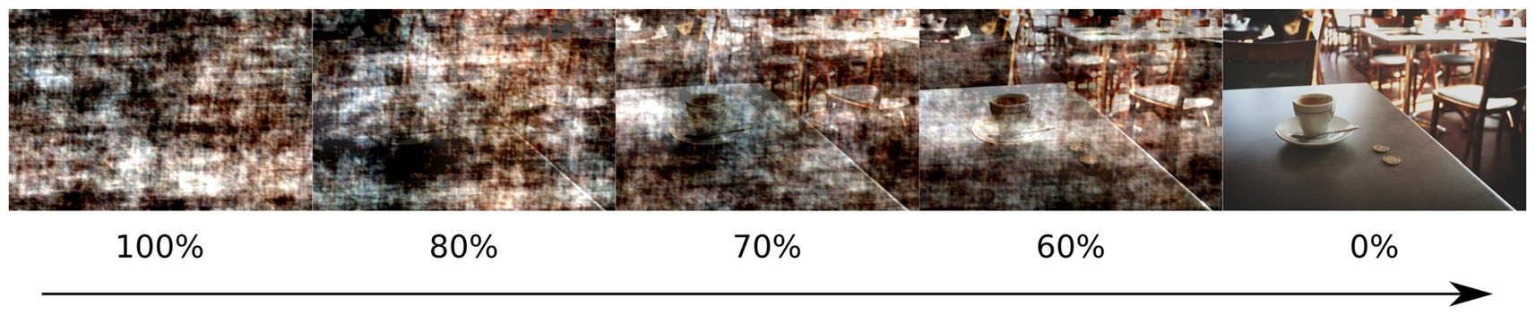
Kunieckietal.
Fixation-RelatedBrainActivations
60Hzsamplingrate.Apositionoftherighteyewasrecorded.
Adefaultnine-pointcalibrationprocedurewasrepeatedatthebeginningofeachexperimentalblock.Additionally,beforeeachsequenceasinglepointdriftcorrectionwasperformed.FixationsandsaccadesweredetectedusingthedefaultArringtonalgorithmfortheViewPointinfraredEyeTracker(velocitybelow26,5◦/s,driftlessthan0.8◦fromthefixationpoint).Fixationsoneachimagewereanalyzedtodeterminewhethertheyfellonakeyobject,oroutsidetheobject,onthebackground.Thedurationofeachfixationwasalsoanalyzed.Thefirstfixationwasdefinedasstartingaftertheonsetofanimage.
Toassessthechanceoffixatinganobject,wecalculatednormalizedfixationproportion(NFP),describedindetailinPilarczykandKuniecki(2014).Thismeasureissimilarinprincipletoothertestsofclassificatorstrengthlikethecommonlyusedreceiveroperatingcurve(ROC)henceenablingtheexclusionofsuchconfoundsasthesizeandpositionofanobject—particularlyitsdistancefromthecenterofthescreen—affectingfixationchance(Parkhurstetal.,2002;Tatleretal.,2005;Tatler,2007).Inbrief,tocalculateNFPthefractionoffixationsthatfallontheobjectwhilelookingattheanalyzedimage(positivesample)isdividedbythefractionoffixationsmadeinthislocationinotherimagespresentedinthesamenoiseandemotionalcondition(negativesample).IfNFPequalsone,thenumberoffixationsonanobjectcanbeentirelyexplainedbytheobject’slocationandsize.Ifitislarger,morefixationsfallonanobjectthanarepredictedbychance.FixationdurationwasanalyzedusingrepeatedmeasuresANOVAwithfactorsofnoiselevel(fivelevels),emotionalcategory(negativeandneutral)andfixationlocation(object,background).NFPwasexaminedwithrepeatedmeasuresANOVAincludingfactorsofnoise(fivelevels)andemotionalcategory(negativeandneutral).Inallcaseswherethesphericityassumptionhasbeenviolated,theresultsarereportedwithH-Fcorrection.SimpleeffectswereinvestigatedusingBonferronicorrection.
wereacquiredusinganEPIsequence;scanparameterswereasfollows:TR=3000ms,TE=21ms,flipangle=90◦,voxelsize2×2×2.5mm3,FOV192×192mm2,GRAPPAaccelerationfactor2,phaseencodingA>P.Wholebrainimage
(excludingcerebellum)wascoveredwith48axialslicestakeninaninterleavedfashion.Therewerefivefunctionalruns;theacquisitiontimeforeachrunwas10’48"(216volumes).Duetomagneticsaturationeffects,thefirstfourvolumes(dummyscans)ofeachrunwereacquiredandthendiscardedbythescanner.
TheexperimentaltaskwaspresentedthroughtheVisualSystemgogglesequippedwithViewPointmonoculareye-trackingcameras(infrared,60Hz)andresponseswerecollectedusingfiber-opticresponsebuttongrips(NordicNeuroLab,Bergen,Norway).Potentialheadmotionwasinhibitedbyusingfoampadstostabilizeheadandarmsandadditionallybycloselyfittingthehead-mountedgogglestoparticipants’eye-sockets.
fMRIDataAnalysis
FunctionaldatawereanalyzedusingFEATFMRIBExpertAnalysisToolversion6.01.ThestandardpreprocessingstepsincludedbrainextractionusingBET(Smith,2002),slicetimingcorrection,motioncorrectionusingMCFLIRT(Jenkinsonetal.,2002), spatialsmoothingwithaGaussiankernel offull-widthathalf-maximumof5mmandhighpasstemporalfilteringwitha100scut-off.Next,wholebraingenerallinearmodel(GLM)analysiswasconductedforeachofthefiverunsseparately.Forstatisticalinference,followingMarsmanetal.(2012),weusedfixationonsetsanddurationstobuildourmatrixfortheGLM.Foreachemotionalcategory,threefixationrelatedregressorswerespecified:objectfixation,backgroundfixation,aswellasallfixationonsetsanddurationsparametricallymodulatedbythemeancenterednoisevalue.Additionally,onsetofanimageanddiagnosticquestionwereaddedasregressorsofnointerest.Allregressorswereconvolvedwithadouble-gammahemodynamicresponsefunction(HRF).On
asecondlevel,eachparticipant’sfiverunswerecombinedusingfixed-effects.Grouplevelanalysiswasconductedusingarandom-effectsmodelwithFLAME(Beckmannetal.,2003).Finally,parameterestimatesweretestedusingRANDOMISE,anFSLtoolfornonparametricinferencebasedonpermutation.

fMRIDataAcquisition
Magneticresonanceimaging(MRI)
wasperformedusinga
3Tscanner(MagnetomSkyra,Siemens)witha20-channel
headcoil.High-resolution,anatomicalimageswereacquiredusingT1MPRAGEsequence(sagittalslices;1×1×1mm3voxelsize;TR=2200ms,TE=2.43ms).Functionalimages
1http://fsl.fmrib.ox.ac.uk/fsl/fslwiki/
FrontiersinHumanNeuroscience|www.frontiersin.org
4
August2017|Volume11|Article429

FIGURE1|Exampleofimageswithsuperimposednoise,analogoustothosepresentedintheexperiment.Percentageofnoisecontentisindicatedbeloweachimage.

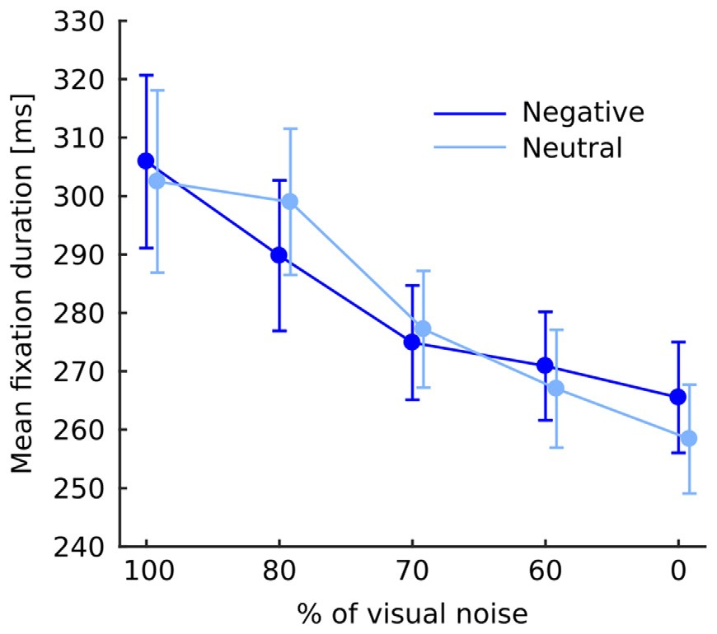
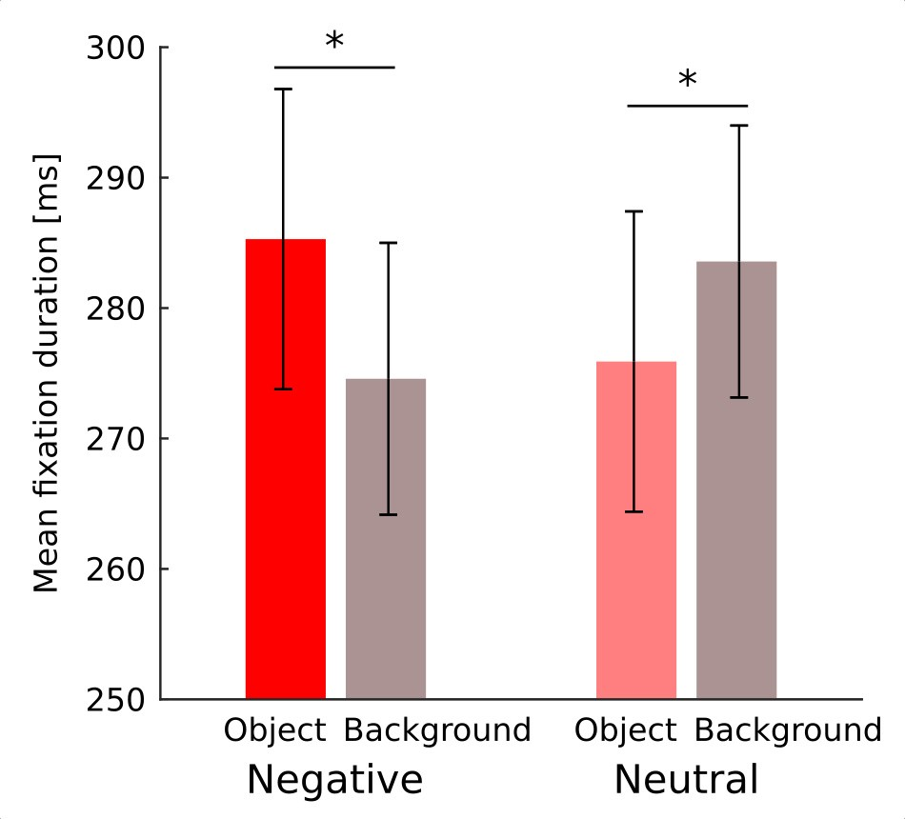
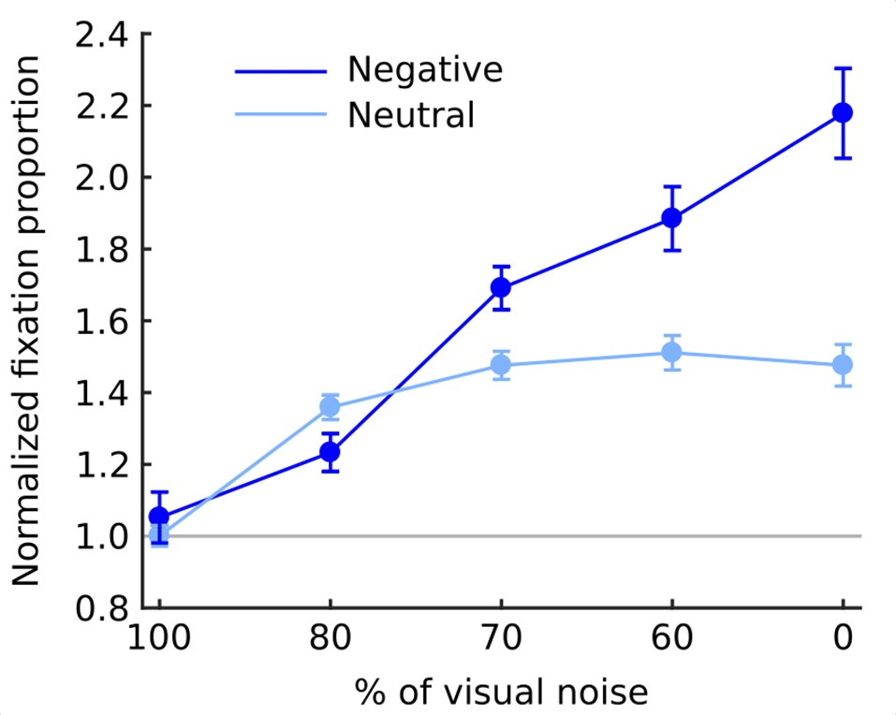
Kunieckietal.
Fixation-RelatedBrainActivations
Weconducted10Kpermutationsandappliedathreshold-free
clusterenhancement(TFCE;SmithandNichols,2009)methodwithdefaultparametersforidentifyingregionsofcontinuousactivation.Theresultingstatisticalmapswerethresholdedatp<0.05(family-wiseerror).
RESULTS
Eye-TrackingResults
FixationDuration
Fixationdurationwasaffectedbynoiselevel
(F(4,76)
=15.46;
p<0.001)showingacontinuousdecreasewithdiminishing
noiseasvalidatedbysignificantlineartrend
(F(1,19)
=25.34;
p<0.001).Interactionbetweennoiselevelandemotional
categorydidnotreachsignificance
(F(4,76)
=1.1;p=0.36;
Figure2).Interactionbetweenemotionalcategoryandobject-
background wassignificant
(F(1,19)
=12.4;p=0.002).
Investigationofthiseffectwithpairwisecomparisonshas
revealedthatinthenegativeconditionfixationsfallingwithinanobjectwerelongerthanthosefallingwithinthebackground(p=0.022),whileintheneutralconditionthereverseeffectemerged,specifically,fixationsfallingwithinanobjectwereshorterthanthosefallingwithinabackground(p=0.011;Figure3).Noothereffectsorinteractionsreachedsignificance.
NormalizedFixationProportion(NFP)
Theoverallchanceoffixatinganobjectareawashigherinthenegative(1.61;SEM=0.062)thanintheneutral
(1.36;SEM=0.028)condition
(F(1,19)
=25.8;p<0.001).
Moreover,asthenoiseleveldecreasedthechanceof
fixatingan
objectsteadily
increased
(F(4,76)
=59.9;
indicated
p<
0.001).
This
relationship
was
monotonic
as
bya
Alsolevel
significantlineartrend
(F(1,19)
=77.8;p<0.001).
interactionbetweenemotionalcategoryandnoise
washighlysignificantinbothomnibusANOVA
(F(4,76)
=29.4;p<0.001)andalineartrend
(F(1,19)
=81.9;
p<0.001)withnegativeobjectsattractingfixationsmuch
strongerindecreasingnoiselevelsthanneutralobjects(Figure4).
fMRIResults
Ingeneral,effectoffixationswaslinkedtolargedeactivationwithinthebilaterallingualgyrus(Figure5,SupplementaryTableS1).Further,toseparatetheeffectsoffixationsfrom
FrontiersinHumanNeuroscience|www.frontiersin.org
5
August2017|Volume11|Article429

FIGURE2|Meanfixationdurationateachlevelofnoisefornegativeandneutralimagesseparately.Errorbarsrepresentstandarderror.Thedifferencebetweennegativeandneutralconditionisnotsignificantandisshownforillustrativepurposesonly.

FIGURE4|Normalizedfixationproportion(NFP;chanceoffixatinganobject)ateachlevelofnoisefornegativeandneutralimagesseparately.Errorbarsrepresentstandarderror.Graylinerepresentsthechancelevel.

FIGURE3|Meandurationoffixationfallingonanobjectandonabackgroundfornegativeandneutralimagesseparately.Asterisksdenotesignificantdifferencesinpairwisecomparisons.Errorbarsrepresentstandarderror.

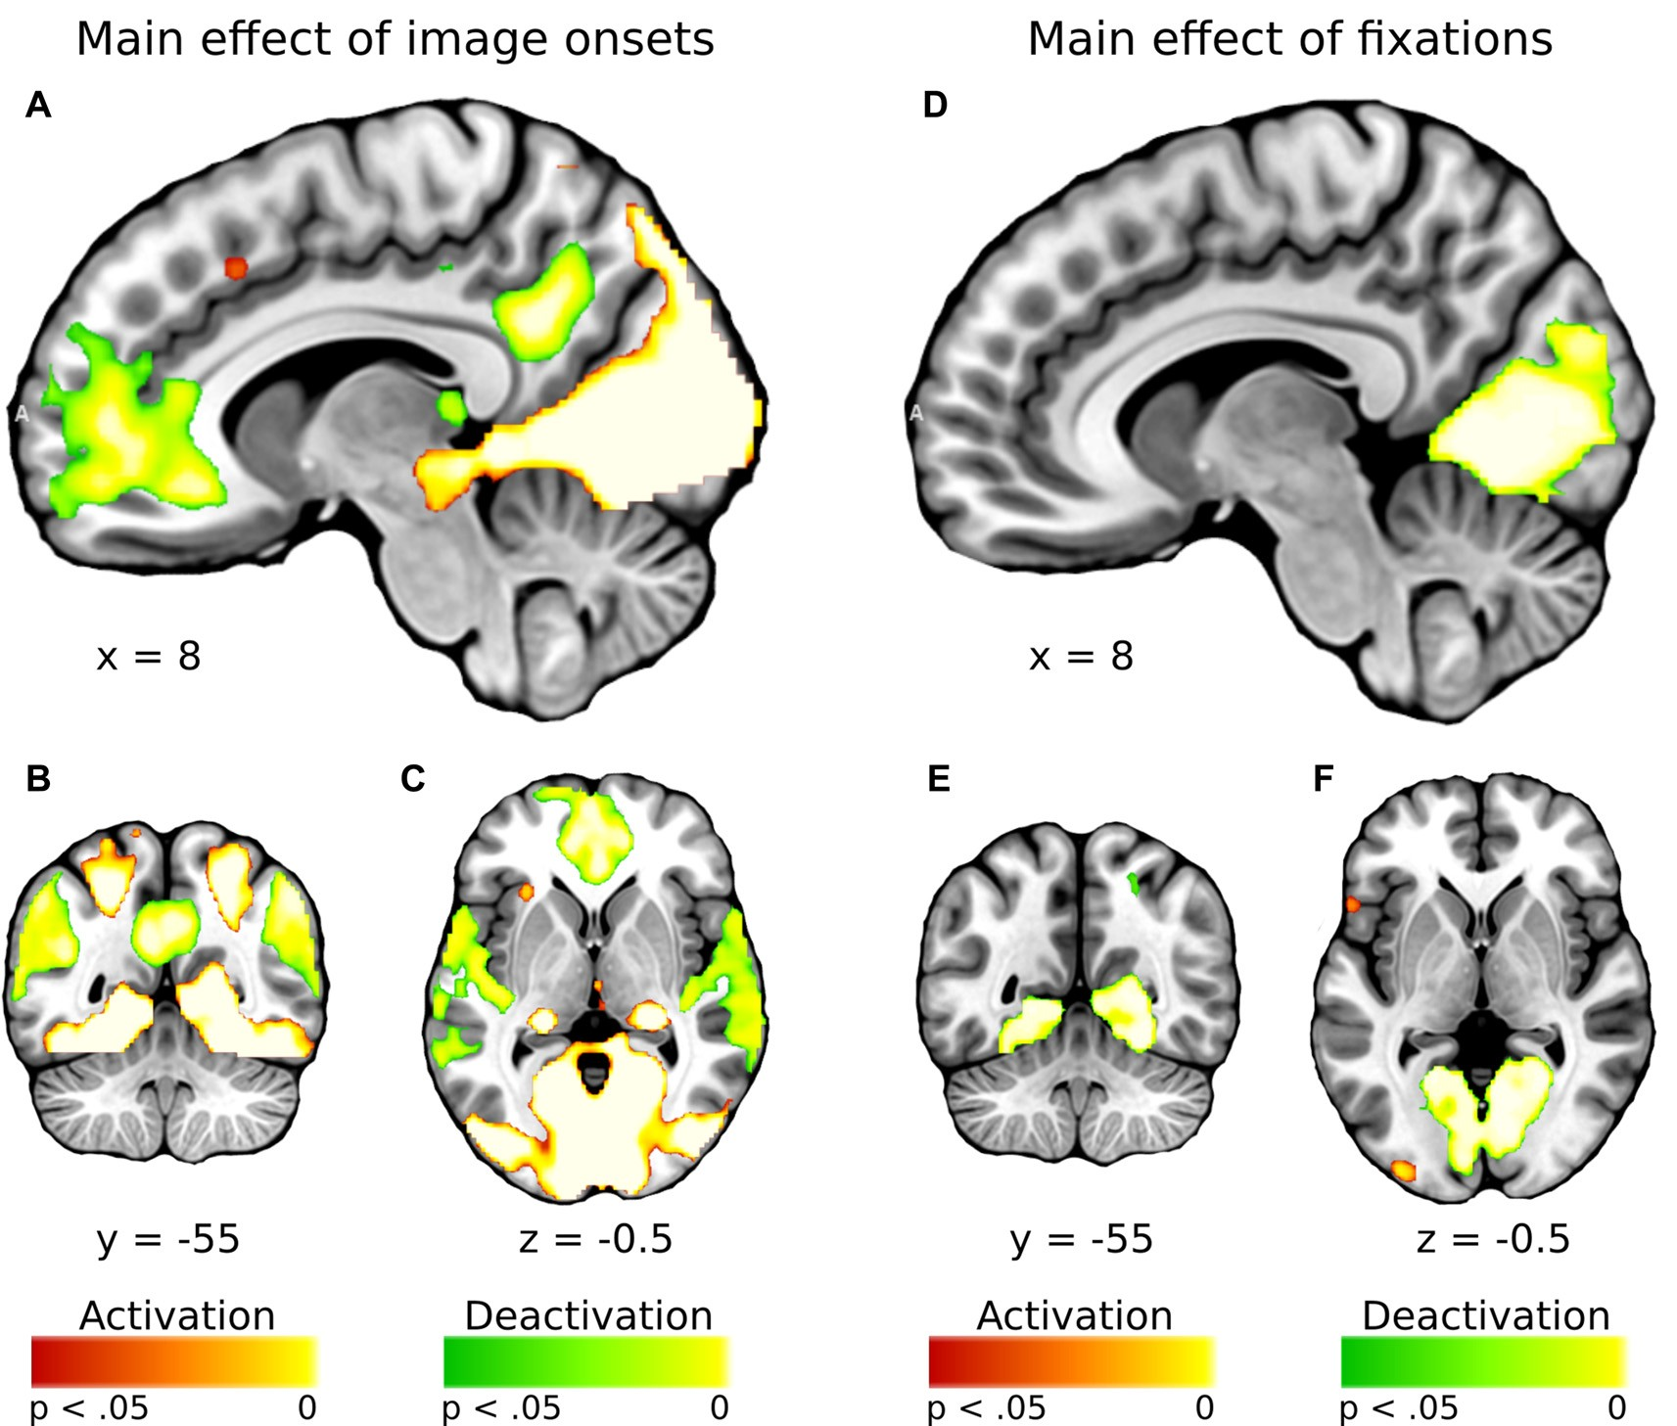
Kunieckietal.
Fixation-RelatedBrainActivations
DISCUSSION
Inthecurrentstudy,weinvestigatedwhethertheinfluenceoflowandhigh-levelpropertiesofanimageonfixationsandtheirbraincorrelatesdifferdependingontheemotionalcategory.WeusedFIBERmethod,thatwasrecentlydevelopedbyMarsmanetal.(2012)toinvestigatefixationsrelatedbrainactivity.AlthoughinMarsmanetal.(2012)worktheTRwas2s,i.e.,itwasslightlyshorter thanthe oneused in ourstudy, itwas stillanorderofmagnitudelongerthanthedurationofanaveragefixation(200–300ms).Furthermore,Yes¸ilyurtetal.(2008)haveshownthatitispossibletoreliablydetectBOLDchangetriggeredbystimulilastingasshortas5mswithTRlasting2s.Moreover,short,sub-secondISImightincreasethepowerofthedesignprovidedtheirrandomization(Dale,1999).Therefore,detectionofBOLDchangesrelatedtoeventslastingaround200–300mswithTRequaling3sshouldalsobefeasible.Infact,ouranalysisshowedthatfixationswereprimarilyrelatedtorobustdeactivationswithinthelingualgyrus.Furthermore,resultsindicatedthatemotionalcategoryaffectsbrainactivitylinkedtofixationsonobjectscomparedtothebackgroundaswell asbrainactivity linkedtofixations madeindifferentlevels
imageprocessingperse,wecalculatedeffectofimageonset
tocheckwhetherimageonsetsandfixationsimpactbrainactivationsdistinctively.Asexpected,imageonsetyieldedaverywidepatternofactivationsinvolvingvisualareas(includingactivationwithinlingualgyrus),aswellasseveralfrontalregions(Figure5,SupplementaryTableS2).Inouropinion,thisresultshowsthatdeactivationwithinthelingualgyrusisspecificallyrelatedtofixationsratherthanimageonset.Regardingcontrastspertainingtoourspecifichypotheses,inthenegativeconditionfixationsonobjectswerelinkedtosignificantlygreaterdeactivationswithintherightlingualgyruscomparedtobackgroundfixations(Figure6,Table1).Intheneutralconditionbothobjectandbackgroundfixationsresultedinsimilardeactivationswithinthisregion,yieldingnosignificantcontrast.Contrarytoourpredictions,therewasnosignificantdifferenceinfixation-relatedbrainactivitybetweenfixatingemotionalandneutralobjects.Theemotionalcategorymodulatedtheeffectofnoiselevelonbraincorrelatesoffixations.Specifically,inthenegativeconditionthecorrelationbetweennoiselevelandactivityintheLOClinkedto
fixationswasstrongerthanintheneutralcondition(Figure7,Table1).
FrontiersinHumanNeuroscience|www.frontiersin.org
6
August2017|Volume11|Article429

FIGURE5|Whole-brainmapsshowingactivations(inred)anddeactivations(ingreen)linkedto(A–C)maineffectofimageonsetsand(D–F)maineffectoffixations.T-statisticalmapswerecorrectedformultiplecomparisonswiththreshold-freeclusterenhancement(TFCE)atp<0.05.

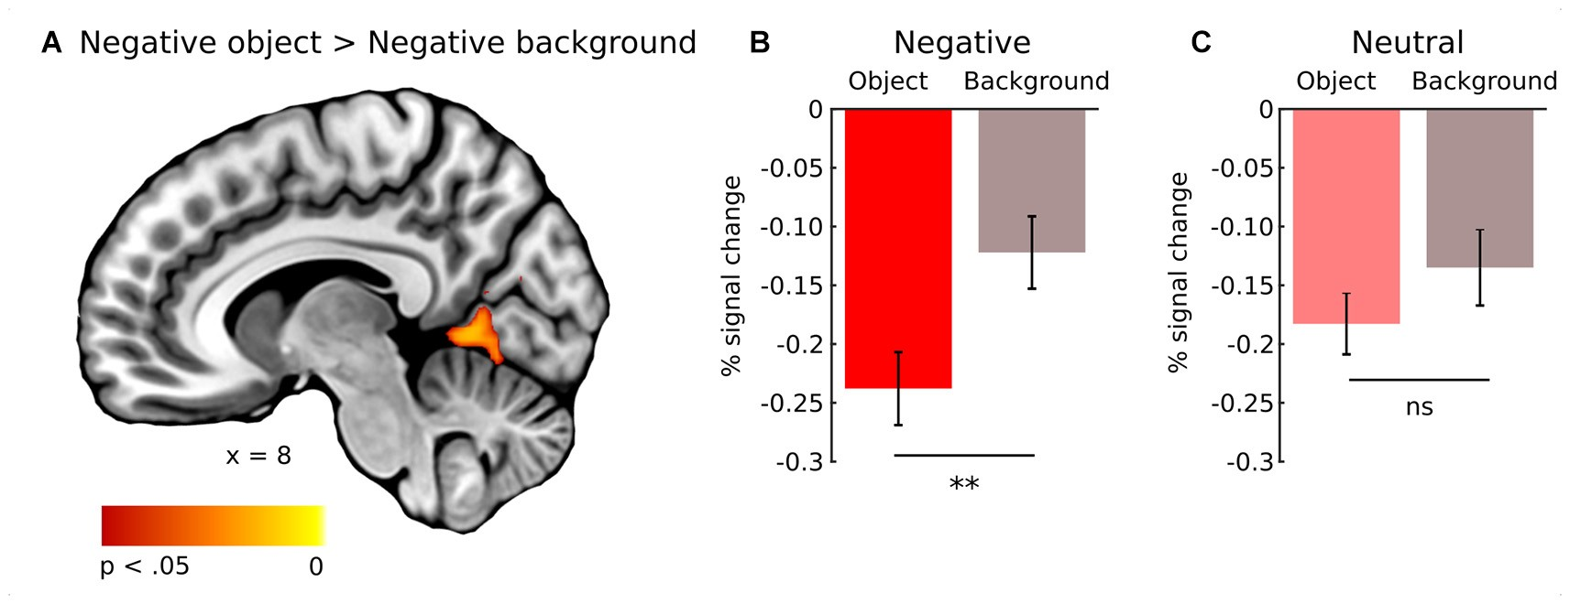
Kunieckietal.
Fixation-RelatedBrainActivations
ofimageclarity.ThesefMRIsignalchangescorrespondtothe
eye-trackingdata,whosetemporalandspatialcharacteristicswereaffectedbybothemotionalcategoryandimageproperties.
Brainactivityassociatedwithfixationsonanobjectdifferedfromactivityassociatedwithfixationsonthebackground,howeveronlyfornegativeimages.Inbothemotionalcategories,allfixationswerelinkedtodeactivationsinthelingualgyrus,however, inthecase ofnegativeimages, theyweresignificantlymorepronouncedforfixationsthatfellontheobject.Inthecaseofneutralimages,therewasnosuchdifference.ThisresultcanbecomparedwiththeonereportedbyFerrietal.’s(2013),whoshowedthatbrainactivationsweregreaterwhenparticipantswereinstructedtofixateanemotionalobjectcomparedtofixatinganon-emotionalregion.Thoseactivationswere,however,muchmorewidespread,astheywerelocatedintheinferioroccipitalgyrus,insula,amygdala,inferiorparietallobe,postcentralgyrusandfusiformgyrus.ThedifferencebetweentheresultsreportedbyFerrietal.’s(2013)andoursarenotsurprisingduetomajormethodologicaldifferencesbetweenthetwostudies.Particularly,theFIBERanalysisentailsusingfixationeventsasregressorsandhenceallowsforevaluationofongoingprocesseslinkedtoindividualfixations,ratherthanmoreglobalstimulusprocessingaveraged
acrosstheentirepresentationtime.Further,weseparatedthe
latterfromthefixation-relatedactivityincludingimageonsetastheregressorofnointerest.Moreover,inFerrietal.’s(2013)procedure,participantswererequiredtofixateapredeterminedfragmentofanimage,thatlimitedparticipants’patternofeyemovements(compareeye-trackingdatainfreeandconstrainedeyemovementconditioninFerrietal.’s,2013).Infact,theauthorsfoundnumberofdifferencesinbrainactivationsbetweenfocusvs.free-viewingcondition(seeSupplementaryTablesS2,S4inFerrietal.’s,2013).
Thefactthatonlyinthenegativeconditionfixation-relatedactivityintherightlingualgyrusdifferedbetweenanobjectandthebackgroundcanbeinterpretedwithrespecttoresearchonsemanticconsistency.Ithasbeenshownthatvisualprocessingofanobjectdependsonitssemanticconsistencywiththecontextinwhichitispresentede.g.,apolarbearpresentedinakitchenoronaniceberg.Ingeneral,participantstendtofocusmoreattentiononanobjectthanonthebackground,however,thistendencyissignificantlymorerobustforinconsistentimages(Hendersonetal.,1999;VõandHenderson,2009,2011;Martensetal.,2011).Inneutralnaturalscenes,objectsdonotseemtodifferfromthebackgroundintermsoftheiremotionalvalueasmuchasinemotionalscenes,inwhichemotionalobjectsareoften
TABLE1|Contrastbetweenobjectandbackgroundfixationsfornegativeimages,andcontrastbetweennegativeandneutralimagesfornoiselevel(signal-to-noiseratio).
Brainregion
Clustersize
Side
MNIcoordinates
t
p
x
y
z
Objectvs.BackgroundfixationsRightlingualgyrusIntracalcarinecortex
LateraloccipitalcortexSignal-to-noiseratio
LateraloccipitalcortexLateraloccipitalcortex
543
59
51
RRR
8
14
28
−58
−80
−74

−70
−70
0
8
50
5.17
4.84
4.63
0.014
0.035
0.041
694
363
RL
54
−54
−2
2
6.46
6.26
0.003
0.009
pvaluesarecorrectedformultiplecomparisonswiththreshold-freeclusterenhancement(TFCE).L,Left;R,Right.Theclustersizeisgiveninvoxels.
FrontiersinHumanNeuroscience|www.frontiersin.org
7
August2017|Volume11|Article429

FIGURE6|Whole-brainmapshowingcontrastbetweenactivitylinkedtofixationsonobjectandbackgroundofnegativeimages.T-statisticalmapswerecorrectedformultiplecomparisonswithTFCEatp<0.05.(A)Activationsintherightlingualgyrus.Percentsignalchangeintherightlingualgyrusforobjectandbackgroundof(B)negativeand(C)neutralimages.Significanceofthepairwisecomparisonsaremarkedonthetopofeachgraph;ns,notsignificant,∗∗p<0.01.Errorbarsrepresentstandarderror.

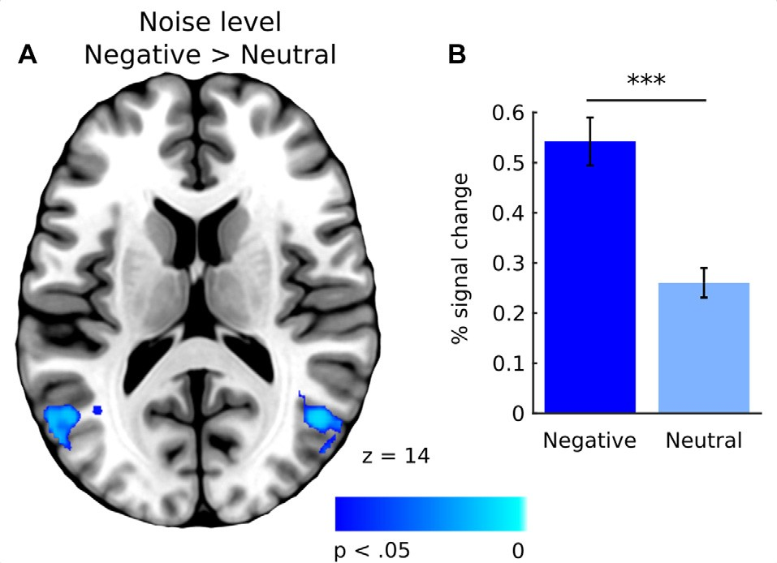
Kunieckietal.
Fixation-RelatedBrainActivations
fMRIexperiments,whichwouldcarefullycontrolscanpaths
andinvestigatethemodulatoryroleofthepreviouslyexecutedfixations onbrain correlatesof theconsecutivefixations.Futureresearchmightalsoexploretheimpactofthecontextinwhich information is presented on brainactivity associated withfixations.
Allobservedeffectsofscenecompositiononfixation-relatedactivityintherightlingualgyrusaredeactivations.ThisresultcorrespondstothedataobtainedbyMarsmanetal.(2013)inthestudy,usingartificial,non-emotionalscenes.Theyfoundthatfixationdurationwasrelatedtodeactivationinthelingualgyrus.Onepossibleexplanationofthiseffectisbasedonthestudy byGengetal.(2009)showingthatthereisalinkbetweenincreasedactivityinthelingualgyrusandsaccadeexecution.Wemayhypothesizethatdeactivationofthelingualgyrusduringfixationsmightbelinkedtodelayingsaccadeexecutionandhenceterminatingtheongoingfixation.Furthermore,itseemsplausiblethatthemoreacurrentlyfixatedobjectengagesandholdsattention,thegreatertheinhibitionofgazerelocation,resultinginmorepronounceddeactivationofthelingualgyrus.Inaddition,thehypothesisthatthecontentofascenemightinfluencetheactivityofthelingualgyrusrelatedtoeyemovementsissupportedbyMorrisandMcCarthy(2007),whoestablishedthatamongseveralbrainregionsactivatedbysaccadeexecution, only activation inthe ventral occipitotemporalcortex(VOTC),includingthelingualgyrus,ismodulatedbythecontentofanimage.
Indeed,ourimagingandeye-trackingdataseemtopartlysupportproposedinterpretation.Regardingbrainactivity,fixatinganemotionalobjectwithinnegativeimagesresultedinsignificantlygreaterdeactivationoftherightlingualgyrusthanfixatingnon-emotionalpartsofthesameimage.Thisisreflectedbythedifferencesinfixationdurationandlocation.Inthecaseofnegativeimages,fixationswerelongerwhenfallingonobjectsasopposedtothebackground,whichisreversedforneutralimages.Further,theprobabilityoffixatinganemotionalobjectwashigherinthecaseofnegativeimagesthanneutralones.However,ourresultscannotbeexplainedsolelybydifferencesinfixationduration.Specifically,iffixationdurationwasamajorfactor,wewouldexpectgreaterdeactivationwithinthelingualgyrusrelatedtofixatingtheneutralbackgroundcomparedtotheneutralobject.Thisdifferencedidnotoccur,indicatingpossibleroleofotherfactorsinfluencingfixation-relatedbrainactivitywithintheregionofthelingualgyrus.
Theothermodulatoryeffectofemotionalcontentonfixation-relatedbrainactivity,foundinourstudy,referstosceneclarity,whichwaspositivelycorrelatedwithactivityintheLOC,thestructurelinkedtoobjectrecognition(Grill-Spectoretal.,2001).Thiscorrelationwassignificantlystrongerinthecaseoffixationsexecutedonnegativeimagesasopposedtoneutralones.Wehypothesizedthatanypossibleinteractionbetweenemotionalcategoryandnoiselevelinbraincorrelatesoffixationswouldberelatedtofixationduration,whichdecreasesinanemotionalcondition(Bradleyetal.,2011;Kasparetal.,2013)andwithadecliningnoiselevel(Glaholtetal.,2013;Hendersonetal.,2014).Ourresults,however,donotsupportthisprediction.Althoughfixationsbecameshorterasthelevelofnoisedecreased,the
placedonaratherneutralbackground(Humphreyetal.,2012).
Infact,AcunzoandHenderson(2011)claimthatemotionalobjectsresemblegist-inconsistentstimuliwithinanimage,whiletheneutralonesresemblegist-consistentstimuli.Bothgist-inconsistentandemotionalobjectsdrawattentionmoreeffectively,whichcanbearesultoftheirgreaterinformativevalue,possiblyrelatedtotheirbehavioralandevolutionaryrelevance.Thus,inthecaseofneutralimages,attentionisdistributedmoreevenlybetweenanobjectandthebackground(Humphreyetal.,2012;Niuetal.,2012;PilarczykandKuniecki,2014).Oureye-trackingresultsfitintothislineofreasoning.Theprobability of fixating an objectwas greater in the negativethanintheneutralcondition,whichwasalsoobservedinourpreviousstudy(PilarczykandKuniecki,2014).Additionally,inthecaseofnegativeimages,averagedurationoffixationsfallingontheobjectswaslongerthanthosefallingonthebackground.Thistendencywasreversedforneutralimages.Takentogether,theseresultsdemonstratethat,indeed,inemotionalscenes,attentioniscapturedandheldmorestronglybytheobject,whichmayaccount for the observed difference in fixation-relatedbrainactivitybetweenanobjectandthebackgroundinthenegativecondition.
Ontheotherhand,theresultsdonotsupportourhypothesisregardingthedifferenceinbrainactivityrelatedtofixationsonemotionalobjectscomparedtoneutralones.Itseemsthattheintensityofprocessingofthe‘‘unitofinformation’’extractedduringasinglefixationdependsonthecontextinwhichitispresentedratherthanitsabsoluteinformativevalue,which,asweargue,shouldbegreaterinthecaseofnegativeobjectsthanneutralones.Furthermore,thispatternofresultsimpliesthatconsideringfixationsas‘‘unitsofinformation’’hassomelimitations,sincebrainactivityassociatedwiththemseemstodependonthemeaningofanentirescene,andhenceprobablyontheprecedingfixations.Thishypothesiscanbetestedinfuture
FrontiersinHumanNeuroscience|www.frontiersin.org
8
August2017|Volume11|Article429

FIGURE7|(A)Whole-brainmapshowingcontrastbetweennegativeandneutralimagesforactivationscovaryingwithnoiselevel.T-statisticalmapswerecorrectedformultiplecomparisonsusingTFCEatp<0.05.(B)Percentsignalchangeinthelateraloccipitalcortex(LOC)fornegativeandneutralimages.Significanceofthepairwisecomparisonsaremarkedonthetopofthegraph;ns,notsignificant,∗∗∗p<0.001.Errorbarsrepresentstandarderror.

Kunieckietal.
Fixation-RelatedBrainActivations
effectdidnotsignificantlydifferbetweentheemotionalcategory
conditions.Therefore,observeddifferencesinbraincorrelatesoffixationsfornegativeandneutralimagescannotbeexplainedsolelybydifferencesinfixationduration.
Alternatively,thisresultmaybeaneffectofeitherenhancedvisualprocessingofemotionalinformationorgreaterattentionaldeploymenttoemotionalobjects.Ithasbeenshownthatvisualnoiseaffectsprocessinginthehighervisualareas,includingtheLOC,whichareresponsibleforobjectandscenerecognition(Grill-Spectoretal.,1998;Tjanetal.,2006;Pratteetal.,2013).Interestingly,thiseffectisreducedinthecaseofemotionalimages(Toddetal.,2012b).Itseemsthatourresultisinlinewiththeseobservations,indicatingthatsuchreductionisdetectablealsoonthelevelofindividualfixations.ItisalsopossiblethattheincreasedLOCactivityduetodecreasingnoiselevels,whichisstronger for negativeimages, might beattributed to thedifferences betweenattentional deploymentduring negative andneutralpictureviewing.Oureye-trackingdatadirectlysupportsthisinterpretation,asinthecaseofnegativeimages,thechanceoffixatinganobjectroseasthenoiseleveldecreased,fasterthaninthe caseof neutralimages.Such animpactof emotionalcontentonattractingattentionalfocusbetweenobjectsandbackgroundwasalsoreportedbyHumphreyetal.(2012),Niuetal.(2012)andadditionallyincludingtheinfluenceofvisualnoise,byPilarczykandKuniecki(2014).
Summingup,inourstudyemotionalcontentchangedthewaythathighandlow-levelfeaturesofanimageaffectfixation-relatedbrainactivity.Inthecaseofemotionalimages,fixation-relatedbrainactivityintherightlingualgyrusdifferedbetweenfixationsonobjectsandonbackgrounds,whichwasnotthecaseforneutralimages.Wehypothesizethatthisdifferencemightbedrivenbygreatersaccadeinhibitionwhenfixatinganemotionalobject.Thisissupportedbythefactthatfixationsonemotionalobjectswerelonger.Further,inthecaseofnegative
images,therelationbetweenLOCactivityandincreasingimage
claritywasstronger,which,aswesuggest,mayberelatedtoeitherenhancedprocessingofemotionalstimuliorgreaterengagementofattentioninemotionalobjects.Oureye-trackingresultsdirectlysupportthesecondinterpretation,asthechanceoffixatingobjectsrelativetothebackgroundwashigherforemotionalscenesthanforneutralones.Overall,itappearsthattheeffectsofhighandlow-levelfeaturesofanimageonfixation-relatedbrainactivityinthecaseofnegativeimagesaremediatedbystrongerengagementofattentionbyemotionalobjects.
AUTHORCONTRIBUTIONS
MKandJPdesignedthestudy.MK,JPandADconductedthestudy.MK,JPandKBWanalyzedandinterpretedthedata.Allauthorswrotethemanuscript.
FUNDING
ThisworkwassupportedbytheNationalScienceCentreinPoland(grantnumber2012/07/E/HS6/01046)andbyPLGridInfrastructure.
ACKNOWLEDGMENTS
TheauthorsthankPiotrFabafortechnicalsupport.
SUPPLEMENTARYMATERIAL
TheSupplementaryMaterialforthisarticlecanbefoundonline
at:
http://journal.frontiersin.org/article/10.3389/fnhum.2017.
00429/full#supplementary-material
REFERENCES
Acunzo,D.J.,andHenderson,J.M.(2011).Noemotional‘‘pop-out’’effectinnaturalsceneviewing.Emotion11,1134–1143.doi:10.1037/a0022586
Beckmann,C.F.,Jenkinson,M.,andSmith,S.M.(2003).GeneralmultilevellinearmodelingforgroupanalysisinFMRI.Neuroimage20,1052–1063.doi:10.1016/s1053-8119(03)00435-x
Bradley,M.M.,Houbova,P.,Miccoli,L.,Costa,V.D.,andLang,P.J.(2011).Scanpatternswhenviewingnaturalscenes:emotion,complexity,andrepetition.Psychophysiology48,1544–1553.doi:10.1111/j.1469-8986.2011.01223.x
Bradley,M.M.,Sabatinelli,D.,andLang,P.(2014).‘‘Emotionandmotivationintheperceptualprocessingofnaturalscenes,’’inSceneVision:MakingSenseofWhatWeSee,edsK.KvergaandM.Bar(CambridgeMA:MITPress),273–290.
Bradley,M.M.,Sabatinelli,D.,Lang,P.J.,Fitzsimmons,J.R.,King,W.,andDesai,P.(2003).Activationofthevisualcortexinmotivatedattention.Behav.Neurosci.117,369–380.doi:10.1037/0735-7044.117.2.369
Buswell,G.T.(1935).HowPeopleLookatPictures.Chicago,IL:UniversityofChicagoPress.
Calvo,M.,Nummenmaa,L.,andHyönä,J.(2008).Emotionalscenesinperipheralvision:Selectiveorientingandgistprocessing,butnotcontentidentification.Emotion8,68–80.doi:10.1037/1528-3542.8.1.68
Calvo,M.,Nummenmaa,L.,andHyönä,J.(2007).Emotionalandneutralscenesin
competition:orienting,efficiency,andidentification.Q.J.Exp.Psychol.(Hove)
60,1585–1593.doi:10.1080/17470210701515868
Calvo,M.G.,andLang,P.J.(2004).Gazepatternswhenlookingatemotionalpictures:Motivationallybiasedattention.Motiv.Emot.28,221–243.doi:10.1023/b:moem.0000040153.26156.ed
Dale,A.M.(1999).Optimalexperimentaldesignforevent-relatedfMRI.Hum.BrainMapp.8,109–114.doi:10.1002/(sici)1097-0193(1999)8:2/3<109::aid-
hbm7>3.3.co;2-n
Ferri,J.,Schmidt,J.,Hajcak,G.,andCanli,T.(2013).Neuralcorrelatesofattentionaldeploymentwithinunpleasantpictures.Neuroimage70,268–277.doi:10.1016/j.neuroimage.2012.12.030
García-García,I.,Kube,J.,Gaebler,M.,Horstmann,A.,Villringer,A.,andNeumann,J.(2016).Neuralprocessingofnegativeemotionalstimuliandtheinfluenceofage,sexandtask-relatedcharacteristics.Neurosci.Biobehav.Rev.68,773–793.doi:10.1016/j.neubiorev.2016.04.020
Geng,J.J.,Ruff,C.C.,andDriver,J.(2009).Saccadestoarememberedlocationelicitspatiallyspecificactivationinhumanretinotopicvisualcortex.J.Cogn.Neurosci.21,230–245.doi:10.1162/jocn.2008.21025
Glaholt,M. G.,Rayner, K.,and Reingold,E.M. (2013).Spatial frequencyfilteringandthedirectcontroloffixationdurationsduringsceneviewing.Atten.Percept.Psychophys.75,1761–1773.doi:10.3758/s13414-013-0522-1
FrontiersinHumanNeuroscience|www.frontiersin.org
9
August2017|Volume11|Article429

Kunieckietal.
Fixation-RelatedBrainActivations
Grill-Spector,K.,Kourtzi,Z.,andKanwisher,N.(2001).Thelateraloccipital
complexanditsroleinobjectrecognition.VisionRes.41,1409–1422.doi:10.1016/s0042-6989(01)00073-6
Grill-Spector,K.,Kushnir,T.,Hendler,T.,Edelman,S.,Itzchank,Y.,andMalach,R.(1998).Asequenceofobject-processingstagesrevealedbyfMRIinthehumanoccipitallobe.Hum.BrainMapp.6,316–328.doi:10.1002/(sici)1097-0193(1998)6:4<316::aid-hbm9>3.3.co;2-u
Hajcak, G., MacNamara,A., Foti, D.,Ferri, J., andKeil, A. (2013).Thedynamicallocationofattentiontoemotion:simultaneousandindependentevidencefromthelatepositivepotentialandsteadystatevisualevokedpotentials.Biol.Psychol.92,447–455.doi:10.1016/j.biopsycho.2011.11.012
Luke,S.G.,andHenderson,J.M.(2016).Theinfluenceofcontent
meaningfulnessoneyemovementsacrosstasks:evidencefromsceneviewingandreading.Front.Psychol.7:257.doi:10.3389/fpsyg.2016.00257
Mackworth,N.H.,andMorandi,A.J.(1967).Thegazeselectsinformativedetailswithinpictures.Percept.Psychophys.2,547–552.doi:10.3758/bf03210264
Marchewka,A.,Zurawski,Ł.,Jednoróg,K.,andGrabowska,A.(2014).Thenenckiaffectivepicturesystem(NAPS):introductiontoanovel,standardized,wide-range,high-quality,realisticpicturedatabase.Behav.Res.Methods46,596–610.doi:10.3758/s13428-013-0379-1
Markovic,J.,Anderson,A.K.,andTodd,R.M.(2014).Tuningtothesignificant:neuralandgeneticprocessesunderlyingaffectiveenhancementofvisualperceptionandmemory.Behav.BrainRes.259,229–241.doi:10.1016/j.bbr.2013.11.018
Marsman,J.B.C.,Cornelissen,F.W.,Dorr,M.,Vig,E.,Barth,E.,andRenken,R.J.(2016).Anovelmeasuretodetermineviewingpriorityanditsneuralcorrelatesinthehumanbrain.J.Vis.16:3.doi:10.1167/16.6.3
Marsman,J.B.C.,Renken,R.,Haak,K.V.,andCornelissen,F.W.(2013).LinkingcorticalvisualprocessingtoviewingbehaviorusingfMRI.Front.Syst.Neurosci.7:109.doi:10.3389/fnsys.2013.00109
Marsman,J.B.C.,Renken,R.,Velichkovsky,B.M.,Hooymans,J.M.M.,andCornelissen,F.W.(2012).Fixationbasedevent-relatedfMRIanalysis:usingeyefixationsaseventsinfunctionalmagneticresonanceimagingtorevealcorticalprocessingduringthefreeexplorationofvisualimages.Hum.BrainMapp.33,307–318.doi:10.1002/hbm.21211
Martens,U.,Trujillo-Barreto,N.,andGruber,T.(2011).Perceivingthetreeinthewoods:segregatingbrainresponsestostimuliconstitutingnaturalscenes.J.Neurosci.31,17713–17718.doi:10.1523/JNEUROSCI.4743-11.2011
McSorley,E.,andvanReekum,C.M.(2013).Thetimecourseofimplicitaffectivepictureprocessing:aneyemovementstudy.Emotion13,769–773.doi:10.1037/a0032185
Morris,J.P.,andMcCarthy,G.(2007).Guidedsaccadesmodulateobjectandface-specificactivityinthefusiformgyrus.Hum.BrainMapp.28,691–702.doi:10.1002/hbm.20301
Niu,Y.,Todd,R.M.,andAnderson,A.K.(2012).Affectivesaliencecanreversetheeffectsofstimulus-drivensalienceoneyemovementsincomplexscenes.Front.Psychol.3:336.doi:10.3389/fpsyg.2012.00336
Nummenmaa,L.,Hyönä,J.,andCalvo,M.G.(2006).Eyemovementassessmentofselectiveattentionalcapturebyemotionalpictures.Emotion6,257–268.doi:10.1037/1528-3542.6.2.257
Ohman,A.,Flykt,A.,andEsteves,F.(2001).Emotiondrivesattention:detectingthesnakeinthegrass.J.Exp.Psychol.Gen.130,466–478.doi:10.1037/0096-3445.130.3.466
Onat,S.,Ac¸lk,A.,Schuman,F.,andKönig,P.(2014).Thecontributionsofimagecontentandbehavioralrelevancytoovertattention.PLoSOne9:e93254.doi:10.1371/journal.pone.0093254
Ossandón,J.P.,Onat,S.,Cazzoli,D.,Nyffeler,T.,Müri,R.,andKönig,P.(2012).Unmaskingthecontributionoflow-levelfeaturestotheguidanceofattention.Neuropsychologia50,3478–3487.doi:10.1016/j.neuropsychologia.
2012.09.043
Parkhurst,D.,Law,K.,andNiebur,E.(2002).Modelingtheroleofsalienceintheallocationofovertvisualattention.VisionRes.42,107–123.doi:10.1016/s0042-6989(01)00250-4
Pilarczyk,J.,andKuniecki,M.(2014).Emotionalcontentofanimageattractsattentionmorethanvisuallysalientfeaturesinvarioussignal-to-noiseratioconditions.J.Vis.14:4.doi:10.1167/14.12.4
Pratte,M.S.,Ling,S.,Swisher,J.D.,andTong,F.(2013).Howattentionextractsobjectsfromnoise.J.Neurophysiol.110,1346–1356.doi:10.1152/jn.00127.2013
Reinders,A.A.T.S.,denBoer,J.A.,andBüchel,C.(2005).Therobustnessofperception.Eur.J.Neurosci.22,524–530.doi:10.1111/j.1460-9568.2005.04212.x
Sabatinelli,D.,Fortune,E.E.,Li,Q.,Siddiqui,A.,Krafft,C.,Oliver,W.T.,etal.(2011).Emotionalperception:meta-analysesoffaceandnatural
Henderson,J.
perception.09.006
M.(2003).Human
TrendsCogn.Sci.
gazecontrolduringreal-worldscene
7,498–504.doi:10.1016/j.tics.2003.
Henderson,J.M.,andChoi,W.(2015).Neuralcorrelatesoffixationduration
duringreal-worldsceneviewing:evidencefromfixation-related(FIRE)fMRI.
J.Cogn.Neurosci.27,1137–1145.doi:10.1162/jocn_a_00769
Henderson,J.M.,andHollingworth,A.(1999).High-levelsceneperception.Annu.Rev.Psychol.50,243–271.doi:10.1146/annurev.psych.50.1.243
Henderson,J.M.,Malcolm,G.L.,andSchandl,C.(2009).Searchinginthedark:cognitiverelevancedrivesattentioninreal-worldscenes.Psychon.Bull.Rev.16,850–856.doi:10.3758/PBR.16.5.850
Henderson,J.M.,Olejarczyk,J.,Luke,S.G.,andSchmidt,J.(2014).Eyemovementcontrolduringsceneviewing:immediatedegradationandenhancementeffectsofspatialfrequencyfiltering.Vis.Cogn.22,486–502.doi:10.1080/13506285.2014.897662
Henderson,J.M.,Weeks,P.A.Jr.,andHollingworth,A.(1999).Theeffectsofsemanticconsistencyoneyemovementsduringcomplexsceneviewing.J.Exp.Psychol.Hum.Percept.Perform.25,210–228.doi:10.1037//0096-1523.25.1.210
Humphrey,K.,Underwood,G.,andLambert,T.(2012).Salienceofthelambs:atestofthesaliencymaphypothesiswithpicturesofemotiveobjects.J.Vis.12:22.doi:10.1167/12.1.22
Jenkinson,M.,Bannister,P.,Brady,M.,andSmith,S.(2002).Improvedoptimizationfortherobustandaccuratelinearregistrationandmotioncorrectionofbrainimages.Neuroimage17,825–841.doi:10.1016/s1053-8119(02)91132-8
Junghöfer,M.,Sabatinelli,D.,Bradley,M.M.,Schupp,H.T.,Elbert,T.R.,andLang,P.J.(2006).Fleetingimages:rapidaffectdiscriminationinthevisualcortex.Neuroreport17,225–229.doi:10.1097/01.WNR.0000198437.59883.bb
Kaspar,K., Hloucal,T. M.,Kriz,J.,Canzler,S.,Gameiro,R.R.,Krapp,V.,et al.(2013).Emotionstimpactonviewingbehaviorundernaturalconditions.PLoSOne8:e52737.doi:10.1371/journal.pone.0052737
Kayser,C.,Nielsen,K.J.,andLogothetis,N.K.(2006).Fixationsinnaturalscenes:interactionofimagestructureandimagecontent.VisionRes.46,2535–2545.doi:10.1016/j.visres.2006.02.003
Keil,A.,Gruber,T.,Müller,M.M.,Moratti,S.,Stolarova,M.,Bradley,M.M.,etal.(2003).Earlymodulationofvisualperceptionbyemotionalarousal:evidencefromsteady-statevisualevokedbrainpotentials.Cogn.Affect.Behav.Neurosci.3,195–206.doi:10.3758/cabn.3.3.195
Keil,A.,Moratti,S.,Sabatinelli,D.,Bradley,M.M.,andLang,P.J.(2005).Additiveeffectsofemotionalcontentandspatialselectiveattentiononelectrocorticalfacilitation.Cereb.Cortex15,1187–1197.doi:10.1093/cercor/bhi001
Lang,P.J.,Bradley,M.M.andCuthbert,B.N.(2008).InternationalAffectivePictureSystem(IAPS):AffectiveRatingsofPicturesandInstructionManual.TechnicalReportA-8.Gainesville,FL:UniversityofFlorida.
Lang,P.J.,Bradley,M.M.,Fitzsimmons,J.R.,Cuthbert,B.N.,Scott,J.D.,Moulder,B.,etal.(1998).Emotionalarousalandactivationofthevisualcortex:anfMRIanalysis.Psychophysiology35,199–210.doi:10.1111/1469-8986.3520199
Lindquist,K.A.,Satpute,A.B.,Wager,T.D.,Weber,J.,andBarrett,L.F.(2015).Thebrainbasisofpositiveandnegativeaffect:evidencefromameta-analysisofthehumanneuroimagingliterature.Cereb.Cortex26,1910–1922.doi:10.1093/cercor/bhv001
FrontiersinHumanNeuroscience|www.frontiersin.org
10
August2017|Volume11|Article429

Kunieckietal.
Fixation-RelatedBrainActivations
scene processing.Neuroimage54,2524–2533.doi:10.1016/j.neuroimage.
2010.10.011
Smith,S.M.(2002).Fastrobustautomatedbrainextraction.Hum.BrainMapp.
17,143–155.doi:10.1002/hbm.10062
Smith,S.M.,andNichols,T.E.(2009).Threshold-freeclusterenhancement:addressingproblemsofsmoothing,thresholddependenceandlocalisationinclusterinference.Neuroimage44,83–98.doi:10.1016/j.neuroimage.2008.03.061
Tatler,B.(2007).Thecentralfixationbiasinsceneviewing:selectinganoptimalviewingpositionindependentlyofmotorbiasesandimagefeaturedistributions.J.Vis.7,4.1–4.17.doi:10.1167/7.14.4
Tatler,B.W.,Baddeley,R.J.,andGilchrist,I.D.(2005).Visualcorrelatesoffixationselection:effectsofscaleandtime.VisionRes.45,643–659.doi:10.1016/j.visres.2004.09.017
Tjan,B.S.,Lestou,V.,andKourtzi,Z.(2006).Uncertaintyandinvarianceinthehumanvisualcortex.J.Neurophysiol.96,1556–1568.doi:10.1152/jn.01367.2005
Todd,R.M.,Cunningham,W.A.,Anderson,A.K.,andThompson,E.(2012a).Affect-biasedattentionasemotionregulation.TrendsCogn.Sci.16,365–372.doi:10.1016/j.tics.2012.06.003
Todd,R.M.,Talmi,D.,Schmitz,T.W.,Susskind,J.,andAnderson,A.K.(2012b).Psychophysicalandneuralevidenceforemotion-enhancedperceptualvividness.J.Neurosci.32,11201–11212.doi:10.1523/JNEUROSCI.0155-12.2012
Võ,M.L.,andHenderson,J.M.(2009).Doesgravitymatter?
Effectsofsemanticandsyntacticinconsistenciesontheallocationofattentionduringsceneperception.J.Vis.9,1–15.doi:10.1167/9.3.24
Võ,M.L.-H.,andHenderson,J.M.(2011).Object-sceneinconsistenciesdonotcapturegaze:evidencefromtheflash-previewmoving-windowparadigm.Atten.Percept. Psychophys.73, 1742–1753.doi:10.3758/s13414-011-0150-6
Yarbus,A.L.(1967).‘‘Eyemovementsduringperceptionofcomplexobjects,’’inEyeMovementsandVision,ed.L.A.Riggs(NewYork,NY:PlenumPress),171–196.
Ye¸silyurt,B.,Ugurbil,K.,andUludag,K.(2008).DynamicsandnonlinearitiesoftheBOLDresponseatveryshortstimulusdurations.Magn.Reson.Imaging26,853–862.doi:10.1016/j.mri.2008.01.008
ConflictofInterestStatement:Theauthorsdeclarethattheresearchwas
conductedintheabsenceofanycommercialorfinancialrelationshipsthatcouldbeconstruedasapotentialconflictofinterest.
Copyright©2017Kuniecki,Wołoszyn,DomagalikandPilarczyk.Thisisan
open-accessarticledistributedunderthetermsoftheCreativeCommonsAttributionLicense(CCBY).Theuse,distributionorreproductioninotherforumsispermitted,providedtheoriginalauthor(s)orlicensorarecreditedandthattheoriginalpublicationinthisjournaliscited,inaccordancewithacceptedacademicpractice.Nouse,distributionorreproductionispermittedwhichdoesnotcomplywiththeseterms.
FrontiersinHumanNeuroscience|www.frontiersin.org
11
August2017|Volume11|Article429

