J Solid State Electrochem (2012) 16:3611–3619 DOI 10.1007/s10008-012-1795-3
Porous alumina membranes with branched nanopores as templates for fabrication
of Y-shaped nanowire arrays
Leszek Zaraska&Elżbieta Kurowska&
Grzegorz D. Sulka&Marian Jaskuła
Received: 20 March 2012 / Accepted: 3 June 2012 / Published online: 24 June 2012
#TheAuthor(s)2012.ThisarticleispublishedwithopenaccessatSpringerlink.com
Abstract Porous anodic alumina membraneswithY-branched and double-branched nanopores were fabricated by the stepwise reduction of anodizing potential during the second step of anodization carried out in 0.3 M oxalic acid. Theprocessofnanoporouslayerformationandinfluenceof anodizing parameters on structural features of as-obtained anodic aluminum oxide (AAO) membranes were discussed indetail.Theporerearrangementprocessoccurringafterthe potential decrease was investigated on the basis ofthecurrent density vs. time curves, and results were correlatedwith thefield-emission scanning electronmicroscopeimages of the pore bottoms taken after different anodizing durations. It was found that the reorganization ofnanopores begins after 600 and 500 s from the time of the potential reduction to 42 and 30 V and the process seems to be completed after about 900 and 800 s, respectively. The through-hole AAO membranes were used as templates for the fabrication of gold and polystyrene nanowires via elec- trochemical deposition and simple immersing in the poly- mersolution,respectively. Thearraysofhierarchicallybranched nanowires were synthesized, and the dimensions ofnanowireswereconsistentwiththeshapeandstructureof used AAOtemplates.
Introduction
Recently, a strong trend towards miniaturization of elec- tronic devices could be observed, therefore, all disciplines of nanotechnology have become the most popular scien- tific areas in both academic science and industry [1,2]. Among numerous nanomaterials fabricated over the last decades, 1D nanostructures, such as nanowires and nano- tubes are subjects of great research interest not only due to their unusual physical and chemical properties, but also because of their potential applications in modern nanodevices [3]. Although great progress has been made in fabrication of simple 1D nanostructures over the last few years [4–6], the synthesis of multifunctional nano- devices often requires more complex nanostructures and, thus, many research groups are working on development of methods fornanomanufacturing.
Among many strategies, the use of porous anodicaluminum oxide (AAO) membranesastemplates fornanofabrication seems to be the most popular, cheapest and simplest way for synthesis of nanowires [7–10], nanotubes [8,11], nanodots [12,13], or even sophisti- cated 3D nanoarrays with precisely controlled dimen- sions [14–16]. A number of reports on fabrication of metallic nanowires and nanotubes by cathodic electrode- position inside nanochannels of AAO templates can be found, but most of them refer to the simplest and linear nanomaterials with uniform diameters[14].
Nowadays, big attention is focused on fabrication of hierarchically structured nanomaterials, e.g., Y-junction and multibranched nanowires and nanotubes that can be potentially used as device interconnectors [17,18]. Nano- porous alumina membranes with branched nanopores can be also obtained by using a simple anodizing procedure. Afewstrategieshavebeenalreadyreported[19–25].
Keywords Anodization.Branched nanopores.Y-shaped nanowires.Electrodeposition

L.Zaraska(*):E.Kurowska:G.D.Sulka:M.Jaskuła
Department of Physical Chemistry and Electrochemistry, Faculty of Chemistry, Jagiellonian University,
Ingardena 3,
30-060 Krakow, Poland
e-mail:zaraska@chemia.uj.edu.pl
ORIGINAL PAPER

3612
J Solid State Electrochem (2012) 16:3611–3619
Wanget al. have synthesized a large-size, multibranched AAO template by anodizing in a phosphate-based solu- tion, at the constant current density of 1.3Adm⁻²and 5°C[20].Itwasfoundthatthediameterofporesonthe
outer surface of the oxide layer ranges from 150 to
220 nm, and each main channel has many branches whose width is about 100–120 nm. The authors sug- gested that the formed complex structure of AAO can be ascribed to the unstable growth of oxide film at the initial stage of the process [20]. On the other hand, Zakeri et al. reported the synthesis of nonlinear nano- pores in alumina films by anodizing of different geomet- ric shaped substrates [21]. It was shown that a control over the orientation of nanopores can be accomplished by controlling the geometric shape of aluminum sub- strates on which alumina layers are grown. A simple model that predicts the shape and orientation of nonlinear nanopores grown on different shaped substrates was also published [21]. Zhang et al. proposed another method for the fabrication of hyper-branched nanoporous structures by sequences of potential- and current-controlled anod- izations performed in an oxalic acidsolution [22].
The most common and widely used strategy to fab-ricateAAOmembraneswithbranched nanoporesischanging the anodizing potential during the second step of anodization [19]. It is widely recognized that both, pore diameter and interpore distance, depend linearly onapplied potentialwithaproportionality constantof
Experimental
Fabrication of AAO templates with branched pores
The high purity (99.999 %) annealed aluminum foil (Good- fellow), 0.5 mm thick was used as a starting material. Alsubstrateswithdimensionsof 25× 5 ×0.5mmweredegreased in acetone and ethanol and electrochemically polished in a mixture of perchloric acid (60 wt%)andethanol (1:4 vol.) at a constant voltage of 20 V for 30 s at 0 °C (Fig.1a).
The nanoporous alumina layerswerepreparedontheAlsurfacebysimple two-step self-organized anodization carriedout in 0.3 Moxalic acidat 20 °C. The firstanodization wasperformed under the constant potential of 60 V for 1 h(Fig.1b).Theoxide layers formedon the Alsurfacewereremovedbychemical etchingin amixtureof 6 wt%H₃PO₄and1.8wt%H₂CrO₄at45°Cfor12h(Fig.1c).Afterthat,the second anodizationwasperformedat 60 V(Fig.1d).Inorderto obtainY-branchednanopores, the applied potential wasreducedto 42 Vafter120 min (Fig.1e)andmaintained for different periodsoftime(5, 10, 20, and 30min).Itallows to investigate the oxide growthrate atthe reduced potential.InordertoformAAOmembraneswithtwolevelbranchedpores, after30 min ofanodizingat 42V,theapplied potential was reducedto 30 Vandthedurationofthisstepwas 10,20, 30, and 40 min (Fig.1h). Allanodizations were performedin asimple electrochemical cell with vigorous magnetic stirring,thermostated by a powerful circulating system (ThermoHaake, DC10-K15).Aworking surface areaof thealuminum sample(about0.5cm²)wasselectedbyinsulationoftherestofthesamplewithanacidresistantpaint.APbplateservedasthe cathodeandthe distance between both electrodes was about3cm.Afteranodizations,sampleswererinsedwithwateranddried.TheremainingAlsubstratewaschemicallyremovedinasaturated HgCl₂solution (Fig.1f and i).After that,thechem-icaletchingofthecontinuousoxidelayerattheporebottoms,called“barrier layer”, was carried out in a 5 wt% H₃PO₄solutionat 35 °C (Fig.1g and j). AAOmembranes were puton amicroscopic glassanddipped intotheacid solution foraspecifiedperiod oftime.Bymonitoringthedurationof thepore-opening process, membranes withadifferent porediam- eterswereobtained.Aftertheporeopening,AAOmembraneswerecleanedinwater then ethanolanddried.
V−1,
about 1.29 and 2.5 nm
respectively [23]. The
reductionoftheanodizing potentialbyafactorof1/√2 results in the formation ofY-branchedpores [24,25].Two-,three-,andfour-generationY-branched(hierarchically
branched) pores can be also obtained by further sequential reductionofanodizingpotentialsbythesamefactor.Usingthe samemethodology,multiplybranchednanoporesareformed asaresultofthereductionoftheanodizingpotentialbya
factor of 1/√n, wherenis a number of branches [24]. Uptonow,there are only a few papers on fabrication ofbranched
metallic nanowires by electrodeposition inside the pores of AAO templates [22,24–29].
Here,wepresent resultson formation ofthrough-hole AAOmembraneswithbranched nanopores. The processofnanoporouslayerformationandinfluenceofanodizing parametersonstructural featuresofas-obtainedmembranesarediscussedin detail. Aspecial emphasisis put on theinvestigationof theporerear-rangement process afterthereductionofanodizingpotential and correlation ofcurrentdensity curves with thefield-emission scanning electron microscope(FE-SEM) imagesof the porebottoms taken after different anodizingdurations. In addition, some results on fab-ricationofY-branchednanowire arraysarealsopresented.
Synthesis of nanowires
As-prepared through-hole AAO membranes were used as templatesforelectrochemicalfabricationofY-shapedmetallic nanowirearrays.Beforetheelectrodeposition,athinAucon- ducting layer was sputtered at the bottom side of the mem- brane.AunanowirearraysweresynthesizedbyasimpleDC galvanostaticelectrodepositionattheconstantcurrentdensity

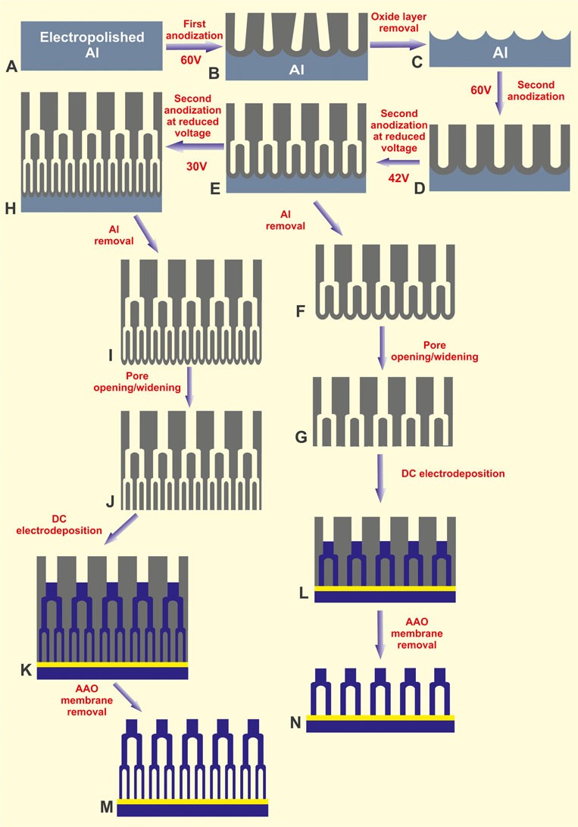
J Solid State Electrochem (2012) 16:3611–3619
3613
Fig. 1 Schematic representation of the anodization procedure used for fabrication of AAOmembranes with Y-branched or two level branched nanochannels and branched metallic nanowire arrays
of 1 mA cm⁻²in a commercially available electrolyte(Aur-una®5000;Aucontent,7gdm⁻³;Fig.1kandl).Allelectro-
deposition experiments were performed in a typical three- electrodecellwiththeAAOmembraneasaworkingelectrode and Pt plates as a counter and reference electrodes using a Reference3000potentiostat(GamryInstruments).Afterthe electrodeposition process, samples were rinsed with water thenethanolanddried.Inordertoreleasethefabricatednano- wires, AAO templates were chemically removed in a 1M
NaOHsolutionatroomtemperaturefor60min(Fig.1mandn).PolystyrenenanowirearrayswereobtainedbyimmersingAAO templates in a 1.5 wt% solution of polystyrene in chloroform.
Characterization
The morphology of AAO templates and nanowire arrays was studied with a FE-SEM/energy dispersive X-ray

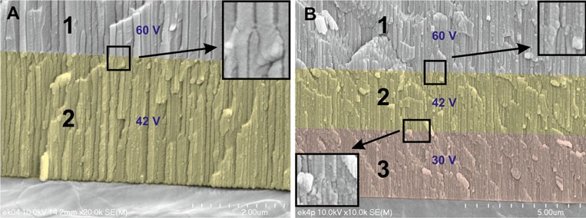
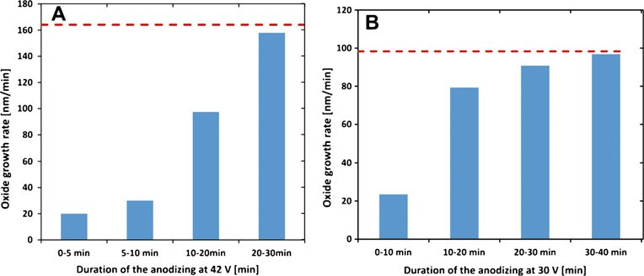
3614
J Solid State Electrochem (2012) 16:3611–3619
Fig. 2 Cross-sectional FE- SEM images of nanoporous AAO membranes withY-branched (a) and two-level- branched (b) nanopores. The anodization at 60 V wascarried outfor120min.Thedurationof anodizing at the reduced poten- tial of 42 V (a and b) and 30V
(b) was 30 min
spectrometer(EDS;HitachiS-4700withaNoranSystem7). ThecompositionofnanowireswasconfirmedbyEDSanal- yses. The characteristic parameters of AAO membranes such as oxide layer thickness, interpore distance and pore diameter were calculated on the basis of SEM images by using the scanning probe image processor WSxMv.12.0[30], ImageJ software [31], and an executable paper[32].
anodizing time. The influence of anodizing conditions on the rate of porous oxide growth was discussed in detail in our previous work [33]. Unfortunately for the AAO tem- plates with hierarchically-branched pores, the dependence between the thickness of the porous oxide layer and the duration of the anodizing step after the reduction of the anodizing potential, is more complicated.
In order to get deeper insight into the oxide growth ratesafter subsequent reductions of the anodizing potential, the thicknesses of oxide layers grown at the reduced potentials were estimated from FE-SEM images for different process durations. Then, the oxide growth rates for different time periods were calculated. The relationships between the ox- ide growth rate and different time periods for anodizations carried out at the reduced potentials of 42 and 30 V are shown in Fig.3a and b, respectively.
It can be seen that the reduction of potential affects considerably the rate of oxide growth. In particular, just after the potential reductions, the oxide growth rates are much lower than those observed during anodizing at fixed potentials of 42 and 30 V (red dash lines). For the process performed at the reduced potential, the oxide growth rate significantly increases with increasing anodizing time. In bothcases,thestablevaluesoftheoxidegrowthrate,closed to the values observed for potentiostatic anodizations under 42 and 30V,are reached after about 30 min.Toexplainthis
Results and discussion
Thecross-sectional viewsofAAOtemplateswithY-branched and two level-branched nanopores are presented in Fig.2a and b, respectively. In both cases, long and parallel nanochannels can be easily recognized. As can be seen, when the anodizing potential is reduced from 60 to 42Veachporeisdividedintotwosmallerchannels(yellow areas“2”in the SEM images), and in that way theY-branchedporestructureisobtained.Asubsequentreduction oftheanodizingpotentialfrom42to30Vleadstoasecond division of nanochannels (pink area“3”in the SEM image) and formation of the template with hierarchically branched nanopores.Itiswellknownthatthethicknessofoxidelayer grown on aluminum is almost linearly proportional to the durationoftheanodizationprocess[33].Therefore,alength of nanochannels can be easily controlled by adjustingthe
Fig. 3 Oxide growth rates for differentanodizingperiodsafter the potential reduction to 42V
(a) and 30 V (b)

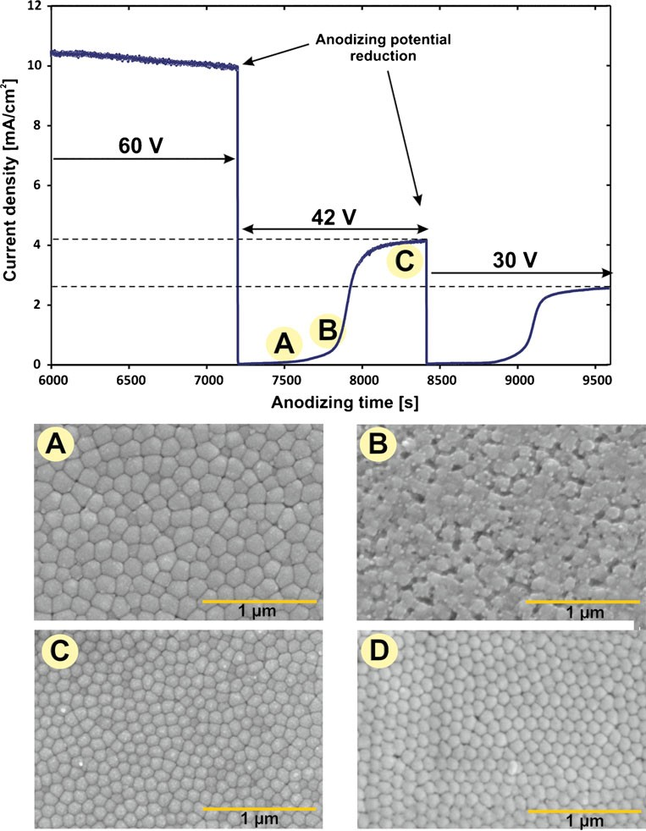
J Solid State Electrochem (2012) 16:3611–3619
3615
tendency, the current density vs. anodizing time curve is shown in Fig.4.
The shape of the current–potential curve, after the anod- izing potential reduction, is consistent with those reported
result of the potential reduction, the current density de- creased to almost negligible values, due to the fact that the electric field across the barrier oxide layer is too small, and remainedalmostconstantforabout500s.Consequently,the lowrateofoxidegrowth,observedduringthefirst10minof anodizing under 42V,is the result of low current densities. Itcanbeseenthatafter300sofanodizingunderthereduced voltage (Fig.4a), the bottom side of the AAO layer looks stillthesameasafteranodizingunder60V[33].Thisfactis also confirmed by an average cell diameter shown in Fig.6whichisclosetothecelldiameteroftheAAOlayerformed by anodizing under 60V.After some time, the thickness of thebarrierlayerstartstodecreaseduetotheprogressive
previously by Takahashi et al. [19]
and O’Sullivan and
Wood [34]. Both observations about the curve shape and formation mechanism leading to the Y-branched channels could be explained in terms of the most reliable field- assisted mechanism of the porous layer growth [35]. It should be noted that the barrier layer thickness is linearly dependent on the anodizing potential with a proportionality
constant of about 1.04 nm V⁻¹[34]. After 2 h of anodizing under 60V,the applied potential was reduced to 42V.Asa
Fig. 4 The relationship between the current densityand duration of the second anodizing step before and after reduction of the anodizing potential from 60 to 42 V together with FE-SEM images of the bottom side of AAO membranes after 300 s(a),
600 s (b), and 1,200 s (c) an- odizing under 42 V, and after two-step anodization under 42 V without any potential changes (d)

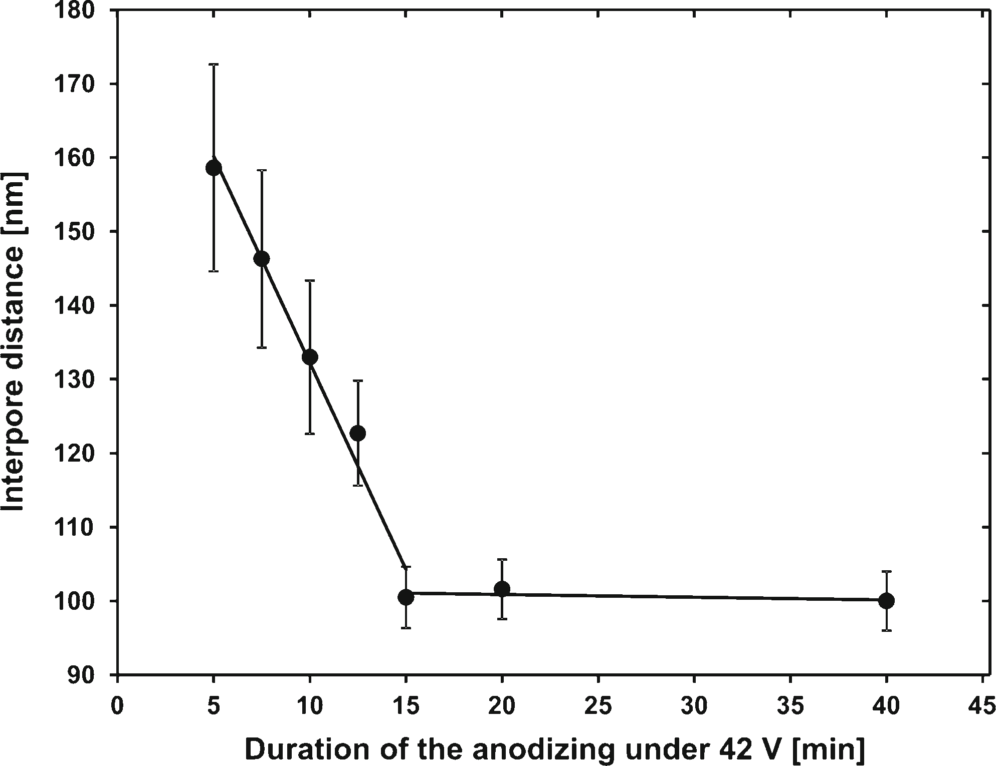
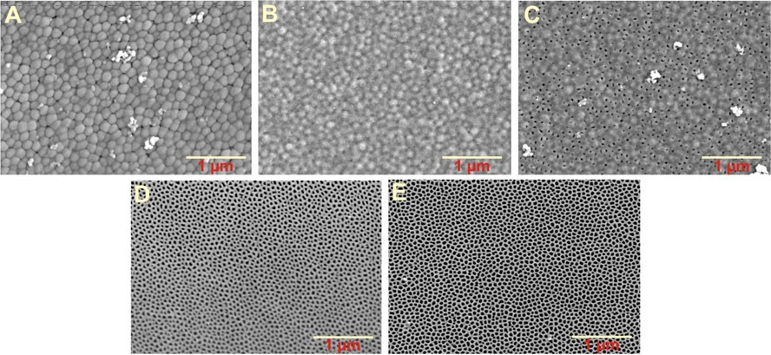
3616
J Solid State Electrochem (2012) 16:3611–3619
900 s. At this stage of the anodizing process, the size of hexagonal cells is similar to the cell size observed in AAO membranes formed under 42 V without any potential changes (about 105 nm).
It is well known that the best pore order in AAOs, anodized in oxalic acid solutions, can be observed at potentials closed to 40 V (self-ordering regime) [23]. As can be clearly seen, the degree of pore order,after reorganization of the structure, is much higher than be- fore the pore rearrangement. However, the regularity of pore arrangement is still not as good as observed for AAOs formed by anodizing under 42 V without any potential changes (compare Fig.4c and d). This phenom- enon can be attributed to the fact that concaves formed on the Al surface during the first anodization carried out at 60 V were arranged in a different way than is required for the anodization at 42V.
In order to fabricate a second level of branches in AAO layers, after 20 min of anodization at 42V,the anodizing potential was reduced to 30V.As a result of the potential reduction,asignificantdecreaseincurrentdensity,toalmost negligible values, and lower rates of the oxide growth were observed (Fig.3b). For this case, the rearrangement of the pores, indicated by the current density increase, begins at about 500 s after the application of the reduced potential. Consequently,forhighercurrentdensitiestheincreaseinthe oxide growth rate is also observed (Fig.3b). The reorgani- zation is completed after about 800 s of anodizing at 30V,and the alumina growth rate reaches a destination value (dashline).
In order to obtain a through-hole AAO membrane a procedure of pore opening by chemical etching in a phosphoric acid should be performed. It is noteworthy
Fig. 5 The relationship between the cell size estimated from the bottom side of the AAO membrane and duration of the anodizing step after the potential reduction from 60 to 42 V
dissolution of the oxide layer in the electrolyte, so the electric field gradually increases. As a result, a gradual increase in the current density and oxide growth rate can be observed after about 600 s of anodizing under 42V.In evidenceofthat,somedisorderedareasatthebottomsideof the AAO with a partially dissolved barrier layer can be noticed (see Fig.4b). When the current density increases, the process of the pore rearrangement begins and new cells are formed [19]. As a consequence of this process, a de- crease in the average cell diameter (see Fig.5) and increase intheoxidegrowthrateareobserved(seeFig.3).
Inaddition,thecurrentdensitybeginstostabilizeandthe rearrangementofporesseemstobecompletedafterabout
Fig.6FE-SEMimagesofbottomsidesofAAOmembraneswithtwolevelbranchedporesbeforetheporeopeningprocedure(a)andafter20min (b),25min(c),30min(d),and40min(e)ofchemicaletchingina5wt%H₃PO₄solutionat35°C

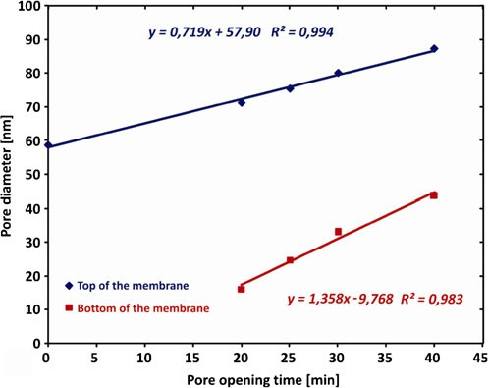
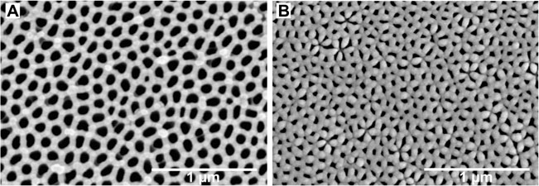
J Solid State Electrochem (2012) 16:3611–3619
3617
layer is achieved after 30 min of etching and the average diameter of opened pores is about 30 nm (Fig.6d). When the duration of the pore opening/widening process is ex- tended to 40 min, the average pore diameter increases to about 45 nm (Fig.6e).
It should be noted that the pore opening procedure carried out in a phosphoric acid solution widens also the nanopore mouths. The adhesion of the top side of the AAO membrane to the microscopic glass results in a slightly lower etching rate at the top of the aluminatemplatethanatthebottomside that wasdirectlyexposed to the acidic solution. Therefore, widening of the pore diameter at the top side of the AAO layerproceedalittlebitslowerthanatthebottomside(Fig.7).
As was mentioned before, pore and cell dimensions in AAO depend linearly on anodizing potential and,thus,it isobvious that these parameters shouldbeconsiderably larger at the top side than at the bottom side of the AAO membrane.Toillustrate this point, FE- SEM images of top and bottom sides of the nanoporous AAOmembrane withY-branchednanochannelsafterpore opening are shown in Fig.8.
The average pore diameter and cell size estimated for both sides of the AAO membranes having one- or two-level-branchedpores arecollectedinTable1.Bothtypes of alumina membranes with Y-branched and two- level-branched nanopores were used as templatesforfabricationof Auandpolystyrene nanowirearrays.The gold nanowire arrays fabricated by cathodic elec-trodepositioninside AAOmembraneswithbranchednanopores are shown in Fig.9a and b. The template with Y-branched channels was synthesized by the two- step anodization in 0.3 M oxalic acid at 20 °C, and the duration of the process at the reduced potential of 42 V was 10 min. After 10 min of electrochemical deposition, a uniform array of ultra short Y-shaped Au nanowires was formed (Fig.9a).
The diameters of the trunk of the nanowire and branches roughly correspond to the dimensions of the Y-branched nanochannelsoftheAAOtemplateusedforelectrodeposition.
Fig. 7 The relationship between the pore diameter and duration of the pore opening procedure for nanoporous membranes with two level branched channels
that the thickness of the barrier layer strongly depends on anodizing conditions, especially on the applied po- tential. Moreover, the etching rate of AAO is stronglyaffectedby theconcentrationofH₃PO₄andetchingtemperature. Thus, the procedure of pore opening, al- ways associated with pore widening, should be opti- mized carefully. Figure6shows FE-SEM imagesof the bottom side of AAO membranes with two level branched nanopores formed by anodizing of the highpurityAlfoilin 0.3 Moxalic acidat 20°C.Theduration of the anodizing under 60, 42, and 30 V was 7,200, 1,200, and 1,800 s,respectively.The pore opening procedure was carried out in 5 wt% H₃PO₄at 35 °C.
It is clearly visible that after 20 min of pore opening pores are still closed (Fig.6b) but, the pore bottoms are smootherwhencomparedwiththoseobservedforthemem-brane beforethechemical etchinginphosphoricacid(Fig.6a). This is a result of an isotropic thinning of the barrier layer by the acidic etchant. After 25 min of pore opening,someholescanbevisible,butthemajorityofpores arestillclosed(Fig.6c).Thecompleteremovalofthebarrier
Fig. 8 FE-SEM images of the top (a) and bottom (b) sides of the AAO membrane with Y- branched pores after 50 min of pore opening in 5 wt% H₃PO₄at 35 °C

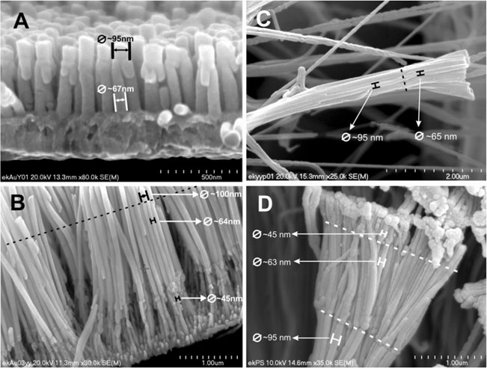
3618
J Solid State Electrochem (2012) 16:3611–3619
Table 1 Pore diameters and cell dimensions for AAO membranes with hierarchically branched nanopores formed by anodizing in 0.3 M oxalic acid at 20 °C and after the pore opening/widening procedure
Type of the membrane
Pore opening conditions
Pore diameter (nm)
Cell diameter (nm)
Top view
Bottom view
Top view
Bottom view
∼90
∼90
∼65
∼40
∼140
∼140
∼100
∼70
AAO with Y-branched nanopores
AAO with two level branched nanopores
5 wt% H₃PO₄; 35 °C; 50 min
5 wt% H₃PO₄; 35 °C; 40 min
The preparedY-branchednanowire array was mechanically stableandeasytohandlethatmakesitpossibletobeusedasa nanostructured electrode in modern applications such asca- talysis,sensorsandcurrentcollectors.TheFE-SEMimageof hierarchicallybranchedAunanowiresgrownbyelectrodepo-
sition at 1 mA cm⁻²for 20 min is shown in Fig.9b. Also in thiscase,thedimensionsofbranchedAunanowiresarecon-
sistent with the shape of alumina nanochannels used as a template.
Another method that involved pore filling of the AAO template with apolymerwas also used forfabricatingbranched polymer nanowire arrays.Thethrough-holeAAO membranes withY-branchedand two level branched nanoporeswereimmersedintothesolutionofpolystyrenein chloroform for the desired amount of time and allowed to dry in air at room temperature. The FE-SEM images offabricatedandreleasedfromthe AAOtemplateY-branched and two-level branched polystyrene nanowires are shown in Fig.9c and d, respectively. The prepared polystyrene nanowires precisely reproduce the dimensions and shape of pores of the AAO templates used for their fabrication.
Conclusions
Insummary,thetwo-step self-organized anodizationwiththe stepwise reductionof theapplied potentialis a simple andeffectivemethodforfabricationofanodicaluminamembranes withY-branchedandtwo-level-branched nanochannels. Just afterthereductionofanodizingpotential,asignificantdecreaseinbothcurrentdensityandoxidegrowthrateswereobserved.Itwasfoundthatforanodizationscarriedoutin0.3MH₂C₂O₄theprocessofporerearrangementiscompletedafterabout900 and800sfromthetimeatwhichthepotentialwasreducedto 42 and 30V,respectively.In order to obtain through-holealumina membranes,asimple pore opening procedurecarriedout in 5 wt%H₃PO₄shouldbeperformed.Theporediameteratthe topandbottom sidesof the AAOmembrane dependslinearly on the etching time. As-prepared anodic aluminamembranescanbeeasilyemployedastemplatesforthefabri- cationofY-branchedandtwo-level-branched gold nanowiresbycathodic electrodeposition. The uniformfilling of AAOtemplateswithpolystyreneresultsintheformationofbranched polymer nanowiresthatprecisely reproduce the dimensionsandshapeofnanopores.
Fig. 9 FE-SEM images of Y-branched Au (a) and poly-
styrene (c) nanowires and two- level-branched Au (b) and polystyrene (d) nanowires after the removal of the alumina template

J Solid State Electrochem (2012) 16:3611–3619
3619
Acknowledgments The research was partially carried out with the equipment purchased thanks to the financial support of the European Regional Development Fund in the framework of the Polish Innovation Economy Operational Program (contractno.POIG.02.01.00-12-023/08).
This work was performed with assistance of the PL-Grid project,contract number: POIG.02.03.00-00-007/08-00, website:www.plgrid.pl.Theprojectisco-fundedbytheEuropeanRegionalDevelopmentFundas part of the Innovative EconomyProgram.
The SEM imaging was performed in the Laboratory of Field Emis- sion Scanning Electron Microscopy and Microanalysis at the Institute of Geological Sciences, Jagiellonian University, Poland.
- KondoT,Miyazaki H, Nishio K, Masuda H (2011) J PhotochPhotobio A221:199–203
- Sulka GD, Zaraska L, Stępniowski WJ (2011) Encyclopedia of nanoscience and nanotechnology, vol 11, 2nd edn. American Sci- entific, CA, pp261–349
- Moyen E, Santinacci L, Masson L, Sahaf H, Mace M, Assaud L,Hanbucken M (2012) Int J Nanotechnol9:246–259
- TsukamotoT,OginoT(2012)JElectrochemSoc159:C155–C159
- LiJ, Papadopoulos C, Xu J (1999) Nature402:253–254
- Papadopoulos C, Rakitin A, Li J,VedeneevAS, Xu JM (2000)Phys Rev Lett85:3476–3479
- Takahashi H, Nagayama M, Akahori H, Kitahara A (1973) JElectron Microsc22:149–157
- WangH,WangHW,ZengP(2008)KeyEngMater373–374:252–255
- ZakeriR,WattsC,WangH,KohliP(2007)ChemMater19:1954–1963
- Zhang J, Day CS, Carroll DL (2009) Chem Commun 2009:6937–6939
- Sulka GD (2008) In: Eftekhari A (ed) Nanostructured materialsinelectrochemistry.Wiley,Weinheim, pp1–116
- Meng G, Jung YJ, Cao A,VajtaiR, Ajayan PM (2005) Proc NatlAcad Sci U S A102:7074–7078
- XuL,YuanZ,ZhangX(2006)ChinSciBull51:2055–2058
- GaoT,Meng G, Zhang J, Sun S, Zhang L (2002) Appl Phys A 74:403–406
- ChoiJ, Sauer G, Nielsch K, Wehrspohn RB, Gösele U (2003) Chem Mater15:776–779
- KongLB, Lu M, Li MK, Li HL (2003) J Mater Sci Lett 22:701–702
- BiswasKG, El Matbouly H, RawatV,Schroeder JL, Sands TD(2009) Appl Phys Lett95:073108/1–4
- HorcasI,FernándezR,Gómez-RodríguezJM,ColcheroJ,Gómez-Herrero J, Baro AM (2007) Rev Sci Instrum 78:013705/1–8
- ImageJ.NationalInstituteofMentalHealth,Bethesda,MD,USA,http://rsb.info.nih.gov/ij
- CiepielaE, Zaraska L, Sulka GD (2012) Lect Notes Comput Sci7136:240–251
- ZaraskaL,SulkaGD,JaskułaM(2011)JSolidStateElectrochem15:2427–2436
- O’SullivanJP,WoodGC (1970) Proc R Soc Lond A317:511–543
- ParkhutikVP,ShershulskyVI(1992)JPhysDApplPhys25:1258–1263
Open Access This article is distributed under the terms of the Crea- tiveCommonsAttributionLicensewhichpermitsanyuse,distribution, and reproduction in any medium, provided the original author(s) and the source arecredited.
References
- BhushanB(ed)(2008)Springerhandbookofnanotechnology,2nd edn. Springer,Berlin
- ChenS(ed)(2010)Nanomanufacturing.AmericanScientific,NewYork
- Iwamoto M, Kaneto K, Mashiko S (eds) (2003) Nanotechnologyandnano-interface controlled electronic devices.Elsevier,Amsterdam
4. Iijima S (1991) Nature 354:56–58
- Morales AM, Lieber CM (1998) Science279:208–211
- PanZW,Dai ZR,WangZL (2001) Science291:1947–1949
- YinAJ, Li J, JianW,Bennett AJ, Xu JM (2001) Appl Phys Lett 79:1039–1041
- Fu J, Cherevko S, Chung CH (2008) Electrochem Commun 10:514–518
- Sulka GD, Brzózka A, Zaraska L, Jaskuła M (2010) Electrochim Acta55:4368–4376
- Li R, ChenQW,HuXY,WangMS,WangCW,Zhong H (2012) RCS Adv2:2250–2253
- YuY,Kant K, Shapter JG, Addai-Mensah J, Losic D (2012) Microporous Mesoporous Mater153:131–136
- Jung JS, Kim EM, Chae WS, Malkinski LM, Lim JH, O’Connor C, Jun JH (2008) Bull Korean Chem Soc29:2169–2171

