
Eur. Phys. J. C (2016) 76:295
DOI 10.1140/epjc/s10052-016-4110-0

The European
Physical journal C
CrossMark
Regular Article - Experimental Physics

Reconstruction of hadronic decay products of tau leptons
with the ATLAS experiment
ATLAS Collaboration*
CERN, 1211 Geneva 23, Switzerland
Received: 21 December 2015 / Accepted: 27 April 2016 / Published online: 25 May 2016
© CERN for the benefit of the ATLAS collaboration 2016. This article is published with open access at Springerlink.com
Abstract This paper presents a new method of reconstruct-
ing the individual charged and neutral hadrons in tau decays
with the ATLAS detector. The reconstructed hadrons are
used to classify the decay mode and to calculate the vis-
ible four-momentum of reconstructed tau candidates, sig-
nificantly improving the resolution with respect to the cali-
bration in the existing tau reconstruction. The performance
of the reconstruction algorithm is optimised and evaluated
using simulation and validated using samples of Z ^ tt
and Z (^ ^)+jets events selected from proton-proton col-
lisions at a centre-of-mass energy */s = 8 TeV, correspond-
ing to an integrated luminosity of 5 fb-1.
1 Introduction
Final states with hadronically decaying tau leptons play an
important part in the physics programme of the ATLAS
experiment [1]. Examples from Run 1 (2009-2013) of the
Large Hadron Collider (LHC) [2] are measurements of Stan-
dard Model processes [3-7], Higgs boson searches [8],
including models with extended Higgs sectors [9-11], and
searches for new physics phenomena, such as supersym-
metry [12-14], new heavy gauge bosons [15] and lepto-
quarks [16]. These analyses depended on robust tau recon-
struction and excellent particle identification algorithms that
provided suppression of backgrounds from jets, electrons and
muons [17].
With the discovery of a Higgs boson [18,19] and evidence
for the Higgs-boson Yukawa coupling to tau leptons [8,20],
a key future measurement will be that of the C P mixture of
the Higgs boson via spin effects in H ^ tt decays [21-
23]. This measurement relies on high-purity selection of the
t- ^ n-v, t- ^ n-n0v and t- ^ n~n+n-v decays,
as well as the reconstruction of the individual charged and
neutral pion four-momenta. The tau reconstruction used in
ATLAS throughout Run 1 (here denoted as “Baseline”), how-
ever, only differentiates tau decay modes by the number of
* e-mail: atlas.publications@cern.ch
charged hadrons and does not provide access to reconstructed
neutral pions.
This paper presents a new method (called “Tau Particle
Flow”) of reconstructing the individual charged and neutral
hadrons in tau decays with the ATLAS detector. Charged
hadrons are reconstructed from their tracks in the tracking
system. Neutral pions are reconstructed from their energy
deposits in the calorimeter. The reconstructed hadrons, which
make up the visible part of the tau decay (Thad-vis), are
used to classify the decay mode and to calculate the four-
momentum of reconstructed Thad-vis candidates. The superior
four-momentum resolution from the tracking system com-
pared to the calorimeter, for charged hadrons with transverse
momentum (pT) less than ~100GeV, leads to a significant
improvement in the tau energy and directional resolution.
This improvement, coupled with the ability to better identify
the hadronic tau decay modes, could lead to better resolu-
tion of the ditau mass reconstruction [24]. The performance
of the Tau Particle Flow is validated using samples of real
hadronic tau decays and jets in Z+jets events selected from
data. The samples correspond to 5 fb-1 of data collected dur-
ing proton-proton collisions at a centre-of-mass energy of
Vs = 8 TeV, which was the amount of data reprocessed
using Tau Particle Flow. While similar concepts for the recon-
struction of hadronic tau decays have been employed at other
experiments [25-31], the Tau Particle Flow is specifically
designed to exploit the features of the ATLAS detector and
to perform well in the environment of the LHC.
The paper is structured as follows. The ATLAS detec-
tor, event samples, and the reconstruction of physics objects
used to select Thad-vis candidates from the 8 TeV data are
described in Sect. 2. The properties of Thad-vis decays and
the Tau Particle Flow method are described in Sect. 3,
including its concepts (Sect. 3.1), neutral pion reconstruc-
tion (Sect. 3.2), reconstruction of individual photon energy
deposits (Sect. 3.3), decay mode classification (Sect. 3.4) and
Thad-vis four-momentum reconstruction (Sect. 3.5). Conclu-
sions are presented in Sect. 4.
1 Springer
295 Page 2 of 26
Eur. Phys. J. C (2016) 76:295
2 ATLAS detector and event samples
- The ATLAS detector
The ATLAS detector [1] consists of an inner tracking sys-
tem surrounded by a superconducting solenoid, electromag-
netic (EM) and hadronic (HAD) calorimeters, and a muon
spectrometer. The inner detector is immersed in a 2 T axial
magnetic field, and consists of pixel and silicon microstrip
detectors inside a transition radiation tracker, which together
provide charged-particle tracking in the region \n\ < 2.5.1
The EM calorimeter is based on lead and liquid argon as
absorber and active material, respectively. In the central
rapidity region, the EM calorimeter is divided radially into
three layers: the innermost layer (EM1) is finely segmented
in n for optimal x/n° separation, the layer next in radius
(EM2) collects most of the energy deposited by electron and
photon showers, and the third layer (EM3) is used to correct
leakage beyond the EM calorimeter for high-energy show-
ers. A thin presampler layer (PS) in front of EM1 and in
the range \n\ < 1.8 is used to correct showers for upstream
energy loss. Hadron calorimetry is based on different detec-
tor technologies, with scintillator tiles (\n\ < 1.7) or liq-
uid argon (1.5 < \n\ < 4.9) as active media, and with
steel, copper, or tungsten as absorber material. The calorime-
ters provide coverage within \n\ < 4.9. The muon spec-
trometer consists of superconducting air-core toroids, a sys-
tem of trigger chambers covering the range \n\ < 2.4, and
high-precision tracking chambers allowing muon momen-
tum measurements within \n\ < 2.7. A three-level trigger
system is used to select interesting events [32]. The first-
level trigger is implemented in hardware and uses a subset of
detector information to reduce the event rate to a design value
of at most 75 kHz. This is followed by two software-based
trigger levels which together reduce the average event rate to
400 Hz.
- Physics objects
This section describes the Baseline Thad-vis reconstruction and
also the reconstruction of muons and the missing transverse
momentum, which are required for the selection of samples
from data. Tau Particle Flow operates on each reconstructed
Baseline tau candidate to reconstruct the charged and neutral
hadrons, classify the decay mode and to provide an alter-
1 ATLAS uses a right-handed coordinate system with its origin at the
nominal interaction point (IP) in the centre of the detector and the z-axis
along the beam direction. The x-axis points from the IP to the centre
of the LHC ring, and the y-axis points upward. Cylindrical coordinates
(r, $) are used in the transverse (x, y) plane, $ being the azimuthal angle
around the beam direction. The pseudorapidity is defined in terms of
the polar angle 9 as n = — lntan(9/2). The distance AR in the n-$
space is defined as AR = (An)2 + (A$)2.
native Thad-vis four-momentum. Suppression of backgrounds
from other particles misidentified as Thad-vis is achieved inde-
pendently of the Tau Particle Flow.
The Baseline Thad-vis reconstruction and energy cali-
bration, and the algorithms used to suppress backgrounds
from jets, electrons and muons are described in detail in
Ref. [17]. Candidates for hadronic tau decays are built from
jets reconstructed using the anti-^ algorithm [33,34] with a
radius parameter value of 0.4. Three-dimensional clusters of
calorimeter cells calibrated using a local hadronic calibra-
tion [35,36] serve as inputs to the jet algorithm. The calcu-
lation of the Thad-vis four-momentum uses clusters within the
core region (AR < 0.2 from the initial jet-axis). It includes a
final tau-specific calibration derived from simulated samples,
which accounts for out-of-cone energy, underlying event,
the typical composition of hadrons in hadronic tau decays
and contributions from multiple interactions occurring in
the same and neighbouring bunch crossings (called pile-up).
Tracks reconstructed in the inner detector are matched to the
Thad-vis candidate if they are in the core region and satisfy the
following criteria: pT > 1 GeV, at least two associated hits in
the pixel layers of the inner detector, and at least seven hits in
total in the pixel and silicon microstrip layers. Furthermore,
requirements are imposed on the distance of closest approach
of the tracks to the tau primary vertex in the transverse plane,
\d0\ < 1.0mm, and longitudinally, \z0 sin 9\ < 1.5mm. The
Thad-vis charge is reconstructed from the sum of the charges
of the associated tracks.
Backgrounds for Thad-vis candidates originating from
quark- and gluon-initiated jets are discriminated against
by combining shower shape and tracking information in a
multivariate algorithm that employs boosted decision trees
(BDTs) [37]. The efficiency of the jet discrimination algo-
rithm has little dependence on the pT of the Thad-vis candi-
dates (evaluated using candidates with pT > 15 GeV) or on
the number of reconstructed primary vertices, which is cor-
related to the amount of pile-up, and has been evaluated up
to a maximum of 25 primary vertices per event. All Thad-vis
candidates are required to have pT > 15 GeV, to be in the
fiducial volume of the inner detector, \n\ < 2.5, and to have
one or three associated tracks. They must also meet jet dis-
crimination criteria, corresponding to an efficiency of about
55 % (40 %) for simulated Thad-vis with one (three) charged
decay products [17], leading to a rate of false identification
for quark- and gluon-initiated jets of below a percent. A dis-
criminant designed to suppress candidates arising from the
misidentification of electrons [17] is also applied.
Muons are reconstructed using tracks in the muon spec-
trometer and inner detector [38]. The missing transverse
momentum is computed from the combination of all recon-
structed and fully calibrated physics objects and the remain-
ing clustered energy deposits in the calorimeter not associ-
ated with those objects [39].
1 Springer
Eur. Phys. J. C (2016) 76:295
Page 3 of 26 295
Table 1 Details regarding the simulated samples of pp collision events.
The following information is provided for each sample: the generator
of the hard interaction, parton shower, hadronisation and multiple par-
ton interactions; the set of parton distribution functions (PDFs) and the
underlying event (UE) tune of the Monte Carlo
- Event samples and selection
The optimisation and measurement of the Thad-vis reconstruc-
tion performance requires Monte Carlo simulated events.
Samples of simulated pp collision events at *Js = 8 TeV are
summarised in Table 1. Tau decays are provided by Z — tt
events. The sophisticated tau decay option of Pythia 8 is
used, which provides fully modelled hadronic decays with
spin correlations [40]. Tau decays in the tt sample are gen-
erated by Tauola [41]. Photon radiation is performed by
Photos [42]. Single-pion samples are also used, in which
the pions originate from the centre of the ATLAS detector
and are generated to have a uniform distribution in $ and n
(\n\ < 5.5) and also in log(E) (200MeV < E < 2 TeV).
The response of the ATLAS detector is simulated using
Geant4 [54,55] with the hadronic-shower model
QGSP_BERT [56,57]. The parameters of the underlying
event (UE) simulation were tuned using collision data.
Simulated pp collision events are overlaid with additional
minimum-bias events generated with Pythia 8 to account
for the effect of pile-up. When comparing to the data, the
simulated events are reweighted so that the distribution of
the number of pile-up interactions matches that in the data.
The simulated events are reconstructed with the same algo-
rithm chain as used for the collision data.
Samples of Thad-vis candidates are selected from the data
using a tag-and-probe approach. Candidates originating
from hadronic tau decays and jets are obtained by selecting
Z — tt and Z(— ii)+jets events, respectively. The data
were collected by the ATLAS detector during pp collisions at
■s/1 = 8 TeV. The sample corresponds to an integrated lumi-
nosity of 5fb—1 after making suitable data quality require-
ments for the operation of the tracking, calorimeter, and muon
spectrometer subsystems. The data have a maximum instan-
taneous luminosity of 7 ■ 1033 cm-2 s—1 and an average num-
ber of 19 pp interactions in the same bunch crossing.
The Z — tt tag-and-probe approach follows Ref. [17];
events are triggered by the presence of a muon from a
leptonic tau decay (tag) and must contain a Thad-vis candi-
date (probe) with pT > 20GeV, which is used to evalu-
ate the tau reconstruction performance. The Thad-vis selec-
tion criteria described in Sect. 2.2 are used. In addition the
Thad-vis must have unit charge which is opposite to that of
the muon. A discriminant designed to suppress candidates
arising from the misidentification of muons [17] is also
applied to increase signal purity. The invariant mass of the
muon and Thad-vis, m (i, Thad-vis), is required to be in the
range 50GeV < m(i, Thad-vis) < 85GeV, as expected for
Z — tt decays. The background is dominated by multijet
and W(— iv)+jets production and is estimated using the
techniques from Ref. [7].
The Z(— ii)+jets tag-and-probe approach follows
Ref. [58], with the following differences: both muons are
required to have pT > 26 GeV, the dimuon invariant mass
must be between 81 and 101 GeV, and the highest- pT jet
is selected as a probe Thad-vis candidate if it satisfies the
Thad-vis selection criteria described in Sect. 2.2 but with
pT > 20 GeV and without the electron discriminant. In this
approach, two more steps are made when comparing sim-
ulated events to the data. Before the Thad-vis selection, the
simulated events are reweighted so that the pT distribution
of the Z boson matches that in data. After the full event selec-
tion, the overall normalisation of the simulation is scaled to
that in the data.
3 Reconstruction of the Thad-vis
Over 90 % of hadronic tau decays occur through just five
dominant decay modes, which yield one or three charged
hadrons (h±), up to two neutral pions (n0) and a tau neu-
trino. The neutrino goes undetected and is omitted in further
discussion of the decay modes. Table 2 gives the follow-
ing details for each of the five decay modes: the branching
fraction, B; the fraction of simulated Thad-vis candidates that
pass the Thad-vis selection described in Sect. 2.2 without the
jet and electron discrimination, A ■ ereco; and the fraction of
those that also pass the jet and electron discrimination, eID.
The h±’s are predominantly n±’s with a minor contribu-
tion from K±’s. The modes with two or three pions proceed
mainly through the intermediate p or ai resonances, respec-
tively. The h±’s are sufficiently long-lived that they typically
12n
Process | Generator | PDFs | UE tune
Z — TT | Pythia 8 [43] | CTEQ6L1 [44] | AU2 [45]
W — jxv | Alpgen [46]+Pythia 8 | CTEQ6L1 | Perugia [47]
W — TV | Alpgen+Pythia 8 | CTEQ6L1 | Perugia
Z —— /x/a | Alpgen+Pythia 8 | CTEQ6L1 | Perugia
tt | MC@NLO [48-50]+Herwig [51,52] | CT10 [53] | AUET2 [45]
295 Page 4 of 26
Eur. Phys. J. C (2016) 76:295
Table 2 Five dominant Thad-vis decay modes [59]. Tau neutrinos are
omitted from the table. The symbol h± stands for n± or K±. Decays
involving K ± contribute ~3 % to the total hadronie branching fraction.
Decays involving neutral kaons are excluded. The branching fraction
(B), the fraction of generated Tilad-vis’s in simulated Z ^ tt events that
are reconstructed and pass the Thad-vis selection described in Sect. 2.2
without the jet and electron discrimination (A • ereco) and the fraction of
those Thad-vis candidates that also pass the jet and electron discrimination
(bjd) for each decay mode are given
Decay mode | B (%) | A • ^reco (%) | ®ID (%)
h± | 11.5 | 32 | 75
h± n0 | 30.0 | 33 | 55
h± >2n0 | 10.6 | 43 | 40
3h± | 9.5 | 38 | 70
3h± >1n0 | 5.1 | 38 | 46
interact with the detector before decaying and are therefore
considered stable in the Tau Particle Flow. The n0’s decay
almost exclusively to a pair of photons. Approximately half
of the photons convert into an e+e- pair because of inter-
actions with the beampipe or inner-detector material. Modes
with more n0’s tend to have lower eiD as they have wider
showers that are more similar to those produced by quark-
and gluon-initiated jets. The mode dependence of A • ereco is
due to a mixture of effects. The fraction of energy carried by
visible decay products is mode dependent and the response
of the calorimeter to h±’s and n 0’s is different, both of which
impact the efficiency of the Thad-vis pT requirement. The effi-
ciency of the track association is also dependent on the num-
ber of h±’s and to a lesser extent the number of n0’s, which
can contribute tracks from conversion electrons.
The goal of the Tau Particle Flow is to classify the five
decay modes and to reconstruct the individual h±’s and n0’s.
The performance is evaluated using the energy and direc-
tional residuals of n0 and Thad-vis and the efficiency of the
Thad-vis decay mode classification. The n and $ residuals are
defined with respect to the generated values: n - ngen and
$ - $gen, respectively. For ET, the relative residual is defined
with respect to the generated value ET/ETen. The core and
tail resolutions for n, $ and ET are defined as half of the
68 and 95 % central intervals of their residuals, respectively.
Decays into higher-multiplicity states are accommodated by
including modes with more than two n0’s in the h± >2n0
category and more than one n0 in the 3h± >1n0 category.
Decays with more than three charged hadrons are not con-
sidered. No attempt is made to reconstruct neutral kaons or
to separate charged kaons from charged pions.
  - Concepts of the tau particle flow method
The main focus of the Tau Particle Flow method is to recon-
struct Thad-vis’s with pT values between 15 and 100 GeV,
which is the relevant range for tau leptons produced in decays
of electroweak and SM Higgs bosons. In this case the hadrons
typically have pT lower than 20 GeV (peaked at ~4 GeV)
and have an average separation of AR « 0.07. The h±’s
are reconstructed using the tracking system, from which the
charge and momentum are determined. Each track associ-
ated with the Thad-vis candidate in the core region is con-
sidered to be a h± and the n ± mass hypothesis is applied.
Approximately 2 % of the selected Thad-vis’s have a misclas-
sified number of h ±’s. Overestimation of the number of h±’s
is primarily due to additional tracks from conversion elec-
trons, which are highly suppressed by the strict track selec-
tion criteria described in Sect. 2.2. Underestimation of the
number of h±’s is primarily caused by tracking inefficien-
cies (~10 % for charged pions with pT > 1 GeV [1]), which
arise from interactions of the h±’s with the beampipe or
detector material. The h±’s also produce a shower in the
calorimeter from which their energy and direction can be
determined, but the tracker has a better performance in the rel-
evant momentum range. The shower shapes of h±’s are also
highly irregular, with a typical width of 0.02 < AR < 0.07
in the EM calorimeter, combined with large fluctuations in the
fractional energy depositions in the layers of the calorime-
ter. The n 0’s are reconstructed from their energy deposits
in the EM calorimeter. The main challenge is to disentan-
gle their energy deposits from h± showers, which have a
width similar to the average separation between hadrons.
The photons from n0 decays are highly collimated, with
a typical separation of 0.01 < AR < 0.03. The majority
of the n0 energy is reconstructed in a single cluster in the
EM calorimeter. Compared to h±’s, n0 showers are smaller
and more regular, leaving on average 10, 30 and 60% of
their energy in PS, EM1 and EM2, respectively. Almost no
n0 energy is deposited beyond EM2, so EM3 is consid-
ered part of the HAD calorimeter in Tau Particle Flow. The
characteristic shower shapes and the kinematics of h±’s and
n0’s are used to identify n0’s and to classify the tau decay
mode.
In the following sections, the individual steps of the
Tau Particle Flow method for Thad-vis reconstruction are
described. The first step is the reconstruction and identifica-
tion of neutral pions. Next, energy deposits from individual
photons in the finely segmented EM1 layer are reconstructed
to identify cases where two n0’s are contained within a sin-
gle cluster. The decay mode is then classified by exploit-
ing the available information from the reconstructed h±’s
and n0’s and the photons reconstructed in EM1. Following
the decay mode classification, the Thad-vis four-momentum is
reconstructed from the individual hadrons and then combined
with the Baseline energy calibration to reduce tails in the ET
residual distribution. The performance of the Tau Particle
Flow is evaluated using Thad-vis candidates from simulated
Z ^ tt events.
1 Springer
Eur. Phys. J. C (2016) 76:295
Page 5 of 26 295
  - Reconstruction and identification of neutral pions
The reconstruction of neutral pion candidates (^0^) within
hadronic tau decays using the Tau Particle Flow proceeds as
follows. First, nS^s are created by clustering cells in the
EM calorimeter in the core region of the Thad-vis. In the next
step, the energy is corrected for contamination from
h±’s. To do this, the energy that each h± deposits in the EM
calorimeter (eEm) is estimated as the difference between
the energy of the h± from the tracking system (eJ±) and the
energy deposited in the HAD calorimeter which is associated
with the h± (eJH^0): EEm = Ej^k - E^0. To calculate
EhH±AD, all clustered energy deposits in the HAD calorimeter
in the core region are assigned to the closest h±, determined
using the track position extrapolated to the calorimeter layer
that contains most of the cluster energy. The eJM of each h±
is then subtracted from the energy of the closest if it is
within AR = 0.04 of the h±.
At this stage, many of the ’s in reconstructed hadronic
tau decays do not actually originate from n 0’s, but rather
from h± remnants, pile-up or other sources. The purity of
n,?and’s is improved by applying a minimum pT requirement
and an identification criterion designed to reject nd^s not
from n0’s. The pT thresholds are in the range 2.1-2.7 GeV.
After the pT requirement the background is dominated by h±
remnants. The n0 identification uses a BDT and exploits the
properties of the clusters, such as the energy density
and the width and depth of the shower. The variables used
for identification are described in Table 3. The BDT
is trained using Thad-vis’s that have only one h±, and which
are produced in simulated Z ^ tt events. The nd^s are
assigned to signal or background based on whether or not
they originated from a generated n0. Figure 1a shows signal
and background distributions for the logarithm of the second
moment in energy density, which is one of the more impor-
tant identification variables. The discriminating power of the
n0 identification is quantified by comparing the efficiency
of signal and background nd^’s to pass thresholds on the
identification score, as shown in Fig. 1b. The pT and identifi-
cation score thresholds are optimised in five | n | ranges, corre-
sponding to structurally different regions of the calorimeter,
to maximise the number of Thad-vis’s with the correct number
of reconstructed h±’s and identified nd^s (n{D’s).
The h± and n0 counting performance is depicted in Fig. 2
by a decay mode classification matrix which shows the prob-
ability for a given generated mode to be reconstructed as a
particular mode. Only Thad-vis decays that are reconstructed
and pass the selection described in Sect. 2.2 are considered
(corresponding efficiencies are given in Table 2). The total
fraction of correctly classified tau decays (diagonal fraction)
is 70.9 %. As can be seen, for Thad-vis’s with one h±, the sep-
aration of modes with and without n0’s is quite good, but
Table 3 Cluster variables used for n? d identification. The variables
|nclus|, (r2)dus, A.£entre> /£££ and log(,o2)dus are taken directly from
the cluster reconstruction [36]. To avoid confusion with other variables
used in tau reconstruction, the superscript clus has been added to each
variable
Cluster pseudorapidity, |nclus|
Magnitude of the energy-weighted n position of the cluster
Cluster width, (r2)clus
Second moment in distance to the shower axis
Cluster n width in EM1, (nEM1 )dus
Second moment in n in EM1
Cluster n width in EM2, (nEM2)dus
Second moment in n in EM2
Cluster fept^ ^tre
Distance of the shower centre from the calorimeter front face
measured along the shower axis
Cluster PS energy fraction, /PcSlus
Fraction of energy in the PS
Cluster core energy fraction, /ccolrues
Sum of the highest cell energy in PS, EM1 and EM2 divided by the
total energy
Cluster logarithm of energy variance, log(p2)dus
Logarithm of the second moment in energy density
Cluster EM1 core energy fraction, /du| em1
Energy in the three innermost EM1 cells divided by the total energy
in EM1
Cluster asymmetry with respect to track, Atcrlaucsk
Asymmetry in n-$ space of the energy distribution in EM1 with
respect to the extrapolated track position
Cluster EM1 cells, NEM
Number of cells in EM1 with positive energy
Cluster EM2 cells, N^2
Number of cells in EM2 with positive energy
it is difficult to distinguish between h± n0 and h± >2n0.
The largest contributions to the misclassification arise from
h± >2n0 decays where one of the n0’s failed selection or
where the energy deposits of both n0’s merge into a single
cluster. It is also difficult to distinguish between the 3h± and
3h± >1n0 modes because the n0’s are typically soft with
large overlapping h± deposits.
Two alternative methods for n0 reconstruction were also
developed. In the first method (Pi0Finder) the number of n0’s
in the core region is first estimated from global tau features
measured using calorimetric quantities and the momenta of
the associated h± tracks. Clusters in the EM calorimeter are
then chosen as nc?and’s using a n0 likeness scorebased on their
energy deposition in the calorimeter layers and the Thad-vis
track momenta. The likeness score does not exploit cluster
moments to the same extent as the n0 identification of the
Tau Particle Flow and cluster moments are not used at all to
1
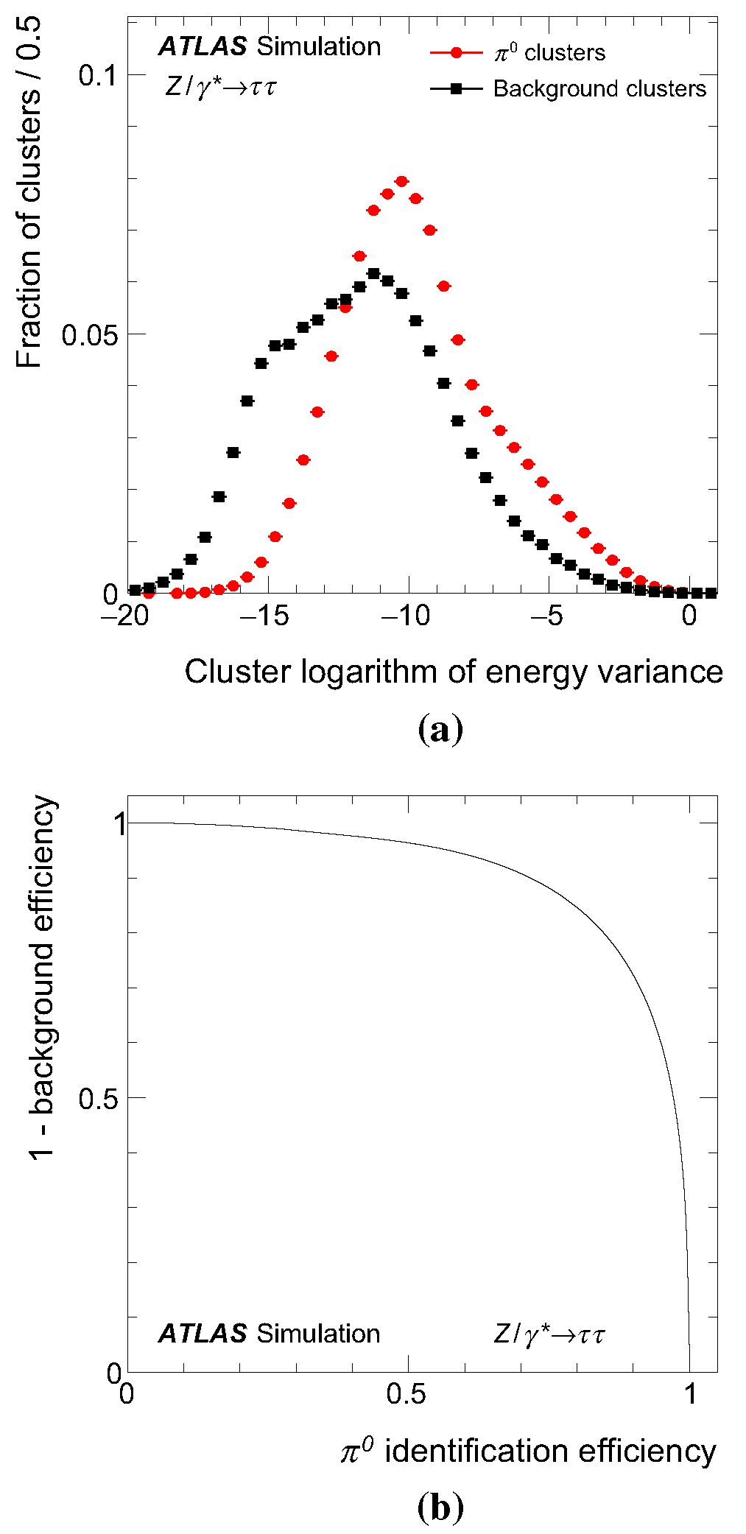
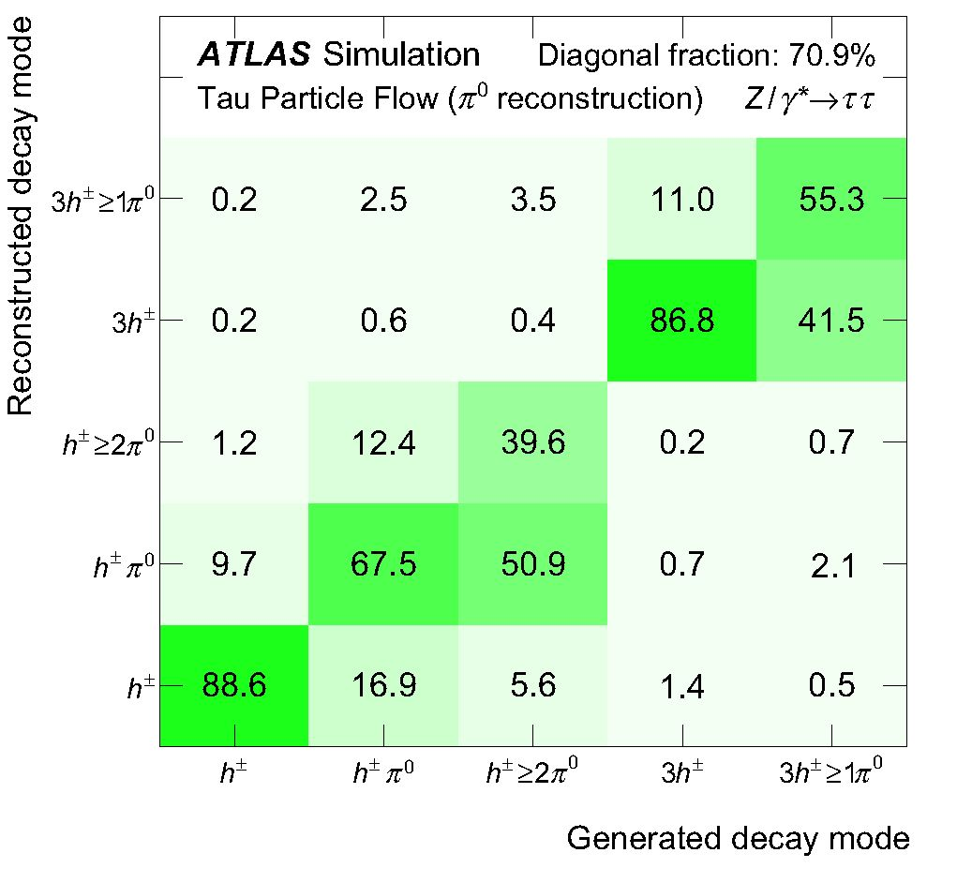
295 Page 6 of 26
Eur. Phys. J. C (2016) 76:295
Fig. 1 a Distribution of the logarithm of the second moment in energy
density of nd^ clusters that do (signal) or do not (background) originate
from n0’s, as used in the n0 identification. b 1 - efficiency for back-
ground n0 d’s vs. the efficiency for signal d’s to pass thresholds on
the n0 identification score. The nd d’s in both figures are associated
with Thad-vis’s selected from simulated Z ^ tt events
estimate the number of n0. This method was used to calcu-
late variables for jet discrimination in Run 1 [17], but was not
exploited further. The other method (shower shape subtrac-
tion, SSS) is a modified version of Tau Particle Flow, which
attempts to subtract the h± shower from the calorimeter at
cell level using average shower shapes derived from sim-
Fig. 2 Decay mode classification efficiency matrix showing the prob-
ability for a given generated mode to be reconstructed as a particu-
lar mode by the Tau Particle Flow after n0 reconstruction in simu-
lated Z ^ tt events. Decays containing neutral kaons are omitted.
Only decays from Thad-vis’s that are reconstructed and pass the selec-
tion described in Sect. 2.2 are considered. The statistical uncertainty is
negligible
ulation. The shower shapes are normalised such that their
integral corresponds to EhE±M and centred on the extrapolated
position of the h± track. They are then subtracted from the
EM calorimeter prior to the clustering, replacing the cluster-
level subtraction of EhE±M.
The n0 ET, n and $ residual distributions for all n0 recon-
struction algorithms are shown in Fig. 3a-c, respectively. The
core angular resolutions for each algorithm are quite simi-
lar with ~0.0056 in n and ~0.012rad in $. The Pi0Finder
algorithm has the poorest performance, with core resolutions
of 0.0086 and 0.016rad in n and $, respectively, and sig-
nificantly larger tails. The core ET resolutions are almost
identical for the Tau Particle Flow and SSS, both with 16 %,
compared to 23 % for Pi0Finder. The Tau Particle Flow and
SSS both show a shift in the reconstructed ET of a few per-
cent, due to incomplete subtraction of the h± remnant. In the
calculation of the Thad-vis four-momentum in the Tau Parti-
cle Flow (Sect. 3.5), this bias is corrected for by a decay-
mode-dependent calibration. Despite the more sophisticated
shower subtraction employed in the SSS algorithm, it does
not perform significantly better; the improvement in the total
fraction of correctly classified tau decays is ~1%. This is
partly because many of the nd^s are sufficiently displaced
from h±’s so that they have little energy contamination and
are unaffected by the subtraction, and partly because the sig-
nature of clusters that contain n0’s, even in the presence of
overlapping h± energy, is distinct enough for the BDT to
identify. Contributions from pile-up have little effect on the
1 n
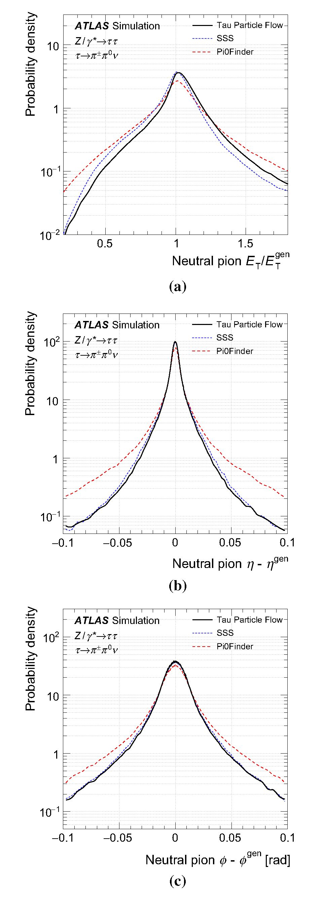
Eur. Phys. J. C (2016) 76:295
Page 7 of 26 295
Fig. 3 Distributions of the n0 residuals in a transverse energy Et,
b pseudorapidity n and c azimuth $ in correctly reconstructed h± n0
decays of tau leptons in simulated Z ^ tt events
n^nd reconstruction in Tau Particle Flow; on average the ET
increases by ~ 15 MeV and its resolution degrades fraction-
ally by ~0.5 % per additional reconstructed vertex.
  - Reconstruction of individual photon energy deposits
in EM1
During the n0 reconstruction, the energy deposits from
both photons typically merge into a single cluster. Further-
more, for Z ^ tt events, in about half of the h± >2n0
decays misclassified as h± n0 by the n0 reconstruction, at
least three of the photons from two n0’s are grouped into
a single cluster. The fraction increases for higher Thad-vis
pT due to the collimation of the tau decay products. The
identification of the energy deposits from individual pho-
tons in the finely segmented EM1 layer can be exploited
to improve the n0 reconstruction, as discussed in the
following.
Almost all photons begin to shower by the time they tra-
verse EM1, where they deposit on average ~30% of their
energy. In contrast, particles that do not interact electromag-
netically rarely deposit a significant amount of energy in this
layer, making it ideal for the identification of photons. Fur-
thermore, the cell segmentation in n in this layer is finer than
the average photon separation and comparable to the aver-
age photon shower width, allowing individual photons to be
distinguished.
The reconstruction of energy deposits in EM1 proceeds as
follows. First, local energy maxima are searched for within
the core region. A local maximum is defined as a single cell
with Et > 100 MeV whose nearest neighbours in n both
have lower ET. Maxima found in adjacent $ cells are then
combined: their energy is summed and the energy-weighted
mean of their $ positions is used. Figure 4 shows the effi-
ciency for photons to create a local maximum (maxima effi-
ciency), evaluated in the sample of single n0’s. The efficiency
decreases rapidly at low photon pT as many of the photons
fall below the 100 MeV threshold. The fraction of misre-
constructed maxima due to noise or fluctuations from the
photon shower is very low for maxima with ET > 500 MeV,
but increases quickly at lower ET. At high photon pT, corre-
sponding to high n0 pT, the boost of the n0 becomes large
enough that the pair of photons almost always creates a single
maximum. Figure 4 also shows the probability that a maxi-
mum is shared with the other photon in the single n0 sample
(share probability).
The h± >2n0 decay mode classification is improved by
counting the number of maxima associated with nc?and’s. An
energy maximum is assigned to a if its cell is part of the
n^nd cluster and it has an ET of more than 300-430 MeV
(depending on the n region). The energy threshold is opti-
mised to maximise the total number of correctly classified
tau decays. Maxima with ET > 10 GeV are counted twice,
1 Springer
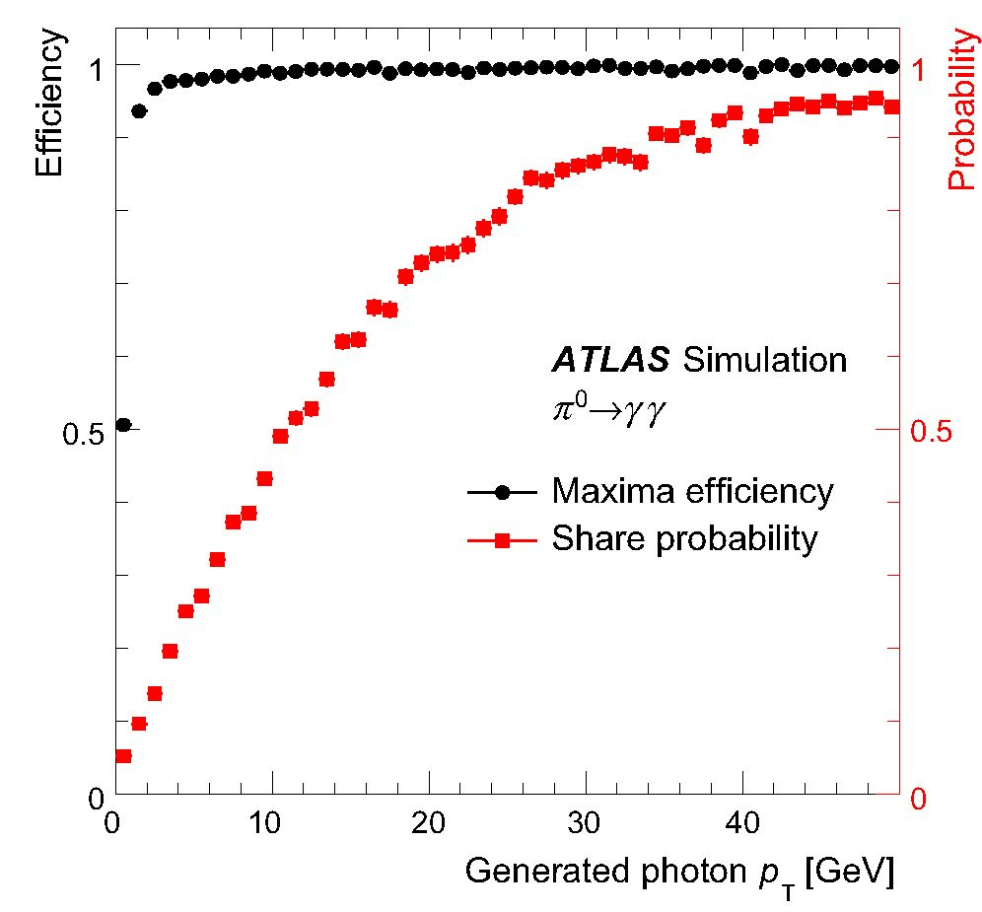
295 Page 8 of 26
Eur. Phys. J. C (2016) 76:295
1 n
Fig. 4 Efficiency for a photon to create a maximum in the first layer
of the EM calorimeter in simulated n0 ^ yy events and the corre-
sponding probability to create a maximum that is shared with the other
photon. The photons are required to not interact with the material in the
tracking system
as they contain the merged energy deposits of two photons
from a n0 decay with a probability larger than 95 %. Finally,
^had-vis candidates that were classified as h± n0, but have
a nc0and with at least three associated maxima are reclassi-
fied as h± >2n0. The method recovers 16 % of misclassified
h± >2n0 decays with a misclassification of h± n0 decays of
2.5%.
  - Decay mode classification
Determination of the decay mode by counting the number
of reconstructed h±’s and nJD’s alone can be significantly
improved by simultaneously analysing the kinematics of
the tau decay products, the n0 identification scores and the
number of photons from the previous reconstruction steps.
Exploitation of this information is performed via BDTs.
As the most difficult aspect of the classification is to
determine the number of n0’s, three decay mode tests are
defined to distinguish between the following decay modes:
h±’s with zero or one n0, h± {0, 1}n0; h±’s with one or
more n0’s, h± {1, >2}n0; and 3h±’s with and without n0’s,
3h± {0, >1}n0. Which of the three tests to apply to a Thad-vis
candidate is determined as follows. The Thad-vis candidates
with one or three associated tracks without any reconstructed
n(?and’s are always classified as h± or 3h±, respectively. The
^had-vis candidates with one associated track and at least two
n(?and’s, of which at least one is n0>, enter the h± {1, >2}n0
test. The Thad-vis candidates with one n-0, that are classified as
h± >2n0 by counting the photons in this cluster, as described
Table 4 Variables used in the BDTs for the r^ad-vis decay mode classi-
fication. They are designed to discriminate against additional misiden-
tified n(0and’s, which usually come from imperfect subtraction, pile-up
or the underlying event
n0 identification score of the first d> SBDT
n0 identification score of the n(°and with the highest n0 identification
score
ETfraction ofthefirst W^d’ fn 0,1
Et of the n(°and with the highest n0 identification score, divided by the
ET-sum of all n(°and’s and h±’s
Hadron separation, AR(h±, n0)
AR between the h± and the n0)and with the highest n0 identification
score
h±distance, Dh±
ET-weighted AR between the h± and the thad-vis axis, which is
calculated by summing the four-vectors of all h±’s and n0)and’s
Number of photons, NY
Total number of photons in the thad-vis, as reconstructed in Sect. 3.3
n0 identification score of second n0)and, 5,BDT
n0 identification score of the n0)and with the second-highest n0
identification score
nc0and ETfraction f„0
ET-sum of ni0and’s, divided by the ET-sum of n^d’s and h±’s
nc0andmass mn0
Invariant mass calculated from the sum of n0)and four-vectors
Numberof n0^ Nn0
Standard deviation of the h± pt, aET,h±
Standard deviation, calculated from the pt values of the h±’s for
rhad-vis with three associated tracks
h±mass, mh±
Invariant mass calculated from the sum of h± four-vectors
in Sect. 3.3, retain their classification and are not considered
in the decay mode tests. The remaining thad-vis candidates
with one or three associated tracks enter the h± {0, 1}n0 or
3h± {0, >1}n0 tests, respectively.
A BDT is trained for each decay mode test using Thad-vis
candidates from simulated Z ^ tt events, to separate
Thad-vis’s of the two generated decay types the test is designed
to distinguish. The Thad-vis candidates entering each decay
mode test are then further categorised based on the number
of nID’s. A threshold is placed on the output BDT score in
each category to determine the decay mode. The thresholds
are optimised to maximise the number of correctly classified
Thad-vis candidates. The BDT training was not split based on
the number of nID’s due to the limited size of the training
sample.
The variables used for the decay mode tests are designed to
discriminate against additional misidentified n(?and’s, which
usually come from imperfect h± subtraction, pile-up or the
underlying event. The associated clusters typically have low
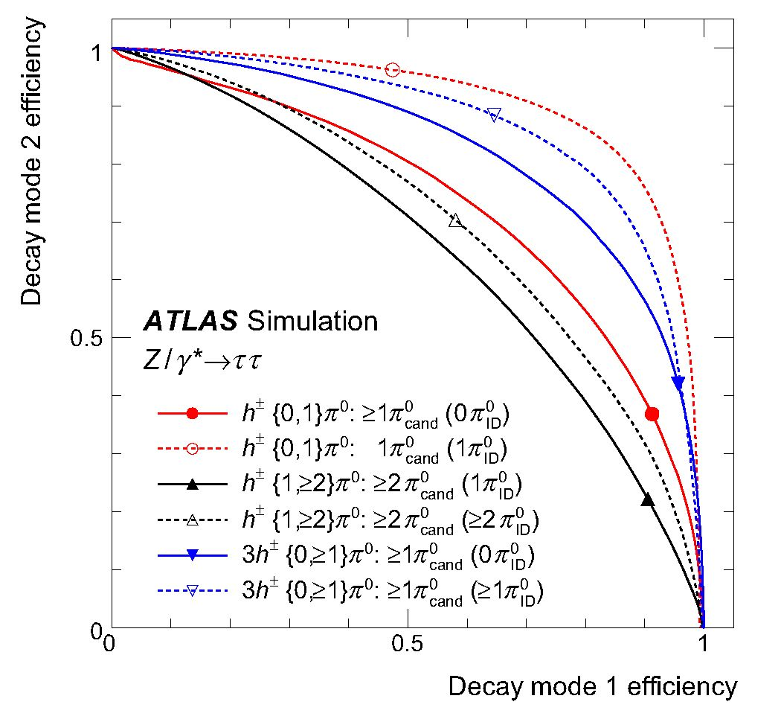
Eur. Phys. J. C (2016) 76:295
Page 9 of 26 295
Fig. 5 Decay mode classification efficiency for the h± {0, 1}n0,
h± {1, >2}n0, and 3h± {0, >1}n0 tests. For each test, “decay mode 1”
corresponds to the mode with fewer n0’s. Working points correspond-
ing to the optimal thresholds on the BDT score for each test are marked
and the h± >2n0 and 3h± >1n0 efficiencies are slightly
overestimated.
  - Four-momentum reconstruction
The Thad-vis four-momentum reconstruction begins with sum-
ming the four-momenta of the h± and n(?and constituents
(Constituent-based calculation). Only the first n n,?and’s with
the highest n0 identification scores are included, where n is
determined from the decay mode classification, and can be at
most 2 n(?and’sinthe h± >2n0 mode and at most 1 in the
3h± >1n0 mode. A pion mass hypothesis is used for n(0and’s.
There are two exceptions: if the decay mode is classified as
h± n0 but there are two identified n(?and’s, the mass of each is
set to zero and both are added to the Thad-vis four-momentum
Table 5 Details regarding the decay mode classification of the Tau Par- on the number of reconstructed, N (n° d), and identified, N (njD), neu-
ticle Flow. BDTs are trained to distinguish decay modes in three decay tral pions. The variables used in the BDTs for each test are listed
mode tests. The fhad-vis ’s entering each test are further categorised based
Decay mode test | N (nc0and) | N (nID) | Variables
h± {0, 1}n0 | >1 | 0 | ^BDT, fn0,1, AR(h±,n0), Dh±, Ny
 | 1 | 1
h±{1, >2}n0 | >2 | 1 | SBDT, fn0, mn0, Nn0, Ny
 | >2 | >2
3h±{0, >1}n0 | >1 | 0 | SBDT, fn0, OET,h± , mh± , Ny
 | >1 | >1
1 Springer
energy and a low n0 identification score. Remnant clusters
from imperfect h± subtraction are also typically close to the
h± track and have fewer associated photon energy maxima.
If the n(0and clusters originate from tau decays, their direc-
tions and fractional energies are correlated with each other.
Additionally, with increasing number of tau decay products,
the available phase space per decay product becomes smaller.
Each variable used in the BDTs is described briefly in Table 4.
Table 5 summarises the decay mode tests and indicates which
variables are used in each.
Figure 5 shows the discrimination power of the tests cat-
egorised by the number of n(0and’s and n{D’s. The decay
mode fractions at the input of each test vary strongly, which
impacts the position of the optimal BDT requirements. The
resulting classification matrix is shown in Fig. 6. The total
fraction of correctly classified tau decays is 74.7 %. High
efficiencies in the important h±, h± n0 and 3h± modes are
achieved. The decay mode purity is defined as the fraction
of rhad-vis candidates of a given reconstructed mode which
originated from a generated Thad-vis of the same mode, also
calculated using Thad-vis’s in simulated Z ^ tt events. The
purity of the h±, h± n0 and 3h± decay modes is 70.3, 73.5
and 85.2%, respectively. For comparison, in the Baseline
reconstruction where n0 reconstruction was not available,
the fractions of generated h± and h± n0 in Thad-vis’s with
one reconstructed track are 27.4 and 52.2 %, respectively,
and the fraction of 3h± in Thad-vis’s with three reconstructed
tracks is 68.9%. Decays containing neutral kaons are omit-
ted from the table. They are classified as containing n0’s
approximately half of the time. Contributions from pile-up
have little effect on the classification efficiency, degrading it
by ~0.04 % per additional reconstructed vertex. The number
of Thad-vis candidates for each classified decay mode is shown
in Fig. 7a for real Thad-vis’s from the Z ^ tt tag-and-probe
analysis and in Fig. 7b for jets from the Z^)+jets
tag-and-probe analysis. While systematic uncertainties have
not been evaluated, the figures indicate reasonable modelling
of the decay mode classification for Thad-vis’s and jets. In
both selections, the 3h± efficiency is slightly underestimated
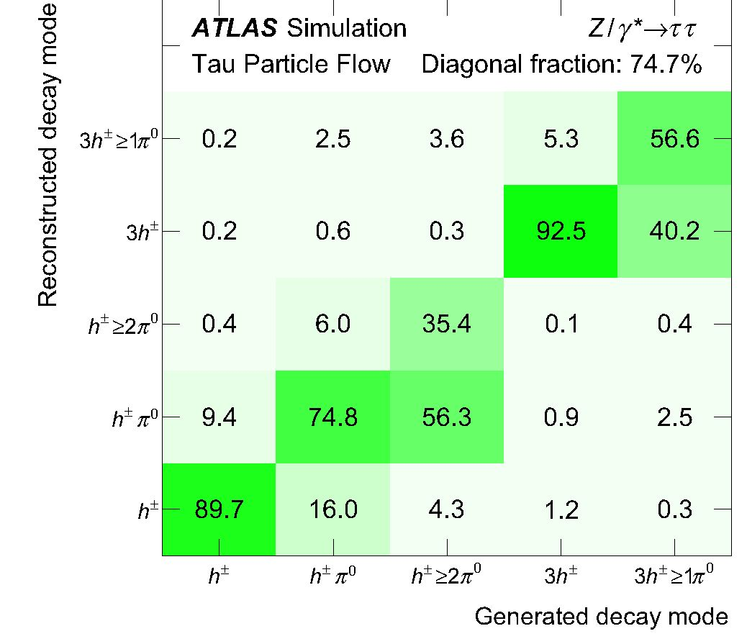
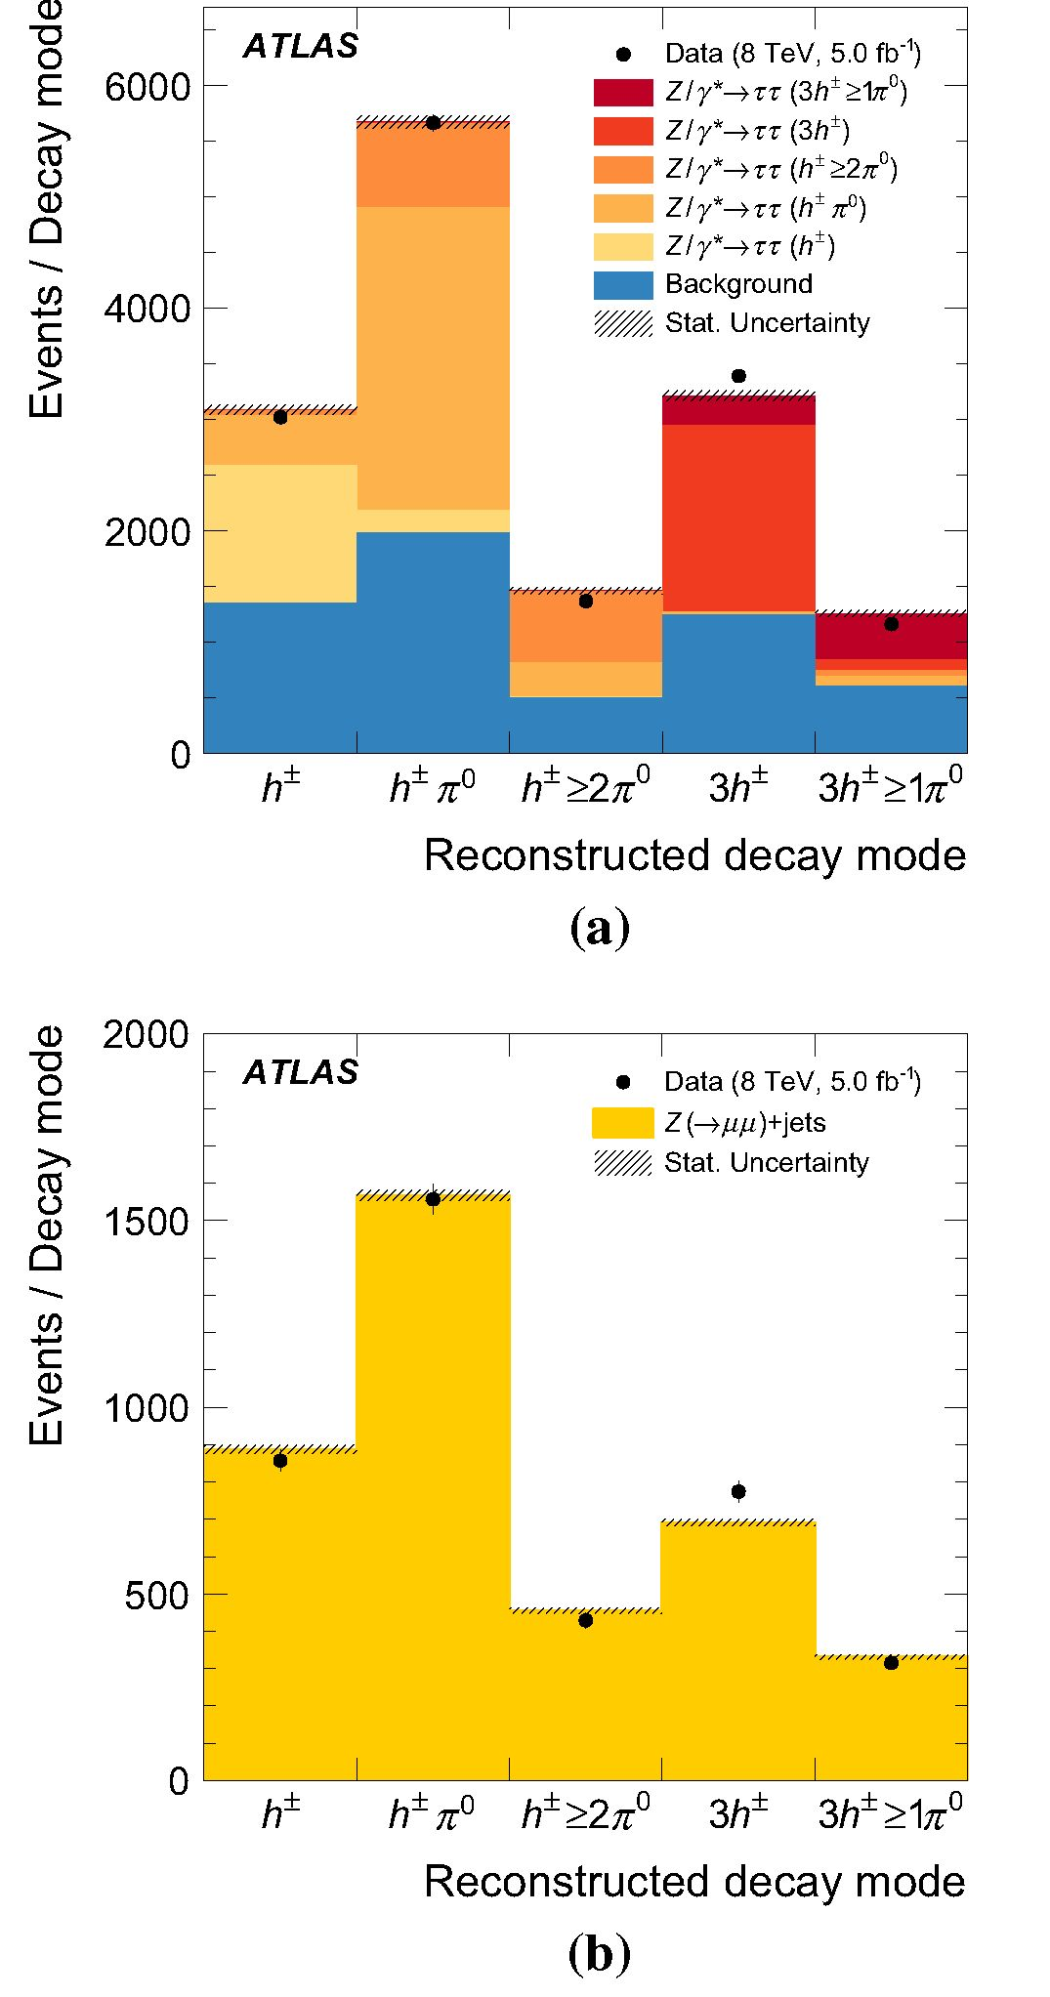
295 Page 10 of 26
Eur.Phys. J.C(2016) 76:295
Fig. 6 Decay mode classification efficiency matrix showing the prob-
ability for a given generated mode to be reconstructed as a particular
mode by the Tau Particle Flow after final decay mode classification in
simulated Z ^ tt events. Decays containing neutral kaons are omitted.
Only decays from Thad-vis’s that are reconstructed and pass the selec-
tion described in Sect. 2.2 are considered. The statistical uncertainty is
negligible
as they are most likely photons from a n0 decay; or if the
Thad-vis candidate is classified as h± >2n0 because three or
more photons are found in a single n(?and, only this n(?and is
added and its mass is set to twice the n0 mass. A calibration is
applied to the Constituent-based Thad-vis energy in each decay
mode as a function of the Constituent-based ET, to correct
for the n(?and energy bias. The resulting four-momentum is
used to set the Thad-vis direction in the Tau Particle Flow. Fig-
ure 8a, b show distributions of the Thad-vis n and $ residuals
of the Tau Particle Flow and the Baseline four-momentum
reconstruction. The core angular resolutions of the Tau Par-
ticle Flow are 0.002 in n and 0.004rad in $, which are more
than five times better than the Baseline resolutions of 0.012
and 0.02rad, respectively.
Figure 9a shows distributions of the ET residuals. The
Constituent-based calculation is inherently stable against
pile-up as both the decay-mode classification used to select
h±’s and n(?and’s, and the reconstruction of h±’s and n(?and’s
themselves, are stable against pile-up. The ET increases by
~6MeV and its resolution degrades fractionally by ~0.6%
per additional reconstructed vertex. Figure 9b shows the res-
olution as a function of the ET of the generated Thad-vis.
For the final energy calibration of the Tau Particle Flow, the
Constituent-based ET is combined with the Baseline ET by
weighting each by the inverse-square of their respective ET-
dependent core resolutions, which ensures a smooth transi-
tion to high pT where the Baseline calibration is superior.
The Baseline ET is used if the two ET values disagree by
more than five times their combined core resolutions, as it
has smaller resolution tails. The resolution of the Tau Particle
Flow is superior in both the core and tails at low ET with a
core resolution of 8% at an ET of 20 GeV, compared to 15%
from the Baseline. It approaches the Baseline performance
1 Springer
Fig. 7 Number of Thad-vis candidates for each classified decay mode
in the a Z ^ tt and the b Z/x/x)+jets tag-and-probe analyses.
The simulated Z ^ tt sample is split into contributions from each
generated tau decay mode. The background in the Z ^ tt analysis is
dominated by multijet and W(^ ^v)+jets production. The simulated
Z(^ /x/x)+jets events are reweighted so that the Z boson pt distribu-
tion and the overall normalisation match that in the data. The hatched
band represents the statistical uncertainty on the prediction
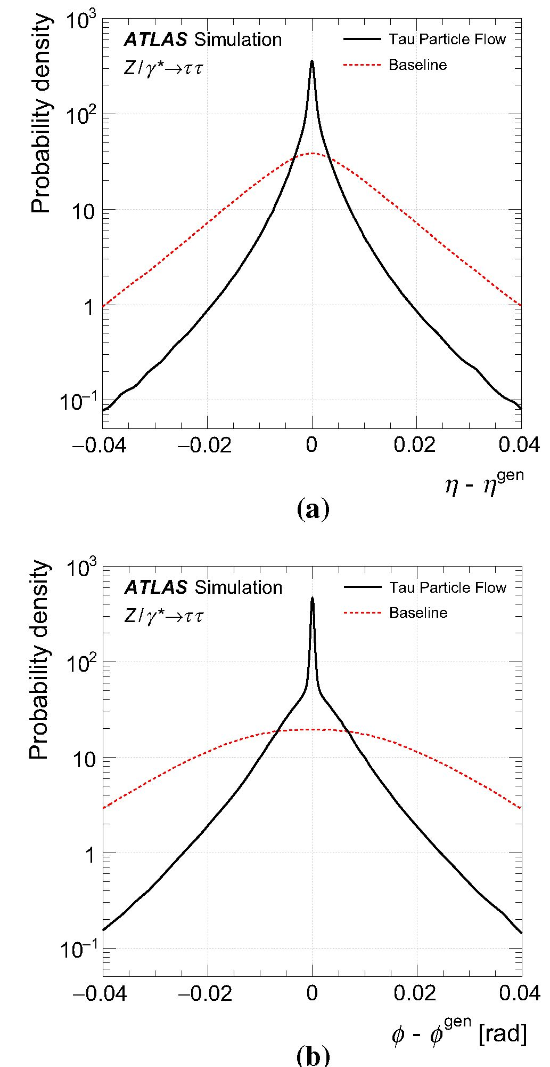
Eur. Phys. J. C (2016) 76:295
Page 11 of 26 295
Fig. 8 The Thad-vis a n and b $ residual distributions of the Tau Particle
Flow compared to the Baseline reconstruction
at high ET. Contributions from pile-up have little effect on
the four-momentum reconstruction of the Tau Particle Flow;
the Et increases by ~4 MeV and its core resolution degrades
fractionally by ~0.5 % per additional reconstructed vertex.
The ET residual distributions of the Tau Particle Flow split
into the reconstructed decay modes are shown in Fig. 9c. The
total is non-Gaussian, as it is the sum of contributions with
different functional forms. Correctly reconstructed decays
containing only h±’s have the best resolution, followed by
correctly reconstructed decays containing n(?and’s. The excel-
lent resolution of these decays leads to a superior overall
4 Summary and conclusions
This paper presents a new method to reconstruct the indi-
vidual charged and neutral hadrons in tau decays with the
ATLAS detector at the LHC. The neutral pions are recon-
structed with a core energy resolution of ~16%. The recon-
structed hadrons are used to calculate the visible four-
momentum of reconstructed tau candidates and to classify
the decay mode, allowing the decays to be distinguished
not only by the number of h±’s but also by the number of
n0’s, which is not possible with the existing tau reconstruc-
tion. This improves the purity with which the t- ^ n-v,
t- ^ n-n0v and t- ^ n-n-v decays can be
selected, by factors of 2.6, 1.4 and 1.2, respectively. The
Thad-vis core directional resolution is improved by more than
a factor of five and the core energy resolution is improved
12n
core resolution. Misreconstructed decays have the poorest
resolution and result in larger tails. In particular, misestima-
tion of the number of n(?and’s leads to a bias of up to 25 %.
Decays containing neutral kaons exhibit a large low-energy
bias because at least some of their energy is typically missed
by the reconstruction.
An alternative method for the ET calibration was also
developed, based on Ref. [30]. It also uses a combination of
calorimetric and tracking measurements and the Tau Parti-
cle Flow decay mode classification. The h± pT is measured
using tracks and the n0 Et is estimated as the difference
between the Et of the seed jet at the EM scale [36] and the
Et from the summed momenta of all h±’s, scaled by their
expected calorimeter response [60]. The method has similar
overall performance to the Tau Particle Flow.
Figure 10a shows the distribution of the invariant mass
of the muon and Thad-vis, m(p, Thad-vis), calculated using the
Thad-vis four-momentum reconstruction from the Tau Particle
Flow in the Z ^ tt tag-and-probe analysis before selection
on m(p, Thad-vis). The m(p, Thad-vis) has a linear dependence
on the Thad-vis Et and analysis of the distribution has previ-
ously been used to calibrate the Thad-vis Et [17]. Data and
simulation agree well, indicating that the Thad-vis Et is well
modelled by the simulation. Finally, Fig. 10b shows the mass
spectrum of the Thad-vis reconstructed with the Tau Particle
Flow in the Z ^ tt tag-and-probe analysis. The a\ reso-
nance in the 3h± mode is reconstructed with negligible exper-
imental resolution compared to the intrinsic line shape due to
the excellent four-momentum resolution of the inner detector
for h±’s. The p and ai resonances in theh± n0 and h± >2n0
modes are also visible, but have significant degradation due to
the resolution from the reconstructed n(?and four-momentum.
The Thad-vis mass spectra in data and simulation agree well,
suggesting good modelling of the individual h± and nc0and
four-momenta.
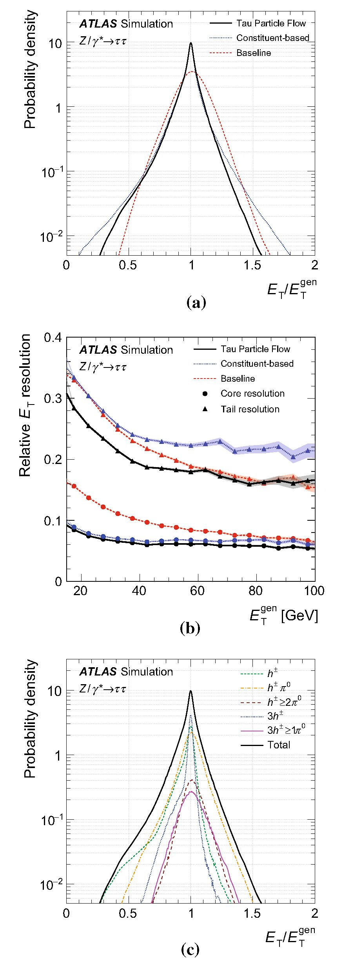
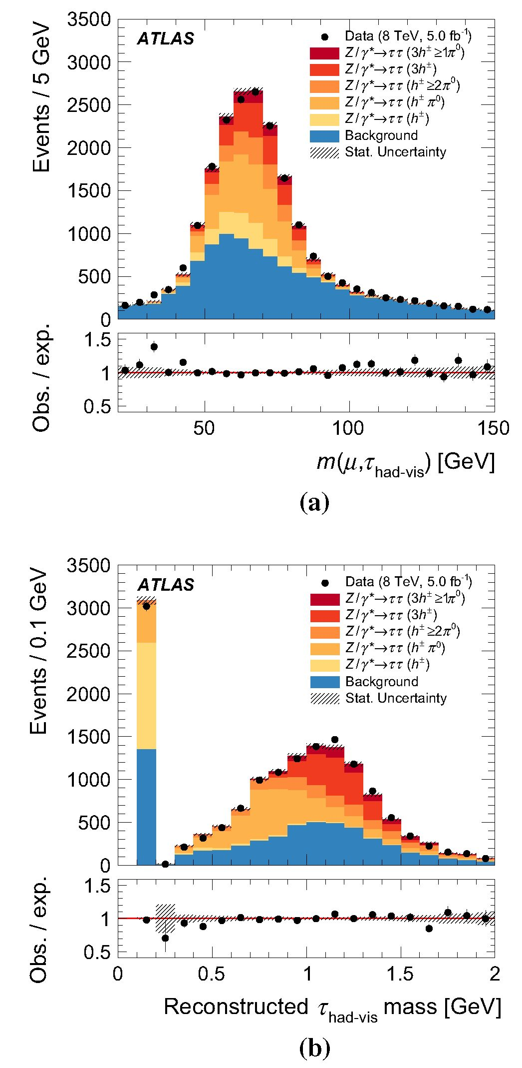
295 Page 12 of 26 Eur. Phys. J. C (2016) 76:295
Fig. 9 The a Thad-vis relative Et residual distribution and b the half-
widths spanned by the 68 and 95 % quantiles, i.e. the core and tail
resolutions, of the relative Et residual distributions as a function of the
generated Thad-vis Et. The Baseline, Constituent-based and Tau Particle
Flow calculations are shown. The relative ET residual distribution of
the Tau Particle Flow split in the reconstructed decay mode c is also
shown
Fig. 10 Distribution of a the invariant mass of the muon and Thad-vis,
m(p, Thad-vis) before selection on m(p, Thad-vis) is applied; and b the
reconstructed mass of the Thad-vis, when using the Tau Particle Flow
Thad-vis four-momentum reconstruction in the Z ^ tt tag-and-probe
analysis. The simulated Z ^ tt sample is split into contributions
from each generated tau decay mode. The background is dominated by
multijet and W(^ pv)+jets production. The hatched band represents
the statistical uncertainty on the prediction
by up to a factor of two at low ET (20 GeV). The per-
formance was validated using samples of Z ^ tt and
Z(^ pp)+jets events selected from pp collision data at
y/s = 8 TeV, corresponding to an integrated luminosity of
12n
Eur. Phys. J. C (2016) 76:295
Page 13 of 26 295
5fb-1. The results suggest good modelling of the Thad-vis
decay mode classification efficiency and four-momentum
reconstruction.
Acknowledgments We thank CERN for the very successful operation
of the LHC, as well as the support staff from our institutions with-
out whom ATLAS could not be operated efficiently. We acknowledge
the support of ANPCyT, Argentina; YerPhI, Armenia; ARC, Australia;
BMWFW and FWF, Austria; ANAS, Azerbaijan; SSTC, Belarus; CNPq
and FAPESP, Brazil; NSERC, NRC and CFI, Canada; CERN; CONI-
CYT, Chile; CAS, MOST and NSFC, China; COLCIENCIAS, Colom-
bia; MSMT CR, MPO CR and VSC CR, Czech Republic; DNRF and
DNSRC, Denmark; IN2P3-CNRS, CEA-DSM/IRFU, France; GNSF,
Georgia; BMBF, HGF, and MPG, Germany; GSRT, Greece; RGC, Hong
Kong SAR, China; ISF, I-CORE and Benoziyo Center, Israel; INFN,
Italy; MEXT and JSPS, Japan; CNRST, Morocco; FOM and NWO,
Netherlands; RCN, Norway; MNiSW and NCN, Poland; FCT, Portu-
gal; MNE/IFA, Romania; MES of Russia and NRC KI, Russian Fed-
eration; JINR; MESTD, Serbia; MSSR, Slovakia; ARRS and MIZS,
Slovenia; DST/NRF, South Africa; MINECO, Spain; SRC and Wal-
lenberg Foundation, Sweden; SERI, SNSF and Cantons of Bern and
Geneva, Switzerland; MOST, Taiwan; TAEK, Turkey; STFC, United
Kingdom; DOE and NSF, United States of America. In addition, indi-
vidual groups and members have received support from BCKDF, the
Canada Council, CANARIE, CRC, Compute Canada, FQRNT, and the
Ontario Innovation Trust, Canada; EPLANET, ERC, FP7, Horizon 2020
and Marie Skłodowska-Curie Actions, European Union; Investisse-
ments d’Avenir Labex and Idex, ANR, Region Auvergne and Fonda-
tion Partager le Savoir, France; DFG and AvH Foundation, Germany;
Herakleitos, Thales and Aristeia programmes co-financed by EU-ESF
and the Greek NSRF; BSF, GIF and Minerva, Israel; BRF, Norway;
the Royal Society and Leverhulme Trust, United Kingdom. The crucial
computing support from all WLCG partners is acknowledged gratefully,
in particular from CERN and the ATLAS Tier-1 facilities at TRIUMF
(Canada), NDGF (Denmark, Norway, Sweden), CC-IN2P3 (France),
KIT/GridKA (Germany), INFN-CNAF (Italy), NL-T1 (Netherlands),
PIC (Spain), ASGC (Taiwan), RAL (UK) and BNL (USA) and in the
Tier-2 facilities worldwide.
Open Access This article is distributed under the terms of the Creative
Commons Attribution 4.0 International License (http://creativecomm
ons.org/licenses/by/4.0/), which permits unrestricted use, distribution,
and reproduction in any medium, provided you give appropriate credit
to the original author(s) and the source, provide a link to the Creative
Commons license, and indicate if changes were made.
Funded by SCOAP3.
References
- ATLAS Collaboration, The ATLAS experiment at the CERN large
hadron collider. JINST 3, S08003 (2008)
- L. Evans, P. Bryant, L.H.C. Machine, JINST 3, S08001 (2008)
- ATLAS Collaboration, Measurement of the tt production cross
section in the tau+jets channel using the ATLAS detector. Eur.
Phys. J. C 73, 2328 (2013). arXiv:1211.7205 [hep-ex]
- ATLAS Collaboration, Measurement of the top quark pair cross
section with ATLAS in pp collisions at .Js = 7 TeV using final
states with an electron or a muon and a hadronically decaying t
lepton. Phys. Lett. B 717, 89 (2012). arXiv:1205.2067 [hep-ex]
- ATLAS Collaboration, Measurement of the W ^ tvt cross sec-
tion in pp collisions at .Js = 7 TeV with the ATLAS experiment.
Phys. Lett. B 706, 276 (2012). arXiv:1108.4101 [hep-ex]
- ATLAS Collaboration, Measurement of T polarization in W ^ tv
decays with the ATLAS detector in pp collisions at .Js = 7 TeV.
Eur. Phys. J. C 72, 2062 (2012). arXiv:1204.6720 [hep-ex]
- ATLAS Collaboration, Measurement of the Z ^ tt cross sec-
tion with the ATLAS detector. Phys. Rev. D 84, 112006 (2011).
arXiv:1108.2016 [hep-ex]
- ATLAS Collaboration, Evidence for the Higgs-boson Yukawa cou-
pling to tau leptons with the ATLAS detector. JHEP 1504, 117
(2015). arXiv:1501.04943 [hep-ex]
- ATLAS Collaboration, Search for charged Higgs bosons through
the violation of lepton universality in tt events using pp collision
data at ys = 7 TeV with the ATLAS experiment. JHEP 1303, 076
- . arXiv:1212.3572 [hep-ex]
- ATLAS Collaboration, Search for charged Higgs bosons decay-
ing via H± ^ tv in tt events using pp collision data at
ys = 7 TeV with the ATLAS detector. JHEP 1206, 039 (2012).
arXiv:1204.2760 [hep-ex]
- ATLAS Collaboration, Search for the neutral Higgs bosons of
the minimal supersymmetric standard model in pp collisions at
ys = 7 TeV with the ATLAS detector. JHEP 1302, 095 (2013).
arXiv:1211.6956 [hep-ex]
- ATLAS Collaboration, Search for supersymmetry in events with
large missing transverse momentum, jets, and at least one tau lepton
in 20 fb-1 ofy? = 8 TeV proton-proton collision data with the
ATLAS detector. JHEP 1409, 103 (2014). arXiv:1407.0603 [hep-
ex]
- ATLAS Collaboration, Search for the direct production of
charginos, neutralinos and staus in final states with at least two
hadronically decaying taus and missing transverse momentum in
pp collisions at a/s = 8 TeV with the ATLAS detector. JHEP
1410, 096 (2014). arXiv:1407.0350 [hep-ex]
- ATLAS Collaboration, Search for a heavy narrow resonance
decaying to ep, eT, or pT with the ATLAS detector in yi =
7 TeV pp collisions at the LHC. Phys. Lett. B 723, 15 (2013).
arXiv:1212.1272 [hep-ex]
- ATLAS Collaboration, A search for high-mass resonances decay-
ing to T + T- in pp collisions at yj = 7 TeV with the ATLAS
detector. Phys. Lett. B 719, 242 (2013). arXiv:1210.6604 [hep-ex]
- ATLAS Collaboration, Search for third generation scalar lepto-
quarks in pp collisions at -fs = 7 TeV with the ATLAS detector.
JHEP 1306, 033 (2013). arXiv:1303.0526 [hep-ex]
- ATLAS Collaboration, Identification and energy calibration of
hadronically decaying tau leptons with the ATLAS experiment in
pp collisions at ys = 8TeV. Eur. Phys. J. C 75, 303 (2015).
arXiv:1412.7086 [hep-ex]
- ATLAS Collaboration, Observation of a new particle in the search
for the Standard Model Higgs boson with the ATLAS detector at
the LHC. Phys. Lett. B 716, 1 (2012). arXiv:1207.7214 [hep-ex]
- CMS Collaboration, Observation of a new boson at a mass of 125
GeV with the CMS experiment at the LHC. Phys. Lett. B 716, 30
(2012). arXiv:1207.7235 [hep-ex]
- CMS Collaboration, Evidence forthe 125 GeV Higgs boson decay-
ingtoapairof T leptons. JHEP 1405,104 (2014). arXiv:1401.5041
[hep-ex]
- K. Desch et al., Probing the CP nature of the Higgs boson at
linear colliders with tau spin correlations: the case of mixed
scalar—pseudoscalar couplings. Phys. Lett. B 579, 157 (2004).
arXiv:hep-ph/0307331 [hep-ph]
- R. Harnik et al., Measuring CP violation in h ^ T + T - atcolliders.
Phys. Rev. D 88, 076009 (2013). arXiv:1308.1094 [hep-ph]
- S. Berge, W. Bernreuther, S. Kirchner, Prospects of constraining
the Higgs boson’s CP nature in the tau decay channel at the LHC.
Phys. Rev. D 92, 096012 (2015). arXiv:1510.03850 [hep-ph]
- A. Elagin et al., A new mass reconstruction technique for reso-
nances decaying to di-tau. Nucl. Instrum. Meth. A 654, 481 (2011).
arXiv:1012.4686 [hep-ex]
12n
295 Page 14 of 26
Eur. Phys. J. C (2016) 76:295
- P. Golonka, Z. Was, PHOTOS Monte Carlo: a precision tool for
QED corrections in Z and W decays. Eur. Phys. J. C 45, 97-107
(2006). arXiv:hep-ph/0506026
- T. Sjostrand, S. Mrenna, P. Skands, A brief introduction to
PYTHIA 8.1. Comput. Phys. Commun. 178, 852-867 (2008).
arXiv:0710.3820 [hep-ph]
- P.M. Nadolsky et al., Implications of CTEQ global analysis for
collider observables. Phys. Rev. D 78(013004), 013004 (2008).
arXiv:0802.0007 [hep-ph]
- ATLAS Collaboration, Summary of ATLAS Pythia 8 tunes. ATL-
PHYS-PUB-2012-003 (2012). http://cds.cern.ch/record/1474107
- M.L. Mangano et al., ALPGEN, a generator for hard multipar-
ton processes in hadronic collisions. JHEP 0307, 001 (2003).
arXiv:hep-ph/0206293 [hep-ph]
- P.Z. Skands, Tuning Monte Carlo generators: the perugia tunes.
Phys. Rev. D 82, 074018 (2010). arXiv:1005.3457 [hep-ph]
- S. Frixione, B.R. Webber, Matching NLO QCD computa-
tions and parton shower simulations. JHEP 0206, 29 (2002).
arXiv:hep-ph/0204244
- S. Frixione et al., Single-top production in MCNLO. JHEP 0603,
92 (2006). arXiv:hep-ph/0512250
- S. Frixione et al., Single-top hadroproduction in association with a
W boson. JHEP 0807, 29 (2008). arXiv:0805.3067 [hep-ph]
- G. Corcellaet al., HERWIG 6: an event generator for hadron emis-
sion reactions with interfering gluons (including supersymmetric
processes). JHEP 0101, 10 (2001). arXiv:hep-ph/0011363
- J.M. Butterworth, J.R. Forshaw, M.H. Seymour, Multiparton inter-
actions in photoproduction at HERA. Z. Phys. C. 72, 637-646
(1996). arXiv:hep-ph/9601371
- H.-L. Lai et al., New parton distributions for collider physics. Phys.
Rev. D 82(074024), 074024 (2010). arXiv:1007.2241 [hep-ph]"
- ATLAS Collaboration, The ATLAS simulation infrastructure. Eur.
Phys. J. C 70, 823 (2010). arXiv:1005.4568 [hep-ex]
- GEANT4 Collaboration, S. Agostinelli et al., Geant4—a simula-
tion toolkit. Nucl. Instr. Meth. A 506, 250-303 (2003)
- G. Folger, J.P. Wellisch, String parton models in Geant4 (2003).
arXiv:nucl-th/0306007
- H.W. Bertini, Intranuclear-cascade calculation of the secondary
nucleon spectra from nucleon-nucleus interactions in the energy
range 340 to 2900 MeV and comparisons with experiment. Phys.
Rev. 188,1711 (1969)
- ATLAS Collaboration, Measurement of the production cross sec-
tion of jets in association with a Z boson in pp collisions at
ys = 7 TeV with the ATLAS detector. JHEP 1307, 032 (2013).
arXiv:1304.7098 [hep-ex]
- K. Olive et al., Review of particle physics. Chin. Phys. C 38,090001
(2014)
- ATLAS Collaboration, A measurement of single hadron response
using data at ys = 8 TeV with the ATLAS detector. ATL-PHYS-
PUB-2014-002 (2014). http://cdsweb.cern.ch/record/1668961
ATLAS Collaboration
- Aad85, B. Abbott113, J. Abdallah151, O. Abdinov11, R. Aben107, M. Abolins90, O. S. AbouZeid158, H. Abramowicz153
- Abreu152, R. Abreu116, Y. Abulaiti146a,146b, B. S. Acharya164a,164b,a, L. Adamczyk38a, D. L. Adams25, J. Adelman108
S. Adomeit100, T. Adye131, A. A. Affolder74, T. Agatonovic-Jovin13, J. Agricola54, J. A. Aguilar-Saavedra126a,126f
S. P. Ahlen22, F. Ahmadov65,b, G. Aielli133a,133b, H. Akerstedt146a,146b, T. P. A. Akesson81, A. V. Akimov96
G. L. Alberghi20a,20b, J. Albert169, S. Albrand55, M. J. Alconada Verzini71, M. Aleksa30, I. N. Aleksandrov65
- Alexa26b, G. Alexander153, T. Alexopoulos10, M. Alhroob113, G. Alimonti91a, L. Alio85, J. Alison31,
S. P. Alkire35, B. M. M. Allbrooke149, P. P. Allport18, A. Aloisio104a,104b, A. Alonso36, F. Alonso71, C. Alpigiani138
A. Altheimer35, B. Alvarez Gonzalez30, D. Alvarez Piqueras167, M. G. Alviggi104a,104b, B. T. Amadio15, K. Amako66
Y. Amaral Coutinho24a, C. Amelung23, D. Amidei89, S. P. Amor Dos Santos126a,126c, A. Amorim126a,126b, S. Amoroso48
N. Amram153, G. Amundsen23, C. Anastopoulos139, L. S. Ancu49, N. Andari108, T. Andeen35, C. F. Anders58b, G. Anders30
J. K. Anders74, K. J. Anderson31, A. Andreazza91a,91b, V. Andrei58a, S. Angelidakis9, I. Angelozzi107, P. Anger44
A. Angerami35, F. Anghinolfi30, A. V. Anisenkov109,c, N. Anjos12, A. Annovi124a,124b, M. Antonelli47, A. Antonov98
J. Antos144b, F. Anulli132a, M. Aoki66, L. Aperio Bella18, G. Arabidze90, Y. Arai66, J. P. Araque126a, A. T. H. Arce45
- A. Arduh71, J-F. Arguin95, S. Argyropoulos63, M. Arik19a, A. J. Armbruster30, O. Arnaez30, H. Arnold48, M. Arratia28
O. Arslan21, A. Artamonov97, G. Artoni23, S. Artz83, S. Asai155, N. Asbah42, A. Ashkenazi153, B. Asman146a,146b
L. Asquith149, K. Assamagan25, R. Astalos144a, M. Atkinson165, N. B. Atlay141, K. Augsten128, M. Aurousseau145b
- Avolio30, B. Axen15, M. K. Ayoub117, G. Azuelos95,d, M. A. Baak30, A. E. Baas58a, M. J. Baca18, H. Bachacou136
K. Bachas154, M. Backes30, M. Backhaus30, P. Bagiacchi132a,132b, P. Bagnaia132a,132b, Y. Bai33a, T. Bain35, J. T. Baines131
O. K. Baker176, E. M. Baldin109,c, P. Balek129, T. Balestri148, F. Balli84, W. K. Balunas122, E. Banas39, Sw. Banerjee173,0
A. A. E. Bannoura175, L. Barak30, E. L. Barberio88, D. Barberis50a,50b, M. Barbero85, T. Barillari101, M. Barisonzi164a,164b
T. Barklow143, N. Barlow28, S. L. Barnes84, B. M. Barnett131, R. M. Barnett15, Z. Barnovska5, A. Baroncelli134a
- Barone23, A. J. Barr120, F. Barreiro82, J. Barreiro Guimaraes da Costa33a, R. Bartoldus143, A. E. Barton72
P. Bartos144a, A. Basalaev123, A. Bassalat117, A. Basye165, R. L. Bates53, S. J. Batista158, J. R. Batley28, M. Battaglia137
M. Bauce132a,132b, F. Bauer136, H. S. Bawa143,f, J. B. Beacham111, M. D. Beattie72, T. Beau80, P. H. Beauchemin161
R. Beccherle124a,124b, P. Bechtle21, H. P. Beck17,g, K. Becker120, M. Becker83, M. Beckingham170, C. Becot117
A. J. Beddall19b, A. Beddall19b, V. A. Bednyakov65, C. P. Bee148, L. J. Beemster107, T. A. Beermann30, M. Begel25
J. K. Behr120, C. Belanger-Champagne87, W. H. Bell49, G. Bella153, L. Bellagamba20a, A. Bellerive29, M. Bellomo86
K. Belotskiy98, O. Beltramello30, O. Benary153, D. Benchekroun135a, M. Bender100, K. Bendtz146a,146b, N. Benekos10
12n
Eur. Phys. J. C (2016) 76:295
Page 15 of 26 295
Y. Benhammou153, E. Benhar Noccioli49, J. A. Benitez Garcia159b, D. P. Benjamin45, J. R. Bensinger23, S. Bentvelsen107
L. Beresford120, M. Beretta47, D. Berge107, E. Bergeaas Kuutmann166, N. Berger5, F. Berghaus169, J. Beringer15
C. Bernard22, N. R. Bernard86, C. Bernius110, F. U. Bernlochner21, T. Berry77, P. Berta129, C. Bertella83, G. Bertoli146a,146b
- Bertolucci124a,124b, C. Bertsche113, D. Bertsche113, M. I. Besana91a, G. J. Besjes36, O. Bessidskaia Bylund146a,146b
M. Bessner42, N. Besson136, C. Betancourt48, S. Bethke101, A. J. Bevan76, W. Bhimji15, R. M. Bianchi125, L. Bianchini23
M. Bianco30, O. Biebel100, D. Biedermann16, N. V. Biesuz124a,124b, M. Biglietti134a, J. Bilbao De Mendizabal49
- Bilokon47, M. Bindi54, S. Binet117, A. Bingul19b, C. Bini132a,132b, S. Biondi20a,20b, D. M. Bjergaard45, C. W. Black150
J. E. Black143, K. M. Black22, D. Blackburn138, R. E. Blair6, J.-B. Blanchard136, J. E. Blanco77, T. Blazek144a
- Bloch42, C. Blocker23, W. Blum83,\ U. Blumenschein54, S. Blunier32a, G. J. Bobbink107, V. S. Bobrovnikov109,c
S. S. Bocchetta81, A. Bocci45, C. Bock100, M. Boehler48, J. A. Bogaerts30, D. Bogavac13, A. G. Bogdanchikov109
C. Bohm146a, V. Boisvert77, T. Bold38a, V. Boldea26b, A. S. Boldyrev99, M. Bomben80, M. Bona76, M. Boonekamp136
A. Borisov130, G. Borissov72, S. Borroni42, J. Bortfeldt100, V. Bortolotto60a,60b,60c, K. Bos107, D. Boscherini20a
M. Bosman12, J. Boudreau125, J. Bouffard2, E. V. Bouhova-Thacker72, D. Boumediene34, C. Bourdarios117
N. Bousson114, S. K. Boutle53, A. Boveia30, J. Boyd30, I. R. Boyko65, I. Bozic13, J. Bracinik18, A. Brandt8, G. Brandt54
- Brandt58a, U. Bratzler156, B. Brau86, J. E. Brau116, H. M. Braun175,ł, W. D. Breaden Madden53, K. Brendlinger122
- J. Brennan88, L. Brenner107, R. Brenner166, S. Bressler172, T. M. Bristow46, D. Britton53, D. Britzger42, F. M. Brochu28
- Brock21, R. Brock90, J. Bronner101, G. Brooijmans35, T. Brooks77, W. K. Brooks32b, J. Brosamer15, E. Brost116
P. A. Bruckman de Renstrom39, D. Bruncko144b, R. Bruneliere48, A. Bruni20a, G. Bruni20a, M. Bruschi20a, N. Bruscino21
L. Bryngemark81, T. Buanes14, Q. Buat142, P. Buchholz141, A. G. Buckley53, I. A. Budagov65, F. Buehrer48, L. Bugge119
M. K. Bugge119, O. Bulekov98, D. Bullock8, H. Burckhart30, S. Burdin74, C. D. Burgard48, B. Burghgrave108
S. Burke131, I. Burmeister43, E. Busato34, D. Buscher48, V. Buscher83, P. Bussey53, J. M. Butler22, A. I. Butt3
- M. Buttar53, J. M. Butterworth78, P. Butti107, W. Buttinger25, A. Buzatu53, A. R. Buzykaev109,c, S. Cabrera Urban167
- Caforio128, V. M. Cairo37a,37b, O. Cakir4a, N. Calace49, P. Calafiura15, A. Calandri136, G. Calderini80, P. Calfayan100
L. P. Caloba24a, D. Calvet34, S. Calvet34, R. Camacho Toro31, S. Camarda42, P. Camarri133a,133b, D. Cameron119
R. Caminal Armadans165, S. Campana30, M. Campanelli78, A. Campoverde148, V. Canale104a,104b, A. Canepa159a
M. Cano Bret33e, J. Cantero82, R. Cantrill126a, T. Cao40, M. D. M. Capeans Garrido30, I. Caprini26b, M. Caprini26b
M. Capua37a,37b, R. Caputo83, R. M. Carbone35, R. Cardarelli133a, F. Cardillo48, T. Carli30, G. Carlino104a
L. Carminati91a,91b, S. Caron106, E. Carquin32a, G. D. Carrillo-Montoya30, J. R. Carter28, J. Carvalho126a,126c, D. Casadei78
M. P. Casado12, M. Casolino12, D. W. Casper163, E. Castaneda-Miranda145a, A. Castelli107, V. Castillo Gimenez167
N. F. Castro126a,h, P. Catastini57, A. Catinaccio30, J. R. Catmore119, A. Cattai30, J. Caudron83, V. Cavaliere165
- Cavalli91a, M. Cavalli-Sforza12, V. Cavasinni124a,124b, F. Ceradini134a,134b, L. Cerda Alberich167, B. C. Cerio45
K. Cerny129, A. S. Cerqueira24b, A. Cerri149, L. Cerrito76, F. Cerutti15, M. Cerv30, A. Cervelli17, S.A. Cetin19c
- Chafaq135a, D. Chakraborty108, I. Chalupkova129, Y. L. Chan60a, P. Chang165, J. D. Chapman28, D. G. Charlton18
- C. Chau158, C. A. Chavez Barajas149, S. Che111, S. Cheatham152, A. Chegwidden90, S. Chekanov6, S. V. Chekulaev159a
- A. Chelkov654, M. A. Chelstowska89, C. Chen64, H. Chen25, K. Chen148, L. Chen33dj, S. Chen33c, S. Chen155
X. Chen33f, Y. Chen67, H. C. Cheng89, Y. Cheng31, A. Cheplakov65, E. Cheremushkina130, R. Cherkaoui El Moursli135e
V. Chernyatin25,\ E. Cheu7, L. Chevalier136, V. Chiarella47, G. Chiarelli124a,124b, G. Chiodini73a, A. S. Chisholm18
R. T. Chislett78, A. Chitan26b, M. V. Chizhov65, K. Choi61, S. Chouridou9, B. K. B. Chow100, V. Christodoulou78
- Chromek-Burckhart30, J. Chudoba127, A. J. Chuinard87, J. J. Chwastowski39, L. Chytka115, G. Ciapetti132a,132b
- K. Ciftci4a, D. Cinca53, V. Cindro75, I. A. Cioara21, A. Ciocio15, F. Cirotto104a,104b, Z. H. Citron172, M. Ciubancan26b
- Clark49, B. L. Clark57, P. J. Clark46, R. N. Clarke15, C. Clement146a,146b, Y. Coadou85, M. Cobal164a,164c, A. Coccaro49
J. Cochran64, L. Coffey23, L. Colasurdo106, B. Cole35, S. Cole108, A. P. Colijn107, J. Collot55, T. Colombo58c
G. Compostella101, P. Conde Muino126a,126b, E. Coniavitis48, S. H. Connell145b, I. A. Connelly77, V. Consorti48
S. Constantinescu26b,C. Conta121a,121b,G. Conti30, F. Conventi104a,k,M. Cooke15, B. D. Cooper78, A. M. Cooper-Sarkar120
T. Cornelissen175, M. Corradi132a,132b, F. Corriveau87,l, A. Corso-Radu163, A. Cortes-Gonzalez12, G. Cortiana101
- Costa91a, M. J. Costa167, D. Costanzo139, D. Cote8, G. Cottin28, G. Cowan77, B. E. Cox84, K. Cranmer110
S. J. Crawley53, G. Cree29, S. Crepe-Renaudin55, F. Crescioli80, W. A. Cribbs146a,146b, M. Crispin Ortuzar120
M. Cristinziani21, V. Croft106, G. Crosetti37a,37b, T. Cuhadar Donszelmann139, J. Cummings176, M. Curatolo47, J. Cuth83
- Cuthbert150, H. Czirr141, P. Czodrowski3, S.D’Auria53, M. D’Onofrio74, M. J. Da Cunha Sargedas De Sousa126a,126b
- Da Via84, W. Dabrowski38a, A. Dafinca120, T. Dai89, O. Dale14, F. Dallaire95, C. Dallapiccola86, M. Dam36
J. R. Dandoy31, N. P. Dang48, A. C. Daniells18, M. Danninger168, M. Dano Hoffmann136, V. Dao48, G. Darbo50a
S.Darmora8, J. Dassoulas3, A. Dattagupta61, W. Davey21, C. David169, T. Davidek129, E. Davies120,m, M. Davies153
P. Davison78, Y. Davygora58a, E. Dawe88, I. Dawson139, R. K. Daya-Ishmukhametova86, K. De8, R. de Asmundis104a
1 Springer
295 Page 16 of 26
Eur. Phys. J. C (2016) 76:295
- De Benedetti113, S. De Castro20a,20b, S. De Cecco80, N. De Groot106, P. de Jong107, H. De la Torre82, F. De Lorenzi64
- De Pedis132a, A. De Salvo132a, U. De Sanctis149, A. De Santo149, J. B. De Vivie De Regie117, W. J. Dearnaley72
R. Debbe25, C. Debenedetti137, D. V. Dedovich65, I. Deigaard107, J. Del Peso82, T. Del Prete124a,124b, D. Delgove117
- Deliot136, C. M. Delitzsch49, M. Deliyergiyev75, A. Dell’Acqua30, L. Dell’Asta22, M. Dell’Orso124a,124b
M. Della Pietra104a,k, D. della Volpe49, M. Delmastro5, P. A. Delsart55, C. Deluca107, D. A. DeMarco158, S. Demers176
M. Demichev65, A. Demilly80, S. P. Denisov130, D. Derendarz39, J. E. Derkaoui135d, F. Derue80, P. Dervan74
K. Desch21, C. Deterre42, K. Dette43, P. O. Deviveiros30, A. Dewhurst131, S. Dhaliwal23, A. Di Ciaccio133a,133b
L. Di Ciaccio5, A. Di Domenico132a,132b, C. Di Donato132a,132b, A. Di Girolamo30, B. Di Girolamo30, A. Di Mattia152
- Di Micco134a,134b, R. Di Nardo47, A. Di Simone48, R. Di Sipio158, D. Di Valentino29, C. Diaconu85, M. Diamond158
- A. Dias46, M. A. Diaz32a, E. B. Diehl89, J. Dietrich16, S. Diglio85, A. Dimitrievska13, J. Dingfelder21, P. Dita26b
S. Dita26b, F. Dittus30, F. Djama85, T. Djobava51b, J. I. Djuvsland58a, M. A. B. do Vale24c, D. Dobos30, M. Dobre26b
- Doglioni81, T. Dohmae155, J. Dolejsi129, Z. Dolezal129, B. A. Dolgoshein98,\ M. Donadelli24d, S. Donati124a,124b
P. Dondero121a,121b, J. Donini34, J. Dopke131, A. Doria104a, M. T. Dova71, A. T. Doyle53, E. Drechsler54, M. Dris10
Y. Du33d, E. Dubreuil34, E. Duchovni172, G. Duckeck100, O. A. Ducu261,85, D. Duda107, A. Dudarev30, L. Duflot117
L. Duguid77, M. Duhrssen30, M. Dunford58a, H. Duran Yildiz4a, M. Duren52, A. Durglishvili51b, D. Duschinger44
- Dutta42, M. Dyndal38a, C. Eckardt42, K. M. Ecker101, R. C. Edgar89, W. Edson2, N. C. Edwards46, W. Ehrenfeld21
T. Eifert30, G. Eigen14, K. Einsweiler15, T. Ekelof166, M. El Kacimi135c, M. Ellert166, S. Elles5, F. Ellinghaus175
A. A. Elliot169, N. Ellis30, J. Elmsheuser100, M. Elsing30, D. Emeliyanov131, Y. Enari155, O. C. Endner83, M. Endo118
J. Erdmann43, A. Ereditato17, G. Ernis175, J. Ernst2, M. Ernst25, S. Errede165, E. Ertel83, M. Escalier117, H. Esch43
- Escobar125, B. Esposito47, A. I. Etienvre136, E. Etzion153, H. Evans61, A. Ezhilov123, L. Fabbri20a,20b, G. Facini31
R. M. Fakhrutdinov130, S. Falciano132a, R. J. Falla78, J. Faltova129, Y. Fang33a, M. Fanti91a,91b, A. Farbin8, A. Farilla134a
T. Farooque12, S. Farrell15, S. M. Farrington170, P. Farthouat30, F. Fassi135e, P. Fassnacht30, D. Fassouliotis9
M. Faucci Giannelli77, A. Favareto50a,50b, L. Fayard117, O. L. Fedin123,n, W. Fedorko168, S. Feigl30, L. Feligioni85
- Feng33d, E. J. Feng30, H. Feng89, A. B. Fenyuk130, L. Feremenga8, P. Fernandez Martinez167, S. Fernandez Perez30
J. Ferrando53, A. Ferrari166, P. Ferrari107, R. Ferrari121a, D. E. Ferreira de Lima53, A. Ferrer167, D. Ferrere49, C. Ferretti89
A. Ferretto Parodi50a,50b, M. Fiascaris31, F. Fiedler83, A. Filipcic75, M. Filipuzzi42, F. Filthaut106, M. Fincke-Keeler169
K. D. Finelli150, M. C. N. Fiolhais126a,126c, L. Fiorini167, A. Firan40, A. Fischer2, C. Fischer12, J. Fischer175, W. C. Fisher90
N. Flaschel42, I. Fleck141, P. Fleischmann89, G. T. Fletcher139, G. Fletcher76, R. R. M. Fletcher122, T. Flick175
- Floderus81, L. R. Flores Castillo60a, M. J. Flowerdew101, G. T. Forcolin84, A. Formica136, A. Forti84, D. Fournier117
- Fox72, S. Fracchia12, P. Francavilla80, M. Franchini20a,20b, D. Francis30, L. Franconi119, M. Franklin57, M. Frate163
M. Fraternali121a,121b, D. Freeborn78, S. T. French28, S. M. Fressard-Batraneanu30, F. Friedrich44, D. Froidevaux30
J. A. Frost120, C. Fukunaga156, E. Fullana Torregrosa83, B. G. Fulsom143, T. Fusayasu102, J. Fuster167, C. Gabaldon55
O. Gabizon175, A. Gabrielli20a,20b, A. Gabrielli15, G. P. Gach18, S. Gadatsch30, S. Gadomski49, G. Gagliardi50a,50b
P. Gagnon61, C. Galea106, B. Galhardo126a,126c, E. J. Gallas120, B. J. Gallop131, P. Gallus128, G. Galster36
K. K. Gan111, J. Gao33t1,85, Y. Gao46, Y. S. Gao143,f, F. M. Garay Walls46, C. Garcia167, J. E. Garcia Navarro167
M. Garcia-Sciveres15, R. W. Gardner31, N. Garelli143, V. Garonne119, C. Gatti47, A. Gaudiello50a,50b, G. Gaudio121a
- Gaur141, L. Gauthier95, P. Gauzzi132a,132b, I. L. Gavrilenko96, C. Gay168, G. Gaycken21, E. N. Gazis10, P. Ge33d
Z. Gecse168, C. N. P. Gee131, Ch. Geich-Gimbel21, M. P. Geisler58a, C. Gemme50a, M. H. Genest55, C. Geng33b,°
S. Gentile132a,132b, S. George77, D. Gerbaudo163, A. Gershon153, S. Ghasemi141, H. Ghazlane135b, B. Giacobbe20a
S. Giagu132a,132b, V. Giangiobbe12, P. Giannetti124a,124b, B. Gibbard25, S. M. Gibson77, M. Gignac168, M. Gilchriese15
T. P. S. Gillam28, D. Gillberg30, G. Gilles34, D. M. Gingrich3,d, N. Giokaris9, M. P. Giordani164a,164c, F. M. Giorgi20a
- M. Giorgi16, P. F. Giraud136, P. Giromini47, D. Giugni91a, C. Giuliani101, M. Giulini58b, B. K. Gjelsten119
S. Gkaitatzis154, I. Gkialas154, E. L. Gkougkousis117, L. K. Gladilin99, C. Glasman82, J. Glatzer30, P. C. F. Glaysher46
A. Glazov42, M. Goblirsch-Kolb101, J. R. Goddard76, J. Godlewski39, S. Goldfarb89, T. Golling49, D. Golubkov130
- Gomes126a,126b,126d, R. Gonęalo126a, J. Goncalves Pinto Firmino Da Costa136, L. Gonella21, S. Gonzalez de la Hoz167
- Gonzalez Parra12, S. Gonzalez-Sevilla49, L. Goossens30, P. A. Gorbounov97, H. A. Gordon25, I. Gorelov105
- Gorini30, E. Gorini73a,73b, A. Gorisek75, E. Gornicki39, A. T. Goshaw45, C. Gossling43, M. I. Gostkin65
- Goujdami135c, A. G. Goussiou138, N. Govender145b, E. Gozani152, L. Graber54,1. Grabowska-Bold38a, P. O. J. Gradin166
P. Grafstrom20a,20b, J. Gramling49, E. Gramstad119, S. Grancagnolo16, V. Gratchev123, H. M. Gray30, E. Graziani134a
Z. D. Greenwood79,p, C. Grefe21, K. Gregersen78,1. M. Gregor42, P. Grenier143, J. Griffiths8, A. A. Grillo137, K. Grimm72
S. Grinstein12,q, Ph. Gris34, J.-F. Grivaz117, S. Groh83, J. P. Grohs44, A. Grohsjean42, E. Gross172, J. Grosse-Knetter54
- C. Grossi79, Z. J. Grout149, L. Guan89, J. Guenther128, F. Guescini49, D. Guest163, O. Gueta153, E. Guido50a,50b
T. Guillemin117, S. Guindon2, U. Gul53, C. Gumpert30, J. Guo33e, Y. Guo331^, S. Gupta120, G. Gustavino132a,132b
1 Springer
Eur. Phys. J. C (2016) 76:295
Page 17 of 26 295
P. Gutierrez113, N. G. Gutierrez Ortiz78, C. Gutschow44, C. Guyot136, C. Gwenlan120, C. B. Gwilliam74, A. Haas110
- Haber15, H. K. Hadavand8, N. Haddad135e, P. Haefner21, S. Hagebock21, Z. Hajduk39, H. Hakobyan177, M. Haleem42
J. Haley114, D. Hall120, G. Halladjian90, G. D. Hallewell85, K. Hamacher175, P. Hamal115, K. Hamano169, A. Hamilton145a
G. N. Hamity139, P. G. Hamnett42, L. Han33b, K. Hanagaki66,r, K. Hanawa155, M. Hance137, B. Haney122, P. Hanke58a
R. Hanna136, J. B. Hansen36, J. D. Hansen36, M. C. Hansen21, P. H. Hansen36, K. Hara160, A. S. Hard173, T. Harenberg175
- Hariri117, S. Harkusha92, R. D. Harrington46, P. F. Harrison170, F. Hartjes107, M. Hasegawa67, Y. Hasegawa140
A. Hasib113, S. Hassani136, S. Haug17, R. Hauser90, L. Hauswald44, M. Havranek127, C. M. Hawkes18, R. J. Hawkings30
- D. Hawkins81, T. Hayashi160, D. Hayden90, C. P. Hays120, J. M. Hays76, H. S. Hayward74, S. J. Haywood131
S. J. Head18, T. Heck83, V. Hedberg81, L. Heelan8, S. Heim122, T. Heim175, B. Heinemann15, L. Heinrich110, J. Hejbal127
L. Helary22, S. Hellman146a,146b, C. Helsens30, J. Henderson120, R. C. W. Henderson72, Y. Heng173, C. Hengler42
S. Henkelmann168, A. M. Henriques Correia30, S. Henrot-Versille117, G. H. Herbert16, Y. Hernandez Jimenez167
- Herten48, R. Hertenberger100, L. Hervas30, G. G. Hesketh78, N. P. Hessey107, J. W. Hetherly40, R. Hickling76
- Higón-Rodriguez167, E. Hill169, J. C. Hill28, K. H. Hiller42, S. J. Hillier18,1. Hinchliffe15, E. Hines122, R. R. Hinman15
M. Hirose157, D. Hirschbuehl175, J. Hobbs148, N. Hod107, M. C. Hodgkinson139, P. Hodgson139, A. Hoecker30
M. R. Hoeferkamp105, F. Hoenig100, M. Hohlfeld83, D. Hohn21, T. R. Holmes15, M. Homann43, T. M. Hong125
- H. Hooberman165, W. H. Hopkins116, Y. Horii103, A. J. Horton142, J-Y. Hostachy55, S. Hou151, A. Hoummada135a
J. Howard120, J. Howarth42, M. Hrabovsky115, I. Hristova16, J. Hrivnac117, T. Hryn’ova5, A. Hrynevich93, C. Hsu145c
P. J. Hsu151,s, S.-C. Hsu138, D. Hu35, Q. Hu33b, X. Hu89, Y. Huang42, Z. Hubacek128, F. Hubaut85, F. Huegging21
T. B. Huffman120, E. W. Hughes35, G. Hughes72, M. Huhtinen30, T. A. Hulsing83, N. Huseynov65,b, J. Huston90
J. Huth57, G. Iacobucci49, G. Iakovidis25, I. Ibragimov141, L. Iconomidou-Fayard117, E. Ideal176, Z. Idrissi135e
P. Iengo30, O. Igonkina107, T. Iizawa171, Y. Ikegami66, M. Ikeno66, Y. Ilchenko31,1, D. Iliadis154, N. Ilic143, T. Ince101
- Introzzi121a,121b, P. Ioannou9, M. Iodice134a, K. Iordanidou35, V. Ippolito57, A. Irles Quiles167, C. Isaksson166
M. Ishino68, M. Ishitsuka157, R. Ishmukhametov111, C. Issever120, S. Istin19a, J. M. Iturbe Ponce84, R. Iuppa133a,133b
J. Ivarsson81, W. Iwanski39, H. Iwasaki66, J. M. Izen41, V. Izzo104a, S. Jabbar3, B. Jackson122, M. Jackson74, P. Jackson1
M. R. Jaekel30, V. Jain2, K. B. Jakobi83, K. Jakobs48, S. Jakobsen30, T. Jakoubek127, J. Jakubek128, D. O. Jamin114
- K. Jana79, E. Jansen78, R. Jansky62, J. Janssen21, M. Janus54, G. Jarlskog81, N. Javadov65,b, T. Javurek48, L. Jeanty15
J. Jejelava51a,u, G.-Y. Jeng150, D. Jennens88, P. Jenni48,v, J. Jentzsch43, C. Jeske170, S. Jezequel5, H. Ji173, J. Jia148
- Jiang64, Y. Jiang33b, S. Jiggins78, J. Jimenez Pena167, S. Jin33a, A. Jinaru26b, O. Jinnouchi157, M. D. Joergensen36
P. Johansson139, K. A. Johns7, W. J. Johnson138, K. Jon-And146a,146b, G. Jones170, R. W. L. Jones72, T. J. Jones74
J. Jongmanns58a, P. M. Jorge126a,126b, K. D. Joshi84, J. Jovicevic159a, X. Ju173, A. Juste Rozas12,q, M. Kaci167
- Kaczmarska39, M. Kado117, H. Kagan111, M. Kagan143, S. J. Kahn85, E. Kajomovitz45, C. W. Kalderon120
- Kaluza83, S. Kama40, A. Kamenshchikov130, N. Kanaya155, S. Kaneti28, V. A. Kantserov98, J. Kanzaki66, B. Kaplan110
L. S. Kaplan173, A. Kapliy31, D. Kar145c, K. Karakostas10, A. Karamaoun3, N. Karastathis10,107, M. J. Kareem54
- Karentzos10, M. Karnevskiy83, S. N. Karpov65, Z. M. Karpova65, K. Karthik110, V. Kartvelishvili72, A. N. Karyukhin130
K. Kasahara160, L. Kashif173, R. D. Kass111, A. Kastanas14, Y. Kataoka155, C. Kato155, A. Katre49, J. Katzy42
K. Kawade103, K. Kawagoe70, T. Kawamoto155, G. Kawamura54, S. Kazama155, V. F. Kazanin109,c, R. Keeler169
R. Kehoe40, J. S. Keller42, J. J. Kempster77, H. Keoshkerian84, O. Kepka127, B. P. Kersevan75, S. Kersten175
R. A. Keyes87, F. Khalil-zada11, H. Khandanyan146a,146b, A. Khanov114, A. G. Kharlamov109,c, T. J. Khoo28
V. Khovanskiy97, E. Khramov65, J. Khubua51b,w, S. Kido67, H. Y. Kim8, S. H. Kim160, Y. K. Kim31, N. Kimura154
O. M. Kind16, B. T. King74, M. King167, S. B. King168, J. Kirk131, A. E. Kiryunin101, T. Kishimoto67, D. Kisielewska38a
- Kiss48, K. Kiuchi160, O. Kivernyk136, E. Kladiva144b, M. H. Klein35, M. Klein74, U. Klein74, K. Kleinknecht83
P. Klimek146a,146b, A. Klimentov25, R. Klingenberg43, J. A. Klinger139, T. Klioutchnikova30, E.-E. Kluge58a, P. Kluit107
S. Kluth101, J. Knapik39, E. Kneringer62, E. B. F. G. Knoops85, A. Knue53, A. Kobayashi155, D. Kobayashi157
T. Kobayashi155, M. Kobel44, M. Kocian143, P. Kodys129, T. Koffas29, E. Koffeman107, L. A. Kogan120, S. Kohlmann175
Z. Kohout128, T. Kohriki66, T. Koi143, H. Kolanoski16, M. Kolb58b, I. Koletsou5, A. A. Komar96,ł, Y. Komori155
T. Kondo66, N. Kondrashova42, K. Koneke48, A. C. Konig106, T. Kono66,x, R. Konoplich110,y, N. Konstantinidis78
R. Kopeliansky152, S. Koperny38a, L. Kopke83, A. K. Kopp48, K. Korcyl39, K. Kordas154, A. Korn78, A. A. Korol109,c
- Korolkov12, E. V. Korolkova139, O. Kortner101, S. Kortner101, T. Kosek129, V. V. Kostyukhin21, V. M. Kotov65
- Kotwal45, A. Kourkoumeli-Charalampidi154, C. Kourkoumelis9, V. Kouskoura25, A. Koutsman159a, R. Kowalewski169
T. Z. Kowalski38a, W. Kozanecki136, A. S. Kozhin130, V. A. Kramarenko99, G. Kramberger75, D. Krasnopevtsev98
M. W. Krasny80, A. Krasznahorkay30, J. K. Kraus21, A. Kravchenko25, S. Kreiss110, M. Kretz58c, J. Kretzschmar74
K. Kreutzfeldt52, P. Krieger158, K. Krizka31, K. Kroeninger43, H. Kroha101, J. Kroll122, J. Kroseberg21, J. Krstic13
U. Kruchonak65, H. Kruger21, N. Krumnack64, A. Kruse173, M. C. Kruse45, M. Kruskal22, T. Kubota88, H. Kucuk78
12n
295 Page 18 of 26
Eur. Phys. J. C (2016) 76:295
S. Kuday4b, S. Kuehn48, A. Kugel58c, F. Kuger174, A. Kuhl137, T. Kuhl42, V. Kukhtin65, R. Kukla136, Y. Kulchitsky92
S. Kuleshov32b, M. Kuna132a,132b, T. Kunigo68, A. Kupco127, H. Kurashige67, Y. A. Kurochkin92, V. Kus127
- S. Kuwertz169, M. Kuze157, J. Kvita115, T. Kwan169, D. Kyriazopoulos139, A. La Rosa137, J. L. La Rosa Navarro24d
L. La Rotonda37a,37b, C. Lacasta167, F. Lacava132a,132b, J. Lacey29, H. Lacker16, D. Lacour80, V. R. Lacuesta167
- Ladygin65, R. Lafaye5, B. Laforge80, T. Lagouri176, S. Lai54, L. Lambourne78, S.Lammers61, C. L. Lampen7
W. Lampl7, E. Lanęon136, U. Landgraf48, M. P. J. Landon76, V. S. Lang58a, J. C. Lange12, A. J. Lankford163, F. Lanni25
K. Lantzsch21, A. Lanza121a, S. Laplace80, C. Lapoire30, J. F. Laporte136, T. Lari91a, F. Lasagni Manghi20a,20b, M. Lassnig30
P. Laurelli47, W. Lavrijsen15, A. T. Law137, P. Laycock74, T. Lazovich57, O. Le Dortz80, E. Le Guirriec85, E. Le Menedeu12
M. LeBlanc169, T. LeCompte6, F. Ledroit-Guillon55, C. A. Lee145a, S. C. Lee151, L. Lee1, G. Lefebvre80, M. Lefebvre169
- Legger100, C. Leggett15, A. Lehan74, G. Lehmann Miotto30, X. Lei7, W. A. Leight29, A. Leisos154,z, A. G. Leister176
M. A. L. Leite24d, R. Leitner129, D. Lellouch172, B. Lemmer54, K. J. C. Leney78, T. Lenz21, B. Lenzi30, R. Leone7
S. Leone124a,124b, C. Leonidopoulos46, S. Leontsinis10, C. Leroy95, C. G. Lester28, M. Levchenko123, J. Leveque5
- Levin89, L. J. Levinson172, M. Levy18, A. Lewis120, A. M. Leyko21, M. Leyton41, B. Li33b,aa, H. Li148, H. L. Li31
L. Li45, L. Li33e, S. Li45, X. Li84, Y. Li33c,ab, Z. Liang137, H. Liao34, B. Liberti133a, A. Liblong158, P. Lichard30, K. Lie165
J. Liebal21, W. Liebig14, C. Limbach21, A. Limosani150, S. C. Lin151,ac, T. H. Lin83, F. Linde107, B. E. Lindquist148
J. T. Linnemann90, E. Lipeles122, A. Lipniacka14, M. Lisovyi58b, T. M. Liss165, D. Lissauer25, A. Lister168, A. M. Litke137
- Liu151,ad,D. Liu151,H. Liu89,J. Liu85,J. B. Liu33b,K. Liu85,L. Liu165,M. Liu45,M. Liu33b,Y. Liu33b,M. Livan121a,121b
- Lleres55, J. Llorente Merino82, S. L. Lloyd76, F. Lo Sterzo151, E. Lobodzinska42, P. Loch7, W. S. Lockman137
- K. Loebinger84, A. E. Loevschall-Jensen36, K. M. Loew23, A. Loginov176, T. Lohse16, K. Lohwasser42, M. Lokajicek127
- A. Long22, J. D. Long165, R. E. Long72, K. A. Looper111, L. Lopes126a, D. Lopez Mateos57, B. Lopez Paredes139
- Lopez Paz12, J. Lorenz100, N. Lorenzo Martinez61, M. Losada162, P. J. Losel100, X. Lou33a, A. Lounis117, J. Love6
P. A. Love72, H. Lu60a, N. Lu89, H. J. Lubatti138, C. Luci132a,132b, A. Lucotte55, C. Luedtke48, F. Luehring61, W. Lukas62
L. Luminari132a, O. Lundberg146a,146b, B. Lund-Jensen147, D. Lynn25, R. Lysak127, E. Lytken81, H. Ma25, L. L. Ma33d
- Maccarrone47, A. Macchiolo101, C. M. Macdonald139, B. Macek75, J. Machado Miguens122,126b, D. Macina30
- Madaffari85, R. Madar34, H. J. Maddocks72, W. F. Mader44, A. Madsen42, J. Maeda67, S.Maeland14, T. Maeno25
- Maevskiy99, E. Magradze54, K. Mahboubi48, J. Mahlstedt107, C. Maiani136, C. Maidantchik24a, A. A. Maier101
T. Maier100, A. Maio126a,126b,126d, S. Majewski116, Y. Makida66, N. Makovec117, B. Malaescu80, Pa. Malecki39
V. P. Maleev123, F. Malek55, U. Mallik63, D. Malon6, C. Malone143, S. Maltezos10, V. M. Malyshev109, S. Malyukov30
J. Mamuzic42, G. Mancini47, B. Mandelli30, L. Mandelli91a, I. Mandic75, R. Mandrysch63, J. Maneira126a,126b
L. Manhaes de Andrade Filho24b, J. Manjarres Ramos159b, A. Mann100, A. Manousakis-Katsikakis9, B. Mansoulie136
R. Mantifel87, M. Mantoani54, L. Mapelli30, L. March145c, G. Marchiori80, M. Marcisovsky127, C. P. Marino169
M. Marjanovic13, D. E. Marley89, F. Marroquim24a, S. P. Marsden84, Z. Marshall15, L. F. Marti17, S. Marti-Garcia167
- Martin90, T. A. Martin170, V. J. Martin46, B. Martin dit Latour14, M. Martinez12,q, S. Martin-Haugh131, V. S. Martoiu26b
A. C. Martyniuk78, M. Marx138, F. Marzano132a, A. Marzin30, L. Masetti83, T. Mashimo155, R. Mashinistov96, J. Masik84
A. L. Maslennikov109,c, I. Massa20a,20b, L. Massa20a,20b, P. Mastrandrea5, A. Mastroberardino37a,37b, T. Masubuchi155
P. Mattig175, J. Mattmann83, J. Maurer26b, S. J. Maxfield74, D. A. Maximov109,c, R. Mazini151, S. M. Mazza91a,91b
- Mc Goldrick158, S. P. Mc Kee89, A. McCarn89, R. L. McCarthy148, T. G. McCarthy29, N. A. McCubbin131
K. W. McFarlane56,ł, J. A. Mcfayden78, G. Mchedlidze54, S. J. McMahon131, R. A. McPherson1694, M. Medinnis42
S. Meehan138, S. Mehlhase100, A. Mehta74, K. Meier58a, C. Meineck100, B. Meirose41, B. R. Mellado Garcia145c
- Meloni17, A. Mengarelli20a,20b, S. Menke101, E. Meoni161, K. M. Mercurio57, S. Mergelmeyer21, P. Mermod49
L. Merola104a,104b, C. Meroni91a, F. S. Merritt31, A. Messina132a,132b, J. Metcalfe6, A. S. Mete163, C. Meyer83
- Meyer122, J-P. Meyer136, J. Meyer107, H. Meyer Zu Theenhausen58a, R. P. Middleton131, S. Miglioranzi164a,164c
L. Mijovic21, G. Mikenberg172, M. Mikestikova127, M. Mikuz75, M. Milesi88, A. Milic30, D. W. Miller31, C. Mills46
- Milov172, D. A. Milstead146a,146b, A. A. Minaenko130, Y. Minami155, I. A. Minashvili65, A. I. Mincer110
- Mindur38a, M. Mineev65, Y. Ming173, L. M. Mir12, K. P. Mistry122, T. Mitani171, J. Mitrevski100, V. A. Mitsou167
- Miucci49, P. S. Miyagawa139, J. U. Mjornmark81, T. Moa146a,146b, K. Mochizuki85, S. Mohapatra35, W. Mohr48
S. Molander146a,146b, R. Moles-Valls21, R. Monden68, M. C. Mondragon90, K. Monig42, C. Monini55, J. Monk36
- Monnier85, A. Montalbano148, J. Montejo Berlingen30, F. Monticelli71, S. Monzani132a,132b, R. W. Moore3
N. Morange117, D. Moreno162, M. Moreno Llacer54, P. Morettini50a, D. Mori142, T. Mori155, M. Morii57, M. Morinaga155
V. Morisbak119, S. Moritz83, A. K. Morley150, G. Mornacchi30, J. D. Morris76, S. S. Mortensen36, A. Morton53
L. Morvaj103, M. Mosidze51b, J. Moss143, K. Motohashi157, R. Mount143, E. Mountricha25, S. V. Mouraviev96^
- J. W. Moyse86, S. Muanza85, R. D. Mudd18, F. Mueller101, J. Mueller125, R. S. P. Mueller100, T. Mueller28
- Muenstermann49, P. Mullen53, G. A. Mullier17, F. J. Munoz Sanchez84, J. A. Murillo Quijada18, W. J. Murray170,131
12n
Eur. Phys. J. C (2016) 76:295
Page 19 of 26 295
- Musheghyan54, E. Musto152, A. G. Myagkov130,ae, M. Myska128, B. P. Nachman143, O. Nackenhorst49, J. Nadal54
K. Nagai120, R. Nagai157, Y. Nagai85, K. Nagano66, A. Nagarkar111, Y. Nagasaka59, K. Nagata160, M. Nagel101, E. Nagy85
A. M. Nairz30, Y. Nakahama30, K. Nakamura66, T. Nakamura155, I. Nakano112, H. Namasivayam41, R. F. Naranjo Garcia42
R. Narayan31, D. I. Narrias Villar58a, T. Naumann42, G. Navarro162, R. Nayyar7, H. A. Neal89, P. Yu. Nechaeva96
T. J. Neep84, P. D. Nef143, A. Negri121a,121b, M. Negrini20a, S. Nektarijevic106, C. Nellist117, A. Nelson163, S. Nemecek127
P. Nemethy110, A. A. Nepomuceno24a, M. Nessi30,af, M. S. Neubauer165, M. Neumann175, R. M. Neves110, P. Nevski25
P. R. Newman18, D. H. Nguyen6, R. B. Nickerson120, R. Nicolaidou136, B. Nicquevert30, J. Nielsen137, N. Nikiforou35
A. Nikiforov16, V. Nikolaenko130,ae, I. Nikolic-Audit80, K. Nikolopoulos18, J. K. Nilsen119, P. Nilsson25, Y. Ninomiya155
A. Nisati132a, R. Nisius101, T. Nobe155, L. Nodulman6, M. Nomachi118, I. Nomidis29, T. Nooney76, S.Norberg113
M. Nordberg30, O. Novgorodova44, S. Nowak101, M. Nozaki66, L. Nozka115, K. Ntekas10, T. Nunnemann100
- Nurse78, F. Nuti88, F. O’grady7, D. C. O’Neil142, V. O’Shea53, F. G. Oakham29,d, H. Oberlack101, T. Obermann21
J. Ocariz80, A. Ochi67, I. Ochoa35, J. P. Ochoa-Ricoux32a, S. Oda70, S. Odaka66, H. Ogren61, A. Oh84, S. H. Oh45
- C. Ohm15, H. Ohman166, H. Oide30, W. Okamura118, H. Okawa160, Y. Okumura31, T. Okuyama66, A. Olariu26b
S. A. Olivares Pino46, D. Oliveira Damazio25, A. Olszewski39, J. Olszowska39, A. Onofre126a,126e, K. Onogi103
P. U. E. Onyisi31,t, C. J. Oram159a, M. J. Oreglia31, Y. Oren153, D. Orestano134a,134b, N. Orlando154, C. Oropeza Barrera53
R. S. Orr158, B. Osculati50a,50b, R. Ospanov84, G. Otero y Garzon27, H. Otono70, M. Ouchrif135d, F. Ould-Saada119
- Ouraou136, K. P. Oussoren107, Q. Ouyang33a, A. Ovcharova15, M. Owen53, R. E. Owen18, V. E. Ozcan19a, N. Ozturk8
K. Pachal142, A. Pacheco Pages12, C. Padilla Aranda12, M. Pagacova48, S. Pagan Griso15, E. Paganis139, F. Paige25
P. Pais86, K. Pajchel119, G. Palacino159b, S. Palestini30, M. Palka38b, D. Pallin34, A. Palma126a,126b, Y. B. Pan173
- St. Panagiotopoulou10, C. E. Pandini80, J. G. Panduro Vazquez77, P. Pani146a,146b, S. Panitkin25, D. Pantea26b
L. Paolozzi49, Th. D. Papadopoulou10, K. Papageorgiou154, A. Paramonov6, D. Paredes Hernandez176, M. A. Parker28
K. A. Parker139, F. Parodi50a,50b, J. A. Parsons35, U. Parzefall48, E. Pasqualucci132a, S. Passaggio50a, F. Pastore134a,134b,ł
Fr. Pastore77, G. Pasztor29, S. Pataraia175, N. D. Patel150, J. R. Pater84, T. Pauly30, J. Pearce169, B. Pearson113
L. E. Pedersen36, M. Pedersen119, S. Pedraza Lopez167, R. Pedro126a,126b, S. V. Peleganchuk109,c, D. Pelikan166, O. Penc127
- Peng33a, H. Peng33b, B. Penning31, J. Penwell61, D. V. Perepelitsa25, E. Perez Codina159a, M. T. Perez Garcfa-Estan167
L. Perini91a,91b, H. Pernegger30, S. Perrella104a,104b, R. Peschke42, V. D. Peshekhonov65, K. Peters30, R. F. Y. Peters84
- A. Petersen30, T. C. Petersen36, E. Petit42, A. Petridis1, C. Petridou154, P. Petroff117, E. Petrolo132a, F. Petrucci134a,134b
N. E. Pettersson157, R. Pezoa32b, P. W. Phillips131, G. Piacquadio143, E. Pianori170, A. Picazio49, E. Piccaro76
M. Piccinini20a,20b, M. A. Pickering120, R. Piegaia27, D. T. Pignotti111, J. E. Pilcher31, A. D. Pilkington84, A. W. J. Pin84
J. Pina126a,126b,126d,M. Pinamonti164a,164c,ag,J. L. Pinfold3,A. Pingel36,S. Pires80,H. Pirumov42,M. Pitt172,C. Pizio91a,91b
L. Plazak144a, M.-A. Pleier25, V. Pleskot129, E. Plotnikova65, P. Plucinski146a,146b, D. Pluth64, R. Poettgen146a,146b
L. Poggioli117, D. Pohl21, G. Polesello121a, A. Poley42, A. Policicchio37a,37b, R. Polifka158, A. Polini20a, C. S. Pollard53
V. Polychronakos25, K. Pommes30, L. Pontecorvo132a, B. G. Pope90, G. A. Popeneciu26c, D. S. Popovic13, A. Poppleton30
S. Pospisil128, K. Potamianos15, I. N. Potrap65, C. J. Potter149, C. T. Potter116, G. Poulard30, J. Poveda30, V. Pozdnyakov65
M. E. Pozo Astigarraga30, P. Pralavorio85, A. Pranko15, S. Prasad30, S. Prell64, D. Price84, L. E. Price6, M. Primavera73a
S. Prince87, M. Proissl46, K. Prokofiev60c, F. Prokoshin32b, E. Protopapadaki136, S. Protopopescu25, J. Proudfoot6
M. Przybycien38a, E. Ptacek116, D. Puddu134a,134b, E. Pueschel86, D. Puldon148, M. Purohit25,ah, P. Puzo117, J. Qian89
- Qin53, Y. Qin84, A. Quadt54, D. R. Quarrie15, W. B. Quayle164a,164b, M. Queitsch-Maitland84, D. Quilty53
S. Raddum119, V. Radeka25, V. Radescu42, S. K. Radhakrishnan148, P. Radloff116, P. Rados88, F. Ragusa91a,91b, G. Rahal178
S. Rajagopalan25, M. Rammensee30, C. Rangel-Smith166, F. Rauscher100, S. Rave83, T. Ravenscroft53, M. Raymond30
- L. Read119, N. P. Readioff74, D. M. Rebuzzi121a,121b, A. Redelbach174, G. Redlinger25, R. Reece137, K. Reeves41
L. Rehnisch16, J. Reichert122, H. Reisin27, C. Rembser30, H. Ren33a, A. Renaud117, M. Rescigno132a, S. Resconi91a
O. L. Rezanova109,c, P. Reznicek129, R. Rezvani95, R. Richter101, S. Richter78, E. Richter-Was38b, O. Ricken21
M. Ridel80, P. Rieck16, C. J. Riegel175, J. Rieger54, O. Rifki113, M. Rijssenbeek148, A. Rimoldi121a,121b, L. Rinaldi20a
- Ristic49, E. Ritsch30, I. Riu12, F. Rizatdinova114, E. Rizvi76, S. H. Robertson87,l, A. Robichaud-Veronneau87
- Robinson28, J. E. M. Robinson42, A. Robson53, C. Roda124a,124b, S. Roe30, O. R0hne119, A. Romaniouk98
M. Romano20a,20b, S. M. Romano Saez34, E. Romero Adam167, N. Rompotis138, M. Ronzani48, L. Roos80, E. Ros167
S. Rosati132a, K. Rosbach48, P. Rose137, O. Rosenthal141, V. Rossetti146a,146b, E. Rossi104a,104b, L. P. Rossi50a
J. H. N. Rosten28, R. Rosten138, M. Rotaru26b, I. Roth172, J. Rothberg138, D. Rousseau117, C. R. Royon136, A. Rozanov85
Y. Rozen152, X. Ruan145c, F. Rubbo143, I. Rubinskiy42, V. I. Rud99, C. Rudolph44, M. S. Rudolph158, F. Ruhr48
- Ruiz-Martinez30, Z. Rurikova48, N. A. Rusakovich65, A. Ruschke100, H. L. Russell138, J. P. Rutherfoord7
N. Ruthmann30, Y. F. Ryabov123, M. Rybar165, G. Rybkin117, N. C. Ryder120, A. Ryzhov130, A. F. Saavedra150
- Sabato107, S. Sacerdoti27, A. Saddique3, H. F-W. Sadrozinski137, R. Sadykov65, F. Safai Tehrani132a, P. Saha108
12n
295 Page 20 of 26
Eur. Phys. J. C (2016) 76:295
M. Sahinsoy58a, M. Saimpert136, T. Saito155, H. Sakamoto155, Y. Sakurai171, G. Salamanna134a,134b, A. Salamon133a
J. E. Salazar Loyola32b, M. Saleem113, D. Salek107, P. H. Sales De Bruin138, D. Salihagic101, A. Salnikov143, J. Salt167
- Salvatore37a,37b, F. Salvatore149, A. Salvucci60a, A. Salzburger30, D. Sammel48, D. Sampsonidis154, A. Sanchez104a,104b
J. Sanchez167, V. Sanchez Martinez167, H. Sandaker119, R. L. Sandbach76, H. G. Sander83, M. P. Sanders100
M. Sandhoff175, C. Sandoval162, R. Sandstroem101, D. P. C. Sankey131, M. Sannino50a,50b, A. Sansoni47, C. Santoni34
R. Santonico133a,133b, H. Santos126a, I. Santoyo Castillo149, K. Sapp125, A. Sapronov65, J. G. Saraiva126a,126d, B. Sarrazin21
O. Sasaki66, Y. Sasaki155, K. Sato160, G. Sauvage5,\ E. Sauvan5, G. Savage77, P. Savard158,d, C. Sawyer131, L. Sawyer79,p
J. Saxon31, C. Sbarra20a, A. Sbrizzi20a,20b, T. Scanlon78, D. A. Scannicchio163, M. Scarcella150, V. Scarfone37a,37b
J. Schaarschmidt172, P. Schacht101, D. Schaefer30, R. Schaefer42, J. Schaeffer83, S. Schaepe21, S. Schaetzel58b
U. Schafer83, A. C. Schaffer117, D. Schaile100, R. D. Schamberger148, V. Scharf58a, V. A. Schegelsky123, D. Scheirich129
M. Schernau163, C. Schiavi50a,50b, C. Schillo48, M. Schioppa37a,37b, S. Schlenker30, K. Schmieden30, C. Schmitt83
S. Schmitt58b, S. Schmitt42, S. Schmitz83, B. Schneider159a, Y. J. Schnellbach74, U. Schnoor44, L. Schoeffel136
- Schoening58b, B. D. Schoenrock90,E. Schopf21,A. L. S. Schorlemmer54,M. Schott83,D. Schouten159a, J. Schovancova8
S. Schramm49, M. Schreyer174, N. Schuh83, M. J. Schultens21, H.-C. Schultz-Coulon58a, H. Schulz16, M. Schumacher48
- A. Schumm137, Ph. Schune136, C. Schwanenberger84, A. Schwartzman143, T. A. Schwarz89, Ph. Schwegler101
- Schweiger84, Ph. Schwemling136, R. Schwienhorst90, J. Schwindling136, T. Schwindt21, E. Scifo117, G. Sciolla23
- Scuri124a,124b, F. Scutti88, J. Searcy89, G. Sedov42, E. Sedykh123, P. Seema21, S. C. Seidel105, A. Seiden137, F. Seifert128
J. M. Seixas24a, G. Sekhniaidze104a, K. Sekhon89, S. J. Sekula40, D. M. Seliverstov123,\ N. Semprini-Cesari20a,20b
- Serfon30, L. Serin117, L. Serkin164a,164b, T. Serre85, M. Sessa134a,134b, R. Seuster159a, H. Severini113, T. Sfiligoj75
- Sforza30, A. Sfyrla30, E. Shabalina54, M. Shamim116, L. Y. Shan33a, R. Shang165, J. T. Shank22, M. Shapiro15
P. B. Shatalov97, K. Shaw164a,164b, S. M. Shaw84, A. Shcherbakova146a,146b, C. Y. Shehu149, P. Sherwood78, L. Shi151,ai
S. Shimizu67, C. O. Shimmin163, M. Shimojima102, M. Shiyakova65, A. Shmeleva96, D. Shoaleh Saadi95, M. J. Shochet31
S. Shojaii91a,91b, S. Shrestha111, E. Shulga98, M. A. Shupe7, P. Sicho127, P. E. Sidebo147, O. Sidiropoulou174, D. Sidorov114
A. Sidoti20a,20b, F. Siegert44, Dj. Sijacki13, J. Silva126a,126d, Y. Silver153, S. B. Silverstein146a, V. Simak128, O. Simard5
Lj. Simic13, S. Simion117, E. Simioni83, B. Simmons78, D. Simon34, M. Simon83, P. Sinervo158, N. B. Sinev116
M. Sioli20a,20b, G. Siragusa174, S. Yu. Sivoklokov99, J. Sjolin146a,146b, T. B. Sjursen14, M. B. Skinner72, H. P. Skottowe57
P. Skubic113, M. Slater18, T. Slavicek128, M. Slawinska107, K. Sliwa161, V. Smakhtin172, B. H. Smart46, L. Smestad14
S. Yu. Smirnov98, Y. Smirnov98, L. N. Smirnova99,aj, O. Smirnova81, M. N. K. Smith35, R. W. Smith35, M. Smizanska72
K. Smolek128, A. A. Snesarev96, G. Snidero76, S. Snyder25, R. Sobie169d, F. Socher44, A. Soffer153, D. A. Soh151,ai
- Sokhrannyi75, C. A. Solans30, M. Solar128, J. Solc128, E. Yu. Soldatov98, U. Soldevila167, A. A. Solodkov130
- Soloshenko65, O. V. Solovyanov130, V. Solovyev123, P. Sommer48, H. Y. Song33b,aa, N. Soni1, A. Sood15, A. Sopczak128
- Sopko128, V. Sopko128, V. Sorin12, D. Sosa58b, M. Sosebee8, C. L. Sotiropoulou124a,124b, R. Soualah164a,164c
A. M. Soukharev109,c, D. South42, B. C. Sowden77, S. Spagnolo73a,73b, M. Spalla124a,124b, M. Spangenberg170
- Spano77, W. R. Spearman57, D. Sperlich16, F. Spettel101, R. Spighi20a, G. Spigo30, L. A. Spiller88, M. Spousta129
R. D. St. Denis53 *, A. Stabile91a, S. Staerz30, J. Stahlman122, R. Stamen58a, S. Stamm16, E. Stanecka39, R. W. Stanek6
- Stanescu134a, M. Stanescu-Bellu42, M. M. Stanitzki42, S. Stapnes119, E. A. Starchenko130, J. Stark55, P. Staroba127
P. Starovoitov58a, R. Staszewski39, P. Steinberg25, B. Stelzer142, H. J. Stelzer30, O. Stelzer-Chilton159a, H. Stenzel52
- A. Stewart53, J. A. Stillings21, M. C. Stockton87, M. Stoebe87, G. Stoicea26b, P. Stolte54, S. Stonjek101, A. R. Stradling8
A. Straessner44, M. E. Stramaglia17, J. Strandberg147, S. Strandberg146a,146b, A. Strandlie119, E. Strauss143, M. Strauss113
P. Strizenec144b, R. Strohmer174, D. M. Strom116, R. Stroynowski40, A. Strubig106, S. A. Stucci17, B. Stugu14
N. A. Styles42, D. Su143, J. Su125, R. Subramaniam79, A. Succurro12, S. Suchek58a, Y. Sugaya118, M. Suk128
V. V. Sulin96, S. Sultansoy4c, T. Sumida68, S. Sun57, X. Sun33a, J. E. Sundermann48, K. Suruliz149, G. Susinno37a,37b
M. R. Sutton149, S. Suzuki66, M. Svatos127, M. Swiatlowski31, I. Sykora144a, T. Sykora129, D. Ta48, C. Taccini134a,134b
K. Tackmann42, J. Taenzer158, A. Taffard163, R. Tafirout159a, N. Taiblum153, H. Takai25, R. Takashima69, H. Takeda67
T. Takeshita140, Y. Takubo66, M. Talby85, A. A. Talyshev109,c, J. Y. C. Tam174, K. G. Tan88, J. Tanaka155, R. Tanaka117
S. Tanaka66, B. B. Tannenwald111, S. Tapia Araya32b, S. Tapprogge83, S. Tarem152, F. Tarrade29, G. F. Tartarelli91a
P. Tas129, M. Tasevsky127, T. Tashiro68, E. Tassi37a,37b, A. Tavares Delgado126a,126b, Y. Tayalati135d, A. C. Taylor105
- E. Taylor94, G. N. Taylor88, P. T. E. Taylor88, W. Taylor159b, F. A. Teischinger30, P. Teixeira-Dias77, K. K. Temming48
- Temple142, H. Ten Kate30, P. K. Teng151, J. J. Teoh118, F. Tepel175, S. Terada66, K. Terashi155, J. Terron82, S. Terzo101
M. Testa47, R. J. Teuscher158,l, T. Theveneaux-Pelzer34, J. P. Thomas18, J. Thomas-Wilsker77, E. N. Thompson35
P. D. Thompson18,R. J. Thompson84, A. S. Thompson53,L. A. Thomsen176,E. Thomson122,M. Thomson28, R. P. Thun89^
M. J. Tibbetts15, R. E. Ticse Torres85, V. O. Tikhomirov96,ak, Yu. A. Tikhonov109,c, S. Timoshenko98, E. Tiouchichine85
P. Tipton176, S. Tisserant85, K. Todome157, T. Todorov5,ł, S. Todorova-Nova129, J. Tojo70, S. Tokar144a, K. Tokushuku66
12n
Eur. Phys. J. C (2016) 76:295
Page 21 of 26 295
K. Tollefson90, E. Tolley57, L. Tomlinson84, M. Tomoto103, L. Tompkins143,al, K. Toms105, E. Torrence116, H. Torres142,
- Torró Pastor138, J. Toth85,am, F. Touchard85, D. R. Tovey139, T. Trefzger174, L. Tremblet30, A. Tricoli30, I. M. Trigger159a,
S. Trincaz-Duvoid80, M. F. Tripiana12, W. Trischuk158, B. Trocme55, C. Troncon91a, M. Trottier-McDonald15,
M. Trovatelli169, L. Truong164a,164c, M. Trzebinski39, A. Trzupek39, C. Tsarouchas30, J. C-L. Tseng120, P. V. Tsiareshka92,
- Tsionou154, G. Tsipolitis10, N. Tsirintanis9, S. Tsiskaridze12, V. Tsiskaridze48, E. G. Tskhadadze51a, K. M. Tsui60a,
- 1. Tsukerman97, V. Tsulaia15, S. Tsuno66, D. Tsybychev148, A. Tudorache26b, V. Tudorache26b, A. N. Tuna57,
S. A. Tupputi20a,20b, S. Turchikhin99,aj, D. Turecek128, R. Turra91a,91b, A. J. Turvey40, P. M. Tuts35, A. Tykhonov49,
M. Tylmad146a,146b, M. Tyndel131, I. Ueda155, R. Ueno29, M. Ughetto146a,146b, F. Ukegawa160, G. Unal30, A. Undrus25,
- Unel163,F. C. Ungaro88, Y. Unno66, C. Unverdorben100, J. Urban144b, P. Urquijo88, P. Urrejola83,G. Usai8, A. Usanova62,
L. Vacavant85, V. Vacek128, B. Vachon87, C. Valderanis83, N. Valencic107, S. Valentinetti20a,20b, A. Valero167, L. Valery12,
S. Valkar129, S. Vallecorsa49, J. A. Valls Ferrer167, W. Van Den Wollenberg107, P. C. Van Der Deijl107, R. van der Geer107,
- van der Graaf107, N. van Eldik152, P. van Gemmeren6, J. Van Nieuwkoop142, I. van Vulpen107, M. C. van Woerden30,
M. Vanadia132a,132b, W. Vandelli30, R. Vanguri122, A. Vaniachine6, F. Vannucci80, G. Vardanyan177, R. Vari132a,
- W. Varnes7, T. Varol40, D. Varouchas80, A. Vartapetian8, K. E. Varvell150, F. Vazeille34, T. Vazquez Schroeder87,
J. Veatch7, L. M. Veloce158, F. Veloso126a,126c, T. Velz21, S. Veneziano132a, A. Ventura73a,73b, D. Ventura86, M. Venturi169,
N. Venturi158, A. Venturini23, V. Vercesi121a, M. Verducci132a,132b, W. Verkerke107, J. C. Vermeulen107, A. Vest44,an,
M. C. Vetterli142,d, O. Viazlo81, I. Vichou165, T. Vickey139, O. E. Vickey Boeriu139, G. H. A. Viehhauser120, S. Viel15,
R. Vigne62, M. Villa20a,20b, M. Villaplana Perez91a,91b, E. Vilucchi47, M. G. Vincter29, V. B. Vinogradov65, I. Vivarelli149,
S. Vlachos10, D. Vladoiu100, M. Vlasak128, M. Vogel32a, P. Vokac128, G. Volpi124a,124b, M. Volpi88, H. von der Schmitt101,
- von Radziewski48, E. von Toerne21, V. Vorobel129, K. Vorobev98, M. Vos167, R. Voss30, J. H. Vossebeld74, N. Vranjes13,
M. Vranjes Milosavljevic13, V. Vrba127, M. Vreeswijk107, R. Vuillermet30, I. Vukotic31, Z. Vykydal128, P. Wagner21,
W. Wagner175, H. Wahlberg71, S. Wahrmund44, J. Wakabayashi103, J. Walder72, R. Walker100, W. Walkowiak141,
- Wang151, F. Wang173, H. Wang15, H. Wang40, J. Wang42, J. Wang150, K. Wang87, R. Wang6, S. M. Wang151,
T. Wang21, T. Wang35, X. Wang176, C. Wanotayaroj116, A. Warburton87, C. P. Ward28, D. R. Wardrope78, A. Washbrook46,
- Wasicki42, P. M. Watkins18, A. T. Watson18, I. J. Watson150, M. F. Watson18, G. Watts138, S. Watts84, B. M. Waugh78,
S. Webb84, M. S. Weber17, S. W. Weber174, J. S. Webster6, A. R. Weidberg120, B. Weinert61, J. Weingarten54, C. Weiser48,
- Weits107, P. S. Wells30, T. Wenaus25, T. Wengler30, S. Wenig30, N. Wermes21, M. Werner48, P. Werner30, M. Wessels58a,
J. Wetter161, K. Whalen116, A. M. Wharton72, A. White8, M. J. White1, R. White32b, S. White124a,124b, D. Whiteson163,
- J. Wickens131, W. Wiedenmann173, M. Wielers131, P. Wienemann21, C. Wiglesworth36, L. A. M. Wiik-Fuchs21,
A. Wildauer101, H. G. Wilkens30, H. H. Williams122, S. Williams107, C. Willis90, S. Willocq86, A. Wilson89, J. A. Wilson18,
- Wingerter-Seez5, F. Winklmeier116, B. T. Winter21, M. Wittgen143, J. Wittkowski100, S. J. Wollstadt83, M. W. Wolter39,
- Wolters126a,126c, B. K. Wosiek39, J. Wotschack30, M. J. Woudstra84, K. W. Wozniak39, M. Wu55, M. Wu31, S. L. Wu173,
X. Wu49, Y. Wu89, T. R. Wyatt84, B. M. Wynne46, S. Xella36, D. Xu33a, L. Xu25, B. Yabsley150, S. Yacoob145a, R. Yakabe67,
M. Yamada66, D. Yamaguchi157, Y. Yamaguchi118, A. Yamamoto66, S. Yamamoto155, T. Yamanaka155, K. Yamauchi103,
Y. Yamazaki67, Z. Yan22, H. Yang33e, H. Yang173, Y. Yang151, W-M. Yao15, Y. C. Yap80, Y. Yasu66, E. Yatsenko5,
K. H. Yau Wong21, J. Ye40, S. Ye25, I. Yeletskikh65, A. L. Yen57, E. Yildirim42, K. Yorita171, R. Yoshida6, K. Yoshihara122,
- Young143, C. J. S. Young30, S. Youssef22, D. R. Yu15, J. Yu8, J. M. Yu89, J. Yu114, L. Yuan67, S. P. Y. Yuen21,
A. Yurkewicz108, I. Yusuff28,ao, B. Zabinski39, R. Zaidan63, A. M. Zaitsev130,ae, J. Zalieckas14, A. Zaman148, S. Zambito57,
L. Zanello132a,132b, D. Zanzi88, C. Zeitnitz175, M. Zeman128, A. Zemla38a, J. C. Zeng165, Q. Zeng143, K. Zengel23,
O. Zenin130, T. Zenis144a, D. Zerwas117, D. Zhang89, F. Zhang173, G. Zhang33b, H. Zhang33c, J. Zhang6, L. Zhang48,
R. Zhang33b,j, X. Zhang33d, Z. Zhang117, X. Zhao40, Y. Zhao33d,n7, Z. Zhao33b, A. Zhemchugov65, J. Zhong120, B. Zhou89,
- Zhou45, L. Zhou35, L. Zhou40, M. Zhou148, N. Zhou33f, C. G. Zhu33d, H. Zhu33a, J. Zhu89, Y. Zhu33b, X. Zhuang33a,
K. Zhukov96, A. Zibell174, D. Zieminska61, N. I. Zimine65, C. Zimmermann83, S. Zimmermann48, Z. Zinonos54,
M. Zinser83, M. Ziolkowski141, L. Zivkovic13, G. Zobernig173, A. Zoccoli20a,20b, M. zur Nedden16, G. Zurzolo104a,104b,
L. Zwalinski30
- Department of Physics, University of Adelaide, Adelaide, Australia
- Physics Department, SUNY Albany, Albany, NY, USA
- Department of Physics, University of Alberta, Edmonton, AB, Canada
- ^Department of Physics, Ankara University, Ankara, Turkey; (^Istanbul Aydin University, Istanbul, Turkey; (^Division
of Physics, TOBB University of Economics and Technology, Ankara, Turkey
- LAPP, CNRS/IN2P3 and Universite Savoie Mont Blanc, Annecy-le-Vieux, France
- High Energy Physics Division, Argonne National Laboratory, Argonne, IL, USA
1 Springer
295 Page 22 of 26
Eur. Phys. J. C (2016) 76:295
- Department of Physics, University of Arizona, Tucson, AZ, USA
- Department of Physics, The University of Texas at Arlington, Arlington, TX, USA
- Physics Department, University of Athens, Athens, Greece
- Physics Department, National Technical University of Athens, Zografou, Greece
- Institute of Physics, Azerbaijan Academy of Sciences, Baku, Azerbaijan
- Institut de Fisica d’Altes Energies (IFAE), The Barcelona Institute of Science and Technology, Barcelona, Spain
- Institute of Physics, University of Belgrade, Belgrade, Serbia
- Department for Physics and Technology, University of Bergen, Bergen, Norway
- Physics Division, Lawrence Berkeley National Laboratory and University of California, Berkeley, CA, USA
- Department of Physics, Humboldt University, Berlin, Germany
- Albert Einstein Center for Fundamental Physics and Laboratory for High Energy Physics, University of Bern, Bern,
Switzerland
- School of Physics and Astronomy, University of Birmingham, Birmingham, UK
- ^Department of Physics, Bogazici University, Istanbul, Turkey; (^Department of Physics Engineering, Gaziantep
University, Gaziantep, Turkey; ^Department of Physics, Dogus University, Istanbul, Turkey
- (a)INFN Sezione di Bologna, Bologna, Italy; (b)Dipartimento di Fisica e Astronomia, Universita di Bologna, Bologna,
Italy
- Physikalisches Institut, University of Bonn, Bonn, Germany
- Department of Physics, Boston University, Boston, MA, USA
- Department of Physics, Brandeis University, Waltham, MA, USA
- (a)Universidade Federal do Rio De Janeiro COPPE/EE/IF, Rio de Janeiro, Brazil; ^Electrical Circuits Department,
Federal University of Juiz de Fora (UFJF), Juiz de Fora, Brazil; ^Federal University of Sao Joao del Rei (UFSJ), Sao
Joao del Rei, Brazil; (d)Instituto de Fisica, Universidade de Sao Paulo, Sao Paulo, Brazil
- Physics Department, Brookhaven National Laboratory, Upton, NY, USA
- (a)Transilvania University of Brasov, Brasov, Romania; ^National Institute of Physics and Nuclear Engineering,
Bucharest, Romania; (c)Physics Department, National Institute for Research and Development of Isotopic and Molecular
Technologies, Cluj Napoca, Romania; ^University Politehnica Bucharest, Bucharest, Romania; (e)West University in
Timisoara, Timisoara, Romania
- Departamento de Fisica, Universidad de Buenos Aires, Buenos Aires, Argentina
- Cavendish Laboratory, University of Cambridge, Cambridge, UK
- Department of Physics, Carleton University, Ottawa, ON, Canada
- CERN, Geneva, Switzerland
- Enrico Fermi Institute, University of Chicago, Chicago, IL, USA
- (a)Departamento de Fisica, Pontificia Universidad Católica de Chile, Santiago, Chile;(b) Departamento de Fisica,
Universidad Tecnica Federico Santa Marfa, Valparaiso, Chile
- (a)Institute of High Energy Physics, Chinese Academy of Sciences, Beijing, China; (b)Department of Modern Physics,
University of Science and Technology of China, Hefei, Anhui, China; (c)Department of Physics, Nanjing University,
Nanjing, Jiangsu, China; (d)School of Physics, Shandong University, Jinan, Shandong, China; (e)Shanghai Key
Laboratory for Particle Physics and Cosmology, Department of Physics and Astronomy, Shanghai Jiao Tong University,
Shanghai, China; (f)Physics Department, Tsinghua University, Beijing 100084, China
- Laboratoire de Physique Corpusculaire, Clermont Universite and Universite Blaise Pascal and CNRS/IN2P3,
Clermont-Ferrand, France
- Nevis Laboratory, Columbia University, Irvington, NY, USA
- Niels Bohr Institute, University of Copenhagen, Copenhagen, Denmark
- (a)INFN Gruppo Collegato di Cosenza, Laboratori Nazionali di Frascati, Frascati, Italy; (b)Dipartimento di Fisica,
Universita della Calabria, Rende, Italy
- (a)Faculty of Physics and Applied Computer Science, AGH University of Science and Technology, Kraków, Poland;
(b)Marian Smoluchowski Institute of Physics, Jagiellonian University, Kraków, Poland
- Institute of Nuclear Physics, Polish Academy of Sciences, Kraków, Poland
- Physics Department, Southern Methodist University, Dallas, TX, USA
- Physics Department, University of Texas at Dallas, Richardson, TX, USA
- DESY, Hamburg and Zeuthen, Germany
- Institut fur Experimentelle Physik IV, Technische Universitat Dortmund, Dortmund, Germany
1 Springer
Eur. Phys. J. C (2016) 76:295
Page 23 of 26 295
- Institut fur Kern- und Teilchenphysik, Technische Universitat Dresden, Dresden, Germany
- Department of Physics, Duke University, Durham, NC, USA
- SUPA-School of Physics and Astronomy, University of Edinburgh, Edinburgh, UK
- INFN Laboratori Nazionali di Frascati, Frascati, Italy
- Fakultat fur Mathematik und Physik, Albert-Ludwigs-Universitat, Freiburg, Germany
- Section de Physique, Universite de Geneve, Geneva, Switzerland
- (a)INFN Sezione di Genova, Genoa, Italy; (b)Dipartimento di Fisica, Universita di Genova, Genoa, Italy
- (a)E. Andronikashvili Institute of Physics, Iv. Javakhishvili Tbilisi State University, Tbilisi, Georgia; (b)High Energy
Physics Institute, Tbilisi State University, Tbilisi, Georgia
- II Physikalisches Institut, Justus-Liebig-Universitat Giessen, Giessen, Germany
- SUPA-School of Physics and Astronomy, University of Glasgow, Glasgow, UK
- II Physikalisches Institut, Georg-August-Universitat, Gottingen, Germany
- Laboratoire de Physique Subatomique et de Cosmologie, Universite Grenoble-Alpes, CNRS/IN2P3, Grenoble, France
- Department of Physics, Hampton University, Hampton, VA, USA
- Laboratory for Particle Physics and Cosmology, Harvard University, Cambridge, MA, USA
- (a)Kirchhoff-Institut fur Physik, Ruprecht-Karls-Universitat Heidelberg, Heidelberg, Germany; (b)Physikalisches Institut,
Ruprecht-Karls-Universitat Heidelberg, Heidelberg, Germany; (c)ZITI Institut fur technische Informatik,
Ruprecht-Karls-Universitat Heidelberg, Mannheim, Germany
- Faculty of Applied Information Science, Hiroshima Institute of Technology, Hiroshima, Japan
- (a)Department of Physics, The Chinese University of Hong Kong, Shatin, NT, Hong Kong; (b)Department of Physics,
The University of Hong Kong, Hong Kong, China; (c)Department of Physics, The Hong Kong University of Science and
Technology, Clear Water Bay, Kowloon, Hong Kong, China
- Department of Physics, Indiana University, Bloomington, IN, USA
- Institut fur Astro- und Teilchenphysik, Leopold-Franzens-Universitat, Innsbruck, Austria
- University of Iowa, Iowa City, IA, USA
- Department of Physics and Astronomy, Iowa State University, Ames, IA, USA
- Joint Institute for Nuclear Research, JINR Dubna, Dubna, Russia
- KEK, High Energy Accelerator Research Organization, Tsukuba, Japan
- Graduate School of Science, Kobe University, Kobe, Japan
- Faculty of Science, Kyoto University, Kyoto, Japan
- Kyoto University of Education, Kyoto, Japan
- Department of Physics, Kyushu University, Fukuoka, Japan
- Instituto de Fisica La Plata, Universidad Nacional de La Plata and CONICET, La Plata, Argentina
- Physics Department, Lancaster University, Lancaster, UK
- (a)INFN Sezione di Lecce, Lecce, Italy;(b)Dipartimento di Matematica e Fisica, Universita del Salento, Lecce, Italy
- Oliver Lodge Laboratory, University of Liverpool, Liverpool, UK
- Department of Physics, Jozef Stefan Institute and University of Ljubljana, Ljubljana, Slovenia
- School of Physics and Astronomy, Queen Mary University of London, London, UK
- Department of Physics, Royal Holloway University of London, Surrey, UK
- Department of Physics and Astronomy, University College London, London, UK
- Louisiana Tech University, Ruston, LA, USA
- Laboratoire de Physique Nucleaire et de Hautes Energies, UPMC and Universite Paris-Diderot and CNRS/IN2P3, Paris,
France
- Fysiska institutionen, Lunds universitet, Lund, Sweden
- Departamento de Fisica Teorica C-15, Universidad Autonoma de Madrid, Madrid, Spain
- Institut fur Physik, Universitat Mainz, Mainz, Germany
- School of Physics and Astronomy, University of Manchester, Manchester, UK
- CPPM, Aix-Marseille Universite and CNRS/IN2P3, Marseille, France
- Department of Physics, University of Massachusetts, Amherst, MA, USA
- Department of Physics, McGill University, Montreal, QC, Canada
- School of Physics, University of Melbourne, Melbourne, VIC, Australia
- Department of Physics, The University of Michigan, Ann Arbor, MI, USA
- Department of Physics and Astronomy, Michigan State University, East Lansing, MI, USA
1 n
295 Page 24 of 26
Eur. Phys. J. C (2016) 76:295
- (a)INFN Sezione di Milano, Milan, Italy; (b)Dipartimento di Fisica, Universita di Milano, Milan, Italy
- B.I. Stepanov Institute of Physics, National Academy of Sciences of Belarus, Minsk, Republic of Belarus
- National Scientific and Educational Centre for Particle and High Energy Physics, Minsk, Republic of Belarus
- Department of Physics, Massachusetts Institute of Technology, Cambridge, MA, USA
- Group of Particle Physics, University of Montreal, Montreal, QC, Canada
- P.N. Lebedev Physical Institute of the Russian, Academy of Sciences, Moscow, Russia
- Institute for Theoretical and Experimental Physics (ITEP), Moscow, Russia
- National Research Nuclear University MEPhI, Moscow, Russia
- D.V. Skobeltsyn Institute of Nuclear Physics, M.V. Lomonosov Moscow State University, Moscow, Russia
- Fakultat fur Physik, Ludwig-Maximilians-Universitat Munchen, Munich, Germany
- Max-Planck-Institut fur Physik (Werner-Heisenberg-Institut), Munich, Germany
- Nagasaki Institute of Applied Science, Nagasaki, Japan
- Graduate School of Science and Kobayashi-Maskawa Institute, Nagoya University, Nagoya, Japan
- (a)INFN Sezione di Napoli, Naples, Italy; (b)Dipartimento di Fisica, Universita di Napoli, Naples, Italy
- Department of Physics and Astronomy, University of New Mexico, Albuquerque, NM, USA
- Institute for Mathematics, Astrophysics and Particle Physics, Radboud University Nijmegen/Nikhef, Nijmegen, The
Netherlands
- Nikhef National Institute for Subatomic Physics and University of Amsterdam, Amsterdam, The Netherlands
- Department of Physics, Northern Illinois University, DeKalb, IL, USA
- Budker Institute of Nuclear Physics, SB RAS, Novosibirsk, Russia
- Department of Physics, New York University, New York, NY, USA
- Ohio State University, Columbus, OH, USA
- Faculty of Science, Okayama University, Okayama, Japan
- Homer L. Dodge Department of Physics and Astronomy, University of Oklahoma, Norman, OK, USA
- Department of Physics, Oklahoma State University, Stillwater, OK, USA
- Palacky University, RCPTM, Olomouc, Czech Republic
- Center for High Energy Physics, University of Oregon, Eugene, OR, USA
- LAL, Univ. Paris-Sud, CNRS/IN2P3, Universite Paris Saclay, Orsay, France
- Graduate School of Science, Osaka University, Osaka, Japan
- Department of Physics, University of Oslo, Oslo, Norway
- Department of Physics, Oxford University, Oxford, UK
- (a)INFN Sezione di Pavia, Pavia, Italy; (b)Dipartimento di Fisica, Universita di Pavia, Pavia, Italy
- Department of Physics, University of Pennsylvania, Philadelphia, PA, USA
- National Research Centre “Kurchatov Institute” B.P.Konstantinov Petersburg Nuclear Physics Institute, St. Petersburg,
Russia
- (a)INFN Sezione di Pisa, Pisa, Italy; (b)Dipartimento di Fisica E. Fermi, Universita di Pisa, Pisa, Italy
- Department of Physics and Astronomy, University of Pittsburgh, Pittsburgh, PA, USA
- (a)Laboratório de Instrumentaęao e Fisica Experimental de Partfculas-LIP, Lisboa, Portugal; (b)Faculdade de Ciencias,
Universidade de Lisboa, Lisboa, Portugal; (c)Department of Physics, University of Coimbra, Coimbra, Portugal; (d)Centro
de Fisica Nuclear da Universidade de Lisboa, Lisbon, Portugal; (e)Departamento de Fisica, Universidade do Minho,
Braga, Portugal; (f)Departamento de Fisica Teorica y del Cosmos and CAFPE, Universidad de Granada, Granada, Spain;
(g)Dep Fisica and CEFITEC of Faculdade de Ciencias e Tecnologia, Universidade Nova de Lisboa, Caparica, Portugal
- Institute of Physics, Academy of Sciences of the Czech Republic, Praha, Czech Republic
- Czech Technical University in Prague, Praha, Czech Republic
- Faculty of Mathematics and Physics, Charles University in Prague, Praha, Czech Republic
- State Research Center Institute for High Energy Physics, (Protvino), NRC KI, Russia
- Particle Physics Department, Rutherford Appleton Laboratory, Didcot, UK
- (a)INFN Sezione di Roma, Rome, Italy; (b)Dipartimento di Fisica, Sapienza Universita di Roma, Rome, Italy
- (a)INFN Sezione di Roma Tor Vergata, Rome, Italy; (b)Dipartimento di Fisica, Universita di Roma Tor Vergata, Rome,
Italy
- (a)INFN Sezione di Roma Tre, Rome, Italy; (b)Dipartimento di Matematica e Fisica, Universita Roma Tre, Rome, Italy
- (a)Faculte des Sciences Ain Chock, Reseau Universitaire de Physique des Hautes Energies-Universite Hassan II,
Casablanca, Morocco; (b)Centre National de l’Energie des Sciences Techniques Nucleaires, Rabat, Morocco; (c)Faculte
1 n
Eur. Phys. J. C (2016) 76:295
Page 25 of 26 295
des Sciences Semlalia, Universite Cadi Ayyad, LPHEA-Marrakech, Marrakech, Morocco; ^d)Faculte des Sciences,
Universite Mohamed Premier and LPTPM, Oujda, Morocco; ^e)Faculte des Sciences, Universite Mohammed V, Rabat,
Morocco
- DSM/IRFU (Institut de Recherches sur les Lois Fondamentales de l’Univers), CEA Saclay (Commissariat a l’Energie
Atomique et aux Energies Alternatives), Gif-sur-Yvette, France
- Santa Cruz Institute for Particle Physics, University of California Santa Cruz, Santa Cruz, CA, USA
- Department of Physics, University of Washington, Seattle, WA, USA
- Department of Physics and Astronomy, University of Sheffield, Sheffield, UK
- Department of Physics, Shinshu University, Nagano, Japan
- Fachbereich Physik, Universitat Siegen, Siegen, Germany
- Department of Physics, Simon Fraser University, Burnaby, BC, Canada
- SLAC National Accelerator Laboratory, Stanford, CA, USA
- (a)Faculty of Mathematics, Physics and Informatics, Comenius University, Bratislava, Slovak Republic; ^Department of
Subnuclear Physics, Institute of Experimental Physics of the Slovak Academy of Sciences, Kosice, Slovak Republic
- (a)Department of Physics, University of Cape Town, Cape Town, South Africa; ^Department of Physics, University of
Johannesburg, Johannesburg, South Africa; ^School of Physics, University of the Witwatersrand, Johannesburg, South
Africa
- (a)Department of Physics, Stockholm University, Stockholm, Sweden; (b)The Oskar Klein Centre, Stockholm, Sweden
- Physics Department, Royal Institute of Technology, Stockholm, Sweden
- Departments of Physics and Astronomy and Chemistry, Stony Brook University, Stony Brook, NY, USA
- Department of Physics and Astronomy, University of Sussex, Brighton, UK
- School of Physics, University of Sydney, Sydney, Australia
- Institute of Physics, Academia Sinica, Taipei, Taiwan
152
- Department of Physics, Technion: Israel Institute of Technology, Haifa, Israel
- Raymond and Beverly Sackler School of Physics and Astronomy, Tel Aviv University, Tel Aviv, Israel
- Department of Physics, Aristotle University of Thessaloniki, Thessaloniki, Greece
- International Center for Elementary Particle Physics and Department of Physics, The University of Tokyo, Tokyo, Japan
- Graduate School of Science and Technology, Tokyo Metropolitan University, Tokyo, Japan
- Department of Physics, Tokyo Institute of Technology, Tokyo, Japan
- Department of Physics, University of Toronto, Toronto, ON, Canada
- (a)TRIUMF, Vancouver, BC, Canada; ^Department of Physics and Astronomy, York University, Toronto, ON, Canada
- Faculty of Pure and Applied Sciences, and Center for Integrated Research in Fundamental Science and Engineering,
University of Tsukuba, Tsukuba, Japan
- Department of Physics and Astronomy, Tufts University, Medford, MA, USA
- Centro de Investigaciones, Universidad Antonio Narino, Bogota, Colombia
- Department of Physics and Astronomy, University of California Irvine, Irvine, CA, USA
- (a)INFN Gruppo Collegato di Udine, Sezione di Trieste, Udine, Italy; (b)ICTP, Trieste, Italy; (c)Dipartimento di Chimica
Fisica e Ambiente, Universita di Udine, Udine, Italy
- Department of Physics, University of Illinois, Urbana, IL, USA
- Department of Physics and Astronomy, University of Uppsala, Uppsala, Sweden
- Instituto de Fisica Corpuscular (IFIC) and Departamento de Fisica Atómica, Molecular y Nuclear and Departamento de
Ingenierfa Electrónica and Instituto de Microelectrónica de Barcelona (IMB-CNM), University of Valencia and CSIC,
Valencia, Spain
- Department of Physics, University of British Columbia, Vancouver, BC, Canada
- Department of Physics and Astronomy, University of Victoria, Victoria, BC, Canada
- Department of Physics, University of Warwick, Coventry, UK
- Waseda University, Tokyo, Japan
- Department of Particle Physics, The Weizmann Institute of Science, Rehovot, Israel
- Department of Physics, University of Wisconsin, Madison, WI, USA
- Fakultat fur Physik und Astronomie, Julius-Maximilians-Universitat, Wurzburg, Germany
- Fakultat fur Mathematik und Naturwissenschaften, Fachgruppe Physik, Bergische Universitat Wuppertal, Wuppertal,
Germany
- Department of Physics, Yale University, New Haven, CT, USA
1 Springer
295 Page 26 of 26
Eur. Phys. J. C (2016) 76:295
- Yerevan Physics Institute, Yerevan, Armenia
- Centre de Calcul de l’Institut National de Physique Nucleaire et de Physique des Particules (IN2P3), Villeurbanne, France
a Also at Department of Physics, King’s College London, London, UK
b Also at Institute of Physics, Azerbaijan Academy of Sciences, Baku, Azerbaijan
c Also at Novosibirsk State University, Novosibirsk, Russia
d Also at TRIUMF, Vancouver, BC, Canada
e Also at Department of Physics and Astronomy, University of Louisville, Louisville, KY, USA
f Also at Department of Physics, California State University, Fresno, CA, USA
g Also at Department of Physics, University of Fribourg, Fribourg, Switzerland
h Also at Departamento de Fisica e Astronomia, Faculdade de Ciencias, Universidade do Porto, Porto, Portugal
i Also at Tomsk State University, Tomsk, Russia
j Also at CPPM, Aix-Marseille Universite and CNRS/IN2P3, Marseille, France
k Also at Universita di Napoli Parthenope, Naples, Italy
l Also at Institute of Particle Physics (IPP), Canada
m Also at Particle Physics Department, Rutherford Appleton Laboratory, Didcot, UK
n Also at Department of Physics, St. Petersburg State Polytechnical University, St. Petersburg, Russia
- Also at Department of Physics, The University of Michigan, Ann Arbor, MI, USA
p Also at Louisiana Tech University, Ruston, LA, USA
q Also at Institucio Catalana de Recerca i Estudis Avancats, ICREA, Barcelona, Spain
r Also at Graduate School of Science, Osaka University, Osaka, Japan
s Also at Department of Physics, National Tsing Hua University, Hsinchu City, Taiwan
- Also at Department of Physics, The University of Texas at Austin, Austin, TX, USA
u Also at Institute of Theoretical Physics, Ilia State University, Tbilisi, Georgia
v Also at CERN, Geneva, Switzerland
w Also at Georgian Technical University (GTU), Tbilisi, Georgia
x Also at Ochadai Academic Production, Ochanomizu University, Tokyo, Japan
y Also at Manhattan College, New York, NY, USA
z Also at Hellenic Open University, Patras, Greece
aa Also at Institute of Physics, Academia Sinica, Taipei, Taiwan
ab Also at LAL, Univ. Paris-Sud, CNRS/IN2P3, Universite Paris-Saclay, Orsay, France
ac Also at Academia Sinica Grid Computing, Institute of Physics, Academia Sinica, Taipei, Taiwan
ad Also at School of Physics, Shandong University, Shandong, China
ae Also at Moscow Institute of Physics and Technology State University, Dolgoprudny, Russia
af Also at Section de Physique, Universite de Geneve, Geneva, Switzerland
ag Also at International School for Advanced Studies (SISSA), Trieste, Italy
ah Also at Department of Physics and Astronomy, University of South Carolina, Columbia, SC, USA
ai Also at School of Physics and Engineering, Sun Yat-sen University, Guangzhou, China
aj Also at Faculty of Physics, M.V. Lomonosov Moscow State University, Moscow, Russia
ak Also at National Research Nuclear University MEPhI, Moscow, Russia
al Also at Department of Physics, Stanford University, Stanford, CA, USA
am Also at Institute for Particle and Nuclear Physics, Wigner Research Centre for Physics, Budapest, Hungary
an Also at Flensburg University of Applied Sciences, Flensburg, Germany
ao Also at University of Malaya, Department of Physics, Kuala Lumpur, Malaysia
* Deceased
1 Springer

