


pubs.acs.org/journal/abseba

Characterization of Partially Covered Self-Expandable Metallic Stents for Esophageal Cancer Treatment: In Vivo Degradation
Article
Paulina Chytrosz, Monika Golda-Cepa,* Janusz Wlodarczyk, Jarosław Kuzdzal, Miroslawa El Fray, and Andrzej Kotarba*


Cite This: ACS Biomater. Sci. Eng. 2021, 7, 1403−1413

ACCESS Metrics & More Article Recommendations *sı Supporting Information

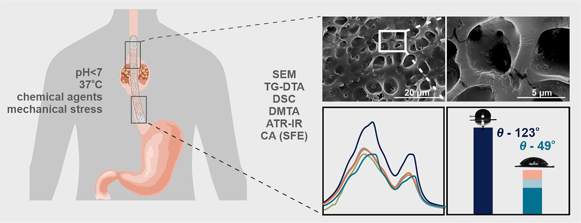
ABSTRACT: Partially covered self-expandable metallic esophageal stent (SEMS) placement is the most frequently applied palliative treatment in esophageal cancer. Structural characterization of explanted 16 nitinol-polyurethane SEMS (the group of 6 females, 10 males, age 40−80) was performed after their removal due to dysfunction. The adverse bulk changes in the polymer structure were identiﬁed using diﬀerential scanning calorimetry (DSC), diﬀerential mechanical thermal analysis (DMTA), and attenuated total reﬂectance infrared spectroscopy (ATR-IR) and discussed in terms of melting point shift (9 °C), glass-transition shift (4 °C), diﬀerences in viscoelastic behavior, and systematic decrease of peaks intensities corresponding to C−H, C O, and C−

N polyurethane structural bonds. The scanning electron and confocal microscopic observations revealed all major types of surface
degradation, i.e., surface cracks, peeling oﬀ of the polymer material, and surface etching. The changes in the hydrophobic polyurethane surfaces were also revealed by a signiﬁcant decrease in wettability (74°) and the corresponding increase of the surface free energy (31 mJ/m2). To understand the in vivo degradation, the in vitro tests in simulated salivary and gastric ﬂuids were performed, which mimic the environments of proximal and distal ends, respectively. It was concluded that the diﬀerences in the degradation of the proximal and distal ends of prostheses strongly depend on the physiological environment, in particular stomach content. Finally, the necessity of the in vivo tests for SEMS degradation is pointed out.
KEYWORDS: esophageal stent, biomaterial, polyurethane, in vivo degradation, esophagus, esophageal cancer

INTRODUCTION
Every sixth death in the world is due to cancer, the second
leading cause of death.1 Esophageal cancer is one of the most commonly diagnosed cancers and the sixth leading cause of cancer-related mortality.2 Due to either a progressive tumor stage or weak physical conditions, the majority of patients are not eligible for curative treatment.3 The most important aspect of esophageal cancer is dysphagia, which is a late symptom of esophageal cancer, leading to weight loss, eating disorders, and related metabolic deﬁciencies; thus, to improve the quality of patients’ life, a palliative treatment must be applied.4
Stent treatment is well documented and commonly applied
on a large scale for palliative treatment of dysphagia and ﬁstula caused by advanced esophageal cancer. Clinical research conﬁrmed that esophageal stent implantation has satisfying

© 2021 The Authors. Published by American Chemical Society

1403

results, leading eﬀectively to patients’ relief.5 The esophageal stenting is a relatively easy method, used for the ﬁrst time in 1885. Since then, rapid development due to the advances in endoscopy has been observed.6
See https://pubs.acs.org/sharingguidelines for options on how to legitimately share published articles.
Nowadays, esophageal stents consist of two main components of diﬀerent functions: nitinol mesh (superelastic shape memory alloy for expansion) and polymeric membrane (biocompatible cover), schematically presented in Figure SI.1.
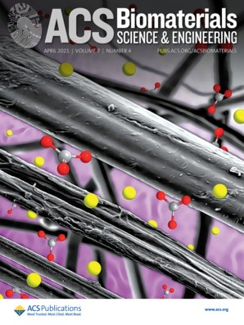
Received: December 21, 2020
Accepted: March 2, 2021
Published: March 12, 2021

https://dx.doi.org/10.1021/acsbiomaterials.0c01773
ACS Biomater. Sci. Eng. 2021, 7, 1403−1413

Table 1. Basic Information on the Investigated SEMS

 |  |  | treatment
patient | gender | stenting | chemotherapy | radiotherapy | complication | residence time (days)
1 | M | + | + | + | bronchus ﬁstula | 35
2 | F | + | + | + | granulation | 66
3 | F | + |  |  | granulation | 153
4 | M | + | + | + | migration | 68
5 | M | + | + | + | granul. empyema | 91
6 | M | + | + | + | none | 93
7 | F | + | + | + | none | 98
8 | M | + | + | + | granulation | 82
9 | M | + | + | + | granulation | 45
10 | M | + | + | + | bronchus ﬁstula | 38
11 | M | + | + | + | none | 101
12 | F | + | + | + | granulation | 31
13 | M | + | + | + | bronchus ﬁstula | 81
14 | F | + | + | + | granulation, dysphagia | 65
15 | M | + | + | + | granulation, dysphagia | 48
16 | F | + | + |  | granulation | 62
Such composite construction combines the advantages of the mechanical performance of metal alloy and elastic polymeric barrier, preventing tumor overgrowth.7 Self-expandable metal stents (SEMSs) are available in three variants, uncovered, partially covered, and fully covered with ﬂanges at both ends, resulting in a “dog bone” shape.8 The greatest beneﬁt of using SEMSs is their suﬃcient elasticity to be compressed for delivery and expanded after implantation in the target area within 24 h at the patient’s body temperature.9
Although the stent implantation procedure is rather simple and limits surgical invasion during stenting, there is still a risk of life-threatening complications. The most frequent post- operation complications are prosthesis migration, esophageal perforation, and overgrowth of the stent by the granulation tissue (hyperplastic tissue reaction). Moreover, there is a possibility of more serious consequences such as hemorrhage
and ﬁstulas between the esophagus and the bronchial tree or mediastinum.4,10−12 The factors causing the complications are
poorly understood; however, despite the side eﬀects, stenting still ensures improvement in the quality of life of palliative patients.
As suggested by producers, the maximum residence time of the prosthesis is 3 months. However, due to the above- mentioned complications, it is unachievable in many cases. A new approach in improving the quality of palliative treatment can be provided by local heat treatment using a nano- functionalized SEMS13 or functionalization of the SEMS polymeric barrier with chemotherapeutic agents (docetaxel, paclitaxel, ﬂuorouracil), antibiotics (doxorubicin), or radio-
therapeutic agents (iodine-125, holmium-166).14−18 It is also worth mentioning the new generation of stents covered with a
biodegradable polymer, which can be additionally equipped with a drug-eluting function. Some of their successful applications include covering a metal stent with a poly- caprolactone (PCL)-based ﬁbrous membrane containing paclitaxel.19 Such an approach allows in-site chemotherapy and eﬀectively reduces the risk of restenosis.20
Polyurethanes (PUs), due to their speciﬁc physicochemical properties,21−23 have a broad gamut of medical applications in
various ﬁelds including coating technology (coatings of orthopedic metal implants, wound dressings24), bulk bio- materials (middle ear implants),25 and scaﬀolds (orthopedic
and cardiovascular).26,27 Polyurethanes are also suitable for applications as cardiovascular,28 neurological,29 and esophageal stents.30 The polymeric membranes made of polyurethanes are used for over 25 years as short-term biomedical devices.31,32 The three principal components of PU include polyol, diisocyanate, and cross-linker between which a urethane linkage (−NHCOO−) is formed. There is a variety of possible polyols (over 500 commercially used) that play an important role in controlling the characteristics of the PUs, such as physicochemical and mechanical properties.33 The PUs used as biomaterials are polyether- and polyester-based, and their choice depends on the application site. Polyether-based PUs are ﬂexible and resistant to hydrolysis but have low oxidative and thermal stabilities, while polyester-based PUs have greater mechanical strength and heat resistance, though susceptible to hydrolytic degradation.34
To improve the polyurethane performance, intense studies are carried out, e.g., to enhance hemocompatibility and antibacterial activity. Two main paths of the PU surface modiﬁcation are focused on the implementation of substances with a speciﬁc function (e.g., antibiotics, metallic nanoparticles, growth factors, natural polymers), or generation of active groups on polymeric surfaces by plasma treatments, ﬂame treatment, UV irradiation, and chemical grafting.35,36
The polyurethane membranes of esophageal stents that prevent tumor overgrowth should be stable and ensure reliable support against dysphagia, and in long-term use, a signiﬁcant loss of biostability is observed.37,38 The degradation is caused by the very aggressive environment of the body ﬂuids, living tissues, and a combination of physical and chemical processes
at the implant−body interface such as hydrolysis, oxidation stress, environmental stress cracking, and calciﬁcation.39−41
Crack formation and propagation on the surface of the polyurethane is mainly caused by environmental stress. In general, the breaks in the polymer chain caused by the synergistic eﬀects of chemical degradation and mechanical stress generate microscopic defects, leading to the formation of cracks and their propagation on the surface.37 Such degradation of PU-based implants results in a decrease in mechanical strength. The process of in vivo degradation depends on many factors, i.e., it is assumed that both the environmental factors of patients (cancer stage and aggressive-
ness, health/condition) and the treatment (chemotherapy, radiotherapy) play an important role here. Unfortunately, the exact causes are unknown, because no scientiﬁc attempts have been made to assess them so far, and there are no systematic scientiﬁc reports, especially for in vivo conditions.
The aim of this study was to compare the reference (as received from the producer) and implanted stents (removed from patients after 1−6 months) in terms of surface and bulk changes in the polyester-based polyurethane membranes. Such an approach requires application of a broad range of physicochemical methods dedicated to the thorough character- ization of polymeric materials such as diﬀerential scanning calorimetry (DSC), diﬀerential mechanical thermal analysis
(DMTA), attenuated total reﬂectance infrared spectroscopy (ATR-IR), scanning electron microscopy (SEM), confocal microscopy (CM), and contact angle (CA) measurements.
■

MATERIALS AND METHODS
Patients. Sixteen patients (10 men, 6 women in the age group of 42−82, average age 59) were palliatively treated for esophageal tumor by the placement of self-expandable polyurethane stents (SEMS,
made of a nitinol mesh and covered with a polymeric membrane with ﬂanges at the proximal and distal ends.) Two main treatments were applied, chemotherapy and radiotherapy. SEMSs were removed from living patients by endoscopy due to total dysphagia caused by an overgrowth of noncancerous granulation above or below the implanted prosthesis or during esophageal resection. Esophagus resection was not a routine surgical procedure for patients qualiﬁed to palliative treatment. A detailed summary of patients’ information (treatments, re-treatments, and complications) is listed in Table 1.
Samples. The removed esophageal stents were cut into three parts (proximal, distal, and middle). Each one was stored separately. Prior to the investigations, for thorough cleaning from adsorbed organic residues (mainly proteins and bacterial bioﬁlm), the samples were placed in a beaker with distilled water and kept in an ultrasonic cleaner for 10 min. After the cleaning, the samples were air-dried.
Material Characterization. Diﬀerential Scanning Calorimetry (DSC). The changes in bulk properties of polyurethane were analyzed using a DSC 821e Mettler Toledo apparatus. The experiments were performed in the temperature range of 25−600 °C with a heating rate of 10 °C/min at an Ar ﬂow.
Dynamic Mechanical Thermal Analysis (DMTA). A Q800 DMA (TA Instruments, New Castle, DE) apparatus operating in a tensile mode was used to determine the storage modulus (E′), loss modulus (E″), and the tangent of the phase angle (tan δ). The glass-transition temperature (Tg) was taken as the maximum of tan δ and the maximum of loss modulus, E″. The relaxation spectrum was scanned from −70 to 150 °C, at a frequency of 1 Hz and a heating rate of 3
°C/min.
Attenuated Total Reﬂectance Infrared (ATR-IR) Spectroscopy. ATR-IR spectroscopy was performed to study the bulk changes in the stents’ polymeric component. The measurements were carried out on a Nicolet 6700 Thermo Scientiﬁc with a diamond crystal. The spectra were acquired in the range of 4000−600 cm−1, and for each sample, the result is an average of 64 scans.
Scanning Electron Microscopy (SEM). The images of eroded samples’ surfaces for the polymer and nitinol were taken using a Hitachi S-4700 scanning electron microscope. The polyurethane samples were coated with Au prior to the observations due to their nonconductive nature.
Confocal Microscopy. The images of polymeric samples to measure their roughness were taken using an Olympus Lext OLS4000 confocal microscope (magniﬁcation, 10×; image size, 1280 × 1281 μm2). Surface roughness was calculated based on the formula for Ra, which is the arithmetic average of the absolute values of the proﬁle height deviations from the mean line, recorded within the evaluation length. The typical image used for evaluation of surface roughness is presented in Figure SI.2.
Contact Angle (CA) Measurements and Surface Free Energy (SFE) Calculations. The changes in the hydrophobicity caused by human body ﬂuids were followed by contact angle measurements, using a Surftens universal instrument (OEG GmbH). Static contact angles of water and diiodomethane were calculated using software
Surftens 4.3. For each sample, at least three 1 μL droplets of water and diiodomethane were applied, respectively. The mean value was the average over 10 independent measurements. SFE calculations, based on contact angle values of water and diiodomethane, were performed
using the standard Owens−Wendt method dedicated to polymeric surfaces. The method of calculation and equations are described in detail in our previous work.42
In Vitro Aging Test of Polyurethane Membrane. To get more in- depth insight into polyurethane membrane degradation, in vitro tests were performed. For the best imitation of the stent environment in the human body (for the proximal and distal ends), two types of body ﬂuids were used: artiﬁcial saliva and simulated gastric ﬂuid. A modiﬁed Fusayama’s artiﬁcial saliva (AS) was used at 37 °C (pH 6), with the following chemical composition: NaCl (0.4 g/L), KCl (0.4 g/L), CaCl2·2H2O (0.795 g/L), Na2S·9H2O (0.005 g/L), NaH2PO4·
2H2O (0.69 g/L), and urea (1 g/L).43 Simulated gastric ﬂuid without pepsin, 0.2% (w/v) NaCl, in 0.7% (v/v) HCl, pH 1.5, was prepared.44
In vitro experiments were performed for 62 days at 37 °C in an incubator with gentle shaking (60 rpm). The simulated body ﬂuids were replaced every 7 days. The samples were collected for 7, 14, 21,
and 62 days.
■

RESULTS AND DISCUSSION
The polyurethane prosthesis membranes were thoroughly characterized in terms of bulk and surface properties to determine the eﬀect of cancer therapy on their structure. Bulk changes in the polyurethane structure were investigated using DSC. Measurements were performed for prostheses exposed to various patient treatments: stenting, chemotherapy, chemo- therapy, and radiotherapy. The DSC curves for representative samples are shown in Figure 1a for the prosthesis proximal end

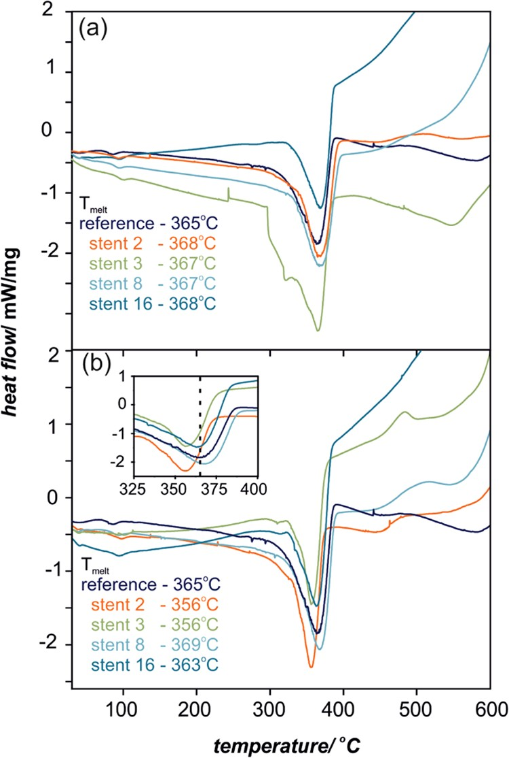

Figure 1. DSC proﬁles and the characteristic Tmelt values for proximal
(a) and distal (b) ends of SEMS polyurethane cover. The inset in (b) shows a narrow range of Tmelt for the distal end of the prostheses.
and in Figure 1b for the distal end. The characteristic parameter that indicates the changes in the polymer bulk properties is melting temperature (Tmelt); in the case of the reference sample, Tmelt = 365 °C. For the implanted samples,
signiﬁcant diﬀerences in Tmelt for proximal and distal ends were
observed (for details, see the inset in Figure 1). In general, the observed trend for the proximal end is increase in Tmelt in the narrow range of 367−368 °C, while for the distal end, the values are spread in the larger range of 356−369 °C, as shown in Figure 2 (the error bars correspond to 0.2 °C). The
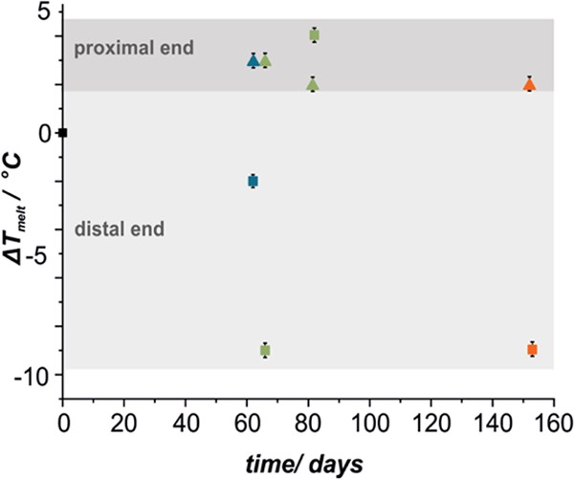
Figure 2. Changes of Tmelt with implantation time for proximal (▲) and distal (■) ends of SEMS polyurethane (colors represent patients’ treatment: blue, chemotherapy; green, chemo- and radiotherapy; orange, palliative treatment only, i.e., stenting).

temperature shift (∼9 °C) for stent 2 and stent 3 points out signiﬁcant bulk changes in the polymeric structure. It is worth mentioning that these samples are representatives of the material, which underwent combined chemo- and radiotherapy (stent 2) and the longest implantation time of 153 days (stent
3). The results also indicate that the distal end of the prosthesis, exposed to harsher environment conditions (i.e., stomach content), is more damaged in contrast to the proximal end, where the changes in the polymeric structure are minor. This also clearly illustrates that the chemistry of degradation processes is diﬀerent on both prosthesis ends, i.e., the increase and decrease in T of proximal and distal ends, respectively.
sights into the mechanical behavior of the investigated polymeric membranes.
The DMTA results are summarized in Figures 3 and 4, where values of the storage modulus, E′, are presented. The E′ values (Figures 3a and 4a) represent elastic behavior in viscoelastic polymers and indicate a clear diﬀerence in the elasticity with the change of various patients’ treatment: stenting, chemotherapy, and combined chemo- and radio- therapy. These changes can also be seen in E′ for proximal (Figure 3a) and distal (Figure 4a) ends of the polymeric stents cover. The highest diﬀerence in E′ between reference and implanted materials in the low-temperature region (before the sharp decrease around the glass-transition temperature, Tg) has been noted for explants after stenting and chemotherapy for the proximal end, while for the distal end, the combination of stenting, chemotherapy, and radiotherapy had the most pronounced eﬀect. Interestingly, all explanted stents from the distal region revealed typical for thermoplastic polyurethanes rubbery plateau, not observed for the reference material. This can indicate signiﬁcant changes in the microphase separation and crystalline structure changes as these materials (stents 2 and 3, Figure 3a) show very distinct ﬂow properties (melting transition). Figures 3b,c and 4b,c show storage modulus, E″, and tan δ curves, respectively. The maximum of E′ and tan δ value is often referred to Tg in thermoplastic polyurethane elastomers, and the values of the maxima of these transitions are summarized in Table 2. Again, the largest diﬀerences in Tg
(taken as the maximum of E″) between the reference material
and explanted PU has been found for the distal end after combined stenting, chemotherapy, and radiotherapy (Figure 4b). A signiﬁcant broadening of the tan δ curves for explants after such treatment clearly indicates that changes in materials’ microstructure have occurred, which is in line with the DSC results.
The more in-depth insight into the chemical changes in the polyester polyurethane molecular structure can be obtained by infrared spectroscopy; therefore, the examined prostheses were investigated using ATR-IR, and the representative spectra are presented in Figures 5 and 6. The characteristic maxima for
polyurethane are observed at 2930 and 2858 cm− 1
Since melting
melt
temperature
is characteristic of the structure of
(asymmetric CH2
stretch vibration),45 1738 and 1716 cm−1
polymeric material, the degradation processes of the examined materials are not conﬁned to the surface but advanced into the bulk. For detailed in-depth characterization of the polymer in vivo degradation and diﬀerence between distal and proximal sides, dynamic mechanical thermal measurements were performed. DMTA allowed for a detailed analysis of the temperature-dependent viscoelastic properties and gave in-
(CO stretch vibration),45,46 1524 cm−1 (coupling N−H blending vibration with C−N stretching vibration),46 1463 and 1403 cm−1 (CH2 bending vibration),47 1244 cm−1 (amine III vibration, C−N), 1044 cm−1 (antisymmetric C−O−C),47 955 cm−1 (C−H benzene ring out-of-plane bending),48 and 790 cm−1 (amine IV vibration).49 Although the overall IR spectra
are essentially similar, the detailed analysis of the three regions

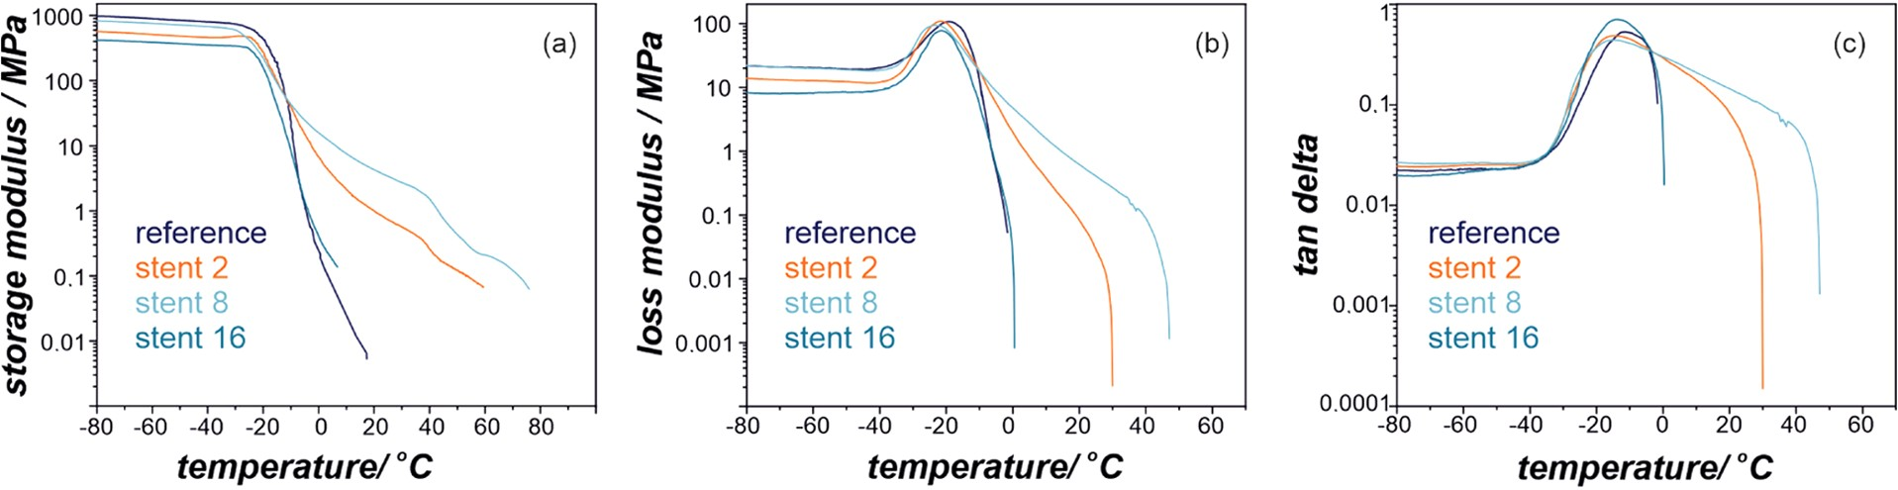

Figure 3. Storage modulus, E′ (a), loss modulus, E″ (b), and tan δ (c) proﬁles for the proximal end of SEMS polyurethane covers.

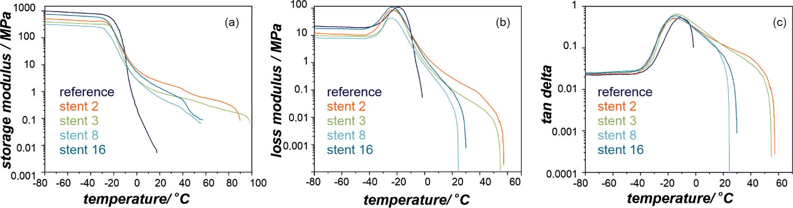
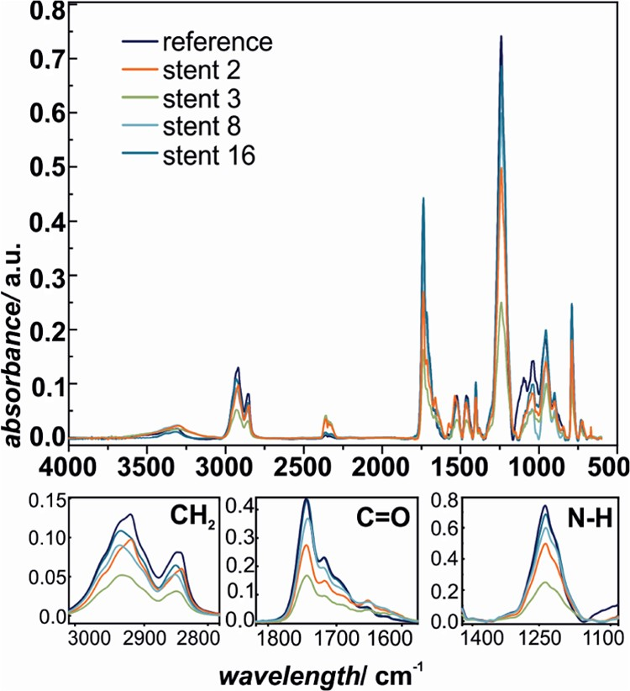
Figure 4. Storage modulus, E′ (a), loss modulus, E″ (b), and tan δ (c) proﬁles for the distal end of SEMS polyurethane covers.
Table 2. Glass-Transition Temperature (Tg) of Polymeric Materials Covering Stents as Determined from DMTA as the Maximum of E″ or the Maximum of tan δaa
sample code Tg (max E″) (°C) Tg (max tan δ) (°C) stent 2 (66 days; S, R, C) −21.62 (−23.02) −14.81 (−14.85)
stent 3 (153 days; S) − (−21.51) − (−14.25)
stent 8 (82 days; S, R, C) −23.21 (−24.45) −15.23 (15.18)
stent 16 (62 days; S, C) −21.31 (−23.44) −13.90 (−14.40)
reference −19.03 (−19.03) −11.45 (−11.45)
aTg (max E″), glass-transition temperature taken from the maximum of storage modulus, E″; Tg (max tan δ), glass-transition temperature taken from the maximum of tan δ. The numbers outside parentheses
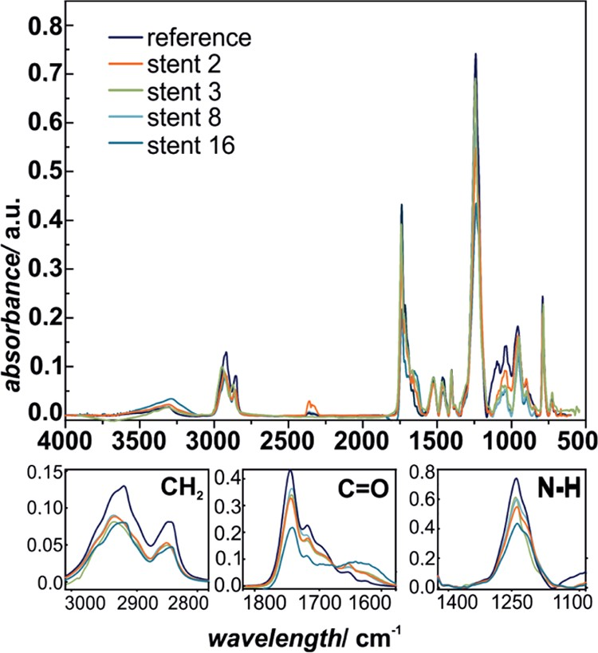
refer to the proximal end of the stent; the numbers within parentheses refer to the distal end of the stent. S, stenting; C, chemotherapy; R, radiotherapy.

Figure 6. ATR-IR spectra of SEMS polyurethane covers: reference sample and selected stents (distal end).

Figure 5. ATR-IR spectra of SEMS polyurethane covers: reference sample and selected stents (proximal end).

assigned to −CH2 (3000−2800 cm−1), CO (1800−1600 cm−1), and C−N (1300−1150 cm−1) shows systematic changes in the characteristic bond absorption intensities, as
presented in the bottom panels of Figures 3 and 4, respectively. This indicates that the extensive degradation process of the polymer took place upon implantation in the case of all of the investigated samples and the damage of distal ends is much greater compared to the proximal end. The ATR-IR results are in line with the Tmelt values obtained using DSC, since again for the prosthesis numbers 2 and 3, the changes were the most
pronounced in terms of all of the observed chemical groups, mainly CH2, C O, and C−N.
All of the methods (DSC, DMTA, and ATR-IR)

complementarily revealed advanced changes in material properties. These adverse bulk changes are the eﬀect of the surface damages caused by the aggressive environment of the body ﬂuids and living tissues, which penetrate the material; therefore, scanning electron and confocal microscopic observations were performed to illustrate the changes in surface morphology. The representative images of the
investigated samples are presented in Figures 7−10.
The SEM images illustrate the morphological diﬀerences in
polymeric coating between the outer (dedicated to contact the tissue) and inner sides, as presented in Figure 7a,b. The outer surface of the polymer is smoother than the inner side, which has micro- (30−50 μm) and submicropores (>10 μm). On the top of each side, granulated particles (white spots) are observed, which were identiﬁed by independent X-ray ﬂuorescence (XRF) measurements as magnesium oxide particles.
After implantation, the topography of the surface dramat- ically changed. The typical examples of prostheses morphol- ogies are shown in Figure 8, where diﬀerent types of surface damages can be observed. Placing the implants in the human body led to several processes resulting in severe changes in the surfaces of the implant. Indeed, in Figure 8, cracks (Figure 8a,c), peeling (Figure 8a), and material surface transformation

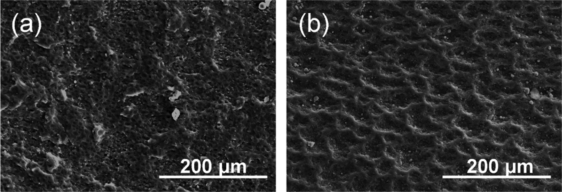

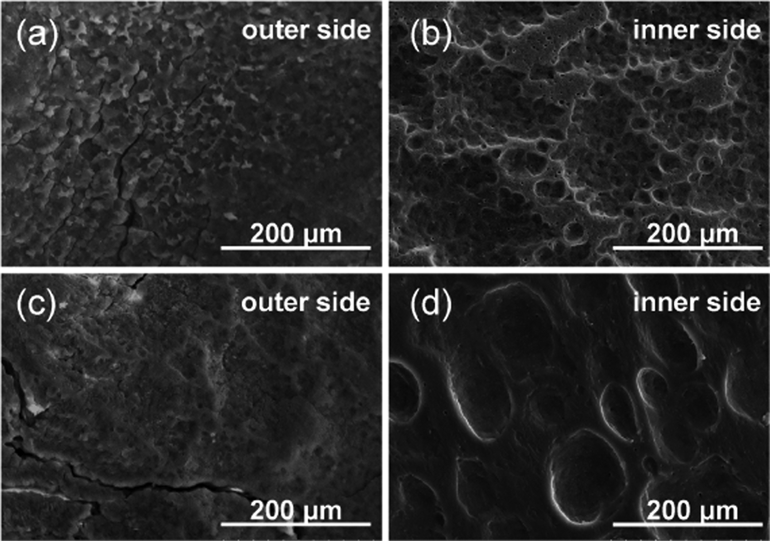
Figure 7. Representative images of reference sample morphology of SEMS polyurethane cover: outer side (a) and inner side (b) of the stent.
suggested that the degradation processes taking part at the polymeric surface are interlaced.
To eliminate the eﬀect of biological moieties we performed in vitro degradation tests of polyurethane membrane in simulated salivary and gastric ﬂuids, representing the environ- ment where the proximal and distal ends are placed. The corresponding images are presented together with in vivo results (Figures 9 and 10; see Figures SI.3−SI.6 for images from more systematic studies). The images clearly illustrate that the simulated body ﬂuids alone already cause the
degradation of the material. The walls of the pores become thinner (Figures 9b and 10b), whereas the longer incubation time results in characteristic cracks. It can also be noted that on the polymeric surface, the crystalline precipitates are formed,
Figure 8. Representative SEM images of SEMS polyurethane covers
with visible surface damages appearing after 9−12 weeks implantation time.

from micron and submicron pores (Figure 8b) to ∼100 μm craters (Figure 8d) in the polymeric surface can be observed, indicating that the destruction processes are quite extensive. This is particularly visible for the inner side of the stents.
During the implantation, the surface of the polymeric component was coated with various human proteins and macrophages, which can strongly enhance the surface degradation process of biomaterials by the extensive release
of oxygen free radicals.50−52 In Figures 9 and 10, more in-
depth morphology analyses for prostheses 16 and 8 are presented, respectively. For combined chemo- and radio- therapy (stenting for 62 days), as well as prolonged residence in the body (82 days), all major types of surface degradation can be distinguished, i.e., polyurethane surface cracks, peeling oﬀ of the material, and surface etching. Thus, it can be
which contain the typical ions presented in the simulated saliva (Na+, K+, Ca2+, PO43−, Cl−). It is mostly visible in the case of artiﬁcial saliva (pH 6) since the high ionic strength of the gastric solution (pH 1.5) hinders the formation of the precipitated salts.
To quantify the surface changes caused by the degradation, the surface roughness was evaluated using a confocal microscope. The changes in Ra values (representing surface roughness) for the samples after in vitro tests are summarized in Figure 11. As can be inferred from the nonmonotonous changes of Ra with time, there are several individual processes involved in the overall degradation mechanism. In the ﬁrst stage (ﬁrst 2 weeks) of degradation, the pores expand, they
become deeper, and their walls become thinner, which is reﬂected in a substantial increase in the Ra value. When the degradation process prolongs, Ra decreases due to the salt precipitation in the pores and the destruction of the walls. In line with the SEM observations and spectroscopic data (Figures 5, 6, 9, and 10), the changes in roughness clearly

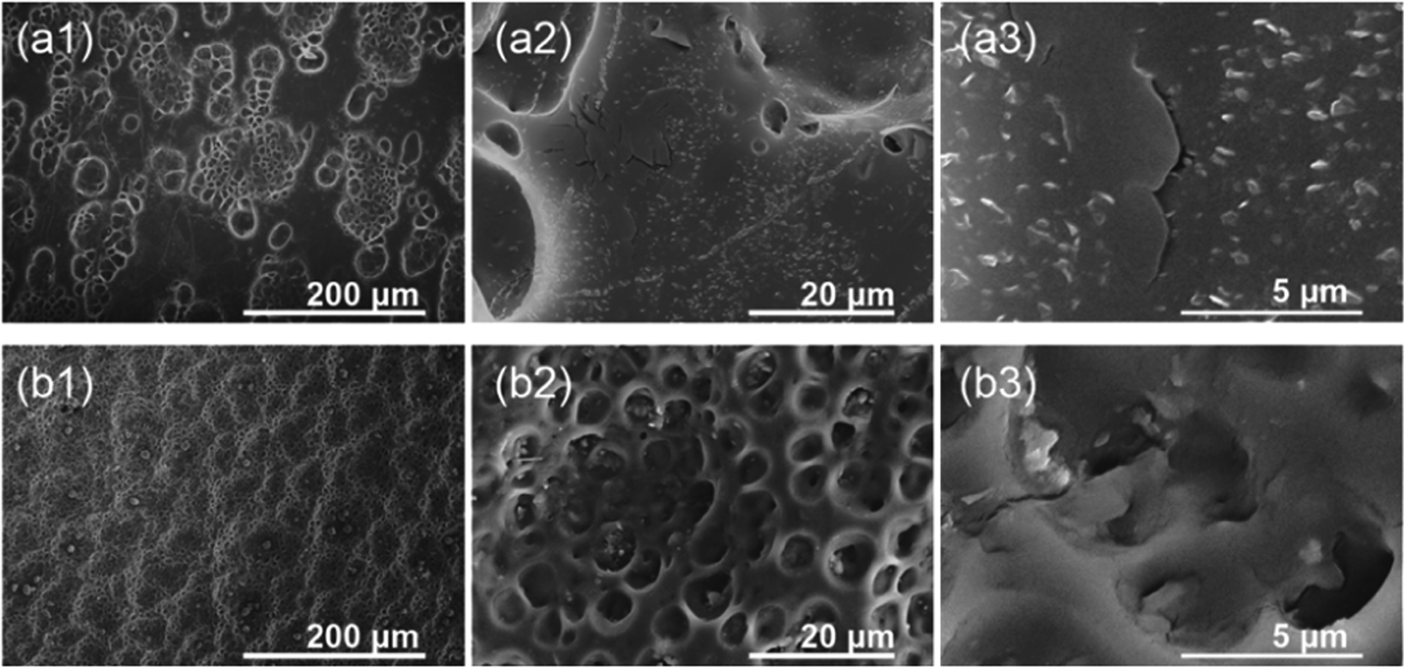

Figure 9. Representative SEM images illustrating the surface degradation (prosthesis 16) for the proximal end of the esophageal implant (a) and for parallel in vitro experiment in artiﬁcial saliva for 2 months (b).

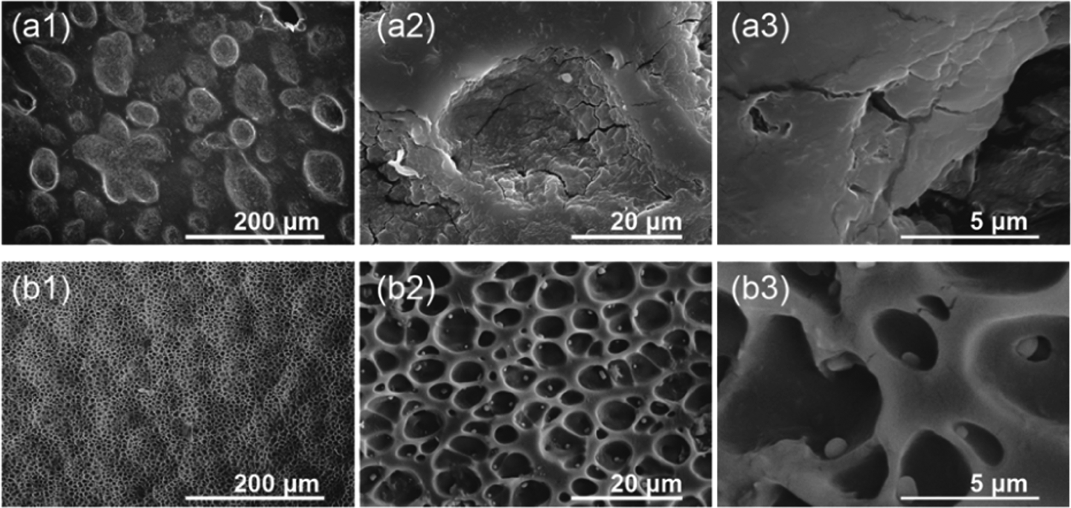

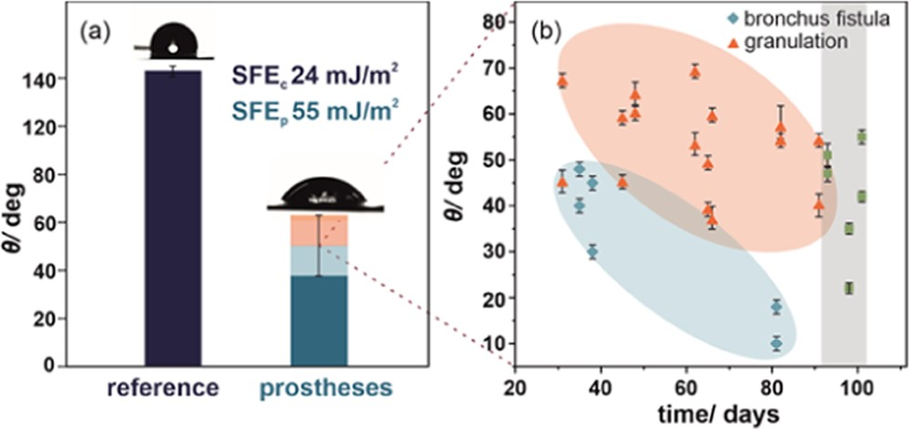
Figure 10. Representative SEM images illustrating the surface degradation (prosthesis 8) for the distal end of the esophageal implant (a) and for in vitro experiment in simulated gastric ﬂuid for 2 months (b).

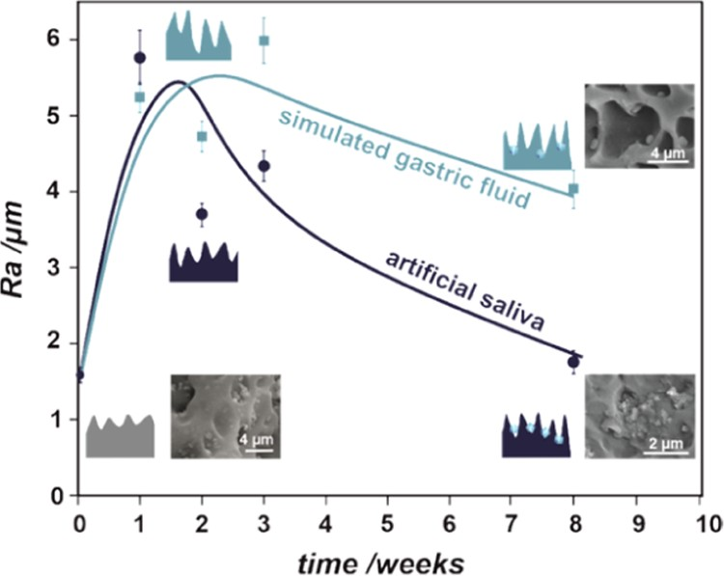
Figure 11. Surface roughness (parameterized by Ra) as a function of incubation in simulated body ﬂuid (gastric and salivary) together with graphical representations showing the changes in surface topography.
Figure 12. Representative results of water contact angle measure- ments and the corresponding surface free energy for the investigated SEMS polyurethane covers (a): reference (navy blue) and implanted prostheses (blue). The shadowing illustrates the range of experimental values for the investigated samples. Detailed analysis of water contact angle measurements as a function of time in the human body (b).

show the diﬀerences in the degradation process under two in vitro conditions (saliva, gastric), mostly manifested after a longer time. Surface irregularities play an important role in the tissue−implant interface. The increase in roughness and related increase in the surface area available for tissue overgrowth may accelerate restenosis, as observed in clinical practice (J.W. and J.K., private information).
Additional surface characterization was provided by the water contact angle measurements; this method quantitatively characterizes the wettability and allows for surface free energy (SFE) determination, often used for evaluation of the biological interactions such as adhesion of proteins, cells, or tissues. The exposure of the esophageal stent to human body ﬂuids causes signiﬁcant changes in the surface properties of the polymeric membrane. The polyurethane cover of the esophageal stent is initially hydrophobic, as revealed by the water contact angle of 123 ± 2° and the corresponding SFE = 24 mJ/m2 for the reference material. The changes induced by prolonged interaction with body ﬂuids strongly aﬀect the examined prostheses with a signiﬁcant decrease in average water contact angle down to 49 ± 15° (Figure 12). This can be explained by changes in the surface morphology, especially
degradation and physical damages observed in SEM images and Ra (Figures 7−11). Nevertheless, it is worth underlying that although the SEM observations provide local information about the degradation, the contact angle measurements characterize the macroscopic changes at the polymeric surface.
As can be observed in Figure 12b, independently the type of complications (granulation, bronchus ﬁstula), the overall trend in contact angle changes is the same: the longer the implantation time, the smaller the contact angle value. The observed trend indicates that polymer degradation is stable within the investigated range of implantation time. The gray shadowing corresponds to the time recommended by the implant producer and was achieved only for stents without complications. It can also be noted that in the case of bronchus ﬁstula, the water contact angle values were lower than those for granulation.
The various methods of the prostheses’ structure examina- tion show the diﬀerent character of the changes in the distal and proximal segments of the prostheses’ polymer. The structural changes result from the inﬂuence of the applied chemo- and radiotherapy treatment, mechanical stress, as well as the inﬂuence of the esophagus and gastric contents. Since the major damage was also observed for the prosthesis not exposed to chemo- or radiotherapy, the surrounding environ- ment of the SEMS is a suﬃcient factor to elicit signiﬁcant surface and structural changes in the polyurethane mem- brane.53,54 The SEM/CM observations conﬁrmed that the destruction processes are quite extensive and interlaced, resulting in etching and peeling oﬀ of the material. The observed crack formation and propagation on the surface of the polyurethane are mainly connected with the high mechanical stress generated by nitinol mesh as well as the surrounding tissue pressure. Thus, it can be concluded that the
applied polyurethane material has insuﬃcient mechanical strength resistance for prolonged use in the body.
The chemical degradation of polyurethanes is mainly caused by hydrolysis as thoroughly discussed elsewhere.55,56 This type of degradation is a combination of in vivo chemical factors such as water sorption, pH, presence of radicals, and biological moieties like cells, enzymes, and lipids. Since the water molecules mostly interact with the polyurethane polar groups, the hydrolytic degradation is dominating and aﬀects carbonyl bands (changes in IR spectra at 1730 cm−1 in Figures 5 and 6). As shown in Figures 9−11, the interaction with simulated body ﬂuids already leads to surface damages and microscopic cracking. However, as reported for in vivo conditions,57 biological factors (i.e., FBGC, enzymes) accelerate the hydrolytic degradation, which can be additionally enhanced by mechanical stress. It is also known that the cracks initiated by chemical interaction can be propagated by residual stress. This in turn causes an increase in the surface area and the number of available surface sites that accelerate the hydrolytic degradation even further.58 It is worth mentioning that the biological degradation is diﬀusion-limited and thus conﬁned to
a few microns and thus can be considered as a mostly surface process. It can be thus concluded that although the cracks may open the diﬀusion pathways for bulk degradation, the obtained results (SEM, IR, CM−Ra) indicate that the polyurethane degradation process begins at the surface. Such results are in good agreements with the previously reported in vivo investigations.51
In the studied group, it was found that among patients with ﬁstula, the polymeric surface was exposed to body ﬂuids for a shorter time (35−81 days) than in the group with granulation
(31−153 days). The mechanism of polymer degradation can
be one of the factors leading to a life-threatening complication,
which is a ﬁstula to the bronchial tree. The formation of granulation tissue after the implantation of the esophageal prosthesis is a typical complication occurring in the range of 4−40%59,60 (in our work, 11%). It is formed in the distal and proximal ends of the prostheses in healthy tissues of the esophagus as well. The granule is a noncancerous connective tissue that surpasses the prosthetic ends most likely due to the exudation of the mechanical stress of the nitinol mesh on the esophageal mucosa.61,62 Based on our operating room observations, such an eﬀect can be caused by a lack of SEMS nitinol biomechanical compatibility causing irradiation
of the esophageal wall, likely causing granulation. Moreover, the irradiation at the esophageal wall−prosthesis interface is enhanced by the progressive degradation of the polymer bulk and surface. The granulation tissue grows up to about 3 months after the prosthesis implantation, leading to complete obstruction of the esophageal stent, which in turn leads to endoscopic removal of the prosthesis, already at high risk of
complications. The mechanism of granulation formation may be also related to the destructive eﬀect of acid gastric contents, especially in its distal segment.
The inﬂuence of prosthetics, irradiation, and chemotherapy on the esophagus and the occurrence of complications after stenting in the course of cancer remain unclear. The observed changes in the microstructure of the esophagus and secondary changes in the esophageal wall are important for the pathophysiology. Factors determining their occurrence are yet to be investigated, and the presented report clearly shows a need and direction for further research. The degradation of polyurethanes is mostly examined in vitro, and in many cases in
stable environments under favorable temperature condi- tions.63,64 Such experiments performed under controllable conditions do not provide thorough feedback of the material in such a complex system as the human body. Within this study, we address this knowledge gap. The in-depth insights are the prerequisites for the development of new-generation pros- theses with better parameters, which can minimize the traumatic impact of the foreign body on the esophagus.
The performed studies clearly point out the important practical implications and the need for diﬀerent optimization of the polymeric material, speciﬁcally for each end of the stent. The hydrophilic/hydrophobic polymeric surfaces at the outer and inner sides of the implant will be beneﬁcial to provide biocompatibility and prevent obstruction, respectively. Such modiﬁcation can be obtained using plasma treatment
(introduction of surface functional groups such as −OH or
−F without changing the bulk properties). Another strategy consists of improving the chemical inertness and mechanical
properties by applying polymeric composites with tunable properties.

CONCLUSIONS
In this work, we have evaluated the eﬀect of the human body
environment and the applied cancer treatment on the degradation process of the polyurethane SEMS membranes. The obtained physicochemical characterization of 16 stents removed from the patients revealed that independent of the treatment (chemo- and/or radiotherapy, none), all of the polymeric membranes systematically degrade in vivo as a
function of implantation times (31−153 days). The diﬀerences between the proximal and distal ends were identiﬁed and
explained in terms of various chemical natures of the body ﬂuids. This study was supported by the parallel in vitro tests in simulated body ﬂuids representative for gastric and saliva environment. These ﬁndings have important practical implications, pointing out the need for diﬀerent optimization of the material properties, speciﬁcally for each end of the stent. The improvement of the chemical stability of the polymeric material is of importance, since even a short implantation time (35 days) led to signiﬁcant changes in the surface and bulk structure, as observed by DSC, DMTA, ATR-IR, SEM, CM, and CA methods. The obtained results also show that the contact angle and the polymer melting temperature can be considered as suitable parameters for analyzing the extent of the stent degradation processes. To the best of our knowledge, this work is the only report in the literature that shows the inﬂuence of chemo- and radiotherapy and the role of the microenvironment of the esophagus and stomach in the structure of the polyurethane/nitinol stents.

ASSOCIATED CONTENT
*sı Supporting Information
The Supporting Information is available free of charge at https://pubs.acs.org/doi/10.1021/acsbiomaterials.0c01773.
Scheme of esophageal stent with proximal release, typical image used for evaluation of polyurethane membrane surface roughness, and detailed SEM images of surface degradation for in vitro experiment in artiﬁcial body ﬂuid (PDF)

AUTHOR INFORMATION
Corresponding Authors
Monika Golda-Cepa − Faculty of Chemistry, Jagiellonian University, 31-007 Kraków, Poland; Email: mm.golda@ uj.edu.pl
Andrzej Kotarba − Faculty of Chemistry, Jagiellonian University, 31-007 Kraków, Poland; orcid.org/0000- 0003-4815-0051; Email: kotarba@chemia.uj.edu.pl
Authors
Paulina Chytrosz − Faculty of Chemistry, Jagiellonian University, 31-007 Kraków, Poland
Janusz Wlodarczyk − Department of Thoracic and Surgical Oncology, Jagiellonian University Medical College, John Paul II Hospital, 30-387 Kraków, Poland
Jarosław Kuzdzal − Department of Thoracic and Surgical Oncology, Jagiellonian University Medical College, John Paul II Hospital, 30-387 Kraków, Poland
Miroslawa El Fray − Department of Polymer and Biomaterials Science, West Pomeranian University of Technology, 70-310 Szczecin, Poland; orcid.org/0000-0002-2474-3517
Complete contact information is available at: https://pubs.acs.org/10.1021/acsbiomaterials.0c01773

Author Contributions
P.C. performed the measurements and drafted the manuscript. M.G.-C. performed the SEM observations, interpreted the results, and drafted the manuscript. M.E.F. performed the DMTA measurements and provided their interpretation. J.W. and J.K. provided the samples and medical expertise and drafted the manuscript. A.K. supervised the project and prepared the ﬁnal draft of the manuscript.
Notes
The authors declare no competing ﬁnancial interest.

ACKNOWLEDGMENTS
This study was ﬁnanced by the Polish National Science Centre
project awarded by decision number DEC-2019/35/D/ST5/ 03107. J.W. acknowledges the ﬁnancial support provided by Jagiellonian University, Medical College Grant No. K/ZDF/ 007542.

REFERENCES
- Naghavi, M.; Abajobir, A. A.; Abbafati, C.; Murray, C. J. L.; et al.
Global, regional, and national age-sex specifc mortality for 264 causes of death, 1980-2016: A systematic analysis for the Global Burden of Disease Study 2016. Lancet 2017, 390, 1151−1210.
- Todua, F.; Gagua, R.; Maglakelidze, M.; Maglakelidze, D. Cancer incidence and mortality − Major patterns in GLOBOCAN 2012, worldwide and Georgia. Bull. Georgian Natl. Acad. Sci. 2015, 9, 168− 173.
- Diamantis, G.; Scarpa, M.; Bocus, P.; Realdon, S.; Castoro, C.; Ancona, E.; Battaglia, G. Quality of life in patients with esophageal stenting for the palliation of malignant dysphagia. World J. Gastroenterol. 2011, 17, 144−150.
- Włodarczyk, J. R.; Kużdżał, J. Stenting in Palliation of Unresectable Esophageal Cancer. World J. Surg. 2018, 42, 3988− 3996.
- Yuan, T.; Zheng, R.; Yu, J.; Edmonds, L.; Wu, W.; Cao, J.; Gao, F.; Zhu, Y.; Cheng, Y.; Cui, W. Fabrication and evaluation of polymer- based esophageal stents for benign esophagus stricture insertion. RSC Adv. 2016, 6, 16891−16898.

- Beynon, J.; Winston, T.; Thompson, M. H. Endoscopic Insertion of Celestin Tubes in Carcinoma of the Oesophagus. J. R. Soc. Med. 1991, 84, 479−480.
- Shanahan, C.; Tiernan, P.; Tofail, S. A. M. Looped ends versus
open ends braided stent: A comparison of the mechanical behaviour using analytical and numerical methods. J. Mech. Behav. Biomed. Mater. 2017, 75, 581−591.
- Van Boeckel, P. G.; Siersema, P. D.; Sturgess, R.; Dwyer, L.;
Raijman, I.; Hirdes, M. M.; Vleggaar, F. P. A new partially covered metal stent for palliation of malignant dysphagia: A prospective follow-up study. Gastrointest. Endoscopy 2010, 72, 1269−1273.
- O’Brien, B.; Zafar, H.; Ibrahim, A.; Zafar, J.; Sharif, F. Coronary
Stent Materials and Coatings: A Technology and Performance Update. Ann. Biomed. Eng. 2016, 44, 523−535.
- Hindy, P.; Hong, J.; Lam-Tsai, Y.; Gress, F. A comprehensive review of esophageal stents. Gastroenterol. Hepatol. 2012, 10, 526− 534.
- Wagh, M. S.; Forsmark, C. E.; Chauhan, S.; Draganov, P. V. Efficacy and safety of a fully covered esophageal stent: A prospective study. Gastrointest. Endoscopy 2012, 75, 678−682.
- Khara, H. S.; Diehl, D. L.; Gross, S. A. Esophageal stent
fracture: Case report and review of the literature. World J. Gastroenterol. 2014, 20, 2715−2720.
- Park, J.; Kim, M. T.; Kim, K. Y.; Bakheet, N.; Kim, T.; Jeon, J.
Y.; Park, W.; Lopera, J. E.; Kim, D.; Song, H. Local Heat Treatment for Suppressing Gastroduodenal Stent- Induced Tissue Hyperplasia Using Nanofunctionalized Self- Expandable Metallic Stent in Rat Gastric Outlet Model. ACS Biomater. Sci. Eng. 2020, 6, 2450−2458.
- Shaikh, M.; Choudhury, N. R.; Knott, R.; Garg, S. Engineering
Stent Based Delivery System for Esophageal Cancer Using Docetaxel.
Mol. Pharm. 2015, 12, 2305−2317.
- Liu, J.; Wang, Z.; Wu, K.; Li, J.; Chen, W.; Shen, Y.; Guo, S.
Paclitaxel or 5-fluorouracil/esophageal stent combinations as a novel approach for the treatment of esophageal cancer. Biomaterials 2015, 53, 592−599.
- Liu, S.; Xiang, C.; Cong, N.; Wang, B.; Zhou, B.; Zhang, B.; Li,
Y.; Wang, Y.; Yuan, S.; et al. Radioactive self-expanding stents give superior palliation in patients with unresectable cancer of the esophagus but should be used with caution if they have had prior radiotherapy. Ann. Thorac. Surg. 2014, 98, 521−526.
- Won, J. H.; Lee, J. D.; Wang, H. J.; Han, J. H.; Kim, J. H.; Kim,
K.-H.; Itkin, M.; Park, K. B. Effects of a Holmium-166 Incorporated Covered Stent Placement in Normal Canine Common Bile Ducts. J. Vasc. Interventional Radiol. 2005, 16, 705−711.
- Lee, S.; Hwang, G.; Kim, T. H.; Kwon, S. J.; Kim, J. U.; Koh,
K.; Park, B.; Hong, H.; Yu, K. J.; Chae, H.; Jung, Y.; Lee, J.; Kim, T. I.
On-Demand Drug Release from Gold Nanoturf for a Thermo- and Chemotherapeutic Esophageal Stent. ACS Nano 2018, 12, 6756−
6766.
- Zhu, Y.; Hu, C.; Li, B.; Yang, H.; Cheng, Y.; Cui, W. A highly flexible paclitaxel-loaded poly(ε-caprolactone) electrospun fibrous- membrane-covered stent for benign cardia stricture. Acta Biomater. 2013, 9, 8328−8336.
- Bai, Y.; Zhang, K.; Xu, R.; Liu, H.; Guan, F.; Luo, H.; Chen, Y.;
Li, J. Surface Modification of Esophageal Stent Materials by a Drug- Eluting Layer for Better Anti-Restenosis Function. Coatings 2018, 8, No. 215.
- Akindoyo, J. O.; Beg, M. D. H.; Ghazali, S.; Islam, M. R.; Jeyaratnam, N.; Yuvaraj, A. R. Polyurethane types, synthesis and applications - a review. RSC Adv. 2016, 6, 114453−114482.
- Hasirci, N.; Hasirci, V. Biomaterials: From Molecules to
Engineered Tissues; Springer Science & Business Media: New York, 2004.
- Kanyanta, V.; Ivankovic, A. Mechanical characterisation of polyurethane elastomer for biomedical applications. J. Mech. Behav. Biomed. Mater. 2010, 3, 51−62.
- Khil, M. S.; Cha, D. I.; Kim, H. Y.; Kim, I. S.; Bhattarai, N.
Electrospun Nanofibrous Polyurethane Membrane as Wound Dressing. J. Biomed. Mater. Res., Part B 2003, 67B, 675−679.
- Didkovskyi, V. S.; Naida, S. A.; Zubchenko, O. A. Technique for rigidity determination of the materials for ossicles prostheses of human middle ear. Radioelectron. Commun. Syst. 2015, 58, 134−138.
- Zienkiewicz, K.; Yoshii, T.; Guelcher, S. A.; Li, B.; Davidson, J.
M.; Hafeman, A. E. Injectable Biodegradable Polyurethane Scaffolds with Release of Platelet-derived Growth Factor for Tissue Repair and Regeneration. Pharm. Res. 2008, 25, 2387−2399.
- Asadpour, S.; Yeganeh, H.; Ai, J.; Kargozar, S.; Rashtbar, M.;
Seifalian, A.; Ghanbari, H. Polyurethane-Polycaprolactone Blend Patches: Scaffold Characterization and Cardiomyoblast Adhesion, Proliferation, and Function. ACS Biomater. Sci. Eng. 2018, 4, 4299− 4310.
- Trigwell, S.; De, S.; Sharma, R.; Mazumder, M. K.; Mehta, J. L. Structural evaluation of radially expandable cardiovascular stents encased in a polyurethane film. J. Biomed. Mater. Res., Part B 2006, 76B, 241−250.
- Rangwala, H. S.; Ionita, C. N.; Rudin, S.; Baier, R. E. Partially
polyurethane-covered stent for cerebral aneurysm treatment. J. Biomed. Mater. Res., Part B 2009, 89B, 415−429.
- Persson, J.; Smedh, U.; Johnsson, Å.; Ohlin, B.; Sundbom, M.;
Nilsson, M.; Lundell, L.; Sund, B.; Johnsson, E. Fully covered stents are similar to semi-covered stents with regard to migration in palliative treatment of malignant strictures of the esophagus and gastric cardia: results of a randomized controlled trial. Surg. Endoscopy
2017, 31, 4025−4033.
- Jaganathan, S. K.; Supriyanto, E.; Murugesan, S.; Balaji, A.;
Asokan, M. K. Biomaterials in cardiovascular research: Applications and clinical implications. BioMed Res. Int. 2014, 2014, No. 459465.
- Miyayama, S.; Matsui, O.; Kadoya, M.; Yoshikawa, J.; Gabata, T.; Kitagawa, K.; Arai, K.; Takashima, T. Malignant Esophageal Stricture and Fistula: Palliative Treatment with Polyurethane-covered Gianturco Stent. J. Vasc. Interventional Radiol. 1995, 6, 243−248.
- Szycher, M. Szychers Handbook of Polyurethanes, 2nd ed.; CRC
Press, 2012; pp 449−494.
- Cooper, S. L.; Guan, J. Advances in Polyurethane Biomaterials;
Elsevier Inc., 2016.
- Kara, F.; Aksoy, E. A.; Yuksekdag, Z.; Hasirci, N.; Aksoy, S. Synthesis and surface modification of polyurethanes with chitosan for antibacterial properties. Carbohydr. Polym. 2014, 112, 39−47.
- Adipurnama, I.; Yang, M. C.; Ciach, T.; Butruk-Raszeja, B.
Surface modification and endothelialization of polyurethane for vascular tissue engineering applications: A review. Biomater. Sci 2017, 5, 22−37.
- Cauich, J.; Chan-Chan, L. H.; Hernández-Sáncehz, F.;
Cervantes, M. Degradation of Polyurethanes for Cardiovascular Applications. In Advances in Biomaterials Science and Biomedical Applications; Intech, 2013; pp 51−82.
- Teo, A. J. T.; Mishra, A.; Park, I.; Kim, Y. J.; Park, W. T.; Yoon,
Y. J. Polymeric Biomaterials for Medical Implants and Devices. ACS Biomater. Sci. Eng. 2016, 2, 454−472.
- Cipriani, E.; Bracco, P.; Kurtz, S. M.; Costa, L.; Zanetti, M. In-
vivo degradation of poly(carbonate-urethane) based spine implants.
Polym. Degrad. Stab. 2013, 98, 1225−1235.
- Alferiev, I.; Vyavahare, N.; Song, C.; Connolly, J.; Travis
Hinson, J.; Lu, Z.; Tallapragada, S.; Bianco, R.; Levy, R. Bisphosphonate derivatized polyurethanes resist calcification. Bio- materials 2001, 22, 2683−2693.
- Santerre, J. P.; Woodhouse, K.; Laroche, G.; Labow, R. S.
Understanding the biodegradation of polyurethanes: From classical implants to tissue engineering materials. Biomaterials 2005, 26, 7457− 7470.
- Golda-Cepa, M.; Brzychczy-Wloch, M.; Engvall, K.; Aminlashgari, N.; Hakkarainen, M.; Kotarba, A. Microbiological investigations of oxygen plasma treated parylene C surfaces for metal implant coating. Mater. Sci. Eng. C 2015, 52, 273−281.
- Alves, S. A.; Rossi, A. L.; Ribeiro, A. R.; Toptan, F.; Pinto, A.
M.; Shokuhfar, T.; Celis, J. P.; Rocha, L. A. Improved tribocorrosion performance of bio-functionalized TiO2 nanotubes under two-cycle
sliding actions in artificial saliva. J. Mech. Behav. Biomed. Mater. 2018,
80, 143−154.
- Gao, X.; He, C.; Xiao, C.; Zhuang, X.; Chen, X. Biodegradable
pH-responsive polyacrylic acid derivative hydrogels with tunable swelling behavior for oral delivery of insulin. Polymer 2013, 54, 1786− 1793.
- Niemczyk, A.; Piegat, A.; Sonseca Olalla, Á.; El Fray, M. New
approach to evaluate microphase separation in segmented polyur- ethanes containing carbonate macrodiol. Eur. Polym. J. 2017, 93, 182−191.
- Rosu, D.; Rosu, L.; Cascaval, C. N. IR-change and yellowing of
polyurethane as a result of UV irradiation. Polym. Degrad. Stab. 2009,
94, 591−596.
- Wilhelm, C.; Rivaton, A.; Gardette, J. L. Infrared analysis of the
photochemical behaviour of segmented polyurethanes: 3. Aromatic diisocyanate based polymers. Polymer 1998, 39, 1223−1232.
- Clough, S. B.; Scheider, N. S. Infrared Structural studies on urethane elastomers. J. Macromol. Sci., Part B 1968, 2, 553−566.
- Mishra, A. K.; Chattopadhyay, D. K.; Sreedhar, B.; Raju, K. V.
S. N. FT-IR and XPS studies of polyurethane urea imide coatings.
Prog. Org. Coat. 2006, 55, 231−246.
- Anderson, J. M.; Rodriguez, A.; Chang, D. T. Foreign body reaction to biomaterials. Semin. Immunol. 2008, 20, 86−100.
- Ward, B.; Anderson, J.; McVenes, R.; Stokes, K. In vivo
biostability of polyether polyurethanes with fluoropolymer surface modifying endgroups: Resistance to biologic oxidation and stress cracking. J. Biomed. Mater. Res., Part A 2006, 79A, 827−835.
- Gunatillake, P. A.; Dandeniyage, L. S.; Adhikari, R.; Bown, M.;
Shanks, R.; Adhikari, B. Advancements in the Development of Biostable Polyurethanes. Polym. Rev. 2019, 59, 391−417.
- Atwood, T. F.; Hsu, A.; Ogara, M. M.; Luba, D. G.; Tamler, B.
J.; DiSario, J. A.; Maxim, P. G. Radiotherapy Dose Perturbation of Esophageal Stents Examined in an Experimental Model. Int. J. Radiat. Oncol. Biol. Phys. 2012, 82, 1659−1664.
- Francis, S. R.; Orton, A.; Thorpe, C.; Stoddard, G.; Lloyd, S.;
Anker, C. J. Toxicity and Outcomes in Patients With and Without Esophageal Stents in Locally Advanced Esophageal Cancer. Int. J. Radiat. Oncol. Biol. Phys. 2017, 99, 884−894.
- Rehman, I. U. Biodegradable polyurethanes: biodegradable low
adherence films for the prevention of adhesions after surgery. J. Biomater. Appl. 1996, 11, 182−256.
- Xie, F.; Zhang, T.; Bryant, P.; Kurusingal, V.; Colwell, J. M.;
Laycock, B. Degradation and stabilization of polyurethane elastomers.
Prog. Polym. Sci. 2019, 90, 211−268.
- Woodard, L. N.; Grunlan, M. A. Hydrolytic Degradation and Erosion of Polyester Biomaterials. ACS Macro Lett. 2018, 7, 976−982.
- Mondal, S.; Martin, D. Hydrolytic degradation of segmented
polyurethane copolymers for biomedical applications. Polym. Degrad. Stab. 2012, 97, 1553−1561.
- Mayoral, W.; Fleischer, D.; Salcedo, J.; Roy, P.; Al-Kawas, F.;
Benjamin, S. Nonmalignant obstruction is a common problem with metal stents in the treatment of esophageal cancer. Gastrointest. Endoscopy 2000, 51, 556−559.
- Homs, M. Y.; Steyerberg, E. W.; Eijkenboom, W. M.; Tilanus,
H. W.; Stalpers, L. J.; Bartelsman, J. F.; van Lanschot, J. J.; Wijrdeman,
H. K.; Mulder, C. J.; Reinders, J. G.; Boot, H.; Aleman, B. M.; Kuipers, E. J.; Siersema, P. D. Single-dose brachytherapy versus metal stent placement for the palliation of dysphagia from oesophageal cancer: multicentre randomised trial. Lancet 2004, 364, 1497−1504.
- Jun, E. J.; Park, J.-H.; Tsauo, J.; Yang, S.-G.; Kim, D.-K.; Kim,
K. Y.; Kim, M. T.; Yoon, S.-H.; Lim, Y. J.; Song, H.-Y. EW-7197, an activin-like kinase 5 inhibitor, suppresses granulation tissue after stent
placement in rat esophagus. Gastrointest. Endoscopy 2017, 86, 219−
228.
- Han, K.; Park, J. H.; Yang, S. G.; Lee, D. H.; Tsauo, J.; Kim, K. Y.; Kim, M. T.; Gang, S. G.; Kim, D. K.; Kim, D. H.; Song, H. Y. EW- 7197 eluting nano-fiber covered self-expandable metallic stent to prevent granulation tissue formation in a canine urethral model. PLoS One 2018, 13, No. e0192430.
- Umare, S. S.; Chandure, A. S. Synthesis, characterization and biodegradation studies of poly(ester urethane)s. Chem. Eng. J. 2008, 142, 65−77.
- Urgun-Demirtas, M.; Singh, D.; Pagilla, K. Laboratory
investigation of biodegradability of a polyurethane foam under anaerobic conditions. Polym. Degrad. Stab. 2007, 92, 1599−1610.

