

ADAM17 Silencing in Mouse Colon Carcinoma Cells: The
Effect on Tumoricidal Cytokines and Angiogenesis

Sudipta Das1, Maria Czarnek1, Monika Bzowska1, Renata Mężyk-Kopeć1, Krystyna Stalińska1,
Barbara Wyroba1, Jolanta Sroka2, Jarosław Jucha1, Dawid Deneka1, Paulina Stokłosa1, Justyna Ogonek1,
Melody A. Swartz3, Zbigniew Madeja2, Joanna Bereta1*
1 Department of Cell Biochemistry, Faculty of Biochemistry, Biophysics and Biotechnology, Jagiellonian University, Krakow, Poland, 2 Department of Cell Biology, Faculty
of Biochemistry, Biophysics and Biotechnology, Jagiellonian University, Krakow, Poland, 3 Institute of Bioengineering and Swiss Institute of Experimental Cancer Research
(ISREC), Ecole Polytechnique Fédérale de Lausanne, Lausanne, Switzerland

Abstract
ADAM17 (a disintegrin and metalloprotease 17) is a major sheddase for numerous growth factors, cytokines, receptors, and
cell adhesion molecules and is often overexpressed in malignant cells. It is generally accepted that ADAM17 promotes
tumor development via activating growth factors from the EGF family, thus facilitating autocrine stimulation of tumor cell
proliferation and migration. Here we show, using MC38CEA murine colon carcinoma model, that ADAM17 also regulates
tumor angiogenesis and cytokine profile. When ADAM17 was silenced in MC38CEA cells, in vivo tumor growth and in vitro
cell motility were significantly diminished, but no effect was seen on in vitro cell proliferation. ADAM17-silencing was
accompanied by decreased in vitro expression of vascular endothelial growth factor-A and matrix metalloprotease-9, which
was consistent with the limited angiogenesis and slower growth seen in ADAM17-silenced tumors. Among the growth
factors susceptible to shedding by ADAM17, neuregulin-1 was the only candidate to mediate the effects of ADAM17 on
MC38CEA motility and tumor angiogenesis. Concentrations of TNF and IFNy, cytokines that synergistically induced
proapoptotic effects on MC38CEA cells, were significantly elevated in the lysates of ADAM17-silenced tumors compared to
mock transfected controls, suggesting a possible role for ADAM17 in host immune suppression. These results introduce
new, complex roles of ADAM17 in tumor progression, including its impact on the anti-tumor immune response.
Citation: Das S, Czarnek M, Bzowska M, MeZyk-Kopec R, Staliiiska K, et al. (2012) ADAM17 Silencing in Mouse Colon Carcinoma Cells: The Effect on Tumoricidal
Cytokines and Angiogenesis. PLoS ONE 7(12): e50791. doi:10.1371/journal.pone.0050791
Editor: Alice Y. W. Chang, Kaohsiung Chang Gung Memorial Hospital, Taiwan
Received June 18, 2012; Accepted October 23, 2012; Published December 10, 2012
Copyright: © 2012 Das et al. This is an open-access article distributed under the terms ofthe Creative Commons Attribution License, which permits unrestricted
use, distribution, and reproduction in any medium, provided the original author and source are credited.
Funding: This work was supported by grant 3144/B/P01/2007/33 from the Ministry ofScience and Higher Education, Poland and the Scientific Exchange Program
between the New Member States ofthe EU and Switzerland (Sciex NMS-CH; grant no. 10.085-2 to R.M-K.). The funders had no role in study design, data collection
and analysis, decision to publish, or preparation of the manuscript.
Competing Interests: The authors have declared that no competing interests exist.
* E-mail: joanna.bereta@uj.edu.pl

Introduction
Protein ectodomain shedding, the proteolytic release of
extracellular domains of transmembrane proteins, is a process
that modifies communication between cells as well as their
interactions with extracellular environment and is thus crucial
for various aspects of the cell biology. Proteases of ADAM family
have emerged as major sheddases. Although there is a significant
redundancy in the substrate recognition across the ADAM family,
two of its members, namely ADAM10 and ADAM17, seem to be
indispensable for development as judged by the complete
embryonic or neonatal lethality of the knockout mice [1].
ADAM17 has been initially identified as the main sheddase
responsible for releasing the soluble form of tumor necrosis factor
(TNF) from the plasma membrane [2,3]. To date, almost 80
substrates susceptible to ADAM17 proteolysis have already been
recognized [4,5]. The central, physiological role of ADAM17 in
the shedding of TNF and both its receptors, several growth factors
of the epidermal growth factor (EGF) family [transforming growth
factor-a (TGFa), heparin binding EGF-like growth factor (HB-
EGF), amphiregulin], E-selectin, fms-like tyrosine kinase receptor-
3 ligand (Flt-3L), and platelet glycoprotein Ib alpha chain (GP1BA)
has been confirmed in vivo through the use of genetically
engineered mice [5]. Most of ADAM17 substrates can be classified
into one of two functional groups: (i) growth factors and growth
factor receptors, whose limited proteolysis constitutes the signal for
proliferation, migration, and survival; (ii) cytokines, cytokine
receptors, cell adhesion molecules, and other protein regulators of
the immune system. In the case of the first group the activity of
ADAM17 is always favorable for growth/survival/motility. As far
as the second group is concerned the effect of ADAM17 is
ambiguous: pro- as well as anti-inflammatory effects can be
expected, although the opinion prevails that the former would
dominate.
ADAM17 has been reported to be overexpressed in a number of
different human tumors including brain, breast, colon, gastric,
kidney, liver, lung, ovarian, pancreatic, and prostate (reviewed in
[6]). In some cases, in which the exact pattern of ADAM17
expression within the tumor tissue has not been determined, it
cannot be excluded that non-neoplastic cells, e.g. infiltrating
macrophages, endothelial cells or stromal fibroblasts are the major
source of ADAM17. However, some studies unambiguously
documented increased ADAM17 expression within tumor cells
and its correlation with tumor progression [7,8,9]. Well-designed
PLOS ONE | www.plosone.org
1
December 2012 | Volume 7 | Issue 12 | e50791
OPEN 3 ACCESS Freely available online
ADAM17 in Tumor Development
experimental approaches confirmed the importance of ADAM17
in tumor progression. Overexpression of ADAM17 in MCF-7
breast cancer cells up-regulated, while ADAM17 silencing in
MDA-MB-435 cell line down-regulated cell proliferation and
invasiveness in vitro [10]. Targeting ADAM17 with siRNA reverted
the malignant phenotype in T4-2 breast cancer cell line [11] and
strongly inhibited the growth of two independent human renal
carcinoma cell lines in immunocompromised mice [12].
The major mechanism by which ADAM17 contributes to
tumor progression was proposed to involve the activation of
growth factor receptors of EGFR (ErbB/HER) family. This
activation, which stimulates multiple signaling pathways, leads to
increased cell survival, proliferation, and motility. Simultaneous
expression/overexpression of receptors belonging to EGFR family
with the expression/overexpression of their ligands is often
observed in cancers of epithelial origin and is responsible for the
autocrine stimulation of their growth and development. The
growth factors of EGF family are produced as transmembrane
proteins (proproteins), but in general only their soluble forms,
generated via shedding, are able to stimulate their receptors
effectively [13]. Thus the activity of ADAM17, the major sheddase
for TGFa, HB-EGF, and amphiregulin, may be regarded as
prerequisite for the pro-tumorigenic effects of these growth factors.
In fact, the requirement of ADAM17-mediated shedding of the
mentioned growth factors for efficient EGFR activation was
confirmed in numerous studies [12,14,15,16,17]. ADAM17 is also
able to release ectodomains of other growth factors such as
epiregulin, epigen, and neuregulin-1 (NRG-1) and along with
other proteases may enable their signaling.
Tumor development depends not only on the tumorigenic
potential of the cancer cells but also on the interactions between
tumor cells and their environment, especially on the mutual
relations between the tumor cells and the immune cells. As
ADAM17 is a major sheddase for a number of protein regulators
of the immune system, as well as for proteins involved in cell-cell
and cell-matrix interactions, it is assumed that ADAM17 may
affect tumor growth also via growth factor independent pathways
[6], although at present this hypothesis lacks strong experimental
support.
As we were looking for a suitable mouse model to study the
effectiveness of potential ADAM17 inhibitors in cancer therapy,
we coincidentally found a tumor cell line, namely MC38CEA
colon carcinoma, in which ADAM17-silencing had no effect on in
vitro cell proliferation but, despite that, strongly inhibited in vivo
tumor growth. Therefore, the aim of our work is to elucidate novel
pathways via which ADAM17 promotes tumor development. We
have excluded the possibility that ADAM17 contributes to
MC38CEA tumor progression via shedding of the ligands for
EGFR and ErbB4. Our results suggest that NRG-1 released from
MC38CEA by ADAM17 activates ErbB2 phosphorylation, which
could play a role in an autocrine tumor promoting network.
ADAM17-silencing resulted in decreased cell motility as well as
expression of protumorigenic genes including those important for
angiogenesis such as vascular endothelial growth factor-A (VEGF-
A) and matrix metalloproteinase-9 (MMP-9). Additionally, we
demonstrate that the decreased expression of ADAM17 in
MC38CEA tumors influenced immune response and particularly
affected the intratumoral cytokine profile including increased
concentration of TNF and interferon-y (IFNy) that had strong
synergistic proapoptotic effect towards cancer cells.
Our findings imply that at the cellular level ADAM17 may
augment malignant potential of colon carcinoma cells by
increasing their motility and expression of pro-angiogenic factors
while at the tissue level enhances angiogenesis and affects the
cross-talk between tumor cells and immune system.

Materials and Methods

Mice
Female C57BL/6 mice were purchased from the Mossakowski
Medical Research Centre, Polish Academy of Sciences, Warsaw,
and housed with ample access to food and water. They were used
at 7-8 weeks of age. All experimental procedures were approved
by the Animal Experiments I Local Ethics Committee, Kraków
(Approval No 11/2007) and all efforts were made to minimize
animal suffering.

Cell culture
Murine colon adenocarcinoma MC38 [18], stably expressing
human carcinoembrional antigen (MC38CEA) was a gift from Dr.
Michał Bereta (Jagiellonian University, Kraków) [19]. The cells
were cultured in DMEM (Lonza) supplemented with 10% heat-
inactivated fetal calf serum (FCS) (Lonza) at standard conditions.
Every few passages the culture medium was enriched in geneticin
(1.5 mg/ml) and for mock-transfected and ADAM17-silenced
MC38CEA (see below) additionally in hygromycin (400 mg/ml).
The cell cultures were routinely tested by PCR for mycoplasma
contamination using mycoplasma-specific primers.

Generation of MC38CEA cell lines with stably silenced
ADAM17
MC38CEA cells were transfected with pGeneClipTMVector
(Promega) coding for ADAM17 shRNA or for non-interfering
control shRNA using lipofectamine-2000 (Invitrogen Life Tech-
nologies) according to the manufacturer’s protocol. Stably
transfected cells were obtained by hygromycin selection. On the
basis of our preliminary results three cell lines with the highest
level of ADAM17-silencing (S2, S3, S35) and three control cell
lines (mock-transfected; M1, M2, M3) were chosen for the
experiments. The coding sequences of ADAM17 shRNA and
control shRNA were AACGAATGCTGGTGTATAAGT and
GCTCAGATATCCAGTCATGTT, respectively.

TNF shedding assay
MC38CEA cells (5 x 105) were incubated for 30 min in 100 ml of
DMEM with PMA (100 ng/ml) or with corresponding volume of
DMSO (solvent). The level of TNF released to the medium was
evaluated using ELISA (R&D Systems).

Neuregulin-1 shedding assay
MC38CEA cells were cultured for 24 h in 12-well plates
(2.5x105 cells/well) in DMEM containing 5% FCS and for the
next 24 h in 0.5 ml of DMEM/F12 enriched in BSA (0.5 mg/ml),
human holotransferrin (5 mg/ml) and sodium selenite (2 ng/ml)
(complete DMEM/F12). Concentration of NRG-1 released to the
medium was evaluated by ELISA (Uscn Life Science Inc.)
according to the manufacturer’s instruction.

Analysis of VEGF-A secretion
MC38CEA cells were plated in 96-well plates (5x103 cells/
well). Next day medium was changed for DMEM containing 2%
FCS and the cells were cultured for 48 h. Concentration of
VEGF-A in the culture media was measured using mouse VEGF
ELISA Duoset (R&D Systems) according to the manufacturer’s
protocol.
PLOS ONE | www.plosone.org
2
December 2012 | Volume 7 | Issue 12 | e50791
ADAM17 in Tumor Development

Proliferation/viability assay (MTT test)
MC38CEA cells were plated in 96-well plates (5 x 103 cells/well)
and cultured for 5 days in DMEM containing 0.5% FCS or in
DMEM without serum. Every day cell metabolic activity being an
indicator of cell number and viability was measured using MTT
assay [20]. The absorbance of solubilized formazan was measured
at 545 nm.

3H-Thymidine incorporation
MC38CEA cells were cultured for 24 h in 12-well plates
(2.5 x105 cells/well) in DMEM containing 5% FCS and for the
next 24 h in fresh, serum-free DMEM or in DMEM containing
5% FCS. For the last 6 h of incubation, 1 pCi of 3H-thymidine
was added to each well. After intensive washing with PBS, the cells
were permeabilized with ice-cold methanol, washed again with
PBS, and the radioactivity incorporated into DNA was determined
by liquid scintillation counting in a Wallac b-counter (Perkin
Elmer).

Western blotting analysis of ErbB2 phosphorylation
MC38CEA cells (2.5 x105 cells/well) were incubated in
complete DMEM/F12. The cells were lysed on ice in buffer
containing 50 mM Tris-HCl pH 7.4, 150 mM NaCl, 0.1% SDS,
1% NP-40 and 1% CHAPS, Complete Protease Inhibitor Cocktail
(Roche Applied Science) and additionally 1 mM PMSF, 5 mM
NaF and 2 mM Na3VO4. Western blotting analysis was
performed according to the standard protocol [21]. Membranes
were probed with rabbit polyclonal anti-ErbB2 (phospho Y1248)
antibody (Abcam) at 1 :1000 dilution and mouse monoclonal anti-
GAPDH antibody clone 6C5 (Biodesign Int.) (0.5 pg/ml) and
HRP-conjugated appropriate secondary antibodies. Bands were
visualized using Immobilon Western Chemiluminescent HRP
Substrate (Millipore). Quantification: Serial dilutions of a lysate
obtained from the M1 cells incubated for 10 min with rmNRG-1
were subjected to Western blotting with anti-phosphorylated
ErbB2 in order to find a slope and a range of linearity of the
standard curve. The curve slope allowed to convert relative
autoradiographic signals to relative levels of phosphorylated
ErbB2 in the parallel experiments. For each sample, the
autoradiographic signal of phosphorylated ErbB2 was normalized
to the GAPDH signal. The values obtained for mock-transfected
M1 cell line were taken as 100% in all performed experiments.

Caspase activity assay
MC38CEA cells were cultured for 24 h in white-walled 96-well
plates (5 x103 cells/well) in DMEM containing 5% FCS. Then the
medium was changed for DMEM containing 2% FCS and the
cells were incubated for 6 h with 120 pl of medium alone, or with
recombinant human TNF (10 ng/ml), or with recombinant mouse
IFNy (10 ng/ml) or with both cytokines. The activity of caspases 3
and 7 in 30 pl samples of the media was evaluated using Caspase-
Glo 3/7 Assay (Promega) according to the manufacturer’s
instruction. Chemiluminescence was measured using Infinite 200
PRO chemiluminometer (Tecan).

Analysis of various mRNA levels using quantitative
reverse-transcription PCR (qRT-PCR)
RNA was isolated from cells by guanidinium thiocyanate-
phenol-chloroform extraction and 2 pg of each sample was used to
synthesize cDNA using the reverse transcription kit (Promega). For
obtaining ErbB4 cDNA the specific primer (5'-
CTTTTTGATGCTCTTTCTTCTGAC-3') apart from oli-
go(dT) was used. Samples of cDNA (~5 ng) were amplified using
one step real time PCR kit (Kapa Biosystems) and the RotorGene-
3000 thermocycler (Corbett Research, Australia). Following
primers (final concentration 200 nM) were used:
ADAM17 - F: CCAGGAGCGCAGCAACAAGGT, R: TCC
TATCACTGCACTGCACACCCG; TNF - F: CATCTTCT-
CAAAATTCGAGTG, R: TGGGAGTAGACAAGGTACAA;
IFNy - F: GCTTTGCAGCTCTTCCTCAT, R:GTCACCA
TCCTTTTGCCAGT;
MCP-1 - F: AGCACCAGCCAACTCTCACT, R: GCTGC
TGGTGATCCTCTTGT;
VEGF-A - F: ATGCGGATCAAACCTCACCAAGGC, R: T
TAACTCAAGCTGCCTCGCCTTGC;
TGFa - F: TGATCCACTGCTGTCAGCTC, R:CTTGG
TTGGGCTGTCATCGG;
EGFR - F: ACACTGCTGGTGTTGCTGAC, R:CCCAAG-
GACCACTTCACAGT;
ErbB2 - F: AGGGGCTGGCTCCGATGTGTTT, R: GGCT
GGTTCACATACTCGGGCT;
ErbB3 - F: CCACGTGGGAGCCAGAGTCTTT, R: TTCA
GCCTCAGAGCCCGTCACA;
ErbB4 - F: GAAATGTCCAGATGGCCTACAGGG, R: CT
TTTTGATGCTCTTTCTTCTGAC;
EF2 - F: GACATCACCAAGGGTGTGCAG, R: GCGGTC
AGCACAATGGCATA.
The levels of various mRNA in individual cell lines (mock-
transfected and ADAM17-silenced were compared to that in wild
type MC38CEA using the ‘‘delta delta Ct’’ relative quantitation
method (Applied Biosystems). EF2 cDNA was used as reference.

Time-lapse monitoring of individual cell movement
MC38CEA cells (1.5 x105 cells) were plated in a T25 culture
flask in DMEM containing 10% FCS. After 24 h cell movement
was recorded for 8 h at 5 min intervals using Leica DM IRE 2
microscope equipped with FW4000 software. The trajectories of
50 individual, randomly chosen cells were analyzed as previously
described [22] in order to obtain: the total length of cell trajectory
(TLT), the velocity of cell movement defined as a total length of
cell trajectory/time of recording, the total length of displacement
(TLD) and the coefficient of movement efficiency (CME) defined
as the ratio of total length of cell displacement to total length of cell
trajectory (TLD/TLT).

Wound healing assay
MC38CEA cells (2x105) were grown in a 6-well plate in
DMEM containing 10% FCS until they reached monolayer. The
medium was aspirated, a scratch wound was made across each
well using a tip, monolayers were washed to remove detached cells
and the cells were incubated in fresh, serum-free DMEM for 24 h.
The pictures were taken at time 0 and 24 h after wounding, and
the widths of the wounds were measured. In some experiments the
cells were starved for 3 h before wounding and then wounded
monolayers were incubated in serum-free DMEM alone or in the
medium enriched in rmNRG-1. The generation and testing of
rmNRG-1 is described in Supporting Information. The lengths of
cell displacement are expressed as the difference between average
pre- and post-healing wound widths. The average width was
calculated on the basis of 5 measurements at random positions
along each wound.

In vivo tumor growth
MC38CEA cells (ADAM17-silenced, mock-transfected and wild
type) were trypsinized and washed twice with PBS. 5 x105 cells in
100 pl of PBS were injected subcutaneously into one flank of each
mouse. Tumor sizes were evaluated by caliper every 2-3 days and
PLOS ONE | www.plosone.org
3
December 2012 | Volume 7 | Issue 12 | e50791
ADAM17 in Tumor Development
the tumor area was determined by multiplying measurements of
two perpendicular diameters.

Cytometric bead array
The levels of cytokines [interleukin-6 (IL-6), IL-10, monocyte
chemoattractant protein 1 (MCP-1), IFNy, TNF, and IL-12p70]
were measured in serum and tumor lysates using the BD
Cytometric Bead Array (CBA) Mouse Inflammation Kit (Becton
Dickinson), according to the manufacturer’s instruction using
50 ml of serum or 100 mg of total lysate protein obtained using
RIPA buffer (25 mM Tris-HCl, pH 7.6, 150 mM NaCl, 1% NP-
40, Complete Protease Inhibitor Cocktail). The fluorescence of
samples was acquired on the LSRII flow cytometer (Becton
Dickinson) and analyzed using Becton Dickinson FCAP Array™
Software.

Immunohistochemical staining of blood- and lymphatic
vessels
Immunochemical staining of frozen tissue sections was per-
formed according to the standard protocol [23]. Briefly, 10 mm-
thick cryosections were air-dried and fixed with a zinc-based
fixative for 24 h, blocked with 10% donkey- and 10% goat serum
in PBS and stained with (i) hamster anti-CD31/Alexa fluor 546-
conjugated anti-hamster IgG; (ii) rabbit anti-lymphatic endothe-
lium specific antigen-1 (LYVE-1)/Alexa Fluor 488-conjugated
anti-rabbit IgG; (iii) rat anti-CD11b/Alexa fluor 594-conjugated
anti-rat IgG; (iv) APC-conjugated rat anti-CD45. In negative
controls primary antibodies were omitted. Cell nuclei were
counterstained with DAPI. Sections were imaged on a Zeiss
LSM 510 Meta confocal microscope at magnification 400 x. Five
randomly chosen fields of peritumoral area and five randomly
chosen fields of tumor peripheral area were analyzed in each
section. The area covered by CD31+LYVE-1 blood vessels in
tumor periphery were calculated using MetaMorph imaging
software and expressed as the percentage of the total area.

Zymography
Zymography was performed according to a standard protocol.
Cells were cultured for 24 h in 6-well plates (5x105 cells/well) in
DMEM containing 5% FCS and for the next 24 h in fresh, serum-
free DMEM. The samples of cell media (20 ml) were subjected to
SDS-PAGE in 10% gels containing 0.1% gelatin. The gels were
stained with Coomassie Brilliant Blue, resulting in a blue
background of nondegraded gelatin with cleared bands of
proteolytic activity.

Statistical analysis
Statistical analysis was performed using the Student’s t-test, with
P<0.05 being considered significant.

Results

Generation of ADAM17-silenced MC38CEA cell lines
In order to study the potential role of ADAM17 in the growth
and progression of colon tumors we generated several MC38CEA
colon carcinoma cell lines with stably silenced ADAM17
expression via transfection with ADAM17 shRNA coding vector.
Parallelly, we obtained MC38CEA cell lines stably transfected
with the equivalent vector coding for non-interfering control
RNA. In our experiments we used three mock-transfected cell lines
(M1, M2, and M3) that showed ADAM17 mRNA levels similar to
that of the wild-type cells (WT) and three cell lines with strong
(around 80-88%) silencing of ADAM17 (S2, S3, S35) (Fig. 1A). All
generated MC38CEA cell lines (mock-transfected and silenced)
expressed TNF mRNA at relatively low but similar levels (data not
shown). ADAM17 activity was estimated in all the cell lines by
measuring the concentration of TNF released to the medium from
the cells in response to PMA-treatment. As expected, this
ADAM17-mediated process was strongly inhibited in ADAM17-
silenced cells (Fig. 1B). Thus, the resulting cell lines meet the basic
criteria for a proper model to study the role of ADAM17 in tumor
progression.

ADAM17-silencing inhibits in vivo growth of MC38CEA
tumors
We next decided to evaluate the effect ofADAM17-silencing on
in vivo growth of MC38CEA tumors. After confirming that the
mock-transfection does not influence in vivo MC38CEA tumor
development (data not shown) we compared the growth of tumors
induced by implanting the same number (5 x 105) of cells of two
different mock-transfected cell lines and three different ADAM17-
silenced cell lines. As shown in Fig. 2A all ADAM17-silenced
tumors at the end of the experiment were over 70% smaller than
the mock-transfected ones. Because individual mock-transfected
and ADAM17-silenced cell lines differed in the level of CEA
expression, we performed the majority of the following exper-
iments using M2 and S3 cell lines which expressed almost identical
levels of CEA as measured by flow cytometry (data not shown) to
ensure correspondence between the two model cell lines. Figure 2B
presents growth curves of tumors in individual mice. The
measurable tumors appeared on day 6 or 7 in case of mock-
transfected MC38CEA and usually one day later in case of
ADAM17-silenced cells. The rate of the tumor growth was
constant for each cell line throughout the duration of the
experiment though significantly lower for ADAM17-silenced
tumors. Overall results of several experiments confirmed that
ADAM17-silenced tumors, as estimated both by the surfaces of
their outer parts and the weights of tumors isolated at the end of
the experiments, were significantly smaller than mock-transfected
ones (Fig. 2C). At the end of some experiments, the cells isolated
from tumors were cultured for two weeks (in the absence of
selection antibiotic) in order to remove immune cells and then the
maintenance of ADAM17 silencing in MC38CEA cells was
confirmed by quantitative RT-PCR (data not shown). The results
indicate that ADAM17 promotes development of MC38CEA
tumors.

ADAM17 silencing does not affect MC38CEA growth in
vitro
In some tumor models ADAM17 was shown to support
autocrine stimulation of cell growth by shedding EGF family
members. In those models, expression of ADAM17 positively
correlated with in vivo tumor progression and in vitro proliferation
rate of tumor cells in serum-free medium [11,12]. Does the same
mechanism explain the requirement of ADAM17 for a robust
MC38CEA development?
Surprisingly, the silencing of ADAM17 in MC38CEA cells did
not affect in vitro cell growth and viability. All mock-transfected and
ADAM17-silenced cell lines showed exactly the same 3H-
thymidine incorporation (407616 cpm/106 cells) during 6-h
incubation with the radiolabeled nucleotide that followed a 24-h
starvation period (0% FBS). In another type of experiment the
cells were plated at a low density and cultured for 5 days in the
absence of serum or at low serum concentration (0.5%). The cells
completely deprived of serum stopped growing no later than on
the third day after plating, which is in contrast to many cancer cell
PLOS ONE | www.plosone.org
4
December 2012 | Volume 7 | Issue 12 | e50791
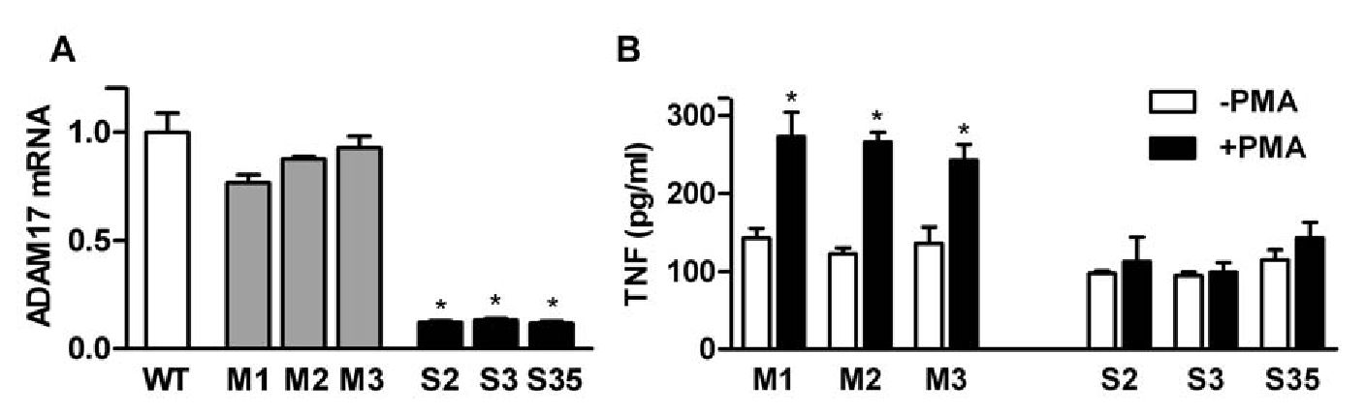
ADAM17 in Tumor Development
Figure 1. Analysis of ADAM17-silencing in MC38CEA cells. (A) Quantitative RT-PCR analysis of ADAM17 mRNA levels in the wild-type
MC38CEA (WT) and in the MC38CEA cell lines stably transfected with control shRNA (M1, M2, M3), or with ADAM17 shRNAs (S2, S3, S35). * - P<0.01
vs. WT and each M cell line. (B) The levels of TNF released to the medium from mock-transfected or ADAM17-silenced MC38CEA cell lines incubated in
the absence or presence of PMA, measured by ELISA. Bars represent average values ± SD from 3 independent experiments performed in duplicates.
* - P<0.01 vs. unstimulated cells.
doi:10.1371/journal.pone.0050791.g001
lines that continue growth upon serum deprivation [12,24,25], and
indicates that autocrine stimulation does not play a major role in
growth of MC38CEA cells in culture. Moreover, in both cases (0%
and 0.5% serum) the total mitochondrial activity, which is
indicative of the number of viable cells, was the same for all
mock-transfected and ADAM17-silenced cell lines after 1, 3, and 5
days in culture, although deleterious effects of the lack of serum
were evident in some mock-transfected as well as ADAM17-
silenced cultures on day 5 (Fig. 3). The results indicate that
ADAM17 does not influence proliferation of MC38CEA cells in
vitro, and suggest that ADAM17 does not promote tumor
development via activation of growth factors.

MC38CEA cells do not express EGFR or ErbB4
ADAM17-silencing was reported previously to decrease cell
proliferation. We did not observe this effect in MC38CEA cells
and so we tested which of the signaling components were missing.
The expression of different members of EGF family and EGF
receptor family was analyzed in MC38CEA cells at the mRNA
level. We found that the cells did not express TGFa for which
ADAM17 is the predominant sheddase (Fig. 4A). HB-EGF,
although visible at the mRNA level, was not detectable at the
protein level (data not shown). What is more, MC38CEA cells did
not express either EGFR or ErbB4, the receptors that may
respond to stimulation by TGFa, HB-EGF, and some other
factors of EGF family. Moreover, the proliferation of MC38CEA
was not stimulated by external EGF in contrast to control 4T1
cells (Fig. 4B). Thus we ruled out the possibility that ADAM17
promoted MC38CEA tumor growth through the activation of the
growth factors for which it was identified as the main sheddase.

MC38CEA cells express ErbB2, ErbB3, and their ligand
NRG-1
The family of EGF receptors also contains ErbB2 and ErbB3
which may form heterodimers and generate intracellular signal in
response to neuregulins (NRG) 1 and 2. NRG-1 has been shown to
be susceptible to proteolysis by various ADAMs including
ADAM17 [26,27,28,29]. Therefore, we analyzed the expression
of ErbB2, ErbB3, and NRG-1 in MC38CEA cells and found out
that the cells, as measured at the mRNA level, expressed both
ErbB2 and ErbB3 (Fig. 4C). Moreover, not only did the cells
release considerable quantities of NRG-1 to the culture medium,
but also the mock-transfected cells released more than twice as
much NRG-1 as ADAM17-silenced cells (Fig. 4D). In spite of this,
we did not observe any autocrine growth stimulation in
MC38CEA cultures nor any difference in the proliferation rate
between mock-transfected and ADAM17-silenced cells. Exoge-
nous rmNRG-ip did not affect growth of these cells either (data
not shown). Since the ErbB2/ErbB3 phosphorylation is prereq-
uisite for intracellular signaling, we analyzed the level of ErbB2
phosphorylation to determine whether in MC38CEA, NRG-1
may activate the receptor in an autocrine manner. Western
blotting analysis revealed that ADAM17-silencing resulted in a
decreased level of ErbB2 phosphorylation (Fig. 4E). Moreover,
ADAM17-silenced cells retained sensitivity to NRG-1, as exoge-
nous NRG-1 b caused phosphorylation of ErbB2 to the level
comparable with that observed for the mock-transfected cells
(Fig. 4E). However, even at a very high concentration of rmNRG-
1b (100 ng/ml), the level of ErbB2 phosphorylation in ADAM17-
silenced cells did not reach the level of its phosphorylation in
mock-transfected ones suggesting a diminished sensitivity of
ADAM17-silenced cells to NRG-1.

ADAM17-silencing decreases MC38CEA motility in vitro
To evaluate a potential impact of ADAM17 silencing on the cell
motile activity we analyzed the movement of individual cells of
WT, mock-transfected, and ADAM17-silenced lines recorded
during an 8-h period. The trajectories of the cells are shown as
circular diagrams in Fig. 5A. These analyses indicated that the
lengths of trajectories and consequently the mean velocities of
movement as well as lengths of cell displacement were comparable
between wild-type and mock-transfected cells and significantly
lower in ADAM17-silenced cells (Fig. 5A). Low CME values,
similar for all three cell types, indicate randomness of the cell
movement.
The importance of ADAM17 for MC38CEA cell motility was
further confirmed in a wound healing assay. ADAM17-silenced
cells migrated over a much shorter distance to cover a gap in the
cell monolayer than the wild-type and mock-transfected cells
(Fig. 5B, C).
Most reports which demonstrate ADAM17-mediated stimula-
tion of cell migration also indicate growth factor-dependent
mechanisms [12,16,30]. Hence the question arose whether the
observed difference in NRG-1 shedding may translate into a
difference in cell motility of MC38CEA cells. Addition of
exogenous rmNRG-1b to wounded monolayers resulted in the
stimulation of migration of both mock-transfected and ADAM17-
silenced cells (Fig. 5D, E). However, ADAM17-silenced cells
always migrated over a shorter distance than mock-transfected
cells, even at a high concentration of NRG-1 (100 ng/ml). This
effect of exogenous rmNRG-1 b on cell motility perfectly reflects its
effect on phosphorylation of ErbB2 in mock-transfected and
ADAM17-silenced MC38CEA cells and suggests that although
NRG-1 may add to the migratory potential of MC38CEA cells,
PLOS ONE | www.plosone.org
5
December 2012 | Volume 7 | Issue 12 | e50791
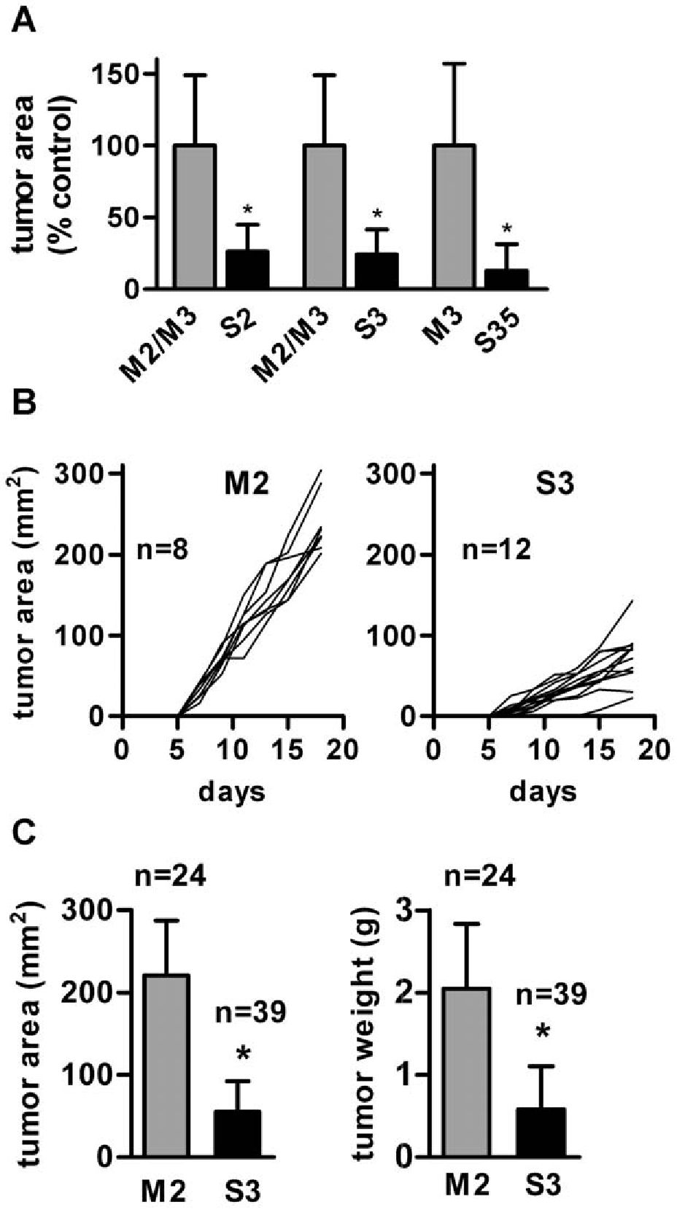
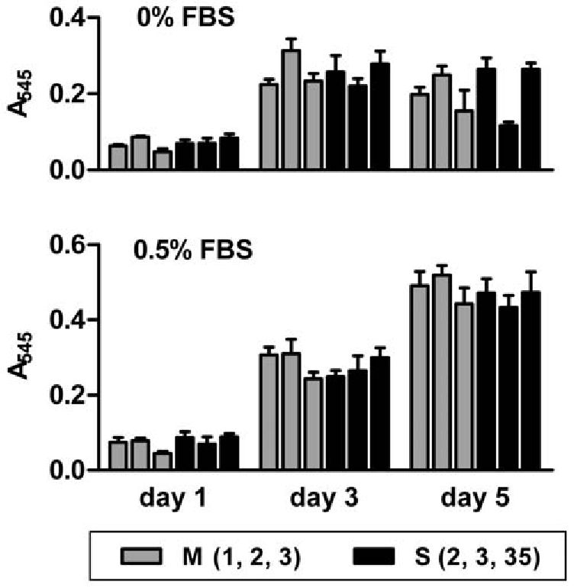
ADAM17 in Tumor Development
Figure 2. Effect of ADAM17-silencing on MC38CEA tumor
growth. (A) Comparison of the final areas of different mock-
transfected and ADAM17-silenced MC38CEA tumors. Data are from
one (for S35) or two experiments (for S2 and S3) and at least 5 mice per
data point. Control mice were injected with M2 (5 mice) or M3 (5 mice)
cells. As there were no statistically significant differences between the
areas of M2 and M3 tumors, the average areas of mock-transfected
tumors (of both M2 and M3 in experiments 1 and 2 and M3 in
experiment 3) were taken as 100%. (B) Individual tumor growth curves
from one representative experiment. Mice were injected with mock-
transfected (M2) or ADAM17-silenced MC38CEA (S3) cells and the tumor
areas were measured every 2-3 days. (C) Overall data from 5
independent experiments presenting the final areas and the final
volumes ± SD of mock-transfected (M2) or ADAM17-silenced MC38CEA
(S3) tumors. * - P<0.01 vs. mock-transfected tumors.
doi:10.1371/journal.pone.0050791.g002
inhibition of its shedding is not the only phenomenon responsible
for diminished motility of ADAM17-silenced cells.

Tumors of mock-transfected and ADAM17-silenced
MC38CEA differ in cytokine profiles
We hypothesized that the immune system that contributes to
tumor microenvironment is at least partially responsible for the
inhibition of the growth of ADAM17-silenced tumors. To
evaluate this hypothesis we have measured the concentration
of selected cytokines: TNF, IFNy, IL-12 (p70), MCP-1, IL-6,
Figure 3. Effect of ADAM17 silencing on proliferation and
viability of MC38CEA cells. The cells were grown in serum-free or
serum-low DMEM and their growth and viability were monitored daily
using the MTT assay. Bars represent average values ± SD from 3
independent experiments performed in sextuplicates.
doi:10.1371/journal.pone.0050791.g003
and IL-10 in the tumor lysates and in the sera taken from mice
at the time of their sacrifice. The levels of IL-10 and IL-12
(p70) in tumor lysates and in sera of all the mice were below or
at the detection limit in the majority of the experiments and, if
measurable, no significant difference appeared between
experimental groups (data not shown). Similarly, we did not
observe statistically valid differences in the concentrations of
IL-6 in the lysates from mock-transfected and ADAM17-
silenced tumors (data not shown). However, the concentrations
of three other cytokines: TNF, IFNy, and MCP-1 were
consistently and significantly higher in ADAM17-silenced
tumors than in mock-transfected ones (Fig. 6A). Augmented
levels of these cytokines resulted from their increased expres-
sion within tumors as they were accompanied by elevated
levels of their transcripts in tumor lysates. At the same time,
serum levels of TNF, IFNy, and MCP-1 were lower in mice
bearing ADAM17-silenced tumors than mock-transfected
ones, which is not surprising as serum levels of the cytokines
usually correlate with the tumor size (Fig. 6B). The cytokine
concentrations varied between experiments and their ranges
(for ADAM17-silenced tumors) are presented in Table 1.
MC38CEA cells express in vitro abundant quantities of MCP-1
(~1800 pg/ml/24 h/10 cells) but we did not observe any
significant differences in MCP-1 mRNA level and the level of
MCP-1 released to the culture media between mock-transfected
and ADAM17-silenced cells used in in vivo experiments, namely S3
and M2 (data not shown).
Moreover, MC38CEA cells express scarce amounts of TNF
(~4.5 pg/ml/24 h/105 cells), but they do not produce IFNy.
An increased level of TNF protein in ADAM17-silenced
tumors may partially result from a diminished activity of
ADAM17, which prevents TNF release from tumor cells.
However, increased levels of TNF mRNA in ADAM17-
silenced tumors, the presence of immune cells in the tumor
mass and a much lower expression of TNF in MC38CEA cells
than that in macrophages prompt us to believe that the
majority of TNF as well as all IFNy in tumors originate from
infiltrating immune cells.
PLOS ONE | www.plosone.org
6
December 2012 | Volume 7 | Issue 12 | e50791
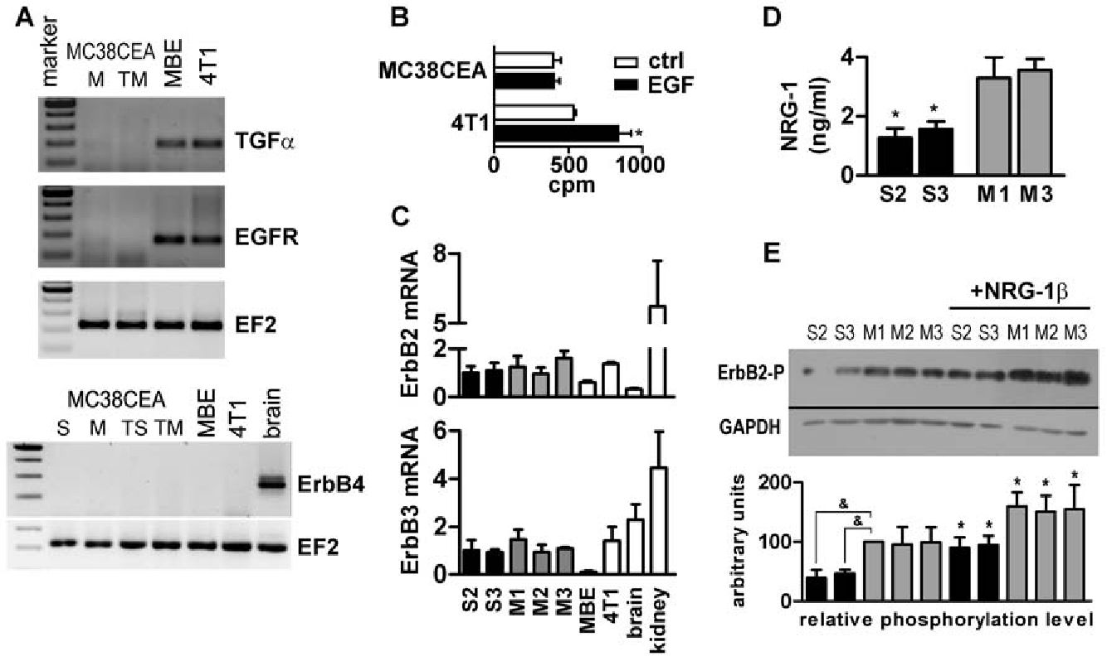
ADAM17 in Tumor Development
Figure 4. Expression of growth factors and growth factor receptors by MC38CEA colon carcinoma. (A) RT-PCR analysis of the expression
of TGFa, EGFR and ErbB4 in MC38CEA cells in culture, in MC38CEA tumors and in positive controls: murine brain endothelial cells (MBE) and murine
breast cancer cell line (4T1) and murine brain. cDNAfrom: M - mock-transfected cells, TM - mock-transfected tumors, S - ADAM17-silenced cells, TS -
ADAM17-silenced tumors. Amplification of cDNA coding for elongation factor 2 (EF2) was performed as a control of samples' quality. (B) Analysis of
the effect of exogenous EGF on 3H-thymidine incorporation into MC38CEA or 4T1 cells (positive control). * - P<0.01 vs. control. (C) Quantitative RT-
PCR analysis of ErbB2 and ErbB3 expression in ADAM17-silenced (S2, S3) and mock-transfected (M1, M2, M3) cell lines and in control cell lines, MBE
and 4T1 as well as in murine tissues. (D) The levels of NRG-1 released to the medium from ADAM17-silenced (S2, S3) and mock-transfected (M1, M3)
cells measured by ELISA. * - P<0.01 vs. M1 and M3. (E) Western blotting analysis of ErbB2 phosphorylation in ADAM17-silenced (S2, S3), mock-
transfected (M1, M2, M3) and wild-type (wt) MC38CEA cells incubated in the serum-free medium alone or in the medium enriched in exogenous
rmNRG-1p. GAPDH was used as a loading control. Quantification of Western blot signals is described in Materials and Methods and is based on at
least 3 independent experiments for a given cell line. * - P<0.01 vs. the same cell line incubated w/o rmNRG-1b; & - P<0.001 vs. M1. All data in panels
A, B, C and D come from at least 3 independent experiments performed in duplicates.
doi:10.1371/journal.pone.0050791.g004

TNF and IFNy synergistically affect viability of MC38CEA
cells
We went on to analyze the influence of TNF and IFNy on the
viability of mock-transfected and ADAM17-silenced MC38CEA
cells (Fig. 6C, D). Incubation of MC38CEA cells either with TNF
or IFNy resulted in a significantly diminished number of viable
MC38CEA cells and, what is more, the cytokines showed a strong
synergistic effect. Only around 10% of the cells treated simulta-
neously with high doses of both cytokines were still viable after
72 h, and both mock-transfected and ADAM17-silenced cells
showed similar sensitivity to TNF+IFNy mixture (Fig. 6C).
Experiments in which the cells were exposed to various
concentrations of TNF+IFNy confirmed that the sensitivity of
MC38CEA to these cytokines does not depend on ADAM17 level
(Fig. 6D). Strong activation of effector caspases 3 and 7 in both cell
types (Fig. 6E) indicates that TNF-induced apoptosis is an
important element of the TNF+IFNy-evoked MC38CEA cell
death. Higher concentration of TNF and IFNy in ADAM17-
silenced than in mock-transfected tumors together with dose-
dependent sensitivity of MC38CEA cells to these cytokines suggest
that the slower growth of ADAM17-silenced tumors may at least
partially result from their cytotoxic/cytostatic effects.

ADAM17 silencing affects pro-angiogenic potential of
MC38CEA cells
The main difference between mock-transfected and ADAM17-
silenced tumors, visible to the naked eye, was the density and
organization of blood vessels on the tumor surface and in the
dermis surrounding the tumors. Irregular, abnormally dilated, and
hemorrhagic vessels visible in mock-transfected but not in
ADAM17-silenced tumors indicate intense angiogenesis occurring
in tumors with intact ADAM17 expression (Fig. 7A). To verify this
finding at a microscopic level we stained tumor sections for CD31
and for lymphatic endothelium specific antigen-1 (LYVE-1) to
compare the density of blood vessels (CD31+, LYVE-1 ) in both
types of tumors (Fig. 7B). LYVE-1-positive cells were present in
peritumoral areas but not in tumors, therefore all CD31+
structures observed within tumor sections represented the blood
vessels. The areas covered by blood vessels in peripheral parts of
mock-transfected tumors were more than twice as big as the ones
in peripheral parts of ADAM17-silenced tumors.
The question arose whether ADAM17-silencing inhibits tumor
growth via inhibiting angiogenesis or, alternatively, whether slower
growth of tumors delays occurrence of hypoxia and initiation of
angiogenesis. The former hypothesis was supported by the
observation that MC38CEA cells expressed in vitro VEGF-A, the
major pro-angiogenic factor. After 48 h of culture of wild-type or
mock-transfected MC38CEA (1 x104/100 pl), the concentration
of VEGF-A in the culture medium reached 50 pg/ml. Moreover,
the expression of VEGF-A was significantly higher in mock-
transfected than in ADAM17-silenced cell lines, at both the
transcript and the protein levels (Fig. 7C). Both cell types produced
the same amount of another pro-angiogenic cytokine, namely KC
(mouse functional homolog of IL8; data not shown), but secreted
different amounts of matrix metalloprotease-9 (MMP-9) which is
able to degrade collagen IV of the basement membrane and
extracellular matrix and may therefore promote angiogenesis. As
evaluated by zymography, the activity of MMP-9 was significantly
higher in the media of mock-transfected than in the media of
ADAM17-silenced cells cultured at the same density (Fig. 7D).
Higher enzymatic activity of MMP-9 in mock-transfected cells
correlated with a higher level of MMP-9 mRNA in these cells as
evaluated by qRT-PCR (data not shown).
PLOS ONE | www.plosone.org
7
December 2012 | Volume 7 | Issue 12 | e50791
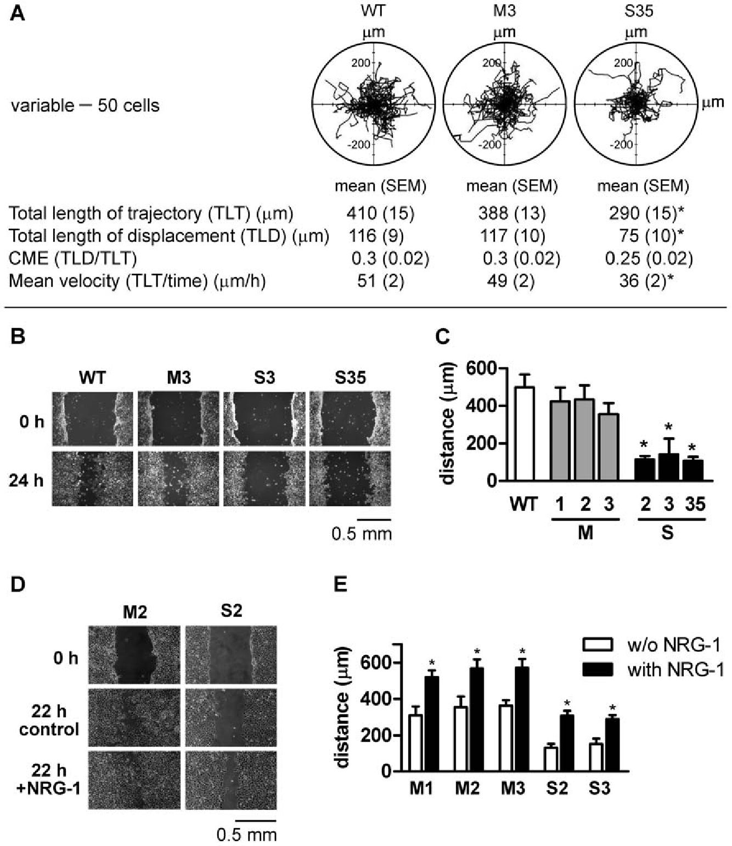
ADAM17 in Tumor Development
Figure 5. Effect of ADAM17 silencing on cell motility. (A) Exemplary trajectories of migrating wild type (WT), mock-transfected (M3) and
ADAM17-silenced (S35) MC38CEA cells displayed in circular diagrams drawn with the initial point of each trajectory placed at the origin of the plot.
Each panel shows the trajectories of 50 cells. The variables of cell movement are presented below diagrams. CME, coefficient of movement efficiency;
*P<0.05 (vs. wild type and mock-transfected cells). Data are from one representative experiment. Comparable results were obtained in the second
experiment with M3 and S35 as well as in two experiments, in which the movements of WT, M2, and S3 were analyzed. (B, C) Wound healing assay
(B) Representative wound images. Micrographs taken at 0 and 24 h after scratch wounding of cell monolayers. (C) Quantification of the results of two
independent experiments performed in duplicates for each cell line. The lengths of cell displacement are expressed as a difference between average
pre- and post-healing wound. * - P<0.01 vs. M3. (D) Influence of rmNRG-1 p on mock-transfected- and ADAM17-silenced MC38CEA cells -
representative wound images. Wounded monolayers were incubated for 22 h in serum-free medium in the absence (control) or in the presence of
rmNRG-1 p. (E) Quantification of the results from a single experiment representative of three performed. * - P<0.01 vs. the same cell line incubated w/
o rmNRG-1 p.
doi:10.1371/journal.pone.0050791.g005
During the analysis of tumor angiogenesis we performed
immunostaining using anti-LYVE-1 antibody in order to distin-
guish between blood vessels (LYVE-1-) and lymphatic vessels
(LYVE-1+). This led to an interesting observation. The peritu-
moral areas of both mock-transfected and ADAM17-silenced
MC38CEA tumors were infiltrated by CD45+CD11b+ cells that
co-expressed the lymphatic endothelial marker LYVE-1 (Fig. 7E).
Those cells did not penetrate tumor tissue. Although the numbers
of the CD45+CD11b+LYVE-1+ cells seemed to be similar in the
vicinity of both tumor types, their shape and arrangement were
strikingly different. In the peritumoral area of ADAM17-silenced
tumors the cells were round and evenly dispersed, while in the
peritumoral area of mock-transfected tumors
CD45+CD11b+LYVE-1+ cells were elongated and arranged in a
more regular pattern. Drawing on the data published by
Maruyama et al. who showed that macrophages can transdiffer-
entiate into lymphatic endothelial cells that integrate into existing
lymph vessels [31], we speculate that CD45+CD11b+LYVE-1+
observed in peritumoral area of MC38CEA tumors represent the
type of transdifferentiating macrophages that would contribute to
the formation of new lymphatic vessels. It seems that this process is
delayed in case of ADAM17-silenced tumors.

Discussion

ADAM17 promotes MC38CEA tumor development in the
absence of EGFR and ErbB4 signaling
ADAM17 is a predominant sheddase for a number of growth
factors of EGF family including TGFa, HB-EGF and amphir-
egulin [32,33]. In many tumors overexpression of these growth
factors and their receptors (ErbB/HER) is accompanied by a high
expression of ADAM17 [9,34]. The availability of growth factors
PLOS ONE | www.plosone.org
8
December 2012 | Volume 7 | Issue 12 | e50791
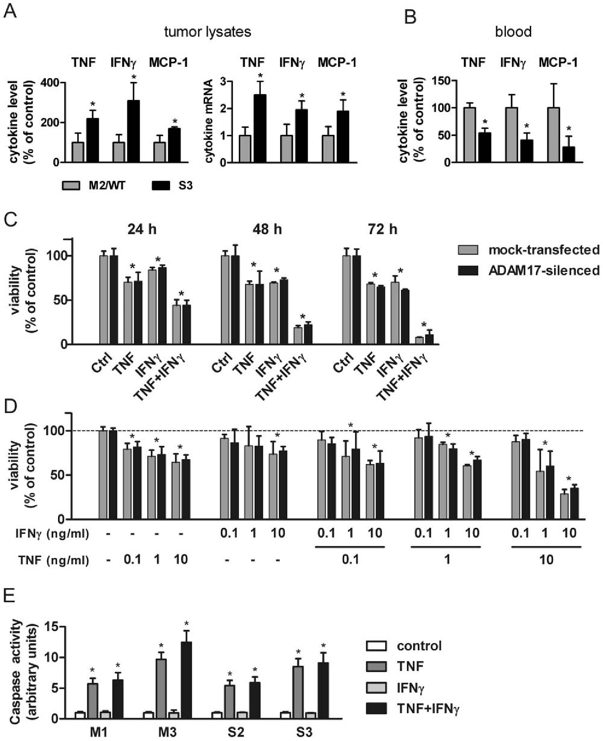
ADAM17 in Tumor Development
Figure 6. Analysis of the cytokine profiles in MC38CEA tumors and their cytotoxic effects on MC38CEA cells. (A) Relative protein and
transcript levels of TNF, IFNy and MCP-1 in lysates from wild type (WT), mock-transfected (M2) and ADAM17-silenced (S3) MC38CEA tumors measured
by cytometric bead array immunoassay (CBA) or qRT-PCR, respectively. Average levels of each cytokine or its mRNA in M2 and/or WT tumor lysates
were taken as 100% (CBA) or 1 (qRT-PCR). Control grups were as follows: M2 (three experiments, 5 mice per each experiment), WT (5 mice in one
experiment) and both M2 (4 mice) and WT (5 mice) in one experiment. (B) Relative levels of TNF, IFNy, and MCP-1 in sera from mice bearing WT,
mock-transfected (M2), and ADAM17-silenced (S3) MC38CEA tumors at the end of the experiments. (C, D) The influence of TNF and IFNy on
MC38CEA viability. (C) Mock-transfected and ADAM17-silenced MC38CEA cells were incubated in DMEM/2% FCS with TNF (10 ng/ml) or IFNy (50 ng/
ml) or with TNF+IFNy for 24,48 or 72 h and then cell viability was assayed using MTT test. (D) Mock-transfected and ADAM17-silenced MC38CEA cells
were incubated for 48 h in DMEM/2% FCS with TNF or IFNy or with TNF+IFNy at various concentrations and then cell viability was assayed using MTT
test. (E) The influence of TNF and IFNy on caspase activity in mock-transfected (M1 and M3) and ADAM17-silenced (S2 and S3) MC38CEA cells. Bars
represent average values ± SD—for (A) and (B) from 5 independent experiments with at least 5 mice per each experimental group, * - P<0.05 vs. M2
and WT controls; for (C) and (D) from 3 independent experiments performed in triplicates, * - P<0.05 vs. untreated controls; (E) from 4 independent
experiments performed in sextuplicates, * - P<0.01 vs. untreated controls.
doi:10.1371/journal.pone.0050791.g006
in their soluble form is usually required for efficient receptor
activation thus the shedding of growth factors is viewed as a major
event responsible for ADAM17 pro-tumorigenic effects. We show
that MC38CEA tumors derived from ADAM17-silenced cells
develop slower than tumors from control cells. Surprisingly, this
difference cannot be attributed to the impaired shedding ofligands
for EGFR or ErbB4, whose role in tumorigenesis is well
established, because MC38CEA cells appear to lack these
receptors.

Does ADAM17 contribute to MC38CEA tumor
development through NRG-1 shedding?
The fact that MC38CEA cells express NRG-1 and both
subunits of its heterodimeric receptor (ErbB2/ErbB3) compelled
PLOS ONE | www.plosone.org
9
December 2012 | Volume 7 | Issue 12 | e50791

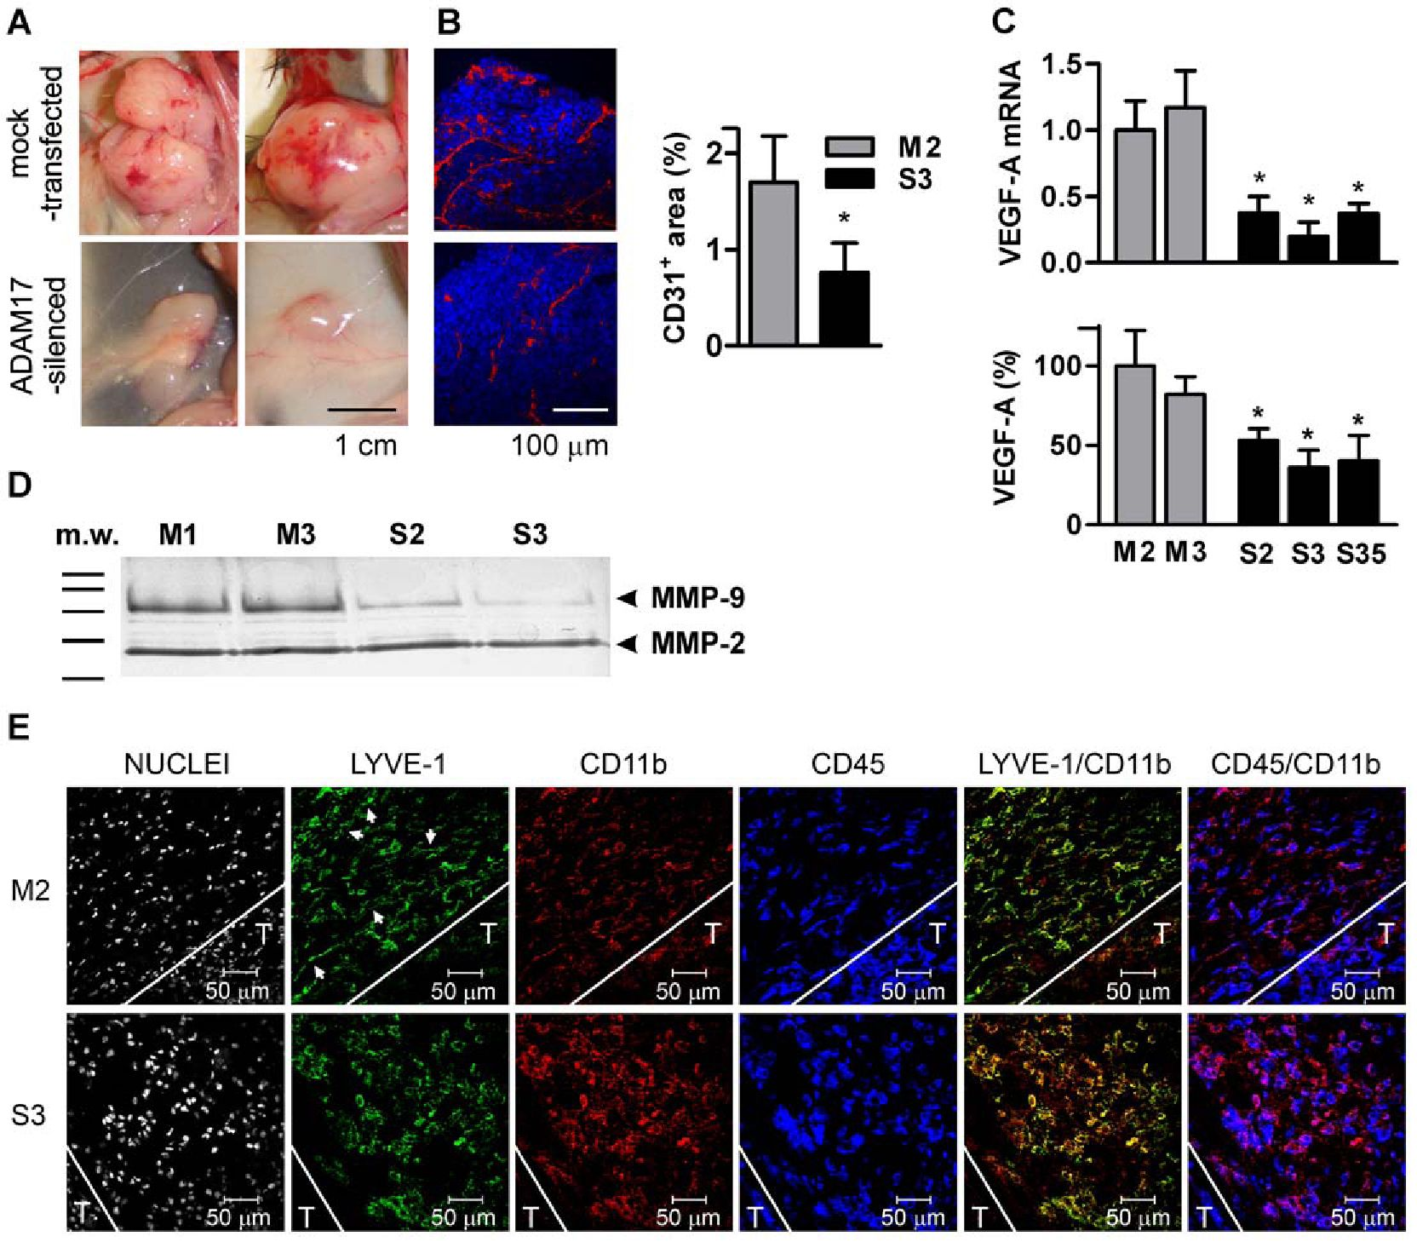
ADAM17 in Tumor Development
Table 1. Ranges of the cytokine concentration between
experiments.
Serum (pg/ml)* Tumor lysates (pg/mg protein)*
TNF 6.21-15.81
IFNc 1.01-1.74
MCP-1 60.5-120.09
5.73-34.03
7.67-17.34
769.97-3164.45
*The values represent the lowest average and the highest average cytokine
concentrations estimated in ADAM17-silenced tumor lysates and in sera from
mice bearing ADAM17-silenced tumor taken from three independent
experiment (at least 5 mice per group). Concentrations of cytokines in the sera
of control healthy mice (pg/ml): TNF - 5.0±1.4; IFNy - 1.560.5; MCP-1 -
20.664.6.
doi:10.1371/journal.pone.0050791.t001
us to consider the possibility that ADAM17-dependent pro-
tumorigenic phenotype of MC38CEA cells at least partially
depends on NRG-1 - ErbB2/ErbB3 axis. Despite the fact that
ErbB2 is ligandless and ErbB3 lacks kinase activity, the ErbB2/
ErbB3 heterodimer is considered the most potent signaling
receptor of the family in respect to cell proliferation and
transformation [35].
Many of NRG-1 isoforms are subjected to shedding. Some
studies point to ADAM17 as the major NRG-1 sheddase
[26,27,28,29] but other recognize ADAM9 [36], ADAM19 [37],
and BACE1 [38] as the key enzymes for NRG-1 shedding. Even
though MC38CEA express ADAM9 and ADAM19 as evaluated
by RT-PCR (data not shown), ADAM17 must be a dominant
NRG-1 sheddase in these cells as its ~80% silencing resulted in
Figure 7. The effect of ADAM17-silencing on tumor angiogenesis and lymphangiogenesis. (A) Representative images of mock-
transfected and ADAM17-silenced tumors on the 17th day after s.c. injection of tumor cells. (B) Representative micrographs of peripheral tumor
tissues and measurements of the areas covered by CD31-positive cells. Nuclei stained with DAPI (blue) and blood vessel endothelial cells stained with
anti-CD31 (red). Experiment was performed twice with 5 tumors of each type analyzed per experiment. Five random fields were analyzed for each
tumor section. * - P<0.01 vs M2. (C) Relative levels of VEGF-A mRNA analyzed by qRT-PCR and relative VEGF-A concentration in the culture media of
mock-transfected and ADAM17-silenced MC38CEA cell lines. The average level of VEGF-A mRNA in mock-transfected (M2) cells was taken as 1 and the
average concentration of VEGF-A in M2 culture medium was taken as 100%. Bars represent average values ± SD from 4 independent experiments
performed in duplicates. * - P<0.01 vs M2 and M3. (D) Zymographic analysis of gelatinase activity in the culture media of mock-transfected (M1 and
M3) and ADAM17-silenced (S2 and S3) MC38CEA cell lines. The result (shown as a photographic negative) is representative of 4 performed analyses.
(E) Immunochemical analysis of lymphangiogenesis in peritumoral areas of mock-transfected and ADAM17-silenced MC38CEA tumors on the 17th
day after s.c. injection of tumor cells. The representative sections were stained with DAPI to visualize nuclei and immunostained with anti-LYVE-1,
anti-CD45, and anti-CD11b antibodies. Single images and overlays of LYVE-1/CD11b and CD45/CD11b are presented. White lines indicate arbitrarily
recognized borders between tumors (denoted as T) and peritumoral areas. Arrows indicate exemplary elongated mock-transfected LYVE-1 + cells
arranged in a regular pattern.
doi:10.1371/journal.pone.0050791.g007
PLOS ONE | www.plosone.org
10
December 2012 | Volume 7 | Issue 12 | e50791
ADAM17 in Tumor Development
~60% inhibition of NRG-1 release and decreased phosphoryla-
tion of ErbB2.
It remains unclear why NRG-1 (endogenous as well as
exogenous one) did not stimulate proliferation of MC38CEA
cells. The consequences of NRG-1 binding to ErbB2/ErbB3
heterodimer may vary depending on the cell type, the set and the
ratio of the EGF receptor family members expressed on the cell
surface, the expression pattern of intracellular signaling molecules,
and probably a number of extracellular factors. It must be
emphasized that NRG-1 isoforms, apart from their ability to
switch on cell proliferation under certain conditions, are crucial for
directing differentiation during organogenesis.
The situation in which the pro-tumorigenic potential of
ADAM17-expressing cells is not correlated with increased cell
proliferation, is not limited to MC38CEA colon carcinoma. We
observed that silencing of ADAM17 had no effect on the
proliferation rate of B16F10 melanoma cells but strongly inhibited
tumor growth after s.c. injection of the cells into syngeneic mice
(data not shown). Similarly, silencing of ADAM17 expression
decreased the invasiveness of pancreatic ductal adenocarcinoma
cells as tested in vitro in matrigel-coated transwell system but did
not influence their proliferation [8].

ADAM17 influences MC38CEA motility
A high migratory potential of cancer cells contributes to tumor
formation and progression. Silencing of ADAM17 significantly
impaired MC38CEA cell motility. Because exogenous rmNRG-1b
stimulated migration of ADAM17-silenced cells, it is possible that
NRG-1 shedding is to some degree responsible for MC38CEA
migratory potential. However, the inability of exogenous NRG-1
to fully restore motile activity of ADAM17-silenced MC38CEA
indicates that other ADAM17-dependent events may add to the
migratory potential of MC38CEA cells.
We cannot reject the hypothesis that other ADAM17-depen-
dent events may add to the migratory potential of MC38CEA
cells. Cell adhesion molecules such as CD44 or L1-CAM may be
involved in the migration of tumor cells and the cleavage events
are required for L1- or CD44-dependent cell migration [39,40].
Although ADAM17 is able to cleave L1 and CD44, it seems that
ADAM10 and not ADAM17 is a major sheddase for these
molecules and is responsible for their constitutive shedding also
from tumor cells [40,41]. ADAM10 is expressed in MC38CEA
cells, which suggests that ADAM17-mediated shedding of CD44
or L1 does not contribute considerably to observed differences in
cell motility. In support, we did not observe any differences in the
surface expression of CD44 between the mock-transfected and
ADAM17-silenced MC38CEA cells as evaluated by flow cytom-
etry (data not shown).
ADAM17 is also a sheddase for EpCAM, homophilic cell
adhesion molecule, often highly expressed on carcinoma cells [42].
It has been shown that the loss of EpCAM weakens cell-cell
interactions contributing to increased migratory potential of the
cells [43]. We disregarded EpCAM as a molecule decisive for the
differences in MC38CEA motility observed upon ADAM17-
silencing because the analysis of recorded cell movements
indicated that impaired migration was characteristic even for
single cells with diminished ADAM17 activity.
To sum up, at this stage of research we are unable to indicate
any ADAM17-dependent events, other than shedding of NRG-1,
that may affect migratory potential of MC38CEA cells.

ADAM17 affects MC38CEA angiogenesis
We have observed enhanced angiogenesis in the mock-
transfected but not in ADAM17-silenced MC38CEA. This could
result directly from the significantly diminished synthesis of
VEGF-A as well as MMP-9 in ADAM17-silenced cells. Both
VEGF-A and MMP-9 are listed among the genes whose expression
may be stimulated by NRG-1 [44,45,46]. ADAM17 has also been
shown to stimulate VEGF-A expression via the shedding of other
growth factors from the EGF family [47,48]. However, stimulation
of VEGF-A expression may occur through activation of such
transcription factors as AP1, NF-kB and SP1/SP3 without the
involvement of growth factors’ signaling [49,50]. It is thus possible
that ADAM17 substrate(s), other than NRG-1, might affect the
level of VEGF-A in MC38CEA cells. However, indicating a
suitable candidate among the known ADAM17 substrates remains
a challenge.

ADAM17 influences cytokine profile within MC38CEA
tumor
We demonstrated that the silencing of ADAM17 in MC38CEA
cells resulted in augmented accumulation of TNF, MCP-1, and
IFNy in developing tumors. Both anti-tumor as well as tumor
promoting effects have been attributed to all three cytokines
[51,52,53]. The outcome of their action may depend both on the
tumor type and the state of its development, as well as on the
environmental conditions, including the presence of particular
cytokines, chemokines, and growth factors in the tumor milieu.
Our in vitro experiments indicated a strong cytotoxic effect of the
combination of TNF and IFNy towards MC38CEA, which is in
agreement with numerous reports showing that simultaneous
action of both cytokines may lead to a strong antitumor effect
[54,55,56].
Both TNF receptors, TNFRI and TNFRII, are ADAM17
substrates, hence one could expect that diminished activity of
ADAM17 would lead to their increased surface expression, which
in turn would potentiate cell sensitivity towards the ligand—TNF.
Surprisingly, we observed no difference in the TNF sensitivity of
mock-transfected and ADAM17-silenced cells. However, as
concentrations of both TNF and IFNy were higher in AD-
AM17-silenced than in mock-transfected tumors we conclude that
the growth inhibition of ADAM17-silenced tumors may at least
partially result from their cytotoxic/cytostatic effects. Apart from
the direct cytotoxic activity of TNF and IFNy against MC38CEA
cells, the cytokines may influence in vivo tumor growth also through
modulating immune response.

How does ADAM17 influence anti-tumor immune
response?
All IFNy and the majority of TNF in MC38CEA tumors are
produced by infiltrating immune cells, thus the differences in their
concentrations between mock-transfected and ADAM17-silenced
tumors must reflect differences in the subpopulations of immune
cells or their activity. It remains unclear which of ADAM17
substrates expressed by MC38CEA cancer cells could trigger
changes in immune response. Tumor associated antigens (TAA)
could fulfill this role as ADAM17-mediated shedding of TAA
might result in weaker recognition of tumor cells by the immune
system. However, so far only one such antigen, namely MUC1,
has been shown to be susceptible to ADAM17-mediated shedding
[57] and CEA, the model TAA expressed by MC38CEA, has not
been released more efficiently from mock-transfected than from
ADAM17- silenced cells (data not shown).
The potential importance of other immune system-related
ADAM17 substrates as IL-6R or MIC-A/B, the ligands of
NKG2D receptors, in murine tumor development is questionable
because of species specificity. ADAM17 is a major sheddase for
PLOS ONE | www.plosone.org
11
December 2012 | Volume 7 | Issue 12 | e50791
ADAM17 in Tumor Development
human- but not for mouse IL-6R [58] and MIC-A/B are not
expressed in mice at all. The identification of the ADAM17
substrate present in MC38CEA that may influence anti-tumor
immune response will be a priority for the future research.

Conclusions
Throughout the last decade ADAM17 has been recognized as a
new, promising target for cancer therapy. A number of ADAM17
selective inhibitors in form of either small molecule compounds
[59] or the specific anti-ADAM17 antibody fragments [60] are
presently being developed. Such therapeutic approaches are
directed against tumors which drive their proliferation in an
autocrine manner via EGF family members. Our results indicate
that ADAM17-directed therapies could be applicable towards a
much wider panoply of cancers.

Supporting Information
Text S1 Generation of mouse recombinant His-NRG-
1P1.
(DOCX)
Figure S1 Analysis of activity of generated rmHis-NRG-
1 b1. (A) Analysis of ErbB2 phosphorylation. MCF7 cells were
incubated for 3 h in FCS-free DMEM and then were left

References
- Edwards DR, Handsley MM, Pennington CJ (2008) The ADAM metallopro-
teinases. Mol Aspects Med 29: 258-289.
- Black RA, Rauch CT, Kozlosky CJ, Peschon JJ, Slack JL, et al. (1997) A
metalloproteinase disintegrin that releases tumour-necrosis factor-alpha from
cells. Nature 385: 729-733.
- Moss ML, Jin SL, Milla ME, Bickett DM, Burkhart W, et al. (1997) Cloning of a
disintegrin metalloproteinase that processes precursor tumour-necrosis factor-
alpha. Nature 385: 733-736.
- Arribas J, Esselens C (2009) ADAM17 as a therapeutic target in multiple
diseases. Curr Pharm Des 15: 2319-2335.
- SchellerJ, Chalaris A, Garbers C, Rose-John S (2011) ADAM17: a molecular
switch to control inflammation and tissue regeneration. Trends Immunol 32:
380-387.
- Murphy G (2008) The ADAMs: signalling scissors in the tumour microenvi-
ronment. Nat Rev Cancer 8: 929-941.
- Kornfeld JW, Meder S, Wohlberg M, Friedrich RE, Rau T, et al. (2011)
Overexpression of TACE and TIMP3 mRNA in head and neck cancer:
association with tumour development and progression. Br J Cancer 104: 138-
145.
- Ringel J, Jesnowski R, Moniaux N, Luttges J, Ringel J, et al. (2006) Aberrant
expression of a disintegrin and metalloproteinase 17/tumor necrosis factor-alpha
converting enzyme increases the malignant potential in human pancreatic ductal
adenocarcinoma. Cancer Res 66: 9045-9053.
- Tanaka Y, Miyamoto S, Suzuki SO, Oki E, Yagi H, et al. (2005) Clinical
significance of heparin-binding epidermal growth factor-like growth factor and a
disintegrin and metalloprotease 17 expression in human ovarian cancer. Clin
Cancer Res 11: 4783-4792.
- McGowan PM, Ryan BM, Hill AD, McDermott E, O’Higgins N, et al. (2007)
ADAM-17 expression in breast cancer correlates with variables of tumor
progression. Clin Cancer Res 13: 2335-2343.
- Kenny PA, Bissell MJ (2007) Targeting TACE-dependent EGFR ligand
shedding in breast cancer. J Clin Invest 117: 337-345.
- Franovic A, Robert I, Smith K, Kurban G, Pause A, et al. (2006) Multiple
acquired renal carcinoma tumor capabilities abolished upon silencing of
ADAM17. Cancer Res 66: 8083-8090.
- Blobel CP (2005) ADAMs: key components in EGFR signalling and
development. Nat Rev Mol Cell Biol 6: 32-43.
- Borrell-Pages M, Rojo F, Albanell J, Baselga J, Arribas J (2003) TACE is
required for the activation of the EGFR by TGF-alpha in tumors. Embo J 22:
1114-1124.
- Braun AH, Coffey RJ (2005) Lysophosphatidic acid, a disintegrin and
metalloprotease-17 and heparin-binding epidermal growth factor-like growth
factor in ovarian cancer: the first word, not the last. Clin Cancer Res 11: 4639-
4643.
- Gschwind A, Hart S, Fischer OM, Ullrich A (2003) TACE cleavage of
proamphiregulin regulates GPCR-induced proliferation and motility of cancer
cells. EmboJ 22: 2411-2421.
- Hart S, Fischer OM, Ullrich A (2004) Cannabinoids induce cancer cell
proliferation via tumor necrosis factor alpha-converting enzyme (TACE/
untreated or were stimulated for 10 min with rmHis-NRG1b1
(100 ng/ml). Protein from cell lysates (10 mg) were subjected to
Western blotting and probed with anti-ErbB2-P. Data are
representative of two independent experiments. (B) MCF-7 cells
were plated in 96-well plate (5000 cells/well). Next day the
medium was changed for DMEM without FCS and to some wells
rmHis-NRG-1 b 1 was added at different concentrations. After 4
days MTT assay was performed. Data are presented as relative
A545 absorbance measurements with the value obtained for
control cells taken as 1. Data are from a single experiment in
sextuplicates representative of two performed.
(TIF)

Acknowledgments
We thank Drs. Grzegorz Bereta and Dominik Czaplicki for critically
reading the manuscript.

Author Contributions
Conceived and designed the experiments: JB MC MB RM-K SD KS JS
ZM. Performed the experiments: SD MC MB RM-K KS BW DD JO PS
JJ. Analyzed the data: JB SD MC RM-K MB KS JS ZM MAS.
Contributed reagents/materials/analysis tools: JB MAS RM-K ZM. Wrote
the paper: JB.
ADAM17)-mediated transactivation of the epidermal growth factor receptor.
Cancer Res 64: 1943-1950.
- Corbett TH, Griswold DP Jr, Roberts BJ, Peckham JC, Schabel FM Jr (1975)
Tumor induction relationships in development of transplantable cancers of the
colon in mice for chemotherapy assays, with a note on carcinogen structure.
Cancer Res 35: 2434-2439.
- Bereta M, Hayhurst A, Gajda M, Chorobik P, Targosz M, et al. (2007)
Improving tumor targeting and therapeutic potential of Salmonella VNP20009
by displaying cell surface CEA-specific antibodies. Vaccine 25: 4183-4192.
- Celis J, editor (1998) Cell Biology: A Laboratory Handbook. London: Academic
Press. 16-18 p.
- Coligan J, Dunn B, Ploegh H, Speicher D, Wingfield P, editors (1997) Current
Protocols in Protein Science,. New York: John Wiley & Sons. 6.6.5-6.6.10 p.
- Sroka J, Antosik A, Czyz J, Nalvarte I, Olsson JM, et al. (2007) Overexpression
of thioredoxin reductase 1 inhibits migration of HEK-293 cells. Biol Cell 99:
677-687.
- Hofman F (2002) Immunochemistry. In: Coligan J, editor. Current Protocols in
Immunology. New Jersey: Wiley and Sons.
- Hofer DR, Sherwood ER, Bromberg WD, Mendelsohn J, Lee C, et al. (1991)
Autonomous growth of androgen-independent human prostatic carcinoma cells:
role of transforming growth factor alpha. Cancer Res 51: 2780-2785.
- Wu JC, Merlino G, Cveklova K, Mosinger B Jr, Fausto N (1994) Autonomous
growth in serum-free medium and production of hepatocellular carcinomas by
differentiated hepatocyte lines that overexpress transforming growth factor alpha
1. Cancer Res 54: 5964-5973.
- Finigan JH, Faress JA, Wilkinson E, Mishra RS, Nethery DE, et al. (2011)
Neuregulin-1-human epidermal receptor-2 signaling is a central regulator of
pulmonary epithelial permeability and acute lung injury. J Biol Chem 286:
10660-10670.
- Horiuchi K, Zhou HM, Kelly K, Manova K, Blobel CP (2005) Evaluation of the
contributions of ADAMs 9, 12, 15, 17, and 19 to heart development and
ectodomain shedding of neuregulins beta1 and beta2. Dev Biol 283: 459M71.
- Montero JC, Yuste L, Diaz-Rodriguez E, Esparis-Ogando A, Pandiella A (2000)
Differential shedding of transmembrane neuregulin isoforms by the tumor
necrosis factor-alpha-converting enzyme. Mol Cell Neurosci 16: 631-648.
- Zhou BB, Peyton M, He B, Liu C, Girard L, et al. (2006) Targeting ADAM-
mediated ligand cleavage to inhibit HER3 and EGFR pathways in non-small
cell lung cancer. Cancer Cell 10: 39-50.
- Maretzky T, Evers A, Zhou W, Swendeman SL, Wong PM, et al. (2011)
Migration of growth factor-stimulated epithelial and endothelial cells depends on
EGFR transactivation by ADAM17. Nat Commun 2: 229.
- Maruyama K, Ii M, Cursiefen C, Jackson DG, Keino H, et al. (2005)
Inflammation-induced lymphangiogenesis in the cornea arises from CD11b-
positive macrophages. J Clin Invest 115: 2363-2372.
- Sahin U, Blobel CP (2007) Ectodomain shedding of the EGF-receptor ligand
epigen is mediated by ADAM17. FEBS Lett 581: 41M4.
- Sahin U, Weskamp G, Kelly K, Zhou HM, Higashiyama S, et al. (2004) Distinct
roles for ADAM10 and ADAM17 in ectodomain shedding of six EGFR ligands.
J Cell Biol 164: 769-779.
PLOS ONE | www.plosone.org
12
December 2012 | Volume 7 | Issue 12 | e50791
ADAM17 in Tumor Development
- Blanchot-Jossic F, Jarry A, Masson D, Bach-Ngohou K, Paineau J, et al. (2005)
Up-regulated expression of ADAM17 in human colon carcinoma: co-expression
with EGFR in neoplastic and endothelial cells. J Pathol 207: 156-163.
- Citri A, Skaria KB, Yarden Y (2003) The deaf and the dumb: the biology of
ErbB-2 and ErbB-3. Exp Cell Res 284: 54-65.
- Dang M, Dubbin K, D’Aiello A, Hartmann M, Lodish H, et al. (2011)
Epidermal growth factor (EGF) ligand release by substrate-specific a disintegrin
and metalloproteases (ADAMs) involves different protein kinase C (PKC)
isoenzymes depending on the stimulus. J Biol Chem 286: 17704—17713.
- Yokozeki T, Wakatsuki S, Hatsuzawa K, Black RA, Wada I, et al. (2007) Meltrin
beta (ADAM 19) mediates ectodomain shedding of Neuregulin beta1 in the Golgi
apparatus: fluorescence correlation spectroscopic observation of the dynamics of
ectodomain shedding in living cells. Genes Cells 12: 329-343.
- Luo X, Prior M, He W, Hu X, Tang X, et al. (2011) Cleavage of neuregulin-1
by BACE1 or ADAM10 protein produces differential effects on myelination.
J Biol Chem 286: 23967-23974.
- Maretzky T, Schulte M, Ludwig A, Rose-John S, Blobel C, et al. (2005) L1 is
sequentially processed by two differently activated metalloproteases and
presenilin/gamma-secretase and regulates neural cell adhesion, cell migration,
and neurite outgrowth. Mol Cell Biol 25: 9040-9053.
- Stamenkovic I, Yu Q(2009) Shedding light on proteolytic cleavage of CD44: the
responsible sheddase and functional significance of shedding. J Invest Dermatol
129: 1321-1324.
- Riedle S, Kiefel H, Gast D, Bondong S, Wolterink S, et al. (2009) Nuclear
translocation and signalling of L1-CAM in human carcinoma cells requires
ADAM10 and presenilin/gamma-secretase activity. Biochem J 420: 391-402.
- Maetzel D, Denzel S, Mack B, Canis M, Went P, et al. (2009) Nuclear signalling
by tumour-associated antigen EpCAM. Nat Cell Biol 11: 162-171.
- van der Gun BT, Melchers LJ, Ruiters MH, de Leij LF, McLaughlin PM, et al.
(2010) EpCAM in carcinogenesis: the good, the bad or the ugly. Carcinogenesis
31: 1913-1921.
- Breuleux M (2007) Role of heregulin in human cancer. Cell Mol Life Sci 64:
2358-2377.
- Bagheri-Yarmand R, Vadlamudi RK, Wang RA, Mendelsohn J, Kumar R
(2000) Vascular endothelial growth factor up-regulation via p21-activated
kinase-1 signaling regulates heregulin-beta1-mediated angiogenesis. J Biol Chem
275: 39451-39457.
- Yonezawa M, Wada K, Tatsuguchi A, Akamatsu T, Gudis K, et al. (2009)
Heregulin-induced VEGF expression via the ErbB3 signaling pathway in colon
cancer. Digestion 80: 215-225.
- Zheng X, Jiang F, Katakowski M, Lu Y, Chopp M (2012) ADAM17 promotes
glioma cell malignant phenotype. Mol Carcinog 51: 150-164.
- Katakowski M, Jiang F, Zheng X, Gutierrez JA, Szalad A, et al. (2009)
Tumorigenicity of cortical astrocyte cell line induced by the protease ADAM17.
Cancer Sci 100: 1597-1604.
- Gonzalez-Perez RR, Xu Y, Guo S, Watters A, Zhou W, et al. (2010) Leptin
upregulates VEGF in breast cancer via canonic and non-canonical signalling
pathways and NFkappaB/HIF-1alpha activation. Cell Signal 22: 1350-1362.
- Eisenach PA, Roghi C, Fogarasi M, Murphy G, English WR (2010) MT1-MMP
regulates VEGF-A expression through a complex with VEGFR-2 and Src. J Cell
Sci 123: 4182-4193.
- Mocellin S, Rossi CR, Pilati P, Nitti D (2005) Tumor necrosis factor, cancer and
anticancer therapy. Cytokine Growth Factor Rev 16: 35-53.
- Yadav A, Saini V, Arora S (2010) MCP-1: chemoattractant with a role beyond
immunity: a review. Clin Chim Acta 411: 1570-1579.
- Zaidi MR, Merlino G (2011) The two faces of interferon-gamma in cancer. Clin
Cancer Res 17: 6118-6124.
- Guan YQ, Li Z, Liu JM (2010) Death signal transduction induced by co-
immobilized TNF-alpha plus IFN-gamma and the development of polymeric
anti-cancer drugs. Biomaterials 31: 9074-9085.
- Townsend PA, Scarabelli TM, Davidson SM, Knight RA, Latchman DS, et al.
(2004) STAT-1 interacts with p53 to enhance DNA damage-induced apoptosis.
J Biol Chem 279: 5811-5820.
- Nava P, Koch S, Laukoetter MG, Lee WY, Kolegraff K, et al. (2010) Interferon-
gamma regulates intestinal epithelial homeostasis through converging beta-
catenin signaling pathways. Immunity 32: 392-402.
- Thathiah A, Blobel CP, Carson DD (2003) Tumor necrosis factor-alpha
converting enzyme/ADAM 17 mediates MUC1 shedding. J Biol Chem 278:
3386-3394.
- Garbers C, Janner N, Chalaris A, Moss ML, Floss DM, et al. (2011) Species
specificity of ADAM10 and ADAM17 proteins in interleukin-6 (IL-6) trans-
signaling and novel role of ADAM10 in inducible IL-6 receptor shedding. J Biol
Chem 286: 14804-14811.
- Duffy MJ, Mullooly M, O’Donovan N, Sukor S, Crown J, et al. (2011) The
ADAMs family of proteases: new biomarkers and therapeutic targets for cancer?
Clin Proteomics 8: 9.
- Tape CJ, Willems SH, Dombernowsky SL, Stanley PL, Fogarasi M, et al. (2011)
Cross-domain inhibition of TACE ectodomain. Proc Natl Acad Sci USA 108:
5578-5583.
PLOS ONE | www.plosone.org
13
December 2012 | Volume 7 | Issue 12 | e50791

