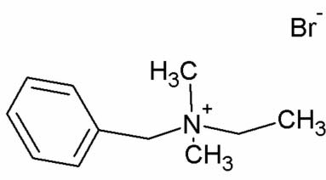

organic compounds
Acta Crystallographica Section E
Structure Reports Online
ISSN 1600-5368
Refinement
R[F ² > 2o-(F ²)] = 0.027
wR(F ²) = 0.065
S = 1.07
3874 reflections
119 parameters
H-atom parameters constrained
�p_{max} = 0.26 e A˚ -3
�p_{min} = -0.49 e A˚ -3
Absolute structure: Flack (1983), with 1627 Friedel pairs
Flack parameter: 0.002 (9)
Benzylethyldimethylammonium bromide
Table 1
Hydrogen-bond geometry (A˚ , º).
Cg1 is the centroid of the benzene ring.

D—H·· ·A D—H H·· ·A D·· ·A D—H·· ·A
Maciej Hodorowicz* and Katarzyna Stadnicka
Faculty of Chemistry, Jagiellonian University, Ingardena 3, 30-060 Krako´w, Poland Correspondence e-mail: hodorowm@chemia.uj.edu.pl
Received 4 January 2008; accepted 23 January 2008
C4—H4A·· ·Br1
0.97
0.96
0.97
0.97
0.97
0.96
0.96
2.81
2.96
2.96
3.08
3.19
2.99
2.69
3.757 (2)
3.850 (3)
3.832 (2)
3.950 (2)
3.959 (2)
3.766 (2)
3.526
164
154
151
151
138
139
145
i
C2—H2A·· ·Br1
Key indicators: single-crystal X-ray study; T = 293 K; mean o-(C–C) = 0.003 A˚;
R factor = 0.027; wR factor = 0.065; data-to-parameter ratio = 32.6.
i
C4—H4B·· ·Br1
i
C3—H3B·· ·Br1
ii
C3—H3A·· ·Br1
iii
C1—H1C·· ·Br1
ii
C2—H2C·· ·Cg1
The crystal structure of the title compound, C H N⁺·Br⁻, has
11 18
Symmetry codes: (i) -x þ 1; y - ; -z þ ; (ii) x þ 1; y; z; (iii) x þ ; -y þ ; -z þ 2.
1
3
1
5
2
2
2
2
been determined as part of an ongoing study of the influence
of the alkyl chain length on amphiphilic activity of quaternary ammonium salts. The title salt forms a three-dimensional
Data collection: COLLECT (Nonius, 2000); cell refinement: SCALEPACK (Otwinowski & Minor, 1997); data reduction: DENZO (Otwinowski & Minor, 1997) and SCALEPACK; program(s) used to solve structure: SIR92 (Altomare et al., 1994); program(s) used to refine structure: SHELXL97 (Sheldrick, 2008); molecular graphics: ORTEP-3 for Windows (Farrugia, 1997) and DIAMOND (Brandenburg, 2006); software used to prepare material for publication: SHELXL97.
network of ionic contacts through weak C—H·· ·Br hydrogen
bonds, with donor–acceptor distances in the range 3.757 (2)– 3.959 (2) A˚ , in which methyl groups serve as donors.
Related literature
For related literature, see: Ogawa & Kuroda (1997); Hodor- owicz et al. (2003, 2005); Kwolek et al. (2003); Allen et al. (1987).
The authors thank the Joint X-ray Laboratory, Faculty of
Chemistry, and SLAFiBS, Jagiellonian University, for making the Nonius KappaCCD diffractometer available.
Supplementary data and figures for this paper are available from the IUCr electronic archives (Reference: CF2179).
References
Allen, F. H., Kennard, O., Watson, D. G., Brammer, L., Orpen, A. G. & Taylor,
R. (1987). J. Chem. Soc. Perkin Trans. 2, pp. S1–19.
Altomare, A., Cascarano, G., Giacovazzo, C., Guagliardi, A., Burla, M. C., Polidori, G. & Camalli, M. (1994). J. Appl. Cryst. 27, 435–436.
Brandenburg, K. (2006). DIAMOND. Version 3.1d. Crystal Impact GbR,
Bonn, Germany.
Farrugia, L. J. (1997). J. Appl. Cryst. 30, 565. Flack, H. D. (1983). Acta Cryst. A39, 876–881.
Hodorowicz, M. A., Czapkiewicz, J. & Stadnicka, K. (2003). Acta Cryst. C59,
o547–o549.
Hodorowicz, M., Stadnicka, K. & Czapkiewicz, J. (2005). J. Colloid Interface Sci. 290, 76–82.
Kwolek, T., Hodorowicz, M., Stadnicka, K. & Czapkiewicz, J. (2003). J. Colloid Interface Sci. 264, 14–19.
Nonius (2000). COLLECT. Nonius BV, Delft, The Netherlands. Ogawa, M. & Kuroda, K. (1997). Bull. Chem. Soc. Jpn, 70, 2593–2618.
Otwinowski, Z. & Minor, W. (1997). Methods in Enzymology, Vol. 276, Macromolecular Crystallography, Part A, edited by C. W. Carter Jr & R. M. Sweet, pp. 307–326. New York: Academic Press.
Sheldrick, G. M. (2008). Acta Cryst. A64, 112–122.
Experimental
Crystal data
V = 1188.90 (3) A˚ 3
Z = 4
Mo Ka radiation
µ = 3.42 mm⁻¹
T = 293 (2) K
0.20 x 0.19 x 0.17 mm
C11H18N+·Br-
M_{r} = 244.17
Orthorhombic, P212121
a = 6.7765 (1) A˚ b = 12.5827 (2) A˚ c = 13.9433 (2) A˚
Data collection
Nonius KappaCCD diffractometer Absorption correction: multi-scan (DENZO and SCALEPACK
Otwinowski & Minor, 1997)
T_{min} = 0.548, T_{max} = 0.594
(expected range = 0.516–0.559)
18366 measured reflections
3874 independent reflections 3483 reflections with I > 2o-(I) R_{int} = 0.041
Hodorowicz and Stadnicka o601
Acta Cryst. (2008). E64, o601
doi:10.1107/S1600536808002481

supporting information
supporting information
Acta Cryst. (2008). E64, o601 [doi:10.1107/S1600536808002481]
Benzylethyldimethylammonium bromide
Maciej Hodorowicz and Katarzyna Stadnicka
S1. Comment
Quaternary alkylammonium salts are widely used to modify natural clay minerals into hydrophobic organo-clays which exhibit high capability to remove hydrophobic contaminants from aqueous solutions (Ogawa & Kuroda, 1997). From the systematic study of the relation between the crystal structures of chosen homologous benzyldimethylalkylammonium bromides and their cations′ ability for sorption on clay minerals (Kwolek et al., 2003; Hodorowicz et al., 2003, 2005), it became obvious that the hydrophobic interactions are responsible for an alkyl-chain bilayer formation when the long- chain (n = 8–12) ammonium cations are adsorbed on montmorillonite (Hodorowicz et al., 2005), whereas a different way of cation packing seems to dominate in the case of short-chain ammonium cations (Kwolek et al., 2003). The crystal structure analysis of benzyldimethylethylammonium bromide was performed to find out the influence of molecular geometry, and the length of the alkyl chain in particular, on the packing properties of the ammonium cations. The structure of the title compound is shown in Fig. 1. The asymmetric unit is composed of a quaternary ammonium cation and a bromide counterion (N+···Br- = 4.439 (2) Å). The bond lengths and angles indicate the typical tetrahedral arragement of the substituents at the N atom. The molecular dimensions are comparable with the values reported in the literature (Allen et al., 1987). Methyl and methylene groups of the quaternary ammonium cation as well as C—H of the benzene ring are involved in weak intermolecular interactions of the C—H···Br- type (Table 1). There are also relatively strong interactions of the C—H···π type observed between the C2 methyl group and the π system of the benzene ring, which result in cation chains along [100] (Fig. 2). The chains are joined into layers parallel to (010) due to C—H···Br- interactions (Fig. 3). The interactions are also responsible for packing of the layers along [010], as shown in Fig. 4. Each layer consists of cations inclined to the anionic layer and arranged in a zig—zag 'head-to-tail′ system. The thickness of the layer is b/2. The observed architecture of the short-chain ammonium cation layers, best seen in Figs. 3 and 4, could be considered as a model for the organic cation layers intercalated into the montmorillonite structure (Kwolek et al., 2003).
S2. Experimental
The title compound was prepared by dissolving a 1:1 mixture of bromoethane and N,N-dimethylbenzylamine in acetone at 273 K. The solution was slowly heated to room temperature to give colourless single crystals of the title compound. Recrystallization from acetone afforded crystals suitable for X-ray measurements.
S3. Refinement
All hydrogen atom positions were observed in a difference Fourier map. Nevertheless, in the refinement procedure the hydrogen atoms were positioned geometrically and refined using a riding model, with C—H = C—H = 0.97 Å for CH₂ groups, 0.96 Å for CH₃ groups, and 0.93 Å for aromatic CH, and with U_{iso}(H) = 1.5U_{eq}(C) for methyl groups and U_{iso}(H)
= 1.2U_{eq}(C) for all other H atoms.
sup-1
Acta Cryst. (2008). E64, o601

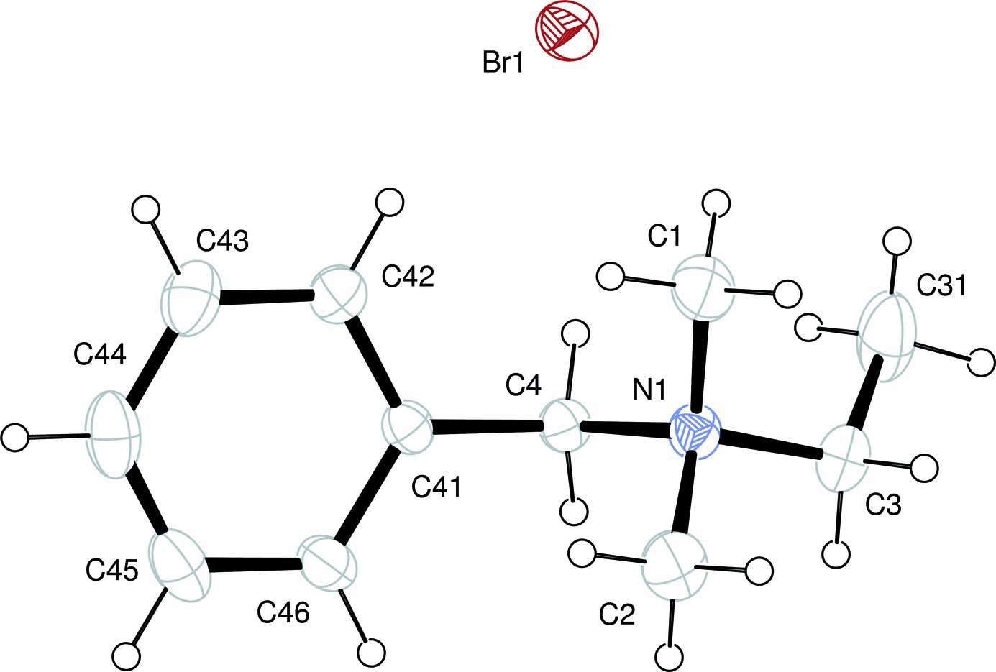
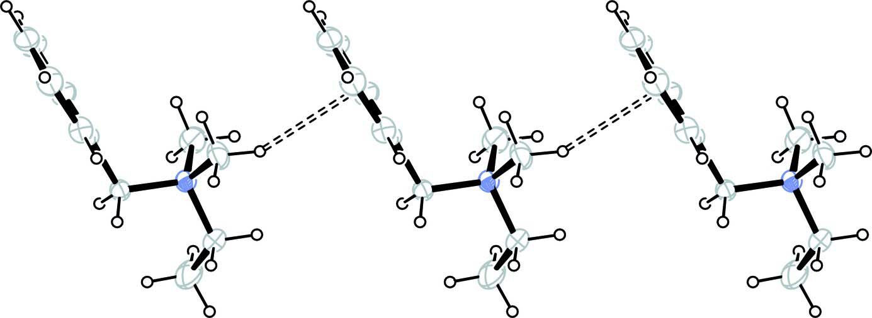
supporting information
Figure 1
ORTEP-3 (Farrugia, 1997) drawing of the asymmetric unit with atom labels. Displacement ellipsoids of non-H atoms are drawn at the 30% probabilty level.
Figure 2
Chain of benzyldimethylethylammonium cations along [100] projected onto (010). The chain is formed due to C—H···π interactions (ORTEP-3; Farrugia, 1997).
sup-2
Acta Cryst. (2008). E64, o601

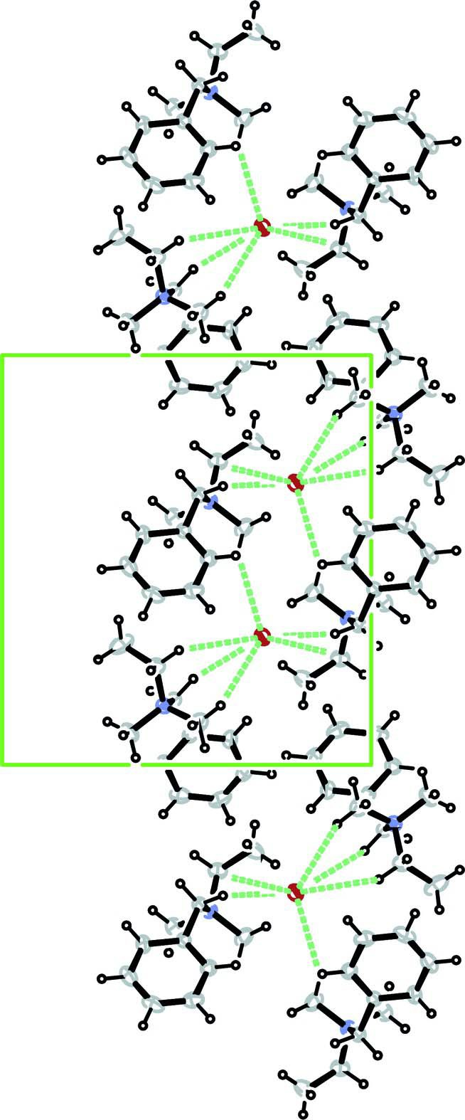
supporting information
Figure 3
Layers parallel to (010) and built of the ammonium cations, arranged in a zig—zag 'head-to-tail′ system, are joined together through Br counterions. View along [100] (ORTEP-3; Farrugia, 1997).
sup-3
Acta Cryst. (2008). E64, o601

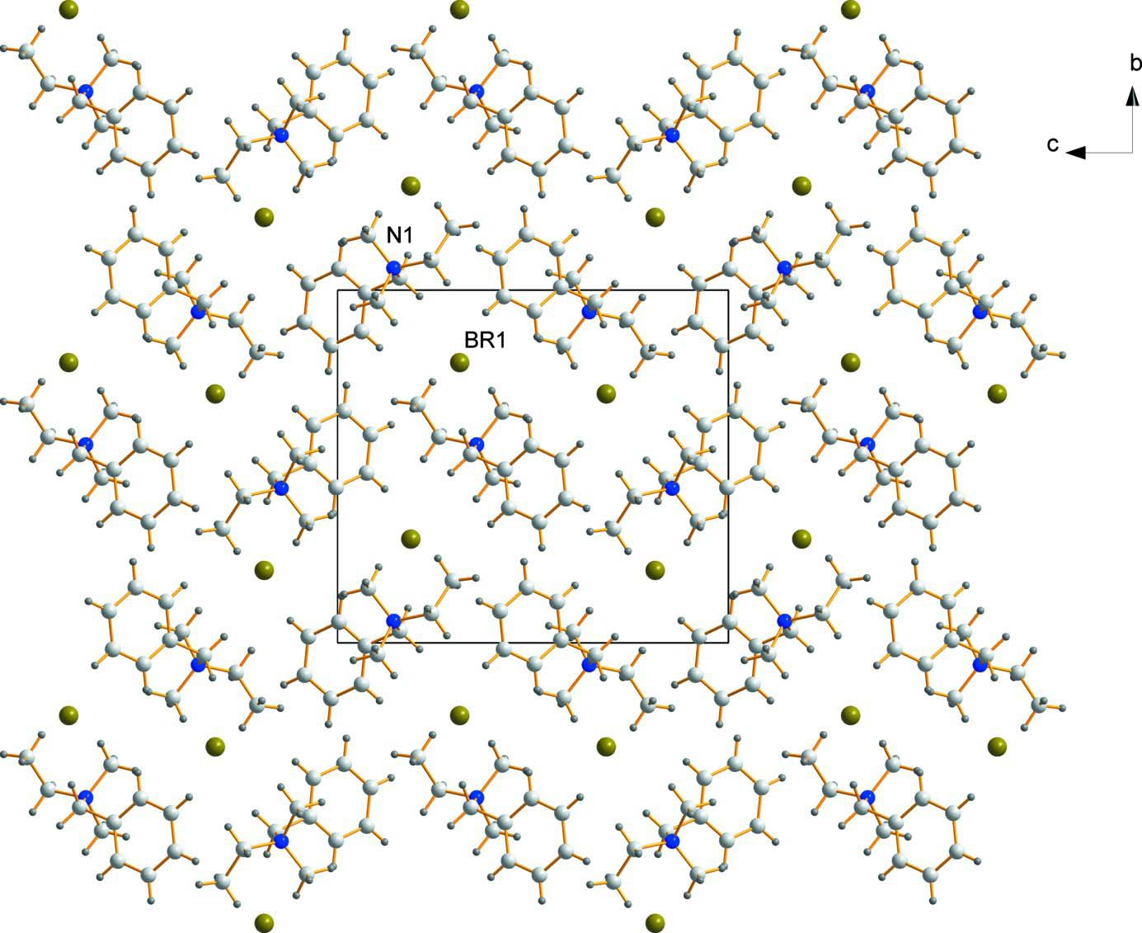
supporting information
Figure 4
The sequence of the cationic and anionic layers along [010] in projecton onto (100) (DIAMOND; Brandenburg, 2006).
Benzylethyldimethylammonium bromide
Crystal data
C11H18N+·Br−
M_{r} = 244.17
Orthorhombic, P2₁2₁2₁ Hall symbol: P 2ac 2ab a = 6.7765 (1) Å
b = 12.5827 (2) Å
c = 13.9433 (2) Å
V = 1188.90 (3) Å3
Z = 4
F(000) = 504
D_{x} = 1.364 Mg m−3
Mo Kα radiation, λ = 0.71073 Å
Cell parameters from 2258 reflections
θ = 1.0–31.5°
µ = 3.42 mm−1
T = 293 K
Prism, colourless
0.20 × 0.19 × 0.17 mm
Data collection
Nonius KappaCCD diffractometer
Radiation source: fine-focus sealed tube Horizontally mounted graphite crystal
monochromator
Detector resolution: 9 pixels mm-1
φ and ω scans
Absorption correction: multi-scan
(DENZO and SCALEPACK Otwinowski & Minor, 1997)
T_{min} = 0.548, T_{max} = 0.594
18366 measured reflections
3874 independent reflections 3483 reflections with I > 2σ(I)
R_{int} = 0.041
θ_{max} = 31.5°, θ_{min} = 2.9°
h = 0→9
k = 0→18
l = −20→20
sup-4
Acta Cryst. (2008). E64, o601

supporting information
Refinement
Refinement on F2
Least-squares matrix: full R[F2 > 2σ(F2)] = 0.027 wR(F2) = 0.065
S = 1.07
3874 reflections
119 parameters
0 restraints
Primary atom site location: structure-invariant direct methods
Secondary atom site location: difference Fourier map
Hydrogen site location: inferred from neighbouring sites
H-atom parameters constrained
w = 1/[σ2(F_{o} ) + (0.0247P) + 0.2756P]
2 2
where P = (F_{o} + 2F_{c} )/3
2 2
(Δ/σ)_{max} = 0.001 Δρ_{max} = 0.26 e Å−3 Δρ_{min} = −0.49 e Å−3
Extinction correction: SHELXL97 (Sheldrick, 2008), Fc*=kFc[1+0.001xFc2λ3/sin(2θ)]-1/4
Extinction coefficient: 0.045 (2)
Absolute structure: Flack (1983), 1627 Friedel pairs
Absolute structure parameter: 0.002 (9)
Special details
Geometry. All e.s.d.'s (except the e.s.d. in the dihedral angle between two l.s. planes) are estimated using the full covariance matrix. The cell e.s.d.'s are taken into account individually in the estimation of e.s.d.'s in distances, angles and torsion angles; correlations between e.s.d.'s in cell parameters are only used when they are defined by crystal symmetry. An approximate (isotropic) treatment of cell e.s.d.'s is used for estimating e.s.d.'s involving l.s. planes.
Refinement. Refinement of F2 against ALL reflections. The weighted R-factor wR and goodness of fit S are based on F2, conventional R-factors R are based on F, with F set to zero for negative F2. The threshold expression of F2 > σ(F2) is used only for calculating R-factors(gt) etc. and is not relevant to the choice of reflections for refinement. R-factors based on F2 are statistically about twice as large as those based on F, and R- factors based on ALL data will be even larger.
Fractional atomic coordinates and isotropic or equivalent isotropic displacement parameters (Å2)
x
y
z
Uiso*/Ueq
Br1 N1 C1 H1A H1B H1C C2 H2A H2B H2C C31 H31A H31B H31C C3 H3A H3B C4 H4A H4B C41 C42
0.29436 (3)
0.7787 (2)
0.8014 (4)
0.7328
0.9389
0.7471
0.8857 (3)
0.8706
0.8317
1.0232
0.7883 (5)
0.8569
0.8025
0.6509
0.8734 (3)
1.0130
0.8617
0.5616 (2)
0.4933
0.5518
0.4578 (2)
0.3755 (3)
1.294368 (16)
1.06178 (12)
1.15508 (19)
1.2150
1.1720
1.1383
0.9680 (2)
0.9081
0.9512
0.9848
1.1763 (3)
1.1845
1.2399
1.1635
1.08411 (19)
1.0972
1.0210
1.03466 (14)
1.0982
0.9824
0.99204 (13)
1.05941 (16)
0.812541 (14)
0.85616 (10)
0.92125 (17)
0.8947
0.9279
0.9830
0.89734 (18)
0.8554
0.9591
0.9039
0.70577 (19)
0.6460
0.7432
0.6936
0.75980 (15)
0.7698
0.7203
0.84108 (12)
0.8197
0.7902
0.92838 (12)
0.99624 (14)
0.05290 (8)
0.0397 (3)
0.0613 (5)
0.074*
0.074*
0.074*
0.0578 (5)
0.069*
0.069*
0.069*
0.0808 (8)
0.097*
0.097*
0.097*
0.0526 (5)
0.063*
0.063*
0.0373 (3)
0.045*
0.045*
0.0368 (3)
0.0483 (4)
sup-5
Acta Cryst. (2008). E64, o601

supporting information
H42 C43 H43 C44 H44 C45 H45 C46 H46
0.3879
0.2748 (4)
0.2222
0.2528 (3)
0.1860
0.3293 (4)
0.3126
0.4319 (3)
0.4832
1.1326
1.0181 (2)
1.0636
0.9094 (2)
0.8817
0.84284 (19)
0.7698
0.88285 (15)
0.8367
0.9892
1.07459 (15)
1.1205
1.08438 (16)
1.1370
1.01657 (18)
1.0229
0.93829 (16)
0.8925
0.058*
0.0617 (5)
0.074*
0.0645 (6)
0.077*
0.0619 (6)
0.074*
0.0477 (4)
0.057*
Atomic displacement parameters (Å2)
U11
U22
U33
U12
U13
U23
Br1 N1 C1 C2 C31 C3 C4 C41 C42 C43 C44 C45 C46
0.06094 (12)
0.0369 (6)
0.0611 (12)
0.0422 (9)
0.0638 (13)
0.0452 (9)
0.0357 (7)
0.0356 (7)
0.0509 (9)
0.0592 (11)
0.0544 (13)
0.0603 (13)
0.0484 (9)
0.04546 (10)
0.0416 (7)
0.0599 (12)
0.0646 (13)
0.106 (2) 0.0642 (12) 0.0384 (8) 0.0363 (8) 0.0470 (10) 0.0815 (15) 0.0901 (17) 0.0531 (11) 0.0363 (8)
0.05230 (11)
0.0405 (6)
0.0629 (12)
0.0667 (13)
0.0727 (15)
0.0482 (10)
0.0378 (7)
0.0386 (7)
0.0470 (9)
0.0444 (9)
0.0489 (10)
0.0722 (14)
0.0584 (10)
0.00357 (9)
−0.0039 (6)
−0.0199 (11)
0.0038 (9)
0.0084 (16)
−0.0012 (9)
−0.0008 (6)
−0.0027 (6)
−0.0018 (8)
−0.0056 (12)
−0.0140 (11)
−0.0119 (10)
−0.0033 (7)
0.00416 (9)
−0.0001 (6)
0.0056 (12)
−0.0115 (9)
0.0168 (13)
0.0100 (8)
−0.0014 (6)
−0.0026 (6)
0.0061 (8)
0.0091 (10)
−0.0012 (8)
−0.0057 (11)
−0.0020 (9)
0.00747 (8)
−0.0024 (5)
−0.0207 (10)
0.0112 (10)
0.0409 (14)
0.0015 (9)
0.0000 (6)
0.0018 (6)
−0.0034 (8)
−0.0051 (10)
0.0251 (11)
0.0228 (10)
0.0034 (8)
Geometric parameters (Å, º)
Br1—N1 N1—C1 N1—C2 N1—C3 N1—C4 C1—H1A C1—H1B C1—H1C C2—H2A C2—H2B C2—H2C C31—C3 C31—H31A C31—H31B C31—H31C C3—H3A
4.4393 (16)
1.492 (2)
1.499 (3)
1.515 (2)
1.525 (2) 0.960 0.960 0.960 0.960 0.960 0.960
1.498 (3) 0.960 0.960 0.960 0.970
C3—H3B C4—C41 C4—H4A C4—H4B C41—C42 C41—C46 C42—C43 C42—H42 C43—C44 C43—H43 C44—C45 C44—H44 C45—C46 C45—H45 C46—H46
0.970
1.505 (2) 0.970 0.970
1.387 (3)
1.392 (2)
1.389 (3) 0.930
1.382 (4) 0.930
1.365 (4) 0.930
1.388 (3) 0.930 0.930
C1—N1—C2 C1—N1—C3
109.66 (17)
110.47 (16)
C31—C3—H3A N1—C3—H3A
108.5
108.5
sup-6
Acta Cryst. (2008). E64, o601

supporting information
C2—N1—C3 C1—N1—C4 C2—N1—C4 C3—N1—C4 C1—N1—Br1 C2—N1—Br1 C3—N1—Br1 C4—N1—Br1 N1—C1—H1A N1—C1—H1B H1A—C1—H1B N1—C1—H1C H1A—C1—H1C H1B—C1—H1C N1—C2—H2A N1—C2—H2B H2A—C2—H2B N1—C2—H2C H2A—C2—H2C H2B—C2—H2C C3—C31—H31A C3—C31—H31B H31A—C31—H31B C3—C31—H31C H31A—C31—H31C H31B—C31—H31C C31—C3—N1
106.30 (16)
111.07 (16)
110.08 (15)
109.15 (14) 68.95 (13)
158.26 (12) 93.99 (11)
54.22 (8) 109.5 109.5 109.5 109.5 109.5 109.5 109.5 109.5 109.5 109.5 109.5 109.5 109.5 109.5 109.5 109.5 109.5 109.5
115.22 (18)
C31—C3—H3B N1—C3—H3B H3A—C3—H3B C41—C4—N1 C41—C4—H4A N1—C4—H4A C41—C4—H4B N1—C4—H4B H4A—C4—H4B C42—C41—C46 C42—C41—C4 C46—C41—C4 C41—C42—C43 C41—C42—H42 C43—C42—H42 C44—C43—C42 C44—C43—H43 C42—C43—H43 C45—C44—C43 C45—C44—H44 C43—C44—H44 C44—C45—C46 C44—C45—H45 C46—C45—H45 C45—C46—C41 C45—C46—H46 C41—C46—H46
108.5
108.5
107.5
114.79 (13) 108.6 108.6 108.6 108.6 107.5
119.00 (18)
121.45 (15)
119.40 (16)
120.3 (2) 119.8 119.8
120.1 (2) 120.0 120.0
119.8 (2) 120.1 120.1
120.8 (2) 119.6 119.6
119.9 (2) 120.0 120.0
C1—N1—C3—C31 C2—N1—C3—C31 C4—N1—C3—C31 Br1—N1—C3—C31 C1—N1—C4—C41 C2—N1—C4—C41 C3—N1—C4—C41 Br1—N1—C4—C41 N1—C4—C41—C42
−60.9 (3)
−179.8 (2)
61.5 (2)
8.1 (2)
−68.2 (2)
53.4 (2)
169.73 (15)
−109.45 (15)
85.4 (2)
N1—C4—C41—C46 C46—C41—C42—C43 C4—C41—C42—C43 C41—C42—C43—C44 C42—C43—C44—C45 C43—C44—C45—C46 C44—C45—C46—C41 C42—C41—C46—C45 C4—C41—C46—C45
−98.94 (19)
2.2 (3)
177.88 (19)
−1.2 (3)
−0.4 (4)
0.9 (4)
0.1 (3)
−1.6 (3)
−177.40 (18)
Hydrogen-bond geometry (Å, º)
D—H···A
D—H
H···A
D···A
D—H···A
C1—H1A···Br1 C4—H4A···Br1 C42—H42···Br1 C31—H31C···Br1
C2—H2A···Br1i C4—H4B···Br1i C3—H3B···Br1i
0.96
0.97
0.93
0.96
0.96
0.97
0.97
3.34
2.81
3.26
3.36
2.96
2.96
3.08
4.144 (3) 3.757 (2) 3.950 (2) 3.953 (3) 3.850 (3) 3.832 (2) 3.950 (2)
143
164
132
122
154
151
151
sup-7
Acta Cryst. (2008). E64, o601

supporting information
C3—H3A···Br1ii C1—H1C···Br1iii C2—H2C···Cg1ii
0.97
0.96
0.96
3.19
2.99
2.69
3.959 (2)
3.766 (2)
3.526
138
139
145
Symmetry codes: (i) −x+1, y−1/2, −z+3/2; (ii) x+1, y, z; (iii) x+1/2, −y+5/2, −z+2.
sup-8
Acta Cryst. (2008). E64, o601

