

Published for SISSA by <£} Springer
Received: July 15, 2020
Accepted: July 28, 2020
Published: September 7, 2020
- Measurements of inclusive and differential cross-sections of combined tt¯γ and tWγ production in the eμ channel at 13TeV with the ATLAS detector
- The ATLAS collaboration
E-mail: atlas.publications@cern.ch
Abstract: Inclusive and differential cross-sections for the production of top quarks in association with a photon are measured with proton-proton collision data corresponding to an integrated luminosity of 139 fb-1. The data were collected by the ATLAS detector at the LHC during Run 2 between 2015 and 2018 at a centre-of-mass energy of 13 TeV. The measurements are performed in a fiducial volume defined at parton level. Events with exactly one photon, one electron and one muon of opposite sign, and at least two jets, of which at least one is b-tagged, are selected. The fiducial cross-section is measured to be 39.6 +|'3 fb. Differential cross-sections as functions of several observables are compared with state-of- the-art Monte Carlo simulations and next-to-leading-order theoretical calculations. These include cross-sections as functions of photon kinematic variables, angular variables related to the photon and the leptons, and angular separations between the two leptons in the event. All measurements are in agreement with the predictions from the Standard Model.
Keywords: Hadron-Hadron scattering (experiments), Top physics
ArXiy ePrint: 2007.06946
Open Access, Copyright CERN,
for the benefit of the ATLAS Collaboration.
Article funded by SCOAP3.
https://doi.org/10.1007/JHEP09(2020)049
JHEP09(2020)049
Contents
- Introduction 1
- ATLAS detector 2
- Signal and background modelling 3
- Event selection 6
- Analysis strategy 8
  - Fiducial region definition 9
  - Fiducial inclusive cross-section 10
  - Absolute and normalised differential cross-sections 11
- Systematic uncertainties 13
  - Experimental uncertainties 13
  - Signal and background modelling uncertainties 14
  - Treatment of the systematic uncertainties in the measurements 15
- Fiducial inclusive cross-section measurement 16
- Differential cross-section measurements 19
- Conclusions 20
The ATLAS collaboration 30
1 Introduction
Precise measurements of top-quark production and decay properties provide crucial information for testing the predictions of the Standard Model (SM) and its possible extensions. In particular, the study of the associated production of a top-quark pair (ft) with a high- energy photon probes the ty electroweak coupling. Furthermore, measurements of the inclusive and differential cross-sections of this process are of particular interest because these topologies are sensitive, for instance, to new physics through anomalous dipole moments of the top quark [1-3] and in the context of effective field theories [4].
First evidence for the production of tt in association with a photon (tty) was reported by the CDF Collaboration [5], while the observation of the tty process was established by the ATLAS Collaboration in proton-proton (pp) collisions at yfs = 7 TeV [6]. Both the ATLAS and CMS Collaborations measured the tty cross-section at yfs = 8 TeV [7, 8].
- 1 -
JHEP09(2020)049
First measurements of the inclusive and differential cross-sections at y/s = 13 TeV were performed by the ATLAS Collaboration [9].
This paper presents a measurement of the fiducial inclusive and differential combined tty + tWy production cross-sections in the final state with one electron and one muon, referred to as the e/i channel. Events where the electrons and muons arise from the leptonic decays of t-leptons are considered as background. The measurement is performed using the full data set recorded at the LHC between 2015 and 2018 at a centre-of-mass energy of yfs = 13 TeV and corresponding to an integrated luminosity of 139 fb-1. The fiducial inclusive cross-section is measured using a profile likelihood fit to the distribution of St, defined as the scalar sum of all transverse momenta in the event, including leptons, photons, jets and missing transverse momentum. The differential cross-sections, absolute and normalised to unity, are measured in the same fiducial region as the inclusive cross-section, as functions of photon kinematic variables, angular variables related to the photon and the leptons, and angular separations between the two leptons in the event.
Compared to the previous tty ATLAS analysis with 13 TeV data [9], only the ep channel is considered since it provides a clean final state with a small background contribution and, thus, no multivariate analysis techniques are needed to separate signal and background processes. Additionally, the cross-sections are measured at parton level rather than at particle level to allow comparison with the theory calculation in refs. [10, 11]. The calculation constitutes the first full computation for tt production with a hard final-state photon in hadronic collisions at next-to-leading order (NLO) in quantum chromodynamics (QCD), pp ^ bWbWy, including all resonant and non-resonant diagrams, interferences, and off-shell effects of the top quarks and the W bosons. Therefore, in this paper the combined cross-section of resonant tty and non-resonant tWy production is measured, referred to as signal in the following. Example Feynman diagrams at leading order in QCD for tty and tWy production are shown in figure 1.
The paper is organised as follows. The ATLAS detector is briefly introduced in section 2. Details of the event-simulation generators and their theoretical predictions are given in section 3. The event selection and the analysis strategy are presented in sections 4 and 5. The systematic uncertainties are described in section 6. The results for the fiducial inclusive and differential cross-sections are presented in sections 7 and 8, respectively. Finally, a summary is given in section 9.
  - 2 ATLAS detector
ATLAS [12-14] is a multipurpose detector with a forward-backward symmetric cylindrical geometry with respect to the LHC beam axis.1 The innermost layers consist of tracking detectors in the pseudorapidity range |n| < 2.5. This inner detector (ID) is surrounded
1ATLAS uses a right-handed coordinate system with its origin at the nominal interaction point (IP) in the centre of the detector and the z-axis along the beam pipe. The x-axis points from the IP to the centre of the LHC ring, and the y-axis points upwards. Cylindrical coordinates (r, 0) are used in the transverse plane, 0 being the azimuthal angle around the z-axis. The pseudorapidity is defined in terms of the polar
angle 0 as y = — lntan(0/2). Angular distance is measured in units of AR = \J(Ay)2 + (A0)2.
-2-
JHEP09(2020)049
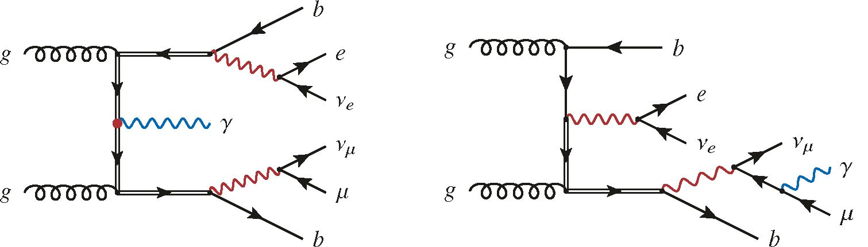
Figure 1. Example Feynman diagrams at leading order for tty (left) and tW7 production (right) in the ep channel. The top-quark mass resonances are marked with double-lined arrows, while W bosons are marked in red.
by a thin superconducting solenoid that provides a 2 T axial magnetic field. It is enclosed by the electromagnetic and hadronic calorimeters, which cover |n| < 4.9. The outermost layers of ATLAS consist of an external muon spectrometer within |n| < 2.7, incorporating three large toroidal magnetic assemblies with eight coils each. The field integral of the toroids ranges between 2.0 and 6.0 Tm for most of the acceptance. The muon spectrometer includes precision tracking chambers and fast detectors for triggering. A two-level trigger system [15] reduces the recorded event rate to an average of 1 kHz.
  - 3 Signal and background modelling
The estimation of signal and background contributions relies on the modelling of these processes with simulated events produced with Monte Carlo (MC) event generators. The response of the ATLAS detector was simulated [16] with Geant4 [17]. For some of the estimates of modelling uncertainties, the fast-simulation package AtlFast-II was used instead of the full detector simulation. Additional pp interactions (pile-up) were generated with Pythia 8 [18, 19] using a set of tuned parameters called the A3 tune [20] and the NNPDF2.3LO parton distribution function (PDF) set [21]. Corrections to the pile-up profile, selection efficiencies, energy scales and resolutions derived from dedicated data samples are applied to the MC simulation to improve agreement with data.
This analysis uses both inclusive samples, in which processes were generated at matrix- element (ME) level without explicitly including a photon in the final state, and dedicated samples for certain processes, where photons were included in the ME-level generation step. Dedicated samples with a photon in the ME were generated for the tty and tWy final states, as well as for Vy processes with additional jets. Here, V denotes either a W or a Z boson. Although no photons were generated at ME level in the inclusive samples, initial- and final-state radiation of photons is accounted for by the showering algorithm. Combining inclusive and dedicated samples for the modelling of processes might result in double-counting photon radiation in certain phase-space regions. As a consequence, a procedure to remove overlaps between the inclusive and dedicated samples was performed. Photon radiation simulated at ME level in dedicated samples achieves higher accuracy than the photon radiation in the showering algorithm. On the other hand, kinematic
- 3 -
JHEP09(2020)049
requirements are applied to the kinematic properties of the photons at ME level in the dedicated samples. In the overlap-removal procedure, all events from the dedicated samples are kept while events from the inclusive samples are discarded if they contain a parton-level photon that fulfils the dedicated samples’ kinematic requirements of pt(y) > 15GeV and AR(y,£) > 0.2, where pT(y) is the photon’s transverse momentum and AR(y,£) is the angular distance between the photon and any charged lepton.
The dedicated sample for the ttY signal process was simulated using the Mad- GRAPH5_aMC@NLO generator (v2.3.3) [22] and the NNPDF2.3LO PDF set at leading order (LO) in QCD. The events were generated as a doubly resonant 2 ^ 7 process, e.g. as pp ^ b£vb£vy, thus, diagrams where the photon is radiated from the initial state (in the case of quark-antiquark annihilation), intermediate top quarks, the b-quarks, and the intermediate W bosons, as well as the decay products of the W bosons, are included. To prevent divergences, the photon was required to have pT > 15 GeV and |n| < 5.0 and the leptons to satisfy |n| < 5.0. The AR between the photon and any of the charged particles among the seven final-state particles were required to be greater than 0.2. The top-quark mass in this and all other samples was set to 172.5 GeV. The renormalisation and the factorisation scales were set to 0.5 x \Jm2i + pT i, where the sum runs over all the particles generated from the ME calculation. The event generation was interfaced to Pythia 8 (v8.212) using the A14 tune [23] to model parton showers, hadronisation, fragmentation and the underlying event. Heavy-flavour hadron decays were modelled with EvtGen [24]; this program was used for all samples, except for those generated using the Sherpa MC program [25, 26]. In the latter case, heavy-flavour decays were modelled directly with Sherpa.
Two dedicated samples for the tWY process were generated with the Mad- GRAPH5_aMC@NLO generator as well. The first one was produced at LO in the five-flavour scheme for the 2 ^ 3 process (e.g. pp ^ tWY) assuming a stable top quark. The second set of events was generated at LO as a 2 ^ 6 process (e.g. pp ^ b£v£vy) in the five-flavour scheme, where the photon is radiated from any other charged final-state particle. In the five-flavour scheme, the b-quarks are treated as massless and the LO representation of the process includes a b-quark in the initial state. The two sets of events are complementary and, once combined, provide a full simulation of the tWY process. Both samples make use of the NNPDF2.3LO PDF set and were interfaced to Pythia 8 (v8.212) for parton showering using the A14 tune. The photon was also required to have pT > 15 GeV and |n| < 5.0 and to be separated by AR > 0.2 from any parton. Although possible interference effects between My and tWY are still missing in the simulated LO samples, the tWY process is treated as part of the signal in this analysis.
Events with Wy and Zy final states (with additional jets) were simulated as dedicated samples. The Wy processes were simulated with Sherpa 2.2.2 at NLO accuracy in QCD using the NNPDF3.0NNLO PDF set, whereas Zy events were generated with Sherpa 2.2.4 at LO in QCD with the same PDF set. The samples are normalised to the cross-sections given by the corresponding MC simulation. The Sherpa generator performs all steps of the event generation, from the hard process to the observable particles. All samples were
- 4 -
JHEP09(2020)049
matched and merged by the SHERPA-internal parton showering based on Catani-Seymour dipoles [27, 28] using the MEPS@NLO prescription [29-31]. Virtual corrections for the NLO accuracy in QCD in the matrix element were provided by the OpenLoops library [32, 33].
Inclusive tt production processes were simulated at matrix-element level at NLO accuracy in QCD using PowHEG-Box v2 [34-36]. The calculation used the NNPDF3.0NLO PDF set [37]. The parton shower was generated with Pythia 8 (v8.230), for which the A14 tune [38] was used. The tt events are normalised to a cross-section value calculated with the Top+—+2.0 program at next-to-next-to-leading order (NNLO) in perturbative QCD, including soft-gluon resummation to next-to-next-to-leading-logarithm order (see ref. [39] and references therein).
Events with inclusive W- and Z-boson production in association with additional jets were simulated with Sherpa 2.2.1 [25, 26] at NLO in QCD. The NNPDF3.0NLO PDF set was used in conjunction with a dedicated tune provided by the Sherpa authors. The samples are normalised to the NNLO cross-section in QCD [40].
Events with two directly produced vector bosons, i.e. WW, WZ and ZZ, were generated with Sherpa versions 2.2.2 (purely leptonic decays) and 2.2.1 (all others) at LO in QCD. The NNPDF3.0NNLO PDF set was used in conjunction with a dedicated tune provided by the Sherpa authors. The samples are normalised to NLO accuracy cross-sections in QCD [41].
Events with a tt pair and an associated W or Z boson (ttV) were simulated at NLO at the ME level with MADGRAPH5_aMC@NLO using the NNPDF3.0NLO PDF set. The ME generator was interfaced to Pythia 8 (v8.210), for which the A14 tune was used in conjunction with the NNPDF2.3LO PDF set. The samples are normalised to NLO in QCD and electroweak theory [42].
The background processes are sorted into three categories based on the origin of the reconstructed photon required in the event selection. The three are estimated from MC simulation by categorising events from all considered samples that are not classified as signal events. The MC simulations for all categories include processes without prompt photons such as tt, W +jets, Z+jets, diboson and ttV production, as well as background processes with an additional prompt photon. The first category is labelled h-fake and contains any type of hadronic fakes that mimic a photon signature in the detector. This category includes not only photon signatures faked by hadronic energy depositions in the electromagnetic calorimeter, but also hadron decays involving photons, for example n0 ^ yy decays. It also includes processes with a prompt photon, where the prompt photon is not reconstructed in the detector or does not pass the selection requirements, but a h-fake photon does. Studies performed with data-driven techniques following the approach described in ref. [9] show that possible data-driven corrections have a negligible effect on the distribution shapes of relevant observables. Possible differences in the total expected number of events are covered by a normalisation uncertainty as described in section 6. The second category is labelled e-fake and contains processes with an electron mimicking a photon signature in the calorimeter. Similarly to the h-fake category, this category includes contributions from processes without a prompt photon but with an e-fake photon, as well as processes with a prompt photon in the simulation but an e-fake photon in the reconstruction. This
-5-
JHEP09(2020)049
category represents a minor background contribution. The third category is called prompt 7 background and contains any type of background process with a prompt photon. The background contribution from tt production with a photon produced in an additional pp interaction in the same bunch crossing was found to be negligible. This was estimated by comparing the significance of the distance in z between the photon’s origin and the primary vertex in data and simulation.
The ttY and tW7 events where one or both W bosons decay into t-leptons, which then subsequently decay into e or p, are categorised as Other ttYftW7, and not as ep signal, following the definition of signal events in the theory calculation in refs. [10, 11]. Single-lepton events, where a second lepton is faked by hadronic energy depositions, are also included in the category Other tt7/tW7. The contribution of tt7 single-lepton events was found to be negligible in the ep final state in the previous measurement [9] and it is therefore estimated from the MC simulation.
  - 4 Event selection
The data set used in this analysis corresponds to the 139 fb-1 of integrated luminosity collected with the ATLAS detector during the Run 2 period. Each event in data and simulation is required to have at least one reconstructed primary vertex with at least two associated reconstructed tracks. Furthermore, only events where at least one of the singleelectron [43] or single-muon [44] triggers was fired are selected.
The main physics objects considered in this analysis are electrons, muons, photons, jets, 6-jets and missing transverse momentum. Electrons are reconstructed from energy deposits in the electromagnetic calorimeter associated with reconstructed tracks in the ID system. They are identified with a combined likelihood technique [45] using a ‘tight’ working point, and are required to be isolated based on calorimeter and tracking quantities. The pT- and n-dependent isolation criteria yield an efficiency of 90% for electrons with pT = 25 GeV and 99% for those with pT = 60 GeV. The origin of the electron track has to be compatible with the primary vertex. Electrons are calibrated with the method described in ref. [45]. They are selected if they fulfil pT > 25 GeV and |nclus| < 2.47, excluding the calorimeter barrel/endcap transition region 1.37 < |nclus| < 1.52.2
Muons are reconstructed with an algorithm that combines the track segments in the various layers of the muon spectrometer and the tracks in the ID system. The reconstruction, identification and calibration methods are described in ref. [46]. Muons are required to be isolated according to track- and calorimeter-based criteria similar to those applied to electrons. Only muons with calibrated pT > 25 GeV and |n| < 2.5 and passing ‘medium’ quality requirements are considered. The muon track is also required to originate from the primary collision vertex.
Photons are reconstructed from energy deposits in the central region of the electromagnetic calorimeters. If the cluster considered is not matched to any reconstructed track in the ID system, the photon candidate is classified as unconverted. If the cluster is matched with one or two reconstructed tracks that are consistent with originating from a photon
2ndus denotes the pseudorapidity of the calorimeter cell cluster associated with the electron.
-6-
JHEP09(2020)049
conversion and if, in addition, a conversion vertex can be found, the photon candidate is classified as converted. Both kinds of photons are considered in this analysis. Photons are reconstructed and identified as described in ref. [47] and their energies are calibrated with the method described in ref. [48]. They are subject to a tight isolation requirement defined as ET°|ar<0 4 < 0.022 ■ Et(y) + 2.45 GeV in conjunction with pT°| AR<0 2 < 0.05 ■ Et(y), where ET° refers to the calorimeter isolation within AR < 0.4 around the direction of the photon candidate and pT° is the track isolation within AR < 0.2 [47]. Only photons with calibrated ET > 20 GeV and |nclus| < 2.37, excluding the calorimeter transition region 1.37 < |nclus| < 1.52, are considered.
Jets are reconstructed using the anti-kt algorithm [49] in the FastJet implementation [50] with a distance parameter R = 0.4. They are reconstructed from topological clusters of cells in the calorimeter [51]. The jet energy scale and jet energy resolution are calibrated using information from both simulation and data [52]. The jets are required to have pT > 25 GeV and |n| < 2.5. Jets with a large contribution from pile-up vertices are identified with the Jet Vertex Tagger [53] and rejected.
The b-tagging algorithm (MV2c10) applied to the selected jets to identify those from b-quark hadronisation [54] labelled as b-jets is based on a boosted decision tree combining information from other algorithms using track impact parameters and secondary vertices, and a multi-vertex reconstruction algorithm. A working point with a selection efficiency of 85% on simulated tt events is used, corresponding to rejection factors of 3.1 and 35 for jets initiated by charm quarks and light-flavour partons, respectively. The flavour-tagging efficiency for b-jets, as well as for c-jets and light-flavour jets, is calibrated as described in ref. [55].
The reconstructed missing transverse momentum E™ss [56, 57] is computed as the negative vector sum over all reconstructed, fully calibrated physics objects, including photons, and the remaining unclustered energy, also called the soft term. The soft term is estimated from low-pT tracks associated with the primary vertex but not with any reconstructed object.
An overlap-removal procedure is applied to avoid the reconstruction of the same energy clusters or tracks as different objects. First, electron candidates sharing their track with a muon candidate are removed and jets within a AR = 0.2 cone around any remaining electron are excluded. Secondly, electrons within a AR = 0.4 cone around any remaining jet are removed. If the distance between a jet and any muon candidate is AR < 0.4, the muon candidate is discarded if the jet has more than two associated tracks, otherwise the jet is removed. Finally, photons within a AR = 0.4 cone around any remaining electron or muon are removed and then jets within a AR = 0.4 cone around any remaining photon are excluded.
The selected events must have exactly one electron and exactly one muon, each with pT > 25 GeV. At least one of these leptons has to be matched to a fired single-lepton trigger. Since the pT threshold of the single-lepton triggers was increased over the different data-taking periods due to increased collisions rates, the offline pT thresholds for these electrons and muons that are matched to a fired single-lepton trigger are chosen to be 25 GeV in 2015, 27 GeV in 2016, and 28 GeV in 2017 and 2018 in order to lie above the trigger thresholds. Electrons and muons must have opposite-sign charges and the
-7-
JHEP09(2020)049
Events
tty | 2391 | ± | 130
tWy e^ | 156 | ± | 15
Other tty/tWy | 279 | ± | 15
h-fake | 78 | ± | 40
e-fake | 23 | ± | 12
Prompt y bkg. | 87 | ± | 40
Total | 3014 ± 160
Data | 3014
Table 1. Event yields before the profile likelihood fit of the signal and background processes to data after the full selection. All categories are estimated from MC simulation and include correction factors for detector effects as described in section 6. The combination of all tty and tW7 categories is scaled to match the event yields in data. The quoted uncertainties correspond to the total statistical and systematic uncertainties (cf. section 6) added in quadrature.
invariant mass is required to be higher than 15 GeV. The event is required to have at least two jets and at least one of the jets must be b-tagged. In addition, all events must contain exactly one reconstructed photon fulfilling the condition that AR between the selected photon and any of the leptons is greater than 0.4.
The observed event yields after selection are listed in table 1 for the different signal and background categories described in section 3. The LO cross-section of the MC samples underestimates the expected number of signal events; therefore, for illustration purposes the combination of all thy and tWy categories is normalised to match the event yields in data. Correction factors for detector effects (described in section 6) are applied, when needed, to improve the description of the data by the simulation.
The modelling of signal and background processes is inspected through the comparison of distributions. A selection of these distributions showing a comparison between the MC simulation before the profile likelihood fit and data is presented in figure 2. The combination of all tty and tWy categories is normalised to match the event yields in data as done in table 1 to allow a comparison of the shapes of the kinematic variables. All systematic uncertainties that are introduced in section 6 are included in these distributions and their sum in quadrature, which assumes they are fully uncorrelated, is illustrated by the shaded error bands.
  - 5 Analysis strategy
The inclusive and differential cross-sections are measured in the fiducial region described in section 5.1 and the same sources of background contributions and systematic uncertainties are considered. In the fiducial inclusive cross-section the ST distribution is fitted and the post-fit background yields and systematic uncertainties are used to extract the signal crosssection, while no fit is performed for the determination of the differential cross-sections.
- 8 -
JHEP09(2020)049
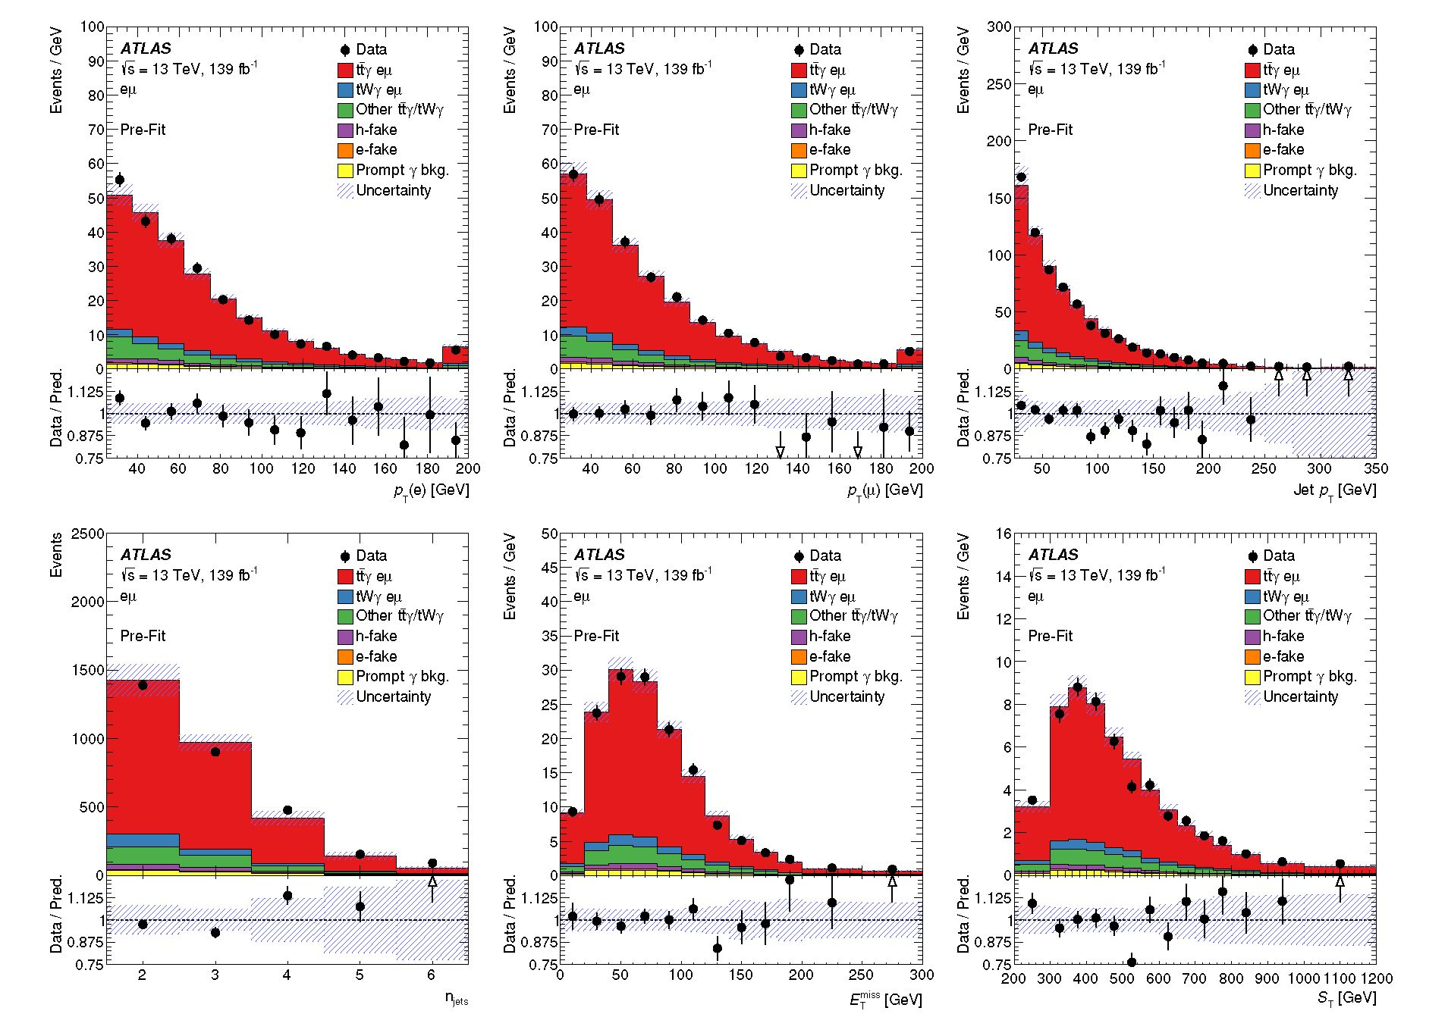
Figure 2. Distributions of the transverse momentum of the electron, the muon and all jets (top row), and the number of jets, Emiss and ST (bottom row) after event selection and before the profile likelihood fit. The combination of all tty and tW7 categories is scaled to match the event yields in data. The shaded bands correspond to the statistical and systematic uncertainties (cf. section 6) added in quadrature. Overflow events are included in the last bin of each distribution. In the case of the ST distribution, the underflow events are included in the first bin. The lower part of each plot shows the ratio of the data to the prediction.
- Fiducial region definition
The cross-sections are reported at parton level in a fiducial region, defined by the kinematic properties of the signal process, in which all selected final-state objects are produced within the detector acceptance. This is done in a way that mimics the event selection as defined in the theoretical calculation. Objects at parton level are taken from the MC simulation history. Photons and leptons are selected as stable particles after final-state radiation. The leptons (y = e, p) must originate from W-boson decays and they are dressed with nearby photons within a cone of size of AR = 0.1 around them and must have pT > 25 GeV and |n| < 2.5. Only events with exactly one electron and one muon are considered. Events with leptons originating from an intermediate t-lepton in the top-quark decay chain are not considered. The b-jets at parton level in the calculation from refs. [10, 11] are jets clustered with the anti-kt algorithm with a distance parameter of R = 0.4. Since showering and hadroni-
- 9 -
JHEP09(2020)049
sation effects are not considered in this calculation, the jets correspond to the b-quarks from the top-quark decay (with an additional parton in the cases where the NLO real emission leads to a parton close by a b-quark). To mimic this definition in the LO MC simulation, parton-level b-jets are defined as follows. The anti-kt algorithm with a distance parameter R = 0.4 is applied to all partons that are radiated from the two b-quarks (including the b-quarks themselves) and from the two initial partons. The jets that include a b-quark from the decay of a top quark are selected as b-jets. The event is kept if there are two b-jets satisfying pT > 25 GeV and |n| < 2.5. Exactly one photon with ET > 20 GeV and |n| < 2.37 is required. Photons are required to be isolated from nearby jets by imposing a modified cone approach as described in ref. [58], as it is also done in the theory calculation in refs. [10, 11], to ensure soft and collinear safety. The event is dropped if any of the following requirements is not fulfilled: AR(y,.£) > 0.4, AR(e, g) > 0.4, AR(b, b) > 0.4 or AR(^, b) > 0.4.
- Fiducial inclusive cross-section
The fiducial inclusive cross-section is extracted using a binned profile likelihood fit to the full distribution. The distribution of ST provides good separation between signal and background and was found to be less sensitive to systematic uncertainties than other distributions considered, such as the jet multiplicity or the pT of individual jets. The expected signal and background distributions are modelled in the fit using template distributions taken from the simulated samples. The parameter of interest, the fiducial cross-section ofid, is related to the number of signal events in bin i of the ST distribution as:
N/ = L x x C x fST.
The term L is the integrated luminosity, /St is the fraction of generated signal events falling into bin i of the ST distribution after fiducial requirements are applied, and C is the correction factor for the signal efficiency e and for migration into the fiducial region /out, defined as follows:
= N™Q-fld e = fi ^C = e = Neco
Nreco ’ NflC 1 - /out ’
where Nreco is the number of simulated signal events passing the event selection described in section 4, N^C is the corresponding number of signal events generated in the fiducial region defined in section 5.1, and NreCo and Nrie<Co-fld are the numbers of signal events that pass the event selection and are generated within and outside the fiducial region, respectively. The efficiency and outside migration are obtained from simulated tty and tWy events. The correction factor is estimated from the signal simulation to be C = 0.462 ±0.002 (statistical uncertainty only).
The likelihood function L, based on Poisson statistics, is given by:
L = n P ( N°bs|N/(0) + £ Nt(9)j x n G(0|0t) 1), i V b J t
where N°bs, N/, and N^ are the observed number of events in data, the predicted number of signal events, and the estimated number of background events in bin i of the ST distribution, respectively. The rates of those tty and tWy events not counted as part of the signal
- 10 -
JHEP09(2020)049
and categorised as Other tty/tWy are scaled with the same parameter as the signal events in the fit, i.e. no independent production cross-section is assumed for these parts of the simulated tty/tWy process. The vector 0, of components 0t, represents the nuisance parameters that describe the sources of systematic uncertainties. Each nuisance parameter Qt is constrained by a Gaussian distribution, G(0|9t, 1). The width of the Gaussian function corresponds to a change of ±1 standard deviation of the corresponding quantity in the likelihood. For systematic uncertainties related to the finite number of simulated MC events, the Gaussian terms in the likelihood are replaced by Poisson terms. The cross-section is measured by profiling the nuisance parameters and minimising —2ln L [59].
- Absolute and normalised differential cross-sections
The measurements of the absolute and normalised differential cross-sections are performed as functions of the pT and |n| of the photon, and of angular variables between the photon and the leptons: AR between the photon and the closest lepton AR(y,f)mjn, as well as A0(l,l) and | An(F, F) | between the two leptons. The kinematic properties of the photon are sensitive to the ty coupling. In particular, AR(y,l)min is related to the angle between the top quark and the radiated photon, which could give insight into the structure of this coupling. The distributions of A0(l, l) and | An(l, l) | are sensitive to the tt spin correlation. The corresponding distributions in data and SM simulations are compared in figure 3. The simulation describes reasonably well the data within the uncertainties although it favours smaller AR(y,l)min and larger A0(l, l) values than the observed ones.
The data are corrected for detector resolution and acceptance effects to parton level in the fiducial phase space using an iterative matrix unfolding that uses Bayes’ theorem [60] implemented in the RooUnfold package [61]. The differential cross-section is defined as:
dXk = L x AXk x ek X S M- X (Nj>bS — Nj>) X fe« X (1 — foutj) •
j
The indices j and k represent the bin indices of the observable X at detector and parton levels, respectively. The variable N°bs is the number of observed events, and Nj is the number of estimated non-tiy/tWy background events (pre-fit) in bin j at detector level. The contribution from the Other tty/tWy category is taken into account by correcting the remaining number of observed events by the signal fraction, fe^,j, defined as the ratio of the number of selected tty and tWy ep events to the total number of selected tty and tWy events, as determined from simulation. This avoids the dependence on the signal cross-section used for the normalisation. The efficiency ek is the fraction of signal events generated at parton level in bin k of the fiducial region that are reconstructed and selected at detector level. The total integrated luminosity is denoted by L, and AXk represents the bin width. The migration matrix Mkj describes the detector response and expresses the probability for an event in bin k at parton level to be reconstructed in bin j at detector level, calculated from events passing both the fiducial-region selection and the event selection. The outside-migration fraction fout,j is the fraction of signal events generated outside the fiducial region but reconstructed and selected in bin j at detector level. The normalised
- 11 -
JHEP09(2020)049
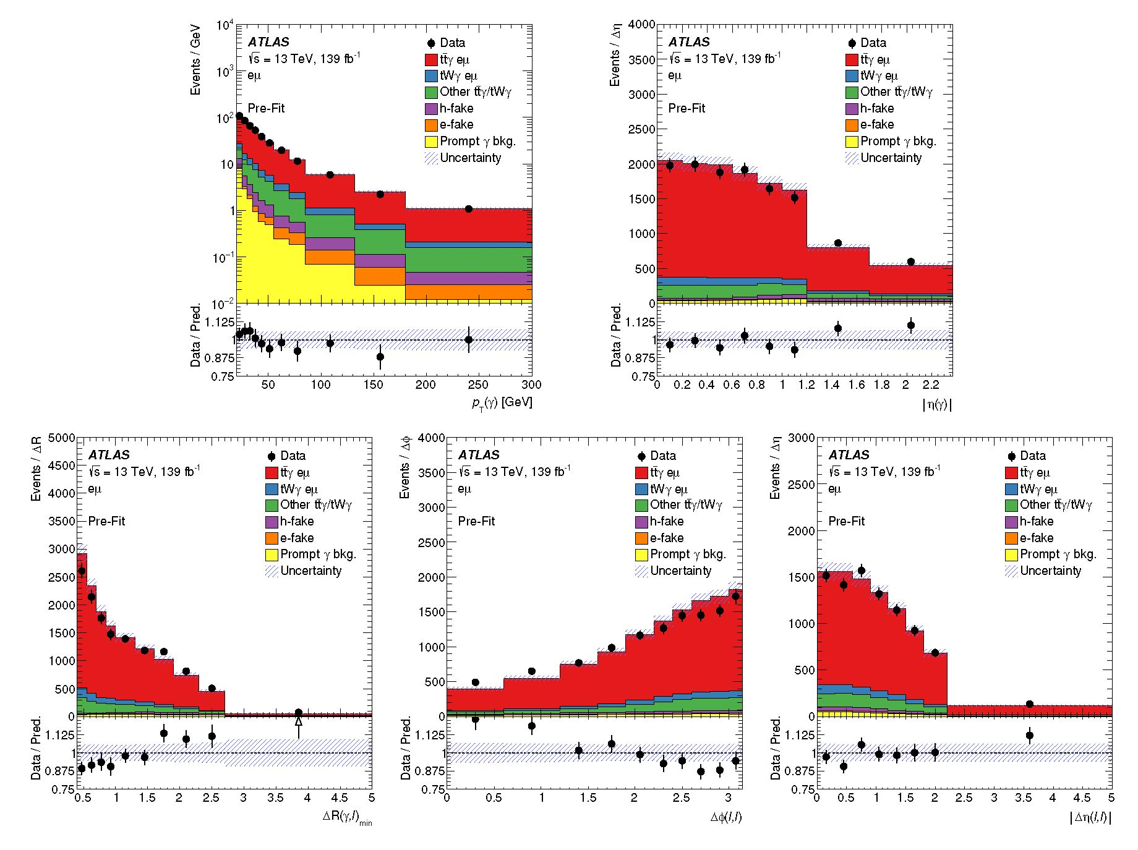
Figure 3. Distributions of the photon pT and |p| in the top row, and AR(y, l)min, A^(l, l) and |Ay(l,l)| in the bottom row after event selection and before the profile likelihood fit. The combination of all tty and tWy categories is scaled to match the event yields in data. The shaded bands correspond to the statistical and systematic uncertainties (cf. section 6) added in quadrature. When overflow events are present, they are included in the last bin of the distribution. The lower part of each plot shows the ratio of the data to the prediction.
differential cross-section is derived by dividing the absolute result by the total cross-section, obtained by integrating over all bins of the observable.
The signal MC samples are used to determine ek, fout,j, and Mkj-. The unfolding method relies on the Bayesian probability formula, starting from a given prior of the parton-level distribution and iteratively updating it with the posterior distribution. The binning choices of the unfolded observables take into account the detector resolution and the expected statistical uncertainty. The bin width has to be larger than twice the resolution, and the statistical uncertainty is required to be around or below 10% across all bins, with the latter being the limiting factor in most of the cases. The resolution of the lepton and photon momenta is very high and, therefore, the fraction of events migrating from one bin to another is small. In all bins, the purity, defined as the fraction of reconstructed events that originate from the same bin at parton level, is larger than 80%, and it is above 90% for all observables except for the pt of the photon. The number of iterations chosen is two, which provides good convergence of the unfolding distribution and a statistically stable result.
- 12 -
JHEP09(2020)049
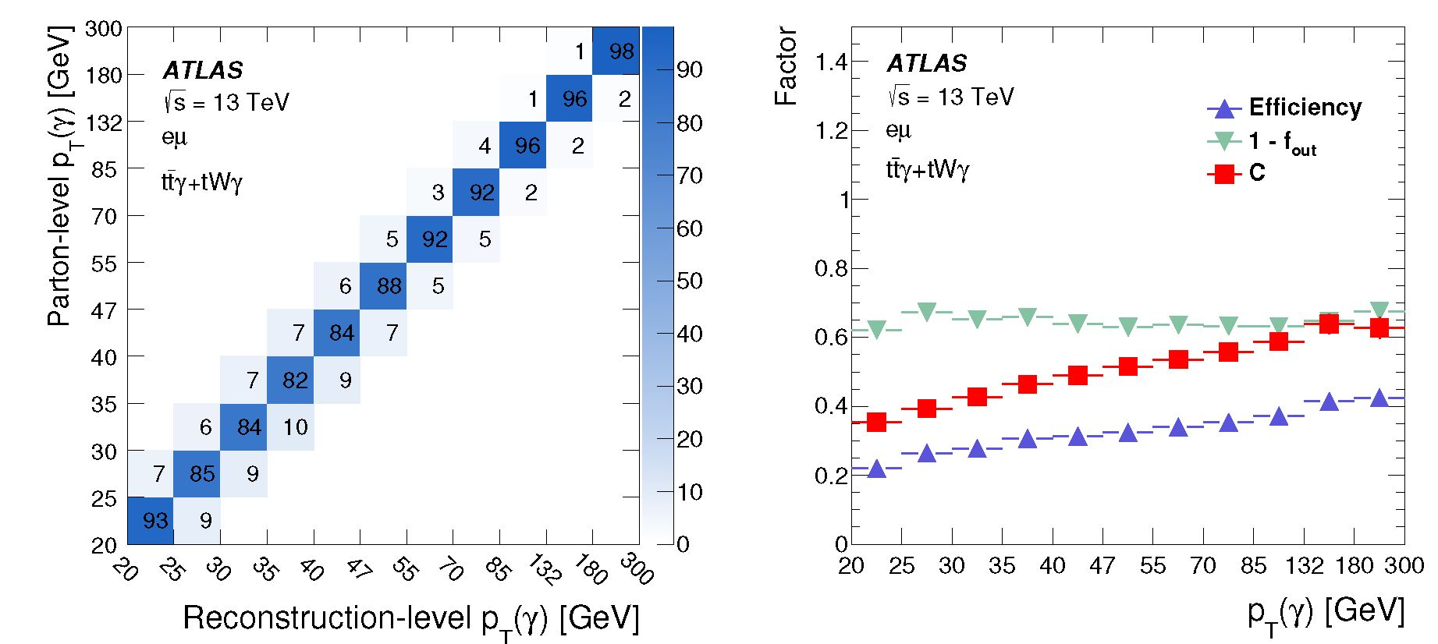
Figure 4. Left: migration matrix relating the photon pT at the reconstruction and parton levels in the fiducial phase space, normalised by column and shown as percentages. Right: signal reconstruction and selection efficiency (e), (1 — /out) fraction and resulting C correction factor as a function of the photon pT.
For illustration purposes, the migration matrix is presented in the left panel of figure 4, while the right panel shows the efficiency, outside-migration fraction and the resulting C correction factor obtained for the distribution of the photon pt. The performance of the unfolding procedure is tested for possible biases from the choice of input model. It was verified that when reweighting the shape of the signal simulation by up to 50% bin-by-bin with respect to the nominal shape, the unfolding procedure based on the nominal response matrix reproduces the altered shapes.
  - 6 Systematic uncertainties
Various systematic uncertainties arising from detector effects are considered, along with theoretical uncertainties. Signal and background predictions are both subject to these uncertainties.
- Experimental uncertainties
Experimental systematic uncertainties affect the normalisation and shape of the distributions of the simulated signal and background samples. These include reconstruction and identification efficiency uncertainties, as well as uncertainties in the energy and momentum scale and resolution for the reconstructed physics objects in the analysis, including leptons, photons, jets and ETpiss. In addition, uncertainties in the flavour-tagging of jets, the jet vertex tagger (JVT) discriminant, the integrated luminosity value and the pile-up simulation are considered.
The photon identification and isolation efficiencies as well as the efficiencies of the lepton reconstruction, identification, isolation, and trigger in the MC samples are all corrected
- 13 -
JHEP09(2020)049
using scale factors to match the corresponding values in data. Similarly, corrections to the lepton and photon momentum scale and resolution are applied in simulation [46, 48]. All these corrections, which are pt and n dependent, are varied within their uncertainties.
The jet energy scale (JES) uncertainty is derived using a combination of simulations, test-beam data and in situ measurements [52]. Additional contributions from jet-flavour composition, n-intercalibration, punch-through, single-particle response, calorimeter response to different jet flavours, and pile-up are taken into account, resulting in 30 uncorrelated JES uncertainty subcomponents, of which 29 are non-zero in a given event depending on the type of simulation used. The most relevant JES uncertainties are related to the pile-up correction (JES pile-up correction) and modelling aspects of the in situ calibration (JES in situ calibration). The jet energy resolution (JER) in simulation is smeared by the measured JER uncertainty [62] split into eight uncorrelated sources. The uncertainty associated with the JVT discriminant is obtained by varying the efficiency correction factors (labelled jet vertex tagging in the results, cf. figure 5).
The uncertainties related to the b-jet tagging calibration are determined separately for b-jets, c-jets and light-flavour jets [63-65]. For each jet category, the uncertainties are decomposed into several uncorrelated components. The corrections are varied by their measured uncertainties.
The uncertainties associated with energy scales and resolutions of photons, leptons and jets are propagated to the E™ss. Additional uncertainties originate from the modelling of its soft term [66].
The uncertainty in the combined 2015-2018 integrated luminosity is 1.7% [67], obtained using the LUCID-2 detector [68] for the primary luminosity measurements.
The uncertainty associated with the modelling of pile-up in the simulation is assessed by varying the pile-up reweighting in the simulation within its uncertainties.
- Signal and background modelling uncertainties
The t?7 signal modelling uncertainties include the uncertainties owing to the choice of QCD scales, parton shower, amount of initial-state radiation (ISR), and PDF set. The effect of the QCD scale uncertainty is evaluated by varying the renormalisation and factorisation scales separately up and down by a factor of two from their nominal chosen values. The uncertainty from the parton shower and hadronisation (Wy PS model) is estimated by comparing the tiY nominal samples, produced with MADGRApH5_aMC@NLO + Pythia 8, with an alternative sample interfaced to Herwig 7 [69, 70]. The ISR uncertainty (tiY ISR) is studied by comparing the nominal MAdGRApH5_aMC@NLO + Pythia 8 sample with the results of varying the A14 tune parameter for radiation [23]. The PDF uncertainty (tiY PDF) is evaluated using the standard deviation in each bin of the respective distribution formed by the set of 100 replicas of the NNPDF set [21].
For the tWY process the uncertainties due to the choice of renormalisation and factorisation scales are also estimated by varying them up and down separately by a factor of two relative to the nominal sample value. A systematic uncertainty from the parton shower and hadronisation model is considered by comparing Pythia 8 and Herwig 7 both interfaced
- 14 -
JHEP09(2020)049
to MADGRAPH5_aMC@NLO. The tWy modelling uncertainties are treated as uncorrelated with the tty signal modelling uncertainties.
The tWy process was generated in the five-flavour scheme at leading order in QCD and one of the two b-quarks is not included in the matrix-element generation step. This b-quark, expected to be produced in the initial state through the PDF, is only found in a fraction of the events at parton level in the MC simulation. The fractions of generated tWy events without a second b-quark were found to be around 30% and 50% for the MC samples interfaced with HeRwig and PytHiA, respectively. Therefore, an additional uncertainty associated with this possibly lost b-quark is assigned (tWy parton definition) as follows. Relative to the nominal tWy simulation, the parton-level event yields are doubled, assuming all b-jets are found, while the number of reconstructed events is kept constant. This leads to a variation of the correction factor C of 2.8%.
Several uncertainties in the modelling of tt processes, which give a dominant contribution to the h-fake and prompt y background categories, are considered as shape-only uncertainties. The uncertainties associated with the parton shower and hadronisation are estimated by comparing the nominal simulation with alternative showering by Herwig 7. Uncertainties in the modelling of final-state radiation are estimated by evaluating the effects of varying four different parameters in the Powheg + Pythia 8 generator set-up described in the following. Uncertainties due to the renormalisation and factorisation scales are estimated by varying them up and down independently by a factor of two relative to the default scale choice. These scale variations are implemented with corresponding weights which are available as part of the nominal MC sample. Uncertainties due to the value of as used in the ISR parton shower modelling are estimated by comparing the nominal Powheg + Pythia 8 simulation with alternative samples that correspond to higher and lower radiation parameter settings in the A14 tune, controlled by the var3c parameter in Pythia 8. This parameter is varied within its uncertainties corresponding to variations of aS(mZ) between 0.115 and 0.140. An additional ISR uncertainty is obtained by comparing the nominal sample with an additional one where the hdamp parameter, which controls the pT of the first additional emission, is varied by a factor of two as supported by measurements reported in ref. [71].
In addition to those background modelling uncertainties, global normalisation uncertainties of 50% are assigned to the following three categories: h-fake photons, e-fake photons and prompt y background [9] (h-fakes, e-fakes, and prompt y normalisation).
- Treatment of the systematic uncertainties in the measurements
As stated in section 5, the impact of systematic uncertainties on the fiducial inclusive cross-section measurement is taken into account via nuisance parameters in the likelihood function. The nuisance parameters d are profiled in the maximum-likelihood fit. Variations of the nuisance parameters can affect the rate of events as well as the shape of the ST distribution. In the case of signal modelling uncertainties, the rate uncertainty is composed of variations of the efficiency e and the fraction /out. All MC samples used to evaluate signal modelling uncertainties are scaled to the same number of events in the fiducial phase space, Nmc. The only uncertainty that is not included as a nuisance parameter in the profile
- 15 -
JHEP09(2020)049
likelihood fit is the uncertainty from the tWy parton definition. This uncertainty does not affect the number of reconstructed events in the corresponding template in the profile likelihood fit. It comprises only an uncertainty in the number of generated events in the fiducial phase space. Thus, the tWy parton definition uncertainty is added in quadrature to the post-fit uncertainty of the profile likelihood fit.
To reduce the sensitivity to statistical fluctuations due to the limited number of events in the MC samples used in systematic variations, smoothing techniques are applied to the MC templates used to evaluate the signal and background modelling systematic uncertainties in the template fit. Additionally, the systematic uncertainties are symmetrised, taking the average of the up- and down-variation as the uncertainty. In the cases where both variations have the same sign or only one variation is available (e.g. the uncertainty from the parton shower and hadronisation signal modelling) the largest variation or the available one, respectively, is taken as both the up- and down-variations for the corresponding source. The ISR uncertainty suffers from statistical fluctuations in the available tty MC samples, so a more conservative approach is chosen for the symmetrisation. In this case, the largest of the two variations is taken and mirrored around the nominal prediction.
In the case of the differential cross-section measurements, each systematic uncertainty is determined individually in each bin of the measurement by varying the corresponding efficiency, resolution, and model parameter within its uncertainty. The same symmetrisa- tion approach described for the fiducial inclusive cross-section is used for this measurement. For each variation, the measured differential cross-section is recalculated and the deviation from the nominal result per bin is taken as the systematic uncertainty. The overall uncertainty in the measurement is then derived by adding all contributions in quadrature, assuming the sources of systematic uncertainty to be fully uncorrelated.
Sources of systematic uncertainty relating only to the background prediction are evaluated by shifting the nominal distribution of the corresponding background process by its associated uncertainty. For the experimental uncertainties, the input is varied by the corresponding shift, which typically affects both the shape and normalisation of signal and background process distributions. The resulting distribution is unfolded and compared with the nominal unfolded distribution and the difference is assigned as an uncertainty. The systematic uncertainties due to signal modelling are evaluated by varying the signal corrections, i.e. the migration matrix Mkj, the efficiency ek and the fraction fout,j, by the corresponding model parameter uncertainty and calculating the difference between the resulting unfolded distributions and the nominal ones.
  - 7 Fiducial inclusive cross-section measurement
The number of signal events is extracted using a profile likelihood fit to the ST distribution and is translated into the signal cross-section in the fiducial phase space given by the kinematic boundaries of the signal as described in section 5.
The best-fit values of the nuisance parameters ranked highest in impact are shown in figure 5 along with their impact on the result. Rate and shape uncertainties from the tty PS model and tty ISR variations are treated as separate nuisance parameters.
- 16 -
JHEP09(2020)049
Category | Uncertainty
t^Y/tWY modelling | 3.8%
Background modelling | 2.1%
Photons | 1.9%
Luminosity | 1.8%
Jets | 1.6%
Pile-up | 1.3%
Leptons | 1.1%
Flavour-tagging | 1.1%
MC statistics | 0.4%
Soft term EPiss | 0.2%
tWY parton definition | 2.8%
Total syst. | 6.3%
Table 2. Illustrative summary of the systematic uncertainties on the fiducial inclusive cross-section measurement grouped into different categories and their relative impact on the measurement (symmetrised). The categories ‘tty/tWY modelling’ and 'Background modelling’ include all corresponding systematic uncertainties described in section 6.2. The 'tWY parton definition’ uncertainty is listed separately since it does not enter the profile likelihood fit directly as described in section 6.3. The category ‘Photons’ corresponds to the uncertainties related to photon identification and isolation as well as photon energy scale and resolution. ‘Jets’ includes the total uncertainty from the JES, JER and JVT discriminant, while the b-tagging-related uncertainties are given in a separate category (‘Flavour-tagging’). The category ‘Leptons’ represents the uncertainties related to lepton identification, isolation and energy/momentum calibration.
This approach prevents pulls on the rate uncertainty due to differences in the shape of the ST distribution between the data and simulation, in particular in the tail where the data overshoot the prediction and the fit compensates for this discrepancy by pulling the nuisance parameter of the t?Y PS model shape uncertainty. The impact of the individual nuisance parameters is evaluated as the difference between the reference best-fit value of the cross-section and the one obtained when fixing the corresponding nuisance parameter under scrutiny to its best-fit value and its ± one standard deviation (±1ct). Table 2 shows the systematic uncertainties and their relative impact on the measurement of the fiducial inclusive cross-section. The effect of each category of uncertainties is calculated from the variance (ct2) difference between the total uncertainty in the measured fiducial cross-section and the uncertainty from the fit with the corresponding nuisance parameters fixed to their fitted values. The uncertainties in the signal modelling, especially the rate uncertainties from the t?Y PS model and the ISR variation, have the largest impact on the result.
The distribution of the fitted ST variable is shown in figure 6. The dashed band represents the post-fit uncertainties. The expected yields after the fit describe the data well.
-17-
JHEP09(2020)049
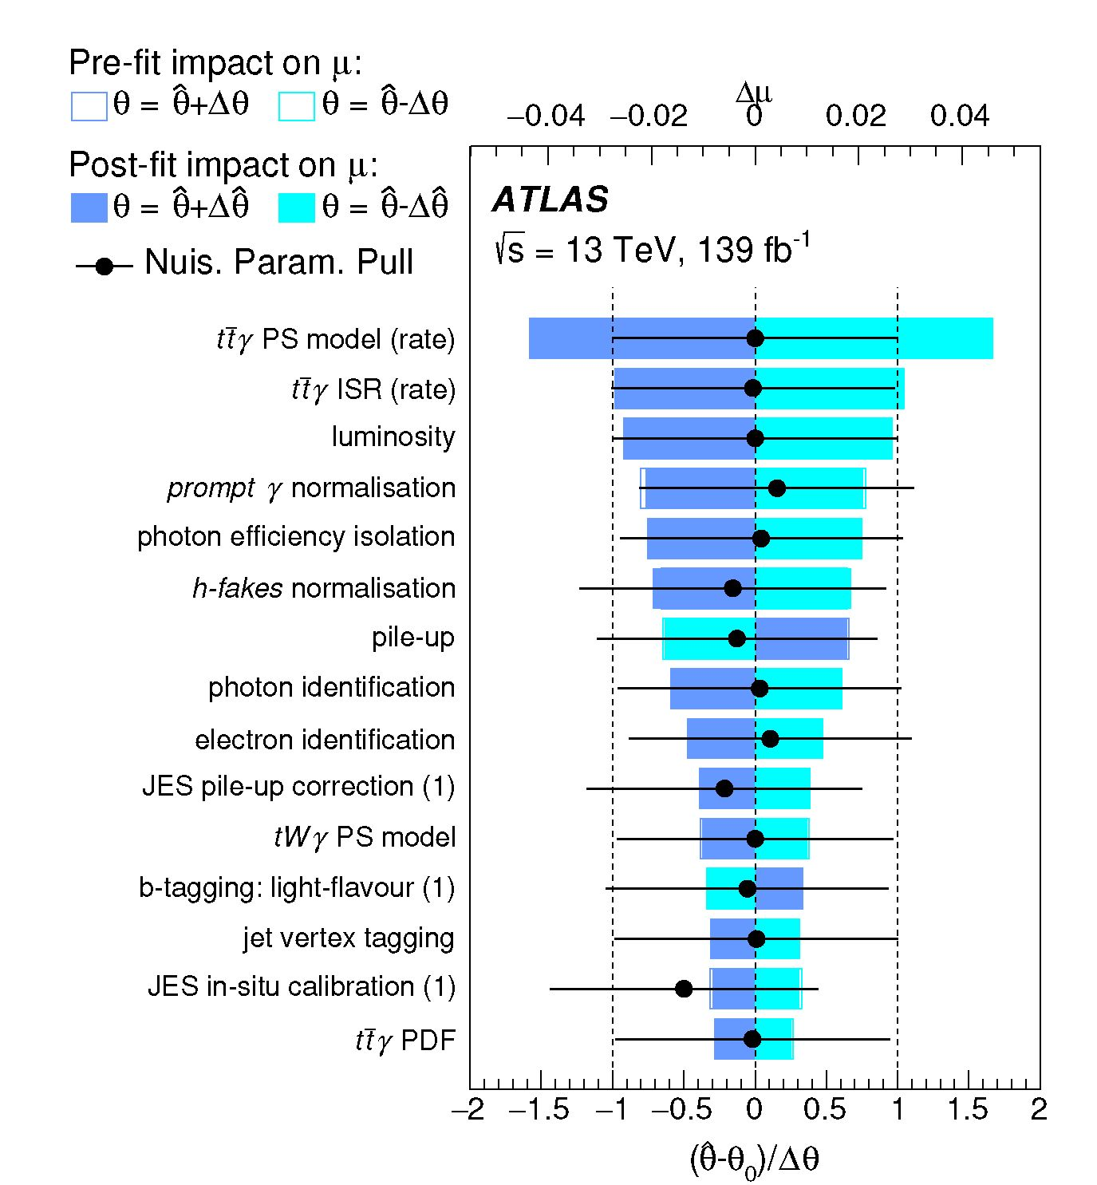
Figure 5. Ranking of the systematic uncertainties included in the profile likelihood fit used in the fiducial inclusive cross-section measurement. The blue and turquoise bands indicate the post-fit impact on the fit result, whereas the outlined blue and turquoise rectangles show the pre-fit impact. The difference between the two reflects the constraint of the nuisance parameter due to correlations in the fit. Most nuisance parameters are not or only marginally constrained. The impact is overlaid with the post-fit values of the nuisance parameters (pulls) shown by the black dots. The black lines represent the post-fit uncertainties normalised to the pre-fit uncertainties. For uncertainties param- eterised with more than one nuisance parameter, the index (1) refers to the leading component.
Extrapolated to the fiducial phase space using the correction factor C, the fit result corresponds to a fiducial inclusive cross-section for the combined ttq/tWq process in the ep channel of = 39.6 ± 0.8 (stat) +2'2 (syst) fb = 39.6 +|'+ fb. The measured cross-section is in good agreement with the dedicated theoretical calculation provided by the authors of refs. [10, 11], which predicts a value of = 38.50 +2' 18 (scale) +} ' I4 (PDF) fb for the chosen fiducial phase space using the CT14 PDF set [72]. The uncertainty in the theory prediction includes uncertainties owing to the scales and PDF. The PDF uncertainty is rescaled to the 68% CL. In the theoretical calculation, the renormalisation and factorisation scales are chosen as 1/4 of the total transverse momentum of the system, defined as the scalar sum of the pT of the leptons, 6-jets, photon and the total missing pT from the neutrinos. The
- 18 -
JHEP09(2020)049
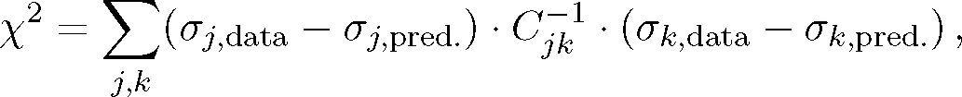
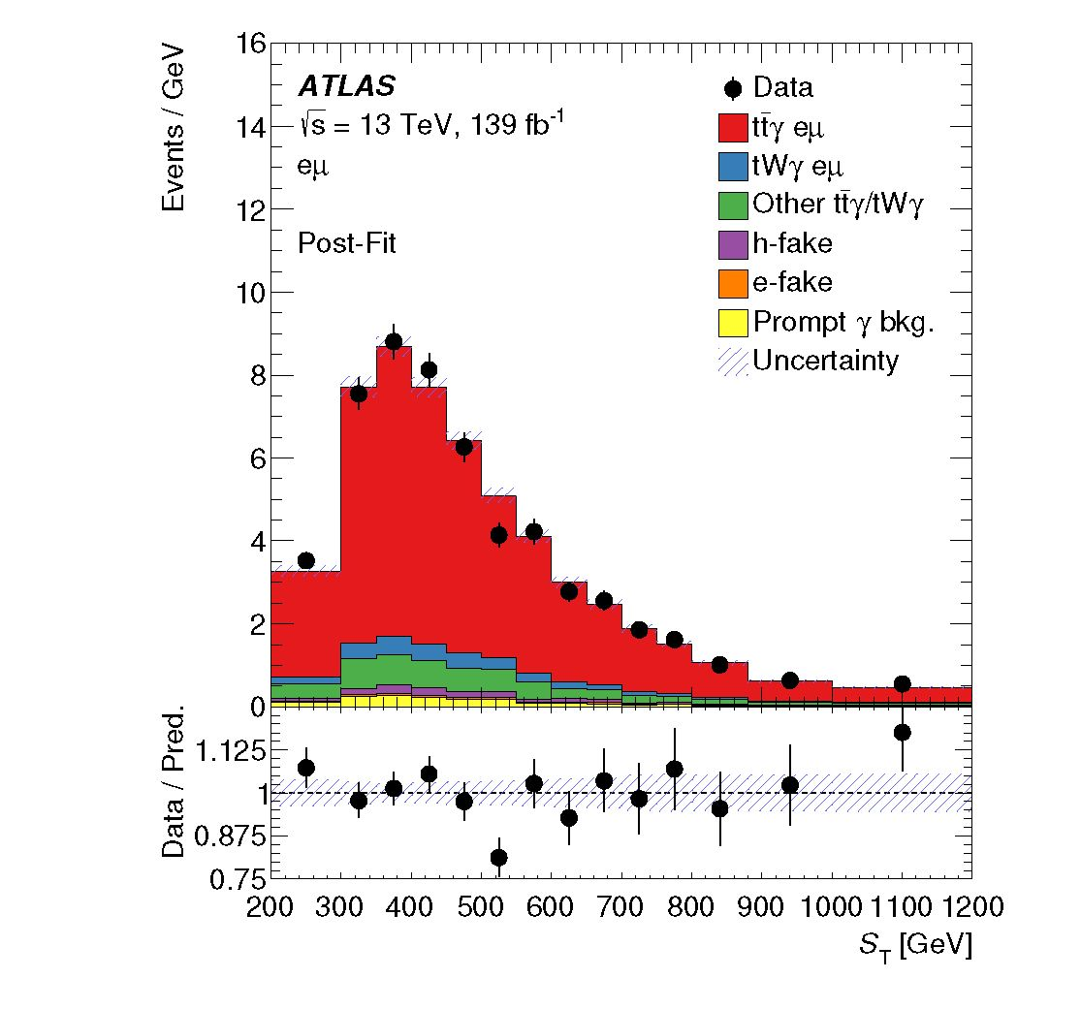
Figure 6. Post-fit distribution of the ST variable. The uncertainty band represents the postfit uncertainties. Underflow and overflow events are included in the first and last bins of the distribution, respectively. The lower part of the plot shows the ratio of the data to the prediction.
mass of the top quark is set to 173.2 GeV. The electroweak coupling in the calculation is derived from the Fermi constant G^ and it is set to acM ~ 1/132, while it is 1/137 for the leading emission. Further details can be found in ref. [10].
  - 8 Differential cross-section measurements
The absolute differential cross-sections are shown in figure 7 while the normalised measured differential cross-sections are presented in figure 8. The cross-sections are compared with the NLO calculation in the same fiducial phase space and with the combination of the tPy and tWq LO MADGRApH5_aMC@NLO simulations interfaced with Pythia 8 and Herwig 7, referred to as MG5_aMC+PYTHiA8 and MG5_aMC+HERWiG7 in the following plots and tables. The calculated x2/ndf values for the absolute and normalised cross-sections and their corresponding p-values are summarised in tables 3 and 4, quantifying the probability of compatibility between data and each of the predictions. The x2 values are calculated as:
where odata and opred. are the unfolded and predicted differential cross-sections, is the covariance matrix of Odata, calculated as the sum of the covariance matrix for the statistical uncertainty and the covariance matrices for the systematic uncertainties, and j and k are the binning indices of the distribution. The covariance matrix for each of the systematic uncertainties is estimated as x ok, where and ok are the symmetrised
- 19 -
JHEP09(2020)049
Predictions | Pt(y )  X2 /ndf p-value | InMI  X2/ndf p-value | AR( YX)min X2 /ndf p-value | Ad(^A)  X2/ndf p-value | |An(T,d)|  X2 /ndf p-value
Theory NLO | 6.1/11 0.87 | 4.5/8 0.81 | 11.7/10 0.31 | 5.8/10 0.83 | 6.2/8 0.62
Table 3. x2/ndf and p-values between the measured absolute cross-sections and the NLO calculation.
Predictions | pt(Y)  X2/ndf p-value | |n(Y)|  X2 /ndf p-value | AR( Y,^)min  X2/ndf p-value | A^X)  X2/ndf p-value | |Ap(^)|  X 2/ndf p-value
tty+tWy (MG5_aMC+PYTHIA8) tty+tWy (MG5j,MC+Herwig7) Theory NLO | 6.3/10 0.79 5.3/10 0.87 6.0/10 0.82 | 7.3/7 0.40 7.7/7 0.36 4.5/7 0.72 | 20.1/9 0.02 18.9/9 0.03 13.5/9 0.14 | 30.8/9 < 0.01 31.6/9 < 0.01 5.8/9 0.76 | 6.5/7 0.48 6.8/7 0.45 5.6/7 0.59
Table 4. x2/ndf and p-values between the measured normalised cross-sections and various predictions from the MC simulation and the NLO calculation.
uncertainties for bin j and bin k of the unfolded distribution. In the case of the normalised differential cross-sections, the last bin is removed from the x2 calculation and the number of degrees of freedom is reduced by one.
The shape of the measured differential distributions is generally well described by both the LO MC predictions from MADGRApH5_aMC@NLO and the NLO theory prediction. The latter tends to describe the shape of the measured distribution slightly better. The shapes of AR(Y,/)min and A0(^,^) are not perfectly modelled by the Mad- GRAph5_aMC@NLO simulation, while the NLO prediction provides a better description of these distributions.
The systematic uncertainties of the unfolded distributions are decomposed into signal modelling uncertainties, experimental uncertainties, and background modelling uncertainties. The breakdown of the categories of systematic uncertainties and the statistical one, which is the dominant source of uncertainty, is illustrated in figures 9 and 10 for the absolute and normalised differential cross-sections, respectively. The systematic uncertainty is dominated by the background and signal modelling.
  - 9 Conclusions
Measurements of the fiducial inclusive production cross-section, as well as absolute and normalised differential production cross-sections, of the combined Hq/tWY process in the ep decay channel are presented using pp collisions at a centre-of-mass energy of 13 TeV, corresponding to an integrated luminosity of 139 fb-1 recorded by the ATLAS detector at the LHC. For the estimation of efficiencies and acceptance corrections, a LO Monte Carlo simulation of the 2 ^ 7 process pp ^ evpvbbY was used for the t?Y part of the signal. The contribution from tWY was estimated from a combination of LO Monte Carlo simulations for the 2 ^ 3 process pp ^ tWY and the 2 ^ 6 process pp ^ evpvbY. The simulations include initial- and final-state radiation of the photon from all involved objects in the matrix element. The resonant top-quark production is taken into account in the
- 20 -
JHEP09(2020)049
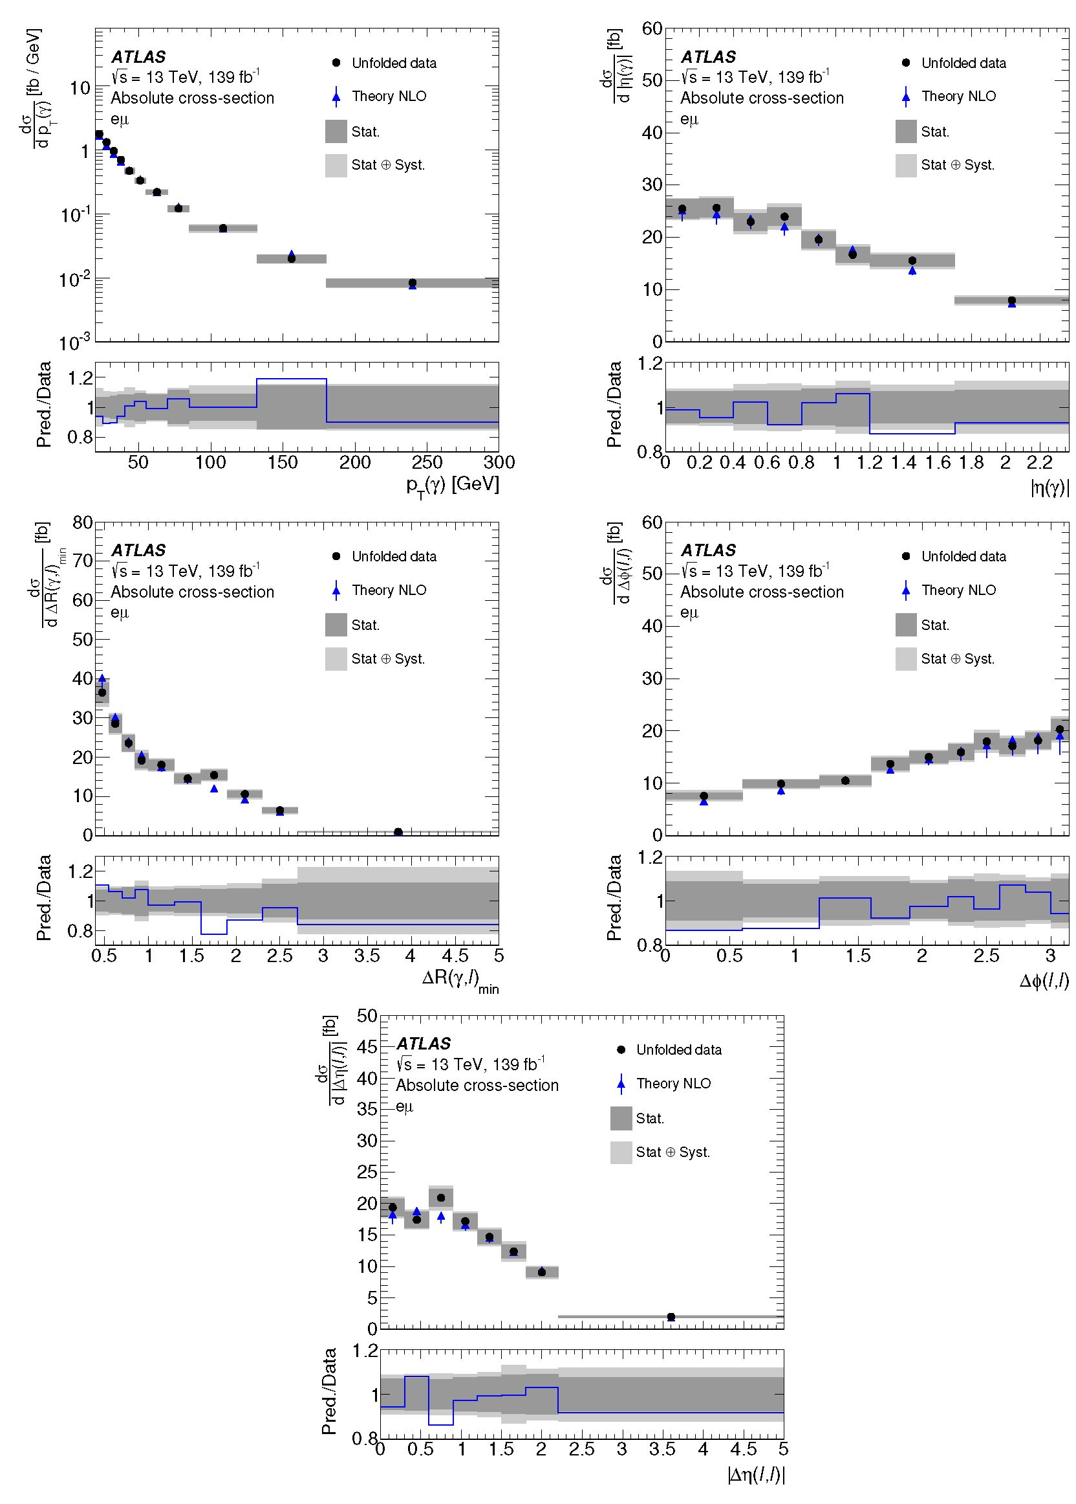
Figure 7. Absolute differential cross-section measured in the fiducial phase space as a function of the photon pT, photon |n|, AR(y, f)min, A^(f, f), and |An(f, f)| (from left to right and top to bottom). Data are compared with the NLO calculation provided by the authors of refs. [10, 11]. The uncertainty in the calculation corresponds to the total scale and PDF uncertainties. The PDF uncertainty is rescaled to the 68% CL. The lower part of each plot shows the ratio of the prediction to the data.
- 21 -
JHEP09(2020)049
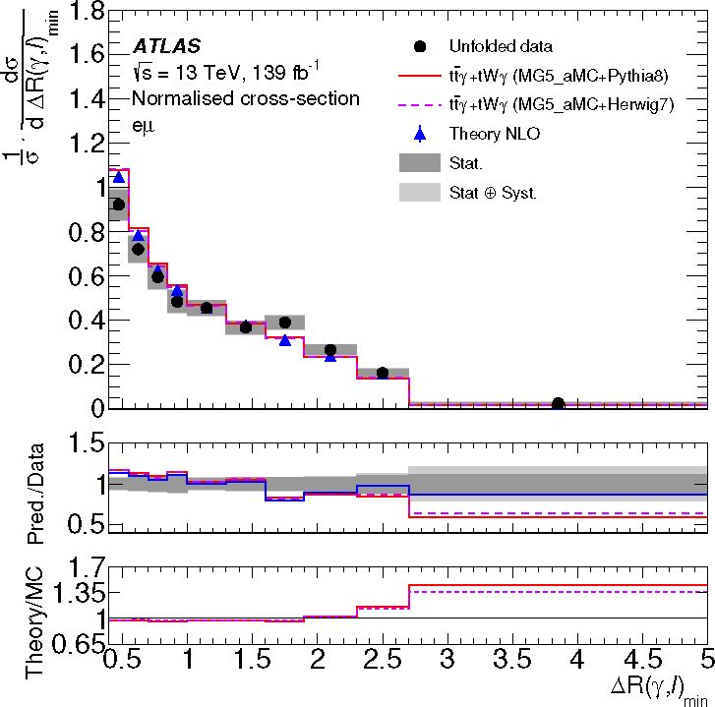
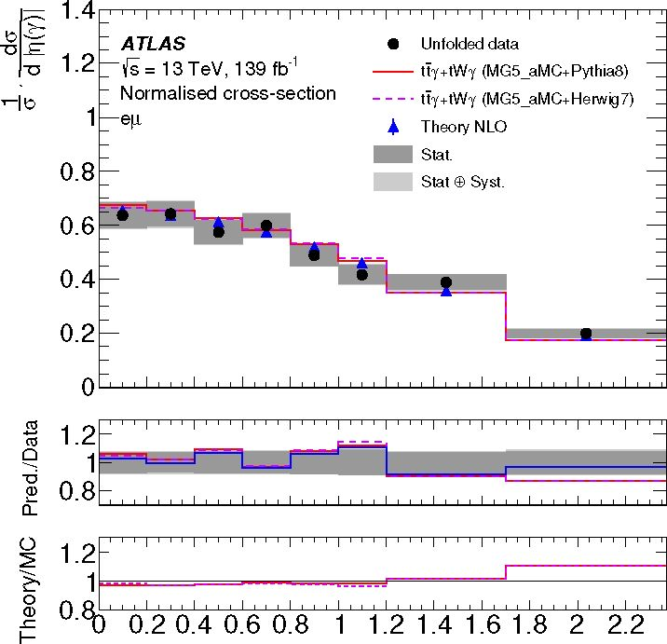
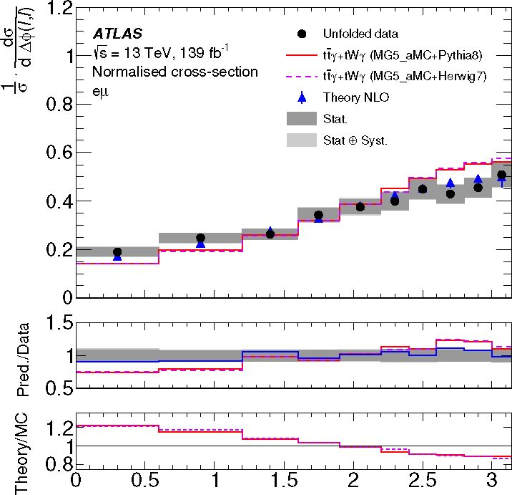
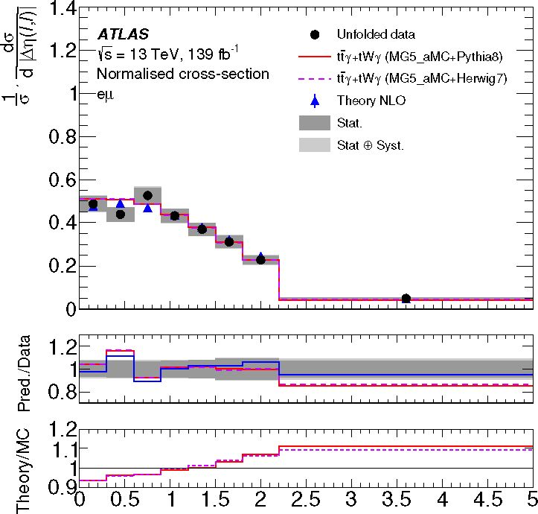
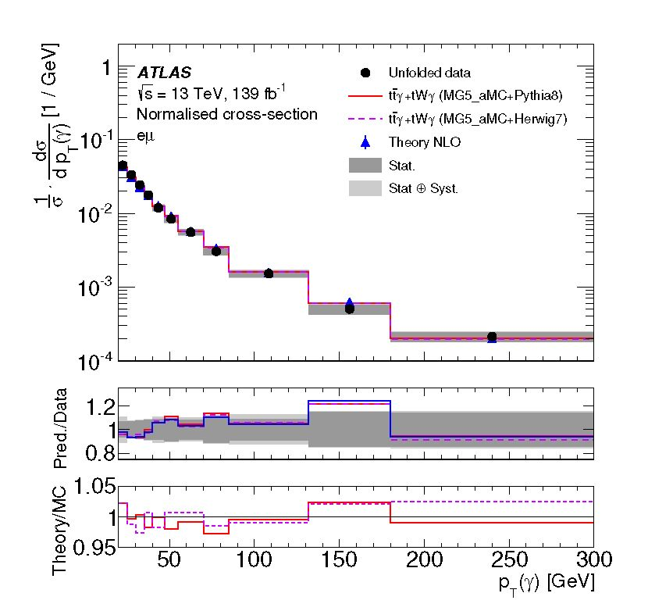
tn(r )l
ty(l,/)
itnrn
Figure 8. Normalised differential cross-section measured in the fiducial phase space as a function of the photon pT, photon |n|, AR(Y%)min, A^(^, ^), and |Ap(^, f) (from left to right and top to bottom). Data are compared with the NLO calculation provided by the authors of refs. [10, 11] and the MAdGRApH5_aMC@NLO simulation interfaced with Pythia 8 and Herwig 7. The uncertainty in the calculation corresponds to the total scale and PDF uncertainties. The PDF uncertainty is rescaled to the 68% CL. The lower parts of each plot show the ratio of the prediction to the data and the ratio of the NLO calculation to the MC simulations.
- 22 -
JHEP09(2020)049
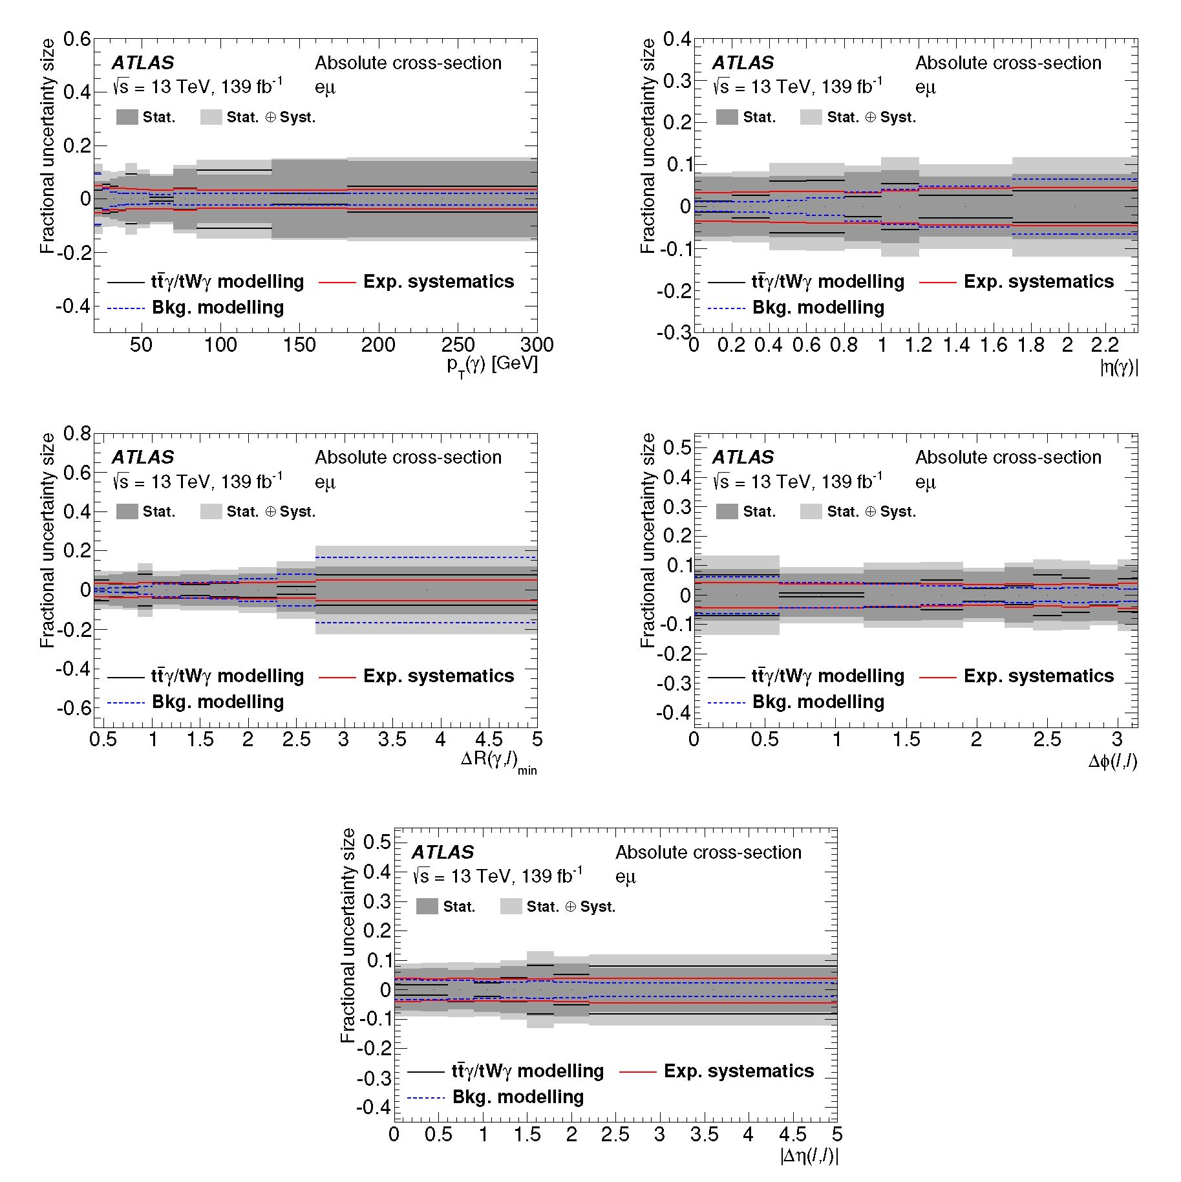
Figure 9. Contribution of each category of systematic uncertainties in each bin of the measurement of the absolute cross-sections as functions of the photon pT, photon |n|, AR(y, ^)min, A^(^, and
|An(€,c)|.
simulation of t^Y. Possible singly resonant production leading to the same final state is included in the simulation of the tWY process.
The results are compared with the prediction from the LO Monte Carlo simulations and also a dedicated NLO theory prediction which includes all off-shell contributions. The measured fiducial inclusive cross-section of a = 39.6 +2'3 fb is found to be in good agreement with the predicted NLO cross-section. All considered differential distributions are also found to be well described by the NLO theory prediction.
- 23 -
JHEP09(2020)049
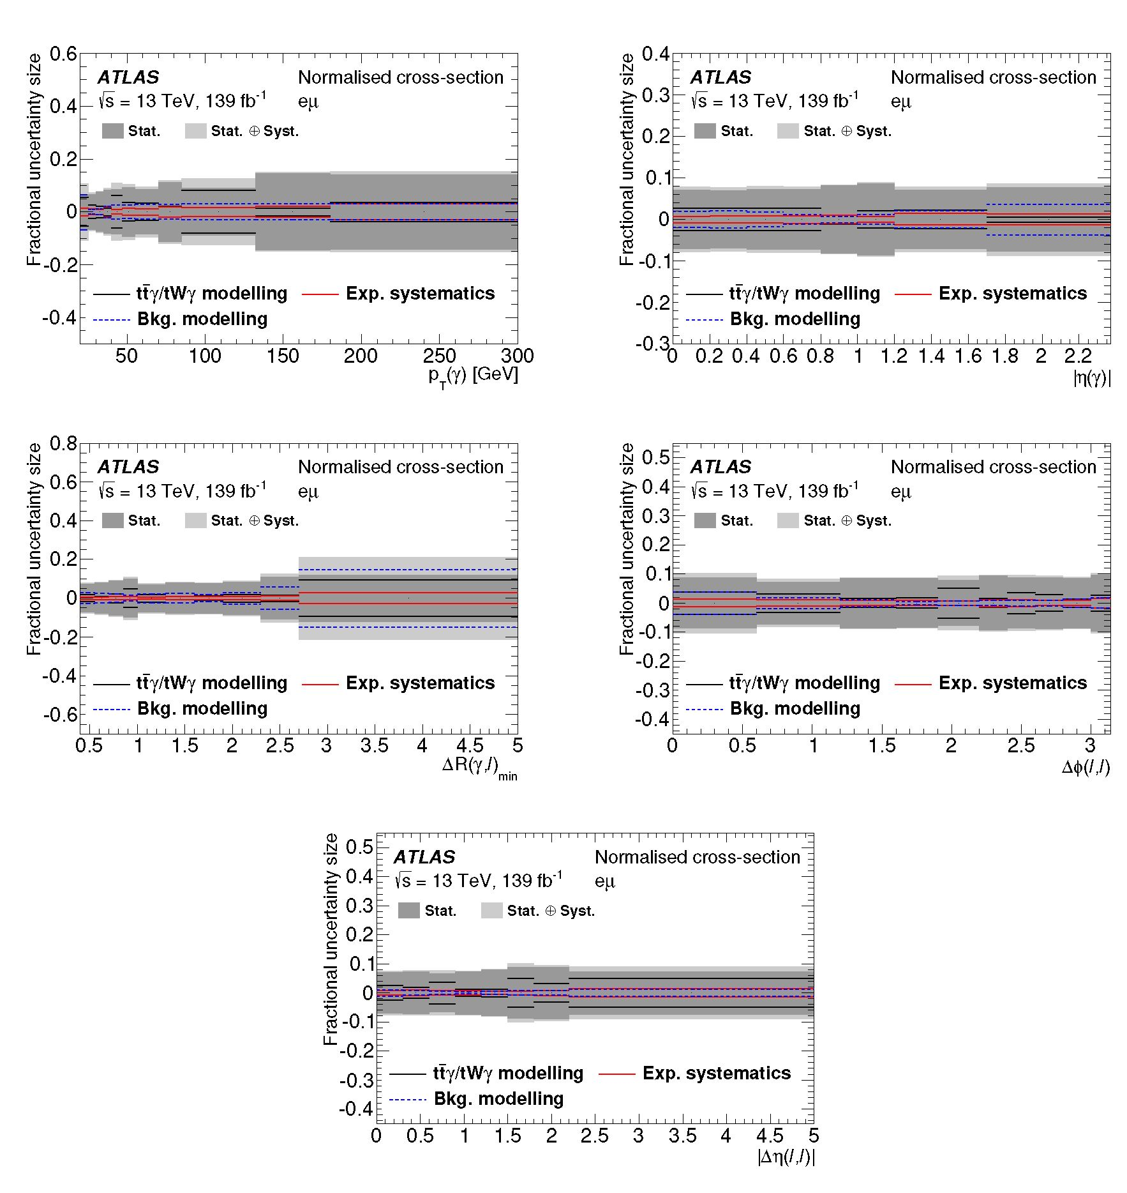
Figure 10. Contribution of each category of systematic uncertainties in each bin of the measurement of the normalised cross-sections as functions of the photon pT, photon |n|, AR(y,f)min, A^(f, f) and |An(f, f)| (from left to right and top to bottom).
  - Acknowledgments
We thank CERN for the very successful operation of the LHC, as well as the support staff from our institutions without whom ATLAS could not be operated efficiently.
We thank the authors, in particular M. Worek, for fruitful discussions and for providing dedicated theory predictions for our measurements.
We acknowledge the support of ANPCyT, Argentina; YerPhI, Armenia; ARC, Australia; BMWFW and FWF, Austria; ANAS, Azerbaijan; SSTC, Belarus; CNPq and FAPESP, Brazil; NSERC, NRC and CFI, Canada; CERN; CONICYT, Chile; CAS,
- 24 -
JHEP09(2020)049
MOST and NSFC, China; COLCIENCIAS, Colombia; MSMT CR, MPO CR and VSC CR, Czech Republic; DNRF and DNSRC, Denmark; IN2P3-CNRS and CEA-DRF/IRFU, France; SRNSFG, Georgia; BMBF, HGF and MPG, Germany; GSRT, Greece; RGC and Hong Kong SAR, China; ISF and Benoziyo Center, Israel; INFN, Italy; MEXT and JSPS, Japan; CNRST, Morocco; NWO, Netherlands; RCN, Norway; MNiSW and NCN, Poland; FCT, Portugal; MNE/IFA, Romania; MES of Russia and NRC KI, Russia Federation; JINR; MESTD, Serbia; MSSR, Slovakia; ARRS and MIZS, Slovenia; DST/NRF, South Africa; MINECO, Spain; SRC and Wallenberg Foundation, Sweden; SERI, SNSF and Cantons of Bern and Geneva, Switzerland; MOST, Taiwan; TAEK, Turkey; STFC, United Kingdom; DOE and NSF, United States of America. In addition, individual groups and members have received support from BCKDF, CANARIE, Compute Canada and CRC, Canada; ERC, ERDF, Horizon 2020, Marie Sklodowska-Curie Actions and COST, European Union; Investissements d’Avenir Labex, Investissements d’Avenir Idex and ANR, France; DFG and AvH Foundation, Germany; Herakleitos, Thales and Aristeia programmes co-financed by EU-ESF and the Greek NSRF, Greece; BSF-NSF and GIF, Israel; CERCA Programme Generalitat de Catalunya and PROMETEO Programme Generalitat Valenciana, Spain; Goran Gustafssons Stiftelse, Sweden; The Royal Society and Leverhulme Trust, United Kingdom.
The crucial computing support from all WLCG partners is acknowledged gratefully, in particular from CERN, the ATLAS Tier-1 facilities at TRIUMF (Canada), NDGF (Denmark, Norway, Sweden), CC-IN2P3 (France), KIT/GridKA (Germany), INFN-CNAF (Italy), NL-T1 (Netherlands), PIC (Spain), ASGC (Taiwan), RAL (U.K.) and BNL (U.S.A.), the Tier-2 facilities worldwide and large non-WLCG resource providers. Major contributors of computing resources are listed in ref. [73].
Open Access. This article is distributed under the terms of the Creative Commons Attribution License (CC-BY 4.0), which permits any use, distribution and reproduction in any medium, provided the original author(s) and source are credited.
  - References
- U. Baur, A. Juste, L.H. Orr and D. Rainwater, Probing electroweak top quark couplings at hadron colliders, Phys. Rev. D 71 (2005) 054013 [hep-ph/0412021] [inSPIRE].
- A.O. Bouzas and F. Larios, Electromagnetic dipole moments of the top quark, Phys. Rev. D 87 (2013) 074015 [arXiv:1212.6575] [inSPIRE].
- M. Schulze and Y. Soreq, Pinning down electroweak dipole operators of the top quark, Eur. Phys. J. C 76 (2016) 466 [arXiv:1603.08911] [inSPIRE].
- O. Bessidskaia Bylund, F. Maltoni, I. Tsinikos, E. Vryonidou and C. Zhang, Probing top quark neutral couplings in the Standard Model effective field theory at NLO in QCD, JHEP 05 (2016) 052 [arXiv:1601.08193] [inSPIRE].
- CDF collaboration, Evidence for tty production and measurement of otiy/oti, Phys. Rev. D 84 (2011) 031104 [arXiv:1106.3970] [inSPIRE].
- 25 -
JHEP09(2020)049
- ATLAS collaboration, Observation of top-quark pair production in association with a photon and measurement of the tty production cross section in pp collisions at ffs = 7 TeV using the ATLAS detector, Phys. Rev. D 91 (2015) 072007 [arXiv:1502.00586] [inSPIRE].
- ATLAS collaboration, Measurement of the tty production cross section in proton-proton collisions at /s = 8 TeV with the ATLAS detector, JHEP 11 (2017) 086 [arXiv:1706.03046] [inSPIRE].
- CMS collaboration, Measurement of the semileptonic tt + y production cross section in pp collisions at /s = 8 TeV, JHEP 10 (2017) 006 [arXiv:1706.08128] [inSPIRE].
- ATLAS collaboration, Measurements of inclusive and differential fiducial cross-sections of tty production in leptonic final states at ffs = 13 TeV in ATLAS, Eur. Phys. J. C 79 (2019) 382 [arXiv:1812.01697] [inSPIRE].
- G. Bevilacqua, H.B. Hartanto, M. Kraus, T. Weber and M. Worek, Hard photons in hadroproduction of top quarks with realistic final states, JHEP 10 (2018) 158 [arXiv:1803.09916] [inSPIRE].
- G. Bevilacqua, H.B. Hartanto, M. Kraus, T. Weber and M. Worek, Precise predictions for ttyjtt cross section ratios at the LHC, JHEP 01 (2019) 188 [arXiv:1809.08562] [inSPIRE].
- ATLAS collaboration, The ATLAS experiment at the CERN Large Hadron Collider, 2008 JINST 3 S08003 [inSPIRE].
- ATLAS collaboration, ATLAS insertable B-layer technical design report, Tech. Rep. CERN-LHCC-2010-013, CERN, Geneva, Switzerland (2010) [ATLAS-TDR-19] [Addendum CERN-LHCC-2012-009] [Addendum ATLAS-TDR-19-ADD-1].
- ATLAS IBL collaboration, Production and integration of the ATLAS insertable B-layer, 2018 JINST 13 T05008 [arXiv:1803.00844] [inSPIRE].
- ATLAS collaboration, Performance of the ATLAS trigger system in 2015, Eur. Phys. J. C 77 (2017) 317 [arXiv:1611.09661] [inSPIRE].
- ATLAS collaboration, The ATLAS simulation infrastructure, Eur. Phys. J. C 70 (2010) 823 [arXiv:1005.4568] [inSPIRE].
- GEANT4 collaboration, GEANT4 — a simulation toolkit, Nucl. Instrum. Meth. A 506 (2003) 250 [inSPIRE].
- T. Sjostrand, S. Mrenna and P.Z. Skands, PYTHIA 6.4 physics and manual, JHEP 05 (2006) 026 [hep-ph/0603175] [inSPIRE].
- T. Sjostrand et al., An introduction to PYTHIA 8.2, Comput. Phys. Commun. 191 (2015) 159 [arXiv:1410.3012] [inSPIRE].
- ATLAS collaboration, The PYTHIA 8 A3 tune description of ATLAS minimum bias and inelastic measurements incorporating the Donnachie-Landshoff diffractive model, Tech. Rep. ATL-PHYS-PUB-2016-017, CERN, Geneva, Switzerland (2016).
- J. Pumplin, D.R. Stump, J. Huston, H.L. Lai, P.M. Nadolsky and W.K. Tung, New generation of parton distributions with uncertainties from global QCD analysis, JHEP 07 (2002) 012 [hep-ph/0201195] [inSPIRE].
- J. Alwall et al., The automated computation of tree-level and next-to-leading order differential cross sections, and their matching to parton shower simulations, JHEP 07 (2014) 079 [arXiv:1405.0301] [inSPIRE].
- 26 -
JHEP09(2020)049
- ATLAS collaboration, ATLAS PYTHIA 8 tunes to 7 TeV datas, Tech. Rep. ATL-PHYS-PUB-2014-021, CERN, Geneva, Switzerland (2014).
- D.J. Lange, The EvtGen particle decay simulation package, Nucl. Instrum. Meth. A 462 (2001) 152 [inSPIRE].
- T. Gleisberg et al., Event generation with SHERPA 1.1, JHEP 02 (2009) 007 [arXiv:0811.4622] [inSPIRE].
- S. Hoche, F. Krauss, S. Schumann and F. Siegert, QCD matrix elements and truncated showers, JHEP 05 (2009) 053 [arXiv:0903.1219] [inSPIRE].
- T. Gleisberg and S. Hoche, Comix, a new matrix element generator, JHEP 12 (2008) 039 [arXiv:0808.3674] [inSPIRE].
- S. Schumann and F. Krauss, A parton shower algorithm based on Catani-Seymour dipole factorisation, JHEP 03 (2008) 038 [arXiv:0709.1027] [inSPIRE].
- S. Hoche, F. Krauss, M. Schonherr and F. Siegert, A critical appraisal of NLO+PS matching methods, JHEP 09 (2012) 049 [arXiv:1111.1220] [inSPIRE].
- S. Catani, F. Krauss, R. Kuhn and B.R. Webber, QCD matrix elements + parton showers, JHEP 11 (2001) 063 [hep-ph/0109231] [inSPIRE].
- S. Hoche, F. Krauss, M. Schonherr and F. Siegert, QCD matrix elements + parton showers:
the NLO case, JHEP 04 (2013) 027 [arXiv:1207.5030] [inSPIRE].
- F. Cascioli, P. Maierhofer and S. Pozzorini, Scattering amplitudes with open loops, Phys. Rev. Lett. 108 (2012) 111601 [arXiv:1111.5206] [inSPIRE].
- A. Denner, S. Dittmaier and L. Hofer, Collier: a fortran-based Complex One-Loop LIbrary in Extended Regularizations, Comput. Phys. Commun. 212 (2017) 220 [arXiv:1604.06792] [inSPIRE].
- P. Nason, A new method for combining NLO QCD with shower Monte Carlo algorithms,
JHEP 11 (2004) 040 [hep-ph/0409146] [inSPIRE].
- S. Frixione, P. Nason and C. Oleari, Matching NLO QCD computations with parton shower simulations: the POWHEG method, JHEP 11 (2007) 070 [arXiv:0709.2092] [inSPIRE].
- S. Alioli, P. Nason, C. Oleari and E. Re, A general framework for implementing NLO calculations in shower Monte Carlo programs: the POWHEG BOX, JHEP 06 (2010) 043 [arXiv:1002.2581] [inSPIRE].
- NNPDF collaboration, Parton distributions for the LHC run II, JHEP 04 (2015) 040 [arXiv:1410.8849] [inSPIRE].
- ATLAS collaboration, Summary of ATLAS PYTHIA 8 tunes, Tech. Rep. ATL-PHYS-PUB-2012-003, CERN, Geneva, Switzerland (2012).
- M. Czakon and A. Mitov, Top++: a program for the calculation of the top-pair cross-section at hadron colliders, Comput. Phys. Commun. 185 (2014) 2930 [arXiv:1112.5675] [inSPIRE].
- ATLAS collaboration, Measurement of W± and Z-boson production cross sections in pp collisions at fs = 13 TeV with the ATLAS detector, Phys. Lett. B 759 (2016) 601 [arXiv:1603.09222] [inSPIRE].
- J.M. Campbell and R. Ellis, An update on vector boson pair production at hadron colliders, Phys. Rev. D 60 (1999) 113006 [hep-ph/9905386] [inSPIRE].
- 27 -
JHEP09(2020)049
- LHC Higgs Cross Section Working Group collaboration, Handbook of LHC Higgs cross sections: 4. Deciphering the nature of the Higgs sector, arXiv:1610.07922 [inSPIRE].
- ATLAS collaboration, Performance of electron and photon triggers in ATLAS during LHC run 2, Eur. Phys. J. C 80 (2020) 47 [arXiv:1909.00761] [inSPIRE].
- ATLAS collaboration, Performance of the ATLAS muon triggers in run 2, arXiv:2004.13447 [inSPIRE].
- ATLAS collaboration, Electron and photon performance measurements with the ATLAS detector using the 2015-2017 LHC proton-proton collision data, 2019 JINST 14 P12006 [arXiv:1908.00005] [inSPIRE].
- ATLAS collaboration, Muon reconstruction performance of the ATLAS detector in proton-proton collision data at a/s = 13 TeV, Eur. Phys. J. C 76 (2016) 292 [arXiv:1603.05598] [inSPIRE].
- ATLAS collaboration, Measurement of the photon identification efficiencies with the ATLAS detector using LHC run 2 data collected in 2015 and 2016, Eur. Phys. J. C 79 (2019) 205 [arXiv:1810.05087] [inSPIRE].
- ATLAS collaboration, Electron and photon energy calibration with the ATLAS detector using 2015-2016 LHC proton-proton collision data, 2019 JINST 14 P03017 [arXiv:1812.03848] [inSPIRE].
- M. Cacciari, G.P. Salam and G. Soyez, The anti-kt jet clustering algorithm, JHEP 04 (2008) 063 [arXiv:0802.1189] [inSPIRE].
- M. Cacciari, G.P. Salam and G. Soyez, FastJet user manual, Eur. Phys. J. C 72 (2012) 1896 [arXiv:1111.6097] [inSPIRE].
- ATLAS collaboration, Properties of jets and inputs to jet reconstruction and calibration with the ATLAS detector using proton-proton collisions at a/s = 13 TeV, Tech. Rep. ATL-PHYS-PUB-2015-036, CERN, Geneva, Switzerland (2015).
- ATLAS collaboration, Jet energy scale measurements and their systematic uncertainties in proton-proton collisions at a/s = 13 TeV with the ATLAS detector, Phys. Rev. D 96 (2017) 072002 [arXiv:1703.09665] [inSPIRE].
- ATLAS collaboration, Tagging and suppression of pileup jets with the ATLAS detector,
Tech. Rep. ATLAS-CONF-2014-018, CERN, Geneva, Switzerland (2014).
- ATLAS collaboration, Optimisation and performance studies of the ATLAS b-tagging algorithms for the 2017-18 LHC run, Tech. Rep. ATL-PHYS-PUB-2017-013, CERN, Geneva, Switzerland (2017).
- ATLAS collaboration, Measurements of b-jet tagging efficiency with the ATLAS detector- using tt events at fs = 13 TeV, JHEP 08 (2018) 089 [arXiv:1805.01845] [inSPIRE].
- ATLAS collaboration, E™ss performance in the ATLAS detector using 2015-2016 LHC pp collisions, Tech. Rep. ATLAS-CONF-2018-023, CERN, Geneva, Switzerland (2018).
- ATLAS collaboration, Performance of missing transverse momentum reconstruction with the ATLAS detector using proton-proton collisions at a/s = 13 TeV, Eur. Phys. J. C 78 (2018) 903 [arXiv:1802.08168] [inSPIRE].
- S. Frixione, Isolated photons in perturbative QCD, Phys. Lett. B 429 (1998) 369 [hep-ph/9801442] [inSPIRE].
- 28 -
JHEP09(2020)049
- G. Cowan, K. Cranmer, E. Gross and O. Vitells, Asymptotic formulae for likelihood-based tests of new physics, Eur. Phys. J. C 71 (2011) 1554 [Erratum ibid. 73 (2013) 2501] [arXiv:1007.1727] [inSPIRE].
- G. D’Agostini, A multidimensional unfolding method based on Bayes' theorem, Nucl.
Instrum. Meth. A 362 (1995) 487 [inSPIRE].
- T. Adye, Unfolding algorithms and tests using RooUnfold, in PHYSTAT 2011, CERN-2011-006.313, CERN, Geneva, Switzerland (2011), pg. 313 [arXiv:1105.1160] [inSPIRE].
- ATLAS collaboration, Jet calibration and systematic uncertainties for jets reconstructed in the ATLAS detector at yS = 13 TeV, Tech. Rep. ATL-PHYS-PUB-2015-015, CERN, Geneva, Switzerland (2015).
- ATLAS collaboration, Measurements of b-jet tagging efficiency with the ATLAS detector- using tt events at yS = 13 TeV, JHEP 08 (2018) 089 [arXiv:1805.01845] [inSPIRE].
- ATLAS collaboration, Measurement of b-tagging efficiency of c-jets in tt events using a likelihood approach with the ATLAS detector, Tech. Rep. ATLAS-CONF-2018-001, CERN, Geneva, Switzerland (2018).
- ATLAS collaboration, Calibration of light-flavour b-jet mistagging rates using ATLAS proton-proton collision data at yT = 13 TeV, Tech. Rep. ATLAS-CONF-2018-006, CERN, Geneva, Switzerland (2018).
- ATLAS collaboration, Performance of missing transverse momentum reconstruction in ATLAS studied in proton-proton collisions recorded in 2012 at 8 TeV, Tech. Rep. ATLAS-CONF-2013-082, CERN, Geneva, Switzerland (2013).
- ATLAS collaboration, Luminosity determination in pp collisions at a/s = 13 TeV using the ATLAS detector at the LHC, Tech. Rep. ATLAS-CONF-2019-021, CERN, Geneva, Switzerland (2019).
- G. Avoni et al., The new LUCID-2 detector for luminosity measurement and monitoring in ATLAS, 2018 JINST 13 P07017 [inSPIRE].
- M. Bahr et al., HERWIG++ physics and manual, Eur. Phys. J. C 58 (2008) 639 [arXiv:0803.0883] [inSPIRE].
- J. Bellm et al., HERWIG 7.0/HERWIG++ 3.0 release note, Eur. Phys. J. C 76 (2016) 196 [arXiv:1512.01178] [inSPIRE].
- ATLAS collaboration, Improvements in tt modelling using NLO+PS Monte Carlo generators for run2, Tech. Rep. ATL-PHYS-PUB-2018-009, CERN, Geneva, Switzerland (2018).
- S. Dulat et al., New parton distribution functions from a global analysis of quantum chromodynamics, Phys. Rev. D 93 (2016) 033006 [arXiv:1506.07443] [inSPIRE].
- ATLAS collaboration, ATLAS computing acknowledgements, Tech. Rep. ATL-SOFT-PUB-2020-001, CERN, Geneva, Switzerland (2020).
- 29 -
JHEP09(2020)049
  - The ATLAS collaboration
G. Aad 102, B. Abbott 128, D.C. Abbott 103, A. Abed Abud 36, K. Abeling 53,
- K. Abhayasinghe 94, S.H. Abidi 166, O.S. AbouZeid 40, N.L. Abraham 155, H. Abramowicz 160, H. Abreu 159, Y. Abulaiti 6, B.S. Acharya 67a,67b,n, B. Achkar 53, L. Adam 100,
- Adam Bourdarios 5, L. Adamczyk 84a, L. Adamek 166, J. Adelman 121, M. Adersberger 114, A. Adiguzel 12c, S. Adorni 54, T. Adye 143, A.A. Affolder 145, Y. Afik 159,
- Agapopoulou 65, M.N. Agaras 38, A. Aggarwal 119, C. Agheorghiesei 27c,
J.A. Aguilar-Saavedra 139f,139a,ad, A. Ahmad 36, F. Ahmadov 80, W.S. Ahmed 104, X. Ai 18,
- Aielli 74a,74b, S. Akatsuka 86, M. Akbiyik 100, T.P.A. Akesson 97, E. Akilli 54,
A.V. Akimov 111, K. Al Khoury 65, G.L. Alberghi 23b,23a, J. Albert 175,
M.J. Alconada Verzini 160, S. Alderweireldt 36, M. Aleksa 36, I.N. Aleksandrov 80, C. Alexa 27b, T. Alexopoulos 10, A. Alfonsi 120, F. Alfonsi 23b,23a, M. Alhroob 128, B. Ali 141, S. Ali 157, M. Aliev 165, G. Alimonti 69a, C. Allaire 36, B.M.M. Allbrooke 155, B.W. Allen 131, P.P. Allport 21, A. Aloisio 70a,70b, F. Alonso 89, C. Alpigiani 147, E. Alunno Camelia 74a,74b,
M. Alvarez Estevez 99, M.G. Alviggi 70a,70b, Y. Amaral Coutinho 81b, A. Ambler 104,
L. Ambroz 134, C. Amelung 26, D. Amidei 106, S.P. Amor Dos Santos 139a, S. Amoroso 46,
- S. Amrouche 54, F. An 79, C. Anastopoulos 148, N. Andari 144, T. Andeen 11,
J.K. Anders 20, S.Y. Andrean 45a,45b, A. Andreazza 69a,69b, V. Andrei 61a, C.R. Anelli 175,
S. Angelidakis 9, A. Angerami 39, A.V. Anisenkov 122b,122a, A. Annovi 72a, C. Antel 54,
M.T. Anthony 148, E. Antipov 129, M. Antonelli 51, D.J.A. Antrim 170, F. Anulli 73a,
M. Aoki 82, J.A. Aparisi Pozo 173, M.A. Aparo 155, L. Aperio Bella 46, N. Aranzabal Barrio 36, V. Araujo Ferraz 81a, R. Araujo Pereira 81b, C. Arcangeletti 51, A.T.H. Arce 49,
- A. Arduh 89, J-F. Arguin 110, S. Argyropoulos 52, J.-H. Arling 46, A.J. Armbruster 36,
A. Armstrong 170, O. Arnaez 166, H. Arnold 120, Z.P. Arrubarrena Tame 114, G. Artoni 134,
- Asada 117, K. Asai 126, S. Asai 162, T. Asawatavonvanich 164, N. Asbah 59,
- M. Asimakopoulou 171, L. Asquith 155, J. Assahsah 35d, K. Assamagan 29, R. Astalos 28a, R.J. Atkin 33a, M. Atkinson 172, N.B. Atlay 19, H. Atmani 65, K. Augsten 141, V.A. Austrup 181, G. Avolio 36, M.K. Ayoub 15a, G. Azuelos 110,al, H. Bachacou 144, K. Bachas 161,
M. Backes 134, F. Backman 45a,45b, P. Bagnaia 73a,73b, M. Bahmani 85, H. Bahrasemani 151, A.J. Bailey 173, V.R. Bailey 172, J.T. Baines 143, C. Bakalis 10, O.K. Baker 182, P.J. Bakker
120, E. Bakos 16, D. Bakshi Gupta 8, S. Balaji 156, R. Balasubramanian 120, E.M. Baldin 122b,122a, P. Balek 179, F. Balli 144, W.K. Balunas 134, J. Balz 100, E. Banas 85,
M. Bandieramonte 138, A. Bandyopadhyay 24, Sw. Banerjee 180,1, L. Barak 160, W.M. Barbe 38, E.L. Barberio 105, D. Barberis 55b,55a, M. Barbero 102, G. Barbour 95, T. Barillari 115, M-S. Barisits 36, J. Barkeloo 131, T. Barklow 152, R. Barnea 159, B.M. Barnett 143,
R.M. Barnett 18, Z. Barnovska-Blenessy 60a, A. Baroncelli 60a, G. Barone 29, A.J. Barr 134, L. Barranco Navarro 45a,45b, F. Barreiro 99, J. Barreiro Guimaraes da Costa 15a, U. Barron 160, S. Barsov 137, F. Bartels 61a, R. Bartoldus 152, G. Bartolini 102, A.E. Barton 90,
P. Bartos 28a, A. Basalaev 46, A. Basan 100, A. Bassalat 65,ai, M.J. Basso 166, R.L. Bates 57, S. Batlamous 35e, J.R. Batley 32, B. Batool 150, M. Battaglia 145, M. Bauce 73a,73b,
- Bauer 144, P. Bauer 24, H.S. Bawa 31, A. Bayirli 12c, J.B. Beacham 49, T. Beau 135,
P.H. Beauchemin 169, F. Becherer 52, P. Bechtle 24, H.C. Beck 53, H.P. Beck 20,p,
K. Becker 177, C. Becot 46, A. Beddall 12d, A.J. Beddall 12a, V.A. Bednyakov 80,
M. Bedognetti 120, C.P. Bee 154, T.A. Beermann 181, M. Begalli 81b, M. Begel 29,
- Behera 154, J.K. Behr 46, F. Beisiegel 24, M. Belfkir 5, A.S. Bell 95, G. Bella 160,
L. Bellagamba 23b, A. Bellerive 34, P. Bellos 9, K. Beloborodov 122b,122a, K. Belotskiy 112, N.L. Belyaev 112, D. Benchekroun 35a, N. Benekos 10, Y. Benhammou 160, D.P. Benjamin 6,
- 30 -
JHEP09(2020)049
M. Benoit 29, J.R. Bensinger 26, S. Bentvelsen 120, L. Beresford 134, M. Beretta 51,
D. Berge 19, E. Bergeaas Kuutmann 171, N. Berger 5, B. Bergmann 141, L.J. Bergsten 26,
J. Beringer 18, S. Berlendis 7, G. Bernardi 135, C. Bernius 152, F.U. Bernlochner 24,
T. Berry 94, P. Berta 100, A. Berthold 48, I.A. Bertram 90, O. Bessidskaia Bylund 181,
N. Besson 144, A. Bethani 101, S. Bethke 115, A. Betti 42, A.J. Bevan 93, J. Beyer 115,
- S. Bhattacharya 176, P. Bhattarai 26, V.S. Bhopatkar 6, R. Bi 138, R.M. Bianchi 138,
- Biebel 114, D. Biedermann 19, R. Bielski 36, K. Bierwagen 100, N.V. Biesuz 72a,72b,
M. Biglietti 75a, T.R.V. Billoud 141, M. Bindi 53, A. Bingul 12d, C. Bini 73a,73b, S. Biondi 23b,23a, C.J. Birch-sykes 101, M. Birman 179, T. Bisanz 53, J.P. Biswal 3, D. Biswas 180’1,
A. Bitadze 101, C. Bittrich 48, K. Bj0rke 133, T. Blazek 28a, I. Bloch 46, C. Blocker 26,
A. Blue 57, U. Blumenschein 93, G.J. Bobbink 120, V.S. Bobrovnikov 122b,122a,
S.S. Bocchetta 97, D. Boerner 46, D. Bogavac 14, A.G. Bogdanchikov 122b,122a, C. Bohm 45a, V. Boisvert 94, P. Bokan 171>171>53, T. Bold 84a, A.E. Bolz 61b, M. Bomben 135, M. Bona 93, J.S. Bonilla 131, M. Boonekamp 144, C.D. Booth 94, A.G. Borbely 57, H.M. Borecka-Bielska 91, L.S. Borgna 95, A. Borisov 123, G. Borissov 90, D. Bortoletto 134, D. Boscherini 23b,
M. Bosman 14, J.D. Bossio Sola 104, K. Bouaouda 35a, J. Boudreau 138,
- V. Bouhova-Thacker 90, D. Boumediene 38, A. Boveia 127, J. Boyd 36, D. Boye 33c,
- R. Boyko 80, A.J. Bozson 94, J. Bracinik 21, N. Brahimi 60d, G. Brandt 181, O. Brandt 32,
- Braren 46, B. Brau 103, J.E. Brau 131, W.D. Breaden Madden 57, K. Brendlinger 46,
R. Brener 159, L. Brenner 36, R. Brenner 171, S. Bressler 179, B. Brickwedde 100,
- L. Briglin 21, D. Britton 57, D. Britzger 115, I. Brock 24, R. Brock 107, G. Brooijmans 39, W.K. Brooks 146d, E. Brost 29, P.A. Bruckman de Renstrom 85, B. Briiers 46, D. Bruncko 28b, A. Bruni 23b, G. Bruni 23b, M. Bruschi 23b, N. Bruscino 73a,73b, L. Bryngemark 152,
T. Buanes 17, Q. Buat 154, P. Buchholz 150, A.G. Buckley 57, I.A. Budagov 80, M.K. Bugge 133, F. Buhrer 52, O. Bulekov 112, B.A. Bullard 59, T.J. Burch 121, S. Burdin 91,
- D. Burgard 120, A.M. Burger 129, B. Burghgrave 8, J.T.P. Burr 46, C.D. Burton 11,
J.C. Burzynski 103, V. Buscher 100, E. Buschmann 53, P.J. Bussey 57, J.M. Butler 25,
- M. Buttar 57, J.M. Butterworth 95, P. Butti 36, W. Buttinger 36, C.J. Buxo Vazquez 107,
- Buzatu 157, A.R. Buzykaev 122b,122a, G. Cabras 23b,23a, S. Cabrera Urban 173, D. Caforio 56, H. Cai 138, V.M.M. Cairo 152, O. Cakir 4a, N. Calace 36, P. Calafiura 18, G. Calderini 135, P. Calfayan 66, G. Callea 57, L.P. Caloba 81b, A. Caltabiano 74a,74b, S. Calvente Lopez 99, D. Calvet 38, S. Calvet 38, T.P. Calvet 102, M. Calvetti 72a,72b, R. Camacho Toro 135,
S. Camarda 36, D. Camarero Munoz 99, P. Camarri 74a,74b, M.T. Camerlingo 75a,75b,
- Cameron 133, C. Camincher 36, S. Campana 36, M. Campanelli 95, A. Camplani 40,
V. Canale 70a,70b, A. Canesse 104, M. Cano Bret 78, J. Cantero 129, T. Cao 160, Y. Cao 172, M.D.M. Capeans Garrido 36, M. Capua 41b,41a, R. Cardarelli 74a, F. Cardillo 148,
- Carducci 41b,41a, I. Carli 142, T. Carli 36, G. Carlino 70a, B.T. Carlson 138, E.M. Carlson 175,167a, L. Carminati 69a,69b, R.M.D. Carney 152, S. Caron 119, E. Carquin 146d, S. Carra 46, G. Carratta 23b,23a, J.W.S. Carter 166, T.M. Carter 50, M.P. Casado 14f, A.F. Casha 166, E.G. Castiglia 182, F.L. Castillo 173, L. Castillo Garcia 14, V. Castillo Gimenez 173,
N.F. Castro 139a,139e, A. Catinaccio 36, J.R. Catmore 133, A. Cattai 36, V. Cavaliere 29,
V. Cavasinni 72a,72b, E. Celebi 12b, F. Celli 134, K. Cerny 130, A.S. Cerqueira 81a, A. Cerri 155, L. Cerrito 74a,74b, F. Cerutti 18, A. Cervelli 23b,23a, S.A. Cetin 12b, Z. Chadi 35a,
- Chakraborty 121, J. Chan 180, W.S. Chan 120, W.Y. Chan 91, J.D. Chapman 32,
- Chargeishvili 158b, D.G. Charlton 21, T.P. Charman 93, M. Chatterjee 20, C.C. Chau 34, S. Che 127, S. Chekanov 6, S.V. Chekulaev 167a, G.A. Chelkov 8°’ag, B. Chen 79, C. Chen 60a, C.H. Chen 79, H. Chen 15c, H. Chen 29, J. Chen 60a, J. Chen 39, J. Chen 26,
S. Chen 136, S.J. Chen 15c, X. Chen 15b, Y. Chen 60a, Y-H. Chen 46, H.C. Cheng 63a,
- 31 -
JHEP09(2020)049
- J. Cheng 15a, A. Cheplakov 80, E. Cheremushkina 123, R. Cherkaoui El Moursli 35e,
- Cheu 7, K. Cheung 64, T.J.A. Chevalerias 144, L. Chevalier 144, V. Chiarella 51,
G. Chiarelli 72a, G. Chiodini 68a, A.S. Chisholm 21, A. Chitan 27b, I. Chiu 162, Y.H. Chiu 175, M.V. Chizhov 80, K. Choi 11, A.R. Chomont 73a,73b, Y.S. Chow 120, L.D. Christopher 33e, M.C. Chu 63a, X. Chu 15a,15d, J. Chudoba 140, J.J. Chwastowski 85, L. Chytka 130,
- Cieri 115, K.M. Ciesla 85, V. Cindro 92, I.A. Cioara 27b, A. Ciocio 18, F. Cirotto 70a,70b, Z.H. Citron 179,j, M. Citterio 69a, D.A. Ciubotaru 27b, B.M. Ciungu 166, A. Clark 54,
M.R. Clark 39, P.J. Clark 50, S.E. Clawson 101, C. Clement 45a,45b, Y. Coadou 102,
M. Cobal 67a,67c, A. Coccaro 55b, J. Cochran 79, R. Coelho Lopes De Sa 103, H. Cohen 160, A.E.C. Coimbra 36, B. Cole 39, A.P. Colijn 120, J. Collot 58, P. Conde Muino 139a,139h,
S.H. Connell 33c, I.A. Connelly 57, S. Constantinescu 27b, F. Conventi 70a,am,
A.M. Cooper-Sarkar 134, F. Cormier 174, K.J.R. Cormier 166, L.D. Corpe 95, M. Corradi 73a,73b, E.E. Corrigan 97, F. Corriveau 104,ab, M.J. Costa 173, F. Costanza 5, D. Costanzo 148, G. Cowan 94, J.W. Cowley 32, J. Crane 101, K. Cranmer 125, R.A. Creager 136,
S. Crepe-Renaudin 58, F. Crescioli 135, M. Cristinziani 24, V. Croft 169, G. Crosetti 41b,41a, A. Cueto 5, T. Cuhadar Donszelmann 170, H. Cui 15a,15d, A.R. Cukierman 152,
W.R. Cunningham 57, S. Czekierda 85, P. Czodrowski 36, M.M. Czurylo 61b,
M.J. Da Cunha Sargedas De Sousa 60b, J.V. Da Fonseca Pinto 81b, C. Da Via 101,
W. Dabrowski 84a, F. Dachs 36, T. Dado 47, S. Dahbi 33e, T. Dai 106, C. Dallapiccola 103, M. Dam 40, G. D’amen 29, V. D’Amico 75a,75b, J. Damp 100, J.R. Dandoy 136, M.F. Daneri 30, M. Danninger 151, V. Dao 36, G. Darbo 55b, O. Dartsi 5, A. Dattagupta 131,
T. Daubney 46, S. D’Auria 69a,69b, C. David 167b, T. Davidek 142, D.R. Davis 49, I. Dawson 148, K. De 8, R. De Asmundis 70a, M. De Beurs 120, S. De Castro 23b,23a, N. De Groot 119, P. de Jong 120, H. De la Torre 107, A. De Maria 15c, D. De Pedis 73a, A. De Salvo 73a,
U. De Sanctis 74a-74b, M. De Santis 74a-74b, A. De Santo 155, J.B. De Vivie De Regie 65,
- V. Dedovich 80, A.M. Deiana 42, J. Del Peso 99, Y. Delabat Diaz 46, D. Delgove 65,
- Deliot 144, C.M. Delitzsch 7, M. Della Pietra 70a,70b, D. Della Volpe 54, A. Dell’Acqua 36, L. Dell’Asta 74a,74b, M. Delmastro 5, C. Delporte 65, P.A. Delsart 58, D.A. DeMarco 166,
S. Demers 182, M. Demichev 80, G. Demontigny 110, S.P. Denisov 123, L. D’Eramo 121,
- Derendarz 85, J.E. Derkaoui 35d, F. Derue 135, P. Dervan 91, K. Desch 24, K. Dette 166,
- Deutsch 24, M.R. Devesa 30, P.O. Deviveiros 36, F.A. Di Bello 73a,73b, A. Di Ciaccio 74a,74b, L. Di Ciaccio 5, W.K. Di Clemente 136, C. Di Donato 70a,70b, A. Di Girolamo 36,
- Di Gregorio 72a,72b, B. Di Micco 75a,75b, R. Di Nardo 75a,75b, K.F. Di Petrillo 59,
R. Di Sipio 166, C. Diaconu 102, F.A. Dias 120, T. Dias Do Vale 139a, M.A. Diaz 146a,
- G. Diaz Capriles 24, J. Dickinson 18, M. Didenko 165, E.B. Diehl 106, J. Dietrich 19,
S. Dlez Cornell 46, C. Diez Pardos 150, A. Dimitrievska 18, W. Ding 15b, J. Dingfelder 24, S.J. Dittmeier 61b, F. Dittus 36, F. Djama 102, T. Djobava 158b, J.I. Djuvsland 17,
M.A.B. Do Vale 81c, M. Dobre 27b, D. Dodsworth 26, C. Doglioni 97, J. Dolejsi 142,
Z. Dolezal 142, M. Donadelli 81d, B. Dong 60c, J. Donini 38, A. D’onofrio 15c, M. D’Onofrio 91, J. Dopke 143, A. Doria 70a, M.T. Dova 89, A.T. Doyle 57, E. Drechsler 151, E. Dreyer 151, T. Dreyer 53, A.S. Drobac 169, D. Du 60b, T.A. du Pree 120, Y. Duan 60d, F. Dubinin
111, M. Dubovsky 28a, A. Dubreuil 54, E. Duchovni 179, G. Duckeck 114, O.A. Ducu 36,
- Duda 115, A. Dudarev 36, A.C. Dudder 100, E.M. Duffield 18, M. D’uffizi 101, L. Duflot 65, M. Duhrssen 36, C. Diilsen 181, M. Dumancic 179, A.E. Dumitriu 27b, M. Dunford 61a,
- Duperrin 102, H. Duran Yildiz 4a, M. Duren 56, A. Durglishvili 158b, D. Duschinger 48,
- Dutta 46, D. Duvnjak 1, G.I. Dyckes 136, M. Dyndal 36, S. Dysch 101, B.S. Dziedzic 85, M.G. Eggleston 49, T. Eifert 8, G. Eigen 17, K. Einsweiler 18, T. Ekelof 171, H. El Jarrari 35e, V. Ellajosyula 171, M. Ellert 171, F. Ellinghaus 181, A.A. Elliot 93, N. Ellis 36,
- 32 -
JHEP09(2020)049
J. Elmsheuser 29, M. Elsing 36, D. Emeliyanov 143, A. Emerman 39, Y. Enari 162,
M.B. Epland 49, J. Erdmann 47, A. Ereditato 20, P.A. Erland 85, M. Errenst 181,
M. Escalier 65, C. Escobar 173, O. Estrada Pastor 173, E. Etzion 160, G.E. Evans 139a,139b,
- Evans 66, M.O. Evans 155, A. Ezhilov 137, F. Fabbri 57, L. Fabbri 23b,23a, V. Fabiani 119,
- Facini 177, R.M. Fakhrutdinov 123, S. Falciano 73a, P.J. Falke 24, S. Falke 36, J. Faltova
142, Y. Fang 15a, Y. Fang 15a, G. Fanourakis 44, M. Fanti 69a,69b, M. Faraj 67a,67c,
A. Farbin 8, A. Farilla 75a, E.M. Farina 71a,71b, T. Farooque 107, S.M. Farrington 50,
P. Farthouat 36, F. Fassi 35e, P. Fassnacht 36, D. Fassouliotis 9, M. Faucci Giannelli 50,
W.J. Fawcett 32, L. Fayard 65, O.L. Fedin 137,°, W. Fedorko 174, A. Fehr 20, M. Feickert
- L. Feligioni 102, A. Fell 148, C. Feng 60b, M. Feng 49, M.J. Fenton 170, A.B. Fenyuk
123, S.W. Ferguson 43, J. Ferrando 46, A. Ferrante 172, A. Ferrari 171, P. Ferrari 120,
R. Ferrari 71a, D.E. Ferreira de Lima 61b, A. Ferrer 173, D. Ferrere 54, C. Ferretti 106,
- Fiedler 100, A. Filipcic 92, F. Filthaut 119, K.D. Finelli 25, M.C.N. Fiolhais 139a,139c,a,
L. Fiorini 173, F. Fischer 114, J. Fischer 100, W.C. Fisher 107, T. Fitschen 21, I. Fleck 150,
P. Fleischmann 106, T. Flick 181, B.M. Flierl 114, L. Flores 136, L.R. Flores Castillo 63a,
- M. Follega 76a,76b, N. Fomin 17, J.H. Foo 166, G.T. Forcolin 76a,76b, B.C. Forland 66,
A. Formica 144, F.A. Forster 14, A.C. Forti 101, E. Fortin 102, M.G. Foti 134, D. Fournier 65, H. Fox 90, P. Francavilla 72a,72b, S. Francescato 73a,73b, M. Franchini 23b,23a,
S. Franchino 61a, D. Francis 36, L. Franco 5, L. Franconi 20, M. Franklin 59, G. Frattari 73a,73b, a.N. Fray 93, P.M. Freeman 21, B. Freund 110, W.S. Freund 81b, E.M. Freundlich 47, D.C. Frizzell 128, D. Froidevaux 36, J.A. Frost 134, M. Fujimoto 126, C. Fukunaga 163,
- Fullana Torregrosa 173, T. Fusayasu 116, J. Fuster 173, A. Gabrielli 23b,23a, A. Gabrielli 36, S. Gadatsch 54, P. Gadow 115, G. Gagliardi 55b,55a, L.G. Gagnon 110, G.E. Gallardo 134,
- J. Gallas 134, B.J. Gallop 143, R. Gamboa Goni 93, K.K. Gan 127, S. Ganguly 179, J. Gao
60a, Y. Gao 50, Y.S. Gao 31-1, F.M. Garay Walls 146a, C. Garcia 173, J.E. Garcia Navarro
- J.A. Garcia Pascual 15a, C. Garcia-Argos 52, M. Garcia-Sciveres 18, R.W. Gardner 37,
N. Garelli 152, S. Gargiulo 52, C.A. Garner 166, V. Garonne 133, S.J. Gasiorowski 147,
P. Gaspar 81b, A. Gaudiello 55b,55a, G. Gaudio 71a, P. Gauzzi 73a,73b, I.L. Gavrilenko 111,
A. Gavrilyuk 124, C. Gay 174, G. Gaycken 46, E.N. Gazis 10, A.A. Geanta 27b, C.M. Gee 145, C.N.P. Gee 143, J. Geisen 97, M. Geisen 100, C. Gemme 55b, M.H. Genest 58, C. Geng
106, S. Gentile 73a,73b, S. George 94, T. Geralis 44, L.O. Gerlach 53, P. Gessinger-Befurt 100,
- Gessner 47, S. Ghasemi 150, M. Ghasemi Bostanabad 175, M. Ghneimat 150, A. Ghosh 65, A. Ghosh 78, B. Giacobbe 23b, S. Giagu 73a,73b, N. Giangiacomi 23b,23a, P. Giannetti 72a,
- Giannini 70a,70b, G. Giannini 14, S.M. Gibson 94, M. Gignac 145, D.T. Gil 84b,
- J. Gilbert 39, D. Gillberg 34, G. Gilles 181, N.E.K. Gillwald 46, D.M. Gingrich 3-a1,
M.P. Giordani 67a,67c, P.F. Giraud 144, G. Giugliarelli 67a,67c, D. Giugni 69a, F. Giuli 74a,74b, S. Gkaitatzis 161, I. Gkialas 9,g, E.L. Gkougkousis 14, P. Gkountoumis 10, L.K. Gladilin 113,
- Glasman 99, J. Glatzer 14, P.C.F. Glaysher 46, A. Glazov 46, G.R. Gledhill 131, I. Gnesi
41b-b, M. Goblirsch-Kolb 26, D. Godin 110, S. Goldfarb 105, T. Golling 54, D. Golubkov 123,
A. Gomes 139a,139b, R. Goncalves Gama 53, R. Goncalo 139a,139c, G. Gonella 131, L. Gonella
21, A. Gongadze 80, F. Gonnella 21, J.L. Gonski 39, S. Gonzalez de la Hoz 173,
S. Gonzalez Fernandez 14, R. Gonzalez Lopez 91, C. Gonzalez Renteria 18,
R. Gonzalez Suarez 171, S. Gonzalez-Sevilla 54, G.R. Gonzalvo Rodriguez 173, L. Goossens 36, N.A. Gorasia 21, P.A. Gorbounov 124, H.A. Gordon 29, B. Gorini 36, E. Gorini 68a,68b,
A. Gorisek 92, A.T. Goshaw 49, M.I. Gostkin 80, C.A. Gottardo 119, M. Gouighri 35b,
- G. Goussiou 147, N. Govender 33c, C. Goy 5, I. Grabowska-Bold 84a, E.C. Graham 91,
J. Gramling 170, E. Gramstad 133, S. Grancagnolo 19, M. Grandi 155, V. Gratchev 137,
P.M. Gravila 27f, F.G. Gravili 68a,68b, C. Gray 57, H.M. Gray 18, C. Grefe 24, K. Gregersen
- 33 -
JHEP09(2020)049
97, I.M. Gregor 46, P. Grenier 152, K. Grevtsov 46, C. Grieco 14, N.A. Grieser 128,
A.A. Grillo 145, K. Grimm 31,k, S. Grinstein 14,w, J.-F. Grivaz 65, S. Groh 100, E. Gross
179, J. Grosse-Knetter 53, Z.J. Grout 95, C. Grud 106, A. Grummer 118, J.C. Grundy 134,
L. Guan 106, W. Guan 180, C. Gubbels 174, J. Guenther 36, A. Guerguichon 65,
J.G.R. Guerrero Rojas 173, F. Guescini 115, D. Guest 170, R. Gugel 100, A. Guida 46,
T. Guillemin 5, S. Guindon 36, J. Guo 60c, W. Guo 106, Y. Guo 60a, Z. Guo 102, R. Gupta
46, S. Gurbuz 12c, G. Gustavino 128, M. Guth 52, P. Gutierrez 128, C. Gutschow 95,
- Guyot 144, C. Gwenlan 134, C.B. Gwilliam 91, E.S. Haaland 133, A. Haas 125, C. Haber
18, H.K. Hadavand 8, A. Hadef 60a, M. Haleem 176, J. Haley 129, J.J. Hall 148,
- Halladjian 107, G.D. Hallewell 102, K. Hamano 175, H. Hamdaoui 35e, M. Hamer 24,
- N. Hamity 50, K. Han 60a’v, L. Han 15c, L. Han 60a, S. Han 18, Y.F. Han 166,
K. Hanagaki 82,t, M. Hance 145, D.M. Handl 114, M.D. Hank 37, R. Hankache 135,
- Hansen 97, J.B. Hansen 40, J.D. Hansen 40, M.C. Hansen 24, P.H. Hansen 40,
- C. Hanson 101, K. Hara 168, T. Harenberg 181, S. Harkusha 108, P.F. Harrison 177,
N.M. Hartman 152, N.M. Hartmann 114, Y. Hasegawa 149, A. Hasib 50, S. Hassani 144,
S. Haug 20, R. Hauser 107, L.B. Havener 39, M. Havranek 141, C.M. Hawkes 21,
R.J. Hawkings 36, S. Hayashida 117, D. Hayden 107, C. Hayes 106, R.L. Hayes 174, C.P. Hays 134, J.M. Hays 93, H.S. Hayward 91, S.J. Haywood 143, F. He 60a, Y. He 164, M.P. Heath
50, V. Hedberg 97, S. Heer 24, A.L. Heggelund 133, C. Heidegger 52, K.K. Heidegger 52,
W.D. Heidorn 79, J. Heilman 34, S. Heim 46, T. Heim 18, B. Heinemann 46’aj, J.J. Heinrich 131, L. Heinrich 36, J. Hejbal 140, L. Helary 46, A. Held 125, S. Hellesund 133, C.M. Helling
145, S. Hellman 45a,45b, C. Helsens 36, R.C.W. Henderson 90, Y. Heng 180, L. Henkelmann
32, A.M. Henriques Correia 36, H. Herde 26, Y. Hernandez Jimenez 33e, H. Herr 100,
M.G. Herrmann 114, T. Herrmann 48, G. Herten 52, R. Hertenberger 114, L. Hervas 36,
T.C. Herwig 136, G.G. Hesketh 95, N.P. Hessey 167a, H. Hibi 83, S. Higashino 82,
- Higón-Rodriguez 173, K. Hildebrand 37, J.C. Hill 32, K.K. Hill 29, K.H. Hiller 46,
S.J. Hillier 21, M. Hils 48, I. Hinchliffe 18, F. Hinterkeuser 24, M. Hirose 132, S. Hirose 168,
- Hirschbuehl 181, B. Hiti 92, O. Hladik 140, J. Hobbs 154, N. Hod 179, M.C. Hodgkinson 148, A. Hoecker 36, D. Hohn 52, D. Hohov 65, T. Holm 24, T.R. Holmes 37, M. Holzbock
115, L.B.A.H. Hommels 32, T.M. Hong 138, J.C. Honig 52, A. Honle 115, B.H. Hooberman 172, W.H. Hopkins 6, Y. Horii 117, P. Horn 48, L.A. Horyn 37, S. Hou 157, A. Hoummada 35a, J. Howarth 57, J. Hoya 89, M. Hrabovsky 130, J. Hrdinka 77, J. Hrivnac 65,
- Hrynevich 109, T. Hryn’ova 5, P.J. Hsu 64, S.-C. Hsu 147, Q. Hu 29, S. Hu 60c, Y.F. Hu
15a,15d,an, D.P. Huang 95, X. Huang 15c, Y. Huang 60a, Y. Huang 15a, Z. Hubacek 141,
- Hubaut 102, M. Huebner 24, F. Huegging 24, T.B. Huffman 134, M. Huhtinen 36,
R. Hulsken 58, R.F.H. Hunter 34, P. Huo 154, N. Huseynov 80,ac, J. Huston 107, J. Huth 59, R. Hyneman 152, S. Hyrych 28a, G. Iacobucci 54, G. Iakovidis 29, I. Ibragimov 150,
L. Iconomidou-Fayard 65, P. Iengo 36, R. Ignazzi 40, O. Igonkina 120’y’*, R. Iguchi 162,
T. Iizawa 54, Y. Ikegami 82, M. Ikeno 82, N. Ilic 119,166,ab, F. Iltzsche 48, H. Imam 35a,
- Introzzi 71a,71b, M. Iodice 75a, K. Iordanidou 167a, V. Ippolito 73a,73b, M.F. Isacson 171, M. Ishino 162, W. Islam 129, C. Issever 19,46, S. Istin 159, J.M. Iturbe Ponce 63a, R. Iuppa 76a,76b, A. Ivina 179, J.M. Izen 43, V. Izzo 70a, P. Jacka 140, P. Jackson 1, R.M. Jacobs 46,
- P. Jaeger 151, V. Jain 2, G. Jakel 181, K.B. Jakobi 100, K. Jakobs 52, T. Jakoubek 179,
J. Jamieson 57, K.W. Janas 84a, R. Jansky 54, M. Janus 53, P.A. Janus 84a, G. Jarlskog 97, A.E. Jaspan 91, N. Javadov 80,ac, T. Javurek 36, M. Javurkova 103, F. Jeanneau 144,
L. Jeanty 131, J. Jejelava 158a, P. Jenni 52,c, N. Jeong 46, S. Jezequel 5, H. Ji 180, J. Jia 154, Z. Jia 15c, H. Jiang 79, Y. Jiang 60a, Z. Jiang 152, S. Jiggins 52, F.A. Jimenez Morales 38, J. Jimenez Pena 115, S. Jin 15c, A. Jinaru 27b, O. Jinnouchi 164, H. Jivan 33e,
- 34 -
JHEP09(2020)049
P. Johansson 148, K.A. Johns 7, C.A. Johnson 66, E. Jones 177, R.W.L. Jones 90,
S.D. Jones 155, T.J. Jones 91, J. Jongmanns 61a, J. Jovicevic 36, X. Ju 18, J.J. Junggeburth 115, A. Juste Rozas 14,w, A. Kaczmarska 85, M. Kado 73a,73b, H. Kagan 127, M. Kagan 152, A. Kahn 39, C. Kahra 100, T. Kaji 178, E. Kajomovitz 159, C.W. Kalderon 29, A. Kaluza 100, A. Kamenshchikov 123, M. Kaneda 162, N.J. Kang 145, S. Kang 79, Y. Kano 117,
J. Kanzaki 82, L.S. Kaplan 180, D. Kar 33e, K. Karava 134, M.J. Kareem 167b, I. Karkanias 161, S.N. Karpov 80, Z.M. Karpova 80, V. Kartvelishvili 90, A.N. Karyukhin 123, E. Kasimi 161, A. Kastanas 45a,45b, C. Kato 60d, J. Katzy 46, K. Kawade 149, K. Kawagoe 88,
T. Kawaguchi 117, T. Kawamoto 144, G. Kawamura 53, E.F. Kay 175, S. Kazakos 14,
V.F. Kazanin 122b,122a, J.M. Keaveney 33a, R. Keeler 175, J.S. Keller 34, E. Kellermann 97,
- Kelsey 155, J.J. Kempster 21, J. Kendrick 21, K.E. Kennedy 39, O. Kepka 140,
S. Kersten 181, B.P. Kersevan 92, S. Ketabchi Haghighat 166, M. Khader 172, F. Khalil-Zada 13, M. Khandoga 144, A. Khanov 129, A.G. Kharlamov 122b,122a, T. Kharlamova 122b,122a,
- E. Khoda 174, A. Khodinov 165, T.J. Khoo 54, G. Khoriauli 176, E. Khramov 80,
J. Khubua 158b, S. Kido 83, M. Kiehn 36, E. Kim 164, Y.K. Kim 37, N. Kimura 95,
- Kirchhoff 53, D. Kirchmeier 48, J. Kirk 143, A.E. Kiryunin 115, T. Kishimoto 162,
D.P. Kisliuk 166, V. Kitali 46, C. Kitsaki 10, O. Kivernyk 24, T. Klapdor-Kleingrothaus 52, M. Klassen 61a, C. Klein 34, M.H. Klein 106, M. Klein 91, U. Klein 91, K. Kleinknecht 100, P. Klimek 121, A. Klimentov 29, T. Klingl 24, T. Klioutchnikova 36, F.F. Klitzner 114,
P. Kluit 120, S. Kluth 115, E. Kneringer 77, E.B.F.G. Knoops 102, A. Knue 52,
- Kobayashi 88, M. Kobel 48, M. Kocian 152, T. Kodama 162, P. Kodys 142, D.M. Koeck 155, P.T. Koenig 24, T. Koffas 34, N.M. Kohler 36, M. Kolb 144, I. Koletsou 5, T. Komarek
130, T. Kondo 82, K. Koneke 52, A.X.Y. Kong 1, A.C. Konig 119, T. Kono 126,
V. Konstantinides 95, N. Konstantinidis 95, B. Konya 97, R. Kopeliansky 66, S. Koperny 84a, K. Korcyl 85, K. Kordas 161, G. Koren 160, A. Korn 95, I. Korolkov 14, E.V. Korolkova 148, N. Korotkova 113, O. Kortner 115, S. Kortner 115, V.V. Kostyukhin 148,165, A. Kotsokechagia 65, A. Kotwal 49, A. Koulouris 10, A. Kourkoumeli-Charalampidi 71a,71b, C. Kourkoumelis 9,
- Kourlitis 6, V. Kouskoura 29, R. Kowalewski 175, W. Kozanecki 101, A.S. Kozhin 123,
V.A. Kramarenko 113, G. Kramberger 92, D. Krasnopevtsev 60a, M.W. Krasny 135,
- Krasznahorkay 36, D. Krauss 115, J.A. Kremer 100, J. Kretzschmar 91, P. Krieger 166,
- Krieter 114, A. Krishnan 61b, M. Krivos 142, K. Krizka 18, K. Kroeninger 47, H. Kroha 115, J. Kroll 140, J. Kroll 136, K.S. Krowpman 107, U. Kruchonak 80, H. Kruger 24,
N. Krumnack 79, M.C. Kruse 49, J.A. Krzysiak 85, A. Kubota 164, O. Kuchinskaia 165,
S. Kuday 4b, J.T. Kuechler 46, S. Kuehn 36, T. Kuhl 46, V. Kukhtin 80, Y. Kulchitsky 108,ae, s. Kuleshov 146b, Y.P. Kulinich 172, M. Kuna 58, A. Kupco 140, T. Kupfer 47,
- Kuprash 52, H. Kurashige 83, L.L. Kurchaninov 167a, Y.A. Kurochkin 108, A. Kurova 112, M.G. Kurth 15a,15d, E.S. Kuwertz 36, M. Kuze 164, A.K. Kvam 147, J. Kvita 130, T. Kwan 104, F. La Ruffa 41b,41a, C. Lacasta 173, F. Lacava 73a,73b, D.P.J. Lack 101, H. Lacker 19,
- Lacour 135, E. Ladygin 80, R. Lafaye 5, B. Laforge 135, T. Lagouri 146c, S. Lai 53,
- K. Lakomiec 84a, J.E. Lambert 128, S. Lammers 66, W. Lampl 7, C. Lampoudis 161,
- Lancon 29, U. Landgraf 52, M.P.J. Landon 93, M.C. Lanfermann 54, V.S. Lang 52,
J.C. Lange 53, R.J. Langenberg 103, A.J. Lankford 170, F. Lanni 29, K. Lantzsch 24,
- Lanza 71a, A. Lapertosa 55b,55a, J.F. Laporte 144, T. Lari 69a, F. Lasagni Manghi 23b,23a, M. Lassnig 36, V. Latonova 140, T.S. Lau 63a, A. Laudrain 100, A. Laurier 34, M. Lavorgna 70a,70b, s.D. Lawlor 94, M. Lazzaroni 69a,69b, B. Le 101, E. Le Guirriec 102, A. Lebedev 79, M. LeBlanc 7, T. LeCompte 6, F. Ledroit-Guillon 58, A.C.A. Lee 95, C.A. Lee 29, G.R. Lee 17, L. Lee 59, S.C. Lee 157, S. Lee 79, B. Lefebvre 167a, H.P. Lefebvre 94, M. Lefebvre 175,
- Leggett 18, K. Lehmann 151, N. Lehmann 20, G. Lehmann Miotto 36, W.A. Leight 46,
- 35 -
JHEP09(2020)049
- Leisos 161,u, M.A.L. Leite 81d, C.E. Leitgeb 114, R. Leitner 142, D. Lellouch 179>*,
K.J.C. Leney 42, T. Lenz 24, S. Leone 72a, C. Leonidopoulos 50, A. Leopold 135, C. Leroy
110, R. Les 107, C.G. Lester 32, M. Levchenko 137, J. Leveque 5, D. Levin 106,
L.J. Levinson 179, D.J. Lewis 21, B. Li 15b, B. Li 106, C-Q. Li 60c,60d, F. Li 60c, H. Li 60a,
- Li 60b, J. Li 60c, K. Li 147, L. Li 60c, M. Li 15a,15d, Q. Li 15a,15d, Q.Y. Li 60a, S. Li 60d,60c, X. Li 46, Y. Li 46, Z. Li 60b, Z. Li 134, Z. Li 104, Z. Liang 15a, M. Liberatore 46,
- Liberti 74a, A. Liblong 166, K. Lie 63c, S. Lim 29, C.Y. Lin 32, K. Lin 107, R.A. Linck
66, R.E. Lindley 7, J.H. Lindon 21, A. Linss 46, A.L. Lionti 54, E. Lipeles 136,
A. Lipniacka 17, T.M. Liss 172,ak, A. Lister 174, J.D. Little 8, B. Liu 79, B.L. Liu 151,
- B. Liu 29, J.B. Liu 60a, J.K.K. Liu 37, K. Liu 60d, M. Liu 60a, M.Y. Liu 60a, P. Liu 15a,
X. Liu 60a, Y. Liu 46, Y. Liu 15a,15d, Y.L. Liu 106, Y.W. Liu 60a, M. Livan 71a,71b,
A. Lleres 58, J. Llorente Merino 151, S.L. Lloyd 93, C.Y. Lo 63b, E.M. Lobodzinska 46,
P. Loch 7, S. Loffredo 74a,74b, T. Lohse 19, K. Lohwasser 148, M. Lokajicek 140, J.D. Long 172, R.E. Long 90, I. Longarini 73a,73b, L. Longo 36, K.A. Looper 127, I. Lopez Paz 101,
A. Lopez Solis 148, J. Lorenz 114, N. Lorenzo Martinez 5, A.M. Lory 114, P.J. Losel 114,
- Losle 52, X. Lou 45a,45b, X. Lou 15a, A. Lounis 65, J. Love 6, P.A. Love 90,
J.J. Lozano Bahilo 173, M. Lu 60a, Y.J. Lu 64, H.J. Lubatti 147, C. Luci 73a,73b,
- L. Lucio Alves 15c, A. Lucotte 58, F. Luehring 66, I. Luise 135, L. Luminari 73a,
- Lund-Jensen 153, M.S. Lutz 160, D. Lynn 29, H. Lyons 91, R. Lysak 140, E. Lytken 97,
- Lyu 15a, V. Lyubushkin 80, T. Lyubushkina 80, H. Ma 29, L.L. Ma 60b, Y. Ma 95,
- M. Mac Donell 175, G. Maccarrone 51, A. Macchiolo 115, C.M. Macdonald 148,
J.C. Macdonald 148, J. Machado Miguens 136, D. Madaffari 173, R. Madar 38, W.F. Mader 48, M. Madugoda Ralalage Don 129, N. Madysa 48, J. Maeda 83, T. Maeno 29, M. Maerker
48, V. Magerl 52, N. Magini 79, J. Magro 67a,67c,q, D.J. Mahon 39, C. Maidantchik 81b,
T. Maier 114, A. Maio 139a,139b,139d, K. Maj 84a, O. Majersky 28a, S. Majewski 131,
Y. Makida 82, N. Makovec 65, B. Malaescu 135, Pa. Malecki 85, V.P. Maleev 137, F. Malek
58, D. Malito 41b,41a, U. Mallik 78, D. Malon 6, C. Malone 32, S. Maltezos 10, S. Malyukov 80, J. Mamuzic 173, G. Mancini 70a,70b, I. Mandic 92, L. Manhaes de Andrade Filho 81a,
- M. Maniatis 161, J. Manjarres Ramos 48, K.H. Mankinen 97, A. Mann 114, A. Manousos 77,
- Mansoulie 144, I. Manthos 161, S. Manzoni 120, A. Marantis 161, G. Marceca 30,
L. Marchese 134, G. Marchiori 135, M. Marcisovsky 140, L. Marcoccia 74a,74b, C. Marcon 97, M. Marjanovic 128, Z. Marshall 18, M.U.F. Martensson 171, S. Marti-Garcia 173, C.B. Martin 127, T.A. Martin 177, V.J. Martin 50, B. Martin dit Latour 17, L. Martinelli 75a,75b,
M. Martinez 14,w, P. Martinez Agullo 173, V.I. Martinez Outschoorn 103, S. Martin-Haugh 143, V.S. Martoiu 27b, A.C. Martyniuk 95, A. Marzin 36, S.R. Maschek 115, L. Masetti 100,
T. Mashimo 162, R. Mashinistov 111, J. Masik 101, A.L. Maslennikov 122b,122a, L. Massa 23b,23a, p. Massarotti 70a,70b, P. Mastrandrea 72a,72b, A. Mastroberardino 41b,41a,
T. Masubuchi 162, D. Matakias 29, A. Matic 114, N. Matsuzawa 162, P. Mattig 24,
J. Maurer 27b, B. Macek 92, D.A. Maximov 122b,122a, R. Mazini 157, I. Maznas 161,
S.M. Mazza 145, J.P. Mc Gowan 104, S.P. Mc Kee 106, T.G. McCarthy 115, W.P. McCormack 18, E.F. McDonald 105, A.E. Mcdougall 120, J.A. Mcfayden 18, G. Mchedlidze 158b,
M.A. McKay 42, K.D. McLean 175, S.J. McMahon 143, P.C. McNamara 105, C.J. McNicol 177, R.A. McPherson 175,ab, J.E. Mdhluli 33e, Z.A. Meadows 103, S. Meehan 36, T. Megy 38, S. Mehlhase 114, A. Mehta 91, B. Meirose 43, D. Melini 159, B.R. Mellado Garcia 33e,
J.D. Mellenthin 53, M. Melo 28a, F. Meloni 46, A. Melzer 24, E.D. Mendes Gouveia 139a,139e,
- M. Mendes Jacques Da Costa 21, L. Meng 36, X.T. Meng 106, S. Menke 115, E. Meoni 41b,41a, S. Mergelmeyer 19, S.A.M. Merkt 138, C. Merlassino 134, P. Mermod 54, L. Merola 70a,70b, c. Meroni 69a, G. Merz 106, O. Meshkov 113,111, J.K.R. Meshreki 150, J. Metcalfe 6,
- 36 -
JHEP09(2020)049
A.S. Mete 6, C. Meyer 66, J-P. Meyer 144, M. Michetti 19, R.P. Middleton 143, L. Mijovic 50, G. Mikenberg 179, M. Mikestikova 140, M. Mikuz 92, H. Mildner 148, A. Milic 166,
- D. Milke 42, D.W. Miller 37, A. Milov 179, D.A. Milstead 45a-45b, R.A. Mina 152,
A.A. Minaenko 123, I.A. Minashvili 158b, A.I. Mincer 125, B. Mindur 84a, M. Mineev 80,
Y. Minegishi 162, Y. Mino 86, L.M. Mir 14, M. Mironova 134, K.P. Mistry 136, T. Mitani 178,
J. Mitrevski 114, V.A. Mitsou 173, M. Mittal 60c, O. Miu 166, A. Miucci 20, P.S. Miyagawa
93, A. Mizukami 82, J.U. Mjornmark 97, T. Mkrtchyan 61a, M. Mlynarikova 142, T. Moa 45a,45b, s. Mobius 53, K. Mochizuki 110, P. Mogg 114, S. Mohapatra 39, R. Moles-Valls 24, K. Monig 46, E. Monnier 102, A. Montalbano 151, J. Montejo Berlingen 36, M. Montella 95,
- Monticelli 89, S. Monzani 69a, N. Morange 65, A.L. Moreira De Carvalho 139a, D. Moreno
22a, M. Moreno Llacer 173, C. Moreno Martinez 14, P. Morettini 55b, M. Morgenstern 159,
S. Morgenstern 48, D. Mori 151, M. Morii 59, M. Morinaga 178, V. Morisbak 133,
- K. Morley 36, G. Mornacchi 36, A.P. Morris 95, L. Morvaj 154, P. Moschovakos 36,
- Moser 120, M. Mosidze 158b, T. Moskalets 144, P. Moskvitina 119, J. Moss 31,m,
- J.W. Moyse 103, S. Muanza 102, J. Mueller 138, R.S.P. Mueller 114, D. Muenstermann 90,
- A. Mullier 97, D.P. Mungo 69a,69b, J.L. Munoz Martinez 14, F.J. Munoz Sanchez 101,
P. Murin 28b, W.J. Murray 177,143, A. Murrone 69a,69b, J.M. Muse 128, M. Muskinja 18,
- Mwewa 33a, A.G. Myagkov 123,ag, A.A. Myers 138, G. Myers 66, J. Myers 131, M. Myska 141, B.P. Nachman 18, O. Nackenhorst 47, A.Nag Nag 48, K. Nagai 134, K. Nagano 82,
Y. Nagasaka 62, J.L. Nagle 29, E. Nagy 102, A.M. Nairz 36, Y. Nakahama 117, K. Nakamura 82, T. Nakamura 162, H. Nanjo 132, F. Napolitano 61a, R.F. Naranjo Garcia 46, R. Narayan 42, I. Naryshkin 137, M. Naseri 34, T. Naumann 46, G. Navarro 22a, P.Y. Nechaeva 111,
- Nechansky 46, T.J. Neep 21, A. Negri 71a,71b, M. Negrini 23b, C. Nellist 119, C. Nelson 104, M.E. Nelson 45a,45b, S. Nemecek 140, M. Nessi 36,e, M.S. Neubauer 172, F. Neuhaus 100, M. Neumann 181, R. Newhouse 174, P.R. Newman 21, C.W. Ng 138, Y.S. Ng 19, Y.W.Y. Ng 170, B. Ngair 35e, H.D.N. Nguyen 102, T. Nguyen Manh 110, E. Nibigira 38, R.B. Nickerson 134, R. Nicolaidou 144, D.S. Nielsen 40, J. Nielsen 145, M. Niemeyer 53, N. Nikiforou 11,
V. Nikolaenko 123’ag, I. Nikolic-Audit 135, K. Nikolopoulos 21, P. Nilsson 29, H.R. Nindhito 54, A. Nisati 73a, N. Nishu 60c, R. Nisius 115, I. Nitsche 47, T. Nitta 178, T. Nobe 162,
- L. Noel 32, Y. Noguchi 86, I. Nomidis 135, M.A. Nomura 29, M. Nordberg 36, J. Novak 92, T. Novak 92, O. Novgorodova 48, R. Novotny 141, L. Nozka 130, K. Ntekas 170, E. Nurse 95,
- G. Oakham 34,al, H. Oberlack 115, J. Ocariz 135, A. Ochi 83, I. Ochoa 39,
J.P. Ochoa-Ricoux 146a, K. O’Connor 26, S. Oda 88, S. Odaka 82, S. Oerdek 53, A. Ogrodnik 84a, A. Oh 101, C.C. Ohm 153, H. Oide 164, M.L. Ojeda 166, H. Okawa 168, Y. Okazaki 86, M.W. O’Keefe 91, Y. Okumura 162, A. Olariu 27b, L.F. Oleiro Seabra 139a, S.A. Olivares Pino 146a, D. Oliveira Damazio 29, J.L. Oliver 1, M.J.R. Olsson 170, A. Olszewski 85,
J. Olszowska 85, O.O. Oncel 24, D.C. O’Neil 151, A.P. O’neill 134, A. Onofre 139a,139e,
P.U.E. Onyisi 11, H. Oppen 133, R.G. Oreamuno Madriz 121, M.J. Oreglia 37, G.E. Orellana 89, D. Orestano 75a,75b, N. Orlando 14, R.S. Orr 166, V. O’Shea 57, R. Ospanov 60a,
- Otero y Garzon 30, H. Otono 88, P.S. Ott 61a, G.J. Ottino 18, M. Ouchrif 35d,
J. Ouellette 29, F. Ould-Saada 133, A. Ouraou 144, Q. Ouyang 15a, M. Owen 57, R.E. Owen 143, V.E. Ozcan 12c, N. Ozturk 8, J. Pacalt 130, H.A. Pacey 32, K. Pachal 49,
- Pacheco Pages 14, C. Padilla Aranda 14, S. Pagan Griso 18, G. Palacino 66, S. Palazzo 50, S. Palestini 36, M. Palka 84b, P. Palni 84a, C.E. Pandini 54, J.G. Panduro Vazquez 94,
P. Pani 46, G. Panizzo 67a,67c, L. Paolozzi 54, C. Papadatos 110, K. Papageorgiou 9,g,
S. Parajuli 42, A. Paramonov 6, C. Paraskevopoulos 10, D. Paredes Hernandez 63b,
S.R. Paredes Saenz 134, B. Parida 179, T.H. Park 166, A.J. Parker 31, M.A. Parker 32,
- Parodi 55b,55a, E.W. Parrish 121, J.A. Parsons 39, U. Parzefall 52, L. Pascual Dominguez
-37-
JHEP09(2020)049
135, V.R. Pascuzzi 18, J.M.P. Pasner 145, F. Pasquali 120, E. Pasqualucci 73a, S. Passaggio
55b, F. Pastore 94, P. Pasuwan 45a,45b, S. Pataraia 100, J.R. Pater 101, A. Pathak 180>i,
J. Patton 91, T. Pauly 36, J. Pearkes 152, B. Pearson 115, M. Pedersen 133, L. Pedraza Diaz 119, R. Pedro 139a, T. Peiffer 53, S.V. Peleganchuk 122b,122a, O. Penc 140, H. Peng 60a,
- S. Peralva 81a, M.M. Perego 65, A.P. Pereira Peixoto 139a, L. Pereira Sanchez 45a,45b,
D.V. Perepelitsa 29, E. Perez Codina 167a, F. Peri 19, L. Perini 69a,69b, H. Pernegger 36,
S. Perrella 36, A. Perrevoort 120, K. Peters 46, R.F.Y. Peters 101, B.A. Petersen 36,
T.C. Petersen 40, E. Petit 102, V. Petousis 141, A. Petridis 1, C. Petridou 161, P. Petroff 65,
- Petrucci 75a,75b, M. Pettee 182, N.E. Pettersson 103, K. Petukhova 142, A. Peyaud 144,
R. Pezoa 146d, L. Pezzotti 71a,71b, T. Pham 105, P.W. Phillips 143, M.W. Phipps 172,
- Piacquadio 154, E. Pianori 18, A. Picazio 103, R.H. Pickles 101, R. Piegaia 30,
- Pietreanu 27b, J.E. Pilcher 37, A.D. Pilkington 101, M. Pinamonti 67a,67c, J.L. Pinfold 3,
- Pitman Donaldson 95, M. Pitt 160, L. Pizzimento 74a,74b, A. Pizzini 120, M.-A. Pleier 29, V. Plesanovs 52, V. Pleskot 142, E. Plotnikova 80, P. Podberezko 122b,122a, R. Poettgen 97,
R. Poggi 54, L. Poggioli 135, I. Pogrebnyak 107, D. Pohl 24, I. Pokharel 53, G. Polesello 71a,
- Poley 151,167a, A. Policicchio 73a,73b, R. Polifka 142, A. Polini 23b, C.S. Pollard 46,
V. Polychronakos 29, D. Ponomarenko 112, L. Pontecorvo 36, S. Popa 27a, G.A. Popeneciu 27d, L. Portales 5, D.M. Portillo Quintero 58, S. Pospisil 141, K. Potamianos 46, I.N. Potrap 80, C.J. Potter 32, H. Potti 11, T. Poulsen 97, J. Poveda 173, T.D. Powell 148, G. Pownall 46, M.E. Pozo Astigarraga 36, A. Prades Ibanez 173, P. Pralavorio 102, M.M. Prapa 44,
S. Prell 79, D. Price 101, M. Primavera 68a, M.L. Proffitt 147, N. Proklova 112, K. Prokofiev 63c, F. Prokoshin 80, S. Protopopescu 29, J. Proudfoot 6, M. Przybycien 84a, D. Pudzha
137, A. Puri 172, P. Puzo 65, D. Pyatiizbyantseva 112, J. Qian 106, Y. Qin 101, A. Quadt
53, M. Queitsch-Maitland 36, M. Racko 28a, F. Ragusa 69a,69b, G. Rahal 98, J.A. Raine 54,
S. Rajagopalan 29, A. Ramirez Morales 93, K. Ran 15a,15d, D.M. Rauch 46, F. Rauscher 114, S. Rave 100, B. Ravina 57, I. Ravinovich 179, J.H. Rawling 101, M. Raymond 36, A.L. Read 133, N.P. Readioff 148, M. Reale 68a,68b, D.M. Rebuzzi 71a,71b, G. Redlinger 29, K. Reeves 43, D. Reikher 160, A. Reiss 100, A. Rej 150, C. Rembser 36, A. Renardi 46, M. Renda 27b, M.B. Rendel 115, A.G. Rennie 57, S. Resconi 69a, E.D. Resseguie 18, S. Rettie 95,
- Reynolds 127, E. Reynolds 21, O.L. Rezanova 122b,122a, P. Reznicek 142, E. Ricci 76a,76b,
R. Richter 115, S. Richter 46, E. Richter-Was 84b, M. Ridel 135, P. Rieck 115, O. Rifki 46,
M. Rijssenbeek 154, A. Rimoldi 71a,71b, M. Rimoldi 46, L. Rinaldi 23b, T.T. Rinn 172,
- Ripellino 153, I. Riu 14, P. Rivadeneira 46, J.C. Rivera Vergara 175, F. Rizatdinova 129,
- Rizvi 93, C. Rizzi 36, S.H. Robertson 104,ab, M. Robin 46, D. Robinson 32,
- M. Robles Gajardo 146d, M. Robles Manzano 100, A. Robson 57, A. Rocchi 74a,74b,
- Rocco 100, C. Roda 72a,72b, S. Rodriguez Bosca 173, A. Rodriguez Rodriguez 52,
- M. Rodriguez Vera 167b, S. Roe 36, J. Roggel 181, O. R0hne 133, R. Rohrig 115,
R.A. Rojas 146d, B. Roland 52, C.P.A. Roland 66, J. Roloff 29, A. Romaniouk 112,
M. Romano 23b,23a, N. Rompotis 91, M. Ronzani 125, L. Roos 135, S. Rosati 73a, G. Rosin 103, B.J. Rosser 136, E. Rossi 46, E. Rossi 75a,75b, E. Rossi 70a,70b, L.P. Rossi 55b,
L. Rossini 46, R. Rosten 14, M. Rotaru 27b, B. Rottler 52, D. Rousseau 65, G. Rovelli 71a,71b, A. Roy 11, D. Roy 33e, A. Rozanov 102, Y. Rozen 159, X. Ruan 33e, T.A. Ruggeri 1, F. Ruhr 52, A. Ruiz-Martinez 173, A. Rummler 36, Z. Rurikova 52, N.A. Rusakovich 80,
- L. Russell 104, L. Rustige 38,47, J.P. Rutherfoord 7, E.M. Ruttinger 148, M. Rybar 39,
- Rybkin 65, E.B. Rye 133, A. Ryzhov 123, J.A. Sabater Iglesias 46, P. Sabatini 53,
L. Sabetta 73a,73b, S. Sacerdoti 65, H.F-W. Sadrozinski 145, R. Sadykov 80, F. Safai Tehrani 73a, B. Safarzadeh Samani 155, M. Safdari 152, P. Saha 121, S. Saha 104, M. Sahinsoy 115,
- Sahu 181, M. Saimpert 36, M. Saito 162, T. Saito 162, H. Sakamoto 162, D. Salamani 54,
- 38 -
JHEP09(2020)049
- Salamanna 75a,75b, A. Salnikov 152, J. Salt 173, A. Salvador Salas 14, D. Salvatore 41b,41a,
- Salvatore 155, A. Salvucci 63a,63b,63c, A. Salzburger 36, J. Samarati 36, D. Sammel 52,
- Sampsonidis 161, D. Sampsonidou 161, J. Sanchez 173, A. Sanchez Pineda 67a,36,67c,
- Sandaker 133, C.O. Sander 46, I.G. Sanderswood 90, M. Sandhoff 181, C. Sandoval 22b,
- P.C. Sankey 143, M. Sannino 55b,55a, Y. Sano 117, A. Sansoni 51, C. Santoni 38, H. Santos 139a,139b, S.N. Santpur 18, A. Santra 173, K.A. Saoucha 148, A. Sapronov 80, J.G. Saraiva 139a,139d, O. Sasaki 82, K. Sato 168, F. Sauerburger 52, E. Sauvan 5, P. Savard 166,al,
R. Sawada 162, C. Sawyer 143, L. Sawyer 96,af, I. Sayago Galvan 173, C. Sbarra 23b,
A. Sbrizzi 67a,67c, T. Scanlon 95, J. Schaarschmidt 147, P. Schacht 115, D. Schaefer 37,
L. Schaefer 136, S. Schaepe 36, U. Schafer 100, A.C. Schaffer 65, D. Schaile 114,
R.D. Schamberger 154, E. Schanet 114, C. Scharf 19, N. Scharmberg 101, V.A. Schegelsky 137,
- Scheirich 142, F. Schenck 19, M. Schernau 170, C. Schiavi 55b,55a, L.K. Schildgen 24,
Z.M. Schillaci 26, E.J. Schioppa 68a,68b, M. Schioppa 41b,41a, K.E. Schleicher 52, S. Schlenker 36, K.R. Schmidt-Sommerfeld 115, K. Schmieden 36, C. Schmitt 100, S. Schmitt 46,
L. Schoeffel 144, A. Schoening 61b, P.G. Scholer 52, E. Schopf 134, M. Schott 100,
J.F.P. Schouwenberg 119, J. Schovancova 36, S. Schramm 54, F. Schroeder 181, A. Schulte
100, H-C. Schultz-Coulon 61a, M. Schumacher 52, B.A. Schumm 145, Ph. Schune 144,
A. Schwartzman 152, T.A. Schwarz 106, Ph. Schwemling 144, R. Schwienhorst 107,
- Sciandra 145, G. Sciolla 26, M. Scornajenghi 41b,41a, F. Scuri 72a, F. Scutti 105,
L.M. Scyboz 115, C.D. Sebastiani 91, P. Seema 19, S.C. Seidel 118, A. Seiden 145,
- D. Seidlitz 29, T. Seiss 37, C. Seitz 46, J.M. Seixas 81b, G. Sekhniaidze 70a, S.J. Sekula 42,
N. Semprini-Cesari 23b,23a, S. Sen 49, C. Serfon 29, L. Serin 65, L. Serkin 67a,67b, M. Sessa 60a, H. Severini 128, S. Sevova 152, F. Sforza 55b,55a, A. Sfyrla 54, E. Shabalina 53,
J.D. Shahinian 145, N.W. Shaikh 45a’45b, D. Shaked Renous 179, L.Y. Shan 15a, M. Shapiro
18, A. Sharma 134, A.S. Sharma 1, P.B. Shatalov 124, K. Shaw 155, S.M. Shaw 101,
M. Shehade 179, Y. Shen 128, A.D. Sherman 25, P. Sherwood 95, L. Shi 95, C.O. Shimmin 182, Y. Shimogama 178, M. Shimojima 116, J.D. Shinner 94, I.P.J. Shipsey 134, S. Shirabe
164, M. Shiyakova 80,z, J. Shlomi 179, A. Shmeleva 111, M.J. Shochet 37, J. Shojaii 105,
- R. Shope 153, S. Shrestha 127, E.M. Shrif 33e, M.J. Shroff 175, E. Shulga 179, P. Sicho 140,
- M. Sickles 172, E. Sideras Haddad 33e, O. Sidiropoulou 36, A. Sidoti 23b,23a, F. Siegert 48, Dj. Sijacki 16, M.Jr. Silva 180, M.V. Silva Oliveira 36, S.B. Silverstein 45a, S. Simion 65,
R. Simoniello 100, C.J. Simpson-allsop 21, S. Simsek 12b, P. Sinervo 166, V. Sinetckii 113,
S. Singh 151, M. Sioli 23b,23a, I. Siral 131, S.Yu. Sivoklokov 113, J. Sjolin 45a,45b, A. Skaf 53,
- Skorda 97, P. Skubic 128, M. Slawinska 85, K. Sliwa 169, R. Slovak 142, V. Smakhtin 179,
- H. Smart 143, J. Smiesko 28b, N. Smirnov 112, S.Yu. Smirnov 112, Y. Smirnov 112,
L.N. Smirnova 113,r, O. Smirnova 97, E.A. Smith 37, H.A. Smith 134, M. Smizanska 90,
K. Smolek 141, A. Smykiewicz 85, A.A. Snesarev 111, H.L. Snoek 120, I.M. Snyder 131,
S. Snyder 29, R. Sobie 175,ab, A. Soffer 160, A. Spgaard 50, F. Sohns 53, C.A. Solans Sanchez 36, E.Yu. Soldatov 112, U. Soldevila 173, A.A. Solodkov 123, A. Soloshenko 80,
O.V. Solovyanov 123, V. Solovyev 137, P. Sommer 148, H. Son 169, A. Sonay 14, W. Song
143, W.Y. Song 167b, A. Sopczak 141, A.L. Sopio 95, F. Sopkova 28b, S. Sottocornola 71a,71b,
R. Soualah 67a,67c, A.M. Soukharev 122b,122a, D. South 46, S. Spagnolo 68a,68b, M. Spalla 115, M. Spangenberg 177, F. Spano 94, D. Sperlich 52, T.M. Spieker 61a, G. Spigo 36, M. Spina 155, D.P. Spiteri 57, M. Spousta 142, A. Stabile 69a,69b, B.L. Stamas 121, R. Stamen 61a,
M. Stamenkovic 120, A. Stampekis 21, E. Stanecka 85, B. Stanislaus 134, M.M. Stanitzki 46, M. Stankaityte 134, B. Stapf 120, E.A. Starchenko 123, G.H. Stark 145, J. Stark 58,
P. Staroba 140, P. Starovoitov 61a, S. Starz 104, R. Staszewski 85, G. Stavropoulos 44,
M. Stegler 46, P. Steinberg 29, A.L. Steinhebel 131, B. Stelzer 151,167a, H.J. Stelzer 138,
- 39 -
JHEP09(2020)049
- Stelzer-Chilton 167a, H. Stenzel 56, T.J. Stevenson 155, G.A. Stewart 36, M.C. Stockton 36, G. Stoicea 27b, M. Stolarski 139a, S. Stonjek 115, A. Straessner 48, J. Strandberg 153,
S. Strandberg 45a,45b, M. Strauss 128, T. Strebler 102, P. Strizenec 28b, R. Strohmer 176,
- M. Strom 131, R. Stroynowski 42, A. Strubig 50, S.A. Stucci 29, B. Stugu 17, J. Stupak 128, N.A. Styles 46, D. Su 152, W. Su 60c,147, X. Su 60a, V.V. Sulin 111, M.J. Sullivan 91,
- M.S. Sultan 54, S. Sultansoy 4c, T. Sumida 86, S. Sun 106, X. Sun 101, C.J.E. Suster 156,
M.R. Sutton 155, S. Suzuki 82, M. Svatos 140, M. Swiatlowski 167a, S.P. Swift 2, T. Swirski 176, A. Sydorenko 100, I. Sykora 28a, M. Sykora 142, T. Sykora 142, D. Ta 100,
K. Tackmann 46,x, J. Taenzer 160, A. Taffard 170, R. Tafirout 167a, E. Tagiev 123,
R. Takashima 87, K. Takeda 83, T. Takeshita 149, E.P. Takeva 50, Y. Takubo 82, M. Talby 102, A.A. Talyshev 122b,122a, K.C. Tam 63b, N.M. Tamir 160, J. Tanaka 162, R. Tanaka 65,
S. Tapia Araya 172, S. Tapprogge 100, A. Tarek Abouelfadl Mohamed 107, S. Tarem 159,
K. Tariq 60b, G. Tarna 27b,d, G.F. Tartarelli 69a, P. Tas 142, M. Tasevsky 140, E. Tassi 41b,41a, A. Tavares Delgado 139a, Y. Tayalati 35e, A.J. Taylor 50, G.N. Taylor 105, W. Taylor 167b, H. Teagle 91, A.S. Tee 90, R. Teixeira De Lima 152, P. Teixeira-Dias 94, H. Ten Kate 36, J.J. Teoh 120, K. Terashi 162, J. Terron 99, S. Terzo 14, M. Testa 51, R.J. Teuscher 166,ab, s.J. Thais 182, N. Themistokleous 50, T. Theveneaux-Pelzer 46, F. Thiele 40,
- W. Thomas 94, J.O. Thomas 42, J.P. Thomas 21, E.A. Thompson 46, P.D. Thompson 21,
- Thomson 136, E.J. Thorpe 93, R.E. Ticse Torres 53, V.O. Tikhomirov 111,ah,
Yu.A. Tikhonov 122b,122a, S. Timoshenko 112, P. Tipton 182, S. Tisserant 102, K. Todome 23b,23a, S. Todorova-Nova 142, S. Todt 48, J. Tojo 88, S. Tokar 28a, K. Tokushuku 82,
- Tolley 127, R. Tombs 32, K.G. Tomiwa 33e, M. Tomoto 82,117, L. Tompkins 152,
P. Tornambe 103, E. Torrence 131, H. Torres 48, E. Torró Pastor 173, M. Toscani 30,
- Tosciri 134, J. Toth 102,aa, D.R. Tovey 148, A. Traeet 17, C.J. Treado 125, T. Trefzger 176,
- Tresoldi 155, A. Tricoli 29, I.M. Trigger 167a, S. Trincaz-Duvoid 135, D.A. Trischuk 174,
W. Trischuk 166, B. Trocme 58, A. Trofymov 65, C. Troncon 69a, F. Trovato 155, L. Truong 33c, M. Trzebinski 85, A. Trzupek 85, F. Tsai 46, J.C-L. Tseng 134, P.V. Tsiareshka 108,ae,
- Tsirigotis 161,u, V. Tsiskaridze 154, E.G. Tskhadadze 158a, M. Tsopoulou 161,
- I. Tsukerman 124, V. Tsulaia 18, S. Tsuno 82, D. Tsybychev 154, Y. Tu 63b, A. Tudorache 27b, V. Tudorache 27b, T.T. Tulbure 27a, A.N. Tuna 59, S. Turchikhin 80, D. Turgeman 179,
- Turk Cakir 4b,s, R.J. Turner 21, R. Turra 69a, P.M. Tuts 39, S. Tzamarias 161, E. Tzovara 100, K. Uchida 162, F. Ukegawa 168, G. Unal 36, M. Unal 11, A. Undrus 29, G. Unel 170,
- C. Ungaro 105, Y. Unno 82, K. Uno 162, J. Urban 28b, P. Urquijo 105, G. Usai 8,
Z. Uysal 12d, V. Vacek 141, B. Vachon 104, K.O.H. Vadla 133, T. Vafeiadis 36, A. Vaidya 95,
- Valderanis 114, E. Valdes Santurio 45a,45b, M. Valente 54, S. Valentinetti 23b,23a, A. Valero 173, L. Valery 46, R.A. Vallance 21, A. Vallier 36, J.A. Valls Ferrer 173, T.R. Van Daalen 14, P. Van Gemmeren 6, S. Van Stroud 95, I. Van Vulpen 120, M. Vanadia 74a,74b, W. Vandelli 36, M. Vandenbroucke 144, E.R. Vandewall 129, A. Vaniachine 165, D. Vannicola 73a,73b,
R. Vari 73a, E.W. Varnes 7, C. Varni 55b,55a, T. Varol 157, D. Varouchas 65, K.E. Varvell 156, M.E. Vasile 27b, G.A. Vasquez 175, F. Vazeille 38, D. Vazquez Furelos 14,
T. Vazquez Schroeder 36, J. Veatch 53, V. Vecchio 101, M.J. Veen 120, L.M. Veloce 166,
- Veloso 139a,139c, S. Veneziano 73a, A. Ventura 68a,68b, A. Verbytskyi 115, V. Vercesi 71a,
M. Verducci 72a,72b, C.M. Vergel Infante 79, C. Vergis 24, W. Verkerke 120, A.T. Vermeulen 120, J.C. Vermeulen 120, C. Vernieri 152, P.J. Verschuuren 94, M.C. Vetterli 151,al,
N. Viaux Maira 146d, T. Vickey 148, O.E. Vickey Boeriu 148, G.H.A. Viehhauser 134,
L. Vigani 61b, M. Villa 23b,23a, M. Villaplana Perez 3, E.M. Villhauer 50, E. Vilucchi 51, M.G. Vincter 34, G.S. Virdee 21, A. Vishwakarma 50, C. Vittori 23b,23a, I. Vivarelli 155,
M. Vogel 181, P. Vokac 141, S.E. von Buddenbrock 33e, E. Von Toerne 24, V. Vorobel 142,
- 40 -
JHEP09(2020)049
K. Vorobev 112, M. Vos 173, J.H. Vossebeld 91, M. Vozak 101, N. Vranjes 16,
M. Vranjes Milosavljevic 16, V. Vrba 141, M. Vreeswijk 120, N.K. Vu 102, R. Vuillermet 36,
- Vukotic 37, S. Wada 168, P. Wagner 24, W. Wagner 181, J. Wagner-Kuhr 114, S. Wahdan 181, H. Wahlberg 89, R. Wakasa 168, V.M. Walbrecht 115, J. Walder 143, R. Walker 114,
S.D. Walker 94, W. Walkowiak 150, V. Wallangen 45a,45b, A.M. Wang 59, A.Z. Wang 180,
- Wang 60a, C. Wang 60c, F. Wang 180, H. Wang 18, H. Wang 3, J. Wang 63a, P. Wang 42, Q. Wang 128, R.-J. Wang 100, R. Wang 60a, R. Wang 6, S.M. Wang 157, W.T. Wang
60a, W. Wang 15c, W.X. Wang 60a, Y. Wang 60a, Z. Wang 106, C. Wanotayaroj 46,
A. Warburton 104, C.P. Ward 32, R.J. Ward 21, N. Warrack 57, A.T. Watson 21,
M.F. Watson 21, G. Watts 147, B.M. Waugh 95, A.F. Webb 11, C. Weber 29, M.S. Weber 20, S.A. Weber 34, S.M. Weber 61a, A.R. Weidberg 134, J. Weingarten 47, M. Weirich 100,
- Weiser 52, P.S. Wells 36, T. Wenaus 29, B. Wendland 47, T. Wengler 36, S. Wenig 36,
N. Wermes 24, M. Wessels 61a, T.D. Weston 20, K. Whalen 131, A.M. Wharton 90,
- S. White 106, A. White 8, M.J. White 1, D. Whiteson 170, B.W. Whitmore 90,
W. Wiedenmann 180, C. Wiel 48, M. Wielers 143, N. Wieseotte 100, C. Wiglesworth 40, L.A.M. Wiik-Fuchs 52, H.G. Wilkens 36, L.J. Wilkins 94, H.H. Williams 136, S. Williams 32, S. Willocq 103, P.J. Windischhofer 134, I. Wingerter-Seez 5, E. Winkels 155, F. Winklmeier 131, B.T. Winter 52, M. Wittgen 152, M. Wobisch 96, A. Wolf 100, R. Wolker 134,
J. Wollrath 52, M.W. Wolter 85, H. Wolters 139a,139c, V.W.S. Wong 174, N.L. Woods 145,
S.D. Worm 46, B.K. Wosiek 85, K.W. Wozniak 85, K. Wraight 57, S.L. Wu 180, X. Wu 54, Y. Wu 60a, J. Wuerzinger 134, T.R. Wyatt 101, B.M. Wynne 50, S. Xella 40, L. Xia 177,
J. Xiang 63c, X. Xiao 106, X. Xie 60a, I. Xiotidis 155, D. Xu 15a, H. Xu 60a, H. Xu 60a,
L. Xu 29, T. Xu 144, W. Xu 106, Y. Xu 15b, Z. Xu 60b, Z. Xu 152, B. Yabsley 156,
S. Yacoob 33a, D.P. Yallup 95, N. Yamaguchi 88, Y. Yamaguchi 164, A. Yamamoto 82,
M. Yamatani 162, T. Yamazaki 162, Y. Yamazaki 83, J. Yan 60c, Z. Yan 25, H.J. Yang
60c’60d, H.T. Yang 18, S. Yang 60a, T. Yang 63c, X. Yang 60b’58, Y. Yang 162, Z. Yang 60a,
W-M. Yao 18, Y.C. Yap 46, E. Yatsenko 60c, H. Ye 15c, J. Ye 42, S. Ye 29, I. Yeletskikh 80,
M.R. Yexley 90, E. Yigitbasi 25, P. Yin 39, K. Yorita 178, K. Yoshihara 79, C.J.S. Young 36,
- Young 152, J. Yu 79, R. Yuan 60b,h, X. Yue 61a, M. Zaazoua 35e, B. Zabinski 85,
- Zacharis 10, E. Zaffaroni 54, J. Zahreddine 135, A.M. Zaitsev 123’as, T. Zakareishvili 158b,
N. Zakharchuk 34, S. Zambito 36, D. Zanzi 36, S.V. Zeifiner 47, C. Zeitnitz 181,
- Zemaityte 134, J.C. Zeng 172, O. Zenin 123, T. Zenis 28a, D. Zerwas 65, M. Zgubic 134,
- Zhang 15c, D.F. Zhang 15b, G. Zhang 15b, J. Zhang 6, Kaili. Zhang 15a, L. Zhang 15c,
L. Zhang 60a, M. Zhang 172, R. Zhang 180, S. Zhang 106, X. Zhang 60c, X. Zhang 60b,
Y. Zhang 15a,15d, Z. Zhang 63a, Z. Zhang 65, P. Zhao 49, Z. Zhao 60a, A. Zhemchugov 80,
Z. Zheng 106, D. Zhong 172, B. Zhou 106, C. Zhou 180, H. Zhou 7, M.S. Zhou 15a,15d,
M. Zhou 154, N. Zhou 60c, Y. Zhou 7, C.G. Zhu 60b, C. Zhu 15a-15d, H.L. Zhu 60a, H. Zhu 15a, J. Zhu 106, Y. Zhu 60a, X. Zhuang 15a, K. Zhukov 111, V. Zhulanov 122b,122a,
- Zieminska 66, N.I. Zimine 80, S. Zimmermann 52, Z. Zinonos 115, M. Ziolkowski 150,
L. Zivkovic 16, G. Zobernig 180, A. Zoccoli 23b,23a, K. Zoch 53, T.G. Zorbas 148, R. Zou 37
and L. Zwalinski 36
- Department of Physics, University of Adelaide, Adelaide; Australia
- Physics Department, SUNY Albany, Albany NY; United States of America
- Department of Physics, University of Alberta,, Edmonton AB; Canada
- Department of Physics, Ankara University, Ankara;(b)Istanbul Aydin University, Application and Research Center for Advanced Studies, Istanbul;^ Division of Physics, TOBB University of Economics and Technology, Ankara; Turkey
- LAPP, Universite Grenoble Alpes, Universite Savoie Mont Blanc, CNRS/IN2P3, Annecy; France
- 41 -
JHEP09(2020)049
- High Energy Physics Division, Argonne National Laboratory, Argonne IL; United States of America
- Department of Physics, University of Arizona, Tucson AZ; United States of America
- Department of Physics, University of Texas at Arlington, Arlington TX; United States of America
- Physics Department, National and Kapodistrian University of Athens, Athens; Greece
- Physics Department, National Technical University of Athens, Zografou; Greece
- Department of Physics, University of Texas at Austin, Austin TX; United States of America
- (a) Bahcesehir University, Faculty of Engineering and Natural Sciences, Istanbul;^ Istanbul Bilgi University, Faculty of Engineering and Natural Sciences, Istanbul;(c) Department of Physics, Bogazici University, Istanbul;(d) Department of Physics Engineering, Gaziantep University, Gaziantep; Turkey
- Institute of Physics, Azerbaijan Academy of Sciences, Baku; Azerbaijan
- Institut de Fisica d’Altes Energies (IFAE), Barcelona, Institute of Science and Technology, Barcelona; Spain
- (a) Institute of High Energy Physics, Chinese Academy of Sciences, Beijing;(b) Physics Department, Tsinghua University, Beijing ;(c') Department of Physics, Nanjing University, Nanjing;(d) University of Chinese Academy of Science (UCAS), Beijing; China
- Institute of Physics, University of Belgrade, Belgrade; Serbia
- Department for Physics and Technology, University of Bergen, Bergen; Norway
- Physics Division, Lawrence Berkeley National Laboratory and University of California, Berkeley CA; United States of America
- Institut fur Physik, Humboldt Universitat zu Berlin, Berlin; Germany
- Albert Einstein Center for Fundamental Physics and Laboratory for High Energy Physics,
University of Bern, Bern; Switzerland
- School of Physics and Astronomy, University of Birmingham,, Birmingham,; United Kingdom
- (a) Facultad de Ciencias y Centro de Investigaciones, Universidad Antonio Narino,
Bogota;(b) Departamento de Fisica, Universidad Nacional de Colombia, Bogota, Colombia; Colombia,
- (a)INFN Bologna and Universita’ di Bologna, Dipartimento di Fisica;(b)INFN Sezione di Bologna; Italy
- Physikalisches Institut, Universitaut Bonn, Bonn; Germany
- Department of Physics, Boston University, Boston MA; United, States of America
- Department of Physics, Brandeis University, Waltham MA; United States of America
- (a) Transilvania University of Brasov, Brasov;(b) Horia Hulubei National Institute of Physics and Nuclear Engineering, Bucharest;(c) Department of Physics, Alexandru Ioan Cuza University of Iasi, Iasi;(d) National Institute for Research and Development of Isotopic and Molecular Technologies, Physics Department, Cluj-Napoca;(e) University Politehnica Bucharest, Bucharest;(f) West University in Timisoara, Timisoara; Romania
- (a) Faculty of Mathematics, Physics and Informatics, Comenius University,
Bratislava;(b) Department of Subnuclear Physics, Institute of Experimental Physics of the Slovak Academy of Sciences, Kosice; Slovak Republic
- Physics Department, Brookhaven National Laboratory, Upton NY; United, States of America,
- Departamento de Fisica, Universidad de Buenos Aires, Buenos Aires; Argentina
- California State University, CA; United States of America
- Cavendish Laboratory, University of Cambridge, Cambridge; United Kingdom
- (a)Department of Physics, University of Cape Town, Cape Town;(b)iThemba Labs, Western Cape;(c) Department of Mechanical Engineering Science, University of Johannesburg,
Johannesburg;(d) University of South Africa, Department of Physics, Pretoria;(e)School of Physics, University of the Witwatersrand, Johannesburg; South Africa
- Department of Physics, Carleton University, Ottawa ON; Canada
- (a)Faculte des Sciences Ain Chock, Reseau Universitaire de Physique des Hautes Energies — Universite Hassan II, Casablanca;(b)Faculte des Sciences, Universite Ibn-Tofail, Kenitra;(c) Faculte des Sciences Semlalia, Universite Cadi Ayyad, LPHEA-Marrakech;(d)Faculte des Sciences, Universite Mohamed Premier and LPTPM, Oujda;(e)Faculte des sciences, Universite Mohammed V, Rabat; Morocco
- 42 -
JHEP09(2020)049
- CERN, Geneva; Switzerland
- Enrico Fermi Institute, University of Chicago, Chicago IL; United States of America
- LPC, Universite Clermont Auvergne, CNRS/IN2P3, Clermont-Ferrand; France
- Nevis Laboratory, Columbia University, Irvington NY; United, States of America
- Niels Bohr Institute, University of Copenhagen, Copenhagen; Denmark
- (a') Dipartimento di Fisica, Universita della Calabria, Rende;(b) INFN Gruppo Collegato di Cosenza, Laboratori Nazionali di Frascati; Italy
- Physics Department, Southern Methodist University, Dallas TX; United, States of America,
- Physics Department, University of Texas at Dallas, Richardson TX; United, States of America,
- National Centre for Scientific Research “Demokritos”, Agia Paraskevi; Greece
- (a) Department of Physics, Stockholm University;(b) Oskar Klein Centre, Stockholm; Sweden
- Deutsches Elektronen-Synchrotron DESY, Hamburg and Zeuthen; Germany
- Lehrstuhl fur Ex,peri,m,en,telle Physik IV, Technische Universitat Dortmund, Dortmund; Germany
- Institut fur Kern- und Teilchenphysik, Technische Universitat Dresden, Dresden; Germany
- Department of Physics, Duke University, Durham NC; United States of America,
- SUPA — School of Physics and Astronomy, University of Edinburgh, Edinburgh; United Kingdom
- INFN e Laboratori Nazionali di Frascati, Frascati; Italy
- Physikalisches Institut, Albert-Ludwigs-Universitat Freiburg, Freiburg; Germany
- II. Physikalisches Institut, Georg-August-Universitat Gottingen, Gottingen; Germany
- Departement de Physique Nucleaire et Corpusculaire, Universite de Geneve, Geneve; Switzerland
- (a) Dipartimento di Fisica, Universita di Genova, Genova;(b)INFN Sezione di Genova; Italy
- II. Physikalisches Institut, Justus-Liebig-Universitat Giessen, Giessen; Germany
- SUPA — School of Physics and Astronomy, University of Glasgow, Glasgow; United, Kingdom
- LPSC, Universite Grenoble Alpes, CNRS/IN2P3, Grenoble INP, Grenoble; France
- Laboratory for Particle Physics and Cosmology, Harvard University, Cambridge MA; United States of America
- (a) Department of Modern Physics and State Key Laboratory of Particle Detection and Electronics, University of Science and Technology of China, Hefei;(b) Institute of Frontier and Interdisciplinary Science and Key Laboratory of Particle Physics and Particle Irradiation (MOE), Shandong University, Qingdao;(c)School of Physics and Astronomy, Shanghai Jiao Tong University, KLPPAC-MoE, SKLPPC, Shanghai;^ Tsung-Dao Lee Institute, Shanghai; China
- (a)Kirchhoff-Institut fur Physik, Ruprecht-Karls-Universitat Heidelberg, Heidelberg;^ Physikalisches Institut, Ruprecht-Karls-Universitat Heidelberg, Heidelberg; Germany
- Faculty of Applied Information Science, Hiroshima Institute of Technology, Hiroshima; Japan
- (a) Department of Physics, Chinese University of Hong Kong, Shatin, N.T., Hong
Kong;(b) Department of Physics, University of Hong Kong, Hong Kong;(c) Department of Physics and Institute for Advanced Study, Hong Kong University of Science and Technology, Clear Water Bay, Kowloon, Hong Kong; China
- Department of Physics, National Tsing Hua University, Hsinchu; Taiwan
- IJCLab, Universite Paris-Saclay, CNRS/IN2P3, 91405, Orsay; France
- Department of Physics, Indiana University, Bloomington IN; United States of America
- (a) INFN Gruppo Collegato di Udine, Sezione di Trieste, Udine;(b) ICTP, Trieste;^ Dipartimento Politecnico di Ingegneria e Architettura, Universita di Udine, Udine; Italy
- (a) INFN Sezione di Lecce;^ Dipartimento di Matematica e Fisica, Universita del Salento, Lecce; Italy
- (a) INFN Sezione di Milano;(b) Dipartimento di Fisica, Universita di Milano, Milano; Italy
- (a) INFN Sezione di Napoli;(b) Dipartimento di Fisica, Universita di Napoli, Napoli; Italy
- (a) INFN Sezione di Pavia;(b) Dipartimento di Fisica, Universita di Pavia, Pavia; Italy
- (a) INFN Sezione di Pisa;(b) Dipartimento di Fisica E. Fermi, Universita di Pisa, Pisa; Italy
- (a) INFN Sezione di Roma;(b) Dipartimento di Fisica, Sapienza Universita di Roma,, Roma; Italy
- (a)INFN Sezione di Roma Tor Vergata;(b) Dipartimento di Fisica, Universita di Roma Tor Vergata,
Roma; Italy
- 43 -
JHEP09(2020)049
- (“) INFN Sezione di Roma Tre;(b) Dipartimento di Matematica e Fisica, Universita Roma Tre,
Roma; Italy
- (a)INFN-TIFPA;(h) Universita degli Studi di Trento, Trento; Italy
- Institut fur Astro- und Teilchenphysik, Leopold-Franzens-Universitat, Innsbruck; Austria,
- University of Iowa, Iowa City IA; United, States of America,
- Department of Physics and Astronomy, Iowa State University, Ames IA; United States of America,
- Joint Institute for Nuclear Research, Dubna; Russia,
- (a) Departamento de Engenharia Eletrica, Universidade Federal de Juiz de Fora (UFJF), Juiz de
Fora;(b) Universidade Federal do Rio De Janeiro COPPE/EE/IF, Rio de Janeiro;(c) Universidade Federal de Sao Joao del Rei (UFSJ), Sa.o Joao del Rei;(d) Instituto de Fisica, Universidade de Sa.o Paulo, SSo Paulo; Brazil
- KEK, High Energy Accelerator Research Organization, Tsukuba; Japan
- Graduate School of Science, Kobe University, Kobe; Japan
- (a) AGH University of Science and Technology, Faculty of Physics and Applied Computer Science, Krakow;(b) Marian Smoluchowski Institute of Physics, Jagiellonian University, Krakow; Poland
- Institute of Nuclear Physics Polish Academy of Sciences, Krakow; Poland
- Faculty of Science, Kyoto University, Kyoto; Japan
- Kyoto University of Education, Kyoto; Japan
- Research Center for Advanced Particle Physics and Department of Physics, Kyushu University, Fukuoka ; Japan
- Instituto de Fisica La Plata, Universidad Nacional de La Plata and CONICET, La Plata; Argentina,
- Physics Department, Lancaster University, Lancaster; United Kingdom
- Oliver Lodge Laboratory, University of Liverpool, Liverpool; United Kingdom
- Department of Experimental Particle Physics, Jozef Stefan Institute and Department of Physics, University of Ljubljana, Ljubljana; Slovenia
- School of Physics and Astronomy, Queen Mary University of London, London; United Kingdom
- Department of Physics, Royal Holloway University of London, Egham; United Kingdom
- Department of Physics and Astronomy, University College London, London; United Kingdom
- Louisiana Tech University, Ruston LA; United States of America
- Fysiska institutionen, Lunds universitet, Lund; Sweden
- Centre de Calcul de l’Institut National de Physique Nucliaire et de Physique des Particules (IN2P3), Villeurbanne; France
- Departamento de Fisica Teorica C-15 and CIAFF, Universidad Autonoma de Madrid, Madrid; Spain
- Institut fur Physik, Universitat Mainz, Mainz; Germany
- School of Physics and Astronomy, University of Manchester, Manchester; United Kingdom
- CPPM, Aix-Marseille Universiti, CNRS/IN2P3, Marseille; France
- Department of Physics, University of Massachusetts, Amherst MA; United States of America
- Department of Physics, McGill University, Montreal QC; Canada,
- School of Physics, University of Melbourne, Victoria; Australia
- Department of Physics, University of Michigan, Ann Arbor MI; United States of America
- Department of Physics and Astronomy, Michigan State University, East Lansing MI; United States of America
- B.I. Stepanov Institute of Physics, National Academy of Sciences of Belarus, Minsk; Belarus
- Research Institute for Nuclear Problems of Byelorussian State University, Minsk; Belarus
- Group of Particle Physics, University of Montreal, Montreal QC; Canada
- P.N. Lebedev Physical Institute of the Russian Academy of Sciences, Moscow; Russia
- National Research Nuclear University MEPhI, Moscow; Russia
- D.V. Skobeltsyn Institute of Nuclear Physics, M.V. Lomonosov Moscow State University, Moscow; Russia
- Fakultat fur Physik, Ludwig-Maximilians-Universitat Munchen, Munchen; Germany
- Max-Planck-Institut fiir Physik (Werner-Heisenberg-Institut), Munchen; Germany
- 44 -
JHEP09(2020)049
- Nagasaki Institute of Applied Science, Nagasaki; Japan
- Graduate School of Science and Kobayashi-Maskawa Institute, Nagoya University, Nagoya; Japan
- Department of Physics and Astronomy, University of New Mexico, Albuquerque NM; United, States of America
- Institute for Mathematics, Astrophysics and Particle Physics, Radboud University Nijmegen/Nikhef, Nijmegen; Netherlands
- Nikhef National Institute for Subatomic Physics and University of Amsterdam, Amsterdam; Netherlands
- Department of Physics, Northern, Illinois University, DeKalb IL; United, States of America
- (a) Budker Institute of Nuclear Physics and NSU, SB RAS, Novosibirsk ;(h) Novosibirsk State University Novosibirsk; Russia
- Institute for High Energy Physics of the National Research Centre Kurchatov Institute, Protvino; Russia
- Institute for Theoretical and Experimental Physics named by A.I. Alikhanov of National Research Centre “Kurchatov Institute”, Moscow; Russia
- Department of Physics, New York University, New York NY; United States of America
- Ochanomizu University, Otsuka, Bunkyo-ku, Tokyo; Japan
- Ohio State University, Columbus OH; United States of America
- Homer L. Dodge Department of Physics and Astronomy, University of Oklahoma, Norman OK; United States of America
- Department of Physics, Oklahoma State University, Stillwater OK; United States of America
- Palacky University, RCPTM, Joint Laboratory of Optics, Olomouc; Czech Republic
- Institute for Fundamental Science, University of Oregon, Eugene, OR; United States of America
- Graduate School of Science, Osaka University, Osaka; Japan
- Department of Physics, University of Oslo, Oslo; Norway
- Department of Physics, Oxford University, Oxford; United Kingdom,
- LPNHE, Sorbonne Universite, Universite de Paris, CNRS/IN2P3, Paris; France
- Department of Physics, University of Pennsylvania, Philadelphia PA; United States of America
- Konstantinov Nuclear Physics Institute of National Research Centre “Kurchatov Institute”, PNPI, St. Petersburg; Russia
- Department of Physics and Astronomy, University of Pittsburgh, Pittsburgh PA; United States of America
- (a) Laboratorio de Instrumentaęao e Fesica Experimental de Parteculas — LIP,
Lisboa;(h) Departamento de Fesica, Faculdade de Ciencias, Universidade de Lisboa,
Lisboa;(c) Departamento de Fesica, Universidade de Coimbra, Coi,m,bra,;(d) Centro de Fesica Nuclear
da Universidade de Lisboa, Lisboa;(e) Departamento de Fesica, Universidade do Minho,
Braga;(f ) Departamento de Fesica Teorica y del Cosmos, Universidad de Granada, Granada (Spain);(g) Dep Fesica and CEFITEC of Faculdade de Ciencias e Tecnologia, Universidade Nova de Lisboa, Caparica;(h) Instituto Superior Tecnico, Universidade de Lisboa, Lisboa; Portugal
- Institute of Physics of the Czech Academy of Sciences, Prague; Czech Republic
- Czech Technical University in Prague, Prague; Czech Republic
- Charles University, Faculty of Mathematics and Physics, Prague; Czech Republic
- Particle Physics Department, Rutherford Appleton Laboratory, Didcot; United Kingdom,
- IRFU, CEA, Universite Paris-Saclay, Gif-sur-Yvette; France
- Santa Cruz Institute for Particle Physics, University of California Santa Cruz, Santa Cruz CA; United States of America
- (a) Departamento de Fesica, Pontificia Universidad Católica de Chile, Santiago;(h') Universidad Andres Bello, Department of Physics, Santiago;(c)Instituto de Alta Investigacien, Universidad de Tarapace;(d) Departamento de Fesica, Universidad Tecnica Federico Santa Marea, Valparaiso; Chile
- Department of Physics, University of Washington, Seattle WA; United States of America
- Department of Physics and Astronomy, University of Sheffield, Sheffield; United Kingdom,
- Department of Physics, Shinshu University, Nagano; Japan
- 45 -
JHEP09(2020)049
- Department Physik, Universitat Siegen, Siegen; Germany
- Department of Physics, Simon Fraser University, Burnaby BC; Canada
- SLAC National Accelerator Laboratory, Stanford CA; United States of America
- Physics Department, Royal Institute of Technology, Stockholm,; Sweden
- Departments of Physics and Astronomy, Stony Brook University, Stony Brook NY; United States of America
- Department of Physics and Astronomy, University of Sussex, Brighton; United Kingdom
- School of Physics, University of Sydney, Sydney; Australie,
- Institute of Physics, Academia Sinica, Taipei; Taiwan,
- (a)E. Andronikashvili Institute of Physics, Iv. Javakhishvili Tbilisi State University, Tbilisi;(b)High Energy Physics Institute, Tbilisi State University, Tbilisi; Georgia
- Department of Physics, Technion, Israel Institute of Technology, Haifa; Israel
- Raymond and Beverly Sackler School of Physics and Astronomy, Tel Aviv University, Tel Aviv; Israel
- Department of Physics, Aristotle University of Thessaloniki, Thessaloniki; Greece
- International Center for Elementary Particle Physics and Department of Physics, University of Tokyo, Tokyo; Japan
- Graduate School of Science and Technology, Tokyo Metropolitan University, Tokyo; Japan,
- Department of Physics, Tokyo Institute of Technology, Tokyo; Japan
- Tomsk State University, Tomsk; Russia
- Department of Physics, University of Toronto, Toronto ON; Canada
- (a) TRIUMF, Vancouver BC;(b) Department of Physics and Astronomy, York University, Toronto ON; Canada
- Division of Physics and Tomonaga Center for the History of the Universe, Faculty of Pure and Applied Sciences, University of Tsukuba, Tsukuba; Japan
- Department of Physics and Astronomy, Tufts University, Medford MA; United States of America
- Department of Physics and Astronomy, University of California Irvine, Irvine CA; United, States of
America
- Department of Physics and Astronomy, University of Uppsala, Uppsala; Sweden
- Department of Physics, University of Illinois, Urbana IL; United States of America
- Instituto de Fisica Corpuscular (IFIC), Centro Mixto Universidad de Valencia, — CSIC, Valencia,; Spain
- Department of Physics, University of British Columbia, Vancouver BC; Canada,
- Department of Physics and Astronomy, University of Victoria, Victoria BC; Canada,
- Fakultat fur Physik und Astronomie, Julius-Maximilians-Universitat Wurzburg, Wurzburg;
Germany
- Department of Physics, University of Warwick, Coventry; United, Kingdom
- Waseda University, Tokyo; Japan
- Department of Particle Physics, Weizmann Institute of Science, Rehovot; Israel
- Department of Physics, University of Wisconsin, Madison WI; United States of America
- Fakultat fur Mathematik und Naturwissenschaften, Fachgruppe Physik, Bergische Universitat Wuppertal, Wuppertal; Germany
- Department of Physics, Yale University, New Haven CT; United States of America
a Also at Borough of Manhattan Community College, City University of New York, New York NY;
United States of America b Also at Centro Studi e Ricerche Enrico Fermi; Italy c Also at CERN, Geneva; Switzerland
d Also at CPPM, Aix-Marseille Universite, CNRS/IN2P3, Marseille; France e Also at Departement de Physique Nucleaire et Corpusculaire, Universite de Geneve, Geneve; Switzerland
f Also at Departament de Fisica de la Universitat Autonoma de Barcelona, Barcelona; Spain
- 46 -
JHEP09(2020)049
g Also at Department of Financial and Management Engineering, University of the Aegean, Chios; Greece
h Also at Department of Physics and Astronomy, Michigan State University, East Lansing MI;
United States of America 1 Also at Department of Physics and Astronomy, University of Louisville, Louisville, KY; United States of America
j Also at Department of Physics, Ben Gurion University of the Negev, Beer Sheva; Israel
k Also at Department of Physics, California, State University, East Bay; United States of America
1 Also at Department of Physics, California State University, Fresno; United States of America
m Also at Department of Physics, California State University, Sacramento; United States of America
n Also at Department of Physics, King’s College London, London; United Kingdom
- Also at Department of Physics, St. Petersburg State Polytechnical University, St. Petersburg;
Russia
p Also at Department of Physics, University of Fribourg, Fribourg; Switzerland q Also at Dipartimento di Matematica, Informatica e Fisica, Universita di Udine, Udine; Italy r Also at Faculty of Physics, M.V. Lomonosov Moscow State University, Moscow; Russia s Also at Giresun University, Faculty of Engineering, Giresun; Turkey
- Also at Graduate School of Science, Osaka University, Osaka; Japan, u Also at Hellenic Open University, Patras; Greece
v Also at IJCLab, Universite Paris-Saclay, CNRS/IN2P3, 91405, Orsay; France w Also at Institucio Catalana de Recerca i Estudis Avancats, ICREA, Barcelona,; Spain, x Also at Institut fur Experimentalphysik, Universitat Hamburg, Hamburg; Germany y Also at Institute for Mathematics, Astrophysics and Particle Physics, Radboud University Nijmegen/Nikhef, Nijmegen; Netherlands z Also at Institute for Nuclear Research and Nuclear Energy (INRNE) of the Bulgarian Academy of Sciences, Sofia; Bulgaria
aa Also at Institute for Particle and Nuclear Physics, Wigner Research Centre for Physics, Budapest; Hungary
ab Also at Institute of Particle Physics (IPP), Vancouver; Canada ac Also at Institute of Physics, Azerbaijan Academy of Sciences, Baku; Azerbaijan ad Also at Instituto de Fisica Teorica, IFT-UAM/CSIC, Madrid; Spain ae Also at Joint Institute for Nuclear Research, Dubna; Russia af Also at Louisiana Tech University, Ruston LA; United States of America ag Also at Moscow Institute of Physics and Technology State University, Dolgoprudny; Russia ah Also at National Research Nuclear University MEPhI, Moscow; Russia ai Also at Physics Department, An-Najah National University, Nablus; Palestine aj Also at Physikalisches Institut, Albert-Ludwigs-Universitat Freiburg, Freiburg; Germany ak Also at The City College of New York, New York NY; United States of America al Also at TRIUMF, Vancouver BC; Canada am Also at Universita di Napoli Parthenope, Napoli; Italy
an Also at University of Chinese Academy of Sciences (UCAS), Beijing; China * Deceased
-47-
JHEP09(2020)049

