J Insect Conserv (2016) 20:99-105
DOI 10.1007/s10841-016-9843-4 CrossMark
I
ORIGINAL PAPER

Invasive goldenrods affect abundance and diversity of grassland
ant communities (Hymenoptera: Formicidae)
Joanna Kajzer-Bonk1 • Damian Szpiłyk1 • Michał Woyciechowski1
Received: 23 September 2015/Accepted: 6 January 2016/Published online: 11 January 2016
© The Author(s) 2016. This article is published with open access at Springerlink.com
Abstract Goldenrods (Solidago sp.) are currently one of
the most invasive plant species in Central Europe. They
threaten abandoned semi-natural wet grasslands which are
extremely vulnerable to plant succession and invasions. We
assessed whether Solidago invasion affects ants, keystone
organisms essential to proper ecosystem functioning and to
the existence of myrmecophilous Phengaris butterflies.
Ten meadows containing 60 plots with and without gold-
enrods were studied. We found a strong, negative depen-
dence between the presence of goldenrod cover and the
number of ant nests (more than 50 % reduction compared
to control) as well as the number of species, and changes in
species composition. Myrmica ants, essential hosts for
Phengaris larvae, were among the most affected species by
goldenrod invasion. Immediate action should be under-
taken for restoration and maintenance of biodiversity hot-
spots affected by goldenrod invasion.
Keywords Goldenrod • Invasion • Maculinea butterflies •
Solidago canadensis • Solidago gigantea • Semi-natural
grasslands

Introduction
The invasion of alien goldenrods (Solidago gigantea and S.
canadensis, Asteraceae) is one of the major threats for
semi-natural habitats in Central Europe. Introduced from
North America in the first half of the nineteenth century as
& Joanna Kajzer-Bonk
joanna.kajzer.bonk@gmail.com
1 Institute of Environmental Sciences, Jagiellonian University,
Gronostajowa 7, 30-387 Krakow, Poland
an ornamental plant, goldenrods began to spread rapidly
into new areas, successfully competing and displacing
native flora (Weber 1998). Their success is due to strong
colonization ability—single plants grow rapidly up to 2 m
height and can produce up to ten thousand light, wind-
dispersed, seeds (Kabuce and Priede 2010). Moreover, they
propagate extremely efficiently by rhizomes, the primary
proliferation route in stable populations (Hartnett and
Bazzaz 1985; Weber 2011). Goldenrods also produce
allelopathic compounds, effectively inhibiting the growth
of other plants (Abhilasha et al. 2008; Callaway and
Aschehoug 2000). The expansion of alien goldenrods is
also reinforced by a lack of herbivores (Jobin et al. 1996),
viruses and pathogens (Mitchell and Power 2003). Addi-
tionally, smaller or slower growing plant species receive
less light, resulting in the displacement of native flora
(Banta et al. 2008). Uncontrolled growth of Solidago may
lead to a reduction in both the number of indigenous plant
species and the degree of plant cover by more than 50 %
(Moron et al. 2009). In consequence, goldenrods establish
stable and widespread monocultures, with high densities of
sprouts. Such large changes in vegetation also bring further
consequences for organisms at higher trophic levels, both
herbivores and predators (de Groot et al. 2007; Moron et al.
2009; Skorka et al. 2010; Fenesi et al. 2015). An investi-
gation into the climatic niche of Solidago showed that its
range and density will increase, mainly in the south-eastern
part of Europe (Weber 2001).
The abandonment of traditional management (mowing,
cattle grazing) of semi-natural grasslands (Luoto et al.
2003; Joyce 2014) results in rapid succession within these
areas and encroachment of invasive species on previously
unavailable habitat, threatening biodiversity (Queiroz et al.
- . Meadows are among the most endangered habitats
in Europe. From the twentieth century, the areas occupied
Ä Springer
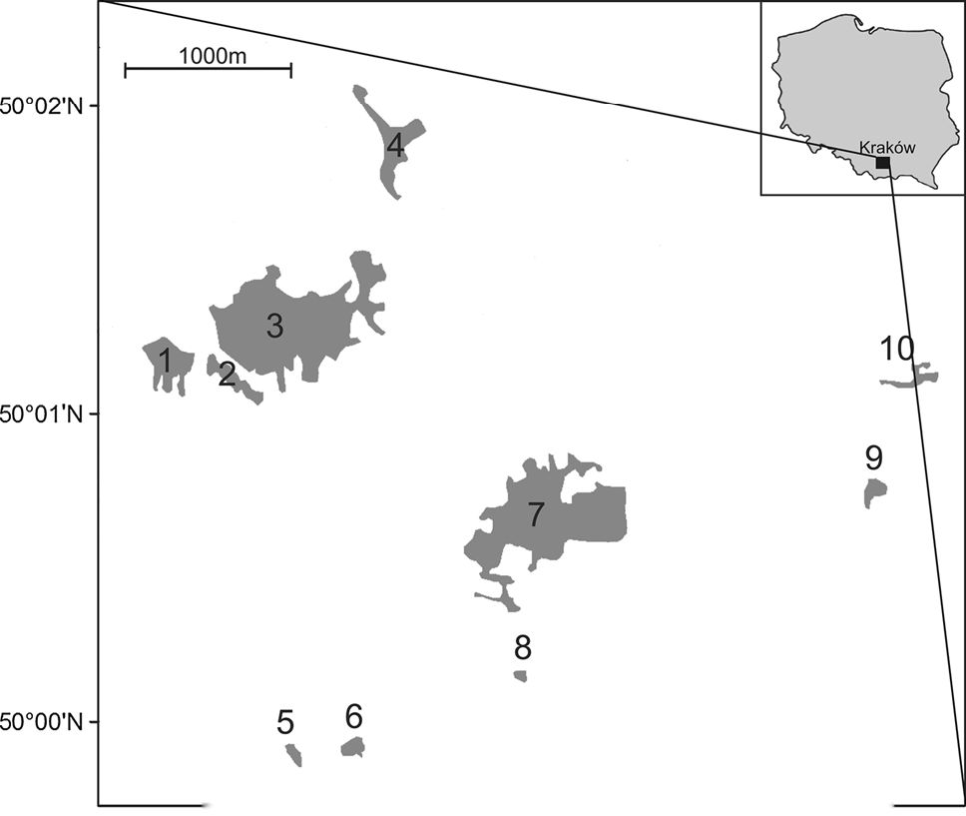
100
J Insect Conserv (2016) 20:99-105
by semi-natural grassland have been reduced by at least
80 % of their original area (Joyce 2014). Semi-natural
meadows are considered to be valuable for nature protec-
tion in Europe and fall under Annex I of the Habitats
Directive of the ‘‘Natura 2000’’ network. They are char-
acterized by relatively high biodiversity (Habel et al. 2013)
including rare and endangered species closely associated
with this specific biotope.
Ants are considered keystone species with an environ-
mental influence disproportionately large in relation to
their biomass (Folgarait 1998; Crist 2009). In one season,
ants are able to consume 3 % of the primary productivity of
meadows and in the case of predatory ants up to 40 % of
the biomass (Petal 1980). Ants also have an important role
in modifying the physico-chemical properties of the soil.
Corridor and nest building by ants not only increases the
porosity of the soil by bioturbation, but also alters the pH
and chemical composition, facilitating soil colonization by
microbiota and hence increasing the rate of decomposition
(Frouz and Jilkova 2008). Moreover, ant activity can sig-
nificantly affect vegetation. The creation of nests favors the
colonization of plant roots by mycorrhizal fungi (Dauber
et al. 2008) and disturbance to the soil can improve the
development of annual plants, some of which are exclu-
sively associated with anthills (Dostal 2007). Ants also
spread plant seeds enabling expansion into new areas
(Servigne and Detrain 2008). In the case of plant species
that use obligatory myrmecochory, displacement of asso-
ciated ants may cause a significant reduction in population
size and may lead to local extinction (Gorb et al. 2013).
There are also strong links between ants and other
invertebrates, i.e. aphids and numerous lycaenid butterflies,
including the scarce large blue Phengaris teleius, the dusky
large blue P. nausithous and alcon blue P. alcon. All are
obligatory parasites of the ant genus Myrmica, spending
major parts of their life cycles in ant nests (Thomas et al.
1989; Thomas and Settele 2004). Metapopulations of blue
butterflies in Krakow are considered to be one of the largest
in Europe (Nowicki et al. 2007) and have been afforded
habitat protection in the “Debnicko-Tyniecki meadow
area’’ of the Natura 2000 network. As an umbrella species,
their preservation entails protection for multiple coexisting
species and the whole semi-natural meadow habitat.
Because of the unique interactions between different
meadow species, interspecific competition among ants can
play an important role in the functioning of the whole
habitat. Among native meadow-inhabiting ants, Lasius
niger is a highly competitive species, resistant to changes
and thus dominant in disturbed habitats. It may displace
other species of ants such as L. flavus, and Myrmica sp.
However, in the case of habitats with high stability, these
species may be able to effectively compete with L. niger
(Wynhoff et al. 2011).
Ants are sensitive to environmental changes and it is
relatively easy to estimate their density, making them
useful bioindicators (Underwood and Fisher 2006). Some
studies have shown changes in ant communities due to
abandonment of semi-natural grassland (Dauber et al.
2006; Wynhoff et al. 2011) suggesting that the quickly
progressing invasion of goldenrod can also have an impact
on this group of insects.
Our aim was to assess whether the invasion of golden-
rods on semi-natural grassland areas triggered changes in
species composition and population density of meadow-
inhabiting ants. We checked whether and how goldenrods
affect ant communities by assessing the number of ant
species, the density of ant nests and proportion of L. niger
in the total nest number of Myrmica and Lasius species. A
negative impact of goldenrods would imply that the inva-
sion is harmful not only to ants, but also indirectly to
Phengaris butterflies as well as to the functioning of the
ecosystem.

Materials and methods
The study was conducted in ten semi-natural wet grass-
lands located in the south-eastern part of Krakow (Fig. 1)
which belong to a meadow complex inhabited by Phen-
garis butterfly metapopulations (Nowicki et al. 2007). Five
of them are situated in the ‘‘Debnicko-Tyniecki meadow
area’’ Natura 2000 network. Until recently, these meadows
were extensively managed. At present, because of the
abandonment of traditional use in all of the surveyed areas,
—i 1 1 1—
19o50'E 19°51'E 19°52'E 19°53'E
Fig. 1 Location of the studied meadows in the Krakow region,
southern Poland
^ Springer
J Insect Conserv (2016) 20:99-105
101
there is a serious problem with uncontrolled spreading of
goldenrod populations.
On each meadow, six 5 x 5 m square plots were ran-
domly selected (tomnicki 2010): three covered with
goldenrods (Solidago canadensis and S. gigantea) and
three controls. Overall 60 plots were studied. Google Earth
photos of each meadow were put on axes according to
cardinal directions (‘x’ and ‘y’ axes demarcated east-west
and north-south orientations, respectively). Points on axes
were selected using random numbers; their intersection
determined coordinates. Next, the list of coordinates was
entered into a GPS device. These coordinates determined
the southwestern corner of each plot. Plots were located at
least 20 m from each other. Goldenrod cover on each plot
was quantified using the Braun-Blanquet Cover-Abun-
dance Scale (Wikum and Shanholtzer 1978; Wysocki and
Sikorski 2002) in five categories: (1—<10 % of goldenrod
cover; 2—10-25 % of goldenrod cover; 3—25-50 % of
goldenrod cover; 4—50-75 % of goldenrod cover; 5—
75-100 % of goldenrod cover). With the exception of two
cases (plot cover approximately 65 %—category 4), we
took into consideration only two categories: 1 (‘control’
plot) and 5 (‘goldenrod’ plot). Hence if the coordinates did
not meet the requirements (i.e. unsuitable meadow type or
proximity to other plots), we reiterated the random selec-
tion procedure until we obtained 3 plots in each meadow
type (3 ‘goldenrod’ and 3 ‘control’).
Each square was investigated in terms of ant nest pres-
ence. The study plots were searched systematically to
detect all ant nests. Several ant workers were collected
from each nest and preserved in 75 % ethyl alcohol for
further identification. All samples were collected in the
period from 8 June to 9 September 2012, with the excep-
tion of a single square, which was inspected on 31 August
2011. Ants were identified using the key of Radchenko
et al. (2004). M. scabrinodis and M. sabuleti were grouped
together as ‘‘M. scabrinodis’’ because of the minor mor-
phological differences between the species making proper
identification contentious. The only certain method in this
case seems to be chromatography (Guillem et al. 2012), but
due to the very large number of contentious samples and
low probability of finding M. sabuleti in this area, this
species was omitted in the analysis.
Because of non-normal distributions of the collected data,
Mann-Whitney U tests were applied to compare the numbers
of nests of Myrmica as well as individual ant species between
goldenrod and control plots. Next, the average (1) number of
ant species, (2) number of ant nests and (3) proportion of L.
niger ants in the total nest number of Myrmica and Lasius
species were calculated for plot type (goldenrod vs. control)
on each meadow separately. The mean values for each
meadow were used to examine differences between control
and goldenrod plots. The Student’s t test for paired samples
with a 95 % confidence interval was applied to evaluate the
impact of goldenrods on the number of ant nests. Data was
square-rooted to obtain a normal distribution. In the case of
the number of ant species as well as the proportion of L. niger
ants in the total nest number of Myrmica and Lasius species,
data distributions were non-normal even after transforma-
tion. Hence, non-parametric Wilcoxon sign-ranked tests
were used to check for differences between control and
goldenrod meadows. A two-dimensional non-metric multi-
dimensional scaling (NMDS) ordination plot was calculated
for visualization of the species composition in both meadow
types. One-way PERMANOVA was performed to test for
potential differences in ant composition between control and
goldenrod plots. Similarly, average nest numbers of each
species for each meadow were used to examine differences
between control and goldenrod plots. The Bray-Curtis dis-
tance was used as a dissimilarity measure because it is well
suited for species abundance data (Quinn and Keough 2002).
Analyses were done in StatSoft Statistica 12 and PAST 3.

Results
We found a total of 1087 ant nests belonging to seven
species. Myrmica was the most common in the ant
assemblage and was more numerous in control than in
goldenrod plots (mean ± SD: 5.19 ± 8.55; 2.12 ± 5.24,
respectively; Mann-Whitney U test U = 155.0;
Z = 4.360; P < 0.0001). Differences in the number of
nests between control and goldenrod plots were statistically
significant in the case of M. ruginodis and M. scabrinodis
(81 % for M. ruginodis: Mann-Whitney U test U = 330.5,
Z = 1.993, P = 0.046; 63 % for M. scabrinodis:
U = 176.0, Z = 4.082, P < 0.001). Non-significantly
lower densities in goldenrod plots were found for M. rubra
and L. flavus (39 % for M. rubra: Mann-Whitney U test
U = 442.0, Z = 0.113; P = 0.910; 65 % for L. flavus:
U = 357.5, Z = 1.649, P = 0.099). The only species that
sustained densities and even showed a slightly higher fre-
quency in goldenrod plots (by 2 %, Mann-Whitney U test
U = 447.0, Z = 0.041, P = 0.968) was L. niger. Single
nests of M. gallienii and Formica sp. ants occurred only in
the control plots.
The number of species per plot (mean ± SE) averaged
3.03 ± 0.69 for the control and 2.3 ± 0.66 for the gold-
enrod plots and this difference was statistically significant
(Wilcoxon-ranked test, N = 10, T = 5.00, Z = 2.293,
P = 0.022; Fig. 2a). Moreover, there was a two-fold dif-
ference in the number of ant nests in the control compared
to goldenrod plots (24.97 ± 7.83 and 11.27 ± 6.54,
respectively, Student’s T test for paired samples N = 10,
DF = 9, T = 8.871, P < 0.001; Fig. 2b). There was also a
slightly higher proportion of L. niger nests in goldenrod
Ô Springer

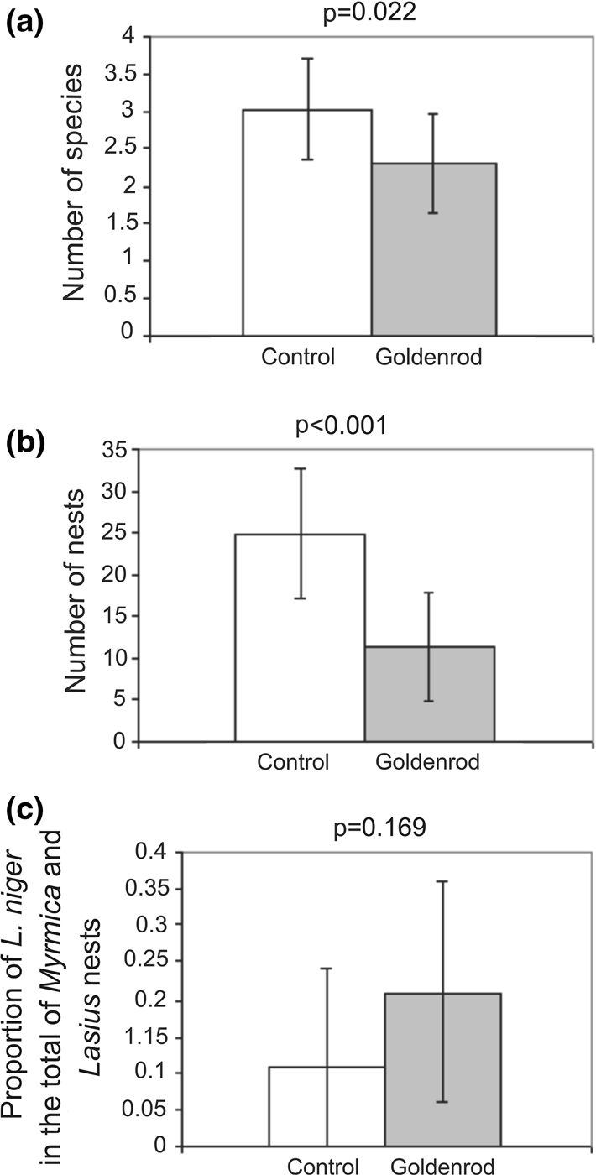
102
J Insect Conserv (2016) 20:99-105
0.32
Fig. 2 The average (±SD) number of species (a); number of nests
(b) and ratio of the number of L. niger nests in the total nest number
of Myrmica and Lasius species (c) in control (white bars) and
goldenrod (gray bars) squares
(0.21 ± 0.15) compared to control plots (0.11 ± 0.13), but
this difference was non-significant (Wilcoxon-ranked test,
N = 10, T = 14.00, Z = 1.376, P = 0.169; Fig. 2c).
The NMDS ordination plot suggested a possible difference
in community structure between control and goldenrod plots
(Fig. 3). A stress value of 0.146 suggests sufficient represen-
tation in reduced dimensions (Quinn and Keough 2002).
Coefficients of determination between distances along each
ordination axis and the original distances explained 46 and
36 % of differences in ant communities between control and
goldenrod plots (Fig. 3). One-way PERMANOVA revealed
differences in ant species composition between control and
goldenrod plots (Npemutation = 9999, SS = 3.49,
MS = 2.767. Pseudo-F = 4.701, P = 0.003).

Discussion
Our results revealed a strong negative effect of goldenrod
on the average number of ant species and ant nest density.
The lower species number in goldenrod plots was
0.00
-0.24
f: /
/ .
• •  m | m
-0.24 -0.16 -0.08 0.00 0.08 0.16 0.24 0.32
NMDS 1
Fig. 3 NMDS ordination plot of ant species composition in control
(grey circles, light grey polygon) and goldenrod (black squares, dark
grey polygon) meadows. Fractions of explained variation:
rNmdsi = 0.458, rNmds2 = 0.357
statistically significant despite the relatively low ant spe-
cies diversity. Strikingly, a more than 50 % reduction
occurred in density of ant nests on goldenrod plots. Ant
species composition also significantly differed between
control and goldenrod plots. Species negatively affected by
goldenrods included L. flavus, M. scabrinodis, M. ruginodis
and M. rubra. The first two species are thermophilic and
prefer heavily insolated areas with low vegetation (Rad-
chenko et al. 2004). Hence, the high shading associated
with goldenrod invasion most probably degraded high-
quality habitat previously available for these species. The
status of M. scabrinodis (the most numerous species in the
control plots) is particularly interesting, because its con-
siderable decline on goldenrod plots indicates a significant
change in habitat conditions. Surprisingly, populations of
M. ruginodis were the most affected. Compared to other
ants of the genus Myrmica found in this study, this species
prefers shaded and slightly cooler habitats such as wood-
lands (Elmes et al. 1998; Radchenko et al. 2004). This
habitat requirement suggests that M. ruginodis could
potentially find favorable conditions within invaded pat-
ches. The presence of goldenrod guarantees the availability
of honeydew and nectar (on which M. ruginodis as well as
M. rubra forage; Radchenko et al. 2004), but not before
July. Ant workers in areas with goldenrod forage over
longer distances (Lenda et al. 2013), which may indicate
lower food availability in areas invaded by goldenrod.
Further studies are required to resolve the detailed mech-
anism of the negative effect of goldenrod on particular
species. All observed Myrmica species are host ants of
Phengaris butterflies (Witek et al. 2008). In the context of
previous studies showing significant correlations between
local extinctions of hosts and parasites (Koh et al. 2004),
Ô Springer
J Insect Conserv (2016) 20:99-105
103
goldenrods may also have a negative effect on these flag-
ship species. In the context of extreme local specificity of
P. alcon for M. scabrinodis ants (Sielezniew and Stankie-
wicz 2002) as well as the high specificity of P. nausithous
for M. rubra, goldenrod invasion potentially threatens these
two butterfly species to a higher degree than the more
flexible P. teleius which does not show local specialization
to host ants (Thomas and Elmes 1998; Witek et al. 2008).
Our results suggest that only L. niger is able to sustain
numerous nests in an environment changed by goldenrod.
As a polyphagous species known for its high resistance to
environmental change (Radchenko et al. 2004), L. niger
seems to be an opportunist not threatened by invasion. The
number of nests of L. niger can even increase because they
probably start to occupy free niche space after the decline
of other ant species for which the goldenrod environment is
unfavorable. Although Wynhoff et al. (2011) showed that
L. niger can displace competing species (L. flavus, Myr-
mica sp.) if habitat conditions undergo a sudden change for
other reasons, e.g. heavy mowing, our study design pre-
cluded an assessment of this mechanism.
Litt et al. (2014) reviewed the literature concerning
effects of invasive plants on arthropods. They found that
the abundance and richness of ant species decreased with
invasion of various plants (including goldenrod, see Lenda
et al. 2013) in almost 50 % of recent studies and increased
in only 7 %. They suggest two main explanations for this
decline. First, deterioration in the food base due to a
decrease in the diversity and coverage of native plants
could have triggered a decline in nectar-feeding ants
(mainly M. rubra and M. ruginodis). Goldenrod is a
strongly melliferous plant, but the time of flowering is
probably too short and too late to provide enough food for
invertebrates (Moron et al. 2009). Moreover, an overall
decline in species richness and densities of different groups
of invertebrates in areas with goldenrod (de Groot et al.
2007; Skorka et al. 2007; Moron et al. 2009; Fenesi et al.
- may cause a decrease in the amount of available food
for carnivorous ant species (Litt et al. 2014), mainly M.
scabrinodis. Many species of ants also feed on the
honeydew produced by aphids. However, the effect of
displacement of native plants by goldenrod on aphids is
unknown. Second, the decline in ant diversity and abun-
dance could be due to changes in microclimatic conditions
(temperature, moisture, light intensity) caused by modifi-
cations in structural characteristics (increasing cover, plant
height) as well as in litter accumulation and in soil char-
acteristics (nutrients, salinity, pH) (Standish 2004; Wolk-
ovich et al. 2009; Talley et al. 2012), which may be
important especially for thermophilic species such as M.
scabrinodis.
The impact of goldenrod invasion has already been
studied in other groups of animals with a documented
decrease in species richness, diversity and abundance of
butterflies, wild bees and hoverflies but only a decrease in
abundance in the case of ground beetles (de Groot et al.
2007; Skorka et al. 2007; Fenesi et al. 2015). The strength
of these relationships depended on the trophic position
occupied by the group of insects, i.e. the most strongly
affected species were food specialists associated with
native plants (de Groot et al. 2007). Such specialists
include Phengaris butterflies which beside Myrmica ants
also need obligatory host plants in their life cycle. Because
invaded parts of meadows are characterized by a signifi-
cantly lower number of flowering Sanquisorba officinalis
and Gentiana pneumonanthe host plants (unpublished
data), goldenrods may threaten Phengaris butterflies as
well as other coexisting meadow species. So far no nega-
tive demographic trends in Phengaris butterfly metapopu-
lations were noticed in the study area (Kajzer-Bonk et al.
2013). However, goldenrod invasion has only recently
commenced (Moron et al. 2009), and a large part of this
particular meadow complex is still in good condition.
Moreover, the abundance of S. officinalis does not affect
densities of Phengaris butterflies (Nowicki et al. 2007).
Notably, S. officinallis is typically the last native flowering
plant in patches invaded by goldenrod (personal observa-
tion). Hence, the negative effect of goldenrod invasion may
be delayed and later expressed as a co-extinction and a
sudden collapse of Phengaris populations.
Despite evidence of the negative effects of goldenrod
invasion (Skorka et al. 2007; Moron et al. 2009), no efforts
have been made to restore this valuable area. Our findings
again show that immediate conservation actions should be
undertaken to suppress goldenrod invasion in grassland
habitats. One way is to systematically mow twice per
season in May and August before seed production and
remove the remaining biomass (Meyer and Schmid 1999;
Weber 2000; Dolle and Schmidt 2009). Even small frag-
ments of grasslands utilized in a traditional and continuous
manner can increase the chances of survival of typical
meadow species. Proper management after goldenrod
removal involves not mowing the whole area at the same
time—uncut fragments constitute a refuge for many spe-
cies that can later recolonize mown areas (Dauber et al.
2006). An alternative method can be controlled burning of
meadow fragments, which is probably much less destruc-
tive for grassland fauna than it is believed by many con-
servationists (Nowicki et al. 2015). Properly conducted
active grassland protection allows the restoration of ant
species richness (Dahms et al. 2010) and preservation of
the whole ecosystem.
Acknowledgments The study was funded by the Jagiellonian
University Grant DS/WBiNoZ/INoS/761/10-12. We are very thank-
ful to M. Bonk, K. Kuszewska and Z. Zagrodzka for their help during
^ Springer
104
J Insect Conserv (2016) 20:99-105
the fieldwork. P. Skorka assisted in statistical analyses. M. Bonk, P.
Nowicki, M. Pabijan as well as B. Hoffmann and a second anony-
mous reviewer provided comments that greatly improved the
manuscript.
Open Access This article is distributed under the terms of the
Creative Commons Attribution 4.0 International License (http://crea
tivecommons.org/licenses/by/4.0/), which permits unrestricted use,
distribution, and reproduction in any medium, provided you give
appropriate credit to the original author(s) and the source, provide a
link to the Creative Commons license, and indicate if changes were
made.

References
Abhilasha D, Quintana N, Vivanco J, Joshi J (2008) Do allelopathic
compounds in invasive Solidago canadensis s.l. restrain the
native European flora? J Ecol 96:993-1001
Banta JA, Stark SC, Stevens MHH, Pendergast TH IV, Baumert A,
Carson WP (2008) Light reduction predicts widespread patterns
of dominance between asters and goldenrods. Plant Ecol
199:65-76
Callaway RM, Aschehoug ET (2000) Invasive plants versus their new
and old neighbors: a mechanism for exotic invasion. Science
290:521-523
Crist TO (2009) Biodiversity, species interactions, and functional
roles of ants (Hymenoptera: Formicidae) in fragmented land-
scapes: a review. Myrmecol News 12:3-13
Dahms H, Lenoir L, Lindborg R, Wolters V, Dauber J (2010)
Restoration of seminatural grasslands: what is the impact on
ants? Restor Ecol 18:330-337
Dauber J, Bengtsson J, Lenoir L (2006) Evaluating effects of habitat
loss and land-use continuity on ant species richness in seminat-
ural grassland remnants. Conserv Biol 20:1150-1160
Dauber J, Niechoj R, Baltruschat H, Wolters V (2008) Soil
engineering ants increase grass root arbuscular mycorrhizal
colonization. Biol Fertil Soils 44:791-796
de Groot M, Kleijn D, Jogan N (2007) Species groups occupying
different trophic levels respond differently to the invasion of
semi-natural vegetation by Solidago canadensis. Biol Conserv
136:612-617
Dolle M, Schmidt W (2009) The relationship between soil seed bank,
above-ground vegetation and disturbance intensity on old-field
successional permanent plots. Appl Veg Sci 12:415-428
Dostal P (2007) Population dynamics of annuals in perennial
grassland controlled by ants and environmental stochasticity.
J Veg Sci 18:91-102
Elmes GW, Thomas JA, Wardlaw JC, Hochberg ME, Clarke RT,
Simcox DJ (1998) The ecology of Myrmica ants in relation to the
conservation of Maculinea butterflies. J Insect Conserv 2:67-78
Fenesi A, Vagasi CI, Beldean M, Foldesi R, Kolcsar L, Shapiro JT,
Torok E, Kovacs-Hostyanszki A (2015) Solidago canadensis
impacts on native plant and pollinator communities in different-
aged old fields. Basic Appl Ecol 16:335-346
Folgarait PJ (1998) Ant biodiversity and its relationship to ecosystem
functioning: a review. Biodivers Conserv 7:1221-1244
Frouz J, Jilkova V (2008) The effect of ants on soil properties and processes
(Hymenoptera: Formicidae). Myrmecol News 11:191-199
Gorb EV, Filippov AE, Gorb SN (2013) Long-term ant-species-
dependent dynamics of a myrmecochorous plant community.
Arthropod-Plant Interact 7:277-286
Guillem RM, Drijfhout FP, Martin SJ (2012) Using chemo-taxonomy
of host ants to help conserve the large blue butterfly. Biol
Conserv 148:39-43
Habel JC, Dengler J, Janisova M, Torok P, Wellstein C, Wiezik M
(2013) European grassland ecosystems: threatened hotspots of
biodiversity. Biodivers Conserv 22:2131-2138
Hartnett DC, Bazzaz FA (1985) The genet and ramet population
dynamics of Solidago canadensis in an abandoned field. J Ecol
73:407-413
Jobin A, Schaffner U, Nentwig W (1996) The structure of the
phytophagous insect fauna on the introduced weed Solidago
altissima in Switzerland. Entomol Exp Appl 79:33-42
Joyce CB (2014) Ecological consequences and restoration potential of
abandoned wet grasslands. Ecol Eng 66:91-102
Kabuce N, Priede N (2010) NOBANIS—invasive alien species fact
sheet—Solidago canadensis. Online database of the European
network on invasive alien species—NOBANIS. www.nobanis.
org
Kajzer-Bonk J, Nowicki P, Bonk M, Skorka P, Witek M, Woy-
ciechowski M (2013) Local populations of endangered Macu-
linea (Phengaris) butterflies are flood resistant. J Insect Conserv
17:1105-1112
Koh LP, Dunn RR, Sodhi NS, Colwell RK, Proctor HC, Smith VS
(2004) Species coextinctions and the biodiversity crisis. Science
305:1632-1634
Lenda M, Witek M, Skorka P, Moron D, Woyciechowski M (2013)
Invasive alien plants affect grassland ant communities, colony
size and foraging behavior. Biol Invasions 15:2403-2414
Litt AR, Cord EE, Fulbright TE, Schuster GL (2014) Effects of
invasive plants on arthropods. Conserv Biol 28:1532-1549
Łomnicki A (2010) Wprowadzenie do statystyki dla przyrodników.
PWN, Warszawa
Luoto M, Pykala J, Kuussaari M (2003) Decline of landscape-scale
habitat and species diversity after the end of cattle grazing. J Nat
Conserv 11:171-178
Meyer AH, Schmid B (1999) Seed dynamics and seedling establish-
ment in the invading perennial Solidago altissima under different
experimental treatments. J Ecol 87:28-41
Mitchell CE, Power AG (2003) Release of invasive plants from
fungal and viral pathogens. Nature 421:625-627
Moron D, Lenda M, Skórka P, Szentgyorgyi H, Settele J, Woy-
ciechowski M (2009) Wild pollinator communities are nega-
tively affected by invasion of alien goldenrods in grassland
landscapes. Biol Conserv 142:1322-1332
Nowicki P, Pepkowska A, Kudlek J, Skorka P, Witek M, Settele J,
Woyciechowski M (2007) From metapopulation theory to
conservation recommendations: lessons from spatial occurrence
and abundance patterns of Maculinea butterflies. Biol Conserv
140:119-129
Nowicki P, Marczyk J, Kajzer-Bonk J (2015) Metapopulations of
endangered Maculinea butterflies are resilient to large-scale fire.
Ecohydrology 8:398-405
Petal J (1980) Ant populations, their regulation and effect on soil in
meadows. Ekol Pol 28:297-326
Queiroz C, Beilin R, Folke C, Lindborg R (2014) Farmland
abandonment: threat or opportunity for biodiversity conserva-
tion? A global review. Front Ecol Environ 12:288-296
Quinn GP, Keough MJ (2002) Experimental design and data analysis
for biologists. Cambridge University Press, Cambridge
Radchenko A, Czechowska W, Czechowski W (2004) Klucze do
oznaczania owadow polski, cześć XXIV-błonkowki-Hy-
menoptera, zeszyt 63-Mrówki-Formicidae. Polskie Towarzystwo
Entomologiczne, Torunś
Servigne P, Detrain C (2008) Ant-seed interactions: combined effects
of ant and plant species on seed removal patterns. Insectes Soc
55:220-230
Sielezniew M, Stankiewicz A (2002) First data on host-ant specificity
of parasitic Maculinea alcon (Den. & Schiff.) (Lepidoptera:
Ô Springer
J Insect Conserv (2016) 20:99-105
105
Lycaenidae) in Poland and eastern Europe. Fragmenta Faunistica
45:123-130
Skorka P, Settele J, Woyciechowski M (2007) Effects of management
cessation on grassland butterflies in southern Poland. Agric
Ecosyst Environ 121:319-324
Skorka P, Lenda M, Tryjanowski P (2010) Invasive alien goldenrods
negatively affect grassland bird communities in Eastern Europe.
Biol Conserv 143:856-861
Standish RJ (2004) Impact of an invasive clonal herb on epigaeic
invertebrates in forest remnants in New Zealand. Biol Conserv
116:49-58
Talley TS, Nguyen K-C, Nguyen A (2012) Testing the effects of an
introduced palm on a riparian invertebrate community in
southern California. PLoS One. doi:10.1371/journal.pone.
0042460
Thomas JA, Elmes GW (1998) Higher productivity at the cost of
increased host-specificity when Maculinea butterfly larvae
exploit ant colonies through trophallaxis rater than by predation.
Ecol Entomol 23:457-464
Thomas JA, Settele J (2004) Butterfly mimics of ants. Nature
432:283-284
Thomas JA, Elmes GW, Wardlaw JC, Woyciechowski M (1989) Host
specificity among Maculinea butterflies in Myrmica ant nests.
Oecologia 79:452-457
Underwood EC, Fisher BL (2006) The role of ants in conservation
monitoring: if, when, and how. Biol Conserv 132:166-182
Weber E (1998) The dynamics of plant invasions: a case study of
three exotic goldenrod species (Solidago L.) in Europe.
J Biogeogr 25:147-154
Weber E (2000) Biological flora of Central Europe: Solidago
altissima L. Flora 195:123-134
Weber E (2001) Current and potential ranges of three exotic
goldenrods (Solidago) in Europe. Conserv Biol 15:122-128
Weber E (2011) Strong regeneration ability from rhizome fragments
in two invasive clonal plants (Solidago canadensis and S.
gigantea). Biol Invasions 13:2947-2955
Wikum DA, Shanholtzer GF (1978) Application of the Braun-
Blanquet cover-abundance scale for vegetation analysis in land
development studies. Environ Manag 2:323-329
Witek M, Sliwmska EB, Skorka P, Nowicki P, Wantuch M, Vrabec
V, Settele J, Woyciechowski M (2008) Host ant specificity of
large blue butterflies Phengaris (Maculinea) (Lepidoptera:
Lycaenidae) inhabiting humid grasslands in East-central Europe.
Eur J Entomol 105:871-877
Wolkovich EM, Bolger DT, Holway DA (2009) Complex responses
to invasive grass litter by ground arthropods in a Mediterranean
scrub ecosystem. Oecologia 161:697-708
Wynhoff I, van Gestel R, van Swaay C, van Langevelde F (2011) Not
only the butterflies: managing ants on road verges to benefit
Phengaris (Maculinea) butterflies. J Insect Conserv 15:189-206
Wysocki C, Sikorski P (2002) Fitosocjologia stosowana. Wydaw-
nictwo SGGW, Warszawa
Ä Springer

