Elektrofizjologia inwazyjna/Invasive electrophysiology
Delayed perforation of the right ventricle as a complication
of permanent cardiac pacing — is following the guidelines
always the right choice? Non-standard treatment — a case
report and literature review
Późna perforacja prawej komory jako powikłanie stałej stymulacji serca — czy przestrzeganie
wytycznych jest zawsze właściwym wyborem? Postępowanie niestandardowe
— opis przypadku i przegląd piśmiennictwa

Anna Rydlewska1, Barbara Małecka1, Andrzej Ząbek1, Piotr Klimeczek2, Jacek Lelakowski1,
Mieczysław Pasowicz2, Marek Czajkowski3, Andrzej Kutarski4
- Department of Electrocardiology, The John Paul II Hospital, Krakow
- Center for Diagnosis, Prevention and Telemedicine with One-Day Diagnostic Unit, The John Paul II Hospital, Krakow
- Department of Cardiology, Medical University, Lublin
- Department of Cardiosurgery, Medical University, Lublin
Abstract
A case of a delayed perforation of the right ventricle by the pacemaker lead in a 67-year-old woman is presented. Perforation,
mimicking stenocardial symptoms, was incidentally diagnosed on a computed tomography chest scan. Percutaneous lead extraction
was successfully performed, with simultaneous implantation of a new pacemaker lead.
Key words: permanent heart stimulation, complication, delayed perforation of the right ventricle
Kardiol Pol 2010; 68: 357-361

Introduction
Heart perforation is a rare complication of pacemaker
implantation. Acute, subacute and delayed lead
perforations have been defined. Acute lead perforation
occurs within 24 h after implantation and is considered to
be associated with more severe clinical presentation: heart
tamponade or even death.
Subacute and delayed perforations are defined in
contrast to acute perforation; to diagnose them normal
chest X-ray and electrical parameters within 24 h after
implantation are required [1]. Subacute and delayed
perforations are differentiated according to whether the
time of their presentation is over one month after
implantation. Incidence of delayed lead perforation has
been estimated by Khan et al. at 0.1-0.8% for pacemaker
implantation and 0.6-5.2% in ICDs [2].
Probably the lower incidence and more benign clinical
presentation in delayed perforations is associated with
'self-sealing' properties of the ventricle wall: by fibrosis,
muscle contraction or by the lead itself [3, 4].
Risk factors of lead perforation have not been defined
yet. The type of lead used might influence the incidence
of perforation. It occurs more often in the case of the
following leads:
- for temporary stimulation,
- atrial,
- with active fixation system,
- defibrillator leads, with double spirals (more wires,
stiffer),
- when excessive length during implantation is left,
- small diameter (increased force per unit area),
- so-called high resistance (small tip surface).
Address for corespondence:
Andrzej Ząbek MD, Oddział Kliniczny Elektrokardiologii, Krakowski Szpital Specjalistyczny im. Jana Pawła II, ul. Prądnicka 80, 31-202 Kraków,
tel.: +48 12 614 20 00, e-mail: andrzej_j_z@poczta.onet.pl
Kardiologia Polska 2010; 68: 3
358
Anna Rydlewska et al.
There have been many reports of a higher perforation
rate for certain lead types (e.g. Riata ST Jude Medical leads),
which might indicate that certain constructive properties
of these leads are associated with increased perforation
risk, but it has not been proved in any larger trial [1, 5-8].
Also the lead tip location is a factor. Perforations occur
more frequently in the apical location, as compared with
septal position or in the right ventricular outflow tract,
which is probably due to the thinner muscle in the right
ventricle apex [1, 2, 6, 9-11].
Apart from the lead type and its location, also the heart
muscle itself may favour perforation. There has been a case
report on perforation in a patient with congenital
cardiomyopathy [12]. Anticoagulation therapy and steroid
use within 7 days of implantation may also have a negative
impact. The elderly, women, and patients with low body
mass (BMI < 20 kg/m2) are also prone to perforation [6, 9].
In the case of defibrillator leads, the perforation rate
rises with the number of shocks delivered [5]. Chest
trauma, especially soon after implantation, may also
indicate a necessity to exclude perforation [5, 10].
Subacute and delayed right ventricle perforation may
have various clinical presentations, from incidentally
diagnosed asymptomatic perforation to death [1-16, 18,
19]. The following clinical symptoms of lead perforation
have been described:
- chest pain,
- dyspnoea,
- syncope (due to improper stimulation or its complete
failure),
- inadequate ICD shocks,
- muscle or diaphragm stimulation,
- abdominal pain (due to diaphragm stimulation or lead
migration to the peritoneal cavity),
- hiccup (as a symptom of phrenic nerve stimulation),
- mammary haematoma,
- consequences of diaphragm, lung, chest wall
perforation,
10. pleural or pericardial effusion, rarely demanding
drainage.
The most common symptom described in the literature
has been the failure of the leads to pace or sense
appropriately [1-3, 5-16, 18, 19]. Decreased lead impedance
and R-wave amplitude, as well as increased pacing threshold
(or even failure to pace), are the most widely described
observations. However, there have been some reports on
delayed perforations with normal electrophysiological
parameters [4]. Therefore, a conclusion may be made that
whereas improper pacemaker function may indicate
perforation, its normal function does not exclude it.
Visualisation is an important stage in perforation
diagnosis. The key tests are: chest X-ray, transthoracic (TTE)
or transoesophageal (TEE) echocardiography and computed
tomography. The X-ray may show the lead's migration
outside the heart: into the pleural cavity, peritoneal cavity
or to the chest wall. It also allows assessment of pleural
effusion. Perforation is suspected when less than 3 mm
separate the lead tip from the epicardial fat [13].
Echocardiography may show lead presence in the
pericardial sac or pericardial effusion. However, it is often
false negative, showing no pericardial effusion, or no
evidence of the lead's migration, while the perforation is
confirmed in other tests [1, 2, 12-15].
Computed tomography (CT) in the perforation
diagnosis seems to play a crucial role, becoming a golden
standard in its visualisation [1, 5, 6, 14, 15]. Cases of
asymptomatic perforations identified on CT scans,
performed for other medical indications, are described in
the literature. Perforation rates were 15% for atrial leads
and 6% for ventricular leads. Small pericardial effusion in
patients with and without perforation have been present
in 20 and 19% respectively [4].

Case report
A 67-year-old woman with coronary heart disease risk
factors - overweight, smoking cigarettes, with arterial
hypertension and hyperlipidaemia - had a CT scan of the
coronary arteries performed due to uncharacteristic chest
pain.
Three years before she had undergone atrioventricular
pacemaker implantation [pacemaker DDDR-Vitatron
C60DR, atrial lead Biotronic Selox JT 53 implanted in the
auricle of the right atrium and ventricular lead with active
fixation system Vitatron Cristalline Actifix ICF 09B
implanted on the anterior wall of the right ventricular
outflow tract (RVOT)] because of sick sinus syndrome with
atrioventricular block. During implantation normal sensing
and pacing parameters were achieved, and post-
implantation X-ray showed normal lead position.
After the implantation, the patient complained of
persistent, uncharacteristic chest pain. The pain was
stabbing, localised in the apex and retrosternal region, not
associated with physical exercise nor body position.
Regular telemetric control (every 6 months) showed
normal pacemaker function. Considering the uncharac-
teristic symptoms and cardiovascular risk factors, coro-
nary heart disease diagnostics was performed. The TTE
performed in April 2009 showed no evident pathologies,
and, significantly, no pericardial effusion.
Angio-CT of the coronary arteries performed in August
2009 showed the lead tip outside the right ventricle, in the
ventricle wall and partially in the pericardial sack (Figure 1).
The patient was admitted to hospital and further
diagnosis was performed. On admission, the patient was
haemodynamically stable. The pacemaker control presented
normal sensing and pacing parameters. Chest X-ray showed
no dislocation of the leads. The TTE revealed pericardial
effusion up to 24 mm behind the right ventricle, the inferior
and posterior wall, with mobile localisation of the lead tip,
with no evident penetration to the pericardium and with the
Kardiologia Polska 2010; 68: 3

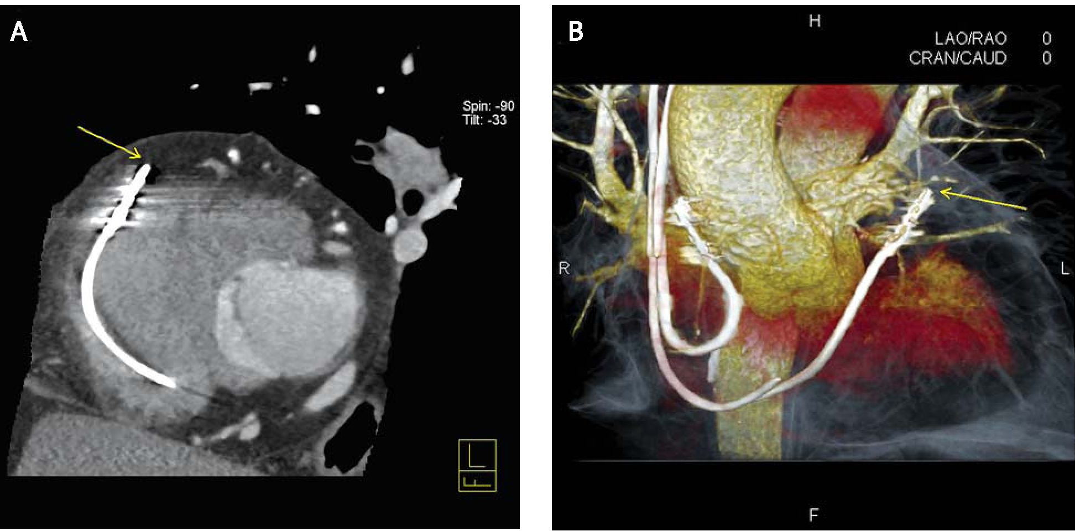
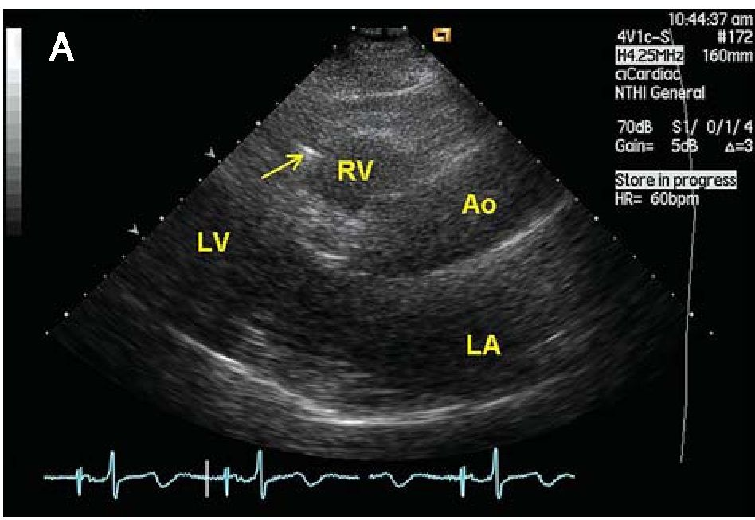
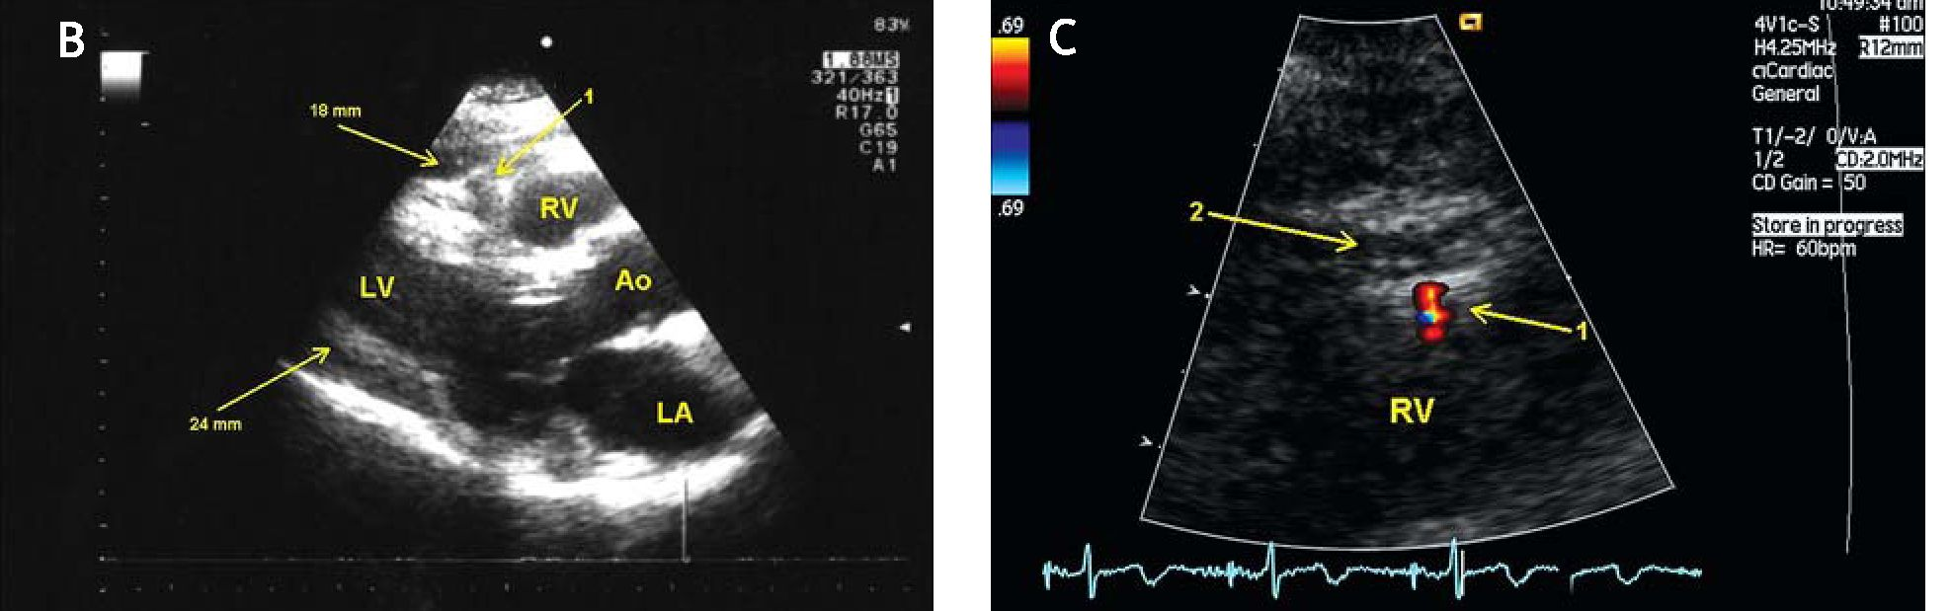
Delayed perforation of the right ventricle as a complication of permanent heart stimulation
359
Figure 1. Picture of the heart in CT. A - visible perforation by ventricular lead to the pericardium (arrow);
B- volume digital reconstruction: visible 2 leads of atrioventricular stimulation system. Ventricular lead is in
the RVOT. Lead's tip is visible outside the outline of the heart in the pericardium (arrow)
blood flow between the right ventricle and the pericardium
visualised by the colour Doppler spectrum (Figure 2).
During the following days of hospitalisation, the
patient was monitored echocardiographically: slight
regression in the quantity of pericardial effusion was
noted (to 16 mm behind the right ventricle and the inferior
wall) and signs of effusion organisation were observed.
Telemetric control of the pacemaker showed its normal
function.
Considering the overall clinical picture and the
available literature, it was decided to perform
percutaneous lead extraction with cardiosurgical backup
and with simultaneous new lead implantation.
Figure 2. TTE before the removal procedure: A - visible lead in the right ventricle with probable perforation to
the pericardium (arrow); B - liquid in the pericardium up to 24 mm behind the left ventricular posterior wall
and up to 18 mm before the right ventricular anterior wall (arrows). Arrow 1 - pacemaker lead; C - blood flow
between liquid space in the pericardium (arrow 2) and right ventricle lumen in Doppler examination (arrow 1)
Ao - aorta, LA - left atrium, LV - left ventricle, RV - right ventricle
Kardiologia Polska 2010; 68: 3

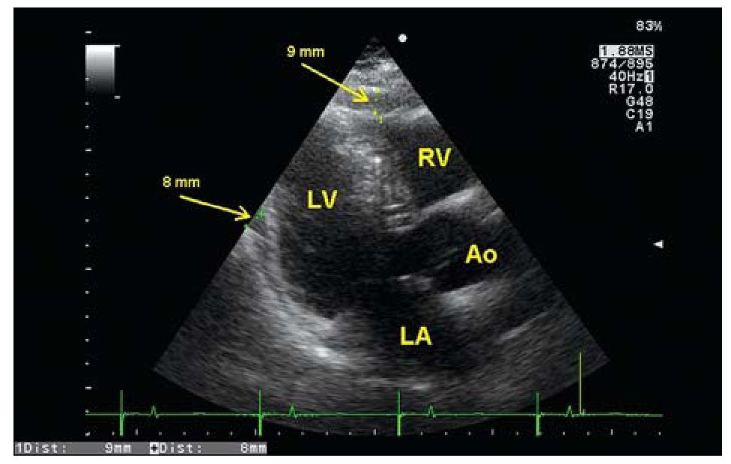
360
Anna Rydlewska et al.
Figure 3. TTE after the removal procedure: visible
liquid in the pericardium up to 8 mm behind the
posterior wall and up to 9 mm before the anterior
wall (arrows)
Ao - aorta, LA - left atrium, LV - left ventricle, RV - right ventricle
The patient was transported to the centre specializing
in percutaneous lead extraction. In the operating room, with
basic live function monitoring, with anaesthesiological,
cardiosurgical and echocardiographic backup, right ventricle
lead percutaneous extraction was performed.
The procedure was performed through the left
subclavian vein, using green polypropylene Byrd dilator
sheaths (10.0/12.1 F), to separate the lead from the
adhesions to the vessels and heart. In order to stiffen the
lead during its extraction, a stylet without anchoring
function was used. The lead was removed without
complications, and no symptoms of tamponade were
observed during or after the procedure. Simultaneously,
a new active fixation lead was implanted in the middle
part of the ventricular septum. The patient was discharged
in a good general condition. In the follow-up, the
symptoms began to retreat. In the TTE performed 2 weeks
after the procedure, small effusion was seen (up to 9 mm
behind the right ventricle, the inferior and posterior wall)
(Figure 3).

Discussion
Most authors agree that the best method of lead
perforation treatment is percutaneous extraction in the
operating room with TTE and TEE monitoring during and/or
after the procedure, with the cardiosurgical and
anaesthesiological team ready to intervene, even if such
a necessity is rare [1, 2, 8, 14, 16, 19]. Such practice is
inconsistent with the HRS expert consensus (2009), which
classifies percutaneous lead extraction as class III
indication, level of evidence C [17]. Percutaneous extraction
of the perforating lead, as not requiring general
anaesthesia, has been performed in case of a very high
operation risk [12]. Described cases of open surgery lead
removal include suspected digestive tract perforation [1],
patients with high risk of tamponade during operation and
with atypical location of the perforating lead [3, 6, 9-11, 13,
15, 18]. In most of these cases, a new pacemaker was
implanted, placing the lead tip in a different location than
before (that is in the RVOT if the tip had been placed in
the apex, and vice versa). In the case of open surgery,
epicardial leads have been used [1, 6]. In one case, a new
pacemaker was not implanted at the patient's demand
[10]. There has also been one case in which the perforating
atrial lead was not removed, and the DDD mode was
switched to the VVI mode, due to the high operation risk
[14]. Hirschl et al. indicate that removing delayed
asymptomatic lead perforations with normal pacemaker
function is disputable [4]. In the postoperative period,
echocardiographic monitoring is necessary, as there have
been cases of cardiac tamponade described [1].
The case presented above is atypical considering the
literature, mainly due to its very late presentation (3 years
after implantation). It is worth underlining that there was
no evident cause of the perforation (e.g. trauma) in the
anamnesis. It also seems as if we have captured the
moment of the full lead perforation with effusion
formation. During the observation, we noted slight
regression in the effusion quantity and its organisation.
Another rare symptom was normal pacemaker
electrophysiological parameters.

Conclusions
Lead perforation of the heart remains a rare, but
genuine threat. Sometimes it creates a real diagnostic
puzzle and has confusing clinical presentation. Normal
pacemaker electrophysiological function does not exclude
lead perforation. Optimal treatment for such a condition
seems to be percutaneous extraction of the perforating
lead with cardiosurgical backup, though this opinion is
inconsistent with the HRS expert consensus.
References
- Laborderie J, Barandon L, Ploux S, et al. Management of subacute
and delayed right ventricular perforation with a pacing or
implantable cardioverter-defibrillator lead. Am J Cardiol 2008;
102: 1352-5.
- Khan M, Joseph G, Khaykin Y, et al. Delayed lead perforation:
a disturbing trend. PACE 2005; 28: 251-3.
- Fisher JD, Fox M, Kim SG, et al. Asymptomatic anterior perforation
of an ICD lead into subcutaneous tissues. PACE 2008; 31: 7-9.
- Hirschl DA, Jain VR, Spindola-Franco H, et al. Prevalence and
characterization of asymptomatic pacemaker and ICD lead
perforation on CT. PACE 2007; 30: 28-32.
- Lau EW, Shannon HJ, McKavanagh Ft Delayed cardiac perforation
by defibrillator lead placed in the right ventricular outflow tract
resulting in massive pericardial effusion. PACE 2008; 31: 1646-1649.
- Krivan L, Kozak M, Vlasinova J, et al. Right ventricular perforation
with an ICD defibrillation lead managed by surgical revision and
epicardial leads-case reports. PACE 2008; 31: 3-6.
- Tavernier R, Duytschaever M, Dossche K, et al. Subacute
implantable cardioverter defibrillator lead perforation: a potentially
life-threatening event. Europace 2009; 7: 966-7.
Kardiologia Polska 2010; 68: 3
Delayed perforation of the right ventricle as a complication of permanent heart stimulation
361
- Satpathy R, Hee T, Esterbrooks D, et al. Delayed defibrillator lead
perforation: an increasing phenomenon. PACE 2008; 31: 10-2.
- Haq SA, Heitner JF, Lee L, et al. Late presentation of a lead
perforation as a complication of permanent pacemaker insertion.
Angiology 2008; 59: 619-21.
- Sassone B, Gabrieli L, Boggian G, et al. Management of traumatic
implantable cardioverter defibrillator lead perforation of the right
ventricle after car accident: a case report. Europace 2009; 7: 961-2.
- Tziakas D, Alexoudis A, Konstantinou F, et al. A rare case of late
right ventricular perforation by a passive-fixation permanent
pacemaker lead. Europace 2009; 7: 968-9.
- Akyol A, Aydin A, Erdinler I, et al. Late perforation of the heart,
pericardium and diaphragm by an active-fixation ventricular lead.
PACE 2005; 28: 350-1.
- Sanoussi A, Nakadi BE, Lardinois I, et al. Late right ventricular
perforation after permanent pacemaker implantation: how far can
the lead go? PACE 2005; 28: 723-5.
- Henrikson CA, Leng CT, Yuh DD, et al. Computed tomography to
assess possible cardiac lead perforation. PACE 2006; 29: 509-11.
- Selcuk H, Selcuk MT, Maden O, et al. Uncomplicated heart and
lung perforation by a displaced ventricular pacemaker lead: a case
report. PACE 2006; 29: 429-30.
- Greenberg S, Lawton J, Chen J. Right ventricular lead perforation
presenting as left chest wall muscle stimulation. Circulation 2005;
111: e451-2.
- Wilkoff BL, Love CJ, Byrd CL, et al. Transvenous lead extraction:
Heart Rhythm Society expert consensus on facilities, training,
indications, and patient management: This document was
endorsed by the American Heart Association (AHA). Heart Rhythm
2009; 6: 1085-104.
- Celik T, Kose S, Bugan B, et al. Hiccup as a result of late lead
perforation: report of two cases and review of the literature.
Europace 2009; 7: 963-5.
- Lopes LR, Brandao L, Carrageta M. Single-step transvenous
extraction of a passive fixation lead with delayed perforation of
the right ventricle. Europace 2009; 8: 672.
Kardiologia Polska 2010; 68: 3

