UNIVERSITATIS IAGELLONICAE ACTA MATHEMATICA
doi: 10.4467/20843828AM.15.005.3909 FASCICULUS LII, 2015
MERTON PORTFOLIO PROBLEM WITH ONE INDIVISIBLE
ASSET
by Jakub Trybula
Abstract. In this paper we consider a modification of the classical Merton
portfolio optimization problem. Namely, an investor can trade in financial
asset and consume his capital. He is additionally endowed with a one unit
of an indivisible asset which he can sell at any time. We give a numerical
example of calculating the optimal time to sale the indivisible asset, the
optimal consumption rate and the value function.
- Introduction. The earliest application of stochastic control theory to
finance was Merton’s portfolio optimization problem which is formulated as
follows. An investor has a positive capital and access to the market where
he can freely buy and sale two assets: a share and a bond. He can also
consume arbitrary part of his wealth. At any time the investor decides which
proportion of his wealth to invest in the risky asset and which part of his capital
to consume. The purpose is to find proportion of wealth and consumption
rate which maximizes the investor’s performance criterion. This problem and
its various modifications have a well known solutions. For more details see
e.g. [3,6,7,9,11] and also Section 2.
In this work we modify Merton’s portfolio optimization problem. Namely,
we assume that our investor has no access to a bank account but is endowed
with a one unit of an indivisible financial asset which he can sell at any time.
By indivisible asset we mean the asset which investor cannot divide and sale
only just part of it. It can be for example a house, an apartment, a work of
art, a car or simply one unit of share. The money received from the sale of
this asset is immediately invested.
2010 Mathematics Subject Classification. 93E20; 49L20.
Key words and phrases. Investor problem, optimal stopping, HJB equation, indivisible
asset.
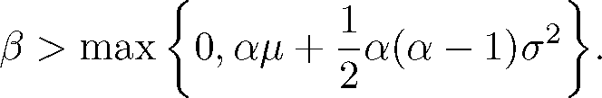
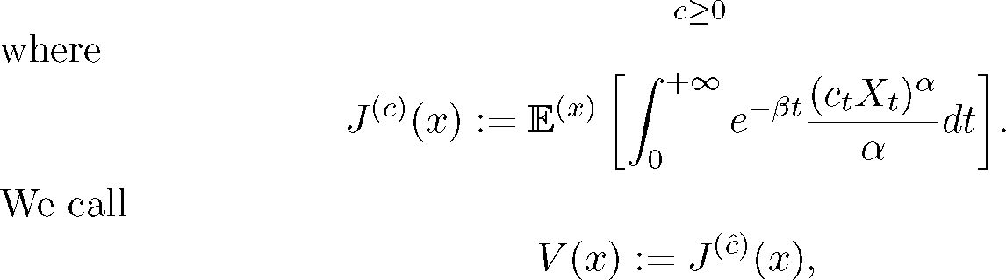
46
The aim is to find the time to sale the indivisible asset and the consumption
rate which maximizes the investor’s performance functional.
It turns out that the problem can be reduced to a one dimensional dif-
ferential equation with a boundary conditions. However, if we add additional
financial assets the problem becomes multidimensional and much harder to
solve.
Investor problems are investigated in many particular cases. Typically, see
e.g. 0ksendal and Sulem [10] and original paper by Merton [9], one is able to
find explicite solution to the HJB equation. In our case we are only able to
find numerically solution assuming its smoothness. The problem if given HJB
equation has a smooth solution or if the value function is smooth, has been
only solved under the uniform ellipticity condition see e.g. [3], p. 165, p. 171,
and references therein and [11], p. 51, for parabolic case. Unfortunately, our
problem fails to be uniformly elliptic.
The problem of optimal selling was also formulated and studied in [1]. The
authors considered an investor with power utility who owns a single unit of an
indivisible asset and who wishes to choose the optimum time to sell this asset.
They showed that the optimal strategy is to sell the indivisible asset the first
time that its value exceeds a certain proportion of the investor’s wealth.
- Classical Merton problem. Let (Q, F, (Ft), P) be a filtered proba-
bility space. Define (Xt) as the wealth process of the investor. Without any
loss of generality we assume that the consumption rate is of the form ctXt,
where the (Ft)-adapted process (ct) will be called the consumption. Then Xt
changes according to the stochastic differential equation
( dXt = (^ — ct) Xtdt + aXtdWt, t > 0,
\ X0 = x > 0,
where a > 0 are constants and (Wt) is a Brownian motion. Let a e (0,1)
and the rate satisfies

(2.1)
The objective is to find a consumption c such that
J(é)(x) := sup J(c)(x),
47
the value function and interpret J(c)(x) as expected value of investor’s con-
sumption rate discounted at rate fi.
This problem can be solved by using the stochastic control theory. Namely,
according to the Hamilton-Jacobi-Bellman verification theorem1 we look for
a function V £ C2 (0, +rc>) such that
  - - fiV(x) + ^xVc(x) + 1 a2x2Vxx(x) + sup cxVx(x) X = 0.
2 c>0 ( a )
It turns out that the above supremum is attained at
1
c = x (Vx(x)) “-1
and the solution of equation (2.2) is of the form
  - V (x) = Axa,
where
(2.4)
A = 1
a
P — ^a — 2 a (a — 1)a2
1 — a
a— 1
It is easy to check that all the assumptions of the Hamilton-Jacobi-Bellman
verification theorem are satisfied, so function V given by (2.3) is the value
function and
1
ct = (Aa)a-1
is the optimal consumption strategy. Note that assumption (2.1) guarantees
that the constant A is well defined.
Remark 2.1. In our setting the consumption rate is of the form ctXt.
It turns out that the same arguments can be applied to the problem when
the investor’s wealth process changes according to the stochastic differential
equation
dXt = yXtdt + aXtdWt — Ctdt, t > 0,
X0 = x > 0,
where (Ct) is a positive, (Ft)-adapted stochastic process and the investor’s
performance criterion is of the form
J (c)(x) = E(
x)
o — dt I
Ct
dt
a
where
Tx := inf {t > 0: Xt = 0} .
In fact, both problems have the same solutions.
T
x
0
1See Theorem 3.1 in [10].
48
- Modified Merton problem. Assume now that our investor is addi-
tionally endowed with a one unit of an indivisible asset. The value of this asset
is given by the equation
j dYt = ¡Ytdt + 1YtdWt, t > 0,
j Yo = y > 0,
where ¡, 1 > 0 are constants and (IWt) is an independent of (Wt) one-
dimensional Brownian motion. The investor can sale the indivisible asset at
arbitrary time t > 0 and must immediately invest the money received from
this sale in the risky asset. We assume that after the indivisible asset is sold
the agent consumes his capital in an optimal fashion. It means that investor
behaves in accordance with solution to the Merton portfolio optimization prob-
lem on interval [t, +rc>) with initial value x = XT = X- + YT, where X- is
value of investor’s wealth process immediately prior to the sale of the indivisible
asset.
The aim is to find a stopping time f and a consumption c such that
J(T,T)(x,y) := sup J(T,c)(x,y),
T>0, c>0
where
J(r’c)(x,y) := E(x’y)
-ßt(ctXt) dt + e-ßTA (XT + Yr)a x{r<+^}
lo e a
and A is given by (2.4). We interpret J(T,c)(x,y) as the expected value of
investor’s consumption rate discounted at rate and increased by premium
for sale of the indivisble asset at time t.
Remark 3.1. Note that if < a¡ + |a(a — 1)a2, then the problem has
a trivial solution. Namely, assume that the time to sale indivisible asset is of
the form Tn = n. Then
J (n’c)(x,y) = E(x>y)
n
e-ßt (ctXt)a dt + e-ßnA(Xn + Yn)c
Jo a
> E(x’y) [e-ßnAYn“
Hence, we have
= Aya ex^ ( —ß + aß + 1 a(a — 1)<t2 ) n
lim J(n,c)(x,y) = +to,
n^+^
so the value function is infinite and there is no optimal stopping time. It is
always better to postpone the decision to sell. Therefore (see also (2.1)), we
assume that
- ß > max 10, ag + 1 a(a — 1)ct2, aß + 1 a(a — 1)ä2 |.
T
49
4. Solution by the Hamilton—Jacobi—Bellman verification theo-
rem. In this section using the verification theorem we reduce the problem to
ordinary differential equation with boundary conditions.
Theorem 4.1. Let us assume that A is a constant given by (2.4) and ft
satisfies (3.1). Suppose that
- (a — 1)ct2 < ft — p. < ^(a — 1) (ct2 — <r2).
Moreover, assume that K e C2(0, +rc>) and z* > 0 are such that for every
z e (z*, +rc>),
- A (z + 1)a <K(z) < A [za + (z + 1)a] ,
a
- 0 <K'(z) < ^K(z)
and
(4.4)
1 (a2 + à2) z2K" (z) + [p — p + (1 - a)à2] zK' (z)
+
—3 + ap + ~ a(a — 1)a2
1 a a
K (z) + (K1 (z)) “-1 = 0,
a
with boundary conditions
(4.5) K(z*) = A (z* + 1)a and K'(z*) = Aa (z* + 1)a
Then
- Free boundary z* satisfies
z* < p — p + 2(a — 1)(a2 — x2)
< p — p — (a — 1)a2
- Optimal time to sale the indivisible asset is of the form
f = inf 11 > 0: Xt < z*
- Optimal consumption rate is of the form
fX. = ( « (K (X)) ^ • if t € |0-f)-
[ (Aa)a-1 X., if t G [f, +rc>).
- The value function is given by
( A(x -( y)a, if y G [0, z*),
V(x y) = 4 „ a TV- (x ) if x ^ \y*
yaK(y), if ye [z*, +~).
50
Proof. Let O := (0, +rc>) x (0, +œ>) and define
- Lc<p(x, y) := (^ - c)x^(x, y) + jlyfy(x, y)
+ 1(^x)2^xx(x,y) + 2(iry)2^yy (x,y),
for all functions ^ : O ^ R which are twice differentiable at (x, y). According to
the verification theorem (see e.g. [10], p. 62) we are looking for the continuation
region D CO and function ^ : O ^ R of class C 2(O\dD) n C 1(dD) such that
I. For all (x, y) G O\D and for all c > 0,
- #x,y) = A (x + y)a,
and
- - ^^(x,y)+ Lc^(x,y) + (cx) < 0.
a
II. For (x*,y*) G dD,
- ^(x*,y*) = A (x* + y*)a,
- ^x(x*,y*) = Aa (x* + y*)a-1 and ^y(x*,y*)= Aa (x* + y*)a-1.
III. For all (x, y) G D,
- ^(x,y) > A (x + y)a
and
- - ^(x, y) + sup
c>0
The key idea of the proof relies on the observation that our problem can
be reduced to one-dimensional. Namely, we expect ^(x, y) to be of the form
- ^(x, y) := yaK for all (x,y) G D,
where K : (0, +œ>) ^ R is unknown function. Moreover, let
- D :^(x,y) gO : x* <x< +^},
where x*/y* =: z* is unknown free boundary.
Summarizing, we need to find the free boundary z* > 0 and the function
K which satisfy the three conditions above.
Now we verify the conditions I, II and III for the function (4.13) and
continuation region (4.14).
Lc^(x,y) +
(cx)a
a
0.
51
Ad. I. In I the function K does not appear but if we put (4.7) into inequality
(4.8) we get a condition for the free boundary. Namely, for all
x
(x, y) e 0\D = <Mx, y) e O: 0 < - < z*
v y
we have that
—fi^(x, y) + sup (Lc^(x, y) + (C-) \ < 0,
c>0 I a J
which can be stated equivalently as follows
1f„. 2 , x , r. y
2 x + y x + y
+ -(a — l)X-—X—-2 + -(a — l)<r2-—y—-2 < 0.
2( ) (x + y)2 2( ) (x + y)2 <
Putting z := x/y we obtain
[/x — i — (a — 1)X] z + /x — i + -(a — l)(x2 — ^2) < 0.
If z ^ 0, then assumption (4.1) guarantees that above inequality is satisfied.
Moreover, we have
z* < i—1 + 2(a —1)(^2 — x2)
< i — i — (a — 1)ct2
Ad. II. For (x*,y*) G dD, from conditions (4.9) and (4.10), we have
K(z*) = A (z* + l)a and K'(z*) = Aa (z* + l)a-1.
Ad. III. For all (x,y) G D, the supremum in (4.12) is attained at
«..» .=x (*(;))*
Thus from the verification theorem we know that
_ i
vv = y(K(f '
If we put (4.15) into HJB equation we obtain
, (<72 + i2) xK"(x) + [i — i + (l - a)i2] yK' (x)
2v y2 \y/ y \y
+
for all (x, y) G D. Putting z := x/y we get the equation (4.4).
—3 + ai + — a(a — l)*x2
a
K^\ + l — a (K,(a-1
y a y
0
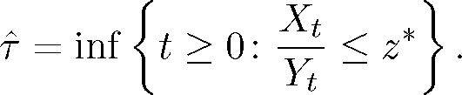
52
Summing up we reduced our problem to ordinary differential equation with
boundary conditions.
Remark 4.2. Condition (4.11) is of the form
A (z + 1)a < K (z) for all z G (z*, +rc>).
Remark 4.3. For all (x,y) G D, using the solution to Merton’s classical
portfolio problem, we get
Remark 4.4. The value function is increasing function of the initial con-
ditions. It means that ÿx(x,y) > 0 and (x, y) > 0 for every (x,y) G D.
Therefore we obtain
Note that by (4.16) the HJB equation is well defined.
Remark 4.5. From the verification theorem the optimal stopping time is
of the form
- Numerical example. In this section we give a numerical example of
calculating the optimal time to sale the indivisible asset, the optimal consump-
tion rate and the value function.
Let us assume that , ¡, a, ¡, 1 and — satisfy the assumptions of Theorem
4.1. Then for every z* G (0,1] we can numerically solve the HJB equation with
the boundary conditions. The numerical observations (using Mathematica 9.0)
suggest that
- There is only one z* = Z for which the equation (4.4) with the boundary
conditions (4.5) has a global solution K(z) which satisfies the conditions
- and (4.3).
- For z* G (0, Z) the conditions (4.2) and (4.3) are not satisfied, that is
either the solution grows too fast or its derivative does not satisfy the
constraints in (4.3).
(c X )a I r
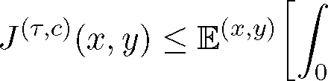e-fiti-iOLdt + E(x,y) \e-iTA (XT + Yr)a x{r<+^}
< Axa + A(x + y)a.
For this reason the function K must satisfy
K (z) < A [za + (z + 1)a] for all z £ (z*, +rc>).
(4.16)
a
0 < K'(z) < —K(z) for all z G (z*, +rc>).
t = inf {t > 0: (Xt,Yt) G D} .
It means that the optimal time to sell the indivisible asset is
□
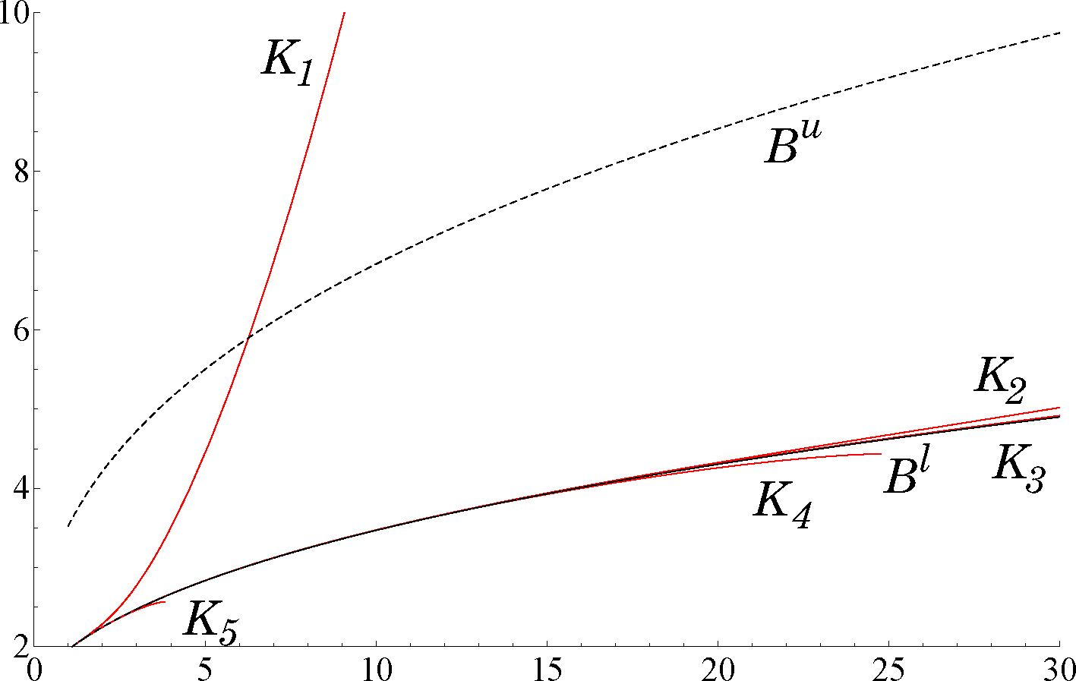
53
- For z* G (z, z] the solution is only local, that is the acceleration goes to
-^ or the conditions (4.2) and (4.3) are not satisfied.
Now we present numerical solution for parameters
ft = 2, p = 1, a = 1, p = 0.5, a = 0.5 and — = 1.
3
Note that the assumptions of Theorem 4.1 are satisfied. Then we have that
A = 1.56006, p = 1.5 and from numerical observations we get
z w 1.3169624.
Let Kj(z) be the solution to equation (4.4) with boundary conditions
Ki(z*) = A (z* + 1)a and K'(z*) = Aa (z* + 1)a-1.
From assumption (4.2) we have that Kftz) must satisfy the following inequality
B*(z) < Ki(z) < Bu(z),
where
B1 (z) = A (z + 1)a and Bu(z) = A [za + (z + 1)a] .
Moreover, from (4.3) the function K((z) must live between two curves C\(z)
and Cu(z), where
a
Cj(z) = 0 and CU (z) = — Kj(z).
In the figure below we present the functions K(z) for i = 1,..., 5, where
z* = 1, z* = 1.31696, z* = z, z4 = 1.31697, and z* = p.
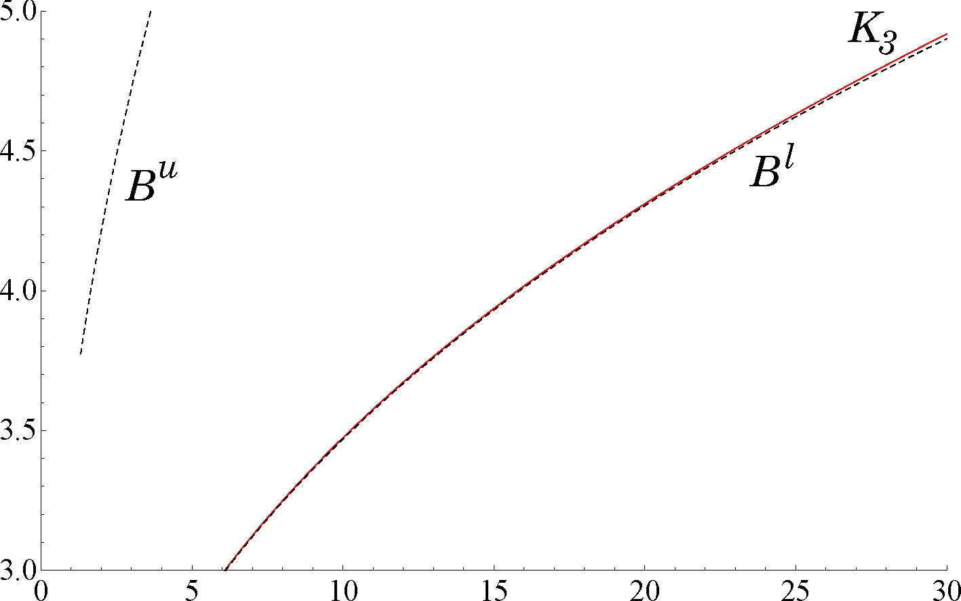
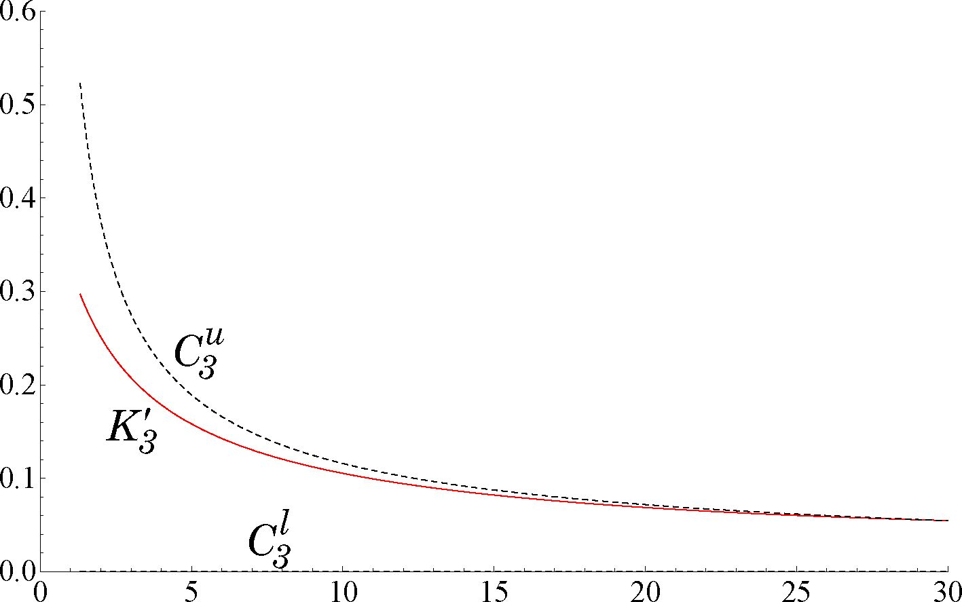
54
Note that the function K3(z) almost coincides with the function Bl (z). The
difference between them is visible in the next figure on a different scale.
Further, we present K (z).
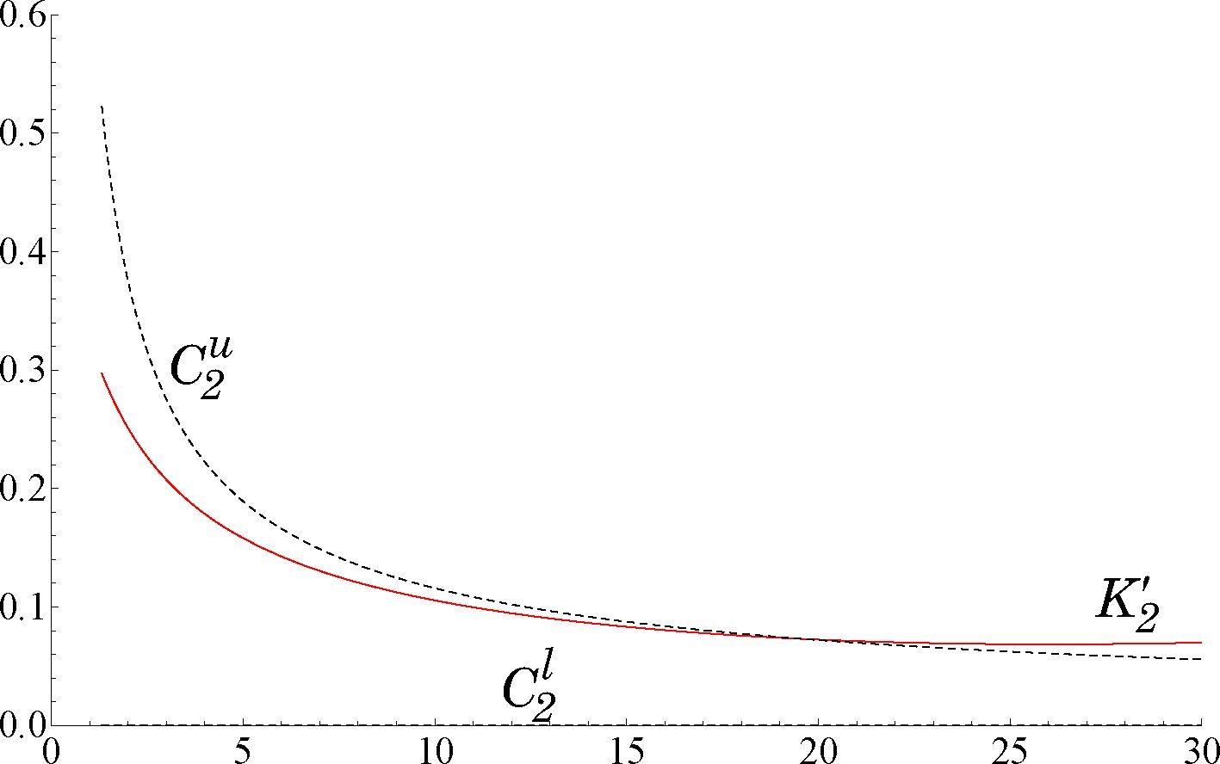
55
Finally, in the next figure we show K(z).
Acknowledgements. The author is very grateful to Professor Szymon Peszat
for his support, meetings, helpful comments and suggestions.

References
- Evans J., Henderson V., Hobson D., Optimal timing for an indivisible asset sale, Math.
Finance, 18 (2008), 545-567.
- Fabre E., Royer G., Touzi N., Liquidation of an indivisible asset with independent invest-
ment, arXiv: 1312.2754v2.
- Fleming W. H., Soner H. M., Controlled Markov processes and viscosity solutions, 2nd
Edition, Springer, New York, 2006.
- Henderson V., Hobson D., An explicit solution for an optimal stopping/optimal control
problem which models an asset sale, Annals of Applied Probability, 18(5) (2008), 1681-
1705.
- Henderson V., Hobson D., Risk aversion, indivisible timing options, and gambling, Op-
erations Research, 61 (2013), 126-137.
- Karatzas I., Shreve S., Brownian motion and stochastic calculus, Springer-Verlag, New
York, 1988.
- Karatzas I., Shreve S., Methods of mathematical finance, Springer-Verlag, New York,
1998.
- Karatzas I., Wang H., Utility maximization with discretionary stopping, SIAM J. Control
Optim., 39 (2000), 306-329.
- Merton R. C., Optimal consumption and portfolio rules in continuous time, J. Econ.
Theory, 3 (1971), 373-413.
56
- 0ksendal B., Sulem A., Applied stochastic control of jump diffusions, Springer-Verlag,
Berlin, 2005.
- Pham H., Continuous-time stochastic control and optimization with financial applica-
tions, Springer-Verlag, Berlin, Heidelberg, 2009.
Received August 22, 2012
Institute of Mathematics
Faculty of Mathematics and Computer Science
Jagiellonian University
Lojasiewicza 6
30-348 Krakow
Poland
e-mail: jakub.trybula@im.uj.edu.pl
e-mail: jakubtrybula@gmail.com

