16
Alloying Effect in Low Loaded Rh Catalysts Supported on High Surface Area Alumina on Their Activity in CH₄and NO Decomposition
Mieczysława Najbar**et al*
Faculty of ChemistryJagiellonian University
Poland
1. Introduction
1.1 The activity of Rh sites in Al-Rh alloys nanocrystallites in the reaction based on the electron transfer to the adsorbed molecules
In the alloys of transition metals (TM) and main group ones (MGM) the valence electrons from MGM can fill the d band of the TMs entirely and slightly increase the number of electrons in their s band (Azaroff, 1960; Kittel, 2005). Such Rh atoms enriched in electrons, present in Al-Rh alloys, were found to be very active electron donors (Pietraszek et al., 2007). It was revealed that they transfer the electrons to the antibondingЛorbital of adsorbed nitric oxide molecules causing NO decomposition to dinitrogen and dioxygen (Pietraszek et al., 2007).
Due to the great difference in the Al and Rh electro-negativity, the alloys are sometimes considered as nonstoichiometric chemical compounds. Because of the large range of nonstoichiometry those compounds should rather be estimated as intermediate phases (IP) (Azaroff, 1960).
The presence of the Al-Rh alloy nanocrystallites isostructural with Al₉Rh₂(Bostrom et al., 2005) was earlier revealed in the freshly prepared Rh/δAl₂O₃catalysts containing 0.06 and
1.5 wt.% Rh (Pietraszek et al., 2007; Zimowska et al., 2006).
It is well known that in bimetallic alloy crystallites (Gasser, 1985) the metal with the lower melting point segregates in their surface layers. The melting point of aluminum is much lowerthanthatofrhodium(Lide,2004-2005).Theenrichmentinaluminumofthesurfaceof
*Patrick Da Costa1, Jarosław Dutkiewicz2, Valerio Choque3,Narcis Homs3, PawełKornelak2,Agnieszka Pietraszek2, Pilar Ramirez de la Piscina3and Janusz Sobczak4
1The Jean le Rond d’Alembert Institute, University Pierre et Marie Curie, France
2Faculty of Chemistry, Jagiellonian University, Poland
3Department of Inorganic Chemistry, University of Barcelona, Spain
4Institute of Physical Chemistry PAS, Poland
**Corresponding Author
www.intechopen.com

354
Noble Metals
the nanocrystallites of the Al-Rh intermediate phase at temperature 873K, close to Al melting point, should be very distinct.
TheelectrontransferfromRhatomsenrichedinelectronstotheantibondingorbitalsofsuch molecules as O₂and CH₄, leading to dissociation, can also be expected. The comparison of the enthalpy of the formation of NO, O₂and CH₄(Lide, 2004-2005) allows to expect the following sequence of the initial temperature of the dissociation: T_{CH4}> T_{O2}>T_{NO}.
Methane dissociation is the main step in one of the most intensively investigated processof the partial methane oxidation (PMO). Thus, it was interesting to compare the activity of the Rh active sites in the Al-Rh nanocrystallites which formed on the surface of the low-loaded Rh/Al₂O₃catalysts with that of the Rh active sites in the rhodium clusters present on the surface of the high-loadedcatalysts.
The study of the influence of the concentration of the atomic oxygen surface species on the Al-Rh alloy nanocrystallites on the composition of the PMO products is necessary to understand the role of the CH₄: O₂ratio in the PMO process.
The investigations of the Al segregation in the Al-Rh alloy nanocrystallites allow one to understand the evolution of the surface structure during the catalyst use at temperatures higher than the synthesis temperature.
The simultaneous studies of the NO direct decomposition and CH₄oxidation may confirm theexpectedsequenceofthetemperaturesoftheinitialdissociationofCH₄,O₂andNO.The knowledge of this sequence would help to estimate the temperature range of the effective directNOdecompositionintheoffgasescontainingmethaneandanexcessofoxygen.
1.2 The methane conversion in the oxygen presence to the synthesis gas over alumina supported rhodium catalysts
CO and H₂mixture (the synthesis gas - syn-gas) is applied in the Fischer-Tropsch and methanol syntheses. Hydrogen for ammonia synthesis and the food industry is also obtained from the syn-gas.
At present the synthesis gas is produced mainly by the highly endothermic, and thus unfriendly for environment, methane steam reforming. The exothermic partial methane oxidation would be more economical and therefore more friendly for environment.
Since a C-H bond can be broken on Rh sites at relatively low temperatures (Wang et al., 1996), the endothermic methane dissociation to C atoms and dihydrogen, followed by carbon oxidation, is most frequently considered as a plausible mechanism of the partial methane oxidation to the synthesis gas over the Rh/Al₂O₃catalysts (Enger et al., 2008; Hofstad et al., 1998; Mallens et al., 1997; Nakagawa et al., 1999; Wang et al., 1996). At PMO temperatures hydrogen practically does not adsorb on the Rh surface and thus the possibility of its interaction with surface oxygen or OH groups is rather low ( Rieck & Bell,1985).
The high price of rhodium limits the use of the high loaded Rh/Al₂O₃catalysts. Therefore it is of interest to investigate the possibility of the use of the low-loaded ones in PMO. In such catalystsAl-Rhalloyscanbeformed,besidesclustersofmetallicRh,asaresultofthestrong metal-supportinteraction(SIMS)(Pietraszeketal.,2007;Zimowskaetal.,2006).
www.intechopen.com

Alloying Effect in Low Loaded Rh Catalysts Supported on
High Surface Area Alumina on Their Activity in CH₄and NO Decomposition
355
As it was discussed elsewhere (Zimowska et al., 2006), calcination of the precursors of the low loaded Rh/δAl₂O₃catalysts (with the specific surface area ca 287m2/g) causes Rh incorporation into the near-to-surface layers of the alumina nanocrystallites resulting in a Rhx+/Al₂O₃solid solution (Rhx+/Al₂O₃s.s.) formation. The reduction of such a s.s. leads to Al-Rh alloys.
1.3 The NO direct decomposition in the oxygen presence over alumina supported precious metal catalysts
Nitrogen oxides NO_{x}in the flue gases from fuel combustion contain more then 90% of NO. It is formed from air in the endothermic N₂oxidation at temperatures above 1273K. NO is a thermodynamically unstable molecule with a high, positive formation enthalpy∆Hº_{f(298)}= 90,2 kJ/mol. Therefore it could decompose to N₂and O₂at low temperatures (between 293 and 973K ) (Chuang & Tan, 1997; Garin, 2001; Tonetto et al.,2003).
The NO decomposition seems to be the best way of NO removal from the flue gases of stationary sources of emission from a practical, environmental as well as an economical point of view. This process does not require any reducer that allows the avoidance of secondary pollutants like oxygenated hydrocarbons, CO, CO₂, NH₃or even cyanate and isocyanate (Chuang & Tan, 1997; Parvulescu et al., 1998; Tonetto et al., 2003). However, in thecaseofthedirectNOdecompositionN₂OcanbeformedasidefromN₂inoneofthetwo possible paths of the process (Parvulescu et al.,1998):
2NO→N₂+ O₂
2NO→N₂O + ½ O₂
(1)
(2)
Oxide supported Pt, Rh and Pd high-loaded catalysts are known to be the most active in the direct NO decomposition among the metal catalysts supported on metal oxides (Almusaiteeretal.,2000;Garin,2001;Gorteetal.,1981;Ishiietal.,2002;Papp&Sabde,2005; Pietraszek et al., 2007; Rahkamaa & Salmi, 1999; Root et al., 1983; Sugisawa et al., 2001; X. Wang et al., 2004). However, the NO dissociation proceeds on Rh active species in rhodium clusters with a satisfactory rate only above 623K and it is greatly suppressed by the oxygen presence.ThereactiveatomicspeciesatsuchtemperaturesfavorNOoxidation.Ontheother hand, the direct NO decomposition on the Rh active sites in Al-Rh alloy nanocrystallites (Pietraszeketal.,2007)formedonthelowloadedaluminasupportedcatalystsmayproceed with a relatively high rate at 473K, below the temperature of the oxygen dissociation. The investigation of the alloying effect on the NO direct decomposition in the presence of oxygen and methane on a 0.18 wt.% Rh/δAl₂O₃catalyst with rhodium present mostly in the Al-Rh nanocrystallites should give relevant information about the direct NO decomposition in off gasses formed during methanecombustion.
2. Results and discussion
2.1 Experimental
Two 0.18 wt.% Rh/δAl₂O₃catalysts were obtained by one- or three-step Rh3+deposition onδ-alumina support. It was expected that such a procedure would produce catalysts with Rh sites of different coordination.
www.intechopen.com

356
Noble Metals
The structure of the Rh sites was determined by the FTIR spectroscopy of CO adsorbed and by XPS.
TheδAl₂O₃support (287m2/g) was obtained by the sol-gel method from aluminum tri-sec- butylate (Zimowska et al., 2006).
The one-step (1-S) and three-step (3-S) Rh depositions were performed from a RhCl₃.2H₂O aqueous solution of the same concentration.
The details of the Rh deposition as well as those of oxidising and reducing thermal treatments were described elsewhere (Pietraszek et al., 2007; Zimowska et al. 2006).
The first step of the 3-S synthesis of the 0.18 wt.% Rh/δAl₂O₃catalyst consists of:
i/theimpregnationoftheδAl₂O₃supportwiththeRhCl₃.2H₂Oaqueoussolution,ii/thedryingofawetprecursor,iii/thecalcinationofadryprecursorat773Kandreductionat623Kand773Kofacalcinedprecursor.Theusedprocedureyieldsthe0.06wt.%Rh/δAl₂O₃catalyst.
The next step of the 3-S synthesis of the 0.18wt.% Rh/δAl₂O₃catalyst differs from the previous one only in the first stage; the 0.06 wt.% Rh/δAl₂O₃catalyst (not theδAl₂O₃support) is impregnated by the RhCl₃.2H₂O aqueous solution. As a result of the next drying, calcination and reduction the 0.12wt.%Rh/δAl₂O₃catalyst is obtained.
In the third step of the 3-S synthesis the 0.12 wt.% Rh/δAl₂O₃catalyst is impregnated by the same RhCl₃.2H₂O aqueous solution. The next drying, calcinations and reduction yields the
0.18 wt. % Rh/δAl₂O₃catalyst.
The1-Ssynthesisofthe0.18wt.%Rh/δAl₂O₃catalystconsistsof:i/theimpregnationoftheδAl₂O₃supportwithatripleportionoftheRhCl₃.2H₂Oaqueoussolution,ii/thedryingofa wet precursor,iii/the calcination of a dry precursor and the reduction of a calcined precursor.
The FTIR spectroscopy of CO adsorbed and XPS measurements were performed for the fresh one-step ( F-1-S) and three-step (F-3-S) catalysts as well as for the one-step and three- stepcatalystssubjectedtotheinteractionwithsixmethanepulses(U-1-S)and(U-3-S).
CO was adsorbed on the surface of the catalysts at room temperature and the spectra were taken also at room temperature after outgasing at 373K using a Nicolet 5700 Nexus spectrometer at a resolution of 4 cm-1.
The XPSmeasurementsforF-1-S, F-3-S, U-1-S,andU-3-S catalysts were carriedout using ascanning photoelectron spectrometerPHI 5000VersaProbe (Physical Electronics USA/ULVAC Japan)withmonochromaticAl Kαradiation (1486.6eV).Thesignalwascollectedfrom200 x200μmareausinganx-raybeamfocusedto100μmdiameterwith25Wpower.Forthecharge shift compensationall themeasurements were madewithneutralizationby low energyelectronsandargon ions.Thesurvey spectra were obtained withapass energyof117.4eV in 0.4eVincrements.ThedetailedspectraoftheRh3d,andtheAl2pregionsweremeasuredwith a pass energy of 23.5eV in 0.1eVincrements.The bindingenergyscale (BE) wascalibrated basedon theAl2pin aAl₂O₃support signal(BE =74.3eV). Signal componentswerefitted usinganon-linearleastsquares fitting CasaXPSsoftware.Thequantitative analysiswasdone afteraShirley-type background subtraction usingtheScofield sensitivityfactors.
www.intechopen.com

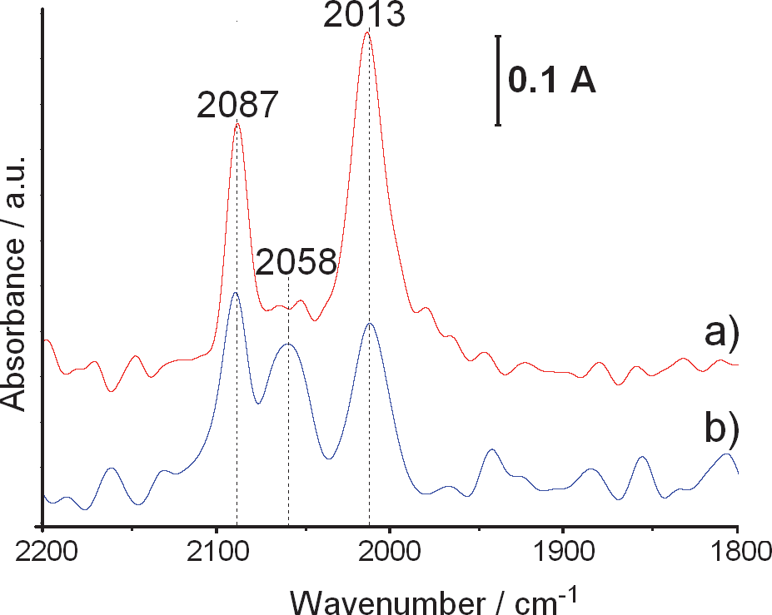
Alloying Effect in Low Loaded Rh Catalysts Supported on
High Surface Area Alumina on Their Activity in CH₄and NO Decomposition
357
The investigation of the interaction of the catalysts with methane pulses was carried out at 873K in an acid-resistant steel tubular reactor with a 6mm internal diameter and 30cm length, under the pressure of 280 kPa and at GHSV =9000h-1. The 700 mm3methane pulses were introduced into the Ar stream flowing through the reactor, the Carboxen 1000 packed columnandtheTCDdetectorofaHewlett-Packard5890chromatograph.Thetimebetween consecutive methane pulses was ca.32min.
The direct NO decomposition in methane and the oxygen presence was investigated under thesteady-stateconditionsin473-673Ktemperaturerange.Thereactionmixtureof150ppm NO1500ppmCH₄,7%O₂andArasabalancepassedoverthecatalystplacedonquartz-wool in a quartz reactor with GHSV = 20 000h-1. Before the steady-state experiment the catalyst washeatedinthereactionmixturefromther.t.to773Kandconsecutivemeasurementswere performed stepwise starting from 673K to 473K. A FID detector was used to follow the total concentrationofhydrocarbonsandtheN₂formationwascheckedbyamicro-GC.
2.2Thephysicochemicalcharacterisationof0.18wt.%Rh/Al₂O₃catalystsbyFTIRspectroscopy of CO adsorbed and XPS
Fig.1.presentstheFTIRspectraofCOadsorbedontheF-3-S0.18wt.%Rh/Al₂O₃catalyst(a)andontheF-3-S0.18wt.%Rh/Al₂O₃one(b).Inagreementwiththedataextensivelyreported in the literature (Finocchio et al., 2007 ; Hadjiivanov &Vayssilov, 2002; Kraus et al., 1989; Lavalley et al., 1990; Paul et al., 1999; Yates et al., 1979) two main bands at 2087 and 2013 cm-1, present in the spectra of both thecatalysts,can beassignedtosymmetric and asymmetric stretching vibrationsofgem-bicarbonyls adsorbedon the Rhatomicallydispersed
Fig. 1. DRIFT spectra CO adsorbed on the surface of the 0.18 wt.% Rh /δAl₂O₃catalysts obtained by: a/three-step rhodium deposition, b/ one-step rhodium deposition
www.intechopen.com

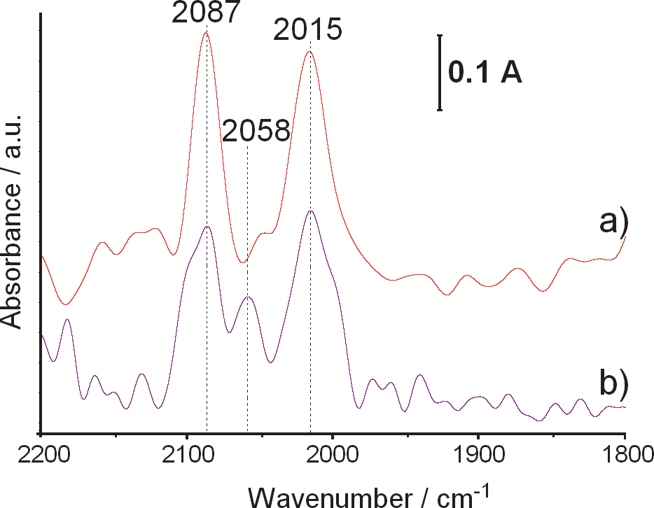
358
Noble Metals
on thealumina surface. However,the exactpositionof theatomically dispersedRh in thestructureofcatalysthas yet to bedetermined (Finocchioet al.,2007;Hadjiivanov &Vayssilov, 2002; Krausetal., 1989; Lavalleyetal., 1990; Pauletal., 1999; Yatesetal., 1979). Accordingtoabove cited papersthe peak at2058cm-1,clearlyseenin thespectrumof theF-1-S catalyst,resultsfromC-OstretchingvibrationsinCOlinearlyadsorbedontheRhclusters.
Fig. 2. DRIFT spectra of CO adsorbed on the surface of the 0.18 wt.% Rh /δAl₂O₃catalysts: a/ obtained by a three-step rhodium deposition and subjected to interaction with six methanepulses,b/obtainedbyaone-steprhodiumdepositionandsubjectedtointeraction with six methane pulses.
ThusonemayconcludethatonthesurfaceoftheF-1-ScatalyststheatomicallydispersedRh coexists with the Rh clusters. However, on the surface of the F-3-S catalyst atomically dispersed species are hardlyseen.
Fig. 2 presents the FTIR spectra of CO adsorbed on the three-step (a) and one-step (b)0.18wt.%Rh/Al₂O₃catalystssubjectedtointeractionwith6methanepulsesat873K.
ThedistinctdecreaseoftheratioofRhinclusterstoRhinalloynanocrystallitesasaresultof the catalysts interaction with methane pulses is observed. The increase of the width of the gem-bicarbonyl peaks reveals that during the pulse experiment atomically dispersed Rh with a coordination slightly different than in the fresh catalysts isformed.
The comparison of XPS results for the fresh and used catalysts gives further insight in the nature of atomically dispersed rhodium species and in the mechanism of their creation as well as their interaction with the clustered metallic rhodium species.
InTable1theBEsofpeaksobtainedbythedeconvolutionoftheAl2p_{3/2}andRh3d_{5/2}bands aswellasthepercentageoftheparticularAlandRhspecies((Mex/ΣRhx+ΣAlx).100)inF-1-S, U-1-S, F-3-S and U-3-S catalysts arepresented.
www.intechopen.com

Alloying Effect in Low Loaded Rh Catalysts Supported on
High Surface Area Alumina on Their Activity in CH₄and NO Decomposition
359
Mx– metallic or cationic Rh and/or Al species
Table 1. The XPS results for the fresh one-step (F-1-S) and the three-step (F-3-S) 0.18 wt.% Rh/δAl₂O₃catalysts and for those catalysts subjected to the interaction with six methane pulses (U-1-S and U-3-S).
The Al2p_{3/2}bands in the spectra of the particular catalysts were deconvoluted into two peaks. The major peaks were ascribed to Al in alumina - BE=74.3eV (Wagner et al., 2007).
The BE of the less intensive Al2p_{3/2}peaks as well as those of the Rh 3d_{5/2}peaks were determinedwithrespecttothisone.ThelessintensiveAl2p_{3/2}peakswithexceptionallyhigh BE (75.4-75.5eV) were ascribed to Al in the Al-Rh alloy. The transfer of the valence Al electrons mainly to Rh unoccupied d-orbitals (Azaroff, 1960; Kittel, 2005) in the alloyshould cause the increase of theAl2p_{3/2}BEand decreaseofRh3d_{5/2}one withrespecttothose inseparatemetals (Wagner,2007).
TheRh3d_{5/2}bandsintheXPSspectraoftheF-1-SandF-3-Scatalystsweredeconvolutedinto the peaks of cationic species with BE equal to 310.0 and 310.2eV and of Al-Rh alloy ones withBEequalto307.4and307.8eV,alittlelowerthanthatofmetallicRh(Wagner,2007).
Theatomically dispersedRhspecies (Finocchioetal.,2007;Hadjiivanov &Vayssilov,2002;Krausetal.,1989;Lavalleyetal.,1990;Pauletal.,1999;Yatesetal.,1979)demonstradedinthe FTIR spectraof COadsorbedon theF-1-Sand theF-3-S catalysts (Fig.1)bybandsat 2087 and2013cm-1,occurprobablyinthesurfacelatticepositionoftheAl-Rhalloynanocrystallites.
www.intechopen.com

Catalyst

Peak

BE[eV]
(Mex/ΣRhx+ΣAlx).100 [at.%]*

F-1-S

Rh3d_{5/2}

Al2p_{3/2}
310.0
307.4

74.3
0.08
0.05

99.87

U-1-S

Rh3d_{5/2}

Al2p_{3/2}

307.5
305.0

75.4
74.3
0.003
0.003

15.69
84.30

F- 3-S

Rh3d_{5/2}

Al2p_{3/2}

310.2
307.8

75.5
74.3
0.06
0.09

9.72
90.13

U- 3-S

Rh3d_{5/2}

Al2p_{3/2}

309.6
307.2

75.4
74.3
0.003
0.003

14.21
85.70

360
Noble Metals
The presence of only one 3d_{5/2}peak of the Rh species with BE =307.4 eV in the spectrum of the F-1-S catalyst reveals an electronic interaction between the Al-Rh intermediate phase nanocrystallites and the Rh clusters. It shows that the Rh clusters occur in the immediate proximity of the Al-Rh nanocrystallites. Such an electronic interaction was earlier observed by Thiam et al. (Thiam et al., 2004) between aluminum foil and a rhodium overlayer.
A higher percentage of the metallic Rh species in the F-3-S catalyst (60 %) than in the F-1-S one (ca 40%) could easily be explained by the differences in the syntheses. The one-step Rh deposition is thought to have occurred preferably on the smallest nanocrystallites with the
highest surface/bulk ratio, possibly by an
Rh3+
cation exchange with protons of the
accessible acidic OH groups on alumina. Thus, the Rh deposition calculated per volume unit of alumina crystallites is higher the smaller their dimensions are. Rhodium clusters are formed from an excess of the aqueous Rh3+ions solution present in pores.
Ontheotherhand,thethree-stepRhdepositionoccursmostlybyexchangeoftheRhcations withtheacidicOHgroupprotonsonthesurfaceofthesmallestδaluminacrystallites,
which is renovated in each synthesis step in the course of the calcinations. It results in the exceptional enrichment of these crystallites in Rh. An incorporation of rhodium intoδalumina during the thermal treatments causes the formation of the Rhx+/Al₂O₃solid solution. The reduction of the s.s. nanocrystallites, resulting in inter-metallic Al-Rh alloy formation, is easier the higher the rhodium concentration is.
It is obvious that the enrichment of Rh atoms in electrons is the greater the higher their dispersion is in the aluminium matrix. Earlier this problem in particular was discussed regarding the Cu-Ni alloys (Kittel, 2005).
The interaction of the F-1-S catalyst with six CH₄pulses causes a complete disappearance of the cationic Rh species and a great decrease in the content of the metallic Rh species. Simultaneously the Rh species with 3d_{5/2}BE equal to 305.0 eV and the Al species with an exceptionally high 2p_{3/2}BE (75.4eV) do appear.
Thedisappearanceofthecationicspeciesrevealstheformationofthenewnanocystallitesof the Al-Rh alloy by the reduction of the Rhx+/Al₂O₃s.s. of low Rhcontent.
The major decrease of the content of Rh species with 3d_{5/2}BE close to 307 eV and the appearance of the species with 3d_{5/2}BE = 305 eV and the Al ones with 2p_{3/2}BE = 75.4 eV couldbetheresultoftheAlsurfacesegregationinthealloynanocrystallitesformedat773K. However, Rh species with 3d_{5/2}BE = 305 eV and the Al ones with 2p_{3/2}BE = 75.4 eV could alsobeformedasaresultofthereductionoftheRhx+/Al₂O₃s.s.withalowRhcontent.
The heating of the F-3-S catalyst and its interaction with 6 methane pulses causes a great decreaseinthetotalcontentsoftheRhspeciesinthesurfacenanolayers,thedisappearance of the species with 3d_{5/2}BE = 307.8 eV, the appearance of the ones with 3d_{5/2}BE = 307.2 eV and an increase of the content Al species with 2p_{3/2}BE = 75.4eV.
The major decrease in the content of the cationic and metallic Rh species, the the decrease in the 3d_{5/2}BE of the Rh metallic species as well as the increase of the content of the Al ones with 2p_{3/2}BE = 75.4 eV reveal the reduction of the Rh/Al₂O₃s.s. areas with a small Rh content and Al segregation in the Al-Rh alloy nanocrystallites formed at 773K. The great extent of the surface Al segregation can be caused by great difference in Al and Rh melting points and the proximity of the used temperature and the temperature of Al melting (Lide,2004-2005).
www.intechopen.com

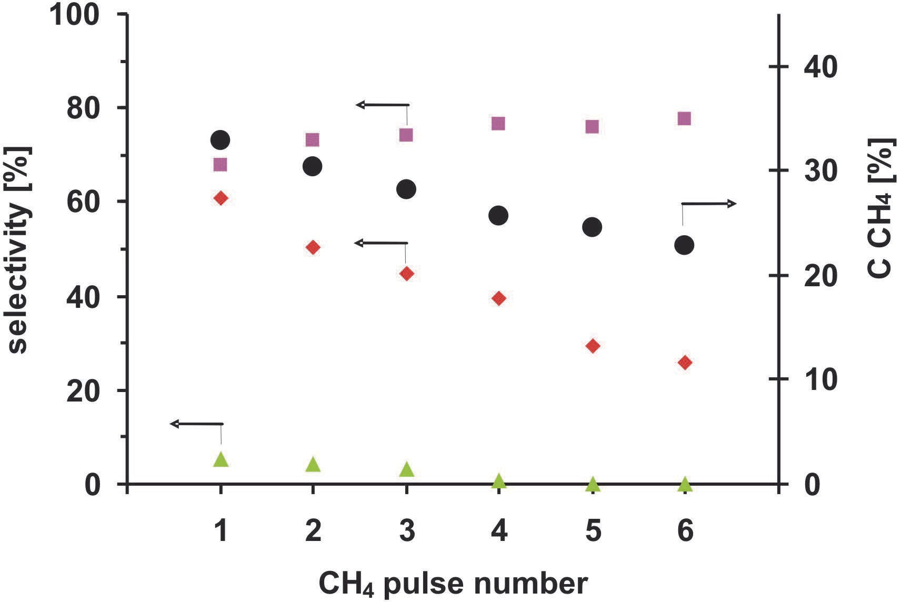
Alloying Effect in Low Loaded Rh Catalysts Supported on
High Surface Area Alumina on Their Activity in CH₄and NO Decomposition
361
2.3 Methane dissociation on 1-S and 3-S 0.18 wt.% Rh/δAl₂O₃catalysts
In Fig 3. the methane conversion (C_{CH4}), selectivity to hydrogen (S_{H2}), selectivity to CO (S_{CO}) and selectivity to CO₂(S_{CO2}) in six consecutive CH₄pulses over F-1-S catalyst are presented.
Fig. 3. CH₄conversion (●) and selectivity to H₂(■), CO (♦) and CO₂(▲) in six consecutive CH₄pulses over the one-step 0.18 wt.% Rh/δAl₂O₃catalyst (873K, 280kPa, 9000 h-1).
The CH₄conversion in the first pulse over the 1-S catalyst is equal to 33%, the selectivity to H₂– 68%, the selectivity to CO - 61% and to CO₂– 10%. In the following methane pulses C_{CH4}continuously decreases down to 23% in the sixth pulse. The S_{H2}increases up to 78 % in the sixth pulse, S_{CO}decreases, almost linearly, down to 22% in the sixth pulse and the S_{CO2}drops to 0% in the fourthpulse.
The simultaneous decrease of the C_{CH4}, the S_{CO}and the S_{CO2}and the increase of S_{H2}in the consecutive methane pulses can be explain by the decreasing concentration of the atomic species of oxygen adsorbed on the surface Rh species in Al-Rh alloy nanocrystallites and in Rh clusters present on the surface of the 1-S catalyst.
The initial S_{H2}increase accompanied by a decrease in S_{CO2}reveals that further formation of alloy nanocrystallites with a low concentration of Rh sites have a greater ability to transfer electronstomethanemolecules.The2.8folddecreaseintheS_{CO}inthesixthmethanepulse withrespecttothatinthefirstmethanepulsewithasimultaneousincreaseoftheselectivity tohydrogen,suggestingdeepermethanedissociation,clearlyshowsacarbondepositionon thecatalystsurfaceasaresultofthedeficitofoxygenspeciesadsorbed.
In Fig. 4 the methane conversion, selectivity to hydrogen, selectivity to CO and the selectivity to CO₂in six consecutive CH₄pulses introduced to the reactor containing the F- 3-S catalyst are presented.
www.intechopen.com

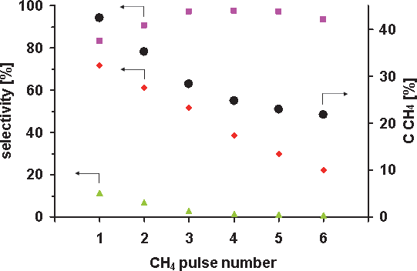
362
Noble Metals
Fig. 4. CH₄conversion (●) and selectivity to H₂(■), CO (♦) and CO₂(▲) in six consecutive CH₄pulses over the 3-S 0.18wt.% Rh/δAl₂O₃catalyst (873K, 280kPa, 9000 h-1).
The C_{CH4}in the first methane pulse is equal to 42%, the S_{H2}- 83%, the S_{CO}- 72% and the S_{CO2}
– 11%. In the next methane pulses the C_{CH4}decreases down to 22% in the sixth pulse. The S_{H2}increasesupto98%inthethirdpulseandslowlydecreasesto94%inthesixthpulse.The S_{CO}decreases almost linearly down to 22% in the sixth pulse and S_{CO2}drops to 0% in the fourth pulse.
The simultaneous decrease in the S_{CO2}and increase of the S_{H2}in the consecutive methane pulses up to the forth one could be ascribed to the formation of the new Al-Rh alloy nanocrystallites of a low content of Rh sites with a great ability to transfer the electrons to the methane molecules adsorbed.
Thereisa50%decreaseintheC_{CH4}andapproximatelya70%decreaseintheS_{CO}inthesixth pulse in comparison with the first one, not accompanied by the decrease in the S_{H2}which reveals carbon deposition on the Al-Rh alloynanocrystallites.
The formation of the new alloy nanocrystallites by the reduction of the Rh/Al₂O₃s.s. of the relatively low rhodium concentration causes the creation of a very active Rh species.
ThestrongerS_{CO}decreaseonthe3-Scatalyst(3.3fold)ofahigheractivitythanonthe1-Sone (2.8 fold)of loweractivity reveals thatcarbon ispreferably depositedon the Al-Rhnanocrystallites.
The higher conversion of the first methane pulse over the F-3-S catalyst than over the F-1-S reveals that the Rh active species in the Al-Rh alloy nanocrystallites are more active in the methanedissociationthanthoseintheRhclusters(Figs.1and2).Thedecreaseoftheactivity of both the catalysts in the consecutive pulses corresponds to the decrease of the total content of the Rh species accessible for methaneadsorption.
www.intechopen.com

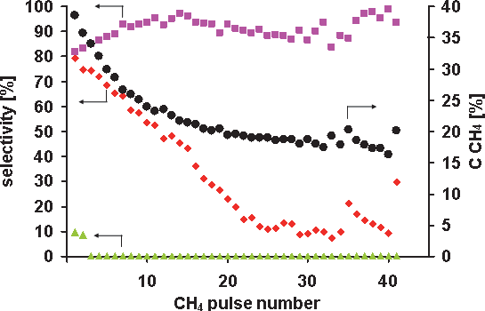
Alloying Effect in Low Loaded Rh Catalysts Supported on
High Surface Area Alumina on Their Activity in CH₄and NO Decomposition
363
Theslowerthedecreaseofthemethaneconversionoverthe1-Scatalystthanthatoverthe3- S one may be assigned to a slower carbon deposition on the Rh clusters than on the Al-Rh nanocrystallites.
Ontheotherhand,thehigherselectivitytohydrogenoverthe3-Scatalystthanoverthe1-S oneclearlyshowsabeneficialinfluenceoftheAlproximityontheRhsitesabilitytotransfer electrons to antibonding orbitals ofmethane.
Fig. 5 presents CH₄conversion and selectivity to H₂, CO and CO₂in 41 consecutive CH₄pulses over the 3-S 0.18wt.% Rh/δAl₂O₃catalyst (873K, 280kPa, 9000 h-1). The methane pulseswereintroducedintothereactormostlyintimeintervalscloseto30min.Lessregular time intervals (30-37min.) were applied between the 11thand 17thpulses as well as the 25thand33rd.TheC_{CH4}andS_{CO}decreaseandS_{H2}increasesinconsecutivepulsesuptothepulse
11. Irregular intervals between the 11 - 17 pulses and the 25 – 33 ones cause fluctuations in theC_{CH4},theS_{CO}andtheS_{H2}thatcanbeascribedtothechangesintheamountofthecarbon deposit oxidized by the oxygen from the gas phase. The 75 min. time interval between 34thand 35thpulses resulted in the C_{CH4}increase of 11% and of the S_{CO}of 110%. The increase of thetimebetweenthe40and41pulsesto110min.resultsintheincreaseoftheC_{CH4}of25% and of the S_{CO}of 230%. However, the selectivity to hydrogen does not change distinctly in any case. Thus, one can conclude that a long term interaction of the surface of the Al-Rh nanocrystallites, containing the carbon deposit, with the gas phase containing traces of oxygen causes both a carbon deposit removal by oxidation and oxygen adsorption. The oxidationofthecarbondepositcausestherecoveryoftheRhsitesactiveinthemethane
dissociation that results in the increase of the
CCH4.
The surface oxygen species cause
oxidation of the carbon formed due to methane dissociation, that leads to the S_{CO}increase.
However, their population is not high enough to have an effect on the S_{H2}. Thus, to perform the PMO with the high methane conversion and the high selectivity to CO and H₂the proper CH₄:O₂ratio is needed.
Fig.5.CH₄conversion(●)andselectivitytoH₂(■),CO(♦)andCO₂(▲)in41consecutive CH₄pulsesoverthe3-S0.18wt.%Rh/δAl₂O₃catalyst(873K,280kPa,9000h-1).
www.intechopen.com

364
Noble Metals
2.4 Direct NO decomposition over the three-step (3-S) 0.18 wt.% Rh/δAl₂O₃catalyst
NO conversion (C_{NO}), selectivity to N₂(S_{N2}) calculated from the results of the steady-state experiments over the 3-S 0.18wt.%Rh/Al₂O₃catalysts, are presented in Figure 6.
The steady-state experiment was performed with the use of the reaction gas containing 150ppm NO, 1500ppm CH₄, 7%O₂and Ar as abalance.
100
50
80
40
60
30
40
20
20
10
0
0
423
473
523
573
623
673
723
Temperature [K]
Fig.6.NOconversion(●)andselectivitytoNO(■)overthree-stepa0.18wt.%Rh/δAl₂O₃catalyst (150ppmNO +1500ppm CH₄+ 7%O₂/He ,20000h-1,data from steady-stateexperiment)
The highest NO conversion, increasing with a temperature increase, from 38 to 47%, is observedatatemperaturerange473K-573K.Thehighestbutdecreasingfrom100%to85% selectivity to N₂is achieved in the same temperature. A simultaneous sudden drop of the S_{N2}and a deep decrease in C_{NO}are observed at623K.
The direct NO decomposition over the high-loaded rhodium catalysts supported on aluminawasearlierobservedonlyattemperatureshigherthan623K(Garin,2001).
Thus, the low-temperature NO decomposition on the low loaded 0.18wt.%Rh/δAl₂O₃catalyst confirms exceptional activity of the Rh sites in Al-Rh alloy.
A simultaneous increase of the C_{NO}and the decreaseofthe with thetemperature
SN2
increase in the 473K - 573K range could be explained by the competitive dissociative O₂adsorption on the Rh active sites, increasing with temperature. The atomic oxygen species block the Rh sites active in the direct NO decomposition and facilitate the NO oxidation.
The simultaneous sudden drop of the S_{N2}and a great decrease in the C_{NO}at 623K shows that blocking the Rh sites-active in the NO dissociation becomes much stronger. Such blocking may originate in a methane dissociation on the same sites. In Fig. 7, the CH₄conversion (C_{CH4}) and selectivity to CO₂(S_{CO2}), measured during the thermo-programmed catalyst heating at the rate of 3K/min in the reaction mixture containing 150ppm NO, 1500ppm CH₄, 7%O₂and Ar as a balance, are presented.
www.intechopen.com
SN2[%]
CNO[%]

Alloying Effect in Low Loaded Rh Catalysts Supported on
High Surface Area Alumina on Their Activity in CH₄and NO Decomposition
365
The temperature of the sudden drop of the S_{N2}and C_{NO}(Fig. 6) corresponds to the initial temperature of the total methane oxidation to CO₂(Fig. 7). This confirms competitive methane adsorption on the Rh active sites leading to the formation of the carbon species undergoing oxidation to CO₂.
100
60
50
80
40
60
30
40
20
20
10
0
0
423
473
523 573 623 673 723 773
Temperature [K]
Fig. 7. CH₄conversion (●) and selectivity to CO₂(▲) over three-step 0.18 wt.% Rh/δAl₂O₃catalyst (150ppmNO +1500ppm CH₄+ 7%O₂/He , 20000h-1, data from TPSR experiment)
3. Conclusions
The DRIFT spectroscopy of the adsorbed CO and XPS were used to show the formation of the Al-Rh alloy nanocrystallites on the surface of the 0.18 wt % Rh/δAl₂O₃catalysts obtained by the one-step or three-step impregnation of the high surface area alumina support with the RhCl₃aqueous solution (1-S and 3-Scatalysts).
The effect of Al-Rh alloying on the catalyst activity in the methane dissociation and the direct NO decomposition was investigated.
The activity and selectivity to dihydrogen and to carbon monooxide of both the catalysts were determined at 873K. The results showed unambiguously that alloying distinctly enhances the Rh site activity in the electron donation to antibonding orbitals of methane molecules adsorbed. The observed enhancement of the Rh site activity was ascribed to the Al valence electrons transfer to the Rh 4d shell and slightly to the Rh 5s shell. The direct NO decompositioninthepresenceofoxygenandmethanewasinvestigatedinthetemperature rangeof673-473Kovera3-Scatalyst.TheNOconversionwith100%selectivitytodinitrogen on the Rh active sites was revealed at an unexpectedly low temperature (473K). Simultaneous increase of the activity and decrease in the selectivity to dinitrogen with a temperature increase up to 573K clearly revealed a competitive dissociative oxygen adsorption on the same active sites. However, the sudden decrease at 623K of the catalyst activity in the NO decomposition and the selectivity to dinitrogen, accompanied by an initialmethaneoxidationtoCO₂,undoubtedlyshowedcompetitivemethanedissociation.
www.intechopen.com
SCO2[%]
CCH4[%]

366
Noble Metals
4. Acknowledgment
The polish authors (M. N, J. D. and P. K.) acknowledge the financial support by the European Regional Development Fund under the Innovate Economy Operational Programme 2007-2013, POIG.01.01.02-12-112/09project.
5. References
Almusaiteer, K.; Krishnamurthy, R. & Chuang, S.S.C. (2000). In situ infrared study of catalytic decomposition of NO on carbon-supported Rh and Pd catalysts.Catalysis Today, Vol.55, No.3, pp. 291-299, ISSN0920-5861
Azaroff, L.V. (1960).Introduction to Solids, McGRAW-Hill Book Cmpany, New York Bostrom, M.; Rosner, H.; Prots, Y.; Burkhardt, U. & Grin,Y. (2005). The Co₂Al₉Structure
Type Revisited.Zeitschrift für anorganische und allgemeine Chemie,Vol.631,No.2-3, pp.534-541, ISSN 1521-3749
Chuang, S.S.C. & Tan, C.–D. (1997). Promotion of oxygen desorption to enhance direct NO decomposition over Tb−Pt/Al₂O₃catalyst.The Journal of Physical Chemistry B, Vol.101, No.15, pp. 3000-3004, ISSN 1520-5207
Enger, B.C.; Lodeng, R. & Holmen, A. (2008). A review of catalytic partial oxidation of methane to synthesis gas with emphasis on reaction mechanisms over transition metal catalysts.Applied Catalysis A: General, Vol.346, No.1-2, pp.1-27, ISSN 0926- 860X
Finocchio, E.; Busca, G.; Forzatti, P.; Groppi, G. & Beretta, A. (2007). State of supported rhodium nanoparticles for methane catalytic partial oxidation (CPO): FT-IR studies.Langmuir, Vol.23, No.20, pp. 10419–10428, ISSN 1520-5827
Garin, F. (2001). Mechanism of NO_{x}decomposition.Applied Catalysis A: General,Vol.222, No.1-2, pp. 183-219, ISSN 0926-860X
Gasser, R.P.H. (1985). An introduction to chemisorption and catalysis by metals, Oxford University Press, ISBN 0-19-855163-0, New York
Gorte, R.J.; Schmidt, L.D. & Gland, J. L. (1981). Binding states and decomposition of NO on single crystal planes of Pt.Surface Science, Vol.109, No.2, pp. 367-380, ISSN 0039- 6028
Hadjiivanov, K.I. & Vayssilov, G.N. (2002). Characterization of oxide surfaces and zeolites bycarbonmonoxideasanIRprobemolecule.AdvancesinCatalysis,Vol.47,pp.307- 511, ISBN0-12-007844-9
Hofstad, K.H.; Hoebink, J.H.B.J.; Holmen, A. & Marin, G.B. (1998). Partial oxidation of methane to synthesis gas over rhodium catalysts.Catalysis Today,Vol.40, No. 2-3, pp. 157-170, ISSN0920-5861
Ishii, M.; Hayashi, T. & Matsumoto, S. (2002). Adsorption, desorption and decomposition of nitrogen monoxide on Rh(1 0 0) studied by electron-stimulated desorption, Auger electron spectroscopy and temperature-programmed desorption.Applied Catalysis A: General, Vol.225, No.1-2, pp. 207-213, ISSN0926-860X
Kittel, Ch. (2005).Introduction to Solid State PhysicsJohn Willey & Sons. Inc, ISBN 0-471- 41526-x, USA
Kraus, L.; Zaki, M.I.; Knözinger, H. & Tesche, B. (1989). Support and additive effects on the state of rhodium catalysts.Journal of Molecular Catalysis, Vol.55, No.1, pp. 55-69
www.intechopen.com

Alloying Effect in Low Loaded Rh Catalysts Supported on
High Surface Area Alumina on Their Activity in CH₄and NO Decomposition
367
Lavalley, J.C.; Saussey, J.; Lamotte, J.; Breault, R.; Hindennann, J.P. & Kiennemann, A. (1990). Infrared study of carbon monoxide hydrogenation over rhodium/ceria and rhodium/silicacatalysts.TheJournalofPhysicalChemistry,Vol.94,No.15,pp.5941– 5947
Lide, D.R. (2004-2005).Handbook of Chemistry and Physics, CRC Press, ISBN 0-8493-0485-7, Boca Raton
Mallens, E. P. J.; Hoebink, J.H.B.J. & Marin, G.B. (1997). The reaction mechanism of the partial oxidation of methane to synthesis gas: A transient kinetic study over rhodium and a comparison with platinum.Journal of Catalysis,Vol.167, No.1, pp. 43-56, ISSN 0021-9517
Nakagawa, K.; Ikenaga, N.; Kobayashi, T. & Suzuki, T. (1999). Transient response of catalyst bed temperature in the pulsed reaction of partial oxidation of methane to synthesis gas over supported rhodium and iridium catalysts.Journal of Catalysis,Vol.186, No.2, pp. 405-413, ISSN0021-9517
Papp, H. & Sabde, D.P. (2005). An investigation on the mechanism of NO decomposition over Rh/SiO₂catalysts in presence of pulse injected H₂.Applied Catalysis B: Environmental, Vol.60, No.1-2, pp. 65-71, ISSN 0926-3373
Parvulescu, V.I.; Grange, P. & Delmon, B. (1998). Catalytic removal of NO.Catalysis Today, Vol.46, No.4, pp. 233-316, ISSN 0920-5861
Paul, D.K.; Marten, C.D. & Yates, J.T.Jr. (1999). Control of RhI(CO)₂formation on Rh/Al₂O₃catalysts by complexation of surface−OH groups using NH₃.Langmuir, Vol.15, No.13, pp. 4508–4512, ISSN 1520-5827
Pietraszek, A.; Da Costa, P.; Marques, R.; Kornelak, P.; Hansen, T.W.; Camra, J. & Najbar, M. (2007). The effect of the Rh–Al, Pt–Al and Pt–Rh–Al surface alloys on NO conversiontoN₂onaluminasupportedRh,PtandPt–Rhcatalysts.CatalysisToday, Vol.119, No.1-4, pp. 187-193, ISSN0920-5861
Rahkamaa, K. & Salmi, T. (1999). Investigation of the catalytic decomposition of NO and N₂O on supported Rh with transient techniques.Chemical Engineering Science, Vol.54, No.20, pp. 4343-4349, ISSN0009-2509
Rieck, J.S. & Bell, A.T. (1985). Studies of the interactions of H₂and CO with silica- and lanthana-supported palladium.Journal of Catalysis,Vol.96, No.1, pp. 88-105, ISSN 0021-9517
Root, T.W.; Schmidt, L.D. & Fisher, G.B. (1983). Adsorption and reaction of nitric oxide and oxygen on Rh(111).Surface Science, Vol.134, No.1, pp. 30-45, ISSN 0039-6028
Sugisawa, T.; Shiraishi, J.; Machihara, D.; Irokawa, K.; Miki, H.; Kodama, C.; Kuriyama, T.; Kubo, T. & Nozoye, H. (2001). Adsorption and decomposition of NO on Pt (112).Applied Surface Science, Vol.169-170, pp. 292-295, ISSN 0169-4332
Thiam, M.M.; Hrčiř, T.; Matolin, V. & Nehasil, V. (2004). EELS and AES investigation of Rh thinfilmgrowthonpolycrystallineAlsubstrate.Vacuum,Vol.74,No.2,pp.141-145, ISSN 0042-207X
Tonetto, G.M.; Ferreira, M.L. & Damiani, D.E. (2003). A combined theoretical and experimental study of NO decomposition on Pd and Pd-Mo catalysts.Journal of Molecular Catalysis A: Chemical, Vol.193, No.1-2, pp. 121-137, ISSN 1381-1169
Wagner, Ch.D.; Naumkin, A.V.; Kraut-Vass, A.; Allison, J.W.; Powell, C.J. & Rumble, J.R.Jr. (2007). NIST X-ray Photoelectron Spectroscopy Database NIST Standard Reference Database 20, Version 3.5, Available from:http://srdata.nist.gov/xps/
www.intechopen.com

368
Noble Metals
Wang, D.; Dewaele, O.; Groote, A.M.D. & Froment, G.F. (1996). Reaction mechanism and role of the support in the partial oxidation of methane on Rh/Al₂O₃.Journal of Catalysis, Vol.159, No.2, pp. 418-426, ISSN 0021-9517
Wang, X.; Sigmon, S.M.; Spivey, J.J. & Lamb, H.H. (2004). Support and particle size effects ondirectNOdecompositionoverplatinum.CatalysisToday,Vol.96,No.1-2,pp.11- 20, ISSN0920-5861
Yates, J.T.; Duncan, T.M.; Worley, S.D. & Vaughan, R.W. (1979). Infrared spectra of chemisorbedCOonRh.TheJournalofChemicalPhysics,Vol.70,pp.1219-1224,ISSN 1089-7690
Zimowska, M.; Wagner, J. B.; Dziedzic, J.; Camra, J.; Borzęcka-Prokop, B. & Najbar, M. (2006). Some aspects of metal-support strong interactions in Rh/Al₂O₃catalyst under oxidising and reducing conditions.Chemical Physics Letters,Vol.417, No.1-3, pp.137-142, ISSN 0009-2614
www.intechopen.com



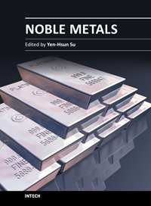
Noble Metals
Edited by Dr. Yen-Hsun Su
ISBN 978-953-307-898-4
Hard cover, 426 pages
Publisher InTech
Published online 01, February, 2012
Published in print edition February, 2012
Thisbookprovidesabroadspectrumofinsightsintotheopticalprinciple,resource,fabrication,nanoscience, andnanotechnologyofnoblemetal.Italsolooksattheadvancedimplementationofnoblemetalinthefieldof nanoscalematerials,catalystsandbiosystem.Thisbookisidealnotonlyforscientificresearchersbutalsoas
a reference for professionals in material science, engineering, nonascience and plasmonics.
How to reference
Inordertocorrectlyreferencethisscholarlywork,feelfreetocopyandpastethefollowing:
Patrick Da Costa, Jarosław Dutkiewicz, Valerio Choque, Narcis Homs, Paweł Kornelak, Mieczysława Najbar, Agnieszka Pietraszek, Pilar Ramirez de la Piscina and Janusz Sobczak (2012). Alloying Effect in Low Loaded RhCatalystsSupportedonHighSurfaceAreaAluminaonTheirActivityinCH4andNODecomposition,Noble Metals, Dr. Yen-Hsun Su (Ed.), ISBN: 978-953-307-898-4, InTech, Available from:http://www.intechopen.com/books/noble-metals/alloying-effect-in-low-loaded-rh-catalysts-supported-on-high-
surface-area-alumina-on-their-activity-
InTech Europe
University Campus STeP Ri Slavka Krautzeka 83/A 51000 Rijeka, Croatia
Phone: +385 (51) 770 447
Fax: +385 (51) 686 166
www.intechopen.com
InTech China
Unit 405, Office Block, Hotel Equatorial Shanghai No.65, Yan An Road (West), Shanghai, 200040, China
Phone: +86-21-62489820
Fax: +86-21-62489821

©2012TheAuthor(s).LicenseeIntechOpen.Thisisanopenaccessarticle
distributed underthetermsoftheCreative Commons Attribution3.0License,whichpermitsunrestricteduse,distribution,andreproductioninanymedium,providedtheoriginalworkisproperlycited.

