Case report
Sclerosing angiomatoid nodular transformation of the spleen treated by laparoscopic partial splenectomy
Andrzej Budzyński1, Sergiusz Demczuk2, Beata Kumiega3, Marcin Migaczewski1, Maciej Matłok1, Anna Zub-Pokrowiecka1
12nd Department of General Surgery, Jagiellonian University Collegium Medicum, Cracow, Poland 2Department of Pathology, Jagiellonian University Collegium Medicum, Cracow, Poland 3Podkarpacki Centre of Oncology, Brzozów, Poland
Videosurgery and Other Miniinvasive Techniques 2011; 6 (4): 249-255
DOI: 10.5114/wiitm.2011.26261
Abstract
The authors describe a case of sclerosing angiomatoid nodular transformation (SANT) of the spleen treated at the 2nd Department of Surgery, Jagiellonian University, Medical College. The patient was a 23-year-old woman. Clinically she presented with 2-year history of recurrent mild fever, diffuse joint pain, abdominal discomfort and iron deficiency anaemia of chronic disease. The laboratory tests revealed a non-characteristic chronic inflammatory response. A splenic solid lesion 9 cm in diameter was found on abdominal computed tomography. The patient underwent uneventful laparoscopic resection of the upper half of the splenic parenchyma. The resected tumour showed charac- teristic histological and immunophenotypical findings of SANT as previously described in the literature. In long-term follow-up, improvement of preoperative symptoms and abnormalities in the blood tests was documented.
Key words: sclerosing angiomatoid nodular transformation, sclerosing angiomatoid nodular transformation, spleen, laparoscopic partial splenectomy.
Introduction
Sclerosing angiomatoid nodular transformation (SANT) of the spleen is a rare benign vascular lesion, first described in the literature under this name in 2004 [1, 2]. This rarely reported benign tumour is characterized by nodular vascular prolif- eration of the red pulp with prominent fibrosis [3]. Its aetiology is generally unknown. Most cases are either completely asymptomatic, an incidental find- ing or are associated with vague abdominal com- plaints. We report a case of SANT found during diagnostic workup in a patient with unexplained iron-deficiency anaemia and unspecific features of chronic inflammation.
Case report
The 23-year-old female patient was referred to the 2nd Department of Surgery of Jagiellonian Univer- sity, Medical College for treatment of tumour of the spleen. The patient presented with 2-year history of recurrent mild fever, and diffuse joint pain mostly of the small joints of the hand and spine. The patient also reported occasional vague abdominal discom- fort, usually localized in the middle abdomen. The patient was lean (body mass index – BMI 17 kg/m2) and the tip of the spleen was palpable during deep breathing. Apart from that her vital signs and physi- cal examination were within normal limits. Her past medical and family history were also unremarkable.
249
Videosurgery and Other Miniinvasive Techniques 2011; 6/4
Address for correspondence
Andrzej Budzyński MD, PhD, 2nd Department of General Surgery, Jagiellonian University Collegium Medicum, 21 Kopernika, 31-501 Cracow, Poland, e-mail: abudzyns@cm-uj.krakow.pl
Videosurgery

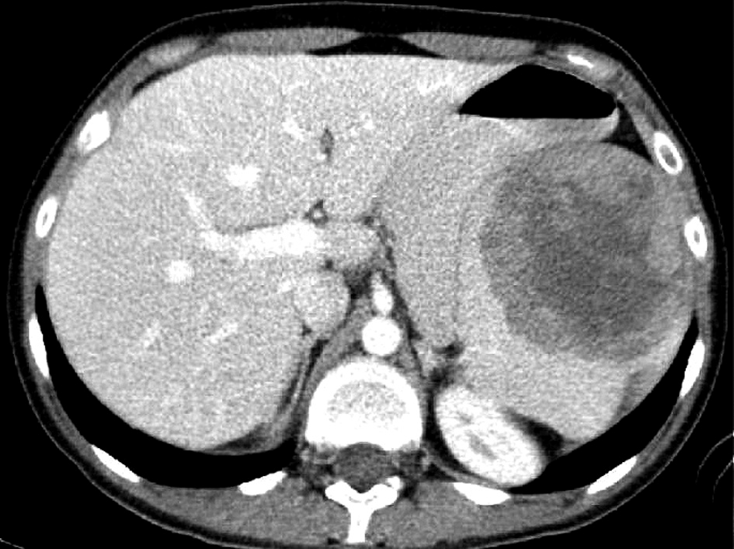
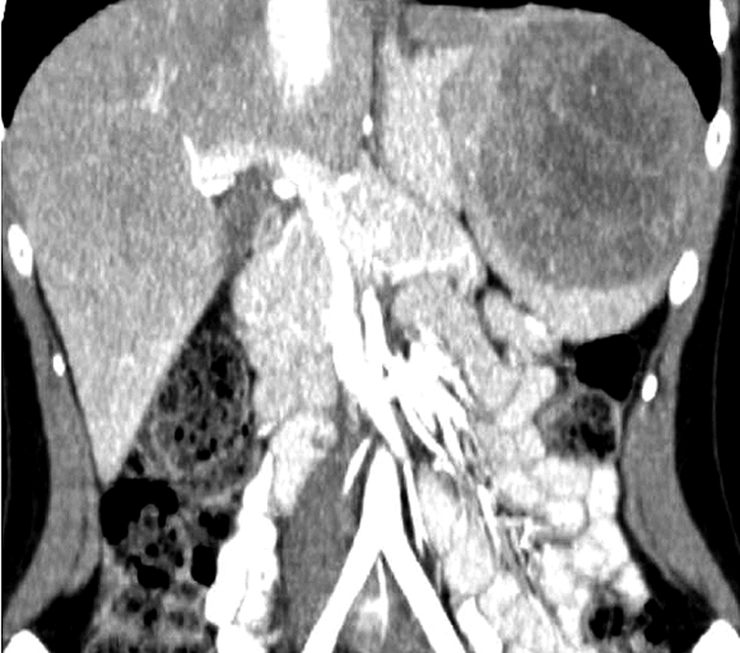
Andrzej Budzyński, Sergiusz Demczuk, Beata Kumiega, Marcin Migaczewski, Maciej Matłok, Anna Zub-Pokrowiecka
Clinical features
The laboratory tests revealed mild iron deficiency anaemia characteristic for chronic disease (RBC – 4.22 × 1012/l, HGB – 8.1 g/dl, HCT – 27%, MCV – 64 fl,
PLT – 458 × 109/l, WBC – 8.5 × 109/l). Apart from that, some features of a chronic inflammatory response were present, mainly represented by increased C-reac- tive protein (CRP) (113.5 mg/l) and fibrinogen (534 mg/dl) and a marked decrease of iron (1.3 μmol/l). The erythrocyte sedimentation rate (ESR) was increased (75/121). Other basic biochemical examina- tions were within normal limits. Bone marrow biopsy revealed mild stimulation of the granulopoietic cell lines with normoblastic erythropoiesis (M : E = 8 : 1). Chronic blood loss through the gastrointestinal tract was ruled out by a negative test for occult blood in the stool, gastroscopy and colonoscopy. No patholo- gy was found on gynaecological examination.
Tests for chronic infectious diseases (mononucle-
osis, CMV, hepatitis B, hepatitis C, borreliosis) were negative. Plasma antinuclear (ANA), antineutrophil cytoplasmic (ANCA) and endomysial antibodies in duodenal biopsy were not present.
Abdominal computed tomography (CT) and mag- netic resonance imaging (MRI) revealed a well-circum- scribed 8.5 cm × 7.5 cm × 9 cm tumour in the upper part of the spleen. The pattern of contrast enhance- ment suggested giant encapsulated cavernous hae- mangioma with pronounced fibrosis (Figure 1).
Treatment
The patient was submitted to laparoscopic par- tial splenectomy. The procedure was performed in the right lateral decubitus position. The pneu- moperitoneum was established with the closed technique and 4 trocars along the left costal margin were inserted. The lesser sac was opened by tran- section of the gastrosplenic ligament using a har- monic scalpel and full mobilization of the spleen was achieved by dissection of its posterior attach- ments. The tumour was localized in the upper part of the spleen (Figure 2). The segmental branches of splenic vessels supplying the affected part of the organ were isolated and transected with Ligasure (Figure 3). Selective devascularization of the upper part of the spleen involving the macroscopically vis- ible tumour was confirmed by the change in colour. The border of ischaemic tissue was marked by electrocautery. The remaining part of the vascular pedicle was temporarily closed with rubber band (Figure 4). In transient ischaemia splenic parenchy- ma was transected with Ligasure. The exposed splenic tissue at the resection line was coagulated with argon plasma coagulation (APC) (Figure 5). After removal of the rubber ligature the revascular- ization was confirmed by change in colour of the remaining part of the spleen and Doppler ultra- sound was performed to document the restoration of normal blood flow (Figure 6).
Figure 1. Well-circumscribed highly vascularised lesion with pronounced fibrosis in the upper part of the spleen found on abdominal CT
250
Videosurgery and Other Miniinvasive Techniques 2011; 6/4
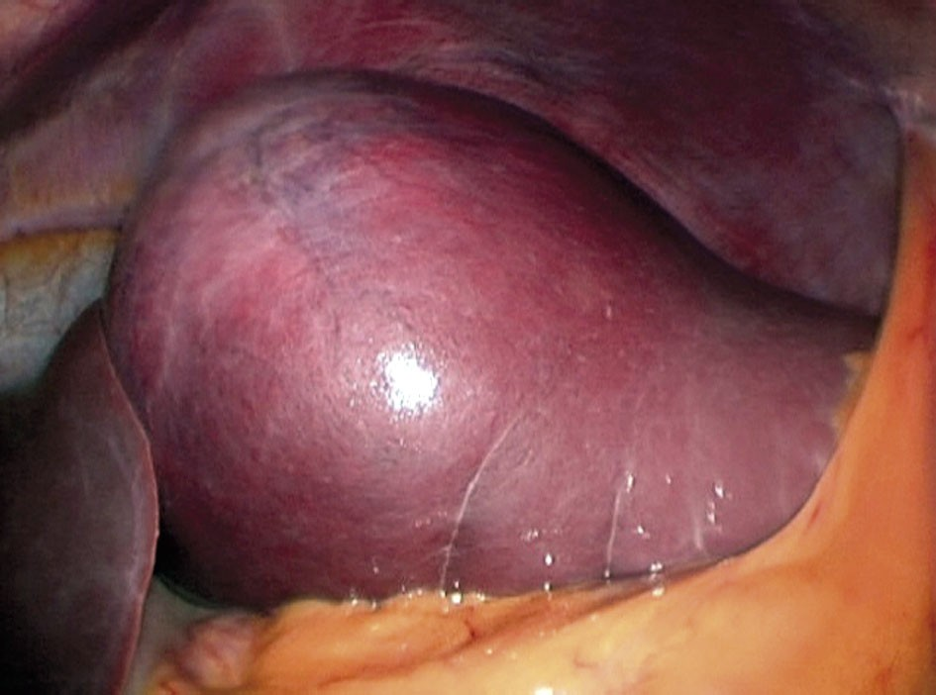
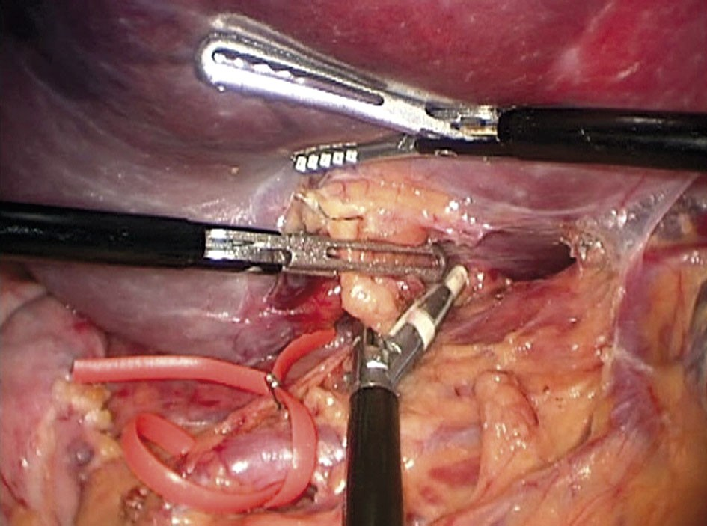
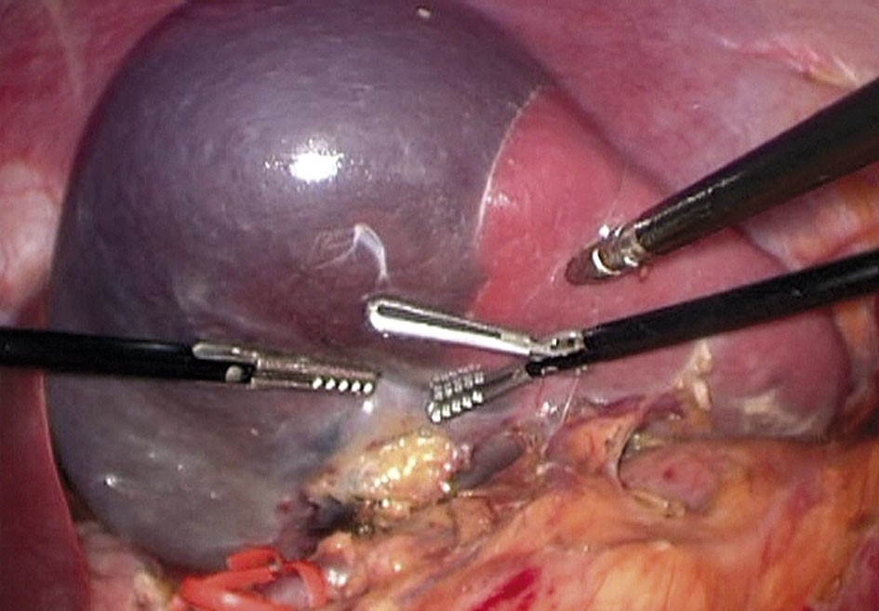
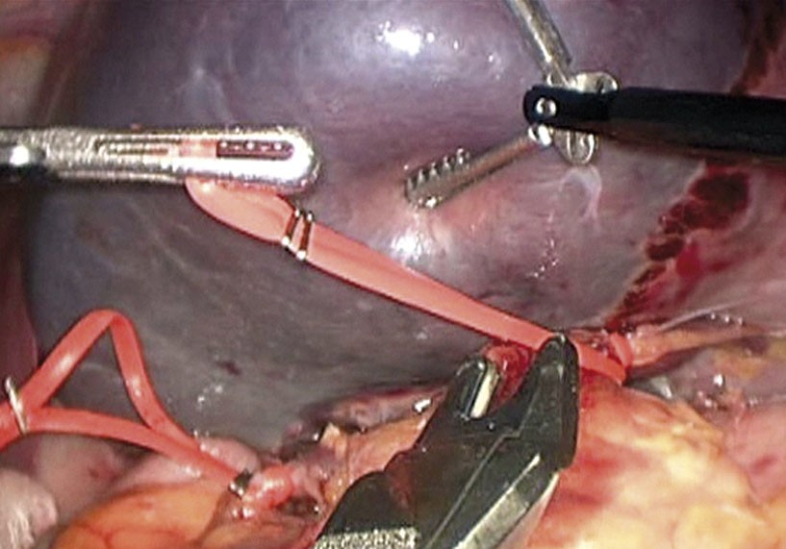
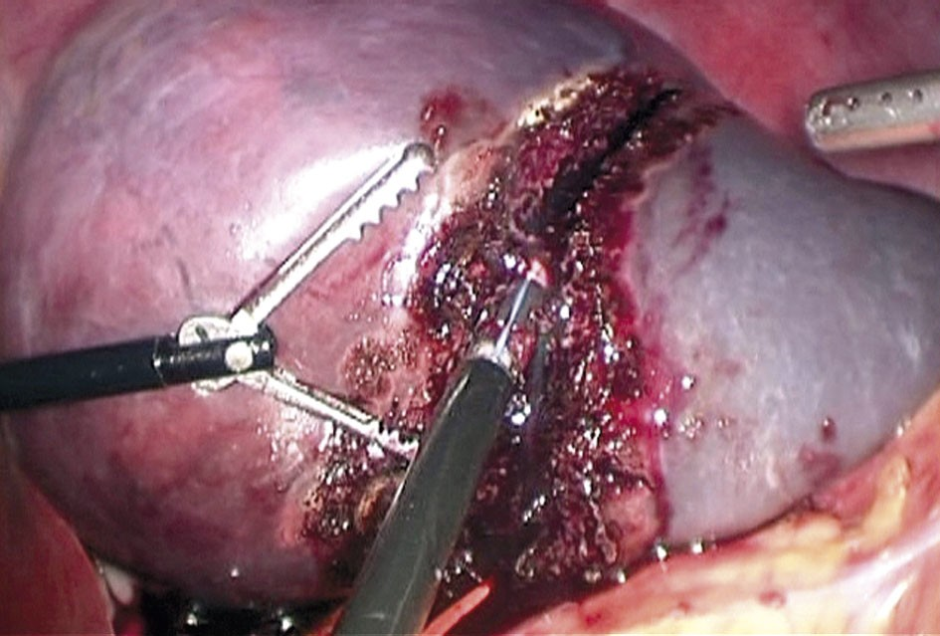
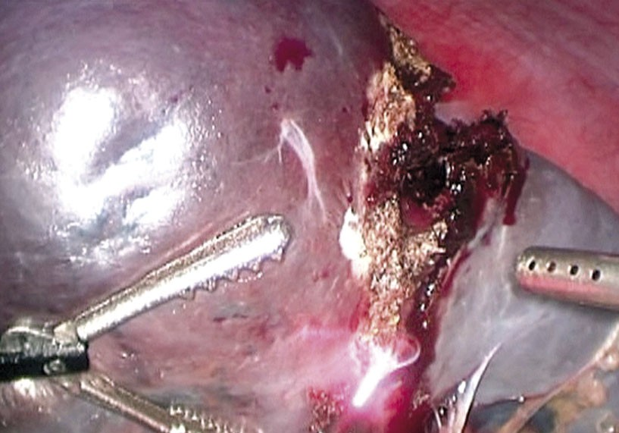
Sclerosing angiomatoid nodular transformation of the spleen treated by laparoscopic partial splenectomy
Figure 2. Solid tumour involving upper 2/3 of the spleen viewed in laparoscopy
Figure 3. Transection of segmental branches of splenic vessels supplying upper part of the spleen
Figure 4. Partially devascularized upper 2/3 of the spleen and temporal closure of the vascular pedicle sup- plying lower 1/3 of the spleen with rubber band
Figure 5. Resection of the splenic parenchyma with Ligasure and argon plasma coagulation
251
Videosurgery and Other Miniinvasive Techniques 2011; 6/4
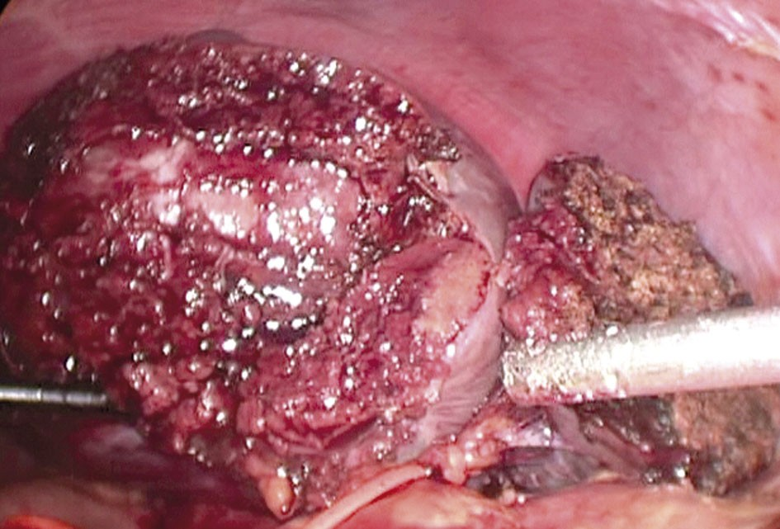
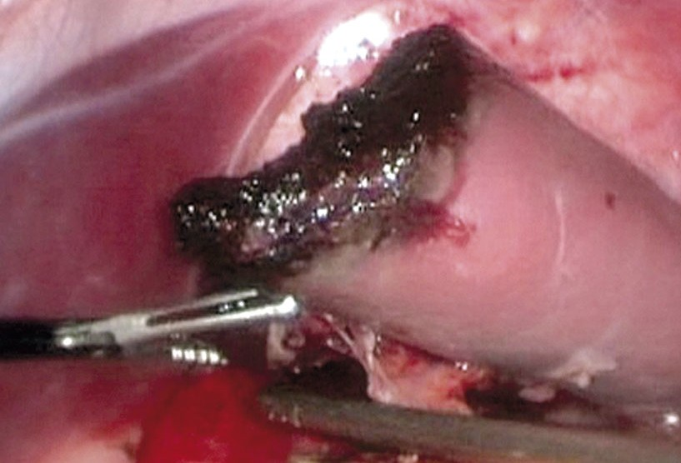
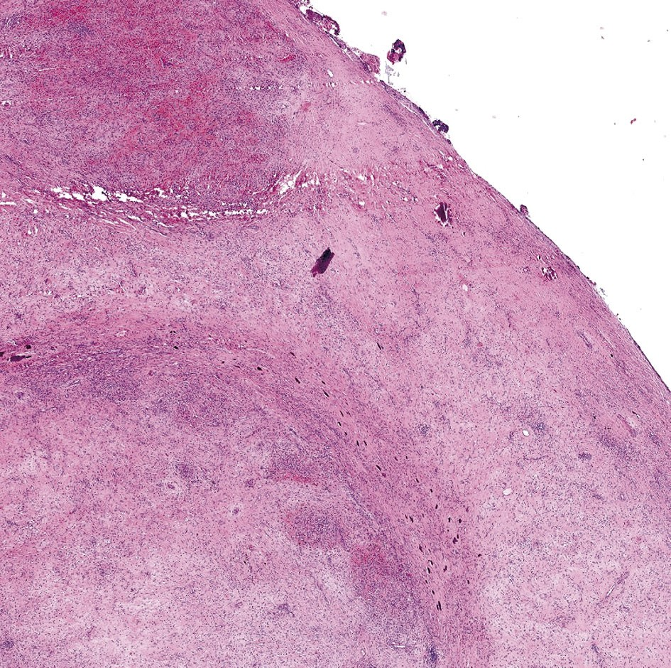
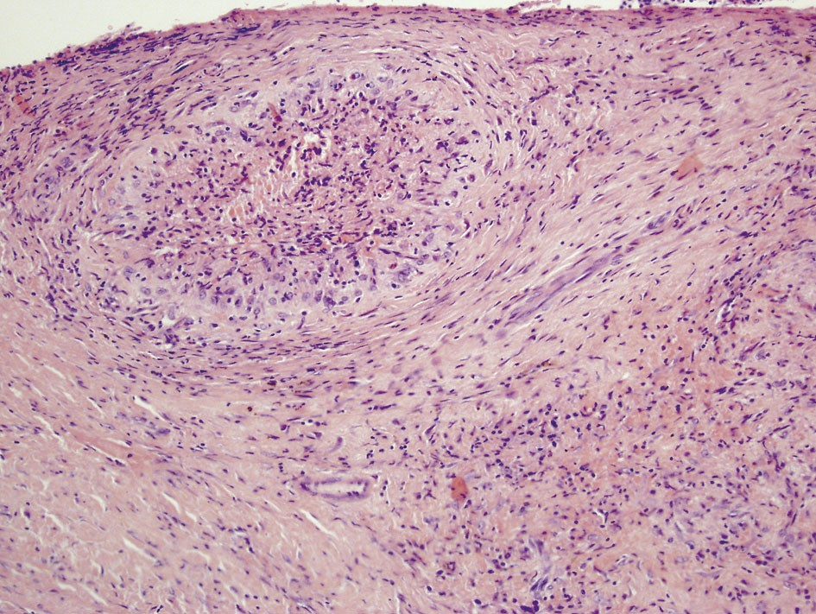
Andrzej Budzyński, Sergiusz Demczuk, Beata Kumiega, Marcin Migaczewski, Maciej Matłok, Anna Zub-Pokrowiecka
Figure 6. Completed resection of upper 2/3 of the spleen and revascularization of the remaining part after removal of the rubber ligature
Pathological findings
The surgical specimen was
calcifications in some areas. Most of the nodules were composed of a haphazardly distributed sieve- like complex of vascular spaces. Vascular spaces dis- played capillaries, sinusoid-like spaces and small, venous-like channels that contained erythrocytes (Figure 8). Numerous cells in the angiomatoid nod- ules were CD31 positive (Figure 9) with only selective CD34 staining of the narrow capillaries (Figure 10).
evaluated in the
Department of Jagiellonian University, Medical Col- lege. It consisted of spleen fragments weighing 266 g with a well-circumscribed unencapsulated mass. Microscopically the lesion comprised multiple variably sized angiomatoid nodules arranged in a lobular pat- tern (Figure 7). Each nodule was surrounded by thick fibrosclerotic stroma with a variable number of lym- phocytes, plasma cells, macrophages and dispersed
Follow-up
One month after surgery the patient underwent complete diagnostic workup which revealed improve- ment in her anaemia (RBC – 4.94 × 1012/l, HGB – 10.4 g/dl, HCT – 33%, MCV – 66 fl, PLT – 345 × 109/l, WBC
– 8.5 × 109/μl), and increase in iron level (5.4 μmol/l). Both CRP (9.8 mg/l) and fibrinogen (384 mg/dl) were
Figure 7. At low power magnification SANT is composed of multiple angiomatous nodules, some of them surrounded by hypocellular scle- rotic stroma with focal calcifications (HE stain, Aperio ScanScope CS System)
Figure 8. Angiomatoid nodules, some of them having a convoluted outline with surrounding concentric rings of collagen (HE stain)
252
Videosurgery and Other Miniinvasive Techniques 2011; 6/4
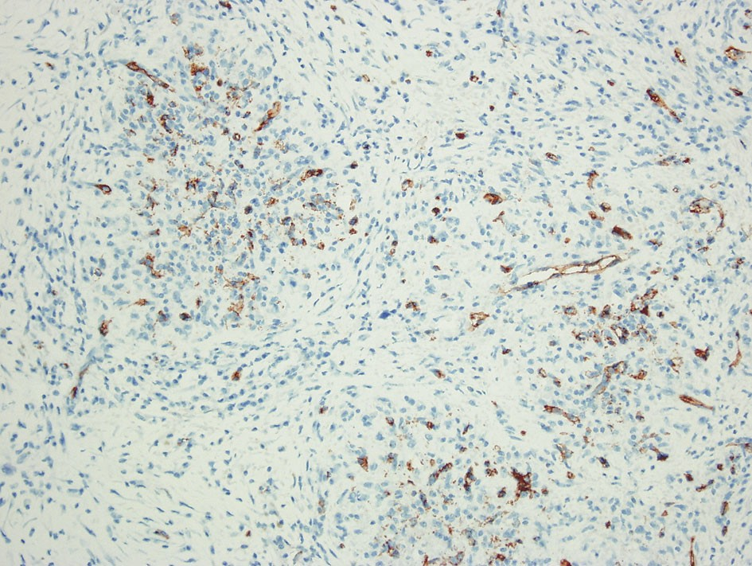
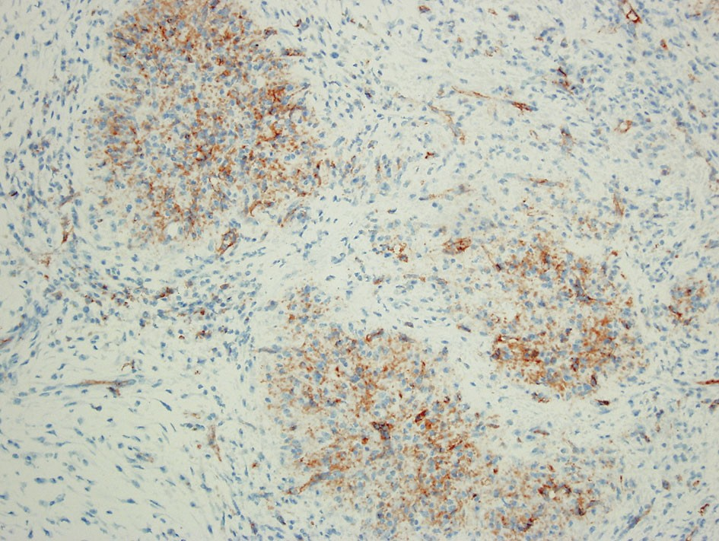
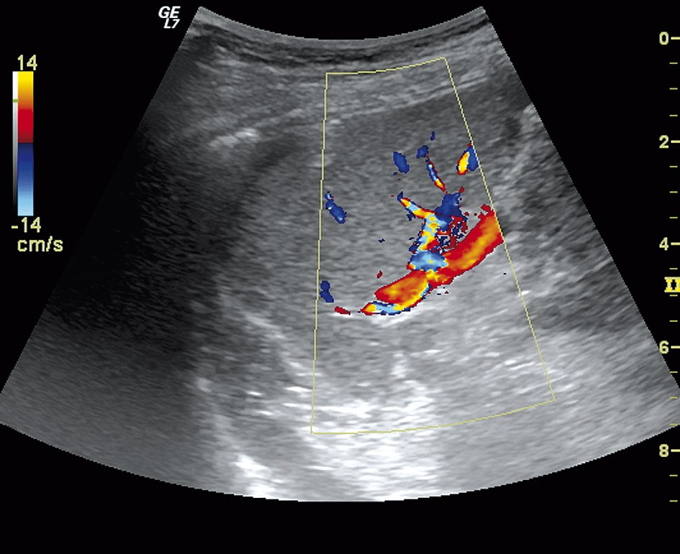
Sclerosing angiomatoid nodular transformation of the spleen treated by laparoscopic partial splenectomy
Figure 9. Positive staining for CD31 in the numerous cells of the angiomatoid nodules
Figure 10. Positive CD34 staining only selective of the narrow capillaries
within the normal range. The remaining part of the spleen showed some enlargement on abdominal ultrasound; its length was 6.5 cm and it has physio- logical blood flow documented by Doppler technique (Figure 11). Similar results were obtained at 1-year fol- low-up.
Discussion
Among isolated primary splenic disorders, approxi- mately 50 cases of benign vascular lesion referred to as sclerosing angiomatoid nodular transformation (SANT) have been described. Formerly reported under different names as cord capillary haemangioma, splenic hamar- toma, multinodular haemangioma or as a variant of splenic haemangioendothelioma, the lesion was finally designated in 2004 by Martel et al. [4, 5].
The most common presentations were incidental finding of an asymptomatic splenic mass, abdominal pain or discomfort, and splenomegaly. To the best of our knowledge, a clear association with other symp- toms or complaints has not been described so far. In the original report of Martel describing the largest series so far, one out of 25 patients presented with leukocytosis, polyclonal gammopathy, and raised ery- throcyte sedimentation rate (ESR), one with fever, one with mild anaemia, and another one with pancy- topenia with elevated ESR. More clinical data are giv- en in the Diebold study [6]. Three out of 16 patients in his study had some inflammatory condition and oth- er 3 had anaemia.
The unique feature of our case was a generalized inflammatory reaction manifested by fever, muscular
Figure 11. Follow-up ultrasound showing normal flow pattern through the fragment of the spleen left after partial splenectomy
and joint pain, elevation of ESR, CRP and fibrinogen, and iron-deficiency anaemia. This clinical picture necessitated a diagnostic workup in the search for a possible explanation, and as a final result the tumour of the spleen was found. This history is somewhat distinct from previous reports. The radi- ographic, gross, histological, and immunophenotypi- cal features were similar to the cases previously described in the literature.
The main differential diagnoses of SANT include littoral cell angioma, splenic haemangioendothe- lioma, inflammatory myofibroblastic tumour, splenic hamartomas and nodular transformation of splenic red pulp in response to metastatic carcinoma [7-13].
253
Videosurgery and Other Miniinvasive Techniques 2011; 6/4
Andrzej Budzyński, Sergiusz Demczuk, Beata Kumiega, Marcin Migaczewski, Maciej Matłok, Anna Zub-Pokrowiecka
Others are congestive splenomegaly, infarction and Kaposi’s sarcoma [14].
The clinical features present in our case support the assumption that there might be some inflamma- tory component in the aetiology of this disease. According to different authors, some lesions may rep- resent some form of inflammatory pseudotumours, hamartomatous lesions, red pulp transformation in response to exaggerated stromal proliferation or organized haematomas [15-17]. The theory about inflammatory components in the aetiology could be supported by complete disappearance of the bio- chemical indicators of inflammation after surgical removal of the tumour.
In practice, highly vascularised lesions in the splenic parenchyma are very difficult to differentiate preoperatively [18]. The most common pathological finding is haemangioma, but other tumours such as splenic hamartoma, haemangioendothelioma, lit- toral cell angioma, benign vascular tumours with myoid and angioendotheliomatous features, inflam- matory myofibroblastic tumour (inflammatory pseudotumour) or hamartomas are occasionally found [6, 19-21]. Usually the only method to estab- lish an unequivocal diagnosis is pathological exami- nation of the spleen, and splenectomy is considered both diagnostic and curative. The main reason for surgical management is uncertainty about the nature of the tumour of the spleen. This approach is particularly supported by the fact that many patients with SANT have a history of previous malig- nancy, and splenic tumour is frequently found during routine follow-up in the search for metastases. Moreover, clinical and radiological features of the SANT may mimic nodular transformation of the splenic red pulp in response to metastatic carcino- ma, and important risk of this pathology is the strongest indication for splenectomy.
In all reports, splenectomy is considered curative with regard to the risk of recurrence. However, this treatment is associated with all the long-term risks related to asplenia. Most important seems the over- whelming post-splenectomy infection (OPSI) with the high mortality rate related to this disease entity. Benign nature of the tumour in various imaging tech- niques including CT, MRI or positron emission tomog- raphy (PET) scans allows for a different surgical approach. Whenever technically possible, partial splenectomy with adequate margins of uninvolved tissue seems appropriate. With high experience in
advanced minimally invasive procedures the laparo- scopic approach is considered beneficial [22, 23].
Owing to the extensive experience in laparoscop- ic operation of the spleen, we may conclude that even though indications for spleen preserving proce- dures are scarce, they are highly beneficial for the patient. If the vascular anatomy and localization of the lesion allow for the selective devascularization of the affected part of the spleen, the SANT tumour could be considered for laparoscopic hemisplenecto- my. Generally, the best indications for this advanced procedure are splenic cysts and tumours with benign radiological phenotype localized in the upper or low- er part of the spleen. Central localization of the lesion usually does not allow for partial splenectomy.
Relatively high prevalence of malignancy among patients with SANT was described. However, further studies are needed to conclude whether it could be classified as paraneoplastic syndrome or it is just the result of frequent use of the variety of imaging stud- ies in oncological patients that lead to the detection of various asymptomatic lesions. So far – as long as the data about the relationship between SANT and malignancy is not clear – regular follow-up should be recommended in all patients with confirmed SANT.
References
- El Demellawy D, Nasr A, Alowami S. Sclerosing angiomatoid nodular transformation of the spleen: case report. Pathol Res Pract 2009; 205: 289-93.
- Koreishi AF, Saenz AJ, Fleming SE, Teruya-Feldstein J. Sclerosing Angiomatoid Nodular Transformation (SANT) of the spleen: a report of 3 cases. Int J Surg Pathol 2009; 17: 384-9.
- Chouchane Mlik O, Lardenois S, Salmon R, et al. Sclerosing angiomatoid nodular transformation of the spleen. Ann Pathol 2008; 28: 317-20.
- Lee JC, Lien HC, Hsiao CH. Coexisting sclerosing angiomatoid nodular transformation of the spleen with multiple calcifying fibrous pseudotumors in a patient. J Formos Med Assoc 2007; 3: 234-9.
- Martel M, Cheuk W, Lombardi L, et al. Sclerosing angiomatoid nodular transformation (SANT): report of 25 cases of a distinc- tive benign splenic lesion. Am J Surg Pathol 2004; 28: 1268-79.
- Diebold J, Le Tourneau A, Marmey B, et al. Is sclerosing angioma- toid nodular transformation (SANT) of the splenic red pulp iden- tical to inflammatory pseudotumour? Report of 16 cases. Histopathology 2008; 53: 299-310.
- Ali TZ, Beyer G, Taylor M, et al. Splenic hamartoma: immunohis- tochemical and ultrastructural profile of two cases. Int J Surg Pathol 2005; 13: 103-11.
- Arber DA, Strickler JG, Chen YY, et al. Splenic vascular tumors: a histologic, immunophenotypic, and virologic study. Am J Surg Pathol 1997; 21: 827-35.
254
Videosurgery and Other Miniinvasive Techniques 2011; 6/4
Sclerosing angiomatoid nodular transformation of the spleen treated by laparoscopic partial splenectomy
- Daze Y, Gosselin J, Bernier V. Sclerosing angiomatoid nodular transformation of the spleen (SANT): a case report. Ann Pathol 2008; 28: 321-3.
- Fakan F, Michal M. Nodular transformation of splenic red pulp due to carcinomatous infiltration. A diagnostic pitfall. Histopathology 1994; 25: 175-8.
- Falk S, Stutte HJ, Frizzera G. Littoral cell angioma. A novel splenic vascular lesion demonstrating histiocytic differentiation. Am J Surg Pathol 1991; 15: 1023-33.
- Kaw YT, Duwaji MS, Knisley RE, et al. Hemangioendothelioma of the spleen. Arch Pathol Lab Med 1992; 116: 1079-82.
- Li L, Fisher DA, Stanek AE. Sclerosing angiomatoid nodular trans- formation (SANT) of the spleen: addition of a case with focal CD68 staining and distinctive CT features. Am J Surg Pathol 2005; 29: 839-41.
- Cook PD, Czerniak B, Chan JK, et al. Nodular spindle-cell vascular transformation of lymph nodes. A benign process occurring pre- dominantly in retroperitoneal lymph nodes draining carcinomas that can simulate Kaposi’s sarcoma or metastatic tumor. Am J Surg Pathol 1995; 19: 1010-20.
- Falk S, Stutte HJ. Hamartomas of the spleen: a study of 20 biop- sy cases. Histopathology 1989; 14: 603-12.
- Neuhauser TS, Derringer GA, Thompson LD, et al. Splenic inflam- matory myofibroblastic tumor (inflammatory pseudotumor): a clinicopathologic and immunophenotypic study of 12 cases. Arch Pathol Lab Med 2001; 125: 379-85.
- Seijo L, Unger P, Strauchen J. Inflammatory pseudotumor of the spleen: an old concept with many questions. Int J Surg Pathol 1996; 43: 289-98.
- Kutok JL, Fletcher CD. Splenic vascular tumors. Semin Diagn Pathol 2003; 20: 128-39.
- Karim RZ, Ma-Wyatt J, Cox M, Scolyer RA. Myoid angioendothe- lioma of the spleen. Int J Surg Pathol 2004; 12: 51-6.
- Kraus MD, Dehner LP. Benign vascular neoplasms of the spleen with myoid and angioendotheliomatous features. Histopatholo- gy 1999; 35: 328-36.
- Szpor J, Dyduch G. From hamartoma to splenic hemangioma. Pol J Pathol 2008; 59: 33-41.
- Bednarek M, Budzyński P, Budzyński A, Demczuk S. Sarcoidosis of the spleen – rare indications for splenectomy. Own experi- ence. Videosurgery and Other Miniinvasive Techniques 2010; 5: 115-9.
- Dzielicki J, Grabowski A, Korlacki W. Optimizing the technique of laparoscopic splenectomy in children. Videosurgery and Other Miniinvasive Techniques 2010; 5: 19-26.
255
Videosurgery and Other Miniinvasive Techniques 2011; 6/4

