337

Neuroendocrinology Letters No.4 August Vol.26, 2005 Copyright © 2005 Neuroendocrinology Letters ISSN 0172–780X www.nel.edu

Comparative analysis of ACTH and oxytocinase plasma concentration during pregnancy
O

Marek Klimek
Department of Gynecology and Infertility, Jagiellonian University, Krakow, Poland.
R
Correspondence to: Ass. Professor Marek Klimek MD, PhD
Gynecology and Infertility Department
I
23 Kopernik Str, 31-501 Krakow, POLAND PHONE: +48 12 4248528
G
FAX: +48124248585
EMAIL: mowicher@cyf-kr.edu.pl
I
Submitted: July 8, 2005 Accepted: July 18, 2005
N
Key words: ACTH; oxytocinase; pregnancy; infertility
A

Neuroendocrinol Lett 2005; 26(4):337–341 PMID: 16136011 NEL260405A07 © Neuroendocrinology Letters www.nel.edu

Abstract INTRODUCTION: Normal function of the hypotalamo-adrenal axis is important for the regulation of feto-maternal intrauterine homeostasis including immuno- modulating activity and may influence the timing of parturition. ACTH is pro- duced during pregnancy by mother pituitary gland and by trophoblast cells, which are the place of oxytocinase production. Oxytocinase is basically secreted by syncytiotrophoblast cells and rises progressively during pregnancy until the labor. Oxytocinase may play a role as one of the main factors suppressing uterine contractions, controlling the vascular resistance and the volume of the retropla- cental blood pool.
L
A
R
MATERIAL AND METHODS: The study group consisted of 102 patients with preg- nancy following infertility treatment. The assessment was provided longitudinally in six selected groups progressively according to the gestational age. Immunoassay was used to measure ACTH plasma concentration. Oxytocinase plasma activity was established using l-cystine-di-β-naphthylamide as a substrate.
T
I
RESULTS: Significantly increased oxytocinase plasma level was identified dur- ing pregnancy, progressive rise was observed beginning with the first trimester of pregnancy, until the labor. ACTH plasma concentration was observed to be at comparable level in the first and second trimester of pregnancy, while sudden statistically significant increase of ACTH plasma level was noted beginning with 28th week of gestation.
C
L
E
CONCLUSIONS: The assessment of ACTH and oxytocinase plasma concentration might be useful for the evaluation of pregnancy development.

Introduction
Epilepsy is a common disease. In the USA abThe efficacy of hormonal therapy treatment depends on the metabolism of hormones and their effectors status, and is represented intermediately by their blood serum level. Each hormone is decomposed by enzymes controlled by metabolic pathways. In sum, enzymes are responsible for hormones effectiveness. The alteration of enzyme level influences the concentration of hormone, the effect depends on the hormone-enzyme and their metabolic environ- ment balance. This phenomenon is demonstrated by, for example, the oxytocinase-oxytocin system. The level of biologically active oxytocin is regulated by oxytocinase activity (serum aminopeptidase activity) [18]. Oxytocinase may be also involved in gonadotropin releasing hormone (GnRH) degra- dation. Hypothalamus is responsible for the regulation of neuro-endocrine system through hypota-
lamo-adrenal axis (HPA) and hypothalamo-gonadal axis. The former secretes ACTH in response to stress stimuli, and the latter, regulates the fertility. In both of them steroid hormones are finally produced. ACTH is produced during pregnancy by mother pituitary gland and by trophoblast cells.
Normal function of the HPA axis is important for the regulation of feto-maternal intrauterine homestasis. It may influence the timing of parturition. The source of CRH growth during pregnancy are both pituitary cells and placental cells. Although it was previously sug- gested that the pregnancy ACTH growth results from CRH secretion, no correlation between CRH levels and answer of maternal as well as fetal HPA axis was identified [9,30,32]. The ACTH and CRH presence in placental microenvironment is directly involved in progesterone regulation in trophoblast cells [12]. Since the blockade of progesterone is one of the mechanism possibly involved in initiation of labor, the labor results from the immune tolerance change. The ACTH and CRH might influence the immune regulation during pregnancy. Progesterone, necessary for normal preg- nancy development accumulates during pregnancy and generally stimulates the conversion of Th0 to Th2 cells [33]. ACTH in not only the neuroendorcine hormone, but is also produced by immune cells (lymphocytes and macrophages), so ACTH receptor is detected on vari- ous immune cells [8,13]. ACTH appears to be a basic factor responsible for the bi-directional communication between neuroendocrine and immune system.
Oxytocinase (cystine amino peptidase – CAP), which was originally recognized during pregnancy in blood serum as an enzymatic activity capable of cleav- ing synthetic substrates such as L-cystine-di-β-naph- thylamide, is a member of mammalian zinc containing the family of aminopeptidases [17,18,27]. In maternal serum a soluble form of CAP can be detected due to the deletion of cytoplasmic and hydrophobic transmem- brane domains of native form. Oxytocinase is basically secreted by syncytiotrophoblast cells and rises progres- sively during pregnancy until the labor [14,29]. The membrane form of oxytocinase was identified also in skeletal muscles, heart, decidua, Graffian follicle, brain and human umbilical vein endothelial cells [38]. CAP is responsible for degradation of the following peptide hormones: vasopresin (AVP), oxytocin (OT), angioten- sin III (ANG III) and it may regulate the level of these peptide hormones in fetal and maternal serum. This enzyme may play a role as one of the main factors sup- pressing uterine contraction, controlling the vascular resistance and the volume of the retroplacental blood pool.
The aim of our study was to evaluate the concen- tration of blood ACTH and oxitocinase serum activ- ity in order to establish the role of these factors in the materno-fetal homeostasis during pregnancy.

Materials and Methods
Group of patients
In all cases patients consent was obtained. The approval for the research program from the Ethical Committee of the Jagiellonian University in Krakow: KBET/379/13/2003 was also granted. The 102 patients in this study were randomly selected from 250 women treated because of infertility at the Gynecology and Infertility Department of the Jagiellonian University between March 2003 and December 2004. The mean age of all patients was 30.3 (± 4.6) years, the average gestational age during the labor was 38.4 (± 2.0) weeks, average newborns birth weight 2890.3 (± 468 g), aver- age newborns length 52.5cm (± 3.7), Apgar 9.6 (± 0.8), K- index of newborns maturity 11.5 (± 1.0) and parity
1.9 (± 1.2). The patients were observed for the whole course of pregnancy. The assessment was provided lon- gitudinally six times during the gestation in following groups: group I – pregnant women between 7th and 9th week of gestation, group II – between 15th and 17th week of pregnancy, group III – between 18th and 20th , group IV – between 28th and 30th , group V – between 32nd and 33rd and group VI – between 36th and 37th weeks of gestation.
Hormone assays
ACTH concentration and oxytocinase serum level were established totally in 612 plasma samples. It was assessed in whole blood samples, collected approx- imetly 9 in the morning in silicon-coated glass tubes containing EDTA as an anticoagulant, and were centri- fuged immediately in a refrigerated centrifuge. All sam- ples were frozen at –20°C until the ACTH analysis was performed. Immunoassay was used to measure ACTH (Immulite 2000 ACTH, DPC Ltd- United States).
The CAP plasma activity was evaluated using Tuppy and Nesvadba method, modified by Klimek [17]. The assessment of oxytocinase in two pH levels using the same substrate (l-cystine-di-β-naphthylamide) results in obtaining two peeks of aminopeptidase’s activity (CAP1 – pH 7.9; and CAP2 – pH 6.7). The detailed method of CAP estimation was described in previous studies [16,22,24].
Statistical analysis
Statistical calculations were performed using Statis- tica computer program (StatSoft, Poland). The normal distribution of value of ACTH and CAP was checked by means of the Shapiro-Wilk test. Mann-Whitney U test was applied to compare the differences between parametric data. A value of p < 0.05 was considered as significant.

Results
The analysis of CAP1 and CAP 2 serum level and ACTH concentration was performed in a group of 102 pregnant women. The assessment was provided longi- tudinally in all selected groups (from group I to group
VI) (Table 1.)
Table 1: ACTH and oxytocinase (CAP1 and CAP2) concentration according to progressive rise of gestational age of pregnant women.
Groups (gestational age) | ACTH (pg/ml) serum level +SD (range) | CAP1 (µmol/l/min) serum level +SD (range) | CAP2 (µmol/l/min) serum level +SD (range)
Group I – 7÷9 weeks | 12.1 ± 5.8 | 0.59 ± 0.2* | 1.35 ± 0.3#
(n=102) | (5 ÷ 2.4) | (0.3 ÷ 1.7) | (0.1 ÷ 2.3)
Group II – 15÷17 weeks | 11.3 ± 4.8 | 1.21 ± 0.5* | 1.8 ± 0.4#
(n=102) | (5 ÷ 23.7) | (0.4 ÷ 3.4) | (1.1 ÷ 3.4)
Group III – 18÷20 weeks | 11.8 ± 5.0 | 1.61 ± 0.7* | 2.11 ± 0.5#
(n=102) | (4.9 ÷ 29.3) | (0.4 ÷ 5.0) | (1.1 ÷ 4.5)
Group IV – 28÷30 weeks | 15.1 ± 5.3 | 3.41 ± 1.4* | 3.45 ± 1.6#
(n=102) | (5.4 ÷ 29.3) | (1.3 ÷ 7.9) | (2.0 ÷ 6.5)
Group V – 32÷33 weeks | 19.3 ± 8.9 | 4.9 ± 2.5* | 4.5 ± 1.9#
(n=102) | (5.4 ÷ 51) | (1.3 ÷ 14) | (2 ÷12.6)
Group VI – 36÷37 weeks | 22.9 ± 1.0 | 7.5 ± 2.3* | 6.2 ± 1.8#
(n=102) | (5.4 ÷ 52.3) | (3.2 ÷ 14.9) | (3.4 ÷12.6)
# The differences statistically significant p<0.01; n-number of patients
* The differences statistically significant p<0.01; n-number of patients

High statistically significant correlation was found between the CAP1 and CAP2 serum levels (r=0.95, p=0.0001). No correlation was observed between ACTH serum concentration and the levels of CAP1 and CAP2, respectively r=0.18 and r=0.11). Enzymes levels rose progressively with the gestational age and the differences between each groups were statistically significant (p<0.0001).
The level of ACTH was at comparable levels in I, II, III groups (gestational age between 7th and 20th weeks of pregnancy). Beginning with 28th week of gestation ACTH concentration started to rise, the dif- ference between 7th–20th (groups I, II, III) and 28th week of gestation (group IV) was statistically significant (p=0.001). Progressive increase of ACTH maintained until the labor, and the difference between group IV and VI was statistically significant (p=0.001), while the growth of ACTH serum level between 30rd and 33th weeks of gestation was not statistically significant, how- ever the tendency of ACTH rise was observed.
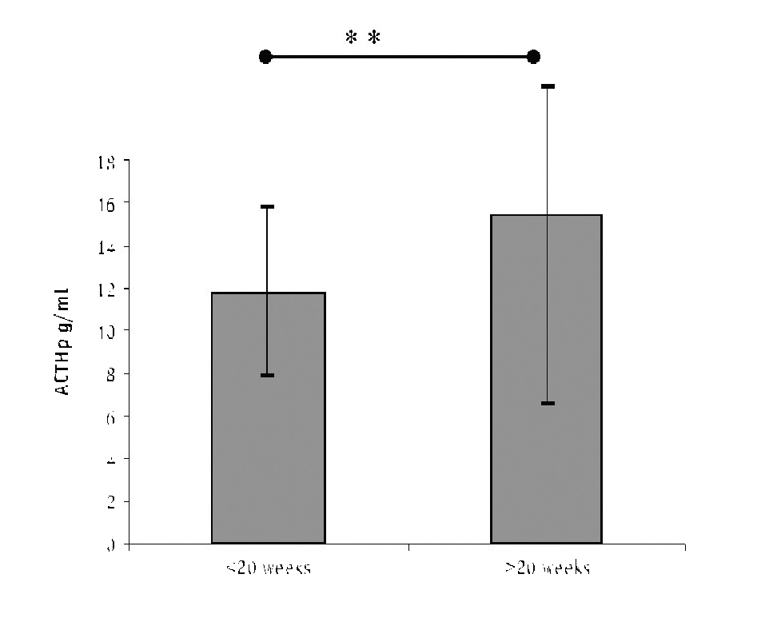
Figure 1. Presents the ACTH plasma concentration changes according to growth of gestational age (**p<0.01)
The comparative analysis between ACTH and oxy- tocinase (CAP1 and CAP2) serum levels before and after 28th week of gestation was also performed. Figure 1 and 2 demonstrate the results of ACTH and CAP1 and CAP2 levels comparison.

Discussion
In the present study, significantly increased oxy- tocinase level was identified during pregnancy, with a progressive growth from early pregnancy until the labor. ACTH plasma concentration was observed to be at comparable level in the first and second trimes- ters of pregnancy, while sudden statistically significant increase of ACTH plasma level was noted beginning 28th week of gestation.
Maternal pituitary ACTH secretion and plasma ACTH levels rise during pregnancy. Additional secre- tion of ACTH from placenta takes place during preg- nancy. Maximum plasma concentration of ACTH was
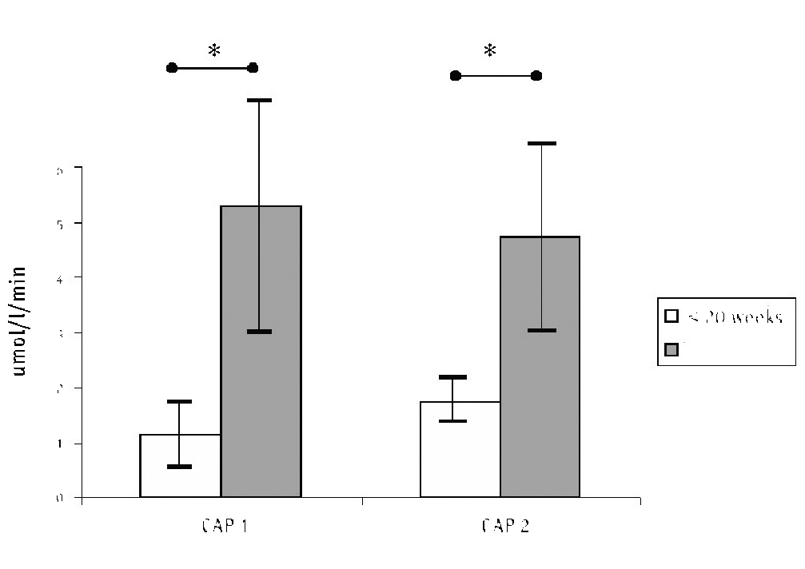
Figure 2. Demonstrates the changes of oxytocinase serum activity during pregnancy (*p<0.001).
reported in 34th week of gestation with a significant fall in late pregnancy [26]. Our study does not confirm this observation, since the ACTH plasma concentration starts to increase beginning 28th week of gestation and progressively rise until the labor. Similarly to our study, progressively the growing ACTH level with the develop- ment of gestation was shown by Jeschke et al [12]. The highest ACTH level identified in pregnancy was noted during the labor [30,31]. ACTH plasma concentration was not associated with the progression of the labor, although concomitant increase of Cortisol serum level was observed [2]. No differences were noticed among ACTH plasma concentrations between patients receiv- ing or not receiving mifepristone therapy during labor at term [2]. ACTH seems to modulate the endocrine function of throphoblast cells downregulating proges- teron production in vitro [12].
The pituitary gland responds to stressful stimuli by rapidly increasing the secretion of adrenocorticotropin, which in turn increases the secretion of cortisol. Since placental clock was suggested to determine the length of gestation, maternal plasma level might be used as an indicator of these events increasing until the labor (cor- tisol, ACTH, CRH) [4]. To confirm the link between increasing labor stress and the growing ACTH serum level standardized CPT (cold pressor test) was per- formed in two groups of pregnant women, fearful and fearless ones. Women with fear of labor were character- ized by reduced pain tolerance both before and after labor. ACTH, cortisol and beta endorphin did not differ between both groups, however ACTH baseline levels during pregnancy were significantly higher than those after pregnancy in both groups (with or without fear of labor) [34]. Contrary to this observation Ochedalski et al. reported that maternal pituitary response to stress factors grew during delivery and the ACTH plasma concentration raised. The rise of the ACTH serum level was higher in women with induced labor in comparison to labor with spontaneous beginning. The ACTH level observed during pregnancy seems to be independent from CRH increasing concentration because ACTH levels are during pregnancy within the range of no pregnant subject, despite extremely elevated maternal CRH. [30,31].
The highest concentration of ACTH observed in induced labor receiving oxytocin treatment might result from the modulation of anterior pituitary secretion by oxytocin as a central maternal regulation of the mater-
(Cytotoxic T Lymphocytes Leukemia cells CTLL-2) and indicates two-directional action (suppression and activation) according to the concentration changes [36]. Serum Il-2 receptor level was also reported to rise during pregnancy [10]. It was also noticed that ACTH modulates macrophages function [8], and macrophages changes in decidua were identified during spontane- ous labor (Sindram 2004). HPA axis is also involved in the pathogenesis of treatment-resistant depression, in which this patient presents disturbance of the activa- tion of lymphocytes function [25]. Immunomodulating activity is also characteristic for oxitocinase [27]. Sta- tistically significantly higher oxytocinase serum level was found a few days before induced labor in compari- son to spontaneous labor in previous studies [21,37]. Spontaneous labor requires the termination of mater- nal immunological tolerance to fetal antigens, and the activation of cytotoxic immune response [11,37]. The ACTH growing level seems to result from these changes in maternal immune response.
Preeclampsia seems to be secondary to anomaly of the the uterine spiral arteries invasions by cytotropho- blast cells and finnaly results in hypertension [1,28]. One of biological effects of oxytocinase activity is the regulation of placental blood flow, what was confirmed by simultaneous assessment of CAP serum level and Doppler ultrasound examination [16,22]. In our previ- ous research CAP1 and CAP2 serum decreased levels in patients with preeclampsia were confirmed [6,21]. Among other vasomotor factors like NO, ET-1 (endo- thelin-1), CAP1 seems to appear as an important factor regulating the placental blood flow. Elevated ACTH level was identified in the umbilical artery in pregnan- cies complicated by preeclampsia or IUGR [5,28].
In conclusion, the assessment of ACTH and CAP might be useful for the evaluation of pregnancy devel- opment.

REFERENCES

- Al-Mulhim AA, Abu-Heija A, Al-Jamma FA, El-Harith EA. Pre-ec- lampsia: maternal risk and perinatal outcome. Fetal Diagn Ther 2004; 18:275–280.
- Byrne JD, Wing DA, Fraser M, Fassett MJ, Goodwin TM, Challis JRG: Mifepristone: effect on plasma corticotropin-releasing hor- mone, adrenocorticotropic hormone, and cortisol in term preg- nancy. J Perinatol 2004; 24:416–420.
- Carson RJ: Detection and prevention of the premature labour. In: Adamson-Macedo EN, ed. Expanding frontiers of neonatology.
nal hypothalamo pituitary axis [30]. The differences
Neuro Endocrinol Lett 2004; 25 (Suppl.1):35–41.
4
. Nat Med
of ACTH maternal plasma level observed in our study
between 28th and 32nd week of gestation might indi- cate that labor associated stress but also other factors seem to be responsible for the ACTH increase. The rise in the ACTH level observed immediately before normal time of the onset of labor might result from immuno- logical activity changes necessary to initiation of spon- taneous labor at term. The neuroendocrine hormone ACTH alters immune responses and may be a factor in mediating stress-induced immunomodulation [35]. Wermerskirchen et al. reports that ACTH modulates in vitro IL-2 secretion from activated splenic lymphocytes
Challis JR: CRH, a placental clock and preterm labour
1995; 1:416.
- Clifton VL, Read MA, Boura AL, Robinson PJ, Smith R: Adrenocor- ticotropin causes vasodilatation in the human fetal placenta cir- culation. J Clin Endocrinol Metab 1996; 81:1406–10.
- Cosmi EV, Klimek R, Di Renzo GC, Kulakov V, Kurjak A, Maeda K, Mandruzzato GP, Van Gelin HP, Wladimiroff J: Prognosis of birth term: recommendations on current practice and overview of new developments. Archiv Perinat Med 1997; 3:31–50.
- Florido J, Oltras CM, Fajardo MC, Gonzalez-Escanuela E, Villav- erde C, Gonzalez-Gomez F: Plasma concentrations of beta-en- dorphin and adrencorticotropic hormone in women with and without childbirth preparation. Eur J Obstet Gynecol Reprod Biol 1997; 73:121–125.

- Fukushima T, Ichinose M, Shingai R, Sawada M: Adrenocortioc- tropic hormone activates an outward current in cultured mouse peritoneal macrophages. J Neuroimmunol 2001; 113:231–235.
- Goland RS, Jozak S, Conwell J: Placental corticotropin-relasing hormone and the hypercortisolism of pregnancy. Am J Obstet Gynecol 1994; 171:1287–1291.
- Gucer F, Balkani-Kaplan P, Yuksel M, Sayin NC, Yuce MA, Yardim T: Maternal serum levels of tumor necrosis factor – alfa and in- terleukin-2 receptor in threatened abortion: a comparison with normal and pathologic pregnancies. Fertil Steril 2001; 76:707– 711.
- Hackmon R, Hallak M, Krup M, Weitzman D, Sheiner E, Kaplan B, Weinstein Y: HLA-G antigen and parturition: maternal serum, fetal serum and amniotic fluid levels during pregnancy. Fetal Di- agn Ther 2004; 19:404–409.
- Jeschke U, Mylonas I, Richter DU, Hocker I, Briese V, Makrigian- nakis A, Friese K: Regulation of progesterone production in human term throphoblasts in vitro by CRH, ACTH and cortisol (prednisolone). Arch Gynecol Obstet 2005; 272:7–12.
- Johnson HM, Torres BA, Smith EM, Dion LD, Blalock JE: Regula- tion of lymphokine (γ-interferon) production by corticotropin. J Immunol 1984; 132:246–250.
- Kikkawa F, Kajiyama H, Ino K, Watanabe Y, Ito M, Nomura S, Itakura A, Tsujimoto M, Mizutani S: Possible involvement of placental peptidase that degrade gonadotropin-releasing hor- mone (GnRH) in the dynamic pattern of placental hCG secretion via GnRH degradation. Placenta 2002; 23:483–489.
- Kishida T, Yamada H, Furuta I, Kobayashi N, Hirayama EK, Ebina Y, Sakuragi N, Fujimoto S: Increases levels of interlekin-6 in cervi- cal secretions and assessment of the uterine cervix by transvag- inal ultrasonography predict preterm premature rupture of the membranes. Fetal Diagn Ther 2005; 20:420–425.
- Klimek M, Klimek R, Skotniczny K, Tomaszewska B, Wicherek L, Wolski H: Auxiological relations between prenatal ultrasound and oxytocinase measurements in high-risk pregnancies. Prenat Neonat Med 2001; 6:350–355.
- Klimek R: Clinical studies on the balance between isooxytoci- nase in the blood of pregnant women. Clin Chim Acta 1968; 20:233–238.
- Klimek R: Enzymes: the most important markers of pregnancy development. Early Pregnancy 2000; 4:219–229.
- Klimek R: Oxytocinase as the most important marker of fetal de- velopment. Early Pregnancy 2001;5:38–39.
- Klimek R, Drewniak K, Bieniasz A: Further studies on the oxy- tocin-oxytocinase system. Am J Obstet Gynecol 1969; 105:427– 430.
- Klimek R, Michalski A, Milewicz S, Rzepecka A, Szlachcic M, Elac- cari S, Fraczek A: Results of psychohormonal prevention of pre- mature deliveries. Int J Prenat Perinat Stud 1991; 1:87–95.
- Klimek R, Klimek M: Biological gestational age and its calendar assessment with ultrasound. Part 2: Biological-calender scales for prediction of birth-date. Gynacol Geburtshilflische Rundsch 1992; 32:159–163.
- Klimek R, Fedor-Freybergh P, Janus L, Walas-Skolicka E, edi- tors. A time to be born. Cracow: DREAM Publishing Company, Inc;1996.
- Klimek R, Basta A, Breborowicz GH, Chazan B, Czajkowski K, Debski R, Dubcak J, Fedor-Freybergh P, Hajek Z, Kaminski K, Klimek M, Krzysiek J, Lauterbach R, Lukacin S, Malarewicz A, Maly Z, Marianowski L, Oleszczuk J, Pisarski T, Reorn A, Roztocil A, Sajdak S, Skret A, Stencl J, Szymanski W, Wilczynski J, Unzeitig V, Zdebski Z: Proposal fro delivery in the XXI century. Ginekol Pol 2002; 73:3–13.
- Kubera M, Basta-Kaim A, Wrobel A, Maes M, Dudek D: Increased mitogen-induced lymphocyte proliferation in treatment resist- ant depression: a preliminary study. Neuro Endocrionol Lett 2004; 25:207–210.
- Mastorakos G, Ilias I: Maternal and fetal hypthalamic-pituitary- adrenal axes during pregnancy and postpartum. Ann N Y Acad Sci 2003; 997:136–149.
- Matsumoto H, Rogi T, Yamshiro K, Kodama S, Tsuruoka N, Hattori A, Takio K, Mizutani S, Tsujimoto M: Characterization of a recom- binant soluble form of human placental leucine aminopepti- dase/oxytocinase expressed in Chinese hamster ovary cells. Eur J Biochem 2000; 267:46–52.
- Merviel P, Carbillon L, Challier JC, Rabreau M, Beaufils M, Uzan S: Pathophysiology of preeclampsia: links with implantation disor- ders. Eur J Obstet Gynecol Repord Biol 2004; 115:134–147.
- Nakanishi Y, Nomura S, Okada M, Ito T, Katsumata F, Kikkawa F, Hattori A, Tsujimoto M, Mizutani S: Immunoaffinity purification and characterization of native placental leucine aminopepti- dase/oxytocinase from human placenta. Placenta 2000; 21:628– 634
- Ochedalski T, Zylinska K, Laudanski T, Lachowicz A: Corticotro- pin releasing hormone and ACTH levels in maternal and fetal blood during spontaneous and oxytocin-induced labour. Eur J Endocrinol 2001; 144:117–121.
- Ochedalski T, Lachowicz A: Maternal and fetal hypothalamo-pi- tuitary-adrenal axis different response depends upon the mode of parturition. Neuro Endocrinol Lett 2004; 25:278–282.
- Papatsonis DNM, Van Geijn HP, Bleker OP, Ader HJ, Dekker GA. Maternal admission characteristics as risk factors fro preterm birth. Eur J Obstet Gynecol Reprod Biol 2004; 112:43–48.
- Saito S: Cytokine network at the feto-maternal interface. J Re- prod Immunol 2000; 47:87–103.
- Saisto T, Kaaja R, Helske S, Ylikorkala O, Halmesmaki E: Norepine- phrine, adrenocortiocotropin, cortisol and beta-endorphin in women suffering from fear of labor: responses to the cold pres- sor test during and after pregnancy. Acta Obstet Gynecol Scand 2004; 83:19–26.
- Weigent DA, Blalock JE: Associations between the neuroendo- crine and immune system. J Leukoc Biol 1995; 58:137–150.
- Wermerskirchen AS, LaTocha DH, Clarke BL: Adrenocorticotropic hormone controls Concanavalin A activation of rat lymphocytes by modulationg IL-2 production. Life Sci 2000; 67:2177–2187.
- Wicherek L, Dutsch-Wicherek M, Mak P, Klimek M: The role of RCAS1 and oxytocinase in immune tolerance during pregnancy. Fetal Diagn Ther 2005; 20:420–425.
- Yamahara N, Nomura S, Suzuki T, Itakura A, Ito M, Okamoto T, Tsujimoto M, Nakazato H, Mizutani S: Placental leucine ami- nopeptidase/oxytocinase in maternal serum and placenta dur- ing normal pregnancy. Life Sci 2000; 66:1401–1410.

