
ACTA BIOLOGICA CRACOVIENSIA Senes Botanica 42/1: 55-59, 2000

Heterochromatin in Pleurozium schreberi (Brid.) Mitt.
Elżbieta Kuta, Lesław Przywara and Tomasz Ilnicki
Department of Plant Cytology and Embryology, Jagiellonian University,
ul. Grodzka 52, 31-044 Cracow, Poland
Received September 21, 1999; revision accepted November 15, 1999
Differential staining of constitutive heterochromatin was used to investigate the karyotype of Pleurozium schreberi
(n = 5), the object of Vaarama’s (1954) classic work. C-banding demonstrated that the haploid karyotype is
heterochromatin-rich. The total amount of heterochromatin is 44.1% of the karyotype length. Telomeric as well as
intercalary bands were observed in particular chromosomes. Centromeric bands were recognized in one chromosome
only. The banding pattern of chromosome A, the longest, largely resembles Vaarama’s description. Heterochromatic
bodies were also observed in interphase nuclei.
Key words; Pleurozium schreberi, heterochromatin, Giemsa C-banding, mosses.
INTRODUCTION
Pleurozium schreberi was the object of a seminal
work by Vaarama (1954). His view of the evolution-
ary relationship between holocentric and monocen-
tric chromosomes was presented in his study of
mitosis and meiosis in this moss. Judging by the
shapes of the arms of the largest bivalent during
anaphase I, Vaarama, and later Anderson (1980),
concluded that the large bivalent (designated the
A-bivalent) has more than one active kinetic ele-
ment. In Vaarama’s opinion, P. schreberi represents
an intermediate condition between holocentric and
monocentric chromosomes. In mitosis, however, the
A chromosome of this moss is clearly monocentric,
as shown in Vaarama’s figures. Vaarama concluded
by calling them chromosomes with semilocalized
centromeres. A schematic figure in Vaarama’s paper
(1954 p. 14, Fig. 20) illustrates his view of the likely
structure of the A-bivalent at metaphase I, with one
arm of chromosome A almost totally heterochro-
matic (named the h-arm). He thought this chromo-
some corresponded to the big heteropycnotic body
observed in interphase nuclei. The second arm was
described as euchromatic (e-arm) with four hete-
rochromatic blocks. Vaarama assumed that the A-
bivalent was composed of four approximately equal
chromosome blocks. The primary constriction separ-
ates the chromosome arms (named the two primary
blocks), and each arm was thought to be divided into
two secondary blocks by secondary constrictions.
Vaarama concluded that this compound structural
character was caused by fusion of whole chromo-
somes. He based this hypothesis on observations of
chromosomes stained in aceto-orcein. No informa-
tion on the amount of heterochromatin in chromo-
somes of P. schreberi was given. Anderson (1980)
stated that such information would be a useful con-
tribution.
To identify constitutive heterochromatin in the
chromosomes of P. schreberi we undertook karyotype
analysis using a C-banding method. Differential stain-
ing has been little used in mosses. Only six species
(Atrichum undulatum, A. crispum, Dicranum tauri-
cum, Gymnostomum aeruginosum, Plagiomnium el-
lipticum, and Rhizomnium pseudopunctatum) are
known to have been investigated using this technique
(Newton, 1977, 1979,1983a, 1984a).
MATERIALS AND METHODS
Living material was collected in Kostrze near Cra-
cow in 1995-96. The plants were harvested random-
PL ISSN 0001-5296
© Polish Academy оГ Sciences, Cracow 2000
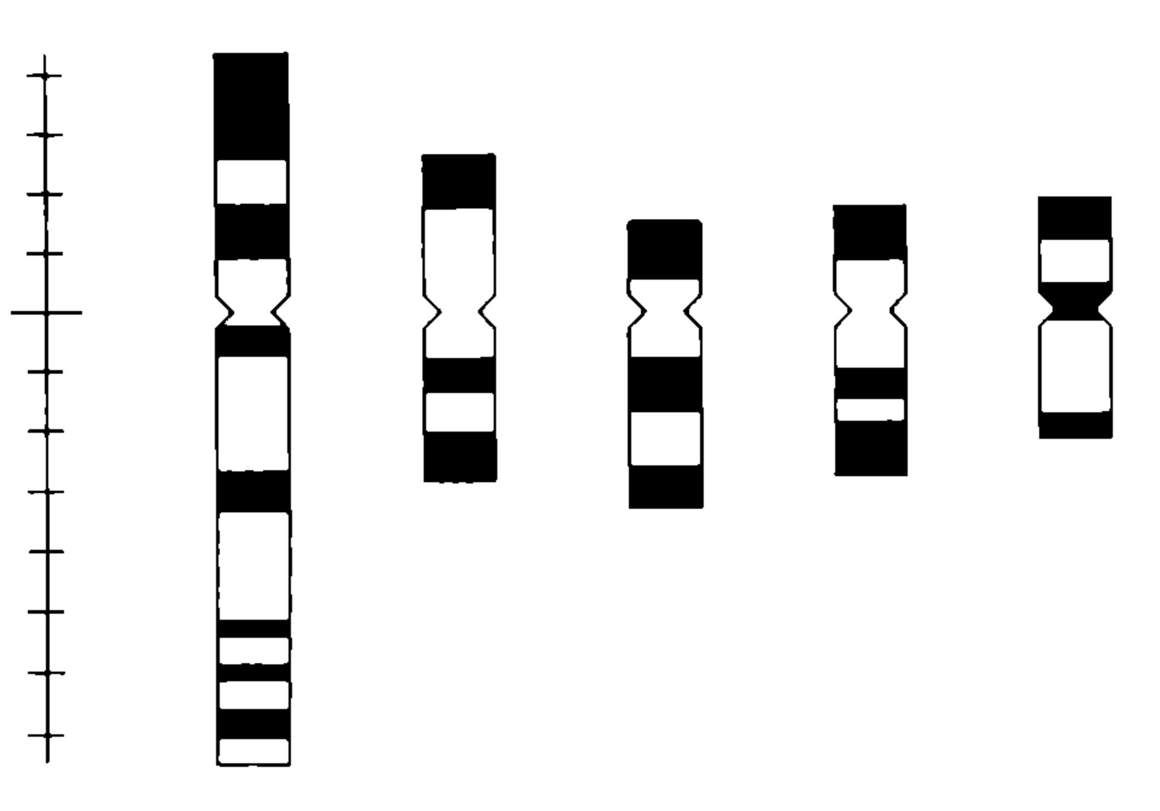
56
Kuta et al.
ly from a 30 x 30 m population area. Voucher speci-
mens are deposited in the Department of Plant
Cytology and Embryology of the Jagiellonian
University in Cracow. The plants were grown in
large glass containers with glass covers, on soil
taken from their natural habitat. The containers
were kept in a growth chamber with a 13 h photo-
period, at 15°C day/12°C night and 70-80% hu-
midity. Material for cytology was taken throughout
the period of cultivation. Gametophytic apices were
excised randomly from plants. A total of - 700 ga-
metophytic apices were examined.
Dissected shoot apices were treated in a satu-
rated solution of alfabromonaphthalene for 24 h at
4°C, then fixed in 1:3 acetic alcohol (1 part glacial
acetic acid, 3 parts absolute ethanol) for 24 h at 4°C
and stained immediately.
Material was prepared for Giemsa C-banding of
chromosomes according to Schwarzacher et al.
(1980). Analyses of karyotypes were based on
squashed material mounted in Euparal. Chromo-
some measurements were made from drawings
taken from photo slides projected on a screen
(x 20000). Chromosome nomenclature is that of
Levan et al. (1964). For calculations and idiogram
drawings, the Mr Karyo ver. 3.10 (by Tokarski and
Joachimiak) program was used. Microphotographs
were taken using a Nikon Labophot-2 microscope
with an FX-35DX attachment, on Agfa APX 25 film
and Kodak EPT 160T color slides.
RESULTS AND DISCUSSION
Pleurozium schreberi possesses one of the lowest
chromosome numbers known in mosses, n = 5
(Fritsch, 1991). Vaarama (1954) suggested that the
haploid complement was derived from an 11-unit set
by end-to-end fusion of 10 chromosomes. In our
investigated material, the number n = 5 was invari-
ably established, confirming the karyological unifor-
mity of this species. It should be mentioned,
however, that in a previous paper concerning ka-
ryotype variability in P. schreberi, the number n = 6
was found in two gametophytes from the same popu-
lation (Kuta et al., 1998).
A total of 120 slides was examined and the
results were based on measurements of 12 prometa-
phases and metaphases. In the analyzed material
the C-banding pattern in all chromosomes was well
defined in only one prometaphase plate (k/4). A
heterochromatin idiogram (Fig. 1) was constructed
on the basis of this plate, and then this plate was
Fig. 1. С-band idiogram of Pleurozium schreberi (n = 5).
chosen for presentation (Figs. 2,3). In the remaining
11 plates the heterochromatic bands were poorly
defined; generally, whole chromosomes were stained
when C-banding technique was applied, due to the
very condensed state of the metaphase chromo-
somes (Fig. 4, Tab. 1). Total chromosome length in
plate k/4 was 30.75 pm, whereas the total lengths of
the remaining 11 plates ranged from 13.5 to 23.4 pm
(mean total length 18.7 pm), indicating that their
chromosomes were markedly shorter (Tab. 1). C-
positive bands were observed in relatively uncon-
densed prometaphase chromosomes. Hetero-
chromatic bands probably fused together in con-
densed metaphase chromosomes, especially in hete-
rochromatin-rich karyotypes. Similar observations
have been reported in flowering plants and animals
with monocentric and holocentric chromosomes
(e.g., see: Ray and Venketeswaran, 1978; Collet and
Westerman, 1984; Manicardi et al., 1991; Manicardi
et al., 1996).
We also observed several other plates in which
bands were clearly seen in particular chromosomes;
for example, telomeric bands were visible in almost
all chromosomes, whereas intercalary bands were
visible only in less condensed ones. These plates
were not measured, however, because the cen-
tromeres were not recognizable [a well known phe-
nomenon in bryophytes (see: Przywara and Kuta,
1995)]. It should be noted that heterochromatin
bands were not visible in fresh preparations (Fig. 2).
A banding pattern appeared on slides after several
weeks (Fig. 3), as observed in angiosperm chromo-
somes stained in Giemsa for C-bands.
In the haploid set of P. schreberi the largest
chromosome (chromosome A) is nearly twice the

Heterochromatin in Pleurozium schreberi 57
TABLE 1. Chromosome length (pm) in 12 selected plates stained using Giemsa C-banding
Chromosome
Plate | 1st | 2nd | 3rd | 4th | 5th | Total chromosome length
k/1 | 6.55 | 4.70 | 4.35 | 3.70 | 3.70 | 23.00
k/2 | 6.65 | 4.80 | 4.30 | 3.30 | 3.00 | 22.05
k/3 | 6.60 | 4.85 | 4.40 | 3.80 | 3.75 | 23.40
k/4 | 11.85 | 5.50 | 4.80 | 4.45 | 4.05 | 30.65
k/5 | 4.05 | 3.00 | 2.60 | 2.20 | 2.20 | 14.05
k/6 | 5.10 | 2.75 | 3.00 | 2.50 | 2.50 | 15.85
k/7 | 4.80 | 2.80 | 2.25 | 2.60 | 2.45 | 14.90
k/8 | 4.15 | 2.80 | 2.50 | 2.05 | 2.00 | 13.50
k/9 | 4.95 | 3.35 | 3.20 | 3.15 | 2.65 | 17.30
k/10 | 6.15 | 4.90 | 4.45 | 4.20 | 3.65 | 23.35
k/11 | 6.65 | 3.60 | 3.45 | 3.20 | 3.00 | 19.90
k/12 | 7.70 | 3.00 | 2.75 | 2.60 | 2.55 | 18.60
TABLE 2. C-banding pattern and heterochromatin amount in a selected prometaphase plate (plate k/4)
Total Arm No of Heterochromatin amount (%)
Chromosome , ’
length (fim) ratio С-bands Total Telomeric Centromeric Intercalary
1st 11.85 1.72 7 40.1 14.8 0.0 25.3
2nd 5.50 1.08 3 40.9 30.9 0.0 10.0
3rd 4.80 2.20 3 53.1 34.4 0.0 18.7
4lh 4.45 1.53 3 50.6 39.6 0.0 11.0
5th 4.05 1.13 3 42.0 27.2 14.8 0.0
length of the next largest chromosome (Tab. 1).
Chromosome A is metacentric or submetacentric,
showing polymorphism regarding centromere posi-
tion and the presence of secondary constrictions
(Kuta et al., 1998). The C-banded karyotype of P.
schreberi is heterochromatin-rich (44.1% of ka-
ryotype length) (Tab. 2). All chromosomes show te-
lomeric blocks of heterochromatin: chromosomes 2,
3, 4 and 5 on both arms and chromosome A on the
shorter arm (Figs. 1, 3). Intercalary bands were
identified in chromosomes 1-4. Centromeric hete-
rochromatin was recognized in chromosome 5 only.
Seven heterochromatic bands differing in size were
observed in the longest A chromosome (Figs. 1, 3).
The shorter arm of this chromosome is highly hete-
rochromatic (61% of its length), with two large
bands. The longer arm is mostly euchromatic, with
five narrow bands representing 28% of its length.
The larger intercalary band observed on the longer
arm could be an effect of the fusion of two bands; on
the other hand, three small blocks at the end of this
arm may have fused together to form the one large
telomeric block indicated on Vaarama’s schematic
figure. Interestingly, in all published C-banded idio-
grams of mosses (Newton, 1977, 1979, 1983a,
1984a), no centromeric bands or dots, typical of
flowering plant chromosomes, were recognized.
In interphase nuclei a number of heterochro-
matin segments of various sizes were observed. The
large size of one body is very conspicuous; the exact
number of smaller bodies is difficult to establish
(Fig. 5). In Vaarama’s opinion the big heteropycnotic
body visible in the haploid nucleus corresponds to
the almost totally heterochromatic short arm of the
A chromosome. This chromosome was suggested to
be associated with sex determination, as P. schreberi
is a dioecious species. Another explanation is that
this large heteropycnotic body is a collective body
including heterochromatin from several chromo-
somes. Collective heterochromatic bodies have
been observed in interphase nuclei of other plants
(see: Newton, 1977; Patankar and Ranjekar, 1988;
Ceccarelli et al., 1998). In mosses the number, size
and position of heteropycnotic bodies have been
studied by some workers since the classic paper of
Heitz (1928) (for review: Smith, 1978; Newton,
1983b; 1984b). Their presence was often corre-
lated with H and h chromosomes (depending on
size) identified as sex-specific chromosomes (e.g.
Tatuno, 1941).
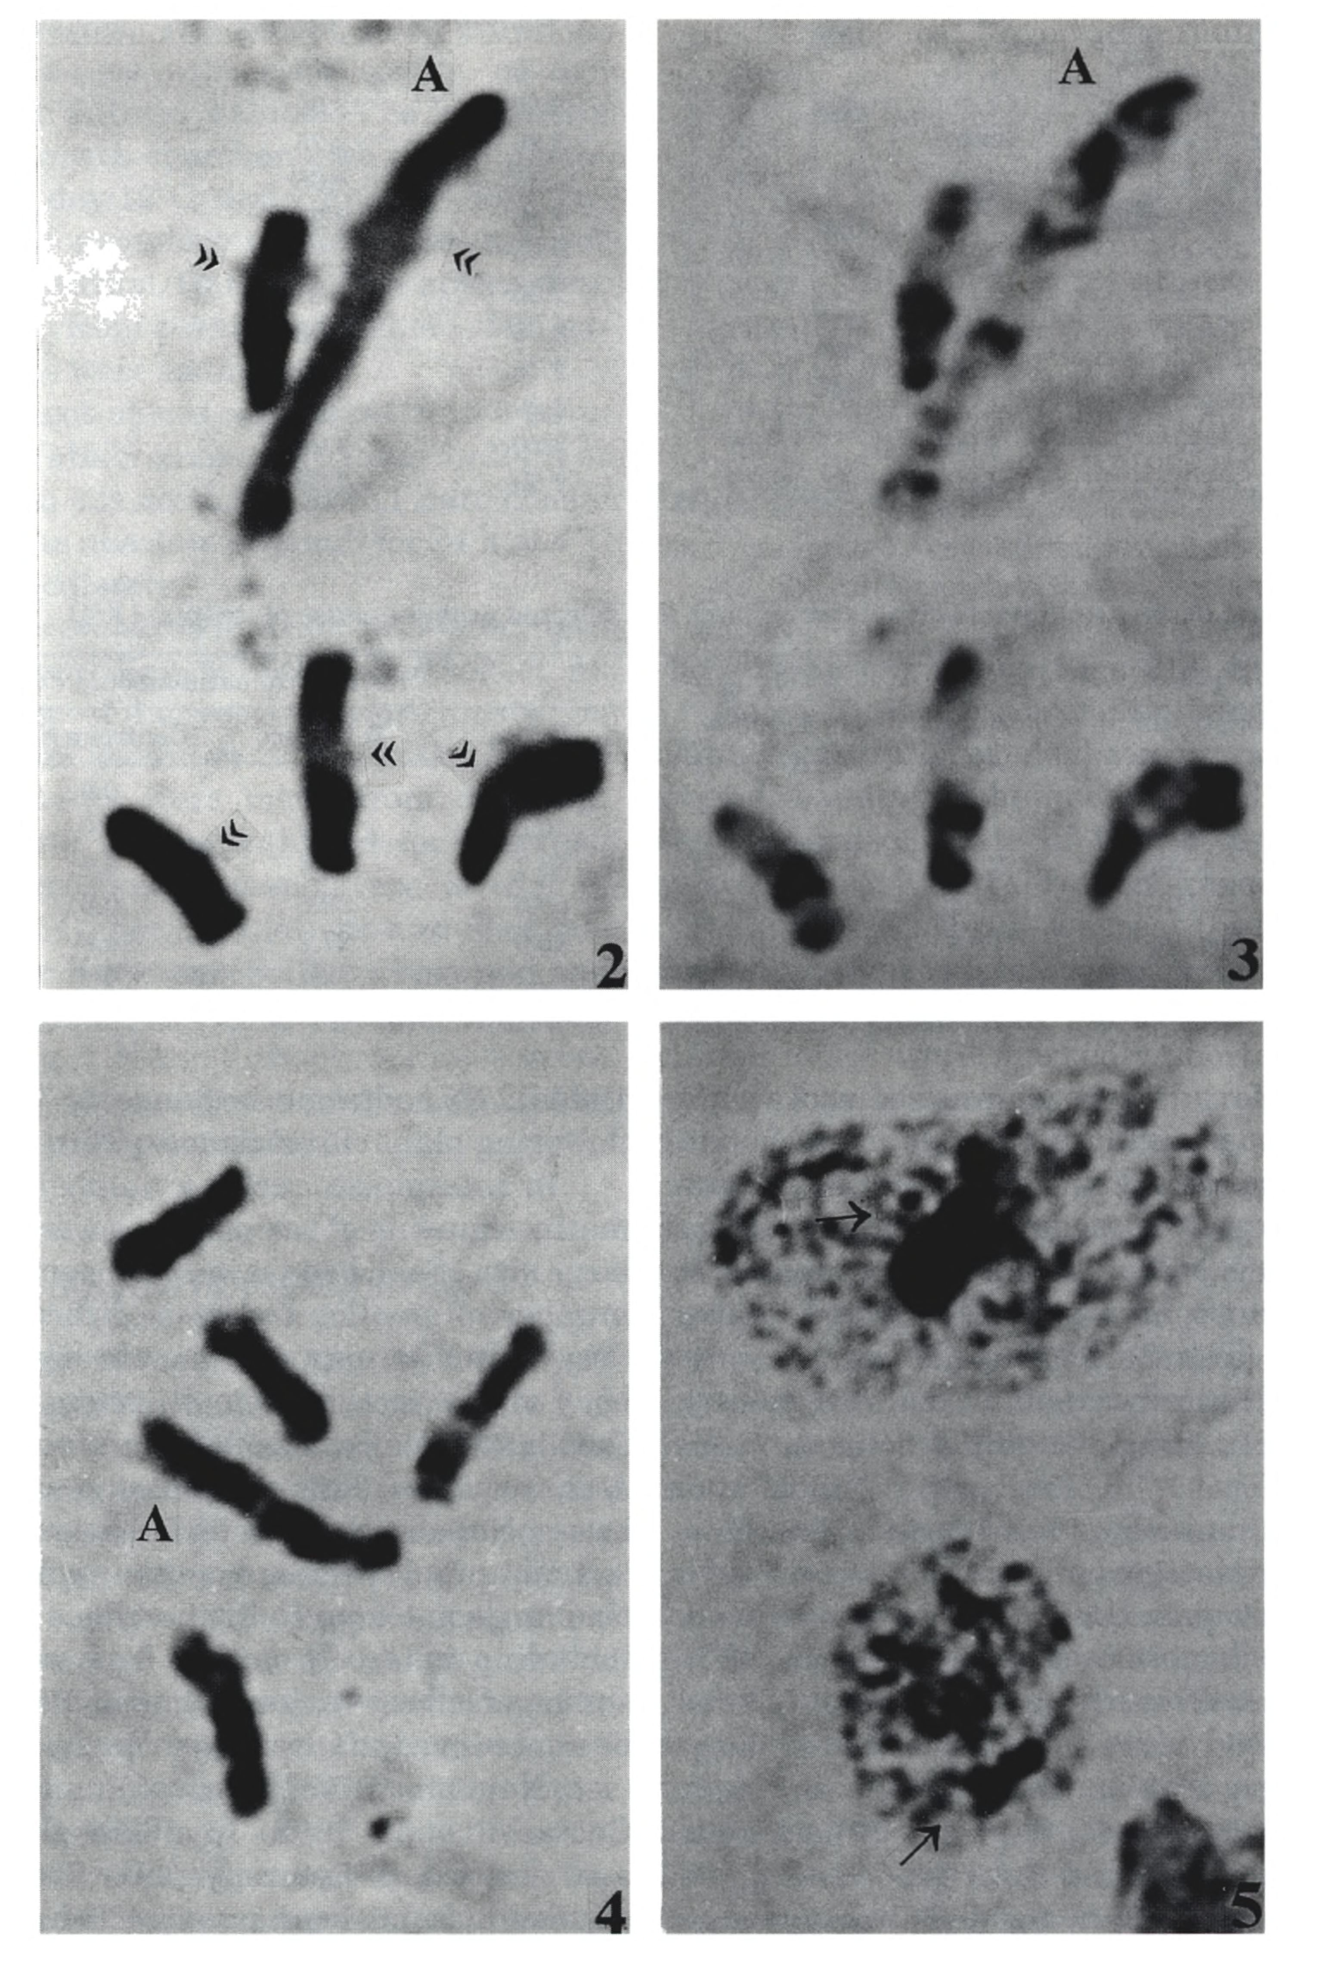
58
Kuta et al.
Figs. 2-4. С-band chromosomes of Pleurozium schreberi (n = 5). Fig. 2. Prometaphase chromosomes photographed immedi-
ately after staining; banding pattern not visible; position of centromeres indicated with double arrowheads. Fig. 3. The same
chromosomes photographed 8 weeks after staining; banding pattern clearly visible in all chromosomes. Fig. 4. Condensed
metaphase chromosomes; banding pattern slightly visible. A - largest chromosome of the complement. All figures x 4400.
Fig. 5. Interphase nuclei; large heterochromatic bodies indicated with arrows, x 4400.
Heterochromatin in Pleurozium schreberi
59
The karyotype of P. schreberi is heterochro-
matin-rich. The data indicate that the pattern of
constitutive heterochromatin distribution in chro-
mosome A approximately corresponds to Vaarama’s
results based on classically stained meiotic and mi-
totic chromosomes.
REFERENCES
Anderson LE. 1980. Cytology and reproductive biology of mosses.
In: Taylor RJ and Levi ton E [eds.J, The mosses of North
America - based on a symposium on the biology of mosses,
37-76. AAAS Pacific division, San Francisco.
Ceccarelli M, Morosi L, and Cionini PG. 1998. Chromocenter
association in plant cell nuclei: determinants, functional
significance, and evolutionary implications. Genome 41:
96-103.
Collet C, and Westerman M. 1984. Interspersed distribution
pattern of С-bands and satellite DNA in the holocentric
chromosomes of Luzula flaccida (Juncaceae). Genetica 63:
175-179.
Fritsch R. 1991. Index to bryophyte chromosome counts.
Bryophytorum Bibliotheca 40: 1-352.
Heitz E. 1928. Das Heterochromatin der Moose I. Jahrbuch fiir
wissenschaftliche Botanik 69: 762-818.
Kuta E, Przywara L, and Hejmej J. 1998. Karyotype variability
in Pleurozium schreberi. Acta Biologica Cracoviensia Series
Botanica 40: 75-84.
Levan A, Fredga K, and Sandberg AA. 1964. Nomenclature for
centromeric position on chromosomes. Hereditas 52: 201-
220.
Manicardi GC, Gautam DC, Bizzaro D, Guicclardi E, Bonvicini
Pagliai AM, and Bianchi U. 1991. Chromosome banding in
aphids: G,C,A/uI, andHaelll banding patterns inMegoura
viciae (Homoptera, Aphididae). Genome 34: 661-665.
Manicardi GC, Bizzaro D, Galli E, and Blanchi U. 1996. Hete-
rochromatin heterogeneity in the holocentric X chromatin
of Megoura viciae (Homoptera, Aphididae). Genome 39:
465-470.
Newton ME. 1977. Chromosomal relationship of heterochro-
matin bodies in a moss Dicranum tauricum Sapehin. Jour-
nal of Bryology 9: 557-564.
Newton ME. 1979. Chromosome morphology and bryophyte sys-
tematics. In: Clarke GCS and Duckett JG [eds.J, Bryophyte
systematics, 207-229. Academic Press, London.
Newton ME. 1983a. Numerical uniformity and structural vari-
ation of moss chromosomes. Journal of Bryology 12: 587-
594.
Newton ME. 1983b. Cytology of the Hepaticae and Anthocerotae.
In: Schuster RM [ed.J, New manual of bryology 1, 117-148.
Hattori Botanical Laboratory, Nichinan.
Newton ME. 1984a. Questions of procedure in moss cyto-taxo-
nomy: new data from some British species. Journal of
Bryology 13: 263-268.
Newton ME. 1984b. The cytogenetics of bryophytes. In: Dyer AF
and Duckett JG [eds.l, The experimental biology of bryo-
phytes, 65-96. Academic Press, London.
Patankar S, and Ranjekar PK. 1988. Constitutive heterochro-
matin during meiosis and mitosis in Allium сера and Rhoeo
discolor. Cytologia 53: 275-281.
Przywara L, and Kuta E. 1995. Karyology of bryophytes. Polish
Botanical Studies 9: 1-83.
Ray JH, and Venketeswaran S. 1978. Constitutive heterochro-
matin distribution in monocentric and polycentric chromo-
somes. Chromosoma 66: 341-350.
Schwarzacher T, Ambros P, and Schweizer D. 1980. Application
of Giemza banding to orchid karyotype analysis. Plant Sys-
tematics and Evolution 134: 293-297.
Smith AJ. 1978. Cytogenetics, biosystematics and evolution in
Bryophyta. Advances in Botanical Research 6: 195-276.
Tatuno S. 1941. Zytologische Untersuchungen über die Leber-
moose von Japan. Journal Sci. Hiroshima University, ser.
B. div. 2, 4: 73-187.
Vaarama A. 1954. Cytological observations on Pleurozium
schreberi, with special reference to centromere evolution.
Annales Botanical Society ‘Vanamo’ 28: 1-59.

