
ACTA BIOLOGICA CRACOVIENSIA Senes Botanica 42/1: 103-107, 2000

Stomatal Cell Length and Ploidy Level in Four Taxa
Belonging to the Phleum Sect. Phleum
Andrzej Joachimiak12* and Aleksandra GrabowskaJoachimiak2
department of Plant Cytology and Embryology, Institute of Botany, Jagiellonian University,
ul. Grodzka 52, 31-044 Cracow, Poland
2Cytogenetics Group, Department of Plant Breeding and Seed Science, Agricultural University,
i/Z. Łobzowska 24, 31-140 Cracow, Poland
Received December 13, 1999; revision accepted March 28, 2000
Stomatal cell length was examined in Tour closely related taxa of sect. Phleum in the genus Phleum (P. nodosum, P.
pratense and in two cytotypes of P. commutatum). It was found that the polyploid taxa (P. pratense, 2n = 6x = 42 and
P. commutatum, 2n = 4x = 28) have longer stomatal cells than their diploid relatives (P. nodosum, 2n = 2x = 14 and
P. commutatum, 2n = 2x = 14). In these two pairs of taxa, stomatal cell length can be a rapid and useful indirect ploidy
level indicator and can assist in their identification. Material taken from live and dried specimens of a given taxon
did not differ in stomatal cell length, meaning that different cytotypes can be identified from herbarium material as
well.
Key words: Phleum, grasses, stomata, ploidy level.

INTRODUCTION
Root tip cell chromosome counting is time-consum-
ing and not suited for routine screening of ploidy
level. For this purpose, the stomatal cell length can
be a rapid and reliable indirect ploidy indicator. The
length of stomatal guard cells is correlated with the
ploidy level in a range of natural and commercial
cytotypes/varieties of different plant species (Speck-
man et al., 1965; Przywara et al., 1988; Cohen and
Yao, 1996; Mishra, 1997).
Grasses are a particularly promising group of
plants in which stomatal features (stomatal fre-
quency, stomatal guard cell length and stomatal
index) generally can be used to determine of ploidy
level. These plants often show significant intraspe-
cific and intrageneric chromosome number vari-
ability, and rapid identification of their different
cytotypes is of great importance in taxonomy, pre-
liminary selection and breeding. For this reason the
*e-mail: joachim@grodzki.phils.uj.edu.pl
correlations between stomatal features and ploidy
level in grasses have been examined many times
(Speckman et al., 1965; Miskin and Rasmusson,
1970; Heichel, 1971; Teare et al., 1971; Liang et al.,
1975; Sapra et al., 1975; Tan and Dunn, 1973,1975;
Lea et al., 1977a,b; Santen and Casier, 1986; Borrino
and Powell, 1988). In the majority of results publish-
ed so far, guard cell length was measured manually
using an ocular micrometer on a microscope, and the
number of stomata measured per plant was small
(6-25). To rationalize this kind of study, measure-
ments should be automated at least in part, to make
it easier to obtain and compare a larger number of
measurements.
Here we attempted to determine stomatal
guard cell length in four taxa from the section
Phleum in the genus Phleum. The examined taxa (P.
nodosum, 2n = 2x = 14, P. pratense, 2n = 6x = 42, and
P. commutatum, 2n = 2x = 14,2n = 4x = 28) represent
three different ploidy levels and are closely related
PL ISSN 0001-5296
© Polish Academy of Sciences, Cracow 2000

104
Joachimiak and Grabowska-Joachimiak
TABLE 1. Provenance and chromosome number of the Phleum samples studied
Taxon
Phleum commutatum Gaud.
Phleum nodosum L.
Phleum pratense L.
Locality
11J Austria, Alps - Nationalpark Hohe Tauern
12] Sweden, Are vicinity
131 Poland, Tatra Mts.
[ 41 Sweden, Are vicinity
15J Scotland, Aonach Beag
16] Poland, Cracow vicinity
|7] Sweden, Stockholm vicinity
18J Poland, Cracow vicinity
19] Sweden, Stockholm vicinity
Chromosome
number (2n)
14 {a}
14 (a)
14 {b}
28 (a)
24 (a)
14 <b)
14 (c)
42 {b}
42 (c)
Number of
plants
5
5
5
5
5
5
5
5
5
Chromosome numbers established in: (a) - Joachimiak and Kula (1996); (b) - Joachimiak and Kula (1993); {с} - this study.
TABLE 2. Stomatal guard cell length in representatives of four Phleum taxa from different populations
P. commutatum
2n = 2x
No
111
12]
[3J
Mean:
ACL
24.5±2.4
22.5±2.3
25.3±2.4
24.112.4
P. commutatum
2n = 4x
No
15]
14]
Mean:
ACL
39.813.5
29.212.9
34.513.2
P. nodosum
2n = 2x
No
[6]
(*)
[7]
Mean:
ACL
29.013.7
- 22.112.2
25.512.9
P. pratense
2n = 6x
No
[8]
(*)
[9j
Mean:
ACL
35.913.9
36.013.7
27.112.6
31.513.4
No - population number (see Tab. 1); ACL - average stomatal guard cell length in pm; 1- standard deviation; (*)- herbarium material.
(Joachimiak and Kula, 1997). There is a lack of good
morphological features to enable differentiation of
P. nodosum (=P. bertolonii DC) from P. pratense and
between the diploid and tetraploid forms of P. com-
mutatum, frequently occurring side by side in Eu-
rope. In particular, morphological identification of
different cytotypes within the P. pratense group (P.
pratense and P. nodosum) is of great importance for
taxonomy and for practical purposes. P. pratense is
largely used as a pasture species and P. nodosum is
used as a turf grass, and both species are used in
various breeding programs in Europe and other
parts of the world. However, no morphological
characters previously studied (plant height, flag
leaf length and width, inflorescence diameter,
glume length, awn length, cilia length and num-
ber) are reliable in distinguishing different ploidy
levels (for review: Cenci et al., 1984). So far, rep-
resentatives of these taxa can be reliably identi-
fied only on the basis of differences in chromosome
number (Nordenskiold, 1945; Joachimiak and
Kula, 1993, 1996) or cytometric DNA estimations.
The amounts of 2C DNA in different races of P.
pratense and P. nodosum are well correlated with
their ploidy level (Alan Steward, personal communi-
cation).
We also checked whether stomatal length meas-
urements can be facilitated by automated computer
procedures and whether stomatal cell length can be
used to identify herbarium specimens.

MATERIALS AND METHODS
The research material consisted of fragments of
upper epidermis from fully developed leaves. For
stomatal measurements the third leaf below the
panicle was sampled from each analyzed plant. The
majority of plants had been collected from various
natural populations in Europe and transferred to an
experimental field. Two years later, leaves were cut
from them for further analysis. In the case of
P. pratense and P. nodosum, fragments of epidermis
from herbarium specimens were examined also. All
the Phleum specimens were cytologically examined
and identified (Tab. 1).
Each piece of upper epidermis was removed
with forceps from the central part of the leaf and
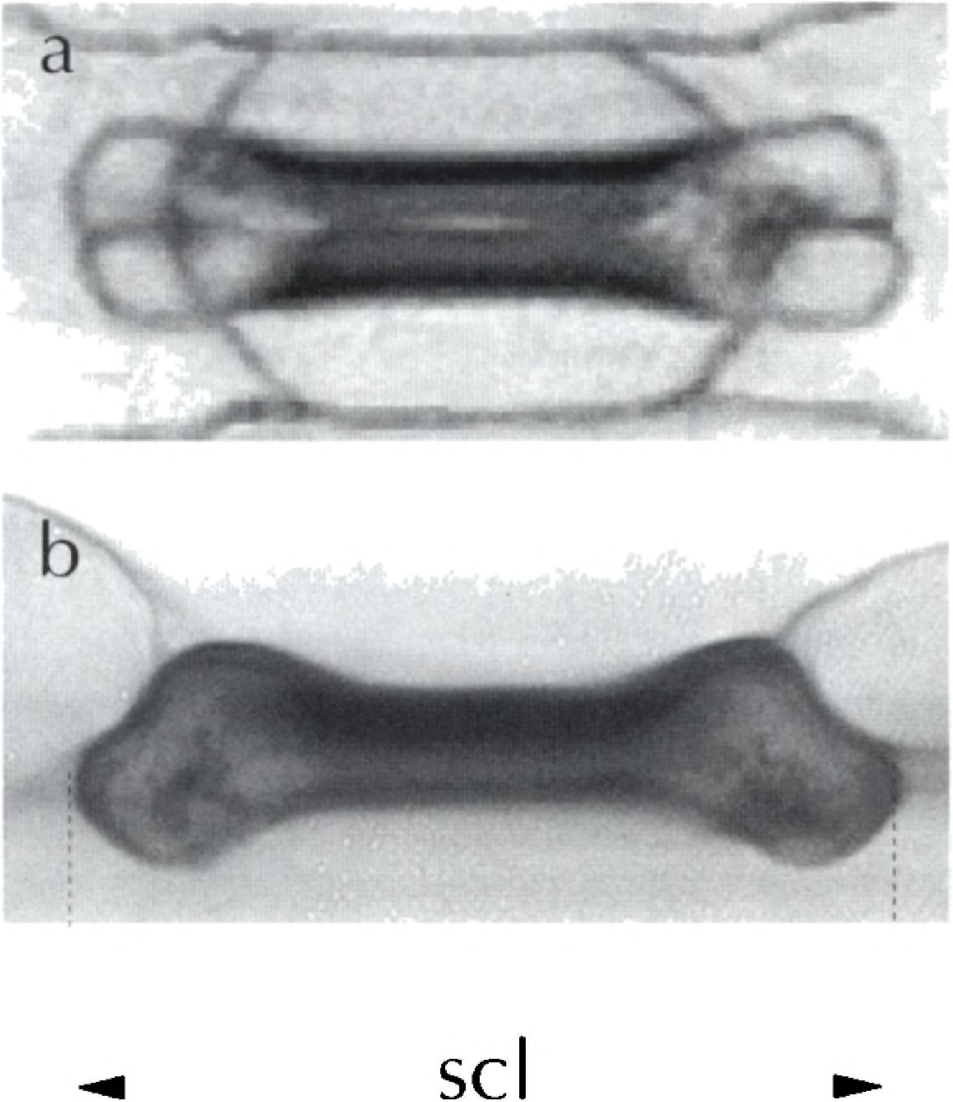
Stomatal cell length and ploidy level in Phleum
105
Fig. 1. Phleum stomatal apparatus and measurement of its
length, (a) Vertical view, (b) Lateral view, scl - stomatal
guard cell length.
placed in commercial chlorine bleach for 30 min,
then rinsed with distilled water and stored in 70%
ethanol. Leaves from herbarium specimens were
soaked in distilled water for 24 h before the epider-
mis fragments were removed. The material was
stained with a 1% solution of safranin in alcohol for
5 min, rinsed in 70% alcohol and distilled water,
counterstained with an acidic solution of alcyan blue
for 10 min, and mounted in a drop of water on a
microscope slide. The preparations were analyzed
under an Eclipse E800 microscope (Nikon Corp.,
Japan) equipped with a Panasonic video camera.
Image grabbing and stomatal guard cell length
measurements were done with Lucia G software
(Laboratory Imaging Ltd.). During the measure-
ments, special attention was paid to measure the
total length of the guard cells, together with those
parts which can be poorly visible in preparations
because of slipping under epidermal cells (Fig. 1). In
each specimen the lengths of at least 200 guard cells
were measured. By using a number of leaves for each
examined collection, at least 1000 measurements
were obtained.
RESULTS AND DISCUSSION
Each of the examined taxa showed a strictly defined
range of stomatal guard cell length variability (Tab.
2). The ranges overlap partially, thus stomatal
TABLE 3. Phleum pratense / nodosum (6x/2x) and P. commu-
tatum (2x/4x). Results of two-tailed Student’s test for mean
stomatal cell lengths. Compared means are statistically sig-
nificant if PcO.0001. AU - Austria, PL - Poland, SW -
Sweden; ** significant, (-) not significant
P. pratense/P. nodosum P• nodosum P. pratense
(6x/2x) pL sw sw
P pratense PL ** ** **
SW (-) **
P. nodosum SW **
P. commutatum |  | 4x | 2x | 2x
 | (2x/4x) | SW | AU | PL
2x | SW | ** | (-) | (-)
2x | PL | ** | (-)
2x | AU | **
length alone cannot be an absolute criterion for
taxonomic identification of particular specimens
within the section Phleum. In spite of this, measure-
ment of stomatal length can be very useful for proper
taxonomic identification of morphologically indis-
tinguishable specimens belonging to closely related
pairs of taxa (P. nodosum/ P. pratense or diploid/te-
traploid P. commutatum), because both polyploid
forms (P. pratense, 2n = 6x = 42 and P. commutatum,
2n = 4x = 28) have definitely longer stomatal cells
than their diploid relatives (P. nodosum, 2n = 2x =
14 and P. commutatum, 2n = 2x = 14) (Tabs. 2, 3).
The stomata of P. nodosum and P. pratense
originating from Sweden are generally smaller than
those of plants from other areas (Tab. 2, and unpubl.
results). The observed differences between Polish and
Swedish representatives of these taxa are statistically
significant (Tab. 3). Intraspecific differences in guard
cell length were previously observed among various
cultivars of Triticum aestivum (Teare et al., 1971)
and Bromus inermis (Tan and Dunn, 1975).
Another question is the assessment of stomatal
cell length in P. commutatum from Scotland. Speci-
mens of this taxon were obtained from seeds col-
lected from a natural population on Aonach Beag,
received from the Royal Botanic Gardens, Kew Seed
Bank, England. In previous research (Joachimiak
and Kula, 1996) it was stated that plants grown from
these seeds were hypotetraploid with somatic chro-
mosome number 2n = 24. The mean length of their
stomata was about 10 pm more (mean = 39.8 pm)
than in Swedish representatives of this tetraploid
taxon (mean = 29.2 pm). Such a difference can sug-
gest the possible influence of aneuploid changes on
the stomatal cell length, but may well be that the
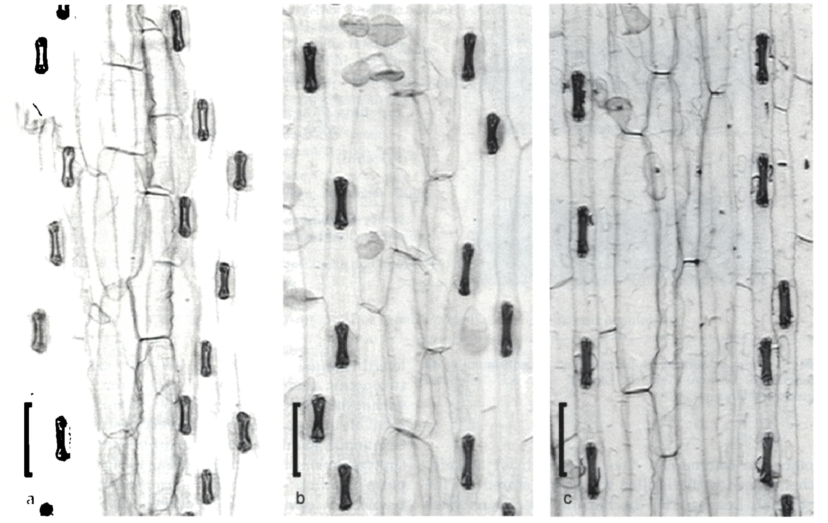
106
Joachimiak and Grabów ska-Joachimiak
Fig. 2. Stomatal length and distribution in leaf epidermis of Polish material 16, 81. (a) P. nodosum, (b, c) P. pratense. a, b -
from living specimens, с - from herbarium specimens. [J - origin of Phleum samples (see Table 1). Bar = 50 pm.
P. commutatum from that area is of different origin
and is a separate taxon within the P. alpinum group
(in which the diploid and tetraploid P. commutatum
as well as P. alpinum subsp. rhaeticum are in-
cluded). It is even more probable because previous
authors have suggested different (auto- or allopoly-
ploid) origins of the tetraploid races of P. commuta-
tum from different areas (Gregor and Sansome,
1930; Mlintzing, 1935; Nordenskióld, 1945; for re-
view: Joachimiak and Kula, 1993, 1996).
The adopted procedure yielded epidermis frag-
ments and stained stomata from both live and dried
specimens. Neither stomata morphology nor stoma-
ta staining ability underwent significant changes
due to storage in a herbarium. The mean stomatal
guard cell length and the range of their variability
were very similar between the two types of speci-
mens (Tab. 2; Fig. 2b,c). This way of identifying
cytotypes in herbarium material provides an extra
tool in taxonomic research.
These results indicate that stomata length
measurements can be useful not only for diploid
and polyploid conspecifics (P. commutatum) but
also for species with different ploidy level if they
are very closely related to each other (Fig. 2a,b).
This was the case of P. nodosum and P. pratense,
which are considered two separate species, how-
ever closely related. Previous studies found at
least four genomes of P. nodosum in the karyotype
of the hexaploid P. pratense (Joachimiak and Kula,
1993; Cai and Bullen, 1994). Measurements of
stomatal guard cell length are especially useful for
identifying different cytotypes of plants growing
in mixed populations or in geographically near
localities (Tabs. 2, 3).
ACKNOWLEDGEMENTS
The authors wish to thank Joanna Kłos (Agricultu-
ral University, Cracow) for technical assistance, and
Dr. Alan Steward (Pyne Gould Guiness Ltd, Christ-
church, New Zealand) for information about his
results on DNA estimations in Phleum.
Stomatal cell length and ploidy level in Phleum
107

REFERENCES
Borrino EM, and Powell W. 1988. Stomatal guard cell length as
an indicator of ploidy in microspore-derived plants of barley.
Genome 30: 158-160.
Caj Q, and Bullen MR. 1994. Analysis of genome-specific sequences
in Phleum species: identification and use for study of genomic
relationships. Theoretical and Applied Genetics 88: 831-837.
Cenci CA, Peglati MT, and Falistocco E. 1984. Phleum pratense
(Gramineae): chromosomal and biometrical analysis of Ita-
lian populations. Willdenowia 14: 343-353.
Cohen D, and Yao J-L. 1996. In vitro chromosome doubling of
nine Zantedeschia cultivars. Plant Cell Tissue and Organ
Culture 47: 43-49.
Gregor JW, and Sansome F. 1930. Experiments on the genetics
of wild populations. II. Phleum pratense L. and the hybrid
P. pratense x P. alpinum L. Journal of Genetics 22: 373-387.
HeichelGH. 1971. Genetic control of epidermal cell and stomatal
frequency in maize. Crop Science 11: 830-832.
Joachimiak A, and Kula A. 1993. Cytotaxonomy and karyotype
evolution in Phleum sect. Phleum (Poaceae) in Poland. Plant
Systematics and Evolution 188: 17-30.
Joachimiak A. and Kula A. 1996. Karyosystematics of the Phleum
alpinum polyploid complex (Poaceae). Plant Systematics
and Evolution 203: 11-25.
Joachimiak A, and Kula A. 1997. Systematics and karyology of
section Phleum in the genus Phleum. Journal of Applied
Genetics 38: 463-470.
Lea HZ, Dunn GM, and Koch DW. 1977a. Stomatal diffusion
resistance in three ploidy levels of smooth bromegrass. Crop
Science 17: 91-93.
Lea HZ, Dunn GM, and Koch DW. 1977b. Stomatal indexes in
three ploidy levels of Bromus inermis Leyss. Crop Science
17: 669-670.
Liang GH, Dayton AD, Сни CC, and Casady AJ. 1975. Herita-
bility of stomatal density and distribution on leaves of grain
sorghum. Crop Science 15: 567-570.
Mishra MK. 1997. Stomatal characteristics at different ploidy
levels in Coffea L. Annals of Botany 80: 689-692.
Miskin KE, and Rasmusson DC. 1970. Frequency and distribu-
tion of stomata in barley. Crop Science 10: 575-578.
Muntzing A. 1935. Cytogenetic studies on hybrids between two
Phleum species. Hereditas 20: 103-136.
Nordenskióld H. 1945. Cytogenetic studies in the genus Phleum.
Acta Agriculturae Suecana 1: 1-137.
Przywara L, Pandey KK, and Sanders PM. 1988. Length of
stomata as an indicator of ploidy level in Actinidia deliciosa.
New Zealand Journal of Botany 26: 179-182.
Santen Van E, and Casler MD. 1986. Evaluation of indirect
ploidy indicators in Dactylis L. subspecies. Crop Science 26:
848-852.
Sapra VT, Hughes JL, and Sharma GC. 1975. Frequency, size,
and distribution of stomata in Triticale leaves. Crop Science
15: 356-358.
Speckman GJ, Post J, and Dijkstra H. 1965. The length of
stomata as an indicator for polyploidy in rye-grasses. Eu-
phytica 14: 225-230.
Tan G-Y, and Dunn GM. 1973. Relationship of stomatal length
and frequency and pollen-grain diameter to ploidy level in
Bromus inermis Leyss. Crop Science 13: 332-334.
Tan G-Y, and Dunn GM. 1975. Stomatal length, frequency, and
distribution in Bromus inermis Leyss. Crop Science 15:
283-286.
Teare ID, Peterson CJ, and Law AG. 1971. Size and frequency
of leaf stomata in cultivars of Triticum aestivum and other
Triticum species. Crop Science 11: 496-498.

