CHAPTER 9.B

Structure of selected fragments of Ab(1e42) in complex with other proteins
Mateusz Banach1, Irena Roterman1
1Department of Bioinformatics and Telemedicine, Jagiellonian UniversityeMedical College, Krakow, Poland

Contents
Non-amyloid conformations of Ab(1e42) fragments 158
Ab(17e27) and Ab(16e28) in complex with lipocain 159
Ab(16e40) in complex with phage-display selected afﬁbody protein Z(Ab3) 160
Ab(1e40) in complex with polyphenol ε-viniferin glucoside (EVG) 163
Ab(1e21) in complex with the JEF ligand 167
Ab(18e41) fragment inserted as the antigen receptor variable domain in shark immunoglobulin
168
Discussion and conclusions 170
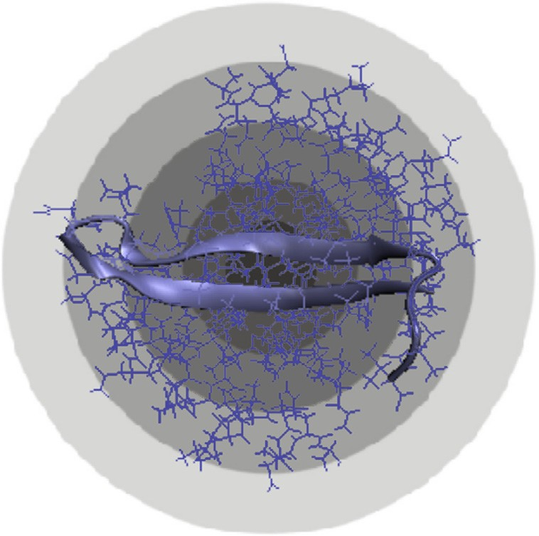
References 171

From Globular Proteins to Amyloids
ISBN: 978-0-08-102981-7 https://doi.org/10.1016/B978-0-08-102981-7.00014-2

© 2020 Elsevier Ltd.
All rights reserved. 157
j
158 Mateusz Banach and Irena Roterman

Visualization of the stable structure of Ab(16e40) conditioned by a permanent chaperone (external protein)
In our search for ways to prevent the generation of amyloid ﬁbrils we have identiﬁed various chemical factors, including ligands and scaffold mol- ecules, capable of binding individual fragments of the Ab(1e42) polypeptide (see chapter 9A).
Techniques discussed in this chapter include complexation of external proteins [1,2], inserting fragments of amyloid proteins into other proteins e in particular the V domain of the IgG light chain [3] and complexation with ligands [4,5]. According to the authors’ intentions, all these factors should result in the base polypeptide adopting conformations which do not produce amyloid ﬁbrils. Analysis of such “arrested” peptides is based on the fuzzy oil drop model, where we compare the structure of the observed hydrophobic core with the corresponding theoretical distribution of hydrophobicity in an ideal protein.
The model is not always applicable e for instance, it fails to produce correct results for very short polypeptides which do not have a tertiary conformation. Nevertheless, it enables us to carry out comparative analysis by facilitating quantitative description of diverse structural forms. As a result, we may identify structural properties which promote amyloidogenesis.

Non-amyloid conformations of Ab(1e42) fragments
This chapter discusses different fragments of the Ab(1e42) peptide which e when complexed with other proteins e do not adopt amyloid- like conformations. Such external proteins (or other stabilizing factors) effec- tively act as “permanent chaperones”, since in their absence the Ab(1e42) chain may instead produce an amyloid-like form. The deﬁnition of a chap- erone highlights its role in preventing the accompanying polypeptide from misfolding. Chaperones perform their function by temporarily disallowing speciﬁc structural rearrangements. The concept of a “permanent chaperone” builds upon this deﬁnition by removing temporal restrictions and assuming that the chaperone must be present at all times, as long as the protein performs its function. This property characterizes all structures discussed in this chapter.
The following proteins are discussed below:
- Ab(17e27) (PDB ID: 4MVL) e “packaged” with lipocain [1].
- Ab(16e28) (PDB ID: 4MVI) e in complex with lipocain [1].
- Ab(16e40) (2OTK) e “packaged” with a synthetic protein [2].
Structure of selected fragments of Ab(1e42) in complex with other proteins 159

- Ab(16e28) (PDB ID: 2M9R and 2M9S) e in complex with the Y23 ligand (2s,3s)-3-(3,5-Dihydroxyphenyl)-2-(4-Hydroxyphenyl)-4- [(E)-2-(4- Hydroxyphenyl)ethenyl]-2,3-Dihydro-1- Benzofuran-6-Yl beta-D-Glucopyra- noside [Polyphenol epsilon-Viniferin glucoside], also referred to as polyphenol ε-viniferin glucoside (EVG) [3].
- Ab(1e21) (PDB ID: 5HOX) e in complex with the JEF ligand e O-(O- (2-Aminopropyl)-O’-(2-Methoxyethyl)polypropylene glycol 500) [Jeffamine] [4]
- Ab(18e41) (PDB ID: 3MOQ) e fragment incorporated into the IgG V domain (hypervariable loop at 88e111 e position in V domain chain) [5].

Ab(17e27) and Ab(16e28) in complex with lipocain
Lipocain, a versatile protein, has been used to bind fragments (17e27) and (16e28) of the Ab(1e42) polypeptide, rendering it soluble. It is ex- pected that such fragments may appear at early stages of degradation of large integral membrane proteins, potentially leading to formation of amyloid ﬁ- brils. b-secretase and g-secretase activity results in production of lipophilic Ab peptides with a total length of 42 or 40 residues (fragments at 672e711/713). The authors hypothesize that the resulting peptides may be “arrested” using lipocain.
Our analysis concerns two complexes, involving Ab(17e27) and Ab(18e28) respectively (Fig. 9.B.1). Chain A is contributed by lipocain, while chain B represents the target peptide (13 aa e 4MVI and 11 aa e 4MVL) [1]. Table 9.B.1 illustrates FOD parameters for the entire complex

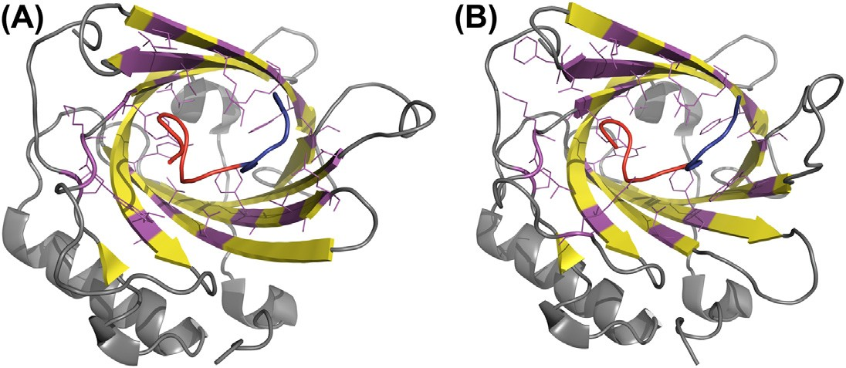
Fig.9.B.1 3D presentation of 4MVI and 4MLV complexes. (A) 4MVI chain A in complex with Ab(16e28) peptide (chain B). (B) 4MVL chain A in complex with Ab(17e27) peptide (chain E).Fragments 16e22 in Ab(16e28) and 17e22 in Ab(17e27) are shown in red. Fragments 22e28 in Ab(16e28) and 22e27 in Ab(17e27) are shown in blue. Residues in chain A in each protein engaged in protein-protein interactions with Ab fragments are magenta-colored and have side chains displayed.
160 Mateusz Banach and Irena Roterman

Table 9.B.1 Fuzzy oil drop parameters for 4MVI (with Ab(16e28) peptide) and 4MVL (with Ab(17e27) peptide. Asterisks mark the absence of Val18, causing a discordance. Values given in bold distinguish the status of discordance in respect to idealized hydrophobicity distribution.

PDB ID Fragment
RD Correlation coefﬁcient T-O-R T-O-H HvT TvO HvO
4MVI Complex A B 0.337 0.291 0.440 0.700 0.765
þ
Chain A 0.300 0.256 0.477 0.762 0.761
Chain B 0.419 0.385 0.239 0.453 0.886
4MVI
Chain B
Ab(16e28) 0.372 0.256 0.617 0.667 0.873
16-22 0.275 0.275 0.660 0.603 0.883
22e28 0.227 0.227 0.869 0.886 0.933
4MVL Complex A E 0.319 0.290 0.449 0.709 0.747
þ
Chain E 0.482 0.400 e0.160 0.333 0.714
Chain A 0.277 0.254 0.487 0.777 0.757
4MVL
Chain E
Ab (17e27) 0.446 0.400 0.173 0.513 0.705
17e22 0.595 0.405 e0.013 0.104 0.615
22e28 0.236 0.270 0.630 0.893 0.859
22e28* 0.306 0.135 0.195 0.837 0.612

(lipocain peptide), for the peptide analyzed as part of the complex, and for the standalone peptide.
þ
As listed in Table 9.B.1, the complex as a whole exhibits low RD (Fig. 9.B.2). The Ab chain, analyzed as a standalone unit (with a custom Gaussian capsule), is also accordant with the theoretical distribution (Fig. 9.B.3). Further analysis reveals, however, that the status of individual fragments varies. In the case of Ab(17e27) the 17e22 fragment has amyloid-like properties: relatively high RD, low HvT and TvO, and high HvO.

Ab(16e40) in complex with phage-display selected afﬁbody protein Z(Ab3)
We will now focus on the structure of Ab(16e40) in complex with phage-display selected afﬁbody protein Z(Ab3) e engineered binding pro- tein. The structure is listed in PDB as 2OTK [2].
Protein Z consists of two chains, 43 aa each, and acts as a packaging for the centrally placed Ab(1e40) peptide. The peptide itself becomes a b-hairpin “arrested” between two mainly alpha up-down bundles (CATH code: 1.20.5.420), as deﬁned in Ref. [6]. Both Z chains are listed as 14e56 fragments, linked with a disulﬁde bond (Cys28).
Structure of selected fragments of Ab(1e42) in complex with other proteins 161

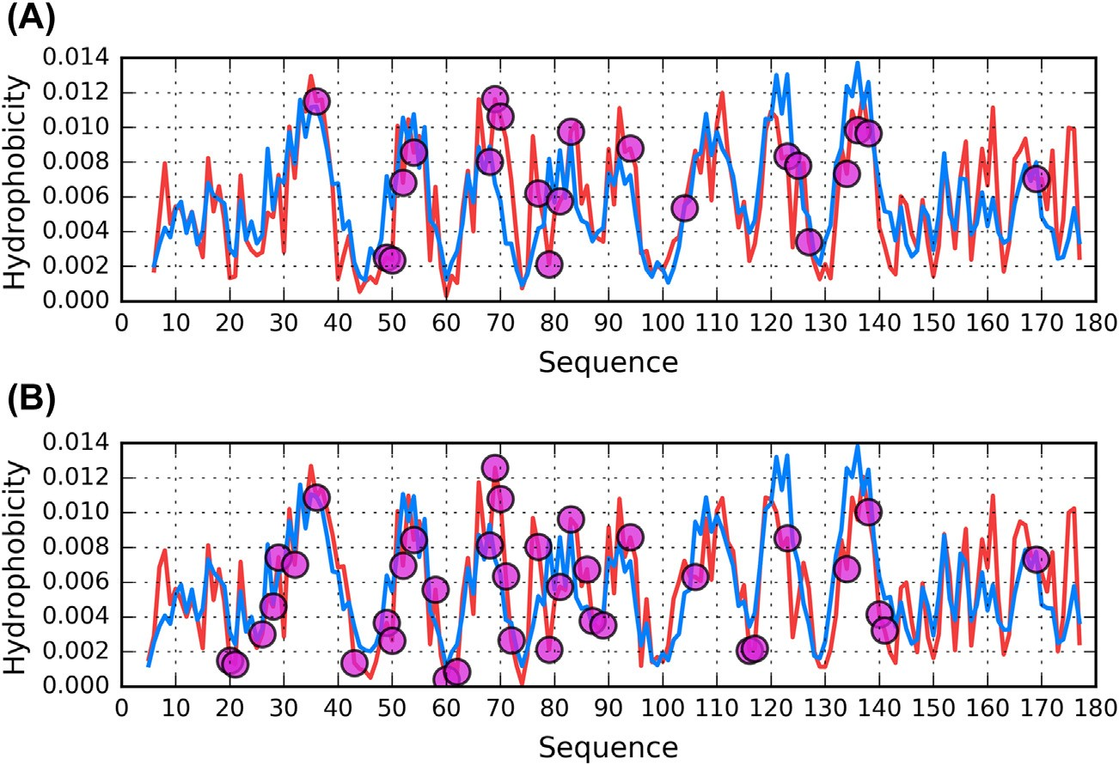
Fig. 9.B.2 Theoretical (T, blue) and observed (O, red) hydrophobicity distribution pro- ﬁles for chains A of 4MVI and 4MVL analyzed as a part of complex with Ab(1e42) pep- tides. (A) 4MVI. (B) 4MVL. Magenta circles denote residues engaged in protein-peptide interactions.

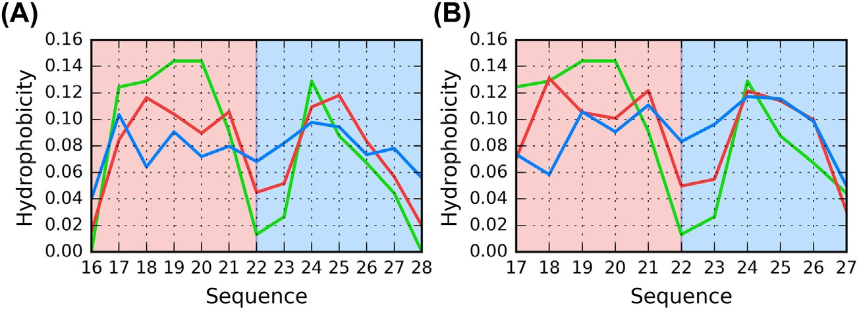
Fig. 9.B.3 Theoretical (T, blue), observed (O, red) and intrinsic (H, green) hydrophobic- ity distribution proﬁles for Ab(1e42) peptides from 4MVI and 4MVL analyzed as individ- ual units. (A) Ab(16e28) e chain B (B) Ab(17e27) e chain E. Colored background denotes fragments which correspond to the building blocks of Ab(1e42) amyloid struc- tures: 16/17e22 e red, 22e27/28 e blue.
162 Mateusz Banach and Irena Roterman

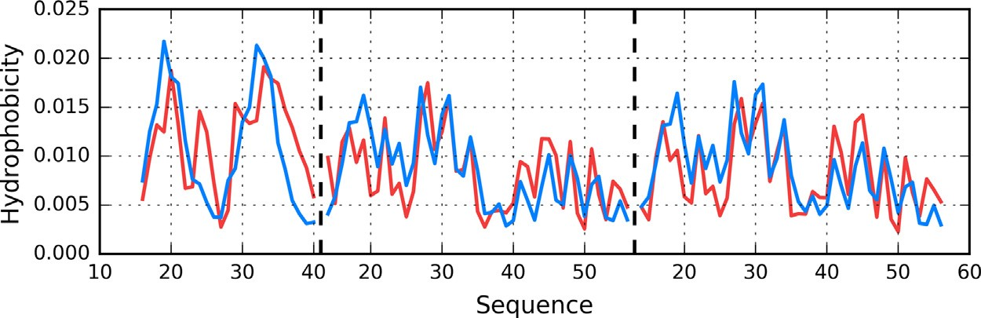
Fig. 9.B.4 Theoretical (T, blue) and observed (O, red) hydrophobicity distribution pro- ﬁles for 2OTK complex. Dashed vertical lines mark boundaries between the chains (from left to right: C, E, F). Chain C represents the Ab(16e40) peptide. Protein-protein contacts are not shown here due to the fact that nearly all residues from chain C interact with the other two chains.

Chains E and F belong to protein Z, while chain C is the Ab(16e40) peptide.
Fig. 9.B.4 illustrates the theoretical and observed hydrophobicity distri- bution in the Z(Abeta3) complex. Note the similarities between protein Z chains (E and F) and the differing C chain.
Table 9.B.2 provides quantitative data e speciﬁcally, RD parameters and correlation coefﬁcients for all presented structures.

Table 9.B.2 Fuzzy oil drop parameters for 2OTK. Chain C corresponds to Ab(16e40). Values listed in boldface mark deviations from theoretical predictions in favor of amyloid-like conditions.

PDB ID Fragment
RD Correlation coefﬁcient T-O-R T-O-H HvT TvO HvO
2OTK Complex E F C 0.407 0.328 0.558 0.702 0.803
þ þ
Complex E F 0.370 0.335 0.622 0.728 0.864
þ
Chain E 0.391 0.340 0.603 0.880 0.709
Chain C In complex 0.660 0.319 0.397 0.613 0.650
16-22 0.241 0.049 0.804 0.776 0.824
22e28 0.578 0.262 e0.394 0.055 0.836
28e40 0.700 0.572 0.171 0.720 -0.173
28e32 0.522 0.163 0.808 0.456 0.816
32e40 0.675 0.583 0.140 0.764 -0.130
Chain C Individual 0.591 0.290 0.279 0.493 0.602
16e22 0.694 0.177 0.164 0.346 0.884
22e28 0.613 0.356 e0.305 e0.018 0.866
28e40 0.571 0.237 0.220 0.658 0.260
Structure of selected fragments of Ab(1e42) in complex with other proteins 163

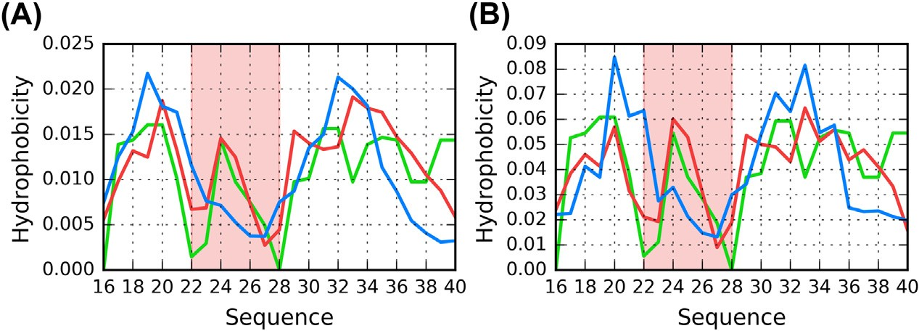
Fig. 9.B.5 Theoretical (T, blue), observed (O, red) and intrinsic (H, green) hydrophobic- ity distribution proﬁles for chain C of 2OTK corresponding to Ab(16e40). (A) as a component of the Z complex. (B) as a standalone unit. The 22-28 fragment is high- lighted as a potential amyloid seed due to its strong discordance.

Values listed in Table 9.B.2 suggest that the complex as a whole contains an ordered hydrophobic core, as evidenced by low RD and balanced corre- lation coefﬁcients. The same is true for chains E and F, which “package” chain C.
Regarding chain C itself (Fig. 9.B.5), it deviates from the theoretical dis- tribution both as a component of the protein complex and as a standalone structure. In attempting to identify the causes of this discordance we have computed RD parameters and correlation coefﬁcients for fragments of the Ab(16e40) chain which meet the amyloid seed criteria. These values, listed in Table 9.B.2, indicate that the fragment at 23e28 may be characterized as amyloid-like, with high RD(T-O-R), high HvO and very low HvT and TvO, even dipping into the negative territory. All these properties are consistent with an amyloid seed [7,8].
While the C chain as a whole is aligned with the structure of the Z com- plex, the 22e28 fragment retains its peculiar amyloid-like properties, similar to those observed in the Ab(16e40) amyloid. Its exposed location within the complex is highlighted in Fig. 9.B.6.

Ab(1e40) in complex with polyphenol ε-viniferin glucoside (EVG)
PDB lists two forms of Ab(1e40) in complex with polyphenol ε-vin- iferin glucoside (EVG), differing with respect to the interaction site (i.e. the residues which engage the ligand): 2M9R and 2M9S [3].
164 Mateusz Banach and Irena Roterman

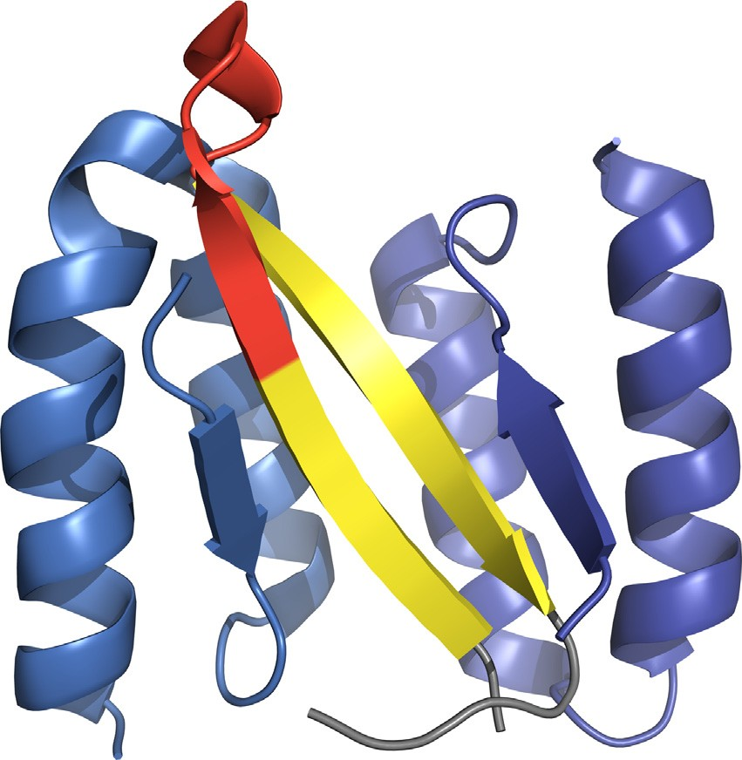
Fig. 9.B.6 3D presentation of 2OTK complex of three chains: E (blue), F (marine) and C e the Ab(16e40) peptide (gray/yellow). Red color marks the 22e28 fragment of this chain. Protein-protein contacts are not shown here due to the fact that nearly all residues from chain C interact with the other two chains.

Table 9.B.3 provides a quantitative summary of both forms. In each case RD remains very high as a result of the random-coil conformation adopted by the chain. Interpretation of the remaining parameters is essentially out of scope of the fuzzy oil drop model, since no tertiary structure can be observed. As already suggested, the model is invoked here only to provide a common platform for comparative structural analysis.

Table 9.B.3 Fuzzy oil drop parameters for 2M9R and 2M9S. The residue numbers given in bold distinguish those of amyloid character in amyloid ﬁbrils (Chapter 10).
RD Correlation coefﬁcient
PDB ID | Fragment | T-O-R | T-O-H |  | HvT | TvO | HvO
2M9R |  | 0.852 | 0.857 |  | 0.050 | e0.051 | 0.630
 | 16e22 | 0.447 | 0.284 |  | 0.463 | 0.410 | 0.895
 | 22-28 | 0.490 | 0.146 |  | 0.490 | 0.405 | 0.762
 | 29-40 | 0.968 | 0.913 |  | 0.130 | e0.046 | e0.398
2M9S |  | 0.789 | 0.769 |  | e0.022 | e0.071 | e0.632
 | 16-22 | 0.455 | 0.544 |  | 0.545 | 0.537 | 0.952
 | 22-28 | 0.366 | 0.218 |  | 0.521 | 0.717 | 0.835
 | 29-40 | 0.966 | 0.884 |  | 0.080 | e0.406 | e0.391

Structure of selected fragments of Ab(1e42) in complex with other proteins 165

It is difﬁcult to directly interpret the values listed in Table 9.B.3 due to the lack of a tertiary conformation; nevertheless, we may conclude that this protein does not appear to contain any hydrophobic core, and that it also does not produce an amyloid-like structure.
While the theoretical distribution of hydrophobicity is expected to contain one global maximum, multiple local maxima are observed instead (Fig. 9.B.7). This replacement of a large maximum with several smaller ones is a characteristic property of the Ab(1e40) polypeptide, and is caused by the Lys residue at position 22, where high hydrophobicity is expected. A local maximum exists between residues 22 and 28. Fragments listed in bold- face in Table 9.B.3 are highly discordant in amyloid conformations of Ab(1e40) e however, they do not reveal strong discordance in either 2M9R or 2M9S.
Ligands play a crucial role in the analyzed polypeptides. The EVG mole- cule is strongly hydrophobic, and may act as a “substitute” hydrophobic core for the polypeptide chain. Such quasi-cores, contributed by ligands (rather than by the aqueous environment), may have a profound impact on the conformations of polypeptide chains, as evidenced by RD values for both ligand-binding and non-ligand-binding residues. As a result of the presence of EVG, the molecule becomes soluble. This suggests a possible design strat- egy for anti-ﬁbril drugs.
The presence of relatively high hydrophobicity in the unstructured (loose) C-terminal fragment is intriguing.

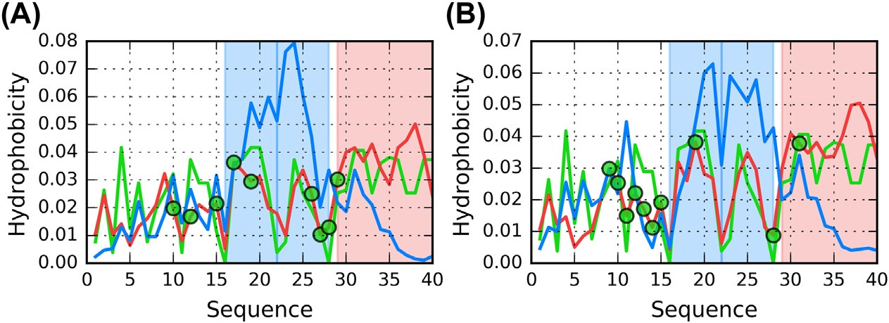
Fig. 9.B.7 Theoretical (T, blue), observed (O, red) and intrinsic (H, green) hydrophobic- ity distribution proﬁles for Ab(1e40) complexes 2M9R and 2M9S. (A) 2M9R. (B) 2M9S. Blue background marks fragments 16-22 and 22-28 which are identiﬁed as amyloid seed in amyloid ﬁbrils generated by Ab(1-42) amyloid (Chapter 10A). Green circles denote resodies engaged in protein-ligand interaction.
166 Mateusz Banach and Irena Roterman

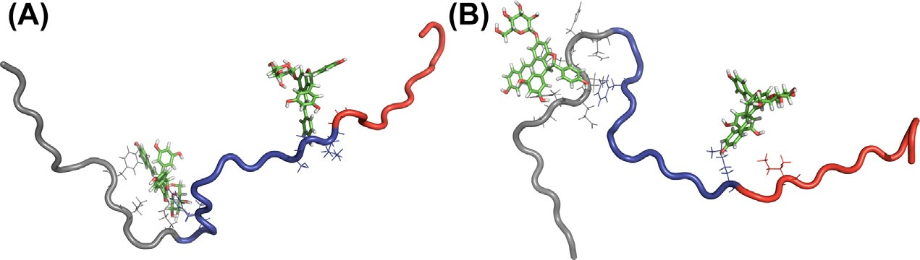
Fig. 9.B.8 3D presentation of 2M9R and 2M9S Ab(1e40) complexes with EVG ligand.
(A) 2M9R. (B) 2M9S. Fragments 16-22 and 22-28 which are treated as amyloid seeds (Chapter 10A) are given in red Residues engaged in ligand complexation are given in form of side-chains displayed.

The role of polyphenol ε-viniferin glucoside (EVG) as a permanent chaperone involves interaction with the central part of the chain (Fig. 9.B.8), producing a conformation which prevents the protein from aggregating into long amyloid-like ﬁbrils.
In summary, it should be underscored that the presence of ligand is essential in preventing certain structural forms of Ab(1e40) from amyloid transformation. The Lys residue at position 22 introduces structural disor- der, which makes it difﬁcult to generate a centralized hydrophobic core. This explains the presence of two local hydrophobicity maxima instead of a single global maximum. Engagement of fragments located on either site of the Lys residue prevents linear propagation, which would otherwise be possible. Thus, the ligand exerts a profound inﬂuence on the conforma- tion of the presented chains. In line with the hypothesis formulated in Ref. [3], EVG appears to play the role of a protector against amyloid formation.
The presented analysis may be criticized as inadequate given that the sample polypeptides are incapable of producing globular structures (which is a prerequisite of applicability of the fuzzy oil drop model). Applicability of fuzzy oil drop model to molecules which do not generate the tertiary structure is not reasonable. This analysis was performed anyway to make the analysis of polypeptides discussed in this chapter complete. This example can be taken as the example to complete wide spectrum of different struc- tural forms treated as targets for fuzzy oil drop model. However, we have decided to include them in order to broaden our study of the various forms adopted by the Ab(1e40) polypeptide. In particular, comparing amyloid- like and non-amyloid-like structures which share identical sequences is of great theoretical interest. The applied model enables assessment of arbitrary
Structure of selected fragments of Ab(1e42) in complex with other proteins 167

molecules with regard to their hydrophobicity distribution e a factor strongly implicated in amyloidogenesis [7,8].

Ab(1e21) in complex with the JEF ligand
The PDB ﬁle with ID 5HOX lists the Ab(1e21) chain in a hexamer (six b-hairpins) complex with the JEF ligand e O-(O-(2-Aminopropyl)-O’- (2-Methoxyethyl)polypropylene glycol 500) [Jeffamine] (C30H63NO10) [4]. All hairpins have the same sequence and share a similar structure. The ligand is centrally located, which suggests its role in coordinating the complex.
Table 9.B.4, (Figs. 9.B.9 and 9.B.10) characterizes the whole peptide as well as selected structural folds comprising the b-hairpin. The fragment at 2e10 exhibits strong amyloid-like properties (Fig. 9.B.9). To enable

Table 9.B.4 Fuzzy oil drop parameters for chain A of 2OTK. Values listed in boldface deviate from theoretical predictions in favor of amyloid-like conditions. The underlined fragment is regarded as weakly amyloid-like.
 |  |  | RD |  |  | Correlation coefﬁcient
PDB ID | Fragment | T-O-R |  | T-O-H |  | HvT TvO HvO
5HOX | 1-21 | 0.554 |  | 0.216 |  | 0.204 0.603 0.767
 | 2-10 | 0.803 |  | 0.545 |  | e0.455 e0.252 0.762
 | 13-21 | 0.484 |  | 0.116 |  | 0.221 0.796 0.657
 | (2e10) D (13e21) | 0.677 |  | 0.282 |  | e0.092 0.390 0.697
 | 16-21 | 0.655 |  | 0.580 |  | e0.167 0.896 0.131

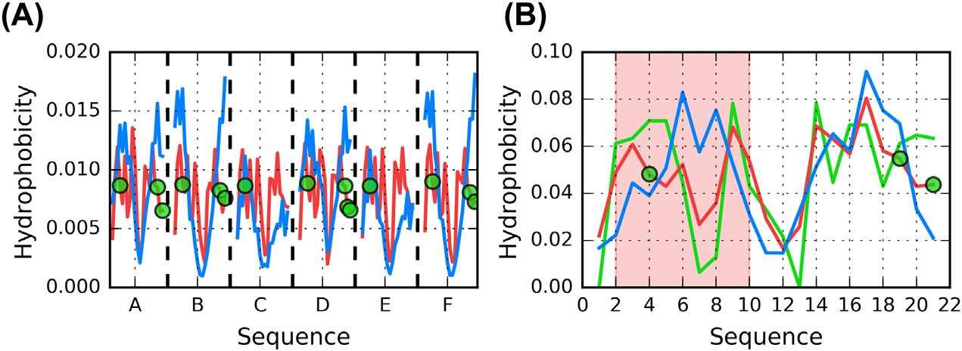
Fig. 9.B.9 Theoretical (T, blue), observed (O, red) and intrinsic (H, green) hydrophobic- ity distribution proﬁles for 5HOX. (A) for every chain as a part of the complex. (B) for chain A as individual unit. Red background distinguishes fragment at 2e10 with strong amyloid-like properties. Green circles denote residues engaged in protein-ligand interactions.
168 Mateusz Banach and Irena Roterman

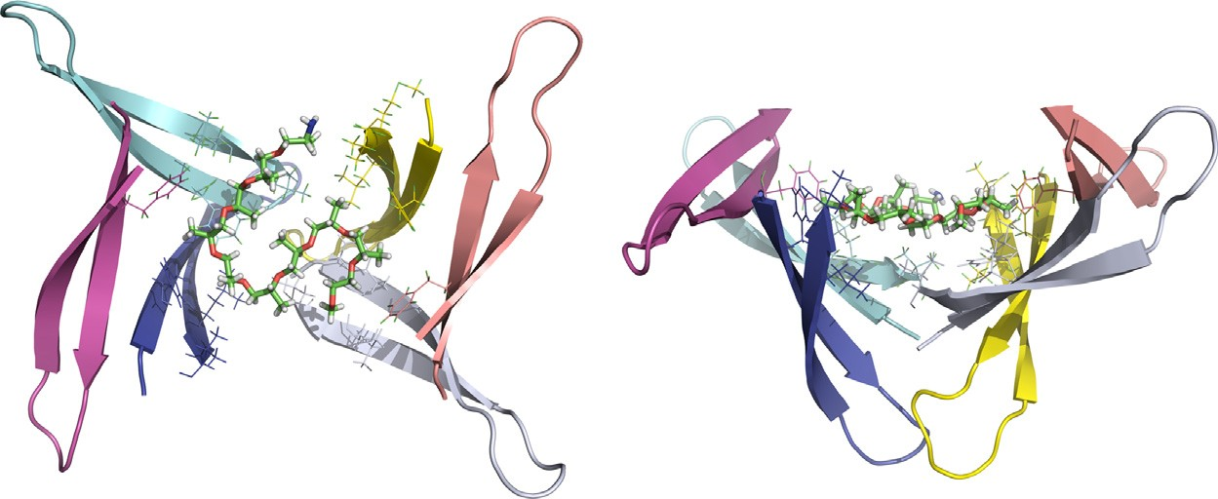
Fig. 9.B.10 3D presentation of 5HOX hexamer from two angles, revealing the crucial role of the JEF ligand in coordinating the b-hairpin complex. Each chain is presented in different color. Residues engaged in protein-ligand interactions have side chains displayed.

comparisons with other peptides and amyloids, we also distinguish the frag- ment at 16e21, which may be described as weakly amyloid-like.
The deviation identiﬁed at 2e10 consists of two local maxima where only a single maximum is predicted by the theoretical model. The existing local maxima are also broader than the expected single maximum. For example, at position 9 the theoretical distribution expects a gradual decline in hydrophobicity; however a local peak is observed instead e effectively “in opposition” to T. Such conditions are common in amyloids.

Ab(18e41) fragment inserted as the antigen receptor variable domain in shark immunoglobulin
In this example, the Ab(18e41) fragment constitutes the antigen re- ceptor variable domain in shark immunoglobulin [5]. It is listed in PDB as 3MOQ.
From among all fragments discussed in this chapter this particular frag- ment has the fewest degrees of freedom. It is inserted into the V domain of immunoglobulin G, which ﬁxes its N- and C-terminal sections e even though its overall length (33 aa) admits ﬂexible rearrangements, since the fragment is classiﬁed as a hypervariable loop, which must align itself to the target antigen in order to perform its biological function.
As expected by the authors, a non-amyloid structural form of Ab(18e41) has been obtained and found to resist aggregation. While ﬁxed on both ends, it nevertheless retains some structural ﬂexibility, enabling us to study its conformational preferences (Table 9.B.5).
Structure of selected fragments of Ab(1e42) in complex with other proteins 169

Table 9.B.5 Fuzzy oil drop parameters for 5HOX. Underlined values indicate a weakly amyloid-like fragment.

PDB ID Fragment
3MOQ 88e111 Ab(18e41)
RD Correlation coefﬁcient

T-O-R T-O-H HvT TvO HvO
0.682 0.691 0.093 0.302 0.670
18e22 | 0.207 | 0.496 | 0.680 | 0.830 | 0.818
22e28 | 0.511 | 0.299 | e0.105 | 0.340 | 0.781

The characteristic presence of Lys98 seen in Fig. 9.B.11 creates a local minimum where a participation in maximum is expected instead (92e106). However in this structure, the lysine residue is only partially exposed on the surface (Fig. 9.B.12) remaining close to the center, where hydrophobicity should otherwise remain high. This amyloid-like deviation, while not clearly revealed in the whole-domain plot, becomes notable when the Ab(18e41) fragment is studied on its own.

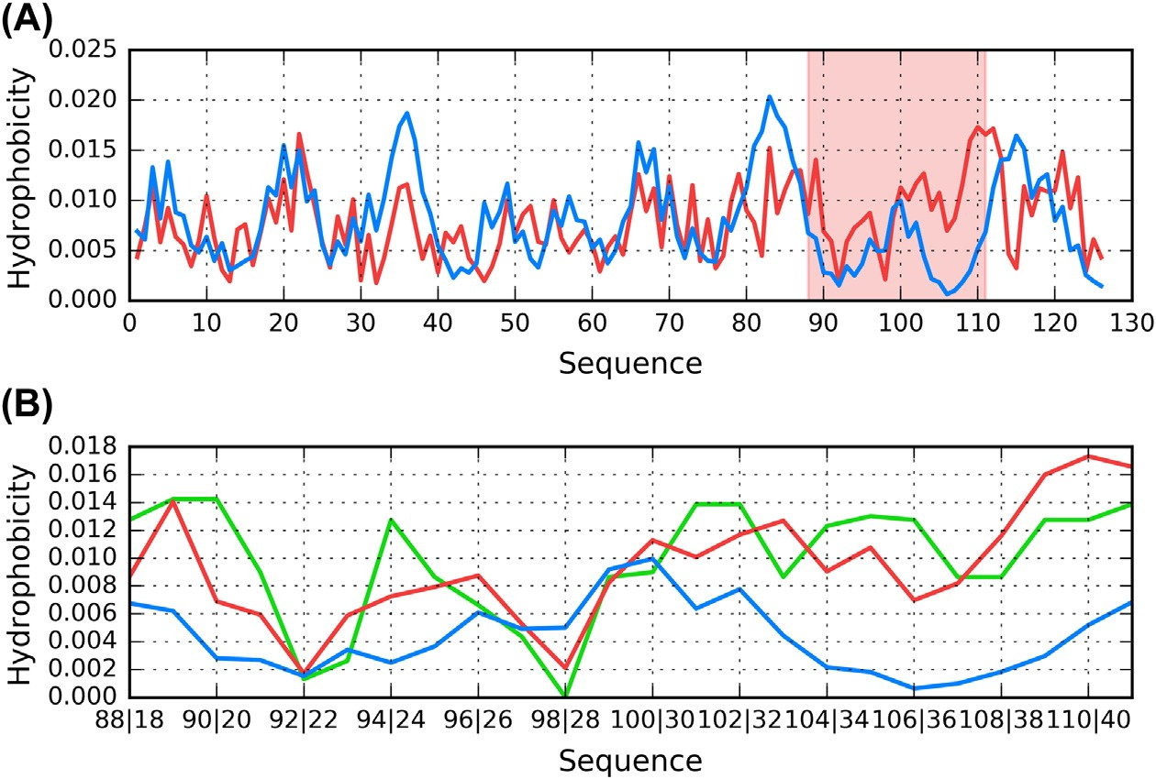
Fig. 9.B.11 Theoretical (T, blue), observed (O, red) and intrinsic (H, green) hydrophobic- ity distribution proﬁles for 3MOQ. (A) complete chain with Ab(18e41) fragment high- lighted in red. (B) Ab(18e41) fragment (residues 88e111). Dual labels on the horizontal axis of B list PDB residue numbers (ﬁrst value) and positions relative to Ab(18-41) (second value).
170 Mateusz Banach and Irena Roterman

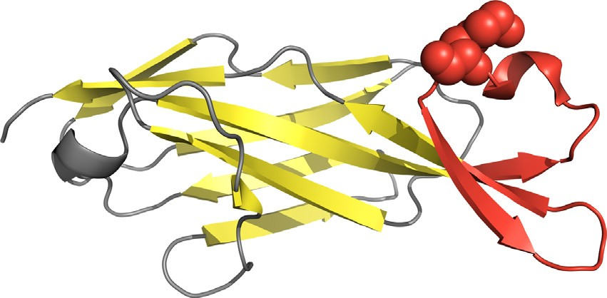
Fig. 9.B.12 3D presentation of 3MOQ, with the Ab(18e41) fragment (residues 88e111) marked in red. Position of Lys98 in this fragment is highlighted with space-ﬁlling display style.

Discussion and conclusions
Fig. 9.B.13 provides a comparative overview of the similarities and differences between proteins discussed in this chapter.
Fig. 9.B.13 underscores the key role of the ligand or peptide with which the protein interacts. b-fragments found in 2OTK and 5HOX are almost fully engaged in interaction with the encapsulating protein e their perma- nent chaperone. 4MVI, 4MVL, 2M9R and 2M9S are all characterized as

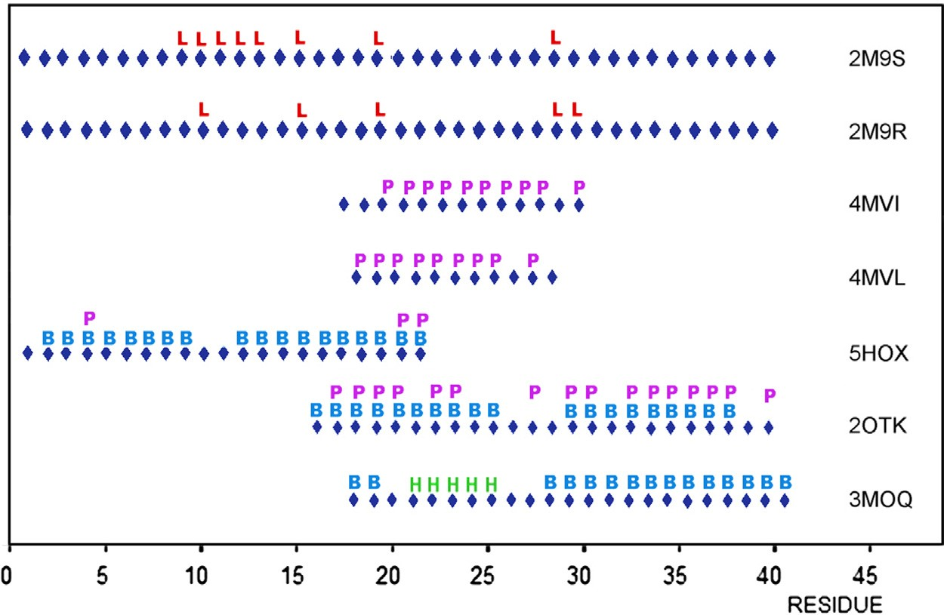
Fig. 9.B.13 Comparison of Ab(1e42) fragments present in each analyzed structure. Speciﬁc ranges are indicated by the lower horizontal bars for each table entry. L e ligand binding, P e protein-peptide interactions, B e sheet, H e helix.
Structure of selected fragments of Ab(1e42) in complex with other proteins 171

random coils. In the two former cases they also remain in full contact with external complexation partners. With regard to 2M9R and 2M9S, the pres- ence of ligands appears to have a decisive inﬂuence on structural stability, likely due to steric hindrance (as a relatively large molecule the ligand effec- tively prevents complexation). In addition, by engaging residues which are quite far apart in the chain, the ligand forces it to adopt a random coil (and therefore non-amyloid-like) conformation.
The b-hairpin found in 5HOX (at 2e10) exhibits amyloid-like proper- ties, while the fragment at 16e21 is characterized by high RD and high HvT, but also by high TvO. Consequently, it may be regarded as “weakly amyloid-like”. Other fragments whose FOD status is similar to that found in amyloids include 22e28 in 2OTK and 17e22 in both 4MVL and 4MVI. As noted above, 2M9R and 2M9S do not appear to contain any amyloid-like fragments.
A common property of all presented forms of the Ab(1e42) peptide is the need for an external factor which guides the folding process. The com- plexes described in this chapter were identiﬁed while seeking structural fac- tors capable of arresting the growth of amyloids. In all cases, this is achieved by interaction with an external ligand or protein, producing a structure which does not permit unrestricted aggregation resulting in amyloid formation.

References
- Rauth S, Hinz D, Borger M, Uhrig M, Mayhaus M, Riemenschneider M, Skerra A. High-afﬁnity Anticalins with aggregation-blocking activity directed against the Alz- heimer b-amyloid peptide. Biochemical Journal 2016;473(11):1563e78. https:// doi.org/10.1042/bcj20160114.
- Hoyer W, Gro€nwall C, Jonsson A, Ståhl S, H€ard T. Stabilization of a b-hairpin in
monomeric Alzheimer’s amyloid-b peptide inhibits amyloid formation. Proceedings of the National Academy of Sciences 2008;105(13):5099e104. https://doi.org/ 10.1073/pnas.0711731105.
- Richard T, Papastamoulis Y, Waffo-Teguo P, Monti J-P. 3D NMR structure of a com- plex between the amyloid beta peptide (1e40) and the polyphenol ε-viniferin glucoside: implications in Alzheimer’s disease. Biochimica et Biophysica Acta (BBA) - General Sub- jects 2013;1830(11):5068e74. https://doi.org/10.1016/j.bbagen.2013.06.031.
- Kreutzer AG, Hamza IL, Spencer RK, Nowick JS. X-ray crystallographic structures of a trimer, dodecamer, and annular pore formed by an ab17e36 b-hairpin. Journal of the American Chemical Society 2016;138(13):4634e42. https://doi.org/10.1021/ jacs.6b01332.
- Streltsov VA, Varghese JN, Masters CL, Nuttall SD. Crystal structure of the amyloid- p3 fragment provides a model for oligomer formation in alzheimer’s disease. Journal of Neuroscience 2011;31(4):1419e26. https://doi.org/10.1523/jneurosci.4259-10.2011.
172 Mateusz Banach and Irena Roterman

- Laskowski RA, Jab1on'ska J, Pravda L, Va�rekov'a RS, Thornton JM. PDBsum: structural summaries of PDB entries. Protein Science 2017;27(1):129e34. https://doi.org/ 10.1002/pro.3289.
- Du1ak D, Gadza1a M, Banach M, Ptak M, Wi'sniowski Z, Konieczny L, Roterman I.
Filamentous aggregates of tau proteins fulﬁl standard amyloid criteria provided by the fuzzy oil drop (FOD) model. International Journal of Molecular Sciences 2018; 19(10):2910. https://doi.org/10.3390/ijms19102910.
- Du1ak D, Banach M, Gadza1a M, Konieczny L, Roterman I. Structural analysis of the Ab(15e40) amyloid ﬁbril based on hydrophobicity distribution. Acta Biochimica Polonica 2018. https://doi.org/10.18388/abp.2018_2647.

