BULLETIN OF GEOGRAPHY /SOCIO-ECONOMIC SERIES/ NO. 9/2008
MONIKA PŁAzIAK, PIOTR TRZEPACZ
Jagiellonian University, Cracow

SPATIAL DISTRIBUTION OF EU STRUCTURAL FUNDS IN POLAND
IN 2004-2006 - FACTORS, DIRECTIONS, AND LIMITATIONS
DOI: 10.2478M0089-008-0003-9
ABSTRAcT: In 2004, Poland joined the European Union. This access means the
possibility of taking advantage of European Union Structural Funds. apart from this
the structural funds play another important role. The popularity of the idea of European
integration in countries like Poland depends largely on the effectiveness of this financial
support, which theoretically should lead to economic and social development on different
levels (local, regional, national, and even continental). The main problem of relying on
EU funds is their unequal availability, which is limited, for example, because of the
granting principles.
KEY WORDS: EU Structural Funds, infrastructure, localization factor.

introduction
Statistics of EU Structural Funds projects allowed carrying out an analysis of
their spatial distribution in Poland on different levels of spatial units. On the level
of regions (in Poland - the voivodeships), such researches can show the correlation
between the deficit of infrastructure and the importance of EU Structural Funds
as a tool which can resolve this problem. This level of analysis should especially
be concentrated on the so-called “Eastern Wall” (“Ściana Wschodnia” in Polish)
of Poland. EU funds distribution can develop such regions and make them more
competitive.
Factors of spatial distribution should emerge from the localization of
particular projects in selected voivodeships. The main research aim of this
analysis is to describe the impact of a gmina (the lowest level of the administrative
division in Poland) localization towards main metropolitan areas (generally
Monika Płaziak, Piotr Trzepacz
a voivodeship’s capital city). The author finds the lion’s share of projects linked
with EU Structural Funds is realized in the direct neighbourhood of the larger
urban areas of Poland. Positive verification of this assumption will (unfortunately)
prove a popular opinion that a process of peripherisation of considerable zones of
Poland is deepening. EU funds directed to these areas are limited, and the main
reason for this situation is that they have no financial possibility to participate
in the costs of implementation of such projects. Poland, as a young member of
the European Union, has to learn what the possibilities are and how to use them
correctly, not only from a local, regional, or national point of view, but from
a continental one as well.
EU STRUCTURAL FUNDS IN POLAND IN THE 2004-2006 PERIOD
According to the data of the Ministry of Regional Development (Ministerstwo
Rozwoju Regionalnego) in Poland in the 2004-2006 period, our country received
the sum of 204,610,110,117 PLN (approx. 5 billion EUR) from EU Structural
Funds. In this initial membership period, over 20 billion PLN was directed
for structural funds beneficiaries in Poland. Groups of recipients were very
differentiated both functionally and spatially. An important part of the funds
was used by initiatives undertaken by particular units of Polish administrative
divisions, by their different levels - from voivodeships (the regional level), poviats
(the second level of local government administration in Poland), gminas (or
groups of such units), higher education institutions (i.e. universities), enterprises,
and others. Also, the Catholic Church in Poland received financial support for
projects connected especially with improving security of sacral objects or for
conservation works (mainly churches from the list of heritage buildings).
European Union structural funds for the first period of Poland’s membership
were divided into 5 sectoral programmes and the Integrated Regional Operating
Programme. Sectoral funds are connected with those areas of social and
economic development where deficits observed should be minimized, especially
in the context of reducing disparities between particular areas.
The main part of European Union structural funds is connected with
infrastructure development. This development has both quantitative and
qualitative aspects. The struggle against the infrastructure’s deficit and an
improvement of this sphere seems to be the most important aim of this part of the
financial support from the European Union to many Polish regions. The relations
between infrastructure and development (Węcławowicz, Bański, Degórski,
Komornicki, Korcelli, Śleszyński 2006) shows that the meaning of financial
support in this area seems to be the most important. It is also important to note
that not only transportation infrastructure received this financial support, but
- 34 -
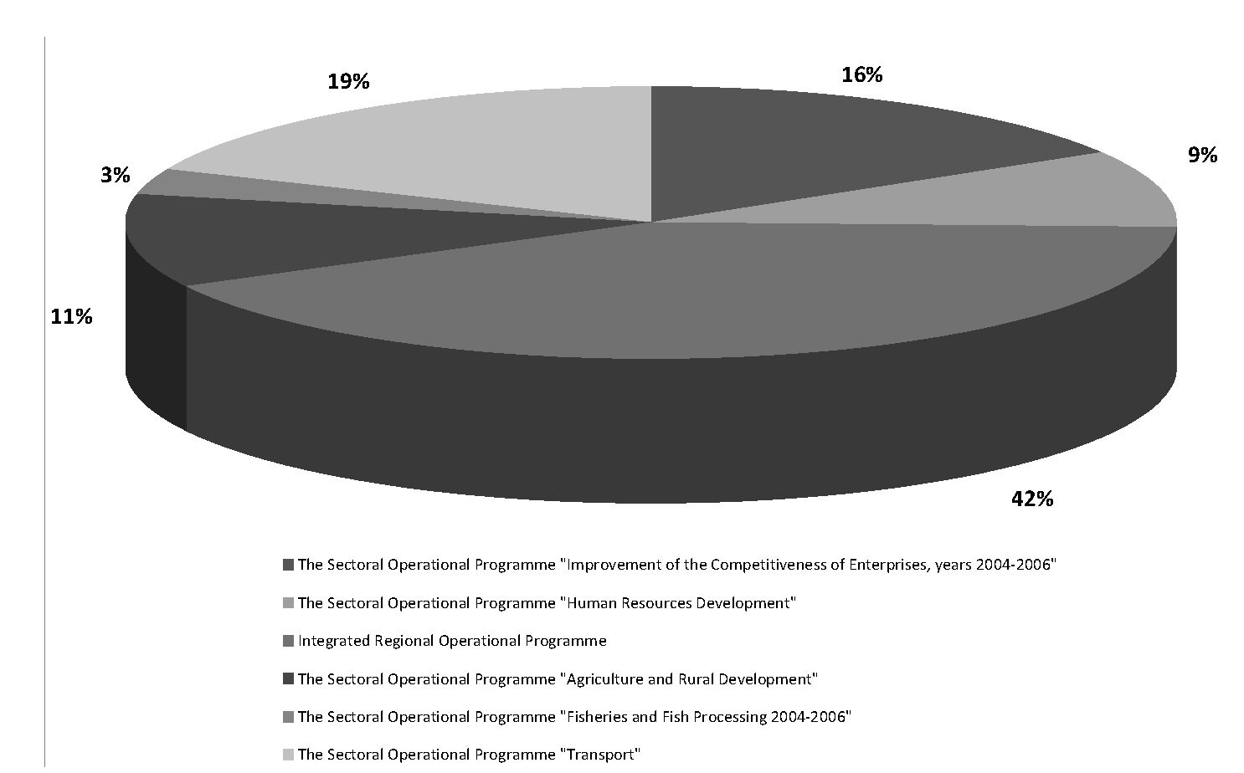
SPATIAL DISTRIBUTION OF EU STRUCTURAL FUNDS IN POLAND IN 2004-2006.
social infrastructure also received support for projects like healthcare objects
revitalization, school standards improvement, etc. The Sectoral Operational
programme “Transport” and the Integrated regional Operational programme
contained 61% of all structural funds, almost 4 billion pLN for the former and
over 8 billion pLN for the latter (Fig. 1).
This programme tries to meet a very wide group of needs (Fig. 2), from
local to regional level, from infrastructure and human resources development to
technical assistance.
The concentration on infrastructure development as a key to success is
often undermined. The example of Eastern Germany shows that infrastructure
development doesn’t have to activate any area enough to stop depopulation.
Some sectoral programmes were mostly directed to a rather narrow group
of recipients, like the Sectoral Operational programme “Fisheries and Fish
processing 2004-2006”. This programme, connected with fishery, structurally
had the lowest importance, with only a 3% share in total amount of EU funds. The
role of this programme was correlated with that of the whole sector in the region
or in the country. Fishery has a defined geographical scope and is linked with the
importance of fishery for particular regional economies.
- 35 -

Fig. 1. Structure of EU Structural Funds in Poland in 2004-2006
Source: author’s research based on Polish Ministry of Regional Development data (www.mrr.gov.pl)
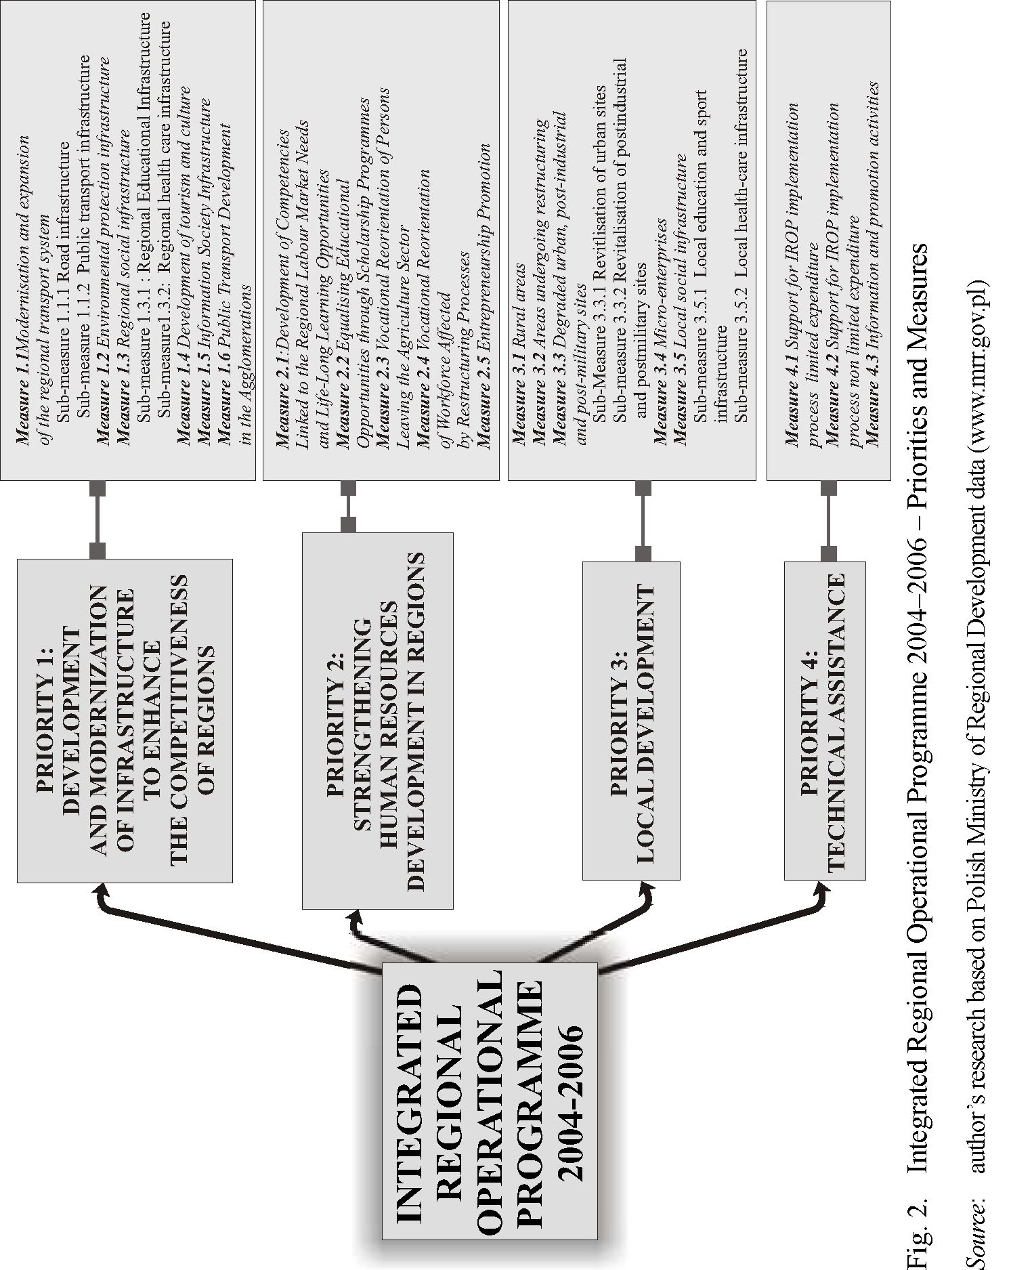

spatial DISTRIBUTION OF EU STRUCTURAL FUNDS IN pOLAND IN 2004-2006.
Sectoral programmes gain results mainly due to the structure of the national
economy. poland, as a country of considerable economic and social importance
in the agricultural sector, has to deal with the consequences of political and social
transition in this sector. The Sectoral Operational programme “Agriculture and
Rural Development” is viewed as financial support for this. The main aim of
this programme is to strengthen the sector in order to make it competitive on the
European market. Of course, this kind of support is only a partial solution, not
limiting other kinds of support (i.e. the problem of holding size). 11% of the share
in EU Structural Funds are devoted to this sector and shows how important the
sector is. Therefore, it has a considerable share of EU financial support.
The idea of “competitiveness strengthening” is a common aim of EU
financial help. Also the improvement of this aspect of the functioning of polish
enterprises is an important aim, concentrating 16% of all structural funds. The
most important group of resources is concentrated in the Sectoral Operational
programme “Improvement of the Competitiveness of Enterprises”.
SPATIAL DISTRIBUTION OF EU STRUCTURAL FUNDS IN POLAND
In a generalized view, the greatest part of European Union funds was directed
to the most populated voivodeships (Mazowieckie, Śląskie, Wielkopolskie), but
in some cases a direct relation between the share of structural funds and the share
of population was disordered (Fig. 3). There are two types of exceptions. The first
and most visible is that of the Zachodniopomorskie voivodeship whose share in
the total of the national population is small (4%giving it only the 11th place), but
its share in EU financial support is among the greatest. In general, the northern
voivodeships of poland form a group of regions where the idea of EU Structural
Funds use is more developed (Fig. 4) than in other areas.
The value of projects belonging to different sectoral programmes also has
spatial disparities. In the case of the agriculture and fishery programme, these
values depended on the economical and social importance of these sectors (Fig. 5).
The agricultural areas of poland are especially interested in financial support from
the Sectoral Operational programme “Agriculture and Rural Development”. The
greatest numbers of projects and their values are concentrated in north-eastern
poland and in the central voivodeships. The voivodeships of Wielkopolskie
and Kujawsko-pomorskie, with relative good level of agriculture showed strong
interests in the use of the EU Structural Funds.
The Sectoral Operational programme “Fisheries and Fishing processing”
projects are realized in all voivodeships (because of inland fishery), but this
programme was most important for coastal voivodeships dealing with the
problems of maritime fishery as an important branch of their economy. The
- 37 -
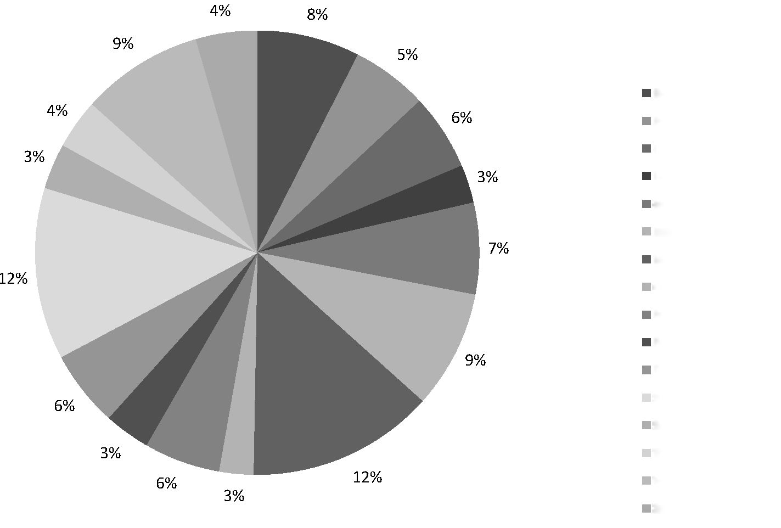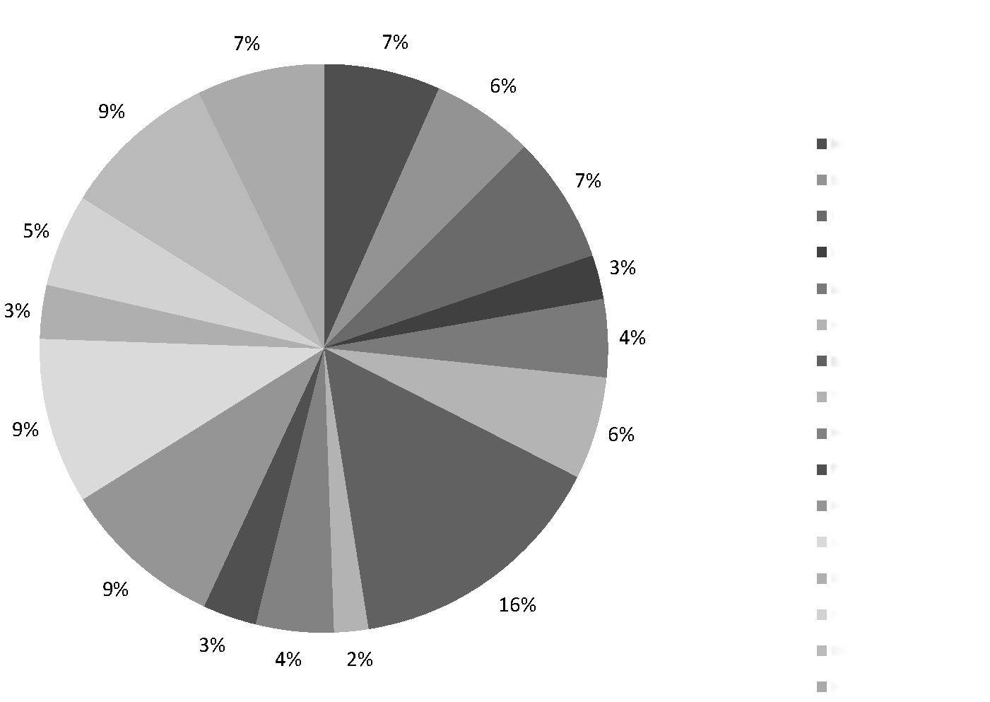
Fig. 3. Geographic structure of EU Structural Funds share and population number in
2004-2006

Source: author’s research based on polish Ministry of Regional Development data (www.mrr.gov.pl)

Population
Dolnośląskie
Kujawsko-pomorskie
Lubelskie
Lubuskie
Łódzkie
Małopolskie
Mazowieckie
Opolskie
Podkarpackie
Podlaskie
Pomorskie
Śląskie
Świętokrzyskie
Warmińsko-mazurskie
Wielkopolskie
Zachodniopomorskie
Dolnośląskie
Kujawsko-pomorskie
Lubelskie
Lubuskie
Łódzkie
Małopolskie
Mazowieckie
Opolskie
Podkarpackie
Podlaskie
Pomorskie
Śląskie
Świętokrzyskie
Warmińsko-mazurskie
Wielkopolskie
Zachodniopomorskie
EU Structural Funds
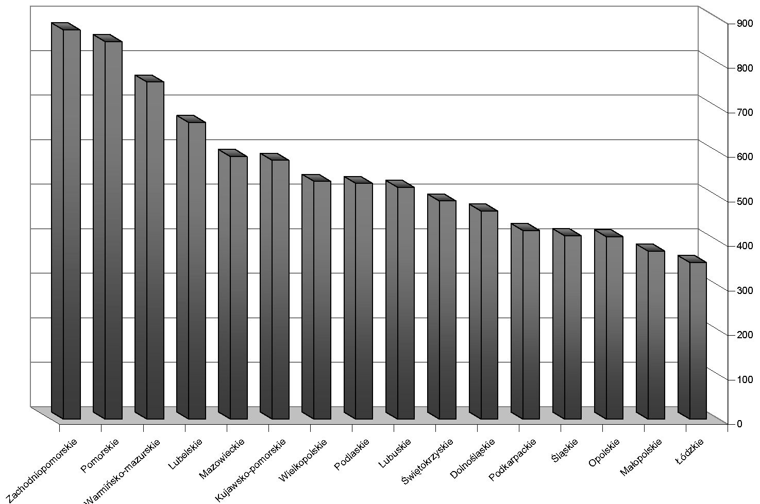
spatial DISTRIBUTION OF EU STRUCTURAL FUNDS IN poland IN 2004-2006.
Fig. 4. Value of EU co-financed projects in polish voivodeships in 2004-2006
Source: author’s research based on polish Ministry of Regional Development data (www.mrr.gov.pl)
voivodeships of Zachodniopomorskie and pomorskie also took the greatest
part of this financial support for their port infrastructure revitalization and
development, modernization of fishery fleets and scrapping of old ships out of use.
The Integrated Regional Operational programme presents interesting spatial
distribution where the outer regions (voivodeships) of poland (border and coastal)
are characterized by a much greater amount of co-financed project values. The
internal regions present a rather visibly lower importance from this point of view.
External regions are dealing with a visible deficit of infrastructure in this way.
Sewage and waterworks system density shows correlated spatial disparities.
The southern part of poland presents a different position at the transportation
infrastructure development level. Still the historical factor (the partition period)
makes the final decision on the spatial distribution of projects connected with
this kind of infrastructure. This factor not only works for quantitative aspects,
but also impacts the qualitative aspect. In southern poland (especially in Upper
Silesia), these projects were connected mostly with infrastructure improvement.
Other voivodeships, because of another level of development, show more interest
in qualitative growth, i.e. that of road systems. This is a partial explanation of
the spatial distribution of the Sectoral Operational programme “Transportation”.
- 39 -

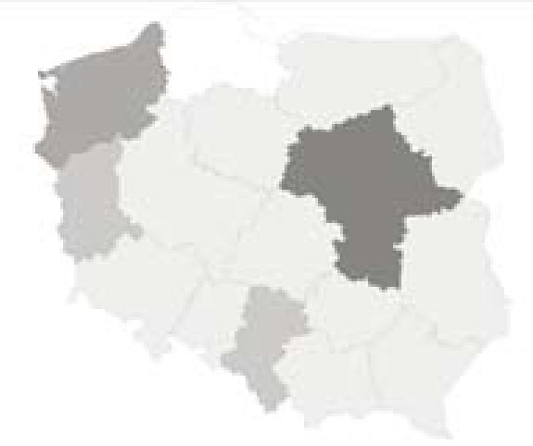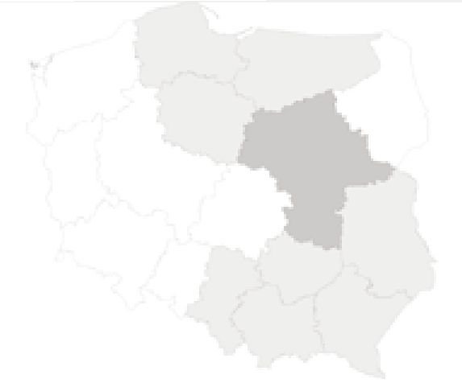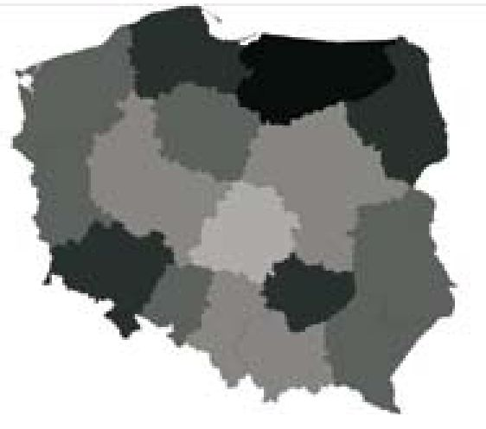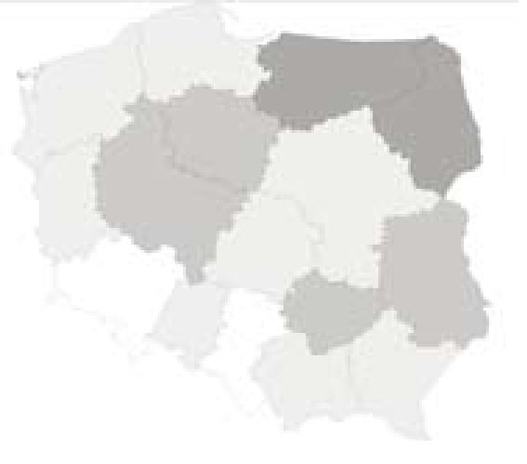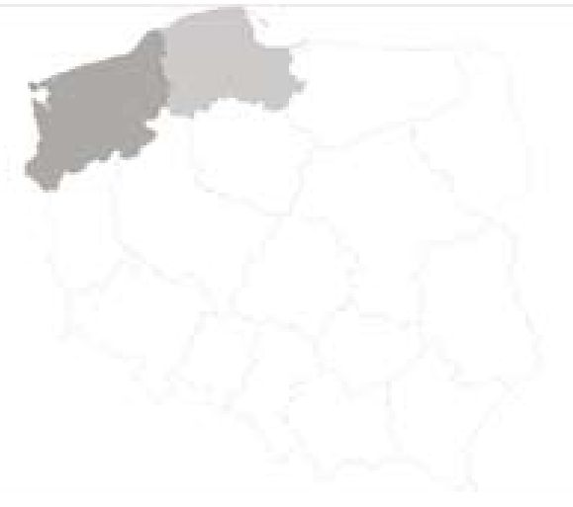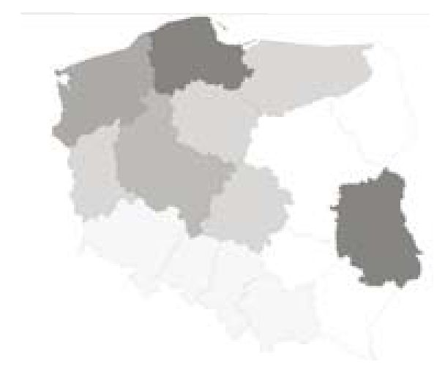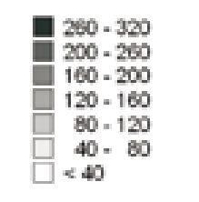
Sectoral Operational Program
“Improvement of the Competitiveness of Enterprises”
Sectoral Operational Program
“Human Resources Development”

Integrated Regional Operational Program
Sectoral Operational Program
“Agriculture and Rural Development”
The Sectoral Operational Program
“Fisheries and Fishing Processing”
The Sectoral Operational Program “Transport”

Fig. 5. Value of EU Structural Funds in Poland in 2004-2006

Source: author’s research based on Polish Ministry of Regional Development data (www.mrr.gov.pl)

Value of projects in PLN / per capita
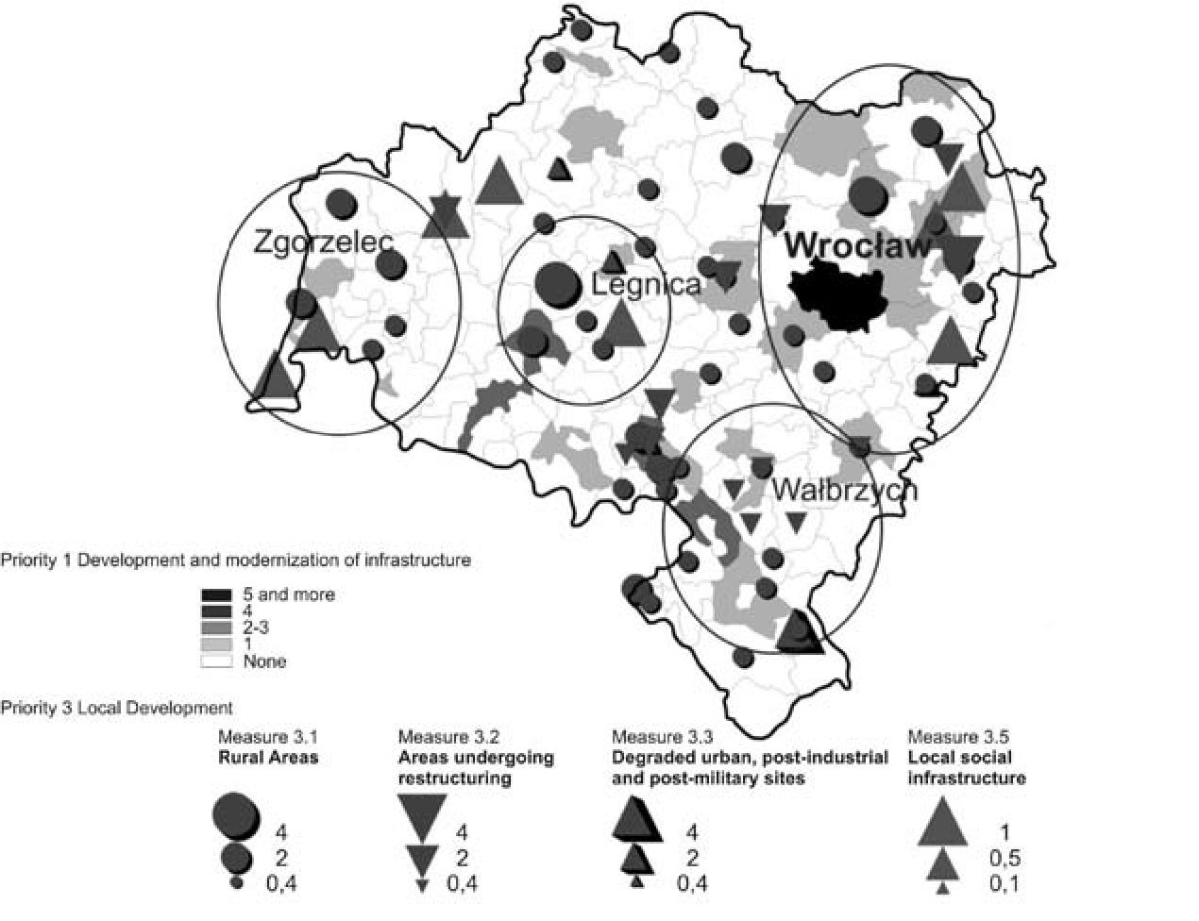
spatial DISTRIBUTION OF EU STRUCTURAL FUNDS IN poland IN 2004-2006.
The reasons for such spatial distribution of infrastructural projects for external
voivodeships can also result from their border function. A detailed analysis of
project localization shows that border crossing infrastructure development is
often realized with the help of the European Union.
FACTORS INFLUENCING SPATIAL DISTRIBUTION
OF EU STRUCTURAL FUNDS IN POLAND
The local level of EU financial support distribution shows a more detailed
perspective of the impact of particular factors. The author has selected 4
voivodeships for detailed project localization analyses. Factors of these selections
were: regional settlement system features, existence of national borders, and in
some cases (Zachodniopomorskie and Dolnośląskie voivodeships) functions
showing spatial concentration (tourist function of the coastal zone in first case
and the mountains in the second).
Cities and urban areas are much more active in the process of the EU fund
raising than rural areas in poland. EU structural policy secures particular support

Fig. 6a. projects co-financed by Integrated Regional Operational programme in
Dolnośląskie voivodeship in 2004-2006
Source: author’s research based on polish Ministry of Regional Development data (www.mrr.gov.pl)
- 41 -
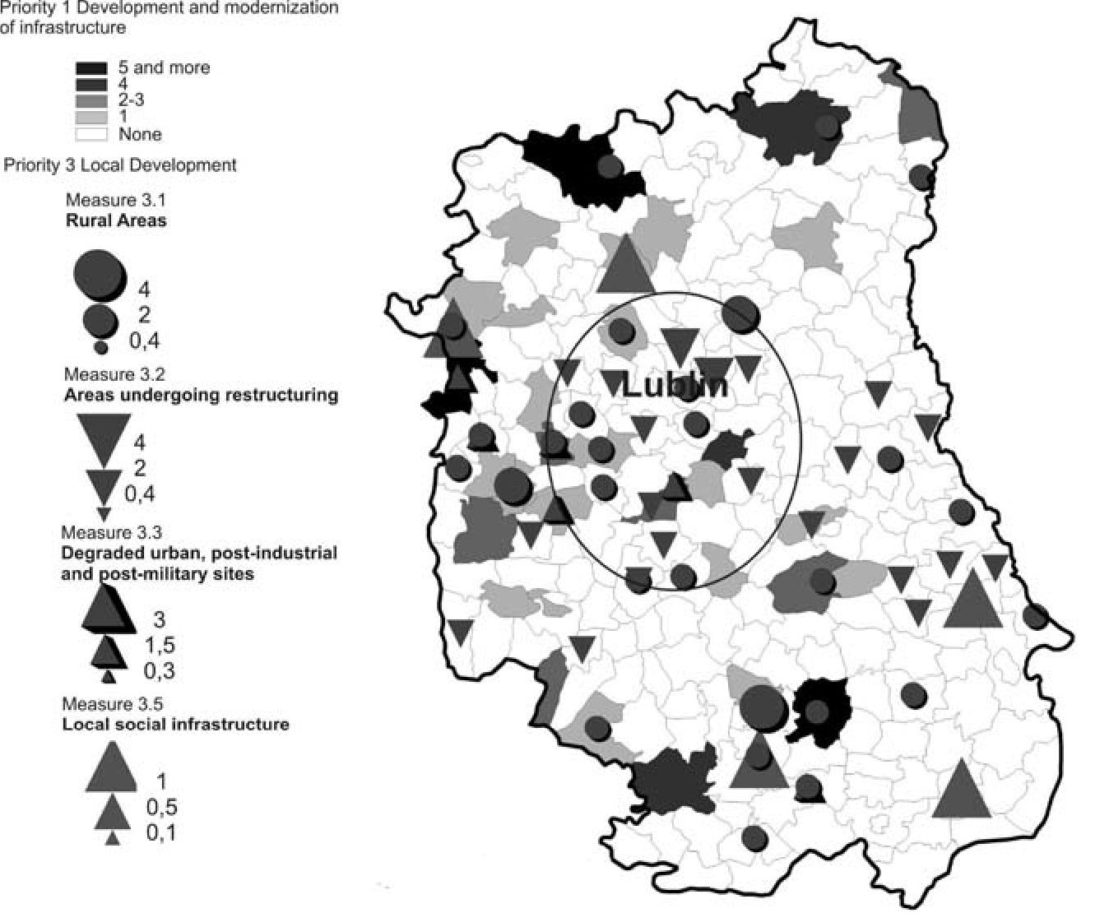
Monika Płaziak, Piotr Trzepacz
for urban areas (Litwińska, 2006). Also the size and functions ofa city matter. Cities
with developing suburban zones concentrate on project localization (supported
by the European Union). This situation is caused by a multifactor impact. In
some cases, a neighbourhood with such an area was a factor of infrastructure

Fig. 6b. projects co-financed by integrated Regional Operational programme in Lubelskie
voivodeship in 2004-2006
Source: author’s research based on Polish Ministry of Regional Development data (www.mrr.gov.pl)
development in the surrounding areas; economically and technically, it is easier to
affix planned investments to existing nodes (cities). Other factors are connected
with land prices in such areas - greater incomes bring resources for partial
project financing. There are also social impacts on the level of project interest in
suburban areas. The local population, connected economically, educationally or
culturally with the centre of an agglomeration, expects at least the same level of
infrastructure availability as in the nearby city. In all the analysed voivodeships,
the surroundings of their capital cities pull in infrastructure development and
strengthen their competitiveness projects. The suburban zones of Wrocław
- 42 -
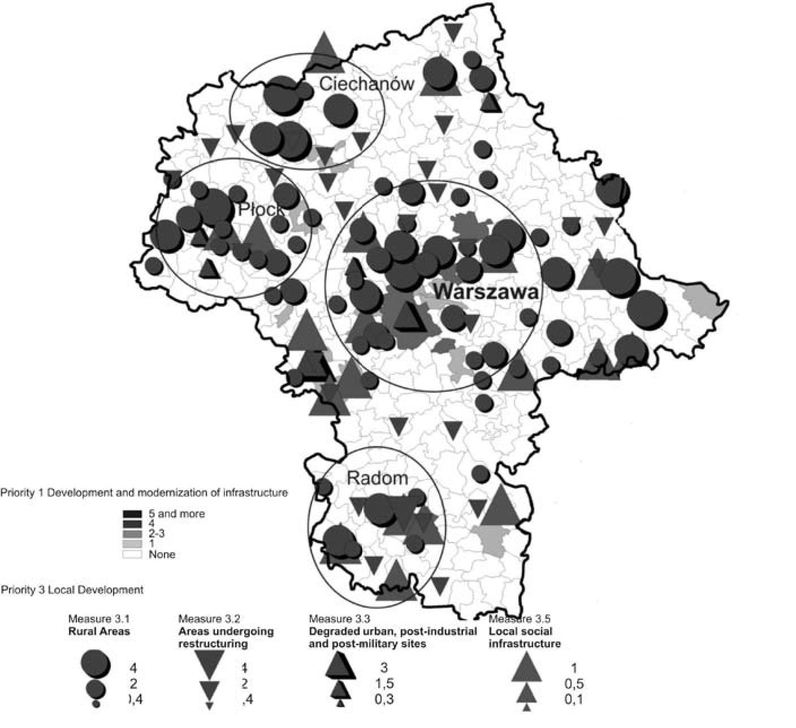
SPATIAL DISTRIBUTION OF EU STRUCTURAL FUNDS IN POLAND IN 2004-2006.

Fig. 6c. projects co-financed by Integrated regional Operational programme in
Mazowieckie voivodeship in 2004-2006
Source: author’s research based on Polish Ministry of Regional Development data (www.mrr.gov.pl)
(Fig. 6a), Lublin (Fig. 6b) Warsaw (Fig. 6c), and Szczecin (Fig. 6d), as well as
those of smaller but equally important urban centres, are creating “collars” of
areas financed with the help of European Union project concentration.
In the case of border voivodeships, border crossing localization influences
interest, especially in infrastructure development. A greater part of the realized
projects between 2004 and 2006 were connected with the improvement of border
crossings, both with internal European Union borders (between Poland and other
members of the EU) and with external borders with the countries of Eastern
Europe. In both cases, improvement is a strategic aim. Internal borders need
solutions which could minimize the time of clearance as well as some investment
in the quality of infrastructure (i.e. approach road systems). In the case of external
- 43 -
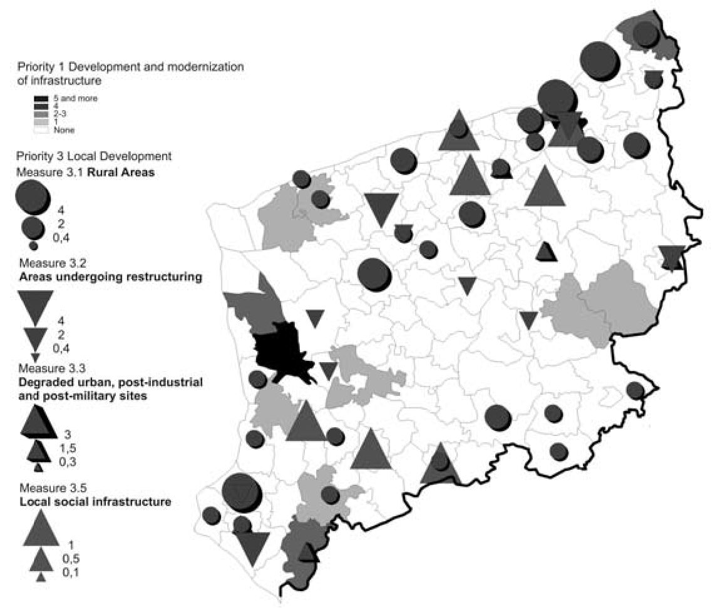
Monika Płaziak, Piotr Trzepacz

Fig. 6d. Projects co-financed by Integrated Regional Operational Programme in
Zachodniopomorskie voivodeship in 2004-2006
Source: author’s research based on Polish Ministry of Regional Development data (www.mrr.gov.pl)
borders of the European Union (as with the eastern Polish border), solutions
improving their functioning are also needed.
Tourism also has an impact on the concentration of EU co-financed projects.
This is the case of the Zachodniopomorskie voivodeship. The entire coastal zone
is covered by these projects. But in this case, the role of tourism is due mostly
to the higher incomes of particular administrative units. Gminas of the coastal
zone belong to the richest in Poland (i.e. Międzyzdroje or Rewal). From this point
of view, their tourist function should be recognized rather as an indirect factor
raising the activity of the local government, enterprises or institutions in the field
of European financial support use.
LIMITATIONS OF EU STRUCTURAL FUNDS USE
The role of European funds distribution is based on the idea that an interested
administrative spatial unit, institution or enterprise is able to invest in a partially
- 44 -
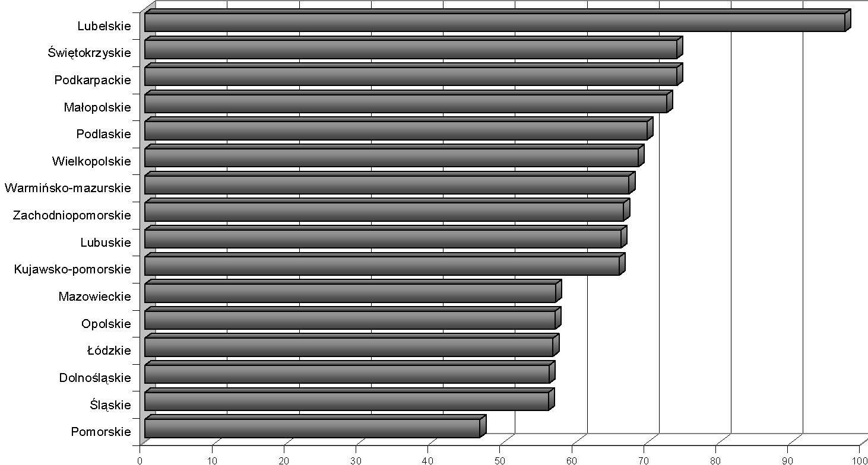
SPATIAL DISTRIBUTION OF EU STRUCTURAL FUNDS IN POLAND IN 2004-2006.
presented project, limiting the number of theoretical recipients. There is also a
specified limit of the sum which an administrative body is allowed for project
realization. The share of self-resources depends on the level of economic
development of a given area (on the regional level). The poorer regions with
smallest GDP values receive the greatest support from EU Structural Funds
(Fig. 7). The divergence between regions of the greatest and smallest shares of
EU Structural Funds in project costs amounts to 20-30 - from over 70% to less
than 50%. Poor voivodeships like Podkarpackie, Świętokrzyskie and especially
Lubelskie (the poorest region of the European Union in 2006), belong to the first
group. In their case, external resources are the main source for infrastructure
development. On the opposite side there are the regions of Pomorskie, Dolnośląskie
and a few others where self-resources have to be much greater.

Fig. 7. Share of EU financial support in 2004-2006
Source: author’s research based on Polish Ministry of Regional Development data (www.mrr.gov.pl)
Besides the economic factor, which creates spatial disparities of fund
distribution, there are other factors which generally reduce the level of EU
financial support. People, institutions, and administration in new EU member
countries are not well prepared for constructing projects correctly. Theoretically,
after the first period of experiences, the level of the use of EU Structural Funds
should be higher in the next period between 2007 and 2013.
- 45 -
Monika Płaziak, Piotr Trzepacz
CONCLUSIONS
An unequal distribution of European Union Structural Funds can be observed
on different levels of a spatial analysis. Regional and interregional disparities
are visible. The problem of funds distribution relies on the divergence between
areas of localization needs and the value of areas where projects are realised
- peripheral areas are left behind the main zones of EU financial support use.
This situation deepens the disparities. In fact, European Union Structural Funds
do not reduce the differences at the development level. The main reasons of
these divergences are the economic conditions of particular administrative units.
Only well organized state or regional support can improve this system to make
it more equally available and actually improve the situation of infrastructural
equipment.
REFERENCES
Litwińska, E. 2006: Programy wspierające rozwój miast finansowane przez Unię
Europejską - inicjatywa Urban i projekty pilotażowe, In: Słodczyk, J. and Rajchel, D.
editors, Polityka zrównoważonego rozwoju oraz instrumenty zarządzania miastem,
Uniwersytet Opolski, p. 89-98.
Węcławowicz, G., Bański, J., Degórski, M., Komornicki, T., Korcelli, P., Śleszyński, P.
2006: Przestrzenne zagospodarowanie Polski na początku XXI wieku, Monografie
vol. 6, Instytut Geografii i Przestrzennego Zagospodarowania PAN, Warszawa.
CORRESPONDENCE TO:
Monika Płaziak
Jagiellonian University
Institute of Geography and Spatial Management
Gronostajowa 7, 30-387 Kraków, Poland
[e-mail: mplaziak@glor.geo.uj .edu.pl]
Piotr Trzepacz
Jagiellonian University
Institute of Geography and Spatial Management
Department of Geography of Population, Settlement and Farming
Gronostajowa 7, 30-387 Kraków, Poland
[e-mail: trzepacz@glor.geo.uj .edu.pl]

