Computer Science • 20(1) 2019
https://doi.org/10.7494/csci.2019.20.1.3010
Abstract
Keywords
Citation
Konrad Jopek
Maciej Paszyński ©
Anna Paszyńska ©
Muhammad Amber Hassan
Keshay Pingali
HYPERGRAPH GRAMMAR-BASED,
MULTI-THREAD, MULTI-FRONTAL
DIRECT SOLVER
SCHEDULED IN PARALLEL
GALOIS ENVIRONMENT
In this paper, we analyze two-dimensional grids with point and edge singulari-
ties in order to develop an efficient parallel hypergraph grammar-based multi-
frontal direct solver algorithm. We express these grids by a hypergraph. For
these meshes, we define a sequence of hypergraph grammar productions ex-
pressing the construction of frontal matrices, eliminating fully assembled nodes,
merging the resulting Schur complements, and repeating the process of elim-
ination and merging until a single frontal matrix remains. The dependency
relationship between hypergraph grammar productions is analyzed, and a de-
pendency graph is plotted (which is equivalent to the elimination tree of amulti-
frontal solver algorithm). We utilize a classical multi-frontal solver algorithm;
the hypergraph grammar productions allow us to construct an efficient elimi-
nation tree based on the graph representation of the computational mesh (not
the global matrix itself). The hypergraph grammar productions are assigned
to nodes on a dependency graph, and they are implemented as tasks in the
GALOIS parallel environment and scheduled according to the developed de-
pendency graph over the shared memory parallel machine. We show that our
hypergraph grammar-based solver outperforms the parallel MUMPS solver.
graph grammar, direct solver, h adaptive finite element method, GALOIS
Computer Science 20(1) 2019: 27-55
27
28
Konrad Jopek et al.

1. Introduction
The multi-frontal solver [11-13] is the state-of-the-art algorithm for the LU factor-
ization of matrices resulting from adaptive finite element method computations [8].
The input to classical multi-frontal solvers like the MUMPS solver [3-5] is the global
matrix obtained by assembling an element’s frontal matrices. The computational com-
plexity of the multi-frontal solver algorithm depends on the quality of the constructed
elimination tree [18]. In this paper, we show that the parallel multi-frontal solver al-
gorithm can be expressed by hypergraph grammar productions, and the elimination
tree can be expressed by a dependency graph between them. The graph grammar
model has already been utilized for both expressing the adaptive mesh transforma-
tions [26-28,30,31] and the multi-frontal solver algorithm itself [20,32]. However, we
utilized composition graph grammars (CP-graph grammars) [26,27,30,31] in our pre-
vious work; in this paper, we propose the use of the hypergraph grammar [36]. The
hypergraph grammar was originally introduced in [15, 16] and instantiated to model
the mesh transformations in [36].
The CP-graph model allows us to reflect on the history of mesh refinements
within particular elements. This is an advantage in the case of a solver performing
a reutilization of LU factorizations or in the case of adaptation with non-stationary
problems requiring unrefinements. The disadvantage of this approach is an expensive
search for adjacent elements. The hypergraph model does not allow us to remember
the history of the refinements, but the graph representing the finite element mesh
is much smaller than the corresponding CP-graph. The advantage of this approach is
the possibility of planning the global ordering and scheduling algorithms not bounded
to single finite element refinements. For example, it is possible to eliminate level by
level in all elements surrounding the singularity area in the case of point singularity
located in the common vertex of four elements. In the CP-graph manner, the solver
would process the refined elements one by one, from the leaves up to the initial
mesh elements level. The cost of such a level-by-level elimination that is natural for
hypergraph grammars is cheaper than the elimination of refinement levels inside one
element until the initial element level is reached and then repeating the elimination
in the neighboring element in the CP-graph-grammar manner.
In this paper, we utilize the classical version of the multi-frontal solver algorithm
without any modern modifications (like the use of H-matrices, for example [35]). We
employ a hypergraph grammar model to construct an elimination tree, which results
in the good performance of the solver.
Namely, we consider hypergraph models of grids with point and edge singularity.
We define a sequence of hypergraph grammar productions over the hypergraphs rep-
resenting the construction of frontal matrices, eliminating the fully assembled nodes
and merging the remaining Schur complement matrices recursively up to the moment
when there is only one frontal matrix left. We analyze the dependency relationships
between these hypergraph grammar productions, and we plot a dependency graph for
them. The dependency graph is equivalent to the elimination tree, and the operations
Hypergraph grammar-based, multi-thread, multi-frontal direct solver.
29
performed by the multi-frontal solver algorithm over the elimination tree are expressed
by hypergraph grammar productions.
The multi-frontal solver expressed by the CP-graph grammar productions de-
scribed in [20] concerns the one-dimensional finite difference method. It doesn’t in-
clude the ordering generation necessary for two- or three-dimensional grids. The
approach presented there can be generalized to two- or three-dimensional model grids
with singularities [14] constructed by performing refinements from a single initial
mesh element. This, however, does not allow for the straightforward processing of
refinements surrounded by several initial mesh elements in a manner that allows the
elements to be processed level by level. The CP-graph, grammar-based, multi-frontal
solver described in [32] concerns the two-dimensional adaptive finite element method.
The CP-graph grammars construct the CP-graph corresponding to the finite element
mesh, remembering the history of the refinement. Each element that was h-refined is
represented in the graph by an interior node and edges connecting with nodes corre-
sponding to the smaller son elements. The CP-graph grammar productions modeling
the solver algorithm must travel the element refinement trees from the leaves up to the
root of the tree. These productions are complex, and it is hard to propose general
productions that are independent of the depth of the refinement trees. In this paper,
we propose a hypergraph grammar that generates graphs without the history of the
refinements; thus, hypergraph grammar productions do not need to travel multiple
levels of the graph - it is possible to process the elements surrounding the singularities
level by level.
Having the solver algorithm expressed by hypergraph grammar productions and
its elimination tree by the dependency graph, we need an efficient scheduler for the
concurrent executions of sets of tasks identified as hypergraph grammar productions.
We implement our hypergraph grammar productions in the GALOIS system [34]. It
automatically schedules the tasks (graph grammar productions) according to DAG
(directed accyclic graph) represented by the dependency graph.
The GALOIS scheduler was used in the solver described in [14]. In this paper,
we utilize the parallel solver over the two- or three-dimensional grids that possess
a structure that is topologically equivalent to a 1D mesh. The GALOIS scheduler
was also used in the solver described in [29]. In this paper, we use the GALOIS
scheduler working on the element partition tree.
In this current paper, we extend these ideas to a hypergraph model of the com-
putational mesh. This has the following advantages:
- The hypergraph is a natural “flat” data structure for storing the refined compu-
tational mesh.
- This allows for the easy construction of operations on finite elements surrounding
the singularities located inside the finite element mesh and performing elimina-
tions of these elements level by level.
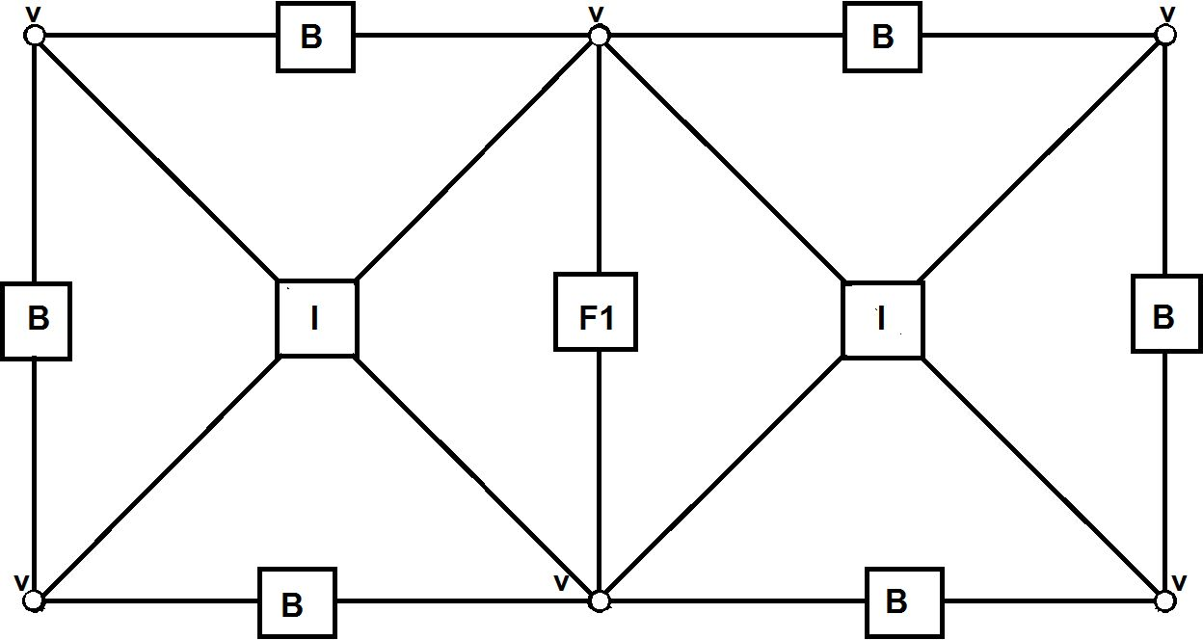
30
Konrad Jopek et al.
- The expression of the solver algorithm by hypergraph grammar production allows
for the decomposition of the solver algorithm into basic undividable tasks (like
in the task-based programming approach).
- These tasks can then be scheduled into multiple cores of parallel shared-memory
machines.
We compare our hypergraph grammar-based solver using the GALOIS scheduler
with the state-of-the-art MUMPS solver [3-5] on model as well as industrial problems.
For a description of the GALOIS system, we refer to [34]. From the practical
point of view, GALOIS can execute several tasks (threads) concurrently, utilizing
multiple cores on a shared-memory machine in an optimal manner.

2. Expressing solver algorithm by hypergraph grammar productions
Let us focus on the two finite element meshes represented by a hypergraph (see Fig-
ure 1). The vertices of the finite element mesh are represented by hypergraph nodes
with v labels. The edges of the mesh located on the boundary are represented by
hypergraph edges with B labels, while the common edge is represented by hypergraph
edge with a F1 label. Finally, the interiors of the finite elements are represented by
hypergraph hyperedges with I labels.
Figure 1. Hypergraph representation of mesh with two elements
Hypergraphs consist of nodes and so-called hyperedges; a hyperedge is an edge
that can connect two or more nodes - it has a sequence of nodes assigned to it. The
nodes and hyperedges can be labeled with the use of a fixed alphabet. Additionally,
each node and hyperedge can have a set of attributes. Figure 1 presents an exemplary
hypergraph with six nodes labeled as v, one hyperedge labeled as F1, two hyperedges
labeled as I, and six hyperedges labeled as B. In the presented graph, no attributes
are assigned to the nodes nor hyperedges.
For a formal definition of a hypergraph and how it differs from composition
graphs (CP-graphs), for example, we refer to [36].
The hypergraph’s grammar was originally introduced in [15,16]. The instanti-
ation of the hypergraph model for the representation of the computational mesh as
well as the instantiation of the hypergraph grammar model for mesh generation is
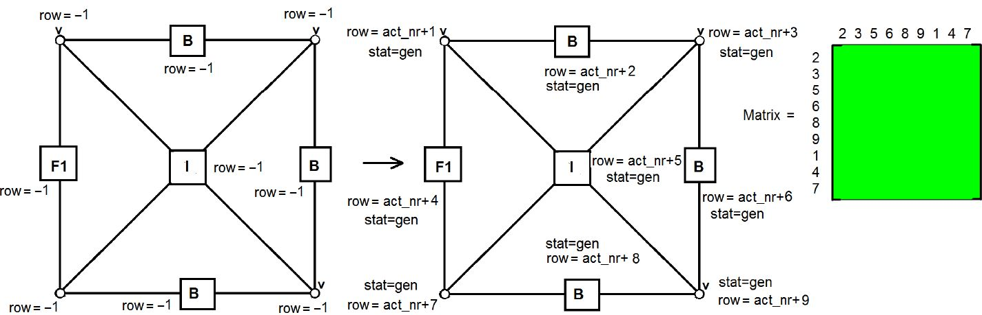
Hypergraph grammar-based, multi-thread, multi-frontal direct solver.
31
introduced in [36]. In this paper, the hypergraph grammar is a tool to express the
order of generations, mergings, and eliminations performed by the multi-frontal solver
algorithm over the computational mesh. To simplify the presentation, we prefer to
illustrate the execution of the productions by highlighting the parts of the hypergraph
where these operations are performed. Below, we present the explanation on how we
understand this notation in the sense of the generation and processing of matrices
and assigning them to the nodes in the hypergraph model. The formal definitions of
hypergraphs and hypergraph grammars as well as hypergraph productions describing
the mesh-generation process can be found in [36].
In our simple example, we use the following hypergraph grammar productions
that model the multi-frontal solver algorithm executed over the two finite element
mesh:
• Hypergraph-grammar production (PgenM) generates the frontal matrix associ-
ated to a single element. It is presented in Figure 2. The production labels the
element nodes with indices of the rows of the matrix and assigns the matrix to
the element interior node, meaning it sets the value-off attribute Matrix of the
hyperedge labeled as I into the generated element matrix. The rows and columns
in the matrix are ordered in such a way that the interior edge rows are localized
at the end of the list. The production sets the value of the attribute row of
each node and hyperedge of a graph representing a finite element. The values
of the attribute row of hyperedges and nodes for the first-generated matrix are
set as in Figure 2, where act jar denotes the global variable initialized by 0. After
performing the production, global variable act jar is increased by 9 in this case.
For the next generated matrices (the matrices for the next elements), some of
the nodes or hyperedges can have the value of an attribute row set into a value
greater than -1. For these hyperedges and nodes, the value of the attribute row
remains the same as on the left-hand side of the production for the corresponding
hyperedges and nodes. Additionally, the value of the attribute stat of each hyper-
edge and node is set to “gen” (which means the generation of the corresponding
part of the matrix).
Figure 2. Hypergraph grammar production (PgenM) for generation of element matrix
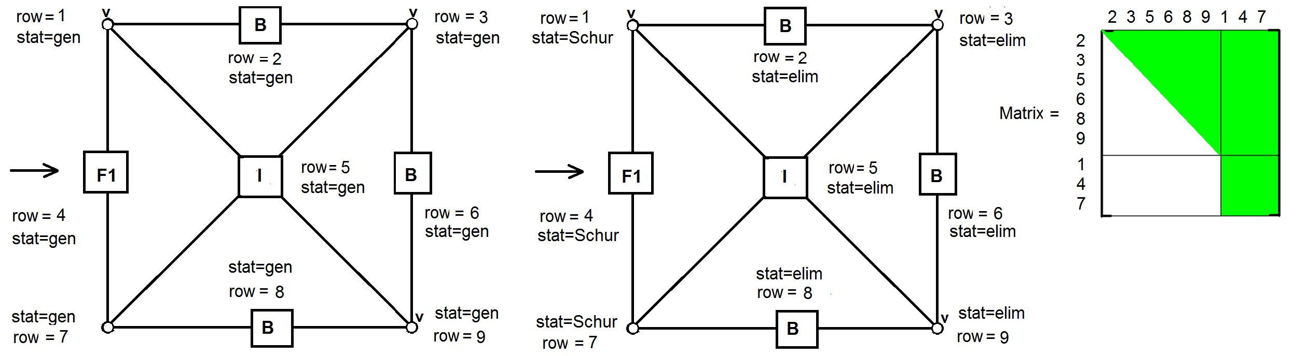
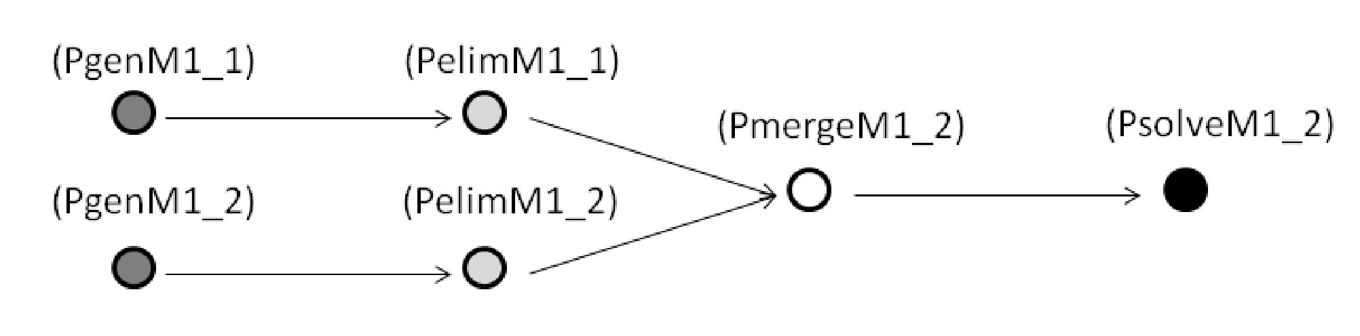
32
Konrad Jopek et al.
• Hypergraph-grammar production (PelimM) eliminates the rows of the element
matrix associated with the interior and boundary nodes. The production is
presented in Figure 3.
Figure 3. Hypergraph grammar production (PelimM) for computing Schur complement of
element matrix (also called static condensation procedure)
The procedure is called the static condensation. It leaves the bottom-right part
of the matrix as the so-called Schur complement sub-matrix. These rows are
associated with the interior edge of the element. The value of the attribute stat
is set to “elim” for the hyperedges or nodes representing the eliminated rows and
Schur for the remaining hyperedges and nodes.
For the finite element represented by the graph in Figure 4, only the hyperedge
and nodes with attribute rows =4,1,7 (respectively) have an attribute stat equal
to Schur because they represent common edge and the common vertex of two
neighboring elements.
Figure 4. Coloring of dependency graph
For simplicity of presentation, we provide exemplary values of the attribute row
of each hyperedge and node in Figure 4. The production remains the same values
of the attribute row set earlier by production (PgenM) and denoted in the left-
hand-side graph of production (PelimM) for the corresponding hyperedges and
nodes of the right-hand side of the production.
• Hypergraph-grammar production (PmergeM) merges the two Schur comple-
ment matrices from the two element matrices after static condensation over the
two adjacent elements. The production is presented in Figure 5. The merging
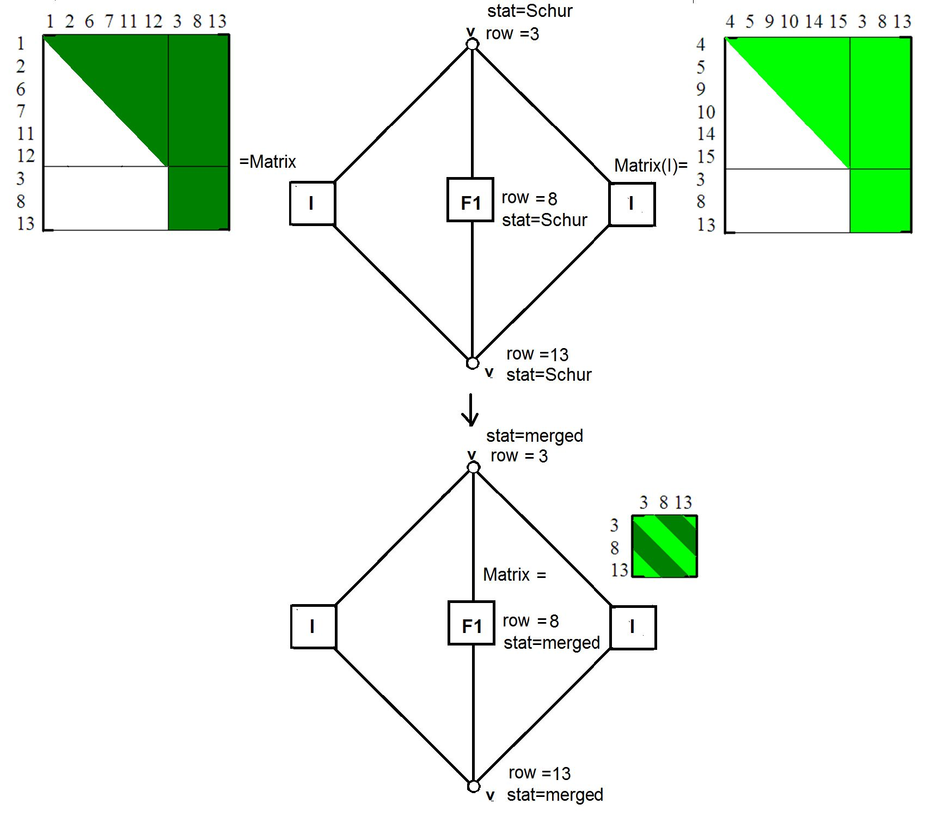
Hypergraph grammar-based, multi-thread, multi-frontal direct solver.
33
follows the association of the rows of the matrices with the nodes of the edge
where the Schur complements are computed.
Figure 5. Hypergraph grammar production (PmergeM) for merging two Schur complement
matrices from two adjacent elements
The production sets the value of the attribute Matrix of the hyperedge labeled as
F1 into the matrix corresponding to the merging of the two Schur complements.
The production also sets the value of the attribute stat of this hyperedge and the
two nodes into the merged.
• Hypergraph-grammar production (PsolveM) factorizes the matrix obtained by
merging the Schur complement matrices over the shared element edge. The pro-
duction is presented in Figure 6. The production sets the value of the attribute
Matrix of the hyperedge labeled as F1 into the factorized matrix corresponding
to the merging of two Schur complements. The production also sets the value of
the attribute stat of this hyperedge and the two nodes into “solved.”
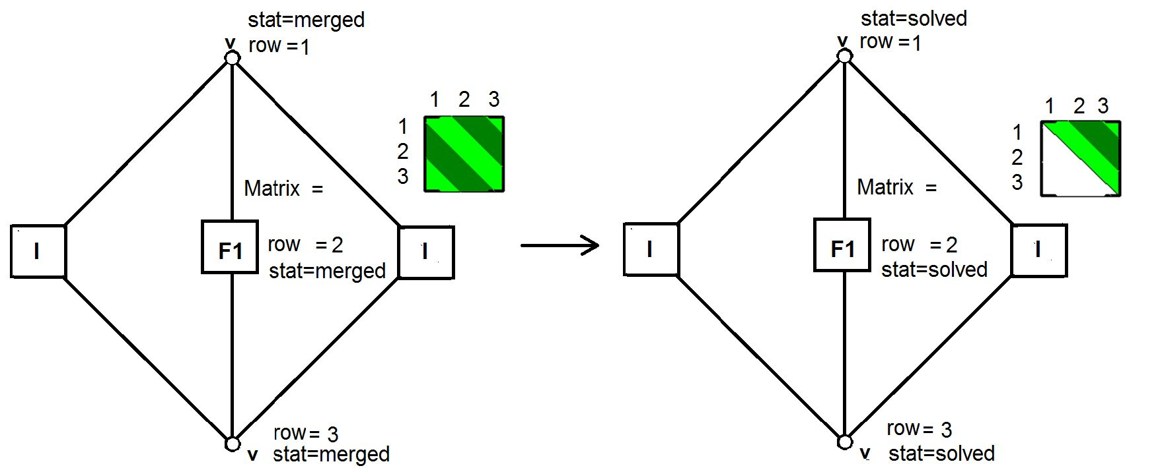
34
Konrad Jopek et al.
Figure 6. Hypergraph grammar production (PsolveM) for solving common edge problem
To simplify the presentation, we illustrate the execution of the hypergraph gram-
mar productions by coloring the nodes of the hypergraph. We highlight the nodes
corresponding to the execution of the generation, merging, and elimination produc-
tions.
Considering the simple two-finite-element-mesh example, we can express the
multi-frontal solver algorithm by hypergraph-grammar productions in the following
manner:
- The generation of the frontal matrix associated with the right element is presented
in Figure 7(a). The hyperedges and nodes representing the matrix rows and
columns are dark gray in color.
- The elimination of the fully-assembled nodes is illustrated in Figure 7(b). The
hyperedges and nodes corresponding to eliminated mesh nodes are light gray in
color.
- The generation of the frontal matrix associated with the left element is illustrated
in Figure 7(c). We need to use a third color to denote the nodes affected by the
generation of the second frontal matrix.
- The elimination of the fully-assembled nodes is illustrated in Figure 7(d). The
hyperedges and nodes corresponding to eliminated mesh nodes are light gray in
color.
- The merging of the two frontal matrices is presented in Figure 7(e). The hyper-
edges and nodes corresponding to the rows and columns of the merged matrices
change colors.
- Finally, the solution of the interface problem is presented in the bottom-right
panel of Figure 7(f). The hyperedges and nodes corresponding to the eliminated
mesh nodes are light gray in color.
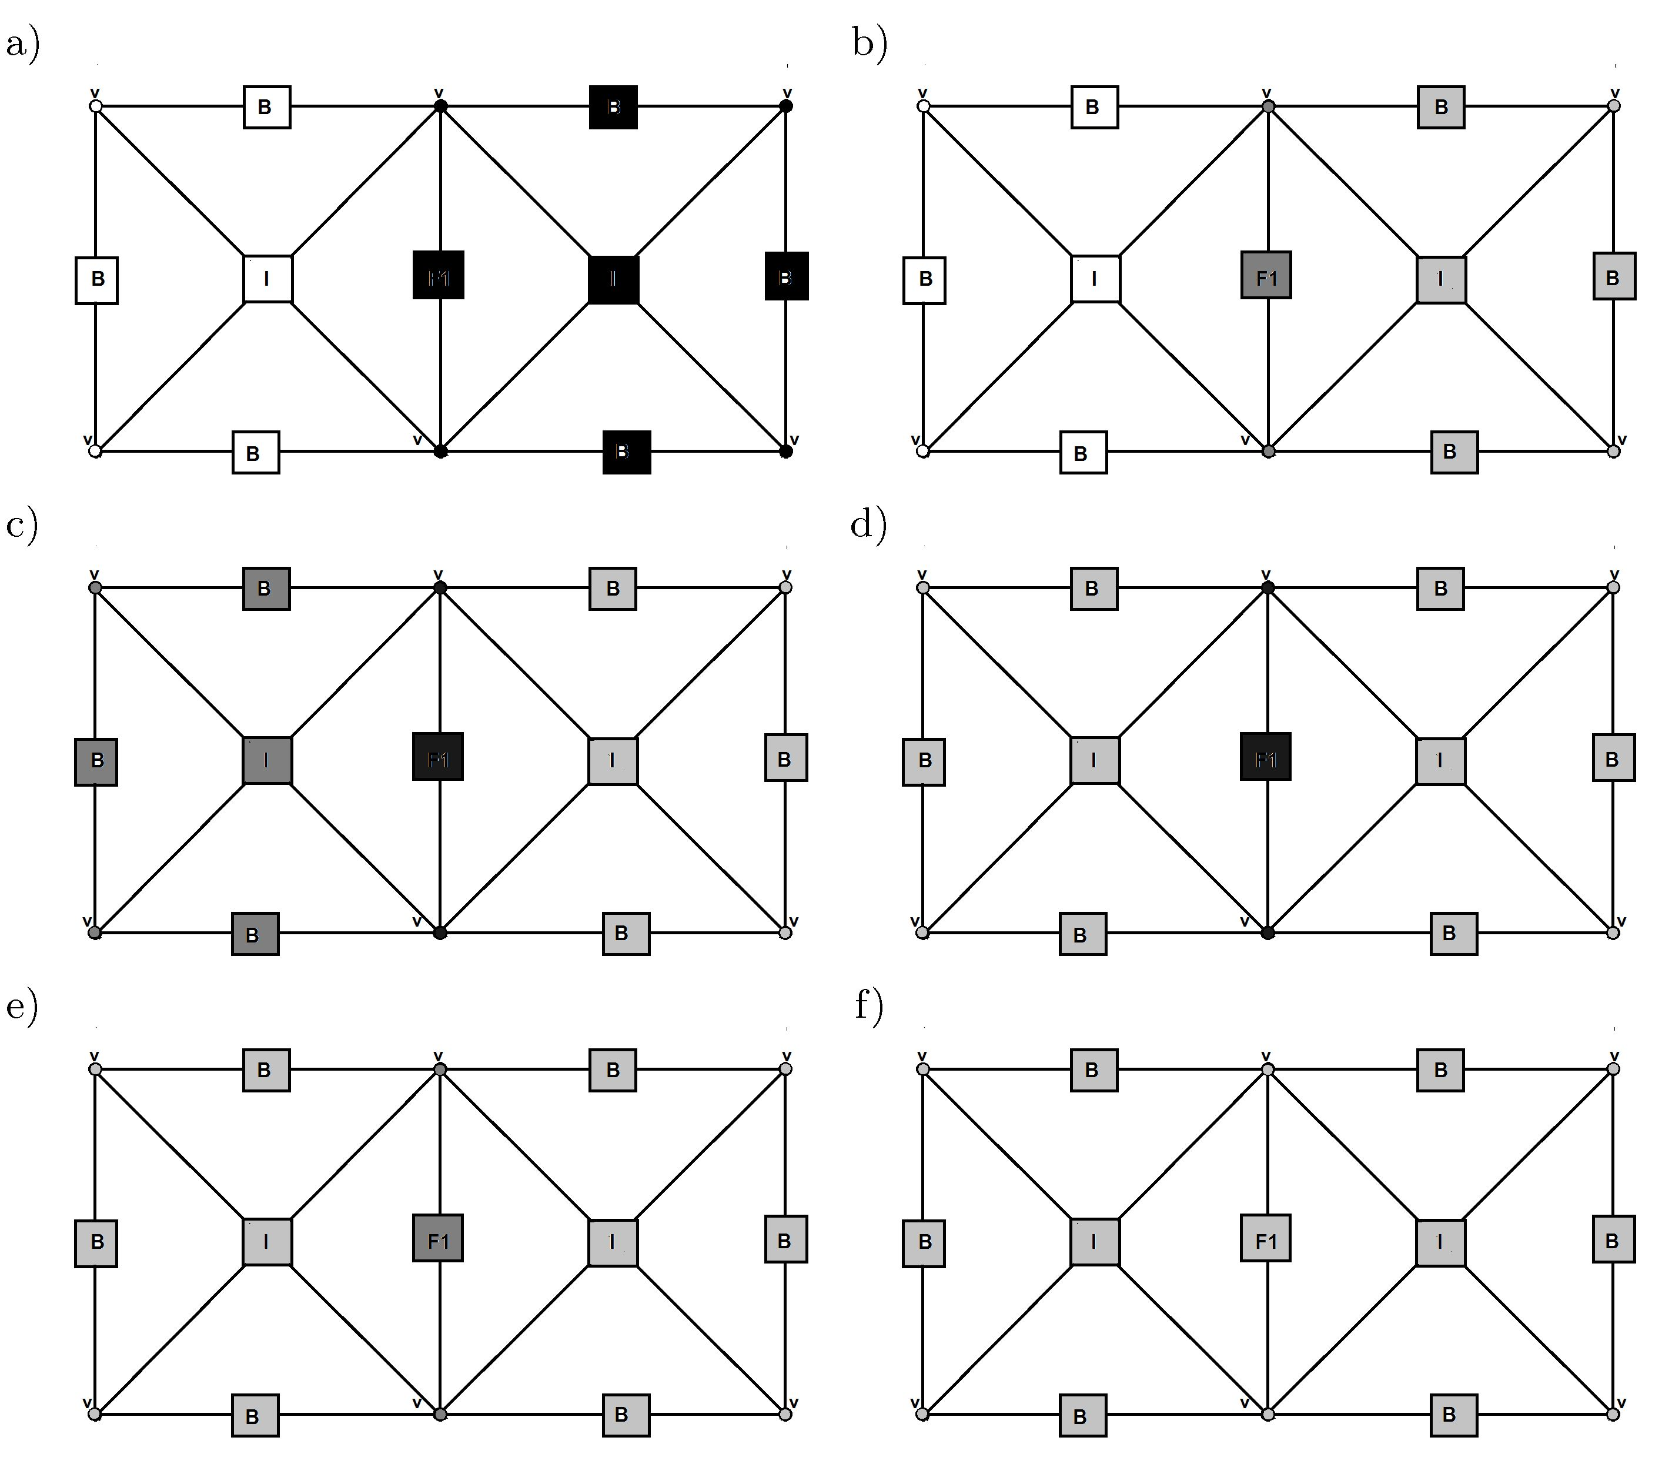
Hypergraph grammar-based, multi-thread, multi-frontal direct solver.
35
Figure 7. Execution of hypergraph grammar productions (PgenM) to the right element
(a), (PelimM) to the right element (b), (PgenM) to the left element (c), (PelimM) to
the left element (d), (Pmerge) for both elements (e) and (Psolve) for both elements (f).
The starting graph is presented in Figure 1
Finally, we can perform a concurrency analysis [9,20]. The application of the con-
crete graph grammar production to a concrete hypergraph can be seen as the so-called
task. Let us denote the application of production (PgenM) to the graph from Figure 1
by (PgemM1_1), the application of production (Pelim) to the graph from Fig-
ure 7a by (PelimM1_2), the application of production (PgenM) to the graph from
Figure 7b by (PgenM1_2), the application of production (Pelim) to the graph
from Figure 7c by (PelimM1_2), the application of production (PmergeM) to
the graph from Figure 7d by (PmergeM1_2), and the application of production
(PsolveM) to the graph from Figur 7e by (PsolveM1_2).
The dependency relationship between these tasks can be represented in the form
of a dependency graph (see Figure 4). The two tasks are “dependent” when the second
one can be started only after the first one is finished. Based on this dependency
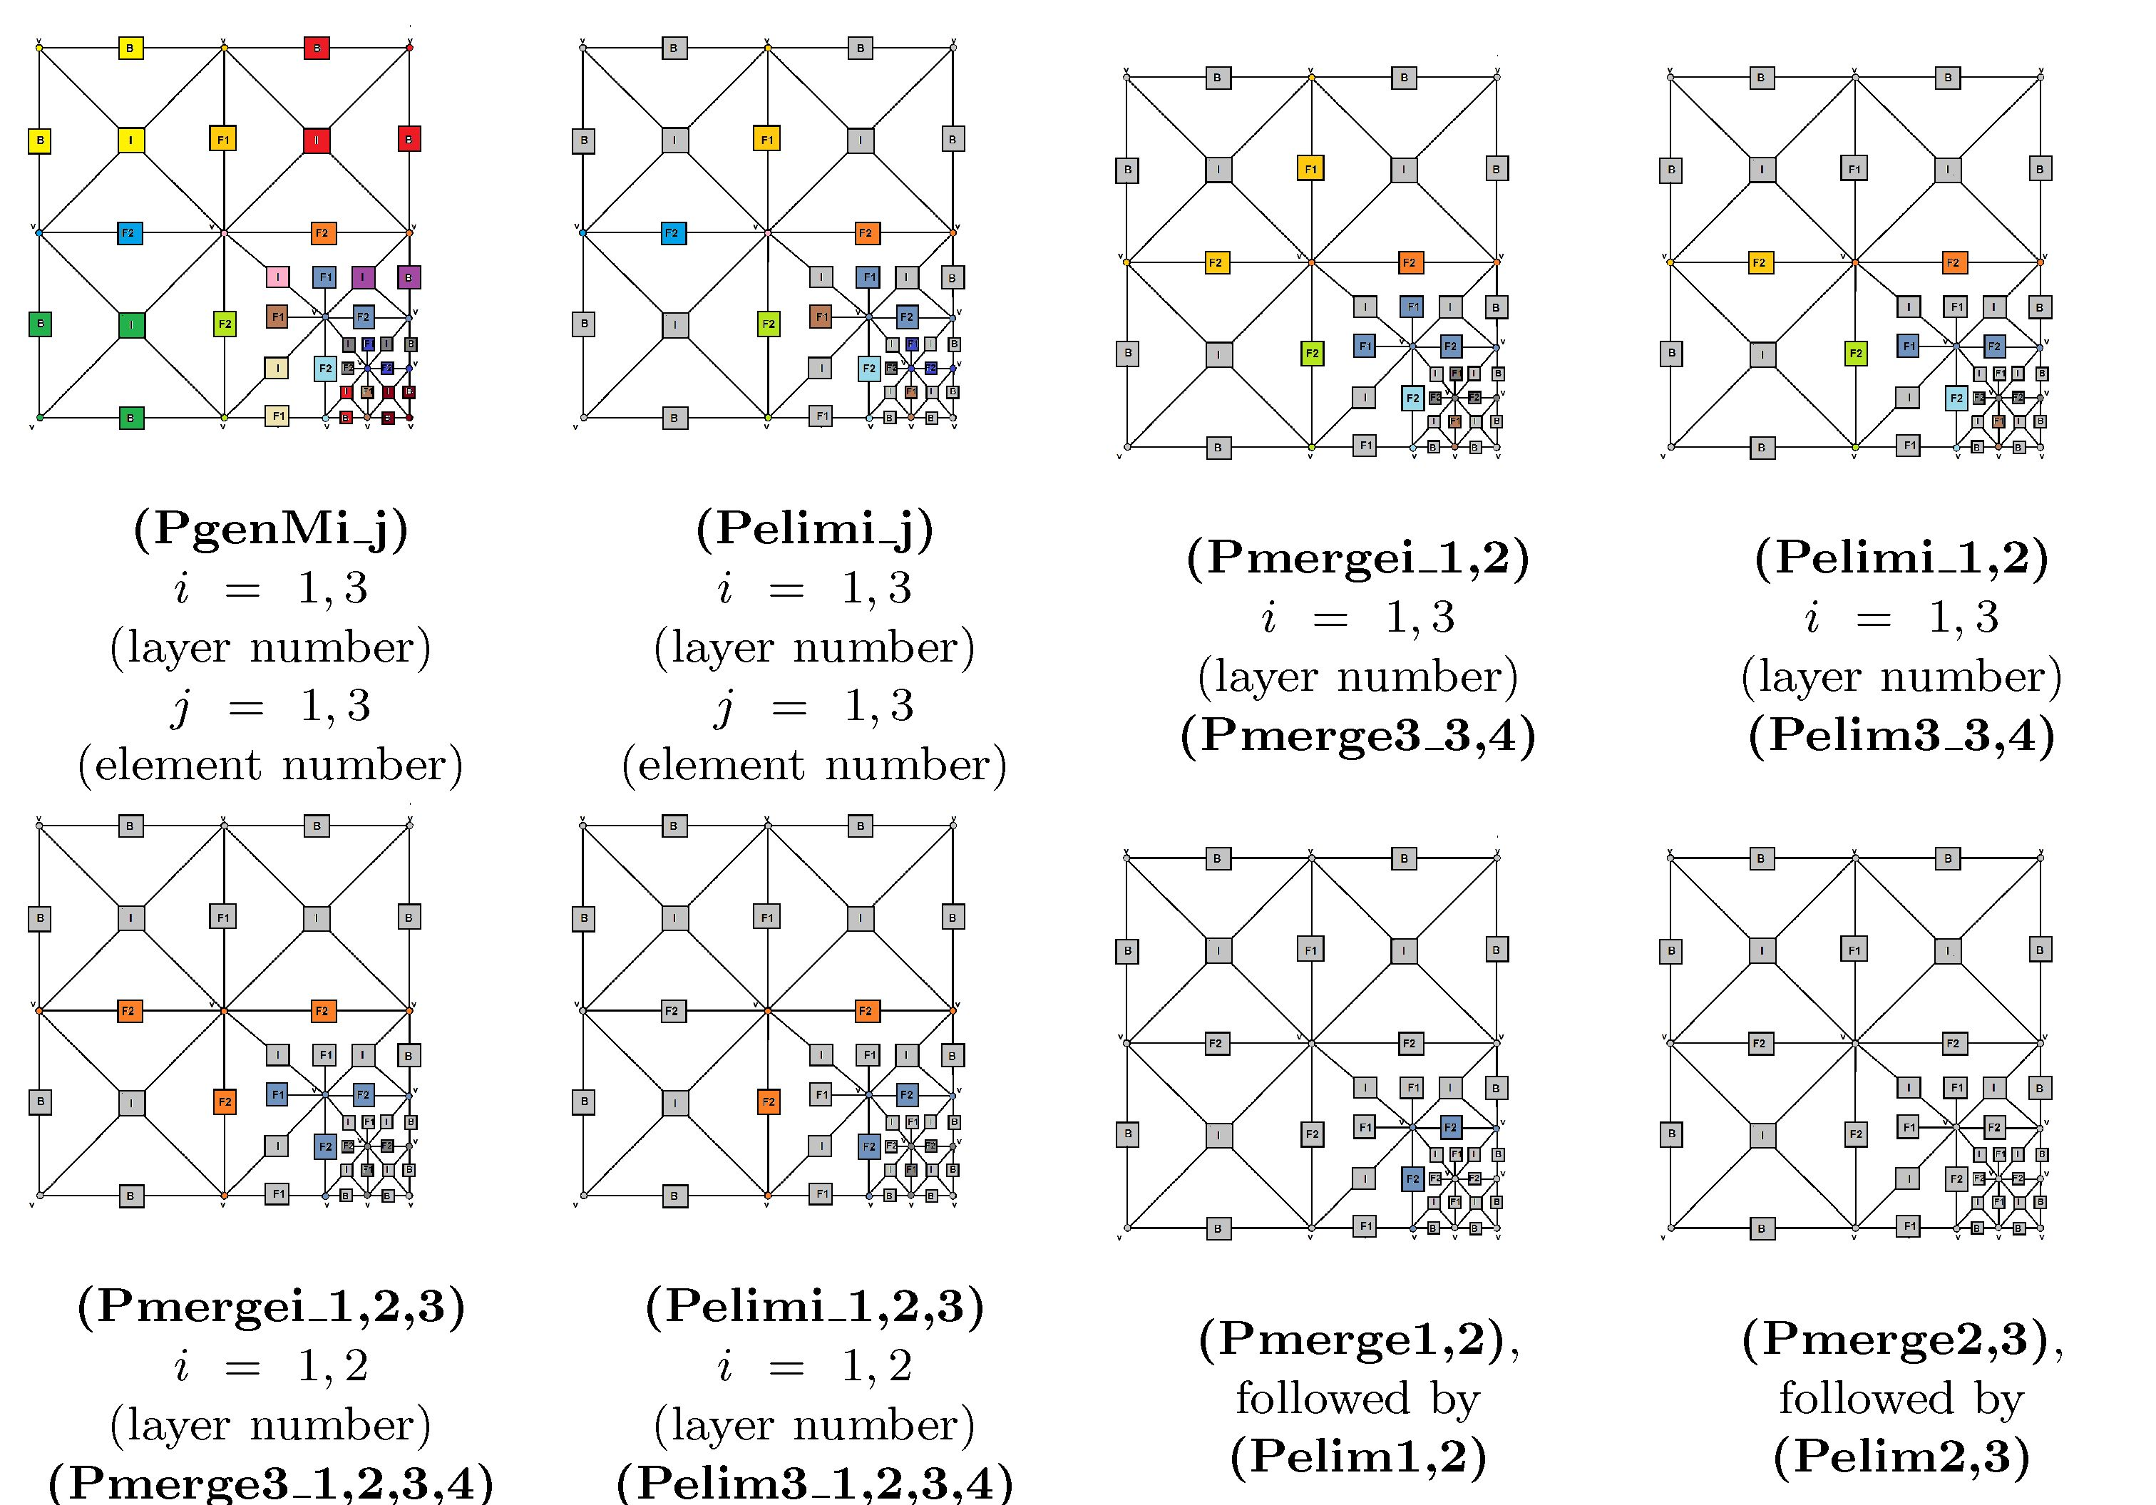
36
Konrad Jopek et al.
graph, we can set up the partial order where the tasks are grouped into sets of
independent tasks that can be scheduled set by set into a parallel shared memory
machine. This can be obtained from the coloring of the dependency graph shown in
Figure 4. From this figure, we can read that tasks (PgenM1_1) and (PgenM1_2)
can be executed concurrently; when they finish, then we can execute (PelimM1_1)
and (PelimM1_2) in concurrent tasks. Later, we can execute task (PmergeM1_2)
and, finally, task (PsolveM1_2).

3. Analysis of the concurrency for different grids with singularities

3.1. Two-dimensional point singularity
We start with the theoretical analysis of the concurrency for the case of the mesh with
point singularity. The exempary deriviation of the hypergraph grammar productions
representing the multi-frontal solver algorithm for a mesh with a point singularity
are presented in Figure 8. We utilize multiple colors to illustrate the parts of the
hypergraph where the particular tasks are executed. The differing shades of colors
correspond to the nodes and hyperedges of the hypergraph associated with the elim-
inated and Schur complement rows in the corresponding matrices.
Figure 8. Exempary deriviation of hypergraph representing multi-frontal algorithms for
mesh with point singularity
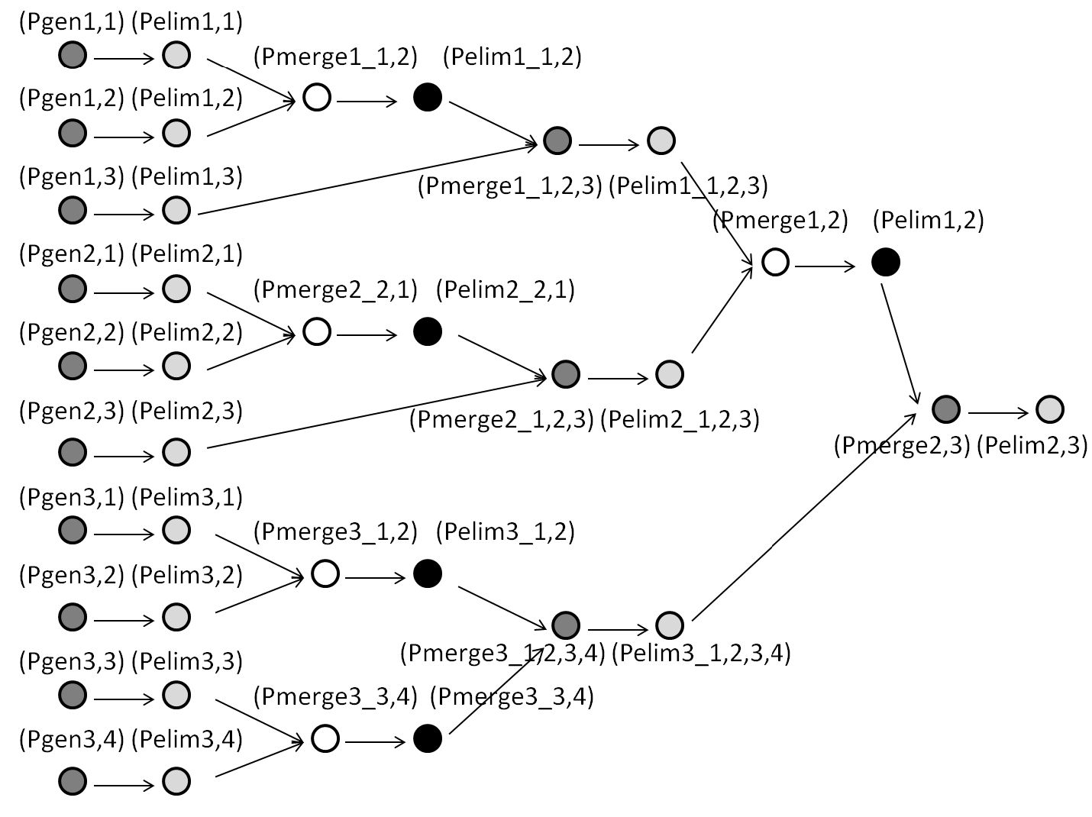
Hypergraph grammar-based, multi-thread, multi-frontal direct solver.
37
In Figure 9, we construct the dependency graph by analyzing the dependency
relationships between these tasks. The nodes in the dependency graph represents
the tasks related to the execution of the hypergraph grammar productions on the
different parts of the mesh represented by a hypergraph. There is a one-to-one re-
lationship between the hypergraph grammar production executed on a given part of
the hypergraph and the task in the dependency graph.
We color the dependency graph layer by layer. Particular sets of tasks are ob-
tained by collecting all of the tasks with the same color on the graph. The graph
colors point out the sets of tasks that can be executed concurrently.
Figure 9. Colored dependency graph for point singularity

3.2. Two-dimensional edge singularity
The exemplary derivation of the hypergraph grammar productions that express the
multi-frontal solver algorithm for a mesh with an edge singularity is presented in
Figures 10 and 11.
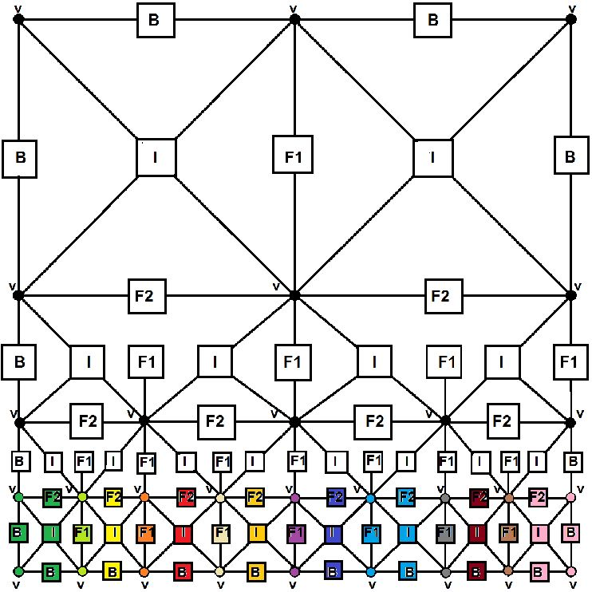
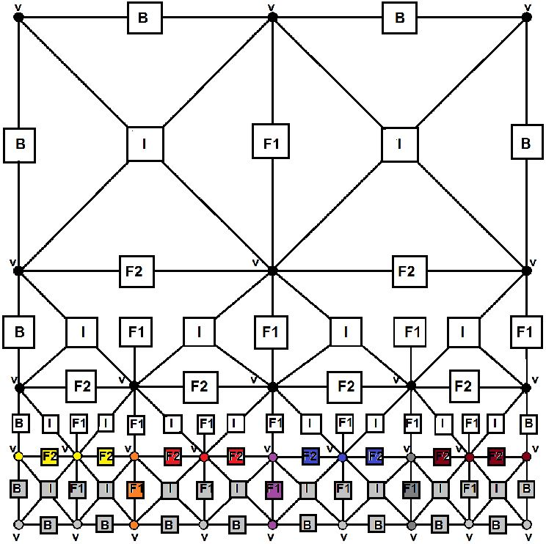
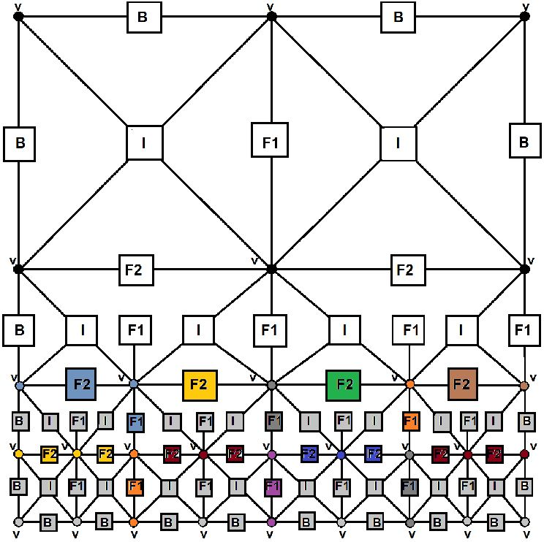
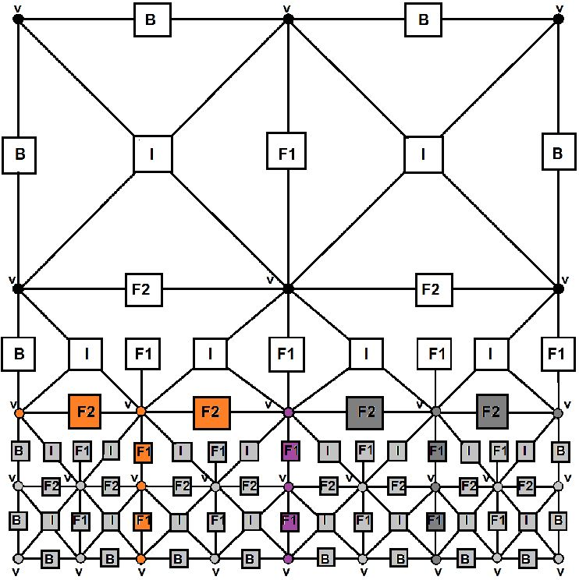
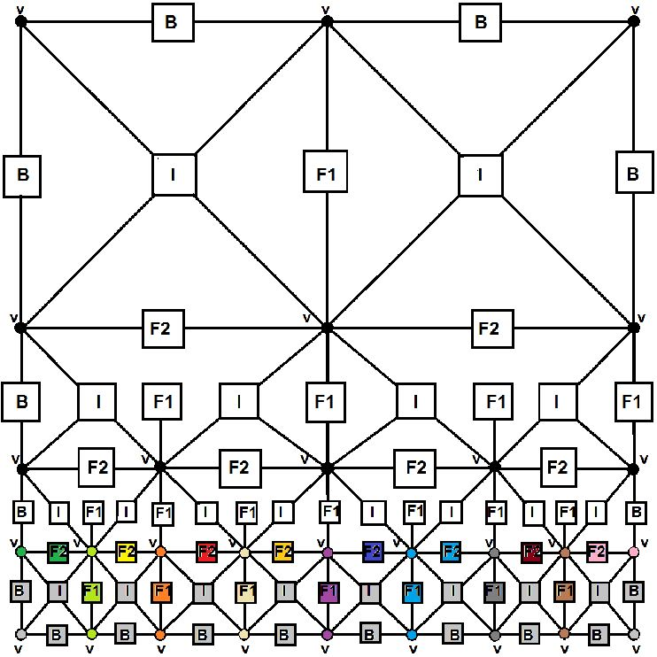
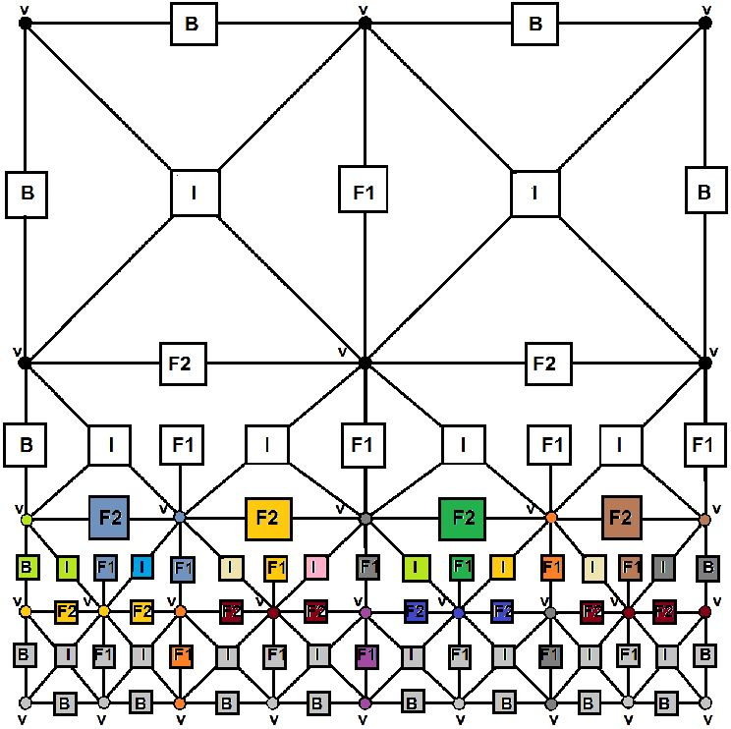
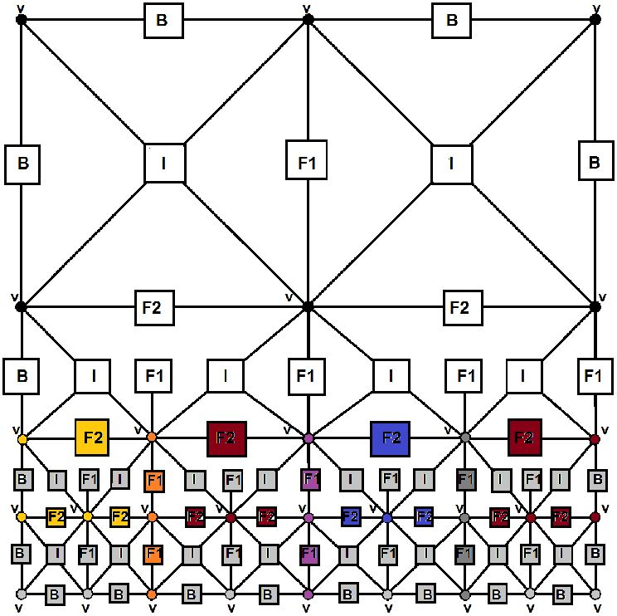
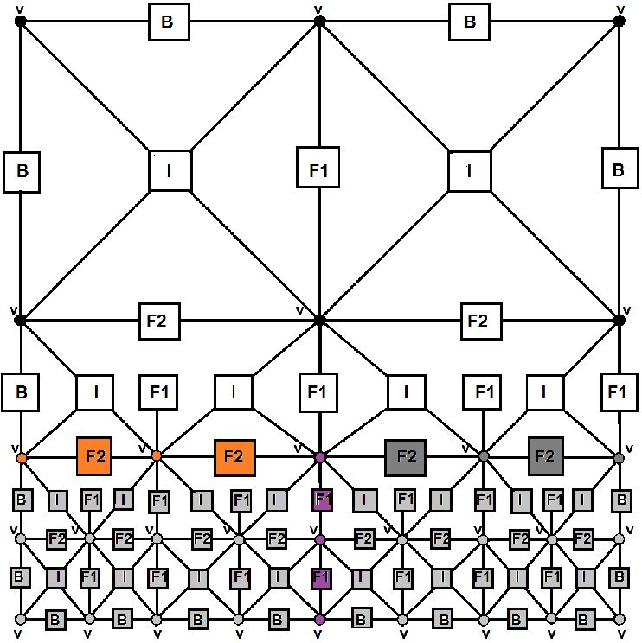
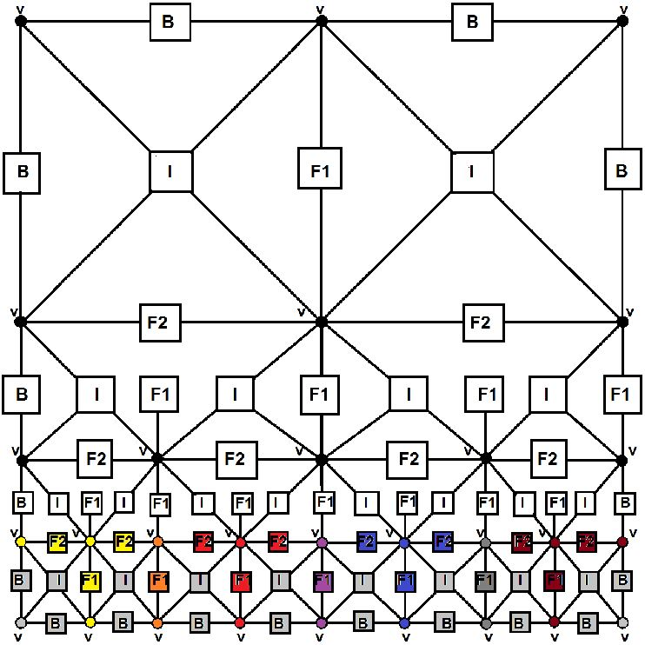
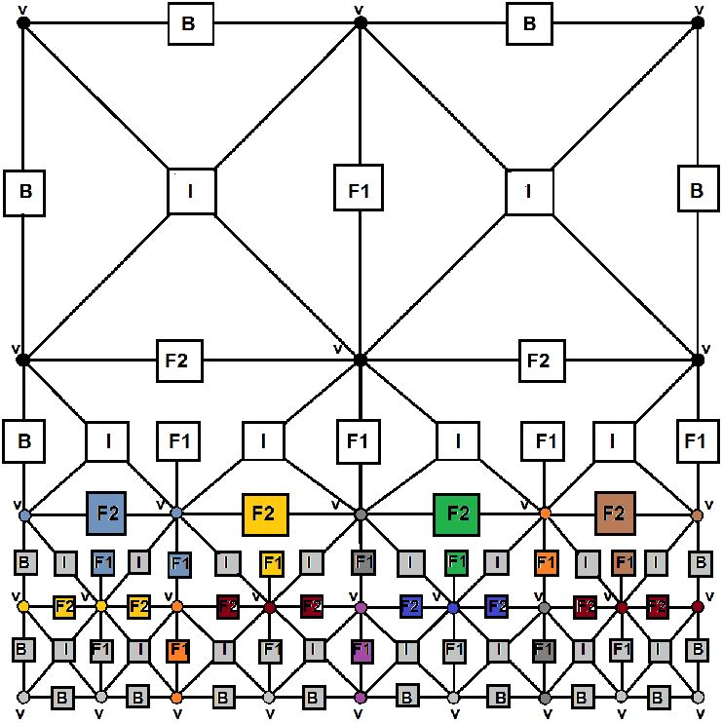
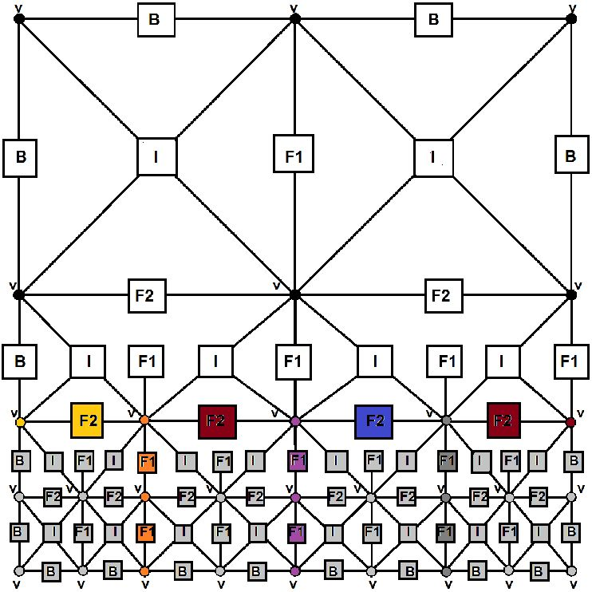
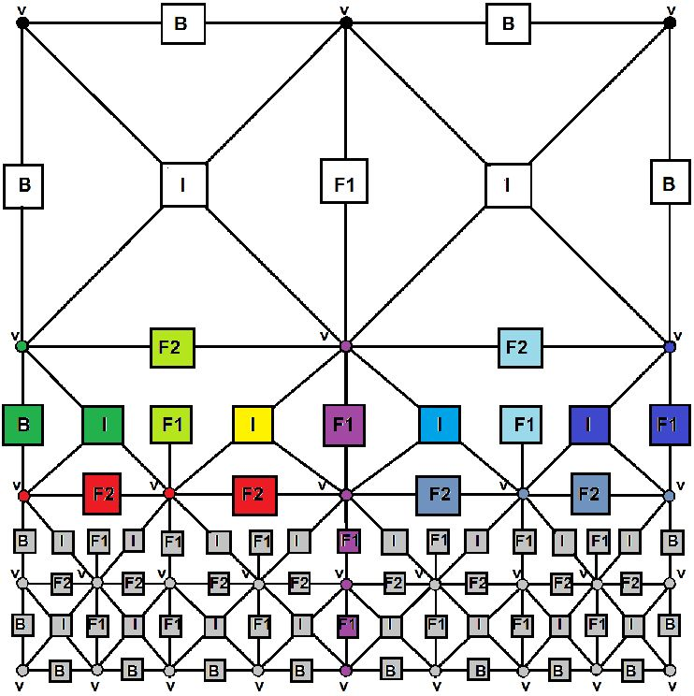
38
(Pgenl_j)
j = 1, 8 (element number)
(Peliml_j)
j = 1, 4 (patch number)
(Pmerge2_2j-l)
(Pelim2_2j-l)
j = 1, 4 (patch number)
(Pmergel,2bis_j)
j = 1, 2 (patch number)
(Peliml_j)
j = 1, 8 (element number)
(Pgen2_j)
j = 1, 8 (element number)
(Pmergel,2_j)
j = 1, 4 (patch number)
(Peliml,2bis_j)
j = 1, 2 (patch number)
Konrad Jopek et al.
(Pmergel_j)
j = 1, 4 (patch number)
(Pelim2_j)
j = 1, 8 (element number)
(Peliml,2_j)
j = 1, 4 (patch number)
(Pgen3_j)
j = 1, 4 (element number)
Figure 10. Exempary deriviation of hypergraph representing multi-frontal algorithms for
mesh with edge singularity
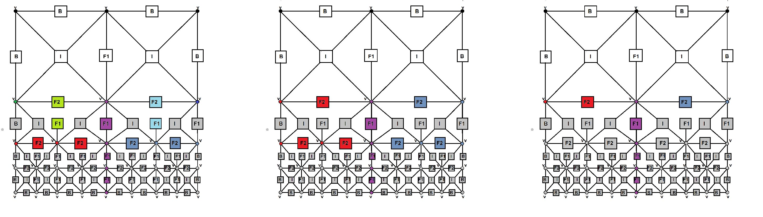
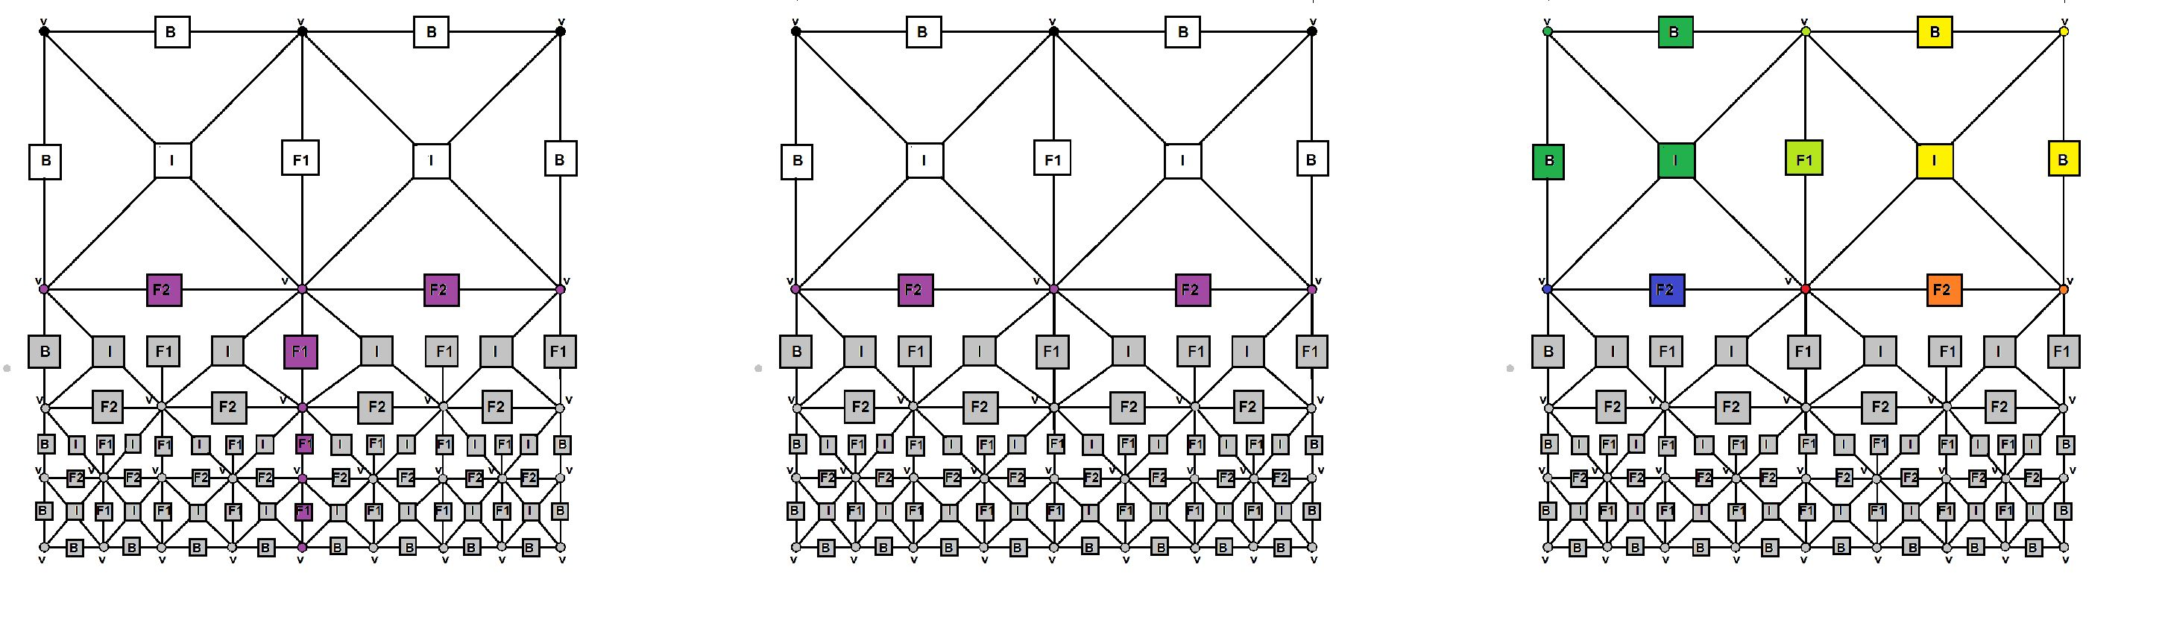
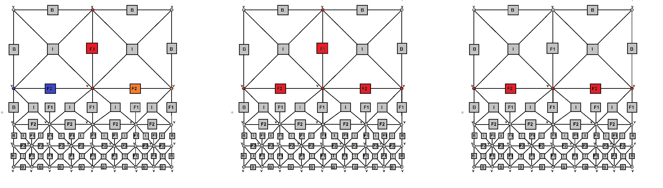
Hypergraph grammar-based, multi-thread, multi-frontal direct solver.
39
(Pmerge3_j) (Pmerge3bis_j)
(Pelim3_j) (Pelim3_j) (Pelim3bis_j)
j = 1, 4 (element number) j = 1, 2 (patch number) j = 1, 2 (patch number)
(Pmerge3prim)
(Pelim3prim)
(Pgen4_j)
j = 1, 2 (element number)
(Pelim4_j)
j = 1, 2 (element number)
(Pmerge4)
(Pelim4)
Figure 11. Exempary deriviation of hypergraph representing multi-frontal algorithms for
mesh with edge singularity
To simplify the presentation, we illustrate the execution of the hypergraph gram-
mar productions by highlighting the nodes and hyperedges of the graph. Again,
we highlight the hyperedges and nodes to which the hypergraph production will be
applied.
In Figure 12, we construct the dependency graph by analyzing the dependency
relationship between these tasks. The graph is colored to point out the sets of tasks
that can be executed concurrently. After the concurrent processing of both parts
of the mesh (observe the analogous colors in both graphs), we need to merge the
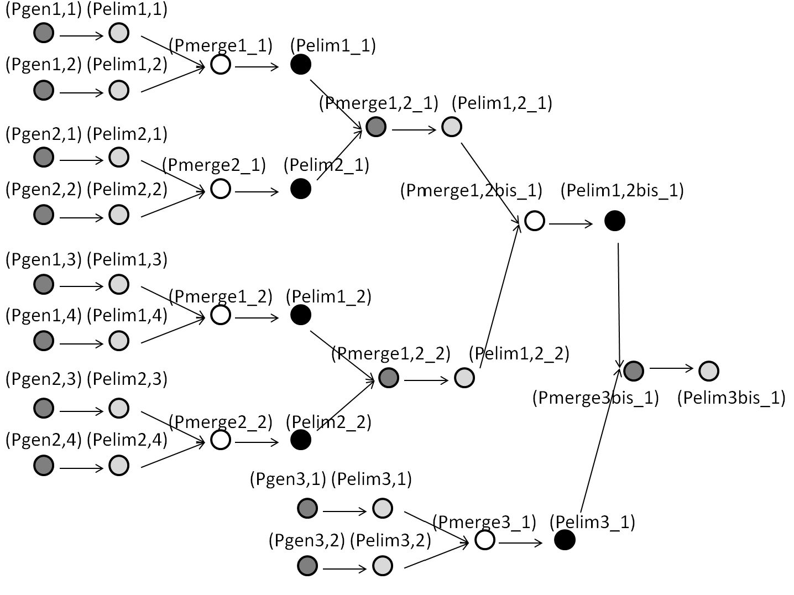
40
Konrad Jopek et al.
two resulting frontal matrices and finish the elimination processes by executing hy-
pergraph grammar productions (Pgen4_1), (Pgen4_2), (Pelim4_1), (Pelim4_2),
(Pmerge4), and (Pelim4).
Figure 12. Colored dependency graph for edge singularity for left-hand side of mesh

4. Numerical results

4.1. Model problems
In this section, we present a detailed comparison of the execution time, efficiency,
and speedup for the implementation of our hypergraph grammar solver with GA-
LOIS scheduler [34] for two-dimensional grids with point and edge singularities. The
singularities are located in the center of the domain in order to investigate the gain
associated with the execution of the hypergraph grammar-based solver that eliminates
elements level by level.
We do not provide a PDE here since we assume that we are solving any PDE
that has a singularity at a point or at an edge that requires several refinements. For
elliptic scalar value problems, the sparsity of the resulting discretization matrix is
identical; thus, the processing of the tasks follows the same pattern and has the same
complexity.
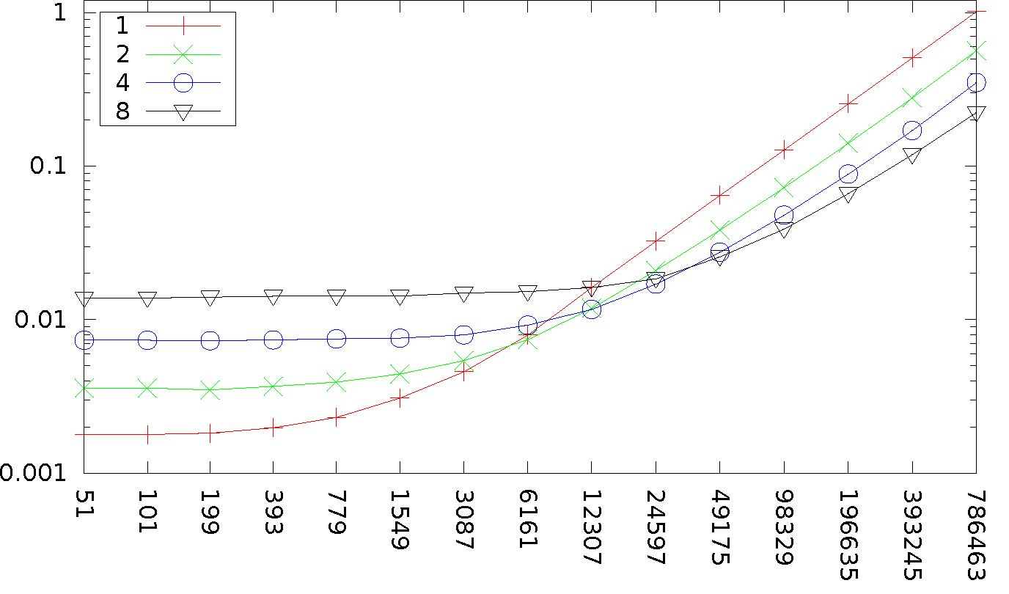
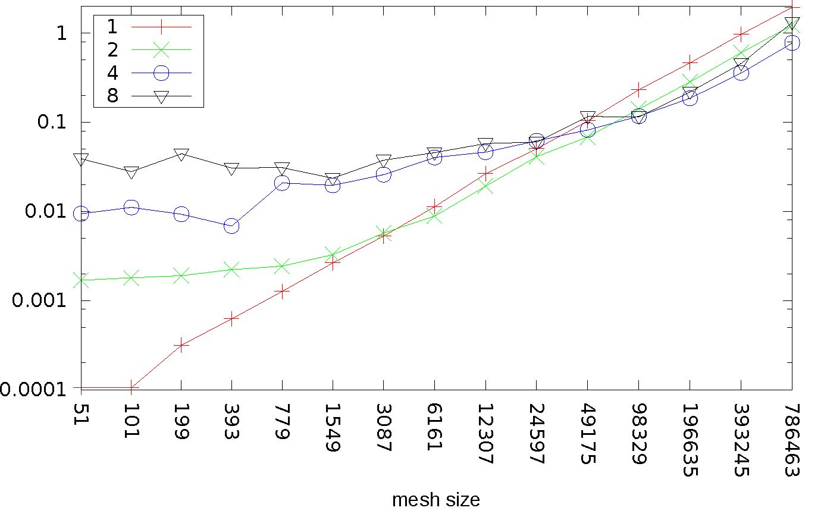
Hypergraph grammar-based, multi-thread, multi-frontal direct solver...
41
From the comparison presented in Figures 13-16 for the edge singularity, we
can read that our sequential GALOIS solver has a faster execution time than the
sequential MUMPS solver.
mesh size
Figure 13. Execution time of GALOIS solver for edge singularity
Figure 14. Execution time of MUMPS solver for edge singularity
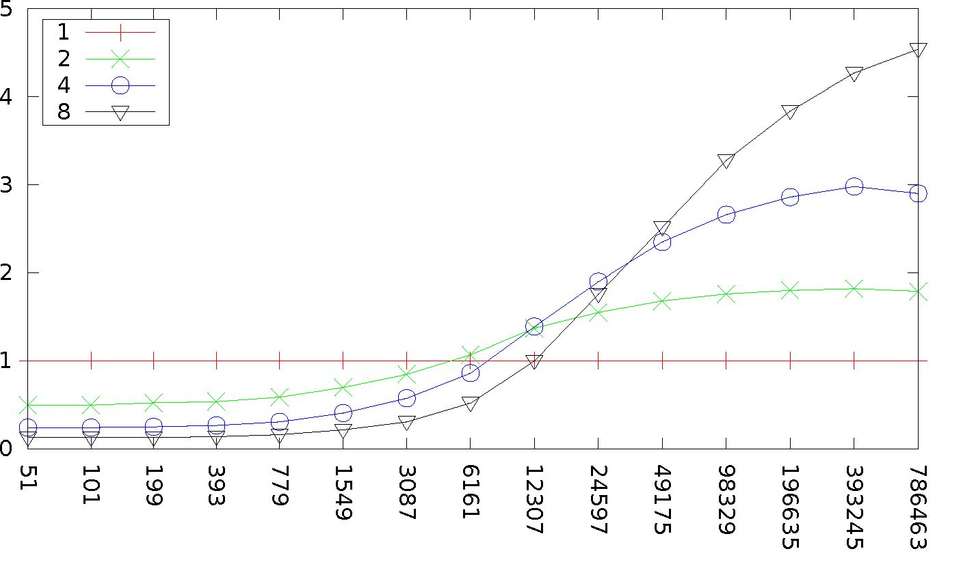
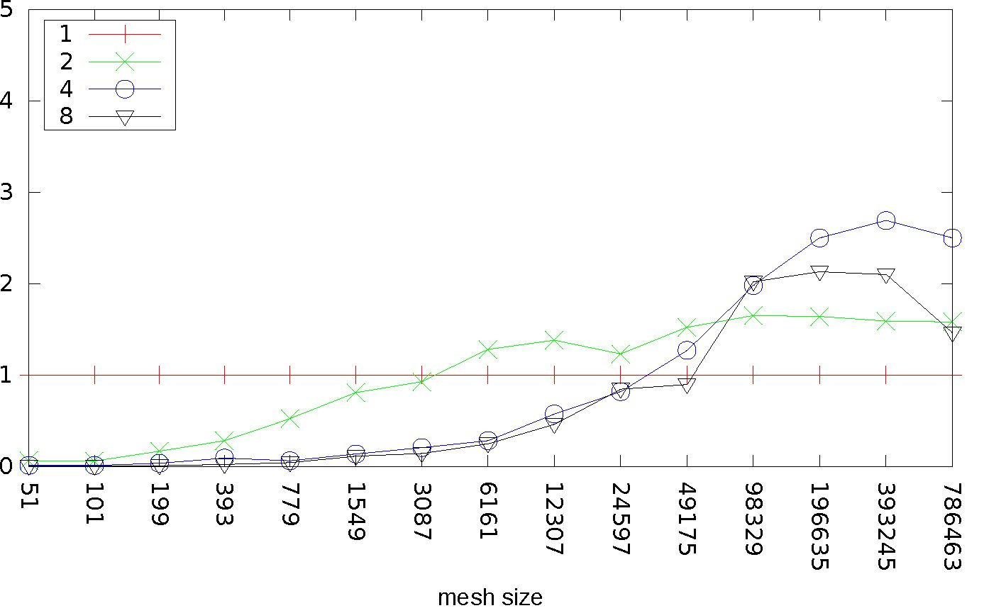
speedup speedup
42
Konrad Jopek et al.
mesh size
Figure 15. Speedup of GALOIS solver for edge singularity
Figure 16. Speedup of MUMPS solver for edge singularity
The MUMPS solver utilizes Cholesky factorization (the problem is symmetric
and positive definite), but our solver utilizes LU factorization. Our solver has better
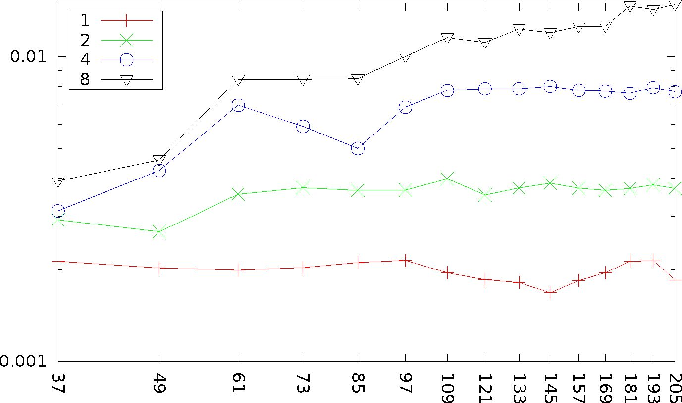
Hypergraph grammar-based, multi-thread, multi-frontal direct solver.
43
granularity in the sense that the hypergraph grammar model allows us to naturally
identify multiple independent tasks that can be grouped together and executed con-
currently. These tasks perform a partial LU factorization. These LU factorizations
performed on the small task matrices are slower than the Cholesky factorization per-
formed inside the MUMPS solver on parts of the global matrix. However, our total
execution time is shorter, as we can perform a better concurrent scheduling of more
small tasks resulting from the hypergraph grammar structure.
Our GALOIS solver is a pure C code and has been compiled with gcc-4.8.0.
The MUMPS solver has been compiled with gfortran-4.8.0 and linked to metis-4.0.3,
atlas-3.10.1, LAPACK-3.4.2, and ScaLAPACK-2.0.2. Thus, both solvers have been
compiled in an optimized way. The tests were performed on a single node of an
ATARI Linux cluster with an 8-core Intel(R) Xeon(R) CPU with 2.4 GHz and 16 GB
RAM. However, the MUMPS solver uses MPI as the communication mechanism, but
the GALOIS uses its own mechanism for multi-thread communication.
From the comparison presented in Figures 17-20 for the point singularity, we can
read that the grids for the point singularities are very small and that both solvers
lost their efficiency there. The MUMPS solver is faster in sequential mode; however,
our GALOIS multi-thread solver has a better speedup. This implies that our solver
has better mechanisms to manage the thread scheduling and communication, and its
overhead is smaller than that of MUMPS, which uses MPI as the communication
mechanism over a shared-memory multi-core machine.
mesh size
Figure 17. Execution time of GALOIS solver for point singularity
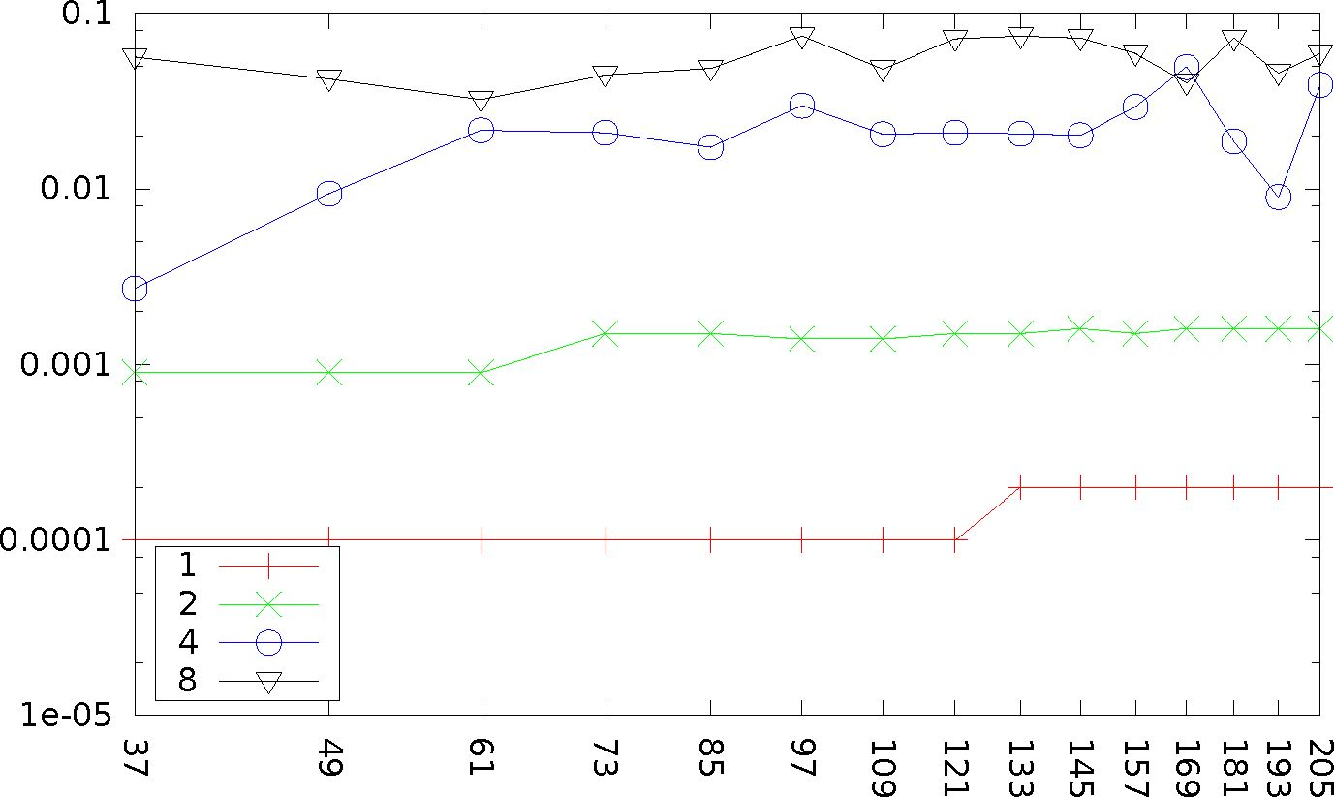
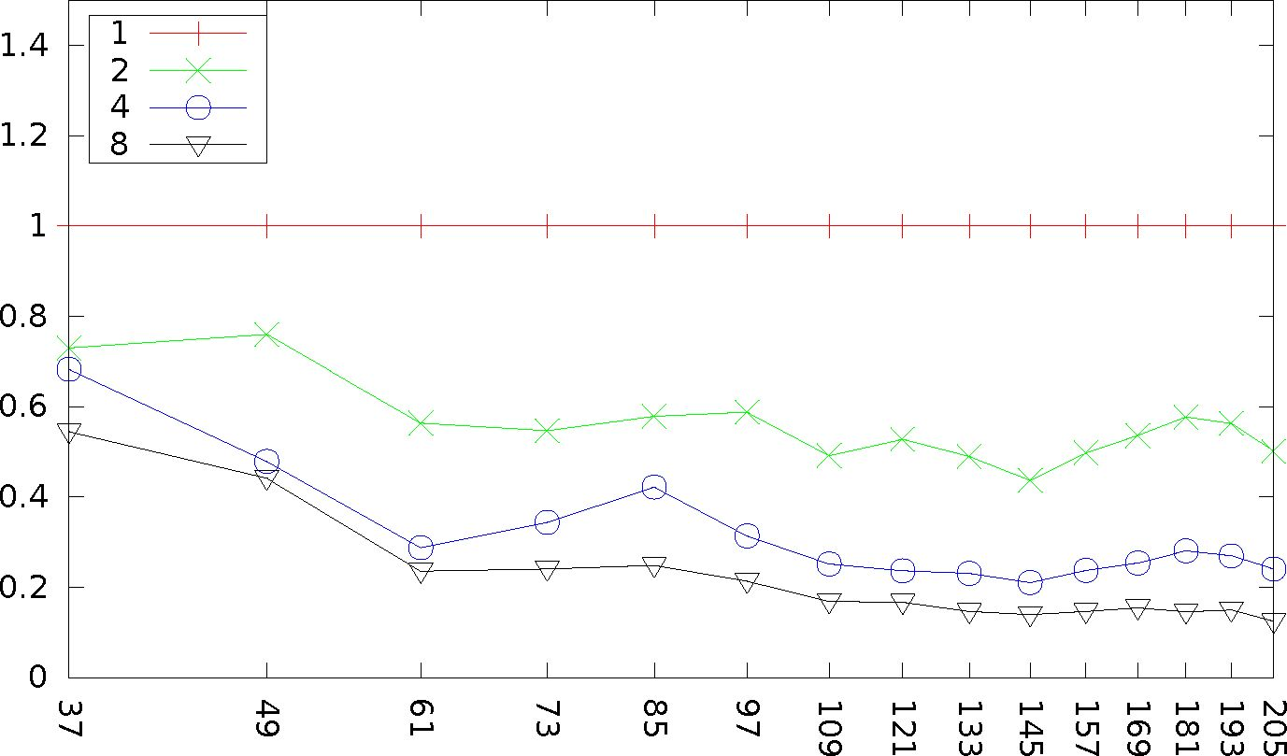
speedup time, s
44
Konrad Jopek et al.
mesh size
Figure 18. Execution time of MUMPS solver for point singularity
mesh size
Figure 19. Speedup of GALOIS solver for point singularity
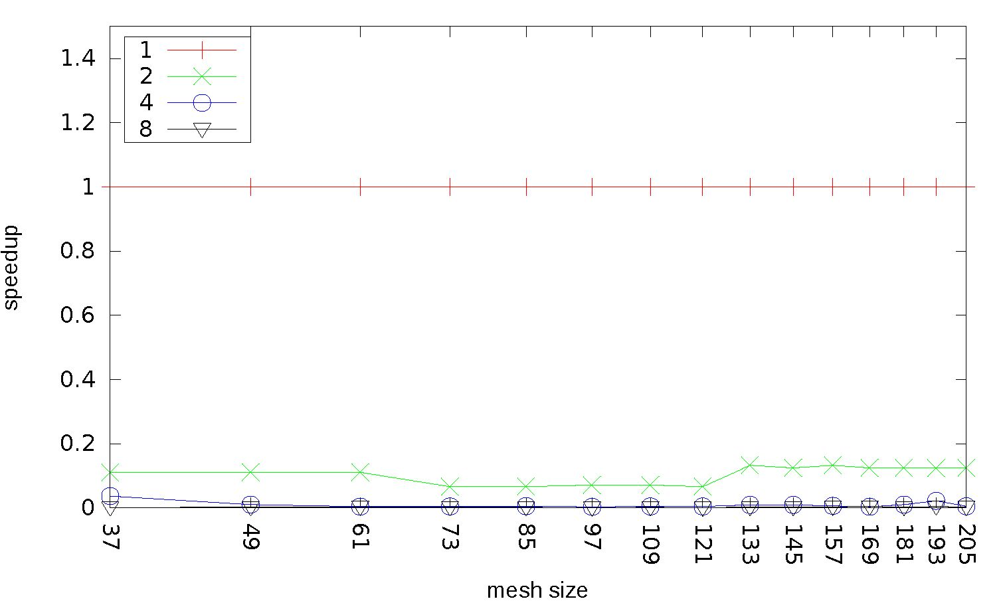
Hypergraph grammar-based, multi-thread, multi-frontal direct solver.
45
Figure 20. Speedup of MUMPS solver for point singularity

4.2. Quality of ordering resulting

from hypergraph grammar sequential processing of mesh
Another issue is how the sequential hypergraph grammar-based solver performs as
compared to traditional multi-frontal solvers.
In order to investigate this issue, it is necessary to transform the hypergraph
grammar-based processing of the mesh into the ordering for the sequential execution.
The ordering may be obtained by considering the sequence of tasks and not from the
sets of tasks processed in a concurrent manner. Each task corresponding to (Pelim*)
production eliminates some degrees of freedom, and this prescribes the ordering.
The method of how we order the tasks in a sequential manner over an arbitrary
mesh is prescribed by the bisections weighted by an element-size algorithm [1]. It is
worth mentioning that this ordering is possible to obtain with the hypergraph model
but not with the CP-graph model due to the structure of the graphs.
This ordering can then be passed to the sequential MUMPS solver, and the ex-
ecution times and flops can be compared with the traditional ordering algorithms
employed by the MUMPS solver (e.g., nested-dissections [17] or AMD [2]). A com-
parison of the nested-dissection ordering as implemented by the METIS library [17]
and the AMD ordering as used by MUMPS [3-5] with the ordering resulting from
our hypergraph grammar solver is presented in Figures 21 and 22. We compare the
number of floating-point operations performed during the elimination using particular
orderings.
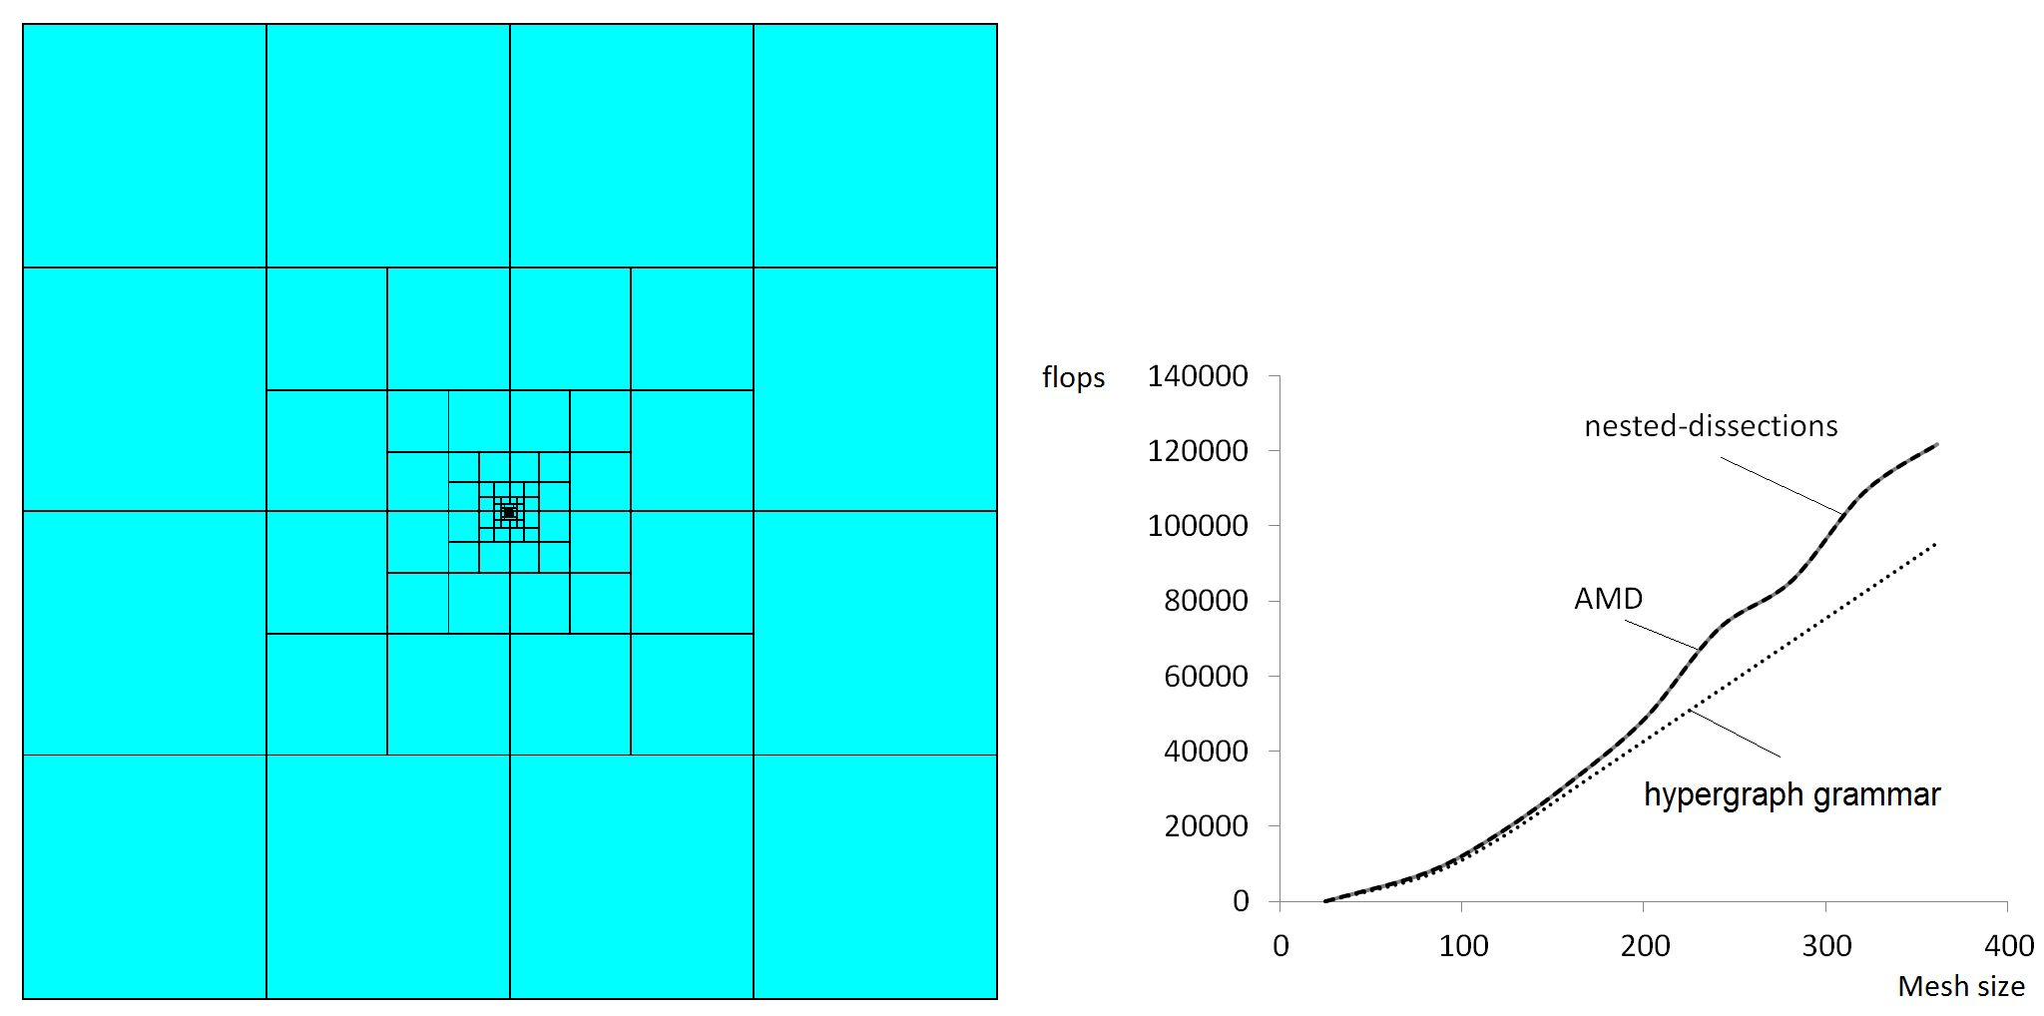
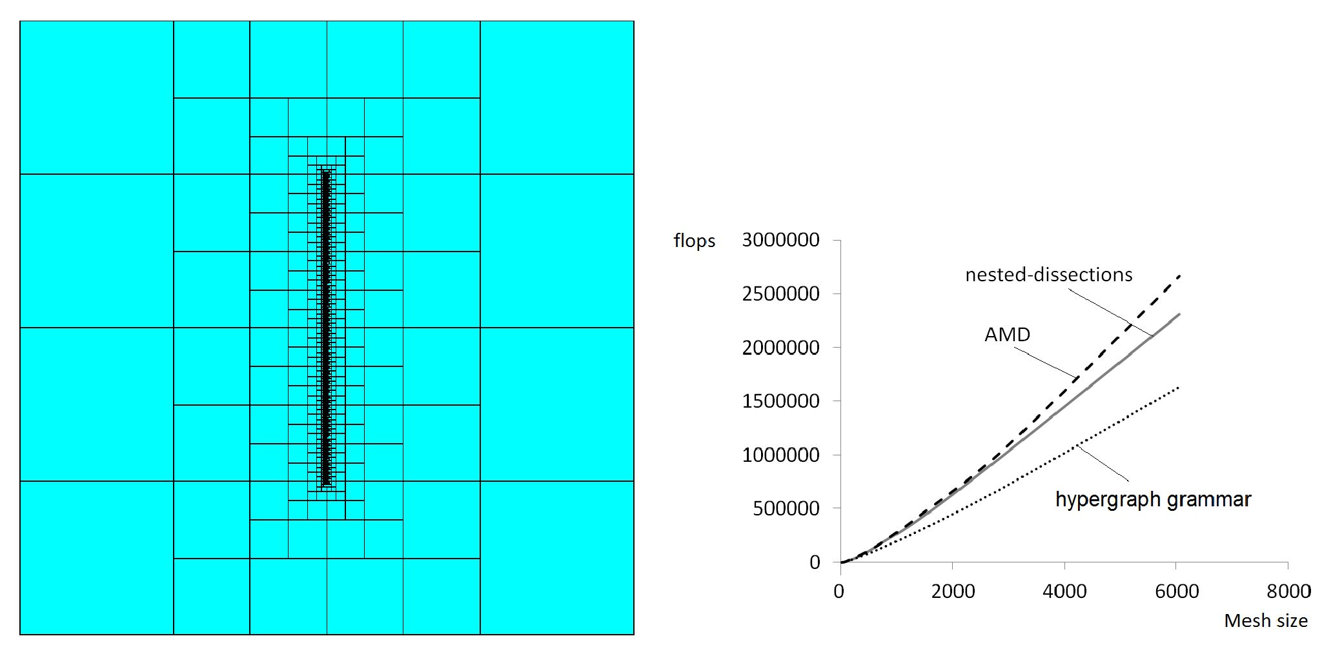
46
Konrad Jopek et al.
The data structure and the ordering that allows for a layer-by-layer elimination
of the elements surrounding the singularities results in a lower number of flops.
Figure 21. Comparison of hypergraph grammar ordering, nested-dissections, and AMD
ordering for point singularity
Figure 22. Comparison of hypergraph grammar ordering, nested-dissections, and AMD
ordering for edge singularity

4.3. Propagation of electromagnetic waves in formation layers
In this section, we provide the numerical results of our solver for a real engineering
problem related to simulations of the propagation of electromagnetic waves in the
formation layers.
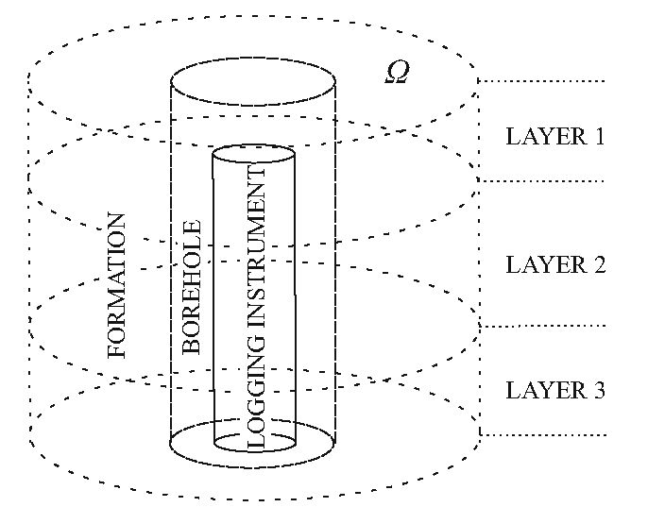
Hypergraph grammar-based, multi-thread, multi-frontal direct solver.
47
Several numerical methods exist for the simulation of forward resistivity measure-
ments (i.e. [6,7,10,19,24,33,37-39]). In this section, the forward problem is solved
by means of the goal-oriented self-adaptive hp Finite Element Method (hp-FEM) de-
veloped in [23,25]. We employ our solver as a key component of the goal-oriented
strategy. The governing equations are described as follows:
The direct current flow in the continuum 3D conductor is governed by time-
-harmonic Maxwell’s equations with an angular frequency of w = 0
curl H
curl E
div(e E)
div(pH)

(a + iwe) E + Jimp
—iwpH
X
0
(Ampere’s law)
(Faraday’s law)
(Gauss’s law of electricity)
(Gauss’s law of magnetism),
(1)
where H is the magnetic field intensity (magnetizing field), E is the electric field,
Jimp is a prescribed impressed electric current density, x is the electric free charge
distribution, and e, ^, and a stand for the permittivity, permeability, and electrical
conductivity of the considered medium, respectively.
We are looking for solutions to (1) in domain Q C R3 being a 3D cylinder
surrounding the borehole (see Fig. 23).
Figure 23. Three-dimensional geometry of logging instrument in vertical borehole penetrat-
ing three dipping layers. x = (x1, x2, x3) represents Cartesian system of coordinates, and
Z = (GA2, Z3) represents new non-orthogonal system of coordinates. New system of coordi-
nates is different in all three sub-domains. Subdomain I corresponds to logging instrument,
Subdomain II to borehole, and Subdomain III to formation. New system of coordinates is
globally continuous (as indicated by parameterization)
Notice that such an Q is a simply connected bounded domain with a Lipschitz
boundary. On boundary r = dQ, we consider homogeneous perfect electric conductor
(PEC) boundary conditions
n x E = 0 on r
(2)
with n being the outward unit normal vector field.
48
Konrad Jopek et al.
We consider the following Hilbert spaces:
H(curl; Q) = {F G L2(Q; C3) : curlF G L2(Q; C3)} (3)
and
V = H0(curl; Q) = {F G H(curl; Q) : n x F = 0 on r} . (4)
Both spaces are endowed with an inner product:
(E F)H(curl;n) = / cUrlE • curlF dx + / E • Fdx (5)
Jn Jn
where u • v = uivi + u2v2 + u3v3 (note that this is not the standard inner product
in C3).
Dividing both sides of Faraday’s law by ^, multiplying them by curlF, integrating
(one term by parts) over domain Q, and finally applying Ampere’s law, we obtain the
following variational formulation (the so-called E-formulation): find E G V such that
/ 1 curlE • curlFdx -/ (w2e - iwa)E • F = -iw f Jimp • Fdx (6)
Jn d Jn Jn
for every test field F G V. We assume that Jimp g L2(Q; C3), (w2e — iwa),d = 0,
d G R, e G R, d > 0,e > 0, and a G LTO(Q), a > a0 > 0 a.e. in Q.
For the case of deviated wells (below 90 degrees) in a horizontally stratified
layered media, we employ the hp-Fourier Finite Element Method described in [21].
This method performs a non-orthogonal change of coordinates followed by a Fourier
series expansion in the azimuthal direction. Using that technique, we obtain fast
and accurate forward simulations of the 3D resistivity logging measurements in the
deviated wells.
The forward problem is formulated for a 3D-skewed cylinder; therefore, we per-
form a change of variables from Cartesian to the non-orthogonal system of coordinates
(see Figure 23). First, we consider the union of three (possibly rotated) cylindrical
systems of coordinates defined over subdomains I, II, and III (respectively) as illus-
trated in Figure 23. The change of coordinates Z = (C1,C2,C3) = "Z(x) is globally
continuous and with a positive Jacobian J; therefore, it is suitable for Finite Element
computations. In addition, we observe that J (as a function of (2) can be represented
as a linear combination of functions 1, sin(Z2), and cos(Z2) because the change of co-
ordinates is composed of rotations of the cylindrical system of coordinates. It is easy
to see that corresponding metric tensor JT J (as a function of (2) can be represented
in terms of the following five Fourier basis functions: 1, cos(Z2), sin(Z2), cos2(Z2), and
sin2(Z2). Since the material properties for the geometry described in Figure 23 (de-
viated wells) are constant with respect to new quasi-azimuthal direction Z2 and the
metric can be represented exactly with only five Fourier modes, we conclude that,
when using a 1D Fourier series expansion in terms of Z2, the corresponding stiffness
matrix becomes penta-diagonal (as opposed to a dense matrix) with respect to Z2,
leading to a dramatic reduction of computational complexity. For details, see [21].
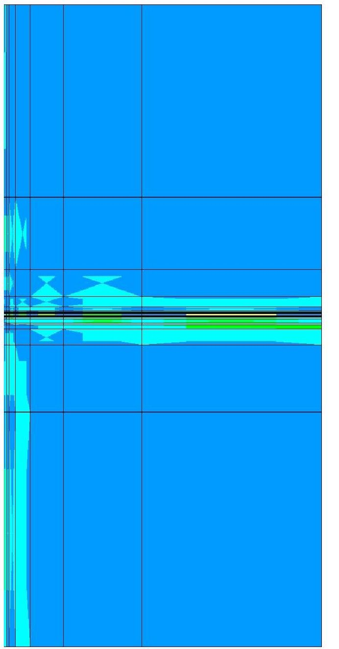
Hypergraph grammar-based, multi-thread, multi-frontal direct solver.
49
The primal direct problem for the conductive media equation can be summarized
as follows: find electric potential u G Hq(Q) assuming the zero Dirichlet condition on
the whole d0 for the given resistivities of all layers and the borehole subdomain. The
influence of the probe is expressed by the assumed displacement of q = V • Jimp in
the borehole subdomain.
We have connected our solver to the goal-oriented hp adaptive finite element
method code solving the problem of the propagation of electromagnetic waves in
the borehole and the formation layers. The code uses a 2D mesh expanded in the
cylindrical system of coordinates. Thus, the computational mesh is treated like a 2D
mesh with the number of unknowns per mesh nodes corresponding to the number
elements in the azimuthal direction.
The exemplary meshes after rotating the 2D mesh and transforming it back to
the skew cylindrical system are presented in Figures 24-25.
Figure 24. Example of two-dimensional grid generated by goal-oriented hp-adaptive finite
element method code solving
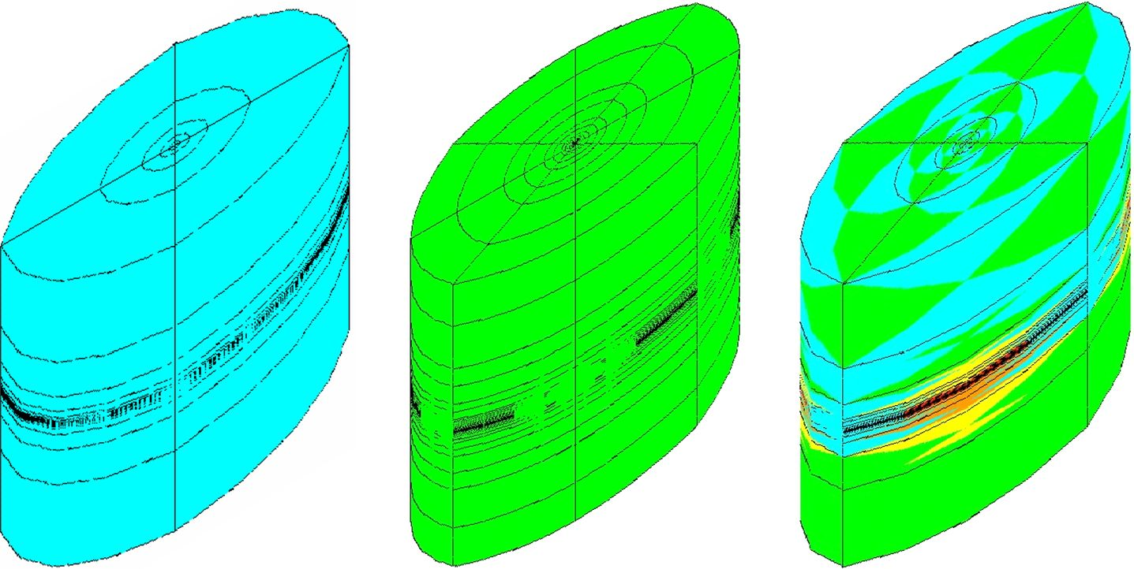
50
Konrad Jopek et al.
Figure 25. Example of three-dimensional grid obtained by rotating two-dimensional one
in azimuthal direction
The code operates in two loops. The first loop iterates through positions of
antennas; for each position, the second loop with mesh refinements are executed. We
refer to [21] for more details. In Table 1, we present a comparison of an execution
time of the MUMPS solver and our solver on a grid generated by the goal-oriented
code as well as the total time of the code for all of the positions of the antennas. We
can read a similar scalability of our solver with the MUMPS solver and around a two-
to three-times-faster execution time of our solver. The largest mesh size from a single
antenna solution is equal to 148,257, but the solver is called several times for different
positions of the antennas. We break the computations for 32 cores since the solver
execution time is larger than for 16 cores. This is due to hyperthreading on the Linux
cluster node.
Table 1
Scalability of our solver on problem of propagation of electromagnetic waves
Cores | 1 | 2 | 4 | 8 | 16 | 32
Hypersolver time [s] | - | 14.506 | 8.124 | 5.209 | 3.35 | 4.038
MUMPS time [s] | - | 27.859 | 17.457 | 12.747 | 10.011 | 11.015
Total time [s] | - | 1087 | 735 | 555 | 295 | -

5. Conclusions
In this paper, we have analyzed the concurrency of the multi-frontal direct solver
executed over model two-dimensional grids with point and edge singularity.
We defined several hypergraph grammar productions over the hypergraph rep-
resentation of the computational mesh. We analyzed the dependency relationship
Hypergraph grammar-based, multi-thread, multi-frontal direct solver.
51
between the so-called tasks (defined as application of the production to the subhyper-
graph of the hypergraph representing the mesh) and constructed dependency graphs
that are the equivalents of elimination trees. The hypergraph grammar productions
were implemented and executed in the GALOIS system. A sequence of numerical
experiments tested the scalability of the resulting multi-thread multi-frontal direct
solver.
We show that our GALOIS-based solver outperforms the MUMPS solver on the
example of edge singularity. This is because MUMPS is not a task-based programming
model solver. The utilization of the graph grammar for the expression of the solver
algorithm allows for a better granularity in the computations, and there are more
independent tasks to be scheduled for concurrent execution. The hypergraph grammar
model allows for a better definition of the computational tasks related to hypergraph
grammar productions. Since the hypergraph represents the computational mesh as
a flat structure, it is easy to process the elements surrounding the singularities layer
by layer. This in turn produces more independent tasks to be scheduled for concurrent
execution.
The hypergraph is just a “flat” data structure allowing for a simple construc-
tion of tasks surrounding the singularities and processing them level by level. The
hypergraph grammar is just a model for expressing the solver algorithm. For more-
-complicated grids, it requires some control algorithm that chooses the parts of the
mesh where the productions will be executed and allow for the selection of sets of tasks
by coloring the dependency graph. For the problem of the propagation of electromag-
netic waves in formation layers, we employ the bisections weighted by an element size
algorithm [1] to identify the tasks. These sets are then scheduled by the GALOIS
using the available cores. Our future work will involve a generalization to three-di-
mensional grids.

Acknowledgements
This work was supported by National Science Center, Poland - Grant No. DEC-2015/
17/B/ST6/01867.

References
- AbouEisha H., Moshkov M., Calo V.M., Paszyński M., Goik D., Jopek K.:
Dynamic programming algorithm for generation of optimal elimination trees
for multi-frontal direct solver over h-refined grids, Procedia Computer Science,
vol. 29, pp. 947-959, 2014.
- Amestoy P.R., Davis T.A., Du I.S.: An Approximate Minimum Degree Or-
dering Algorithm, SIAM Journal of Matrix Analysis & Application, vol. 17(4),
pp. 886-905, 1996.
52
Konrad Jopek et al.
- Amestoy P.R., Duff I.S., L’Excellent J.Y.: Multifrontal parallel distributed sym-
metric and unsymmetric solvers, Computer Methods in Applied Mechanics and
Engineering, vol. 184(2), pp. 501-520, 2000.
- Amestoy P.R., Duff I.S., L’Excellent J.Y., Koster J.: A fully asynchronous mul-
tifrontal solver using distributed dynamic scheduling, SIAM Journal on Matrix
Analysis and Applications, vol. 23(1), pp. 15-41, 2001.
- Amestoy P.R., Guermouche A., L’Excellent J.Y., Pralet S.: Hybrid schedul-
ing for the parallel solution of linear systems, Parallel Computing, vol. 32(2),
pp. 136-156, 2006.
- Avdeev D.B., Kuvshinov A.V., Pankratov O.V., Newman G.A.: Three-dimen-
sional induction logging problems, Part I: An integral equation solution and model
comparisons, Geophysics, vol. 67(2), pp. 413-426, 2002.
- Davydycheva S., Druskin V., Habashy T.: An efficient finite-difference scheme
for electromagnetic logging in 3D anisotropic inhomogeneous media, Geophysics,
vol. 68(5), pp. 1525-1536, 2003.
- Demkowicz L.: Computing with hp-Adaptive Finite Elements, Vol. I. One and
Two Dimensional Elliptic and Maxwell Problems, Chapman and Hall/CRC Ap-
plied Mathematics and Nonlinear Science, 2006.
- Diekert V., Rozenberg G.: The book of traces, World Scientific Publishing, 1995.
- Druskin V.L., Knizhnerman L.A., Lee P.: New spectral Lanczos decomposition
method for induction modeling in arbitrary 3-D geometry, Geophysics, vol. 64(3),
pp. 701-706, 1999.
- Duff I.S., Reid J.K.: The Multifrontal Solution of Indefinite Sparse Symmetric
Linear, ACM Transactions on Mathematical Software, vol. 9, pp. 302-325, 1983.
- Duff I.S., Reid J.K.: The Multifrontal Solution of Unsymmetric Sets of Linear
Equations, SIAM Journal on Scientific and Statistical Computing, vol. 5,
pp. 633-641, 1984.
- Geng P., Oden J., van de Geijn R.: A parallel multifrontal algorithm and
its implementation, Computer Methods in Applied Mechanics and Engineering,
vol. 149(1), pp. 289-301, 1997.
- Goik D., Jopek K., Paszyński M., Lenharth A., Nguyen D., Pingali K.: Graph
Grammar based Multi-thread Multi-frontal Direct Solver with Galois Scheduler,
Procedia Computer Science, vol. 29, pp. 960-969, 2014.
- Habel A., Kreowski H.J.: May we introduce to you: Hyperedge replacement.
In: Ehrig H., Nagl M., Rozenberg G., Rosenfeld A. (eds.), Graph-Grammars and
Their Application to Computer Science. Graph Grammars 1986, Lecture Notes
in Computer Science, vol. 291, pp. 15-26, Springer, Berlin, Heidelberg, 1987.
Hypergraph grammar-based, multi-thread, multi-frontal direct solver.
53
- Habel A., Kreowski H.J.: Some Structural Aspects of Hypergraph Languages
Generated by Hyperedge Replacement. In: Brandenburg F.J., Vidal-Naquet G.,
Wirsing M. (eds.), STACS 87. STACS 1987, Lecture Notes in Computer Science,
vol. 247, pp. 207-219, Springer, Berlin, Heidelberg, 1987.
- Karypis G., Kumar V.: MeTis: Unstructured Graph Partitioning and Sparse
Matrix Ordering System, Version 4.0, 1998. http://umn.edu/home/karypis.
- Liu J.: The role of elimination trees in sparse factorization, SIAM Journal of
Matrix Analysis and Applications, vol. 11(1), pp. 134-172, 1990.
- Newman G.A., Alumbaugh D.L.: Three-dimensional induction logging problems,
Part 2: A finite-difference solution, Geophysics, vol. 67(2), pp. 484-491, 2002.
- Obrok P., Pierzchala P., Szymczak A., Paszynski M.: Graph grammar-based
multi-thread multi-frontal parallel solver with trace theory-based scheduler, Pro-
cedia Computer Science, vol. 1(1), pp. 1993-2001, 2010.
- Pardo D., Calo V., Torres-Verdm C., Nam M.: Fourier series expansion in a non-
-orthogonal system of coordinates for the simulation of 3D-DC borehole resis-
tivity measurements, Computer Methods in Applied Mechanics and Engineering,
vol. 197(21), pp. 1906-1925, 2008.
- Pardo D., Demkowicz L., Torres-Verdm C., Paszyński M.: A self-adaptive goal-
-oriented hp-finite element method with electromagnetic applications. Part II:
Electrodynamics, Computer Methods in Applied Mechanics and Engineering,
vol. 196(37), pp. 3585-3597, 2007.
- Pardo D., Demkowicz L., Torres-Verdm C., Paszynski M.: Two-Dimensional
High-Accuracy Simulation of Resistivity Logging-While-Drilling (LWD) Measure-
ments Using a Self-Adaptive Goal-Oriented hp-Finite Element Method, SIAM
Journal on Applied Mathematics, vol. 66(6), pp. 2085-2106, 2006.
- Pardo D., Torres-Verdm C., Paszynski M.: Simulations of 3D DC borehole re-
sistivity measurements with a goal-oriented hp finite-element method. Part II:
through-casing resistivity instruments, Computational Geosciences, vol. 12(1),
pp. 83-89, 2008.
- Pardo D., Torres-Verdin C., Demkowicz L.F.: Simulation of multifrequency bore-
hole resistivity measurements through metal casing using a goal-oriented hp
finite-element method, IEEE Transactions on Geoscience and Remote Sensing,
vol. 44(8), pp. 2125-2134, 2006.
- Paszynńska A., Grabska E., Paszynński M.: A Graph Grammar Model of the hp
Adaptive Three Dimensional Finite Element Method. Part I, Fundamenta Infor-
maticae, vol. 114, pp. 149-182, 2012.
- Paszynńska A., Grabska E., Paszynński M.: A Graph Grammar Model of the hp
Adaptive Three Dimensional Finite Element Method. Part II, Fundamenta In-
formaticae, vol. 114, pp. 183-201, 2012.
54
Konrad Jopek et al.
- Paszyńska A., Paszynski M., Grabska E.: Graph Transformations for Modeling
hp-Adaptive Finite Element Method with Mixed Triangular and Rectangular
Elements. In: Allen G., Nabrzyski J., Seidel E., van Albada G.D., Dongarra J.,
Sloot P.M.A. (eds.), Computational Science - ICCS 2009. ICCS 2009, Lecture
Notes in Computer Science, vol. 5545, pp. 875-884, Springer, Berlin, Heidelberg,
2009.
- Paszyńska A., Paszyński M., Jopek K., Wozniak M., Goik D., Gurgul P.,
AbouEisha P., Moshkov M., Calo V.M., Lenharth A., Nguyen D., Pingali K.:
Quasi-Optimal Elimination Trees for 2D Grids with Singularities, Scientific Pro-
gramming, vol. 2015, pp. 1-18, 2015.
- Paszyński M.: On the Parallelization of Self-Adaptive hp-Finite Element Meth-
ods, Part I. Composite Programmable Graph Grammar Model, Fundamenta In-
formaticae, vol. 93(4), pp. 411-434, 2009.
- Paszyński M.: On the Parallelization of Self-Adaptive hp-Finite Element Meth-
ods, Part II. Partitioning Communication Agglomeration Mapping (PCAM)
Analysis, Fundamenta Informaticae, vol. 4(93), pp. 435-457, 2009.
- Paszyński M., Schaefer R.: Graph grammar-driven parallel partial differential
equation solver, Concurrency and Computation Practice and Experience, vol. 22,
pp. 1063-1097, 2010.
- Paszyński M., Demkowicz L., Pardo D.: Verification of goal-oriented HP-adap-
tivity, Computers & Mathematics with Applications, vol. 50(8), pp. 1395-1404,
2005.
- Pingali K., Nguyen D., Kulkarni M., Burtscher M., Hassaan M.A., Kaleem R.,
Lee T.H., Lenharth A., Manevich R., Mendez-Lojo M., Prountzos D., Sui X.: The
Tao of Parallelism in Algorithms, SIGPLAN Not., vol. 46(6), pp. 12-25, 2011.
- Schmitz P.G., Ying L.: A fast direct solver for elliptic problems on general meshes
in 2D, Journal of Computational Physics, vol. 231(4), pp. 1314-1338, 2012.
- Ślusarczyk G., Paszyńska A.: Hypergraph Grammars in hp-adaptive Finite Ele-
ment Method, Procedia Computer Science, vol. 18, pp. 1545-1554, 2013.
- Wang T., Fang S.: 3-D electromagnetic anisotropy modeling using finite differ-
ences, Geophysics, vol. 66(5), pp. 1386-1398, 2001.
- Wang T., Signorelli J.: Finite-difference modeling of electromagnetic tool re-
sponse for logging while drilling, In: Geophysics, vol. 69(1), pp. 152-160, 2004.
- Zhang J., Mackie R.L., Madden T.R.: 3-D resistivity forward modeling and in-
version using conjugate gradients, Geophysics, vol. 60(5), pp. 1313-1325, 1995.
Hypergraph grammar-based, multi-thread, multi-frontal direct solver.
55

Affiliations
Konrad Jopek
AGH University of Science and Technology, Department of Computer Sciences, Krakow,
Poland, kjopek@gmail.com
Maciej Paszyński 0
AGH University of Science and Technology, Department of Computer Sciences, Krakow,
Poland, maciej.paszynski@agh.edu.pl, ORCID ID: https://orcid.org/0000-0001-7766-6052
Anna Paszyńska 0
Jagiellonian University, Krakow, Poland, anna.paszynska@uj.edu.pl,
ORCID ID: https://orcid.org/0000-0002-0716-0619
Muhammad Amber Hassan
The University of Texas at Austin, Institute for Computational and Engineering Sciences,
USA, amberuet@gmail.com
Keshav Pingali
The University of Texas at Austin, Institute for Computational and Engineering Sciences,
USA, amberuet@gmail.com
Received: 08.08.2018
Revised: 17.11.2018
Accepted: 17.11.2018

