Nr 10 (659—740)

PAŹDZIERNIK 2000
Tom XLV

MIESIĘCZNIK POŚWIĘCONY CHEMIĘ TECHNOLOGII I PRZETWÓRSTWU POLIMERÓW
JULITA JAKUBIAK'*, JAN F. RABEK"

Kinetics modeling of linear and crosslinking photopolymerizations

Part II. OVERALL RATE OF POLYMERIZATION (INCLUDING INITIATION,
PROPAGATION AND TERMINATION STEPS)'")
Summary — A review with 36 references covering a comparison of mode-
ling of linear and crosslinking photopolymerizations. The overall rates of
polymerization are discussed, including initiation, propagation and termi-
nation steps. The kinetics of free-radical polymerization is described and
ways are presented to evaluate individual rate constants.
Key words: photopolymerization, photoinitiators, kinetics of initiation, pro-
pagation and termination steps.
When a free radical polymerization is first started the
number of propagating radicals in the system increases
from zero. In the early stage of polymerization the
frequency of termination reactions will also increase
from zero, because the termination rates (klc and kk:t), are
proportional to the square of the total concentrations of
all radicals in the system. The rate at which radicals are
generated will be balanced by the rate at which radicals
recombine, and the concentration of radicals in the sys-
tem will reach a steady value. This steady state is rea-
ched very early in the linear polymerization reaction.
The assumption that the rate of initiation (R,) equals the
rate of termination (R,) is known as the steady-state as-
sumption [2, 3]:
R, = 2/MI]
R, = 2 k,[P'f
Ri = Ri under steady-state conditions
(1)
(2)
(3)
Jagiellonian University, Department of Chemistry, Ingardena 3,
30-060 Cracow, Poland. To whom all correspondence should be
addressed.
) Polymer Research Group, Department of Dental Biomaterial
Science, Karolińska Institute (Royal Academy of Medicine), Box
4064, 141 04 Huddinge (Stockholm), Sweden.
*) Part I see [1].
where (cf. Part I, eqns. 13 and 70):fis the photoinitiator ef-
ficiency, ktl and k, are the rate constants of photoinitiator de-
composition and termination, respectively, [I] and [P’]are
the concentrations of photoinitiator and propagating radicals,
respectively.
Under the steady-state condition
d[P‘]
df
! = 0
(4)
Substitution of eqns. (1) and (2) into eqn. (3) gives:
2fkJ[l]=2k,[rf (5)
Hence, the total concentration of propagating radicals
(experimentally accessible quantities) is
(6)
The rate of polymerization is defined as the rate of
disappearance of the monomer, which is d[M]/df (the
concentration of monomer [M] decreases with time, so
d[M]/df is negative). The monomer is consumed by
two reactions, initiation and propagation, therefore
-d[M]
df
= R: + R.
(7)

POLIMERY
660
POLIMERY 2000, 45, nr 10
The initiation process accounts for a negligible amo-
unt of monomer if a high-molecular-weight crosslinked
polymer is produced. Then the rate of polymerization
(P()) can be taken as equal to the rate of propagation
(R,„)
R,, = Rrr (8)
and the polymerization rate constant (kp) is equal to the
propagation rate constant (kpr)
(9)
k„ = k„,
and R,, is given by
R,,=^-]=yM]n
Substitution of eqn. (6) into eqn. (10) gives
Rr =
-d[M]
dt k'!2
(10)
(11)
Tire rate of polymerization (R()) is given in mol ■ liter'1
•s'1. The photoinitiator concentration [I] given by
equation (12) (cf. Part I, eqn. 7)
[I] = [I]0 exp(-k,,t)
can be inserted into eqn. (11) to give
-d[M]
[M]
= k.
k> .
(12)
(13)
Integration of eqn. (13) between [M]
and [M] at t gives
0/2
[M]„ at f = 0
- In
[M]
[Ml,
(l-exp(T,f)) (14)
The above equation gives the amount of polymer in
terms of the mols of monomer converted which was
produced in time t.
Dead-end linear polymerization is a useful technique
to evaluate kEquation (14) can be written [2] as
where parameter V0 is defined as
V0=k„
[If
(15)
(16)
Tire useful feature of eqn. (15) is that k,, is separated
from the other rate constants because it is the only kine-
tic parameter in the experimental function. If the star-
ting initiator concentration [I]0 is insufficient to make all
the monomer polymerize, the reaction will reach a dead
end after a long time (f -> co). The corresponding limi-
ting value of [M] can be used to assess kt„ provided this
concentration can be determined accurately and the
polymerization does not exhibit autoacceleration effects
at high conversions [4]. It is convenient to expand the
exponential function in eqn. (15) into a power series
and to simplify the resulting expression to
- In
[M]
(17)
If the f term is much larger than the f2, eqn. (17) can
be reduced to
-In
[M]
j^l = V0-Vb(^\ t
(18)
A plot of the left-hand side of eqn. (18) vs. time pro-
duces a straight line with intercept (at t = 0) equal to V0
and slope useful to calculate k,t [5].
For linear photopolymerization, Rp is given [3] by the
equation
k„
R.. = -
where
(19)
(20)
h = Jo e[I]oI
where: /„ is the intensity of light absorbed, Iv is the intensity
of incident light, ct>i( is the quantum yield of the photoinitiator
decomposition into free radicals, e is the molar extinction co-
efficient of the photoinitiator, I is the path length of a sample
(cf. Part I, eqn. 16).
According to eqns. (19) and (20), Rp should vary initial-
ly with the square-root of initiator concentration ([I]). As-
suming the Beer-Lambert law to hold true, Rp becomes
K,=pr((I,AW) [M]
(21)
For the photoinitiator endowed with a high molecu-
lar absorptivity (e), Rp will not exhibit the half-order de-
pendence on initial initiator concentration [6], The valu-
es of e vary on passing from one initiator to another
and so varies the concentration at which deviations
from the square-root dependence are observed.
It is difficult to measure k, directly [7—10]. However,
photopolymerizations offer the unique advantage of
controlling the propagating radical concentration [P’]
by exposing or shielding the polymerizing sample from
the light source [11—13]. Assuming termination to be
exclusively a bimolecular process and k, to be approxi-
mately constant over a small time interval, the termina-
tion rate constant (k,) can be calculated from eqns. (22)
and (23) [13] as follows
2 (Wo)
K
k'r-
i
k'r-
[M], [Ml,
k'r-
(R„), (R,X
R
(22)
(23)
where [M]0 and [M], arc the monomer concentrations and
(Rr)o and (R^), arc the rates of polymerization at the begin-
ning of polymerization (t0) and after a time of irradiation (t,),
respectively.
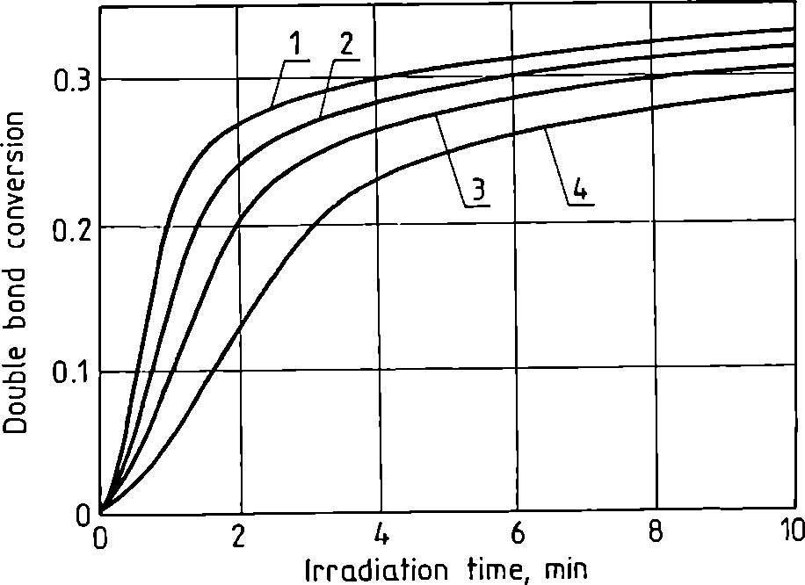
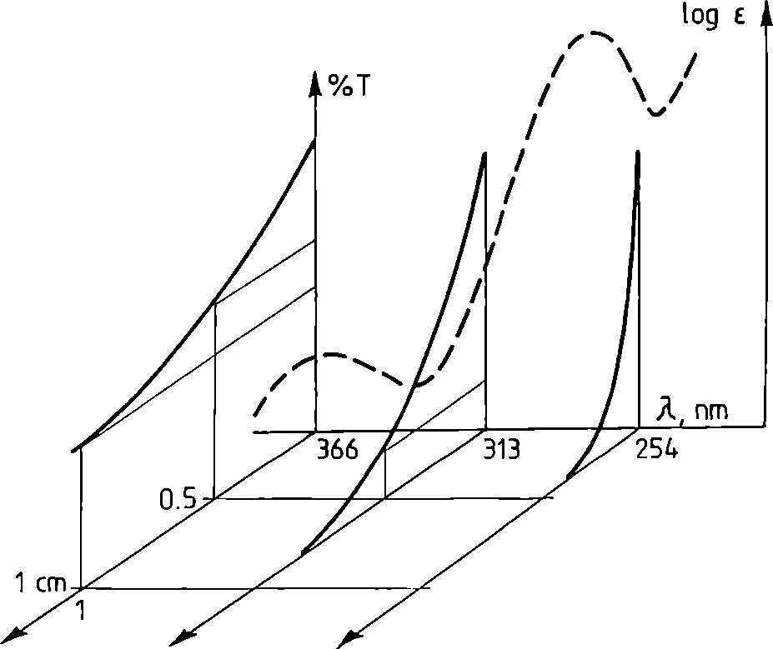
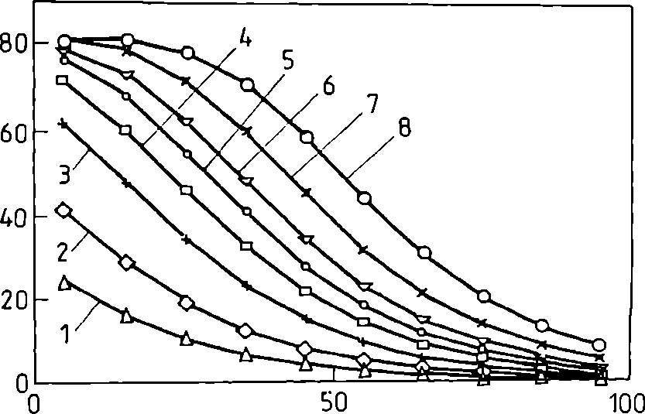
POLIMERY 2000, 45, nr 10
661
The rate of polymerization (R;) can be measured
directly by the photo-DSC (cf. Part III). The ratio kfff
can be calculated from the dependence of k, and /c(, on
the monomer conversion (i.e., monomer conversion =
degree of double bonds conversion, only for monofunc-
tional monomers) (p) [14—17]. Tire monomer conver-
sion can be measured directly by the photo-DSC (cf.
Part III).
In the photocrosslinking polymerization, the rate of
polymerization (R(1) is dependent on the monomer dif-
fusivity in the polymerized matrix and on the distance
from the illuminated surface of the polymerized film (x)
(depth of curing) (Fig. 1.) [18, 19]. A sample at the sur-
face is exposed to the highest intensity of light and doub-
le bond conversions are greatest. Depending on the
thickness of the sample, the differences between
Fig. 2. Simula ted profile of conversion of double bonds in a
multifunctional monomer vs. polymerization time at
different depths in the polymer: 1 — surface, 2 — 1.4 mm,
3 — 2.8 mm, and 4 — 4.6 mm [16]
Fig. 2. Absorption spectrum of a photoinitiator, log e = fCk);
fraction of light transmitted (% T) at different wavelengths
as a function of the optical path length (x); in this example,
one-half of the incident light is absorbed ivithin 1 cm, 1 mm
and 10 pm at 366, 313 and 254 nm, respectively [18]
conversions at the surface and in the bulk of the sample
can be appreciably different. The variations in the con-
version with depth are dependent on the molar absorp-
tivity and concentration of the photoinitiator (Fig. 2).
The rate of polymerization is expressed as
dt -knM
dx2
(24)
where kDM (cm2 ■ s1) is the monomer diffusion rate constant.
In the initiation by photolysis of an initiator (I), the
rate of initiation (R[) depends directly on the intensity
of the incident light (IQ), as well as on [I], and the rate of
linear polymerization is ideally proportional to (Iu[I])l/2.
Deviations from the predicted dependence of Rr on [M],
[I]1/2, and x are common in crosslinking photopolymeri-
zation. The initiation rate and the initiation efficiency /
may depend on [M] if primary radicals escape from
their monomer cage by reaction with the nearest mono-
mer molecules. At high initiation rates, some of the pri-
mary radicals formed by photodecomposition of the
initiator can terminate kinetic chains. This primary ter-
mination causes that the observed R(, depends on [M]
raised to a power greater than unity and reduces the
dependence of Rr on [I] to less than the power 0.5. The
intensity of incident light (Ia) dependence (Fig. 3) and
Film thickness, jjm
Fig. 3. Calculated plots of the photocuring profiles at
different UV-irradiation energies [19] (mf/cnf): 1 — 5, 2 —
10, 3 — 20, 4 — 30, 5 — 40, 6 — 50, 7 — 50, 8 — 100
depth (z) dependence (Fig. 4) of the photocuring level
(gel content) have been modeled with computer pro-
grames [19, 21, 22].
Then n-th order polymerization model assumes the
rate of polymerization (Rf to obey the following equa-
tion
Rp=kp0-pr (25)
where kp is the polymerization rate constant, p is the fractio-
nal conversion of double bonds after time (t) [23—25].
The autocatalytic model considers the effect of auto-
catalysis by the reactant as an independent reaction of
order m [26, 27]:
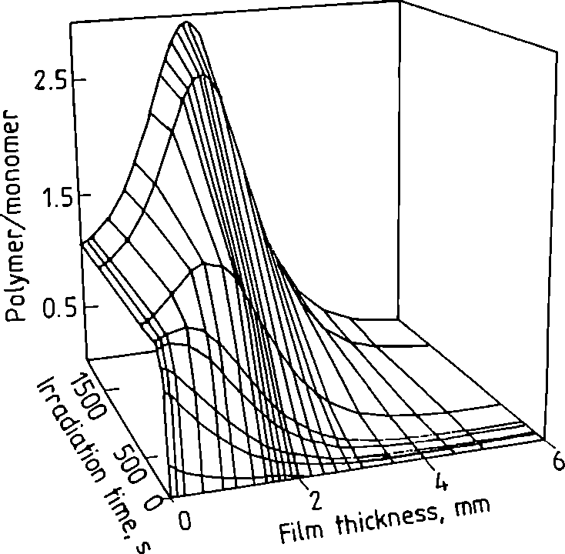
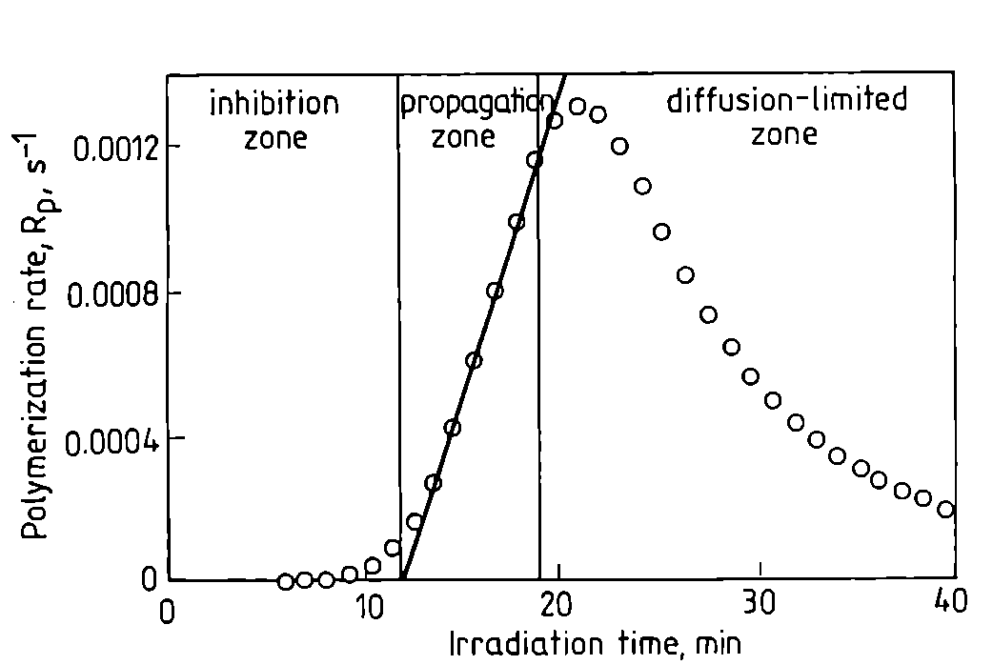
662
POLIMERY 2000, 45, nr 10
Fig. 4. Calculated plots of the photocuring profiles at
different distances from the irradiated surface [17]
(26)
where n is the reaction order exponent and m is the
autocatalytic exponent.
However, the autocatalytic model does not explicitly
include the effects of initiator and inhibitor concentra-
tions on the rate of polymerization.
The average life time of the kinetic chain (t) is given
by the ratio of the steady-state radical concentration to
the steady-state rate of radical disappearance [2]:
F'] 1
T 2 (K+kJIP-f 2(/c, + fc„,)[P-] (27)
where klc and kul are the rate constants of termination by
combination and disproportionation.
Substitution for [P’] from eqn. (10)
R.
[P-
UM]
gives
where:
MM]
2(ir„+/c„)R,
ki — k/r + kt.,
(28)
(29)
(30)
is obtained as the average life time of the kinetic cha-
in (t):
t = i (fkM)vlk!n (31)
Generally crosslinking polymerization has three regi-
mes in the reaction kinetics mechanism (Fig. 5) [18,
28—33]:
- inhibition zone: radicals generated by photoinitia-
tor decomposition are consumed by oxygen and/or in-
hibitor present in the monomer;
- propagation zone: after inhibitor has been consu-
med, the radical concentration increases with time to
accelerate curing;
Fig. 5. Rate of polymerization vs. lime, defining the
inhibition zone, propagation zone and the diffusion-limited
zone [30]
— diffusion-limited zone: polymerization rate slows
on account of diffusion limitations of radicals and the
monomer.
The influence of temperature of individual rate con-
stant k,t, k and k, can be expressed by the Arrhenius
equation [35]
(32)
k = A exp —-
n RT
where A is the preexponential factor, E„ is the Arrhenius
activation energy, R is the gas constant (1.987 cal ■ deg1 ■ mol'1),
and T is the absolute temperature.
Taking the natural logarithms on both sides gives:
Ink = In A
RT
and the differential form is:
dink _ -£,
(33)
(34)
A plot of In k vs. 1/T yields a straight line; A and E„
can be determined from the intercept and the slope
(-Eu/R), respectively. Because of experimental uncer-
tainities, a plot covering a larger temperature range will
produce a grater precision in the value of E„ [36]. The
intercept of the plot corresponds to a value of 1/T of 0,
and is equal to In A. However, a long extrapolation of a
plot of experimental data may produce an inaccurate
value of A [37]. An alternative approach is to calculate
In A from the E„ value and the data for the reaction rate
constant at some temperature in the middle of the ran-
ge of temperature-rate data. Each 10°C increase in reac-
tion temperature will result in a two- to three-fold in-
crease in the rate of polymerization. Chain transfer to
polymer increases as the reaction temperature is in-
creased.
The values of A and E„ can provide a full description
of the thermodynamic data polymerization: enthalpy of
activation (AG") and entropy of activation (AS") [38]:
POLIMERY 2000, 45, nr 10
663
AS1’ = R| ln/\-ln|y 1-1
(36)
where: k is the Boltzmann constant, h is Planck's constant.
The three separate /c,„ kp and k, Arrhenius expressions
can be combined in a straightforward manner to obtain
the temperature dependence of the kv{kjktfn ratio in
the expression for Rp in eqn. (11) [2]
' fk V/21 ( ( A Y/21 (E + 1 E - 1 E )
In k ^ =in a fk _ (37)
1k 1 A RT
X ' ‘ ' ) \ I J ) \ )
The overall activation energy for the rate of polymeri-
zation (E(, ) is
ERF=Ell + jE,-jEl (38)
and can be measured by plotting R/: against 1/T. The
units of the activation energies are:
E(, = kj • mol'1 of polymerizing monomer
E, = kj • mol'1 of propagating radicals
£,, = kj • mol'1 of initiator
For photochemically initiated polymerization, El( is
practically zero.
Note: This article has been written by Dr. Julita Jaku-
biak Head of the Joint Project "Mechanisms, kinetics and
applications of photopolymerization initiated by visible light
photoinitiators", supervised by Prof. J. F. Rabck and Prof. J.
P. Fouassicr. Dr. J. Jakubiak spent one year (1998/1999) as
post-doc researcher with the Polymer Research Group, De-
partment of Dental Biomaterial Science, Karolinska Institu-
te, The Royal Academy of Medicine, Stockholm, Sweden
(directed by Prof. J. F. Rabck) and one year (1999/2000) as
post-doc researcher at the Laboratoirc de Photochimie Gcne-
rale, CNRS, University of Mulhousc, France (directed by
Prof. J. P. Fouassicr).
REFERENCES
- Jakubiak J., Rabek J. F.: Polimery 2000, 45, 485.
- Rudin A.: "Tire Elements of Polymer Science and En-
gineering", 2nd ed., Academic Press, San Diego 1999.
- Rabek J. F. in: "Radiation Curing in Polymer
Science and Technology", Vol I, "Fundamentals
and Methods" (Eds. Fouassier J. P., Rabek J. F.),
Elsevier Applied Science, London 1993, p. 453.
- Tobolsky A. V., Rogers C. E., Brickman R. D.: /.
Am. Chcm. Soc. 1960, 82, 1277.
- Ng S. C., Chee K. K.: J. Polym. Sei. Polym. Chcm.
Ed. 1982, 20, 409.
- Linden L. A., Pączkowski J., Rabek J. F., Wrzy-
szczyński A.: Polimery 1999, 44,161.
- Buback M., Garcia-Rubio L. H., Napper D. H.,
Guillot J., Hamielc A. E., Hill D. J. T., O'Driscooll
K. F., Olaj O. F., Shen J., Solomon D., Moad G.,
Stockier M., Tirrell M., Winnik M. A.: J. Polym. Sei.
Polym. Chcm. Ed. 1988, 26, 293.
- Buback M., Gilber R. G„ Russell G. T„ Hill D. J. T„
Moad G., O'Droscoll K. F., Shen J., Winnik M. A.:
J. Polym. Sci. Polym. Chcm. Ed. 1992, 30, 851.
- O'Neil G. A., Wisnudel M. B., Torkelson J. M.:
AIChE J. 1998, 44,1226.
- O'Neil G. A., Torkelson J. M.: Macromolecides 1999,
32, 411.
- Sastre R., Conde M., Mateo J. L.: J. Photochcm.
Photobiol., A. Chcm. 1988, 44, 111.
- Mateo J. L., Bosch P., Lozano A. E.: Macromolecules
1994, 27, 7794.
- Mateo J. L., Serrano J., Bosch P.: Macromolecides
1997, 30,1285.
- Anseth K., Browman C. N., Peppas N. A.: /.
Polym. Sci. Polym. Chcm. Ed. 1994, 32,139.
- Anseth K. S., Wang C. M., Bowman C. N.: Polymer
1994, 35, 3243.
- Anseth K. S., Wang C. M., Bowman C. N.: Macro-
molecules 1994, 27, 650.
- Andrzejewska E., Andrzejewski M., Linden L. Á.,
Rabek J. F.: Polimery 1998, 43, 427.
- Anseth K. S., Newman S. M., Bowman C. N.: Adv.
Polym. Sci. 1995,122,179.
- Krongauz V. V. in: "Processes in Photoreactive
Polymers" (Eds. Krongauz V. V., Trifunac A. D.),
Chapman and Hall, New York 1995, p. 185.
- Fouassier J. P.: "Photoinitiation, Photopolymeriza-
tion, and Photocuring: Fundamentals and Appli-
cations", Hanser Publ., Munich 1995.
- Koehler U., Guse G.: Proc. Radtech Europe '93
Mediterráneo, 1993, p. 298.
- Goodner M. D., Bowman C. N. in: "Solvent-Free Poly-
merizations and Processes" (Eds. Lond T. E., Hunt M.
O.), ACS Symposium Series, No. 713, American Che-
mical Society, Washington, DC, 1998, p. 220.
- Waters D. N., Paddy J. L.: Anal. Chcm. 1988, 60, 53.
- Chandra R., Sonik R. K.: Proc. Polym. Sci. 1994,19,137.
- Andrzejewska E., Linden L. A., Rabek J. F.: Polym.
Intern. 1997, 42,179.
- Sourour S., Kamal M. R.: Thermochim. Acta. 1976,
14, 41.
- Strombeck L. A., Gebart B. R.: Thermochim. Acta
- 214,145.
- Buback M.: Makromol. Chem. 1990,191,1575.
- Chern C. S., Poehlein G. W.: Polym. Plast. Tcchnol.
Eng. 1990, 29, 577.
- Bowman C. N., Peppas N. A.: Macromolecides
- 24,1914.
- Cook W. D.: Polymer 1992, 33, 2152.
- Batch G. L., Macosco C. W.: /. Appl. Polym. Sci.
- 44,1711.
- Kurdikar D. L., Peppas N. A.: Macromolecides
- 27, 4084.
- Anseth K. S., Bowman C. N.: Polym. React. Eng.
1993,1, 499.
- Laidler K. J.: J. Cliein. Ed. 1984, 61, 494.
- Kolantar A. H.: J. Phys. Chem. 1986, 90, 6301.
- Hulett J. R.: Quart. Rev. Chcm. Soc. 1964,18, 227.
- Boots H. M. J., Dotson N.: Polym. Comm. 1988, 29, 346.
Received 7 XII 1999.

