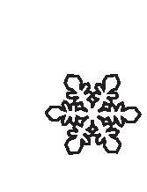

vol. 34, no. 1, pp. 87-99, 2013
doi: 10.2478/popore-2013-0002

Pygoscelid penguins breeding distribution and population
trends at Lions Rump rookery, King George Island

Małgorzata KORCZAK-ABSHIRE Michał WĘGRZYN 2, Piotr J. ANGIEL3
and Maja LISOWSKA2
1 Instytut Biochemii i Biofizyki PAN, Zakład Biologii Antarktyki, ul. Ustrzycka 10/12, 02-141
Warszawa, Poland <korczakm@gmail.com>, corresponding author
2 Instytut Botaniki Uniwersytetu Jagiellońskiego, Zakład Badań i Dokumentacji Polarnej im. Prof.
Zdzisława Czeppego, ul. Kopernika 27, 31-501 Kraków, Poland
3Department of Earth Sciences, The University of Western Ontario, 1151 Richmond St., London,
Ontario, Canada N6A
Abstract: Long term changes (46 years) in the abundance of pygoscelid penguins breeding
populations and nests distribution in the Lions Rump (King George Island) colony were in-
vestigated in three time intervals, according to previously published two censuses and one
original study conducted in 2010. At that time a detailed colony map based on the GIS system
was made. Results of this study showed different trends for each investigated species. In the
last three decades Adelie penguin breeding populations showed strong declining tendencies
(69.61%). In contrast, the population of gentoo penguins represents the reverse trend, increas-
ing 171.85% over the same period. Observed changes in both penguin population sizes are re-
flected in the different spatial and geographic distribution of their nests. The population
changes observed at the Lions Rump colony are consistent with the relevant pygoscelid pen-
guin tendencies in the western Antarctic Peninsula region. Breeding penguin population dy-
namics at Lions Rump area with a minimal disturbance by human activity may well illustrate
a natural response of those birds to environmental changes in the Antarctic.
Key words: Antarctic, South Shetlands, Pygoscelis, spatial structure, population trends.

Introduction
Lions Rump is situated on King George Island in the South Shetland archipel-
ago, West Antarctic. This ice-free area contains diverse biota and geological fea-
tures representing examples of the terrestrial, freshwater, and littoral habitats of
the maritime Antarctic. Lions Rump area was posted as an Antarctic Specially Pro-
tected Area No. 151 to protect its ecological values. This reference site with its di-
verse avian and mammalian fauna, has been subjected to minimal disturbances by

Pol. Polar Res. 34 (1): 87-99, 2013
88
Małgorzata Korczak-Abshire et al.
human activity except for occasional monitoring of the mammal and bird popula-
tions, as well as geological, geomorphological and botanical studies. Lions Rump
area is a breeding site of three penguin species, the Adelie (Pygoscelis adeliae),
gentoo (P. papua) and chinstrap (P. antarcticus)The majority of breeding pairs at
this site are Adelie and gentoo penguins. The populations of these three species in
the South Shetlands have been undergoing rapid changes with significant fluctua-
tion (Ciaputa and Sierakowski 1999; Hinke et al. 2007; Sander et al. 2007;
Chwedorzewska and Korczak 2010; Korczak-Abshire 2010; Trivelpiece et al.
2011; Korczak-Abshire et al. 2012).
The earliest information about penguin populations at Lions Rump was given
by Stephens in 1958 who roughly estimated their breeding population (Croxall and
Kirkwood 1979; after: Stephens in 1958 unpublished). More comprehensive stud-
ies come from works by Jabłoński (1984) and Trivelpiece et al. (1987) who con-
ducted censuses of all breeding penguin populations on King George Island and
the later studies by Ciaputa and Sierakowski (1999) from the mid-1990s focused
on the Lions Rump rookery. Due to differences in census timing and techniques
applied by each of the authors, some discrepancies between the early and later re-
sults may appear. However, census results up to 1996 reveals that the most numer-
ous species breeding in the area were Adelie penguins accompanied by a few nests
of chinstraps.
King George Island is located in the Antarctic Peninsula region, a region of dy-
namic climate characterised by variable maritime conditions which make this region
particularly susceptible to climate change. Annual temperature trends observed at
King George Island show a significant temperature rise of about 0.4°C/10 years
(King et al. 2003). This increase of air temperature is positively correlated with the
increase of sea surface temperature and decrease of sea ice concentration in the
Bellingshausen Sea (e.g. King 1994; Marshall et al. 2002; Vaughan et al. 2003).
A result of climate warming during recent decades is significant glacier retreats ob-
served on King George Island (e.g. Park et al. 1998; Braun and GoBmann 2002). Bi-
ological response of seabirds to such environmental perturbations may be mani-
fested by changes in distribution, population sizes and densities, phenology, behav-
ior, community interactions, morphology or physiology and migration patterns
(Trathan et al. 2007).
The aim of this study was to compare the long term (46 years) changes in the
abundance of breeding penguin pairs and nests distribution in the Lions Rump col-
ony. In 2008, twelve years after the last penguin breeding population study on
Lions Rump, the census of Pygoscelis penguins nests was recorded and then re-
peated in the next two breeding seasons. A map of this colony based on the GIS
system was made. Additionally, the published data by Croxall and Kirkwood
(1979), Jabłoński (1984) as well as Ciaputa and Sierakowski (1999) enabled us to
analyze breeding population sizes in fifteen-year intervals from 1965. Due to local
minimal environmental disturbance caused by human activity and significant cli-
Pygoscelid penguins breeding distribution and population trends
89
mate warming in the South Shetlands region, the changes in breeding populations
of penguins at Lions Rump may represent the natural response of the penguin pop-
ulations to recent environmental changes in the Antarctic.

Materials and methods
The investigated penguin colony is situated in the Antarctic Specially Pro-
tected Area No. 151 (ASPA 151), formerly the Site of Special Scientific Interest
No. 34 (SSSI No. 34) (Fig. 1). The study area includes approximately 1.3 km2 at
the western shore of King George Bay at King George Island (South Shetland Is-
lands, West Antarctic) (Fig. 1).
In the three breeding seasons (2008/09, 2009/10 and 2010/11 ) the total num-
ber of nests in the Lions Rump penguin colony were calculated during the egg in-
cubation period applying two different methods depending on the breeding group
size. Counts of Adelie and gentoo breeding groups with < 500 nests followed the
CCAMLR Ecosystem Monitoring Program standards. The number of occupied
nests in each breeding group was recorded one week after the peak of egg laying
(e.g. Nov 4th 2008, Nov 18th 2009 and Nov 10th 2010). Three separate counts
were made for each group on the same day. If one of counts differed over 5% from
the others, the procedures were repeated until the criteria were fulfilled. The popu-
lation size was calculated using an average of the three obtained numbers. Breed-
ing groups with more than 500 nests (mainly Adelie) were photographed from
cliffs when at 70-90% of the nests at least only one of the mates was present (e.g.
Nov 6th 2008, Nov 21st 2009 and Nov 13th in 2010). These high quality and high
resolution images were processed and the numbers of occupied nests were counted
from the images.
To assess multidecadal trends in the population dynamics of the studied pen-
guin species (Fig. 2) the published data from the following years: 1965, 1980,
1981 and from 1994 to 1996 were used (Croxall and Kirkwood 1979; Jabłoński
1984; Trivelpiece et al. 1987; Ciaputa and Sierakowski 1999). To describe the
changes in breeding pair numbers over time, linear regression of log transformed
data was employed. Pearson’s correlation coefficient (r) was used to test statistical
significance of the changes. Intrinsic annual rates of population changes were de-
termined as follows (Caughley 1977; after van den Hoff et al. 2009):
R = (lnNt - lnN0)/t
where: lnNt - natural logarithm of the population size at time t, lnN0 - natural loga-
rithm of the population at starting time, t - time interval (years) between popula-
tion counts.
Data from 1965 (Croxall and Kirkwood 1979) were not included in the statisti-
cal analyses due to the roughness of the estimation. It should be noted that the cen-
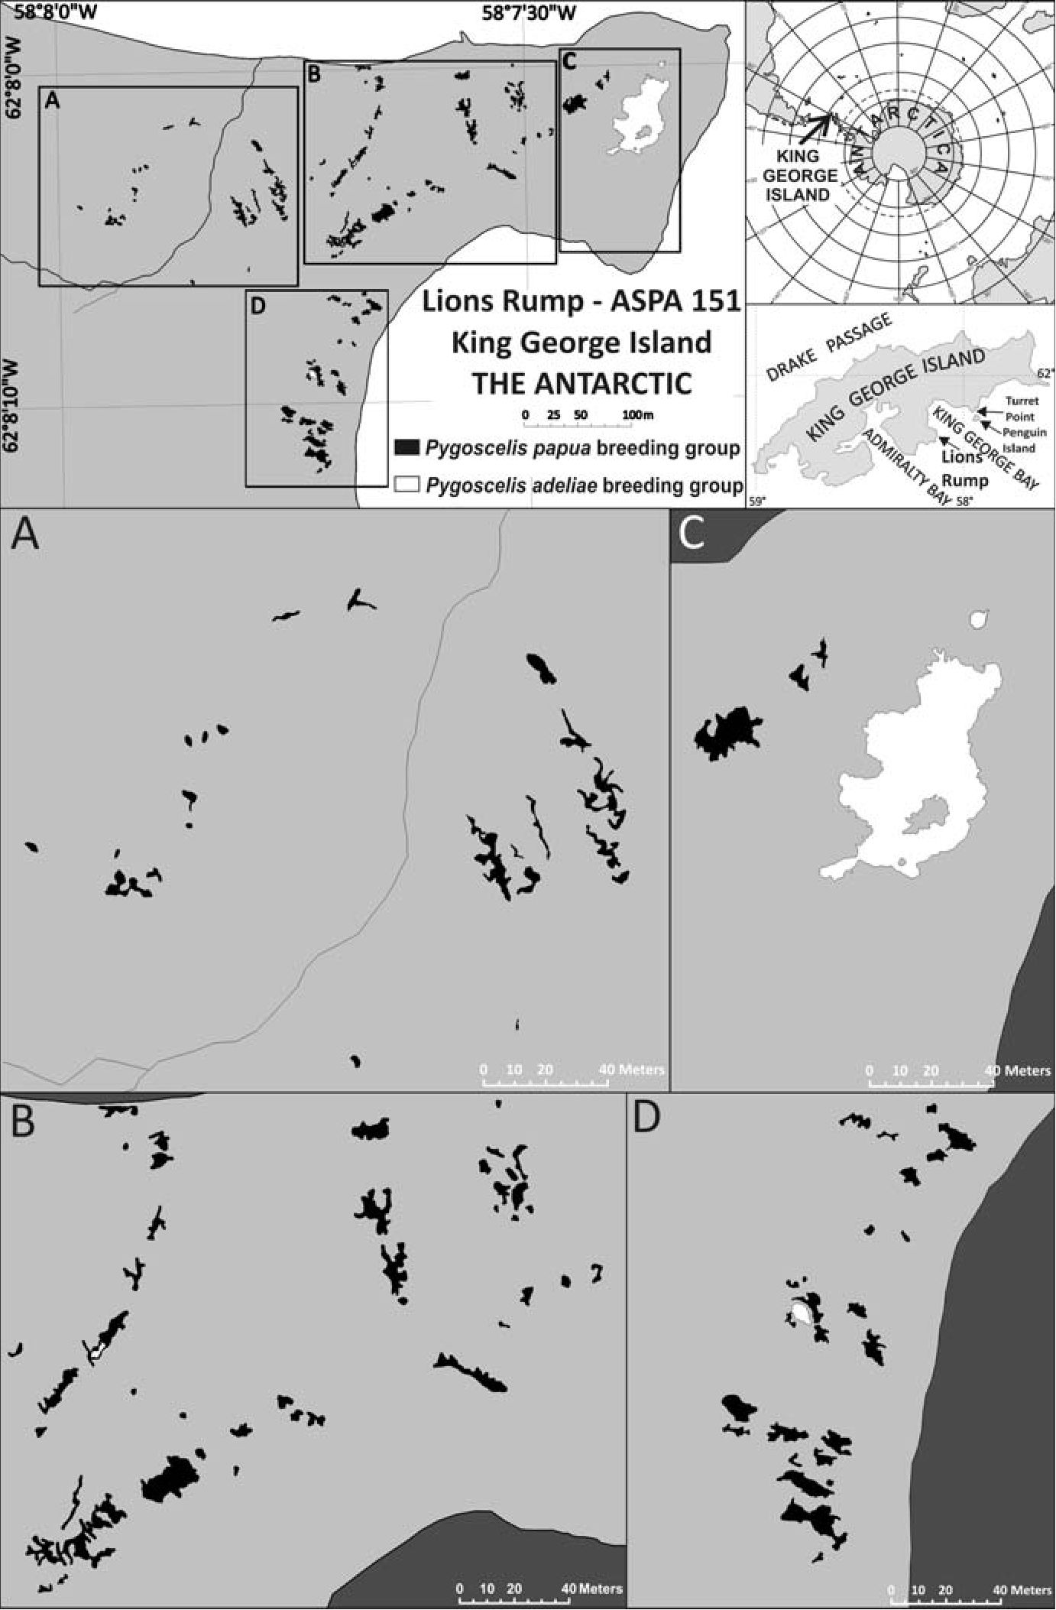
90
Małgorzata Korczak-Abshire et al.
Fig. 1. Distribution of Pygoscelis adeliae and Pygoscelis papua breeding groups in Lions Rump pen-
guin colony in 2010/2011 season, the Antarctic Specially Protected Area No. 151 (ASPA 151), King
George Island, South Shetlands, Western Antarctic. A, B, C and D sub-figures present enlarged im-
ages of Lions Rump penguin colony area.
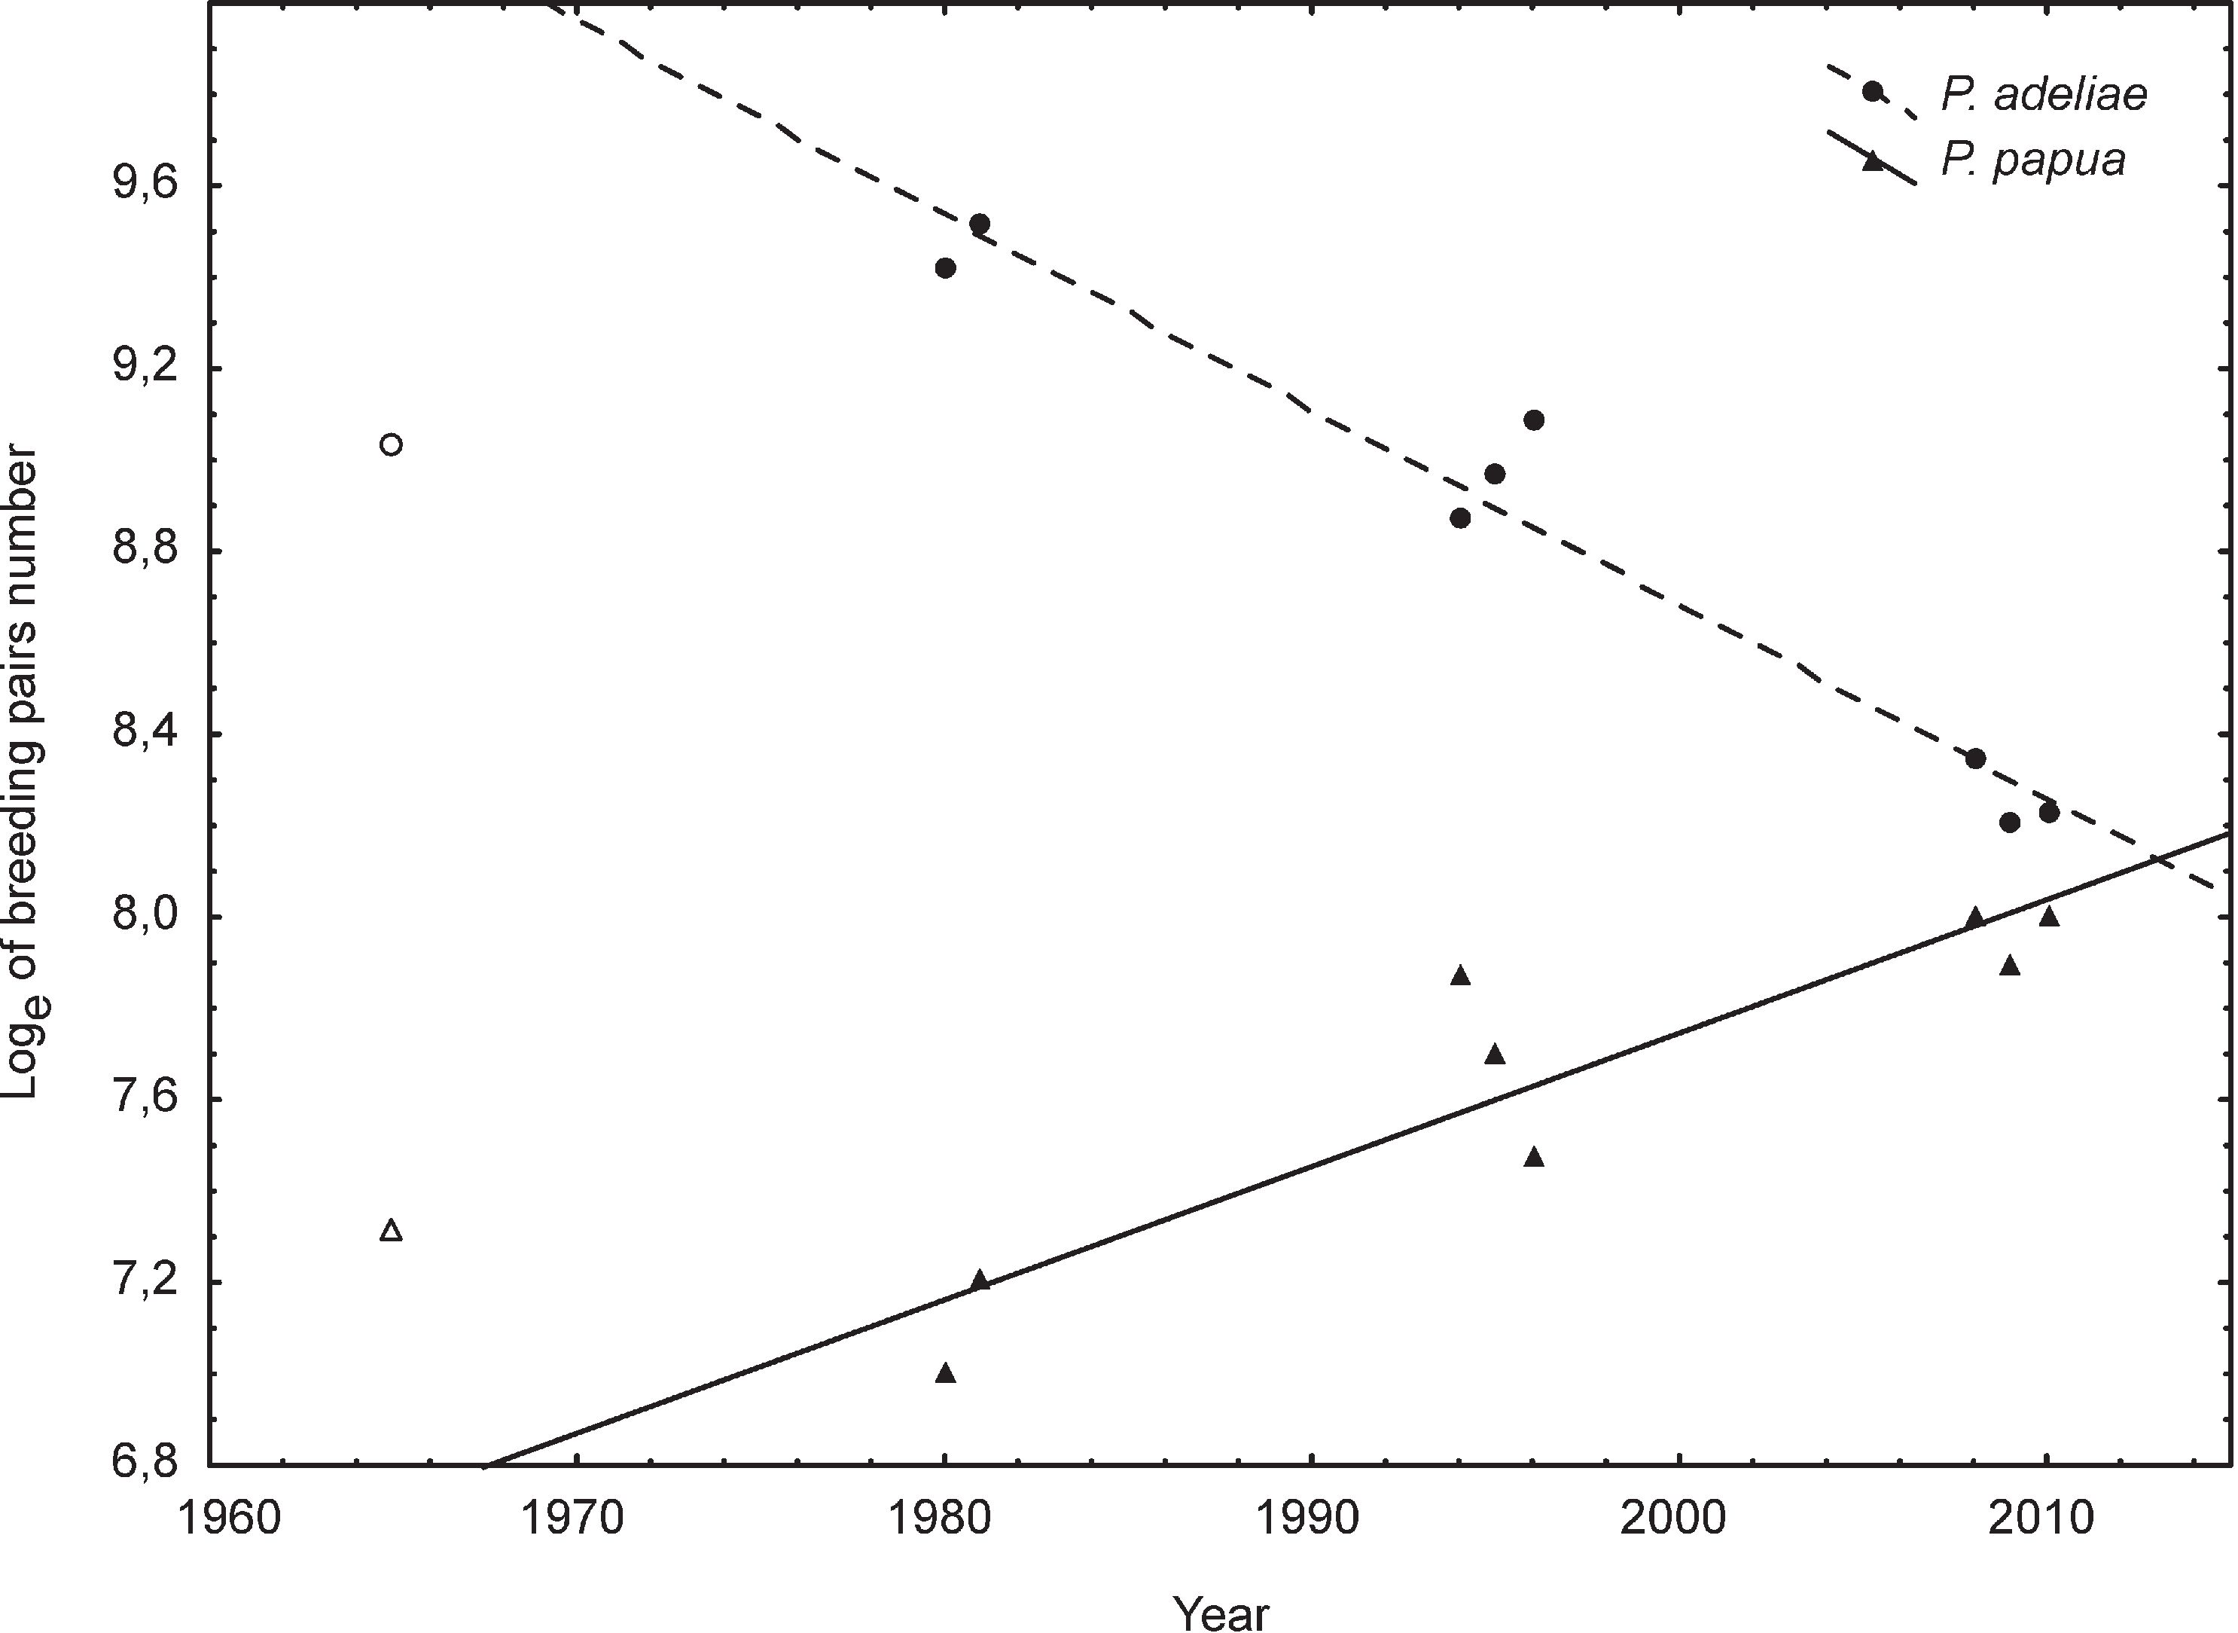
Pygoscelid penguins breeding distribution and population trends
91
Fig 2. Natural logarithms of the numbers of Adelie and gentoo penguins breeding pairs between 1965
and 2010 at Lions Rump colony, King George Bay, King George Island, South Shetlands, the Antarc-
tic. Historical data after: Croxall and Kirkwood (1979) - 1965 (hollow symbols, not included in the
regression analyses); Jabłoński (1984) - 1980; Trivelpiece et al. (1987) - 1981; Ciaputa and Siera-
kowski (1999) - 1994 to 1996. P. adeliae: r = -0.9761; p = 0.00003; r2 = 0.9528; P. papua: r = 0.9139;
p = 0.0015; r2 = 0.8352.
sus made by Trivelpiece et al. (1987) was conducted one week after the respective
peaks of egg laying, whereas census by Jabłoński (1984) and Ciaputa and Siera-
kowski (1999) were conducted later in the season. The analyses were performed
using StatSoft, Inc. (2011) and STATISTICA 10.0 software.
Additionally, a digital map of the colony arrangement was elaborated. The
map was developed in two steps. During the field work the observers conducted
monitoring of individual penguin breeding groups in 2008/09, 2009/10, and
2010/11 seasons. The distributional limits of an individual group were marked us-
ing a system of track-logs running on the Magellan Mobile Mapper 6 GPS (soft-
ware ESRI® ArcPad 7.0). Boundaries of each breeding group were determined
counterclockwise along the border, so that the extent of the group marked the set of
points describing consecutive numbers. All track-logs had the projection GCS
WGS 1984 Geographic Coordinate System. In the next stage, the collected
track-logs were transformed into closed features (shape files) as polygons using
ESRI® ArcMAPTM 10.0 application. The polygons were given a new projection
Transverse Mercator Projection, WGS 84 Spheroid; Central Meridian: 57W, Ref-
92
Małgorzata Korczak-Abshire et al.
erence Latitude 0. The applied method described above was used before to deter-
mine the boundaries of plant communities (Węgrzyn et al. 2011; Olech et al.
2011). The current coastline and the main proglacial river were marked on the
map. Beginning from the season 2008/09 annual detailed calculation of each
breeding group area was estimated by ArcGIS application.

Results
A comparison of nest census data (Table 1) and dispersion of breeding groups
from different breeding seasons was conducted to follow the population dynamics
of pygoscelid penguins from Lions Rump. Based on the published and the original
data (see Tables 1 and 2) the number of nests in three fifteen year intervals:
from1965/66 to 1980/81, from 1980/81 to 1995/96, from 1995/96 to 2010/11 were
analyzed. In 1965, estimate (10-15%) of 1500 and 8400 breeding pairs of gentoo
and Adelie, respectively, were noted (Table 1). In the 1980/81 1105 gentoo and
12345 Adelie nests were recorded, so the population of gentoo decreases (26.3%)
while Adelie population increased (46.9%) in the first fifteen year interval (Table
1). In the second and the third intervals the tendencies in populations are reversed.
The number of Adelie penguin breeding pairs decreased by 36.6% in the second
interval, and further by 52.1% in the third interval (Table 2). On the contrary, the
population of gentoo penguins increased by 99.7% and by 36.1% in the second and
third interval, respectively (Table 1). The annual intrinsic rates of change (R) be-
tween 1980/81 and 2010/11 were -4% for Adelie and 3.3% for gentoo. Decrease of
abundance in population of Adelie and increase in population of gentoo between
1980/81 and 2010/2011, which was based on the natural logarithm of nests num-
bers counted, were statistically significant, with p < 0.001 and p < 0.05, respec-
tively, and they represented almost linear correlations, with the Pearson’s coeffi-
cient values -0.9761 and 0.9139, respectively (Fig. 2).
Changes in the breeding population of chinstrap penguins on Lions Rump
were significant, however, due to the small number of nests these changes were ir-
relevant (Tables 1 and 2). In 1965 no nests of chinstrap penguins in the rookery
were observed (Croxall and Kirkwood 1979).
The range of penguin breeding groups and the number of breeding pairs within
these groups were estimated in 2010/11 and was compared with data from the
1995/96 Lions Rump breeding colony (Table 2). According to the archival data from
1995/96 about 91% of Adelie penguin breeding birds were concentrated in one big
nesting group on the Lions Rump rock; the remaining 5% of nests were in two mid-
dle size groups (>100 nests <1,000 nests) and 4% of nests were in six small groups
(<100 nests). In 2010/11, about 96% of Adelie breeding pairs were concentrated in
one big nesting group on the Lions Rump rock (Fig. 1C), while the remaining 4% of
nests were in three small groups (<100 nests) shared with gentoo penguins (Table 2).
Pygoscelid penguins breeding distribution and population trends
93
Table 1
Number of breeding pairs (submitted as nests) of Pygoscelis adeliae, P. papua and P.
antarcticus in different breeding seasons at the Lions Rump colony, King George Bay,
King George Island, South Shetlands, the Antarctic. Changes in the number of breeding
pairs in fifteen year intervals: from1965/66 to 1980/81 (I), from 1980/81 to 1995/96 (II),
from 1995/96 to 2010/11 (III) expressed as a percentage. a-Croxall and Kirkwood (1979),
b - Jabłoński (1984), c - Trivelpiece et al. (1987), d - Ciaputa and Sierakowski (1999).
 |  |  |  | Census year |  |  |  |  |  | Ffifteen year intervals
Species | cvo  VO  m  VO  o\ | 40  00  o  00  o\ | C<N  00  00  o\ | T3  g\  Ov  Os | T3  VO  g\  m  Os  Os | T3  c-~  g\  vo  Os  Os | 2008/09 | 2009/10 | 2010/11 | I (%) | II (%) | III (%)
P. adeliae | 8400 | 12345 | 13580 | 7113 | 7825 | 8882 | 4216 | 3661 | 3751 | +46.9 | -36.6 | -52.1
P. papua | 1500 | 1105 | 1348 | 2642 | 2207 | 1759 | 2996 | 2699 | 3004 | -26.3 | +99.7 | +36.1
P. antarcticus | 0 | 10 | 12 | 16 | 7 | 3 | 11 | 24 | 32 |  | - 30.0 | +357.1
Table 2
The number of breeding groups and the total number of breeding pairs (submitted as nests)
of Pygoscelis papua, P. adeliae and P. antarcticus in 1995/96 and 2010/11 breeding sea-
sons at the Lions Rump colony. Due to the different number of nests in particular breeding
group the three main categories of breeding group size were distinguished: <100 nests;
>100 nests and <1000 nests; >1000 nests. * Historical data 1995/96 collected by Siera-
kowski, archive of the Department of Antarctic Biology.
 | Pygoscelis papua |  |  |  | Pygoscelis adeliae |  |  |  | Pygoscelis antarcticus
 | 1995/96* |  | 2010/11 |  | 1995/96* |  | 2010/11 |  | 1995/96* |  | 2010/11
Size of  breeding group | number of breeding groups | total number of nests | number of breeding groups | total number of nests | number of breeding groups | total number of nests | number of breeding groups | total number of nests | number of breeding groups | total number of nests | number of breeding groups | total number of nests
<100 nests | 77 | 1676 | 124 | 2257 | 7 | 332 | 5 | 141 | 2 | 7 | 5 | 32
>100 nests and  <1,000 nests | 4 | 531 | 5 | 747 | 2 | 357 | 0 | 0 | 0 | 0 | 0 | 0
>1,000 nests | 0 | 0 | 0 | 0 | 1 | 7136 | 1 | 3610 | 0 | 0 | 0 | 0
total | 81 | 2207 | 129 | 3004 | 10 | 7825 | 6 | 3751 | 2 | 7 | 5 | 32
On the contrary, gentoo penguin nest sites in, both 1995/96 and 2010/11 were dis-
persed in many groups over a variety of landforms (Fig. 1, Table 2). In 2010/11
about 75% of gentoo penguin nests were concentrated in small size groups (<100
nests) and the remaining 25% of the nests were in middle size groups (>100 nests).
In 1995/96 76% of breeding pairs were concentrated in small breeding groups (<100
nests) and the remaining 24% in more numerous middle ones (>100 nests <1,000
94
Małgorzata Korczak-Abshire et al.
nests). In 1995/96 and 2010/11 most of the gentoo penguin sites (~80%) were situ-
ated on moraines of the White Eagle Glacier which retreated during the twentieth
century (Angiel and D^bski 2012) so some of the present nest sites were covered by
ice in 1956. The remaining gentoo penguin nests were positioned on elevated bed-
rock exposures on the Lions Rump rock and on raised beaches.

Discussion
Penguin populations are good indicators of ecosystem status and therefore
they are one of the best studied marine birds in the Antarctic (e.g. Croxall et
al.2002; Forcada et al. 2006; Hinke et al. 2007; Sander et al. 2007; Trathan et
al.2007; Forcada et al. 2008; Trivelpiece et al. 2011). In the last two centuries the
main principal changes in the distribution and abundance of the top-marine preda-
tors of the Southern Ocean were caused by human over-exploitation of sea re-
sources (Croxall et al. 1992). Since arecent introduction of the directives to protect
the endangered species, climate change is thought to have the main influence on
bird and mammal population conditions (Wilson et al. 2001; Hinke et al. 2007;
Korczak-Abshire 2010; Korczak-Abshire et al. 2011). Observation of bird and
pinniped population dynamics on Lions Rump gives paramount reference to ad-
dress the influence of pure natural climate changes on the ecosystem in contrast to
the western part of King George Island with significant human impact (nine per-
manent and three summer stations); see Lityńska-Zając et al. (2012).
A comparison of the long term (46 years) changes in the abundance of two
penguin species, Adelie and gentoo and their breeding populations as well as nests
distribution in the Lions Rump colony showed different population trends and rep-
resent opposite dynamics (Fig. 2).
Croxall and Kirkwood (1979) reported, that in 1960 Downham described that
Adelie penguins in the Lions Rump colony were divided into one large and one
much smaller sub-colonies. Also the number of breeding pair counts done early in
the 1965 seasons is difficult to interpret. However, even taking into account the in-
accuracy of the estimation made by Croxall and Kirkwood (1979), it can be as-
sumed that the Adelie population increased between 1965 and 1980. Trivelpiece
and Volkman (1979) suggested that the decimation of marine mammals of the
Southern Ocean during the latter half of the 19th and the early 20th centuries made
some species of seabirds, including penguins, to increase in abundance. According
to this thesis the Adelie population rise was a natural response to an increase in the
food supply. This so-called “Krill Surplus” is still invoked to explain the popula-
tion dynamics of some other krill predators. The less numerous gentoo population
on Lions Rump in the same period decreased insignificantly (Jabłoński 1984).
However, due to a small population size this decrease might be negated by accu-
racy error. In the second and third intervals the tendencies in populations reversed.
Pygoscelid penguins breeding distribution and population trends
95
A decrease in the Adelie population (overall 69.61 %, annual rate of decline (R)
-4%) was accompanied with an increase in the gentoo population (overall 171.85
%, annual rate of decline (R) 3.3%). In the 2010/11 season the breeding population
sizes for Adelie and for gentoo were very similar.
After the absence of a breeding populations of chinstrap penguins on Lions
Rump in the 1960s (Croxall and Kirkwood 1979), a small population of these birds
has been observed since the 1980s. We can speculate, that the recently noted in-
crease in the breeding pair number (32 in 2010/11) originated from penguins migrat-
ing from the nearest chinstrap penguin rookeries at Turret Point, Penguin Island or
Admiralty Bay. In 1980/81 breeding season the King George Island chinstrap pen-
guin population has been estimated to 302388 pairs (Jabłoński 1984), so the Lions
Rump rookery represents only a fragment of the population inhabiting this island.
The last fifteen years of penguin population studies on Lions Rump show sig-
nificant changes in the distribution and range of breeding groups (Fig. 2, Table 2),
which stays congruent with population size tendencies. Reduction in the number
of Adelie breeding groups is probably the result of the population decline. Gentoo
penguins, whose breeding population increased over fifteen years, almost 40%,
spread to adjacent areas.
After abandoning seal and whale hunting, human presence on Lions Rump
was sporadic and its interference on the environment was minor. Since then, the
most significant human disturbance on penguin populations on Lions Rump was
reported by Stephens (1958) who noted 1000 eggs collected on Lions Rump on
1 November 1957, although it was not indicated if this practice had occurred in
other seasons (Croxall and Kirkwood 1979). After the first reports by Stephens,
one day censuses of breeding populations of penguins were made several times
(Croxall and Kirkwood 1979; Jabłoński 1984; Ciaputa and Sierakowski 1999). In
the South Shetlands intensive whaling exploitation took place in the early twenti-
eth century (Chwedorzewska 2009). Intensive commercial fishing for fish and
krill in the area began in the early 1970s (Everson and Goss 1991; Croxall and
Nicol 2004) and continues up to the present day (Nicol et al. 2012). Over the last
50 years the area has experienced major warming with consequent reductions in
seasonal sea ice (Turner et al. 2005). Further, variations in the timing of sea ice
coverage have been linked to physical forcing driven by the El Nino-Southern Os-
cillation (ENSO) and Southern Annular Mode (SAM) (Yuan and Martinson 2000;
Yuan 2004; Turner 2004; Stammerjohn et al. 2008; Dunn et al. 2011). The de-
crease in sea ice cover was followed by a period of limited krill abundance, which
is the main source of food for Adelie and chinstrap penguins, and also, although to
a lesser extent, for gentoo (Fraser et al. 1992; Hinke et al. 2007; Trivelpiece et al.
2011). In particular, strong correlations between indices of penguin and krill re-
cruitment suggest that Adelie and chinstrap penguins in the South Shetlands may
live under an increasingly krill-limited system that has disproportionate effects on
the survival of juvenile birds (Hinke et al. 2007). In contrast to Adelie and chin-
96
Malgorzata Korczak-Abshire et al.
strap penguins, gentoo prey essentially opportunistically on various crustaceans,
fish and cephalopods (Bost and Jouventin 1990) although significant geograph-
ical, seasonal and interannual variations are observed. Their diet is dominated by
fish, squid, or amphipods at more northerly locations (Robinson and Hindell 1996;
Putz et al. 2001; Lescroel et al. 2004; Miller et al. 2009). So the flexibility to target
variable prey, also hunting at greater depths in different habitats (benthic and pe-
lagic), greater plasticity in breeding phenology, as well as no preference for spe-
cific nesting sites would be favorable for this species in the investigated area
(Hinke et al. 2007; Trivelpiece et al. 2011; Lynch et al. 2012).
Ciaputa and Sierakowski (1999) interpreted changes in the Lions Rump pen-
guin colony in terms of food availability (“Krill Surplus” and different species
diet preferences), environmental warming in the Antarctic Peninsula and hu-
man-related disturbances. However, our results for the last fifteen years show
that human-related disturbances probably are currently not a significant factor
shaping the penguin population tendencies on Lions Rump. Firstly, the direct hu-
man disturbance on this region is minor. Secondly, the decrease of Adelie pen-
guins was higher in the Lions Rump region than in breeding sites in Admiralty
Bay where two permanent and two summer stations and two refuges are located
(Chwedorzewska and Korczak 2010; Korczak-Abshire 2010). An example of
disappearing penguin nesting areas due to human activity in the vicinity of re-
search station which was recorded by Chwedorzewska and Korczak (2010) is not
taking place in the Lions Rump rookery. Therefore, as climate change progresses
it will be important to continue monitor these impacts on penguin populations on
King George Island.
Acknowledgements. — The authors wish to thank Anna Gasek, Dominika Rupp-Bisek,
Piotr Horzela and Ewa Libera who collected data during the 33rd, 34th and 35th Polish Antarc-
tic Expedition. The authors also wish to delegate special thanks to Kazimierz Sierakowski for
providing archived data and the map of Lions Rump penguin colony and to dr Katarzyna
Chwedorzewska for her comprehensive support. The authors are grateful to all members of
these three Polish Antarctic Expeditions to Arctowski Station for their logistical support. This
research was supported by the Ministry of Scientific Research and Higher Education grant
102/IPY/2007/01 CLICOPEN (ID-34). We would like to thank two anonymous reviewers for
constructive advice that has improved our paper.

References
ANGIEL P.J. and D^BSKI M. 2012. Lichenometric ages of the Little Ice Age moraines on King
George Island and of the last volcanic activity on Penguin Island (West Antarctica). Geografiska
Annaler, Series A: Physical Geography 94: 395-412.
Antarctic Protected Areas Database ASPA 151: Lions Rump, King George Island, South Shetland Is-
lands http://www.ats.aq/devPH/apa/ep_protected_detail.aspx?type=2andid=55andlang=e
BOST C.A. and JOUVENTIN P. 1990. Evolutionary ecology of the gentoo penguin Pygoscelis papua.
In: L. Davis and J. Darby (eds) Penguin biology. Academic Press, San Diego: 85-112.
Pygoscelid penguins breeding distribution and population trends
97
BRAUN M. and GOSSMANN H. 2002. Glacial changes in the area of Admiralty Bay and Potter Cove,
King George Island, Antarctica. In: M. Beyer and M. Boelter (eds) GeoEcology of Terrestrial
Antarctic Oases. Springer Verlag, Berlin-Heidelberg: 75-89.
CHWEDORZEWSKA K.J. 2009. Terrestrial Antarctic ecosystems at the changing world - An over-
view. Polish Polar Research 30: 263-273.
CHWEDORZEWSKA K.J. and Korczak M. 2010. Human impact upon the environment in the vicinity
of Arctowski Station, King George Island, Antarctica. Polish Polar Research 31: 45-60.
CIAPUTA P. and SIERAKOWSKI K. 1999. Long-term population changes of Adelie, chinstrap, and
gentoo penguins in the regions of SSSI No. 8 and SSSI No. 34, King George Island, Antarctica.
Polish Polar Research 20: 355-365.
CROXALL J.P. and Kirkwood E.D. 1979. The distribution of penguins on the Antarctic Peninsula and
islands of the Scotia Sea. Life Science Division, British Antarctic Survey, Cambridge: 186 pp.
CROXALL J.P. and Nicol s. 2004. Management of Southern Ocean Fisheries: global forces and fu-
ture sustainability. Antarctic Science 16: 569-584.
CROXALL J.P., Callaghan T., CERVELLATI R. and Walton D.W.H. 1992. Southern Ocean Envi-
ronmental Changes: Effects on Seabird, Seal and Whale Populations [and Discussion]. Philo-
sophical Transactions of the Royal Society B: Biological Sciences 338: 319-328.
CROXALl J.P., TRATHAN P.N. and MURPHY E.J. 2002. Environmental change and Antarctic seabird
populations. Science 297: 1510-1514.
DUNN M.J., Silk J.R.D. and TRATHAN P.N. 2011. Post-breeding dispersal of Adelie penguins
(Pygoscelis adeliae) nesting at Signy Island, South Orkney Islands. Polar Biology 34: 205-214.
EVERSON I. and Goss C. 1991. Krill fishing activity in the southwest Atlantic. Antarctic Science 3:
351-458.
FORCADA J., TRATHAN P.N. and MURPHY E.J. 2008. Life history buffering in Antarctic mammals
and birds against changing patterns of climate and environmental variation. Global Change Bi-
ology 14: 2473-2488.
Forcada J., Trathan P.N., Reid K., Murphy E.J. and Croxall J.P. 2006. Contrasting popula-
tion changes in sympatric penguin species in association with climate warming. Global Change
Biology 12: 411-423.
Fraser W.R., Trivelpiece W.Z., Ainley D.G. and Trivelpiece S.G. 1992. Increases in Antarctic
penguin populations-reduced competition with whales or a loss of sea ice due to environmental
warming. Polar Biology 11: 525-531.
Hinke J.T., Salwicka K., Trivelpiece S.G., Watters G.M. and Trivelpiece W.Z. 2007. Diver-
gent responses of Pygoscelis penguins reveal a common environmental driver. Oecologia 153:
845-855.
JABŁOŃSKI B. 1984. Distribution and numbers of penguins in the region of King George Island
(South Shetland Islands) in the breeding season 1980/1981. Polish Polar Research 5: 17-30.
JABŁOŃSKI B. 1986. Distribution, abundance and biomass of a summer community of birds in the re-
gion of the Admiralty Bay (King George Islands, South Shetland Islands, Antarctica) in
1978/79. Polish Polar Research 7: 217-260.
KING J.C. 1994. Recent climate variability in the vicinity of the Antarctic Peninsula. International
Journal of Climatology 14: 357-369.
King J.C., Turner J., Marshall G.J., Connolley W.M. and Lachan-Cope T.A. 2003. Antarc-
tic Peninsula climate variability ant its causes as revealed by analysis of instrumental records. In:
E. Domack, A. Leventer, A. Burnett, R. Bindschadler, P. Convey and M. Kirby (eds) Antarctic
Peninsula Climate Variability. Antarctic Research Series, Amercian Geophysical Union, Wash-
ington DC 79: 17-30.
KORCZAK-ABSHIRE M. 2010. Climate change influences on Antarctic bird populations. Papers on
Global Change 17: 53-43.
98
Małgorzata Korczak-Abshire et al.
Korczak-Abshire m., ANGIEL P.J. and WIERZBICKI G. 2011. Records of white-rumped sandpiper
(Calidris fuscicollis) on the South Shetland Islands. Polar Record 47: 262-267.
Korczak-Abshire m., chwedorzewska k.J., Wąsowicz P. and bednarek P.T. 2012. Genetic
structure of declining chinstrap penguin (Pygoscelis antarcticus) populations from South Shet-
land Islands (Antarctica). Polar Biology 35:1681-1689.
LESCROEL a., RIDOUX V. and BOST C.A. 2004. Spatial and temporal variation in the diet of the
gentoo penguin (Pygoscelis papua) at Kerguelen Islands. Polar Biology 27: 206-216.
Lityńska-Zając m., chwedorzewska k.J., Olech m., Korczak-Abshire M. and Augu-
STYNIUK-KRAM A. 2012. Diaspores and phyto-remains accidentally transported to the Antarctic
Station during three expeditions. Biodiversity and Conservation 21: 3411-3421.
Lynch H.J., Fagan W.F., Naveen r., Trivelpiece S.G., and Trivelpiece W.Z. 2012. Differen-
tial advancement of breeding phenology in response to climate may alter staggered breeding
among sympatric pygoscelid penguins. Marine Ecology Progress Series 454: 135-145.
MARSHALL G.J., Lagun V. and LaCHLAN-CoPE T.A. 2002. Changes in Antarctic Peninsula tropo-
spheric temperatures from 1956-1999: A synthesis of observations and reanalysis data. Interna-
tional Journal of Climatology 22: 291-310.
MILLER A.K., KaRNOVSKY n.J. and Trivelpiece W.Z. 2009. Flexible foraging strategies of gentoo
penguins Pygoscelis papua over 5 years in the South Shetland Islands, Antarctica. Marine Biol-
ogy 156: 2527-2537.
NICOL s., Foster J. and Kawaguchi S. 2012. The fishery for Antarctic krill - recent developments.
Fish and Fisheries 13: 30-40.
Olech m., Węgrzyn m., Lisowska m., Słaby A. and ANGIEL P. 2011. Contemporary changes in
vegetation of polar regions. Papers on Global Change 18: 35-53.
PaRKB.K., CHANG S.K. and YOON H.1.1998. Recent retreat of ice cliffs, King George Island, South
Shetland Islands, Antarctic Peninsula. Annals of Glaciology 27: 633-635.
PÜTZ K., INGHAM R.J., Smith J.G. and croxall J.P. 2001. Population trends, breeding success,
and diet composition of gentoo Pygoscelis papua, magellanic Spheniscus magellanicus and
rockhopper Eudyptes chrysocome penguins in the Falkland Islands. Polar Biology 24:
793-807.
ROBINSON S.A. and HiNDELL M.A. 1996. Foraging ecology of gentoo penguins Pygoscelis papua at
Macquarie Island during the period of chick care. Ibis 138: 722-731.
Sander m., BALBÄO T.C., COSTA E.S., Santos C.R. and PETRY M.V. 2007. Decline of the breed-
ing population of Pygoscelis antarctica and Pygoscelis adeliae on Penguin Island, South Shet-
land Antarctica. Polar Biology 30: 651-654.
SIERAKOWSKIK. 1991. Birds and mammals in the region of SSSI No. 8 in the season 1988/89 (South
Shetlands, King George Island, Admiralty Bay). Polish Polar Research 12: 25-54.
StAMMERJOHN S.E., Martinson D.G., Smith R.C., yuan X. and rind D. 2008. Trends in Antarc-
tic annual sea ice retreat and advance and their relation to El Nino-Southern Oscillation and
Southern Annular Mode variability. Journal of Geophysical Research Oceans 113: 1-20.
TRATHAN P.N., Forcada J. and MURPHY E.J. 2007. Environmental forcing and Southern Ocean
marine predator populations: effects of climate change and variability. Philosophical Transac-
tions of the Royal Society B: Biological Sciences 362: 2351-2365.
Trivelpiece W.Z., Trivelpiece S.G. and VoLKMAN N. 1987. Ecological segregation of Adelie,
gentoo, and chinstrap penguins at King George Island, Antarctica. Ecology 68: 351-361.
Trivelpiece W.Z., hinke J.T., Miller A.K., Reiss C.S., Trivelpiece S.G. and Watters G.M.
2011. Variability in krill biomass links harvesting and climate warming to penguin population
changes in Antarctica. Proceedings of the National Academy of Sciences 108: 7625-7628.
TURNER J. 2004. The El Nino-southern oscillation and Antarctica. International Journal of Climatol-
ogy 24: 1-31.
Pygoscelid penguins breeding distribution and population trends
99
Turner J., Colwell S.R., Marshall G., Lachleton A.M., Carleton-Cope T.A., Jones P.D.,
LAGUN V., REID P.A. and IAGOVKINA S. 2005. Antarctic Climate Change During the Last 50
Years. International Journal of Climatology 25: 279-294.
Scientific Committee for the Conservation of Antarctic Marine Living Resources. 2004. Commission
for the Conservation of Antarctic Living Marine Resources Ecosystem Monitoring Program
(CEMP) Standard Methods for Monitoring Studies. Hobart, Australia (revised). http://www.
ccamlr.org/pu/e/e_pubs/std-meth04.pdf
VAN DEN HOFF J., McMahon C.R., and FIELD I. 2009. Tipping back the balance: recolonization of
the Macquarie Island isthmus by king penguins (Aptenodytes patagonicus) following extermi-
nation for human gain. Antarctic Science 21: 237-241.
Vaughan D.G., Marshall G.J., Connolley W.M., Parkinson C., Mulvaney R., Hodgson
D.A., KING J.C., PUDSEY C.J. and TURNER J. 2003. Recent rapid regional climate warming on
the Antarctic Peninsula. Climatic Change 60: 243-274.
WĘGRZYN M., Lisowska M., Olech M. and OsYCZKA P. 2011. Methods and materials. Botanical
research. In: W. Ziaja (ed.) Transformation of the natural environment in Western S0rkapp Land
(Spitsbergen) since the 1980s. Jagiellonian University Press, Kraków: 23-24.
Wilson P.R., Ainley D.G., Nur N., Jacobs S.S., Barton K.J., Ballard G. and Comiso J.C.
2001. Adelie penguin population change in the Pacific sector of Antarctica: relation to sea-ice
extent and the Antarctic Circumpolar Current. Marine Ecology Progress Series 213: 301-309.
YUAN X.J. and MARTINSON D.G. 2000. Antarctic sea ice extent variability and its global connectiv-
ity. Journal of Climate 13: 1697-1717.
YUAN X.J. 2004. ENSO-related impacts on Antarctic sea ice: a synthesis of phenomenon and mecha-
nisms. Antarctic Science 16: 415-425.
Received 5 July 2012
Accepted 8 Jan 2013

