

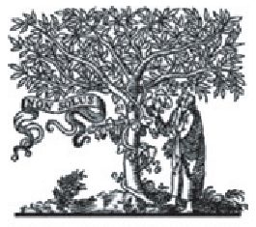
Biochimica et Biophysica Acta 1827 (2013) 751-760
ELSEVIER

Catalytically-relevant electron transfer between two hemes bL in the
hybrid cytochrome bc1-like complex containing a fusion of Rhodobacter
sphaeroides and capsulatus cytochromes b

Monika Czapla, Ewelina Cieluch, Arkadiusz Borek, Marcin Sarewicz, Artur Osyczka *
Department of Molecular Biophysics, Faculty of Biochemistry, Biophysics and Biotechnology, Jagiellonian University, 30-387 Kraków, Poland
ARTICLE INFO ABSTRACT
To address mechanistic questions about the functioning of dimeric cytochrome bc-i new genetic
approaches have recently been developed. They were specifically designed to enable construction of
asymmetrically-mutated variants suitable for functional studies. One approach exploited a fusion
of two cytochromes b that replaced the separate subunits in the dimer. The fusion protein, built from
two copies of the same cytochrome b of purple bacterium Rhodobacter capsulatus, served as a template
to create a series of asymmetrically-mutated cytochrome bcj-like complexes (B-B) which, through ki-
netic studies, disclosed several important principles of dimer engineering. Here, we report on construc-
tion of another fusion protein complex that adds a new tool to investigate dimeric function of the enzyme
through the asymmetrically mutated forms of the protein. This complex (BS-B) contains a hybrid protein
that combines two different cytochromes b: one coming from R. capsulatus and the other — from a closely
related species, R. sphaeroides. With this new fusion we addressed a still controversial issue of electron
transfer between the two hemes bL in the core of dimer. Kinetic data obtained with a series of BS-B
variants provided new evidence confirming the previously reported observations that electron transfer
between those two hemes occurs on a millisecond timescale, thus is a catalytically-relevant event. Both
types of the fusion complexes (B-B and BS-B) consistently implicate that the heme-bL-bL bridge forms an
electronic connection available for inter-monomer electron transfer in cytochrome bct.
© 2013 Elsevier B.V. Open access under CC BY license.
Article history:
Received 18 October 2012
Received in revised form 6 February 2013
Accepted 11 February 2013
Available online 18 February 2013
Keywords:
Cytochrome bc1
Asymmetric mutagenesis
Fusion hybrid membrane protein
Rhodobacter capsulatus
Rhodobacter sphaeroides
Electron transfer

1. Introduction
Cytochrome bc1 is an integral component of many biological energy
conversion systems. Its role is to oxidize quinol and reduce cytochrome
c and to couple these reactions with proton translocation across the mem-
brane. This way it contributes to generation of protomotive force used to
synthesize ATP. The enzyme is a homodimer in which each monomer
Abbreviations: FeS subunit, subunit of cytochrome bc1 containing 2 iron-2 sulfur
cluster; R., Rhodobacter; EDTA, Ethylenediaminetetraacetic acid; HRP, horseradish per-
oxidase; B-B complex, cytochrome b^-like complex containing fused cytochrome bb
in the place of two separate cytochrome b subunits in the dimer; BS complex, cyto-
chrome bc1 complex containing cytochrome bs in the place of cytochrome b; Bs-B, cy-
tochrome bc1-like complex containing fused cytochrome bSb in the place of two
separate cytochrome b subunits in the dimer; cytochrome bb, a fusion of two cyto-
chromes b of R. capsulatus; cytochrome bS, cytochrome b of R. sphaeroides expressed
in R. capsulatus cells; cytochrome bSb, a hybrid fusion ofcytochrome b ofR. sphaeroides
and cytochrome b of R. capsulatus; B-B strain, MT-RBC1 strain complemented with
pMTS1-BBST plasmid used to express the B-B complex; Bs strain, MT-RBC1 strain
complemented with pMTS1-BS plasmid used to express the BS complex; BS-B strain,
MT-RBC1 strain complemented with pMTS1-BSBST plasmid used to express the BS-B
complex
* Corresponding author. Tel.: +48 12 664 6348; fax: +48 12 664 69 02.
E-mail address: artur.osyczka@uj.edu.pl (A. Osyczka).
0005-2728 © 2013 Elsevier B.V. Open access under CC BY license.
http://dx.doi.org/! 0.1016/j.bbabio.2013.02.007
consists of three, universally conserved subunits, cytochrome c1, the FeS
subunit and cytochrome b. Each monomer embeds two catalytic quinone
oxidation/reduction sites located on two opposite sides ofthe membrane
(named the Qo and Qi sites) and two chains of cofactors that connect the
sites together and also allow them to communicate with quinol pool in
the membrane and cytochrome c pool outside the membrane (for recent
reviews see [1-3]).
The distances between the cofactors in different monomers, as
revealed by X-ray crystallography, are large enough to exclude possibil-
ity of inter-monomer electron transfer except for one point: a bridge
formed by two hemes bL which in the center of the dimer are at 14 A
edge to edge. This distance appears to be just at the limit of distances
between the centers that exchange electrons within micro- to millisec-
onds, a timescale generally considered to be catalytically-relevant [4].
The revelation about the close distance between two hemes bL
inspired an intense discussion about possible electron transfer between
the monomers and its role in a catalytic cycle. An assumption that such
electron transfer exists means that the cofactor chains and catalytic
sites of two monomers form an H-shaped electron transfer system that
all together connects functionally all four catalytic sites of the dimer
(see Fig. 5A). Indeed, the possibility of electron transfer between the
hemes bL was so appealing that it became an integral part of several
752
M. Czapla et al. / Biochimica et Biophysica Acta 1827 (2013) 751-760
models of the operation of cytochrome bc1 (see examples in refs [5-7])
and also was considered as providing potential means to diminish levels
of unpaired electrons, thus lower risks of superoxide generation by
cytochrome bc1 [6,8,9].
The kinetic evidence that the electron transfer between the
hemes bL takes place on a catalytically-relevant timescale came re-
cently from the studies that used bacterial genetic systems to cre-
ate asymmetrically-mutated variants suitable for functional
studies. One approach was based on a fusion protein that replaced
two cytochromes b in the dimer [10]. The fusion, built from two
copies of the same cytochrome b of purple bacterium Rhodobacter
capsulatus, was used to create a series of asymmetrically-mutated cyto-
chrome bc1-like complexes (B-B). To examine the path that exclusively
relies on the heme bL-bL electron transfer, a cross-mutated variant of B-
B was used in which the complementary segments of the dimer were
cross-inactivated leaving the inter-monomer path as the only way
connecting the catalytic sites (see scheme shown in Fig. 5B). Flash-
induced electron transfer measurements performed with this mutant
revealed that electron transfer between the two hemes bL takes place
on a millisecond timescale [10]. In addition, the functional connection
between the catalytic Q and Qj sites in this mutant was confirmed by
analysis of its enzymatic activity both in the membranes and in the iso-
lated form [11]. Another genetic approach exploited a two plasmid sys-
tem with two different tags to generate and analyze the heterodimeric
cross-inactivated forms of cytochrome bc1 of R. capsulatus [12]. This
study provided independent experimental indications for the existence
of the heme bL-bL electron transfer.
The two approaches just described, together with a two-plasmid
system developed for Paraccocus denitrificans [13], are so far the only
known systems that allow studying the operation of the dimeric cyto-
chrome bc1 through asymmetric mutagenesis. In all cases the expression
of heterodimers relies on two copies of the same gene that serve as a
template for mutagenesis. From the technical point of view this makes
those systems challenging in that it requires a special experimental
care to guard against genetic recombination to maintain the desired
constructs at genetic level (see [14] for discussion on this issue). Here,
we present a new system that overcomes this difficulty. The system
follows our original strategy of replacing two separate cytochrome b
subunits in the dimer with a fusion protein, however now instead
of fusing two identical cytochromes b of R. capsulatus we created a
hybrid protein combining two different cytochromes b: one coming
from R. capsulatus and the other — from closely related R. sphaeroides.
With this new fusion we provide further kinetic evidence for the exis-
tence of heme bL-bL electron transfer on a catalytically-relevant
timescale.

2. Materials and methods
  - Bacterial strains, growth conditions and plasmids
E. coli (HB101 and DH5a) were grown in liquid or solid Luria-
Bertrani (LB) medium supplemented with appropriate antibiotics
(ampicillin or kanamycin), at 37 °C. R. capsulatus cells were cultivated
on liquid or solid mineral-peptone-yeast extract (MPYE) medium
supplemented with kanamycin when needed. They were grown
at 30 °C in the dark under semiaerobic conditions or in light under
anaerobic conditions. Photosynthetic growth abilities were tested
on MPYE plates using anaerobic jars (GasPakTM Anaerobe Container
System, BD). MT-RBC1, a strain in which the chromosomal copy of
petABC operon has been deleted, was used as a host for expression of
cytochrome bc1 and its derivatives from expression vectors introduced
into MT-RBC1 via triparental crosses [15].
The plasmids pPET1-BL [14], pUC-BLST [14], and pBC9 [16] were
used as templates for genetic manipulations. The plasmid pMTS1 [15]
(carries a petABC operon coding for three subunits of R. capsulatus
cytochrome bc1) and its mutagenized derivatives were used as expres-
sion vectors.
  - Construction of expression plasmids
The plasmid pMTS1-BS used for expression of BS complex
(cytochrome bci containing R. capsulatus FeS and cytochrome c1
subunits and R. sphaeroides cytochrome b) was constructed from
two plasmids: pPET1-BL and pBC9. The steps of pMTS1-BS con-
struction are described in details in Supplementary data Fig. S1.
The plasmid pMTS1-BSBST used for expression of BS-B complex
(cytochrome bc-i-like complex in which two separate cytochrome b
subunits in dimer are replaced with a hybrid cytochrome bSb built
of R. sphaeroides and R. capsulatus cytochromes b fused together)
and its mutagenized derivatives containing various combinations of
point mutations of cytochrome b: G158W, H198N and H212N, were
constructed according to description in Supplementary data Fig. S2.
  - Isolation of membranes and proteins, electrophoresis and Western blot
The chromatophore membranes were prepared from semiaerobically
grown cultures of R capsulatus as described in [17]. Membranes solubili-
zation with n-dodecyl-p-D-maltoside (DDM) and protein purifications
were performed as described in [14]. The BS complex was purified using
DEAE-Biogel column (BioRad), while the BS-B complexes were purified
using Strep-tag affinity chromatography (IBA Biotagnology). Sodium
dodecyl sulfate polyacrylamide gel electrophoresis (SDS-PAGE) was
performed as described in [18]. The Western blot against Strep-tag
was performed according to the protocol supplied by IBA with HRP-
streptactin.
  - Optical and electron paramagnetic resonance spectroscopy and
flash-induced electron transfer measurements
Optical spectra for b- and c-type cytochromes were recorded at room
temperature using Shimadzu UV-2450 spectrophotometer. The differ-
ence spectra were obtained with samples that were first oxidized by an
addition of potassium ferricyanide and then reduced by using either
sodium ascorbate or a minimal amount of solid sodium dithionite. Contin-
uous wave electron paramagnetic resonance (EPR) spectra of2Fe-2S clus-
ter in chromatophores were measured according to the protocol
described in [19]. Flash-induced electron transfer of BS and BS-B com-
plexes were performed as described in [20]. For the measurements, chro-
matophore membranes were suspended in 50 mM MOPS buffer pH 7,
containing 100 mM KCl, 1 mM EDTA, 3.5 pM valinomycin, and appro-
priate redox mediators (7 pM 2,3,5,6-tetramethyl-1,4-phenylenediamine,
1 pM phenazine methosulfate, 1 pM phenazine ethosulfate, 5.5 pM
1,2-naphthoquinone, 5.5 pM 2-hydroxy-1,4-naphthoquinone).
The samples were poised at an ambient potential of 100 mV. Tran-
sient cytochrome c and b reduction kinetics were followed at 550-
540 nm and 560-570 nm, respectively. Inhibitors antimycin A and
myxothiazol were used at a final concentration of 7 pM.

3. Results
  - Cytochrome b ofR. sphaeroides can replace native cytochrome b in
R. capsulatus cytochrome bc1
As prerequisite for experiments of fusing two different cytochromes
b described in the following sections, we have tested the effect of re-
placing native cytochrome b of R. capsulatus cytochrome bc1 with that
coming from the closely related strain, R. sphaeroides. To this end we
constructed an expression vector pMTS1-BS, which in the place of na-
tive R. capsulatus petB gene in petABC operon contained the gene fbcB
coding for R. sphaeroides cytochrome b (Fig. 1). The major steps of
pMTS1-BS construction are summarized in Supplementary data Fig. S1.
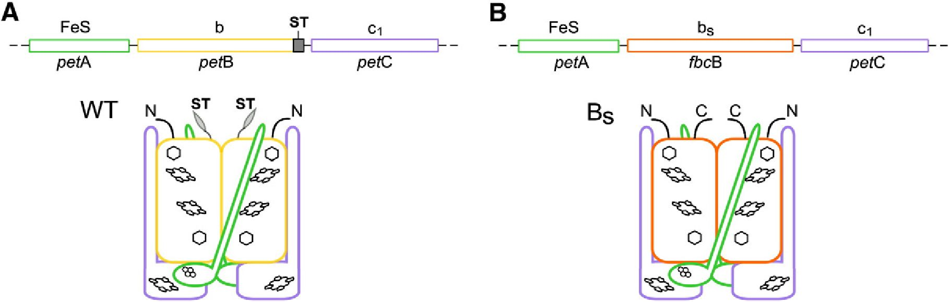
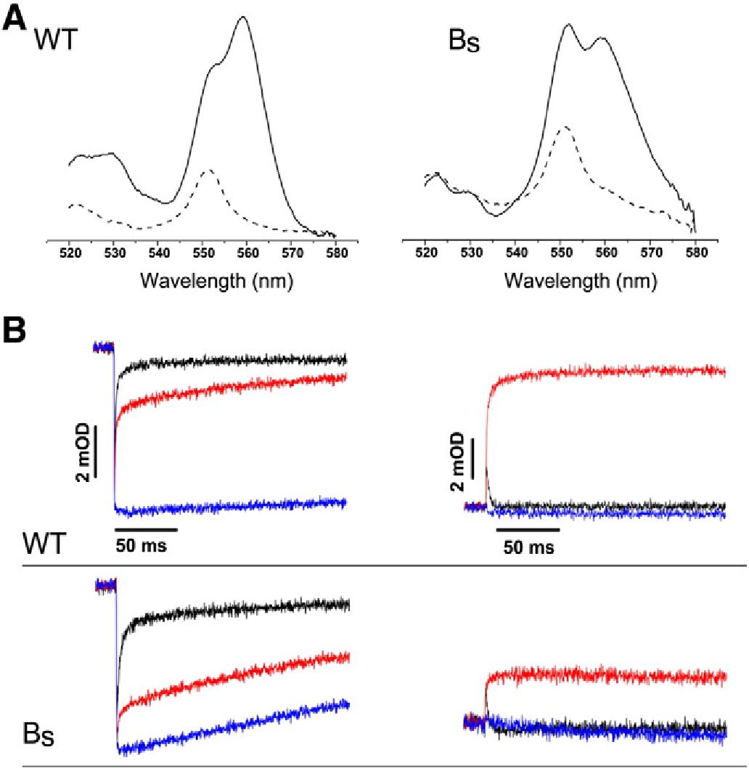
M. Czapla et al. / Biochimica et Biophysica Acta 1827 (2013) 751-760
753
Fig. 1. Schematic representation of operon and subunit composition of native Rhodobacter capsulatus cytochrome bc, and engineered BS complex. (A) Native operon petABC contains
three genes coding for three catalytic subunits that assemble as a homodimer: petA for FeS subunit (green), petB for cytochrome b subunit (yellow) and petC for cytochrome c,
(violet). ST — sequence coding for the Strep-tag (gray). (B) In the petABC operon, petB gene was replaced by fbcB gene encoding cytochrome b subunit of R. sphaeroides bc, complex
(orange). The expression of this operon resulted in a formation of the dimeric BS complex in which the cytochrome c, and FeS subunits are from R. capsulatus while the cytochrome
b subunit is from R. sphaeroides (orange). This cytochrome is named bS.
We introduced this plasmid to R. capsulatus MT-RBC1 strain and found
that an appropriately assembled and functional cytochrome bc1
(named BS) was expressed in the cells. The absorption redox difference
spectra of chromatophore membranes confirmed presence of hemes b
and c (peaks at 560 and 550 nm in Fig. 2A, respectively). The isolated
from membranes BS complexes showed similar optical spectra and
contained all three catalytic subunits, cytochrome b, c1, and FeS, as seen
on SDS-PAGE gels (not shown).
Light-induced electron transfer measurements in chromatophore
membranes confirmed that BS showed typical phases of electron
transfer related to the action of the catalytic sites and responded in
Fig. 2. Spectroscopic and kinetic properties of BS complex. (A) Reduced minus oxidized op-
tical difference spectra of b- and c-type hemes in chromatophore membranes isolated from
wild-type (WT) and the BS strain (BS). Dithionite minus ferricyanide spectra — solid lines,
ascorbate minus ferricyanide spectra — dashed lines. (B) Light-induced cytochrome c oxida-
tion and re-reduction (left panel) and cytochrome b reduction and re-oxidation (right panel)
of WT and BS complexes recorded at 550-540 nm and 560-570 nm, respectively, at pH 7
and an ambient potential of 100 mV. Color code: no inhibitor, black; antimycin, red; and
myxothiazol, blue. The vertical and horizontal scales of the lower panel are as those of the
upper panel shown in the figure.
native-like manner to an addition of specific inhibitors of cytochrome
bc1 (myxothiazol for the Q site and antimycin for the Qi site)
(Fig. 2B). From kinetic transients of cytochrome c reduction and cyto-
chrome b re-oxidation in the absence of inhibitor it is clear that the
enzyme is fully operational (both the reduction of cytochrome c and
the re-oxidation of heme b proceed to completion). However the
rates of the light-induced reactions were lower, comparing to the re-
spective rates of native cytochrome bc1, and also the amplitude of
heme b reduction in the presence of antimycin was smaller (Fig. 2B,
BS vs WT). This indicates that in the presence of this inhibitor the dis-
tribution of electrons within the cofactor chains is altered in BS (see
ref. [20]). The reason of these effects is currently unknown but may
reflect some structural distortions associated with a necessity to ac-
commodate R. sphaeroides cytochrome b. For example, the lack of
subunit IV, which in native cytochrome bc1 of R. sphaeroides naturally
interacts with cytochrome b subunit [21 ] but is missing in native cyto-
chrome bc1 of R. capsulatus, and thus is not present in BS either, may
contribute to these effects. (Detailed analysis of BS is under way and
will be a subject of separate studies.) Consistent with the kinetic results,
the strain expressing BS showed Ps + phenotype indicating that this en-
zyme is functional in vivo.
Based on these results we concluded that cytochrome b of
R. sphaeroides is capable of replacing native cytochrome b in
R. capsulatus cytochrome bc1, and the engineered BS retains
functional and structural properties of cytochrome bc1.
  - Hybrid cytochrome bSb obtained by fusion of cytochromes b from R.
sphaeroides and R. capsulatus assembles with other core subunits to
form BS-B complex
The fusion of cytochromes b from R. capsulatus and R. sphaeroides
was achieved adopting similar strategy that was previously used to
fuse two cytochromes b of R. capsulatus [10]. At genetic level, this
strategy requires modification of the expression vector so that the
operon coding for cytochrome bc1 contains cytochrome b gene
(petB) extended in frame with an additional copy of cytochrome b
gene. While in our previous work, the two halves of the fusion gene
were alike, each containing a sequence of the same petB gene origi-
nated from R. capsulatus [10], in this work we constructed a fusion
gene assembled from two different genes: fbcB and petB (Fig. 3).
The first half of the fusion gene contained the sequence of fbcB from
R. sphaeroides while the second half contained the sequence of petB
from R. capsulatus with the sequence encoding Strep-tag at its 3'
end (this fusion gene was named fbcB/petB). The other two genes of
the operon petABC, encoding the FeS subunit and cytochrome c1,
were left unchanged. All three genes were expressed using a vector
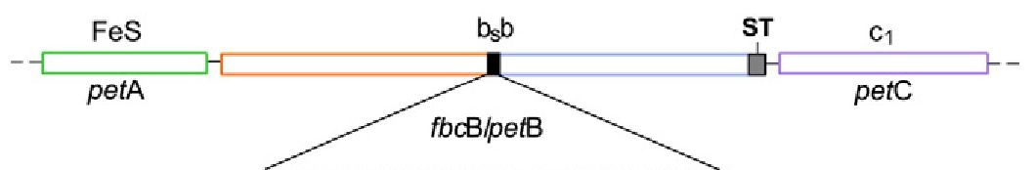
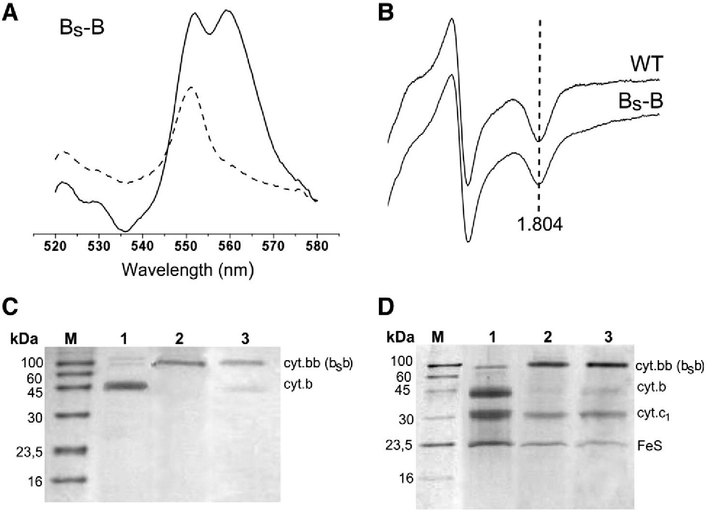
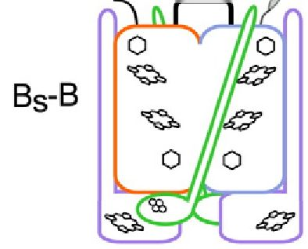
754
M. Czapla et al. / Biochimica etBiophysica Acta 1827 (2013) 751-760
gcagGCGGCCGCACCGCATCGGGCCCGtcc
AGGRTASGPS
N A ST
Fig. 3. Operon organization and subunit composition of the fusion hybrid BS-B com-
plex. In the petABC operon, the petB gene was replaced by a hybrid fusion gene fbcB/
petB composed of fbcB of R. sphaeroides and petB of R. capsulatus (orange and blue).
The remaining genes in the operon are: petA coding for the FeS subunit (green), and
petC coding for cytochrome c, (violet). The expression of this operon resulted in a for-
mation of the BS-B complex in which the two cytochrome b subunits in the dimer are
replaced with hybrid cytochrome bSb (a fusion of cytochromes b of R. sphaeroides and
R. capsulatus). DNA sequence and amino acid composition of the linker is shown in
black. Orange and blue letters indicate the last and the first codons/amino acid residues
that were left unchanged in R. sphaeroides and R.capsulatus gene/protein, respectively.
ST- sequence coding for the Strep-tag (gray).
pMTSl-BSBST, which was a derivative of pMTSl containing fbcB/petB
in the place of petB gene. The major steps of construction of
pMTSl-BSBST are described in Supplementary data Fig. S2.
Fig. 4 summarizes the results of expression of pMTSl-BSBST in
MT-RBC1 cells. First, spectroscopic measurements of membranous
fractions revealed the presence of redox cofactors characteristic for
cytochrome bcl-type complexes: absorption redox difference spectra
showed presence of hemes b and c (peaks at 560 and 550 nm in
Fig. 4A, respectively) while EPR showed presence of Rieske protein
appropriately interacting with occupants of the Q site [22] (charac-
teristic gx value of the spectrum of Fig. 4B). Second, Western blots re-
vealed the presence of the fusion protein of correct size (two times
larger than cytochrome b) in the membranes (Fig. 4C). The fusion
protein was also clearly visible on SDS-PAGE of complexes isolated
from the membranes using affinity chromatography (Fig. 4D). The
electrophoretic profile of isolated complexes showed that the fusion
protein was accompanied by the two remaining subunits of cytochrome
bc1: cytochrome c1 and the FeS subunit, consistent with spectroscopic fea-
tures just described. These results provided first indication that the mem-
branes contained a cytochrome fo^-like complex built of the hybrid fusion
protein (named cytochrome bSb) assembled together with cytochrome c-i
and the FeS subunit (the entire complex was named Bs-B). Further
kinetic experiments confirmed that BS-B did assemble in the membranes
(see below). In the remaining text the system of expression of BS-B in
R. capsulatus cells will be referred as the sphaer-caps system. For consis-
tency, the system of expression of B-B described earlier in [10,14] will
be named as the caps-caps system.
We note that Western blot and Coomassie blue-stained gels revealed
also traces of a protein in size corresponding to native cytochrome b
(Fig. 4C, D). The amount of this cytochrome b in relation to the fusion pro-
tein was always significantly smaller, as exemplified on gel in Fig. 4D.
These results indicate that in addition to the dominant fraction of BS-B,
the membranes contain a small fraction of cytochrome b either alone or
assembled with cytochrome c1 and FeS subunits. At present, the origin
of this phenomenon is not clear. Given that the fusion constructs are com-
monly reported to encounter problems with proteolysis upon expression
and/or isolation of proteins [23-27], we favor an explanation that in our
case it is also a result of partial degradation of protein, especially of a for-
eign R. sphaeroides portion of the fusion protein with retention of the R.
capsulatus part (this part contains Strep-tag used for Western blot
Fig. 4. Spectroscopic properties and Western blot/SDS-PAGE analyses of BS-B. (A) Optical redox difference spectra of b- and c-type hemes in chromatophore membranes isolated from the Bs-B
strain. Dithionite minus ferricyanide spectra — solid lines, ascorbate minus ferricyanide spectra — dashed lines. (B) X-band continuous wave EPR spectra of the 2Fe-2S cluster of WT and BS-B
complexes in chromatophore membranes. Dotted line shows the position of gx transition. (C) Western blot against Strep-tag II (IBA Biotagnology) of chromatophore membranes isolated from
wild type (lane 1 ), the B-B strain (lane 2) and the BS-B strain (lane 3). M, Molecular weight marker. Names cyt. bb and cyt. bSb depict the protein shown in line 2 and 3, respec-
tively. (D) Coomassie blue stained SDS-PAGE analysis of complexes isolated using affinity chromatography (Strep-tag) from wild-type (lane 1), the B-B strain (lane 2) and theBS-B strain
(lane 3). M, Molecular weight marker. Names cyt. bb and cyt. bSb are the same as in C.
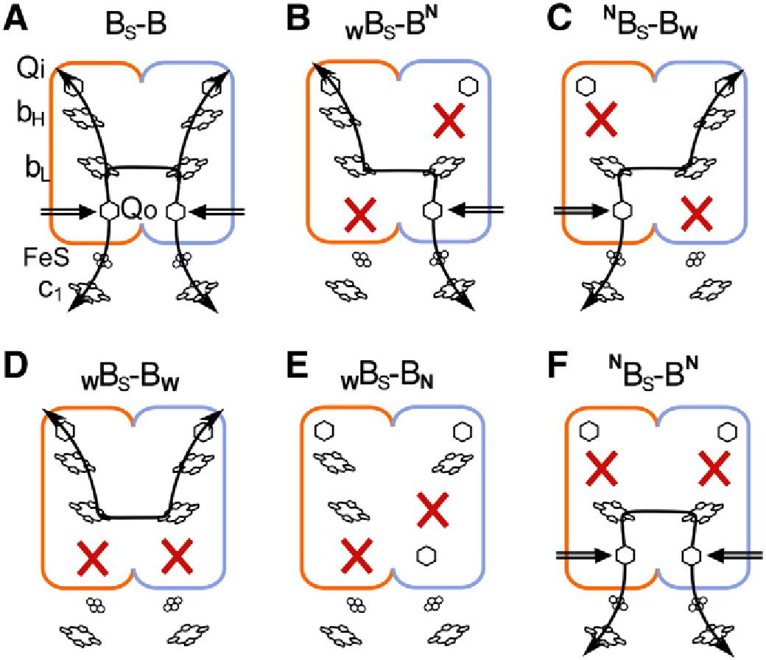
M. Czapla et al. / Biochimica et Biophysica Acta 1827 (2013) 751-760
755
Fig. 5. Symmetric and asymmetric knockout patterns in the fusion hybrid BS-B complex.
(A) BS-B complex without mutation — four branches for electron transfer are open
forming an H-shaped electron transfer system characteristic for the intact wild-type cyto-
chrome bcp (B) wBs-Bn and (C) NBS-BW — two branches across removed
(cross-inactivation) and heme bL-bL connection maintained; (D) WBS-BW — both lower
branches removed; (E) WBS-BN — two branches across removed and heme bL-bL connec-
tion disrupted; (F) NBS-BN — both upper branches removed (note that this form is drawn
schematically but was not obtained as a fusion protein complex). W, N (subscript), and N
(superscript) refer to G158W, H198N, and H212N point mutations in cytochrome b, re-
spectively. Black arrows indicate functional branches. Black double arrows indicate elec-
tron entry point at the Qo site. Red crosses display distribution of G158W, H198N, and
H212N point mutations in BS-B complexes.
detection and affinity chromatography). At the same time we are certain
that this cannot be due to genetic recombination leading to shortening of
the fused gene. The results shown in the next paragraphs have demon-
strated that the sphaer-caps system exhibits high genetic stability.
Our initial attempts to eliminate completely this background
of cytochrome b have proven that this was not a straightforward
task. We did not investigate this issue any further as for the main
purpose of this work it was not necessary. We reasoned that as long
as BS-B complex was assembled in the membranes and there was a pos-
sibility to perform all appropriate control experiments, the background
of cytochrome b would not compromise the kinetic experiments that
were a subject of present studies.
  - BS-B protein accommodates several point mutations introduced in
symmetric and asymmetric patterns
In the next series of experiments, we introduced point mutations to
pMTSl-BSBST template repeating the strategy used earlier to create
symmetrically and asymmetrically mutated B-B complexes [10]
(Fig. 5). The point mutations included G158W to inactivate the Qo site
and the lower branch of the H-shaped electron transfer system [22]
and H212N to inactivate the Q site and the upper branch of this system
[8] (numbering corresponds to the sequence of R. capsulatus cyto-
chrome b). The asymmetric combinations contained an equivalent of
G158W in one half of the hybrid gene and an equivalent of H212N in
the other half (to obtain WBS-BN or NBS-BW, Fig. 5B, C). The symmetric
combinations contained equivalents of G158W or H212N in both halves
of the gene (to obtain WBS-BW or NBS-BN, Fig. 5D, F). Table 1 and Fig. 6
summarize the results of expression of pMTS1-BSBST derivatives
containing appropriate mutations in MT-RBC1 strain. Table 1 also
compares these results with those obtained previously when the same
combinations of mutations were tested with the caps-caps system
[10,14].
From Table 1 and Fig. 6, it is clear that BS-B complex containing
the fusion protein is assembled in all cases, except for NBS-BN. Most
importantly, both asymmetric combinations WBS-BN and NBS-BW
resulted in an assembly of the fusion protein. The sphaer-caps system
allowed also for an assembly of the complex containing one of the
symmetric mutation patterns (i.e. WBS-BW). The latter pattern was pre-
viously unavailable with the caps-caps system, which in general did not
tolerate the presence of the same mutation in both halves of the fusion
protein [14].
In this work we also tested a new asymmetric pattern WBS-BN or
wB-Bn (for sphaer-caps or caps-caps system, respectively) (Fig. 5E).
This combination contained G158W in the first half of the fusion protein
and an equivalent of H198N introduced in the second half and was
specifically designed to perform a series of genetic and kinetic control
experiments described in next paragraphs. In cytochrome b, mutation
H198N replaces one of the histidine ligand to iron of heme bL with
non-competent asparagine and, as previous studies with R. sphaeroides
have indicated, results in an assembly of the cytochrome bc1 complex
with an impaired Qo site [28]. This mutation has not been described
earlier for R. capsulatus, but our initial experiments confirmed that
also in this species H198N mutant assembles as cytochrome bc-! with
impaired Qo site (manuscript in preparation). We thus used H198N
and G158W to create a form intended to disable both the Qo sites,
each by a different point mutation. Those two point mutations were
separated from each other in DNA sequence of petB, which was impor-
tant from a genetic point of view for the planned experiments (this sep-
aration was one of the reasons for selection of H198N over other
mutations in cytochrome b that are also known to inactivate the Qo
site but are closer to G158W in sequence).
As Table 1 indicates, the form containing equivalents of H198N and
G158W assembled as fusion protein only as WBS-BN in the sphaer-caps
system. For the caps-caps system, the results were similar to those pre-
viously described for all symmetrically mutated forms (NB-BN, WB-BW)
[14].
In general, from the comparison shown in Table 1 it appears that
BS-B have more structural flexibility to accommodate larger number
of mutational patterns than B-B. Possibility to analyze those combinations
of BS-B that were previously unavailable with B-B (i.e. WBS-BW, WBS-BN)
Table 1
Assembly of B-B and BS-B complexes in R. capsulatus cells.
Name of fusion protein (caps-caps system) | Assembly of B-B | Name of fusion protein (sphaer-caps system) | Assembly of BS-B
B-B | + | Bs-B | +
WB-BW | - | WBS-BW | +
nB-Bn | - | nBs-Bn | -
WB-BN | - | WBS-BN | +
nB-Bw | - | nBs-Bw | +
wB-Bn | + | wBs-Bn | +
W, N (subscript), and N (superscript) indicate position of mutation corresponding to G158W, H198N and H212N in cytochrome b subunit, respectively. “+” indicates assembly of the
complex containing the fusion protein. “—” indicates lack of the fusion protein (for NBS-BN WB-BW, NB-B^ wB-Bn) or the presence of dominant fraction of the complex with unfused
protein (for nB-Bw) see ref. [14].
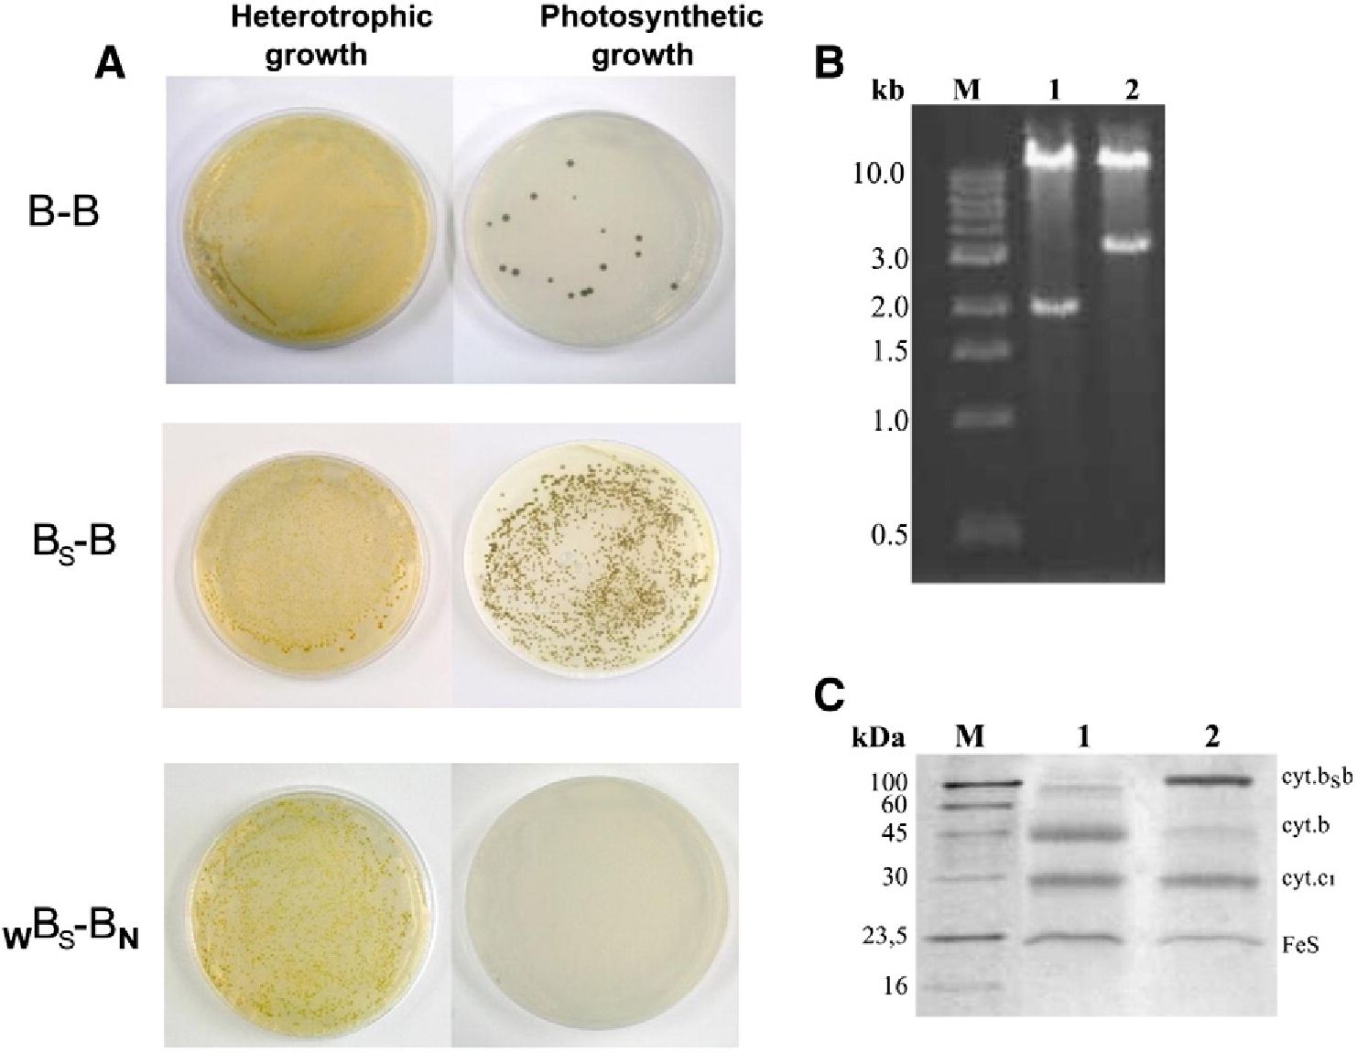
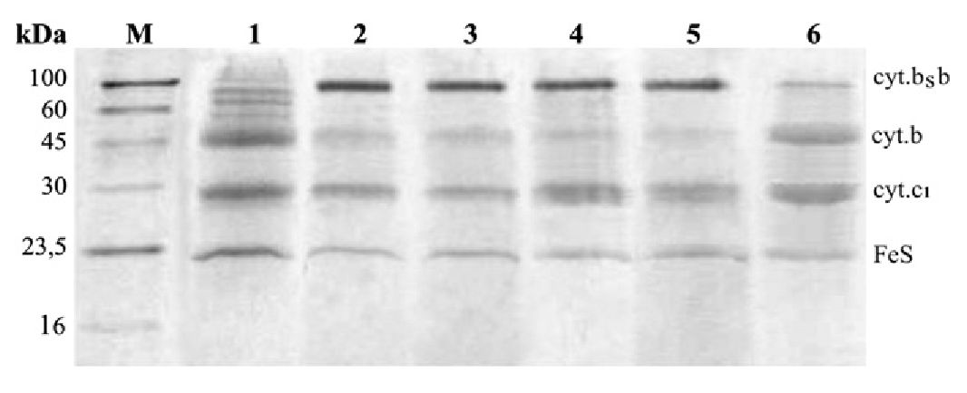
756
M. Czapla et al. / Biochimica etBiophysica Acta 1827 (2013) 751-760
Fig. 6. SDS-PAGE analysis of various BS-B complexes with knockout mutations isolated using
affinity chromatography (Strep-tag). Lanes: M, Molecular weight marker (IBA); 1, wild-type
cytochrome bci ; 2, wBs-Bn; 3, nBs-Bw; 4, wBs-Bw; 5, wBs-Bn; 6, nBs-BN.
is highly valuable as it offers additional level of control and means to ver-
ify conclusions drawn earlier with B-B.
- The sphaer-caps system exhibits high genetic stability
We have previously observed that in the caps-caps system, the
cells carrying genes coding for B-B did not grow photosynthetically
(exhibited Ps — phenotype). However, the photosynthetic growth
conditions allowed for selection of revertants. The cells that regained
Ps + phenotype carried plasmids containing only a short version of
the gene (corresponding in size to a single copy of petB) (Fig. 7B).
The reversions to Ps+ occurred with a frequency of 10—3-10—4,
which was estimated from the number of cells that were able to
grow photosynthetically at given concentration of cells. The tests in-
volved serial dilutions experiments where the number of colonies
that can grow under photosynthetic conditions was compared to
the total number of cells equal to the number of cells growing
under aerobic conditions (an example of the result for a given con-
centration of cells is shown in Fig. 7A, top).
Similar tests were now performed for the cells carrying pMTSl-
BSBST (used for expression of BS-B) in the sphaer-caps system. First,
we checked the cells expressing BS-B without additional mutations
and observed that the number of colonies that grow under photosyn-
thetic and aerobic conditions for given concentrations of the cells was
always similar (Fig. 7A, middle). We also found that the cells grown
under photosynthetic conditions retained the original plasmid
pMTSl-BSBST with intact fused gene fbcB/petB and showed no signs
of a short copy of the gene (Fig. 7B). Furthermore, the SDS profile of
complexes isolated from the membranes of these cells (Fig. 7C, lane
2) indicated that they contained BS-B complex with fusion protein
(the SDS profile of the complexes obtained from the photosynthetic
cultures was very similar to that obtained from the semiaerobic cul-
tures, see, lane 3 of Fig. 4D). This all was a first indication that the fre-
quency of genetic recombination in the sphaer-caps system is low and
that this system is genetically more stable than the caps-caps system.
We note that because the cells expressing BS-B show some back-
ground of unfused cytochrome b subunit (Fig. 4C, D), the Ps + pheno-
type in itself cannot be used as an argument in discussions about
possible functionality of BS-B in vivo. Clearly, other experiments are
needed to asses it (such experiments are currently under way).
To further asses genetic stability of the sphaer-caps system we
analyzed the non-functional WBS-BN variant which had two of its Qo
sites disabled by two different mutations positioned in protein
sequence 40 amino acids apart (G158W in one half and an equivalent
of H198N in the other). In this case, although the mutant cells express-
ing WBS—Bn complex were Ps —, as expected, there was a theoretical
possibility of homologous recombination between parts of the fusion
gene resulting in a sequence that would remove deleterious mutation
and restore the functional Qo site. Those types of recombinant cells
Fig. 7. Effect of photosynthetic selection on strains expressing various fusion proteins. (A) Comparison of heterotrophic and photosynthetic growth of R. capsulatus strains expressing B-B
(top), BS-B (middle), WBS-BN (bottom). For each strain the same amount of cells was plated for heterotrophic and photosynthetic growth. (B) Restriction analysis of expression plasmids
isolated from the B-B and BS-B strains grown under photosynthetic anaerobic condition (lanes 1 and 2, respectively). The presence of-3.3 kb DNA fragment indicates that the plasmid
bears fusion gene fbcB/petB, while -2 kb DNA fragment corresponds to the native form of gene petB. M, Molecular weight marker. (C) Coomassie blue stained SDS-PAGE analysis of com-
plexes isolated from the BS-B strain grown under photosynthetic conditions (lane 2) in comparison with wild-type cytochrome bc1 (lane 1). M, Molecular weight marker.
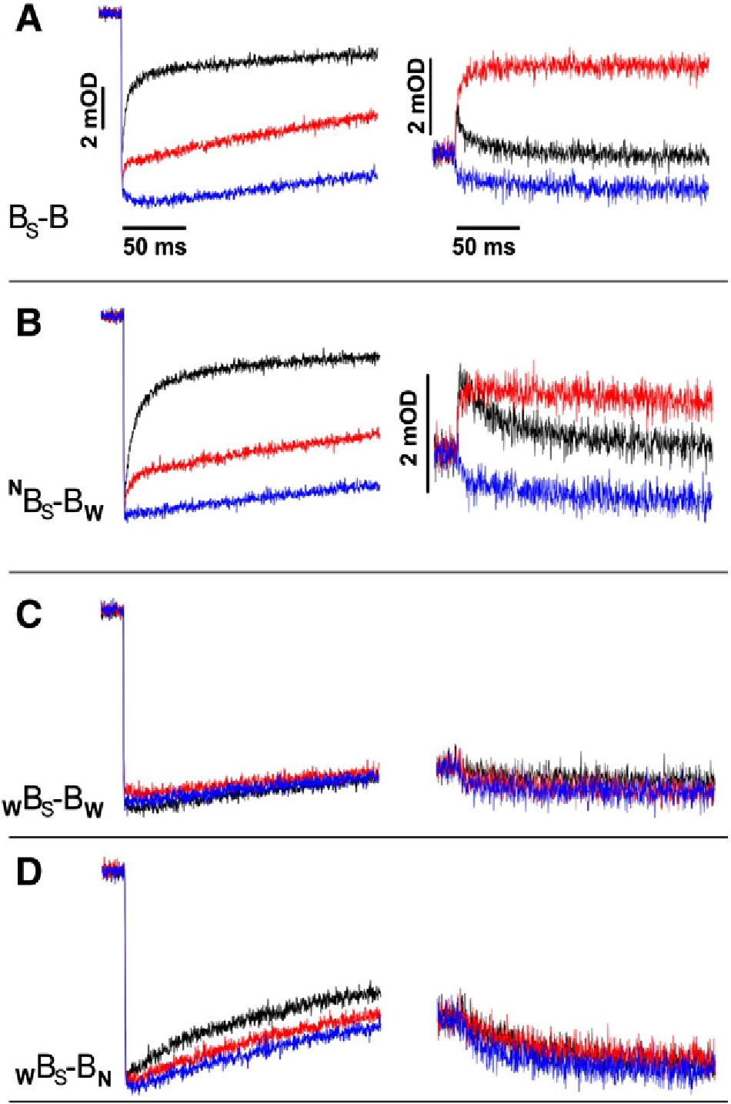
M. Czapla et al. / Biochimica et Biophysica Acta 1827 (2013) 751-760
757
can be selected by growing the cells under photosynthetic conditions.
Remarkably, however, we could not obtain recombinant cells for this
mutant even when very high concentrations of cells were tested. As
exemplified in Fig. 7A, bottom, all the cells exhibited Ps — phenotype.
Based on the serial dilution tests [14] it was estimated that the frequen-
cy of recombination is below 10—6. These results provide evidence that
the sphaer-caps system exhibits high genetic stability. The frequency of
reversion in this system is clearly orders of magnitude lower from that
estimated for the caps-caps system [14]. We note that it also appears to
be lower from the frequency of reversions estimated for the alternative
two-plasmid system [12].
  - Light-induced electron transfer in BS-B derivatives confirm occurrence
of fast electron transfer between two hemes bL
Fig. 8 compares kinetic traces of light-induced electron transfer in
chrompatophore membranes containing various forms of BS-B. In the
chromatophores containing BS-B complex without any additional
mutations in the absence of any inhibitors, hemes c (c1 and c2) of cy-
tochromes c were rapidly photo-oxidized then reduced, while heme
bH of cytochrome b was rapidly reduced and re-oxidized (Fig. 8A).
Antimycin, inhibitor of the Qi site, greatly diminished heme c
Fig. 8. Light-induced cytochrome c oxidation and re-reduction (left panel) and cyto-
chrome b reduction and re-oxidation (right panel) in chromatophore membranes
containing BS-B (A), cross-inactivated NBS-BW (B) and two controls: WBS-BW and WBS-
Bn (C and D, respectively). The traces were recorded at 550-540 nm and 560-570 nm
for cytochrome c and b, respectively, at pH 7 and an ambient potential of 100 mV. Color
code: no inhibitor, black; antimycin, red; and myxothiazol, blue. In each panel, the vertical
and horizontal scales for cytochrome c are as shown in A. The horizontal scales for all cy-
tochrome b are as shown in A. The vertical scale for cytochrome b in C and D is as in B.
reduction phase and fully abolished heme b re-oxidation phase leav-
ing only its reduction phase. Myxothiazol, inhibitor of the Q site,
abolished heme c reduction phase and also fully abolished heme b re-
duction and re-oxidation phases. From this data it is clear that BS-B
exhibits all phases of electron transfer reminiscent of the functional
catalytic Qo and Q sites connected together, as known for the
wild-type enzyme and described earlier for B-B [10].
Most significantly, asymmetric nBs-Bw exhibited kinetic behavior
consistent with the same mode of operation (Fig. 8B). Again, there was
a clear and large phase of antimycin-sensitive reduction of hemes c.
Heme b reduction and re-oxidation phases were antimycin-sensitive: in
the absence of any inhibitors heme bH was rapidly reduced and
re-oxidized, while in the presence of antimycin re-oxidation phase was
eliminated and only reduction phase was observed. Similar kinetic re-
sults were obtained for the mirror asymmetric form WBS-BN (not
shown).
In the asymmetric form nBs-Bw the functional connection between
the Qo and Q sites can only be accomplished if electrons are transferred
between the hemes bL. This is because in this mutant electrons enter the
b chain (reflected as flash-induced reduction of heme bH) only through
one active Qo site and leave this chain (reflected as flash-induced
oxidation of heme bH) only through one active Qi site, but each of
these two sites is located on a separate half of the fusion protein
(Fig. 5C). Thus, to reach the active Q site, electrons that entered the
enzyme through the active Qo site must use the path: heme bL-heme
bL-heme bH. This also means that when the Q site is inactive (in the
presence of antimycin), heme bH cannot be reduced in flash experi-
ments unless the quinol-derived electron is transferred from one
heme bL (that associated with active Qo site) to another heme bL (that
associated with inactive Qo site).
A profound antimycin-sensitive phase of cytochrome c reduction
and the Qi-site-mediated re-oxidation of heme bH seen in nBs-Bw
indicate that the functional connection between the Qo and Qi sites is
preserved in this mutant. At the same time, the reduction of heme bH
in the presence of antimycin confirms that this heme is reducible by
electrons coming from the active Qo site. We note that consistent with
hemes c and b reduction/oxidation kinetics, NBS-BW displayed all cyto-
chrome bc1-related phases of carotenoid band shifts typical for native
cytochrome bc1 confirming full turnover of the cross-inactivated
enzyme in the absence of any inhibitors (not shown). Thus, in light of
the above considerations, kinetic traces of the asymmetric nBs-Bw
clearly indicate that electron transfer between two hemes bL must
take place on catalytically-relevant timescale. This result is fully consis-
tent with our earlier demonstration of existence of heme bL-bL electron
transfer reported for cross-inactivated WB-BN constructed using the
caps-caps fusion system [10].
We note that re-reduction of cytochromes c in the absence of inhib-
itors reaches similar level in both nBs-Bw and BS-B, but at the same time
the amplitude of heme bH reduction in nBs-Bw in the presence of
antimycin is smaller comparing to the respective amplitude of BS-B
(Fig. 8B and A). This indicates that, in the post-flash redistribution, elec-
trons equilibrate on cofactors chains to the same final levels in NBs-Bw
and BS-B as long as the Qo and Q sites communicate with the quinone
and cytochrome c pools. On the other hand, when the outflow of elec-
trons through the Qi site is blocked by antimycin the final distribution
of electrons is different and reduction of heme bH in nBs-Bw is less
complete. At this stage deciding what causes this shift in the final equi-
librium is difficult, however this result should not be considered unex-
pected, especially in light of similar changes in electron distribution
observed in antimycin-inhibited cytochrome bc1 when a barrier for a
particular electron transfer reaction was specifically modified [20].
Fig. 8C, D show the results of the controls that involved two fusion
forms designed to have heme bL-bL electron transfer eliminated:
WBS-BW and WBS-BN (Fig. 5D and E, respectively). These controls
deserve particular attention as, for reasons discussed earlier in [14],
they were not previously available with the caps-caps fusion system.
758
M. Czapla et al. / Biochimica et Biophysica Acta 1827 (2013) 751-760
In WBS-BW, no kinetic phases of heme c reduction or heme b reduc-
tion and re-oxidations were observed (Fig. 8C). Furthermore, addition
of either antimycin or myxhotiazol had no effect on the kinetic traces.
These results are similar to the effects of G158W [10,22] and report
that both the Qo sites in WBS-BW are inactive. WBS-BW demonstrates
that the complex containing the fusion protein can be fully inactivated
when the Qo-site-inactivating mutation is present in both of its halves.
Kinetic traces recorded for the second control, WBs-BN, are shown
in Fig. 8D. The heme c reduction phase was almost fully suppressed
(we note that the residual cytochrome c reduction kinetics seen in the
absence of any inhibitors must have come from the half of WBS-BN
containing the equivalent of H198N, as we also observed such residual
activity in the H198N mutant) and there were no signs of any phases
of heme b reduction or re-oxidation. Furthermore, the traces recorded
for heme bH were not sensitive to antimycin or myxhotiazol. Clearly,
WBS-BN shows no signs of functional connection between the Qo and Qi
sites nor electron transfer between two hemes bL. We emphasize that
the kinetic traces of WBS-BN are clearly different from those of NBS-BW
(Fig. 8D vs B).
The form WBS-BN, adds to WBS-BW as another version of control with
both of the Q sites inactivated (Fig. 5D, E). But in the case of WBS-BN,
unlike in WBS-BW, there exists a possibility of genetic recombination
between parts of the fusion gene to obtain pseudo-native form of the
enzyme. Occurrence of such reversions at significant level would
manifest itself as a background of native-like kinetic traces visible in
flash-induced electron transfer measurements. The results obtained
with WBS-BN clearly demonstrate that this is not the case. The lack of
any background of native-like kinetics in chromatophores containing
wBs-Bn is consistent with the observation that the sphaer-caps system
exhibits high genetic stability, thus recombinations between parts of
the fused gene that would obscure the kinetic results do not occur.
Fig. 5F presents schematically the cofactor pattern in the mutant
allowing to test the conditions when the active Qo site mediates re-
duction of heme bL but further electron transfer to heme bH is
prevented. Although such a mutant was not obtained as fusion
protein complex (see Fig. 6, lane 6), the characteristic light-induced
kinetic transients of the corresponding bH knockout (cytochrome
bc1 mutant lacking both hemes bH) [8] are available for comparison
with the transients of NBS-BW. As described previously [10], and
also shown in Fig. S3A, the bH knockout does not exhibit profound
antimycin-sensitive phase of cytochrome c reduction present in
wild-type cytochrome bc1 (Fig. 2B) and in NBS-BW (Fig. 8B). The bH
knockout neither shows heme bH reduction/re-oxidation phases
in the absence of inhibitors, nor heme bH reduction in the presence
of antimycin (Fig. S3B), as observed at 560-570 nm in wild-type
cytochrome bc1 (Fig. 2B) and in NBS-BW ( B). The involvement
of heme bL in the bH knockout can be seen as antimycin-insensitive
reduction phase at 566-573 nm (Fig. S3C). The clear differences
between the kinetic traces of the bH knockout with that of NBS-BW
rule out the possibility that the latter ones result from electron trans-
fer reactions involving just heme bL without participation of heme bH
(and the Qj site in the absence of inhibitors).
To sum up the results of control experiments, the kinetic traces
recorded for two control fusion forms WBS-BW and WBS-BN and for
the bH knockout show no signs of functional connection between
the catalytic Qo and Qi sites, nor the heme bH reduction/reoxidation
reminiscent of heme bL-bL electron transfer (Fig. 8C, D). This further
substantiates the conclusion that the kinetic traces of the cross-
inactivated asymmetric form NBS-BW (Fig. 8B) do reveal heme bL-bL
electron transfer and functional connection between the catalytic sites.

4. Discussion
Our earlier work has shown that a genetic approach of fusing two
cytochrome b subunits in cytochrome bc1 offers an attractive opportu-
nity to address crucial bioenergetic questions related to the
mechanisms of operation of this enzyme. This in particular concerned
controversial issues of possible allostery within the dimeric complex
and possibility of communication between the monomers. Experi-
mental results addressing these points have demonstrated that mono-
mers operate independently, but at the same time — can exchange
electrons using the electron-transfer bridge formed by two hemes bL
in the core of the dimer [10,11,14].
Mechanistic conclusions were drawn from kinetic analysis of the
mutants containing a fusion protein (cytochrome bb) assembled with
other core subunits to form cytochrome bc1-like complex named B-B.
The point mutations introduced to cytochrome bb enabled inactivation
of individual segments of cofactor chains in various symmetric and
asymmetric combinations, exposing various electron transfer paths
within B-B for kinetic testing. The path that specifically exposed the
electron transfer between two hemes bL was identified in the asymmet-
ric form wB-Bn, in which the complementary parts of the fusion protein
were cross-inactivated [10].
From the protein engineering point of view this fusion system
(referred in this paper as the caps-caps system) came as a remarkable
example of flexibility within the whole protein expression and assem-
bly system, which clearly was able to adopt itself to accommodate B-
B and several of its mutant derivatives. Because, however, the fusion
was based on the two copies of the same gene, the risk of genetic
recombination (to remove one copy of a gene or exchange complemen-
tary fragments of a gene) imposed a necessity of experimental care to
implement protocols that ensured that samples used for kinetic analysis
were devoid of unwanted background of recombined proteins.
This present work provides an attractive alternative template for asym-
metric mutagenesis: a cytochrome bci-like complex with a new fusion
protein expressed from a gene of improved genetic stability. This new
system allowed us to obtain a whole family of mutants that included
the cross-inactivated variants together with an extended set of control
forms to further analyze electronic communication between two
hemes bL.
The system was based on a fusion of two cytochromes b, one com-
ing from R. sphaeroides and the other from R. capsulatus (the
sphaer-caps system). Because the new fusion comprised two different
genes, the sphaer-caps system turned out to be genetically more sta-
ble than the caps-caps system. Indeed, 17.6% of difference between
the two genes in the sphaer-caps system appeared sufficient to
lower the frequency of recombination between the genes [29,30] or-
ders of magnitude in comparison to the caps-caps system. At the
same time, the structure of those two closely related cytochromes is
very similar [31,32] (90.4% of similarity based on primary sequence)
and, as we have shown here, not only cytochrome b of R. sphaeroides
can replace native cytochrome b in R. capsulatus cytochrome bc1, but
also hybrid cytochrome bSb (a fusion of R. sphaeroides and R. capsulatus
cytochromes b) assembled with other subunits in membranes of R.
capsulatus cells to form a hybrid cytochrome bc1-like complex. This
latter complex, named BS-B, corresponds to the previously described
B-B [10].
Using BS-B as a template we prepared the cross-inactivated variants
nBs-Bw and WBS-BN which repeated the asymmetric combination
of mutations in wB-Bn originally used to test the electron transfer
between the two hemes bL. In addition, we prepared the control forms
WBS-BW and WBS-BN, which had both of the Qo sites of the complex
inactivated by mutations and thus allowed us to test the conditions
when electron transfer between two hemes bL was not possible within
the fusion protein.
The flash-induced experiments performed with NBS-BW and WBS-BN
showed the presence of kinetic phases reminiscent of the functional con-
nection between the Qo and Q sites. In addition, these experiments re-
vealed reduction of heme bH in the presence of antimycin. As all these
reactions in those mutants can only be accomplished if the heme bL-bL
electron transfer takes place, it is clear that the kinetic traces proved
that these two hemes exchange electrons on a catalytically-relevant
M. Czapla et al. / Biochimica etBiophysica Acta 1827 (2013) 751-760
759
timescale. nBs-Bw and wBs-Bn demonstrated this reaction in the same
manner as the previously described wB-Bn .
On the other hand, the traces of wBs-Bw and wBs-Bn showed
neither signs of functional connection between the Q and Q
sites nor signs of reduction of heme bH in the presence of antimycin,
confirming that the heme bL-bL electron transfer does not occur
in those two mutants. The observation that the kinetic traces of those
two controls clearly differ from the traces of cross-inactivated nBs-Bw
and wBs-Bn further substantiated the conclusion that the latter ones
did reveal heme bL-bL electron transfer.
The lack of electron transfer between two hemes bL in kinetic traces
of wBs-Bn deserves particular emphasis, as this is a variant in which
the recombination between the parts of fusion gene to restore the func-
tional Qo site was theoretically possible. Such recombination was
described recently by Hong et al. [33] who constructed similar types
of mutants nB-Bn or nB-Bn in R. sphaeroides cells (in those forms the
complex was fully inactivated by mutations H198N and H212N) and
observed that they grew photosynthetically. As the photosynthetic
growth in those cases must have come from the reverted forms that
were effectively selected during photosynthetic cultivation, the authors
assumed that similar reversions occurred in the cross-inactivated forms
used to test heme bL-bL electron transfer. Based on this assumption they
raised concern that our kinetic traces of cross-inactivated wB-Bn [10]
did not reveal heme bL-bL electron transfer but rather originated from
the pseudo-native contaminants. The results presented here do not
support this view. The cells expressing wBs-Bn did not grow photosyn-
thetically and the estimated frequency of reversion was very low.
Consistent with this behavior, the kinetic traces of wBs-Bn showed no
signs of native-like activity. Yet the kinetic traces of cross-inactivated
Nbs-Bw matched the traces recorded earlier for the wB-Bn. Clearly, the
traces of all our cross-inactivated forms revealed electron transfer
between the hemes bL. It follows that our original kinetic experiments
with wB-Bn that were prepared using the caps-caps system [10] were
free of any pseudo-native contaminants despite the fact that recombina-
tion frequency was larger in this system comparing to the sphaer-caps
system.
It should be emphasized that the effect of selection of cells that
expressed unfused cytochrome b in R. sphaeroides under photosynthetic
conditions described in ref. [33] is consistent with our observations
made for the caps-caps system [14]. However, we do not share a view
that the photosynthetic selection in these cases reflects in vivo enforce-
ment for monomeric electron transfer, as suggested [33]. While various
reasons can be envisaged for this selection (see discussion in ref. [14]), it
is clear that it took place irrespective of whether the original mutations
within the fusion gene enforced the inter-monomer electron transfer
within B-B or not.
It should also be emphasized that the reported by Hong et al. diffi-
culties with interpretation of kinetic experiments [33] originate from
the fact that they used photosynthetic growth conditions selecting
recombined proteins to prepare the samples for kinetic analysis. we,
on the other hand, specifically avoided this type of selection in our
preparations.
The successful expression of hybrid cytochrome bSb and its assem-
bly with other core subunits to form Bs-B adds to B-B as another
remarkable example of the overall structural plasticity of cytochrome
bc1 design and a flexibility within the whole protein expression and
assembly system (see [34] for discussion of this issue). However, like
in the case of B-B and its derivatives, some distortions from the native
structure cannot be ruled out. In this context, one may wonder how
much these proteins, which all should undoubtedly be treated as
model proteins, resemble native cytochrome bc1. The biochemical,
spectroscopic and kinetic properties of these proteins (in particular the
occurrence of all of the characteristic kinetic phases of electron transfer)
allow us to be confident that the overall mode of operation follows the
catalytic cycle of native cytochrome bc1. The fact that heme bL-bL elec-
tron transfer was confirmed independently by the asymmetric forms
of the cytochrome bc-^like fusion complexes coming from two different
genetic systems (caps-caps and sphaer-caps) provides strong evidence
in support ofthe notion that the heme-bL-bL bridge forms an electronic
connection available for inter-monomer electron transfer in cytochrome
bc-i.
The experimental evidence for the electron transfer between
hemes bL emerging from our studies and supported by other in-
dependent investigations [12] opens doors to discussions about the
physiological significance of the intermonomer electron transfer for
cytochrome bc1 operating in living cells. In this respect, one of the cru-
cial aspects that needs detailed investigation concerns the ratio of
intra-monomer vs inter-monomer electron transfer [1,9,35]. This
ratio is likely to change in response to the changes in redox conditions
and/or changes in the membrane potential. In addition, the ratio
might be affected by certain mutations that inactivate or impair
parts of the protein and are associated with the process of accumula-
tion of mitochondrial mutations occurring in mitochondrially-coded
cytochrome b subunit. Future studies with asymmetrically mutated
forms of cytochrome bc1 should provide information on those and
other related issues to advance our general understanding on the op-
eration of this complex enzyme.

Acknowledgements
This work was supported by The wellcome Trust International
Senior Research Fellowship (095078/Z/10/Z) and Ministry of Science
and Higher Education grant (NN301032339) to AO.

Appendix A. Supplementary data
Supplementary data to this article can be found online at http://
dx.doi.org/10.1016/j.bbabio.2013.02.007.

References
[1 ] W.A. Cramer, S.S. Hasan, E. Yamashita, The Q cycle of cytochrome bc complexes:
a structure perspective, Biochim. Biophys. Acta 1807 (2011) 788-802.
[2] D.M. Kramer, W. Nitschke, J.W. Cooley, The cytochrome bc1 and related bc complexes:
the Rieske/cytochrome b complex as the functional core of a central electron/proton
transfer complex, in: N. Hunter, F. Daldal, M.C. Thurnauer, J.T. Beatty (Eds.), The purple
phototrophic bacteria, Springer, The Netherlands, (2009) 451-473.
[3 ] E.A. Berry, D.-W. Lee, L.-S. Huang, F. Daldal, Structural and mutational studies of
the cytochrome bc1 complex, in: N. Hunter, F. Daldal, M.C. Thurnauer, J.T. Beatty
(Eds.), The purple phototrophic bacteria, Springer, The Netherlands, 2009,
pp. 425-450.
- C.C. Page, C.C. Moser, X. Chen, P.L. Dutton, Natural engineering principles of elec-
tron tunneling in biological oxidation-reduction, Nature 402 (1999) 47-52.
- J.W. Cooley, D.-W. Lee, F. Daldal, Across membrane communication between the
Qo and Qi active sites of cytochrome bc1, Biochemistry 48 (2009) 1888-1899.
- R. Covian, B.L. Trumpower, Regulatory interactions in the dimeric cytochrome bc1
complex: the advantages of being a twin, Biochim. Biophys. Acta 1777 (2008)
1079-1091.
- A.Y. Mulkidjanian, Activated Q-cycle as a common mechanism for cytochrome bc1
and cytochrome bgf complexes, Biochim. Biophys. Acta 1797 (2010) 1858-1868.
- A. Osyczka, C.C. Moser, F. Daldal, P.L. Dutton, Reversible redox energy coupling in
electron transfer chains, Nature 427 (2004) 607-612.
- W.A. Rutherford, A. Osyczka, F. Rappaport, Back-reactions, short-circuits, leaks
and other energy wasteful reactions in biological electron transfer: redox tuning
to survive life in O2, FEBS Lett. 586 (2012) 603-616.
- M. Swierczek, E. Cieluch, M. Sarewicz, A. Borek, C.C. Moser, P.L. Dutton, A. Osyczka, An
electronic bus bar lies in the core of cytochrome bc1, Science 329 (2010) 451-454.
- M. Czapla, A. Borek, M. Sarewicz, A. Osyczka, Enzymatic activities of isolated
cytochrome bc1-like complexes containing fused cytochrome b subunits with
asymmetrically inactivated segments of electron transfer chains, Biochemistry 51
(2012) 829-835.
- P. Lanciano, D.-w. Lee, H. Yang, E. Darrouzet, F. Daldal, Intermonomer electron
transfer between the low-potential hemes of cytochrome bc1, Biochemistry 50
- 1651-1663.
- M. Castellani, R. Covian, T. Kleinschroth, O. Anderka, B. Ludwig, B.L. Trumpower,
Direct demonstration of half-of the sites reactivity in the dimeric cytochrome
bc1 complex, J. Biol. Chem. 285 (2010) 502-510.
- M. Czapla, A. Borek, M. Sarewicz, A. Osyczka, Fusing two cytochromes b of
Rhodobacter capsulatus cytochrome bc1 using various linkers defines a set of pro-
tein templates for asymmetric mutagenesis, Protein Eng. Des. Sel. 25 (2012)
15-25.
760
M. Czapla et al. / Biochimica etBiophysica Acta 1827 (2Q13) 751-76Q
- E. Atta-Asafo-Adjei, F. Daldal, Size of the amino acid side chain at position 158 of
cytochrome b is critical for an active cytochrome bci complex and for photosyn-
thetic growth of Rhodobacter capsulatus, Proc. Natl. Acad. Sci. U. S. A. 88 (1991)
492-496.
- C.-H. Yun, R. Beci, A.R. Crofts, S. Kaplan, R.B. Gennis, Cloning and DNA sequencing
of the fbc operon encoding the cytochrome bc1 complex from Rhodobacter
sphaeroides. Characterization of fbc deletion mutants and complementation by a
site-specific mutational variant, Eur. J. Biochem. 194 (1990) 399-411.
- M.B. Valkova-Valchanova, A.S. Saribas, B.R. Gibney, P.L Dutton, F. Daldal, Isolation and
characterization of a two-subunit cytochrome b-c1 subcomplex from Rhodobacter
capsulatus and reconstitution of its ubihydroquinone oxidation (Qo) site with purified
Fe-S protein subunit, Biochemistry 37 (1998) 16242-16251.
- A. Osyczka, P.L. Dutton, C.C. Moser, E. Darrouzet, F. Daldal, Controlling the function-
ality of cytochrome c1 redox potentials in the Rhodobacter capsulatus cytochrome bci
complex through disulfide anchoring of a loop and a ß-branched amino acid near the
heme-ligating methionine, Biochemistry 40 (2001) 14547-14556.
- M. Sarewicz, M. Dutka, W. Froncisz, A. Osyczka, Magnetic interactions sense
changes in distance between heme bL and iron-sulfur cluster in cytochrome bc1,
Biochemistry 48 (2009) 5708-5720.
- E. Cieluch, K. Pietryga, M. Sarewicz, A. Osyczka, Visualizing changes in electron
distribution in coupled chains of cytochrome bc1 by modifying barrier for elec-
tron transfer between the FeS cluster and heme c1, Biochim. Biophys. Acta 1797
(2010) 296-303.
- S.-C. Tso, S.K. Shenoy, B. Quinn, L. Yu, Subunit IV of cytochrome bc1 complex from
Rhodobacter sphaeroides, J. Biol. Chem. 275 (2000) 15287-15294.
- H. Ding, C.C. Moser, D.E. Robertson, M.K. Tokito, F. Daldal, P.L. Dutton, Ubiquinone
pair in the Qo site central to the primary energy conversion reactions of cyto-
chrome bc1 complex, Biochemistry 34 (1995) 15979-15996.
- M. Jahic, M. Gustavsson, A.-K. Jansen, M. Mertinelle, S.-O. Enfors, Analysis and control
of proteolysis of a fusion protein in Pichiapastoris fed-batch processes, J. Biotechnol.
102 (2003)45-53.
- D.-W. Lee, Y. Oztruk, A. Mamedova, A. Osyczka, J.W. Cooley, F. Daldal, A functional
hybrid between the cytochrome bc1 complex and its physiological membrane-
anchored electron acceptor cytochrome cy in Rhodobacter capsulatus, Biochim Biophys.
Acta 1757 (2006)346—352.
- D.-W. iee, Y. Ozturk, A. Osyczka, J.W. Cooley, F. Daldal, Cytochrome bcl-cy fusion
complexes reveal the distance constraints for functional electron transfer between
photosynthetic components, J. Biol. Chem. 283 (2008) 13973—13982.
- H. Hellebust, A. Veide, S.-O. Enfors, Proteolytic degradation of fused protein A-ß-
galactosidase in Escherichia coli, J. Biotechnol. 7 (1988) 185—197.
- F. Baneyx, G. Georgiou, In vivo degradation of secreted fusion proteins by the
Escherichia coli outer membrane protease OmpT, J. Bacteriol. 172 (1990) 491—494.
- S. Yang, H.-W. Ma, i. Yu, C.A. Yu, On the mechanism of quinol oxidation at the
Qp site in the cytochrome bcl complex, J. Biol. Chem. 283 (2008) 28767—
28776.
- M. Vulic, F. Dionisio, F. Taddei, M. Radman, Molecular keys to speciation: DNA
polymorphism and the control of genetic exchange in enterobacteria, Proc. Natl.
Acad. Sci. U. S. A. (1997) 9763—9767.
- S. Stambuk, M. Radman, Mechanism and control ofinterspecies recombination in
Escherichia coli. I. Mismatch repair, methylation, recombination and replication
functions, Genetics 150 (1998) 533—542.
- EA Berry, i.-S. Huang, i.K. Saechao, N.G. Pon, M.B. Valkova-Valchanova, F. Daldal,
X-ray structure of Rhodobacter capsulatus cytochrome bcl : comparison with its mito-
chondrial and chloroplast counterparts, Photosynth. Res. 81 (2004) 251—275.
- i. Esser, M. Elberry, F. Zhou, C.A. Yu, D. Xia, Inhibitor-complexed structures of the
cytochrome bc1 from the photosynthetic bacterium Rhodobacter sphaeroides,
J. Biol. Chem. 283 (2008) 2846—2857.
- S. Hong, V. Doreen, A.R. Crofts, Inter-monomer electron transfer is too slow to
compete with monomeric turnover in bc1 complex, Biochim. Biophys. Acta 1817
- 1053—1062.
- M. Czapla, M. Sarewicz, A. Osyczka, Fusing proteins as an approach to study
bioenergetic enzymes and processes, Biochim. Biophys. Acta 1817 (2012)
1847—1851.
- V.P. Shinkarev, C.A. Wraight, Intermonomer electron transfer in the bc1 complex dimer
is controlled by the energized state and by impaired electron transfer between low and
high potential hemes, FEBS iett. 581 (2007) 1535—1541.

