Sprawozdania archeologiczne 72/1, 2020
pl iSSn 0081-3834 doi: 10.23858/Sa/72.2020.1.005

Marek Nowak*, Maria Lityńska-Zając**,
Magdalena Moskal-del Hoyo***, Aldona Mueller-Bieniek****, Magda Kapcia*****, Krzysztof Kotynia*****

Plants of the funnel Beaker culture in Poland

AbstrAct

Nowak M., Lityńska-Zając M., Moskal-del Hoyo M., Mueller-Bieniek A., Kapcia M., Kotynia K. 2020. Plants of the Funnel Beaker culture in Poland. Sprawozdania Archeologiczne 72/1, 87-114.

Neolithic communities appeared in Polish territories around the mid-6th millennium BC. However, until the beginning of the 4th millennium BC, they inhabited only small enclaves. This situation changed within the first half of the 4th millennium BC, when the most of the Polish territories became settled by Neolithic groups at- tributed to the Funnel Beaker culture (TRB). There is a fairly large amount of data on plants cultivated by TRB people. Based on this, one can conclude that mainly Triticum dicoccon, T. monococcum and Hordeum vulgare were grown. T. dicoccon and T. monococcum could be sown together. It should be noted that large amounts of weeds typical of cereal fields have been recorded. It is much more difficult to determine the economic impor- tance of other cultivars because of their low numbers. Nevertheless, the TRB inventories contain remains of Pisum sativum, Lens culinaris, Linum usitatissimum and Papaver somniferum.

Keywords: Poland, Neolithic, Funnel Beaker culture, cultivated plants, cultivation model Received: 18.02.2020; Revised: 09.04.2020; Accepted: 02.06.2020

* Institute of Archaeology, Jagiellonian University, Gołębia 11, 31-007 Kraków, Poland; mniauj@interia.pl
** Institute of Archaeology and Ethnology, Polish Academy of Sciences, Sławkowska st. 17, 31-016 Kraków, Poland; marialitynska@gazeta.pl
*** W. Szafer Institute of Botany, Polish Academy of Sciences, Lubicz 46, 31-512 Kraków, Poland; m.moskal@botany.pl
**** W. Szafer Institute of Botany, Polish Academy of Sciences, Lubicz 46, 31-512 Kraków, Poland; a.mueller@botany.pl
***** W. Szafer Institute of Botany, Polish Academy of Sciences, Lubicz 46, 31-512 Kraków, Poland; magdakapcia@wp.pl
****** W. Szafer Institute of Botany, Polish Academy of Sciences, Lubicz 46, 31-512 Kraków, Poland; krzykot54@wp.pl

88M. nowak, M. lityńska-Zając, M. Moskal-del hoyo, a. Mueller-Bieniek, M. kapcia, k. kotynia

INtroductIoN

Neolithic communities appeared in Polish territories after the mid-6th millennium BC. The early phase of the Neolithic is represented by the Linear Band Pottery culture (Linear- bandkeramik = LBK), like in other parts of Central Europe (e.g. Czekaj-Zastawny et al. 2020; Bogucki 2008a). Settlement of the LBK can be described as island-like, because the majority of sites concentrate in relatively small enclaves, which are characterized by eco- logical conditions favourable for agriculture. After the disappearance of the LBK in the early 5th millennium BC, the pattern of spatial distribution of Neolithic settlement re- mained basically unchanged. A substantial majority of sites of the Stroke Band Pottery culture and archaeological groupings belonging to the so-called Lengyel-Polgár complex (L-PC) still occurred in the same enclaves as sites of the LBK (e.g. Bogucki 2008b; Pyzel 2010; 2018, 138-200).
In the very late 5th millennium BC and onwards, this pattern began to change. The area of Neolithic settlement was gradually expanding, and tended to cover the whole land- scape. Consequently, the island-like settlement pattern disappeared. At about 3500 BC ca. 80% of territories in the Vistula and Oder basins were included into the Neolithic forma- tion. It is possible to say that during the first half of the 4th millennium BC, the Second Stage of Neolithisation took place in east-central Europe, which was equally as important as the first one (Kozłowski and Nowak 2019; Nowak 2001, 2009). This stage is connected with the Funnel Beaker culture (Trichterbecherkultur = TRB), which covers not only Po- land, also but vast territories from the Netherlands to western Ukraine, and from southern Sweden to Lower Austria.

MAterIALs ANd MetHods

Currently, there is a relatively large amount of data on plants connected with the TRB. In the paper, analyses made on 57 sites will be used. However, our study is first and fore- most based on sites where more than 10 specimens of all taxa were found, although in the literature other methods of material selection have also been applied (e.g. Kirleis and Fischer 2014; Mueller-Bieniek and Walanus 2012; Wasylikowa et al. 1991). Sites that meet this requirement are concentrated in western Lesser Poland, in Lower and Upper Silesia as well as in Kuyavia and Greater Poland (Fig. 1). We are aware that this situation is disadvanta- geous in terms of the spatial representativeness of these data. The vast territories in which quantitatively and qualitatively substantial remains of TRB communities have been re- corded – important for our knowledge of this phenomenon – such as Pomerania, Chełmno Land, Central and Eastern Lesser Poland, have provided little, if any, relevant information. Notwithstanding the absence of sites that correspond to the above criterion, this state of affairs is also due to a somewhat objective factor, i.e. the low number of archaeobotanical

Plants of the funnel Beaker culture in Poland
89

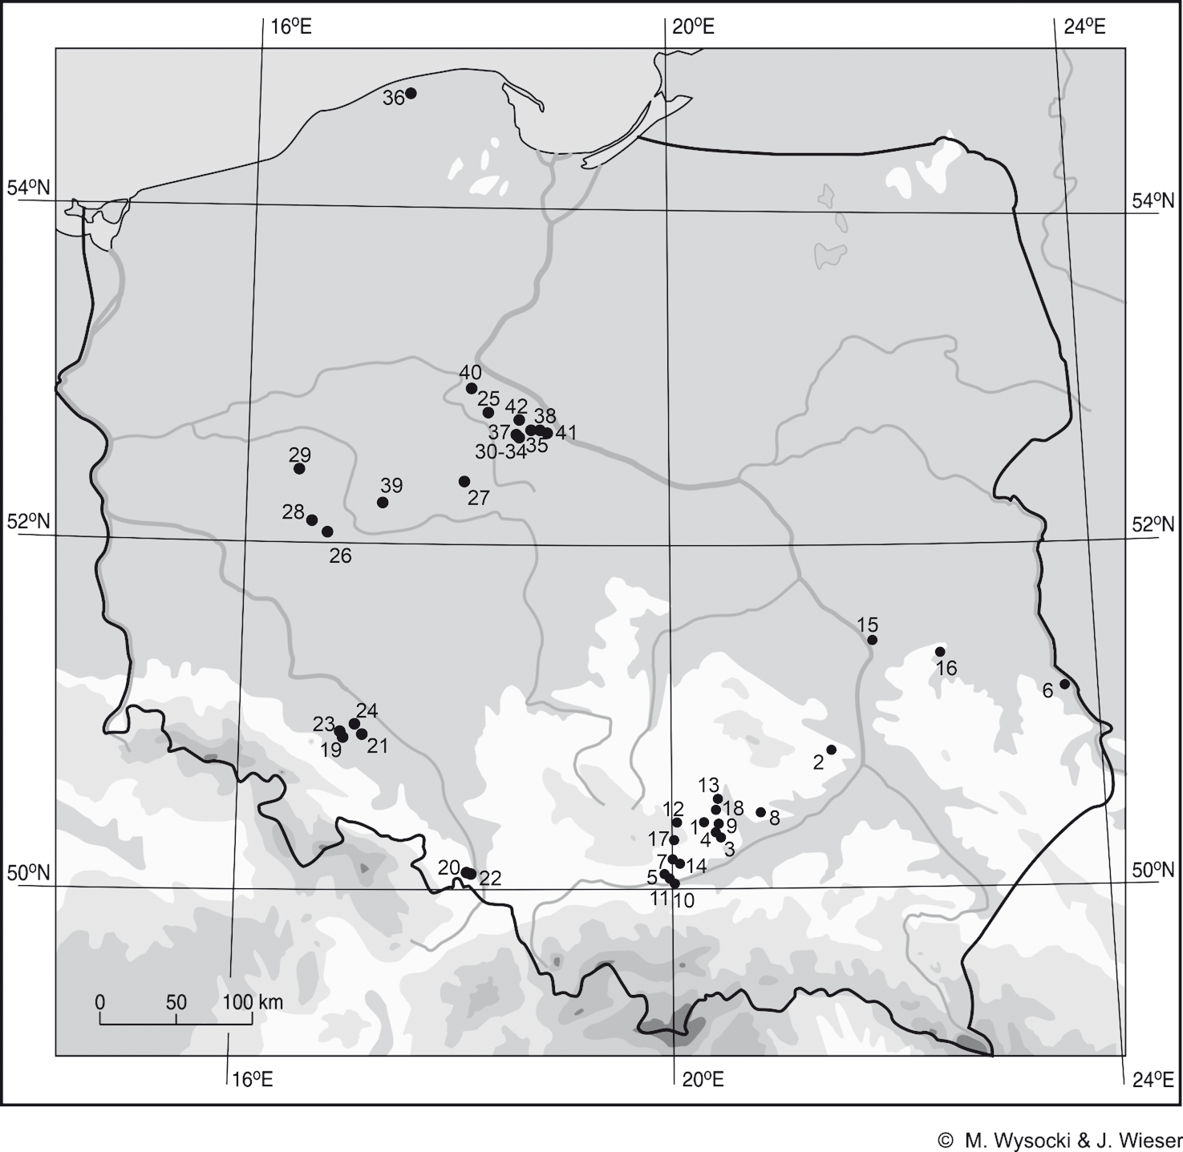
fig. 1. Locations of the trB sites on which the sum of the preserved specimens of all taxa exceed 10 pieces.
lesser Poland: 1. Bronocice (Lityńska-Zając 2007a; Kruk et al. 2016); 2. Ćmielów (Podkowińska 1961);
3. donatkowice, site 23 (Mueller-Bieniek, unpublish.); 4. donosy, site 3 (Lityńska-Zając 2007a); 5. Giebuł- tów, site 1 (Lityńska-Zając unpublish.); 6. Husynne, site 1 (Klichowska 1969a); 7. Iwanowice-Klin (Lityńska 1990), 8. Kawczyce, site 1 (det. by Lityńska-Zając in: Nowak 1994); 9. Kobylniki, site 4 (Kruk et al. 2016);
10. Kraków-Mogiła, site 62 (Gluza et al. 1988; Kapcia and Mueller-Bieniek 2018); 11. Kraków-Prądnik czerwony (rook and Nowak 1993); 12. Miechów, site 3 (Moskal-del Hoyo et al. 2017; Mueller-Bieniek et al. 2018a); 13. Mozgawa, site 1-3 (Kotynia 2016; Moskal-del Hoyo et al. 2018); 14. Niedźwiedź (Burchard and Lityńska-Zając 2002); 15. Parchatka, site 12 (Lityńska-Zając 1995); 16. Pliszczyn, site 9 (sady 2015);
17. smroków, site 17 (Lityńska-Zając 2010); 18. Zawarża, site 1 (Lityńska-Zając 2002); silesia: 19. Janó- wek (Klichowska 1968); 20. Pietrowice Wielkie (Klichowska 1969b); 21. Polwica-skrzypnik (Lityńska- Zając 2009a); 22. racibórz, site 423 (sady 2014); 23. strachów, site 2 (Lityńska-Zając 1997b); 24. Woj- kowice, site 15 (Lityńska-Zając 2009b); kuyavia, Greater Poland and Pomerania: 25. Inowrocław-Mątwy, site 1 (det. by Klichowska in: Kośko 1981); 26. Kokorzyn, site 2 (Klichowska 1972); 27. Kopydłowo, site 6 (Abramów 2015); 28. Kotowo, site 1 (Klichowska 1972); 29. Mrowino, site 3 (Klichowska 1972; det. by dzięczkowski in: Wierzbicki 2013); 30. opatowice, site 1 (Koszałka 2007a); 31. opatowice, site 3 (Koszałka 2014); 32. opatowice, site 12 (Klichowska 1979); 34. opatowice, site 42 (Koszałka 2007b);
35. osłonki, site 2 (Mueller-Bieniek 2016); 36. Poganice, site 4 (Klichowska 1985, det. by Luijten, Polcyn and Wasylikowa in: Wierzbicki 1999); 37. radziejów Kujawski (Klichowska 1970); 38. smólsk, site 2/10 (Mueller-Bieniek 2016; Mueller-Bieniek et al. 2016); 39. szlachcin, site 3 (Klichowska 1966); 40. tarkowo, site 23A-23B (det. by Klichowska in: Kośko 1981); 41. Wolica Nowa (Bieniek 2007; Mueller-Bieniek 2016);
42. Zarębowo, site 1 (Klichowska 1972)

90M. nowak, M. lityńska-Zając, M. Moskal-del hoyo, a. Mueller-Bieniek, M. kapcia, k. kotynia

samples. However, it is our belief that waiting for this situation to improve is unrealistic, or in any case it would take too long. The available database, despite its uneven dispersion, is so extensive and scientifically valuable that it deserves to be synthesized these days.
The identification of cultivated and wild plants was possible thanks to the examination of charred remains and/or plant impressions on burnt clay. Charred remains were either scattered in different kinds of features (pits, postholes, fireplaces) or found concentrated in storage pits. Different numbers of samples were analysed at archaeological sites. These were either single samples or numerous samples, collected systematically in many fea- tures. At some sites only imprints preserved in daub and/or on pottery were taken into account. Archaeobotanical analyses of only four graves were executed; all these graves come from Bronocice (Lityńska-Zając et al. 2016). This makes consideration of social and ritual behaviours connected with plants impossible (see e.g. Kirleis et al. 2012).
The cereal remains were preserved as the charred caryopsis and fragments of spike and spikelet as glume, palea, lemma, spikelet forks, spike (rachis internodes) and stem frag- ments. Other cultivated and wild plant remains preserved as charred seeds and fruits. Only fruits of Lithospermum arvense (field gromwell) and L. officinale (common grom- well) were mostly uncharred. Other uncharred remains found in settlements are consi- dered to be younger or present-day contaminations. Burnt clay fragments and ceramics contained cereal impressions of caryopsis and vegetative part of plants. Some of them contained charred plant fragments preserved inside.

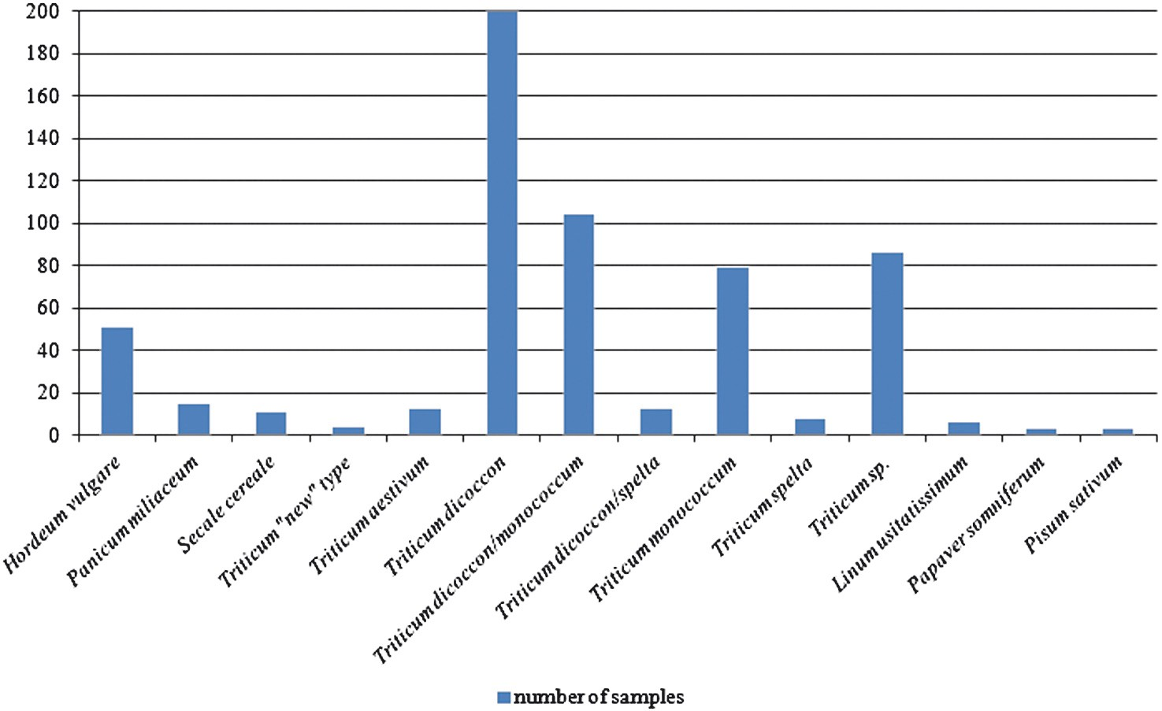

fig. 2. Frequency of cereals and other cultivated plants, in number of samples with cultivated plants in the LBK

Plants of the funnel Beaker culture in Poland
91

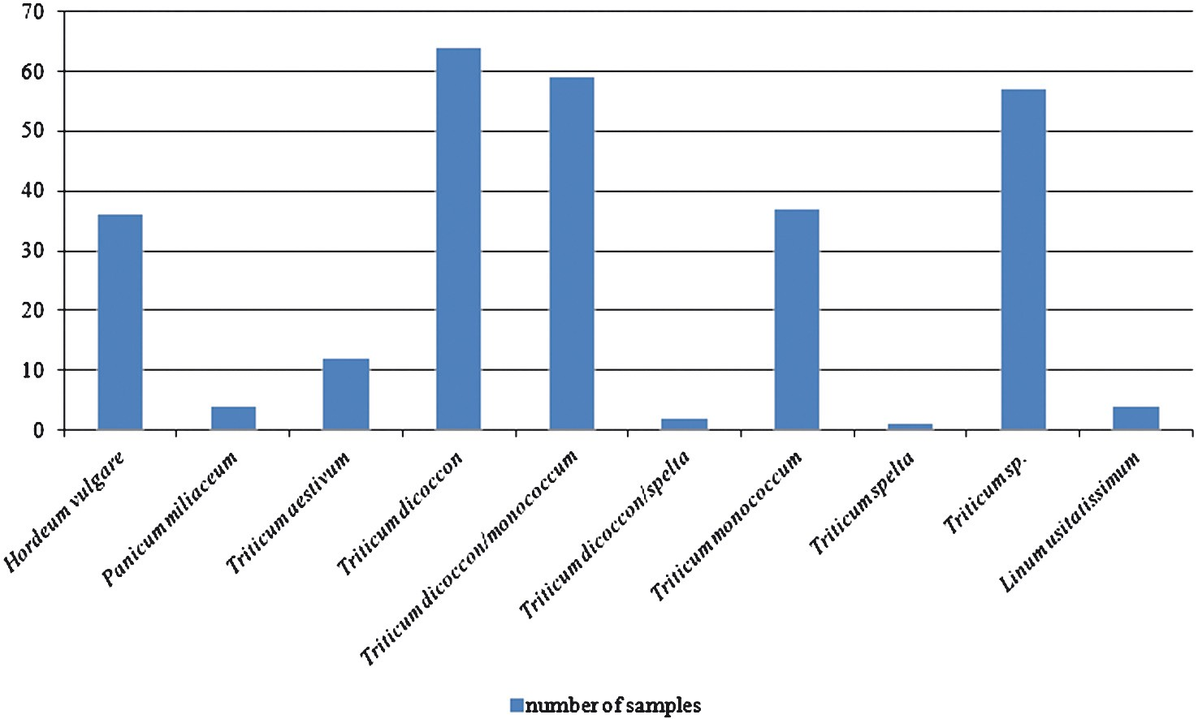
fig. 3. Frequency of cereals and other cultivated plants, in number of samples with cultivated plants in the L-Pc

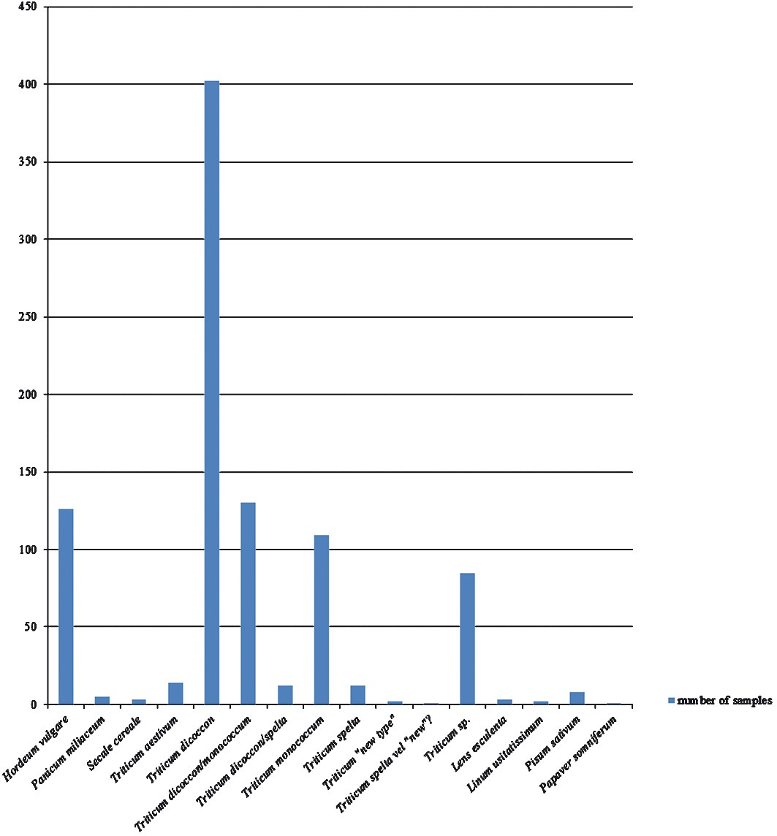
fig. 4. Frequency of cereals and other cultivated plants, in number of samples with cultivated plants in the trB

92M. nowak, M. lityńska-Zając, M. Moskal-del hoyo, a. Mueller-Bieniek, M. kapcia, k. kotynia

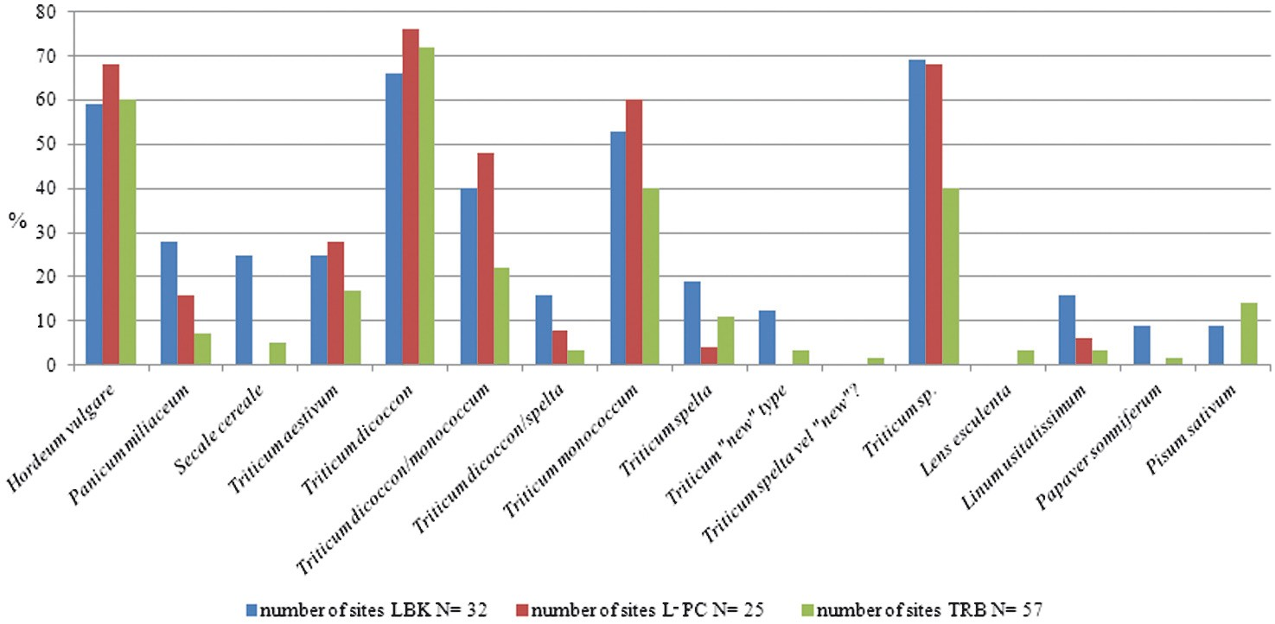

fig. 5. Frequency of cereals and other cultivated plants by percent, calculated in relation to the total number of sites with cultivated plants in three archaeological Neolithic phenomena

Based on the TRB sites from Poland, 8 species of cereals, 4 of other cultivated plants, as well as 13 species and 18 genera of wild herbaceous plants were identified (see Lityńska- Zając 2005, table VI). Due to aforementioned regional concentrations of sites with ar- chaeobotanical data analysis of the structure of crops was carried out with regard to the division into three regions: Lesser Poland (Table 1), Upper and Lower Silesia (Table 2), and Greater Poland, Kuyavia and Pomerania (Table 3).
Numbers of plant remains have not been compared. This is due to two reasons: 1. For some sites we do not have quantitative data; in some cases, we know only that there were numerous findings of particular species, 2. Comparison of the number of specimens from storage pits – occurring in the thousands in each pit – with single remains, preserved scat- tered in different features, would mean that a given deposit of grain can be crucial for the alleged dominance of a particular species, found in this deposit. Deposits of this kind usually are not very representative, even for a specific site, and are not relevant to the structure of cultivated plants in a particular village, because they probably contain grain from only one harvest (Lityńska-Zając 1997a).
In order to standardize results of analyzes and facilitate further interpretations, a com- parison method was used (Tables 1-3) in which remains of cereals were grouped into caryop- ses and chaff. State of preservation was omitted. Consequently, burned and imprinted specimens were treated together. The following numerical intervals were used: 1. Up to 10 specimens, 2. 11-100, 3. 101-1000, 4. Over 1000 specimens. Remains described only as Cerealia indet. or Cerealia indet. vel. Poaceae indet. were also skipped. For a given taxon, remains identified to the species level and probably to the species (“cf.”) level were in- cluded.

Plants of the funnel Beaker culture in Poland
93

The TRB in many respects differs from the so-called Danubian Neolithic, i.e. the LBK and L-PC. It is interesting to investigate, therefore, whether the crystallisation and deve- lopment of the TRB correlate with changes in plant economy. Thus, the TRB data were compared to data from these two older phenomena. Such comparison was made taking into account the number of samples with cereals and other crops, calculated for these three archaeological units, across all of Poland (Figs. 2-4). The mutual quantitative pro- portions of cereals and other crops are shown in Fig. 5.

resuLts

cereal crops

In Lesser Poland, seven cereal species were identified (Table 1). Remains of plants oc- cur mainly scattered in various kinds of anthropogenic features. At some sites, they were found in storage pits. Triticum dicoccon (emmer) was discovered very frequently (16 of 18 sites taken into consideration) and in large amounts. At five sites, several hundred caryop- ses and imprints were recorded, not to mention the foregoing deposits where the number of identified specimens exceeded 1,000. An extreme case is feature 32 at Kraków-Prądnik Czerwony, where this figure is estimated at 150,000 (Rook and Nowak 1993). T. monococ- cum (einkorn), preserved also as caryopses and chaff, co-occurred with T. dicoccon at 13 sites. There are no cases of the exclusive occurrence of T. monococcum. Einkorn was ge- nerally less numerous than emmer. The quantity of Hordeum vulgare (barley) is rela- tively small. Its most numerous assemblage was found at Niedźwiedź (267 imprints on daub – Burchard and Lityńska-Zając 2002). Despite small numbers, H. vulgare occurred relatively frequently, i.e. at 13 sites, in two of which neither emmer nor einkorn was identi- fied. At a few sites, finds of T. spelta (spelt), Secale cereale (rye), as well as – at one site – Panicum miliaceum (millet) were recorded.
In the case of the multi-phase settlement at Bronocice (Kruk et al. 2016), T. dicoccon,
T. monococcum and H. vulgare were present in all phases. In the very first (BR I) phase, dated, according to different views (Kruk and Milisauskas 2018; Kruk et al. 2018; Nowak 2017
– these quotations refer also to later Bronocice phases), to ca. 3950/3750-3800/3700 BC,
H. vulgare is the most frequently found, but in the subsequent phases of BR II (ca. 3700/3600-3500 BC), BR III and BR IV (ca. 3500/3400-3200/3100 BC), T. dicoccon is the most important cereal crop. In the last phase (BR V – ca. 3200/3100-2850/2750 BC),
H. vulgare “returns,” but in lower frequency than in phase BR I. Starting from BR III, specimens of T. spelta were also found in plant assemblages.
In all of the analysed sites in Silesia (Table 2), T. dicoccon and H. vulgare were recog- nized, whereas T. monococcum occurred in only two sites. The numbers of identified charred remains and imprints were low. Only on the sites of Strachów and Polwica were more than 10 specimens of T. dicoccon found.

table 1. occurrence of cultivated plants on sites of the trB in Lesser Poland. explanations: state of preservation: ch – charred remains, i – imprint; kind of remains: c – caryopsis, s – seed, chaff – including fragments of spike and spikelet as glume, palea, lemma, spikelet forks, spike rachis. Frequency X: up to 10 specimens, XX: 11-100 specimens, XXX: 101-1000 specimens, XXXX: over 1000 specimens
94
M. nowak, M. lityńska-Zając, M. Moskal-del hoyo, a. Mueller-Bieniek, M. kapcia, k. kotynia

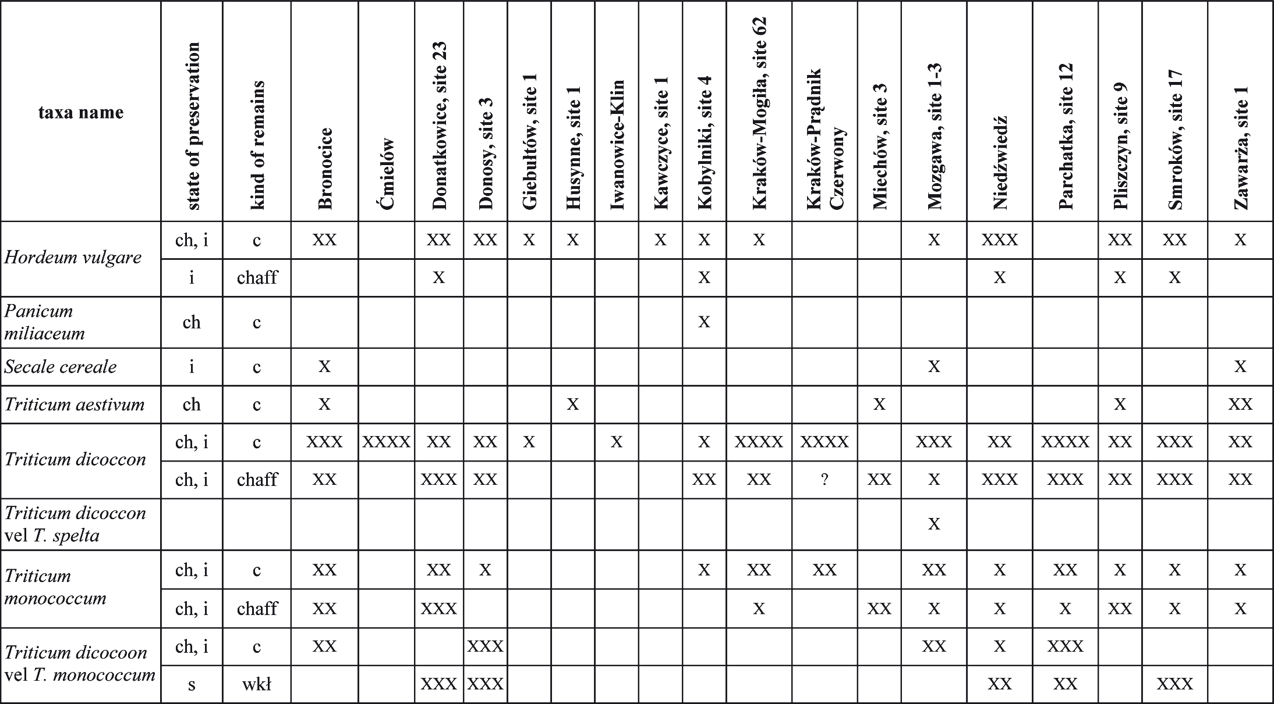

"1:l  o;;·  ";i  "'  ·  ";i | " t--.  Vs:l · -·  E"· ;i  §"  ";i | t--.  ";:',  "'  ""'  "..,  o;;· | o  "!l"  ng.  :;::·  "o..  'O  ;;;-  1j} | g:  ";i  "' |  | :  ";i  {l |  | „s„-  „=  .=..
"::i-- | "::i-- | "::i-- | o  "!l"  ng.  :;::·  "o..  'O  ;;;-  1j} | ."-?"· | ."-?"· | - | · ."-?"· | state of preservation
"' | "' | "' | o  "!l"  ng.  :;::·  "o..  'O  ;;;-  1j} | "::i--  "' | " | "::i--  "' | " | kind of remains
 |  | >< | o  "!l"  ng.  :;::·  "o..  'O  ;;;-  1j} |  | >< |  | a | Bronocice
·<> | ·<> |  | o  "!l"  ng.  :;::·  "o..  'O  ;;;-  1j} |  |  |  |  | Ćmielów
 |  |  | o  "!l"  ng.  :;::·  "o..  'O  ;;;-  1j} | ><  >< |  |  |  | Donatkowice, site 23
 |  |  | o  "!l"  ng.  :;::·  "o..  'O  ;;;-  1j} |  |  |  |  | Donosy, site 3
 |  |  | o  "!l"  ng.  :;::·  "o..  'O  ;;;-  1j} |  | >< |  |  | Giebułtów, site I
 |  |  | o  "!l"  ng.  :;::·  "o..  'O  ;;;-  1j} |  |  |  |  | Husynne, site 1
 |  |  | o  "!l"  ng.  :;::·  "o..  'O  ;;;-  1j} |  | >< |  |  | Iwanowice-Klin
 |  |  | o  "!l"  ng.  :;::·  "o..  'O  ;;;-  1j} | >< |  |  |  | Kawczyce, site 1
 |  |  | o  "!l"  ng.  :;::·  "o..  'O  ;;;-  1j} |  |  |  |  | Kobylniki, site 4
 |  |  | o  "!l"  ng.  :;::·  "o..  'O  ;;;-  1j} |  | ·<> |  |  | Kraków-Mogiła, site 62
 |  |  | o  "!l"  ng.  :;::·  "o..  'O  ;;;-  1j} |  |  |  |  | Kraków-Prądnik Czerwony
 |  |  | o  "!l"  ng.  :;::·  "o..  'O  ;;;-  1j} | ><  >< |  |  |  | Miechów, site 3
 | >< | ><  >< | o  "!l"  ng.  :;::·  "o..  'O  ;;;-  1j} | ><  >< | ><  >< |  |  | Mozgawa, site 1-3
 |  |  | o  "!l"  ng.  :;::·  "o..  'O  ;;;-  1j} |  |  |  |  | Niedźwiedź
 |  |  | o  "!l"  ng.  :;::·  "o..  'O  ;;;-  1j} |  |  |  |  | Parchatka, site 12
 |  |  | o  "!l"  ng.  :;::·  "o..  'O  ;;;-  1j} |  |  |  | >< | Płiszczyn, site 9
 |  |  | o  "!l"  ng.  :;::·  "o..  'O  ;;;-  1j} |  |  |  |  | Smroków, site 17
 |  |  | o  "!l"  ng.  :;::·  "o..  'O  ;;;-  1j} | >< | >< | >< | >< | Zawarża, site 1

S6 pue1od U! aJni1n::i Ja)jeas 1auun:1 a4i.J.o siue1d

96M. nowak, M. lityńska-Zając, M. Moskal-del hoyo, a. Mueller-Bieniek, M. kapcia, k. kotynia

table 2. occurrence of cultivated plants on sites of the trB in silesia; explanations in table 1

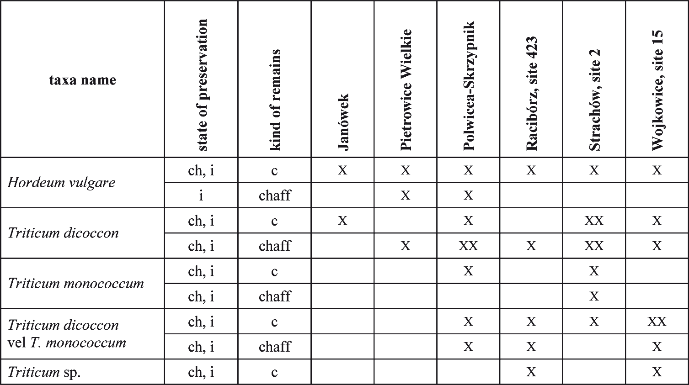

In Kuyavia, Greater Poland and Pomerania, seven species of cereal crops were identi- fied (Table 3). T. dicoccon occurred in 13 of the 18 investigated sites. On eight of these 13 sites charred remains and imprints of T. monococcum were recorded. T. monococcum was found without emmer on only one site (Szlachcin). On the other hand, there were sites in Kuyavia where T. monococcum predominates and T. dicoccon is scarcely represented, e.g. Osłonki 2 (159 specimens of einkorn vs. 14 of emmer – Mueller-Bieniek 2016). H. vulgare was recorded on 10 sites. T. aestivum, T. spelta and “new” glume wheat were identified in a smaller number of plant assemblages, similar to P. miliaceum.
The numbers of remains of the aforementioned taxa in single assemblages usually did not exceed a few dozen specimens, even in the case of emmer. This is a situation similar to Silesia, and different from Lesser Poland, where amounts of identified finds were gene- rally higher. This observation applies, interestingly enough, even to those sites in Kuyavia and Greater Poland that have been investigated in recent years, i.e. sites in which syste- matic sampling has been performed (Kopydłowo, Osłonki, Smólsk, Wolica Nowa), though no doubt this resulted in a greater taxonomical diversity (vide Kopydłowo, Wolica Nowa). The exceptions are constituted by hundreds of charred grains and imprints of H. vulgare at Mrowino 3 (Wierzbicki 2013, 251) and thousands of charred grains of T. dicoccon on the Pomeranian site of Poganice 4 (Wierzbicki 1999). Certainly, deposits discovered at Opato- wice 12, Radziejów Kujawski, Zarębowo 1, and Poganice 4, containing several thousand specimens of T. dicoccon mixed with T. monococcum (but not at Poganice 4), constitute another exception.

Plants of the funnel Beaker culture in Poland
97

other cultivated plants

Only four taxa of other cultivated plants were identified on the TRB sites (Tables 1-3): Linum usitatissimum (flax), Papaver somniferum (opium poppy), Lens culinaris (lentil) and Pisum sativum (pea). The numbers of identified specimens were very low. The only exception is at the newly investigated site of Mozgawa, due to a higher amount of L. culi- naris and P. sativum (Kotynia 2016). We cannot exclude, however, that this results from the extensive sampling strategy.

Wild plants

On the whole, 31 weed taxa were identified at TRB sites,, including 19 archaeophytes and 12 apophytes (see the full list in: Lityńska-Zając 2005, table VI). Table 4 presents the 10 species of weeds that were found at the highest number of sites (sites of the LBK and L-PC were also included there). In the examined materials, remains of Bromus secalinus (rye brome), Agrostemma githago (corn-cockle), Echinochloa crus-galli (cockspur), Che- nopodium album (goosefoot) and Fallopia convovulus (wild buckwheat) were most often represented. Of the other wild plants that might have had alimentary importance, Malus sylvestris (wild apple), Pyrus sp. (wild pear) and hazelnuts should be mentioned (Bieniek 2007; Bieniek and Lityńska-Zając 2001; Kruk et al. 2016; Wierzbicki 1999, 220, 223-226).

comparison with earlier Neolithic units

Turning to the comparison between the TRB and the earlier, Danubian Neolithic units, we find that the L-PC is characterized by the lowest taxonomical variability. However, this could be the result of the L-PC having the lowest number of investigated sites, as the variability for the LBK and TRB is similar. In other words, we should not interpret this observation as a reflection of any trends or changes within the plant economy of the L-PC. In general, there are no conspicuous differences between the TRB and earlier Neolithic units. In all of them, emmer is the most important crop, while einkorn and barley are ranked in second and third place, respectively (see Figs. 2-4). Only minor differences can be postulated. The importance of einkorn seems to be lowest in the TRB. In case of the absolute number of sites, these ratios are 53% for the LBK, 60% for the L-PC and 42% for the TRB. On the other hand, if we calculate the ratio of einkorn to emmer by the number of samples, it turns out that it amounts to over 50% for the LBK and the L-PC, and approx. 30% for the TRB. These trends are clearly visible in specimens identified as T. dicoccon vel
T. monococcum. In the TRB, there are even lower proportions of einkorn as compared to barley. In turn, barley seems to have a bit lower share in the LBK, at least when we con- sider quantity of samples.
Table 3. Occu rrence of cultivated plants on sites of the TRB i n Kuyavia, Greater Poland, and Pomerania; explanations i n Table 1
taxa name | .=::  <;i  !„:;  "„...'  ..c....  o  ..!:! | ·"='  e„  ........  o  -==  :!il | ...  ·i  ,;.  t  '""  <=:  o...  o  .5 | "„'  ć...,  t:  o  .:.:  o | \C  ·i  ó  o  :.;..,  c.  o | -  ·i  ó  .oo... | ....,  ·i  ó  ·=  o...  ::; | -  ·i  .r  <J  ·  E=  oc. | ....,  ·i  .r  <J  ·  E=  oc. | .".'.  ·i  .r  <J  ·  E=  oc. | ........,,  .r  <J  ·  E=  oc. | .".,.'.  .r  <J  ·  E=  oc. | "'  :i  =  o | ..,..  „  -  .r  <J  ·==  IOJ)  o | :!il  ·==  .•.O,,  ·;::;  -==  a: | Q...  M  :"o'  e  rJ'J | ....,  .ś  <J  -=  =<J  "N  rJ'J | =....,  "'  .<...,  "'  ·i  ó  o  .:....:  = | .„..  ....  "'  'o"  z  =<J  o | ...  ·i  ó  „o  .......  N=
Hordeum vulgare | eh, i | e | xxx | XX | X | XX | xxx |  |  |  |  | X |  | X |  | XX | X | xxx
Hordeum vulgare | i | ehaff | XX |  | X |  | xxx |  |  |  |  |  |  |  |  |  |  | XX
Panicum miliaceum | eh | e | X |  |  |  |  |  |  |  |  |  |  |  |  |  | XX | X
Triticum aestivum | eh, i | e |  |  |  |  |  |  |  | XX |  | X |  |  | XX |  | X |  |  | X
Triticum dicoccon | eh, i | e |  | X | X |  | X | X | X | xxxx | X | X |  | xxxx | xxxx |  |  |  | X | xxxx
Triticum dicoccon | eh, i | ehaff |  |  | XX |  |  |  |  | XX |  | X | xxx | xxxx |  |  |  |  | X
Triticum dicoccon vel T spe/ta |  |  |  |  |  |  |  |  |  |  |  |  |  | X
Triticum monococcum | eh, i | e |  |  | X |  |  | X |  | X |  | X |  |  | xxx |  | X |  | X | xxx
Triticum monococcum | eh, i | ehaff |  |  | XX |  |  | X |  |  |  | X | XX |  |  |  |  |  | XX
Triticum "new" type |  |  |  |  |  |  |  |  |  |  |  |  |  |  |  |  |  |  | X
Triticum spe/ta | i | e |  |  |  | X |  |  |  |  |  | X
Triticum spe/ta vel "new"? | i | ehaff |  |  |  |  |  |  |  |  |  |  | X
Triticum sp. | eh, i | e | X |  |  | X | XX | X | X |  |  | X | X |  |  |  |  |  | XX
Triticum sp. | eh, i | ehaff |  |  | X |  |  | X | X |  |  | X |  |  |  |  |  |  | XX
other eultivated plants
Lens culinaris | i | s |  |  |  |  |  |  |  |  | X
Pisum sativum | eh, i | s |  | X |  |  |  |  |  |  |  | X |  |  |  |  | X |  | X
Papaver somniferum | eh | n |  |  |  |  |  |  |  |  |  |  |  |  |  |  |  |  | X

""'

'o°o
;I
z

l"
;I
,ą-
:J,

...!!!.

;I
3:
Q
T
c..

I
i

;t>- 3:
c:

ro
1
c;:J
ro·

:rJo·
l"
;I
7'
""'C'
n

F
i"
-i

iii'

Plants of the funnel Beaker culture in Poland
99

table 4. Frequency of weeds in archaeological sites representing the LBK, L-Pc, and trB and their present day phytosociological classification (after Matuszkiewicz 2001 and Zarzycki et al. 2002). Present day phytosociological classification: A – Aperion, Bt – Bidention tripartiti, caucalid – Caucalidion lappulae, cc – Centuretalia cyani, L – Linion, Pan-setar – Panico-Setarion, Pol-chen – Polygono-Chenopodietalia, stel med – Stellarietea mediae

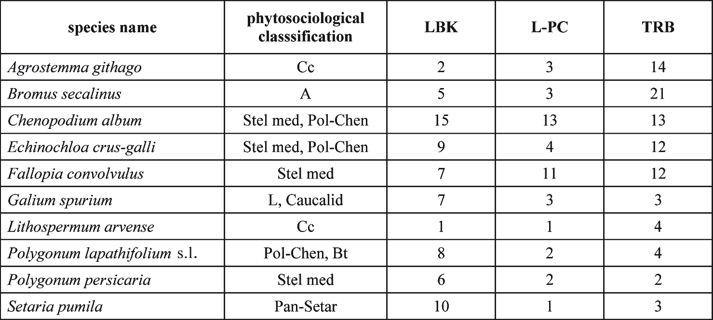

An interesting observation is connected with other crops. Most of them seem to be the least important in the TRB (see especially Fig. 4). This applies particularly to P. miliaceum,
S. cereale, T. aestivum, “new” glume wheat, L. usitatissimum and P. somniferum. Against this background, the predominance of emmer, as well as the considerable importance of barley and einkorn, is seen even more convincingly.
As regards cultivated plants other than cereals, it should be emphasized that from a general perspective, their significance was low in all three cultural units. In the TRB,
L. usitatissimum and P. somniferum seem to comprise a slightly smaller share and Faba- ceae a slightly higher one than in the earlier Neolithic.

dIscussIoN

crops in the trB

In the TRB in Polish territories, three cereal species clearly predominate: T. dicoccon,
T. monococcum and H. vulgare. This is also reflected by the high shares of T. dicoccon vel
- monococcum. T. dicoccon is definitely ranked first. The importance of the other two crops is similar, perhaps with a slight predominance of barley. These three cereals oc- curred at a significant majority of the analyzed sites. There are only three sites where em- mer was not “accompanied” by einkorn and barley, and four sites where einkorn or barley occurred “alone”.

100 M. nowak, M. lityńska-Zając, M. Moskal-del hoyo, a. Mueller-Bieniek, M. kapcia, k. kotynia

The great importance of cereal cultivation can be demonstrated by storage pits con- taining deposits of grain. They were discovered in at least eight sites of the TRB (Ćmielów, Kraków-Mogiła 62, Kraków-Prądnik Czerwony, Opatowice 12, Parchatka 12, Poganice 4, Radziejów Kujawski and Zarębowo 1). In these deposits, emmer distinctly predominates, but there is almost always an admixture of einkorn. Certainly, this suggests joint cultiva- tion of these taxa (maslin), since both have similar edaphic requirements and similar life cycles (sowing, flowering, harvesting). One pit at Ćmielów, where clean grain of emmer was recorded, is an exception. Similarly, of the cereals, only emmer grains were registered in three or four pits at the site of Poganice 4. However, in addition to emmer, quite a num- ber of hazelnut shells were discovered in these pits. It is worth noting that only three pits of this kind were found in the LBK and L-PC (Gluza 1984; Godłowska and Gluza 1989; Grygiel 2008, 550, 664-665; Lityńska 1990). In the TRB deposits, there is no barley. We should add, however, that barley deposits were recorded in the TRB context in the Czech Republic (Dreslerová and Kočár 2013).
Other cultivated plants formally appear to have minimal significance. Of course, the question arises whether a small share of other wheats, millet, pulses, flax, and poppy in macroscopic remains may result from their marginal role in past crops or from other causes, i.a. the number of tested samples, or certain taphonomic disturbances. For example, in the multi-cultural site 3 at Miechów (Fig. 1), some grains of millet were found in the Lublin-Volhynian features. However, one grain was 14C dated and the result clearly indi- cated a chronology of the Late Bronze Age (Mueller-Bieniek et al. 2018a, 605).
In the case of pulses, there are suggestions that their poor representation in sub-fossil materials is conditioned by the fragility of the charred Fabaceae seeds. For instance, at the site of Tell el-Kerkh, 29 specimens of Vicia faba (broad beans) were obtained through flotation. However, after the transportation and unpacking of samples, only four pieces survived (Tanno and Wilcox 2006). On the other hand, at the TRB site at Mozgawa, pulses were found quite often and in a good state of preservation. In addition, we cannot forget that on many archaeological sites from later periods, numerous remains of pulses were present (e.g. L. culinaris at the Bronze Age site of Sobiejuchy in eastern Greater Poland – Palmer 2004). This corresponds to the views of some authors (e.g. Kohler-Schneider 2001), that pea and lentil became popular only in the late Bronze Age, simultaneously with the spread of millet. Besides, these plants (in the full, “Near Eastern” set, i.e. Lathyrus sativus, L. culinaris, P. sativum, Vicia ervilia and V. faba) are represented in the First Temperate Neolithic in the Balkans (e.g. Conolly et al. 2008). Thus, in these cases, the fragility of charred seeds did not negatively affect their preservation.
Altogether, one could wager that pea and lentil were probably sown in gardens by the TRB people, as was the case of the LBK and L-PC (Bogaard 2004; Kruk and Milisauskas 1999; Kruk et al. 2016, 147; Nowak 2009, 184, 392), but their importance in the diet was lower than in subsequent ages.

Plants of the funnel Beaker culture in Poland
101

The status of S. cereale, T. aestivum and T. spelta, not only in the context of TRB, re- mains debatable. It is common belief that rye and spelt were only weeds of cereal crops in the Neolithic (Behre 1992; Lityńska-Zając 2007b, 213; Wasylikowa et al. 1991, 222-224), and we cannot rule out that such status should be assigned to all three aforementioned plants (Lityńska-Zając 2007a, 323). On the other hand, the identification of T. spelta in three phases at Bronocice (Kruk et al. 2016) suggests that this wheat could be grown, at least locally. The relatively early presence of T. spelta in eastern Central Europe should be studied in detail in the light of other European findings (Akeret 2005). Let us add that spelt is not very demanding in terms of soil, and it is resistant to low temperatures and excessive humidity (Janushevich 1976); furthermore, it produces a luxurious flour. For Neolithic people, these factors could be arguments for its cultivation.

Wild herbaceous plants

The frequent presence in the sub-fossil materials of herbaceous taxa, such as B. seca- linus, E. crus-galli, Ch. album and F. convovulus, may result from their economic useful- ness. Even A. githago, also frequently represented, can be used therapeutically and as a poison (Mueller-Bieniek 2012, 100; Zemanek 2012). Diasporas of these plants could have been intentionally collected (Behre 2008; Colledge and Conolly 2014; Mueller-Bieniek et al. 2018b; 2019a), or perhaps stored food was not cleaned of them, because they were fit for human consumption. Some of them are characterized by high fertility, e.g. one speci- men of goosefoot produces about 100,000 seeds (Tymrakiewicz 1962, 31-32).
Regardless of their potential usefulness, the presence of field weeds in macroscopic assemblages provides important information about the patterns of cultivation. Cereal pre- dominance in the plant economy of the TRB is implied not only by deposits and taxa struc- tures, but also by weeds found in the context of the TRB, including the foregoing deposits as well. As we already know, the degree of weed infestation in grain found in deposits is insignificant. This could be due not only to the very good cleaning of grain by the farmers of the time, but also due to low (natural) contamination of crops. The degree of infestation of fields depends i.a. on the duration of their use. Therefore, a small number of weeds typical of cereal crops may reflect the short use of these fields.
According to M. Lityńska-Zając (2005, 264-267) plants found in cereal deposits of the TRB are linked (acc. to the current phytosociological perspective) with different environ- ments: field, ruderal and forest. The large share of apophytes from riverine grasslands, meadows, and forest communities, and the predominance of perennial species among them, indicate that new stretches of land were taken for tillage. Native species, undamaged in the course of preparing the soil for sowing, could grow there. At the same time, a modest number of sites containing large amounts of weeds can be, to some extent, an argument for the sowing of cereals on freshly prepared fields. This aspect somewhat resembles the LBK

102 M. nowak, M. lityńska-Zając, M. Moskal-del hoyo, a. Mueller-Bieniek, M. kapcia, k. kotynia

(Lityńska-Zając 2005, 267). Generally, all these facts and interpretations may mean that fields were located in different ecological conditions, including areas not previously ex- ploited for agricultural purposes.

trajectories and models of the plant economy

A serious deficiency in our knowledge on the plant economy of the TRB in Poland is due to the almost complete lack of information about early stages of this culture. Data obtained from the first phase of the TRB settlement at Bronocice point to the existence of a cereal economy as early as the first quarter of the 4th millennium BC (Kruk et al. 2016), similar to the not-so-distant site of Kawczyce (Nowak 1994). As regards the early phase of the eastern group of the TRB, currently only one imprint of T. aestivum on a pottery fragment at Łącko 6 (Domańska and Kośko 1983), and only two imprints of supposed T. dicoccon and T. monococcum on pottery fragments at Redecz Krukowy 20 (Mueller-Bieniek 2018) can be mentioned, which does not prove the everyday usage of cereals or their by-pro- ducts. Perhaps it is significant that in the meticulously investigated site of Dąbki (north- central Pomerania), there are no domesticated plants in the context of the local early TRB, up to approx. 3700 BC (Czekaj-Zastawny et al. 2013, 423). Most probably, what we see here is the continuation of patterns of the local Mesolithic (Kalis et al. 2015). The cereal economy in the early TRB is also supported by pollen spectra obtained from ploughing furrows in the monumental, unchambered tomb no. 8 at Sarnowo 1 (Kuyavia), as well as from anthropogenic features at the settlement on the same site. They provided i.a. pollen of wheat and barley (Dąbrowski 1971). Similarly, an analysis of phytolites from ploughing furrows under the barrows of the monumental tombs at Zagaje Stradowskie (western Lesser Poland) suggests a cultivated field with wheat and probably barley (Polcyn et al. 1999).
Overall, the scarce data from the early TRB seem to demonstrate that cultivation was practiced by TRB people since the very beginning, although the significance of cereal cul- tivation, particularly in the Lowland zone, may have been moderate until ca. 3700/3600 BC. This interpretation closely mirrors observations made in northern Germany (Kirleis and Fischer 2014; Kirleis et al. 2012).
If we consider the global (i.e. not restricted to early stages) relationships to other groups of the TRB, we should indicate some similarities to the southern groups of this culture (Dreslerová and Kočár 2013), and some differences in relation to the northern group. In the latter, in addition to the noticeable importance of free threshing wheats in the Early Neolithic I, the share of barley is incomparably higher. In a large part of the Early Neolithic II and Middle Neolithic sites, it is the dominant species. On the other hand, the share of einkorn is surprisingly low (Kirleis and Fischer 2014).
Differences between the “Polish” archaeobotanical assemblages of the LBK, L-PC, and TRB seem to be small, both in quantitative and qualitative terms. They consist of a slightly

Plants of the funnel Beaker culture in Poland
103

greater predominance of emmer, and a slightly greater importance of barley, in the case of the TRB. Interestingly enough, this impression has been confirmed by χ2 test, performed on the basis of the data presented in Figs. 2-4 for emmer, barley, and einkorn. The resul- ting p-value of 0.0244 means that there is a statistically significant difference between the LBK, L-PC and TRB. This conclusion is also visible in the correspondence analysis for the same data (Fig. 6: A). It shows that the differences between the LBK and L-PC are of the same order as that between the Danubian Neolithic units and the TRB. A similar picture has been obtained (Fig. 6: B) when complemented with the respective ratios for T. aesti- vum, T. spelta, S. cereale and P. miliaceum (due to the small sample sizes of these taxa, the χ2 test cannot be applied).
The comparison of these three archaeological units with respect to weeds is perhaps more interesting (Table 4). In current phytosociological terms, segetal weeds are classified in two distinct groups. The first includes species characteristic of cereal crops, and the second comprises species related to root plants (Matuszkiewicz 2001). This division, in spite of various objections to its usefulness in palaeoecology (Jones 2002, see further li- terature), is reflected in analyses of fossil sources. To weeds associated with root-crop communities (Polygono-Chenopodietalia and Panico-Setarion) belong Ch. album, E. crus- galli, Polygonum lapathifolium (pale persicaria) and Setaria pumila (yellow foxtail). Segetal communities found in cereal crops (Aperion, Caucalidion lappulae and Centaure- talia cyani) include A. githago, B. secalinus, G. spurium and L. arvense.
It turns out that some species associated with root crops (P. lapathifolium and S. pumi- la) occur more often on sites of the LBK and L-PC. On the other hand, some weeds occur- ring in cereal crops (A. githago and B. secalinus) were recognized more frequently on TRB sites. This may be related to changes in patterns of cultivation. Remains of the weeds of root-crop communities usually occurred in conjunction with remains of caryopses of hulled wheats and/or barley. Therefore, the presence of these weeds should rather be con- nected with cereal cultivation, in which soil was prepared with a technique similar to hoe farming (Kruk 1993). This was very close to the techniques used for root crops. In turn, the frequent presence of cereal weeds in the TRB was associated with cultivating fairly large amounts of land and giving up hoe farming techniques (e.g. Lityńska-Zając 2005, 367; Mueller-Bieniek 2016). In other words, in the TRB, an extensive cultivation of cereals would have prevailed.
The aforementioned data and interpretations, in themselves, do not give a clear answer to the question about patterns of plant cultivation in the TRB. The suggested picture of the dominant role of cereal crops might, however, compliment the classic model describing Neolithic settlement and economy, formulated in Polish literature by J. Kruk in 1970s (1973; 1980), and later developed in collaboration with S. Milisauskas (Kruk et al. 1996; Kruk and Milisauskas 1999).
This model assumes that the economy and settlement pattern of the TRB communities required the exploitation of extensive areas. The predominant type of farming was slash-

104 M. nowak, M. lityńska-Zając, M. Moskal-del hoyo, a. Mueller-Bieniek, M. kapcia, k. kotynia

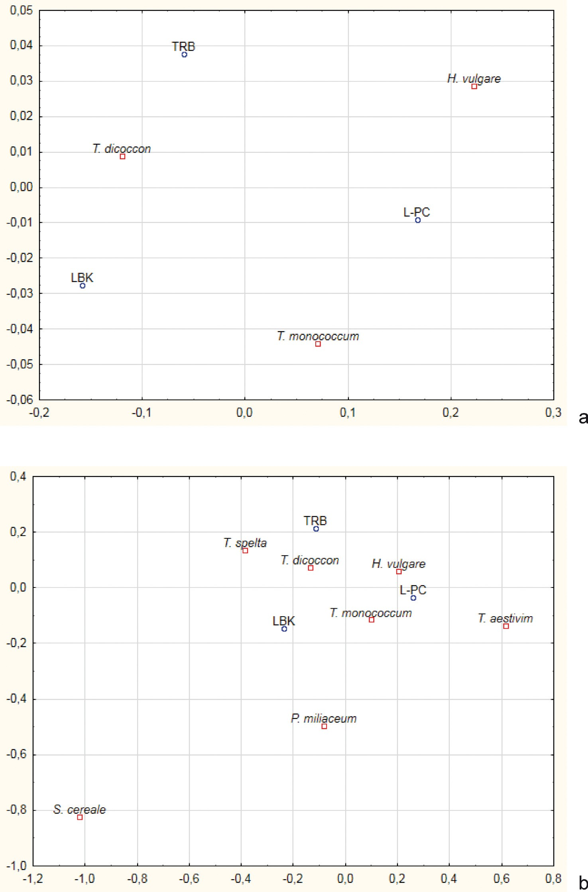
fig. 6. correspondence analysis of the LBK, L-Pc, and trB data (see Figs. 2-4) for a) emmer, einkorn, and barley and b) emmer, einkorn, barley, bread wheat, spelt, rye and millet

Plants of the funnel Beaker culture in Poland
105

and-burn shifting cultivation practised on a massive scale, and the basic tool of agricul- tural technology was fire. Such a system was focused on cereal crops (Kruk and Milisauskas 1999, 147). The final result of this system was the significant deforestation of the land- scape. The model under discussion referred primarily to the loess upland zone. However, some processes of anthropogenic deforestation could also have taken place in lowland areas (Kruk and Milisauskas 1999, 255-256).
It is worth mentioning at this point the recent analyses of isotopic compositions of carbonized cereal grains from the territory of Poland, including the TRB grains (Mueller- Bieniek et al. 2019b). The δ15N values indicated that almost all cereal fields from which the TRB samples originated “could have received some inputs of fertilizer, including manure and household waste” (Mueller-Bieniek et al. 2019b, 11). This seems to contradict the above mentioned hypotheses of landscape deforestation, and implies intensive, perma- nent cultivation, at least in the upland zone of southern Poland, as almost all TRB samples come from there. On the other hand, in theory, it cannot be entirely ruled out that such isotopic signals of manuring may result from intentional burning of the vegetation to clear the land for agriculture (Mueller-Bieniek et al. 2019b, 2, 10, see further literature) the more so since δ13C values demonstrate that part of the TRB fields in southern Poland existed in more open, elevated landscapes, with lower water availability (Mueller-Bieniek et al. 2019b).
Obviously, this is a very complex issue among other reasons because not all categories of palaeoenvironmental data and not all palaeoenvironmental interpretations support Kruk’s views. At present, his model seems to be supported more by geomorphological data, indicating intensive slope erosion in the 4thmillenium BC (Kruk et al. 1996; Poręba et al. 2012; Szwarczewski 2009), than by palynological data, though of course there are some profiles with indicators of a substantial opening of woodland cover and traces of fire (e.g. Nowak 2001). On the other hand, we can easily point to many pollen profiles, obtained in regions with quite intensive TRB settlement, in which human traces are quite scarce (i.a. they contain little to no cereal pollen). This applies mainly to lowland areas (e.g. Herking 2004; Niewiarowski and Noryśkiewicz 1999; Noryśkiewicz 2006), but also upland ones (e.g. Na- lepka 2003). We must remember, however, that palynological data are much less frequent in the loess highlands. It may therefore give a false impression of minimal human activity, based on the overrepresented lowland pollen data. For instance, the situation recorded in the recently investigated pollen profile at Mozgawa (i.e. in the loess zone) is very signifi- cant. The series of anthropogenic indicators seems to support the thesis of intense and widespread human environmental impact (Moskal-del Hoyo et al. 2018).
It should be emphasized that the lack of differences in palynological indicators of cereals between the LBK, L-PC and TRB (Milecka et al. 2004) does not necessarily imply similar cultivation systems. Palynological data do not reflect the actual species composi- tion, nor the role of given crops (Grikpėdis and Motuzaitė Matuzevičiūtė 2016; Latałowa 2003; 2007). Species of the Triticum and Hordeum are self-pollinated; therefore, the possi-

106 M. nowak, M. lityńska-Zając, M. Moskal-del hoyo, a. Mueller-Bieniek, M. kapcia, k. kotynia

bility of dispersions of sporomorphs is significantly reduced. As a result, their real impor- tance is undervalued. To an even greater extent, this applies to P. miliaceum (Latałowa 2003, 279; Milecka et al. 2004).
The discussion of the possibility of distinguishing between permanent and shifting cul- tivation, based on archaeobotanical, palynological and archaeological data, has been going on for years (Ehrmann et al. 2014; Robin and Nelle 2014; Rösch et al. 2014; Baum et al. 2016; Jacomet et al. 2016; Rösch and Lechterbeck 2016). Totally opposed opinions have occurred in this regard. Universal indicators of these two types of cultivation have not been worked out, despite the fact that, in many cases, incomparably superior sets of source data (e.g. Jacomet et al. 2016) were available, when compared, for example, with the “Polish” TRB. Therefore, we took the liberty not to propose a decisive hypothesis for the “Polish” TRB in this matter. We are of the opinion that the current state of data and interpretations do not authorize us to do so. Certainly, this does not mean that shifting cultivation could not be practiced by the TRB communities in the Vistula and Oder basins. We can suppose that there was a patchwork of agricultural techniques, which best fit the local environmental and social conditions.

coNcLusIoNs

The following are the most important conclusions that should be put forward as re- gards the plants and the plant economy of the Funnel Beaker culture in Poland.
  - There is a predominance of Triticum dicoccon in the TRB, both in scattered material and in deposits.
  - Triticum monococcum frequently co-occurs in deposits as an admixture in small amounts. The pattern of deposition of caryopses of these two species of wheat suggests that they could be sown together, in the form of maslin with a predominance of emmer (up to 90%).
  - Hordeum vulgare occurs in a slightly higher number of sites than Triticum mono- coccum, but in lower amounts (mostly detected as imprints); there are no confirmed de- posits of Hordeum vulgare.
  - The proportions (and importance) of other cereals and other cultivated plants are insignificant.
  - Weeds connected with the extensive cultivation of cereals grow in importance when compared to the Danubian Neolithic.
  - New archaeobotanical data suggest that pulses (pea and lentil) and flax were locally cultivated.

Plants of the funnel Beaker culture in Poland
107

Acknowledgements
Part of the investigations was carried out under the auspices of the National Centre of Science (Poland) project, number NCN 2013/11/B/HS3/03822, headed by M. Moskal-del Hoyo. We are grateful for support from this Project.

references

Abramów J. 2015. Analiza archeobotaniczna polepy i odcisków ziaren na ceramice. In A. Marciniak,
    - Sobkowiak-Tabaka, M. Bartkowiak and M. Lisowski (eds), Kopydłowo, stanowisko 6. Osady neolityczne z pogranicza Kujaw i Wielkopolski. Poznań, Pękowice: Uniwersytet im. Adama Mickiewicza w Poznaniu, Wydawnictwo Profil-Archeo, 171–189.
Akeret Ö. 2005. Plant remains from a Bell Beaker site in Switzerland, and the beginnings of Triticum spelta (spelt) cultivation in Europe. Vegetation History and Archaeobotany 14, 279–286.
Baum T., Nendel C., Jacomet S., Colobran S. and Ebersbach R. 2016. ”Slash and burn” or ”weed and manure”? A modelling approach to explore hypotheses of late Neolithic crop cultivation in prealpine wetland sites. Vegetation History and Archaeobotany 25, 611–627.
Behre K-E. 1992. The history of rye cultivation in Europe. Vegetation History and Archaeobotany 1, 141-156.
Behre K-E. 2008. Collected seeds and fruits from herbs as prehistoric food. Vegetation History and Archaeobotany 17, 65-73.
Bieniek A. 2007. Neolithic plant husbandry in the Kujawy region of central Poland. In S. Colledge and
J. Conolly (eds), The Origins and Spread of Domestic Plants in Southwest Asia and Europe. Walnut Creek: Left Coast Press, 327-342.
Bieniek A. and Lityńska-Zając M. 2001. New finds of Malus sylvestris Mill. (wild apple) from Neo- lithic sites in Poland. Vegetation History and Archaeobotany 10, 105-106.
Bogaard A. 2004. Neolithic Farming in Central Europe. An Archaeobotanical Study of Crop Hus- bandry Practices. London, New York: Routledge.
Bogucki P. 2008a. Forest Farmers and Stockherders. Early Agriculture and its Consequences in North-Central Europe, 2nd edn. Cambridge: Cambridge University Press.
Bogucki P. 2008b. The Danubian-Baltic borderland: northern Poland in the fifth millennium BC.
Analecta Praehistorica Leidensia 40, 51-66.
Burchard B. and Lityńska-Zając M. 2002. Plant remains from the Funnel Beaker Culture site at Niedźwiedź, Słomniki commune, Małopolska province. Acta Palaeobotanica 41(2), 171-176. Colledge S. and Conolly J. 2014. Wild plant use in European Neolithic subsistence economies: a for- mal assessment of preservation bias in archaeobotanical assemblages and the implications
for understanding changes in plant diet breadth. Quaternary Science Review 101, 193-206.
Conolly J. Colledge S. and Shennan S. 2008. Founder effect, drift, and adaptive change in domestic crop use in early Neolithic Europe. Journal of Archaeological Science 35, 2797-2804.

108 M. nowak, M. lityńska-Zając, M. Moskal-del hoyo, a. Mueller-Bieniek, M. kapcia, k. kotynia

Czekaj-Zastawny A., Kabaciński J. and Terberger T. 2013. The origin of the Funnel Beaker culture from the southern Baltic coast perspective. In S. Kadrow and P. Włodarczak (eds), Environ- ment and Subsistence – Forty Years after Janusz Kruk’s “Settlement Studies...”. Rzeszów, Bonn: Institute of Archaeology Rzeszów University, Dr. Rudolf Habelt GmbH, 409-428.
Czekaj-Zastawny A., Rauba-Bukowska A., Kukułka A., Kufel-Diakowska B., Lityńska-Zając M., Moskal-del Hoyo M. and Wilczyński J. 2020. The earliest farming communities north of the Carpathians: The settlement at Gwoździec site 2. PLoS ONE 15(1): e0227008. https://doi. org/10.1371/journal.pone.0227008.
Dąbrowski M.J. 1971. Analiza pyłkowa warstw kulturowych z Sarnowa, pow. Włocławek. Prace i Materia- ły Muzeum Archeologicznego i Etnograficznego w Łodzi. Seria Archeologiczna 18, 147-163. Domańska L. and Kośko A. 1983. Łącko, woj. Bydgoszcz stanowisko 6 – obozowisko z fazy „AB” kul-
tury pucharów lejkowatych. Folia Archaeologica 4, 3-48.
Dreslerová D. and Kočar P. 2013. Trends in cereal cultivation in the Czech Republic from the Neolithic to the Migration period (5500 B.C.-A.D. 580). Vegetation History and Archaeobotany 22, 257-268.
Ehrmann O., Biester H., Bogenrieder A. and Rosch M. 2014. Fifteen years of the Forchtenberg ex- periment – results and implications for the understanding of Neolithic land use. Vegetation History and Archaeobotany 23 (Suppl. 1), 5-18.
Gluza I. 1984. Neolithic cereals and weeds from the locality of the Lengyel Culture at Nowa Huta – Mogiła near Cracow. Acta Palaeobotanica 23(2), 123-184.
Gluza I., Tomczyńska Z. and Wasylikowa K. 1988. Uwagi o użytkowaniu drewna w neolicie na podsta- wie analizy węgli drzewnych ze stanowisk archeologicznych w Krakowie-Nowej Hucie. Mate- riały Archeologiczne Nowej Huty 12, 1-19.
Godłowska M. and Gluza I. 1989. Lengyel Culture. Cracow-Nowa Huta-Mogiła. Przegląd Archeolo- giczny 36, 225-227.
Grikpėdis M. and Motuzaitė Matuzevičiūtė G. 2016. The beginnings of rye (Secale cereale) cultivation in the East Baltics. Vegetation History and Archaeobotany 25, 601-610.
Grygiel R. 2008. The Neolithic and Early Bronze Age in the Brześć Kujawski and Osłonki Region, Vol. II, Middle Neolithic: The Brześć Kujawski Group of the Lengyel Culture. Łódź: Fundacja Badań Archeologicznych Imienia Profesora Konrada Jażdżewskiego, Muzeum Archeologicz- ne i Etnograficzne w Łodzi.
Herking C. M. 2004. Pollenanalytische Untersuchungen zur holozänen Vegetationsgeschichte ent- lang des östlichen unteren Odertals und südlichen unteren Wartatals in Nordwestpolen. Dissertation, University of Göttingen. http://webdoc.sub.gwdg.de/diss/2005/herking/in- dex.html (accessed June 2009).
Jacomet S., Ebersbach R., Akeret Ö., Antolín F., Baum T., Bogaard A., Brombacher C., Bleicher N.K., Heitz-Weniger A., Hüster-Plogmann H., Gross E., Kühn M., Rentzel P., Steiner B., Wick L. and Schibler J. 2016. On-site data cast doubts on the hypothesis of shifting cultivation in the late Neolithic (c. 4300-2400 cal. BC): Landscape management as an alternative paradigm. Holocene 26(11), 1858-1874.

Plants of the funnel Beaker culture in Poland
109

Janushevich Z. V. 1976. Kulturnye rasteniya jugo-zapada SSSR po paleoetnobotanicheskim issledo- vaniyam. Kishinev: Shtiintsa.
Jones G. 2002. Weed ecology as a method for the archaeobotanical recognition of crop husbandry practices. Acta Palaeobotanica 42(2), 185-193.
Kalis A. J., Kubiak-Martens L. and Meurers-Balke J. 2015. Archäobotanische Untersuchungen am mesolithischen Fundplatz Dąbki 9. In J. Kabaciński, S. Hartz, D. C. M. Raemaekers and
T. Terberger (eds), The Dąbki Site in Pomerania and the Neolithisation of the North Euro- pean Lowlands (c. 5000-3000 cal BC). Rahden/Westf.: Marie Leidorf, 31-50.
Kapcia M. and Mueller-Bieniek A. 2018. Archaeobotanical analysis of abundant cereal finds from Kraków Nowa Huta Mogiła 62 – getting back to the old story. Folia Quaternaria 86, 217-231. DOI: 10.4467/21995923FQ.18.004.9822.
Kirleis W. and Fischer E. 2014. Neolithic cultivation of tetraploid free threshing wheat in Denmark and Northern Germany: implications for crop diversity and societal dynamics of the Funnel Beaker Culture. Vegetation History and Archaeobotany 23, 81-96.
Kirleis W., Klooß S., Kroll H. and Müller J. 2012. Crop growing and gathering in the northern German Neolithic: a review supplemented by new results. Vegetation History and Archaeobotany 21, 221-242.
Klichowska M. 1966. Badania odcisków roślinnych na ceramice z neolitycznego stanowiska w Szlach- cinie w pow. średzkim. Przegląd Archeologiczny 17, 84-86.
Klichowska M. 1968. Odciski zboża na neolitycznej polepie i ceramice z Janówka, pow. Dzierżoniów.
Sprawozdania Archeologiczne 19, 451-452.
Klichowska M. 1969a. Wyniki badań szczątków roślinnych z neolitycznej osady w Husynnem, pow. Chełm, z 1966 roku. Sprawozdania Archeologiczne 20, 417.
Klichowska M. 1969b. Analiza botaniczna materiałów z osady neolitycznej z Pietrowic Wielkich, pow.
Racibórz. Sprawozdania Archeologiczne 20, 413-416.
Klichowska M. 1970. Neolityczne szczątki roślinne z Radziejowa Kujawskiego. Prace i Materiały Mu- zeum Archeologicznego i Etnograficznego w Łodzi. Seria Archeologiczna 17, 165-174.
Klichowska M. 1972. Rośliny naczyniowe w znaleziskach kulturowych Polski północno-zachodniej.
Prace Komisji Biologicznej Poznańskiego Towarzystwa Przyjaciół Nauk 25(2), 1-73.
Klichowska M. 1979. Pszenica z neolitycznego stanowiska w Opatowicach, woj. włocławskie. Prace i Mate- riały Muzeum Archeologicznego i Etnograficznego w Łodzi. Seria Archeologiczna 26, 57-65. Klichowska M. 1985. Wyniki badań paleobotanicznych z trzech stanowisk archeologicznych: Poga- nice, Warszkowo, i Sławsko z 1985 r. Dissertation. Institute of Archaeology and Ethnology of
the Polish Academy of Sciences.
Kohler-Schneider M. 2001. Verkohlte Kultur- und Wildpflanzenreste aus Stillfried an der March (= Mitteilungen der Prähistorischen Kommission 37). Wien: Verlag Österreichischen Aka- demie der Wissenschaften.
Koszałka J. 2006. Odciski roślin na ceramice kultury pucharów lejkowatych oraz kultury amfor koli- stych. In A. Kośko and M. Szmyt (eds), Opatowice – Wzgórze Prokopiaka 1. Poznań: Wydaw- nictwo Poznańskie, 263-268.

110 M. nowak, M. lityńska-Zając, M. Moskal-del hoyo, a. Mueller-Bieniek, M. kapcia, k. kotynia

Koszałka J. 2007a. Odciski roślin na ceramice i polepie kultury pucharów lejkowatych. In A. Kośko and M. Szmyt (eds), Opatowice – Wzgórze Prokopiaka 2. Poznań: Wydawnictwo Poznańskie, 247-248.
Koszałka J. 2007b. Odciski roślin na ceramice i polepie kultury pucharów lejkowatych oraz kultury amfor kulistych. In A. Kośko and M. Szmyt (eds), Opatowice – Wzgórze Prokopiaka 3. Poznań: Wydawnictwo Poznańskie, 363-369.
Koszałka J. 2014. Odciski roślin na ceramice i polepie oraz makrofosylia. In A. Kośko and M. Szmyt (eds),
Opatowice – Wzgórze Prokopiaka 4. Poznań: Wydawnictwo Poznańskie, 449-456.
Kośko A. 1981. Udział południowo-wschodnioeuropejskich wzorców kulturowych w rozwoju niżo- wych społeczeństw kultury pucharów lejkowatych. Poznań: Wydawnictwo Poznańskie.
Kotynia K. 2016. Gospodarka roślinna na osadzie KPL w Mozgawie (stanowiska 1-3) na tle danych z południowo-wschodniej grupy kultury pucharów lejkowatych. MA Dissertation. Institute of Archaeology, Jagiellonian University.
Kozłowski S. K. and Nowak M. 2019. I przyszli ludzie zza Gór Wysokich. Ziemie polskie od VI do IV tysiąclecia BC. Rzeszów-Warszawa: Instytut Archeologii Uniwersytetu Rzeszowskiego, Ośro- dek Badań nad Antykiem Europy Południowo-Wschodniej Uniwersytetu Warszawskiego.
Kruk J. 1973. Studia osadnicze nad neolitem wyżyn lessowych. Wrocław: Ossolineum.
Kruk J. 1980. Gospodarka w Polsce południowo-wschodniej w V-III tysiącleciu p.n.e. Wrocław: Ossoli- neum.
Kruk J. 1993. Rozwój społeczno-gospodarczy i zmiany środowiska przyrodniczego wyżyn lessowych w neolicie (4800-1800 bc). Sprawozdania Archeologiczne 45, 7-17.
Kruk J., Alexandrowicz S.W., Milisauskas S. and Śnieszko Z. 1996. Osadnictwo i zmiany środowiska na- turalnego wyżyn lessowych. Kraków: Instytut Archeologii i Etnologii Polskiej Akademii Nauk.
Kruk J., Lityńska-Zając M. and Milisauskas S. 2016. Gospodarka roślinna w neolicie. Studium przy- padku – Bronocice. Kraków: Instytut Archeologii i Etnologii Polskiej Akademii Nauk O/Kraków.
Kruk J. and Milisauskas S. 1999. Rozkwit i upadek społeczeństw rolniczych neolitu. Kraków: Instytut Archeologii i Etnologii Polskiej Akademii Nauk.
Kruk J. and Milisauskas S. 2018. Bronocice. The Chronology and Development of a Neolithic Settle- ment of the Fourth Millennium BC. Kraków: Institute of Archaeology and Ethnology, Polish Academy of Sciences.
Kruk J., Milisauskas S. and Włodarczak P. 2018. Real Time. Radiocarbon Dates and Bayesian Analysis of the Neolithic Settlement at Bronocice, Fourth Millennium BC. Kraków: Institute of Archaeo- logy and Ethnology, Polish Academy of Sciences.
Latałowa M. 2003. Holocen. In S. Dybova-Jachowicz and A. Sadowska (eds), Palinologia. Kraków: Instytut Botaniki Polskiej Akademii Nauk, 273-307.
Latałowa M. 2007. Gospodarka człowieka w diagramach pyłkowych. In M. Makohonienko, D. Makowiec- ki and Z. Kurnatowska (eds), Studia interdyscyplinarne nad środowiskiem i kulturą w Polsce. Poznań: Bogucki Wydawnictwo Naukowe, 171-188.
Lityńska M. 1990. Zboża i chwasty z neolitycznego stanowiska Iwanowice-Klin, woj. Kraków. Spra- wozdania Archeologiczne 42, 105-109.

Plants of the funnel Beaker culture in Poland
111

Lityńska-Zając M. 1995. Charakterystyka niektórych aspektów upraw na podstawie analizy szczątków roślinnych ze stanowiska 12 w Parchatce gm. Kazimierz Dolny, woj. lubelskie. Sprawozdania Archeologiczne 47, 255-263.
Lityńska-Zając M. 1997a. Środowisko i uprawa roślin w czasach pra- i wczesnohistorycznych. In
K. Tunia (ed.), Z archeologii Małopolski. Historia i stan badań zachodniomałopolskiej wy- żyny lessowej. Kraków: Polska Akademia Nauk. Instytut Archeologii i Etnologii, 459-482. Lityńska-Zając M. 1997b. Wyniki badań odcisków roślinnych z neolitycznego stanowiska w Stracho- wie, woj. Wrocław. In A. Kulczycka-Leciejewiczowa (ed.), Strachów. Osiedla neolitycznych rolników na Śląsku. Wrocław: Instytut Archeologii i Etnologii Polskiej Akademii Nauk, 267-277. Lityńska-Zając M. 2002. Odciski roślinne na polepie z osady kultury pucharów lejkowatych w Zawarży.
In A. Kulczycka-Leciejewiczowa (ed.), Zawarża. Osiedle neolityczne w południowopolskiej strefie lessowej. Wrocław: Instytut Archeologii i Etnologii Polskiej AkademiI Nauk, 129-134. Lityńska-Zając M. 2005. Chwasty w uprawach roślinnych w pradziejach i wczesnym średniowie-
czu. Kraków: Instytut Archeologii i Etnologii Polskiej Akademii Nauk.
Lityńska-Zając M. 2007a. Early Neolithic agriculture in south Poland as reconstructed from archaeo- botanical plant remains. In S. Colledge and J. Conolly (eds), The Origins and Spread of Do- mestic Plants in Southwest Asia and Europe. Walnut Creek: Left Coast Press, 315-326.
Lityńska-Zając M. 2007b. Znaczenie znalezisk roślinnych dla archeologii i paleoekologii. In M. Mako- honienko, D. Makowiecki and Z. Kurnatowska (eds), Studia interdyscyplinarne nad środo- wiskiem i kulturą w Polsce. Poznań: Bogucki Wydawnictwo Naukowe, 211-220.
Lityńska-Zając M. 2009a. Odciski roślinne na polepie z neolitycznego stanowiska Polwica-Skrzypnik, pow. Oława. In B. Gediga (ed.), Osadnictwo neolityczne w Polwicy i Skrzypniku, powiat Oława (= Archeologiczne Zeszyty Autostradowe IAiE PAN 8: Badania na autostradzie A4 6). Wrocław: Instytut Archeologii i Etnologii Polskiej Akademii Nauk, 143-152.
Lityńska-Zając M. 2009b. Przyczynek do historii upraw zbożowych na podstawie analizy odcisków roślinnych na polepie z wielokulturowego stanowiska Wojkowice 15, powiat Wrocław. In
B. Gediga (ed.), Archeologiczne Zeszyty Autostradowe, zeszyt 9. Badania na autostradzie A4 7. Wrocław: Instytut Archeologii i Etnologii Polskiej Akademii Nauk, 169-178.
Lityńska-Zając M. 2010. Botanical analysis of the multicultural site in Smroków, Słomniki commune.
Sprawozdania Archeologiczne 62, 335-352.
Lityńska-Zając M., Kruk J. and Milisauskas S. 2016. Plant and charcoal remains from the burials of Bronocice. In S. Milisauskas, J. Kruk, M-L. Pipes and E. Haduch, Neolithic Human Burials Practices. The Interpretation of Funerary Behaviors at Bronocice. Kraków: Institute of Ar- chaeology and Ethnology, Polish Academy of Sciences, 191-196.
Matuszkiewicz W. 2001. Przewodnik do oznaczania zbiorowisk roślinnych Polski (= Vademecum Geobotanicum). Warszawa: Wydawnictwo Naukowe PWN.
Milecka K., Makohonienko M., Okuniewska-Nowaczyk I. and Nalepka D. 2004. Cerealia (Secale ce- reale L. excluded) – Cereals. In M. Ralska-Jasiewiczowa et al. (eds), Late Glacial and Holo- cene History of Vegetation in Poland Based on Isopollen Maps. Kraków: W. Szafer Institute of Botany, Polish Academy of Sciences, 263-272.

112 M. nowak, M. lityńska-Zając, M. Moskal-del hoyo, a. Mueller-Bieniek, M. kapcia, k. kotynia

Moskal-del Hoyo M., Mueller-Bieniek A., Alexandrowicz W.P., Wilczyński J., Wędzicha S., Kapcia M. and Przybyła M.M. 2017. The continuous persistence of open oak forests in the Miechów Up- land (Poland) in the second half of the Holocene. Quaternary International 458, 14-27.
Moskal-del Hoyo M., Wacnik A., Alexandrowicz W. P., Stachowicz-Rybka R., Wilczyński J., Pospuła- Wędzicha S., Szwarczewski P., Korczyńska M., Cappenberg K. and Nowak M. 2018. Open country species persisted in loess regions during the Atlantic and early Subboreal phases: New multidisciplinary data from southern Poland. Review of Palaeobotany and Palynology 253: 49-69. DOI: 10.1016/j.revpalbo.2018.03.005.
Mueller-Bieniek A. 2012. Rośliny użytkowe w badaniach archeobotanicznych średniowiecznego Kra- kowa. In A. Mueller-Bieniek (ed.), Rośliny w życiu codziennym mieszkańców średniowiecz- nego Krakowa. Kraków: Instytut Botaniki im. W. Szafera Polskiej Akademii Nauk, 25-113.
Mueller-Bieniek A. 2016. Archaeobotanical materials of the Funnel Beaker culture in the Brześć Ku- jawski. In R. Grygiel, The Neolithic and Early Bronze Age in the Brześć Kujawski and Osłonki Region, Vol. III, Middle and Late Neolithic: The Funnel Beaker Culture. Łódź: Fundacja Badań Archeologicznych Imienia Profesora Konrada Jażdżewskiego, Muzeum Archeologiczne i Et- nograficzne w Łodzi, 753-770.
Mueller-Bieniek A. 2018. Analiza archeobotaniczna ceramiki i polepy z Redecza Krukowego, stano- wisko 20, pow. Włocławek, woj. kujawsko-pomorskie. In P. Papiernik and D. K. Płaza, Od epoki kamienia do współczesności. Badania archeologiczne w Redeczu Krukowym na Ku- jawach, t. 1. Łódź: Fundacja Badań Archeologicznych Imienia Profesora Konrada Jażdżew- skiego, 575-578.
Mueller-Bieniek A., Bogucki P., Pyzel J., Kapcia M., Moskal-del Hoyo M. and Nalepka D. 2019a. The role of Chenopodium in the subsistence economy of pioneer agriculturalists on the northern frontier of the Linear Pottery culture in Kuyavia, central Poland. Journal of Archaeological Science 111, 105027. DOI:10.1016/j.jas.2019.105027.
Mueller-Bieniek A., Moskal-del Hoyo M., Kapcia M. and Przybyła M. M. 2018a. Traces of supposed Neolithic plant husbandry in the multicultural site 3 at Miechów, southern Poland. In P. Valde- Nowak, K. Sobczyk, M. Nowak, J. Źrałka (eds), Multas Per Gentes Et Multa Per Secula. Amici Magistro Et College Suo Ioanni Christopho Kozłowski Dedicant. Kraków: Institute of Ar- chaeology, Jagiellonian University, 601-608.
Mueller-Bieniek A., Nowak M., Styring M., Lityńska-Zając M., Moskal-del Hoyo M., Sojka A., Paszko B., Tunia K. and Bogaard A. 2019b. Spatial and temporal patterns in Neolithic and Bronze Age agriculture in Poland based on the stable carbon and nitrogen isotopic composition of cereal grains. Journal of Archaeological Science: Reports 27, 101993. https://doi.org/10.1016/j. jasrep.2019.101993.
Mueller-Bieniek A., Pyzel J. and Kapcia M. 2018b. Chenopodium seeds in open-air archaeological sites – How to not throw the baby out with the bathwater. Environmental Archaeology https://doi.org/10.1080/14614103.2018.1536500.
Mueller-Bieniek A., Kittel P., Muzolf B., Cywa K. and Muzolf P. 2016. Plant macroremains from an early Neolithic site in eastern Kuyavia, central Poland. Acta Palaeobotanica 56(1), 79-89.

Plants of the funnel Beaker culture in Poland
113

Mueller-Bieniek A. and Walanus A. 2012. Codzienność mieszkańców średniowiecznego Krakowa w świetle analizy statystycznej danych archeobotanicznych. In A. Mueller-Bieniek (ed.), Rośliny w życiu codziennym mieszkańców średniowiecznego Krakowa. Kraków: Instytut Botaniki im. W. Sza- fera Polskiej Akademii Nauk, 115-165.
Nalepka D. 2003. Prehistoric and historic settlements recorded in a terrestrial pollen profile: Boreal to Subatlantic forest succession in a 60 cm thick sediment in Stanisławice (southern Poland). Acta Palaeobotanica 43(1), 101-112.
Niewiarowski W. and Noryśkiewicz B. 1999. Environmental changes in the vicinity of Biskupin in se- lected period of the last six thousand years and their reflection in pollen diagrams. In L. Stu- chlik (ed.), Proceedings of the Fifth European Palaeobotanical and Palynological Confe- rence, June 26-30, Kraków (= Acta Palaeobotanica, Supplementum 2). Kraków: W. Szafer Institute of Botany, Polish Academy of Sciences, 582-588.
Noryśkiewicz A. 2006. Historia cisa w okolicy Wierzchlasu w świetle analizy pyłkowej. Toruń: Instytut Archeologii Uniwersytetu Mikołaja Kopernika, Towarzystwo Przyjaciół Dolnej Wisły.
Nowak M. 1994. Wyniki dotychczasowych badań na stanowisku 1 w Kawczycach, woj. Kielce. Osada kultury pucharów lejkowatych. Sprawozdania Archeologiczne 46, 115-134.
Nowak M. 2001. The second phase of Neolithization in East-Central Europe. Antiquity 75(289), 582- 592.
Nowak M. 2009. Drugi etap neolityzacji ziem polskich. Kraków: Instytut Archeologii Uniwersytetu Jagiellońskiego.
Nowak M. 2017. Do 14C dates always turn into an absolute chronology. The case of the Middle Neolithic in western Lesser Poland. Documenta Praehistorica 45, 240-271. DOI: 10.4312\dp.44.15.
Palmer C. 2004. Palaeoeconomic and palaeoenvironmental studies: 1. The carbonized macroscopic plant remains. In A. Harding, J. Ostoja-Zagórski, C. Palmer and J. Rackham, Sobiejuchy: A Fortified Site of the Early Iron Age in Poland. Warsaw: Institute of Archaeology and Eth- nology, Polish Academy of Sciences, 66-119.
Podkowińska Z. 1961. Spichrze ziemne w osadzie kultury pucharów lejkowatych na Gawrońcu-Pały- dze w Ćmielowie, pow. Opatów. Archeologia Polski 6, 23-63.
Polcyn M., Polcyn I. and Burchard B. 1999. Zagadnienie funkcji orki neolitycznej na stanowisku Mogiła Stradowska (Zagaje Stradowskie, woj. świętokrzyskie) w świetle analizy fitlitów. In K. Wasyli- kowa (ed.), Rośliny w dawnej gospodarce człowieka (= Polish Botanical Studies, Guidebook Series 23). Kraków: W. Szafer Institute of Botany, Polish Academy of Sciences, 107-113.
Poręba G., Śnieszko Z. and Moska P. 2012. New perspectives of dating prehistoric soil erosion in loess areas. Sprawozdania Archeologiczne 64, 113-148.
Pyzel J. 2010. Historia osadnictwa społeczności kultury ceramiki wstęgowej rytej na Kujawach.
Gdańsk: Instytut Archeologii Uniwersytetu Gdańskiego.
Pyzel J. 2018. Kultury pamięci, kultury zapomnienia. Osady pierwszych rolników w percepcji młod- szych ugrupowań naddunajskich. Studium wybranych przypadków. Gdańsk: Wydawnic- two Uniwersytetu Gdańskiego.

114 M. nowak, M. lityńska-Zając, M. Moskal-del hoyo, a. Mueller-Bieniek, M. kapcia, k. kotynia

Robin V. and Nelle O. 2014. Contribution to the reconstruction of central European fire history, based on the soil charcoal analysis of study sites in northern and central Germany. Vegetation Hi- story and Archaeobotany 23, 51-65.
Rook E. and Nowak M. 1993. Sprawozdanie z badań wielokulturowego stanowiska w Krakowie-Prąd- niku Czerwonym w latach 1990 i 1991. Sprawozdania Archeologiczne 45, 35-71.
Rösch M., Kleinmann A., Lechterbeck J. and Wick L. 2014. Botanical off-site and on-site data as indi- cators of different land use systems: a discussion with examples from Southwest Germany. Vegetation History and Archaeobotany 23, 121-133.
Rösch M. and Lechterbeck J. 2016. Seven millennia of human impact as reflected in a high resolution pollen profile from the profundal sediments of Litzelsee, Lake Constance region, Germany. Vegetation History and Archaeobotany 25, 339-358.
Sady A. 2014. Analiza archeobotaniczna odcisków roślinnych na fragmentach polepy. In P. Bobrow- ski, B. Gediga, D. Minta-Tworzowska and J. Piekalski (eds), Badania archeologiczne na tere- nie „Zbiornika przeciwpowodziowego Racibórz Dolny na rzece Odrze, województwo śląskie (polder)”. Wrocław: Instytut Archeologii i Etnologii Polskiej Akademii Nauk, Instytut Prahi- storii Uniwersytetu im. Adama Mickiewicza w Poznaniu, Instytut Archeologii Uniwersytetu Wrocławskiego, 99-114.
Sady A. 2015. Pozostałości roślin uprawnych i drewna. Uwagi o gospodarce roślinnej i lokalnym śro- dowisku. In T.J. Chmielewski and T. Mitrus (eds), Pilszczyn. Eneolityczny kompleks osadni- czy na Lubelszczyźnie. Pękowice, Wrocław: Profil Archeo, 165-188.
Szwarczewski P. 2009. The formation of deluvial and alluvial cones as a consequence of human settle- ment on a loess plateau: an example from the Chroberz area (Poland). Radiocarbon 51, 445-455.
Tanno K. and Wilcox G. 2006. The origins of cultivation of Cicer arietinum L. and Vicia faba L.: early finds from Tell el-Kerkh, north-west Syria, late 10th millennium B.P. Vegetation His- tory and Archaeobotany 15, 197-204.
Tymrakiewicz W. 1962. Atlas chwastów. Warszawa: Państwowe Wydawnictwa Rolnicze i Leśne. Wasylikowa K., Cârciumaru M., Hajnalová E., Hartyányi B. P., Pashkevich G.A. and Yanushevich Z. V.
1991. East-Central Europe. In W. Van Zeist, K. Wasylikowa and K-E. Behre (eds), Progress in Old World Palaeoethnobotany. Rotterdam: Balkema, 207-240.
Wierzbicki J. 1999. Łupawski mikroregion osadniczy ludności kultury pucharów lejkowatych. Poznań: Wydawnictwo Naukowe Uniwersytetu im. Adama Mickiewicza.
Wierzbicki J. 2013. Wielka kolonizacja społeczności kultury pucharów lejkowatych w dorzeczu środkowej Warty. Poznań: Stowarzyszenie Naukowe Archeologów Polskich.
Zarzycki K., Trzcińska-Tacik H., Różański W., Szeląg Z., Wołek J. and Korzeniak U. 2002. Ecological indicator of vascular plants of Poland (= Biodiversity of Poland 2). Kraków: W. Szafer Insti- tute of Botany, Polish Academy of Sciences.
Zemanek A. 2012. Wybrane rośliny średniowiecznego Krakowa w polskich zielnikach renesansu. Selected plants of medieval Kraków in the Polish herbals of the Renaissance. In A. Mueller- Bieniek (ed.), Rośliny w życiu codziennym mieszkańców średniowiecznego Krakowa. Kra- ków: Instytut Botaniki im. W. Szafera Polskiej Akademii Nauk, 211-242.

