Acta Poloniae Pharmaceutica ñ Drug Research, Vol. 67 No. 5 pp. 537ñ542, 2010
ISSN 0001-6837
Polish Pharmaceutical Society
ANTIARRHYTHMIC ACTIVITY OF NOVEL S-ENANTIOMERS OF PYRRO- LIDIN-2-ONE DERIVATIVES WITH ADRENOLYTIC PROPERTIES
JACEK SAPA
Department of Pharmacodynamics, Laboratory of Pharmacological Screening, Faculty of Pharmacy, Medical College, Jagiellonian University, Medyczna 9, 30-688 KrakÛw, Poland
Abstract: A six new analogs of MG-1(S), 1-[2-hydroxy-3-(4-phenyl-1-piperazinyl)propyl]-pyrrolidin-2-one, with adrenolytic properties were tested for electrocardiographic and antiarrhythmic activity in model ventricu- lar arrhythmias associated with coronary artery occlusion and reperfusion in the non-working isolated perfused rat heart and additionally in barium chloride ñ induced arrhythmia in vivo. All tested compounds slightly decreased the heart rate, prolonged P-Q, Q-T intervals and QRS complex. The antiarrhythmic effects of all test- ed compounds were weaker than the reference compound MG-1(S).
Keywords : pyrrolidin-2-one derivatives, α-adrenoceptor blocking activity, antiarrhythmic, occlusion and reperfusion
Our earlier research showed that racemic mix- ture MG-1(R,S), 1-[2-hydroxy-3-(4-phenyl-1-piper- azinyl)propyl]-pyrrolidin-2-one and its S-enan- tiomer, significantly decreased systolic and diastolic blood pressure, and possessed antiarrhythmic activ- ity but the highest effect was shown by S-enan- tiomer. R-enantiomer did not show antiarrhythmic and hypotensive activity. S-enantiomer of MG-1 statistically diminished arrhythmias associated with coronary artery occlusion and reperfusion in isolat- ed rat hearts. This compound had affinity for α₁ ñ and α₂ ñ adrenoceptors and antagonized the pressor response elicited by epinephrine and methoxamine, (1ñ4).
As a continuation of this study, 6 new analogs of S-enantiomer of MG-1 with adrenolytic proper- ties (active in adrenaline-induced arrhythmia) (4), were tested in model ventricular arrhythmias associ- ated with coronary artery occlusion and reperfusion in the non-working isolated perfused rat heart and additionally in barium chloride-induced arrhythmia in vivo.
constant temperature facilities exposed to 12:12 h light-dark cycle and maintained on a standard pellet diet and tap water given ad libitum. All procedures were according to the Animal Care and Use Committee Guidelines, and approved by the Ethical Committee of Jagiellonian University, KrakÛw. Control and experimental groups consisted of 6ñ8 animals each.
Drugs and compounds
All tested compounds (Scheme 1) were synthe- sized in the Department of Physicochemical Drug Analysis, Pharmaceutical Faculty, Jagiellonian University. Synthesis of tested compounds was described previously (4).
Barium chloride (POCh, Poland), sodium heparin (Polfa), thiopental sodium (Biochemie GmbH, Vienna), diphenylhydantoin sodium salt (Epanutin, Parke-Davis), quinidine (Sigma Aldrich).
Ventricular arrhythmias associated with coronary artery occlusion and reperfusion in the non-work- ing isolated perfused rat heart
Hearts from thiopental-anesthetized (45ñ60 mg/kg, ip) rats were perfused according to the Langendorff technique (4ñ6), at constant pressure of 70 cm H₂O (6.87 kPa) with Chenoweth-Koelle solu- tion continuously gassed with 95% O₂ plus 5% CO₂
EXPERIMENTAL
Animals
The experiments
were carried out on male
Wistar rats (180ñ250 g). Animals were housed in
* Corresponding author: jaceksapa@interia.pl
537

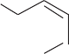
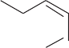
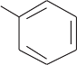
538
JACEK SAPA
Scheme 1. Structure of tested compounds and MG-1(S)
of the following composition (mmol/l):
NaCl
effluent), electrocardiogram (obtained by two stain- less steel electrodes, one inserted into the muscle of the ventricular wall and another attached to the metal aortic cannula) were assessed after 15ñ20 min of initial stabilization.
(120.0), KCl (5.6), MgCl₂ (2.2), NaHCO₃ (19.0),
CaCl₂ (2.4), and glucose (10.0).
The effect of tested compounds, in concentra-
tion of to M, on coronary flow (cardiac
10-8 10-4

539
Antiarrhythmic activity of novel S-enantiomers of pyrrolidin-2-one derivatives...
Non-working isolated hearts were mounted as described above for recording coronary flow and ECG. After a 15 min stabilization period, acute regional myocardial ischemia was produced for 15 min by installing a clip on the left coronary artery close to its origin (ischemic period). The clip was then reopened, and changes during reperfusion were moni- tored for 30 min (reperfusion period). Occlusion and reperfusion were verified by measuring coronary flow before occlusion, after occlusion and after reperfusion. Ligation of the coronary artery resulted in 24ñ28% reduction in coronary flow. Reperfusion was followed by a return of the coronary flow. Reperfusion induced arrhythmias manifested by ventricular premature beats (VBs), ventricular
tachycardia (VT) and ventricular fibrillation (VF).
Electrocardiograms (ECGs) were analyzed according to the guidelines of the Lambeth Conventions for VBs, bigeminy, salvos (less than 4 successive VBs), VT (4 or more successive VBs and VF.
In order to obtain a measure for the intensity of the arrhythmias, an Arrhythmia Severity Index was calculated for each heart according to Bernauer (7). The following values were attributed: occurrence of up to 10 ventricular extrasystoles during the first 30 min of reperfusion ñ 1, more than 10 ñ 2, VT or ven- tricular flutter ñ 3, and VF ñ 4. Bigeminy and salvos were not quantified separately but included with VBs.
Agents were added to the perfusion medium 15 min before coronary artery ligation and the concentra- tion was maintained for the rest of the perfusion period.
oped VBs. The incidence of VT and VF was 60 and 50%, respectively (Table 1).
Compared with control hearts, all tested com- pounds not significantly diminished the incidence of VT and VF. The compounds reduced the incidence of VT and VF at a concentration 10-5 M. At this con- centration their arrhythmias severity index was sim- ilar and had a value about 4.5 ñ 4.8 (control hearts 5.4) (Table 1). This effect was weaker comparative- ly to MG-1(S). In previous studies compound MG- 1(S) significantly diminished the incidence of VT and VF. In concentration 10-6ñ10-5 M it significantly reduced the incidence of VBs (about 50ñ20%), VT (about 90ñ80%) and VF (15%). The arrhythmias severity index was lower (2.1 ñ 2.9), compared with control hearts (Table 1).
Reference drugs in this model; phenytoin and quinidine (I class Vaughan Williams classification)
(8) showed significantly antiarrhythmic effect in this test in concentrations 10-5 M (phenytoin) and 10-6ñ5
◊ 10-6 M (quinidine) (Table 1).
Influence of tested compounds on ECG parame- ters on the non-working isolated perfused rat heart
The six tested compounds (EP-79(S), EP- 81(S), EP-82(S), EP-86(S), EP-88(S) and EP-89(S))
decreased the number of cardiac beats per minute, prolonged P-Q, Q-T, intervals and QRS complex.
All compounds in concentration 10-6 ñ 10-4 M significantly decreased the number of cardiac beats per minute (10-6 M: 9ñ14%; 10-4 M: 17ñ22%). This chronotropic effect was similar to phenytoin (10-6 M: 11%; 10-4 M: 21%) and weaker than quinidine (10-7 M ñ 10-4 M: 17ñ35%) (Fig. 1).
The tested compounds in concentration 10-6 ñ 10-4 M significantly prolonged P-Q intervals (10-6 M: 14ñ25%; 10-4 M: 27ñ39%), Q-T intervals (10-6 M:
12ñ27%; 10-4 M: 24ñ39%) and QRS complex (10-6 M: 12ñ17%; 10-4 M: 23ñ31%), (Figs. 2ñ4). The elec-
trocardiographic changes observed after administra- tion of the tested compounds were similar to those observed for quinidine but weaker. Phenytoin simi- larly prolonged P-Q and Q-T interval, but did not change the QRS complex, (Figs. 1ñ4). The obtained results suggest that the new pirrolidin-2-one deriva- tives possess Ñquinidine-likeî properties.
Prophylactic antiarrhythmic activity in barium chloride-induced arrhythmia (8)
Barium chloride solution was injected into the caudal vein of rat (32 mg/kg, in a volume of 1 mL/kg). The tested compounds were given i.v. 15 min before arrhythmogen. The criterion of antiar-
rhytmic activity was a gradual disappearance arrhythmia and restoration of sinus rhythm.
of
Statistical analysis
The data are expressed as the means + SEM. The data were evaluated by one-way analysis of variance (ANOVA) followed by Duncan test; p <
0.05 was considered significant.
RESULTS
Prophylactic antiarrhythmic activity in barium chloride-induced arrhythmia
For examined rats, intravenous injections of high dose of barium chloride (32 mg/kg) caused a rapid ventricular extrasystoles and VF in all animals (100%), that led to death within 3ñ8 min. The tested
Ventricular arrhythmias associated with coronary artery occlusion and reperfusion in the non-work- ing isolated perfused rat heart
During the 30 min period of coronary artery reperfusion, all hearts in the control group devel-
540
JACEK SAPA
Table 1. Effect of tested compounds on reperfusion-induced arrhythmias.
Each value was obtained from 6ñ8 hearts. Significantly different vs. control: **** p < 0.001, *** p < 0.01, ** p < 0.02, * p < 0.05.
compounds were given intravenously 15 min before arrhythmogen.
The highest activity was demonstrated by ref- erence compound MG-1(S), which reduced inci- dence of VF (by 20ñ60%) in doses 5, 10 and 20 mg/kg. At these doses it protected the animals against death, too (by 10ñ60%). The ED₅₀ value of compound MG-1(S) was 10.4 mg/kg, (Table 2).
Compounds: EP-79(S), EP-81(S), EP-82(S),
EP-86(S), EP-88(S) and EP-89(S) possessed weak antiarrhythmic properties, reduced incidence of ven- tricular fibrillation in 10ñ33% in a dose of 10 mg/kg and protected the animals against death by 10ñ20% (Table 2).
DISCUSSION
In model ventricular arrhythmias associated with coronary artery occlusion and reperfusion, compound MG-1(R,S) and its S-enantiomer signifi- cantly diminished the incidence of VT and VF. This effect was similar to that of quinidine. It was sug- gested that S-enantiomer had high affinity to α₁- adrenergic receptors and had the most antiarrhyth- mic activity. On the ground of these results, new six analogs of S-enantiomer MG-1 were investigated. Binding studies presented in (4) showed that all these compounds [(EP-79(S), EP-81(S), EP-82(S), EP-86(S), EP-88(S) and EP-89(S)] displaced

Compound

Concentration (M)
VBs incidence (%)
Bigeminy incidence (%)
Salvos incidence (%)
VT
incidence (%)
VF
incidence (%)
Arrhytmias severity index

Control
-
100
50
30
60
50
5.4 ± 0.6

EP-79(S)

10-6
100
60
20
50
30
4.9 ± 0.7
10-5
80
30
20
50
25
4.6 ± 1.2
10-4
75
50
25
50
75
5.5 ± 0.6

EP-81(S)

10-6
100
60
20
60
80
6.0 ± 0.4
10-5
50
50
30
60
40
4.8 ± 1.2
10-4
80
50
25
50
75
5.5 ± 0.3

EP-82(S)

10-6
100
40
20
60
40
5.0 ± 0.5
10-5
100
50
20
60
20
4.5 ± 0.3
10-4
100
20
20
60
30
4.6 ± 0.4

EP-86(S)

10-6
100
60
20
60
80
6.0 ± 0.6
10-5
50
100
40
60
40
4.8 ± 0.8
10-4
100
50
30
60
40
5.0 ± 0.3

EP-88(S)

10-6
100
60
40
62.5
37.5
5.0 ± 0.2
10-5
100
25
25
62.5
25
4.5 ± 0.8
10-4
100
30
30
75
25
5.0 ± 0.5

EP-89(S)

10-6
60
50
30
60
40
4.8 ± 0.6
10-5
100
40
30
50
40
4.8 ± 0.3
10-4
80
50
40
40
60
5.4 ± 1.1

MG-1(S)

10-6
50
25
0
10
10
2.1 ± 0.4 ***
10-5
80
20
0
20
10
2.9 ± 0.8*
10-4
100
50
17
33
33
4.0 ± 0.9

PHENYTOIN

10-6
100
0
0
75
0
4.3 ± 0.3
10-5
100
0
0
25
0
2.6 ± 0.4**
10-4
100
25
0
40
20
4.1 ± 0.7

QUINIDINE
10-6
83.3
16.7
0
50
0
2.3 ± 0.8 *
5 x 10-6
16.7
0
0
33.3
0
1.2 ± 0.6****
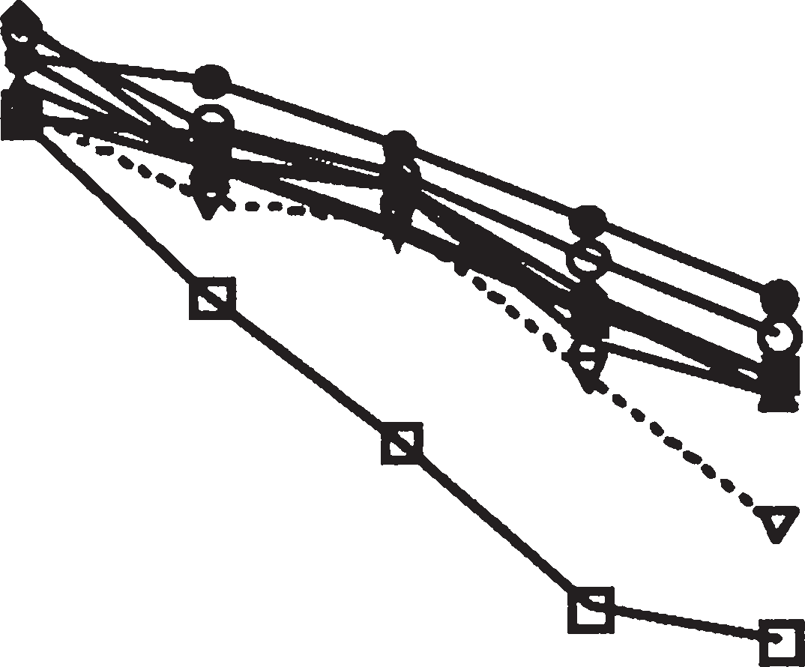
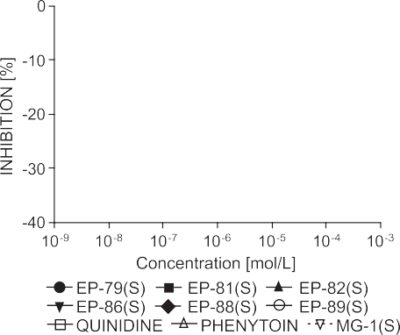
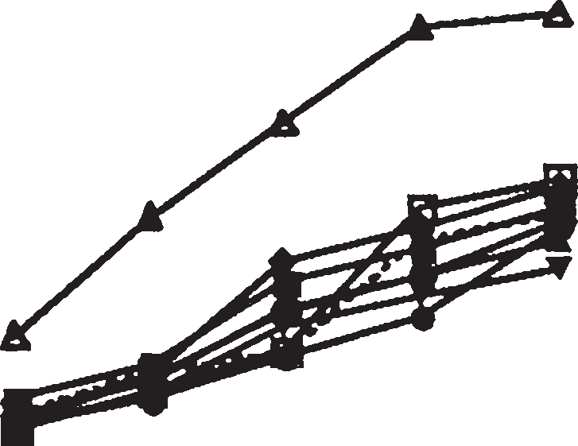
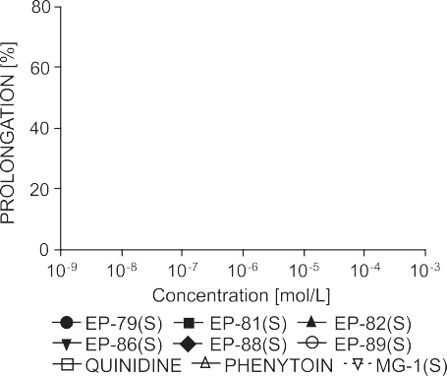
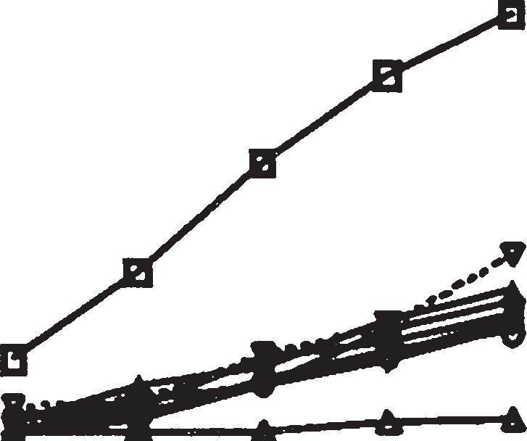
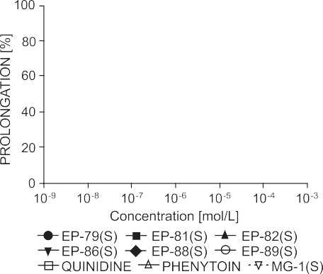
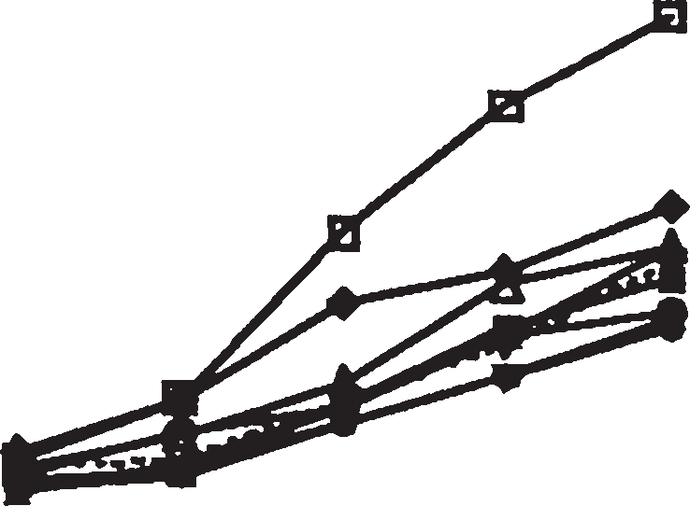
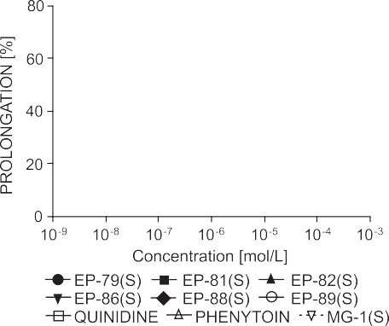
541
Antiarrhythmic activity of novel S-enantiomers of pyrrolidin-2-one derivatives...
Figure 1. Influence of tested compounds on heart rate
Figure 3. Influence of tested compounds on QRS complex
Figure 2. Influence of tested compounds on PñQ intervals
Figure 4. Influence of tested compounds on QñT intervals
Table 2. Prophylactic antiarrhytmic activity in barium chloride-induced arrhythmia.
[3H]prazosin from cortical binding sites (K_{i} = 370ñ880 nM) and decreased pressor response elicit- ed by epinephrine, norepinephrine and methoxam- ine. These compounds injected intravenously 15 min before adrenaline, diminished the occurrence of
extrasystoles and reduced mortality (ED₅₀ = 6.2 ñ
13.2 mg/kg) (4).
The antiarrhythmic activity of tested com- pounds was examined in arrhythmia associated with coronary artery occlusion and reperfusion rat mod-

Compound

Dose (mg/kg)

Ventricular fibrillation reduction (%)
ED50
(mg/kg)
Mortality reduction (%)
EP-79(S)

10

15
-
20
EP-81(S)
33
-
10
EP-82(S)
20
-
16
EP-86(S)
12
-
10
EP-88(S)
20
-
10
EP-89(S)
10
-
16

MG-1(S)

5
20

10.4
(8.7 ñ 12.5)
10
10
55
60
15
60
40
542
JACEK SAPA
els. Many authors suggest that the rat coronary artery ligation and reperfusion model can be recom- mended as a screen for new antiarrhythmic agents (9ñ13). It has been well known that α-blocking agents (phentolamine, prazosin, corynanthine, rau- wolscine and yohimbine) in relatively high doses diminished or prevented reperfusion arrhytmias and cardiac arrhythmias caused by adrenaline intoxica- tion (7, 14ñ17). Phentolamine, a non-selective blocker of α₁- and α₂-adrenoceptors, and the selec- tive α₁-adrenoceptor antagonist prazosin could reduce the incidence of ischemia-induced ventricu- lar fibrillation, which is in accordance with several studies in the ischemic or reperfused rat, cat and dog myocardium (18ñ25). All tested compounds had a worse effect in this model of the arrhythmia com- paratively to MG-1(S), which in a concentration of 10-5ñ10-6 M significantly diminished the incidence of VT and VF. The arrhythmias severity index was lower (2.1 ñ 2.9), compared with control hearts (5.4). The antiarrhythmic activity of MG-1(S) in this test was comparable to that reported for phenytoin and quinidine.
The electrocardiographic changes observed after administration of all tested compounds are sim- ilar to those seen after administration of MG-1(S). The changes in ECG were similar but significantly weaker that those after quinidine (8).
Only compound MG-1(S), contrary to tested compounds, administered 15 min before barium chloride in doses 10 and 15 mg/kg prevented in a statistically significant manner the occurrence of VF in 55ñ60%.
These results suggest that six new analogs of S 1-[2-hydroxy-3-(4-phenyl-1-piperazinyl)propyl]- pyrrolidin-2-one have weaker antiarrhythmic effect than the reference compound.
6.
Lubbe W.F., Daries P.S.: Cardiovasc. Res. 12, 212 (1978).
Bernauer M., Ernenputsch I.: Naunyn- Schmiedebergís Arch. Pharmacol. 338, 88
(1988).
Vaughan Williams E.M.: Pharmacol. Ther. B1, 115 (1975).
Szekeres L., Papp J.G.: in Handbook of Experimental Pharmacology. Vol. XVI/3, pp. 131ñ182, Springer Verlag, New York, Berlin, Heidelberg 1975.
Starmer C.F., Laastra A.A., Nesterenhs V.W., Grant A.O.: Circulation 84, 1364 (1991).
Brooks R.R., Miller K.E., Carpenter J.F.: Proc. Soc. Exp. Biol. Med. 191, 201 (1989).
Curtis M.J., Macleod B.A., Walker J.A., Moll J.: Cell. Cardiol. 19, 399 (1987).
Uematsu T., Vozeh S., Ha H.R., Hof R.P., Follath F.: J. Pharmacol. Methods 16, 53 (1986) Walker M.J.A, Curtis M.J., Hearse D.J., Campbell R.W.F, Janse M.J., Yellon D.M. et al.: Cardiovasc. Res. 22, 447 (1988).
Bralet J., Didier J.P, Moreau D., Opie L.H., Rochette L.: Br. J. Pharmacol. 84, 9 (1985).
Colucci W.S.: Ann. Intern. Med. 97, 67 (1982). Lamontagne D., Yamaguchi N., Nadeau R., Champlan J., Godin D., Campeau N.: Eur. J. Pharmacol. 123, 1 (1986).
Tolg R., Kurz T., Ungerer M., Schreieck J, Gorge B, Richard G.: Naunyn-Schmiedebergís Arch. Pharmacol. 356, 62 (1997).
Corr P.B., Penkoske P.B., Sobel B.E.: Br. Heart J. 40 (Suppl), 62 (1978).
Corr P.B., Shayman J.A., Kramer J.B., Kipnis R.J.: J. Clin. Invest. 67, 1232 (1981).
Corr P.B., Yamada K.A., Witkowski F.X.: in The Heart and Cardiovascular System. Fozzard H.A., Jennings R.B., Katz A.M., Morgan H.E. Eds., pp. 1343-1403, Raven Press, New York 1986.
Stewart J.R., Burmeister W.E., Burmeister J., Lucchesi B.R.: J. Cardiovasc. Pharmacol. 2, 77 (1980).
Sheridan D.J., Penkoske P.A., Sobel B.E., Corr P.B.: J. Clin. Invest. 65, 161 (1980).
Sharma A., Lee B., Saffitz B., Sobel B., Corr P.: J. Clin. Invest. 72, 802 (1983).
7.
8.
9.
10.
11.
12.
13.
14.
15.
16.
17.
18.
19.
20.
21.
REFERENCES
22.
1.
Malawska B., Kulig K., Filipek B., Sapa J., Maciπg D., Zygmunt M., Antkiewicz-Michaluk L.: Eur. J. Med. Chem., 37, 183 (2002).
Malawska B., Kulig K., Gippert A., Filipek B., Sapa J., Maciπg D.: Farmaco 60, 793, (2005). Kulig K., Sapa J., Maciπg, D., Filipek B., Malawska B.: Arch. Pharm. Chem. Life Sci. 340, 466 (2007).
Kulig K., Sapa J., Nowaczyk A., Filipek B., Malawska B.: Acta Pol. Pharm. Drug Res. 66, 649 (2009).
Langendorff O.: Pfl¸gers Arch. Ges. Physiol. 61, 291(1895).
23.
2.
24.
3.
25.
Thandroyen
F.T.,
Worthington
M.G.,
Higginson L., Opie L.H.: J. Am. Coll. Cardiol. 1, 1056 (1983).
Benfey B.G., Elfellah M.S., Ogilvie R.I., Varma D.R.: Br. J. Pharmacol. 82, 717 (1984).
4.
26.
5.
Received: 30. 03. 2010

