



Article
Structure, Biosynthesis, and Biological Activity of Succinylated
Forms of Bacteriocin BacSp222
Justyna Śmiałek 1 , Michał Nowakowski 2, Monika Bzowska 3, Oliwia Bocheńska 1, Agnieszka Wlizło 1,
Andrzej Kozik 1 , Grzegorz Dubin 4 and Paweł Mak1z ©
1 Department of Analytical Biochemistry, Faculty of Biochemistry, Biophysics and Biotechnology,
Jagiellonian University, Gronostajowa 7 St., 30-387 Kraków, Poland; justyna.smialek@doctoral.uj.edu.pl (J.S.);
oliwia.bochenska@gmail.com (O.B.); agnieszka.wlizlo47@gmail.com (A.W.); andrzej.kozik@uj.edu.pl (A.K.)
- Biological and Chemical Research Centre, Faculty of Chemistry, University of Warsaw,
Zwirki i Wigury 101 St., 02-089 Warszawa, Poland; lyam@chem.uw.edu.pl
- Department of Cell Biochemistry, Faculty of Biochemistry, Biophysics and Biotechnology,
Jagiellonian University, Gronostajowa 7 St., 30-387 Kraków, Poland; monika.bzowska@uj.edu.pl
- Małopolska Centre of Biotechnology, Jagiellonian University, Gronostajowa 7a, 30-387 Krak ó w, Poland;
grzegorz.dubin@uj.edu.pl
* Correspondence: pawel.mak@uj.edu.pl; Tel.: +48-126-646-511
Citation: Smialek, J.; Nowakowski, M.;
Bzowska, M.; Bochefnska, O.; Wlizlo, A.;
Kozik, A.; Dubin, G.; Mak, P. Structure,
Biosynthesis, and Biological Activity
of Succinylated Forms of Bacteriocin
BacSp222. Int. J. Mol. Sci. 2021, 22,
6256. https://doi.org/10.3390/
ijms22126256
Academic Editor: Oxana V. Galzitskaya
Abstract: BacSp222 is a multifunctional peptide produced by Staphylococcus pseudintermedius 222.
This 50-amino acid long peptide belongs to subclass IId of bacteriocins and forms a four-helix bundle
molecule. In addition to bactericidal functions, BacSp222 possesses also features of a virulence
factor, manifested in immunomodulatory and cytotoxic activities toward eukaryotic cells. In the
present study, we demonstrate that BacSp222 is produced in several post-translationally modified
forms, succinylated at the e-amino group of lysine residues. Such modifications have not been
previously described for any bacteriocins. NMR and circular dichroism spectroscopy studies have
shown that the modifications do not alter the spatial structure of the peptide. At the same time,
succinylation significantly diminishes its bactericidal and cytotoxic potential. We demonstrate that
the modification of the bacteriocin is an effect of non-enzymatic reaction with a highly reactive
intracellular metabolite, i.e., succinyl-coenzyme A. The production of succinylated forms of the
bacteriocin depends on environmental factors and on the access of bacteria to nutrients. Our study
indicates that the production of succinylated forms of bacteriocin occurs in response to the changing
environment, protects producer cells against the autotoxicity of the excreted peptide, and limits the
pathogenicity of the strain.
Received: 20 May 2021
Accepted: 7 June 2021
Published: 10 June 2021
Keywords: bacteriocin; antibacterial; cytotoxic; Staphylococcus pseudintermedius; succinylation; succinyl-
coenzyme A; nuclear magnetic resonance (NMR); Krebs/tricarboxylic acids cycle
Publisher 's Note: MDPI stays neutral
with regard to jurisdictional claims in
published maps and institutional affil-
iations.
Copyright: © 2021 by the authors.
Licensee MDPI, Basel, Switzerland.
This article is an open access article
distributed under the terms and
conditions of the Creative Commons
Attribution (CC BY) license (https://
creativecommons.org/licenses/by/
4.0/).

1. Introduction
Succinylation is a posttranslational modification based on attachment of the succinic
group (3-carboxypropanoyl, -CO-CH2-CH2-CO2H) to the e-amino group of lysine residues
in proteins. The modification was first described as late as in 2011 [1] and due to its
widespread distribution in different proteomes, it is attracting increasing attention [2-7].
Succinylation changes the positive charge of the lysine side chain into a negative one.
The change radically alters the overall chemical reactivity and introduces a relatively
bulky substituent (+100.02 Da mass shift). The side chain of lysine with its primary
e-amino group constitutes reactive centres ina number ofenzymes and is involved inmany
intra- and intermolecular noncovalent interactions. Consequently, succinylation induces
significant changes in the function, catalytic properties, structure, and immunogenicity of
proteins and influences many different metabolic pathways. Proteomic studies indicate
that succinylation is relatively widespread in nature. For example, it involves 738 different
Int. J. Mol. Sci. 2021, 22, 6256. https://doi.org/10.3390/ijms22126256
https://www.mdpi.com/journal/ijms

Int. J. Mol. Sci. 2021, 22, 6256
2 of 21
proteins in human HeLa cells, 844 proteins in human gastric cancer cells, 861 proteins in
mouse liver, 184 proteins in mouse heart, or 990 proteins in E. coli [5,7].
Succinylation occurs predominantly via a nonenzymatic mechanism where proteins
are modified by succinyl coenzyme A (suc-CoA), a common metabolite in the tricarboxylic
acid (TCA) cycle. Suc-CoA is a highly reactive thioester, and its reactivity is a consequence
of the ability to form cyclic succinic anhydride intermediate reacting with primary amines
in a dose- and pH-dependent manner [8]. Effective succinylation of proteins by suc-CoA is
a further consequence of the high level of this metabolite in cells (100-600 nM in eukaryotic
mitochondria and ca. 100 nmol g-1 in bacterial cells) [7,9]. The level of succinylated
proteins in certain cells results from the equilibrium between the activity of enzymes
catalysing suc-CoA formation and enzymes that desuccinylate proteins. The former group
of enzymes is represented by a critical constituent of the TCA cycle—an a-ketoglutarate
dehydrogenase complex (KGDHC) and, to a lesser degree, succinyl-CoA ligase (orsuccinyl-
CoA synthetase, SCS) as well as carnitine palmitoyltransferase 1A (CPT1A) [7]. All these
enzymes regulate the level of succinylated proteins by maintaining the level of cellular
suc-CoA. In turn, the most common enzyme that is able to desuccinylate proteins is
Sirtuin 5 (SIRT5), which is active both in bacteria and in eukaryotic cells [10]. The enzyme
removes the succinyl group in an NAD+-dependent manner, yielding a free lysine side
chain, nicotinamide, and succinyl-ADP-ribose [2].
A large number of comprehensive studies address the influence of succinylation on
the complex proteomes in different cells, tissues, diverse metabolic pathways, diseases,
and microorganisms [2,3,5-7,11-17]. At the same time, there are limited numbers of pub-
lications that focus on the influence of succinylation on the structure and functions of
particular proteins. These studies are primarily focused on evaluation of the effects of
in vitro succinylation on such proteins as bovine serum albumin, Y-globulin, lysozyme,
and glutamate dehydrogenase [8,18,19]. The influence of physiological succinylation on
the structure and activity of a functional protein was most extensively studied in the case
of aB-crystallin from the human lens [20]. The present work reports investigation of the
structure, biological activity, and mechanism of succinylation of bacteriocin BacSp222.
This 50-amino acid long peptide is produced and excreted into the culture medium by a
commensal bacterium from dog skin Staphylococcus pseudintermedius strain 222 [21]. The
peptide is encodedona 15kb p222 plasmid, does not contain cysteine, is rich in tryptophan,
lysine, and arginine residues, and has formylated methionine at the N-terminus (Figure 1).
The sequence of BacSp222 does not exhibit significant similarities to other known proteins.
However, our earlier nuclearmagnetic resonance (NMR) investigation of its structure docu-
mented close similarity of BacSp222 to four bacteriocins: aureocin A53, lacticin Q, entrocin
7A/JSA, and enterocin 7B/JSB. The similarity and the particular structural features of the
BacSp222 molecule allowed us to distinguish a new four-helix bundle type of bacteriocins
belonging to subclass IId of bacteriocins from Gram-positive bacteria, comprising linear
non-pediocin-like peptides [22].
Bacteriocins are defined as ribosomally synthesized peptides or proteins produced
by bacteria and capable of killing phylogenetically related strains at very low concentra-
tions [23]. BacSp222 affects a broad range of staphylococci at micromolar concentrations by
forming pores in their membranes, most probably via a barrel-stave mechanism [24]. Most
interestingly, the biological role of BacSp222 also involves features typical for virulence
factors, i.e., a group of molecules produced by pathogenic microorganisms facilitating the
replication and dissemination within the host by subverting or eluding defence mecha-
nisms [25]. In particular, BacSp222 is cytotoxic to many eukaryotic cells, including human
skin fibroblasts and keratinocytes as well as murine monocytes and macrophages.
Moreover, at low concentrations (in a nM range), BacSp222 efficiently enhances in-
terferon gamma-induced nitric oxide (NO) release in macrophage-like cell lines. In con-
sequence, immunomodulatory activity of the peptide has been suggested, as NO is a
multipotent factor inhibiting leukocyte infiltration and proliferation and regulating cy-
tokine expression and cyclooxygenase activity [21]. Other immunomodulatory activities of

Int. J. Mol. Sci. 2021, 22, 6256
3 of 21
BacSp222 suggest protein receptor-dependent action, which is presently being investigated
in a separate study.
In the present work, we show that BacSp222 is secreted by Staphylococcus pseudinter-
medius 222 in several forms modified by succinylation. A detailed analysis of the structure,
biological activity, and mechanism of post-translational modification of these peptides
is reported.

2. Results and Discussion

2.1. Staphylococcus pseudintermedius 222 Produces Native BacSp222 and Its Two Posttranslationally
Modified Forms: Suc-K20-BacSp222 and suc-K11/K20-BacSp222
The RP-HPLC separation of the S. pseudintermedius 222 post-culture medium revealed
the main peak of bacteriocin BacSp222 and two additional compounds (No. 2 and 3;
Figure 1, the peaks are indicated by red and green arrows). The corresponding compounds
were purified to homogeneity using a second RP-HPLC step. The molecular masses were
5921.9, 6020.3, and 6120.2 Da, respectively, for BacSp222 and compounds No. 2 and 3,
showing an equal ca. 99-Da mass increase between each form. The mass spectrometry
analyses of tryptic peptide fragments of the compounds of interest revealed modifications
in one tryptic peptide (residues 14-25, sequence ALYNWAKSHVGK) in compound 2 and
in two tryptic peptides (residues 7-13, sequence FLLSKGR and residues 14-25, sequence
ALYNWAKSHVGK) in compound 3. The molecular masses of peptides 7-13 and 14-25
were determined as 919.54 Da and 1472.79 Da. The comparison with the theoretical mass
of the respective peptides, i.e., 819.51 Da and 1372.74 Da, indicates a 100-Da increase in
each case. The comparison of the MS/MS and MS3 spectra confirmed the modification at
lysine residues, particularly K5 in peptide FLLSKGR and K7 in peptide ALYNWAKSHVGK.
The determined mass shift was used to deduce the possible modification. Based on the
annotation from Unimod, an online database of protein modifications for mass spectrome-
try (http://www.unimod.org/, accessed on 20 May 2016), and Zhinong Zhang et al. [1],
two most probable modifications were chosen for further evaluation: succinylation or
addition of a methylmalonyl group. Since no significant neutral loss of CO2 (-44 Da)
for single charged ions nor -22 Da for double-charged ions was observed, as would be
expected for methylmalonyllysine, we concluded that succinylation was the modifica-
tion found in the BacSp222 variants. Overall, the mass spectrometry analyses identified
compound 2 as a BacSp222 molecule succinylated at lysine 20 (suc-K20-BacSp222), and
compound 3 was identified as a BacSp222 molecule succinylated at lysines 11 and 20
(suc-K11/K20-BacSp222).
These conclusions were independently verified by analysing tryptic peptide fragments
of all forms of BacSp222 using automated protein sequencing. The chromatogram corre-
sponding to the sequencing cycle of residue 20 (peptide 14-25 from suc-K20-BacSp222) and
from the sequencing cycles corresponding to residues 11 and 20 (peptides 7-13 and 14-25
obtained from suc-K11/K20-BacSp222) revealed an unusual amino acid peak with retention
time corresponding to the synthetic N-s-succinyl lysine standard (Supplementary Materials
Figure S1). This finding supports the conclusion that S. pseudintermedius 222 produces
unmodified native BacSp222 bacteriocin and two succinylated forms: suc-K20-BacSp222
and suc-K11/K20-BacSp222.

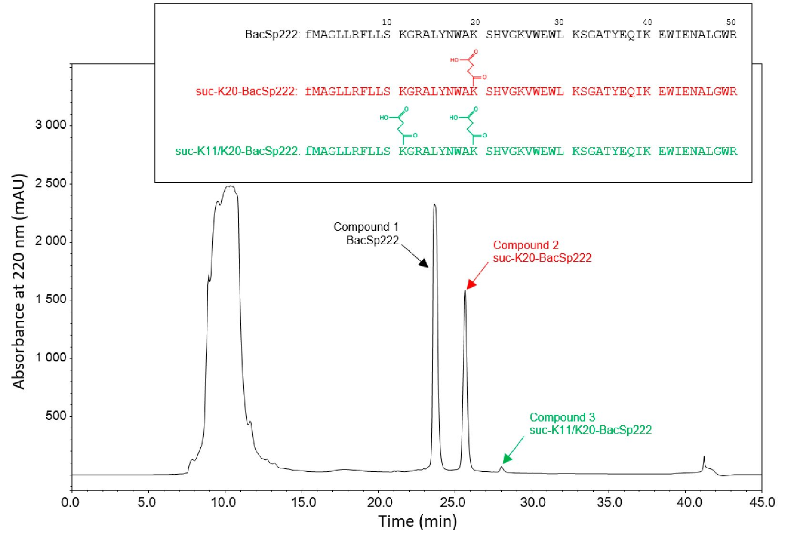
Int. J. Mol. Sci. 2021, 22, 6256
4 of 21
Figure 1p RP-HPLC chromatogram from purification of BacSp222 and its succinylated forms (denoted
cbhyarbalcatcekrs,,rreedpaencdtivgerleye)n. Tchheapraecptteidrse, sreqsupencctievaenlyd).thTeheucpceipnytildateiosneqpulaecneceaarendprtehenstuecdcinythlaetinonerpt.lafcMesd
are presented in the insert. fM denotes the formylated methionine residue at the N-terminus.
Secretion of famcetnotrss ofrfoamll cfoerlmlssreoqfuBiarecSsptr2a2n2sumsienmgbaruatnoemtartaendspproortte. iBnascetqeurieanacrinege.qTuhipe pchedro
with a variety of protein secretion systems. Two types dominate the secretion of bacteri-
ocins by Gram-poBsaictiSvpe22b2a)catenrdiaf:rotmhethgenseqraulesneccnregtcioynclessycsoterrmes(pSoencd) ionrgtthoereTswdiune-As 1r1gianidne2
Transport (Tat) pathway [26]. Both these systems require a secretion signal in the exported
molecule, while BacSp222 is not equipped with such a propeptide, as we have shown
earlier [21]. Othe(rSauuptphleomrsenhtavre sMugetgeerisetlesdFtihgeurienvSo1l)v. eTmh eisntfionfdtihnge AsuBpCp-otrytps ethmeucltoindcrlugsi
resistance transpopsreteurdipntreortmeeindiuLsm22r2BpinrotdhuecesxupnomrtoodfifsiuedchneletiavdeeBrelecSssp2b2a2cbteercitoecrioncsin[27]d. Itnw
this study, we tested whether the excretion of BacSp222 and its modified forms was related
to production of extraSceeclrleutiloanr voefsifcelcetso.rsPofrsot-mcuclteullrse rmeqeudiiruesmtrdeenps rmivemedbroefnbeatcrteenrsiaplocrte.llBs
was fractionated euqsuinipgpaed10w0i-tkh Deavceurite-toyffofmpermotebirnanseec,raetniodnthsyesntetmhes.BTawcoSpty2p2e2sfdoormisnweterteh
determined both in the presumed vesicle-containing fraction and in the low-molecular-
weight filtrate. ThAe rgeisnuilntes cTlreeanrslyposrho(wTeth) apteahllwBeaycS[2p62]2. 2Bfoohrmhseasreescyosnetma snerdequnirtehee ssoelcureblieo
fraction but not intctthexvpeostitctldesm. Soilmtlultta, nwecoiultslBy,elwSep2c2o2uilidnnootttdqeutiepcpttadnwy ibtcacituerlicoceinptfoprtmpt
in the bacterial cycteovptlaiscmow, nwtheitclhittsu[2g1g].eOsttecdttraupticdoetixpcoevrtt oifugthgestetdpetcpttiidnevsoilvmtmendtiaotfetlcyt
after synthesis. Thmeumltiedcthuagntitsimiisteinlvtotltveendi proetmttatipnttoottbi ne LdmetteBrminintcetdt.xpott of iulc ltedttltii
Identification of lysines 11 and U0 cis sites ot succinylation raises a question of why the
other lysine residues in the BacSp222 motecule (K25, K31, and K40) do not undergo such
modification. Numerous studies mapping thousands of sutcinyiation sites; in proteomes of
different microorganisms and in animal and human tissues contributed to identification
of succinylation pinattcetrniosluabnldt fdteelvteiolon pbmu tenot toifn mtcatc vhtiniielltleia. rSniminugltanlgt ouriitlhy m, wsttolopurldednioct
succinylation sitesbeinlttptaiortlicnufloarmprionttecint sbbelatstetdielolnythopeilreiamm, iwnocialccidiusgegqtuitetndcetes,paidmtixnpooattciodf
properties, and theoretical spatial arrangement of amino acid residues [28-34]. We evalu-
ated the following tooIldst:nGtiPfilSeutcio[31]f,liySiuinct-iPs1e1AeAdC2[34i],iiiSttuico-Pf seuOl lpinty[30i]o, pSteuicit-Li yesq[29i]t,i
SuccFind [28], antdctSuotccctint Slyitiein[32t].iiHduotwi einvetcr,tthBeelrSeps2u2l2tsmpolotlrulyltm(Ka2tc5h, Ko3u1r, eexndpeKri4m0)ednotanlo
findings. Only three algorithms (iSuc-PseOpt, pSuc-Lys, and iSuc-PseAAC) indicated
K20 as a potential succinylation site. The most frequently indicated site of succinylation
was K30 (indicated by four algorithms), while two other algorithms indicated K40. The
inconsistency between the prediction and the experimental data and between the dif-
ferent algorithms demonstrates considerable lack of understanding of the determinants

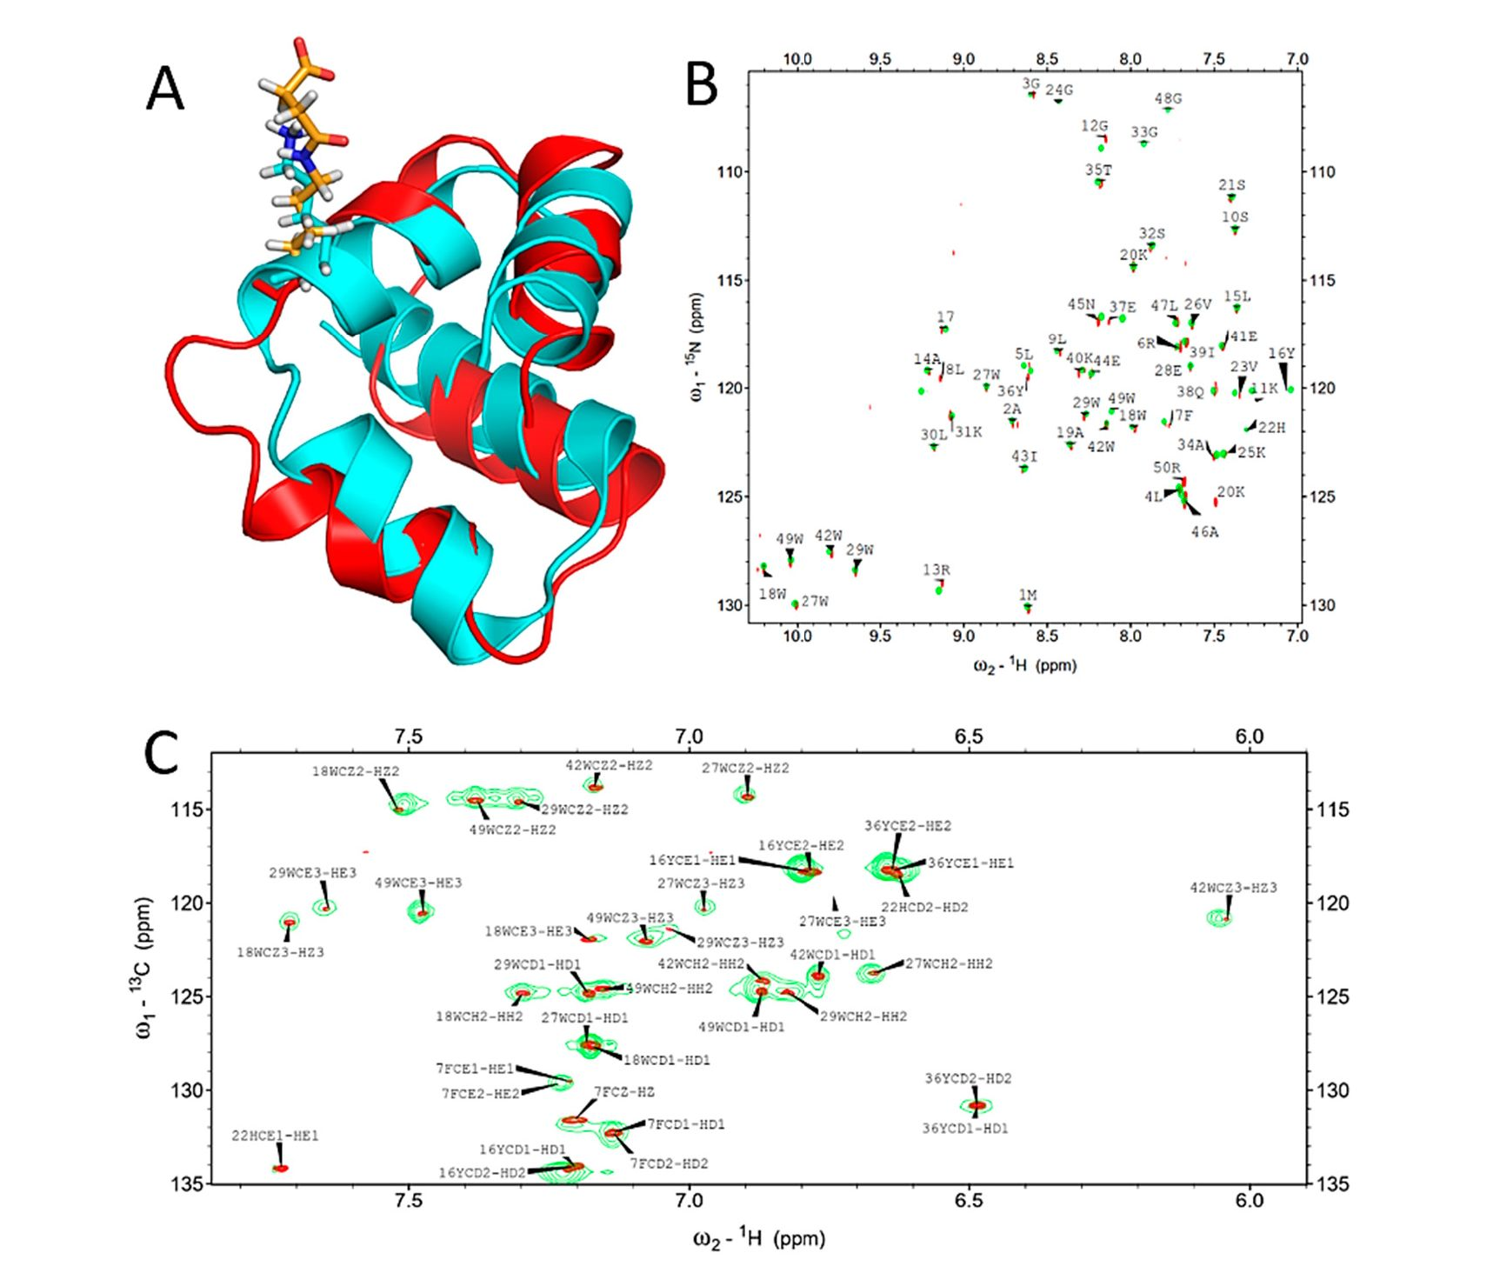
Int. J. Mol. Sci. 2021, 22, 6256
5 of 21
of succinylation site selection. The algorithms clearly require further improvement to
take into account the structure of considered proteins and include more information on
species-specific factors.

2.2. Succinylation Does Not Significantly Influence the Overall Structure of BacSp222
The influence of succinylation on the bacteriocin structure was investigated using
suc-K20-BacSp222 and two complementary techniques-NMR and circular dichroism (CD)
spectroscopy. The overlay of the 1H-15N HSQC spectra of the native and modified BacSp222
(Figure 2B) demonstrates that succinylation of lysine 20 does not significantly influence
the backbone chemical shifts, with the exception of L8 and E37. The significant changes in
chemical shifts for those residues may not be explained by the proximity of the modification
site. The overlay of the 1H-13C HSQC spectra tuned to aromatic carbons (Figure 2C)
demonstrates that resonances characteristic for residues buried in the hydrophobic core
of the peptide remain mostly unaffected. The chemical shift assignment of succinylated
BacSp222 was based on chemical shifts obtained previously for an unmodified peptide
(BMRB accession number 34044) and carefully verified by analysis of a set of 2D homo-
and heteronuclear NMR spectra. 80% of chemical shifts were assigned (75% of backbone
atoms, 79% of protons and carbons of aliphatic side chains, and 93% of proto6nosf ,22nitrogens,
and carbons of aromatic side chains).
Fiigguurree22.. Reessuultlsts off NMR studiiess of tthe ssttrructure off uunnmodifified and ssuccinylated formss of BacSp222.
Panel (A) illustrateu the superimpositksn of the most representative structures of dnmodified
BacSp222 (cyan) and suc-K20-BacSp222 (red). The side chain of lysirie 20 in both structures is
represented as sticks-hydrogens white;, nitrogens blue, carbons of unmodified lysine cyan, and
carbons of modified lysine orange. The superimpssition of 1H-15N HSQC spectra and -H-13C HSQC
psrpieicitnrtaidtuinepda ntiolia(rBo)m,(Ca)t,icriciapribcot invislfyo.runmodified BacSP222 (green) and suc-K20-BacSp222 (red) is
presented in panels (B),(C), respectively.
ally idTihnetisctarlutcotuthre oitfrsuuctcucriinyolfathedi uBnamcSopd2i2fi2idcaplciupltaidted(FfiogrumriNOA)E. sTyhriesmtriaintgslowbasl virtually
bidaceknbtoicnail RtoMtShDe sctarlucuctlautriedofforththeiuintrmucotduirfiieidofpmepotdiidfieid(Faingduruen2Ao)d. iTfihied mBaecaSnp globwaalibackbone

Int. J. Mol. Sci. 2021, 22, 6256
6 of 21
RMSD calculated for the structures of modified and unmodified BacSp222 was 1.9 ± 0.9 Á,
indicating no significant structural differences. The statistics of 20 lowest energy structures
of modified BacSp222 are presented in Supplementary Materials Table S1.
The comparison of the circular dichroism spectra recorded for BacSp222 and suc-K20-
BacSp222 indicated no significant changes. The calculated content of the helical structure
within the succinylated form was slightly increased (75% in comparison to 81%, Supplemen-
tary Materials Figure S2A), but this difference was within the relatively large uncertainty
of such estimations. The CD analysis additionally allowed us to estimate the structural
changes in the peptide molecule in the presence of liposomes, which was particularly
interesting, as our previous studies revealed that the killing activity of BacSp222 is related
to disruption of the bacterial membrane [21]. The spectra of native and succinylated bacteri-
ocins in the presence and absence of liposomes are similar but, again, the calculated content
of helical structures in suc-K20-BacSp222 was higher than in BacSp222 (94.4% in compari-
son to 86.2%; Supplementary Materials Figure S2A). It is also important that the near-UV
CD spectroscopy, providing information on the tertiary structure, gave very similar shapes
of the spectra (Supplementary Materials Figure S2B), suggesting that succinylation does
not affect the overall shape of the bacteriocin molecule, which also confirms the results
from NMR spectroscopy.
It can be speculated that the slight but consistent increase in the helical structure con-
tent in suc-K20-BacSp222 reflects a more rigid and/or compact structure of the unmodified
bacteriocin. This conclusion is, however, not supported by our NMR result. Many authors
emphasize that succinylation is an essential post-translational modification that alters
e.g., the structure of proteins [2,3,15,35]; unfortunately, there are almost no experimental
findings in favour of such a conclusion. Certain reports on in vitro succinylation of bovine
serum albumin or glutamate dehydrogenase suggest such a possibility [4]; however, the
only study evaluating the influence of physiological succinylation on the structure of a
functional protein was focused on aB-crystallin from the human lens [20]. As shown
by the results, the modification does not alter the secondary structure of crystallin but
mildly perturbates its tertiary and quaternary structure, consequently leading to increased
chaperone activity of this protein. Similarly, the influence of succinylation on the structure
of BacSp222 in our case is negligible, if any.

2.3. Succinylation Decreases the Antibacterial Activity of BacSp222 Bacteriocin
The antibacterial activity of the BacSp222 forms against selected Gram-positive bacte-
ria was compared with the use of the radial diffusion assay. The unmodified form inhibited
the growth of each tested bacterial strain, as shown in our previous study [21]. The ac-
tivity of the succinylated forms was significantly reduced, depending on the degree of
succinylation and the bacterial strain. The residual activity of suc-K20-BacSp222 compared
to the activity of the unmodified BacSp222 reached 93% against Micrococcus luteus, but only
3% against Staphylococcus intermedius. The residual bactericidal activity of suc-K11/K20-
BacSp222 against Lactococcus lactis was estimated at 49%, while the peptide applied at the
tested concentration was completely inactive against Staphylococcus aureus, Staphylococcus
intermedius, or Staphylococcus pseudintermedius 22221 (unlike BacSp222) (Table 1). These
results indicate that succinylation of lysine reduces the antibacterial activity of BacSp222.
The observation is in agreement with other reports on succinylated bactericidal peptides.
Cochrane and colleagues demonstrated reduced activity of analogues of the lipopeptide
antibiotic cerexin with succinylated hydroxylysine residues [36]. Fuchs and others demon-
strated an identical effect in the case of entianin bacteriocin succinylated at the tryptophan
residue [37]. Unlike BacSp222, the succinylated forms had no antibacterial activity against
producer strain Sp222. This allows us to speculate that succinylation provides a mecha-
nism that protects producer cells against the autotoxicity of the secreted peptide. Other
authors have suggested a similar functional role of peptides succinylation. For example,
Bowers and colleagues suggested that lysine succinylation of thiazolyl peptides may serve
a protective function for the producer organism [38].

Int. J. Mol. Sci. 2021, 22, 6256
7 of 21
Table 1. Antibacterial activities of post-translationally modified forms of BacSp222. The activ-
ity of suc-K20-BacSp222 and suc-K11/K20-BacSp222 against selected Gram-positive bacteria was
assessed using the radial diffusion assay and expressed as percentages related to the activity of
unmodified BacSp222.
Bacteria | Residual Antibacterial Activity in Relation to the  Activity of Unmodified BacSp222 (Percent ± SD)
Bacteria | Suc-K20-BacSp222 | Suc-K11/K20-BacSp222
Bacillus subtilis ATCC 6633 | 72.24 ± 4.42 | 32.66 ± 6.78
Lactococcus lactis LOCK 0871 strain 239 | 80.32 ± 3.67 | 48.95 ± 6.21
Micrococcus luteus ATCC 4698 | 92.97 ± 0.56 | 41.97± 4.77
Staphylococcus aureus ATCC 25923 | 33.20 ± 5.42 | N.a.
Staphylococcus epidermidis ATCC 35547 | 64.19 ± 7.80 | 18.00 ± 7.55
Staphylococcus intermedius ATCC 29663 | 3.24 ± 2.51 | N.a.
Staphylococcus pseudintermedius 222 | N.a. | N.a.
Staphylococcus pseudintermedius 22221 | 49.51 ± 11.44 | N.a.
N.a.—not active.

2.4. Succinylation limits BacSp222 Cytotoxic Activity Against Eukaryotic Cells
BacSp222 is a multifunctional peptide with toxicity against both Gram-positive bac-
teria and eukaryotic cells [21]. Having demonstrated the reduced antibacterial activity
of succinylated forms, we wondered whether a similar effect was exerted on cytotoxicity
towards eucaryotic cells. The incubation of human neutrophils at 6 pM BacSp222 forms for
2 h induced changes in the morphology of the cells, but most pronounced alterations were
observed in cells treated with the unmodified BacSp222. The control (untreated) cells were
spherical, whereas a significant number of BacSp222-treated cells were adherent, and their
morphology was changed to bipolar. At the same time, only a minor fraction of the cells
treated with the succinylated forms exhibited changes in their shape (Figure 3A). Neu-
trophils can change their shape rapidly, and this phenomenon is associated with migration
to sites of inflammation and phagocytosis-dependent killing of microbes [39]. BacSp222
is known to have immunomodulatory properties [21] and such activity results from its
interaction with eukaryotic cells. In turn, the immunomodulatory potential of succinylated
forms remains to be determined.
We compared the cytotoxicity of the BacSp222 forms considered in this study. The
viability of the cells was assessed by determining the level of intracellular ATP (neutrophils)
or mitochondrial activity (other tested cells). Additionally, we assessed the integrity of
cellular membranes with an LDH release assay. Significant differences between the activ-
ities of the BacSp222 forms were observed only at the highest tested concentration. At
3.13 pM, the viability of neutrophils treated with the unmodified peptide was around 50%
in the assay conditions, whereas the viability of cells treated with suc-K20-BacSp222 or
suc-K20-BacSp222 was about 95% (Figure 3B,C). The reduction in the cytotoxic activity
of the succinylated forms, compared to the unmodified bacteriocin, was also observed
in the murine and human fibroblasts and in murine monocytic macrophages (Figure 4,
Supplementary Materials Figure S3). Only the unmodified form of BacSp222 significantly
affected the membrane integrity and viability of the RAW 264.7 and MDF cells (Figure 4).
The extension of the incubation time from 4 to 24 h did not significantly affect the results
(Supplementary Materials Figure S3). Overall, our results showing the lower cytotoxicity
of succinylated forms of BacSp222 agree with literature reports on decreased activity of
succinylated variants of other proteins. For example, a decrease in the cytotoxicity of
succinylated forms of the EBI protease inhibitor against Molt4 cells was described by
Ohba and colleagues [40]. We speculate that the reduced cytotoxic activity and dimin-
ished bactericidal effects of the succinylated forms of bacteriocin are a consequence of the
modification of the overall charge of the peptide and charge distribution. Introduction
of the negative charge is likely to lower the electrostatic affinity of the cationic peptide to
negatively charged cell membranes.

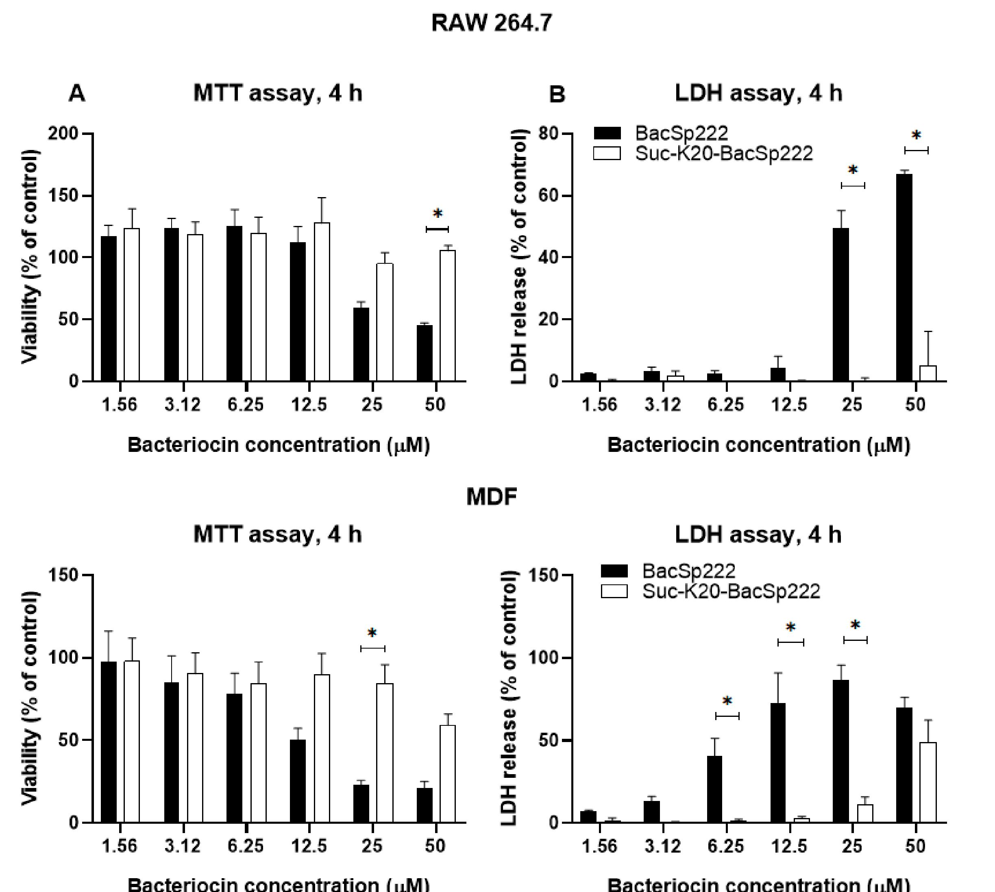
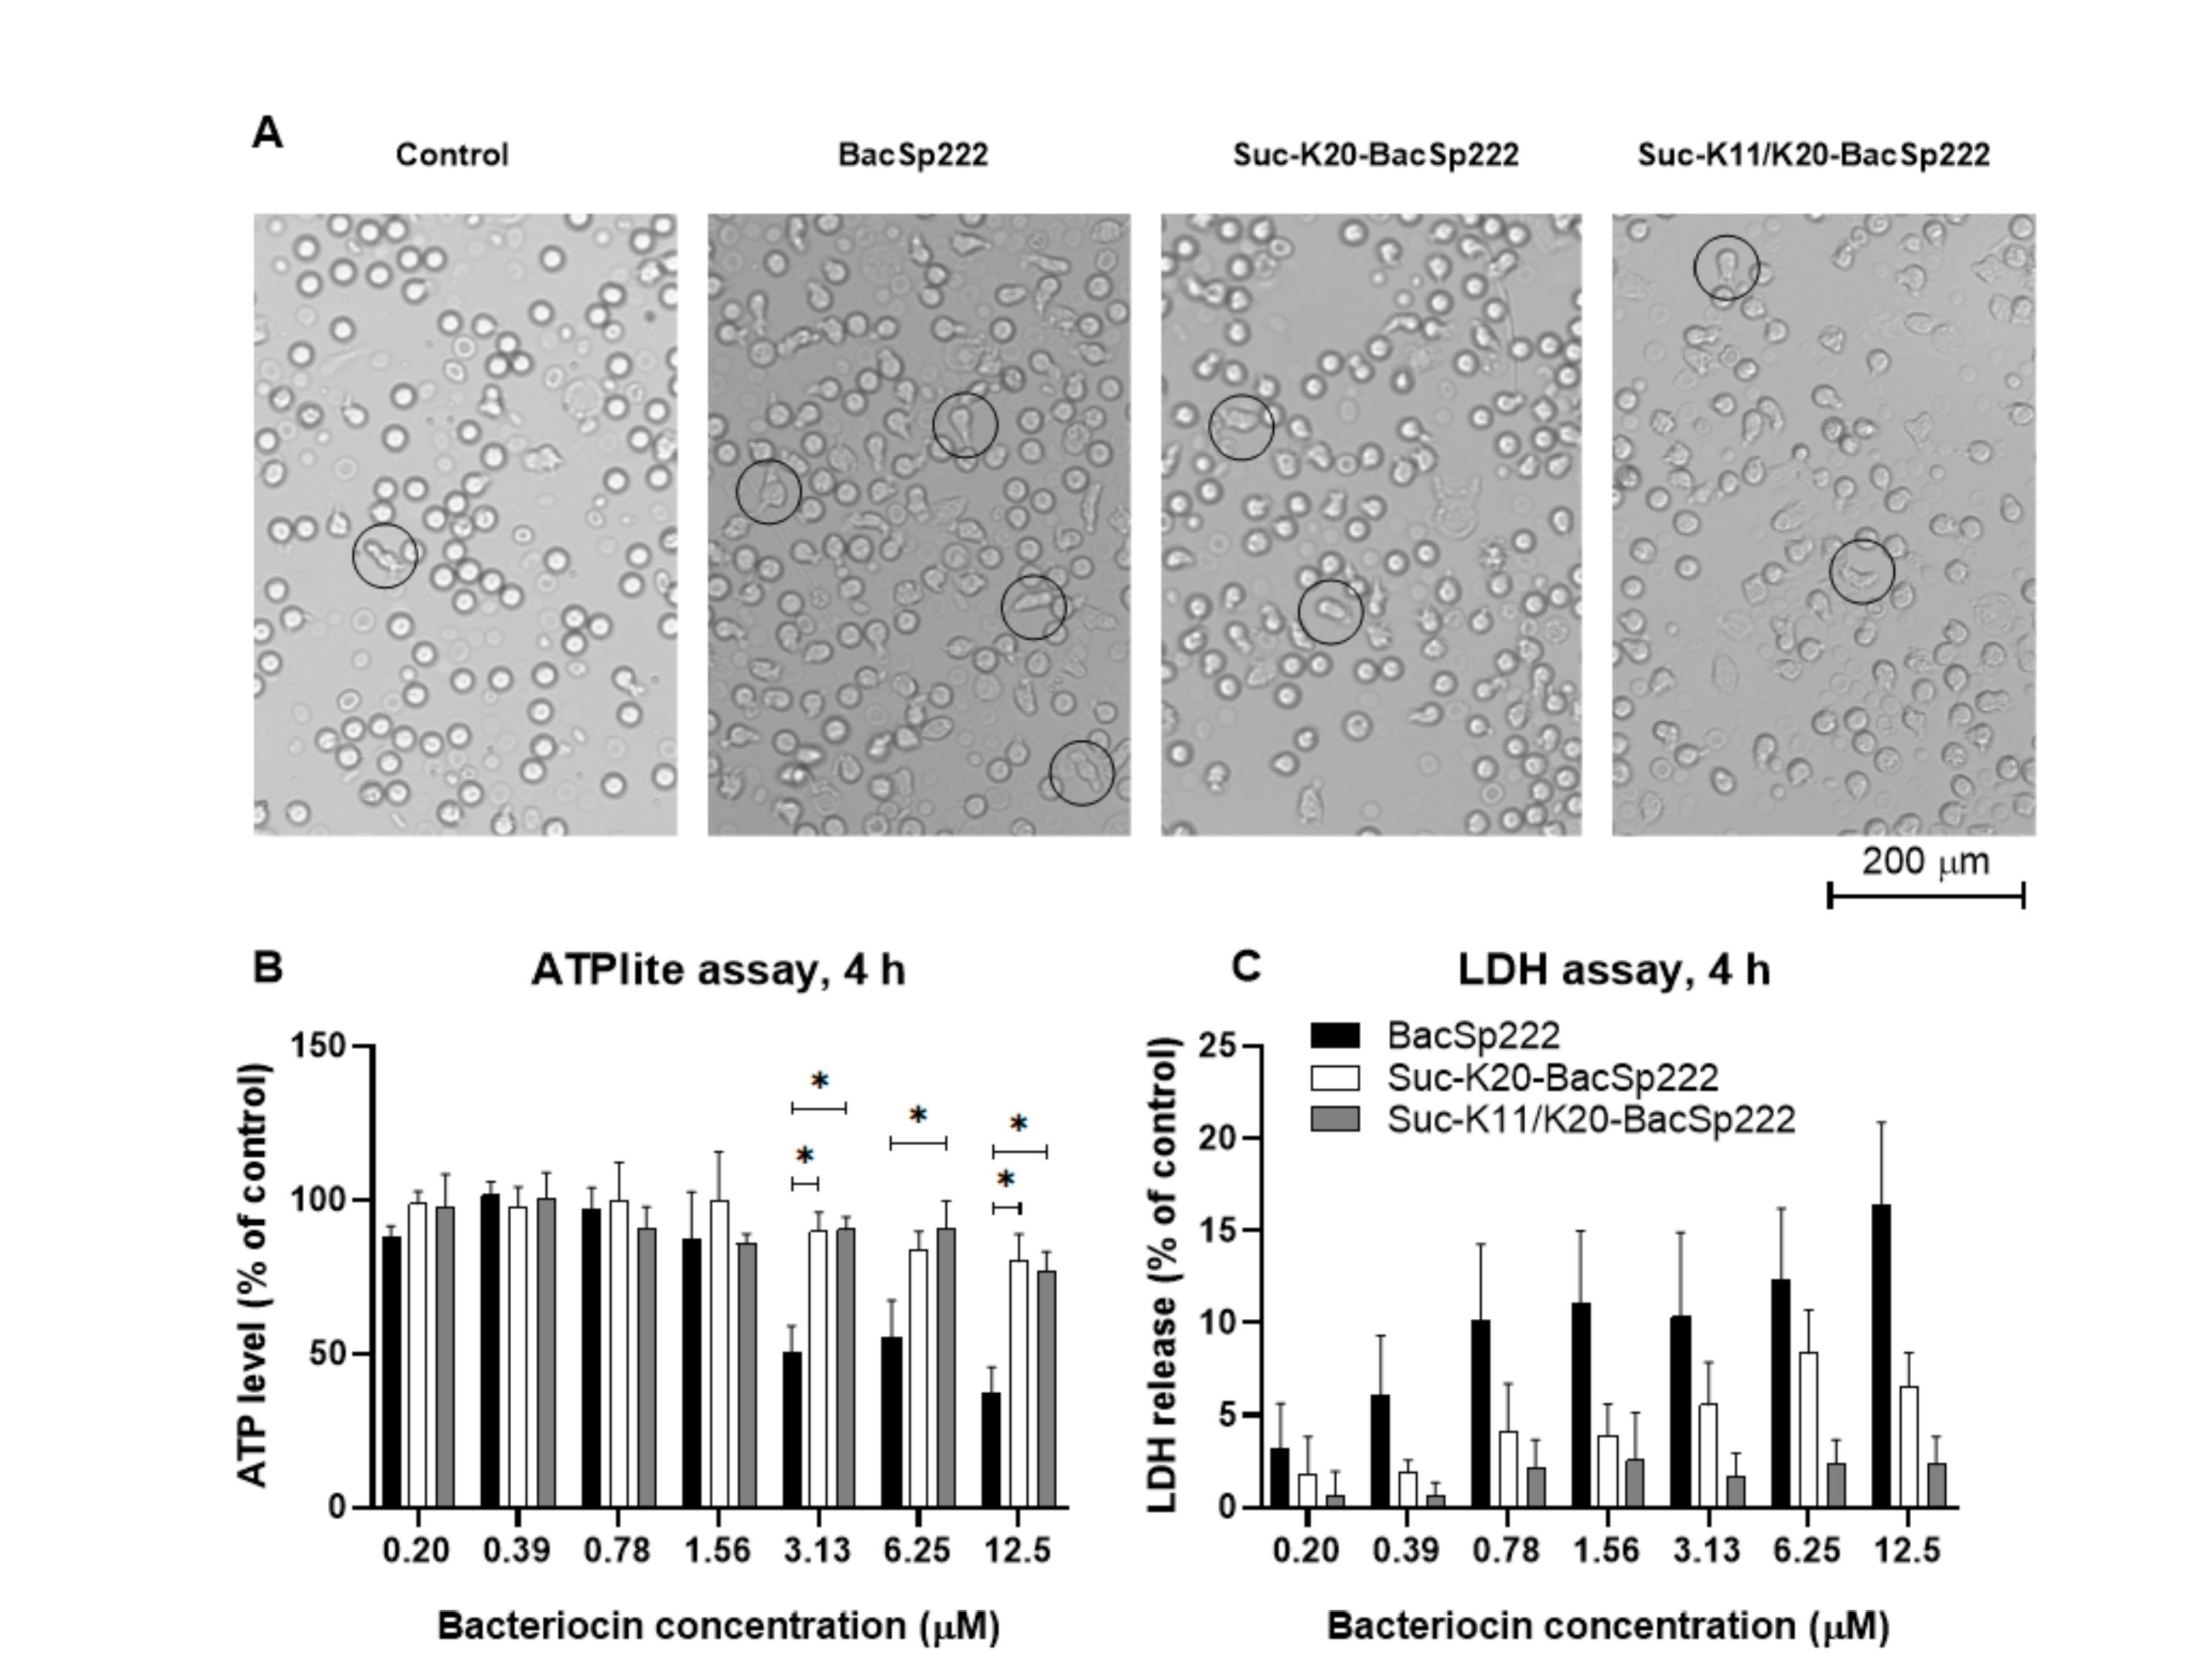
Int. J. Mol. Sci. 2021, 22, 6256
8 of 21
Figure 3. Comparison of the cytotoxic activity of different forms of bacteriocin BacSp222 against
human neutrophils. "The cells were isolated from healthy volunteers' blood and immediately exposed
to various concentrations of BacSp222 forms for 4 h: unmodificed BacSp222, suc-K20-BacSp222, or
suc-KHd/K20-BacSp222. After incubation, the ceOls were centrifuged, and tire supernatants were
transferred to a fresh plate for further analyses. (A) Morphological changes were analysed using an
inverted light microscope. The circles indicate activated neutrophils. (B) The viability of the cells
was determined using an ATPlite assay. (C) LDH activity in the medium indicates cell membrane
damage in the presence oL various forms of bacteriocin. * p < 0.05.
Figure 4. Cytotoxicity of different BacSp222 forms against murine monocyte-macrophage cells RAW
264.7 and murine primary dermal fifbroblasts MDF. The cells were incubated for 4 h in a medium
containing various concentrations of BacSp222 forms: unmodified BacSp222 and suc-K20-BacSp222.
tAhefteerediinfceuibnadtiTiotnes, Ttehlleeceueltburrneemdaeedigaewinetrhee ptrraesnesnfTeeraryetdheovnraiaffrseysahrepslaaytbeafToterrifauTirnt.h*er analyses. (A) The
pv i<a 0b.0i5li.ty of the cells was measured using the MTT method. (B) The LDH activity in the medium
indicates cell membrane damage in the presence of the various forms of bacteriocin. * p < 0.05.

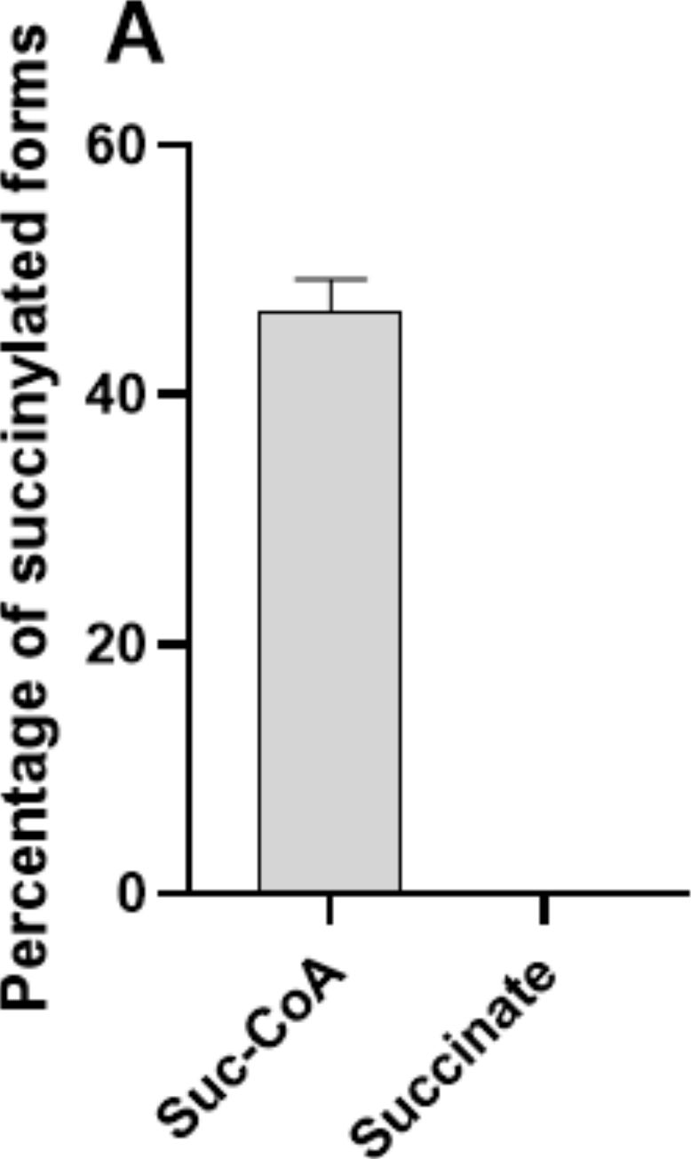
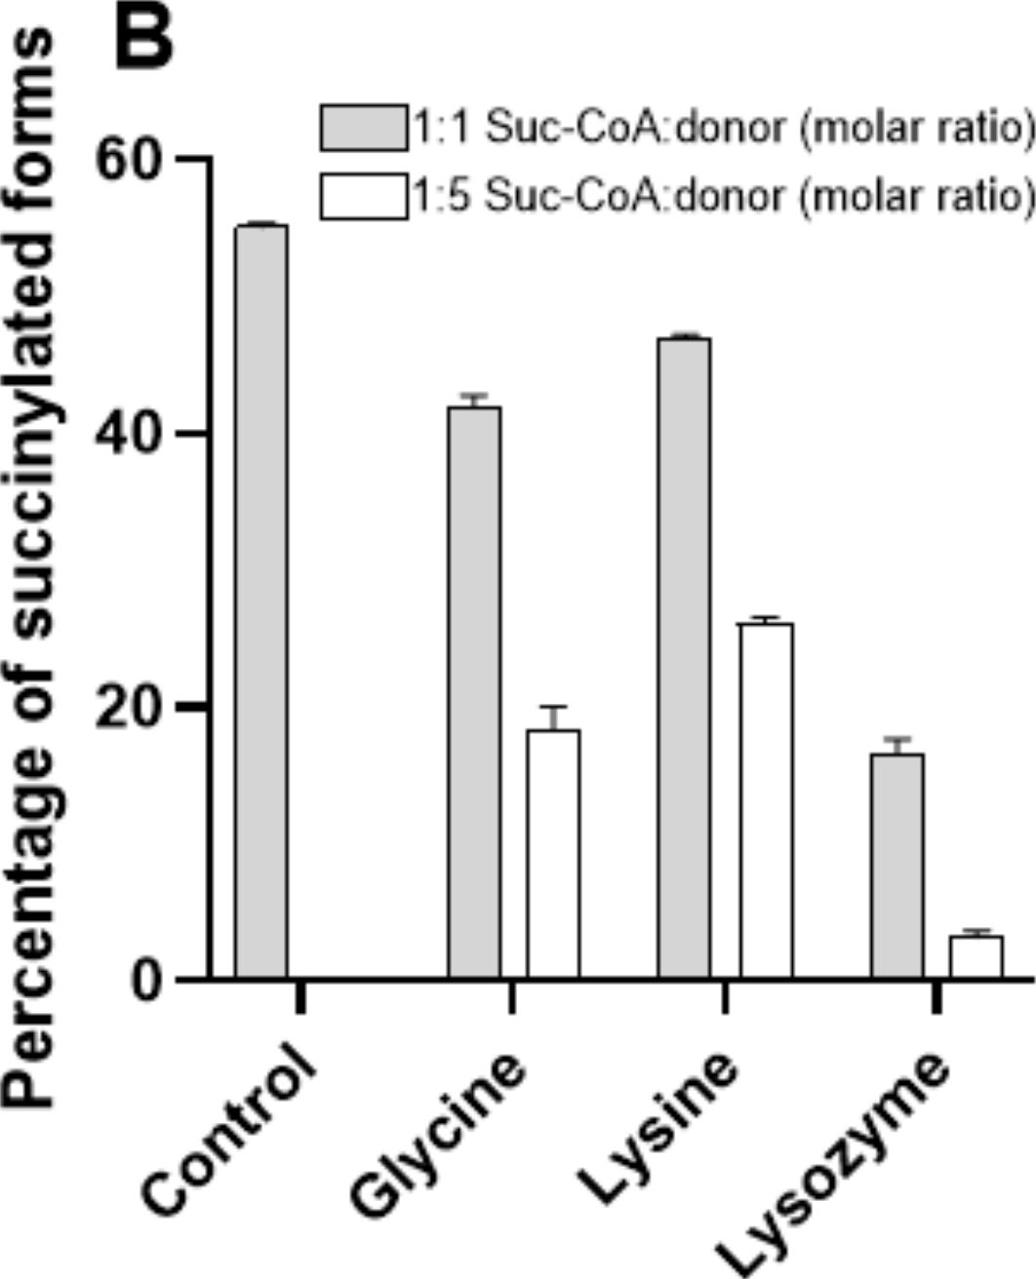
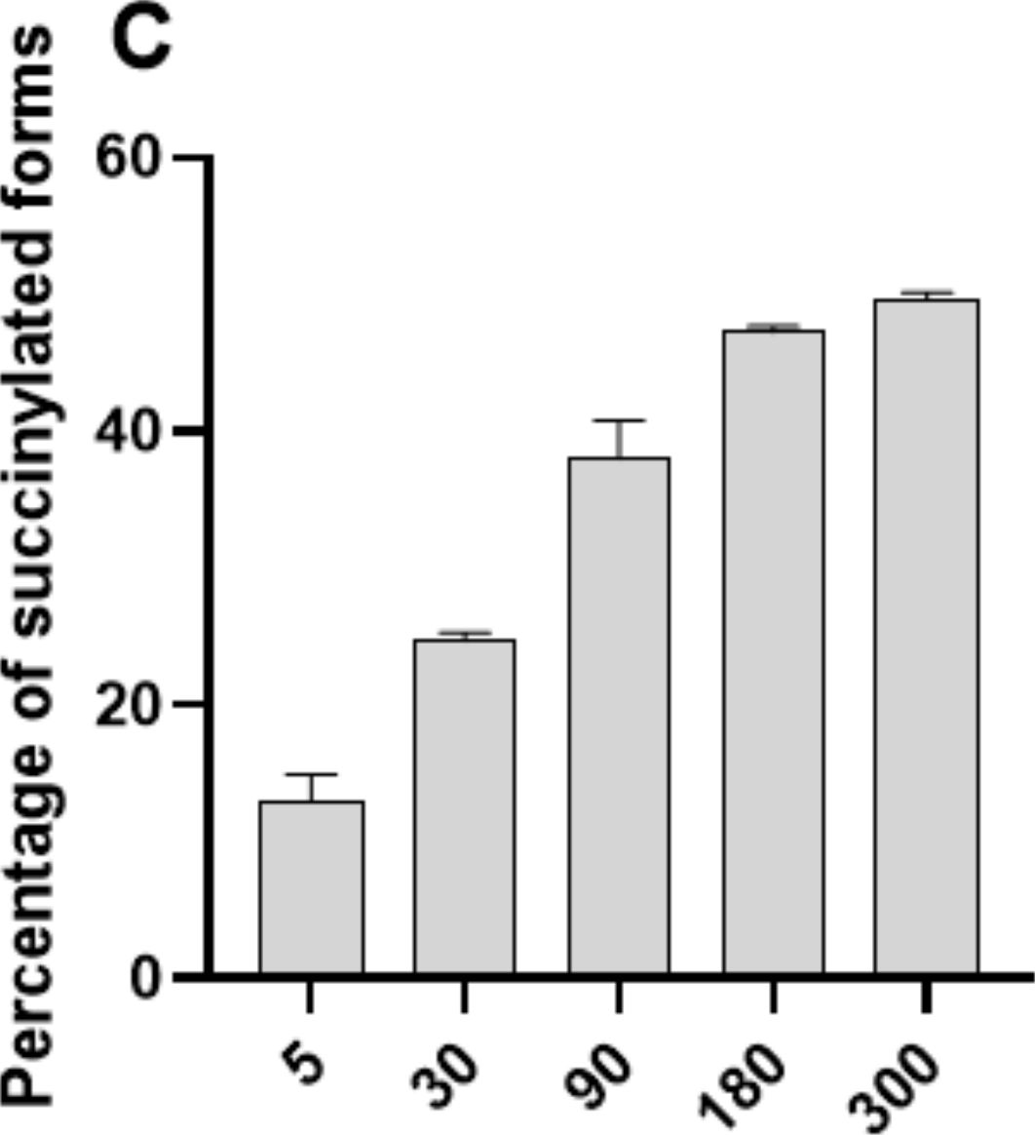
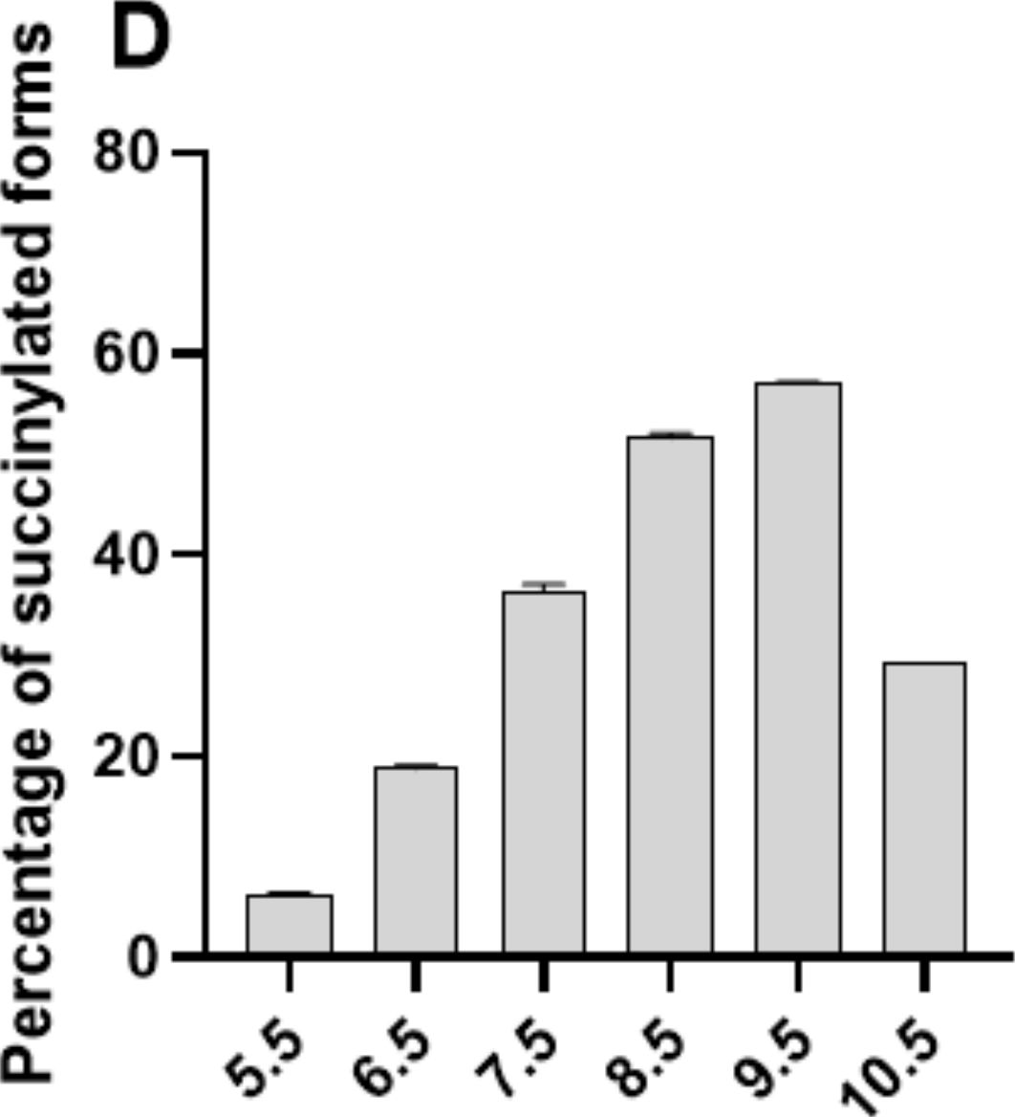
Int. J. Mol. Sci. 2021, 22, 6256
9 of 21

2.5. BacSp222 Succinylation Is a Nonenzymatic Process Dependent On Suc-CoA and pH, Whereas
Desuccinylation Requires NAD+ and Cytoplasmic Enzymes
To establish whether BacSp222 succinylation may proceed via a nonenzymatic re-
action, the unmodified bacteriocin was incubated with two physiological donors of the
succinyl group existing in living bacteria-succinyl-CoA and succinate. Only succinyl-CoA
was able to modify BacSp222 (Figure 5A). The reaction products were essentially identical
to products excreted by living bacteria, i.e., suc-K20-BacSp222 and suc-K11/K20-BacSp222.
The observed rate of the reaction was relatively fast: after 5 min 13% of bacteriocin was
modified (Figure 5C). The reaction diminished gradually over time, and ca. 50% succinyla-
tion level was achieved after 180 min. No further increase of the succinylated forms was
detected up to 300 min of the reaction. However, addition of a new dose of suc-CoA at
90 min of the reaction increased the level of succinylated forms to 60% (data not shown).
These results indicate that the yield of in vitro BacSp222 succinylation is limited by the
instability of suc-CoA in the water solution. This explanation is supported by literature
data: suc-CoA solutions are stable for about 2 h [41]. The lysine modification reaction
is not specific for BacSp222, as equivalent reactions have been described for a variety of
proteins [20,42,43]; however, the site-specificity of modification is BacSp222 specific.
Figure 5. Results of in vitro studies of nonenzymatic succinylation of BacSp222. The unmodified
form of BacSp222 was incubated with donors of the butanedioic group in different conditions. Next,
the amount of BacSp222 forms was determined by RP-HPLC. (A) Ability of physiological donors
of the butanedioic group to modify BacSp222. (B) Influence of the presence of other molecules
containing amino groups on the modification of BacSp222 by suc-CoA. Effect of the reaction time (C)
and pH of the solution (D) on the degree of BacSp222 succinylation.
The yield of succinylation of BacSp222 by suc-CoA was also dependent on the pH of
the reaction. The highest succinylation rate was observed at pH 9.5, whereas the modifica-

Int. J. Mol. Sci. 2021, 22, 6256
10of 21
tion of lysines in slightly acidic conditions (pH 5.5) was practically blocked (Figure 5D).
This observation agrees with the results of Wagner and Payne, who demonstrated that
nonenzymatic BSA succinylation was most efficient at alkaline pH [43]. At pH 9.5, ly-
sine e-amino groups are significantly protonated, as pKa of this moiety is 10.53 [44]. The
most likely mechanism of succinylation comprises the nucleophilic attack of a positively
charged e-amino group of lysine on the carbonyl carbon of the succinyl group in suc-
CoA. Additionally, alkaline pH increases the rate of formation of a highly reactive cyclic
succinic anhydride intermediate, which reacts with primary amines in a dose-dependent
manner [8].
The ability of suc-CoA to react with lysine residues is a common phenomenon [42,43].
Not surprisingly, our further experiments revealed that the excess of non-target amino
groups reduces the efficiency of BacSp222 succinylation. For example, a 500-fold molar
excess of lysozyme resulted in almost complete inhibition of the BacSp222 succinylation
process, decreasing the level of succinylated forms from 55 to 3%. Moreover, the presence
of e-amino groups and a-amino groups affect the succinylation efficiency, as revealed
during the reaction in the presence of free amino acids, glycine, and lysine (Figure 5B).
Moreover, the presence of the bacterial intracellular or extracellular proteome inhi-bited
the succinylation of BacSp222 (data not shown). These results suggest that succinylation
of lysine by suc-CoA is nonspecific. The site of modification is most likely dictated by the
structural arrangement of the peptide molecule.
We attempted to elucidate the mechanism of possible desuccinylation of BacSp222.
Suc-K20-BacSp222 was incubated with bacterial cell lysates and/or with a NAD+ solution,
and the decrease in succinylated BacSp222 was determined. We showed that bacteriocin
desuccinylation was catalysed by constituents of the intracellular proteome of Sp222
and a similar bacterial strain, Sp22221, only in the presence of NAD+ (Supplementary
Materials Figure S4). A common bacterial NAD+-dependent enzyme responsible for the
lysine desuccinylation is the sirtuin-like protein CobB [17]. In fact, the Staphylococcus
pseudintermedius genome contains NAD+-dependent protein deacylase [45].
Overall, our results indicate that, contrary to the succinylation process, BacSp222
desuccinylation requires enzymatic catalysis.

2.6. Environmental Factors Affect the Level of Excreted Succinylated BacSp222 Forms
The secretion of all forms of BacSp222 is growth phase-dependent. When bacteria
were cultivated in the standard laboratory medium (TSB2), the highest concentrations were
detected in the stationary growth phase, i.e., about 7 gM for the unmodified BacSp222,
ca. 3.5 gM for suc-K20-BacSp222, and ca. 0.1 gM for suc-K11/K20-BacSp222. The access
to various nutrients affected the concentration of the BacSp222 forms produced by Sp222.
In the nutrient-poor peptone water medium, the final concentrations of BacSp222 were
about seven to five times lower (for the unmodified BacSp222 and suc-K20-BacSp222
forms, respectively), than in the high-nutrient media (Figure 6A). A similar correlation was
described by Aasen and colleagues, who demonstrated that the level of sakacin P produced
by Lactobacillus sakei depended on the availability of amino acids and growth factors [46].
The kinetics of production of different forms was unaffected by nutrient content.
Independently, we wanted to identify specific features that characterize Staphylococcus
pseudintermedius 222 and ensure BacSp222 succinylation. To this end, we compared the cy-
tosol pH value, the intracellular level of suc-CoA, and the degree of intracellular proteome
succinylation between Sp222, two other representative strains of staphylococci (Staphylo-
coccus pseudintermedius 22221 and Staphylococcus aureus ATCC 25923), and E. coli K12. No
significant differences in the analysed factors were detected among the different bacteria.
Staphylococcus aureus was characterized by the highest level of succinylated proteins, which
correlated with the highest intracellular pH. All staphylococci were characterized by similar
concentrations of suc-CoA, while the Gram-negative bacterium was characterized by a
five-fold lower concentration of this metabolite (Supplementary Materials Figure S6). Un-
fortunately, numerous attempts to produce BacSp222 in a heterologous expression system

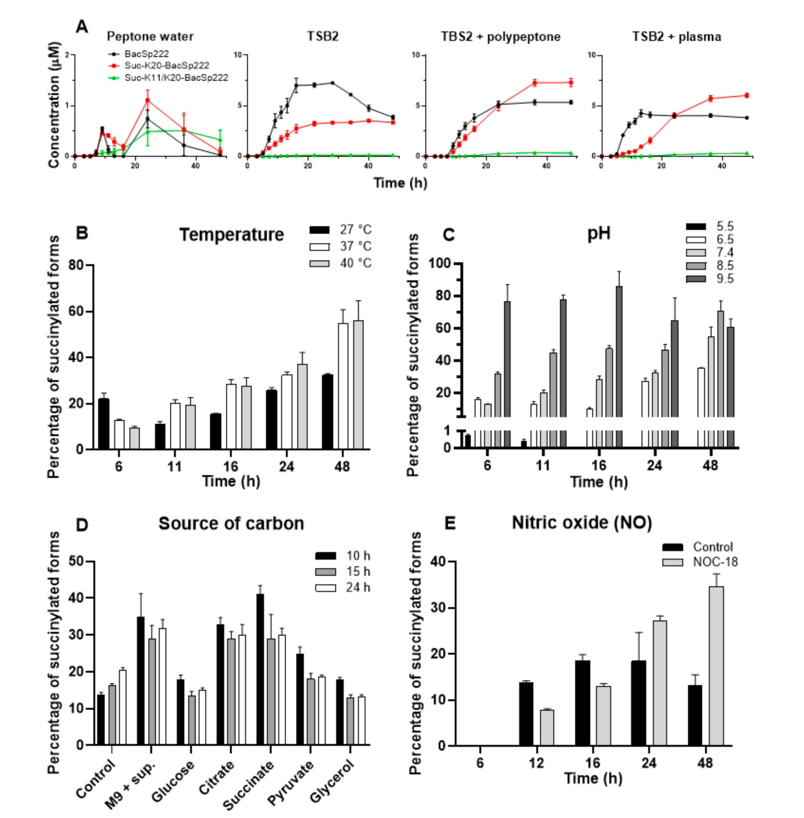
Int. J. Mol. Sci. 2021, 22, 6256
11 of 21
failed, so we were unable to determine whether the succinylation of the peptide is specific
for S. pseudintermedius 222. However, the results obtained in this study indicate that the
observed succinylation of excreted bacteriocin is not associated with the possible unusual
biochemical features of Sp222 in relation to the other bacteria.
Figure 6. Effect of environmental factors on production of BacSp222 and its post-translationally
modified forms by strain Sp222. The bacteria were cultured for various time intervals in different
conditions; next, the levels of all BacSp222 forms were determined in the post-culture media by RP-
HPLC. (A) Effect of the access to nutrients on the biosynthesis of all BacSp222 forms. The successive
panels illustrate the effect of culture temperature (B), pH of the culture (C), carbon source (D), and
biological stress (presence of nitric oxide) (E) on the amount of modified BacSp222forms.
We evaluated the influence of the temperature and pH of the medium on succiny-
lation of BacSp222 at different intervals of time during culture (Figure 6B). The lower
temperature (27 ◦ C) resulted in a lower percentage of succinylated forms of BacSp222, but
this was related to the significantly lower metabolism and bacterial growth rate (two-fold
reduction in the optical density of the culture, Supplementary Materials Figure S5B). A
high correlation between pH and BacSp222 succinylation was observed. At pH 5.5, the
modification of BacSp222 was entirely inhibited, while the overall amount of succinylated
forms of BacSp222 at pH 9.5 was greater than 80% (Figure 6C). The observed increase in the
succinylated forms at alkaline pH was probably not affected by changes in intracellular pH,
as bacteria can maintain the neutral pH of the cytosol even at extreme environmental pH
values [47]. However, such maintenance of constant intracellular pH requires a different
pattern of expressed proteins and significant changes in the entire metabolic pathways [48].
These overall modifications of cellular physiology are probably the cause of the observed
increase in the degree of BacSp222 succinylation.
The level of suc-CoA depends on the activity of the Krebs cycle [49], while the activity
of the Krebs cycle is modulated by the availability of particular carbon sources. We assessed
whether the level of the BacSp222 forms depends on the type of the carbon source utilised

Int. J. Mol. Sci. 2021, 22, 6256
12of 21
during the bacterial culture. The BacSp222 forms were quantified upon the growth of Sp222
in media containing glucose, citrate, succinate, pyruvate, or glycerol as a primary carbon
source and in a control medium without an additional source of carbon at different time
points (10, 15, and 24 h) (Figure 6D). The citrate- or succinate-supplemented media were
characterized by highest level of succinylated forms, while the lowest level was recorded in
those containing glucose and pyruvate. Glucose is known to inhibit Krebs cycle enzymes
and stimulate glycolysis. In turn, citrate and other TCA intermediate metabolites activate
the Krebs cycle, while pyruvate and glycerol stimulate both glycolysis and the Krebs
cycle [50]. We speculate that the high level of modified BacSp222 in samples containing
TCA intermediates (citrate or succinate) may exactly be a consequence of the increased
intracellular level of suc-CoA.
We have demonstrated that unmodified BacSp222 enhances interferon gamma-
dependent NO production in murine macrophages. Nitric oxide is not only a multi-
potent immunomodulatory molecule but also an effective killing or stressing factor for
bacterial cells [21]. We evaluated the effect of NO on the production of BacSp222 forms
by Sp222 cells. We applied NOC-18 as a source of nitric oxide [51]. This compound
has expected half-life in a solution of ca. 57 h and is able to release nitric oxide steadily.
First, we determined that the presence of the bacteria reduced the half-life of NOC-18
(Supplementary Materials Figure S5F), but it was still sufficient for our purpose. The re-
sults of the experiment showed that the presence of NO in the bacterial culture enhanced
the succinylation of BacSp222 in the late phase of the culture, and the levels of the suc-
cinylated forms were twice as high as in the control medium (Figure 6E). Nitric oxide has
antibacterial activity [21]; however, the applied concentration of NOC-18 had no significant
effect on the growth of bacteria-the growth was slightly diminished only in the initial phase
of the culture (Supplementary Materials Figure S5E). Grosser and co-workers have demon-
strated that NO induces the expression of nitric oxide resistance proteins in Staphylococcus
aureus [52]. Possibly, the ability of Staphylococcus pseudintermedius to grow in the presence
of NO is related to adequate changes in gene expression, which may further contribute to
the enhanced level of BacSp222 succinylation. Nevertheless, such a conclusion requires
further investigation. The present results indicate that the level of BacSp222 succinyla-
tion depends on the presence of a biological stressor, and Sp222 probably modulates the
yield of post-translationally modified forms of BacSp222 in response to the host immune
response. This phenomenon suggests that increased production of succinylated forms may
be a mechanism to avoid the over-activation of the host immune system; however, this
hypothesis requires further verification.

3. Materials and Methods

3.1. Bacterial Strains and Culture Conditions
The following bacterial strains were used in this study: Staphylococcus pseudintermedius
222/PCM 2791 (Sp222), Staphylococcus pseudintermedius LMG 22221 (Sp22221), Staphylococ-
cus intermedius ATCC 29663, Staphylococcus aureus ATCC 25923 (Sa25923), Staphylococcus
epidermidis ATCC 35547, Bacillus subtilis ATCC 6633, Lactococcus lactis ŁOCK 0871, Micro-
coccus luteus ATCC 4698, and Escherichia coli K12/ATCC 10798 (EcK12). All bacteria were
cultivated at 37 ◦ C in tryptic soy broth 2 (TSB2, Sigma, St. Louis, MO, USA), except E. coli,
which was cultured in Luria-Bertani (LB) broth (Sigma, St. Louis, MO, USA).

3.2. Eukaryotic Cells and Culture Conditions
Human blood (containing citrate as an anticoagulant) from healthy volunteers was
obtained from the Regional Centre of Blood Donation and Treatment (RCBDT) in Kraków,
Poland. RCBDT deidentified the samples, which was relevant in order to keep the subjects'
identity confidential, and the study complied with appropriate rules of exclusion of human
subjects. Neutrophils were isolated from the blood using centrifugation in a Ficoll-Paque
Plus (GE Healthcare, Chicago, IL, USA) density gradient, and erythrocytes were elimi-
nated by polyvinyl alcohol (POCH, Gliwice, Poland) treatment and osmotic lysis. Murine

Int. J. Mol. Sci. 2021, 22, 6256
13of 21
monocyte/macrophage RAW264.7 cells (ATCC TIB-71), murine monocyte/macrophage
P388.D1 cells (ATCC CCL-46), and human skin fibroblast (HSF) cells (ATCC CRL-2522)
were obtained from the American Type Culture Collection (Manassas, VA, USA). Murine
primary dermal fibroblasts (MDF) were a kind gift from Dr. Krystyna Stalińska (Faculty
of Biochemistry, Biophysics and Biotechnology, Jagiellonian University in Kraków). All
cells were cultured at 5% CO2, 37 ◦ C, and >95% humidity in DMEM (GIBCO, Paislay, UK)
containing 5% (v/v) foetal bovine serum (FBS, GIBCO, Paislay, UK) and 4.5 g glucose/L,
except neutrophils, which were cultured in 10% (v/v) FBS in RPMI medium (LONZA,
Basel, Switzerland).

3.3. Isolation of BacSp222 and Its Succinylated Forms
BacSp222 and its succinylated forms were purified from S. pseudintermedius 222 culture
supernatant after 24 h of cultivation in TSB2 at 37 ◦ C with shaking (200 rpm). After
centrifugation (5000 x g for 15 min at 4 ° C), the supernatant was cooled to 4 ° C and
precipitated with ammonium sulphate to 60% saturation for four hours in an ice bath. The
precipitated material was recovered by centrifugation at 21,000x g for 30 min at 4 ◦ C. The
pellet was dissolved in H2O, acidified to pH 3.0 with trifluoroacetic acid (TFA), centrifuged
again, filtered through a 0.45 ^m filter, and subjected to reverse-phase high-pressure
liquid chromatography (RP-HPLC) on a Discovery Bio Wide Pore C8 250 x 10 mm column
(Sigma, St. Louis, MO, USA). The separations were performed at room temperature using
an UltiMate 3000 HPLC system (Thermo, Waltham, MA, USA) and spectrophotometric
detection at 220 nm. Two solvents were used: A—0.1% TFA (v/v) in water and B—
0.07% TFA in 80% acetonitrile (both v/v). After equilibration of the column at 60% of
buffer B, a linear gradient from 60 to 100%of buffer Bwas applied over 20 minat a flow
rate of 1.5 mL/min. Fractions containing BacSp222, suc-K20-BacSp222, and suc-K11/K20-
BacSp222 were collected, dried in a centrifugal evaporator, dissolved in water, and subjected
to the second RP-HPLC step in identical conditions as above. The preparations of peptides
obtained had a purity of over 99%, as evaluated by analytical RP-HPLC chromatography.
Each batch of purified bacteriocin was essentially free of lipopolysaccharide (LPS), as
assayed by an E-TOXATE kit (Sigma, St. Louis, MO, USA).

3.4. NMR Spectroscopy and Structural Calculations
The nuclear magnetic resonance (NMR) spectra were acquired using a 0.5 mM solution
of native unlabelled suc-K20-BacSp222 dissolved in 650 pL of an H2O:D2O mixture (9:1,
v/v) containing 100 mM of deuterated sodium acetate, pH 5.0. The NMR experiments were
performed using a Varian 700 MHz DDR2 spectrometer equipped with an HCN probe at
25 ◦ C (calibrated with a standard ethylene glycol reference sample). The chemical shifts in
the 1H NMR spectra were reported with respect to external DSS-d4. The chemical shifts of
the 13C and 15N signals were referenced indirectly using frequency ratios of 0.251449530 for
13C/1H and 0.101329118 for 15N/1H [53]. The assignment of the chemical shifts was based
on our previous study of an unmodified BacSp222 peptide [22] and verified by analysis
of a standard set of 2D NMR experiments consisting of TOCSY [54], NOESY [55], 1 H-15N
HSQC, and two 1H-13C HSQC [56] (the 13C HSQC spectra were recorded with the offset,
spectral widths, and 13C-1H coupling constant adjusted to aliphatic or aromatic carbons,
respectively). The experimental data were processed using the NMRPipe software pack-
age [57], while the processed spectra were analysed with SPARKY software [58]. Relevant
parameters of the NMR spectra are provided in Supplementary Materials Table S1. The
1H, 13C, and 15N resonance assignments were deposited in BioMagResBank (BMRB) under
accession code 34614.
Distance constraints were derived from the 2D NOESY spectrum. Initial structural
calculations were performed with CYANA 3.98 software [59], and the automatic NOESY
assignment procedure provided 235 distance constraints. The additional restraints for the
backbone p and angles for regions with a well-defined secondary structure (alpha-helices)
were derived from the chemical shifts using the TALOS-N server [60]. XPLOR-NIH 2.26

Int. J. Mol. Sci. 2021, 22, 6256
14of 21
was used for structural calculations [61]. The topology of two additional amino acids
(formylated methionine at the N-terminus and succinylated lysine) was manually added
to the XPLOR-NIH 2.26 topology file. Evaluation of the suc-K20-BacSp222 final structures
was performed with the Protein Structure Validation Server (PSVS) [62]. Twenty structures
with the lowest energy (out of the 400 calculated in the final structural refinement) were
deposited in PDB under accession code 7NYI.

3.5. CD Spectroscopy
The circular dichroism (CD) spectra were obtained using 0.1 (for the 190-240 nm range)
or 0.5 (for the 240-350 nm range) mg/mL solutions of BacSp222 or suc-K20-BacSp222
dissolved in 50 mM sodium phosphate pH 6.0. All measurements were made in a 1 mm
quartz cuvette using a J-715 spectropolarimeter (Jasco, Tokyo, Japan) at 25 ◦ C without or
in the presence of unilamellar dipalmitoylphosphatidyl glycerol (DPPG, Sigma, St. Louis,
MO, USA) liposome suspension. The liposomes were prepared using an Avanti Polar
Lipids syringe extruder equipped with a 100 nm filter and mixed with bacteriocins at a
100:1 phospholipid-to-bacteriocin molar ratio. All spectra were recorded with appropriate
blank subtractions and averaged from three independent measurements. The amounts of
structural motifs were calculated using the BeStSel server [63,64].

3.6. Biochemical Techniques
The N-terminal amino acid sequences were determined using automatic protein
sequencers Procise 491 (Applied Biosystems, Fosters City, CA, USA) and PPSQ-31A (Shi-
madzu, Kyoto, Japan). The concentration of purified bacteriocin and its succinylated forms
was determined by amino acid analysis as described previously [65], while the concen-
tration of these peptides in mixtures or biological fluids was determined by analytical
RP-HPLC using a Discovery Bio Wide Pore C18 250 x 4.6 mm column (Sigma, St. Louis,
MO, USA) and a linear gradient 0-100% of buffer B for 15 min developed at 40 ◦C. The
other details of the HPLC separations were identical to those described in Section 3.3.
The system was calibrated using a set of standard solutions of the bacteriocin and its
succinylated forms.
Digestion of BacSp222 and its succinylated forms by trypsin (Gold grade, Pierce,
Rockford, IL, USA) was performed for 17 h at 37 ◦ C in 0.2 M Tris-HCl, pH 8.1, containing
4% (w/v) sodium deoxycholate, using a 1:20 enzyme-to-substrate mass ratio. To denature
the peptides and facilitate digestion, the reaction mixtures were heated to 99 ◦ C for 5 min
and chilled. Trypsin was added after chilling. The peptide fragments were purified by RP-
HPLC using a Discovery Bio Wide Pore C18 4.6 x 250 mm column (Sigma, St. Louis, MO,
USA) and a linear gradient 0-100% of buffer B for 30 min developed at room temperature.
The other details of the HPLC separations were identical to those described in Section 3.3.
A synthetic peptide SRVLDGLVMTTISSSK was used to obtain the peptide standard
containing N-e-succinyl-lysine. A quantity of 10 nmol of the peptide was dissolved in
1 mL of 0.2 M sodium borate, pH 8.2, and 3 mg of solid succinic anhydride (Sigma) was
added. The reaction was performed at room temperature for 1 h on a magnetic stirrer
and at constant pH maintained by dropwise addition of a 5 M NaOH solution. After the
reaction, the peptide was digested by cyanogen bromide to obtain the peptide fragment
TTISSSL-suc-K, which was used to calibrate the automatic protein sequencer.
For mass spectrometry, the peptideswere dissolved in30% methanol with0.1% formic
acid (both v/v). An HTC Ultra ETD II mass spectrometer equipped with an electrospray
ionizationionsourceand anelectron-transferdissociationIIfragmentationmodule(Bruker)
was used. The samples were injected directly using a syringe pump at a flow rate of
180 gL/hour. The analyses were performed in a positive ion mode with a capillary voltage
of 3.5 kV, a nebulizer pressure of 10 psi, a drying gas flow of 5 Lmin, and an ion source
temperature of 300 ◦ C. The spectra were acquired in the MS and MSn modes in the range
of 100-3000 m/z with both CID (collision-induced dissociation) and ETD (electron-transfer

Int. J. Mol. Sci. 2021, 22, 6256
15of 21
dissociation) ion fragmentation. The tandem MS data were processed manually using
DataAnalysisTM 4.0 and BiotoolsTM 3.2 software (Bruker, Billerica, MA, USA).
To determine the physicochemical character of the excreted forms of bacteriocin,
10 mL of the bacterial post-culture medium was prepared by centrifugation at 10,000 x g for
20 min to remove bacterial cells. The supernatant was fractionated using a 100-kDa cut-off
membrane (Millipore, Burlington, MA, USA). The filtrate and the supernatant containing
possible macromolecular aggregates or membrane vesicles excreted by bacterial cells were
solubilized with 6 M guanidine hydrochloride (Sigma). The level of each form of bacteriocin
was determined by RP-HPLC using a Discovery Bio Wide Pore C8 250 x 4.6 mm column
(Sigma) developed in a linear gradient from 0 to 100% of buffer B over 15 min at 40 ◦ C
and a flow rate of 1 mL/min. The other details of the separations were identical to those
described in Section 3.3.
Bacterial cell lysate was obtained via a combination of enzymatic and mechanical
factors. A volume of 10 mL of bacterial culture was centrifuged at 5000x g for 10 min. The
pellet was washed 3 times wth PBS and suspended in 80 gL of phosphate-buffered saline
(PBS, Sigma). The cells were pretreated with 40 gg/mL lysostaphin (Sigma) and 125 U/mL
Omni nuclease (Eurx, Gdansk, Poland) with shaking at 1,000 rpm for 1 h at 37 ° C. The
suspension was sonicated using a UP50H sonicator (Hielscher, Teltov, Germany, 30 pulses
at 100% of power, amplitude 0.5). The incubation and sonication steps were repeated. As a
final step, the suspension was centrifuged at 15,000x g for 20 min at 4 ◦C. The collected
lysate was stored at -20 ◦ C.
The concentration of succinyl-coenzyme A (suc-CoA) was determined by RP-HPLC
using a Discovery C18 250 x 4.6 mm column (Sigma). Two solvents were used: A-150 mM
NaH2PO4 containing 5% methanol (v/v) and B-150 mMNaH2PO4 containing 30% methanol
(v/v). After equilibration of the column at 0% of buffer B, a linear gradient from 0 to 100%
of buffer B was applied over 7.5 min. The flow rate was 1 mL/min. The spectrophotometric
detection was performed at 254 nm while the temperature of the column was maintained
at 40 ◦C. Before measurements, the column was calibrated using a set of standard solutions
of suc-CoA (Santa Cruz Biotechnology, Santa Cruz, CA, USA).
The level of lysine succinylation in intracellular bacterial proteomes was determined by
Western Blotting. Tris-glycine sodium dodecyl sulphate polyacrylamide gel electrophoresis
(SDS-PAGE) was performed in reducing conditions using Mini-Protean Precast Gels (Bio-
Rad, Hercules, CA, USA). After electrophoresis, the proteins were transferred on a 0.4 gm
pore size polyvinylidene difluoride (PVDF) membrane (Millipore, Burlington, MA, USA)
using 10 mM N-cyclohexyl-3-aminopropanesulfonic acid (CAPS) buffer, pH 11.0, contain-
ing 10% (v/v) methanol. The transfer was evaluated by transient staining the membranes
using 0.5% (w/v) Ponceau S dissolved in 5% (v/v) acetic acid. The immunodetection was
performed using a 0.05% (v/v) solution of anti-succinyl lysine (anti-Ksu) rabbit polyclonal
antibodies (PTM BIO, Cesarea, Israel) dissolved in 5% (w/v) skimmed milk in Tris-buffered
saline containing 0.05% Tween-20 (TBST). The primary antibodies were detected using a
0.1% (v/v) solution of HRP-labelled goat anti-rabbit IgG antibodies (Sigma, St. Louis, MO,
USA) in 5% (w/v) skimmed milk in TBST. DAB peroxidase substrate (Sigma) was used to
visualize the results.
Bioinformatic prediction of succinylation sites in BacSp222 was performed using
available algorithms: SuccinSite [32], GPSuc [31], iSuc-Opt predictor [30], pSuc-Lys predic-
tor [29], iSucPseAAC [34], and SucFind [28].

3.7. Antibacterial Radial Diffusion Assay
A radial diffusion assay was used to compare the bactericidal activity of the BacSp222
forms. Soft TSB plates (0.75% agarose, w/v) contained the tested bacteria. Aliquots of 5 gL
of the tested bacteriocin were added as drops at different sites. BacSp222 was applied in
serial two-fold dilutions at concentrations ranging from 0.62 gM to 40 gM, whereas both
succinylated forms were used only at the highest concentration (40 gM). After 16 h of
incubation at 37 ◦C, the antibacterial activity ofthe peptides was determined as the diameter

Int. J. Mol. Sci. 2021, 22, 6256
16of 21
of the bacterial growth inhibition zone. Because the correlation between the diameter of
inhibition zones and concentration of the peptides was nonlinear the antibacterial activities
of both modified forms of the bacteriocin were calculated and presented as a percentage of
the activity of unmodified BacSp222.

3.8. Analysis of the Effect of Bacteriocin on Eukaryotic Cells
Human blood neutrophils were transferred to a half-area 96-well plate (50,000 cells
per well in 50 pL RPMI, 10% FBS, Sigma, St. Louis, MO, USA). 5 pL of PBS or bacteriocin
solutions was added and the cells were cultured for 4 h. After incubation, the cells were
centrifuged at 1280 x g, and the supernatants were used to determine the activity of lactate
dehydrogenase (LDH). Cell viability was determined using an ATPlite kit. Both assays were
performed in accordance with the manufacturers' instructions (Roche, Basel, Switzerland,
and Perkin Elmer, Waltham, MA, USA, respectively). A positive control for the LDH release
was obtained by treating the cells with 5% (v/v) Triton X-100 (Sigma, St. Louis, MO, USA)
in RPMI. The absorbance (in the case of LDH detection) and luminescence (for the viability
assay) were measured with the use of a Synergy H1 hybrid plate reader controlled by
Gene5 version 2.00.18 Software (BIOTEK Instruments, Winooski, VT, USA). The viability of
cells was calculated using the following formula:
Luminescence of bacteriocin-treated cells
ATP level (% of control) = x 100% (1)
Luminescence of PBS-treated cells
LDH activity was calculated according to the formula:
Absorbance of bacteriocin-treated cells
LDH release (% of control) = x 100% (2)
Absorbance ofTriton X-100-treated cells
The morphology of neutrophils upon the treatment with bacteriocins was inspected
using an inverted light microscope DM IL LED Fluo (Leica, Wetzlar, Germany).
RAW264.7, MDF, P388.D1, and HSF cells were seeded on half-area 96-well plates in
50 pL of growth medium at a density of 20,000 cells per well. After 24 h, the media were
removed and replaced with fresh DMEM containing 2% FBS and 5 pL of PBS (for control
cells) or 5 pL of bacteriocins (final concentrations: 50, 25, 12.5, 6.25, 3.12, and 1.56 pM). After
4- or 24-h exposure to the bacteriocins, the supernatants were collected and used to measure
LDH activity (as described above), while the viability of the cells was determined by an
MTT assay according to the standard protocol. All measurements were performed using a
Synergy H1 hybrid reader running with Gene5 v2.00.18 Software (BIOTEK Instruments,
Winooski, VT, USA). The viability of cells was calculated using the following formula:
Absorbance of bacteriocin-treated cells
Viability (% of control) = x 100% (3)
Absorbance of PBS-treated cells

3.9. In Vitro Analysis of Succinylation and Desuccinylation of BacSp222
BacSp222 or suc-K20-BacSp222 were incubated at 37 ◦C for 3 h (unless otherwise
indicated) in PBS or in Britton-Robinson buffer with a 3-carboxypropanoyl group donor
suchassuccinylcoenzymeAsodiumsalt(SantaCruzBiotechnology)ordisodiumsuccinate
(Sigma) at molar ratios of 1:100 (for succinylation studies) or independently with the
bacterial lysate or/and with 25 mM NAD+ (Roanal) (in case of desuccinylation studies).
The pH and ionic strength of the Britton-Robinson buffer were adjusted by KOH and NaCl,
respectively. Compounds containing amino groups i.e., glycine (Sigma), lysine (Sigma,
St. Louis, MO, USA), and human lysozyme (Sigma, St. Louis, MO, USA) and the BacSp222
variants were used at compound:donor molar ratios of 1:100 or 1:500. The concentration
of the BacSp222 forms was determined by RP-HPLC using a Discovery Bio Wide Pore
C8 250 x 4.6 mm column (Sigma, St. Louis, MO, USA) and a linear gradient from 0 to
100% of buffer B over 15 min developed at 40 ◦ C and a flow rate of 1 mL/min. The other
details of the separations were identical to those described in Section 3.3. The results are

Int. J. Mol. Sci. 2021, 22, 6256
17of 21
presented as a percentage of the succinylated form in the pool of all BacSp222 forms (for
succinylation studies) or a percentage of detected suc-K20-BacSp222 relative to the control
suc-K20-BacSp222 sample (in the desuccinylation studies).

3.10. Analysis of the Influence of Environmental Factors on the Level of Succinylated Forms of BacSp222
Staphylococcus pseudintermedius 222 (Sp222) was cultivated in TSB2 or in M9 medium
with supplementation dedicated to staphylococci [66] at 37 ◦ C (unless otherwise stated)
and 180 rpm shaking for different periods. pH of the media were adjusted with NaOH
or HCl. The carbon sources included glucose (BioShop, Burlington, ON, Canada), citrate
(POCH), succinate (Merck), pyruvate (Eurochem BGD), or glycerol (BioShop, Burlington,
ON, Canada), and were tested at a 60 mM concentration. The donor of nitric oxide, NOC-18
(ChemCruz, Santa Cruz, CA, USA), was used at a 4 gM concentration. Optical density
(OD) at 600 nm was used to monitor the growth. After cultivation, the bacterial suspension
was centrifuged at 10,000 x g for 5 min to remove the cells, and the concentration of all
BacSp222 forms was determined by RP-HPLC (in conditions as described in Section 3.9).
The results were shown as a percentage of succinylated forms in relation to the amount of
all BacSp222 forms.
Nitric oxide release was determined using the Griess assay. Briefly, 50 gL of 1% (w/v)
sulfanilic acid (Sigma, St. Louis, MO, USA) in 2.5% (v/v) H3PO4 and 50 gL of 0.1% (w/v)
N-(1-naphtyl) ethylenediamine dihydrochloride (Sigma) in 2.5% (v/v) H3PO4 were added
to 100 gL of post-culture medium. Absorbance was determined at 545 nm using a Synergy
H1 hybrid reader and Gene5 v2.00.18 Software (BIOTEK Instruments, Winooski, VT, USA).

3.11. Determination of Intracellular pH in Bacteria
The bacteria were incubated for 30 min at 37 ◦ C with shaking (300 rpm) upon addition
of 10 gg/mL of the pH-sensitive dye BCECF-AM (Thermo, Waltham, MA, USA). The
cultures were centrifuged for 5 min at 5000x g, and the bacterial pellet was suspended at
OD of 0.4 in PBS supplemented with 25 mM glucose. The suspensions were mixed with
PBS (control sample) or with a solution of Intracellular pH Calibration Buffer (Thermo) con-
taining 10 gM nigericin (Thermo, Waltham, MA, USA) and 10 gM valinomycin (Thermo,
Waltham, MA, USA) (for Gram-positive bacteria) or 10 gM CCCP (Sigma, St. Louis, MO,
USA) (in the case of Gram-negative bacteria) at a volume ratio 1:1. The mixtures were
incubated in darkness at room temperature for 45 min, and the fluorescence at excita-
tion/emission wavelengths of 440/530 nm and 505/530 nm (for Gram-positive bacteria) or
490/530 nm (in the case of Gram-negative bacteria) was determined using a Synergy H1
hybrid reader and with Gene5 version 2.00.18 Software (BIOTEK Instruments, Winooski,
VT, USA). The results were analysed using online tool “Quest Graph™ Four Parameter
Logistic (4PL) Curve Calculator” [67].
  - Statistics
Statistical significance for the cytotoxicity assays was calculated by one-way ANOVA
on ranks using Statistica v13.3 software (StatSoft), with p < 0.05 considered significant. The
bars on the charts represent the average values from three experiments ± SD.

4. Conclusions
We have shown that S. pseudintermedius 222 excrete bacteriocin BacSp222 in three forms:
unmodified and two forms (suc-K20-BacSp222 and suc-K11/K20-BacSp222) modified post-
translationally by succinyl groups attached to e-amino moieties of lysine residues. The
NMR and CD experiments have revealed that the structure of suc-K20-BacSp222 does
not significantly differ from that of the native unmodified bacteriocin. At the same time,
succinylation of BacSp222 leads to a significant reduction in antibacterial and cytotoxic
activity. We have also shown that succinylation is a nonenzymatic process with the highest
efficiency at slightly alkaline pH, and the Krebs cycle intermediate succinyl-CoA is the most
likely physiological donor capable of modifying the bacteriocin. The amount of BacSp222

Int. J. Mol. Sci. 2021, 22, 6256
18of 21
excreted by bacteria depends on various environmental factors. We demonstrated that
the level of BacSp222 forms was associated with access to nutrients and reached the
highest values in high-nutrient media. Moreover, the amount of the excreted succinylated
forms was higher at a temperature close to that of the host body and in the post-culture
media supplemented with citrate or succinate than in those supplemented with glucose.
Furthermore, a higher level of succinylated forms of the peptide was excreted when Sp222
was cultured in stress conditions (nitric oxide).
Overall, the reduced bactericidal activity of succinylated forms of bacteriocin inter-
preted together with the increased amount of succinylated forms in stress conditions
suggest that post-translational modifications are a form of protection of producer cells
against the secreted bacteriocin. We speculate that (i) the reduced cytotoxic activity of the
succinylated forms of the bacteriocin, (ii) the stimulatory effect of NO on succinylation, and
(iii) the fact that Sp222 is an opportunistic specie may indicate that the posttranslational
modification of BacSp222 is an element of the mechanism responsible for making Sp222 a
natural element of the canine bacterial flora rather than a conventional pathogen.
Supplementary Materials: The following are available online at https://www.mdpi.com/article/10
.3390/ijms22126256/s1, Figure S1: Identification of N-e-succinyl lysine on a set of three overlayed
chromatograms from sequencing cycles of tryptic peptide fragments obtained from succinylated
forms of BacSp222; Figure S2: Results of CD measurements in the far (A) and near (B) UV region for
unmodified and succinylated forms of BacSp222 recorded both without and in the presence of DPPG
liposomes; Figure S3: Comparison of the cytotoxic activity of different forms of bacteriocin BacSp222
against murine monocyte-macrophage cells (RAW 264.7), murine dermal primary fibroblasts (MDF),
human skin primary fibroblasts (HSF), and murine monocyte-macrophage cells (P388.D1); Figure
S4: Results of in vitro studies of desuccinylation of suc-K20-BacSp222; Figure S5: Growth curves of
Sp222 bacteria showing the effect of (A) access to nutrients, (B) temperature of bacterial culture, (C)
pH value of the medium, (D) source of carbon, (E) presence of nitric oxide; Figure S6: Comparison
of selected biochemical factors between Staphylococcus pseudintermedius 222 and the other bacteria,
- e., Staphylococcus pseudintermedius 22221, Staphylococcus aureus 25923, and Escherichia coli K12; Table
S1: NMR-derived constraints and statistics for the suc-K20-BacSp222 structure calculated with
XPLOR-NIH 2.26.
Author Contributions: Conceptualization, P.M.; methodology, P.M., J.S., M.N. and M.B.; software,
J.S. and M.N.; validation, P.M., J.S., M.N. and M.B.; formal analysis, P.M.; investigation, P.M., J.S.,
M.N., M.B., O.B. and A.W.; resources, P.M.; data curation, P.M.; writing—original draft preparation,
P.M., J.S., M.N., M.B. and O.B.; writing—review and editing, P.M., J.S., G.D. and A.K.; visualization,
P.M. and J.S.; supervision, P.M.; project administration, P.M.; funding acquisition, P.M. All authors
have read and agreed to the published version of the manuscript.
Funding: The work was financed by National Science Centre, Poland, in the framework of the project
No 2018/31/B/NZ3/01226 (to P.M.).
Institutional Review Board Statement: Not applicable.
Informed Consent Statement: Not applicable.
Data Availability Statement: The study did not report any data.
Acknowledgments: The authors thank Kinga Chlebicka, Łukasz Mazurek, Anna Mądry, Marcin
Piejko and Benedykt Władyka for their precious tips and help. Krystyna Stalińska is acknowledged
for providing us murine primary dermal fibroblasts.
Conflicts of Interest: The authors declare no conflict of interest.
References
- Zhang, Z.; Tan, M.; Xie, Z.; Dai, L.; Chen, Y.; Zhao, Y. Identification of lysine succinylation as a new post-translational modification.
Nat. Chem. Biol. 2011, 7, 58-63. [CrossRef] [PubMed]
- Alleyn, M.; Breitzig, M.; Lockey, R.; Kolliputi, N. The dawn of succinylation: A posttranslational modification. Am. J. Physiol.
Physiol. 2018, 314, C228-C232. [CrossRef] [PubMed]

Int. J. Mol. Sci. 2021, 22, 6256
19of 21
- Sreedhar, A.; Wiese, E.K.; Hitosugi, T. Enzymatic and metabolic regulation of lysine succinylation. Genes Dis. 2020, 7,166-171.
[CrossRef] [PubMed]
- Weinert, B.T.; Schölz, C.; Wagner, S.A.; Iesmantavicius, V.; Su, D.; Daniel, J.A.; Choudhary, C. Lysine succinylation is a frequently
occurring modification in prokaryotes and eukaryotes and extensively overlaps with acetylation. Cell Rep. 2013, 4, 842-851.
[CrossRef] [PubMed]
- Song, Y.; Wang, J.; Cheng, Z.; Gao, P.; Sun, J.; Chen, X.; Chen, C.; Wang, Y.; Wang, Z. Quantitative global proteome and lysine
succinylome analyses provide insights into metabolic regulation and lymph node metastasis in gastric cancer. Sci. Rep. 2017, 7,
42053. [CrossRef]
- Li, X.; Hu, X.; Wan, Y.; Xie, G.; Li, X.; Chen, D.; Cheng, Z.; Yi, X.; Liang, S.; Tan, F. Systematic identification of the lysine
succinylation in the protozoan parasite Toxoplasma gondii. J. Proteome Res. 2014, 13, 6087-6095. [CrossRef]
- Yang, Y.; Gibson, G.E. Succinylation links metabolism to protein functions. Neurochem. Res. 2019, 44, 2346-2359. [CrossRef]
- Wagner, G.R.; Bhatt, D.P.; O'Connell, T.M.; Thompson, J.W.; Dubois, L.G.; Backos, D.S.; Yang, H.; Mitchell, G.A.; Ilkayeva, O.R.;
Stevens, R.D.; et al. A class of reactive acyl-coa species reveals the non-enzymatic origins of protein acylation. Cell Metab. 2017,
25, 823-837. [CrossRef]
- Gläser, L.; Kuhl, M.; Jovanovic, S.; Fritz, M.; Vögeli, B.; Erb, T.J.; Becker, J.; Wittmann, C. A common approach for absolute
quantification of short chain CoA thioesters in prokaryotic and eukaryotic microbes. Microb. Cell Factories 2020, 19. [CrossRef]
- Park, J.; Chen, Y.; Tishkoff, D.X.; Peng, C.; Tan, M.; Dai, L.; Xie, Z.; Zhang, Y.; Zwaans, B.M.M.; Skinner, M.E.; et al. SIRT5-mediated
lysine desuccinylation impacts diverse metabolic pathways. Mol. Cell 2013, 50, 919-930. [CrossRef]
- Zhang, K.; Xiong, Y.; Sun, W.; Wang, G.; Liu, W. Global proteomic analysis reveals widespread lysine succinylation in rice
seedlings. Int. J. Mol. Sci. 2019, 20, 5911. [CrossRef]
- Xie, L.; Liu, W.; Li, Q.; Chen, S.; Xu, M.; Huang, Q.; Zeng, J.; Zhou, M.; Xie, J. First succinyl-proteome profiling of extensively
drug-resistant mycobacterium tuberculosis revealed involvement of succinylation in cellular physiology. J. Proteome Res. 2015, 14,
107-119. [CrossRef]
- Zhou, H.; Finkemeier, I.; Guan, W.; Tossounian, M.A.; Wei, B.; Young, D.; Huang, J.; Messens, J.; Yang, X.; Zhu, J.; et al. Oxidative
stress-triggered interactions between the succinyl- and acetyl-proteomes of rice leaves. Plant Cell Environ. 2018, 41, 1139-1153.
[CrossRef]
- Yang, M.; Wang, Y.; Chen, Y.; Cheng, Z.; Gu, J.; Deng, J.; Bi, L.; Chen, C.; Mo, R.; Wang, X.; et al. Succinylome analysis reveals
the involvement of lysine succinylation in metabolism in pathogenic mycobacterium tuberculosis. Mol. Cell. Proteom. 2015, 14,
796-811. [CrossRef]
- Zhao, Y.; Han, Y.; Sun, Y.; Wei, Z.; Chen, J.; Niu, X.; An, Q.; Zhang, L.; Qi, R.; Gao, X. Comprehensive succinylome profiling
reveals the pivotal role of lysine succinylation in energy metabolism and quorum sensing of Staphylococcus epidermidis. Front.
Microbiol. 2021, 11, 632367. [CrossRef]
- Xie, Z.; Dai, J.; Dai, L.; Tan, M.; Cheng, Z.; Wu, Y.; Boeke, J.D.; Zhao, Y. Lysine succinylation and lysine malonylation in histones.
Mol. Cell. Proteom. 2012, 11, 100-107. [CrossRef]
- Colak, G.; Xie, Z.; Zhu, A.Y.; Dai, L.; Lu, Z.; Zhang, Y.; Wan, X.; Chen, Y.; Cha, Y.H.; Lin, H.; et al. Identification of lysine
succinylation substrates and the succinylation regulatory enzyme CobB in Escherichia coli. Mol. Cell. Proteom. 2013, 12, 3509-3520.
[CrossRef]
- Kidwai, S.A.; Ansari, A.A.; Salahuddin, A. Effect of succinylation (3 carboxypropionylation) on the conformation and immuno-
logical activity of ovalbumin. Biochem. J. 1976, 155, 171-180. [CrossRef]
- Habeeb, A.F.S.A. Quantitation of conformational changes on chemical modification of proteins: Use of succinylated proteins as a
model. Arch. Biochem. Biophys. 1967, 121, 652-664. [CrossRef]
- Nandi, S.K.; Rakete, S.; Nahomi, R.B.; Michel, C.; Dunbar, A.; Fritz, K.S.; Nagaraj, R.H. Succinylation is a gain-of-function
modification in human lens ab-crystallin. Biochemistry 2019, 58,1260-1274. [CrossRef]
- Wladyka, B.; Piejko, M.; Bzowska, M.; Pieta, P.; Krzysik, M.; Mazurek, h.; Guevara-Lora, I.; Bukowski, M.; Sabat, A.J.; Friedrich,
A.W.; et al. A peptide factor secreted by Staphylococcus pseudintermedius exhibits properties of both bacteriocins and virulence
factors. Sci. Rep. 2015, 5, 14569. [CrossRef]
- Nowakowski, M.; Jaremko, h.; Wladyka, B.; Dubin, G.; Ejchart, A.; Mak, P. Spatial attributes of the four-helix bundle group of
bacteriocins—The high-resolution structure of BacSp222 in solution. Int. J. Biol. Macromol. 2018, 107, 2715-2724. [CrossRef]
- Mak, P. Staphylococcal bacteriocins. In Pet-to-Man Traveling Staphylococci: A World in Progress; Savini, V., Ed.; Elsevier: Amsterdam,
The Netherlands, 2018.
- Pieta, P.; Majewska, M.; Su, Z.; Grossutti, M.; Wladyka, B.; Piejko, M.; Lipkowski, J.; Mak, P. Physicochemical studies on
orientation and conformation of a new bacteriocin BacSp222 in a planar phospholipid bilayer. Langmuir 2016, 32, 5653-5662.
[CrossRef]
- Cross, A.S. What is a virulence factor? Crit. Care 2008, 12. [CrossRef]
- Briaud, P.; Carroll, R.K. Extracellular vesicle biogenesis and functions in gram-positive bacteria. Infect. Immun. 2020, 88. [CrossRef]
- Perez, R.H.; Zendo, T.; Sonomoto, K. Circular and leaderless bacteriocins: Biosynthesis, mode of action, applications, and
prospects. Front. Microbiol. 2018, 9, 2085. [CrossRef]
- Xu, H.D.; Shi, S.P.; Wen, P.P.; Qiu, J.D. SuccFind: A novel succinylation sites online prediction tool via enhanced characteristic
strategy. Bioinformatics 2015, 31, 3748-3750. [CrossRef]

Int. J. Mol. Sci. 2021, 22, 6256
20 of 21
- Jia, J.; Liu, Z.; Xiao, X.; Liu, B.; Chou, K.C. PSuc-Lys: Predict lysine succinylation sites in proteins with PseAAC and ensemble
random forest approach. J. Theor. Biol. 2016, 394, 223-230. [CrossRef]
- Jia, J.; Liu, Z.; Xiao, X.; Liu, B.; Chou, K.C. ISuc-PseOpt: Identifying lysine succinylation sites in proteins by incorporating
sequence-coupling effects into pseudo components and optimizing imbalanced training dataset. Anal. Biochem. 2016, 497, 48-56.
[CrossRef]
- Hasan, M.; Kurata, H. GPSuc: Global prediction of generic and species-specific succinylation sites by aggregating multiple
sequence features. PLoS ONE 2018, 13, e0200283. [CrossRef]
- Hasan, M.M.; Yang, S.; Zhou, Y.; Mollah, M.N.H. SuccinSite: A computational tool for the prediction of protein succinylation sites
by exploiting the amino acid patterns and properties. Mol. BioSyst. 2016, 12, 786-795. [CrossRef] [PubMed]
- Ning, Q.; Zhao, X.; Bao, L.; Ma, Z.; Zhao, X. Detecting succinylation sites from protein sequences using ensemble support vector
machine. BMC Bioinform. 2018, 19, 237. [CrossRef]
- Xu, Y.; Ding, Y.X.; Ding, J.; Lei, Y.H.; Wu, L.Y.; Deng, N.Y. ISuc-PseAAC: Predicting lysine succinylation in proteins by incorporat-
ing peptide position-specific propensity. Sci. Rep. 2015, 5, 10184. [CrossRef]
- Zeng, F.; Pang, H.; Chen, Y.; Zheng, H.; Li, W.; Ramanathan, S.; Hoare, R.; Monaghan, S.J.; Lin, X.; Jian, J. First succinylome
profiling of Vibrio alginolyticus reveals key role of lysine succinylation in cellular metabolism and virulence. Front. Cell. Infect.
Microbiol. 2021, 10, 626574. [CrossRef] [PubMed]
- Cochrane, S.A.; Surgenor, R.R.; Khey, K.M.W.; Vederas, J.C. Total synthesis and stereochemical assignment of the antimicrobial
lipopeptide cerexin A1. Org. Lett. 2015, 17, 5428-5431. [CrossRef] [PubMed]
- Fuchs, S.W.; Jaskolla, T.W.; Bochmann, S.; Kötter, P.; Wichelhaus, T.; Karas, M.; Stein, T.; Entian, K.D. Entianin, a novel subtilin-like
lantibiotic from Bacillus subtilis subsp. spizizenii DSM 15029T with high antimicrobial activity. Appl. Environ. Microbiol. 2011, 77,
1698-1707. [CrossRef] [PubMed]
- Bowers, A.A.; Walsh, C.T.; Acker, M.G. Genetic Interception and structural characterization of thiopeptide cyclization precursors
from Bacillus cereus. J. Am. Chem. Soc. 2010, 132, 12182-12184. [CrossRef] [PubMed]
- Roberts, R.E.; Hallett, M.B. Neutrophil cell shape change: Mechanism and signalling during cell spreading and phagocytosis. Int.
J. Mol. Sci. 2019, 20, 1383. [CrossRef]
- Ohba, H.; Nishikawa, M.; Kimura, M.; Yamasaki, N.; Moriwaki, S.; Itoh, K. Cytotoxicity Induced by Erythrina variegata serine
proteinase inhibitors in tumor hematopoietic stem cell lines. Biosci. Biotechnol. Biochem. 1998, 62, 1166-1170. [CrossRef]
- Simon, E.J.; Shemin, D. The preparation of s-succinyl coenzyme A. J. Am. Chem. Soc. 1953, 75. [CrossRef]
- Sadhukhan, S.; Liu, X.; Ryu, D.; Nelson, O.D.; Stupinski, J.A.; Li, Z.; Chen, W.; Zhang, S.; Weiss, R.S.; Locasale, J.W.; et al.
Metabolomics-assisted proteomics identifies succinylation and SIRT5 as important regulators of cardiac function. Proc. Natl. Acad.
Sci. USA 2016, 113, 4320-4325. [CrossRef]
- Wagner, G.R.; Payne, R.M. Widespread and enzyme-independent Ne-acetylation and Ne-succinylation of proteins in the chemical
conditions of the mitochondrial matrix. J. Biol. Chem. 2013, 288, 29036-29045. [CrossRef]
- O'Neil, M.J. The Merck Index: An Encyclopedia of Chemicals, Drugs, and Biologicals, 15th ed.; Royal Society of Chemistry: Cambridge,
UK, 2013.
- Bonar, E.; Bukowski, M.; Chlebicka, K.; Madry, A.; Bereznicka, A.; Kosecka-Strojek, M.; Dubin, G.; Miedzobrodzki, J.; Mak, P.;
Wladyka, B. Human skin microbiota-friendly lysostaphin. Int. J. Biol. Macromol. 2021, 183, 852-860. [CrossRef]
- Aasen, I.M.; M0retr0, T.; Katla, T.; Axelsson, L.; Storr0, I. Influence of complex nutrients, temperature and ph on bacteriocin
production by Lactobacillus sakei CCUG 42687. Appl. Microbiol. Biotechnol. 2000, 53, 159-166. [CrossRef]
- Padan, E.; Bibi, E.; Ito, M.; Krulwich, T.A. Alkaline PH homeostasis in bacteria: New insights. Biochim. Biophys. Acta Biomembr.
2005, 1717, 67-88. [CrossRef]
- Krulwich, T.A.; Sachs, G.; Padan, E. Molecular aspects of bacterial PH sensing and homeostasis. Nat. Rev. Microbiol. 2011, 9,
330-343. [CrossRef]
- Vallari, D.S.; Jackowski, S.; Rock, C.O. Regulation of pantothenate kinase by coenzyme A and its thioesters. J. Biol. Chem. 1987,
262, 2468-2471. [CrossRef]
- Kosono, S.; Tamura, M.; Suzuki, S.; Kawamura, Y.; Yoshida, A.; Nishiyama, M.; Yoshida, M. Changes in the acetylome and
succinylome of bacillus subtilis in response to carbon source. PLoS ONE 2015, 10, e0131169. [CrossRef]
- Shibuta, S.; Mashimo, T.; Ohara, A.; Zhang, P.; Yoshiya, I. Intracerebroventricular administration of a nitric oxide-releasing
compound, NOC-18, produces thermal hyperalgesia in rats. Neurosci. Lett. 1995, 187, 103-106. [CrossRef]
- Grosser, M.R.; Paluscio, E.; Thurlow, L.R.; Dillon, M.M.; Cooper, V.S.; Kawula, T.H.; Richardson, A.R. Genetic requirements for
Staphylococcus aureus nitric oxide resistance and virulence. PLoS Pathog. 2018, 14, e1006907. [CrossRef]
- Wishart, D.S.; Bigam, C.G.; Yao, J.; Abildgaard, F.; Dyson, H.J.; Oldfield, E.; Markley, J.L.; Sykes, B.D. 1H, 13C and 15N chemical
shift referencing in biomolecular NMR. J. Biomol. NMR 1995, 6, 135-140. [CrossRef] [PubMed]
- Braunschweiler, L.; Ernst, R.R. Coherence transfer by isotropic mixing: Application to proton correlation spectroscopy. J. Magn.
Reason. 1983, 53, 521-528. [CrossRef]
- Jeener, J.; Meier, B.H.; Bachmann, P.; Ernst, R.R. Investigation of exchange processes by two-dimensional NMR spectroscopy.
J. Chem. Phys. 1979, 71, 4546-4553. [CrossRef]
- Bodenhausen, G.; Ruben, D.J. Natural abundance nitrogen-15 NMR by enhanced heteronuclear spectroscopy. Chem. Phys. Lett.
1980, 69, 185-189. [CrossRef]

Int. J. Mol. Sci. 2021, 22, 6256
21of 21
- Delaglio, F.; Grzesiek, S.; Vuister, G.W.; Zhu, G.; Pfeifer, J.; Bax, A. NMRPipe: A multidimensional spectral processing system
based on UNIX pipes. J. Biomol. NMR 1995, 6, 277-293. [CrossRef]
- Goddard, T.D.; Kneller, D.G. Sparky—NMR Assignment and Integration Software. Available online: https://www.cgl.ucsf.edu/
home/sparky/ (accessed on 9 June 2021).
- Guntert, P.; Mumenthaler, C.; Wuthrich, K. Torsion angle dynamics for NMR structure calculation with the new program dyana.
J. Mol. Biol. 1997, 273, 283-298. [CrossRef]
- Shen, Y.; Bax, A. Protein backbone and sidechain torsion angles predicted from NMR chemical shifts using artificial neural
networks. J. Biomol. NMR 2013, 56, 227-241. [CrossRef]
- Schwieters, C.D.; Kuszewski, J.J.; Tjandra, N.; Marius Clore, G. The Xplor-NIH NMR molecular structure determination package.
J. Magn. Reason. 2003, 160, 65-73. [CrossRef]
- Rosato, A.; Tejero, R.; Montelione, G.T. Quality assessment of protein NMR structures. Curr. Opin. Struct. Biol. 2013, 23, 715-724.
[CrossRef]
- Micsonai, A.; Wien, F.; Kernya, L.; Lee, Y.H.; Goto, Y.; Refregiers, M.; Kardos, J. Accurate secondary structure prediction and fold
recognition for circular dichroism spectroscopy. Proc. Natl. Acad. Sci. USA 2015, 112, E3095-E3103. [CrossRef]
- Micsonai, A.; Wien, F.; Bulyaki, E.; Kun, J.; Moussong, E.; Lee, Y.H.; Goto, Y.; Refregiers, M.; Kardos, J. BeStSel: A web server for
accurate protein secondary structure prediction and fold recognition from the circular dichroism spectra. Nucleic Acids Res. 2018,
46, W315-W322. [CrossRef]
- Wladyka, B.; Wielebska, K.; Wloka, M.; Bochenska, O.; Dubin, G.; Dubin, A.; Mak, P. Isolation, biochemical characterization,
and cloning of a bacteriocin from the poultry-associated Staphylococcus aureus strain CH-91. Appl. Microbiol. Biotechnol. 2013, 97,
7229-7239. [CrossRef]
- Diribe, O.; Thomas, S.; AbuOun, M.; Fitzpatrick, N.; la Ragione, R. Genotypic relatedness and characterization of Staphylococcus
pseudintermedius associated with post-operative surgical infections in dogs. J. Med. Microbiol. 2015, 64, 1074-1081. [CrossRef]
- AAT Bioquest. Four Parameter Logistic (4PL) Curve Calculator. Available online: https://www.aatbio.com/tools/four-
parameter-logistic- 4pl-curve-regression-online-calculator (accessed on 20 April 2021).

