

FoodAnal.Methods(2016)9:1246–1253 DOI10.1007/s12161-015-0300-x
DevelopmentofAdvanceExtractionMethodsfortheExtraction of Myristicin fromMyristicafragrans
Julia Nowak¹&MichałWoźniakiewicz¹&Marta Gładysz¹&
Anna Sowa¹&PawełKościelniak¹
Received:18May2015/Accepted:20August2015/Publishedonline:4September2015
#TheAuthor(s)2015.ThisarticleispublishedwithopenaccessatSpringerlink.com
KeywordsMyristicin.Myristicafragrans.Nutmeg.Microwave-assisted extraction.Ultrasound-assisted extraction.GC-MS
AbstractMyristicin in a psychoactive, hallucinogenic sub- stance and as a constituent of nutmeg and mace (Myristicafragransnutanditsaril,respectively)iswidelyavailablefor peopleseekingso-calledlegalhighsofnaturalorigin.Inthiswork,wepresentthreemethodsfordeterminationofmyristicinfromplantmaterial.Themethodsconsistofopti- mizedextractionprocedures:microwave-assistedextraction, ultrasound-assisted extraction utilizing ultrasound bath or sonotrodeandgaschromatography-massspectrometry(GC- MS) analysis method. The methods were validated: repeat- abilityandintermediatewerebelow10%andrecoveryranged from97to109%.Thedevelopedmethodswerethenusedfor determinationofmyristicinincommerciallyavailablenutmeg and mace samples. The concentration rangedfrom 0.58 to
12.94μg mg⁻¹, and the highest concentration of myristicin wasobservedinsamplesofthoseproducers,whichareoften recommended by individuals experimenting with nutmeg. Themicrowave-assistedextraction(MAE)methodhasbeen proven to be the most effective one for the extraction of myristicin from plant material, as it also generates deeperchanges in sample structure thanUAEtechniques.TheMAE/GC-MSmethodwassuccessfullyusedfornutmegres- idueanalysis,allowingidentificationoffivecharacteristicvi- olate constituents ofnutmeg.
Introduction
Myristicin is the main psychoactive substance inMyristicafragransandoneofthemainconstituentsofitsessentialoil. Myristicincontentinplantorgansvaries,dependingonboth growingandstoragecondition,anditcanamountupto13mg per1ginthehigh-qualityM.fragransnut(nutmeg);itisalso abundantinarilofthenut(mace)(HallströmandThuvander1997)anditspericarp(Chooetal.1999).Psychoactiveeffects usuallydevelopafteradministrationofatleast10gofground- ednutmegandincludeamphetamine-likeeffectsandhalluci- nations (Ehrenpreis et al.2014). For this reason, nutmeg is oftenabusedasso-calledlegalhighbyyoungpeoplelooking foreconomicandeasilyavailablealternativetoillicitdrugs. The abuse of nutmeg may lead to poisonings, as even fatal ones have been reported (Sjöholm et al.1998; Stein et al.2001; Carstairs and Cantrell2011; Ehrenpreis et al.2014). Therefore,thereisaneedforaneffectivemethodofidentifi- cationandpossiblydeterminationofmyristicin,particularlyin smallsampleamounts,whichcanbeleftafteradministration of nutmeg ormace.
Themostcommonmethodfordeterminationofmyristicin inplantmaterialbasesonanalysisofessentialoilobtainedby the hydrodistillation (Choo et al.1999; Kiralan et al.2012;Pavlovićetal.2012)orthesupercriticalfluidextraction(SFE) (Machmudah et al.2006; Piras et al.2012). Solid-liquidex- tractiontechniques,suchasmacerationandrefluxextraction, aswellasultrasonic-assistedextraction(UAE),i.e.intheul- trasonicbath,werealsoreported(Chooetal.1999;Dhalwal et al.2007; DawidowiczandDybowski2012).Aclear
ElectronicsupplementarymaterialTheonlineversionofthisarticle(doi:10.1007/s12161-015-0300-x)containssupplementarymaterial, which isavailableto authorizedusers.
*MichałWoźniakiewiczmichal.wozniakiewicz@uj.edu.pl
1
Laboratoryfor ForensicChemistry, Departmentof AnalyticalChemistry,FacultyofChemistry,JagiellonianUniversityinKraków,Ingardena 3, 30-060Krakow,Poland

FoodAnal.Methods(2016)9:1246–1253
1247
advantageofhydrodistillationandSFEislackoforganicex- tractionsolvents;however,bothtechniquesrequireconsider- ablelargeamountofsampleandtheyarerathertime-consum- ing.Ontheotherhand,thesolid-liquidextractioncanbead- justedtoenabletheanalysisofsmallsampleamounts,andthe timeofextractioncanbesignificantlyshortened,especiallyif advanced sample preparation techniques are used. In this work,wepresentthreefastandeffectivesamplepreparation methodsfordeterminationofmyristicininnutmegandmace samples, utilizing the UAE techniques: an ultrasonic bath (UAE-B) and an ultrasonic probe or sonotrode (UAE-S), as well as the microwave-assisted extraction(MAE).
The UAE-B technique is a well-known and widely used technique,asitrequiresonlysimpleequipment,availablein most analytical laboratories. UAE-S, however, demands a specializedinstrument,inwhichultrasoundwavesaregener-atedbyaprobe,immerseddirectlyintheextractionmixture. This technique enables rapid extraction with high powerul- trasoundwaves,yetithasadisadvantageofallowingonlyone sample extraction at the time, and it is performed in open vessels.UAE-Shasbeensuccessfullyappliedforextraction ofsmallorganiccompoundsfromplantmaterial(Torreetal.2001;Wuetal.2001;Adametal.2009;Sanz-Landaluzeetal.2010;JermanKlenandMozetičVodopivec2012),buttothe authors’bestknowledge,ithasnotbeenusedforextractionof myristicinbefore.
Theseconddevelopedtechnique,MAE,utilizestheenergy ofelectromagneticwavestoenhancetheextractionprocess. MostofMAEapparatusenablemultipleextractioninasingle run performed even in temperature over a boiling point of extractionsolvent,asitisperformedinairtightvessels.This techniqueisbecomingmoreandmorepopularinthefieldof sample preparation (Chan et al.2011),yet there is no pub- lished report on using it for samples ofM.fragrans.
Theaimofthisworkwastodevelop,optimizeandvalidate novel,fastandsimplesamplepreparationmethods,followed by the gas chromatography-mass spectrometry (GC-MS) method,toproviderapidandplausiblemethodfordetermina- tionofmyristicininaslittleasacouplemilligramsofnutmeg ormacesamples,aswellasestablishthepossibilityoftrace analysisofnutmegpowder,whichmaybeappliedinforensics andtoxicology.
in our laboratory in a Milli-Q system by Merck-Millipore (Darmstadt, Germany).
Samples of nutmeg and mace were purchased from local and online shops, so that there was at least onesamplerepresentingeachofsixwidelyknownproducers.Therewere six samples of grounded nutmeg (GN1–GN6) collected, to- getherwithasampleofwholenutmeg(WN6)andsampleof mace (NM6) from the same producer as GN6. All samples were kept in original packaging, tightlyclosed.
Preparation of Stock and Standard Solutions
Stock solution myristicin (10 mg mL⁻¹), standard solutions(0.1,0.2,0.5,1.0,5.0,10.0,20.0,30.0,50.0,
100.0μg mL⁻¹), stock solution of IS (1 mg mL⁻¹) and a standardISsolution(5.0μgmL⁻¹),usedineveryexperiment, wereallpreparedinn-hexane.Allstocksolutionswerestored inamberglassvialsat+4°C,whereasstandardsolutionswere keptinroomtemperatureandhavebeenanalysedinlessthan 24 h sincepreparation.
Instruments
AnXA220/XanalyticalbalanceequippedwithaDJ-02anti- staticionizer(Radwag,Poland)wasusedinordertominimize theelectrostaticforceinfluenceonpowderedplanttissuesam- plesandinthiswaytominimizetheweighingerror.MAEwas carriedoutinaCEM5microwave-assistedsampleprepara- tion system (CEM, Matthews, NC, USA) equipped with Xpress®PFAextraction vessels (75 mL capacity). UAE-BwascarriedoutinSonic3ultrasonicBathof310W (Polsonic, Poland), and UAE-S was performed using theVibraCellVC-50deviceof50Wequippedwithasonotrode (Sonic & Materials Inc.,CT,USA).
The GC-MS system consisting of a 6850 Series II gaschromatographanda5975CMSDmassspectrometer(AgilentTechnologies,USA)wasemployed.AHP-5msultra inert capillary column (30 m, 0.25 mm i.d., 0.25μm film thickness)byAgilentTechnologieswasused.Theoventem- peraturewassettoinitialtemperatureof70°C,heldfor1min, then increased to 300 °C (25 °C min⁻¹) and held for 3 min withthetotalanalysistimeof13.2min.Heliumwasusedasa carriergaswithaflowrateof1.0mLmin⁻¹.Injectionof1μLwasperformedat290°Cwith1:4splitforqualitativeanalysis and,respectively,insplitlessmodefortraceanalysis.TheMStransferlinetemperaturewassetupto290°C,whiletheion sourcetemperaturewas230°C.Theelectronimpactioniza- tionenergyof70eVwasusedthroughout.Themassrangefor theMSdetectorinscanmodewasfrom45to400m/z.Forthe SIM mode, monitored ions included 192m/zfor myristicin and 85m/zfor IS. Qualitative analysis was completed in the SIMmodewhileanalytesidentificationwasperformedinthe scanmode.Formassspectraidentification,NIST11(The
Materials and Methods
Materials
n-Hexane (MS purity grade), methanol (MS purity grade), myristicin,γ-octalactone(internalstandard,IS),alkanestan- dard solution C₈–C₂₀and magnesium sulphate were pur-chasedfromSigma-Aldrich(St.Louis,MO,USA).Ultrapure water (18.2MΩ·cm,3 ppb TOC) wasgenerated

1248
FoodAnal.Methods(2016)9:1246–1253
NIST Mass Spectra Search Program, version 2.0 g, 2011) database was used.
conditions,asthesonotrode produces excessiveheat whileop-erating.For thisreason, extractionwasalways startedfromtheroomtemperatureandthenthetemperatureofextractionmixturewasverified directly aftertheextraction process.TheUAE-Sapparatuscanoperateat 25and50W;however,preliminary experiments indicatedthat25Wisineffective.
IncaseofUAE-B,theauthorsaimedtoreproducecondi- tions described in literature (Dawidowicz and Dybowski2012).Aseventuallydifferentsolventwasused,temperature of extraction was optimized. The power of ultrasound bath (310 W) is fixed by amanufacturer.
Sample Preparation
SamplePre-treatment
For every type of tested extraction technique, 4 to 8 mg of sample was used, depending on concentration of myristicin assessedinpreliminaryexperiments.Samplesofwholenut- megweregroundeddirectlybeforeweighing,andsamplesof groundednutmegandmacewereanalysedwithoutanyaddi- tionalpre-treatment.Forquantitativeanalysis,sampleswere prepared intriplicate.
Forthetraceanalysis,severalmilligramsofGN3andGN4 were placed on plastic foil, evenly distributed and then re- moved, so that only a trace amount of powder was left due toelectrostatics.Then,5-,10-,15-and20-cmsegmentsoffoil werewipedinasinglestraightmovewithsterilecottonswabs pre-wettedinultrapurewater.Thesegmentswere0.3–0.4cm wide,whichwasdeterminedbytheshapeoftheswabs.Whole swabs were extracted using the optimized MAE procedure. The samples were prepared induplicate.
Method Validation
Thelinearity,limitofdetection(LOD)andlimitofquantifi- cation(LOQ)werecommonforalltestedextractionmethods, whilerecoveryandprecisionwereevaluatedseparately.The linearity was tested by analysing a set of standardsolutions, andLODandLOQwerecalculatedasthreeandtentimesthe standarddeviationoftheresponseforthelowestconcentration standardsolutiontotheslopeofthecalibrationcurve.
As there is no myristicin-free nutmeg, it is impossible to obtain blank samples. Thus for the precisionstudy,nutmegsamples were testedonthree concentration levels:low(4.7μg mg⁻¹), mid (6.5μg mg⁻¹) and high (9.2μg mg⁻¹), byanalysingthreekindsofnutmegsamples:oneofthelow- est,oneofthehighestmyristicinconcentrationandfinallyone from the middle of the range of myristicin concentration. While testing ofrecovery,a chosen testing nutmeg sample, containing2.8μgmg⁻¹myristicin,wasspikedwithanequiv- alentofabout25,50and75%ofmyristicinamountandthen it was analysed in three replicates. The intra- and interday precisionwereevaluatedasrepeatabilityandintermediatepre- cision, respectively, and they were calculated by one-wayANOVAfromresultsobtainedin3days,withfivereplicates aday.The threshold limit for precision and recovery study wassetto10%,whilethelinearitydemandedR²>0.995.
OptimisationofSamplePreparationMethod
During development of sample preparation method,thefol-lowingfactorsweretakenintoconsideration:typeofextrac-tion reagent—polar or nonpolar solvents; amountofsampleand volume of solvent; choice of IS; and twoextraction pa-rameters,timeandtemperature.Duetothedifferentcharac-teristicofinvestigatedextractiontechniques,acommonpro-cedureofoptimisationofextractionparameterscouldnotbeexecutedandeverymethodhadtobeoptimizedindependent-ly.Thecriterionusedforoptimisationwasthehighestamountofmyristicinafterextraction,definedaspeakareaoftheex-tractedionchromatogramatm/z192,for1mgofthesample.
TheMAEprocedurewasevaluatedintimerangefrom10 to30min,with10-minstep,andontwotemperaturelevels:50 and70°C,at800W(defaultpowerforextractionprocedures, asapplicationofhigherpower,e.g.1600Wasitispossiblein case of MARS 5, disturbs controlling of temperature, espe- cially when low solvent volumes are used). Temperature- constantheatingwaschosenoverpower-constantonetoavoid overheating,whichcouldresultinanalytedegradationorde- pressurizationofextractionvesselsanduncontrolledevapora- tion of extraction solvent. Moreover, an important require- ment for MAE is that the polar liquid should be present in theextractionsystem,duetothefactthatonlysubstanceswith non-zero dipole moment can absorb microwaves and then distribute energy thorough the extractionmixture.
UAE-Sprocedurewasevaluatedintimedurationof0.5,1,2, 3,4and5.UAE-Sprocedurecannotbeheldinthermostatic
ResultsandDiscussion
Optimized Extraction Procedures
ExtractionSolvent
Accordingtothementionedliterature,itmaybestatedthatthe mostcommonlyusedextractionsolventformyristicinisola- tionismethanol.Inthiswork,n-hexanewasalsotested,asit wasassumedthattheuseofnonpolarsolventshouldprovide better extraction efficiency and higher selectivity. Indeed, comparisonapplicationofthesesolventsrevealedthatn-hex- aneisabetterchoicewhenaimingformoreselectiveextrac- tion of allylbenzenes(Table1).

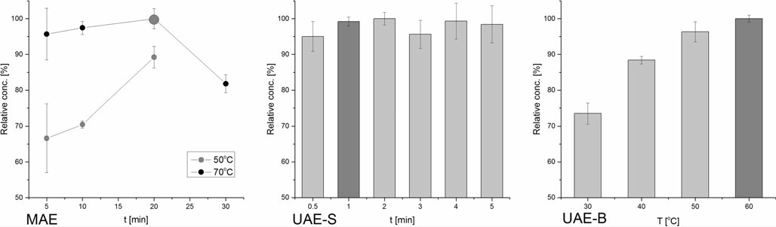
FoodAnal.Methods(2016)9:1246–1253
1249
Table1Identification of peaks inGC-MSrunaftern-hexaneand methanolMAEextraction(70°C, 10min)ofequalamountsofnut- meg sample. Thecompoundswere identified using NIST11database
LRIª
RelativeabundanceafterMAEextraction^{b}(%)
Retentiontime(min)
Compound
n-Hexane
Methanol
6.36
6.57
6.70
6.85
7.11
7.62
7.77
11.30–11.60
1467
1504
1540
1562
1618
1726
1757
Eugenol Methyleugenol Myristicin Elemicin Methoxyeugenol
MyristicacidmethylesterMyristicacid
Sterols
14
4
100
5
22
Notdetected 7
≤21
7
2
42
4
27
56
4
≤8
aLinearretentionindices(LRI)determinedexperimentallyforHP-5msGCcolumn,usingn-alkanesmixture
bExpressed as percentage of abundance of myristicin peak after extraction inn-hexane
SampleandSolventAmount,ChoiceofIS
samplewasneededinordertoassurethatthemyristicincon- centrationinextractwillnotfallbelowlinearityrange.
As unfortunately no deutered standard of myristicin was availableineconomicallyreasonablescale,non-deuteredsub- stancehadtobeconsidered.ThechoiceofISwasrestrictedby thepropertiesofMAEextractionmixture.Agroupofnatural volatile aroma substances, absent inM. fragransproducts, characterized by high logPvalues, was tested, including phenylethyl acetate, benzyl isobutyrate, methyl cinnamate andγ-octalactone. But onlyγ-octalactone concentration inn-hexane was not changed after MAE with water addition, andlater,it was also found to be stable in all optimized ex- tractionconditions.
The developed methods should be able to operate with low sampleamounts,butinsuchcase,theweightingofthesample introduce a significanterror.It was assumed that the lowest acceptableuncertaintyofsampleweightingis5%andforXA 220/Xanalyticalbalance,suchaccuracyisachievedforabout
3.7mgofsample.Forthisreason,thechosensampleamount used in the procedure was4.0±0.1mg.
Asitwasverifiedinthepreliminaryexperiments,atleast 7 mL of solvent is needed for even heating during theMAE procedure.Therefore,5mLofn-hexanewithISand2mLof ultrapurewaterwereusedtoformatwo-phaseextractionmix- ture. It was experimentally checked that the quantity ofmyristicin extractedtowater phasewasnegligible.Forultrasound-assisted extraction procedures, only 5 mL ofn- hexane with IS were found to be sufficient. Such approach limitsorganicsolventconsumptionanddisposalproduction; thus, it favours green chemistryprincipals.
Concentrationofmyristicinintheextractsfittedwellinthe calibration curve for most of the analysed nutmegs. Fortwo nutmegs with the lowest myristicin content,8.0±0.1mgof
Method Optimization
ForMAE,thebestresultswereobtainedfor20minextraction in70°C.Longerextractionprocessresultedinlossofanalyte, probably due to its decomposition (see Fig.1). Higher tem- peratureoftheprocessresultedinsubstantiallyhigherextrac- tionefficiency.In case of 5-min-long extraction, significant concentrationerrormaybecausedbyunevenheatdistribution
Fig.1RelativeconcentrationofmyristicinduringextractionmethodoptimizationforMAE,UAE-SandUAE-B(n=5).Theoptimalconditionswere highlighted

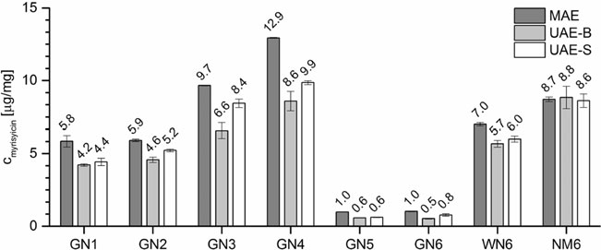
1250
FoodAnal.Methods(2016)9:1246–1253
Table2Valuesofvalidation parametersforthedeveloped extractionmethods
Repeatability(%)
Intermediate precision (%)
Recovery(%)
Conc.level
Conc.level
Standardaddition
Low
Mid
High
Low
Mid
High
+25 %
+50 %
+75 %
MAEUAE-S
UAE-B
4.9
5.2
4.3
5.9
7.4
7.2
3.7
5.9
4.3
9.7
9.7
7.4
7.9
7.3
7.7
8.3
8.0
8.3
97
103
105
104
105
107
102
109
107
insuchshorttime.ForUAE-S,themaximumconcentrationof myristicin was obtained after only 1 min of extraction. The average temperature of extraction mixture did not exceed 40 °C in any case, and therefore, boiling ofn-hexane was not observed; however, higher concentration error was ob- served for longer extraction times, possibly due to local overheating of the solvent, caused by cavitation.Lastly,the highestmyristicinconcentrationwasobtainedafterUAE-Bin 60°C.Highertemperaturecouldnotbetested,astheextrac- tionvesselswerenotdesignedtooperateatelevatedpressure caused by boilingn-hexane.
The completeness of extraction was also evaluated. The samples extracted in optimal conditions were subjected to subsequent extraction process with fresh extractingsolvent. No trace of myristicin was found in the secondary extracts, anditwasstatedthatthedevelopedextractionmethodsguar-antee maximum extractionefficiency.
Extracts obtained after optimized extraction procedures could be injected into the GC-MS systemdirectly,without diluting,andnopurificationwasneededotherthanfiltration through0.22μmPTFEsyringefilter.Onemayfindthisasthesuperiorityofthedeveloped methodsover otherones(DawidowiczandDybowski2012),especiallyineconomical and operational dimensions, as any additional SPEcleaning up was notnecessary.
ofacceptancewithin10%limit.Therecoverywasgoodfor each extractionmethod.
Thelinearityofthemethodswasbetween0.50and100μg mL⁻¹(corresponding to 0.625 and 125μg mg⁻¹in relationto4.0mgsample,testedonsevencalibrationpoints). Higherconcentrationwasnottestedasitcouldresultincol- umnoverloading.Theworkingrangeofcalibrationcurvewas from 0.50 to 20μg mL⁻¹(from 0.625 to 125μg mg⁻¹, five calibration points), andR²was between 0.998 and 1.000 throughentirevalidationprocess.CalculatedLODandLOQ
mL−1
values were 0.03 and 0.10μg
(0.0375 and
0.125μg mg⁻¹), respectively. It was assumed that such pa-
rametersaresuitableforanalysisofnaturalsamplesofnutmeg and mace in amount of 4 mg. The robustness of the method was tested in terms of a sample amount at 4, 8 and 20 mg, without changing the volume of extraction solution. It re- vealedthatthesemassesaresuitableforthemyristicindeter- minationinnutmeg;however,highermassmayrequireaddi- tion dilution of the extract beforeanalysis.
Analysis of Myristicin in Commercially Available Spices
Resultsofdeterminationofmyristicinincommerciallyavail- ablesamplesarepresentedinFig.2.Myristicinconcentration ranged from 0.6μg mg⁻¹(GN6, UAE-B) to 12.9μg mg⁻¹(GN4,MAE).
Concentrations of myristicin in mace sample determined byallthreedevelopedmethodsareconsistentwitheachother,and there is no statistically significant difference between UAE-S and UAE-B, as evaluated using Studentttest(α=95%).However,incaseofwholenutandpreviously
Method Validation
Repeatability,intermediateprecisionandrecoveryarelistedinTable2.Repeatabilityandintermediateprecisionfitstherange
Fig. 2Concentration of myristicin in nutmeg and mace frompopularspiceproducers(n=3)

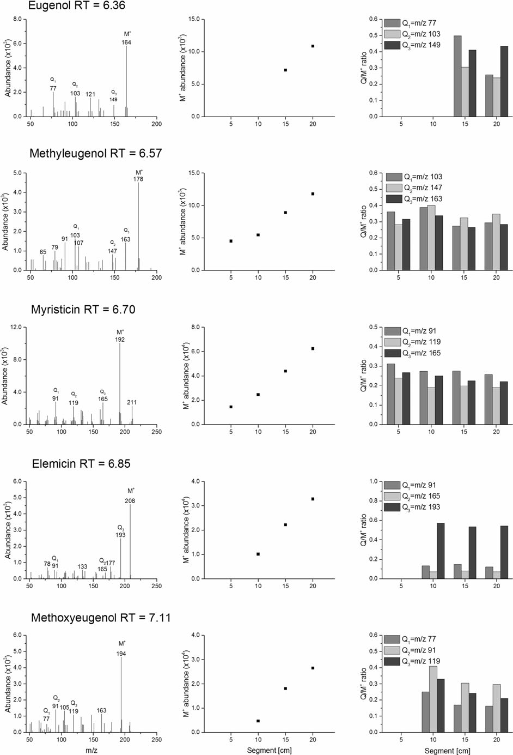
FoodAnal.Methods(2016)9:1246–1253
1251

1252
FoodAnal.Methods(2016)9:1246–1253
R
Fig. 3Analysis of residues of GN4 sample swabbed from plastic foil surface. Incolumns: mass spectra of identified distinct compound, recorded for the smallest swabbed surface enabling the identification; M⁺ion abundance in analysed extracts; Q/M⁺ratio for three ions
method can be used for detecting residues of nutmeg from surfacessuchasfoilbags,byidentifyingcharacteristicviolate substances in theextract.
groundednutmeg,thehighestconcentrationisobservedafter MAEandtheeffectisstatisticallysignificant(α=95%).Such relationisnotobservedincaseofmacesample(NM6).
Itwastheorizedthattheeffectdescribedaboveresultsfrom betterextractionefficiencyofMAEincaseofsamplesrichin wood constituents, such as cellulose, lignin and others. ThehypothesiswasverifiedbyanalysisofSEMimagesofgroundednutmegparticlesafterextraction(seeSupplementaryMaterial,section1).Indeed,investigationof SEM images revealed that MAE caused greater and deeper changes in nutmeg matrix structure than UAE techniques; therefore,itallowsbetterpenetrationoftheextractingsolvent andthusmoreeffectivemyristicinextraction.Theeffectisnot visibleformace,asitconsistsmostlyofnaturalgum,proteins and fats; hence, its structure is more elastic and disposed to breakdown duringextraction.
The results ofanalysis have given interesting insight into quality of spices available on the market in comparison to preferencesofpeopleabusingnutmeg.Itisacommonsense resultthatGNcontainslessmyristicinthanWNofthesameproducer,asitisvisibleparticularlyforproducerno.6;how-ever,additionallyitcanbeconcludedthatproducerno.6sells spices of generally lower quality than producers no. 1–4. MyristicinconcentrationfoundinGN4isclosetomaximum reportedconcentration(HallströmandThuvander1997),and onthisbasis,itcanbestatedthatGN4isahigh-qualityspice.Moreover,itwasnoticedthattheresultssomehowcorrespond with relations of people abusing nutmeg, published on the Internet (see Supplementary material, section 2), as nutmeg from producers 4, 3 and sometimes 2 are recommended for giving the best psychoactive effects. As psychoactivity of a nutmegcomesfromthemyristicincontent,thoserelationsare in good agreement with the presentedresults.
Conclusions
Inthisstudy,threeextractionmethodsutilizingMAE,UAE-S andUAE-Bweredevelopedandoptimizedfordetermination ofmyristicininnutmegandmace.Theproceduresarefastand simpleandrequirelowvolumeoforganicsolventandonly4–8mgofsample,andnoadditionalextracttreatmentisneeded. On the other hand, larger amount of sample can be used if needed,duetowiderangeoflinearityoftheGC-MSmethod, andthedevelopedmethodcanbescaledupto20mgofsam- ple.Themethodswerevalidatedwithgoodresults,provingto besuitableforanalysisofspices,althoughUAE-Swaschar- acterizedbylowerprecisionthanothermethods.Theanalysis ofnaturalsamplesshowsthatMAEtechniqueisthebestsuit- edoneforextractionofmyristicinfromnutmegandprobablyother samplesrichincelluloseandlignin. Analysisofmyristicin concentration in commercially available nutmeg revealedthatspicesrecommendedbynutmegabusersindeed containthehighestextentofmyristicin.Moreover,thedevel- opedMAE/GC-MStechniquewassuccessfullyusedforiden- tification of residues of groundednutmeg.
AcknowledgmentsThe authors gratefully acknowledge the MinistryofScienceandHigher Educationfor thefinancial support(M.Woźniakiewicz,Iuventus Plus 2015–2017, grant no. IP2014 052273). The research was carried out with equipment purchased thanks to the financial support of the European Regional Development Fund within theframeworkofthePolishInnovationEconomyOperationalProgram(contractno.POIG.02.01.00-12-023/08).The equipment has been used according to the contractpolicy.
Compliance with Ethical Standards
Conflict of InterestThe authors declare that they have no competing interests.
AnalysisofTraceAmountsofNutmegPowder
EthicalApprovalThisarticledoesnotcontainanystudieswithhuman participantsoranimalsperformedbyanyoftheauthors.
For both GN3 and GN4, identification of full MSspectrum, afterbackgroundsubtraction,waspossiblefor:myristicinandmethyleugenol—in samples takenfrom5cmsegment;elemicinandmethoxyeguenol—insamples takenfrom10cmsegment;andeugenol—insamplestakenfrom15cm segment(Fig.3).Myristicacidanditsmethylesterwerenot found.Theintensityofthemostabundantion(molecularion, M⁺,incaseofeveryanalysedcompound)andintensityratio of three subsequent ions (qualifier ions, Q) Q/M⁺has been assessed. The Q/M⁺intensity ratio is stabilizing for longer segmentsandisconsistentwithdatafoundinthemassspectra database(Fig.3).Itwasthereforeproventhatthedeveloped
InformedConsentInformedconsentisnotapplicableforthenatureof thisstudy.
OpenAccessThisarticleisdistributedunderthetermsoftheCreativeCommonsAttribution4.0InternationalLicense (http://creativecommons.org/licenses/by/4.0/),whichpermitsunrestricteduse, distribution, and reproduction in any medium, provided you giveappropriatecredittotheoriginalauthor(s)andthesource,providealink totheCreativeCommonslicense,andindicateifchangesweremade.

FoodAnal.Methods(2016)9:1246–1253
1253
Kiralan M, Bayrak A, AbdulazizOF,Ozbucak T (2012) Essential oilcompositionandantiradical activityof the oil of Iraqplants. Nat Prod Res 26:132–9. doi:10.1080/14786419.2010.535149
MachmudahS,SulaswattyA,SasakiMetal(2006)SupercriticalCO2extraction of nutmeg oil: experiments and modeling. J SupercritFluids 39:30–39.doi:10.1016/j.supflu.2006.01.007
PavlovićI,PetrovićS,RadenkovićMetal(2012)Composition,antimi-crobial, antiradical and spasmolytic activity of Ferula heuffelii Griseb.exHeuffel(Apiaceae)essentialoil.FoodChem130:310–315.doi:10.1016/j.foodchem.2011.07.043
PirasA,Rosa A,MarongiuB etal(2012) ExtractionandseparationofvolatileandfixedoilsfromseedsofMyristicafragransbysupercritical
References
Adam M, DobiásP,Eisner A,VenturaK (2009) Extraction of antioxi- dants from plants using ultrasonic methods and their antioxidantcapacity.J Sep Sci 32:288–94.doi:10.1002/jssc.200800543
CarstairsSD,CantrellFL(2011)Thespiceoflife:ananalysisofnutmeg exposures in California. ClinToxicol(Phila) 49:177–80. doi:10.3109/15563650.2011.561210
ChanC-H,YusoffR,NgohG-C,KungFW-L(2011)Microwave-assistedextractionsofactiveingredientsfromplants.JChromatogrA1218: 6213–25.doi:10.1016/j.chroma.2011.07.040
Choo L-C,WongS-M, Liew K-Y (1999) Essential oil of nutmeg peri- carp. J Sci Food Agric 79:1954–1957. doi:10.1002/(SICI)1097-0010(199910)79:13<1954::AID-JSFA460>3.0.CO;2-I
DawidowiczAL,DybowskiMP(2012)Determinationofmyristicinin commonlyspicesapplyingSPE/GC.FoodChemToxicol50:2362–7.doi:10.1016/j.fct.2012.04.013
Dhalwal K, Shinde VM, Mahadik KR (2007) Efficient and sensitivemethodforquantitative determinationandvalidationofumbelliferone,carvoneandmyristicininAnethumgraveolensand Carum carvi seed. Chromatographia 67:163–167. doi:10.1365/s10337-007-0473-6
EhrenpreisJE,DeslauriersC,LankP,etal(2014)Nutmegpoisonings:a retrospectivereviewof10yearsexperiencefromtheIllinoisPoison Center, 2001-2011. J MedToxicol13–16. doi:10.1007/s13181-013-0379-7
HallströmH,ThuvanderA(1997)Toxicologicalevaluationofmyristicin.
Nat Toxins 5:186–92. doi:10.1002/nt.3
Jerman KlenT,MozetičVodopivecB (2012) Optimisation of oliveoilphenolextraction conditionsusingahigh-powerprobeultrasonication. Food Chem 134:2481–8. doi:10.1016/j.foodchem.2012.04.096
CO :chemical compositionandcytotoxic activityonCaco-2 cancer
2
cells.JFood Sci77:C448–53.doi:10.1111/j.1750-3841.2012.02618.x
Sanz-Landaluze J, Bocanegra-Salazar M, Ortiz-Pérez D, Cámara C (2010)Miniaturisatedmethodfortheanalysisofpolycyclicaromat- ic hydrocarbons in leaf samples. J Chromatogr A 1217:3567–74.doi:10.1016/j.chroma.2010.03.049
SjöholmA,LindbergA,PersonneM(1998)Acutenutmegintoxication.JIntern Med243:329–31
SteinU,GreyerH,HentschelH(2001)Nutmeg(myristicin)poisoning—report on a fatal case and a series of cases recorded by a poisoninformation centre. Forensic Sci Int118:87–90
TorreJ, LorenzoMP,Martínez-AlcázarMP,Barbas C (2001) Simplehigh-performance liquid chromatography methodforalpha-tocopherolmeasurementinRosmarinusofficinalisleaves.Newdata onalpha-tocopherolcontent.JChromatogrA919:305–11.doi:10.1016/S0021-9673(01)00808-1
WuJ,LinL,ChauFT(2001)Ultrasound-assistedextractionofginseng saponins from ginseng roots and cultured ginseng cells. Ultrason Sonochem 8:347–52.doi:10.1016/S1350-4177(01)00066-9

