

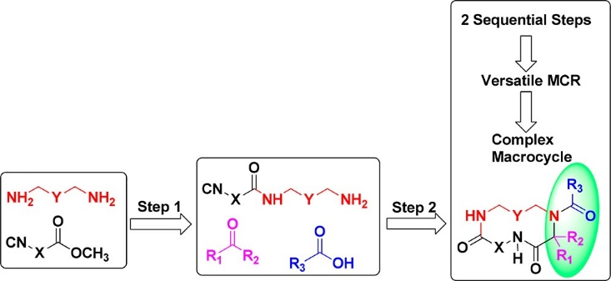

This is an open access article published under a Creative Commons Non-Commercial No Derivative Works (CC-BY-NC-ND) Attribution License, which permits copying and redistribution of the article, and creation of adaptations, all for non-commercial purposes.
Article
pubs.acs.org/joc
Cite This: J. Org. Chem. 2018, 83, 1441−1447
Two-Step Macrocycle Synthesis by Classical Ugi Reaction
Eman M. M. Abdelraheem,†,‡ Samad Khaksar,† Katarzyna Kurpiewska,§
Justyna Kalinowska-Tłusćik,§
Shabnam Shaabani,†
and Alexander Dömling*,†
†Department of Drug Design, University of Groningen, A. Deusinglaan 1, 9713 AV Groningen, The Netherlands
‡Chemistry Department, Faculty of Science, Sohag University, Sohag, 82524, Egypt
§Faculty of Chemistry, Jagiellonian University, Gronostajowa 2, 30-387 Krakow, Poland
*S Supporting Information
■
INTRODUCTION
realized, while the last three still deserve validation: α-isocyano- ω-carboxylic acids, α-carboxylic acid-ω-amines, α-isocyano-ω- amines, α-carboxylic acid-ω-aldehydes, α-isocyano-ω-aldehyde, and α-amino-ω-aldehydes. In light of our extended research interest in MCRs and our previous experience in the chemistry of macrocycles, herein we report the use of α-isocyano-ω-amine for the synthesis of macrocycles via the Ugi-macrocyclization
The Ugi four-component reaction (U-4CR) is a widely used multicomponent reaction (MCR) to provide a general route to diverse peptides, macrocycles, and other complex small molecules.1,2 This reaction has emerged as a powerful synthetic method for organic and pharmaceutical targets. Among MCRs, isocyanide-based multicomponent reactions (IMCRs) play an important role in pharmaceutical and drug discovery research3−7 and provide access to more diverse, complex, and novel scaﬀolds including small molecules and macrocycles. Macrocycles as intermediates between small molecules and biologics are useful to target ﬂat, large, and featureless protein− protein interfaces.8,9 Artiﬁcial macrocycles promise to provide better control over synthesizability and over their physico- chemical properties resulting in drug-like properties. However, there are only very few general and short synthetic routes toward macrocycles. Therefore, we report here such a general and short two-step synthesis of macrocycles using the Ugi reaction.
Macrocycles can be synthesized through MCRs by using bifunctional substrates. Failli et al. ﬁrst used N,C-unprotected tri- and hexapeptides to synthesize bioactive cyclic hexapep-
reaction.
■
RESULTS AND DISCUSSION
The ﬁrst step of our current work is an extension of our recent
report on using α-isocyano-ω-amines as building blocks in the cyclization reaction.16 We started our study by the synthesis of amino isocyanides via coupling of diamines with isocyanide esters under protecting group free conditions. Their synthesis and isolation is demanding due to the highly polar nature of α,ω-amino isocyanides. Therefore, various solvents such as chloroform, dichloromethane (DCM), methanol, water, tetrahydrofuran, ethanol, and triﬂuoroethanol were tested at room temperature (Table 1). Screening of diﬀerent solvents revealed that dioxane was the best solvent for this process. Puriﬁcation was performed by preparative column chromatog- raphy on silica (60−200 μm) using 1:1 dichloromethane:ethyl acetate as eluent A and ammonia in methanol 5% as eluent B in a gradient method. Under the optimized conditions, ten α- isocyano-ω-amines of diﬀerent lengths were synthesized from commercially available diamines in good purity and yields, each on a gram scale (Scheme 1).
tides.10 Wessjohann et materials to synthesize
al. used homobifunctional starting macrocycles using Ugi reactions.11
Yudin et al. introduced
formylaziridines as bifunctional Ugi
starting materials to synthesize spectacular macrocycles.12,13
Recently, Dömling et al. has shown the great impact of the direct use of bifunctional substrates such as α-isocyano-ω- carboxylic acids14 and α-carboxylic acid-ω-amines15 in macro- cycle synthesis via the Ugi reaction (Figure 1). Of all six possible permutations of bifunctional substrates for macro- cyclizations via the Ugi reaction, three have been already
Received: Published:
November 30, 2017
January 12, 2018
1441
© 2018 American Chemical Society
DOI: 10.1021/acs.joc.7b02984
J. Org. Chem. 2018, 83, 1441−1447
ABSTRACT: The direct nonpeptidic macrocycle synthesis of α-isocyano-ω-amines via the classical Ugi four-component reaction (U-4CR) is introduced. Herein an eﬃcient and ﬂexible two-step procedure to complex macrocycles is reported. In the ﬁrst step, the reaction between unprotected diamines and isocyanocarboxylic acids gives high diversity of unprecedented building blocks in high yield. In the next step, the α-isocyano-ω-amines undergo a U-4CR with high diversity of aldehydes and carboxylic acids in a one-pot procedure. This synthetic approach is short and eﬃcient and leads to a wide range of macrocycles with diﬀerent ring sizes.

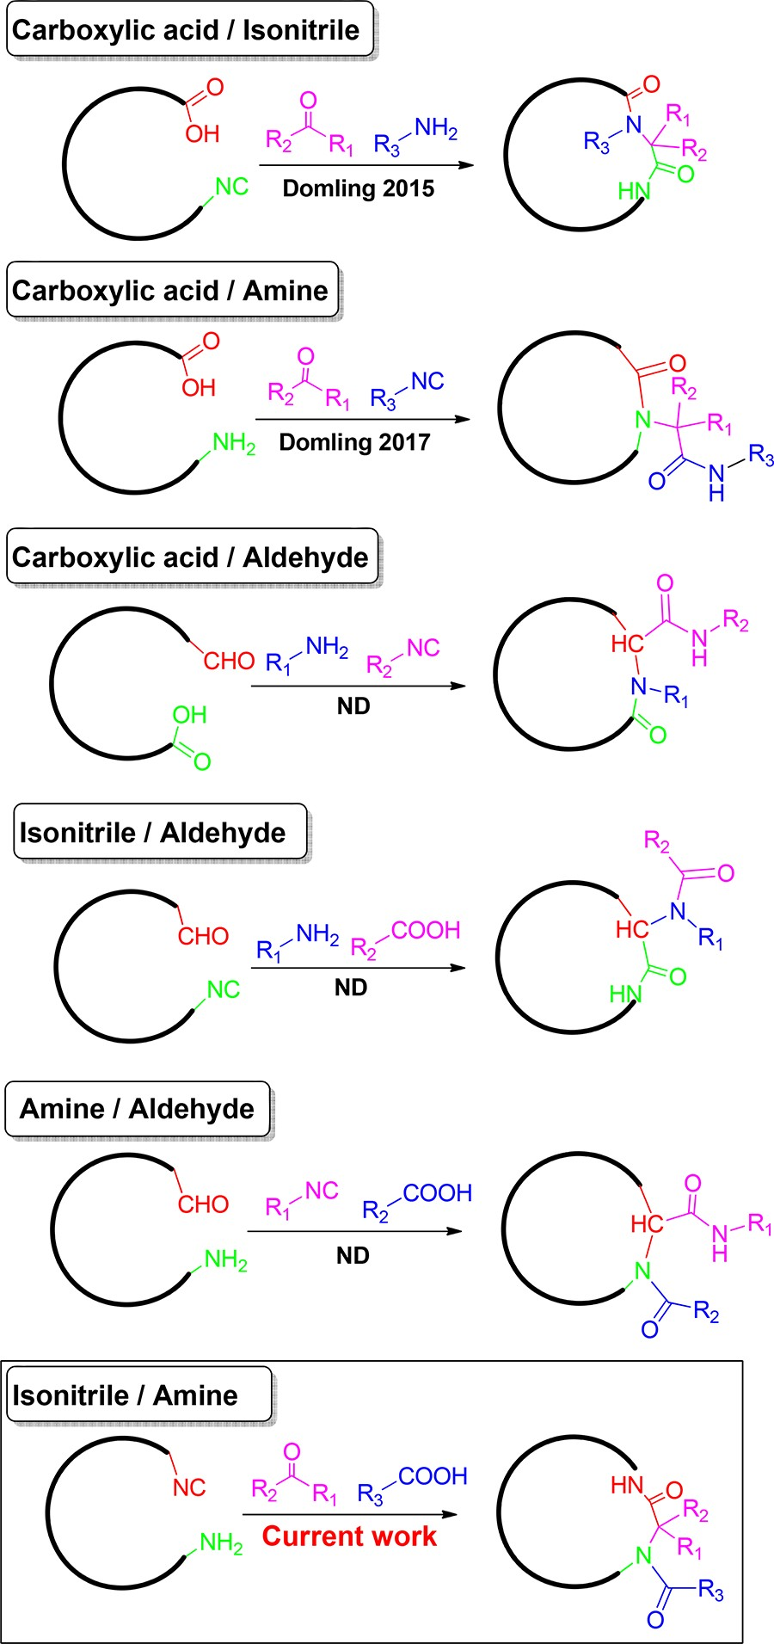
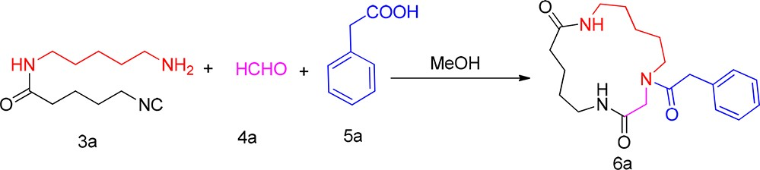
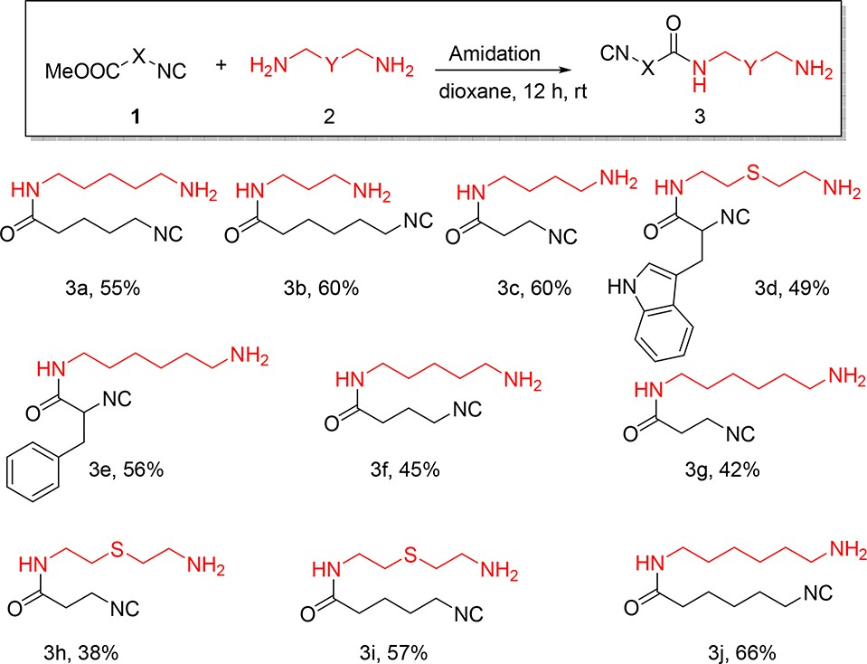
The Journal of Organic Chemistry
Article
Table 1. Optimization of Ugi-4CR
1
2
3
4
5
6
7b 8b 9
10
MeOH (1.0)
MeOH (0.1)
MeOH (0.01)
TFE (0.01)
CH3CN (0.01)
THF (0.01)
MeOH (0.01)
TFE (0.01)
MeOH (0.01)
MeOH (0.01)
12
12
12
12
12
12
12
12
24
12
rt rt rt rt rt rt
ZnCl2 ZnCl2 rt
sonication
traces 15
48
65
22
30
43
25
60
20
aThe reaction was carried out with N-(5-aminopentyl)-5-isocyano- pentanamide (1.0 mmol), paraformaldehyde (1.0 mmol), and 2- phenylacetic acid (1.0 mmol). b10 mol % catalyst used. cYield of isolated product.
Scheme 1. Synthesized α,ω-Amino Isocyanides with Corresponding Yields
Figure 1. Six theoretical possibilities for macrocycle synthesis by classical Ugi 4-CR.
(43%). Under sonication conditions, however, the reaction led to low yield of the product (Table 1).
With the optimized reaction conditions in hand, the scope and limitations of the Ugi-macrocyclization reaction were further investigated by synthesizing 15 diﬀerent macrocycles (12−17 membered ring size) which are shown in Scheme 2. In this reaction, several commercially available carboxylic acids, aliphatic and aromatic aldehydes, and ketones as oxo- components assemble to aﬀord macrocyclic derivatives in good yields of 33−74% after puriﬁcation by column chromatography. With aliphatic aldehydes, product was obtained in good yields, up to 50%; however, aliphatic carboxylic acids such as isobutyric acid, butyric acid, and pivalic acid resulted in only trace amounts of product.
To investigate potential intramolecular hydrogen bonds of our compounds, a sulfur-containing macrocycle was treated with m-chloroperbenzoic acid (mCPBA) in DCM to aﬀord sulfoxide and sulfone. As an example, the reaction of macrocycle 6m with 1 equiv and 4 equiv of mCPBA in DCM aﬀorded sulfoxide 7a and sulfone 7b in good yields of 65% and
DOI: 10.1021/acs.joc.7b02984
J. Org. Chem. 2018, 83, 1441−1447
In the next step, the macrocyclic ring closure was carried out by an U-4CR under optimized conditions using 1 equiv of an oxo component and an acid (Scheme 2). The optimization was performed by using N-(5-aminopentyl)-5-isocyanopentana- mide, paraformaldehyde, and 2-phenylacetic acid as a model reaction. The reaction did not proceed in 1.0 M methanol solution. The same reaction was carried out in diﬀerent dilutions of methanol, and it was found that a highly diluted
0.01 M equimolar mixture of reactants in methanol gives the 15-membered macrocycle 6a in good yields (60%). Although triﬂuoroethanol (65% yield) was slightly superior to MeOH, we chose MeOH for further scope and limitation studies due to the higher price of TFE. Polar aprotic solvents such as THF and CH3CN gave the product in moderate yields of 30% and 22%, respectively, at room temperature. Next, diﬀerent Lewis acids such as ZnCl2 in MeOH and TFE as a solvent were screened. It was found that ZnCl2 in MeOH aﬀords product in good yield
1442
entry solvent (M) time (h) catalyst/conditions yield (%)c

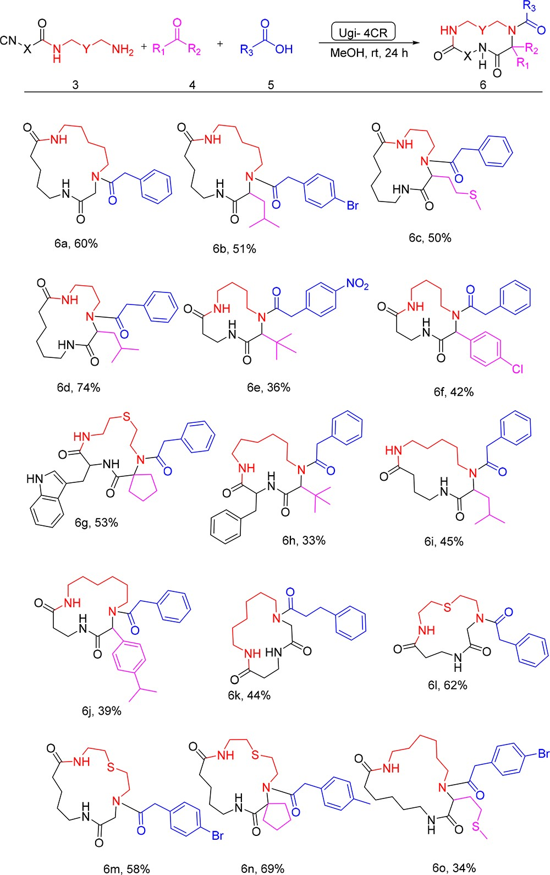
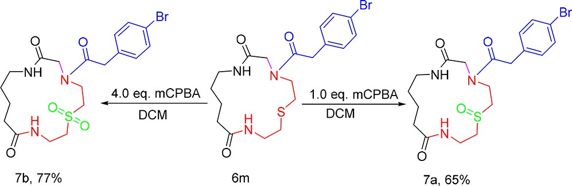
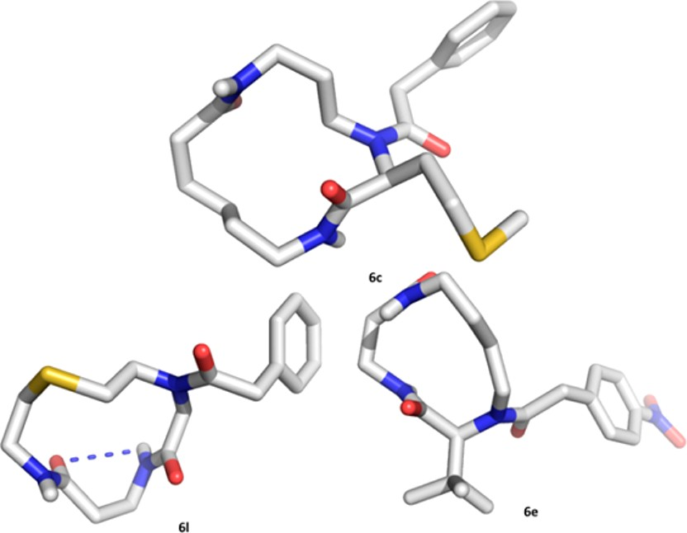
The Journal of Organic Chemistry
Article
Scheme 2. Synthesized Macrocycles with Corresponding Yields
Figure 2. X-ray crystal structure of some synthesized macrocyles.
Physicochemical properties are of high importance for the development of drug-like compounds. What is the property proﬁle of our macrocycles? To answer this question, we constructed a random virtual 1000 macrocycle library (SI). We calculated some properties of the library related to drug- likeliness including molecular weight, lipophilicity, number of hydrogen bond donors and acceptors, number of rotatable bonds, polar surface area, and moment of inertia (Figure 3). Interestingly, analysis of the library shows that 21% obey the Lipinski rule of 5 (RO5). The cLogP vs MW distribution of a considerable fraction of the chemical space is favorable drug- like with an average MW and cLogP of 572 and 4.1, respectively.
Moreover, punctual analysis of 3D modeled representatives and X-ray structures underline the nonﬂat shapes of the medium sized rings. Overall, a considerable fraction of our macrocyclic space is predicted to have drug-like properties. This is in accordance with the recent proposal that the chemical space from 500 to 1000 Da remains virtually unexplored and represents a vast opportunity for those prepared to venture into
new territories of drug discovery.17,18
■
77%, respectively, after 4 h. As shown in Scheme 3, these sulfoxide and sulfone functional groups are potentially capable
CONCLUSIONS
A very mild, straightforward, two-step, rapid, and highly diverse
macrocycle (12−17 membered) synthesis pathway via MCRs was introduced. In this strategy, macrocyclic ring closure was performed through Ugi-4CR to aﬀord novel complex compounds with potentially biological and pharmaceutical importance. Moreover, our strategy will allow a unique simple route for the synthesis of nonpeptidic macrocycles. Other macrocyclic scaﬀolds obtained from diﬀerent combinations of MCRs and their applications as inhibitors for protein−protein interactions are currently being investigated in our laboratory
Scheme 3. Selective Oxidative Modiﬁcations of a Sulfur- Containing Macrocycle
and will be reported shortly.
■
EXPERIMENTAL SECTION
General Methods. All chemicals were purchased from commercial
suppliers and used without any puriﬁcation unless otherwise noted.
to form amide−sulfoxide and amide−sulfone intramolecular hydrogen bonds leading to lower energy conformations of the corresponding macrocycles with interlocked structures which could have a signiﬁcant impact on biological membrane permeability.
X-ray crystal structures of several macrocycles with diﬀerent sizes and substituents can further provide some ﬁrst insight into possible solid-state conformations (Figure 2). For instance, compound 6l shows an intramolecular hydrogen bonding.
Nuclear magnetic resonance spectra were recorded. Chemical shifts for 1H NMR are reported as δ values, and coupling constants are in hertz (Hz). The following abbreviations are used for spin multiplicity: s = singlet, bs = broad singlet, d = doublet, t = triplet, q = quartet, quin = quintet, dd = double of doublets, ddd = double of doublet of doublets, m = multiplet. Chemical shifts for 13C NMR reported in ppm relative to the solvent peak. Thin layer chromatography was performed on silica gel plates (0.20 mm thick, particle size 25 μm). Flash chromatography was performed using RediSep Rf normal-phase silica

DOI: 10.1021/acs.joc.7b02984
J. Org. Chem. 2018, 83, 1441−1447
1443

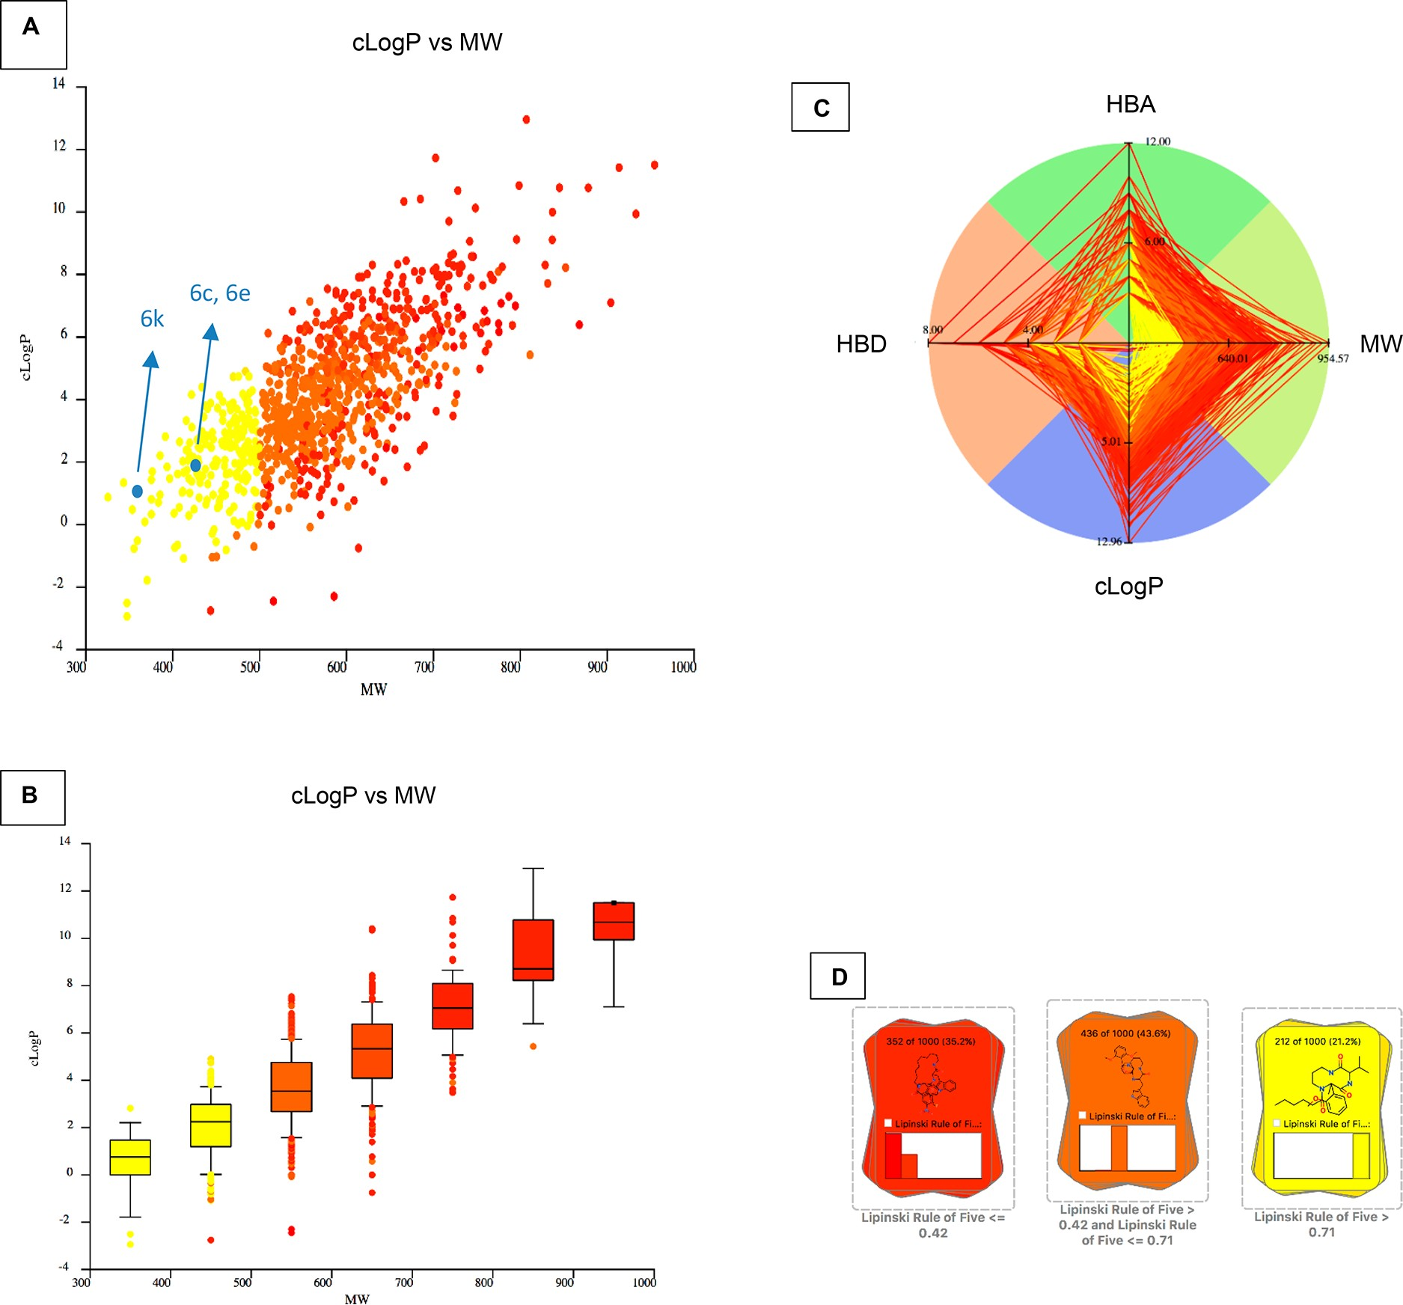
The Journal of Organic Chemistry
Article
Figure 3. Some calculated physicochemical properties of the chemical space of macrocycles. A: cLogP over MW scatter plot, B: cLogP over MW box plot, C: Lipinski RO5 radar plot, D: compound distribution based on Lipinski RO5.
ﬂash columns (silica gel 60 Å, 230−400 mesh). Electrospray ionization mass spectra (ESI-MS) were recorded.
Procedure and Analytical Data for Synthesis of α-Isocyano-ω- amine. A round-bottom ﬂask was charged with a magnet stirrer, the diamine (6.0 equiv), and the α-isocyano-ω-methyl ester (5.0 equiv), and 1,4-dioxane (0.1 M) was added. The reaction mixture was stirred
at room temperature overnight. The solvent was removed under reduced pressure, and the residue was puriﬁed by column chromatography on silica (eluent: 0−100% AB; A 1:1 mixture of EtOAc:DCM, B: methanol, next with C: methanol containing 5% concd aq ammonia, particle size: 40−63 μm).
N-(5-Aminopentyl)-5-isocyanopentanamide 3a. The product was obtained as an oil (55%, 0.580 g). 1H NMR (500 MHz, CDCl3) δ 6.58 (t, J = 5.8 Hz, 1H), 3.41−3.34 (m, 2H), 3.15 (q, J = 6.7 Hz, 2H), 2.65
(t, J = 7.1 Hz, 2H), 2.16 (t, J = 7.0 Hz, 2H), 1.74−1.61 (m, 4H), 1.49− 1.38 (m, 4H), 1.33−1.24 (m, 2H). 13C NMR (126 MHz, CDCl3) δ
172.3, 155.6, 41.4, 39.2, 35.2, 32.1, 29.2, 28.5, 24.0, 22.5. HRMS (ESI-
1.42 (m, 2H); 13C NMR (126 MHz, CDCl3) δ 172.8, 155.6, 50.2,
41.5, 39.8, 37.7, 36.3, 32.2, 28.8, 25.9.
N-(4-Aminobutyl)-3-isocyanopropanamide 3c.16 The product was obtained as an oil (60%, 0.464 g). NMR (500 MHz, CD3OD) δ 3.78 (t, J = 6.3 Hz, 2H), 3.26 (t, J = 6.5 Hz, 2H), 2.73 (t, J
= 6.5 Hz,, 2H), 2.66−2.51 (m, 2H), 1.64−1.51 (m, 4H); 13C NMR
(126 MHz, CD3OD) δ 171.6, 156.8, 42.0, 40.3, 39.1, 36.7, 30.3, 27.9.
N-(2-((2-Aminoethyl)thio)ethyl)-3-(1H-indol-3-yl)-2-isocyanopro- panamide 3d.16 The product was obtained as an oil (49%, 0.774 g). 1H NMR (500 MHz, CD3OD) δ 7.58 (d, J = 8.0 Hz, 1H), 7.36 (d, J =
8.0 Hz, 1H), 7.20 (s, 1H), 7.10 (t, J = 7.5 Hz, 1H), 7.04 (t, J = 7.5 Hz,
1H), 4.56 (t, J = 6.6 Hz, 1H), 3.40−3.35 (m, 2H), 3.32 (p, J = 1.6 Hz,
1H), 3.29−3.18 (m, 2H), 2.72 (t, J = 6.6 Hz, 2H), 2.51 (t, J = 6.6 Hz,
2H), 2.32 (t, J = 7.1 Hz, 2H); 13C NMR (126 MHz, methanol-d4) δ
167.1, 158.4, 136.6, 127.1, 123.9, 121.2, 118.6, 118.0, 111.0, 107.7,
58.3, 40.1, 39.1, 33.7, 29.7, 29.5.
N-(6-Aminohexyl)-2-isocyano-3-phenylpropanamide 3e.16 The product was obtained as an oil (56%, 0.764 g). NMR (500 MHz, CD3OD) δ 7.42−7.23 (m, 5H), 3.34 (t, J = 1.7 Hz, 1H), 3.28−
3.09 (m, 4H), 2.67 (t, J = 7.2 Hz, 2H), 1.57−1.41 (m, 4H), 1.40−1.31
(m, 4H); 13C NMR (126 MHz, CD3OD) δ 166.3, 158.7, 135.1, 129.1,
128.3, 127.1, 58.3, 40.9, 39.3, 38.9, 31.7, 28.7, 23.3.
1H
TOF) m/z: [M + H]+ Calcd for C H N O 212.1758; found
11 22 3
1H
212.1757.
N-(3-Aminopropyl)-6-isocyanohexanamide 3b.16 The product
1H
was obtained as an oil (60%, 0.591 g). NMR (500 MHz,
CDCl3) δ 6.62 (bs, 1H), 3.42−3.36 (m, 2H), 3.36−3.29 (m, 2H), 2.77
(t, J = 6.4 Hz, 2H), 2.18 (t, J = 7.5 Hz, 2H), 1.72−1.59 (m, 6H), 1.51−
1444
DOI: 10.1021/acs.joc.7b02984
J. Org. Chem. 2018, 83, 1441−1447

The Journal of Organic Chemistry
Article
N-(5-Aminopentyl)-4-isocyanobutanamide 3f. The product was obtained as an oil (45%, 0.443 g). 1H NMR (500 MHz, CD3OD) δ 3.60−3.53 (m, 1H), 3.37−3.32 (m, 1H), 3.23 (t, J = 7.0 Hz, 1H),
2.99−2.90 (m, 2H), 2.39 (t, J = 8.4, 6.4 Hz, 1H), 2.05−1.97 (m, 2H),
1.77−1.67 (m, 2H), 1.65−1.55 (m, 2H), 1.51−1.41 (m, 2H), 1.34 (t, J
= 7.1 Hz, 1H), 1.28 (td, J = 7.2, 1.7 Hz, 1H). 13C NMR (126 MHz,
CD3OD) δ 172.9, 154.9, 40.6, 39.3, 38.6, 32.0, 28.5, 27.0, 25.1, 23.4. HRMS (ESI-TOF) m/z: [M + H]+ Calcd for C10H20N3O 198.1601;
found 198.1600.
N-(6-Aminohexyl)-3-isocyanopropanamide 3g. The product was obtained as an oil (42%, 0.413 g). 1H NMR (500 MHz, CD3OD) δ 3.83−3.72 (m, 1H), 3.38 (s, 2H), 3.36−3.32 (m, 1H), 3.25 (t, J = 7.0
Hz, 1H), 2.67 (t, J = 7.1, 0.9 Hz, 2H), 2.63−2.55 (m, 1H), 1.62−1.47
(m, 4H), 1.40 (m, 4H). NMR (126 MHz, CD3OD) δ 170.0, 155.2, 41.0, 40.9, 39.0, 37.6, 35.1, 32.2, 32.1, 29.0. HRMS (ESI-TOF) m/z: [M + H]+ Calcd for C10H20N3O 198.1601; found 198.1599.
N-(2-((2-Aminoethyl)thio)ethyl)-3-isocyanopropanamide 3h. The
product was obtained as an oil (38%, 0.381 g). 1H NMR (500 MHz, CDCl3) δ 6.96 (t, J = 5.7 Hz, 1H), 3.73 (t, J = 6.7, 3.4 Hz, 2H), 3.51−
3.45 (m, 2H), 2.92−2.87 (m, 2H), 2.72−2.63 (m, 4H), 2.62−2.55 (m,
2H). 13C NMR (126 MHz, CDCl3) δ 168.5, 156.8, 41.0, 39.0, 37.9,
35.9, 35.7, 31.6. HRMS (ESI-TOF) m/z: [M + H]+ Calcd for C8H15N3OS 202.1009; found 202.1008.
N-(2-((2-Aminoethyl)thio)ethyl)-5-isocyanopentanamide 3i. The
product was obtained as an oil (57%, 0.652 g). 1H NMR (500 MHz, CDCl3) δ 6.52 (t, J = 5.6 Hz, 1H), 3.47−3.36 (m, 4H), 2.88 (t, J = 6.3
Hz, 2H), 2.71−2.58 (m, 4H), 2.23 (t, J = 7.0 Hz, 2H), 1.85−1.67 (m, 4H). 13C NMR (126 MHz, CDCl3) δ 172.2, 155.9, 41.4, 41.0, 38.7,
35.6, 35.2, 31.6, 28.5, 22.4. HRMS (ESI-TOF) m/z: [M + H]+ Calcd
for C10H20N3OS 230.1322; found 230.1320.
N-(6-Aminohexyl)-6-isocyanohexanamide 3j. The product was obtained as an oil (66%, 0.788 g). 1H NMR (500 MHz, CDCl3) δ 3.42 (tt, J = 6.6, 1.8 Hz, 1H), 3.22 (q, J = 6.7 Hz, 2H), 2.93−2.80 (m, 4H),
2.23 (t, J = 7.4 Hz, 1H), 1.76−1.58 (m, 6H), 1.57−1.44 (m, 5H),
1.43−1.35 (m, 5H). 13C NMR (126 MHz, CDCl3) δ 173.0, 155.4,
41.5, 41.1, 40.6, 39.3, 36.2, 31.3, 29.9, 28.8, 26.1, 26.0, 24.8, 24.5. HRMS (ESI-TOF) m/z: [M + H]+ Calcd for C13H26N3O 240.2070;
found 240.2069.
Procedure and Analytical Data for the Macrocyclization Reactions. α-Isocyano-ω-amine (1.0 mmol) and aldehyde (1.0 mmol) were stirred at room temperature in MeOH (10 mL) for 1
h. The reaction was diluted to (0.01 M, 100 mL), and then the carboxylic acid (1.0 mmol) was added. The mixture was stirred for 24
h. The solvent was removed under reduced pressure, and the residue was puriﬁed using ﬂash chromatography (DCM:MeOH (9:1)).
4-(2-Phenylacetyl)-1,4,10-triazacyclopentadecane-2,11-dione 6a. The product was obtained as a white solid (60%, 0.215 g, mp 164−166 °C); 1H NMR (500 MHz, CDCl3) δ 7.66 (t, J = 7.0 Hz,
1H), 7.39−7.26 (m, 5H), 6.41 (t, J = 6.3 Hz, 1H), 3.96 (s, 2H), 3.79
(s, 2H), 3.47 (t, J = 6.0 Hz, 2H), 3.28 (q, J = 7.0 Hz, 2H), 3.18 (q, J =
5.6 Hz, 2H), 2.24 (t, J = 7.1 Hz, 2H), 1.67−1.55 (m, 4H), 1.53−1.44 (m, 4H), 1.10 (q, J = 7.9 Hz, 2H). 13C NMR (126 MHz, CDCl3) δ 173.5, 172.9, 170.4, 134.5, 128.8, 128.8, 127.2, 53.0, 51.8, 40.8, 38.1,
36.8, 35.2, 28.7, 27.9, 27.8, 23.4, 23.1. HRMS (ESI-TOF) m/z: [M + H]+ Calcd for C20H30N3O3 360.2282; found 360.2281.
4-(2-(4-Bromophenyl)acetyl)-3-isobutyl-1,4,10-triazacyclopenta- decane-2,11-dione 6b. The product was obtained as a white solid (51%, 0.251 g, mp 170−172 °C); 1H NMR (500 MHz, CDCl3) δ 7.44 (d, J = 8.3 Hz, 2H), 7.09 (d, J = 8.4 Hz, 2H), 6.59 (t, J = 6.1 Hz, 1H),
4.72 (s, 1H), 3.70 (d, J = 3.9 Hz, 2H), 3.55 (s, 1H), 3.44 (s, 1H),
3.39−3.30 (m, 2H), 3.14−2.81 (m, 2H), 2.34−2.13 (m, 2H), 1.88−
1.75 (m, 1H), 1.74−1.33 (m, 10H), 1.23 (m, 2H), 0.89 (dd, J = 11.2,
6.6 Hz, 6H). 13C NMR (126 MHz, CDCl3) δ 173.5, 172.7, 172.1,
133.8, 131.8, 130.8, 121.1, 40.8, 40.7, 38.8, 36.9, 36.4, 35.1, 28.5, 28.0,
24.9, 24.4, 22.8, 22.7, 22.5. HRMS (ESI-TOF) m/z: [M + H]+ Calcd
for C24H37N3O3Br 494.2013; found 494.2011.
3-(2-(Methylthio)ethyl)-4-(2-phenylacetyl)-1,4,8-triazacyclotetra- decane-2,9-dione 6c. The product was obtained as a white solid (50%, 0.209 g, mp 183−185 °C); A mixture of rotamers is observed and the major of the rotamers taken ; 1H NMR (500 MHz, CDCl3) δ
7.46−7.29 (m, 3H), 7.29−7.20 (m, 2H), 6.10 (s, 1H), 4.85 (t, J = 7.3
Hz, 1H), 3.77 (s, 2H), 3.73−3.54 (m, 2H), 3.53−3.37 (m, 1H), 3.35−
3.20 (m, 1H), 3.18−2.96 (m, 2H), 2.57−2.34 (m, 3H), 2.34−2.21 (m,
2H), 2.12 (s, 3H), 2.08−1.92 (m, 2H), 1.86−1.58 (m, 3H), 1.45 (t, J =
11.1 Hz, 2H), 1.36−1.13 (m, 2H); 13C NMR (126 MHz, CDCl3) δ
173.6, 172.5, 170.7, 135.0, 129.3, 129.2, 127.5, 59.7, 53.4, 46.5, 41.9,
38.5, 37.8, 36.5, 31.2, 30.2, 29.4, 28.9, 24.2, 15.8. HRMS (ESI-TOF)
m/z: [M + H]+ Calcd for C22H34N3O3S 420.2315; found 420.2313.
3-Isobutyl-4-(2-phenylacetyl)-1,4,8-triazacyclotetradecane-2,9- dione 6d. The product was obtained as brown oil (74%, 0.296 g); 1H NMR (500 MHz, CDCl3) δ 7.42−7.37 (m, 2H), 7.36−7.31 (m, 3H), 6.32 (dd, J = 15.3, 8.5 Hz, 1H), 5.69 (t, J = 6.1 Hz, 1H), 5.24−5.17 (m,
1H), 3.73 (s, 2H), 3.33−3.24 (m, 4H), 3.13−3.02 (m, 2H), 2.18 (t, J =
7.5, 1.9 Hz, 2H), 1.71 (dd, J = 7.2, 5.8 Hz, 2H), 1.66−1.59 (m, 5H),
1.35−1.27 (m, 2H), 1.27−1.19 (m, 2H), 0.92 (dd, J = 8.2, 6.3 Hz,
6H).; NMR (126 MHz, CDCl3) δ 173.6, 170.9, 170.3, 133.6,
129.2, 128.9, 127.6, 73.0, 41.6, 40.8, 38.8, 36.4, 36.0, 35.8, 29.7, 28.9,
26.2, 25.1, 24.5, 23.1, 21.7. HRMS (ESI-TOF) m/z: [M + H]+ Calcd
for C23H36N3O3 402.2751; found 402.2750.
2-(tert-Butyl)-1-(2-(4-nitrophenyl)acetyl)-1,4,8-triazacyclodode- cane-3,7-dione 6e. The product was obtained as a white solid (36%, 0.150 g, mp 188−190 °C); 1H NMR (500 MHz, DMSO-d6) δ 8.29 (d, J = 8.2 Hz, 1H), 8.21−8.16 (m, 2H), 7.56−7.52 (m, 2H), 4.67 (s, 1H),
4.21−3.97 (m, 2H), 3.85−3.67 (m, 2H), 3.56 (dd, J = 15.2, 8.4 Hz,
1H), 3.18−2.93 (m, 2H), 2.85 (d, J = 13.4 Hz, 1H), 2.38−2.26 (m,
1H), 2.26−2.11 (m, 1H), 1.80−1.64 (m, 1H), 1.50−1.35 (m, 1H),
1.35−1.17 (m, 1H), 1.12 (d, J = 18.4 Hz, 1H), 1.10−1.02 (m, 1H),
0.89 (s, 9H). 13C NMR (126 MHz, DMSO-d6) δ 171.2, 171.0, 169.9,
146.7, 145.2, 131.5, 123.6, 37.9, 37.4, 37.3, 37.0, 36.9, 35.9, 28.2, 27.8,
27.1, 26.7. HRMS (ESI-TOF) m/z: [M + H]+ Calcd for C21H31N4O5
419.2289; found 419.2287.
2-(4-Chlorophenyl)-1-(2-phenylacetyl)-1,4,8-triazacyclodode- cane-3,7-dione 6f. The product was obtained as a yellow oil (42%, 0.179 g); 1H NMR (500 MHz, CDCl3) δ 8.66 (t, J = 5.2 Hz, 1H),
7.39−7.31 (m, 3H), 7.31−7.25 (m, 2H), 7.24−7.17 (m, 2H), 7.17−
7.04 (m, 1H), 6.37 (t, J = 6.6 Hz, 1H), 3.77 (s, 2H), 3.55−3.39 (m,
4H), 3.28−3.07 (m, 2H), 2.69−2.52 (m, 2H), 1.47 (q, J = 3.6 Hz,
4H). 13C NMR (126 MHz, CDCl3) δ 177.6, 174.9, 171.9, 134.9, 129.3,
128.8, 128.7, 128.5, 127.0, 63.5, 45.9, 44.2, 38.8, 38.1, 35.4, 26.4, 26.1,
25.3. HRMS (ESI-TOF) m/z: [M + H]+ Calcd for C23H27N3O3Cl 428.1735; found 428.1734.
14-((1H-Indol-3-yl)methyl)-6-(2-phenylacetyl)-9-thia-6,12,15- triazaspiro[4.11]hexadecane-13,16-dione 6g. The product was obtained as a yellow solid (53%, 0.274 g, mp 180−182 °C);1H NMR (500 MHz, CDCl3) δ 8.84 (d, J = 7.3 Hz, 1H), 8.18 (s, 1H),
7.66 (d, J = 7.9 Hz, 1H), 7.36 (s, 1H), 7.34 (d, J = 7.4 Hz, 2H), 7.29
(d, J = 2.6 Hz, 1H), 7.18 (t, J = 7.4 Hz, 3H), 7.15−7.10 (m, 2H), 6.79
(t, J = 6.0 Hz, 1H), 4.67−4.55 (m, 1H), 3.88 (s, 2H), 3.68 (s, 1H),
3.61−3.56 (m, 2H), 3.45 (dd, J = 15.0, 5.4 Hz, 1H), 3.24 (dd, J = 15.0,
8.9 Hz, 1H), 3.06−2.98 (m, 2H), 2.90−2.79 (m, 1H), 2.74−2.61 (m,
1H), 2.56−2.45 (m, 1H), 2.32−2.18 (m, 1H), 1.87−1.77 (m, 1H),
13C
13C
1.58−1.47 (m, 4H), 1.34−1.26 (m, 1H), 1.25−1.15 (m, 1H).
13C
NMR (126 MHz, CDCl3) δ 175.4, 173.8, 171.8, 136.3, 134.9, 129.4,
128.8, 128.7, 128.6, 127.3, 127.0, 123.2, 122.0, 119.4, 118.9, 111.1,
72.2, 54.9, 45.7, 43.7, 37.6, 37.2, 36.0, 35.5, 34.7, 26.2, 21.6, 21.0. HRMS (ESI-TOF) m/z: [M + H]+ Calcd for C29H35N4O3S 519.2424;
found 519.2424.
3-Benzyl-6-(tert-butyl)-7-(2-phenylacetyl)-1,4,7-triazacyclotride- cane-2,5-dione 6h. The product was obtained as a white oil (33%, 0.157 g); 1H NMR (500 MHz, CDCl3) δ 7.45−7.33 (m, 5H), 7.34−
7.21 (m, 3H), 4.75 (s, 1H), 3.99 (s, 2H), 3.68 (d, J = 5.2 Hz, 4H), 3.38
(s, 1H), 3.20−3.08 (m, 2H), 1.63−1.49 (m, 3H), 1.46−1.39 (m, 2H),
1.28 (d, J = 2.9 Hz, 1H), 1.24−1.20 (m, 3H), 1.15−1.09 (m, 4H), 1.07 (s, 9H). 13C NMR (126 MHz, CDCl3) δ 190.3, 183.6, 134.0, 129.0,
128.7, 127.6, 70.2, 52.0, 47.0, 40.7, 36.4, 35.7, 29.8, 28.6, 26.5, 26.4,
26.2, 26.2. HRMS (ESI-TOF) m/z: [M + H]+ Calcd for C29H40N3O3
478.2912; found 478.2912.
2-Isobutyl-1-(2-phenylacetyl)-1,4,9-triazacyclotetradecane-3,8- dione 6i. The product was obtained as a yellow oil (45%, 0.180 g); 1H NMR (500 MHz, CDCl3) δ 7.39−7.32 (m, 5H), 7.18 (d, J = 5.9 Hz,
DOI: 10.1021/acs.joc.7b02984
J. Org. Chem. 2018, 83, 1441−1447
1445

The Journal of Organic Chemistry
Article
1H), 1.84−1.71 (m, 3H), 1.60−1.43 (m, 7H), 1.41−1.23 (m, 7H).13C NMR (126 MHz, CDCl3) δ 173.0, 172.6, 171.1, 133.8, 131.9, 131.0,
121.1, 59.6, 46.5, 40.3, 39.4, 37.7, 36.2, 30.8, 29.7, 29.7, 28.8, 27.8,
26.7, 25.6, 25.0, 24.2, 15.4. HRMS (ESI-TOF) m/z: [M + H]+ Calcd
for C25H39N3O3SBr 540.1890; found 540.1890.
General Procedure and Analytical Data for the Synthesis of Sulfoxide Macrocycle. Macrocycle 6q (1.0 mmol) was dissolved in 1 mL of DCM, and m-chloroperoxybenzoic acid (1 equiv) was added. The solution stirred at room temperature for 4 h. After completion of
the reaction, the solvent was removed under reduced pressure and the residue was puriﬁed using ﬂash chromatography (DCM:MeOH (9:1)).
4-(2-(4-Bromophenyl)acetyl)-1-thia-4,7,13-triazacyclopentade- cane-6,12-dione 1-Oxide 7a. The product was obtained as a white
1H), 5.56 (t, J = 6.4 Hz, 1H), 4.26 (s, 1H), 3.83 (d, J = 5.9 Hz, 2H),
3.62−3.54 (m, 2H), 3.32 (q, J = 5.3 Hz, 2H), 3.18−3.11 (m, 1H),
3.07−2.99 (m, 1H), 2.43−2.34 (m, 1H), 2.26−2.19 (m, 1H), 2.15−
2.08 (m, 1H), 1.87 (t, J = 7.2 Hz, 2H), 1.81−1.74 (m, 1H), 1.53−1.48
(m, 2H), 1.46−1.42 (m, 1H), 1.37−1.32 (m, 1H), 1.29−1.26 (m, 1H),
1.23 (d, J = 6.0 Hz, 1H), 1.01 (t, J = 6.5 Hz, 1H), 0.90 (d, J = 6.2 Hz,
6H). 13C NMR (126 MHz, CDCl3) δ 173.2, 172.8, 172.4, 134.9, 128.9,
128.7, 127.0, 61.1, 48.9, 41.5, 40.7, 37.5, 37.2, 35.2, 29.1, 28.6, 25.0,
23.8, 23.1, 23.0, 22.1. HRMS (ESI-TOF) m/z: [M + H]+ Calcd for
C23H36N3O3 402.2751; found 402.2750.
2-(4-Isopropylphenyl)-1-(2-phenylacetyl)-1,4,8-triazacyclotetra- decane-3,7-dione 6j. The product was obtained as a white solid (39%, 0.180 g, mp 166−168 °C); 1H NMR (500 MHz, CDCl3) δ 7.40−7.29 (m, 3H), 7.28 (s, 1H), 7.24−7.12 (m, 5H), 6.65 (s, 1H), 5.60 (s, 1H),
3.93−3.60 (m, 4H), 3.62−3.39 (m, 3H), 3.28 (d, J = 51.2 Hz, 2H),
3.04−2.80 (m, 1H), 2.73−2.35 (m, 2H), 1.77−1.48 (m, 4H), 1.41 (s,
2H), 1.25 (d, J = 7.1 Hz, 6H), 1.23 (s, 2H). 13C NMR (126 MHz,
CDCl3) δ 172.8, 171.8, 171.0, 129.8, 129.2, 129.1, 128.9, 128.1, 127.3,
127.1, 126.9, 65.7, 49.8, 42.1, 39.8, 36.8, 36.0, 34.1, 29.0, 26.8, 26.5,
25.6, 24.2. HRMS (ESI-TOF) m/z: [M + H]+ Calcd for C28H38N3O3
464.2908; found 464.2906.
1-(3-Phenylpropanoyl)-1,4,8-triazacyclotetradecane-3,7-dione 6k. The product was obtained as a white solid (44%, 0.157 g, mp 177− 179 °C); 1H NMR (500 MHz, CDCl3) δ 7.34 (t, J = 7.5 Hz, 2H), 7.25 (q, J = 9.3, 7.9 Hz, 3H), 6.39 (t, J = 5.9 Hz, 1H), 4.01 (s, 2H), 3.54 (q,
J = 5.9 Hz, 2H), 3.39−3.29 (m, 4H), 3.02 (t, J = 7.8 Hz, 2H), 2.71 (t, J
= 7.9 Hz, 2H), 2.50 (t, J = 5.8 Hz, 2H), 1.63−1.51 (m, 4H), 1.44−1.36 (m, 2H), 1.28−1.20 (m, 2H). 13C NMR (126 MHz, CDCl3) δ 173.8, 170.9, 170.6, 141.0, 128.6, 128.5, 126.3, 52.3, 50.6, 39.3, 36.3, 35.6,
35.3, 31.2, 28.4, 26.7, 26.3, 25.5. HRMS (ESI-TOF) m/z: [M + H]+
Calcd for C20H30N3O3 360.2282; found 360.2279.
4-(2-Phenylacetyl)-1-thia-4,7,11-triazacyclotridecane-6,10-dione
6l. The product was obtained as a white solid (62%, 0.216 g, mp 173−
solid (65%, 0.264 g, mp 205−207 °C); NMR (500 MHz,
1H
methanol-d4) δ 7.36 (dd, J = 17.7, 8.0 Hz, 2H), 7.13 (d, J = 8.1 Hz,
1H), 7.06 (d, J = 8.0 Hz, 1H), 5.27−5.23 (m, 4H), 5.17 (s, 2H), 3.82
(s, 1H), 3.74 (s, 1H), 3.50 (d, J = 8.8 Hz, 2H), 3.23−3.14 (m, 5H),
2.18−2.05 (m, 2H), 1.59−1.33 (m, 4H). NMR (126 MHz,
methanol-d4) δ 173.1, 172.0, 168.6, 134.6, 133.2, 130.0, 126.6, 125.4,
118.8, 61.2, 54.5, 51.8, 51.7, 35.7, 35.4, 26.0, 22.0, 17.6. HRMS (ESI-
TOF) m/z: [M + H]+ Calcd for C19H27N3O4SBr 472.0900; found 472.0901.
General Procedure and Analytical Data for the Synthesis of Sulfone Macrocycle. Macrocycle 6q (1.0 mmol) was dissolved in 1 mL of DCM, and m-chloroperoxybenzoic acid (4 equiv) was added.
13C
The solution stirred at room temperature for 4 h. After completion of the reaction, the solvent was removed under reduced pressure and the residue was puriﬁed using ﬂash chromatography (DCM:MeOH (9:1)).
4-(2-(4-Bromophenyl)acetyl)-1-thia-4,7,13-triazacyclopentade- cane-6,12-dione 1,1-Dioxide 7b. The product was obtained as a white solid (77%, 0.375 g, mp 211−212 °C); 1H NMR (500 MHz, DMSO-
d6) δ 7.81 (d, J = 17.2 Hz, 1H), 7.65 (s, 1H), 7.35 (dd, J = 16.2, 7.9
Hz, 2H), 7.14 (d, J = 8.0 Hz, 1H), 7.04 (d, J = 8.0 Hz, 1H), 3.99 (d, J
= 22.7 Hz, 2H), 3.86−3.72 (m, 2H), 3.54 (d, J = 14.6 Hz, 3H), 3.38 (t,
J = 7.6 Hz, 1H), 3.30 (d, J = 7.7 Hz, 1H), 3.27−3.09 (m, 5H), 2.57−
2.51 (m, 1H), 2.12 (d, J = 7.3 Hz, 2H), 1.63−1.37 (m, 4H). 13C NMR
(126 MHz, DMSO-d6) δ 174.6, 172.5, 169.7, 140.1, 132.4, 132.1,
132.0, 125.0, 55.2, 54.9, 53.2, 52.9, 43.1, 40.6, 38.6, 36.0, 34.8, 29.4,
23.8. HRMS (ESI-TOF) m/z: [M + H]+ Calcd for C19H27N3O5SBr
174 °C); 1H NMR (500 MHz, DMSO-d ) δ 8.53−8.43 (m, 1H), 8.42
6
(d, J = 6.1 Hz, 1H), 7.35−
7.26 (m, 2H), 7.27−7.18 (m, 3H), 3.98 (s,
2H), 3.81 (s, 2H), 3.36−3.25 (m, 6H), 2.69 (m, 2H), 2.63−2.58 (m,
2H), 2.41 (t, J = 5.8 Hz, 2H). 13C NMR (126 MHz, DMSO-d6) δ
171.6, 170.9, 169.7, 136.5, 129.8, 128.6, 126.7, 52.4, 48.6, 42.6, 40.6,
36.2, 34.5, 30.8, 29.8. HRMS (ESI-TOF) m/z: [M + H]+ Calcd for
C17H24N3O3S 350.1533; found 350.1532.
4-(2-(4-Bromophenyl)acetyl)-1-thia-4,7,13-triazacyclopentade- cane-6,12-dione 6m. The product was obtained as a white solid (58%, 0.264 g, mp 196−198 °C); 1H NMR (500 MHz, CDCl3) δ 7.48−7.44 (m, 2H), 7.44−7.40 (m, 1H), 7.19−7.13 (m, 2H), 7.11 (d, J
= 8.2 Hz, 2H), 3.98 (s, 2H), 3.77 (s, 2H), 3.67 (t, J = 6.2 Hz, 2H), 3.57
(d, J = 3.4 Hz, 1H), 3.46−3.37 (m, 2H), 3.33−3.22 (m, 2H), 2.90 (t, J
= 6.2 Hz, 2H), 2.83−2.75 (m, 2H), 2.29 (t, J = 6.3 Hz, 2H), 1.67−1.57 (m, J = 5.7, 4.8 Hz, 4H). 13C NMR (126 MHz, CDCl3) δ 174.3, 172.3,
170.4, 133.3, 131.9, 130.8, 121.3, 53.1, 50.1, 40.0, 37.9, 36.7, 34.4, 31.4,
30.4, 27.8, 22.5. HRMS (ESI-TOF) m/z: [M + H]+ Calcd for C19H27N3O3SBr 456.0949; found 456.0949.
6-(2-(p-Tolyl)acetyl)-9-thia-6,12,18-triazaspiro[4.14]nonadecane- 13,19-dione 6n. The product was obtained as a yellow solid (69%, 0.307 g, mp 195−197 °C); 1H NMR (500 MHz, CDCl3) δ 8.16 (s,
1H), 7.12 (s, 4H), 6.66 (s, 1H), 3.76 (s, 2H), 3.67−3.56 (m, 2H),
3.48−3.36 (m, 2H), 3.32−3.18 (m, 2H), 2.79−2.61 (m, 6H), 2.31 (s,
3H), 2.21 (t, J = 7.2 Hz, 2H), 1.87−1.71 (m, 2H), 1.71−1.55 (m, 6H),
1.49 (dd, J = 7.8, 5.7 Hz, 2H). 13C NMR (126 MHz, CDCl3) δ 174.0,
173.3, 136.6, 131.5, 129.3, 128.5, 72.5, 45.9, 42.6, 39.9, 37.1, 36.0, 34.8,
31.9, 27.8, 22.5, 21.7, 20.9. HRMS (ESI-TOF) m/z: [M + H]+ Calcd
for C24H36N3O3S 446.2472; found 446.2471.
4-(2-(4-Bromophenyl)acetyl)-3-(2-(methylthio)ethyl)-1,4,11-tria- zacycloheptadecane-2,12-dione 6o. The product was obtained as a yellow oil (34%, 0.183 g). A mixture of rotamers was observed, and the major rotamer analyzed: 1H NMR (500 MHz, CDCl3) δ 7.53 (t, J = 8.8 Hz, 2H), 7.27 (dd, J = 7.9, 5.1 Hz, 2H), 7.20 (d, J = 8.2 Hz, 1H),
6.25 (s, 1H), 5.49 (t, J = 6.2 Hz, 1H), 4.96 (s, 1H), 3.85−3.77 (m,
1H), 3.73 (d, J = 15.1 Hz, 1H), 3.54−3.46 (m, 1H), 3.42−3.34 (m,
1H), 3.22−3.10 (m, 1H), 3.08−2.90 (m, 2H), 2.66−2.53 (m, 1H),
2.51−2.41 (m, 2H), 2.41−2.27 (m, 1H), 2.10 (s, 3H), 2.02−1.89 (m,
488.0849; found 488.0848.
■
ASSOCIATED CONTENT
*S Supporting Information
The Supporting Information is available free of charge on the ACS Publications website at DOI: 10.1021/acs.joc.7b02984.
NMR spectra, crystal structure determinations, and virtual library synthesis (PDF)
CIF data for 6c (CIF)
CIF data for 6e (CIF) CIF data for 6l (CIF)
■
AUTHOR INFORMATION
Corresponding Author
*E-mail: a.s.s.domling@rug.nl, www.drugdesign.nl.
ORCID
Eman M. M. Abdelraheem: 0000-0002-9008-2729
Justyna Kalinowska-Tłusćik: 0000-0001-7714-1651
Shabnam Shaabani: 0000-0001-5546-7140
Alexander Dömling: 0000-0002-9923-8873
Notes
The authors declare no competing ﬁnancial interest.
DOI: 10.1021/acs.joc.7b02984
J. Org. Chem. 2018, 83, 1441−1447
1446

The Journal of Organic Chemistry
Article
■
ACKNOWLEDGMENTS
The work was ﬁnancially supported by NIH 2R01GM097082- 05, the Innovative Medicines Initiative (grant agreement no.115489), and also European Union’s Seventh Framework Programme (FP7/2007-2013) and EFPIA companies’ in-kind contribution. Funding came also from the European Union’s Horizon 2020 research and innovation programme under MSC ITN “Accelerated Early Stage Drug Discovery” (no. 675555), CoFund ALERT (no. 665250). The work was supported by the European Regional Development Fund in the framework of the Polish Innovation Economy Operational Program (contract no. POIG.02.01.00-12-023/08). Eman M. M. Abdelraheem was supported by the Egyptian government.
■
REFERENCES
- Domling, A.; Ugi, I. Angew. Chem., Int. Ed. 2000, 39, 3168.
- Domling, A. Curr. Opin. Chem. Biol. 2002, 6, 306.
- Ruijter, E.; Scheffelaar, R.; Orru, R. V. A. Angew. Chem., Int. Ed.
2011, 50, 6234.
(4) Domling, A.; Wang, W.; Wang, K. Chem. Rev. 2012, 112, 3083.
- Koopmanschap, G.; Ruijter, E.; Orru, R. V. A. Beilstein J. Org. Chem. 2014, 10, 544.
- Sinha, M.K.; Khoury, K.; Herdtweck, E.; Domling, A. Org. Biomol. Chem. 2013, 11, 4792.
- Brauch, S.; van Berkel, S. S.; Westermann, B. Chem. Soc. Rev.
2013, 42, 4948.
- Marsault, E.; Peterson, M. L. J. Med. Chem. 2011, 54, 1961.
- Driggers, E. M.; Hale, S. P.; Lee, J.; Terrett, N. K. Nat. Rev. Drug Discovery 2008, 7, 608.
- Failli, A.; Immer, H.; Gotz, M. Can. J. Chem. 1979, 57, 3257.
- Wessjohann, L. A.; Voigt, B.; Rivera, D. G. Angew. Chem., Int. Ed.
2005, 44, 4785.
(12) Hili, R.; Rai, V.; Yudin, A. K. J. Am. Chem. Soc. 2010, 132, 2889.
- Jebrail, M. J.; Ng, A. H. C.; Rai, V.; Hili, R.; Yudin, A. K.; Wheeler, A. R. Angew. Chem., Int. Ed. 2010, 49, 8625.
- Liao, G. P.; Abdelraheem, E. M. M.; Neochoritis, C. G.; Kurpiewska, K.; Kalinowska-Tluscik, J.; McGowan, D. C.; Dömling, A. Org. Lett. 2015, 17, 4980.
- Madhavachary, R.; Abdelraheem, E. M. M.; Rossetti, A.; Twarda-Clapa, A.; Musielak, B.; Kurpiewska, K.; Kalinowska-Tłusćik, J.; Holak, T. A.; Dömling, A. Angew. Chem., Int. Ed. 2017, 56, 10725.
- Abdelraheem, E. M. M.; de Haan, M. P.; Patil, P.; Kurpiewska, K.; Kalinowska-Tłuscik, J.; Shaabani, S.; Domling, A. Org. Lett. 2017, 19, 5078.
- Matsson, P.; Kihlberg, J. J. Med. Chem. 2017, 60, 1662.
- Pye, C. R.; Hewitt, W. M.; Schwochert, J.; Haddad, T. D.; Townsend, C. E.; Etienne, L.; Lao, Y.; Limberakis, C.; Furukawa, A.; Mathiowetz, A. M.; Price, D. A.; Liras, S.; Lokey, R. S. J. J. Med. Chem. 2017, 60, 1665.
1447
DOI: 10.1021/acs.joc.7b02984
J. Org. Chem. 2018, 83, 1441−1447

