


Analytical and Bioanalytical Chemistry (2022) 414:6355-6370
https://doi.org/10.1007/s00216-022-04064-w
RESEARCH PAPER
A sustainable approach for the stability study of psychotropic
substances using vitreous humor and liver as alternative matrices
Anna Wojtowicz1 • Marcin Reciak1 • Paweł Mateusz Nowak1 • Renata Wietecha-Posłuszny1
Received: 28 January 2022 / Revised: 18 March 2022 / Accepted: 5 April 2022 / Published online: 5 May 2022
© The Author(s) 2022
Abstract
The stability of psychotropic substances representing various drug groups important from the perspective of forensic chem-
istry, including benzodiazepines, antidepressants, carbamazepine, cocaine, and their selected metabolites, was investigated
for 1 month in two alternative biological matrices, vitreous humor and liver homogenate. Three different thermal storage
conditions (-20, 4, and 20 °C) were tested. Liquid chromatography-mass spectrometry (LC-MS) analysis was preceded by
an effective solid-phase microextraction (SPME) procedure. The results were statistically analyzed using one-way ANOVA
to find significant concentration variations over time. The results obtained allowed for dividing the analytes into four groups:
stable under all tested conditions, only at -20 and 4 °C, only at 20 °C, and overall unstable. Nordiazepam, venlafaxine, and
cocaine and its metabolites turned out to be the most unstable substances, while fluoxetine showed the highest storage stability
in both matrices. The SPME/LC-MS method was comprehensively evaluated according to the principles of white analytical
chemistry (WAC), which reconcile the greenness and functionality of the method. A close to 100% whiteness score proves
its sustainability and suitability for the intended application.
Keywords SPME/LC-MS ■ Postmortem analysis ■ Vitreous humor ■ Liver ■ Green analytical chemistry ■ RGB model

Introduction
In forensic toxicology, it is very important to correctly determine
the concentration of primary xenobiotics as well as their metabo-
lites in the biological matrices available in a given case, that is,
both classical matrices, such as blood, and alternative ones, such
as vitreous humor or liver. The result of such analysis may play
an important role in determining how the crime occurred, find-
ing the suspect guilty, or, in the event of a fatal event, determin-
ing the cause of death [1]. However, the analysis is hampered
by the fact that the concentration of xenobiotics can change over
time after death, mainly due to the postmortem redistribution
[2] or degradation of the analyte in the samples [1]. Therefore,
for cadavers that have decomposed under different conditions
Published in the topical collection featuring Sustainability in
(Bio-)Analytical Chemistry.
* Renata Wietecha-Posłuszny
wietecha @ chemia. uj. edu.pl
1 Laboratory for Forensic Chemistry, Department
of Analytical Chemistry, Faculty of Chemistry, Jagiellonian
University, 2 Gronostajowa St., 30-387 Kraków, Poland
for different periods of time or in cases where autopsy samples
were analyzed for up to several days, the results of the toxico-
logical analysis may differ significantly from the concentration
of the analytes at the time of death [3]. Thus, it is important to
investigate the stability of various analytes in biological matri-
ces during storage under different conditions. Additionally, the
subject of stability studies should be the widest possible group of
compounds of various structures to obtain the broadest possible
information on the potential significance of this effect (stability)
for laboratory practice.
Blood is the most widely used biological matrix in foren-
sics. It can be easily obtained from humans, and thus many
protocols for its analysis have been developed. However, it
is susceptible to microbial growth and may undergo autoly-
sis or putrefaction, so in some cases, such as in advanced
decomposition of the cadaver, it may not be available [4].
In addition, there are reports of postmortem redistribution
of xenobiotics in blood. Barnhart et al. [5] showed that
the postmortem concentrations of methamphetamine and
amphetamine were higher in the cardiac blood than in the
heart muscle. Therefore, alternative matrices are sought.
One frequently used alternative biological matrix is
vitreous humor (VH). It is a gel-like tissue located in the

6356
Wójtowicz A. et al.
posterior chamber of the eye. Because of its location inside
the eyeball and isolation from the rest of the body by the
retina, VH is well protected against contamination and post-
mortem redistribution [6-8]. Our group recently reviewed
the contemporary trends in VH drug analysis for toxicologi-
cal and forensic purposes [9]. The VH matrix was found to
be more stable than the blood matrix, especially for heroin
metabolites [10] and gamma-hydroxybutyric acid (GHB)
[11]. In addition, the stability of drugs in VH was reported
to increase with a decrease in temperature and the addition
of preservatives such as NaF or KF [12, 13].
Another important alternative biological matrix in foren-
sic toxicology is the liver. The main functions of the liver
are the metabolism of xenobiotics, the excretion of bile, the
storage of vitamin reserves, and the production of various
proteins, e.g., albumins. Because of these functions, the con-
centration of analytes in the liver is generally higher than
that in blood, so the liver can be used successfully when
blood is not available [14]. Regarding the stability of ana-
lytes in the liver, Kiszka et al. [15] found that the rate of
cocaine decomposition in the liver is slower than that in
the blood at the same temperature. This was explained by a
greater decrease in enzyme activity in the liver, which may
be related to the influence of pH. Since liver tissue con-
tains more compounds that can cause acidity than blood, the
reduction in enzyme activity due to the decrease in pH will
be greater in this case [15].
Psychotropic substances (PS) most commonly found in
biological matrixes in forensic cases include drugs from the
groups of benzodiazepines [16-19], tricyclic antidepressants
(TCAs) [16, 20, 21], selective serotonin reuptake inhibitors
(SSRIs) [16, 21] and serotonin and norepinephrine reup-
take inhibitors (SNRIs) [16, 21], carbamazepine [22], and
numerous illicit drugs such as cocaine, opioids, and canna-
bis [23, 24]. A characteristic feature of all these substances
is their psychoactive effect. Due to the metabolism of sub-
stances introduced into the body, it is also very important to
detect the relevant metabolites in the examined tissues and
organs to determine the actual concentration of the primary
substances.
Reports on the stability of PS in alternative biological
matrices are still limited, usually focusing on single groups
of analytes [15, 17, 24] and/or relating to storage only at
low temperatures [13]. The stability of benzodiazepines was
studied in postmortem blood, bile, and VH samples stored at
different temperatures over 6 months. The benzodiazepine
concentration was shown to remain almost unchanged in
all samples stored at -20 and -80 °C. Furthermore, some
benzodiazepines were relatively stable for several weeks at
4 and 25 °C [17]. Another stability study by Holmgren et al.
[13], in addition to benzodiazepines, included drugs from
the group of antidepressants, analgesics, and hypnotics, and
was carried out on postmortem femoral blood and VH stored
for 1 year at -20 °C. Concentration changes were observed
only for seven substances: a decrease in the concentra-
tion of ethanol, desmethylmianserin, 7-amino-nitrazepam,
THC, and zopiclone, and an increase in the concentration
of ketobemidone and thioridazine. Regarding illicit drugs,
cocaine in VH was studied by Peres et al. [24] in terms of
short-term stability (room temperature, 24 h), freeze-thaw
stability (three cycles), and long-term stability (-20 °C, 7
and 30 days). VH samples were collected in vials containing
2% NaF. No degradation of the analyte was observed under
any of the tested conditions. Kiszka et al. [15] also studied
the stability of cocaine, but in four biological matrices of
blood, liver, kidney, and brain and at three temperatures of
25, 4, and -20 °C for 90 days. The study showed that freez-
ing tissues to -20 °C ensured the stability of cocaine practi-
cally throughout the duration of the experiment. In the case
of liver samples stored at 25 °C, approximately 70% of the
cocaine was degraded after 7 days. A slightly slower deg-
radation rate was observed at 4 °C: after 1 day, a reduction
by approximately one fourth of the initial concentration, an
average loss of 48% after 7 days, and 62% reduction in the
first month of storage [15].
As can be seen from the above examples, the stability
of the concentration of psychoactive drugs in alternative
biological matrices is not fully understood. In light of the
importance of the results of quantitative analysis in deter-
mining the cause of death, analytically proven methods
are needed for this purpose, including an effective stage
of sample preparation and the simultaneous determina-
tion of analytes with high sensitivity and precision using
a high-resolution separation technique. Other criteria are
also important to consider, such as practicality and com-
pliance with the idea of green analytical chemistry (GAC).
Therefore, this work focused on examining the stability of
the most popular and most important—from the perspec-
tive of forensic chemistry—psychotropic drugs, and their
few metabolites in two alternative matrices: VH and liver
homogenate (LH). Animal biological samples were applied
to use matrices with a confirmed lack of the tested analytes,
blank matrices to which drugs were added only at the stage
of sample preparation. In light of the complexity of the
matrix and the need to simultaneously analyze many struc-
turally diverse compounds, we used a previously developed
and verified method based on solid-phase microextraction
(SPME) in combination with liquid chromatography-mass
spectrometry (LC-MS) applied to blood samples. The qual-
ity of this approach compared to the available alternatives
was already demonstrated in our previous work [25]. The
current method was subjected to some modifications taking
into account the specifics of the biological matrices used as
an alternative to blood, and then validated and re-evaluated.
We applied the previously proposed 12 principles of white
analytical chemistry (WAC), which are an extension of the

A sustainable approach for the stability study of psychotropic substances using vitreous humor.
6357
known 12 principles of GAC. Besides greenness, WAC
includes “red” and “blue” criteria corresponding to the ana-
lytical and practical functionality of the method [25]. The
results showed that the applied method is fully sustainable,
i.e., reasonably green and fit for purpose in terms of other
important functional features.

Materials and methods
Chemicals and reagents
Standard solutions of the analytes alprazolam (ALP), citalo-
pram (CIT), diazepam (DIAZ), doxepin (DOX), flunitraze-
pam (FLUN), fluoxetine (FLUOX), carbamazepine (CARB),
cocaethylene (COCET), cocaine (COC), norcocaine (NOR-
COC), nordiazepam (NORDIAZ), nortriptyline (NORTR),
oxazepam (OXA), temazepam (TEM), and venlafaxine
(VEN) were purchased from Lipomed AG (Arlesheim,
Switzerland). Deuterated derivatives of the analytes alpra-
zolam-d5, diazepam-d5, flunitrazepam-d3, fluoxetine-d6,
carbamazepine-d10, nordiazepam-d5, oxazepam-d5, and
temazepam-d5, used as internal standards, were also pur-
chased from Lipomed AG (Arlesheim, Switzerland). The
selected number of 15 analytes, including six metabolites,
was considered sufficient given that it was a preliminary
study, and increasing the complexity of the method could
potentially cause selectivity problems.
High-purity LC-MS chromatographic solvents acetoni-
trile, methanol, isopropyl alcohol, and sodium hydroxide
obtained from Fluka Analytical (Seelze, Germany) were
used in the experiment. Analytical-grade solvents acetoni-
trile, methanol, isopropyl alcohol, sodium hydroxide, and
ammonium formate from Sigma-Aldrich (St. Louis, MO,
USA) and formic acid obtained from Merck (Darmstadt,
Germany) were also used. Deionized ultrapure water (18.2
M ^ ■ cm, TOC < 5 ppb) was obtained with the Milli-Q Plus
system (Millipore, Bedford, MA, USA).

LC-MS analysis
LC-MS analysis was performed using the UltiMate 3000
RS ultrahigh-performance liquid chromatography system
(UHPLC; Dionex, Sunnyvale, CA, USA) equipped with a
Hypersil GOLD Phenyl column (50 mm x 2.1 mm I.D.,
particles 1.9 ^m: Thermo Scientific, Bremen, Germany).
The chromatograph was coupled to a mass spectrometer
with an electrospray ionization source and a MicrOTOF-
Q II time-of-flight analyzer (Bruker, Bremen, Germany).
The detection was based on the intensity analysis of the
[M+H]+ ion signals in the range of approximately 237 to
337 m/z and the retention times of the analytes. The soft-
ware used in the LC-MS analysis included Chromeleon 6.8
(Dionex) and software provided by Bruker Daltonics: HyS-
tar 3.2, Data Analysis 4.0, QuantAnalysis 2.0, and Compass
IsotopePattern.
The parameters of the LC-MS method were selected on
the basis of the previous study by our laboratory [26]. Two
mobile phases were used. Phase A contained 0.1% formic
acid in ultrapure water and phase B was acetonitrile. The
phases were pumped at a flow rate of 0.3 mL/min at 35 °C.
The gradient elution program was used as follows: phase
B: 0 min, 15%; 4-7 min, 40%; 10 min, 70%; 12.5-17 min,
15%. Three injections were used for each sample. For the
MS parameters, positive ionization mode, capillary voltage
of 4.5 kV, nebulizer pressure of 2.5 bar, dry gas flow of 5.5
L/min, dry gas temperature of 200 °C, and mass range of
50-800 m/z were applied. Before each sequence, the mass
calibration of the cluster was performed using a 10 mM
sodium formate solution in a mixture of isopropanol and
water (1:1, v/v). Additionally, the calibration solution was
supplied to the MS throughout the entire run using a valve,
allowing the calibration solution to be injected before each
measurement.

Sample preparation
Biological samples
Postmortem bovine VH was collected from the eyes of
calves provided by a meat plant (Laskopol, Poland). The
VH samples were then centrifuged (14,000 rpm, 10 min)
using an Allegra X-30R centrifuge (Beckman Coulter,
Brea, CA, USA). The liver was purchased from a grocery
store and homogenized using a TEquipment SCILOGEX
D160 homogenizer (Boston, MA, USA) with the addition
of a saline solution (0.9% NaCl) in a 1:3 ratio for 1 min.
The supernatant was transferred to falcons and centrifuged
(14,000 rpm, 10 min).
Analyte standard solutions
Mixtures of PS and their deuterated derivatives (internal
standards, IS) were prepared from working standard solu-
tions in methanol at a concentration of 10 ^g/mL. The con-
centration of analytes in the PS and IS mixtures was 250 ng/
mL for each compound. The PS mixture contained a total of
15 analytes and the IS mixture contained eight analytes, as
not all deuterated derivatives were available.
Biological samples containing analytes for stability studies
For the preparation of biological samples containing ana-
lytes for stability studies, the appropriate amounts of the PS
mixture were evaporated in a concentrator (20 min, 45 °C);
then VH/LH was added and the samples were stored until

6358
Wójtowicz A. et al.
analysis under various conditions: at room temperature (20
°C), in the refrigerator (4 °C), and in the freezer (-20 °C).
The time points selected for the stability studies included 0,
1, 3, 6, 12, 18, and 30 days prior to measurement. One sam-
ple was prepared for each time point and conditions tested.
On the day of analysis, the appropriate amounts of the IS
mixture were evaporated, then the previously prepared bio-
logical sample containing PS was added and mixed. Subse-
quently, SPME extraction was performed. Two independent
SPME extractions were performed from each sample; two
200 ^L aliquots of each solution were collected. The con-
centration of PS and IS in each sample was constant and
equal to 50 ng/mL.
The samples for the calibration curves were prepared on
the day of measurement similarly to those for the stability
studies. PS concentrations in the samples used to prepare the
calibration curves were 2.5, 5, 10, 30, 50, 75, and 100 ng/
mL, while the IS concentration was kept constant at 50 ng/
mL. The samples for the calibration curves were analyzed
by taking only one portion of each solution for the SPME
procedure.
Because this was a preliminary study, only one analyte
concentration was tested, and, for comparison purposes, it
was the same for both biological matrices studied. Due to
the expected lower concentrations of the tested drugs, espe-
cially in the VH, a concentration of 50 ng/mL, in the middle
of the calibration curve (2.5-100 ng/mL), was selected for
the stability study.

SPME procedure
SPME-LC fiber probes (45 ^m C18-Silica; Merck, Darm-
stadt, Germany) were used for the microextraction. The
SPME procedure was derived from a previously published
study [26]. The extraction was performed manually. The
first step included conditioning of the SPME fibers. The
fibers were placed directly in vials containing a mixture of
methanol and water (1:1, v/v) and then shaken for 45 min
at 2200 rpm. In the next step, 200 ^L of biological samples
(for the stability studies or calibration curve) was pipetted
into inserts, which were placed in vials, and then the SPME
fibers were introduced. The vials were then shaken for 60
min to adsorb the analytes on the fibers. After the adsorp-
tion process, the fibers were cleaned by immersing them
in distilled water and shaking for approximately 10 s on a
vortex to remove any residual biological matrix. A mixture
of acetonitrile, methanol, and 0.1% formic acid (2:2:1. v/v/v)
was used for desorption; the desorption time was 30 min.
The solution obtained after desorption was evaporated in
a concentrator (20 min, 45 °C) and then the mobile phase
(50 ^L of 0.1% formic acid) was added. The samples were
then subjected to the LC-MS analysis. At the same time,
the SPME fibers were cleaned to allow reuse in subsequent
analyses. For this, they were shaken for 60 min in a solution
of methanol/water/isopropanol (2:2:1, v/v/v).

Results and discussion
SPME/LC-MS analysis
Calibration
Analyte concentrations in samples stored at different tem-
peratures were determined on the basis of the respective
calibration plots. Calibration curves were prepared by plot-
ting the ratio of the area under the peak for a given PS to the
area under the peak of the corresponding internal standard
(y-axis) as a function of the standard concentration (x-axis).
IS selected for the individual PS in VH and LH are presented
in Online Resource 1.
Calibration plots included seven levels of PS concen-
tration: 2.5, 5, 10, 30, 50, 75, and 100 ng/mL. The trend
line was fitted to the results obtained and its equation was
determined using the linear regression method in Microsoft
Excel. For each analyte, the value of the regression coef-
ficient (R2) was greater than 0.99 for VH and 0.98 for LH,
which proved the satisfactory linearity of the calibration
curves. Detailed data on the linearity of the respective sub-
stances can be found in Online Resource 2. Data on preci-
sion and accuracy determined at the concentration of 50 ng/
mL selected for the stability studies are presented in Table 1.

Method evaluation according to the principles
of WAC
The WAC concept is based on the red-green-blue color rep-
resentation model, which was first used to evaluate analytical
methods in 2019 [27]. It is an extension of the concept of the
“green” method by adding two additional primary colors:
red, denoting analytical performance, and blue, denoting
practical and economic efficiency. As a result, the final color
of the method depends on the extent to which the method
can be defined as red, green, and blue. At best, the method
is white, which signifies its completeness. In our last paper,
we presented the development of the RGB model by formu-
lating 12 WAC principles, divided into four red, four green,
and four blue principles. For that purpose, the previously
known 12 GAC principles were reduced to the four most
primary, independent green criteria. A detailed description
of the assumptions of the WAC concept and individual prin-
ciples is available in the original work [25].
As an example of using this model to compare many
alternative methods, several different analytical methods for
the determination of psychoactive compounds in biologi-
cal material were tested [25]. The best overall result turned


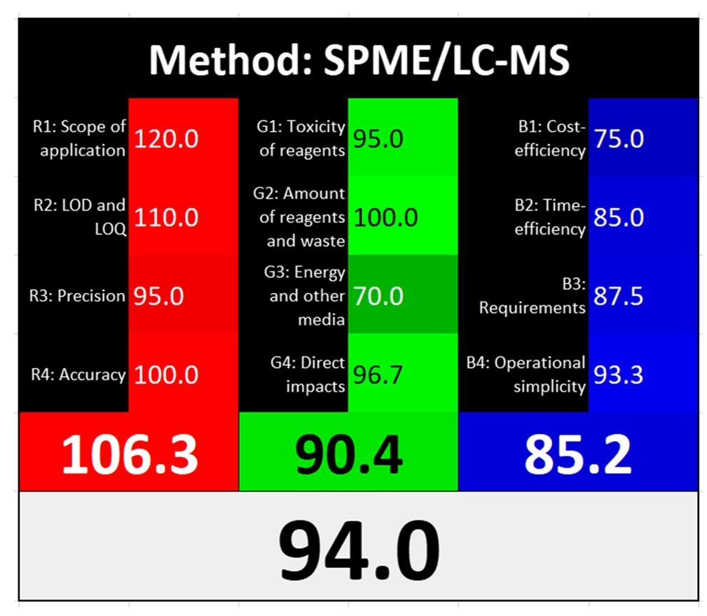
A sustainable approach for the stability study of psychotropic substances using vitreous humor.
6359
Table 1 Precision and
accuracy of the determination
of psychotropic substances in
VH and LH using the SPME/
LC-MS method
Vitreous humor
 | ALP | CIT | DIAZ | DOX | FLUN | FLUOX | CARB
Mean [ng/ml] | 53.33 | 45.60 | 46.47 | 46.60 | 52.36 | 45.61 | 44.32
SD [ng/mL] | 11.89 | 3.14 | 1.87 | 4.24 | 5.09 | 8.90 | 2.14
Precision CV [%] | 22.29 | 6.90 | 4.02 | 9.10 | 9.73 | 19.52 | 4.82
Accuracy [%] | 106.66 | 91.19 | 92.93 | 93.21 | 104.72 | 91.21 | 88.64
 | COCET | COC | NORCOC | NORDIAZ | NORTR | OXA | TEM | VEN
Mean [ng/ml] | 53.50 | 58.65 | 48.37 | 46.27 | 45.64 | 50.52 | 50.04 | 55.89
SD [ng/mL] | 8.04 | 1.85 | 6.76 | 2.48 | 9.93 | 7.25 | 6.99 | 3.16
Precision CV [%] | 15.02 | 3.15 | 13.97 | 5.37 | 21.75 | 14.36 | 13.96 | 5.65
Accuracy [%] | 107.00 | 117.31 | 96.74 | 92.55 | 91.27 | 101.05 | 100.09 | 111.78
Liver homogenate
 | ALP | CIT | DIAZ | DOX | FLUN | FLUOX | CARB
Mean [ng/ml] | 53.22 | 49.66 | 53.90 | 44.48 | 44.01 | 48.32 | 56.51
SD [ng/mL] | 7.18 | 6.81 | 5.90 | 5.50 | 5.83 | 3.14 | 2.22
Precision CV [%] | 13.50 | 13.71 | 10.95 | 12.36 | 13.25 | 6.50 | 3.94
Accuracy [%] | 106.45 | 99.33 | 107.81 | 88.96 | 88.03 | 96.64 | 113.02
 | COCET | COC | NORCOC | NORDIAZ | NORTR | OXA | TEM | VEN
Mean [ng/ml] | 49.14 | 51.76 | 45.01 | 49.72 | 53.16 | 45.81 | 48.08 | 55.42
SD [ng/mL] | 9.89 | 7.54 | 8.88 | 3.36 | 12.34 | 4.37 | 3.95 | 7.34
Precision CV [%] | 20.12 | 14.56 | 19.72 | 6.76 | 23.21 | 9.54 | 8.21 | 13.24
Accuracy [%] | 98.28 | 103.52 | 90.03 | 99.43 | 106.31 | 91.62 | 96.16 | 110.84

CV - coefficient of variation, SD - standard deviation, ALP - alprazolam, CIT - citalopram, DIAZ - diaz-
epam, DOX - doxepin, FLUN - flunitrazepam, FLUOX - fluoxetine, CARB - carbamazepine, COCET
- cocaethylene, COC - cocaine, NORCOC - norcocaine, NORDIAZ - nordiazepam, NORTR - nortriptyl-
ine, OXA - oxazepam, TEM - temazepam, VEN - venlafaxine
out to be SPME-LC/MS applied to blood samples, which
was characterized by a high degree of balance of the red,
green, and blue attributes. On this basis, this method was
selected for the experiment described in this paper, subject-
ing it to the necessary modifications taking into account a
larger number of analytes and a different type of matrix.
This required the introduction of an additional centrifugation
step during sample preparation. To determine to what extent
the applied modifications influenced the overall degree of
sustainability and overall effectiveness of the method, it was
critically reassessed against the scores previously assigned
to the individual 12 WAC principles for the original method.
A summary of the method assessment results is illustrated
in Fig. 1.
In the case of the red criteria, only the precision assess-
ment was changed from 100 to 95, as upon validation the
obtained relative standard deviation (RSD) values for the
determination of analytes in VH and LH were slightly higher
in total. In the case of the scope of application, the pre-
vious score was left unchanged, as the greater number of
analytes increasing the usability of the method was com-
pensated for by the lower linearity range. In the case of the
limit of detection/limit of quantification (LOD/LOQ), the
values improved; however, it should be borne in mind that
Fig. 1 A summary of the assessment results obtained for the applied
method according to the 12 principles of WAC (a detailed algorithm
description is presented in the original work [25]). The values 106.3,
90.4, and 85.2 represent the average scores associated with the red,
green, and blue criteria, respectively; 94.0 is the average total score
including all 12 rules
Ö Springer

6360
Wójtowicz A. et al.
in the case of VH and LH, taking into account the specificity
of drug distribution and metabolism, lower concentrations
should be expected, so at the same time, the requirements
for LOD/LOQ are increasing for this type of samples. There-
fore, the score remained unchanged. The accuracy expressed
by recovery was similar for both methods; therefore, the
assessment also remained unchanged.
For the green criteria, the toxicity of the reagents and
the total amount of waste were evaluated in the same man-
ner for both methods. However, the assessment of energy
consumption changed from 75 to 70, due to the use of an
additional centrifugation step. At the same time, a smaller
number of harmful factors were identified—the remaining
noise (resulting from the loud sound of the mass spectrom-
eter) and solvent vapors (the bottles with the mobile phase
were not isolated from the operator)—while the potential
hazard resulting from working with human blood disap-
peared. Taking into account the fact that neither animals
nor genetically modified organisms (GMOs) were used, the
final score of the principle of direct impacts increased from
95 to 96.7 (a detailed algorithm for calculating points was
described in the original paper [25]).
When considering the blueness, i.e., the practical and
economic criteria, all parameters deteriorated slightly.
The new method turned out to be a bit more expen-
sive (change from 80 to 75), less time-efficient due to
the additional centrifugation step (change from 90 to
85), requiring more laboratory infrastructure (centri-
fuge; change from 90 to 87.5), and also characterized by
slightly worse operational simplicity (automation, port-
ability; change from 100 to 93.3).
As can be seen from Fig. 1, the average assessment
score of the red criteria remained very high, above 100,
clearly indicating that from an analytical point of view,
the choice of this method for the present experiment is
beyond any doubt. The greenness of the method is rated
lower, but it still exceeds 90, and this is largely due to the
energy consumption of the method associated with the
selection of advanced research instruments, mainly the
mass spectrometer. However, given the analytical ben-
efits offered, this decision seems justified. The practical
aspects were assessed overall above 85, which is still a
good result, also stemming from the advanced instrumen-
tal techniques used, which seem adequate for this pur-
pose. The final whiteness index of the method is high,
94%, which indicates unambiguous appropriateness of
the method and its high degree of balance of opposing
attributes. This proves its true sustainability. The objec-
tivity of this statement is supported by the reference to
the other methods evaluated in the previous work [25],
against which the procedure discussed here still looks the
best overall. The key in this respect is the choice of an
effective extraction method, a high-resolution separation
method, and a sensitive detector, which are also reason-
ably good in terms of eco-friendliness and practicality
compared to alternative techniques [25].

Concentration changes
Concentration versus storage day plots
The values determined for the concentrations of indi-
vidual PS in the consecutive days of storage, including
the error value as +/- standard deviation, are graphically
presented in Figs 2a and b for VH and LH, respectively.
Each bar represents the concentration of the respective
analyte obtained at a given temperature after the speci-
fied storage time (in days). It should be noted that some
results were rejected and thus not included in the graphs
due to strongly deviating concentration values. This was
the case for FLUOX on day 3, COCET on day 3 at -20
°C, DOX on day 3 at 4 °C, and FLUN on day 30 at 4
°C in VH, and for CIT on day 30 at 20 °C, FLUOX on
day 30 at 20 °C, FLUN from 6 to 30 days at 20 °C, and
DIAZ on day 30 and DOX on day 6 in LH. The rejected
results were characterized by concentration values that
clearly exceeded the assumed value of 50 ng/mL, which
could have resulted from some random errors in the sam-
ple preparation stage or could be related to errors in the
internal standard method.
In general, it can be observed that during 1 month of
storage, a temperature of -20 °C ensured the stability of
most PS in VH. However, storage at 4 and 20 °C resulted
in a significant drop in most PS concentrations, which was
the fastest and led to the largest decrease in concentration
after 1 month for COC and its two metabolites, NORCOC
and COCET.
Based on the results obtained for LH, it can first be
seen that fewer PS than in VH were stable when stored
even at the lowest temperature of -20 °C. After only 24
h, a significant decrease in the concentration of COC and
its metabolites was observed at all storage temperatures
tested. A clear decrease in concentration after 12 days was
also observed for DIAZ, NORDIAZ, and VEN. Higher
storage temperatures, as in VH, further reduced the stabil-
ity of PS in this matrix, such as CIT, OXA, and TEM, for
which the concentration dropped significantly at 20 °C.
To evaluate the statistical significance of the observed
concentration changes over time, a one-way analysis of vari-
ance (ANOVA) with temperature as a factor was performed
in the next step.
One-way ANOVA
A one-way ANOVA was performed on the basis of the con-
centrations of individual analytes on consecutive days of
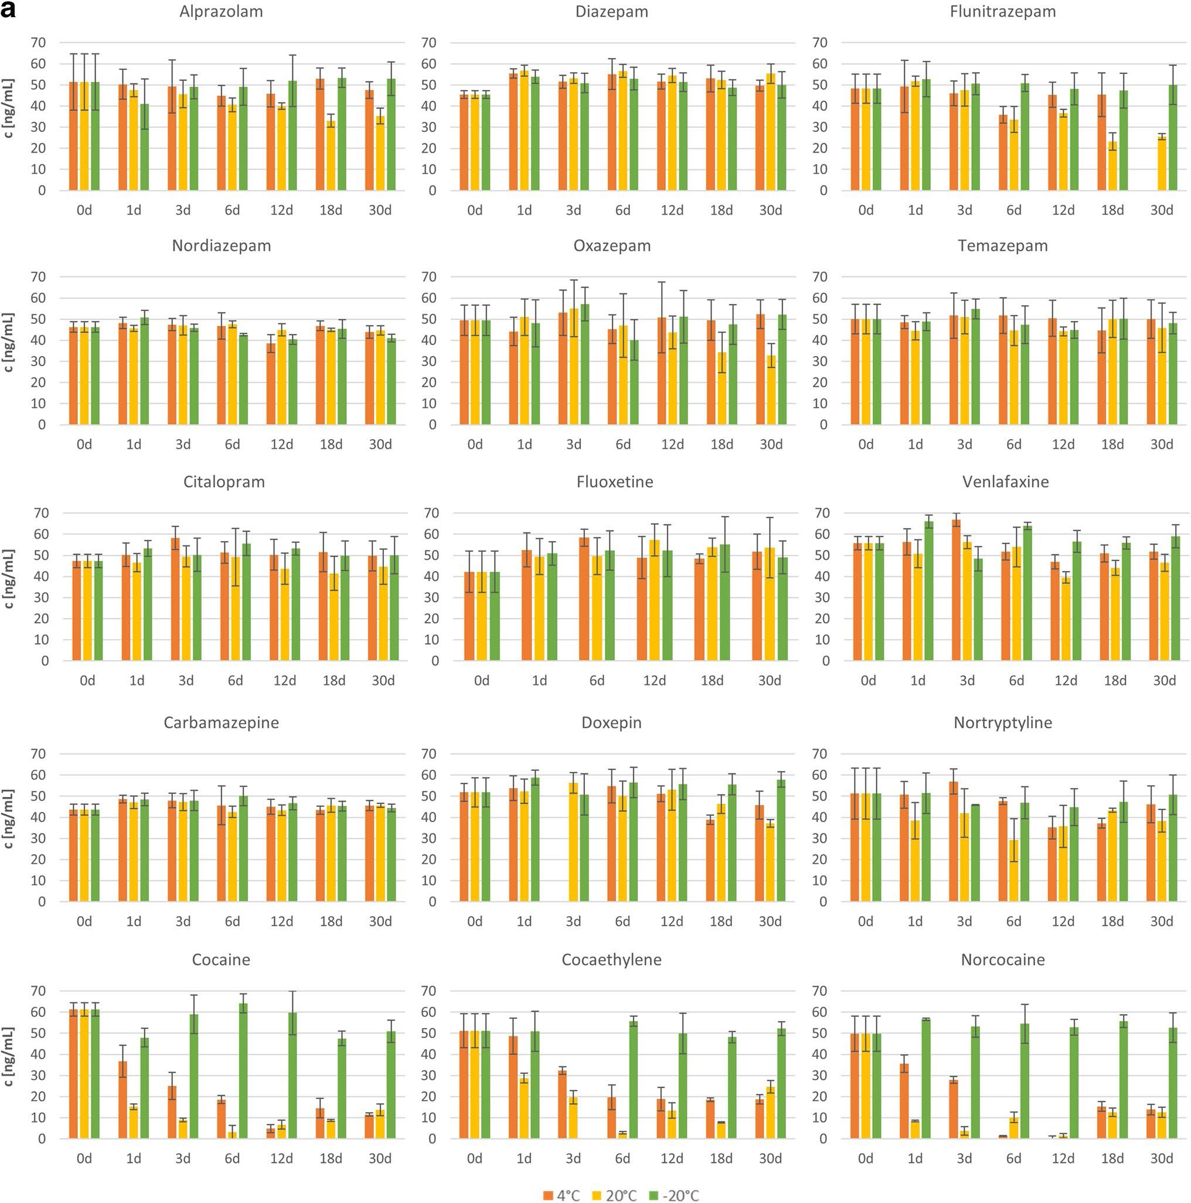
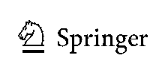
A sustainable approach for the stability study of psychotropic substances using vitreous humor.
6361
Fig. 2 a Changes in the concentrations of individual psychotropic
substances in VH on consecutive days of storage for 1 month at the
three tested temperatures. b Changes in the concentrations of individ-
ual psychotropic substances in LH on consecutive days of storage for
1 month at the three tested temperatures
storage at a given temperature, selecting the day of storage
as a qualitative factor. The null hypothesis tested was the
following:
H0: Storage day does not affect PS concentration.
Thus, the alternative hypothesis was:
HA: Storage day affects PS concentration.
Therefore, it was checked whether the differences in the
average PS concentration over time were statistically signifi-
cant and the PS could be considered stable (H0 acceptance) or
unstable (H0 rejection) under given conditions. The calcula-
tions were performed in Statistica software, where the values
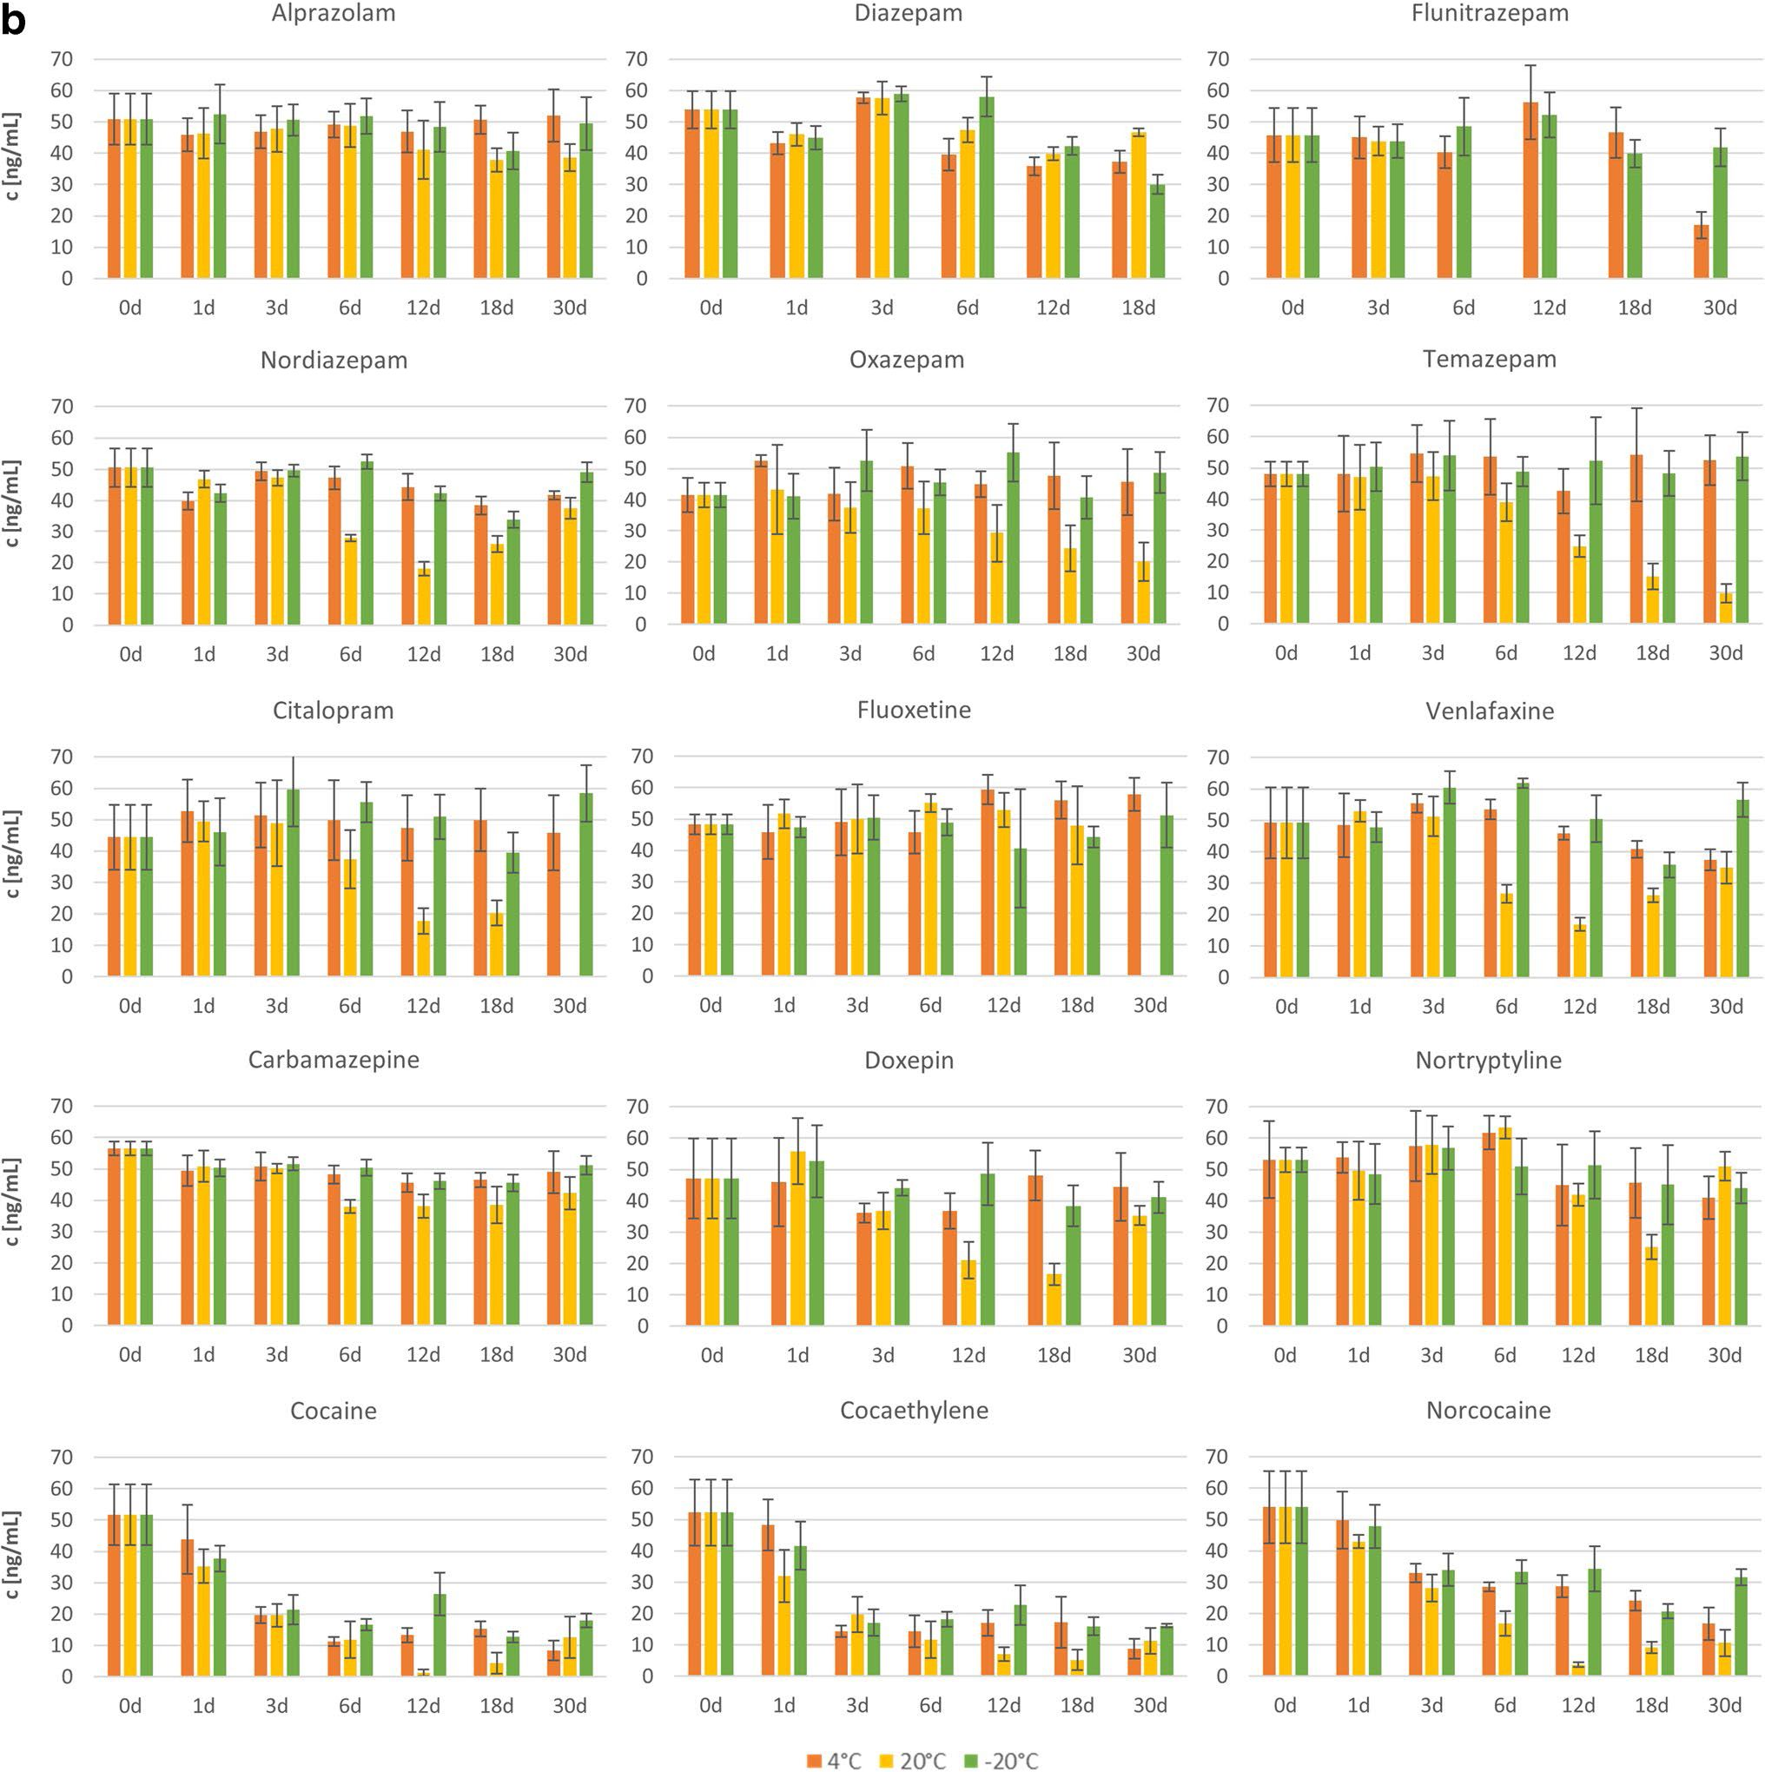

6362
Wójtowicz A. et al.
Fig. 2 (continued)
of the F-statistic (F-value) and probability (p-value) were
determined. The adopted significance level was 0.05 (a). If the
F-value was greater than the value read from the F-distribution
table for a = 0.05 and a given number of degrees of freedom
(df = n - 1, where n is the number of trials), or the p-value
was less than 0.05, the null hypothesis was rejected in favor of
accepting the alternative hypothesis at the adopted significance
level of 95%.
The ANOVA results obtained for each PS in both biologi-
cal matrices tested are summarized in Table 2. The ANOVA
results for the concentration changes are discussed below
separately for each analyte tested.

ALP
No grounds were found to reject the null hypothesis for this
analyte when stored at temperatures of -20 and 4 °C in
either matrix. However, at a temperature of 20 °C, a decrease
in concentration was observed after about 6 days. Therefore,

A sustainable approach for the stability study of psychotropic substances using vitreous humor.
6363
Table 2 One-way ANOVA results obtained for VH and LH
Storage  temp. [°C] | Vitreous humor |  |  |  |  |  | Liver homogenate
SS | df | MS | F | P | H0 rejected  Yes/No? | SS | df | MS | F | P | H0 rejected  Ye0s/No?
Alprazolam  20 | 1109.6 | 6 | 184.9 | 5.564 | 0.00073 | Yes | 1476.9 | 6 | 246.1 | 3.246 | 0.01212 | Yes
4 | 265.8 | 6 | 44.3 | 0.6048 | 0.72392 | No | 412.8 | 6 | 68.8 | 1.254 | 0.30438 | No
-20 | 156.1 | 6 | 26.0 | 0.1997 | 0.97386 | No | 981.5 | 6 | 163.6 | 2.327 | 0.05384 | No
Carbamazepine  20 100.5 |  | 6 | 16.8 | 1.994 | 0.10161 | No | 2217.0 | 6 | 369.5 | 23.432 | 0.00000 | Yes
4 | 116.0 | 6 | 19.3 | 0.928 | 0.48892 | No | 494 | 6 | 82.3 | 4.789 | 0.00123 | Yes
-20 | 185.6 | 6 | 30.9 | 2.935 | 0.02315 | Yes | 495.8 | 6 | 82.6 | 12.62 | 0.00000 | Yes
Citalopram  20 | 271.1 | 6 | 45.2 | 0.6657 | 0.67789 | No | 9061.5 | 5 | 1812 | 12.7368 | 0.00000 | Yes
4 | 311.2 | 6 | 51.9 | 1.158 | 0.35843 | No | 280.6 | 6 | 46.8 | 0.1381 | 0.99012 | No
-20 | 274.3 | 6 | 45.7 | 1.243 | 0.32698 | No | 1572.5 | 6 | 262.1 | 1.9557 | 0.10285 | No
Cocaethylene  20 6884.0 |  | 6 | 1147 | 116.164 | 0.00000 | Yes | 7652.3 | 6 | 1275 | 31.5382 | 0.00000 | Yes
4 | 6059.9 | 6 | 1010 | 39.887 | 0.00000 | Yes | 6884.8 | 6 | 1147 | 6.8738 | 0.00010 | Yes
-20 | 120.8 | 5 | 24.2 | 0.3237 | 0.89306 | No | 4592.8 | 6 | 765.5 | 23.0233 | 0.00000 | Yes
Cocaine  20 | 12063 | 6 | 2011 | 415.118 | 0.00000 | Yes | 10063 | 6 | 1677 | 48.035 | 0.00000 | Yes
4 | 11172 | 6 | 1862 | 94.216 | 0.00000 | Yes | 8273.1 | 6 | 1379 | 40.2716 | 0.00000 | Yes
-20 | 1278 | 6 | 213.0 | 5.729 | 0.00074 | Yes | 6164.9 | 6 | 1027 | 43.744 | 0.00000 | Yes
Diazepam  20 | 310.2 | 6 | 51.7 | 4.821 | 0.00255 | Yes | 927.4 | 5 | 185.5 | 12.447 | 0.00000 | Yes
4 | 239.9 | 6 | 49.0 | 2.305 | 0.06315 | No | 2127.8 | 5 | 425.6 | 26.486 | 0.00000 | Yes
-20 | 198.7 | 6 | 33.1 | 1.696 | 0.15752 | No | 3430.3 | 5 | 686.1 | 34.005 | 0.00000 | Yes
Doxepin  20 | 795.4 | 6 | 132.6 | 1.8069 | 0.14210 | No | 5622.4 | 5 | 1124 | 19.3364 | 0.00000 | Yes
4 | 864.4 | 5 | 172.9 | 3.443 | 0.01988 | Yes | 675.1 | 5 | 135.0 | 1.5237 | 0.22320 | No
-20 | 229.6 | 6 | 38.3 | 0.69 | 0.66001 | No | 647.5 | 5 | 129.5 | 1.6288 | 0.19407 | No
Flunitrazepam  20 4079.8 |  | 6 | 680.0 | 25.324 | 0.00000 | Yes
4 | 715.9 | 5 | 143.2 | 1.9223 | 0.13129 | No | 6091.5 | 5 | 1218 | 19.671 | 0.00000 | Yes
-20 | 66.1 | 6 | 11.0 | 0.209 | 0.97131 | No | 329.7 | 5 | 65.93 | 1.319 | 0.28585 | No
Fluoxetine  20 | 605.1 | 5 | 121.0 | 1.4172 | 0.25705 | No | 145.0 | 5 | 29.01 | 0.48 | 0.7876 | No
4 | 336.3 | 5 | 67.3 | 1.1137 | 0.38616 | No | 848.0 | 6 | 141.3 | 2.865 | 0.02722 | Yes
-20 | 326.1 | 5 | 65.2 | 0.6238 | 0.68303 | No | 148.0 | 6 | 24.6 | 0.1776 | 0.98070 | No
Norcocaine  20 | 8493.7 | 6 | 1416 | 118.467 | 0.00000 | Yes | 9676.2 | 6 | 1613 | 51.3513 | 0.00000 | Yes
4 | 8578.9 | 6 | 1430 | 89.061 | 0.00000 | Yes | 5380.1 | 6 | 896.7 | 22.661 | 0.00000 | Yes
-20 | 99.1 | 6 | 16.5 | 0.447 | 0.84011 | No | 3106.4 | 6 | 517.7 | 12.193 | 0.00000 | Yes
Nordiazepam  20 128.7 |  | 6 | 21.5 | 3.04 | 0.01906 | Yes | 5824.7 | 6 | 970.8 | 89.717 | 0.00000 | Yes
4 | 409.3 | 6 | 68.2 | 5.652 | 0.00051 | Yes | 897.5 | 6 | 149.6 | 4.83 | 0.00123 | Yes
-20 | 283.4 | 6 | 47.2 | 5.835 | 0.00065 | Yes | 1602.7 | 6 | 267.1 | 24.069 | 0.00000 | Yes
Nortriptyline  20 | 1283.8 | 6 | 214.0 | 2.323 | 0.06270 | No | 4359.1 | 6 | 726.5 | 4.5228 | 0.00363 | Yes
4 | 1681.3 | 6 | 280.2 | 7.004 | 0.00021 | Yes | 1741.3 | 6 | 290.2 | 1.6817 | 0.15872 | No
-20 | 97.6 | 6 | 16.3 | 0.1989 | 0.97324 | No | 502.5 | 6 | 83.8 | 0.408 | 0.86760 | No

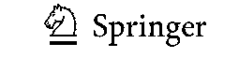
6364
Wójtowicz A. et al.
Table 2 (continued)
Storage  temp. [°C] | Vitreous humor |  |  |  |  |  | Liver homogenate
SS | df | MS | F | P | H0 rejected  Yes/No? | SS | df | MS | F | P | H0 rejected  Ye0s/No?
Oxazepam  20 | 2139.1 | 6 | 356.5 | 2.9392 | 0.02299 | Yes | 3361.6 | 6 | 560.3 | 6.9056 | 0.00009 | Yes
4 | 185.9 | 6 | 31.0 | 0.2759 | 0.94298 | No | 437.5 | 6 | 72.9 | 1.0889 | 0.39827 | No
-20 | 302.5 | 6 | 50.4 | 0.57 | 0.74992 | No | 686.9 | 6 | 114.5 | 1.977 | 0.10902 | No
Temazepam  20 | 282.6 | 6 | 47.1 | 0.776 | 0.59540 | No | 8154.5 | 6 | 1359 | 38.401 | 0.00000 | Yes
4 | 177.1 | 6 | 29.5 | 0.392 | 0.87756 | No | 607.9 | 6 | 101.3 | 0.9033 | 0.50603 | No
-20 | 347.6 | 6 | 57.9 | 1.371 | 0.26328 | No | 165.4 | 6 | 27.6 | 0.3556 | 0.89925 | No
Venlafaxine  20 | 1380.9 | 6 | 230.1 | 8.039 | 0.00003 | Yes | 6568.1 | 6 | 1095 | 32.999 | 0.00000 | Yes
4 | 915.1 | 6 | 152.5 | 9.812 | 0.00001 | Yes | 1435.3 | 6 | 239.2 | 5.516 | 0.00071 | Yes
-20 | 864.7 | 6 | 144.1 | 7.72 | 0.00011 | Yes | 2244.1 | 6 | 374.0 | 7.97 | 0.00006 | Yes

SS - sum of squares, df - degrees of freedom, MS - mean squares, F - F-value, p - probability value
“-” indicates the lack of results due to insufficient data
ALP was found to be stable in VH and LH during 30 days of
storage only at -20 and 4 °C.

CARB
The results of the statistical analysis obtained for CARB
in VH indicated the stability of this analyte when stored
at 4 and 20 °C and its instability at -20 °C. The lack of
stability at -20 °C is not compatible with the assump-
tion that stability will increase with decreasing storage
temperature. Furthermore, when analyzing the course of
changes in the concentration of this analyte over time
(Fig. 2a), it can be seen that the CARB content seems
to remain at a similar level at all storage temperatures,
and the rejection of the null hypothesis was probably due
to the low concentration on day 0. Therefore, the one-
way ANOVA for this analyte was repeated after rejecting
Table 3 One-way ANOVA
results obtained after the
rejection of the 0-day data for
CARB and DIAZ in VH, after
the rejection of the 18-day data
for DOX in VH, and after the
rejection of the 12-day data for
FLUOX in LH
Storage temp.  [°C] | SS | df | MS | F | P | H0 rejected  Ye0s/No?
Carbamazepine -  20 | VH  100.1 | 5 | 20.0 | 2.144 | 0.09467 | No
4 | 37.4 | 5 | 7.5 | 0.316 | 0.89867 | No
-20 | 106.5 | 5 | 21.3 | 1.876 | 0.13615 | No
Diazepam - VH  20 | 54.1 | 5 | 10.8 | 0.884 | 0.51109 | No
4 | 89.5 | 5 | 17.9 | 0.906 | 0.49439 | No
-20 | 92.7 | 5 | 18.6 | 0.84 | 0.53419 | No
Doxepin - VH  20 | 714.3 | 5 | 142.9 | 1.6874 | 0.18601 | No
4 | 222.4 | 4 | 55.6 | 0.914 | 0.47825 | No
-20 | 228.5 | 5 | 45.7 | 0.758 | 0.59061 | No
Fluoxetine - LH
20 | 137.4 | 4 | 34.3 | 0.5129 | 0.72709 | No
4 | 419.0 | 5 | 83.8 | 1.551 | 0.21338 | No
-20 | 141.9 | 5 | 28.4 | 0.677 | 0.64520 | No

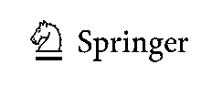
A sustainable approach for the stability study of psychotropic substances using vitreous humor.
6365
the 0-day data, and the results obtained are summarized
in Table 3. This time, the results did not indicate any
grounds for rejecting the null hypothesis in any of the
cases tested, so it was concluded that CARB is stable in
VH during 30 days of storage under all conditions tested:
at -20, 4 and 20 °C.
However, for CARB in LH, the ANOVA results indi-
cated the instability of this analyte under all storage con-
ditions. The decrease in drug concentration occurred after
the first day of storage, intensified on day 6, and was
most pronounced at the highest temperature of 20 °C.
Consequently, CARB in LH was found to be unstable at
all temperatures tested: -20, 4 and 20 °C.

CIT
CIT in VH was found to be stable under all storage condi-
tions tested, but in LH only at temperatures of -20 and 4 °C.
A decrease in the concentration of CIT in LH at 20 °C was
observed from about the sixth day of storage.

COC and its metabolites COCET and NORCOC
The ANOVA results showed that COC and its two tested
metabolites were generally unstable in VH and LH, except
for COCET and NORCOC, stable in VH at -20 °C.
For the VH matrix, a clear decrease in the concentra-
tion of COC and its two metabolites was observed after
the first day of storage at 4 and 20 °C (Fig. 2a). The initial
decrease in concentration was much faster at the tempera-
ture of 20 than at 4 °C, but then the concentration val-
ues have leveled out. It should also be mentioned that in
the last days of storage, an increase in the concentrations
of analytes was observed at these temperatures, which
may be due to some random errors or may indicate the
occurrence of more complicated processes. To investigate
this phenomenon, further studies are needed for samples
stored longer than 30 days. In contrast, for storage at -20
°C, a concentration decrease was observed only for COC
and occurred on about day 18, while the concentration of
both COC metabolites remained constant throughout the
30-day study period.
When analyzing the concentration-time plots for LH
(Fig. 2b), a clear decrease in the concentration of COC
and its two metabolites can be seen after the first day
of storage. The intensity of the drop in concentration is
greater as the storage temperature increases.

DIAZ and its metabolites NORDIAZ, OXA,
and TEM
The results of a one-way ANOVA performed for DIAZ
and its metabolites in VH indicated the stability of DIAZ
and OXA when stored at -20 and 4 °C, complete stabil-
ity of TEM, and instability of NORDIAZ. These con-
clusions are consistent with the concentration changes
over time shown in Fig. 2a for OXA and TEM, although
questionable for DIAZ and NORDIAZ. In the case of
DIAZ, as discussed above for CARB, the rejection of the
null hypothesis at 20 °C may be due to a low concentra-
tion of the analyte in the sample on day 0. Therefore,
the analysis was repeated after rejecting these data and
the results obtained are presented in Table 3. The new
results did not indicate any grounds for rejecting the null
hypothesis at any temperature; therefore, DIAZ was con-
sidered stable in VH under all storage conditions tested.
However, the case of NORDIAZ was more complicated.
The results shown in Fig. 2a indicated similar concentra-
tion values, but the statistical analysis proved the sig-
nificance of the observed differences. As shown in the
concentration versus storage day plots (Fig. 3) obtained
in Statistica, clear fluctuations in the concentration
of the analyte were observed at each of the tempera-
tures tested, which makes it difficult to unequivocally
assess the storage stability of this analyte in VH. Even
if removing the most distant outlier concentration values
at 4 and 20 °C, so that the data obtained on days 12 and
3, respectively, would lead to the finding of no change
in concentration over time for these storage conditions,
elimination of the outliers for the data obtained at -20
°C would still indicate a declining trend in NORDIAZ
concentration over time. The instability of this analyte in
the sample stored at -20 °C, considered the most stable
storage conditions, with stability at 4 and 20 °C, may
indicate an error in this sample or difficulties in assess-
ing the stability of this analyte by the SPME/LC-MS
method used. Therefore, NORDIAZ in VH was found to
be unstable under all the tested conditions.
The statistical results obtained for the LH samples
showed instability of DIAZ and NORDIAZ under all
storage conditions, and stability of OXA and TEM only
at temperatures of -20 and 4 °C. These results agree with
the changes observed in Fig. 2b. DIAZ and NORDIAZ
concentrations decreased significantly on the sixth day of
storage at 4 and 20 °C and on the 12th day at -20 °C. In
the case of NORDIAZ, it is also worth noting the increase
in the concentration of this analyte on the 30th day of
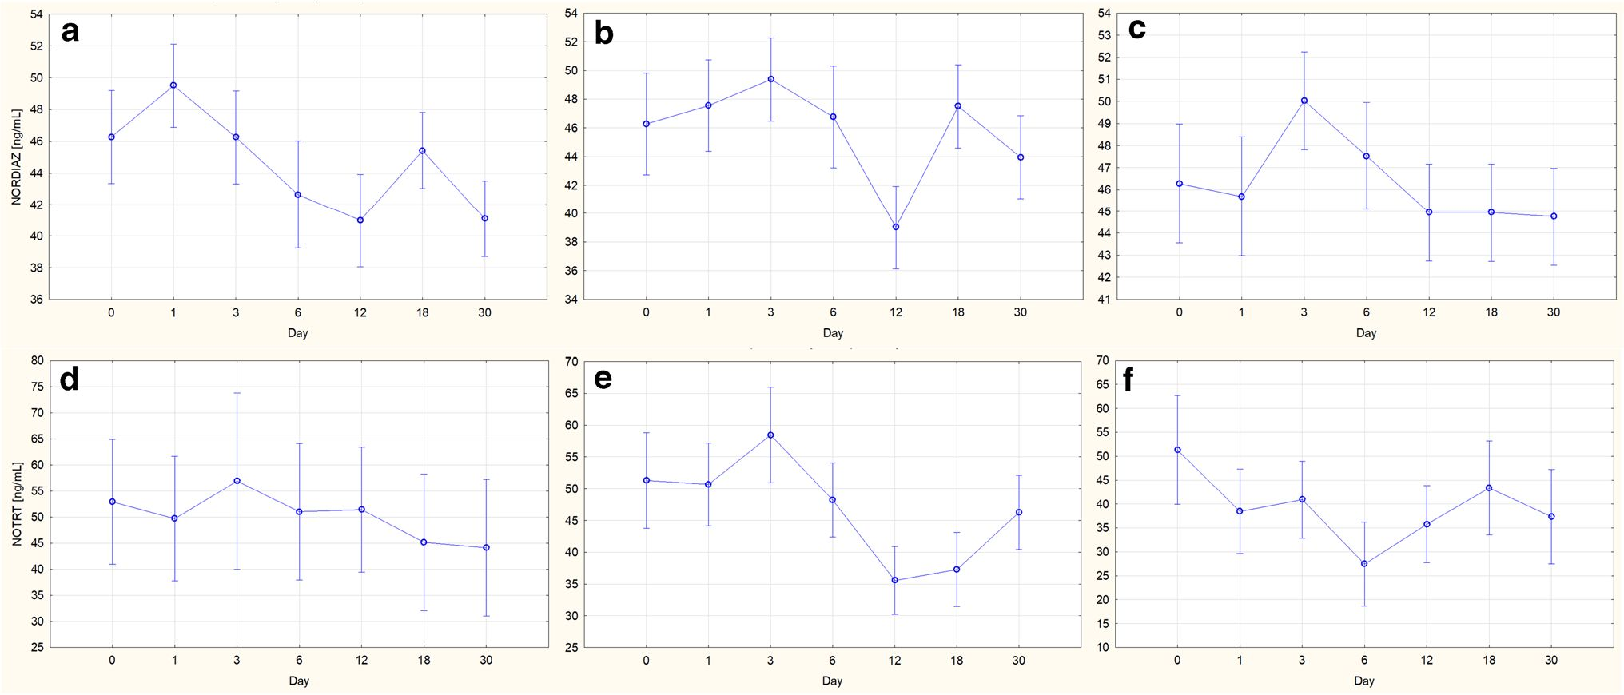

6366
Wójtowicz A. et al.
Fig. 3 Changes in drug concentration in VH on consecutive days of storage: NORDIAZat temperature of a -20, b 4, c 20 °C, and NORTR at
temperature of d -20, e 4, f 20 °C. The vertical bars indicate 0.95 confidence intervals
storage under all tested conditions, which may indicate
errors in these samples or may require further studies for
longer storage periods. For OXA and TEM, the stability
of the analyte concentration was observed at -20 and 4
°C, while at 20 °C the concentration decreased signifi-
cantly after about 3-6 days.

DOX
The ANOVA results obtained for DOX indicated the sta-
bility of this analyte in VH when stored at -20 and 20 °C,
and in LH at -20 and 4 °C. Although the results obtained
for LH are consistent with the assumption that stability
increases with decreasing storage temperature, the results
obtained for VH may indicate an error. By analyzing the
changes in DOX concentration over time (Fig. 2a), it can
be seen that the rejection of the null hypothesis for the
results obtained at 4 °C was probably due to a randomly
lower concentration value obtained on day 18. Therefore,
the analysis was repeated after omitting the data for that
day, and the results obtained are summarized in Table 3.
The new results demonstrated the stability of DOX in VH
during storage at all temperatures tested.
The conclusions drawn from the statistical analysis of
changes in DOX concentration in LH correspond to the
changes observed in Fig. 2b. At 20 °C, a clear decrease
in concentration was observed on the 12th day of storage,
and at -20 and 4 °C, no statistically significant changes
were observed.

FLUN
FLUN was found to be stable in VH when stored at -20
and 4 °C, but in LH only when stored at -20 °C. The
decrease in FLUN concentration in VH at 20 °C began on
day 6, while in LH at 4 °C, the decrease in concentration
did not occur until day 30. It should also be noted that the
ANOVA results could not be obtained for FLUN in LH
stored at 20 °C due to the lack of data on the concentra-
tion values on days 6-30.

FLUOX
The ANOVA results showed that FLUOX was stable in
VH during storage at all temperatures tested, which is
consistent with the data presented in Fig. 2a. For the
LH matrix, instability in analyte concentration was only
observed when stored at 4 °C. However, after analyzing
the plot obtained for FLUOX concentration changes in
Fig. 2b, it was concluded that the rejection of the null
hypothesis, in this case, could have been caused by an
incidentally high concentration value obtained on day
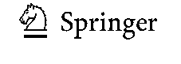
A sustainable approach for the stability study of psychotropic substances using vitreous humor.
6367
12. Therefore, the statistical analysis was repeated after
discarding the results for that day. The results obtained,
which are summarized in Table 3, indicated the stability
of FLUOX also in the LH matrix during storage under all
conditions tested.
concentration on day 12 when stored at 20 °C. At this
temperature, attention should also be paid to the increase
in concentration on day 30, which requires further
investigation.

NORTR
The statistical analysis results obtained for NORTR in VH
showed the stability of this analyte when stored at -20 and 20
°C. However, by analyzing the concentration versus storage
day plots obtained in Statistica and shown in Fig. 3, it can be
seen that the concentration of NORTR during storage at 20
°C decreased from day 0 to day 6 and then started to increase.
The lack of stability of this analyte is clearly visible, and the
acceptance of the null hypothesis was the total effect of the
decrease and increase in concentration. It can therefore be
concluded that NORTR in VH is stable when stored at -20
°C and unstable at 4 and 20 °C.
For NORTR in LH, the ANOVA results showed the
stability of the analyte when stored at -20 and 4 °C.
These results are consistent with the observed trend
of concentration changes over time (Fig. 2b), includ-
ing constant concentration values at -20 and 4 °C
throughout the entire study, and a decrease in analyte

VEN
For VEN, the results of the statistical analysis indicated
the instability of the concentration during storage at all
temperatures for both tested matrices. The decrease in
concentration for the VH matrix was observed from day
12 and was highest at 20 °C, while for LH the decrease
in concentration occurred at -20 and 4 °C also on day
12 and at 20 °C on day 6, and was also highest at this
highest storage temperature. In the case of VEN in LH,
an increase in concentration was also observed in the last
days of storage, which was previously mentioned for the
other drugs.

Classification of the analytes depending on their
stability
Based on the data presented in Tables 2 and 3 and Figs. 2
and 3, the analytes tested were divided into four groups that
differed in stability as follows.
Table 4 Assignment of the
analytes to appropriate stability
groups
 | Vitreous humor | Liver homogenate
I. Stable under all storage conditions | Carbamazepine  Citalopram  Diazepam  Doxepin  Fluoxetine  Temazepam | Fluoxetine
II. Stable at 4and -20 °C | Alprazolam | Alprazolam
 | Flunitrazepam | Citalopram
 | Oxazepam | Doxepin  Nortriptyline  Oxazepam  Temazepam
III. Stable at -20 °C | Cocaethylene  Norcocaine  Nortriptyline | Flunitrazepam
IV. Unstable under all storage conditions | Cocaine | Carbamazepine
 | Nordiazepam | Cocaethylene
 | Venlafaxine | Cocaine  Diazepam  Norcocaine  Nordiazepam  Venlafaxine


6368
Wójtowicz A. et al.
I Stable under all storage conditions
- Stable at 4 and -20 °C
- Stable at -20 °C
- Unstable under all storage conditions.
The assignment of the analytes to the respective groups
is presented in Table 4.
FLUOX from the SSRI group was found to be the most
stable analyte in both matrices under all conditions tested.
The second SSRI drug, CIT, also showed good stability—
under all conditions tested in VH and at -20 and 4 °C in
LH. Benzodiazepines and TCAs were also relatively sta-
ble in both matrices during storage, except for NORDIAZ,
which in both cases was unstable under all conditions
tested, and DIAZ was unstable in LH. However, CARB
was characterized by completely different stability for the
two matrices tested, being stable under all conditions in
VH and unstable under all conditions in LH. The lowest
storage stability in both matrices, apart from the previ-
ously mentioned NORDIAZ, was found for VEN and COC
and its metabolites. Therefore, special attention should be
paid to the concentrations of these analytes when analyzing
biological samples stored for some time, from a few days
to 1 month.
The results obtained confirmed the previously reported
good storage stability of PS at -20 °C [13, 18]. The instabil-
ity of COC at higher temperatures (4 and 20 °C) was also
confirmed, but in contrast to previous studies [15, 24], a
decrease in COC concentration at -20 °C was observed after
18 days in VH and after only 24 h in LH. Differences in the
stability of COC in VH may be due to the lack of added
preservatives, whereas in the case of LH, stability was not
tested in the whole organ, but only in the homogenate.
It is also worth noting that, considering the mean
changes in concentration from all temperatures, the ana-
lyzed analytes can be divided into three groups: a group
with relatively similar stability in both matrices, a group
of drugs clearly more stable in VH than in LH, and a
group clearly more stable in LH than in VH. The first
includes ALP, CIT, FLUN, COCET, COC, NORCOC,
NORTR, and OXA, the second (more stable in VH)
DIAZ, CARB, NORDIAZ, TEM, and FLUOX, and the
third (more stable in LH) DOX and VEN.
Attention should also be paid to the high values of the
standard deviation of some results. It is suspected that
this could have been affected by the SPME procedure,
in particular by the multiple uses of SPME fibers. The
tests carried out in our laboratory showed that the fiber
cleaning process used and described in the manuscript
is effective, and no fiber damage is observed after one
series of experiments [26]. However, in the course of our
study, the same group of fibers was used several times.
Therefore, further research is needed on the multiple uses
of SPME fibers.

Hypothetical explanation for stability/instability
An attempt was made to explain the observed stability of
the investigated psychotropic drugs taking into account
their basic properties, such as molecular weight, hydropho-
bicity measured by logP value, topological polar surface
area, water solubility, and acidity expressed by p^a. The
relevant data were taken from the ChemBank open data-
base. Attempts were made to compare the values of these
parameters with the average changes in the concentrations
of individual drugs to find a potential correlation. However,
no significant trend was detected, indicating the lack of a
direct link between the stability of the compounds under
consideration and their basic physicochemical properties.
Therefore, the most likely cause of the observed changes
in concentrations is subtle structural differences that may
affect supramolecular interactions of drugs with the cel-
lular environment, including enzymes, carriers, and struc-
tural proteins, including the host organism as well as the
bacterial, especially postmortem microflora. This hypoth-
esis is supported by quite consistent results obtained for
structurally similar compounds, e.g., COC and NORCOC.
The specificity of a given organ also plays an important
role, as evidenced by the significant differences between
LH and VH. Therefore, further research on this topic seems
necessary.

Conclusions
The stability of structurally diverse PS from the group of
benzodiazepines, tricyclic antidepressants, SSRIs, SNRIs,
carbamazepine, cocaine, and their selected metabolites
was studied in two biological matrices, LH and VH, using
the SPME/LC-MS method. The study consisted in 30 days
of storage at three different temperatures of -20, 4, and
20 °C. The results obtained allowed the classification
of the analytes into four general groups: (I) stable at all
tested temperatures, (II) only at 20 and 4 °C, (III) only at
-20 °C, and (IV) generally unstable. COC, NORDIAZ,
and VEN were found to be substances whose concentra-
tion changed significantly during storage and therefore
should be carefully considered when determining them
in biological samples. Additionally, in the LH matrix,
CARB, COCET, DIAZ, and NORCOC also showed
poor storage stability. FLUOX demonstrated the highest
storage stability in both tested matrices under all tested
conditions.

A sustainable approach for the stability study of psychotropic substances using vitreous humor.
6369
The results of the stability studies in the VH matrix
showed that during 1 month of storage, a temperature of
-20 °C prevents changes in the concentration of most of
the substances tested. Twelve out of 15 analytes tested were
found to be stable at this temperature. At the same time,
only eight of the 15 analytes were stable at this temperature
in the LH matrix. The number of storage-stable analytes at
4 and 20 °C was also greater in VH than in LH. At 4 °C, out
of 15 tested analytes, nine were stable in VH and seven in
LH. Similarly, at 20 °C, six analytes were stable in VH and
only one in LH. The study conducted confirmed that VH is a
biological matrix that ensures relatively high stability of the
analytes and is therefore valuable in toxicological analysis.
We ensured the selection of the optimal method for this
purpose based on the concept of WAC, combining the evalu-
ation of greenness with other criteria determining overall
functionality. The applied procedure was based on a method
originally used for blood samples, which was tested and
evaluated in this respect in our previous work. Herein, it
was subjected to the necessary modifications, validation, and
critical reassessment using the same tool. In our opinion,
the SPME/LC-MS used here deserves the name of “white”
obtained from the evaluation outcomes, which in relation to
the WAC concept means a high degree of balance between
analytical performance (red), environmental friendliness
(green), and practical efficiency (blue), which should also
be understood as true evidence of sustainability.
Supplementary Information The online version contains supplemen-
tary material available at https://doi.org/10.1007/s00216-022-04064-w.
Acknowledgements The authors gratefully acknowledge the Min-
istry of Science and Higher Education, National Science Centre,
Poland for financial support under the following projects: Sonata Bis
6 (R. Wietecha-Posłuszny, A. Wojtowicz, P. Nowak, no. 2016/22/E/
ST4/00054) for methodology development of VH analysis and Opus
19 (R. Wietecha-Posłuszny, A. Wojtowicz, M. Reciak, no. 2020/37/B/
ST4/01364) for stability studies of VH and LH.
Data availability Data and meta-data are available from the corre-
sponding author at the request of the reader.

Declarations
Source of biological material Animal samples were obtained from enti-
ties selling animal materials for consumer purposes and thus meet the
requirements of the marketing authorization. The biological samples
were taken postmortem. Laboratory animals were not used during the
experiment and experiments were not carried out on live animals.
Conflict of interest All authors certify that they have no affiliations
with or involvement in any organization or entity with any financial
interest or non-financial interest in the subject matter or materials dis-
cussed in this manuscript.
Open Access This article is licensed under a Creative Commons Attri-
bution 4.0 International License, which permits use, sharing, adapta-
tion, distribution and reproduction in any medium or format, as long
as you give appropriate credit to the original author(s) and the source,
provide a link to the Creative Commons licence, and indicate if changes
were made. The images or other third party material in this article are
included in the article's Creative Commons licence, unless indicated
otherwise in a credit line to the material. If material is not included in
the article's Creative Commons licence and your intended use is not
permitted by statutory regulation or exceeds the permitted use, you will
need to obtain permission directly from the copyright holder. To view a
copy of this licence, visithttp://creativecommons.org/licenses/by/4.0/.

References
- Peters FT. Stability of analytes in biosamples—An important
issue in clinical and forensic toxicology? Anal Bioanal Chem.
2007. https ://doi.org/10.1007/s00216-007-1267-2.
- Pounder DJ, Jones GR. Post-mortem drug redistribution —a
toxicological nightmare. Forensic Sci Int. 1990. https://doi.org/
10.1016/0379-0738(90)90182-x.
- Kachhawa K, Kachhawa P, Varma M, Behera R, Agrawal D,
Kumar S. Study of the stability of various biochemical analytes
in samples stored at different predefined storage conditions at an
accredited laboratory of India. J Lab Physicians. 2017. https://
doi.org/10.4103/0974-2727.187928.
- Skopp G. Preanalytic aspects in postmortem toxicology. Foren-
sic Sci Int. 2004. https://doi.org/10.1016/j.forsciint.2004.02.
012.
- Barnhart FE, Fogacci JR, Reed DW. Methamphetamine: a study
of postmortem redistribution. J Anal Toxicol. 1999. https://doi.
org/10.1093/jat/23.1.69.
- Bevalot F, Cartiser N, Bottinelli C, Fanton L, Guitton J. Vitre-
ous humor analysis for the detection of xenobiotics in forensic
toxicology: a review. Forensic Toxicol. 2016. https://doi.org/10.
1007/s11419-015-0294-5.
- Mannermaa E, Vellonen KS, Urtti A. Drug transport in corneal
epithelium and blood-retina barrier: emerging role of transport-
ers in ocular pharmacokinetics. Adv Drug Deliv Rev. 2006.
https://doi.org/10.1016/jhaddr.2006.07.024.
- Del Amo EM, Rimpela AK, Heikkinen E, Kari OK, Ramsay E,
Lajunen T, Schmitt M, Pelkonen L, Bhattacharya M, Richardson
- Subrizi A, Turunen T, Reinisalo M, Itkonen J, Toropainen
- Casteleijn M, Kidron H, Antopolsky M, Vellonen KS, et al.
Pharmacokinetic aspects of retinal drug delivery. Prog Retin
Eye Res. 2017. https://doi.org/10.1016/j.preteyeres.2016.12.
001.
- Wojtowicz A, Wietecha-Posłuszny R, Snamina M. Contempo-
rary trends in drug analysis of vitreous humor: a critical review.
TrAC Trends Anal Chem. 2020. https://doi.org/10.1016/j.trac.
2020.115935.
- Antonides HM, Kiely ER, Marinetti LJ. Vitreous fluid quanti-
fication of opiates, cocaine, and benzylecgonine: comparison
of calibration curves in both blood and vitreous matrices with
corresponding concentrations in blood. J Anal Toxicol. 2007.
https://doi.org/10.1093/jat/31.8.469.
- Busardo FP, Mannocchi G, Giorgetti R, Pellegrini M, Baglio G,
Zaami S, Marinelli E, Pichini S. Stability of endogenous GHB
in vitreous humor vs peripheral blood in dead bodies. Forensic
Sci Int. 2017. https://doi.org/10.1016/j.forsciint.2016.12.025.

6370
Wójtowicz A. et al.
- Rees KA, Jones NS, McLaughlin PA, S. Seulin, Leyton V, Yon-
amine M, Osselton MD. The effect of sodium fluoride preserva-
tive and storage temperature on the stability of cocaine in horse
blood, sheep vitreous and deer muscle. Forensic Sci Int. 2012;
https://doi.org/10.1016/j.forsciint.2011.11.001
- Holmgren P, Druid H, Holmgren A, Ahlner J. Stability of
drugs in stored postmortem femoral blood and vitreous humor.
J Forensic Sci. 2004. https://doi.org/10.1520/JFS2003433.
- Jones GR. Interpretation of postmortem drug levels. In: Karch
SB, editor. Drug Abuse Handbook. Boca Raton: CRC Press;
2006. p. 970-85.
- Kiszka M, Buszewicz G, Mądro R. Stability of cocaine in
blood and in other tissues. Z Zagadnień Nauk Sądowych.
2001;45:16-35.
- Moffat AC, Osselton MD, Widdop B. Clarke’s analysis of drugs
and poisons in pharmaceuticals, body fluids and postmortem
material. 4th ed. London: Pharmaceutical Press; 2011.
- Melo P, Bastos ML, Teixeira HM. Benzodiazepine stability in
postmortem samples stored at different temperatures. J Anal
Toxicol. 2012. https://doi.org/10.1093/jat/bkr008.
- Westland JL, Dorman FL. QuEChERS extraction of benzodiaz-
epines in biological matrices. J Pharm Anal. 2013. https://doi.
org/10.1016/j .j pha.2013.04.004.
- Mercolini L, Mandrioli R, Iannello C, Matrisciano F, Nico-
letti F, Raggi MA. Simultaneous analysis of diazepam and its
metabolites in rat plasma and brain tissue by HPLC-UV and
SPE. Talanta. 2009. https://doi.org/10.1016/jhtalanta.2009.06.
074.
- Evenson MA, Engstrand DA. A SepPak HPLC method for tri-
cyclic antidepressant drugs in human vitreous humor. J Anal
Toxicol. 1989. https://doi.org/10.1093/jat/13.6.322.
- 0iestad AML, Karinen R, Rogde S, Nilsen S, Eldor KBB, Bro-
chmann GW, Arnestad M, 0iestad EL, Peres MD, Kristoffersen
L, Vindenes V. Comparative study of postmortem concentra-
tions of antidepressants in several different matrices. J Anal
Toxicol. 2018. https://doi.org/10.1093/jat/bky030.
- Logan BK, Stafford DT. Direct analysis of anticonvulsant drugs
in vitreous humour by HPLC using a column switching tech-
nique. Forensic Sci Int. 1989. https://doi.org/10.1016/0379-
0738(89)90244-2.
- Drugs of Abuse, A DEA Resource Guide 2020 EDITION, Drug
Enforcement Administration, U.S. Department of Justice.
- Peres MD, Pelicao FS, Caleffi B, De Martinis BS. Simultaneous
quantification of cocaine, amphetamines, opiates and cannabi-
noids in vitreous humor. J Anal Toxicol. 2014. https://doi.org/
10.1093/jat/bkt093.
- Nowak PM, Wietecha-Posłuszny R, Pawliszyn J. White Analyti-
cal Chemistry: An approach to reconcile the principles of Green
Analytical Chemistry and functionality. TrAC Trends in Anal
Chem. 2021. https://doi.org/10.1016/j.trac.2021.116223.
- Majda A, Mrochem K, Wietecha-Posłuszny R, Sz Z, Zawadzki
M. Fast and efficient analyses of the post-mortem human blood
and bone marrow using DI-SPME/LC-TOFMS method for
forensic medicine purposes. Talanta. 2020. https://doi.org/10.
1016/j. talanta. 2019.12053 3.
- Nowak PM, Kościelniak P. What color is your method? Adap-
tation of the RGB additive color model to analytical method
evaluation. Anal Chem. 2019. https://doi.org/10.1021/acs.analc
hem.9b01872.
Publisher's note Springer Nature remains neutral with regard to
jurisdictional claims in published maps and institutional affiliations.

