Optica Applicata, Vol. XLV, No. 4, 2015
DOI: 10.5277/oa150413

Transparent yttrium oxide ceramics as potential optical isolator materials

ANDRZEJ KRUK1, ANNA WAJLER2, MARIUSZ MRÓZEK3, ŁUKASZ ZYCH1, WOJCIECH GAWLIK3, TOMASZ BRYLEWSKI1*

1 AGH University of Science and Technology, Faculty of Materials Science and Ceramics, al. Mickiewicza 30, 30-059 Kraków, Poland
2 Institute of Electronic Materials Technology, ul. Wólczyńska 133, 01-919 Warszawa, Poland
3 Jagiellonian University, Faculty of Physics, Astronomy and Applied Computer Science, ul. Reymonta 4, 30-059 Kraków, Poland
*Corresponding author: brylew@agh.edu.pl

The objective of the presented study was to investigate the usefulness of transparent, sintered yttrium oxide for application as optical isolators, i.e., materials with high Verdet constant. The study utilizes the magneto-optical Faraday effect. To obtain yttrium oxide sinters, a commercial Y2O3
powder was applied, with LiF added to facilitate sintering. As a result of hot-press sintering and
heating, transparent, dense sinters were obtained. The structure and morphology of the powders and bulk samples and the optical properties of the latter were investigated by means of X-ray diffraction, scanning electron microscopy, visible and near-infrared reflectance spectroscopy, and a study of magneto-optical (Faraday) effects. Measurements of the Faraday effect in the wavelength range of 500–1000 nm indicate high Verdet constants for the above-described materials, which means that they can be effectively applied in laser optics.

Keywords: transparent ceramics, optical properties, yttrium oxide.

Introduction
One of the requirements for material applications in laser optics is to minimize the light absorption in the widest possible spectral range. Typical quartz glass does not exhibit physicochemical properties required by many industrial and technological applica- tions. Alternative materials offering high refractive index and good optical polarization quality, while maintaining high transmittance and satisfactory chemical and mechan- ical stability, are attracting more and more attention. Yttrium oxide ceramics discussed in this paper is an example of such an alternative ceramic material. It crystallizes in the regular structure, has a high melting point of 2723 K, high chemical stability, rel-
atively good mechanical properties, and a low thermal expansion coefficient [1, 2]. An- other important feature of this material is its transmittance, which can reach 80% [3–6]. Such high transmittance and low energy cut-off of phonons, as well as the feasibility to incorporate rare earth elements into the yttrium oxide lattice, make the transparent Y2O3 a good candidate for applications in Nd lasers [7].
Due to the extremely rapid development in the field of optoelectronics and laser
techniques, efforts are being made to design new materials which can be used to pro- duce optical isolators for application in optical devices that transmit light only in one direction. Studies on optical isolators utilize the Faraday effect, in which the plane of light polarization undergoes rotation when light travels through a medium placed in a magnetic field. When choosing a material suitable for this purpose, the main criterion is a sufficiently high Verdet constant [8, 9], i.e., the optical constant of a material, named after the French physicist Èmile Verdet [10]. The Faraday effect can be ob- served in gaseous [11, 12], liquid, and solid samples, including ceramics [13, 14],
amorphous substances [15, 16], and crystals, such as Cd1–x–yMnxFeyTe [17]. The high- est Verdet constants are observed for paramagnetic media, such as heavy flint glass doped with paramagnetic terbium ions or terbium gallium garnet – Tb3Ga5O12 (TGG). At 632.8 nm, the Verdet constant for TGG is reported to be –134 rad/(T·m), whereas at 1064 nm it falls to –40 rad/(T·m). A TGG with an absorption coefficient of 0.0015
is resistant to damage caused by laser light [18]. Tb-doped glass with an absorption coefficient of 0.003, on the other hand, exhibits a Verdet constant equal to –70 rad/ (T·m) at 632.8 nm and –20 rad/ (T·m) at 1064 nm [19]. As previously reported [20], ceramics with the composition of La0.1Nd0.1Y1.8O3 is highly capable of rotating the light polar-
ization, which reflects its potential to be used in optical isolators.
Yttrium is the initial material for the group of X-Y2O3 oxides doped with rare earth metals, i.e., La, Eu, Th and Nd (all denoted by X in the formula). The determination
of the properties of the initial material which exhibits magneto-rotation makes it pos- sible to establish the influence of doping on the optical properties. A major issue con- cerning the wider application of transparent yttria-based ceramics, for example in the
Y2O3-ThO2 system, which exhibits a linear transmittance of over 70% [21], is the ne- cessity of sintering the material at high temperature on the order of 2273–2473 K. The temperature and duration of sintering can be reduced via the application of hot
isostatic pressing (HIP). When using this technique, it is possible to obtain Y2O3 ma- terials with a density close to the theoretical one at lower temperatures, i.e., in the range of 1973–2073 K, based on commercially available yttria powders [2, 22]. The rheo-
logical requirements set for powders sintered by means of HIP are therefore not as strin- gent as in the case of free sintering where the grain size and the degree of powder agglomeration are very significant [23]. To improve the transmittance of the Y2O3 ce-
ramics for optical applications, some additions that facilitate sintering are also used.
Based on the applied mechanism, these additions may be divided into two groups. The first group comprises compounds, which promote the formation of the liquid phase during sintering (e.g., La2O3, Al2O3, MgO, LiF), while the second one includes com-
pounds that change the sintering kinetics via the introduction of lattice defects (e.g.,
Eu2O3, ThO2, HfO2, ZrO2, TiO2, SrO) [22]. It should, however, be emphasized that the application of some additions helps to densify the material, but its final transmit-
tance also strongly depends on the parameters of the applied powders and on the sintering procedure.
Taking into account the possibility of reducing the sintering temperature of yttria via the addition of LiF as well as the advantages offered by HIP with regard to obtaining sinters with the appropriate microstructure, an attempt was made to synthesize trans- parent bulk yttria samples, and investigate their structure, microstructure, and the op- tical and magneto-optical (Faraday) properties.

Experiment

Sample preparation
The commercial yttria powder 39R-0803 of high purity (99.995%), purchased from Inframat Advanced Materials (USA), was used. As a sintering aid, 1 wt% of LiF pow-
der was used (Aldrich, 99.995% purity). The Y2O3-LiF mixtures were prepared via 30 min of milling in an attritor mill with alumina balls and ethanol. The powder mixture was dried in air and crushed in an agate mortar. All sintering experiments were con-
ducted using a hot-press (Astro Division, Thermal Technology, Inc.) with a graphitic interior and an argon (99.99% purity) atmosphere. The 25.4 mm diameter die was lined with graphite foil, and the foil disks were cut to fit on the ends of punches. Instead of fine powder, pressed pellets weighing ca. 12 g (120 MPa, isostatic pressing) were in- serted into the graphite die. The sintering temperature was set to 1723 K and the dwell- ing time was 2 hours. A uniaxial load was applied during the hot-pressing process. A maximum pressure of 30 MPa was applied at 1573 K, and maintained for the whole dwelling time. The first series of bulk samples was prepared as described above, and the second series was additionally annealed for 1 hour in air at 1673 K.

Methodology
The particle (agglomerate) size of the yttria powders was determined by the laser light diffraction method (Mastersizer 2000S, Malvern Instruments).
The morphology of powders as well as the microstructure of ceramics were ob- served by a scanning electron microscope (SEM) (Carl Zeiss CrossBeam Workstation AURIGA).
X-ray diffraction measurements were performed by a Siemens D500 powder diffrac- tometer, equipped with a high-resolution semiconductor Si:Li detector, using KαCu radiation λ = 1.5418 Å. The diffraction pattern was measured in the Bragg–Brentano mode, with a step of 0.05°, counting time of 4 s/step and 2θ range 10°–60°.
The relative density of the sintered samples was measured by means of the Archimedes floating method, using water as the immersion medium.
The absorption coefficient of yttria ceramics was measured over the wavelength region from 350 to 1100 nm using a visible and near-infrared (VIS/NIR) reflectance
spectrometer (AvaSpec-ULS3648). The applied light source was the SL1 12W halogen lamp, capable of emission in the range of 350–2200 nm, supplied by StellarNet, Inc. The sample thickness was 0.9 mm.
Measurements of the Faraday effect were carried out using the apparatus shown schematically in Fig. 1. The necessary value of the field induction B was adjustable by varying the distance between the magnets. For the described measurements, B was set to 0.2±0.001 T. To determine the spectral dispersion of the Verdet constant, rather than its single values, four different monochromatic light sources operating at different wavelengths were employed in the experiment: the second harmonic of the 532 nm Nd:YAG laser, a 633 nm He-Ne laser, and a diode laser with a wavelength of 780 nm.

Laser
M1
Sample
Steel rods with axial bores
M2
P
P
D
Magnetic housing
Permanent magnets

Fig. 1. Schematic diagram of the apparatus used for Faraday effect measurements (M1 and M2 – mirrors, P – crystal linear polarizers, D – photodetector).

The method of measurement and the procedure used for data analysis are described elsewhere [24]. The measurement procedure involved recording the intensity of light transmitted by the sample placed between two crossed crystal linear polarizers (P) in a given magnetic field. The light intensity was measured with a photodiode D (ThorLabs, S120C), and calibrated with a power meter (ThorLabs, PM100D). The measured val- ues of the Verdet constant were determined on the basis of the relationship

V = -----θ------
Bs
where θ is the measured Faraday rotation angle, B is the magnetic field strength, and
s is the sample length.

Results

Powder characteristics
XRD analysis of the as-received yttria powder (Inframat 39R 0803) indicated a single-
-phase structure consisting of Y2O3 (JCPDS card no. 83 0927).

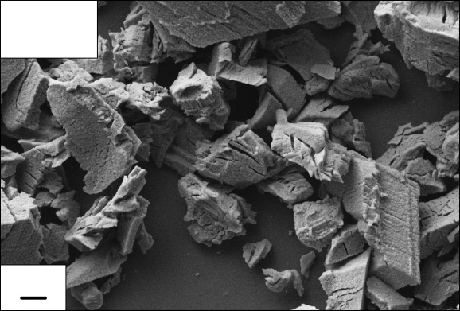
Y2O3-LiF
Inframat 39R-0803
1 μm

Fig. 2. SEM microphotograph of the Y2O3-LiF powder obtained after milling and drying.

To obtain information about the shape and size of the powder particles, their morphology was studied by means of the SEM technique. An SEM microphotograph
of Y2O3-LiF mixtures obtained after milling followed by drying in air is presented in Fig. 2. As can be seen, this material is characterized by the presence of large, irregular agglomerates with dimensions ranging from about 0.2 to 12 μm. The grain-size dis- tribution of the Y2O3-LiF powder presented in Fig. 3 suggests that this material exhibits a single-modal agglomerate distribution.

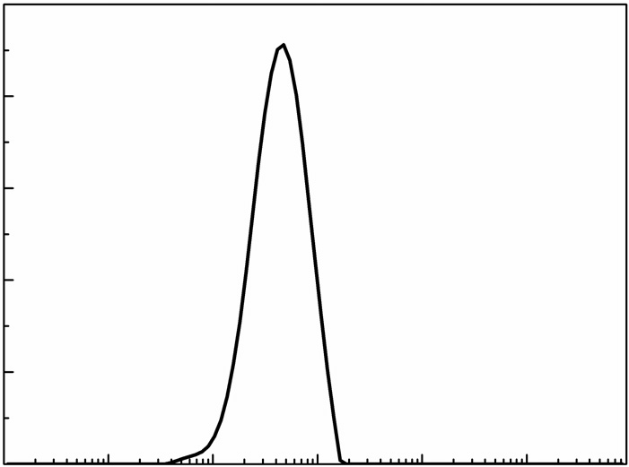
10

8
Volume fraction [%]

6

4

2

0
0.01 0.1 1 10 100 1000
Particle size [μm]
Fig. 3. Mass particle size distribution of the Y2O3-LiF powder obtained after milling and drying.

The size of the mode inferred from this distribution, i.e., the diameter of the most significant grains in the distribution, is Dmod = 4 μm.

Bulk sample characteristics
Figure 4 presents the X-ray diffraction patterns of the two types of yttria sinters obtained after 2 hours of hot-press sintering in argon at 1723 K. The XRD studies of sinters without any additional thermal treatment (Fig. 4a) and after 1 hour of annealing
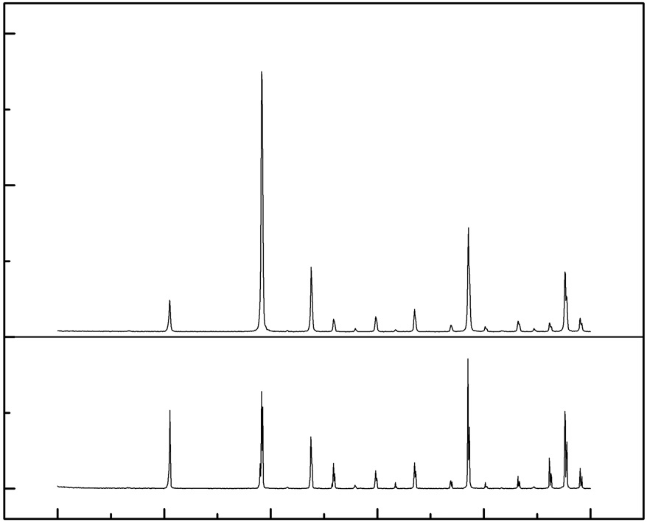
15000
a
b
(222)

10000
Intensity [a. u.]
(211)
(400)
(411)
(322)
(134)
(125)
(622)
(613)
(444)

5000

0

10 20 30 40 50 60
2θ [deg]

Fig. 4. XRD patterns of yttria samples obtained after 2 hours of hot-press sintering in argon at 1723 K without annealing (a) and after 1 hour of annealing in air at 1673 K (b).

in air at 1673 K (Fig. 4b) confirmed their single-phase composition featuring Y2O3 with a cubic structure.
Figure 5 shows the surface morphology of a fractured yttria bulk sample obtained after 2 hours of hot-press sintering in argon at 1723 K followed by 1 hour of annealing in air at 1673 K.

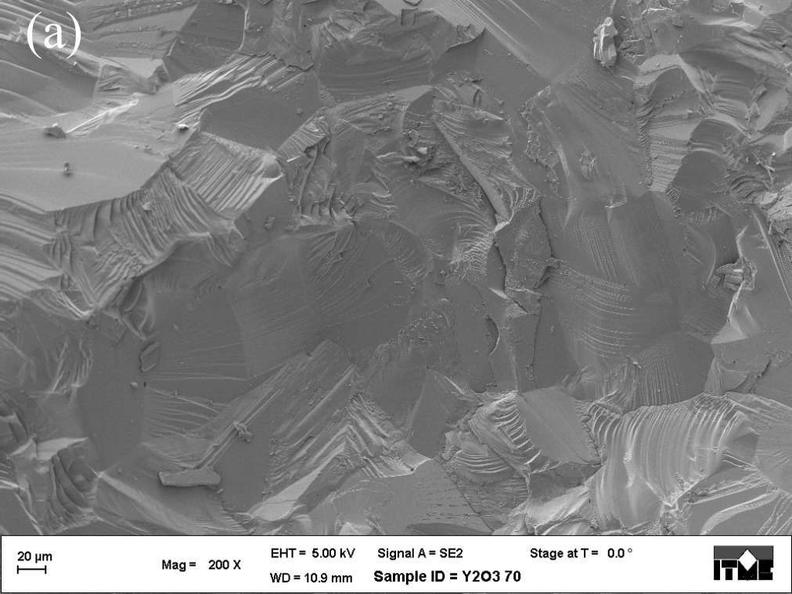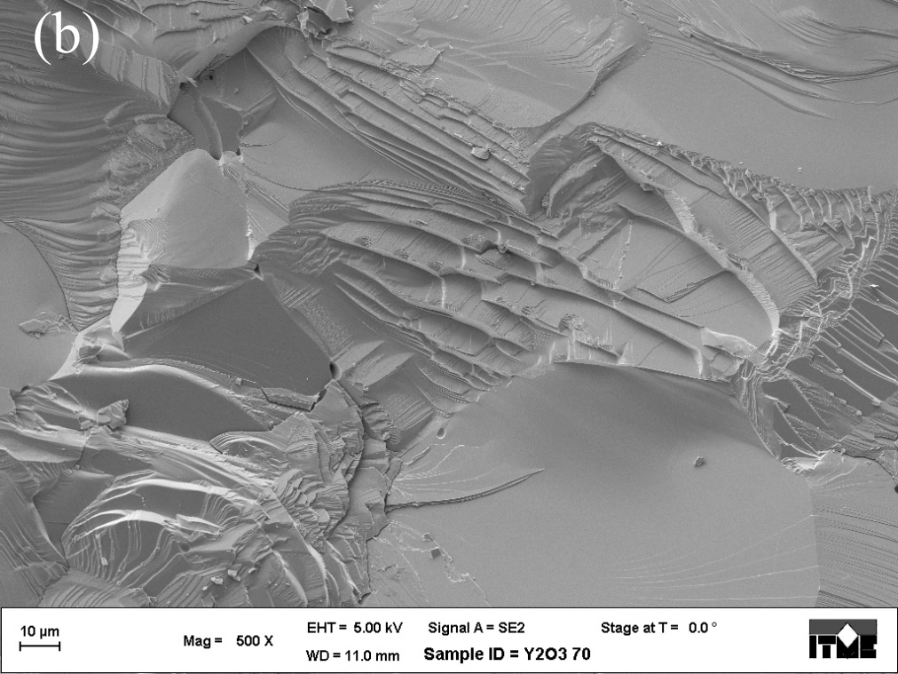
a
b

Fig. 5. SEM microphotographs of the surface of a fractured yttria bulk sample obtained after 2 hours of hot-press sintering in argon at 1723 K followed by 1 hour of annealing in air at 1673 K. Magnification: 200× (a) and 500× (b).

The examination of the morphology of the surface of this sinter revealed a coarse-
-crystalline, compact grain structure with well-developed, irregular grains. The size of these grains ranged from ca. 5 to ca. 75 μm. Small amounts of isolated pores with

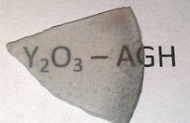

Fig. 6. A photograph of a 0.9 mm thick yttria bulk sample obtained after 2 hours of hot-press sintering in argon at 1723 K followed by 1 hour of annealing in air at 1673 K.

a diameter that did not exceed 0.5 μm were observed in the sinter; these pores were surrounded by large grains. The relative density of the ceramics was approximately 99.2 ± 0.5%.
A fragment of sintered Y2O3 prepared for optical studies is shown in Fig. 6. The sinter has high transmittance in the range of visible light. The very low porosity of the yttria samples translates to their high transmittance due to the lack of diffraction of incident
light.
Light transmittance is the main optical property considered when evaluating trans- parent ceramics. The maximum transmittance of a 0.9 mm thick yttria bulk sample obtained after 2 hours of hot-press sintering in argon at 1723 K was 33%, up to 1000 nm; for the same sample this value increased to 48% after additional annealing.
Figure 7 shows the absorption spectrum of the two studied types of samples in the wavelength range of 350–1100 nm.
Based on spectrophotometric measurements carried out in the visible spectrum, it was found that the additional annealing caused a reduction of absorption, especially for

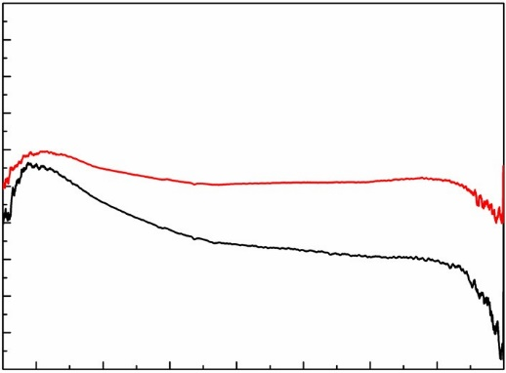
10
1 – Y2O3 (T = 33%)
2 – Y2O3 (T = 48%)
1

2
Absorption coefficient [cm–1]

8

6

4

2

0
400 600 800 1000
Wavelength [nm]

Fig. 7. Optical absorption coefficient of the two types of sintered Y2O3: the sample without annealing (spectrum 1) and the sample after 1 hour of additional annealing in air at 1673 K (spectrum 2).

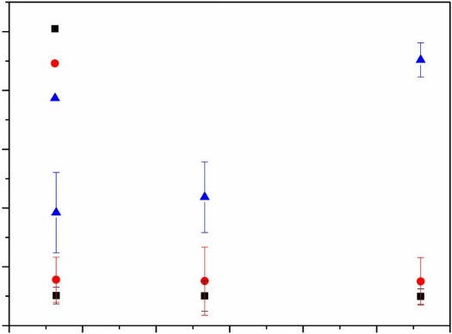
500
Y2O3 (T = 48%) Y2O3 (T = 33%)
La0.1Nd0.1Y1.8O3 (T = 7%)
Verdet constant [deg/(T·cm)]

400

300

200

100

0
500 600 700 800
Wavelength [nm]

Fig. 8. Verdet constants of the two types of sintered Y2O3: the sample without annealing () and the sample after 1 hour of additional annealing in air at 1673 K (). The results obtained for the La0.1Nd0.1Y1.8O3 ceramics are included for reference () [20].

the longer wavelengths. The increase in the transmission of visible light after the an- nealing of the samples in air is most likely due to the reduction in the number of point defects (oxygen vacancies) in the crystal lattice [25]. When sintering polycrystalline yttria under pressure in graphite moulds, annealing in air or oxygen is indispensable for the restoration of the material’s stoichiometry; this is due to the partial reduction of yttria. A more extensive explanation of this phenomenon requires further research. Figure 8 shows the results of Verdet constant measurements for the two different types of yttria bulk samples, performed at three different wavelengths: 532, 633 and 780 nm. As can be seen, varying transmittance has a very little effect on the Verdet constant. Its values are similar for both types of samples, i.e., over 50 deg/(T·cm), re- gardless of the wavelength. For the comparison, the plot also shows the results of the Verdet constant measurements for the La0.1Nd0.1Y1.8O3 material sintered for 2 hours
in argon at 1973 K by means of hot isostatic pressing (HIP) [20]. Doping Y2O3 in-
creased the value of the Verdet constant about two times, but resulted in decreased
transmittance (7% at 1000 nm) [20].
In general, the relation between the absorption coefficient and the refractive index of a given material is the Kramers–Kronig relation, which predicts strong spectral var- iations of the refractive index around the absorption resonance of the sample under con- sideration [26]. The Verdet constant, however, is the quantity which reflects not just the sample’s refraction, but rather its magnetic/polarization anisotropy (birefringence). Its spectral dependence is not directly related to its absorption.
Based on the spectrophotometric measurements of absorption and the Verdet con- stant, performed in the wavelength range of 500–1000 nm, the possibility of applying sintered Y2O3 as an optical isolator was demonstrated. Doping with lanthanum and neodymium is recommended in order to increase the value of the Verdet constant.

Conclusions
The as-received material was the commercially available Y2O3 powder supplied by Inframat Advanced Materials (USA). After milling, the powder consisted of fine grains in the form of plates with the ability to agglomerate. The efficacy of the LiF powder
as a lubricant facilitating the sintering process without the need to modify the crystal lattice of Y2O3 was confirmed. The study of the morphology of the sintered Y2O3-LiF powder obtained by means of hot-pressing revealed the presence of grains with a reg- ular shape and a very low number of visible pores. Annealing the studied sinters for
1 hour in air improves their transmittance to 48% compared to the 33% obtained for the samples without any additional annealing. The Verdet constants for the two types of samples were measured at three wavelengths: 532, 633 and 780 nm. The influence of the transmittance of the sintered Y2O3 samples on their Verdet constants was found
to be insignificant. The obtained values of the Verdet constants (> 50 deg/(T·cm)) were
indicative of the high potential of the material for use as a good optical isolator.

Acknowledgements – This work was done as part of the statutory activities of the Department of Physical Chemistry and Modeling, Faculty of Materials Science and Ceramics, AGH University of Science and Technology (contract No. 11.11.160.257).

References
[1] EILERS H., Fabrication, optical transmittance, and hardness of IR-transparent ceramics made from nanophase yttria, Journal of the European Ceramic Society 27(16), 2007, pp. 4711–4717.
[2] WAJLER A., WĘGLARZ H., TOMASZEWSKI H., MOŻDŻONEK M., SIDOROWICZ A., LIBRANT Z., Wytwarzanie
przezroczystej ceramiki Y2O3 metodą spiekania pod ciśnieniem, Materiały Ceramiczne 64(1), 2012, pp. 108–114, (in Polish).
[3] XIAORUI HOU, SHENGMING ZHOU, TINGTING JIA, HUI LIN, HAO TENG, Effect of Nd concentration on
structural and optical properties of Nd:Y2O3 transparent ceramic, Journal of Luminescence 131(9), 2011, pp. 1953–1958.
[4] WOOHONG KIM, VILLALOBOS G., BAKER C., FRANTZ J., SHAW B., BAYYA S., SADOWSKI B., HUNT M.,
AGGARWAL I., SANGHERA J., Ceramic windows and gain media for high-energy lasers, Optical Engineering 52(2), 2013, article 021003.
[5] LIN GAN, YOUNG-JO PARK, MI-JUNG PARK, HANEUL KIM, JIN-MYUNG KIM, JAE-WOONG KO,
JAE-WOOK LEE, Facile fabrication of highly transparent yttria ceramics with fine microstructures by a hot-pressing method, Journal of the American Ceramic Society 98(7), 2015, pp. 2002–2004.
[6] MANN R., LAISHRAM K., AHMED S.A., MALHAN N., Novel amorphous precursor densification to transparent Nd:Y2O3 ceramics, Ceramics International 38(5), 2012, pp. 4131–4135.
[7] SHIRAKAWA A., TAKAICHI K., YAGI H., BISSON J.-F., LU J., MUSHA M., UEDA K., YANAGITANI T., PETROV
T., KAMINSKII A., Diode-pumped mode-locked Yb3+:Y2O3 ceramic laser, Optics Express 11(22), 2003, pp. 2911–2916.
[8] CASTÉRA J.-P., HEPNER G., Isolator in integrated optics using Faraday and Cotton–Mouton effects, Applied Optics 16(8), 1977, pp. 2031–2033.
[9] DEETER M.N., ROSE A.H., DAY G.W., Faraday-effect magnetic field sensors based on substituted iron garnets, Proceedings of the SPIE 1367, 1991, p. 243.

[10] http://en.wikipedia.org/wiki/
[11] JACOB D., VALLET M., BRETENAKER F., LE FLOCH A., LE NAOUR R., Small Faraday rotation
measurement with a Fabry–Pérot cavity, Applied Physics Letters 66(26), 1995, pp. 3546–3548. [12] GAWLIK W., KOWALSKI J., NEUMANN R., WIEGEMANN H.B., A new method for measuring oscillator
strengths using the resonant Faraday effect in monochromatic light, Journal of Physics B: Atomic and Molecular Physics,12(23), 1979, pp. 3873–3882.
[13] KAGAMITANI Y., PAWLAK D.A., SATO H., YOSHIKAWA A., MACHIDA H., FUKUDA T., Annealing effect in
terbium-scandium-aluminum garnet single crystal, Japanese Journal of Applied Physics 41(Part 1, 10), 2002, pp. 6020–6022.
[14] KAGAMITANI Y., PAWLAK D.A., SATO H., YOSHIKAWA A., MARTINEK J., MACHINA H., FUKUDA T.,
Dependence of Faraday effect on the orientation of terbium-scandium-aluminum garnet single crystal, Journal of Materials Research 19(2), 2004, pp. 579–583.
[15] TAN C.Z., ARNDT J., Faraday effect in silica glasses, Physica B: Condensed Matter 233(1),1997, pp. 1–7.
[16] TAN C.Z., ARNDT J., Faraday effect in TiO2–SiO2 glasses, Journal of Non-Crystalline Solids 222, 1997, pp. 391–395.
[17] YOUNGHUN HWANG, HYEKYEONG KIM, SUNGLAE CHO, TAESOO KIM, YOUNGHO UM, HYOYEOL PARK,
GWANGSOO JEEN, Magnetic and magneto-optical properties in diluted magnetic semiconductors: Cd1–x–y Mnx FeyTe single crystals, Journal of Magnetism and Magnetic Materials 304(1), 2006, pp. e309–e311.
[18] WENJING ZHANG, FEIYUN GUO, JIANZHONG CHEN, Growth and characterization of Tb3Ga5–x AlxO12 single crystal, Journal of Crystal Growth 306(1), 2007, pp. 195–199.
[19] www.as.northropgrumman.com/synoptics
[20] KRUK A., MRÓZEK M., DOMAGAŁA J., BRYLEWSKI T., GAWLIK W., Synthesis and physicochemical properties of yttrium oxide doped with neodymium and lanthanum, Journal of Electronic Materials 43(9), 2014, pp. 3611–3617.
[21] ANDERSON R.D., Transparent yttria-based ceramics and method for producing same, US Patent 3545987, 1970.
[22] PODOWITZ S.R., GAUMÉ R., FEIGELSON R.S., Effect of europium concentration on densification of transparent Eu:Y2O3 scintillator ceramics using hot pressing, Journal of the American Ceramic Society 93(1), 2010, pp. 82–88.
[23] PAMPUCH R., HABERKO K., KORDEK M., Nauka o procesach ceramicznych, PWN, Warszawa, 1992, (in Polish).
[24] NAKIELNA P., CZERWIEC J., Czujniki magnetyczne wykorzystujące efekt Faradaya, Master Thesis, Jagiellonian University, 2007, (in Polish).
[25] KRELL A., KLIMKE J., HUTZLER T., Transparent compact ceramics: inherent physical issues, Optical Materials 31(8), 2009, pp. 1144–1150.
[26] HUTCHINGS D.C., SHEIK-BAHAE M., HAGAN D.J., VAN STRYLAND E.W., Kramers–Krönig relations in
nonlinear optics, Optical and Quantum Electronics 24(1), 1992, pp. 1–30.

Received May 6, 2015
in revised form July 22, 2015

