Published: xx xx xxxx
www.nature.com/scientificreports
OPEN
Quantum fluctuation theorem
for error diagnostics in quantum annealers
Bartłomiej Gardas 1,2,3 & Sebastian Deffner4
Near term quantum hardware promises unprecedented computational advantage. Crucial in its development is the characterization and minimization of computational errors. We propose the use of the quantum fluctuation theorem to benchmark the accuracy of quantum annealers. This versatile tool provides simple means to determine whether the quantum dynamics are unital, unitary, and adiabatic, or whether the system is prone to thermal noise. Our proposal is experimentally tested on two generations of the D-Wave machine, which illustrates the sensitivity of the fluctuation theorem to the smallest aberrations from ideal annealing. In addition, for the optimally operating D-Wave machine, our experiment provides the first experimental verification of the integral fluctuation in an interacting, many-body quantum system.
Received: 9 August 2018
Accepted: 29 October 2018
It is generally expected that for specific tasks already the first generations of quantum computers will have the potential to significantly outperform classical hardware1,2. This relies on the fact that the quantum computational space is exponentially larger than the classical logical state space3–5.
In classical computers, Landauer’s principle assigns a characteristic thermodynamic cost to processed infor-
mation – namely to erase (or write) one bit of information at least kBT ln(2) of thermodynamic work (or heat) have to be expended6–10. Recent years have seen the rapid advent of thermodynamics of information9,11–14, which is a generalization of thermodynamics to small, information processing systems that typically operate far from equilibrium. In their description, tools and methods from stochastic thermodynamics have proven to be versatile and powerful. In particular, the fluctuations theorems enabled to generalize and specify Landauer’s principle to a wide variety of systems15–17.
In stochastic thermodynamics work is essentially a concept from classical mechanics, and it is given by a functional along a trajectory of the system18–20. For quantum systems the situation is significantly more involved, since quantum work is not an observable in the usual sense21,22. Thus, progress in the development of “quantum thermodynamics of information” has been hindered by the conceptual difficulties arising from identifying the appropriate definition of quantum work23–29.
The most prominent approach relies on two projective measurements of the energy, one in the beginning and one at the end of the process30,31. If the system is thermally isolated, then the difference of the measurement out- comes can be considered as thermodynamic work performed during the process21,22,32–35. This notion of quantum work fulfills a quantum version of the Jarzynski equality30,31, which has been verified in several experiments36–38. However, the question remains whether such a notion of quantum work, and the corresponding fluctuation the- orem is useful in the sense that something can be “learned” about the system that one did not know already – before the experiment was performed.
Since projective measurements are an important tool in quantum information and quantum computation5, it was only natural to generalize the quantum Jarzynski equality to a more general fluctuation theorem for arbitrary
observables. The resulting theorem,〈exp(−∆ω)〉 = γ, is formulated for the information production, ∆ω, during
arbitrary quantum processes39–41. Here, γ is the quantum efficacy that encodes the compatibility of the initial state, the observable, and the quantum map, and it is closely related to Holevo’s bound40. Remarkably, γ becomes a constant independent of the details of the process for unital quantum channels33,40. Physically, unital dynamics
1Theoretical Division, LANL, Los Alamos, New Mexico, 87545, USA. 2Institute of Physics, University of Silesia, 40-007, Katowice, Poland. 3Instytut Fizyki Uniwersytetu Jagiellońskiego, ul. Łojasiewicza 11, PL-30-348, Kraków, Poland. 4Department of Physics, University of Maryland Baltimore County, Baltimore, MD, 21250, USA. Correspondence and requests for materials should be addressed to B.G. (email: bartek.gardas@gmail.com) or S.D. (email: deffner@ umbc.edu)
1
Scientific RepoRts |
(2018) 8:17191 | DOI:10.1038/s41598-018-35264-z

www.nature.com/scientificreports/
can be understood as systems which are subject to information loss due to pure decoherence42, but do not experi- ence thermal fluctuations38.
In the following, we propose and exemplify the applicability of the general quantum fluctuation theorem in the characterization of the accuracy of quantum annealers. In particular, we show that the fluctuation theorem40 can be utilized to test whether the quantum annealer is prone to noise induced computational errors. To this end, we will see that (i) if the quantum annealer is isolated from thermal noise, i.e., its dynamics is unital the fluctua-
tion theorem is fulfilled, (ii) if the dynamics are unitary and adiabatic the probability density function of ∆ω is a
δ-function, i.e., a unique outcome of the computation is obtained.
Our conceptual proposal was successfully tested on two generations of the D-Wave machine (2X and 2000Q). Our findings allow to quantify the resulting error rates from decoherence and other noise sources. It is worth emphasizing that in our analysis we are not interested in a detailed analysis the physics of the D-Wave machine. Rather, the purpose of the work is the conceptual proposal of the quantum fluctuation theorem as a tool for the accuracy diagnostics of any quantum annealer. Our experimental trials on the D-Wave machine merely illustrate that the quantum fluctuation theorem and its related methods provide a powerful tool in the characterization of quantum computing hardware and their computational accuracy.
Remarkably, we identified one D-Wave machine (2X) that posses an optimal regime of parameters for which the dynamics is unital. To the very best of our knowledge, our experiment provides thus also the first verification of the integral fluctuation theorem for an interacting, many-body quantum system.
General Information Fluctuation Relation
To begin we briefly review notions of the general quantum fluctuation theorem40 and establish notations.
Information about the state of a quantum system, ρ0, can be obtained by performing measurements of observa-
i
i i
i
bles. At t = 0, i.e., to initiate the computation, we measure Ω = ∑m ωmΠm. Note that the eigenvalues ωm can be
i
i
and Ω do not commute,
degenerate, and hence the projectors Π may have rank greater than one. Typically ρ
m
0
5
and thus ρ0 suffers from a measurement back action . Accounting for all possible measurement outcomes, the statistics after the measurement are given by the weighted average of all projections,
i
i
i
M [ρ ] =
∑
m
Π ρ
Π .
m
m
0
0
(1)
i
After measuring ωm, the quantum systems undergoes a generic time evolution over time τ which we denote by
f
f f
Ετ. At time t = τ a second measurement of observable Ω
= ∑n ωn Πn is performed Accordingly, the transition
40
probability pm→n reads
f i i
pm→n = tr {Πn Ετ[Πmρ0Πm]}.
(2)
Our main object of interest is the probability distribution of all possible measurement outcomes, (∆ω),
which we can write as40
(∆ω) = ∑ δ (∆ω − ∆ωn,m) pm→n ,
m,n
(3)
f i
where ωn,m ≡ ωn − ωm. It is then easy to see40
〈exp(−∆ω)〉 = γ.
The quantum efficacy γ plays a crucial role in the following discussion and it can be written as
(4)
γ = tr {exp(−Ωf) Ετ [M i(ρ )exp(Ωi)]}.
(5)
0
Note that γ is constant, (i.e. process independent), for unital quantum dynamics40, in particular γ becomes independent of the process length τ. For such cases, it is always possible to redefine Ωi and Ωf such that γ = 1.
Thus, one could say that Eq. (4) constitutes a general fluctuation theorem for unital dynamics. On the contrary, for non-unital dynamics the right hand side depends on the details of the dynamics, and thus Eq. (4) is not fluc- tuation theorem in the strict sense of stochastic thermodynamics43.
Fluctuation Relation for the Ideal Quantum Annealer
We will now see that, on the one hand, the quantum fluctuation relation (4) provides simple means to benchmark the accuracy of the hardware. On the other hand, quantum annealers such as the D-Wave machine provide opti- mal testing grounds to verify fluctuation relations in a quantum many body setup.
To this end, we will assume for the remainder of the discussion that the quantum system is described by the quantum Ising model in transverse field44,
L−1

L
L
z

x
z z
H(t)/(2π) = −g(t) σ − ∆(t) Jσ σ + h σ .
∑
i=1
∑
∑
i=1

i 
i
 i=1
i i i+1
i

(6)
Although, the current generation of quantum annealers can implement more general many body systems45, we focus on the simple one dimensional case for the sake of simplicity46. An implementation of the latter Hamiltonian on the D-Wave machine is depicted in Fig. 1a. On this platform, users can choose couplings Ji and longitudinal magnetic field hi, which in our case are all zero. In general, however, one can not control the
2
Scientific RepoRts |
(2018) 8:17191 | DOI:10.1038/s41598-018-35264-z

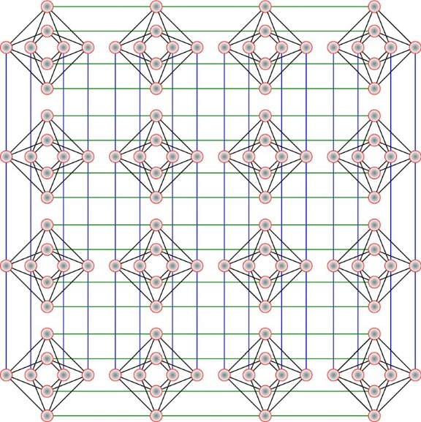
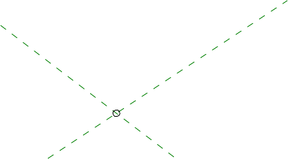
www.nature.com/scientificreports/
Figure 1. Characteristics of D-Wave processors. (a) A typical annealing protocol for the quantum Ising chain defined in Eq. (6) and implemented on the chimera graph. (b) 4 × 4 × 8 chimera graph with L = 128 qubits. The
annealing time reads τ.
annealing process by manipulating g(t) and ∆(t). In the ideal quantum annealer the quantum Ising chain (6)
undergoes unitary and adiabatic dynamics, while ∆(t) is varied from ∆(0) ≈ 0 to ∆(τ)  0, and g(t) from
g(0)  0 to g(τ) ≈ 0 (cf. Fig. 1a).
The obvious choice for the observables is the (customary renormalized) Hamiltonian in the beginning and the end of the computation, Ωi = Ι − H(0)/[2πg(0)] and Ωf = −H(τ)/[2πJ∆(τ)]. Consequently, we have
L
L−1
Ωi = Ι − ∑ σn and Ωf = − ∑ σn σn+1,
x
z z
(7)
i=n
n=1
where we included Ι in the definition of Ωi to guarantee γ = 1 for unital dynamics.
by ρ0 =
→ → ,
For the ideal computation, the initial
state, ρ0 ,
is chosen to be given
where
→ :=
☹ → → → ☹ is a non-degenerate, paramagnetic state – the ground state of H(0) (and thus of Ωi),
where all spins are aligned along the x-direction. As a result,
Mi[ρ0] = ρ0 and ωi = L − 1,
(8)
as Ωi and H(0) commute by construction (Unfortunately, the D-Wave system does not allow us to test the accu-
racy of the initial preparation that leads to Eq. (8)).
Moreover, if the quantum annealer is ideal, then the dynamics is not only unitary, but also adiabatic. In gen- eral, we can write Ετ [ρ] = UτρUτ , where
†
 i
τ

−fi H (s) ds
∫
Uτ = T>exp 

(9)
0
and as a result Ετ [ρ0] = |f 〉〈f | for the adiabatic evolution. Here,|f 〉 is the final state, a defect-free state where all spins are aligned along the z-direction. Therefore, ωf = ωi.
In general, however, due to decoherence47, dissipation48 or other (hardware) issues49, the evolution may be neither unitary nor adiabatic and thus Ετ [ρ] = ρτ. Nevertheless, for the computation to succeed there has to be a
finite probability on the ground state, p = 〈f |ρτ|f 〉 > 0. Therefore, the quantum efficacy (5) in the adiabatic limit
becomes
γ = e−∆ω f |f = p + ∑ p → 1,
n
n≠0
(10)
that is, a process independent quantity.
The D-Wave annealer prepares the initial state by thermal relaxation, thus the initial state is at best a thermal
→
state with a hight weight on the ground state of H(0),
. Therefore, we can further write
pm→n ≈ δ0,m pn|m = δ0,m pn|0 ,
(11)
3
Scientific RepoRts |
(2018) 8:17191 | DOI:10.1038/s41598-018-35264-z

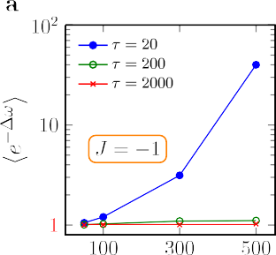
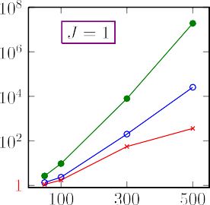
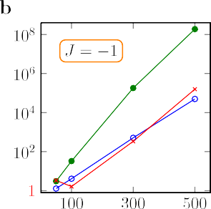
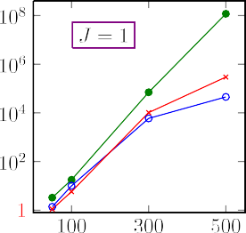
www.nature.com/scientificreports/
Figure 2. Test of the quantum fluctuation theorem. (a) The quantum efficacy (4) as a function of system size L
for different annealing times τ. The results were obtained using the DW2X chip. (b) Shows the same results as in
a for the newest 2000Q processor. Note that〈exp(−∆ω)〉 = 1 signifies unital dynamics.
f
where pn|0 is the probability of measuring ωn , conditioned on having first measured the ground state. Since we assume the latter event to be certain, pn|0 ≡ pn is just the probability of measuring the final outcome ωn (we
dropped the superscript). Therefore,
〈e−∆ω〉 = e−∆ω p
−∆ω
∑
+ e p .
n
0
n
(12)
n≠0
Comparing this equation with Eq. (10) we finally obtain a condition that is verifiable experimentally:
1
p = (|ω |) =
if |ωn| = L − 1,
otherwise.

n
n
0
(13)
The probability density function (|ωn|) is characteristic for every process that transforms one ground state of
the Ising Hamiltonian (6) into another. It is important to note that the quantum fluctuation theorem (4) is valid for arbitrary duration τ – any slow and fast processes. Therefore, even if a particular hardware does not anneal the initial state adiabatically, but only unitally (which is not easy to verify experimentally) Eq. (13) still holds – given that the computation starts and finishes in a ground state, as outlined above.
As an immediate consequences, every τ-dependence of  must come from dissipation or decoherence. This is a clear indication that the hardware interacts with its environment in a way that cannot be neglected.
Experimental Test on the D-Wave Machine
We generated several work distributions (|ωn|) – (3) through “annealing” on two generations of the D-Wave machine (2X and 2000Q), which implemented an Ising chain as encoded in Hamiltonian (6). All connections on the chimera graph have been chosen randomly. A typical example is shown in Fig. 1b, where red lines indicate
nonzero zz-interactions between qubits. The experiment was conducted N = 106 times. Figure 3 shows our final
results obtained for different chain lengths L, couplings between qubits Ji and annealing times τ on 2X, and Fig. 4 for 2000Q. The current D-Wave solver reports the final state energy which is computed classically from the meas-
ured eigenstates of the individual qubits. In Fig. 2 we show the resulting exponential averages,〈exp(−∆ω)〉.
Discussion of the Experimental Findings
We observe, that there are cases for which the agreement is almost ideal. In particular, this is the case on 2X for
J = −1 and slow anneal times τ, see Fig. 3. In this case the (|ωn|) is close to a Kronecker-delta, and the dynamics is unital, see Fig. 2. Note that the validity of the fluctuation theorem (4) is a very sensitive test to aberrations, since rare events and large fluctuations are exponentially weighted.
However, in the vast majority of cases (|ωn|) is far from our theoretical prediction (13) and the dynamics is
clearly not even unital, compare Fig. 2. Importantly,  clearly depends on τ indicating a large amount of compu- tational errors are generated during the annealing. Similar conclusions have been obtained in the literature, and it has been suggested that D-Wave’s dynamics can be described by a quantum master equation32,50–54. Note, how- ever, that an analysis of the source of error in the D-Wave machine is not the purpose of the present work. Rather, our experimental findings prove the utility of the quantum fluctuation theorem in the diagnostics of quantum annealers.
Interestingly, the D-Wave 2X we tested (This machine is based in Los Alamos National Laboratory) produces asymmetric results. The work distributions for ferromagnetic (J > 0) and antiferromagnetic (J < 0) couplings
should be identical. On the other hand, the newest 2000Q D-Wave machine exhibits less asymmetrical behavior, however, its overall accuracys is not as good as its predecessor’s (see Fig. 4).
Complicated optimization problems involve both negative and positive values of the coupling matrix Jij. That makes debugging “asymmetric” quantum annealers a much harder task. Our proposal for diagnosing the hard- ware with the help of the quantum fluctuation theorem allows users to asses to what extent a particular hardware exhibits this unwanted behavior. Moreover, our test is capable of detecting any exponentially small departure
4
Scientific RepoRts |
(2018) 8:17191 | DOI:10.1038/s41598-018-35264-z

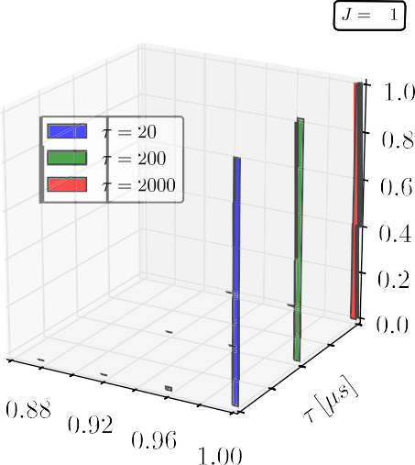
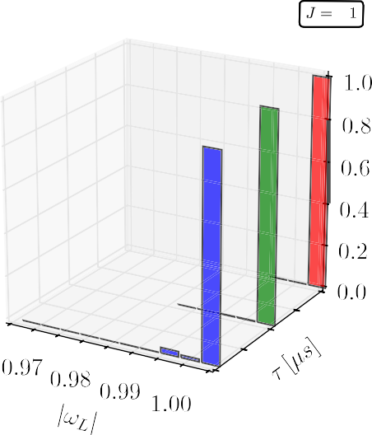
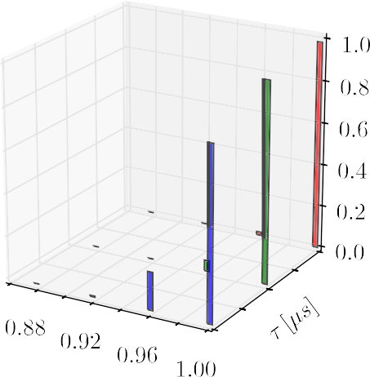
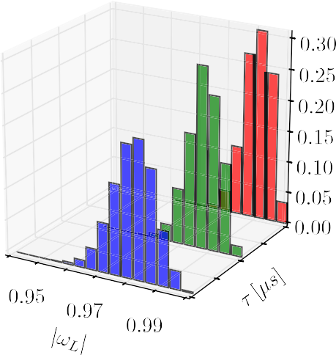
www.nature.com/scientificreports/
Figure 3. Work distribution for a quantum annealer. Distribution (∆ω) – (3) for the quantum Ising chain (6) implemented on a D-Wave 2X chip. Plots (a,b) show the final results for J = −1 (antiferromagnetic) and J = 1 (ferromagnetic) cases, respectively. To obtain each distribution (∆ω) the experiment was repeated N = 106. Error bars are negligible and thus not shown in the plots. The renormalized energy is given by ωL = ω/(L − 1),
where L is the length of a randomly chosen chain.
from “normal operation” that may potentially result in a hard failure. We believe this to be the very first step to create fault tolerant quantum hardware55.
As a final note, we emphasize that any departure from the ideal distribution  (13) for the Ising model indi- cates that the final state carries “kinks” (topological defects). Counting the exact number of such imperfections allows one to determine by how much the annealer misses the true ground state56. In a perfect quantum annealer this number should approach zero.
The Ising model (6) undergoes a quantum phase transition44. Near the critical point, i.e., at tc where
∆(tc) = g(tc), the gap – energy difference between the ground and a first accessible state – scales like 1/L. Thus, one could argue that the extra excitations come from a Kibble-Zurek like mechanism57,58. However, even the
fastest quench (τ ∼ 20 µs) exceeds the adiabatic threshold59,
2
L
τ ∼
∼ 10 µs,
ad
∆(tc)
(14)
for the system sizes of order L ~ 102. The error observed are due to decoherence54.
5
Scientific RepoRts |
(2018) 8:17191 | DOI:10.1038/s41598-018-35264-z

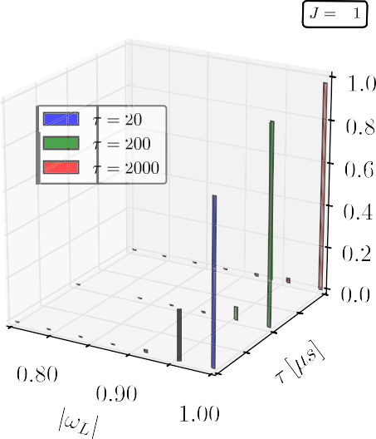
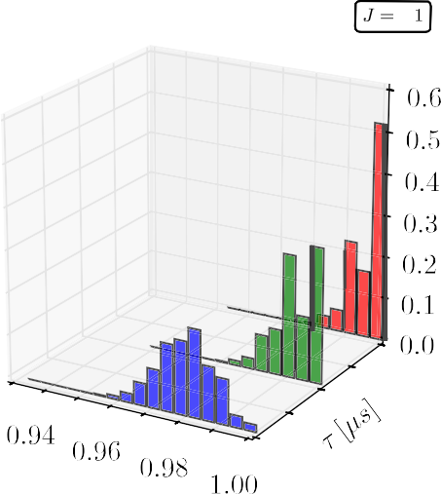
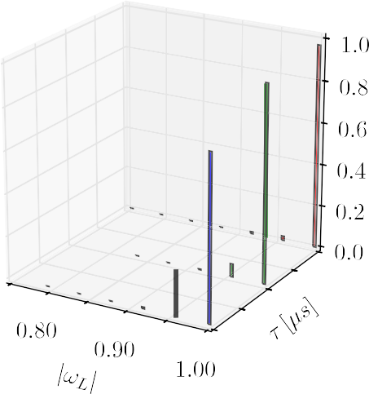
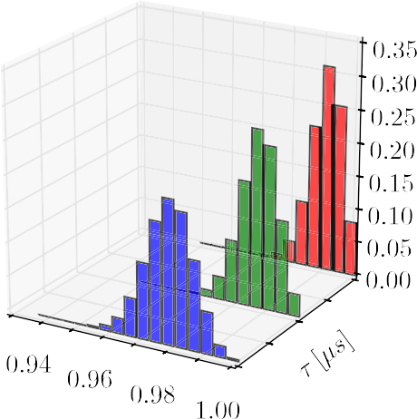
www.nature.com/scientificreports/
Figure 4. Work distribution for a quantum annealer. The same results as depicted in Fig. 3 but obtained from the newest generation of D-Wave quantum annealers – 2000Q.
Concluding Remarks
In the present analysis we have obtained several important results: (i) We have proposed a practical use and appli- cability of quantum fluctuation theorems. Namely, we have argued that the quantum fluctuation theorem can be used to benchmark the accuracy of quantum annealers. Our proposal was tested on two generations of the D-Wave machine. Thus, (ii) our results indicate the varying accuracy of distinct machines of the D-Wave hardware, and our method can be used to identify underperforming machines, which are in need of re-calibration. Finally,
(iii) almost as a byproduct we have performed the first experiments and verification of quantum fluctuation the- orems in a many particle system.
An interesting and immediate application of our present work would be to diagnose the accuracy of the D-Wave machine when applying quantum error correction. In particular in this case, the exponential sensitivity to computational errors of the fluctuation theorem might provide a guideline for developing optimal strategies.
References
- Boixo, S. et al. Characterizing quantum supremacy in near-term devices. Nat. Phys. 14, 595 (2018).
- Gardas, B., Rams, M. M. & Dziarmaga, J. Quantum artificial intelligence to simulate many body quantum systems. Preprint at arXiv:1805.05462v1 (2018).
- Gao, X., Wang, S.-T. & Duan, L.-M. Quantum supremacy for simulating a translation-invariant ising spin model. Phys. Rev. Lett.
118, 040502 (2017).
- Bremner, M. J., Montanaro, A. & Shepherd, D. J. Achieving quantum supremacy with sparse and noisy commuting quantum computations. Quantum 1, 8 (2017).
6
Scientific RepoRts |
(2018) 8:17191 | DOI:10.1038/s41598-018-35264-z

www.nature.com/scientificreports/
- Nielsen, M. A. & Chuang, I. L. Quantum Computation and Quantum Information. (Cambridge University Press, Cambridge, UK, 2010).
- Landauer, R. Irreversibility and heat generation in the computing process. IBM J. Res. Dev. 5, 183 (1961).
- Landauer, R. Information is physical. Phys. Tod. 4, 23 (1991).
- Bérut, A. et al. Experimental verification of Landauer’s principle linking information and thermodynamics. Nature 483, 187 (2012).
- Deffner, S. & Jarzynski, C. Information processing and the second law of thermodynamics: An inclusive, hamiltonian approach.
Phys. Rev. X 3, 041003 (2013).
- Boyd, A. B. & Crutchfield, J. P. Maxwell demon dynamics: Deterministic chaos, the szilard map, and the intelligence of thermodynamic systems. Phys. Rev. Lett. 116, 190601 (2016).
- Sagawa, T. & Ueda, M. Minimal energy cost for thermodynamic information processing: Measurement and information erasure.
Phys. Rev. Lett. 102, 250602 (2009).
- Horowitz, J. M. & Esposito, M. Thermodynamics with continuous information flow. Phys. Rev. X 4, 031015 (2014).
- Parrondo, J. M. R., Horowitz, J. M. & Sagawa, T. Thermodynamics of information. Nat. Phys. 11, 131 (2015).
- Strasberg, P., Schaller, G., Brandes, T. & Esposito, M. Quantum and information thermodynamics: A unifying framework based on repeated interactions. Phys. Rev. X 7, 021003 (2017).
- Sagawa, T. & Ueda, M. Second law of thermodynamics with discrete quantum feedback control. Phys. Rev. Lett. 100, 080403 (2008).
- Horowitz, J. M. & Vaikuntanathan, S. Nonequilibrium detailed fluctuation theorem for repeated discrete feedback. Phys. Rev. E 82, 061120 (2010).
- Sagawa, T. & Ueda, M. Generalized Jarzynski equality under nonequilibrium feedback control. Phys. Rev. Lett. 104, 090602 (2010).
- Jarzynski, C. Nonequilibrium equality for free energy differences. Phys. Rev. Lett. 78, 2690 (1997).
- Jarzynski, C. Equalities and inequalities: Irreversibility and the second law of thermodynamics at the nanoscale. Ann. Rev. Cond. Mat. Phys. 2, 329 (2011).
- Jarzynski, C. Diverse phenomena, common themes. Nat. Phys. 11, 105 (2015).
- Talkner, P., Lutz, E. & Hänggi, P. Fluctuation theorems: Work is not an observable. Phys. Rev. E 75, 050102 (2007).
- Campisi, M., Hänggi, P. & Talkner, P. Colloquium: Quantum fluctuation relations: Foundations and applications. Rev. Mod. Phys. 83, 771 (2011).
- Gardas, B. & Deffner, S. Thermodynamic universality of quantum carnot engines. Phys. Rev. E 92, 042126 (2015).
- Deffner, S. Quantum entropy production in phase space. EPL 103, 30001 (2013).
- Allahverdyan, A. E. Nonequilibrium quantum fluctuations of work. Phys. Rev. E 90, 032137 (2014).
- Roncaglia, A. J., Cerisola, F. & Paz, J. P. Work Measurement as a Generalized Quantum Measurement. Phys. Rev. Lett. 113, 250601 (2014).
- Hänggi, P. & Talkner, P. The other QFT. Nat. Phys. 11, 108 (2015).
- Talkner, P. & Hänggi, P. Aspects of quantum work. Phys. Rev. E 93, 022131 (2016).
- Deffner, S., Paz, J. P. & Zurek, W. H. Quantum work and the thermodynamic cost of quantum measurements. Phys. Rev. E 94, 010103 (2016).
- Kurchan, J. A Quantum Fluctuation Theorem. arXiv:cond-mat/0007360 (2000).
- Tasaki, H. Jarzynski Relations for Quantum Systems and Some Applications. arXiv:cond-mat/0009244 (2000).
- Albash, T., Lidar, D. A., Marvian, M. & Zanardi, P. Fluctuation theorems for quantum processes. Phys. Rev. E 88, 032146 (2013).
- Rastegin, A. E. Non-equilibrium equalities with unital quantum channels. J. Stat. Mech.: Theo. Exp. 2013, P06016 (2013).
- Jarzynski, C., Quan, H. T. & Rahav, S. Quantum-classical correspondence principle for work distributions. Phys. Rev. X 5, 031038 (2015).
- Gardas, B., Deffner, S. & Saxena, A. Non-hermitian quantum thermodynamics. Sci. Rep. 6, 23408 (2016).
- Batalhão, T. B. et al. Experimental reconstruction of work distribution and study of fluctuation relations in a closed quantum system.
Phys. Rev. Lett. 113, 140601 (2014).
- An, S. et al. Experimental test of the quantum Jarzynski equality with a trapped-ion system. Nat. Phys. 11, 193 (2015).
- Smith, A. et al. Verification of the quantum nonequilibrium work relation in the presence of decoherence. New J. Phys. 20, 013008 (2018).
- Vedral, V. An information-theoretic equality implying the Jarzynski relation. J. Phys. A: Math. Theor. 45, 272001 (2012).
- Kafri, D. & Deffner, S. Holevo’s bound from a general quantum fluctuation theorem. Phys. Rev. A 86, 044302 (2012).
- Manzano, G., Horowitz, J. M. & Parrondo, J. M. R. Nonequilibrium potential and fluctuation theorems for quantum maps. Phys. Rev. E 92, 032129 (2015).
- Alicki, R. Pure decoherence in quantum systems. Open Sys. & Inf. Dyn. 11, 53 (2004).
- Seifert, U. Stochastic thermodynamics: principles and perspectives. Euro. Phys. J. B 64, 423 (2008).
- Zurek, W. H., Dorner, U. & Zoller, P. Dynamics of a quantum phase transition. Phys. Rev. Lett. 95, 105701 (2005).
- Lanting, T. et al. Entanglement in a quantum annealing processor. Phys. Rev. X 4, 021041 (2014).
- Kadowaki, T. & Nishimori, H. Quantum annealing in the transverse ising model. Phys. Rev. E 58, 5355 (1998).
- Zurek, W. H. Decoherence, einselection, and the quantum origins of the classical. Rev. Mod. Phys. 75, 715 (2003).
- Chenu, A., Beau, M., Cao, J. & del Campo, A. Quantum simulation of generic many-body open system dynamics using classical noise. Phys. Rev. Lett. 118, 140403 (2017).
- Young, K. C., Blume-Kohout, R. & Lidar, D. A. Adiabatic quantum optimization with the wrong hamiltonian. Phys. Rev. A 88, 062314 (2013).
- Boixo, S., Albash, T., Spedalieri, F. M., Chancellor, N. & Lidar, D. A. Experimental signature of programmable quantum annealing.
Nat. Comm. 4, 2067 (2013).
- Albash, T., Vinci, W., Mishra, A., Warburton, P. A. & Lidar, D. A. Consistency tests of classical and quantum models for a quantum annealer. Phys. Rev. A 91, 042314 (2015).
- Albash, T., Hen, I., Spedalieri, F. M. & Lidar, D. A. Reexamination of the evidence for entanglement in a quantum annealer. Phys. Rev. A 92, 062328 (2015).
- Albash, T., Boixo, S., Lidar, D. A. & Zanardi, P. Quantum adiabatic markovian master equations. New J. Phys. 14, 123016 (2012).
- Albash, T. & Lidar, D. A. Decoherence in adiabatic quantum computation. Phys. Rev. A 91, 062320 (2015).
- Martinis, J. M. Qubit metrology for building a fault-tolerant quantum computer. npjQI 1, 15005 (2015).
- Gardas, B., Dziarmaga, J., Zurek, W. H. & Zwolak, M. Defects in quantum computers. Sci. Rep. 8, 4539 (2018).
- Kibble, T. W. B. Topology of cosmic domains and strings. J. Phys. A: Math. Gen 9, 1387 (1976).
- Zurek, W. H. Cosmological experiments in superfluid helium? Nature 317, 505 (1985).
- Dziarmaga, J. Dynamics of a quantum phase transition: Exact solution of the quantum Ising model. Phys. Rev. Lett. 95, 245701 (2005).
Acknowledgements
We appreciate stimulating and insightful discussions with Edward Dahl of D-Wave Systems and Daniel Lidar.
B.G. was supported by Narodowe Centrum Nauki under Project No. 2016/20/S/ST2/00152 and QuantERA program 2017/25/Z/ST2/03028. This research was supported in part by PL-Grid Infrastructure. SD acknowledges support by the U.S. National Science Foundation under Grant No. CHE-1648973.
7
Scientific RepoRts |
(2018) 8:17191 | DOI:10.1038/s41598-018-35264-z

www.nature.com/scientificreports/
Author Contributions
B.G. and S.D. developed ideas and derived the main results. B.G. prepared figures. B.G., S.D. wrote and reviewed the manuscript.
Additional Information
Competing Interests: The authors declare no competing interests.
Publisher’s note: Springer Nature remains neutral with regard to jurisdictional claims in published maps and institutional affiliations.
Open Access This article is licensed under a Creative Commons Attribution 4.0 International License, which permits use, sharing, adaptation, distribution and reproduction in any medium or
format, as long as you give appropriate credit to the original author(s) and the source, provide a link to the Cre- ative Commons license, and indicate if changes were made. The images or other third party material in this article are included in the article’s Creative Commons license, unless indicated otherwise in a credit line to the material. If material is not included in the article’s Creative Commons license and your intended use is not per-
mitted by statutory regulation or exceeds the permitted use, you will need to obtain permission directly from the copyright holder. To view a copy of this license, visit http://creativecommons.org/licenses/by/4.0/.
© The Author(s) 2018
8
Scientific RepoRts |
(2018) 8:17191 | DOI:10.1038/s41598-018-35264-z

