
Molecular degradation of ancient documentsrevealedby1HHR-MASNMR spectroscopy
CarmeloCorsaro1,DomenicoMallamace2,JoannaLIojewska3,FrancescoMallamace1,LucianoPietronero4& MauroMissori5
OPEN
SUBJECT AREAS:CHEMICAL PHYSICSBIOPOLYMERS
APPLIED PHYSICS
POLYMERS
Received18June2013
Accepted23 September 2013
Published9 October2013
1DipartimentodiFisicaeScienzedellaTerraandCNISM,Universita`diMessina,VialeF.Stagnod’Alcontres31,I-98166,Messina,Italy,2DipartimentodiScienzedell’Ambiente,dellaSicurezza,delTerritorio,degliAlimentiedellaSalute,Universita`diMessina,VialeF.Stagnod’Alcontres31,98166Messina,Italy,3FacultyofChemistry,JagiellonianUniversity,Ingardena3,30-060Krako´w,Poland,4Istituto dei Sistemi Complessi, Consiglio Nazionale delle Ricerche, Via dei Taurini 19, 00185 Roma, Italy,5Istituto dei SistemiComplessi,ConsiglioNazionaledelleRicerche,ViaSalariakm29.300,00015MonterotondoStazione(Roma),Italy.
For centuries mankind has stored its knowledge on paper, a remarkable biomaterial made of natural cellulosefibers.However,spontaneouscellulosedegradationphenomenaweakenanddiscoloratepaperover time. The detailed knowledge of products arising from cellulose degradation is essential in understanding deterioration pathways and in improving durability of cultural heritage. In this study, for the first time, products of cellulose degradation were individually detected in solid paper samples by means of an extremely powerful proton HR-MAS NMR set-up, in combination to a wise use of both ancient and, as reference, artificially aged paper samples. Carboxylic acids, in addition to more complex dicarboxylic and hydroxy-carboxylic acids, were found in all samples studied. Since these products can catalyze further degradation, their knowledge is fundamental to improve conservation strategies of historical documents. Furthermore, the identification of compounds used in ancient production techniques, also suggests for artifacts dating, authentication andprovenance.
Correspondenceandrequestsformaterialsshouldbeaddressedto
C.C. (ccorsaro@unime.it) or M.M.(mauro.missori@isc.
cnr.it)
C
isproducedinanaturalwayatanannualrateof1011–1012tonnes.Itisproducedeitherinahighlypure
ellulose is the most abundant biopolymer on Earth and has served mankind for thousands of years as an
1
indispensable material for human civilization, such as clothing, housing and as writing medium. Cellulose
form, as for example in the cotton plants or by some strains of bacteria2, or combined with lignin and with other polysaccharides, so-called hemicelluloses in the cell wall of woody plants1,3.
SincetheEgyptianpapyri,cellulosehasplayedanimportantroleinhumanculturebecauseithasbeenwidely used as convenient vehicle for the acquisition, storage and dissemination of human knowledge. Paper, in particular,wasinventedinChinainthe2ndcenturyA.D.and,independently,inMesoamericainthe7thcentury A.D..TheartcraftofmakingpaperspreadfromtheFarEasttotheWesternWorldintheMiddleAges,andfor centuries,agrowingnumberofculturalresourceshavebeenaccumulatinginarchives,librariesandmuseums,all over theworld4.
Paper is produced from a dilute suspension of cellulose fibers in water, that are then drained through a sieve, pressed and dried, to obtain a sheet composed of a network of randomly interwoven fibers. The paper composi- tion varies depending on the production period and technology employed. In the Middle Ages in Europe paperwasmadeupofpurecellulosefibers(.90%inweight)fromcotton,linenorhemp,usuallyobtainedfromragswith the addition of animal glue as a sizing agent4,5.
Cellulose is a linear homopolymer composed of b-D-glucopyranose units (C₆H₁₀O₅)_{n}, which are linked togetherbyb-(1,4)-glycosidicbondsuptoformchainswithnfrom<102to<104elements.Thecellulosechains haveastrongtendencytoaggregateintohighlyorderedstructuralentitiesthroughanextendednetworkofboth intra and intermolecular hydrogen bonds. As a consequence, a hierarchical arrangement is formed, fromele- mental fibrils through microfibrils up to fibers, whose diameter ranges from around 1 to around 10 mm1. Elementalfibrils,basiccomponentsofthecellulosesupramolecularstructure,includeassemblyofhighlyordered (crystalline)domainsandofdisordered(amorphous-like)regions6.Crystallinedomainsconstitutefromaround 60 to 70%, of total cellulose material depending on its origin andhistory.
SCIENTIFICREPORTS| 3 : 2896 | DOI: 10.1038/srep02896
1

www.nature.com/scientificreports
The occurrence of a system of pores and voids, non-uniform in sizesandshapes,iscomplementarytothemoleculararchitectureof cellulose fibers. A quantitative analysis on their sizedistributionrevealsthatporesdiametersareapproximately1nmwhentheyarefullyconfinedintheamorphousregionsofcelluloseelementalfibrils,otherwise their diameter can reach hundreds of nanometerswithin thecellulosefibers.Arrangementandcontributionofporesandvoids within the polymeric structure is of great importance, since they stronglyinfluencereactivityofcellulose(duetowaterandexternal agentsaccessibility)aswellasmechanicalpropertiesoffibers7–9.
Isolated cellulose possesses the most thermodynamically stable conformation amongst polysaccharides that allows its excellent stability over time10. Natural aging of paper-based materials can be accelerated by internal components and external agents often acting in a synergic manner11,12. Internal components include lignin, rosin and alum, whereas external agents comprise humidity, air, visible and/or ultraviolet radiation, pollutants, or microorganisms. On mac- roscopic scale, paper degradation is revealed by the weakening of mechanical properties of sheets and by widespread or localized dis- coloration. From a microscopic perspective paper degradation can be seen as the combination of three most important processes: i) recrys- tallization, ii) acid hydrolysis of b-D-(l,4)-glycosidic bonds, and iii) oxidation of the b-D-glucopyranose units; processes which, however, occur in different time scales1,11,13.
Acidhydrolysis,moreprofoundinmodernpapers,mainlyaffects the mechanical properties of sheets, by shortening the cellulose chains. The cleavage of the glycosidic bond is catalyzed either by the hydronium cations (H₃O1), formed through acidic hydrolysis ofinternalcomponents,suchasalum,orbytheactionofcellulolytic enzymes1,12.
Incontrasttoacidhydrolysis,oxidationofcellulose,runningthrough the radical mechanism initiated by activeoxygenspecies,isacomplexprocesswithmanypossibleroutescomprisingnumer-ousparallelandconsecutivestepsofreaction.Oxidativedegradationusuallystartswiththeconversionofsingleb-D-glucopyranoseunitstoafairlyunstableoxidizedderivativewhichinducesringopeningand/orchaincleavage1,13.Destabilizationofchairconformationofb-D-glucopyranoserings,accompaniedbytheoccurrenceofcarbonylgroups(includingchromophores14),isduetoachangeinthehybrid-izationofcarbonatomscomposingtheringfromsp3tosp2.Thisinturnchangesthechargedistributiononoxygenatomsinthegluco-pyranoseoxidizedformwhichfurtherfacilitatesdepolymerization10.Depolymerization,throughhydrolysisofglycosidicbondscanbeprofoundlyenhancedbyacidicoxidationproductssuchascarboxylicgroupsembeddedintocellulosepolymerand,also,bylightproductsofdegradationsuchasvolatilecompounds15.Overall,thesedegrada-tionprocessesfinallyresultintheformationofagreatnumberoflowmolecular mass-products, such as glucopyranose, orseveralotherorganiccompounds,suchasaceticandformicacids16,17,oligomers
of different composition (also hydrocarbons) and furfural15,18.
Oneofthemainproblemsinstudyingthedegradationofancientartifacts is that the environmental conditions to whichthesamplesweresubjectedthroughouttheirhistoryareunknown.However,anartificialhigh-temperatureageingallowsconstantmonitoringofenvironmental conditions even though it cannot perfectlymimicaslownaturaldegradationprocess,whichprovidesusefulinformationforancientpaper11.Therefore,tounderstandtheroleofthedifferentagingfactorsweusedmodelpapersamplesthatwereartificiallyaged.The study of lightproductsof paperdegradationformedduringnaturalagingisnecessarytounderstanddegradationpathwaysandtoachievefurtherprogressinpreservationandconservationofcellulosicmaterials19. Recognitionand description of lightproducts(degrada-tionmarkers)canalsobeusedtoevaluatethepaperdegradationstage
- important from the point of view of paper conservators15.
The light products of paper degradation are usually analysed bymeansofdifferentexperimentalmethodslikegasorliquid
chromatography15, electrophoresis16, mass spectrometry16,17, X-ray and Neutron Scattering6–8and Nuclear Magnetic Resonance (NMR)18; techniques which sometimes involve special multistep sample preparation protocols. In order to simplify studies which wouldallowfocusingonareducednumberofspecies,anextraction procedure can be applied to degraded cellulolytic materials. Extractionprocesseswereusedtoseparatespecificclassesofchem- icalcompounds,suchaslowmolarmassaliphaticorganicacids,and aromatic(phenolicandfuranic),orhydroxybenzoquinones17–19.The procedures hence require an a priori selection of the target com- pounds after the paper degradation.
Another method of sampling, which is non-destructive in char- acter,isbasedoncollectingthevolatileorganiccompounds(VOCs) emitted by paper during its degradation, which are believed to be responsibleforthecharacteristicsmellofoldbooks.Theformation ofVOCswithlowmolecularmasshasbeenknownsincethemiddle ofthe20thcentury.Recentadvancesinanalyticalmethods,suchas gas chromatography-mass spectrometry, allowed for the experi- mental identification of several compounds emitted during paper degradation,e.g.furfural and long-chainhydrocarbons10,20,21.
If analyses of precious paper-based artifacts are considered in terms of assessing their degradation state, fully non-destructive methods have to be applied.
Amongdifferentspectroscopicmethods,highresolutionNMRisa well-suited technique to study complex materials like: soft matter (polymers, polyelectrolites, gels, etc.), biological samples (cells, DNA, proteins, etc.) intact tissues, organs, food specimens, mem- branes and interfaces at or out of the equilibrium. In this frame1HHigh Resolution Magic Angle Spinning (HR-MAS) represents a recent and extremely powerful NMR method for the investigation of micro quantities of semi-solid compounds without the need of time-consuming separation procedures. It is the techniqueparticu- larlysuitedforthestudyofcomplexmaterials,likesoftmatterand biological samples. Specifically, it allows the characterization of metabolicphenotypesormetaboliteprofilesofcells,intacttissues, organs, food specimens, hydrated protein and DNA and others, under both normal and altered conditions22–24. For this purpose1HHR-MAStakesalsoadvantageofmostoftheclassicaloneandtwo dimensional homonuclear and heteronuclearexperiments23,25.
Furthermore, it enables the investigation of the effect of hydrogen bonding that is of fundamental importance during paper degrada- tion. Hence, we take advantage of this sensitive technique to study light degradation products in ancient and artificially aged paper. In addition, NMR two dimensional (2D) experiments like COrrelation SpectroscopY (COSY) and TOtal Correlation SpectroscopY (TOCSY) can be used for the same target.
Inreferencetothisworkthedifferencebetweennaturalandarti- ficial paper degradation is described just in terms of degradation products. Specifically, for the first time, the light degradationpro- ductsofcellulosewereindividuallydetectedinsolidpapersamples both artificially and naturally aged. In Fig. 1 we show the1H HR- MASNMRspectrumofasampleproducedinMilan(Italy)in1430 fromwhichweareabletoidentifythemainproductsofdegradation of paper over the centuries. As an example Fig. 1 shows the char- acteristic NMR peaks that evolve directly from the hydrolytic and oxidative mechanisms leading to glycosidic bond scission of cel- lulose.Inaddition,wewereabletoidentifyanextremelyinteresting bio-markerinformofcholine(andotheramino-compoundssuchas phenylalanineandtrimethylammine)whosepresencegivesevidence of ancient production methods, which employed glue fromanimal connectivetissues(i.e.denaturedcollagen)toimprovepaperwriting quality4.Forexample,thepresenceofcholinewhichiseasilyfoundin fishtissues,providesapossiblemarkertoaddresstheprovenanceof ancient artifacts.
Theaimofourworkistodemonstratetheopportunitiesof1HHR- MASNMRtechniquetorevealthemaincellulosedegradation
SCIENTIFICREPORTS| 3 : 2896 | DOI: 10.1038/srep02896
2

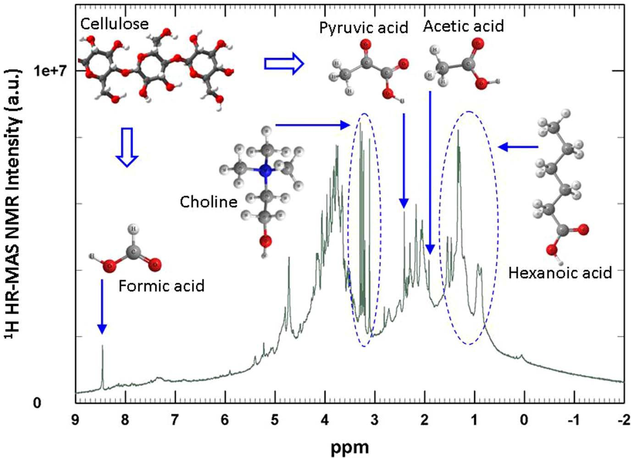
www.nature.com/scientificreports
Figure 1|1H HR-MAS NMR spectrum of ancient sample A3 (green line). The chemical structures of main degradation products of cellulose and additives used in the ancient production techniques, as revealed in this study, are also shown.
products in ancient and artificially aged paper on site without the needofaprioriextractionfromthesolid.Thisapproachishopedto open perspectives for the molecular understanding of thedegrada- tion processes of cultural heritage supported on cellulose, fortheir conservation and preservation. Finally, the identification of com- pounds used in ancient production techniques, can shed light on artifacts provenance andauthentication.
resonances as, for instance, butyric acid (4 carbon atoms) which shows bands at 0.86, 1.54 and 2.16ppm28.
BesidesNMRpattern typicalofcarboxylic acids,anevident shoul-derispresentinthespectrumofsampleP2centered around3.4ppm,superimposed with severallowintensity peaks (Fig.4B). Thechemicalshiftofthisshoulder dropsinto the rangeofthe characteristic frequen-ciesofcellobiose,thatisbetween3and4ppm(Fig.2,dark blueline).
These results show that non-negligible amount of carboxylic acids is present even in the not artificially aged sample (P2) made of pure cellulose (Fig. 2, black line). The fact that the characteristic bands of carboxylic acids are more intense than those of cellulose is due to higher sensitivity of1H HR-MAS NMR to amorphous regions in comparison with crystalline regions of cellulose (prevailing in sam- ples). It is noteworthy that degradation processes take place within amorphous regions, which makes HR-MAS technique, especially, useful in studying degradation processes and recognizing degrada- tion products in ancient samples.
As the paper ages (byapplyinghightemperatureandhumidity),sharp peak components increase whereas the broadresonances decrease(Fig. 2 B, grey and greenlines).Thistendencyis probably due to the fact that the paper is beinghydratedduring the aging process,enablingthespectrato reveal the signals ofmobilecel-lulose-like species(3–4ppm) and lightproductsofcellulose degrada-tion(0–3ppm).Indeed,waterisaknowncelluloseplasticizer.Infact, uponartificialaging of P2 samples, as thecellulose structure swells, makingthecellulose fibersmoreaccessibleto water andoxygen,theincreasedmolecularmobility makes evident newfeaturesin the1H NMR spectra. For moderately aged sample P2C9024, even though peaks at 0.86,1.30,1.54 and 2.16ppmare stilldiscernible,new rel- evantfeaturesappear.Firstly,sharppeaksat1.91and8.45ppm(Fig.2
B)canbeattributedtothesimplestcarboxylicacids,aceticandformic acids,respectively28. Furthermore,a sharppeakat about 2.40ppmcanbeattributedtodicarboxylicacids with 4carbonatoms such as suc- cinic and pyruvic acids (Fig. 3 B)28. By means of Chenomx package even minorcompoundswere safely identified, as for example,methylmalonic acid (aC-methylated derivativeofmalonicacid), whichshows peaksatabout1.12 and 3.07ppm(Fig.3B and Fig. 4 B). Thepresenceofthese acidic compounds reinforcesthehypothesisthat thedegradation processesareinitially oxidativeinnature16.
Results
The1H HR-MAS NMR spectra ofD₂O-hydrated samples are re- portedinFig.2:ancientsamplesA1,B1andA3inpanelA,model samplesP2,P2C9024andP2C9048inpanelB.Atthebottomofboth panelsthespectrumofcellobiose,therepeatingfragmentofcellulose, dissolved inD₂O, is reported as areference.
ThespectrumofthenotagedmodelpapersampleP2(blacklinein Fig.2B),madeofverypurecottoncellulose,representsamoderately simple case where only two broad bands are evident, one centeredat
1.30ppmand another much broader at 1.54ppm. Secondary bands at 0.86 and a smoother one around 2.16ppmare also observed. To look at these ensembles in more detail the horizontally expanded spectra are shown in Fig. 3 (from 3 to 0.5ppm), in Fig. 4 (from 4.5 to 3ppm) and in Fig. 5 (from 5 to 0.8ppm).
The detected resonances in NMR spectra were assignedbymeansof the well established NMR Suite Professional version7.1(Cheno-mx, Alberta, Canada)26,27, 2D homonuclear NMRexperimentsandmost reliable online NMR databases basedonexperimentallyacquired spectra: the online Human MetabolomeDatabase28andBiologicalMagneticResonanceDataBank29(seeMethodsfordetails).The simplest possible interpretation of theobservedensemblesinvolvescarboxylicacidsasproductsofcelluloseoxidation.Fromachemicalpointofview,becausecelluloseunitsarecomposedof6carbon atoms bonded in a glucopyranose ring, adegradationproductresulting from oxidation coupled with ringopening, should bethehexanoic acid (C₅H₁₁COOH). Just for a visual comparison,thehex-anoic acid1H NMR spectrum inD₂O(taken from theonlineHumanMetabolomeDatabase28)isreportedatthebottomofFig.3.Thespectrumofhexanoicacidshowsfourpeaks(ofdifferentmultipli-city) centered at 0.86, 1.30, 1.54 and 2.16ppm. However,othercarb-oxylicacidsoflowermolecularmasscanalsooccurwithsimilar
SCIENTIFICREPORTS| 3 : 2896 | DOI: 10.1038/srep02896
3

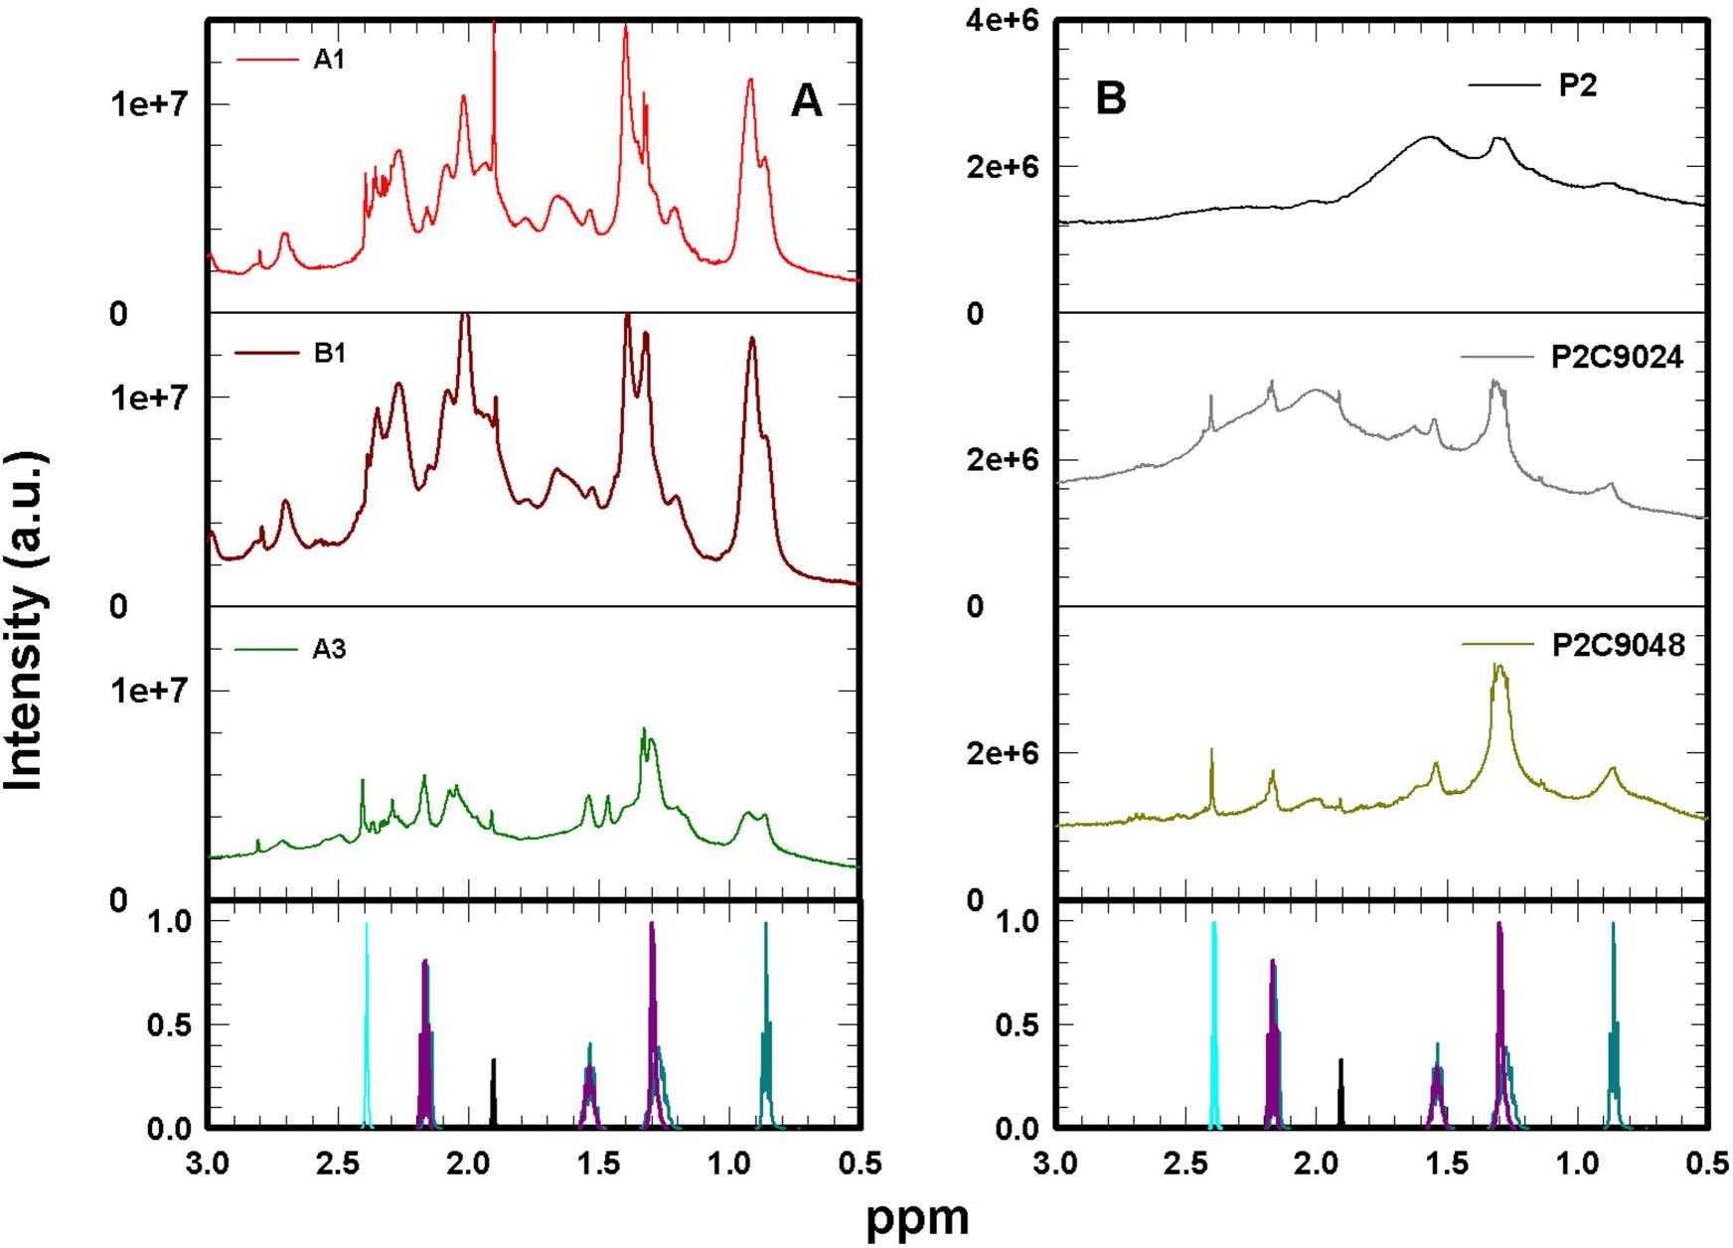
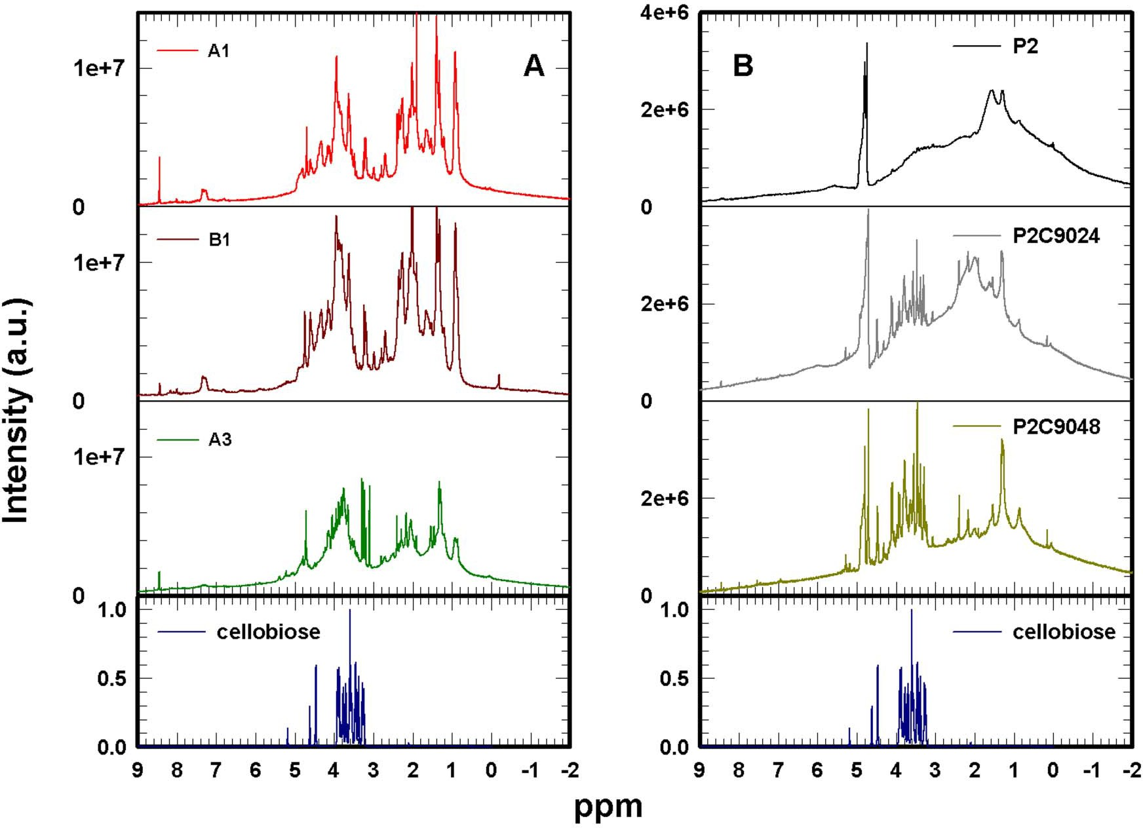
www.nature.com/scientificreports
Figure2|1HHR-MASNMRspectraofancientsamplesA1(redline),B1(brownline)andA3(darkgreenline)(panelA);modernsamples:notagedP2 (black line), and artificially aged P2C9024 (grey line) and P2C9048 (light green line) (Panel B); cellobiose dissolved inD₂O(dark blue line at the bottom of bothpanels).
Figure 3|Enlarged view of1H HR-MAS NMR spectra shown in Fig. 2. Ancient samples A1 (red line), B1 (brown line) and A3 (dark green line) (panelA);modernsamplesP2(blackline),P2C9024(greyline)andP2C9048(lightgreenline)(PanelB);aceticacid(blackline),hexanoicacid(dark greenline),pyruvicacid(cyanline)andsebacicacid(darkpinkline)1HHR-MASNMRspectrainD₂O,from28,areplottedforcomparisonatthebottom of bothpanels.
SCIENTIFICREPORTS| 3 : 2896 | DOI: 10.1038/srep02896
4

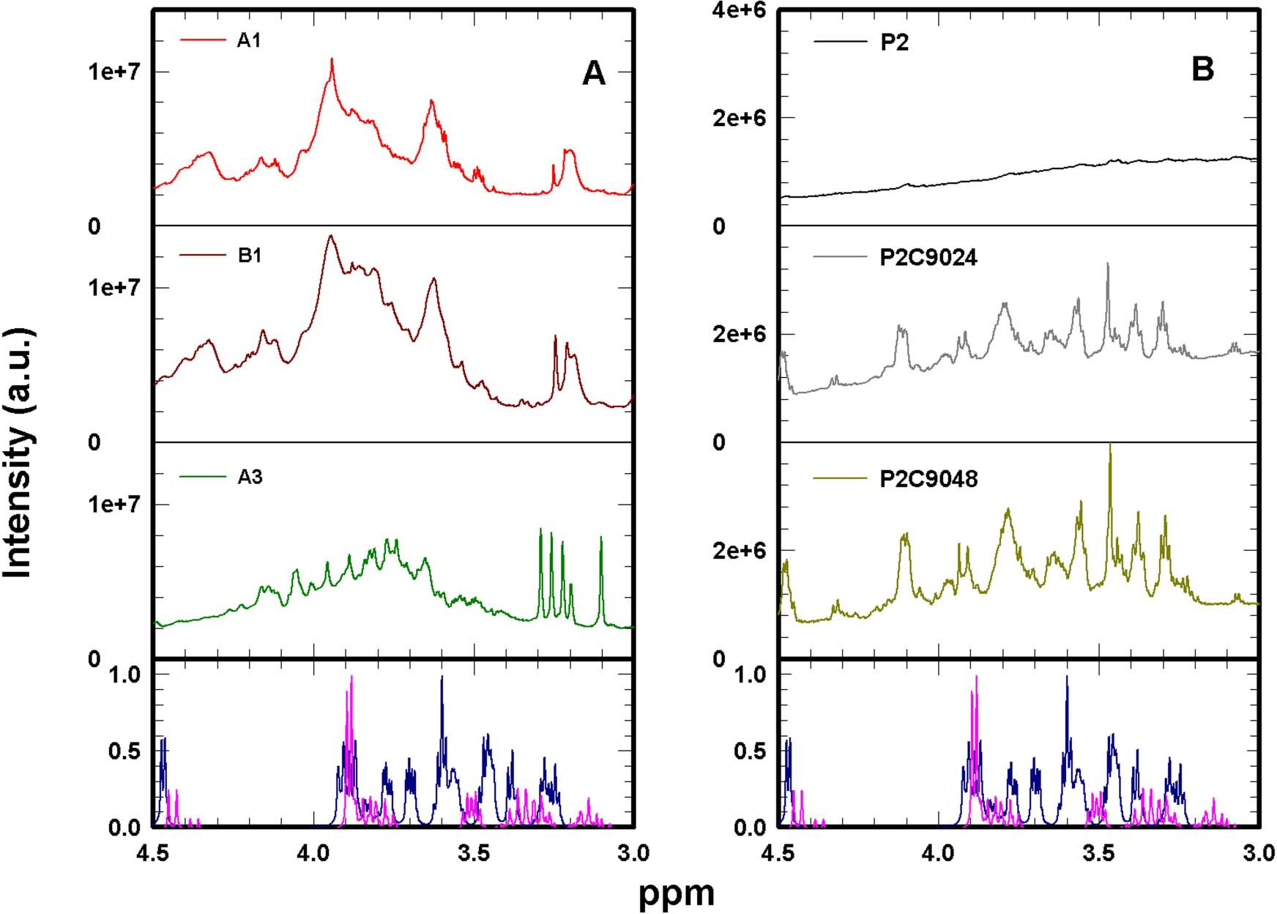
www.nature.com/scientificreports
Figure4|Enlargedviewof1HHR-MASNMRspectrashowninFig.2.AncientsamplesA1(redline),B1(brownline)andA3(darkgreenline)(panel A); modern samples P2 (black line), P2C9024 (grey line) and P2C9048 (light green line) (Panel B); cellulose from28(dark blue line), and cellobiose (purple line)1H HR-MAS NMR spectra inD₂Oare plotted for comparison at the bottom of bothpanels.
Apart from carboxylic acid signals, other features are also evident in the spectrum of P2C9024: a broad peak at 1.99ppm, which seems also present but less intense in P2, and several intense sharp peaks covering the frequency range from 3.20 to 4.52ppmand at about
5.2ppm.Thesewellresolvedpeaksareassignedtocellobiose(bot- tom of Fig. 2) and their strong increase in P2C9024 indicates an enhancedpresenceofwaterwithinthecellulosefibers.Thisisaccom- paniedbythecleavageofintra-molecularhydrogenbondingincel- lulose, which at this stage of degradation makes more degraded cellulosesamplesmoreaccessibletooxygenactivespeciesandthus pronetofurtheroxidation.Anincreaseofcellobiose-likefragments canbeaccountedforbyfractionationofcellulosepolymerinduced by hydrolysis andoxidation3,8.
In the spectrum of the most artificially aged P2C9048 sample (Fig.2B,greenline)thepreviouslydescribedpeaksareessentially present with stronger intensity. However, all features aresuperim- posed to a much flatter background than that observed for P2 and P2C9024. In particular, the large resonance centered atabout
1.99ppmis now reduced to an evident but low intensity peak. This could be explained in terms of consumption of amorphous regions of cellulose fibers due to progressive degradation: they become dis- rupted and cellulose polymers are transformed into degradation products like carboxylic and dicarboxylic acids. In this way reso- nances of poorly mobile compounds that were broad become nar- rower as the compounds become more mobile in degraded cellulose plasticized by water. This finding is in agreement with previously observed results which describe increasing recrystallization of cel- lulose upon ageing30.
All compounds detected in modern artificially aged samples are also found in ancient paper samples A1, B1 and A3, although the bands assigned to them show slightly different shapes and intensities (Fig.2A,Fig.3A,Fig.4A).1HNMRspectraofancientsamplesA1,
B1andA3(Fig.2A)arecharacterizedbyaflatbackgroundsimilarto that observed for the most degraded modern sample P2C9048. This confirms that degradation processes affect amorphous regions which become disrupted, then more mobile, so providing well resolved sharp peaks in1H NMR spectra. This can also be inferred from the sharpening of the peak centered at about 1.99ppm.
In ancient samples, the characteristics peaks of cellobiose (bottom of Fig. 2) are less evident. Most intense peaks are likely due to hydroxy-carboxylic acids, such as glucaric and lactic acids. Glu- caric acid is derived from the oxidation of D-glupyranose, which can be also oxidized to pyruvic acid and finally transformed in lactic acid31. Both these compounds are identified in our samples. In par- ticular, the cross-peaks of lactic acid are also very intense in the COSY and TOCSY spectra (Fig. 6 and 7, respectively). In fact,lactic acid cross-peaks are well evident in both 2D spectra at about 1.3and
4.1ppm. In the following cross-peaks will be indicated withinbrack- ets, such as (1.3, 4.1)ppm.
Interestingly,ancientsamplesshowbandswhichcouldbeassigned to several amino-acids. In particular, the peak at about 1.46ppmcan be assigned to alanine (Ala) whereas the broad one at about1.6–
1.75ppmto arginine (Arg). Other peaks from 1.96 to 2.20ppmand from 2.30 to 2.44ppmare assigned to proline (Pro), glutamic acid (Glu) and hydroxyproline (Hyp). Characteristic peaks of phenylala- ninecanbealsoidentifiedatabout3.1,3.3,4.05andaround7.3ppm, some of them originate evident TOCSY cross-peaks at (3.1, 3.3) and (3.1, 4.05)ppm(Fig.7).
The presence of these amino-acids gives evidence of ancient production methods, which employed glue from animal connective tissues (gelatin, i.e. denatured collagen) to improve paper writing quality4. Collagen consists of a triple chain of amino-acids, the most abundant of which are glycine (Gly), proline (Pro) and alanine (Ala).
SCIENTIFICREPORTS| 3 : 2896 | DOI: 10.1038/srep02896
5

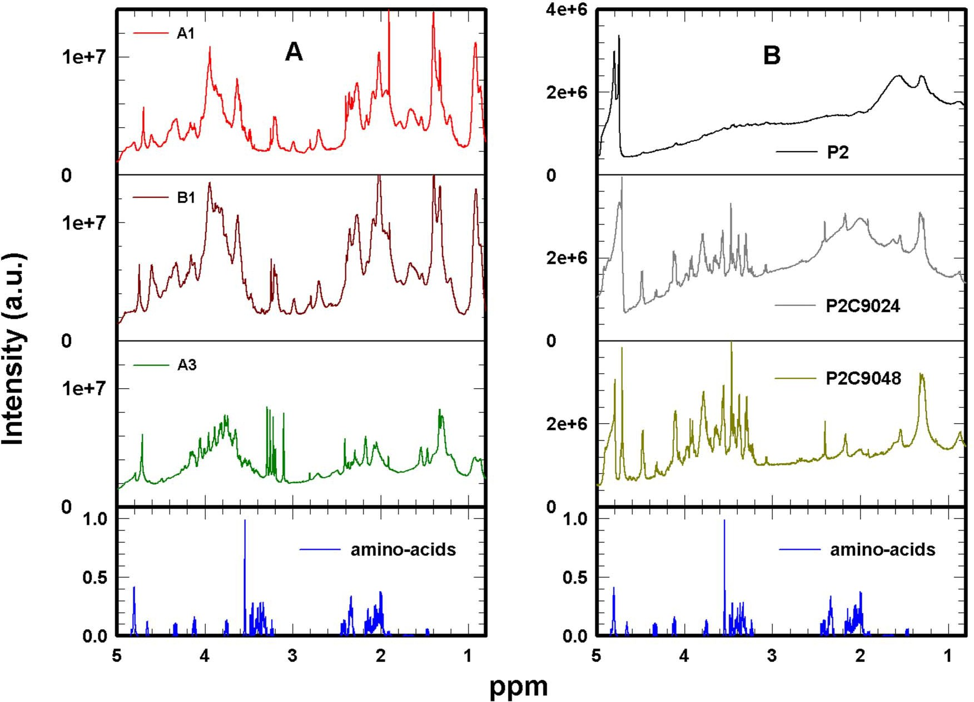
www.nature.com/scientificreports
Figure5|Enlargedviewof1HHR-MASNMRspectrashowninFig.2.AncientsamplesA1(redline),B1(brownline)andA3(darkgreenline)(panel A);modernsamplesP2(blackline),P2C9024(greyline)andP2C9048(lightgreenline)(PanelB);theweightedlinearcombinationofaminoacids1HHR- MASNMRspectra(seetextfordetails)obtainedfromon-lineNMRdatabases28,29(blueline)isplottedforcomparisonatthebottomofbothpanels.The smallerpresenceofcollagenNMRfeaturesinA3isduetotheintensedegradationofthissample14.Asaconsequence,collagenunderwentheavychemical and biological degradation processes which have strongly reduced its original amount in thepaper.
For a visual comparison between spectra of ancient paper and collagen,weusedaweightedlinearcombination,I,ofsinglespectra (in aqueous solution) of most abundant amino-acids in collagen (Gly, Pro, Ala, Hyp, Glu, Asp and Arg), obtained from on-line NMR databases28,29(bottom of Fig.5):
I~0:329Glyz0:126Proz0:109Alaz0:095Hyp
To summarize briefly, except for cellulose oxidation, as clearly shown in the case of modern samples, carboxylic acids could also originatefromcollagendegradation,evenifitisnotsimpletodis- criminate the origin of these compounds in ancientsamples.
Theintensefivepeaksbetween3.19and3.30ppmareverywell resolved in the most degraded ancient sample A3 (Fig. 4 A). In samples A1 and B1 only 3 less resolved peaks appear in the same region of chemical shift at about 3.21, 3.23 and 3.26ppm. In this region amines derivatives such as trimethylamine may appear. In addition,anisolatedsharppeakatabout2.81ppmcanbeattributed totrimethylaminewhichtogetherwithotheramines,mayevolveasa degradationproductofplantandanimalorigin.Particularly,itcan befoundinanimaltissue,especiallyinfish.Moreover,thesharppeak atabout3.26ppmcanbeassignedtotrimethylamineoxide,whereas that at about 3.2ppmto carnitine. Another compound of thesame classischoline,aprecursoroftrimethylamine,whichdisplayspeaks at about 3.1, 3.5 and 4.1ppm.
COSY and TOCSY analyses confirm and improve the identifica- tion of these compounds (Fig. 6 and 7, respectively). The COSY cross-peak at (1.54, 2.16)ppmin sample A3 confirms the presence of hexanoic and adipic acids, whereas that at (2.31, 2.48)ppmindi- cates the presence of 3-hydroxy butyric acid. Cross-peaks in the chemical shift region between 3.5 and 3.9ppmare due to mobile cellulose-like signals. These last cross-peaks are also present in the TOCSYspectrum(Fig.7),eveniftheirnumberishigherandtheppmrange is extended due to the different mechanism of magnetization transfer (see Methodssection).
In the TOCSY spectrum the cross-peaks at about (1.30, 1.54) and (1.30, 2.16)ppmconfirm the presence of hexanoic, adipic and other carboxylic and dicarboxylic acids, like sebacic acid reported at the
ð1Þ
z0:074Gluz0:047Aspz0:049Arg
Contributions of spectra of amino-acids have been chosenaccord- ingly to the average amino-acid composition for fish andmammal skin, and considering only those present at least at 4.9 wt%32. The agreement between spectra of ancient paper and collagen seems betterforA1andB1samples.Thiscanbeexplainedbythefactthat A3samplewaswetinthepastand,asaresult,itispresentlychar- acterized by an intense level of degradation14. As a consequence, collagenunderwentheavychemicalandbiologicaldegradationpro- cesseswhichhavestronglyreduceditsoriginalamountinthepaper, as can be observed nowadays by means of our NMR approach. Furthermore, it should be noted that the used linear combination couldnotwellaccountforthetypeofcollagenemployedtosizethe specific ancient papers. Finally, the collagen peak positions and shapes could be significantly modified because gelatin in ancient samples is in solid form and could bedegraded.
It is also interesting to note that formic acid is a final degradation product of glycine (the most abundant amino-acid in collagen). This observationcanjustifytheweakintensityofthecharacteristicglycine peak at about 3.54ppm, and consequently the stronger intensity of the formic acid peak at about 8.45ppmwith respect to the modern samples made of pure cellulose (Fig. 2A).
SCIENTIFICREPORTS| 3 : 2896 | DOI: 10.1038/srep02896
6

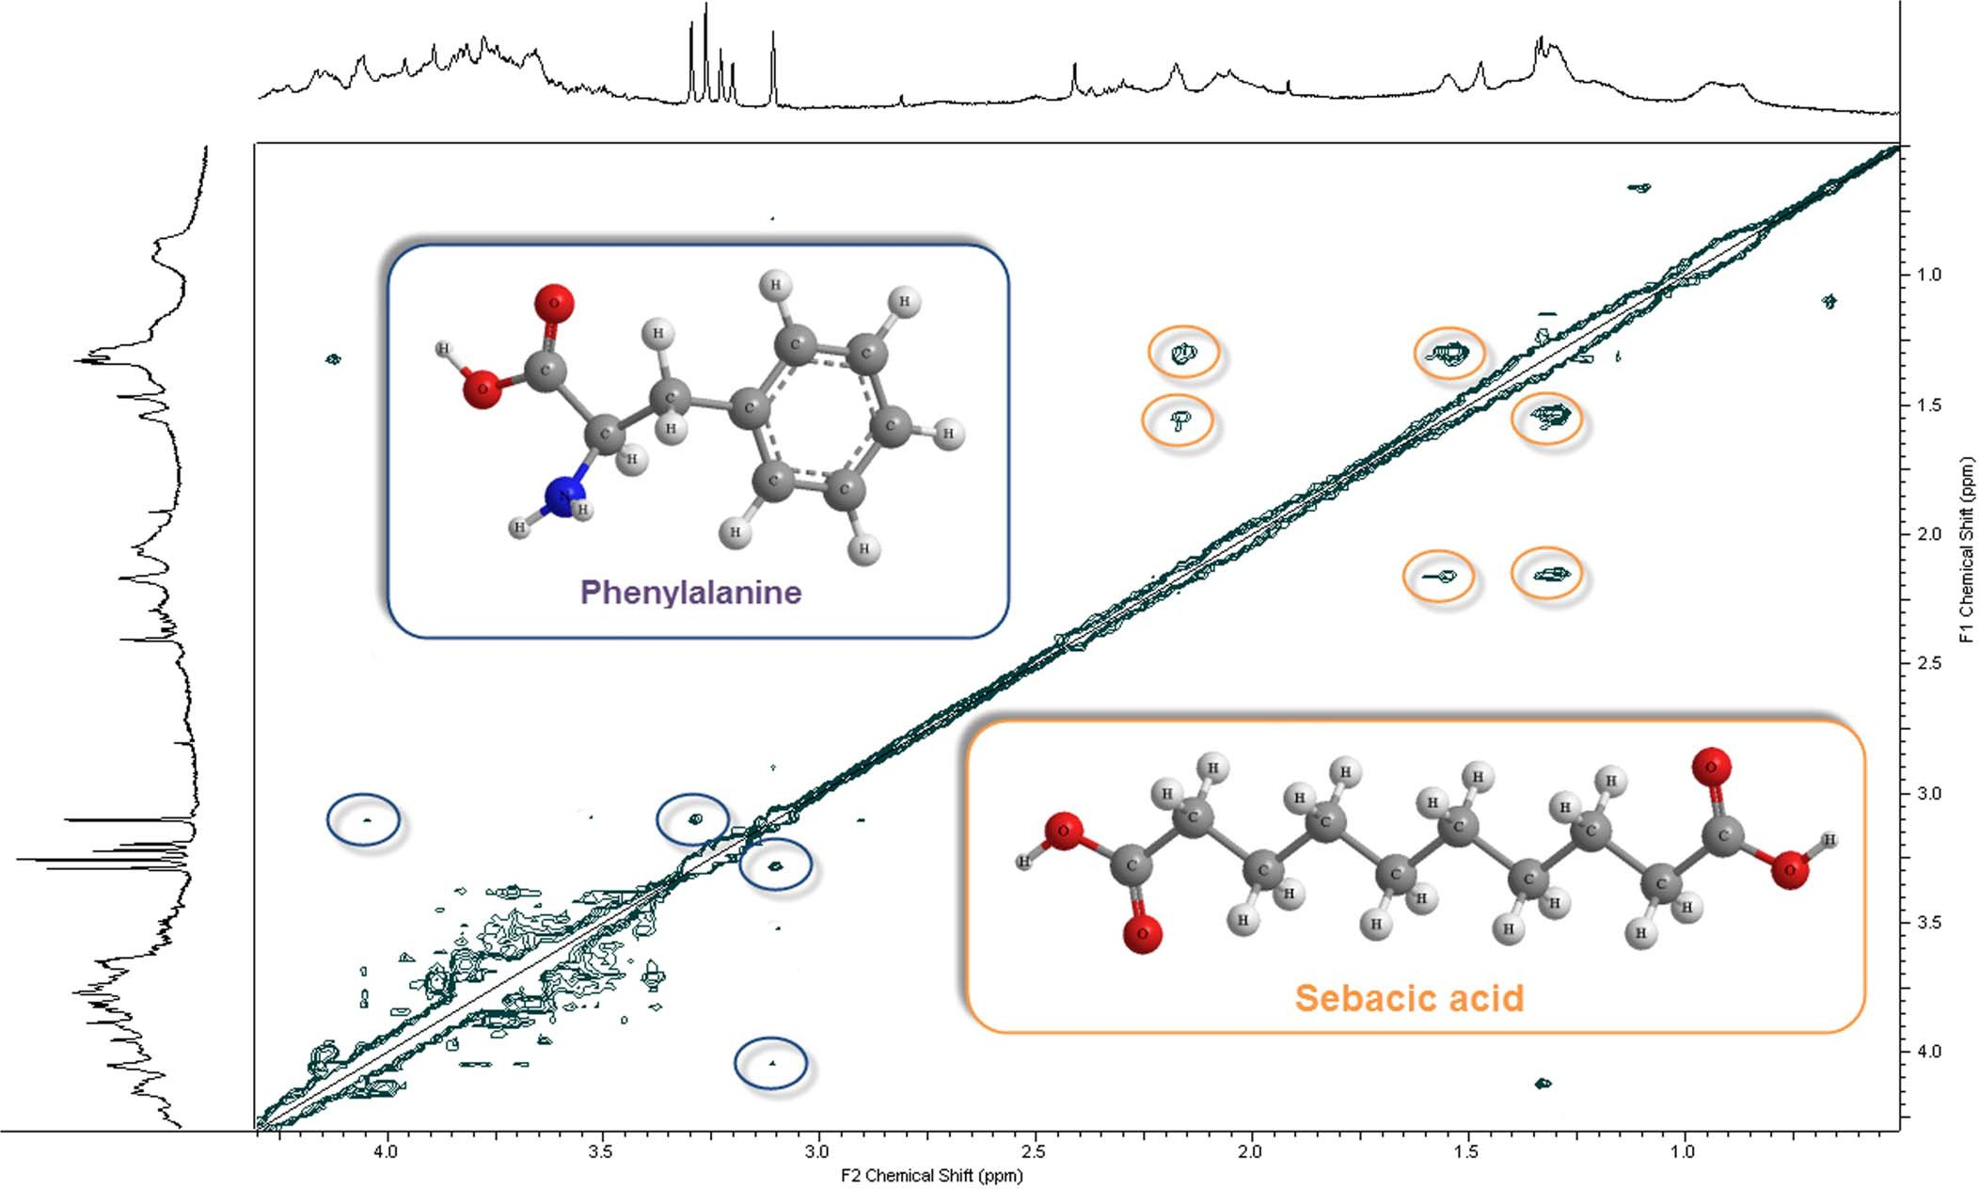
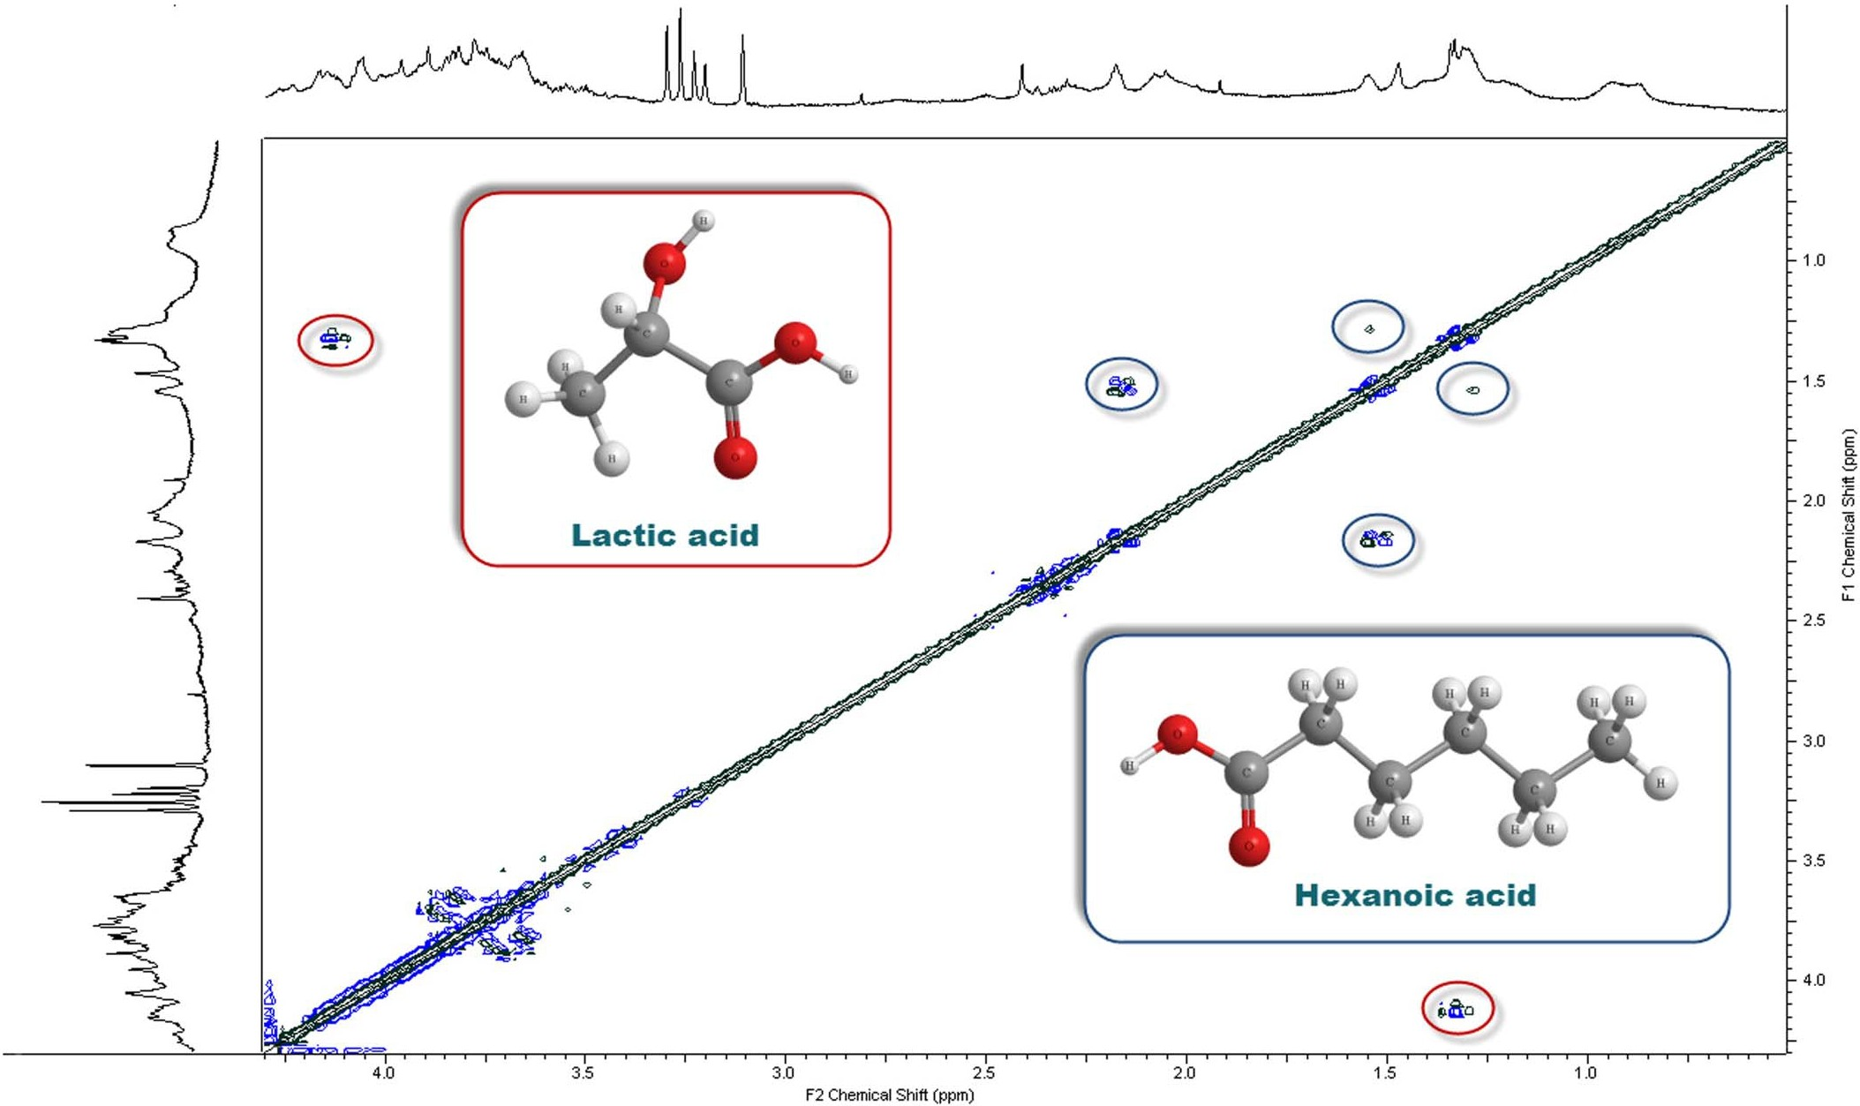
www.nature.com/scientificreports
Figure 6|COSY spectrum of ancient paper A3. In the graph are shown the compounds that origin the most intense signals.
Figure 7|TOCSY spectrum of ancient paper A3. In the graph are shown the compounds that origin the most intense signals.
SCIENTIFICREPORTS| 3 : 2896 | DOI: 10.1038/srep02896
7

www.nature.com/scientificreports
bottom of Fig. 3. In addition, the cross-peaks at about (0.7, 1.1)ppmarethesignatureofthepresenceoffattyacidssuchasoleanolicacid,a compound widely present in plants. Cross-peaks at about (2.9, 3.1)ppmcan be assigned to phenyl-lactic acid, which is, together with phenethylamine, a degradation product ofphenylalanine.
Some cross-peaks remain unassigned as those at (1.15, 1.31) and (3.1, 3.55)ppm, however, since their chemical shift falls in the same spectral region as carboxylic- and amino-acids, respectively, they are probably due to compounds with a similar chemical structure that can derive from both cellulose and collagen degradation. In sum- mary, the overall results suggest that our approach is able to furnish fine details about the production process of ancient paper, as for example the use of collagen for paper sizing during production, whichcouldbeveryusefulforhistoricalandprovenancestudies.
Thisresultopensthewaytodetailedstudiesofpaperartifactsdating andauthentication.
Ourresultscomplywithpreviousstudiescarriedoutbyusingvery differenttechniquessuchasgasorliquidchromatography15,electro- phoresis16, mass spectrometry16,17, for the detection of carboxylic acid, such as acetic and formic acids. In addition, our approach clearly shows the evidence of more complex carboxylic acids and specific minor compounds.
In summary, the knowledge of the presence of carboxylic, dicar- boxylic and hydroxy-carboxylic acids in ancient paper, could play a relevant role in the optimization of conservation procedures like those based on deacidification. Furthermore, the knowledge of spe- cific degradation products, when associated with their formation rate, could also give hints concerning condition and also age estima- tionofancientmaterialsbasedoncellulose.Thisknowledgecouldbe used to improve conservation, preservation and restoration of cul- turalheritagemadeofcellulose,andsuggestsfortheirdating,authen- tication andprovenance.
Discussion
Ancient paper documents, even if made of durable cotton, linen or hemp cellulose fibers, are subjected to degradation during their life span. Degradation phenomena are due to acid hydrolysis, oxidation or recrystallization of cellulose polymers. However, little is known about the products of these processes and their possible risk factors for ancient documents preservation.
Inthiswork,bymeansofanextremelypowerfulprotonHR-MASNMRset-up,forthefirsttime,thepresenceoflowmolecularmasscompoundswasdetectedinsolidfibersofcellulose.Thiswaspossiblethorough comparison of ancient and artificially agedmodelpapersamples,incombinationwiththeknowledgeofwater-celluloseinter-action.Theexperimentalapproachhasbeenoptimizedfortheana-lysis of paper based artifacts and was applied todeepen ourunderstanding of degradation phenomena that occurwithinthem.Degradation products were assigned by means ofChenomx NMRSuite,aidedbycorrelationspectroscopymethods,suchasCOSYandTOCSY,andtheuseofNMRonlinedatabases(seeMethodssection).Firstofallourresultsevidencethepresenceofcarboxylicacidsinall not aged and artificially aged model samples made ofpurecel-luloseaswellasinnaturallyagedsamplesofancientpaper.ThemostevidentacidiccompoundwhichwasfoundinNMRspectrawasassignedtohexanoicacid.Thiscanbeaccountedfortheringopeningofb-D-glucopyranose,followedbyoxidation.Whendegradationisenhancedinpaperbyheatingatatemperatureof90uCinthepres-enceofhumidity,alargersetofdifferentacidicproducts,includinglow molecular mass aliphatic acids, evolves over time. Ithasbeenprovedthatcommoncompoundsinalldegradedsamplesaretheformic and the acetic acid. More complex compoundsthansimplecarboxylic acids, such as dicarboxylic andhydroxy-carboxylicacids,arealsopresent.Thisfindingshowsthatevenatamoderateartificialagingb-D-glucopyranoseunitsarebrokentogiveproductsinform
of acidic compounds.
Furthermore, the presence of the simplest carboxylic acids, acetic and formic acids, together with the cellobiose-like fragments inmod- ern aged samples, is an indication of coupling between hydrolytic and oxidative degradationroutes.
Overall, a greater number of degradation products can be iden- tified in ancient samples which constitute some sort of their finger- print. Interestingly, degradation phenomena in paper materials are driven by complex reactions that take place during centuries even at ambient conditions. This is extremely important for the improve- ment of conservation strategies, which should always use relatively low conservation temperature, low relative humidities and, possibly, adopt conservation environment with reduced oxygen content.
Ourtechniquewasalsoabletodetectthepresenceofamino-acids inallancientsamples.Amino-acidsareindicativeofthepresenceof gelatin, a material which was usually used in the production of European paper in the Middle Ages as sizing compound. Another interestingoutcomeisthedetectionofimpuritiestypicalofspecific animaltissues,suchascholine,whichcanbefoundinfishcollagen.
Methods
Ancientsamplesusedinthisresearchconsistofsmallpiecesofpaper,producedinthe 15thcentury in European countries, that had already been used for other investi- gations7,14,33. Samples showed different degrees of degradation anddiscoloration.
Thesefragmentsoriginatedfromendleaves,meaningtosaythesheetsnormallyused by book binders at the beginning and end of a book, as protection for the main text block.Thisfeatureallowsforafairlyprecisedeterminationoftheageofpapersamples whilstthepresenceofwatermarksallowsforapreciseidentificationofthemillwhere itwasproduced.Allancientpaperusedintheexperimentscarriednoprinting.Aswas the custom in ancient times our samples were made of cotton and linen cellulose fibersand,toimprovethepaperwritingquality,theywereprobablysizedwithgelatin. AncientsamplesarenamedA1andB1(bothmadeinPerpignan,France,in1413),in good and in intermediate conservation conditions respectively, and A3 (made in Milan, Italy, in 1430) in bad conservation conditions (within a waterstain)14.
Model samples, obtained from Netherlands Organization for Applied Scientific Research (TNO), are made of unbleached cotton linters, containing very low inor- ganicingredients(ashcontent,0.005%inweight)andnoadditivesorlignin,with high mean degree of polymerization. These samples are named P210,14. P2 samples were artificially aged in air in a climatic chamber at relative humidity of 59% and temperature of 90uC for 24 and 48 days. We named accordingly the aged samples P2C9024andP2C9048,respectively.Inthissituationtheassumeddegradationfac- torsareairandwatervapor.Theseagingconditionsweredesignedasacompromise inordertogetmeasurablechangesin1HNMRspectraofmodelpapersampleswithin a reasonable period of time. Thus at 90uC a moderate degradation of the cellulose polymers is expected tooccur10,14.
Asareferencecellobiosesamplewasalsoused(obtainedfromMerckChemicalsLtd,UnitedKingdom).The1DHR-MASNMRspectrumofthesampledissolvedinD₂O(purity 98%) was acquired in the same way as paper samplesforcomparisons.TheadvantageofHR-MASwithrespecttothestaticNMRtechniqueistoprovideseparatedinformationonthepresenceoflowmassmoleculesspreadinsolidcellulose
materials. In fact, because of strong dipolar interactions that produce very large resonances(waterandcellulosecontributions),thestaticNMRtechniquecannotbe used for a microscopic characterization of paper degradation processes34,35. Several studiesperformedbymeansofCrossPolarizationMagicAngleSpinning(CP-MAS) were able to investigate the local variation of the amorphous and crystalline com- position,bylookingat13Csignals35,36.Asconfirmedbythisstudy,thedetermination of cellulose degradation products may be better achieved by means of1Hdetection that also permits most of the classical one and two dimensional homo- and hetero- nuclearexperiments25.
Hydrogen one and two dimensional NMR experiments on ancient and modern cellulosesamples,andoncellobiose,wereconductedatambientpressurebyusinga Bruker Avance spectrometer operating at 700 MHz1Hresonance frequency in the experimental configuration known as Magic Angle Spinning (MAS). By tilting samplesofapreciseangle(about54.7u)withrespecttothedirectionoftheapplied magneticfield,theHamiltoniantermcorrespondingtodipolarinteractionsvanishes and NMR peaks become narrower25. Furthermore, by spinning the sample holder (rotor)atthemagicanglebyfewthousandsofHertz,linebroadeningeffectsdueto susceptibilitydifferenceswithinthesampleareremovedresultinginhighresolution quality spectra. The sample temperature was kept at 300Kand controlled by acoldN₂flowandaheatingelement,calibratedagainstthestandardCH₃OHreference(4%CH₃OHinCD₃OD) with an accuracy of 0.2K.
Small rectangular pieces, 0.731.8cm2, of about 10mgin weight, of different papers were rolled up and carefully placed in the rotor. After placing the rolled samples in the rotor 30 mlofD₂Owere added. The rotor was then sealed (with the corresponding insert) and, in order to have a complete hydration of samples, approximately30minuteswerewaited.1HHR-MASmeasurementswereconducted byspinningtherotorat7000Hzatthemagicangletoincreasethespectralresolution.
SCIENTIFICREPORTS| 3 : 2896 | DOI: 10.1038/srep02896
8

www.nature.com/scientificreports
During samples spinning at a frequency of several thousands of Hertz, an high intensity centrifugal force acts on samples pushing them towards the rotor internal surface.However,duetothefactthatpaperisessentiallyabi-dimensionalmaterial, rolling the samples and inserting them in form of small cylinders, causes no mac- roscopicmechanicaldamages.Byjustdryingeachsamplebeforeremovingitfromthe rotor, we were able to recover its shape and appearance as it was before measure- ments. However, one has to consider that the hydration process could modify the original state of papersamples.
PapersampleswerehydratedwithD₂Oinordertoenhancethemolecularmobility and then the detection by the NMR technique of the cellulose components and degradationproducts,whilekeepingrelativelysmallthesignalduetowatercontained withincelluloseporesandvoids.Theuseofdeuteratedwaterasasolventisexpected to evidence polar compounds preferentially. A common feature of all spectra is a residualHODpeak at 4.7ppmeven if for all samples a presaturation pulse was executed.
Inourone-dimensionalexperimentsweused16000pointsinthetimedomainandaspectralwidthof20ppm(,14kHz).Therepetitiontimewassetto3sandthenumber of transients was 512. The duration of the hard pulse was of 7 mswith an attenuation of 3dB. To reduce the residual water peak we use a standard presa- turationpulsesequencefromBrukercalledzgpr.Everyacquisitionlasted33minutes. Free induction decays were multiplied by an exponential weighting function equi- valenttoa1Hzline,afterwhichtheywereFouriertransformedfromthetimetothe frequencydomainandreferencedtothetetramethylsilane(TMS)bymeansofBruker Xwinnmr 3.5 softwarepackages.
IndividualmetaboliteswereidentifiedbymeansofNMRSuiteProfessionalversion
7.1(Chenomx,Alberta,Canada).Thisisawellestablishedsoftwarepackagebasedon an highly sophisticated targeted profiling technology which allows an easy decon- volution of complex NMR spectra into their individual components with good accuracy. The Chenomx reference libraries contain hundreds of fully searchable compound models that are automatically calibrated by adjusting compound line shapes, peak widths, and chemical shifts to better match the sample conditions. In ordertoconfirmthechemicalshiftassignmentperformedbymeansofChenomxwe also carried out 2D homonuclear NMR experiments, and made use of mostreliable onlineNMRdatabasesbasedonexperimentallyacquiredspectra:theonlineHuman MetabolomeDatabase28andBiologicalMagneticResonanceDataBank29.Thecom- binationoftheseanalysesincreasesthelevelofconfidenceoftheperformedchemical shiftassignments.1H-13Cheteronuclearexperimentswerealsoattemptedwithinthis survey, however, no significant signal was detected with ourset-up.
The2DCOSYandTOCSYexperiments,byprobingthehomonuclearcorrelations, allow determining and characterizing the molecular structure. In particular, COSY cross-peaks correlate the chemical shifts of1H nuclei which are J-coupled to one another. In TOCSY experiments, instead, cross-peaks are generated between all membersofacoupledspinnetworkbyanetmagnetizationtransferfromonespinto anotherevenwithoutdirectcoupling.Double-QuantumFilteredCOSYusingPulsed Field Gradients (GRASP-DQF-COSY) experiments were performed by collecting 1024(F2)3256(F1)complexdatapointsof32scanseach,zerofilledto512alongF1 dimensionpriortoFouriertransform.Weusedaspectralwidthof3500Hz,centered at 2ppmto highlight the spectral region between -0.5 and 4.5ppm, in both dimen- sionsandarelaxationdelayof3s.ThesameparameterswereusedfortheTOCSY experiments(Brukermlevphprpulsesequencewithpresaturation)butwithaspectral width of 7000 Hz (centered at 4.7ppm) in both dimensions and a mixing time of 100ms. Every acquisition lasted 130minutes.
- Sterflinger,K.&Pinzari,F.Therevengeoftime:fungaldeteriorationofcultural heritage with particular reference to books, paper and parchment.Environ.Microbiol.14, 559–566(2012).
- Kolar,J.MechanismofAutoxidativedegradationofcellulose.Restaurator18, 163–217(1997).
- MoscaConte,A.etal.RoleofCelluloseOxidationintheYellowingofAncient Paper.Phys. Rev. Lett.108, 158301(2012).
- Lojewski,T.etal.Furfuralasamarkerofcellulosedegradation.Aquantitative approach.Appl. Phys. A-Mater.100, 873–884(2010).
- Souguir,Z.&Dupont,A.-L.FormationofBrownLinesinPaper:Characterization of Cellulose Degradation at the Wet-Dry Interface.Biomacromolecules9, 2546–2552 (2008).
- Bogolitsyna, A.et al. Determination of carbohydrate- and lignin-derived components in complex effluents from cellulose processing by capillary electrophoresis with electrospray ionization-mass spectrometric detection.J.Chromatogr. A1218, 8561–8566(2011).
- Rosenau, T.et al. Chromophores in cellulosics, VI. First isolation and identificationofresidualchromophoresfromagedcottonlinters.Cellulose18, 1623–1632 (2011).
- Dupont, A.-L., Seemann, A. &Lave´drine,B. Capillary electrophoresis with electrosprayionisation-massspectrometryforthecharacterisationofdegradation products in aged papers.Talanta89, 301–309(2012).
- Strliˇc,M.,KraljCigic´,I.,Kolar,J.,deBruin,G.&Pihlar,B.Non-DestructiveEvaluationofHistoricalPaperBasedonpHEstimationfromVOCEmissions.Sensors7, 3136–3145(2007).
- Lattuati-Derieux,A.,Bonnassies-Termes,S.&Lavedrine,B.Characterisationof compounds emitted during natural and artificial ageing of a book. Use of headspace-solid-phasemicroextraction/gaschromatography/massspectrometry.J. Cult. Herit.7, 123–133(2006).
- Moestue,S.,Sitter,B.,Bathen,T.F.,Tessem,M.-B.&Gribbestad,S.I.HRMAS MR Spectroscopy in Metabolic Characterization of Cancer.Curr. Top. Med.Chem.11, 2–26(2011).
- Beckonert,O.etal.High-resolutionmagic-angle-spinningNMRspectroscopyfor metabolic profiling of intact tissues.Nat. Protoc.5, 1019–1032(2010).
- Corsaro, C. & Mallamace, D. A Nuclear Magnetic Resonance study of the reversibledenaturationofhydratedlysozyme.PhysicaA390,2904–2908(2011).
- Winter, W. T. & Barnhart, D. HR-MAS: The Other NMR Approach toPolysaccharide Solids.Polysaccharide Materials: Performance by Design.Edgar,
K.J.,Heinze,T.&Buchanan,C.M.(eds),261–270(AmericanChemicalSociety, Washington, DC,2010).
- Behrends,V.etal.MetaboliteProfilingtoCharacterizeDisease-relatedBacteria: gluconate excretion by pseudomonas aeruginosa mutants and clinical isolates from cystic.J. Biol. Chem.288, 15098–15109 (2013), doi: 10.1074/ jbc.M112.442814.
- Ahmed, S. S. S. J. Systems biology in unruptured intracranial aneurysm: a metabolomicsstudyinserumforthedetectionofbiomarkers.Metabolomics1–11 (2013),doi:10.1007/s11306-013-0551-8.
- Wishart,D.S.et al.HMDB3.0–TheHumanMetabolomeDatabasein2013.
Nucleic Acids Res.41, D801–7 (2013).
- Ulrich,E.L.etal.BioMagResBank.NucleicAcidsRes.36,D402–D408(2008).
- Ali,M.,Emsley,A.M.,Herman,H.&Heywood,R.J.Spectroscopicstudiesoftheageing of cellulosic paper.Polymer42, 2893–2900(2001).
- Lehninger Albert, L., Nelson David, L. & Cox Michael, M.Principles ofBiochemistry(5thed.)(W.H.FreemanandCompany,NewYork,NY,2008).
- Szpak,P.Fishbonechemistryandultrastructure:implicationsfortaphonomyand stable isotope analysis.J. Archaeol. Sci.38, 3358–3372(2011).
- Missori,M.,Righini,M.&Selci,S.Opticalreflectancespectroscopyofancient papers with discoloration or foxing.Opt. Commun.231, 99(2004).
- Topgard,D.&So¨derman,O.DiffusionofWaterAbsorbedinCelluloseFibersStudied with1H-NMR.Langmuir17, 2694–2702 (2001).
- Capitani,D.,Proietti,N.,Ziarelli,F.&Segre,A.L.NMRStudyofWater-Filled Pores in One of the Most Widely Used Polymeric Material: The Paper.Macromolecules35, 5536–5543(2002).
- Federici,C.etal.AncientPaperandItsNMRCharacterisation.Sci.Tech.Cult.Herit.5, 37–47(1996).
1.
Klemm,D.,Philipp,B.,Heinze,T.,Heinze,U.&Wagenknecht,W.ComprehensiveCelluloseChemistry;VolumeI:FundamentalsandAnalyticalMethods(WILEY- VCH Verlag GmbH, Weinheim, Germany1998).
Svensson,A.etal.Bacterialcelluloseasapotentialscaffoldfortissueengineering of cartilage.Biomaterials26, 419–431(2005).
Krassig,H.A.Cellulose-Structure,AccessibilityandReactivity(Gordonand Breach Science Publisher, Singapore,1993).
Hunter,D.Papermaking:TheHistoryandTechniqueofanAncientCraft(Dover Publications, New York, 1978).
Missori, M., Righini, M. & Dupont, A.-L. Gelatine sizing and discoloration: A comparative study of optical spectra obtained from ancient and artificially aged modern papers.Opt. Commun.263, 289–294 (2006).
Nishiyama,Y.,Langan,P.&Chanzy,H.CrystalStructureandHydrogen-Bonding SysteminCelluloseI_{b}fromSynchrotronX-rayandNeutronFiberDiffraction.J.Am. Chem. Soc.124, 9074–9082(2002).
Missori,M.etal.ModificationsoftheMesoscopicStructureofCelluloseinPaper Degradation.Phys. Rev. Lett.97, 238001(2006).
DeSpirito,M.etal.Modificationsinsolventclustersembeddedalongthefibersof a cellulose polymer network cause paper degradation.Phys. Rev. E77, 041801 (2008).
2.
3.
4.
5.
6.
Acknowledgments
The research in Messina is supported by the Fondazione Frisone (Catania, Italy). All authors thank the Istituto Centrale per il Restauro e la Conservazione del Patrimonio ArchivisticoeLibrario(Roma,Italy)andtheCentroItalianodiStudieRicerchediStoriae TecnologiadellaCarta’’AndreaF.Gasparinetti’’Fabriano,Italyfortheirsupport.Dr.Pawel Wojcieszek is acknowledged for his close reading and correction of text in the English language.
7.
8.
- Kato,K.L.&Cameron,R.E.Areviewoftherelationshipbetweenthermally- acceleratedageingofpaperandhornification.Cellulose6,23–40(1999).
- Lojewski,T.etal.FTIRandUV/visasmethodsforevaluationofoxidative
degradationofmodelpaper:DFTapproachforcarbonylvibrations.CarbohydratePolymers82, 370–375(2010).
Author contributions
C.C.,D.M.andM.M.carriedouttheNMRmeasurementsandperformeddataanalysis.J.L. performed the artificial aging of paper samples. F.M. and L.P. supervised the research project. All authors discussed the results and reviewed this manuscript.
11.Zervos,S.Naturalandacceleratedageingofcelluloseandpaper:Aliteraturereview. Cellulose: Structure and Properties, Derivatives and IndustrialUses
Lejeune,A.&Deprez,T.(eds.),155–203(NovaPublishing,NewYork,2010).
SCIENTIFICREPORTS| 3 : 2896 | DOI: 10.1038/srep02896
9


www.nature.com/scientificreports
Additional information
Competing financial interests: The authors declare no competing financial interests.
How to cite this article: Corsaro, C.et al. Molecular degradation of ancient documents revealedby1HHR-MASNMRspectroscopy.Sci.Rep.3,2896;DOI:10.1038/srep02896 (2013).
This work is licensed under a Creative Commons Attribution-
NonCommercial-NoDerivs3.0Unportedlicense.Toviewacopyofthislicense,visithttp://creativecommons.org/licenses/by-nc-nd/3.0
SCIENTIFICREPORTS| 3 : 2896 | DOI: 10.1038/srep02896
10

